15th Century Contribution to the Study of Vaulted Structure in Iran

Gholam Hossain Memarian, PhD Associated Professor of Architecture, Iran, Tehran, Iran University of Science & Technology, School of Architecture and Environmental Design,
E-mail: memarian@iust.ac.ir, Tel: +989123766834.

M. Anwarul Islam: Manchester School of Architecture, University of Manchester, Manchester, U.K.

Seyed Mohammad Farid Mousavian: MSc. Arch. Student of Urban Housing, Iran, Tehran, Iran University of Science & Technology, School of Architecture and Environmental Design,
E-mail: s_fmoosaviyan@arch.iust.ac.ir, Tel: +989188158845.

Abstract:

Vaulted structure has been in use for nearly 4000 years and believed to have been studied by scientists and builders for nearly 2000 years. There are few publications about the geometry and constructional aspects of arches and vaults before Renaissance age. One of the most interesting works on this subject belongs to Jamshid Kashani known as a mathematician. Ghiayth Al-Din Kashani, has made some valuable contribution in the field of building construction in general and vaulted structures in particular. This paper aims to introduce and analyze a part of his work on building construction, that is on pointed arches. In this paper first we provide a short history of pointed arch. Then we will see a number of works from Roman period to Kashani age which had some contribution about arches. The third part of the paper deals with Kashani's book Meftah Al-Hesab or the key of mathematics. The final section of the paper has devoted to Kasahni's contribution to pointed arches. And finally showing one of the calculation charts which could be used to find different parts of the arches can be the best case in the point.

Keywords: Arch, Vault, Kashani, History of Architectural Construction.

Introduction
The major part of the 13th century Persia, which included the modern state of Iran and its surrounding areas in Iraq, Central Asia and Afghanistan, was conquered by the Mongols, whose attack began in 1218 AD and almost everything was destroyed in the lands they occupied. A country with long heritage of civilisation where examples of earliest known architecture dates back to c. 6200 BC, was almost in ruins and the great cities like Samarkand, Bukhara, Tus, Neishboor and Ray were razed to the ground. Towns and cities which were once the centres of excellence in science, literature, philosophy, religion, etc, were suddenly non-existent. All the establishments relevant to the pursuit of knowledge, e.g., libraries, laboratories, etc., disappeared overnight and as a consequence, the scholars in the various fields, who were the pioneers in the Islamic world, had to discontinue their work and were no longer capable of raising the flag of achievement in the way they did before. Similar fate occurred to scholars of all the other countries which suffered from the Mongol invasion. In spite of that, work continued albeit at a much smaller scale and in the next couple of centuries, works of some of the Iranian scientists reached very high standards with significant contributions in their respective fields. Among them were Tusi, Helli and Kashani.
As mentioned above, the fields in which scholarly activities were pursued in Iran were religion, philosophy, mathematics, astronomy and geometry. Like the pre-Mongol period, applied science was the most favourite field. However, a new branch of the applied science came into prominence - the science of building construction - which is not known to have been given as much importance in the pre-Mongol period. This was due to the enormous damage to the built environment of the country caused by the Mongol invasion and the need for its speedy reconstruction. Ghiayth Al-Din Kashani, apart from a number of other fields that he was interested in, has made some valuable contribution in the field of building construction in general and vaulted structures in particular. In this paper only a part of his work on building construction, those on arches, will be presented.

Pointed Arch
Although the arch was known to the Mesopotamians and the Egyptians, the elliptical form of arch used as an element of building structure dates back from the period of Ilamids in the south-west of Iran in the 14th century BC. Existence of arches in the Egyptian tombs in Sakara and Thebes, the latter claimed to be of 1500 BC, are discussed by Gwilt in his The Encyclopaedia of Architecture first published in 1842 [7]. He also states that ‘no trace of the arch has been found in the ruins’ of Babylonian architecture. In Persia, where some of the buildings before the Achaemenid rulers (560-330 BC) are believed to have had arched entrances and openings, the use of arches and vaults continued in different periods of its history. During its rule by the Selucids, Parthians and Sasanids (312 BC - 642 AD) there were extensive use of arches and vaults in buildings and other civil engineering structures for water supply, sewage disposal and drainage systems, etc. The earliest example of a fire temple, the typical form of which is a dome resting on four arches, dates from the Parthian period (174 BC - 224 AD).
In the west, it is generally agreed that the Greeks did not use arch and their columnar style of architecture, derived from the post and lintel system, did not call for elements like arch or dome for the transfer of load to the vertical members of the structures. Afterwards, the Romans have used arch and exploited it on a grand scale both as structural members and as a symbolic form, as seen in their prestigious buildings like theatres, amphitheatres, aqueducts and bridges. The practice using arches, vaults and domes continued in the subsequent periods of Early Christian and Byzantine architecture.
Apart from the elliptical shapes of Persia, the arches that have been used during these periods are essentially of semicircular type deriving directly from the geometry of a circle and providing a simple shape for construction. The pointed arch made up of the arcs of at least two circles, as opposed to the semicircular arch, were not commonly used in the western architecture before the 11/12th c. AD, whereas later on it became one of the essential element of Gothic architecture (12/13th c. AD). It is accepted by some architectural historians that the pointed arch have been used in Europe only after the first crusade with the implication that the idea was imported from the east where it was already in use. According to Creswell [3].. the renowned authority on the history of Islamic architecture, ‘this feature is of Syrian origin’ - either in the pre-Islamic building at Qasr ibn Wardan built between 561 and 564 AD or in the Islamic buildings of the 8th century AD some of which are mentioned below. He defines pointed arch as one whose ‘two halves are struck from a different centre’ and ‘the less the separation of these two centres, the less the acuteness of the arch’. He sites example of this type of arches in the buildings of the Umayyad Period of Islamic architecture (661-750 AD), such as the Great Mosque of Damascus in Syria (709 AD) where the separation of centres is about one-tenth to one-eleventh of the span, Qusayr ’Amra in Jordan (715 AD), Hammam As-Sarakh (725-30 AD) and Mshatta (744 AD) also in Jordan. In the last example, separation of the centres is one-fifth of the span.
A new type of pointed arch has been (750-1258 AD), the four-centred arch, which is usually struck from two pairs of centres located symmetrical to the vertical axis and produces a shallower profile than a two-centred arch. According to Creswell, the earliest example of the type was in the Baghdad Gate of the walled city of Raqqa in Syria built by Caliph Al-Mansur in 772 AD. “The splendid arch is built of two rings of square bricks, each being two bricks thick, so that the total depth is about a metre”[3].
While there seems to be a general acceptance of the fact that the pointed arch is not of European origin, there are some who believe that, like the semicircular arches, pointed arch was also used first in Persia. Professor Pirnia, a renowned Iranian architectural researcher, claimed that the use of semi-elliptical and pointed arches in Iran goes back to 3400 years - “semi-elliptical of different kinds and pointed arches (shakh bozi) have been adopted in the basement and underground spaces of Chogha-Zanbil.” [10]. He provides three types of semi-elliptical shapes-i) biz-i kond, ii) biz-i tond and iii) bastoo -that were mainly used in domes and arches. In the first type the span is twice the vertical diameter of the ellipse and the arch has a low rise. In the second type the span is equal to the vertical diameter of the ellipse and this type could be used for large arches. In the third type, one-sixth of the span is equal to one-eighth of vertical diameter, i.e., the span is 3/4th of the vertical diameter of the ellipse and the type is used for high domes specially in the construction of underground cisterns. He also suggested that ellipses were used to create other types of arch profiles. For example, a type of arch called sabooii used in the construction of Uljeitu dome is obtained by the intersection of two arches.
Among the existing buildings of Iran the earliest known examples of pointed arch are in the Jami Fahraj and the Tari-Khana Mosque in Damghan (c. 760 AD) which is considered to be the oldest existing example of Islamic architecture in Iran. The earlier arches, especially the non-semicircular ones of the Sasanid period (224-642 AD), are of elliptical form rather than pointed. All types of arches became common features of Seljuk architecture(1000-1157 AD).

3. A Short View On Study Of Vaulted Structure Before 15th Century
Although vaulted structure has been in use for nearly 4000 years and believed to have been studied by scientists and builders for nearly 2000 years, no publication about the geometry and constructional aspects of arches and vaults is available other than those from very recent times. Vitruvius, the Roman architect/engineer, who served the Emperor Augustus in the first century BC, wrote in Chapter VIII of Book VI of his ‘The Ten Books on Architecture [13]. about ‘archings composed of voussoirs with joints radiating to the centre’ as a method of discharging the load of the walls. Then he discussed about the horizontal thrust caused at the end pier supporting the arches and suggested that ‘if the piers at the ends are of large dimension, they will hold the voussoirs together, and make such work durable’. He did not discuss in any more detail about the geometry of arches and the above description implies that the type of arch he defines is a semicircular one. In different sections of his book Vitruvius discusses about architecture, the various elements of buildings as well as the materials and construction. There is no section on geometry or construction of arches, domes or vaulted structures.
In the middle ages, the Early Christian, the Byzantine and the Romanesque styles of architecture used arches usually of the round type. In the second half of the 12th century architecture in Europe used both round and pointed arches and, as mentioned earlier, during the following period of Gothic Style, pointed arches became a distinctive feature of its buildings. The work of Vitruvius, as mentioned above was rediscovered in the early 15th century during the Renaissance Period (15/16th c. AD) and some written contribution about these types of structures are available from this period. The versatile Italian Leonardo da Vinci (1429-1519 AD) gave a short account of arches amongst his original contribution on many other aspects of science. As described by an Italian author he defined arch as “a strong united elements which consisted of two other words, a completed arch consists of two symmetrical arcs which can not stand up and remain in vertical position on their own and only when they are attached together that they make a strong structural element’⁶. He did not provide any other information regarding the geometry and construction of arches or their types.
In the mid-16th century Palladio made some contribution on vaulted structure which deals more with their geometry rather than their constructional aspects. In his ‘Tre Libri dell Architettura’ (1554-56 and 1562-65) he discusses about the height of vaults and describes different types of vaults [12]. The first part of his work is on finding the height of arches and vaults with different profiles including the semicircular ones by both the geometrical and the numerical methods. In the second part he discusses six types of vaults-crossed vault, barrel vaults (two types), rotunda, lunette and conca. He suggests that the first four types were used in ancient buildings while other two were used in modern buildings. Unlike Kashani’s work, Palladio does not give any definition for arches and domes nor does his work deal with their measurements and structural application.

Meftah Al-Hesab
Ghiyath al-Din Kashani studied the geometry of pointed arches in the 15th century Iran and produced methods of constructing five types of pointed arches along with simple methods of calculating their dimensional properties and application criteria. His book entitled Meftah al Hesab or ‘The Key to Arithmetic’ published in the first half of the 15th century remains to be the only publication which deals substantially on the geometry, measurement and calculation of arched and vaulted structure until the 17th century. The original book was written by him in Arabic which was the language of Islamic science at the time and was translated into Persian at a later date. Apart from reference to some of these works as part of the Timurid architecture [6]and Necipoglu [9], the authors have not found English version of Meftah-al-Hesab or any publication in English dealing in detail with its section on arches, vaults and domes. There is an article in Russian dealing with the discussion and analysis of this section published in a journal of Azerbaijan[1]which has been translated into Italian.
Some information about the life of Ghiyath al-Din Kashani are available from different sources. Kashani is the title meaning that he was born in the city of Kashan which is located on the border of the great salt desert (kavir) to the south of Tehran. He was born in around 790 AH (1394 AD) and his ancestors were medical doctors (tabib). In his youth Kashani became interested in mathematics and astronomy and was educated in these fields by one of the students of the great Islamic scientist Sheikh Tusi. At the time Samarkand was the centre of Islamic science, specially in mathematics and astrology, and soon he became well known as a scientist in that city. ‘He always showed due respect to the fellow scientists and strongly believed in the help and blessing of God in the level of understanding and achievement that he has attained. He was one of the scientists involved with the construction of Samarkand Astrology Site and published eight books in Arabic and Persian, mostly on astrology, arithmetic and geometry[12].
Meftah al Hesab starts with an introduction on arithmetic (hesab) followed by five articles/chapters (maghaleh) on i) integral number, ii) fractional system, iii) arithmetic of astrology, iv) measurement and v) extraction of algebraic problem. The fourth article, i.e., the one on measurement, is divided into different sections of which the ninth section is about the measurements relating to arch, vault, dome and muqarnas. This section contains definitions of relevant architectural terms, charts, drawings, methods of measurements as well as comments, discussions and his personal views on the subject.
This paper is based on the study of the contents of Meftah al Hesab received from several authentic sources. The first of these is copies of the original manuscript of Kashani received by courtesy of Habib Mahbbob, an Iranian researcher on the history of architectural technology and Persian architectural terminology. The second source was the revised edition of the book in Arabic by two scholars at the University of Cairo [4]. The third source was the book in Persian as revised and translated by the Iranian scholar Jazbi [5]and finally the article in Russian published in Art of Azerbaijan journal [1]. As mentioned earlier, in the 9th section of the 4th article/chapter of his book Meftah al Hesab Kashani deals with the geometry and measurement of arches, vaults, domes and muqarnas and provides other information about these structural elements based on previous studies available at the time as well as his own work. His discussion about the various aspects of these elements are more thorough than was done before and was important information for the reconstruction of post-Mongol Persia. Introduction to this section includes two main points. Firstly, that he was aware of the previous studies and experiences although he does not quote the sources. At the beginning of the section Kashani states that 150 buildings were measured by others which included only arches (tagh) and vaults (azaj). Secondly, his emphasis on the importance of further knowledge in this field expressed as ‘need for more measurement of buildings’. In his discussions he reminds the readers that these aspects were not dealt with adequately in the past and the Muslim scientists of this period worked hard in the fields of applied science which were essential in the aftermath of destruction and devastation caused by the Mongols. The reconstruction and development that followed needed whole hearted and co-ordinated efforts from both the ordinary people and the scientists of all the Muslim countries which were affected by the Mongol invasion.
The 9th section of the book Meftah al Hesab is divided into three sub-sections. The first is on the measurement (masahat) of arch (tagh) and vault (azaj), the second is on dome (qobbe) and the third is on muqarnas. The scope of this paper is confined to the work on arches in the first sub-section. The section begins with a reference to the available knowledge of arches and vaults based on previous works. Then he discusses about the proper definition of an arch. He states that in the past an arch was known to be an empty or hollow semicircular element (mojavaf) and not many examples complying to this definition are seen in the ancient and new buildings. While he mentions about a few buildings with ‘hollow semi-circular vaults’, he also notes that ‘many of the arches are raised and pointed (muhadab) in the middle.’ He then puts forward the standardised description of an arch which is possibly more appropriate, in the context of contemporary Iranian architecture, than the previously mentioned definition of a pointed arch by da Vinci given a few years later. "Fig 1", which is a representation of the original drawing as drawn by Kashani, is based on this description which is as follows:
“a true arch (tagh) is a ceiling (musaqaf) which stands on two bases which are on the same horizontal plane. It consists of five pieces/elements (qeta) of which the two lower pieces (parts A) - resting on the bases one on the left and the other on the right of the vertical axis - are parts of the perimeter of the same circle (qate falaki) or ring (halghe) whose diameter is not smaller than the span of the arch. The two upper pieces (parts B) resting on the lower pieces, symmetrical to the vertical axis, are arcs of a circle whose interior diameter is bigger than that of the first circle (parts A). Thickness of these two pieces of the arch, however, are the same as that of the two lower pieces to which they are joined together along the lines HEDK and GECL as seen in Fig 2. These four pieces form the main body of the arch joined at the top by a fifth piece (part 3), which is like an almond shaped lozenge made of plane (not curved) surfaces, to complete the structural unit. [5].
From the above description it is apparent that he was defining a pointed arch struck from three centres, the lower parts being the arcs of the same circle and the upper curved pieces are the arcs of two other circles of same diameter. We shall find later on that two of the five types of arches analysed by him do not satisfy this description.

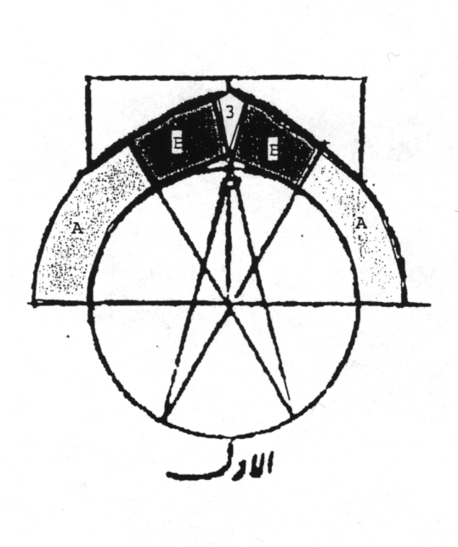
Fig. 1 The Arch

Types Of Arches
After giving the definition Kashani explains the difference between arch (tagh) and the vault (azaj) (In modern Persian, tagh means vault and arch denoted by dour or quos). He states, ‘the depth (arth) of an arch may not be more than its span, whereas that of a vault may be equal to or more than its span and is called length (tul) of the vault’. Or, in other words, he is setting parameters to distinguish between an arch and a vault, i.e., when the length is less than the span it is an arch, otherwise it is a vault. By the word azaj he probably meant barrel vaults only. In his description of an arch, as will be seen later, he also uses different terminology for different parts of its surface.
This section of Meftah al Hesab then continues with Kashani’s description of the five types of arches. He begins by stating ‘as we have seen there are five methods for drawing arches’, suggesting that he had his own survey carried out in this particular field in addition to the information available to him as result of contemporary research on traditional and modern buildings. He also compares these five types of arches with those in the existing buildings After describing the geometry of these five types of arches Kashani presents a chart with coefficients for simplified calculation of geometrical properties, e.g., lengths, areas, etc., of these arches. Although no formula or method of calculation of structural properties of these arches are given, he mentions about the suitable span length of some of the types. His description of the arches are as follows:
Type 1 “Fig 2”
Draw a circle (daira) ABCD with its diameter equal to the span of the arch. The point (nughta) E is the centre of the circle. Divide the circumference of the circle into six equal parts with each arc AD, DC, CB, BH, HG and GA subtending a 60 degrees angle. Draw the diagonals AB, CG and DH and extend them to I, K, L and M so that AI = DK = CL = BM = the desired thickness of the arch. Draw arcs IK and LM with centre at E and radius EI (=EM). So they will be parallel to AD and CB. Then with H as the centre and HD as radius draw the arc DF and G as the centre and GC as radius draw the arc CF, F being the point in the vertical axis where these two arcs intersect. Now draw the lines HF and GF and extend them up to S and T, FS and FT being equal to the thickness of the arch. Draw the arch KS with H is the centre and LT with G as the centre. Draw straight line SN and NT as perpendicular to SF and TF respectively. Thus the five pieces AIKD, DKSF, FSNT, FTLC and CLMB joined together forms the facade of the arch [5].

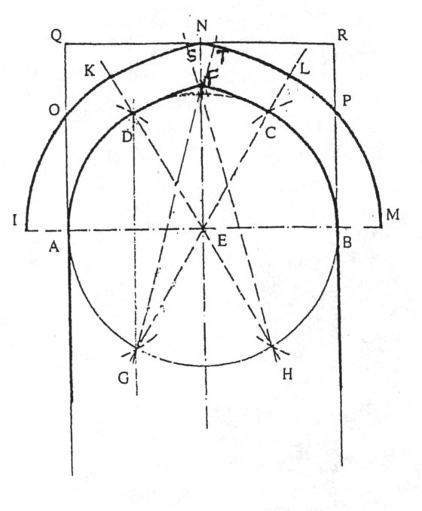
Fig. 2 The Arch Type 1
Kashani then provides his terminology for various parts of the arch. He calls the intrados of the arch ADFCB as the ‘interior surface’ of the arch, known to the Persian masons (banna) as esbareh. He uses another term ‘ketf’ which may be translated as the arm or shoulder of the arch and is the area of part of the facade found by drawing the line QNR parallel to AB and the lines AQ and BR parallel to the vertical axis EN. The surfaces OQN and PRN are termed as ketf. He considers the areas AIO and BMP to be parts of the wall rather than those of the arch. The line EF represents the height of the intrados (or rise of the arch) and the line EN that of the extrados (mohadab). Kashani then comments that ‘in some buildings it is seen that the lines DF, FC, KS and TL are drawn as straight lines instead of arcs of circles.
He makes the following recommendation regarding the structural suitability of this type of arches: ‘this method of drawing is good when the span of the arch is about five zar’, each zar being about 104 centimetres [5].
Type 2 “Fig 3”
Draw the semi-circle ADCB with diameter AB equal to the span of the arch and the centre at E. Extend the line AB on both sides up to I and M, AI and BM representing the thickness of the arch. The semi-circle is then divided into four equal parts AD, DJ, JC and CB. Draw the radii ED and EC and draw a line joining the points B and J. Extend the lines DE and CE towards the bottom up to the points G and H, EH and EG being equal to the length of BJ. G and H are also the points where vertical lines through A and B intersect with the extensions of CE and DE. On the upper side extend ED and EC up to the points K and L so that DK = CL = the thickness of the arch. With centre at E and radius EI (=EM) draw the arcs IK and LM. Then with centres at G and H and radius HD (=GC) draw arcs DF and CF, F being the point on the vertical axis where they intersect. Join GF and HF and extend up to S and T with FS = FT = the thickness of the arch. With radius EI (=EM) and E as centre draw arcs IK and ML and with radius KH (=GL) and centres at G and H draw arcs KS and TL. Draw straight lines SN and TN perpendicular to FS and FT, N being their point of intersection which is on the vertical axis of the arch. Like the first type the five parts of the facade of the arch are AIKD, DKSF, FSNT, FTCL and CLMB. Again, by drawing the rectangle AQRB the areas KQN and LRN or the ketf (shoulder) of the arch are identified. Arches of this type are more acute than those of the first type with a greater rise in proportion to the span.

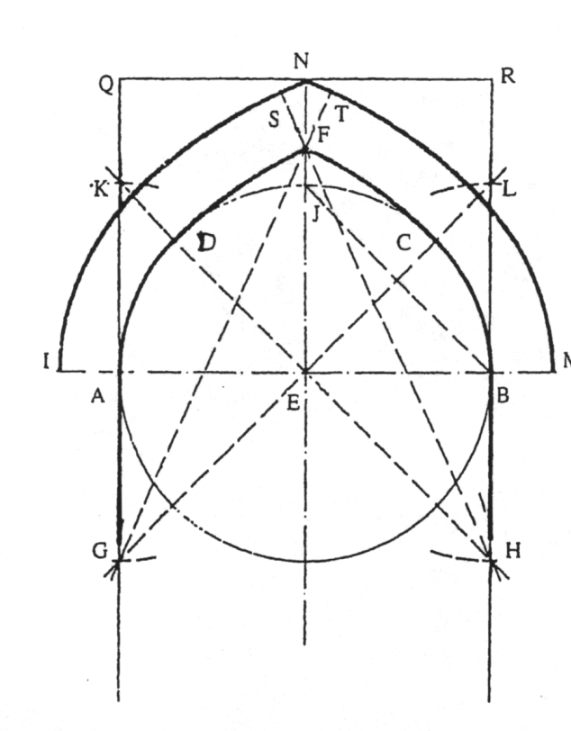
Fig. 3 The Arch Type 2
According to Kashani ‘this method of drawing an arch is suitable for spans of 5, 10 and 15 zera. A zera is the distance btween the tip of the middle finger and the elbow^{13(p.29)} (or a cubit) and is a length of about 50 cm [5].
Type 3 “Fig 4”
Draw the circle with AB, the span of the arch, as diameter and E as the centre. Its circumference intersect the vertical axis of the arch at J. Draw the straight line BJ. On the line AB locate points P₁ & P₂ on either side of E with EP₁ = EP₂ = 1/8th of AE. Through P₁ draw a line parallel to BJ and cut off P₁H equal to BJ. Draw AD, the arc of a circle with P₁ as centre and P₁A as radius. This arc intersects extension of the line HP₁ at D. Draw AI equal to the thickness of the arch and with P₁I as radius draw the arc IK of the outer circle, DK being equal to the thickness of the arch. Now, with H as the centre and HD as radius draw the arc DF, F being the point where this arc intersect the vertical axis. Join HF and extend upwards. Again, with H as centre and radius HK, draw the arc KS, S being its point of intersection with the extension of HF. Draw the line SN perpendicular to SF, N being its point of intersection with the vertical axis. Thus, half of the arch has been drawn with P₁ and H as centres. The other half may then be drawn by finding the point G, in exactly the same way as that used for H, and using G and P₂ as centres. The arch type 3, thus drawn, has a rise - in proportion to the span - greater than those in types 1 and 2.

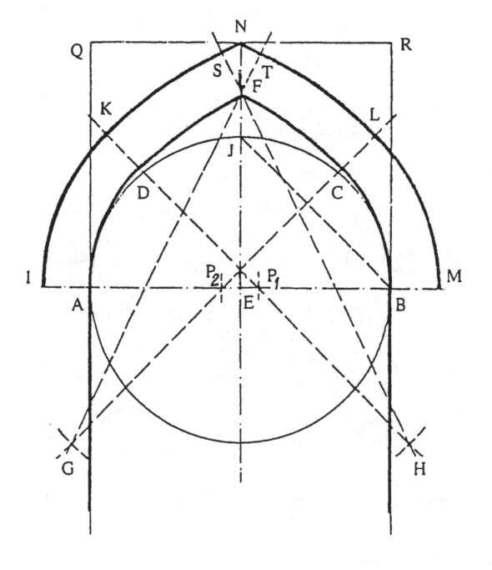
Fig. 4 The Arch Type 3
For this type of arch, Kashani recommends the following, ‘this method is suitable for large and very large arches with spans more than 10 baa, a baa being equal to the distance between the tip of the middle finger of the right hand and the corresponding point on the left hand when they stretched apart horizontally^{13(p.29)}, which will be roughly equal to 175 cm [5].
Type 4 “Fig 5”
Divide the span of the arch AB into three equal parts at points P and O. Then, with centre at O and radius OA draw arc AF, intersecting the vertical axis at F, and with centre at P and radius PB draw the arc BF. Draw the lines PF and OF and extend them upwards. Draw arcs IS and MT with O and P as centres and OI (=PM) as radius, AI (=BM) being equal to the thickness of the arch. They intersect extensions of OF and PF at S and T respectively. As in the previous three types, complete the arch by drawing the lines SN and TN. However, unlike the previous three types, which are made up of five parts, this arch has a three-part facade, AISF, FSNT and FTMB.
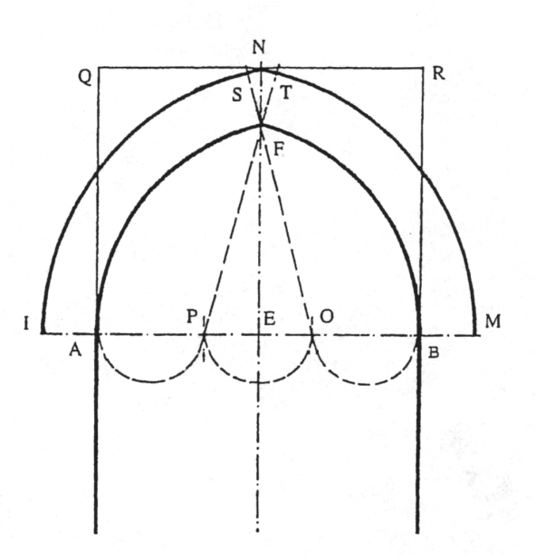
Fig. 5 The Arch Type 4
Kashani does not recommend a suitable span for this type.
Type 5 “Fig 6”
Through the points A and B of the span AB draw two vertical lines perpendicular to AB. Cut off AG and BH, equal to AB, and with H and G as centres and HA (=GB)
as radius draw the arcs AF and BF. Join HA and GB and extend up to J and K respectively so that AJ (= BK) is equal to the thickness of the arch. Again, with H and G as centres and HJ
(=GK) as radius, draw the arcs IS and TM, I and M being their points of intersection with the line of the springing and the points S and T are on the extensions of HF and GF. Like the previous types draw the lines SN and NT. Like the arch type 4, this is also made up of three parts AISF, FSNT and FTMB.
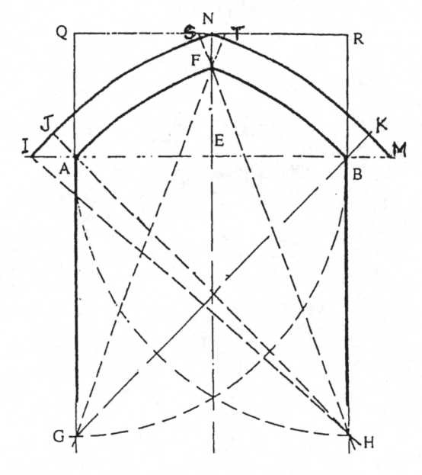
Fig. 6 The Arch Type 5
Again, Kashani does not recommend a suitable span for this type of arch [5].
The second part of this section of Meftah al Hesab dealing with arches and vaults is devoted to the presentation of three charts, the first of which gives coefficients for the easy calculation of some geometrical properties of the first four types of arches. Although not meant to help in the structural design of the arches, these coefficients were of great help to the builders and technicians in laying out and construction of the arches as well as estimating the required building materials, scaffolding, etc. With regard to these charts, Kashani’s statement is as follows:
“After getting through the definitions of arch and vault, we proceed to measure them and we arrange some charts or tables with the description of their use on the basis of relationships between some of their measurements or sizes and their spans. After providing the methods of finding these measurements, we arrange other tables with change in Indian Numbers (argham hendi) [5].
In this method Arabic letters are used as symbols for numbering. For each of the first four types of arches, the chart provides coefficients to calculate i) the rise or height of concavity (intrados), ii) the length of intrados, iii) the height of convexity or the maximum height, iv) area of the facade of the arch and v) the empty area underneath the arch.
The chart is explained by the corresponding diagrams in “Fig 7, 8”.

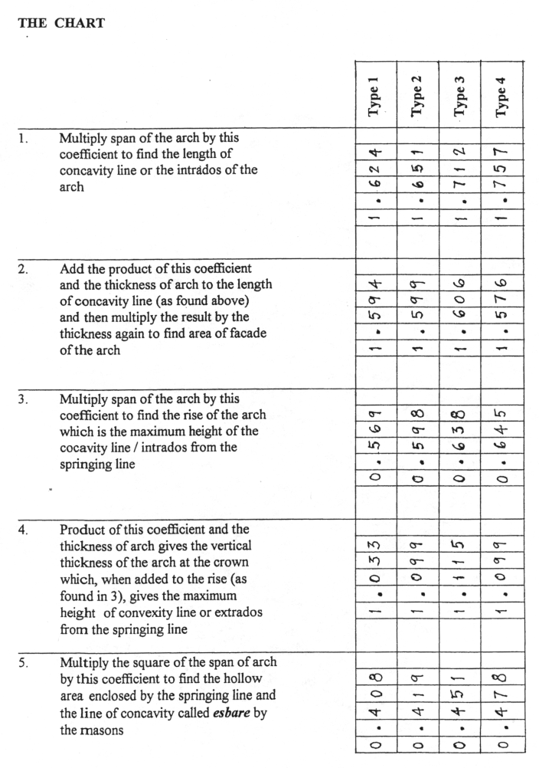
Fig. 7 The Chart
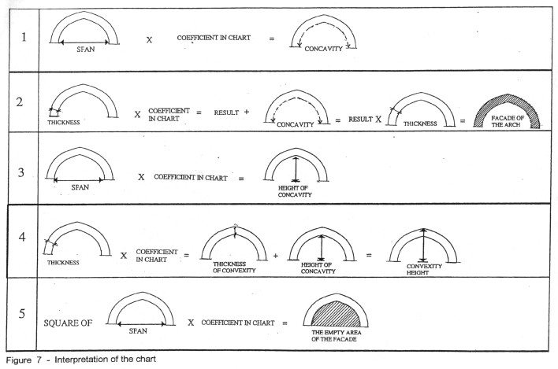
Fig. 8 Interperation Of The Chart
Example: Let us now calculate the dimensional properties of an arch of the Type 2 (Fig 3), the type used mostly in that period, with a span of 20 units of measurement and thickness of 5 units by using the chart.
1. Length of intrados = 1.651 x 20 = 33.02 units
2. Area of the facade of arch = 5 x 1.599 = 8.0 + 33.02 = 41.02 x 5 = 205.1 unit²
3. Rise of intrados = 20 x 0.598 = 11.96 units
4. Height of convexity = 5 x 1.099 = 5.50 = 11.36 = 16.86 units
5. Empty area underneath the arch = 20² x 0.419 = 167.6 unit²

6. CONCLUSION
As early as in the 15th century AD Giyath Al-Din Jamshid Kashani published his work on arches, vaults, domes, etc., based on the results of field work done by him as well as by others before him. Because of his background as a mathematician he was able to present some valuable information on the various types of arches prevalent in Iran at the time specifically about their geometrical layout and their suitability for use in relation to the span of the opening.
Of the five types of arches described by him, only the first three comply with the main theme of his definition of an arch, i.e., that it is made up of five pieces. However, his definition of an arch and the detailed description of the geometry of all the five types show one common characteristic and that is that these are all pointed arches. As mentioned above, his study was based on ‘state of the art’ as existed in Persia at the time. It may then be concluded that the pointed arch existed in abundance in Persia in the 15th century AD which reinforces the view that they were being used in that part of the world for a long time in the past.
Being a mathematician, he also produced coefficients for easy calculation of certain dimensions of these arches which helped the engineers and builders in their work. In this paper these coefficients have not been checked for their mathematical accuracy. However, the worked out example shows that the results could not be very far away from the exact dimensions. The authors intend to check their accuracy and present the findings in a future publication. In his book Kashani also provides two other charts to calculate other dimensional properties of these arches which were not included in this paper.
After dealing with the arches the ninth section of the fourth article of Meftah Al Hesab continues with the study of vaults, domes and muqarnas. Like the arch, methods of drawing and charts for calculating dimensional properties of these structural elements are then presented.

References:

[1] Britanisky, L.S, B. Rosinfied, “Ghais al din Jamshid Kashani”, Azerbaijan Art 5, 1956.

[2] Buti, A, Cognizioni Scientifiche sulle Strutture Voltate prima dell, 18simo Secolo, (Genoa: Ecig,), 1980, p. 34.

[3] Creswell, K.A.C, A Short Account of Early Muslim Architecture, (London: Penguin Books), 1958, p 103.

[4] Ghiass-al Din Jiamshid Kashani, Meftah al Hesab, Rivised by Adamerdanes & Asheikh, ( Cairo: Dar al Ketab al Arabi Atab va Nashr), 1967.

[5] Ghiass-al Din Jamshid Kashani, Rasaleh Tagh va Azaj, (Translated in to Persian by A. Jazbi) (Tehran: Soroush), 1367/1987.

[6] Golombek, L., Timurid Architecture of Iran & Turan, Vol I & II (Persian translation), (Tehran: Miras), 1988.

[7] Gwilt, J, The Encyclopaedia of Architecture, (New York: Crown Publishers), 1982, pp 19, 34 & 35.

[8] Memarian, G.H, Niaresh sazehaie taghi dar memari islami irani ( Vaulted Structure in the Iranian Islamic Architecture) (Tehran: Jehad Daneshgahi), 1987.

[9] Necipuglu Gulru, The Topkopi Scroll-Geometry and Ornament in Islamic Architecture, The Getty Center of the History of Art and Humanities, 1995.

[10] Pirinia, M, Ashnaii ba Memari Islami Irani, (an introduction to Iranian Islamic Architecture), (Tehran: Iran University of Science and Technology), 1992, p 25.

[11] Puppi, L., (ed), Andrea Palladio, (Vicenza: Neri Pozza Editore), 1988, pp. 81-83.

[12] Taba Tabaii Mohit, “Ghiasse al-Dinn Jiamshid Kashani”, Amoozesh va Parvaresh, 1339/1960, PP. 9-16, 59-65.

[13] Vitruvius, The Ten Books of Architecture, Translated by Morgan, M.H, (New York: Dover), 1971

