**THE VERNACULAR EARTHQUAKE PROOF DWELLINGS IN QUCHAN-NORTHEAST OF IRAN**

, Fatemeh MEHDIZADEH SARADJ1, Farhang MOZAFFAR2, Elham MOUSSAVIAN3

1 Assistant professor in the department of Architecture and Urbanism Engineering, Iran University of Science and Technology

2 Assistant professor in the department of Architecture and Urbanism Engineering, Iran University of Science and Technology

3 Ph.D. student of architecture, Iran University of Science and Technology

Corresponding author: Fatemeh MEHDIZADEH SARADJ

Department of Conservation of Historic Buildings and Sites, Faculty of Architecture and Built Environment, Iran University of Science and Technology, Narmak/Tehran

Tel. 0912-2215727

Fax. 021-77240468

E-mails: f.mehdizadeh@gmail.com

**THE VERNACULAR EARTHQUAKE PROOF DWELLINGS IN QUCHAN-NORTHEAST OF IRAN**

**Abstract**

Despite the utilization of several earthquake resistant traditional techniques in Iranian architecture throughout the centuries, the high seismic vulnerability of Iranian vernacular constructions is obvious. One of the latest innovations in building earthquake-proof emergency dwellings prior to introducing the modern seismic design codes, took place during the successive destructive earthquakes of 1871, 1893 and 1895 in Quchan located in the northeast of Iran. These new shelters stood successfully during 1893 and 1895 shocks and were stayed in use for at least 30 years later. Accordingly this local effort of building earthquake proof constructions will be verified in this paper as an intangible heritage of regional knowledge which its successful experiences should be introduced to save it.

At the first step this essay attempts to describe the process of innovation of these new shelters, the specific earthquake resistant features of them which did not have any peers in shape in the history of the construction of the region, their evolution and finally extinction. On the next stage the paper mostly focuses on describing the capability of these shelters in comparison with similar geometrical forms of construction to indicate how local people chose the best shape alternative based on 3 factors of their seismic resistance, their ease of built and the amount of spatial similarity with previous local buildings

Keywords: vernacular seismic resistant technique, earthquake resistant configuration, geometry, Quchan 19th century earthquakes

1. **Introduction**

Relatively weak seismic performances of the Iranian local houses have been so far reported during several earthquakes. Nicolas Ambraseys (1982) carried out wide researches on the Middle East and Mediterranean earthquakes by comparing Anatolian and Iranian methods of construction. He concluded that while vernacular buildings in Anatoly relatively modified to withstand earthquake shocks, Iranian traditional constructions did not have such adaptability in general. Implementation of any notable modification in reconstruction process were some how rare in Iranian traditional buildings. This is however mostly true about the local settlements and traditional methods of construction in vernacular housings rather than architectural monuments of the region. Ray, Nishabour and Tabriz are some of important historical cities which were reconstructed several times with no seismic proof changes after successive earthquakes [1].

Mostly the aftermath reconstructions began soon after event. There are several reports of cities which exactly were rebuilt on the wreckages of previous collapsed buildings just few days after the disaster. Tsimbalenko (1893) mentioned the great concern of experts about the unhealthy condition after the 1893 Quchan earthquakes because of the dangers of decaying corps of human or animals buried under the ruins. This quick reconstruction relatively represents the lowest amount of modification in traditional method of construction implied aftermath [2].

Beside this high vulnerability of local settlements mentioned above there are also several examples of earthquake resistant methods of construction in the region implied in local houses or monumental structures. As the dominant material of structures in northern part of Iran was wood, these structures have had relatively more acceptable seismic performances rather than structures of the other parts of the country. In the central part of Iran with masonry dominant constructions, use of wooden ties inside joints and also between arches, vaults and domes is the most common traditional method to improve seismic responses of buildings [3]. Strengthening vaulted and domed structures with ribs and use of buttresses against walls are some other solutions that improve seismic performance of structures [3]. There are also some rare reports on the usage of wood inside the foundations in this region [1]. In mountainous part of the country that wood can be found relatively more easily rather than arid areas use of wood inside walls as framed structures had been applied sporadically as an earthquake proof method of construction. Among all these experiences, the earthquake proof dwelling of Quchan which is mostly known as innovation rather than the modification was one of the successful methods of earthquake resistant construction while it should be mentioned that these dwellings mostly can be categorized as emergency shelters rather than the permanent housings.

Successive earthquakes of Quchan from 1871 up to 1895 caused a unique situation which led to the innovation of local earthquake proof shelters. A high frequency of shocks and therefore the unsafe condition of local houses, beside the aim of relocation of the town forced people to design some temporary earthquake proof structures. The proper performance of these new shelters after 2 destructive earthquakes of 1893 and 1895 increased the trust of people, led to the planning of their house extension as their permanent huts.

The following sections will explain the history of this innovation as seismic resistant local structure and the extensions of the primay ones. The paper specifically focuses on the seismic responses based on their configuration and tries to estimate the rate of success for these shelters in comparison to other geometrical shapes with same materials.

1. **The process of earthquake proof dwellings innovation in Quchan**

On the 23rd December 1871, Quchan was stricken by an intensive earthquake (7.1 M) [4]. Almost all the local houses built with masonry walls and flat timbers composite roofs (Fig. 1) were destroyed completely [1].Reconstruction of the buildings based on traditional methods was begun soon aftermath. However, the frequency of aftershocks at least up to 2 years later, particularly the strong 7.0 M shock of 6th January 1872 [4], forced people to live inside tents as they were more safe shelters. Use of Turkmen and Kurdish tents was reported after the successive earthquakes of these years [5].

McGregor in 1875 described a new kind of structure innovated by local people to be used as a shelter against severe climatic condition of the region [6]. These shelters are relatively looking like tent, a shape (Fig. 2) as Yate (1894) resembled them as wigwams [7]. These new constructions had no wall and seemed to be gable roofs located on the earth. People were erecting old timbers pulled out of ruins against the ridge pole and then plastered them with bushes and mud [5]. More detailed features of these shelters beside the process of their extension during next years will be described in section 3.

While it is unclear even if these huts were initially designed as an earthquake proof building or their acceptable seismic responses revealed later, McGregor mentioned about the faith of people on these structures against earthquakes in 1875, before the chance of being tested during destructive earthquakes of 1893 and 95 [5]. The seismic behavior of these huts will be discussed in section 3.

The destructive shock of the 17th of November 1893 destroyed utterly the rebuilt town after 1871 earthquake. The traditional method of construction of the local houses failed again [1]. The public structures which mostly constructed in arched shape roofs also collapsed widely [8].

Wooden huts were of the rare structures remained intact after shocks [1]. This proper performance resulted in the wide use of these structures after the earthquake as safe shelters. Rapid construction, high capability of sheltering against the severe climate, and the earthquake proof feature made these shelters the common emergency housings. Use of these cottages as a post-earthquake shelter became a costume for at least 40 years later. Yate during visiting Quchan in December of 1894 mentioned that about 10000 people who were survived after the earthquake inhabited in these shelters [7]. During this time the planning of the relocation of the town were also in progress [9].

After the 3rd strong shock of 17th January of 1895 a few amounts of the people which refused to leave their town started to extend these shelters to suit them for long term life (Fig. 3). Pumpelly in 1904 described this extension which enabled the shelters to encompass 3 separated rooms [11].

The last strong earthquake of the region in the first half of the 20th century occurred on 1st May 1929 near the Shirvan approximately 60 kilometers far from Quchan [4]. There are several reports and photographs represent these shelters had been used aftermaths as an emergency shelters (Fig. 4).

1. **Features of construction and seismic behavior of the “A shaped” shelters**

The “A shaped” shelter had wooden structure frame taken from the debris of collapsed structures. Reuse of material of ruins for reconstruction in Iran relatively has been a kind of tradition in almost all part of the country. While the use of old material sometimes causes more vulnerability in structural behavior of buildings, helps people to decrease the cost of rebuilding and increase the speed of construction.

To build the “A shaped” shelter the timbers had been remained intact, firstly pulled out of the ruins. These timbers were erected in diagonal shape against the ridge pole and then tied together and to the ridge beam [5]. The upper part of the timbers crossed the ridge beam because of the variable sizes of the old timbers. The final configuration of the structure section resembles the x shaped which the crossing point is shifted toward the upper part. Other ends of the timbers were buried inside the earth [5]. The rectangular shaped frame also added to the frame as the entrance of shelters. After setting up the construction the spaces between the wooden rafters filled with light material such as bushes. On the last stage all of the surfaces were plastered with mud. Two main points that people tried to consider on "A shaped" shelters construction, were achieving the lightest structure and firmest ties in joints [7]. Shelters were erected in various sizes; however, the common dimensions of them were about 4.5 m width, 9 m length, and 4 m height. Wooden timbers also were set around 12 cm intervals.

The “A shaped” structures in comparison with rectangular cubic shape of the traditional houses, have better seismic responses. This is mostly true when the seismic shocks are paralleled to the diagonal timbers of the shelters. Lack of any bracing between the vertical elements of the rectangular cubic shape model cause the structural deflection toward the parallelogram shape. This is mostly because of the rigidity of the structural elements and the semi-pin joints of connections the structure. In this case the structures become unstable and the vertical load of roof increases this instability. Therefore the structure will be collapsed easily under the moderate lateral loads. Deformations in the elements of “A shaped” structures is lower than the rectangular ones.

When the quake loads are paralleled to the diagonal timbers, the structural elements bend under the shock loads. In this case the elements on the other side resist against this deflection therefore represent a proper seismic performance (Graphic 2). How ever the shelters cannot have this earthquake proof response against the shocks perpendicular to the diagonal elements. Whereas their seismic behavior still is better than the rectangular cubic shapes. This is mostly because of their lighter structure. The half of the dead load of the diagonal roofs (walls) transfer to the earth. Therefore the loads structure should carry decrease. As all the successive shocks of Quchan relatively had same directions (Fig. 5), maybe the shelters which their diagonal elements had been erected parallel to this direction represented more suitable seismic responses.

The disjointing of the connections or break of the structural elements are two main reasons of the probable collapse of “A shaped” buildings. The X shaped joints and the extra length of the timbers in this part help to reduce the dangerous of disjointing and therefore destruction of the structure. This means that these “A shaped” shelters had better seismic response rather than ordinary gable shaped ones (Graphic 1).

The earthquake proof feature of these shelters which is described above, led to their further extension after the 1895 earthquake. For the extension, at first 2 primary structures of “A shaped” shelters were set up. Most of the time one of them had been erected and settled before. Then a flat roof room connects two shelters together [11]. The structure of this flat roof was made of timber beams paralleled to the ridge beam of “A shaped” frames. Each of the three parts of these dwellings had a separate entrance (Graphic 3).

These extensions however reduce the seismic resistance of the shelters. The bridged flat roof when is not exactly located on the same level of the ridge beam, causes breaks of the diagonal load-bearing timbers. When the roofs are erected on same the level of the ridge beam the vulnerability will be reduced. However, the seismic resistance still will be lower than the single “A shaped” shelters.

The A shaped shelters were in use for approximately 60 years. People not only set them up as an emergency shelters after the earthquakes but also figure on their proper seismic performances.

As it was mentioned before the main purpose of the paper is to analyze the amount of success of this structural innovation which shows the progress of local knowledge in the region. The “A shaped” shelters have had two main innovative characteristic in comparison with Quchan traditional buildings. Firstly they had wooden structure and secondly their shapes were not cubic.

On the next sections of the essay firstly the history of use of wood in earthquake proof buildings of Mediterranean and Middle East will be represented. Then the shape of the shelters in comparison to other common geometries have been used to build small dwellings will be thoroughly analyzed.

1. **A review on the wooden earthquake resistant structures of Mediterranean and Middle East**

Timber framed buildings are the most well known earthquake proof structures among the various constructional methods of Mediterranean and Middle East. Wooden framed buildings have been widely used in central, eastern and northern part of Anatolia (Fig. 6). Some experts believe that this type of construction originates from Mycenaean era which had been developed to resist earthquake shocks. The first written evidence on the use of timber frame construction to withstand earthquake acceleration dates back to early 16th century. Two main form of Turkish earthquake proof structures were remained up to 20th century were “Himis” (of timber framed group) and “Bag˘dadi” (of timber lath group) [13]. Earthquake proof timber framed constructions also can be found in Greece [14]. In Kashmir there are two main methods of seismic resistant local structures named “dhajji dewari” (Fig. 7) and taq [15].there is a similar method of construction to “taq” in Pakistan named “bhatar” (Fig. 8) [15]. A type dual structure consists of load bearing walls with horizontal wooden bands and separated row of columns which are able to carry the roof when the walls collapse also are common in north-east of Pakistan (pattan) (Fig. 9) [16].

Use of wood in Iranian methods of construction also had been known as a proper method to withstand earthquakes. In mountains parts of the country which wood have been moderately available the roofs of houses were built by timber beams. How ever use of wood inside the walls was not common as well. Reinforcement of walls with wooden elements has been found just in mountainous part of north of Iran [3], Ardabil [17], Tabriz named “Takhteh Poush” (had been common after the 1780 earthquake of Tabriz) [1]. “Taleh Bast” (Graphic 4) is another timber framed structures which was common method of construction. Taleh Bast consists of timbers were set about 1 meter or more interval vertically and horizontally and then braced with lateral timbers [3].

Wood also was the dominant structural material of vernacular housings of north of Iran. The plentiful resource of wood in this region made use of this material as the most economic one. Based on several reports, timber structures of the region have had the proper seismic performances. Of the recent earthquake reports before introducing modern methods of construction, were the 5th March 1935 earthquake of Tallar Roud and 11th April 1935 earthquake of Kasout in Mazandaran province which both mentioned the proper seismic response of local wooden structures [1].

The structure of the “A shaped” shelters also consisted of wooden timbers. The main purpose of use of wood as structure and bushes as filler between timbers were their light weight which was mentioned in reports. Use of wood also increases the speed of construction rather than masonry ones. Wooden structures in addition did not have the vulnerability of masonry brittleness against the seismic shocks.

On the next step the essay mostly will concentrate on the shape of these dwellings. An analysis examines the viability of the “gable shaped” models as an earthquake proof emergency shelter in comparison to various geometrical models of shelters. The shape perspective comparison does not mean the inattention to other factors of constructions like the material effects or the influence of the joints on the seismic behavior of the models. This mostly means that during the analysis of different models, geometry will be varied but other factors such as material or type of joints will be same in all models and during the analysis all these factors will be considered.

1. **Geometrical analysis of the A shaped shelters**

As it was mentioned before the main innovative aspect of “A shaped” shelters was their geometrical configuration which had not had any peers among settlements of the region. To understand how much this configuration was able to cover the needs of “Quchan situation” (the condition of the town after three successive earthquakes of late 19th century) firstly it is important to indicate what criteria should the vernacular post disaster shelters fulfill.

The post disaster sheltering and housing mostly are divided in definition. Emergency shelters are the first sheds which are constructed after the disaster. They could be even tents or kinds of prefabricated mobile homes. Post disaster housings how ever need more time to plan for the analysis of reconstruction and should be suitable for the long term life style of the local people. Between these 2 stages there is an intermediate stage named temporary housing. Temporary housings mostly can be a core of the main housing which can extend in future. This can solve the paradoxical items of urgent needs of sheltering and the necessity of considerable amount of time to reconstruct of suitable housing [18]

The “A shaped” shelters were constructed soon aftermath and were used for more than 2 years. This indicates that among the 3 stages of post disaster sheltering, “A shaped” shelters are more similar to temporary housings. “The urgency and rapid construction” are of the fundamental features of the intermediate stage of reconstruction as like as emergency sheltering. How ever these temporary housings should contain “spatial values adapting to the local life style” as well as a permanent reconstructed housings. Although it is clear that the most critical characteristic of the post earthquake temporary shelters should be the seismic resistance.

It is believed that these three main features should be achieved by a cooperation of government (or any assistant from outside) and local people. Outside assistance helps in 1. financing the project, 2. provision or accelerate of the provision of constructional resources such proper material and laboring, 3. introduction of more suitable methods of construction ( for example techniques to achieve more seismic resistance) [18]

As in “Quchan case” there was not any outside assistance, at least during the construction the temporary shelters, all the process of post disaster urgent housing were done by local people. While use of local, simple and available method of construction always help to increase the participation of people in reconstruction programme, lack of any assistance intensify the importance of these items. Therefore beside the rapid of construction, simple one is also critical and both of them are categorized as the first criterion of the analysis named “ease of construction”. Two other features were described as the main characteristics of post earthquake temporary shelters are other criteria in the names of “earthquake resistance” and “spatial similarities”.

The following analysis tries to investigate how much different shelters with different shapes and similar materials could be suitable for the Quchan situation (the condition of the town after three successive earthquakes of late 19th century) with regards to three main aspects of ease of construction, earthquake resistance and spatial similarities. How they are ranking and where is the place of “A shaped” shelters among other geometrical alternatives. All of these 3 main aspects include several criteria. In the following sections these three main aspects will be named as three main “categories”. Each of these “categories” consists of “criteria” as their subsets

The main purpose of the paper is to investigate the amount of the success of local people innovation of new kind of earthquake proof shelters. This will be achievable by comparison between “A shaped” geometry and other simple shapes could be used for setting up the huts. The results will indicate how much local people made a proper decision. The introduction and investigation on this example of regional knowledge helps to save it as a successful local experience in history of Iran construction.

The mechanism of the following analysis is based on the Multi Criteria Decision Making methods. To organize the analysis, 7 geometrical models as alternatives and 3 main categories will provide raw data of the analysis. Final results are trying to rate the suitability of the alternatives due to “Quchan situation”. The criteria have numerical scale or convert to this type of scaling. In some criteria the least number indicates the most value which will be rated by minimum ranking and the Vice versa situation will be rated by maximum ranking.

The geometrical alternatives of the analysis are rectangular cubic, gable shaped, pyramidal, conic and domed shaped models (Graphic 5). The dimensions of these shelters have been defined with regards to equal areas of plan and also equal height. The diameter of timbers has been chosen 15cm. the joints of all models are considered flexible. Timbers are set up in 12cm intervals next together in two models with rectangular cubic and gable shapes. For the pyramidal and conic models, two pattern of construction are considered. In the first pattern, the number of timbers is chosen similar to the vertical elements of gabled and rectangular cubic models (eight timbers). In this case while models can be built with lower number of timbers, filling the spaces between timbers with bushes becomes difficult because of notable gap between timbers (3.25 m on the base of the pyramidal and 2.83 m on the base of the conic model). In the second type, the number of timbers can be increased to simplify the process of filling however an extra load without any necessity is imposed to the structure. The full information of the alternative models dimensions are represented in table no.1

* 1. *Category no.1: Ease of construction*

The ease of construction as one of the main categories based on the specific “Quchan situation” consists 6 subset criteria. Due to the description on the most important features of temporary shelters in section 5, it was mentioned that for the “Quchan case”, because of the lack of outside assistance, urgency should be followed by simplicity and availability of resources. In general the main reasons of the use of outside assistance in construction programme are provision of: 1. the materials, 2. construction equipments 3. building tools and. 4. skillful labors or training the simple labors [18]. Therefore in the case of lack of outside assistance choosing the way of construction with available materials and with the least amount of need of skillful labors or complicated building tools are critical. Consequently all the criteria of the first category are chosen due to the availability of the row materials, speed of construction and least amount of extra gadgets, scaffoldings or skillful laboring. The first criterion of this category is the number of timbers. Due to the shortage of intact timbers which were pulled out of ruins aftermath the models which need lower amount of timbers will be known as more suitable alternatives. The similarity of the length of timbers is considered as the second criterion of the first category (while the type of joints of models is capable to use timbers with different length, this difference should not be notable.). As the pulled out timbers from the ruins had been used to span the roofs of the traditional buildings with 5 to 6.5 meter length, the models which need timbers longer or shorter than this range of sizes are considered in the third criterion. This represents the number of aforementioned timbers. The next item of the first category is the number of joints which indicates the ease and speed of construction. In 2 types of pyramidal and conic models each of two timbers next together has separated joints. Then a final joint ties all the timbers together. An “Ease of erection” criterion is scored from number 1 for the easiest to number 3 for the hardest models to be erected. Ease of plastering is rated in two scores of 1 and 4. This is measured due to the the spaces between the timber structures. These two score indicates the interval in their value. All criteria of the first category have minimum ranking. As the importance of these items is not equal, there are specific weighting for each of them which is considered in the table no.2



1. *Category no.2: earthquake resistance*

The overall shape of buildings consisting their geometry, size, and proportion has a significant impact on the seismic behavior of structures [19]. Any kind of asymmetry in plans causes torsion during the quake. Shapes like + or U in plans beside any irregularity in the volume of buildings lead to variable seismic performances and therefore the failure of structural resistance against earthquake shocks [20]. In addition some forms like dome [18] and pyramid has better seismic behavior in comparison to others [20].

Different geometries in addition to their intrinsic different seismic responses, cause variable seismic behaviors according to the kind of structures that various shapes dictate to their construction. All these items will be considered in the seismic assessments of the second category.

In the analysis of seismic behavior of the alternatives, models are scored from 10 as the best value of the assumptive ideal model. As the direction of the shocks may varies the seismic performance of models two kind of ranking will be considered for either of the shocks in X or Y direction. These two separated rankings are maximum type.

To analyze these structures and as they are just compare with each other, the simple analysis mostly based on engineering judgment is used. This is because use of classic structural analysis based on seismic codes results a considerable amount of uncertainty because of following items:

1. uncertainty in the mechanical features of all timbers mostly after the earthquakes as they were pulled out of debris
2. the type of the joints of the “A shaped” shelters elements are too unreliable as these joints (ties with ropes) are not obey any specific rule or guideline
3. uncertainty and variety in the parts of timbers buried inside the earth on the dimension of timbers inside the ground
4. lack of enough information on the ground and mechanical characteristics of soil under the structure
5. construction by local people, without enough care and accuracy

Therefore

The gable shaped models have the proper response in x direction due to the structural behavior which explained in section 3 of the paper, grades 9 of 10 in X axis direction and 5 of 10 in Y axis direction. The domed shape model which behaves as the industrial frame also is scored 9 of 10 in two directions.

The scores of Pyramidal and conic models relatively are similar to each other. The circular plan of conical shelter improves its seismic performance more than the pyramidal model. However, timbers of conic models are longer than pyramidal one and therefore face more bending moment and risk of break. According to this explanation the score of these two models are estimated equal to each other. Seismic behavior of Pyramidal and conic models in both axis directions is quite similar to the gable shaped model response in X axis direction. The most difference of these models with the gable one is their joints. As each timber lies on the next timber, any kind of leaning of timbers from the vertical plane, increase the seismic vulnerability of joints. As all timbers are joined together any kind of disjointing leads to a thoroughly collapse. Types 1 on these two models with fewer amounts of timbers have better seismic behavior rather than the second types with more structural elements which increase the dead loads without any structural advantages. The scores of all alternatives in 2 direction of X and Y is performed in table no. 3

1. *Category no.3: spatial similarities*

The similarity between living spaces of the shelters and the traditional local houses can improve the spatial quality of shelters due to its capability of coping with the local lifestyle. There are several reports on the rejection of aftermath shelters by local people because of their disability to adaptation with new spaces. For example lack of corner was introduced as one of the main reasons of the abandonment of “igloo” shaped emergency shelters after the 1971 earthquake Caraz, Peru, by local people [21]. In the “Quchan case” two items of the similarity in shape of plan and verticality of walls are considered as main criteria in the third category. These two criteria can show the spatial vertical and horizontal resemblance. In the first criterion the models with rectangular or square plan score number 1 and models with circular plan score 0. This scoring shows the importance of existence of corner as described above lack of it had caused problems for local people of Caraz. In the second criterion the number of vertical walls which for example was more suitable to build the openings and doors will be represented as an advantage of the shelters. These 2 criteria have the maximum ranking. The third criterion which mostly focuses on the least interruption in the interior space counts the number of columns which should be erected inside the space. Therefore the ranking of the third criterion is a minimum type. The last criterion of the third category is the volume of the spaces which obviously has the maximum ranking. As like as the first category for each of these criteria a specific weight is allocated which are represented in the table no. 4

1. **Multi criteria decision making**

The main analysis is processed in the D-sight decision making software. The 3 main categories of criteria including ease of construction, earthquake resistance and spatial similarities are weighted 30%, 50% and 20%. This weighting is determined as the earthquake proof feature was the most important aspect of emergency shelters construction in “Quchan case”. After this, the ease of construction is indicated slightly more decisive than the spatial similarity because the first one fulfils the primary need of sheltering. Final results of the ranking of models with their final scores come in table no. 5. Ranking of the table indicates that 2 rectangular and pyramid type 1 place the first and second positions with relatively similar scores. This shows by a little change in weighting or score the place of these 2 models may vary. Therefore both of them will be known as the most successful alternatives for “Quchan situation”.



1. **Conclusion**

The main purpose of this paper was the overestimation of the amount of successes of the “A shaped” shelters which were innovated after successive earthquakes of Quchan in the late 19th century. To achieve the rate of success of this shelter, it was compared with 6 other geometrical alternative models due to 3 main criteria of ease of construction, earthquake resistance and spatial similarities which were determined as 3 main features of the aftermath emergency shelters. The results of the Multi Criteria Decision Making analysis indicated that gable shaped shelter beside the pyramidal model with lower amount of structural timbers are the most proper choice for “Quchan situation”. Therefore the A shaped shelters as a regional experience can be informed among the successful local efforts of traditional seismic design.

**Acknowledgment**

I would like to acknowledge the consultancies of Behrouz Zakizadeh – civil engineering graduate student of Tehran University- on the structural analysis of the paper.

**References**

1. *Ambraseys, N. N. and Melville, C. P.: 1982, A history of Persian earthquakes, 1st ed., Cambridge University Press, Cambridge.*
2. *Tsimbalenko, L.I.: 1975, earthquake of Quchan. In: Vahid (in Farsi), March, no. 135, pp. 988-992, Tehran.*
3. *Zomarshidi, H.: 2001, Iranian Architecture: Building with Traditional Materials (in Farsi), Zemorrod Press, Tehran.*
4. *Hollingsworth, J., J. Jackson, et al.: 2006, Strike-slip faulting, rotation, and along-strike elongation in the Kopeh Dagh mountains, NE Iran. In Geophysical Journal International, vol.166, 1ssue 3, pp. 1161-1177.*
5. *MacGregor, C. M. S.: 1879, Narrative of a journey through the province of Khorassan and on the N.W. frontier of Afghanistan in 1875. 1st ed. vol. 2, Elinbron Classics, London.*
6. *Baker, V.: 1876, Clouds in the East: Travels and adventures on the Perso-Turkoman frontier. 1st ed., Chatto and Windus, London.*
7. *Yate, C. E.: 1900, Khurasan and Sistan. 1st ed., W. Blackwood, Edinburgh.*
8. *Great Britain. India, O. and Napier G. C. H.,: 1874, Collection of journals and reports received from Captain the Hon. G. C. Napier, Bengal Staff Corps, on special duty in Persia, H. M. S. O, London.*
9. *Sepehr, A.: 1989, Meraatolvaghaye-e-Mozaffari and Malekolmovarekhin's records (in Farsi). Zarrin Press, Tehran.*
10. *Referring Web Pages Web: http://www.iichs.org/index.asp?id=227&img_type=0*
11. *Pumpelly, R.: 1905, Explorations in Turkestan: Expedition of 1903. Carnegie Institution of washington, Washington.*
12. *1929, Ettelaat Newspaper (in Farsi). Persian daily newspaper. 21st July, no. 816, Tehran.*
13. *Sahin Güçhan, N.: 2007, Observations on earthquake resistance of traditional timber-framed houses in Turkey. In Building and Environment, vol. 42, issue 2, pp. 840-851.*
14. *Makarios, T. and Demosthenous M.: 2006, Seismic response of traditional buildings of Lefkas Island, Greece. Engineering Structures, vol.28, issue s, pp. 264-278.*
15. *Langenbach, R.: 2009, Don't tear it down!: preserving the earthquake resistant vernacular architecture of Kashmir. UNESCO, New Delhi.*
16. *Ambraseys, N. N.: 2009, Earthquakes in the Mediterranean and Middle East: a multidisciplinary study of seismicity up to 1900. Cambridge University Press, Cambridge.*
17. *Tasnimi A., Raheb GH. And Mirmoghtadaii M.: 2010, pattern of rural dwellings of Ardabil province (in Farsi), BHRC, Tehran.*
18. *Coburn, A. and Spence. R. J. S,: 2002, Earthquake protection. 2nd ed., Chichester, J. Wiley, New York.*
19. *Arnold, C. 2001, Architectural Consideration in Naeim, The seismic design handbook. 2nd ed. pp. 275-326, Kluwer Academic Publishers, Boston.*
20. *Arnold, C. and Reitherman, R., 1982, Building configuration and seismic design. Chichester, Wiley, New York.*
21. *Reps, W. F., E. Simiu, et al. 1974. Design, siting, and construction of low-cost housing and community buildings to better withstand earthquakes and windstorms: a report, U.S. Gov. Print. Off.*

**Tables**

Table 1: dimensions of alternative models

|  |  |  |  |
| --- | --- | --- | --- |
| shape | Width (m) | Length (m) | Height (m) |
| Rectangular cubic | 4.5 | 9.1 | 4 |
| Gable shape | 4.5 | 9.1 | 4 |
| Pyramidal type 1 | 6.5 | 6.5 | 4 |
| Conic type 1 | Radius: 3.6 | | 4 |
| Pyramidal type 2 | 6.5 | 6.5 | 4 |
| Conic type 2 | Radius: 3.6 | | 4 |
| Domed shape | Radius: 3.6 | | 3.6 |

Table 2: Criteria of the 1st category: ease of construction

|  |  |  |  |  |  |  |
| --- | --- | --- | --- | --- | --- | --- |
| shape | No. of timbers | No. of types of timbers | No. of timbers longer than 6.5 m or shorter than 5 m | No. of joints | Ease of erection | Ease of plastering |
| Rectangular cubic | 26 | 3 | 2 | 16 | 2 | 1 |
| Gable shape | 17 | 2 | 1 | 8 | 1 | 1 |
| Pyramidal type 1 | 9 | 3 | 5 | 9 | 1 | 3 |
| Conic type 1 | 9 | 2 | 9 | 9 | 1 | 3 |
| Pyramidal type 2 | 17 | 4 | 13 | 17 | 2 | 1 |
| Conic type 2 | 17 | 2 | 17 | 17 | 2 | 1 |
| Domed shape | 24 | 4 | 24 | 11 | 3 | 1 |
| Weight of criteria in % | 30 | 15 | 25 | 10 | 10 | 10 |

Table 3: Criteria of the 2nd category: earthquake resistance

|  |  |  |
| --- | --- | --- |
| shape | Seismic responses in X direction of 10 score | Seismic responses in Y direction of 10 score |
| Rectangular cubic | 4 | 3 |
| Gable shape | 9 | 5 |
| Pyramidal type 1 | 7 | 7 |
| Conic type 1 | 7 | 7 |
| Pyramidal type 2 | 6 | 6 |
| Conic type 2 | 6 | 6 |
| Domed shape | 9 | 9 |
| Weight of criteria in % | 50 | 50 |

Table 4: Criteria of the 3rd category: special similarities

|  |  |  |  |  |
| --- | --- | --- | --- | --- |
| shape | Rectangular geometry of plan | No. of vertical walls | No. of Columns inside the space | Space volume  m³ |
| Rectangular cubic | 1 | 4 | 0 | 164 |
| Gable shape | 1 | 2 | 0 | 82 |
| Pyramidal type 1 | 1 | 0 | 1 | 56 |
| Conic type 1 | 0 | 0 | 1 | 54 |
| Pyramidal type 2 | 1 | 0 | 1 | 56 |
| Conic type 2 | 0 | 0 | 1 | 54 |
| Domed shape | 0 | 0 | 0 | 98 |
| Weight of criteria in % | 30 | 20 | 10 | 40 |

Table 5: Criteria of the 2nd category

|  |  |  |
| --- | --- | --- |
| action | **Rank** | **Score** |
| Gable shape | 1 | 0.288 |
| Pyramidal type 1 | 2 | 0.288 |
| Domed shape | 3 | 0.198 |
| Conic type 1 | 4 | 0.177 |
| Pyramidal type 2 | 5 | -0.236 |
| Conic type 2 | 6 | -0.317 |

**Figures**

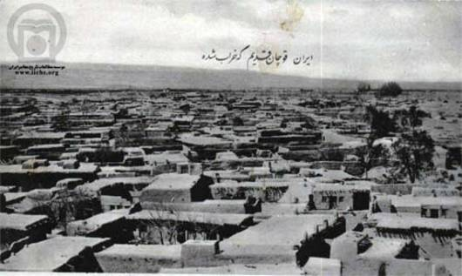

Fig. 1: Traditional houses of Quchan with masonry walls and wooden composite roofs [10]

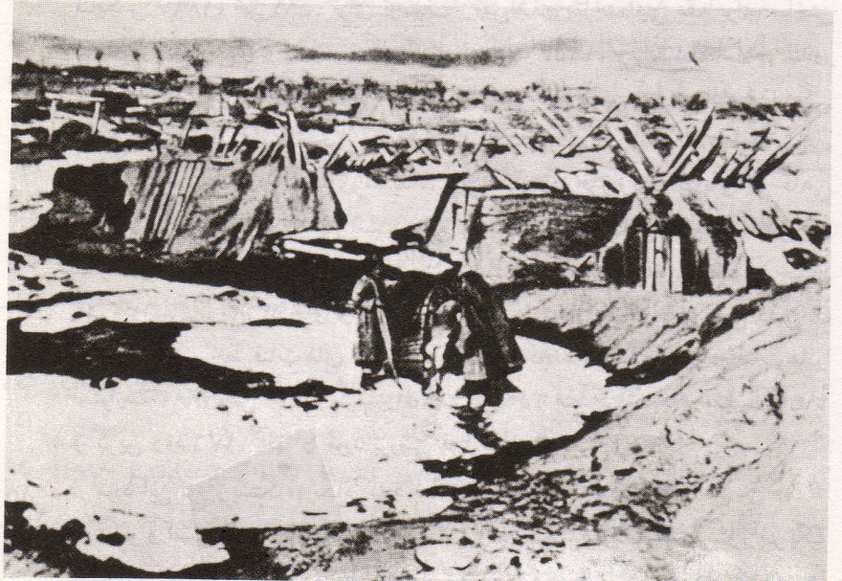

Fig. 2: Earthquake-proof “A shaped” shelters of Quchan [1]

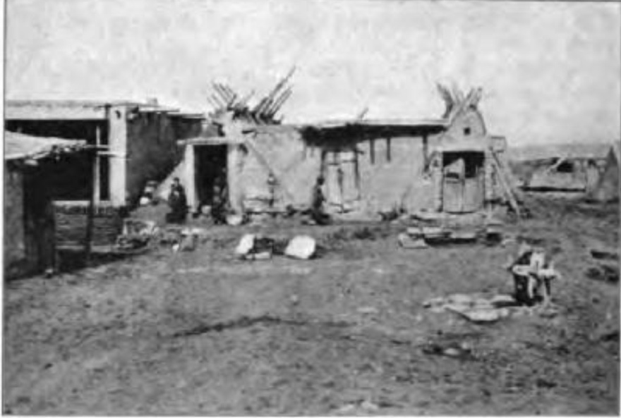

Fig. 3: Extended model of “A shaped” shelters consist of 2 tent-models bridged with a flat roof [11]

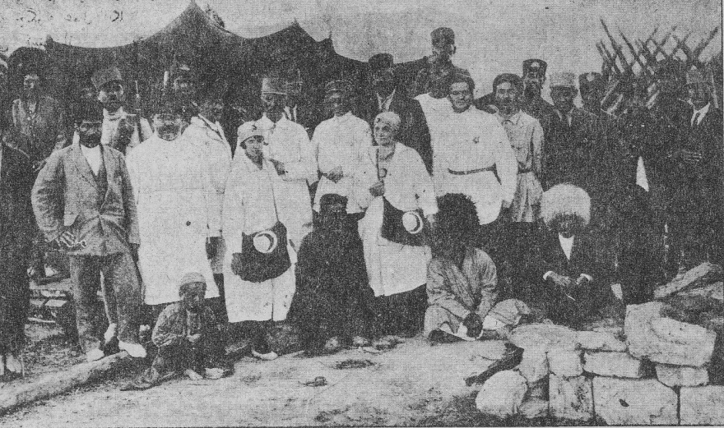

Fig. 4: Timbers of “A shaped” shelters and a Kurdish tent can be seen backward of the Red Crescent group aftermath of 1929 Shirvan earthquake [12]



Fig. 5: The directions of the earthquake shocks of 1871-2, 1893 and 95 [4]

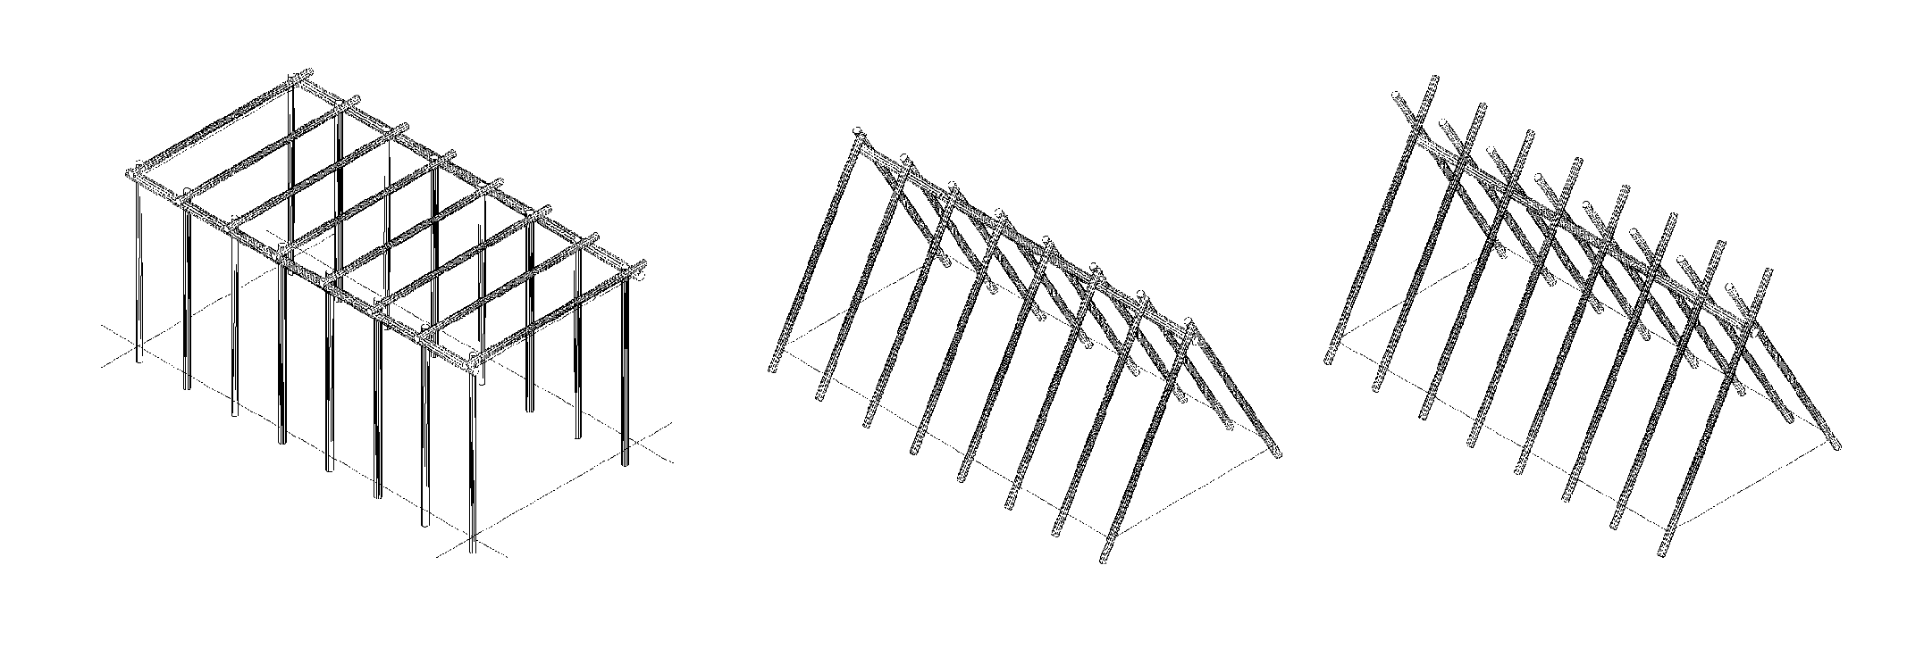

Graphic 1: Timber structures of cubic, gable shaped, and “A shaped” Quchani shelters

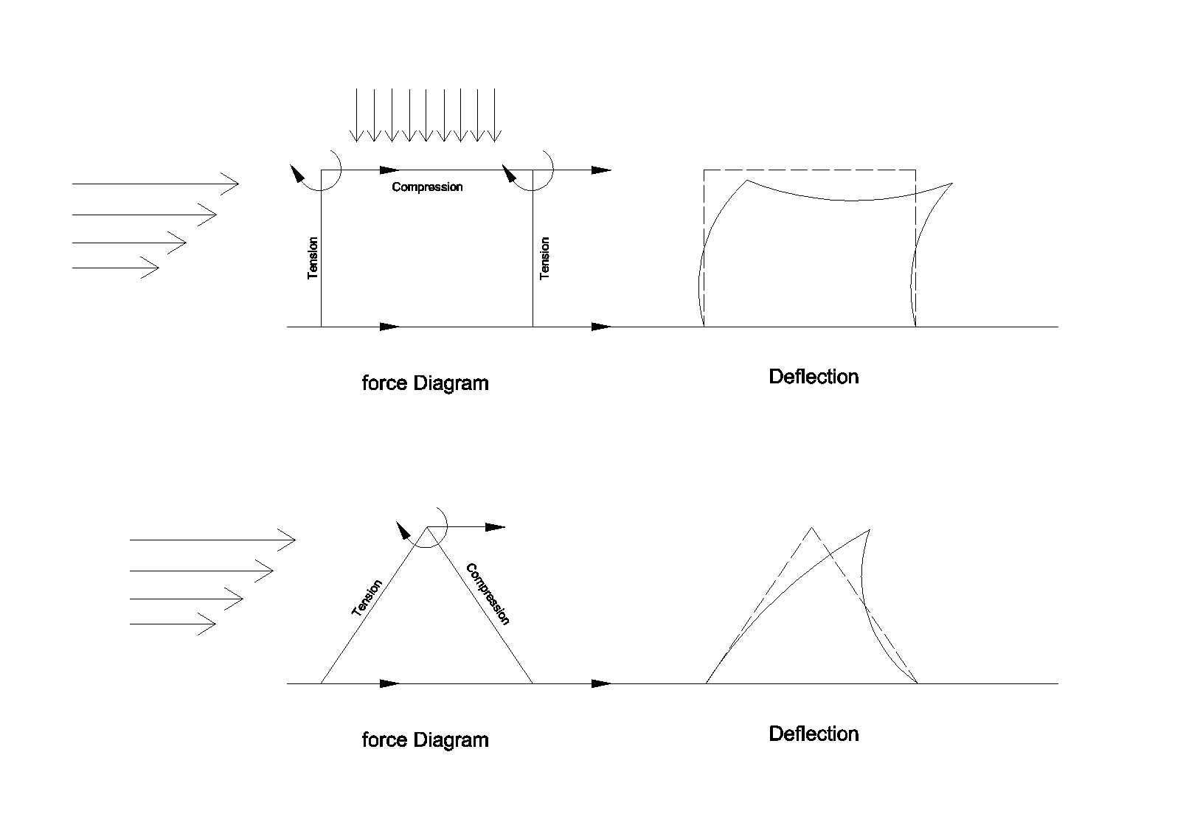

Graphic 2: Diagrams of rectangular and triangular frames deflections under lateral forces

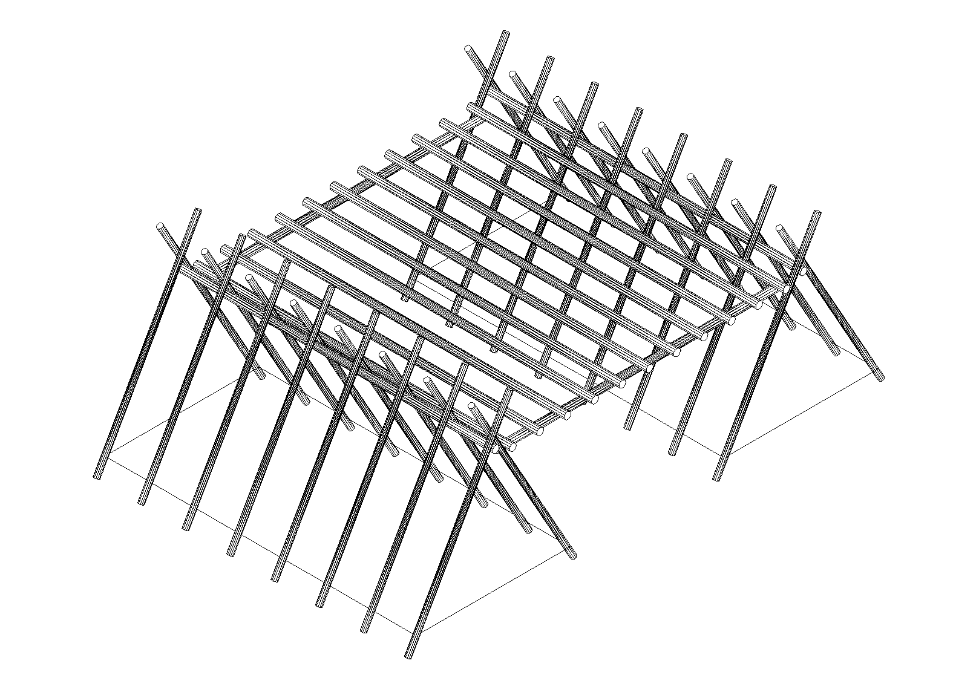

Graphic 3: The structure of the extended model of “A shaped” shelters



Fig.6: A timber framed local houses in turkey [13]

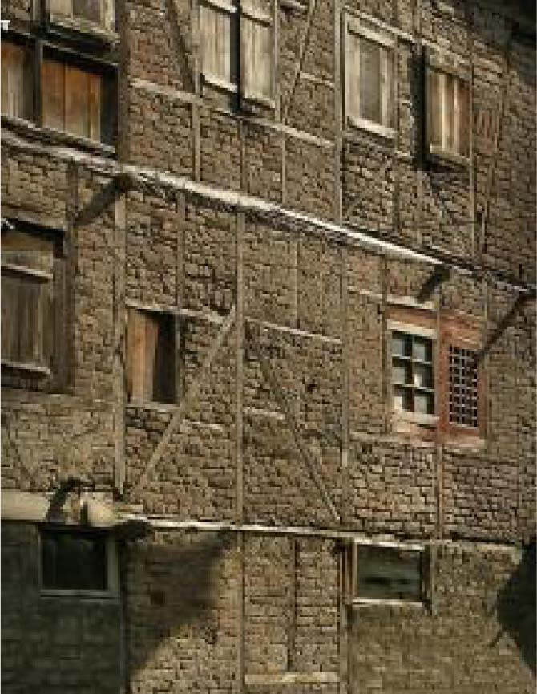

Fig.7: “dhajji dewari” structures in Kashmir [15]

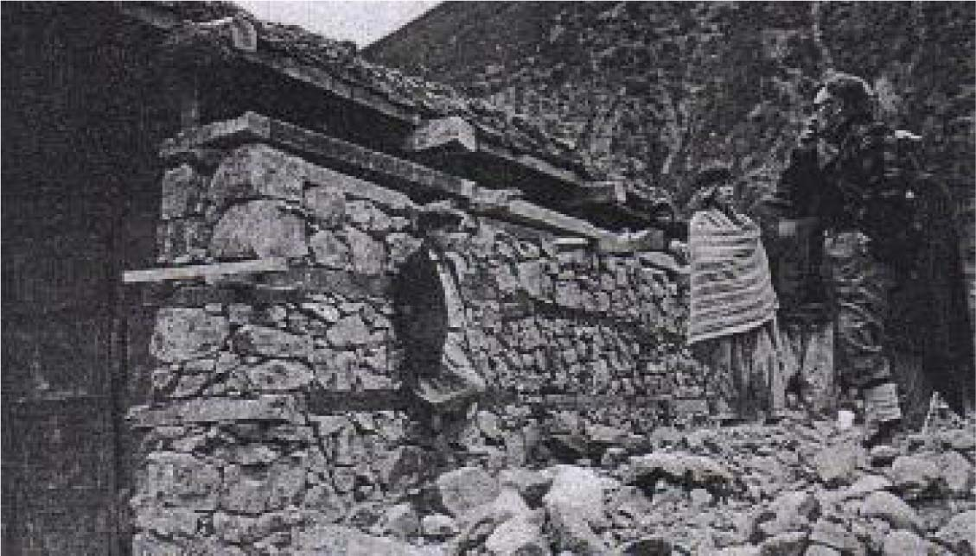

Fig.8: dual structure consists of load bearing walls with horizontal wooden bands and separated row of columns [16]

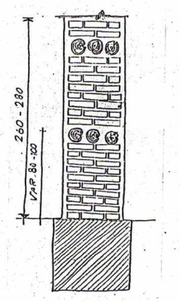 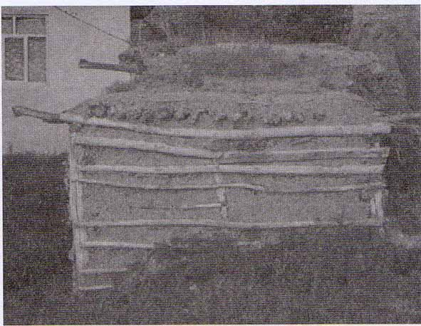

Fig.9: left. Section of reinforcing of adobe wall by wooden timbers- rural housings of Ardabil,

Right. A timber framed local houses in Zatosht Abad village, Ardabil [17]

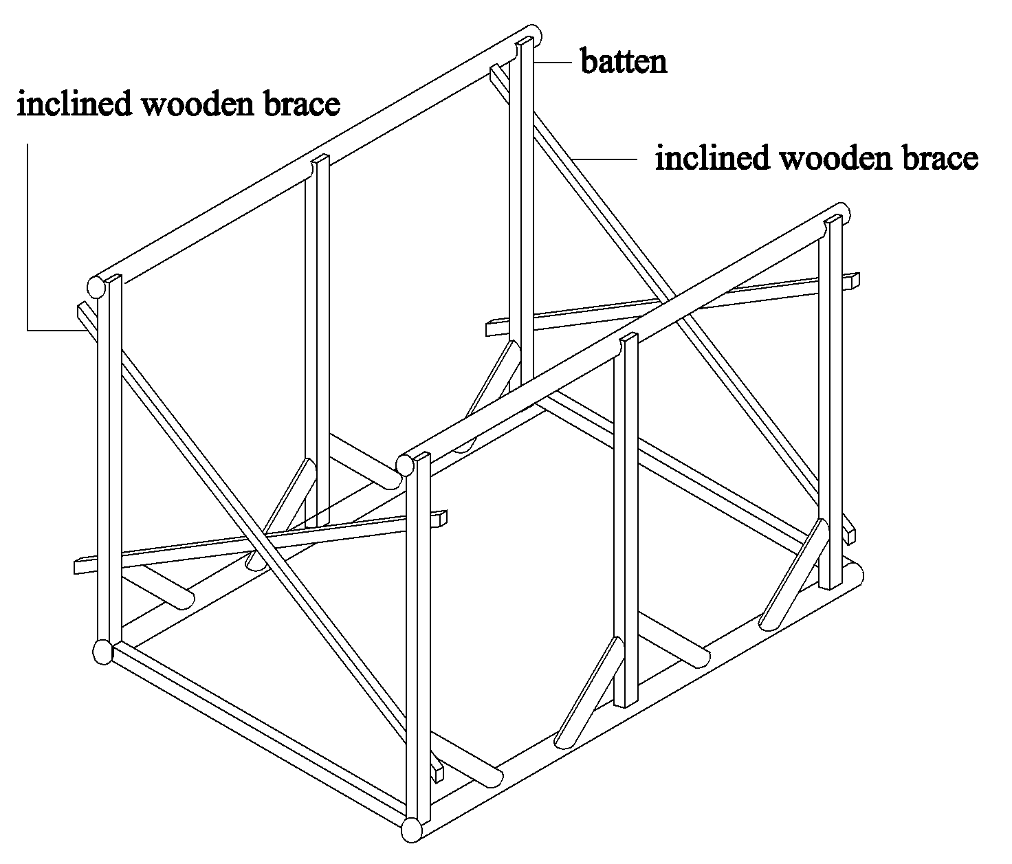

Graphic 4: Taleh Bast wooden structure filled with masonry after Zomarshidi H., Iranian Architecture: Building with Traditional Materials

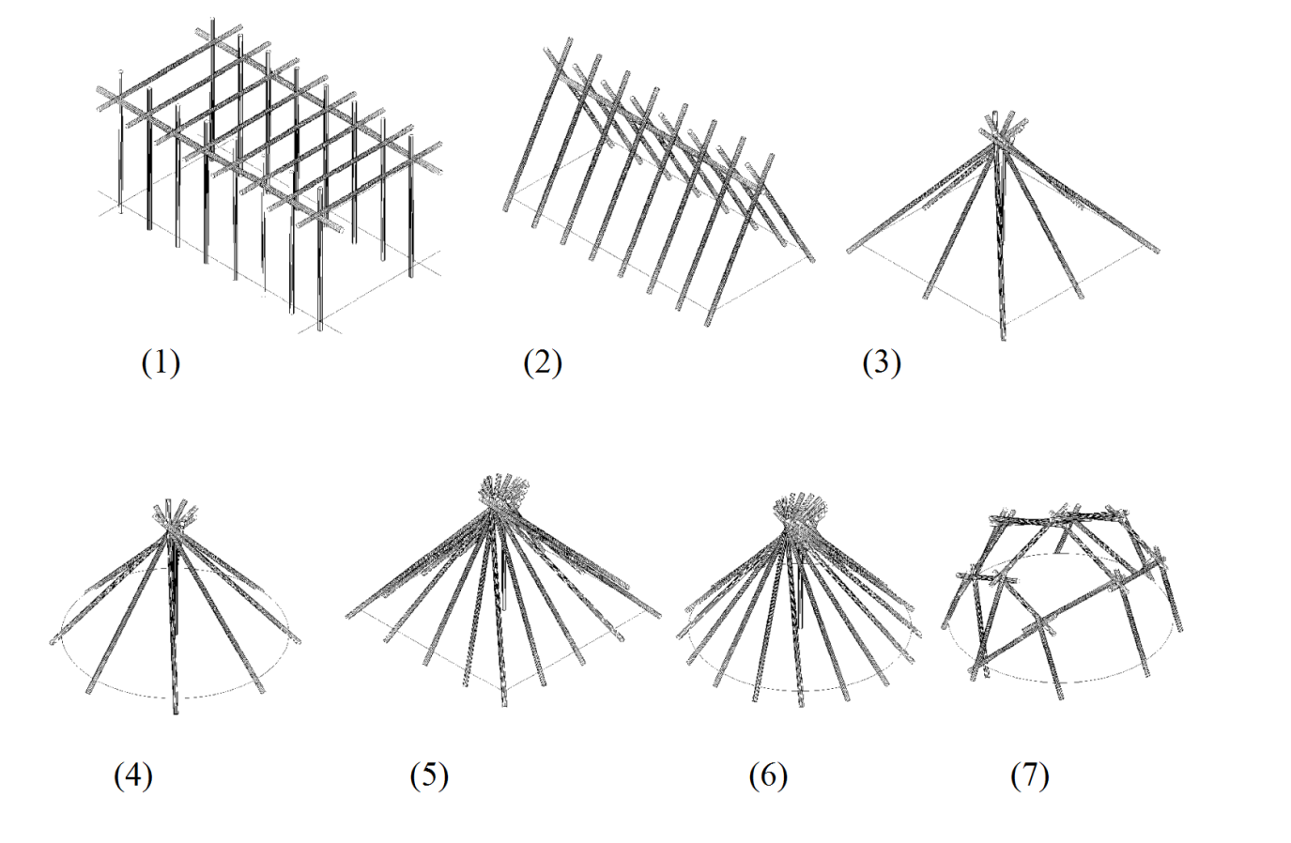

Graphic 5: 7 geometrical models (1. rectangular cubic, 2. gable shaped, 3. pyramidal type 1, 4. conic type 1, 5. pyramidal type 2, 6. conic type 2, 7. domed shaped models)

**Figures and Graphics legend**

Fig. 1: Traditional houses of Quchan with masonry walls and wooden composite roofs …………….20

Fig. 2: Earthquake-proof A shaped shelters of Quchan ……………………………………………….20

Fig. 3: Extended model of “A shaped” shelters consist of 2 tent-models bridged with a flat roof …...20

Fig. 4: Timbers of A shaped shelters and a Kurdish tent can be seen backward of the Red Crescent group aftermath of 1929 Shirvan earthquake …………………………………………………………21

Fig. 5: The directions of the earthquake shocks of 1871-2, 1893 and 95 ……………………………..21

Graphic 1: Timber structures of cubic, gable shaped, and “A shaped” Quchani shelters …………….21

Graphic 2: Diagrams of rectangular and triangular frames deflections under lateral forces ………….22

Graphic 3: The structure of the extended model of “A shaped” shelters ……………………………..22

Fig.6: A timber framed local houses in turkey ………………………………………………………..22

Fig.7: “dhajji dewari” structures in Kashmir ………………………………………………………….23

Fig.8: dual structure consists of load bearing walls with horizontal wooden bands and separated row of columns ………………………………………………………………………………………………..23

Fig.9: left. Section of reinforcing of adobe wall by wooden timbers- rural housings of Ardabil, Right. A timber framed local houses in Zatosht Abad village, Ardabil ……………………………………...23

Graphic 4: Taleh Bast wooden structure filled with masonry ………………………………………...24

Graphic 5: 7 geometrical models (1. rectangular cubic, 2. gable shaped, 3. pyramidal type 1, 4. conic type 1, 5. pyramidal type 2, 6. conic type 2, 7. domed shaped models) ………………………………24