**Explicating Integrated Strategic Planning in Promoting Values of Natural Environment Cultural Heritage With Emphasis on The Quality of Life (QOL)**

**Abstract**

Preserving natural environmental cultural heritage and improving the urban quality of life are among important urban planning issues with key roles in the sustainability of cities. There are several sources on the quality of life (QOL) in cultural heritage documents, i.e., scientific and operational reports, but the relationship between QOL and heritage has not yet been appropriately explicated. The present study aims to investigate how natural environment culturalheritage and QOL have evolved to be implemented in urban strategic planning to enhance the values of natural environment culturalheritage and QOL. The research time scope covers 1920, when the first use of “standard of living” (before QOL) was proposed, until 2021. By reviewing, analyzing, and rewriting primary sources and documents, the data related to natural environment culturalheritage and QOL were extracted and organized via historic-structural analysis, comparative analysis of the common fields of the two basic concepts in a time sequence based on cause and effect analysis. The data were qualitative documents and historical events. The research results presented a strategic planning model according to natural environmental culturalheritage and QOL components, the historical review, and the description and analysis of time sequence (ten-year intervals). Due to the nature of strategic planning; focus on the principle of uncertainty in planning; the probability of the planning process; the need to expand the scope of planning in the broader political, social, economic, and environmental fields; focus on paying attention to diverse actors (shareholders); and the ability to support urban planning models based on dual or multiple integrated concepts involves a three-phase process (description, analysis, and prescription) with six steps: assessing the situation, identifying the problem (problem-finding), identifying the cause of the problem, producing the final statement of significant problems and goals, presenting decision options and suggestions (problem-solving), and sharing strategic planning related to cultural and natural heritage among key shareholders and residents.

**Keywords**

Natural Environment CulturalHeritage, Quality of Life(QOL), Strategic Urban Spatial Planning

**Introduction**

The natural environment cultural heritage express each country’s historical background, civilization, culture, and natural attractions. The rapid growth of urbanization in the contemporary era and the emergence of metropolises have exposed natural and human-made hazards. Besides, the emergence of new needs in urban life has weakened the natural environment and cultural heritage in cities, reducing the citizens’ sense of belonging and satisfaction to the natural environment and cultural heritage and creating a profound challenge for city officials. Given that natural environment cultural heritage are part of the body, spirit, and identity of a city that acts as a system, there is a correlation between natural-cultural heritages as an element of the urban system. Therefore, any interference in the urban system affects its other components.

The awareness of analogies between natural environment and cultural heritage developed gradually throughout the 20th century. Perhaps the best known and most straight forward parallel between them is drawn in the „Convention Concerning the Protection of the World Cultural and Natural Heritage‟ adopted by UNESCO in 1972 considering both natural and cultural resources the universal heritage of humankind. In the convention both types of heritage, i.e. cultural and natural, are defined similarly as individual structures, their groups or entire sites. The reasons for their preservation are also much alike – i.e. taking into account historic, aesthetic or scientific considerations. So are the obligations of signatories of the convention consisting of „ensuring identification, protection, conservation, presentation and transmission to future generations (UNESCO, 1972). Considering the legacy of nature and previous generations of humankind as natural and cultural heritage, important practical parallels between them are becoming obvious (MURZYN-KUPISZ, 2010: 380).

In the last twenty years, the role of natural environmental cultural heritage in urban management has evolved from the institutionalization of conservation measures to the placement of heritage at the center of strategic planning (Guzmán et al., 2018). Ever since urban strategic planning became a global practice, historical urban areas have been the focus of planning strategies, and the management of cultural and spiritual assets has become as important as the physical capital management of a city. As a result, special planning is needed to preserve and promote tangible and intangible cultural heritage in cities, including development measures that identify and manage natural and cultural heritage values sustainably (Guzmán et al., 2014: 3). Therefore, there is a need to develop systematic evaluation methods considering the gap between cultural heritage management and sustainable urban development (Guzmán et al., 2014: 1). Given that urban heritage is an important topic in urban planning, and improving the quality of urban life is a goal for urban planning, both issues have critical roles in the sustainability of cities. There are also numerous sources on the quality of life (QOL) in scientific and operational reports and documents on cultural heritage preservation. Improving the QOL is beneficial in heritage preservation; however, the relationship between QOL and natural environmental cultural heritage has not been stated clearly (Mohamad Mostafa, 2012: 255).

There is a gap in expressing the substantive values of urban planning with the values of the natural heritage[1], and failures in paying attention to the natural environmental cultural heritage values from the view of key stakeholders (residents and specialists of organizations involved in urban planning) as an effective factor in changing the inhabitants’ QOL are other challenges in urban planning. Therefore, urban planning of natural environment cultural heritage requires an approach that reduces these damages and improves conditions. Urban planning can reduce the gap between natural environment cultural heritage and the improvement of QOL, both as fundamental issues in the urban planning content.

In this paper, urban strategic spatial planning was employed due to the emphasis on the principle of uncertainty in planning; the probability of the planning process; the need to expand the scope of planning in broader political, social, economic, and environmental fields; emphasis on paying attention to the role of various actors (stakeholders); and the ability to support urban planning models based on dual or multiple integrated basic concepts. Also, efforts were made to achieve a strategic spatial planning model based on the two concepts of natural environment cultural heritage and QOL. Besides using the two concepts in a strategic spatial planning process, the research aims to achieve an urban planning model supporting the two basic concepts, via which the values of natural environment cultural heritage and the QOL can be integrated into strategic planning for the development and preservation of the natural environment cultural heritage as part of the urban heritage. The questions raised in this study are as follows:

1. How can the Characteristics of natural environmental cultural heritage and quality of life via process of transformation be classified?
2. How can these Characteristics be integrated into process and substance of urban strategic planning ?

In the following sections, first, the research methodology is discussed. Then, the primary fields are analyzed and discussed in the discussion section based on historical-structural analysis. After that, the research findings section presents the integration of primary fields in strategic urban spatial planning; and finally, the conclusion section presents a strategic planning process to promote the values of natural environment cultural heritage with an emphasis on the QOL.

**Methodology**

The type of research in this paper was descriptive-analytical and its methodology was based on historic structural research. The time frame of this research was from 1920, when the first use of “standard of living” (before QOL) was proposed, until 2021 –the year of this research. Reviewing texts related to theoretical, technical, and experimental frameworks of the natural environmental cultural heritage and QOL, and applying documentary analysis, based on historic-structural analysis and comparative analysis, the common fields of the natural environmental cultural heritage and QOL were organized in a sequence of cause and effect relations based on time. In this research, the evidence (especially historical evidence) as the research material led the researcher to answer the question “What was it?”. This research method was historical-adaptive that evidence was interpreted with a "contingent and probabilistic" (versus algebra) view of cause and effect and used synthetic explanations. Data and information that were required for this research were historical and qualitative evidence and were gathered from four paths (1) primary texts and sources (2) secondary texts and sources (3) current texts (4) recovered texts. Then, via descriptive research and historic structural analysis, International charters and theories of the two concepts of natural environmental cultural heritage and QOL were obtained. In the final stage, the two primary fields and urban strategic spatial planning, urban strategic planning model, in the macro descriptive stages, analysis and prescription, support of promoting QOL and natural environmental cultural heritage values were produced and introduced using comparative analysis.

The data sources consisted of historical written documents and evidence (books, articles, credible reports, and manuscripts) extracted from primary sources, data, and secondary data using multiple document reviews, document analysis, and document rewriting. Then, their key components were interpreted and confirmed. To achieve the main research aims, first, a historic structural analysis of the transformation of natural-cultural heritage and QOL was accomplished; then, the timeline (sequential) diagram of the evolution of each concept was provided based on the cause and effect analysis; third, the timeline diagram of the evolutions was drawn based on the comparative and integrated analysis; fourth, the substantive and procedural link of promoting QOL and natural environment cultural heritage were inferred; after that, the substance of improving natural-cultural heritage and QOL was integrated with urban strategic spatial planning; and finally, the strategic planning approach was explicated to support the promotion of natural environmental cultural heritage and QOL.

**Components and characteristics of the QOL (substantive and procedural components)**

**Historic-structural analysis of the quality of life(QOL)**

1-collecting appropriate data:

* Using the method of documentary research (document review) and document analysis (extraction of documentations and events)

2-interpreting key components:

* providing the timeline of the evolution of quality of life(QOL) based on the cause and effect analysis

**Values and characteristics of natural environmental cultural heritage (substantive and procedural components)**

**Historic-structural analysis of the natural enviornmental and cultural heritage**

1-collecting appropriate data:

* Using the method of documentary research (document review) and document analysis (extraction of documentations and events)

2-interpreting key components:

* providing the timeline of the evolution of natural environmental cultural heritage based on the cause and effect analysis

**Designing a strategic urban spatial planning that supports the promotion of quality of life and the values of natural environmental cultural heritage**

Figure 1: The process of adaptive-analytic research process of the two basic concepts of natural environmental cultural heritage and quality of life based on the strategic planning approach

**Adaptive analysis of strategic planning with integrated substance of the two basic concepts**

1-integrating the substance of improving natural-cultural heritage and QOL with urban strategic planning process:

* Introducing the Characteristics and process of urban spatial strategic planning
* Relation of steps of strategic urban spatial planning and expected results of transformation process analysis of natural environmental cultural heritage and QOL

**Integrated historic-adaptive analysis of of two basic concepts**

1-Integrating the substantive and procedural link of promoting QOL and natural environment cultural heritage:

* Conditional and probable view to evidedence transformation
* Presenting the final statement of the adaptive analysis of two basic concepts via timeline

**The steps of research process**

**The output of research steps**

**Relation between research process**

**Findings**

This section discusses the evolution of the two basic concepts of natural environment cultural heritage and QOL via historic structural analysis, introduces the features of strategic urban spatial planning, and compares two basic concepts of natural environment cultural heritage and QOL using strategic planning.

*Introducing the features of strategic urban spatial planning*

Strategic planning is a systematic approach to deciding and implementing activities related to forming and managing a system and its functions. Strategic urban spatial planning emphasizes selectivity and severality of strategic issues and identification of the planning environment with an analytical-critical perspective. In addition, it emphasizes flexibility and the simultaneous presence of long-term and short-term attitudes (Mahmoudpour & Moradi Chadegani, 2019: 45). These features are briefly introduced below (Mehdizadeh, 2006: 22; Mahmoudpour and Moradi Chadegani, 2017: 45-47; Alberchts, 2004: 747 Healey, 1997: 30):

* Emphasis on relativity and flexibility of goals, methods, and implementation;
* Emphasis on comprehensive and sustainable development and justice;
* Emphasis on public interest, social equality, citizenship rights, and indigenous identity;
* Emphasis on integrated and cyclical process;
* Emphasis on democracy, public participation, social cohesion, and local governance;
* Reflection of community values;
* Focus on the main goals, problems, and priorities of planning and limited key issues;
* Strategic knowledge and analysis of environmental planning and attention to the driving forces of spatial change;
* Emphasis on the process in addition to the emphasis on substance.

Figure 2: Continuation of the planning process over time

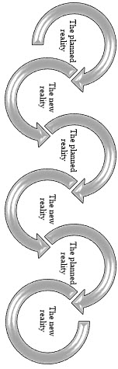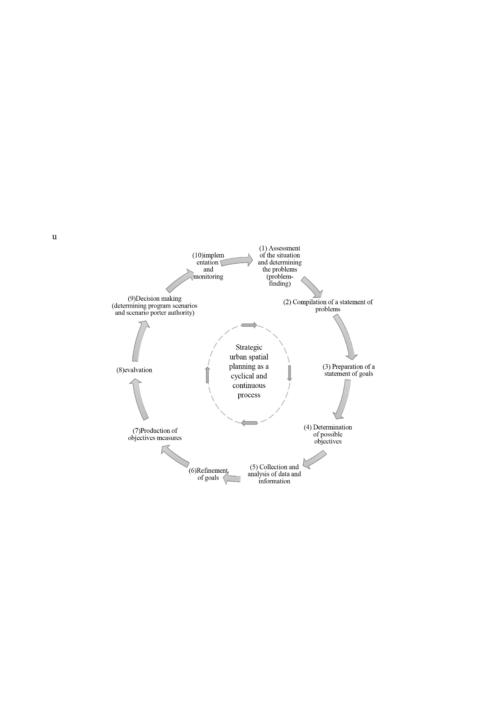

Therefore, the natural environment cultural heritage of cities needs to be planned for passing it on to future generations; thus, all its values should be preserved. Strategic urban spatial planning can be consistent with the issue of sustainable development; it can deal with complex issues in natural heritage planning. A holistic view and attention to the values of natural environment cultural heritage and emphasis on the characteristics of cyclicality, probability, and complexity can be a good approach in topics such as natural environment cultural heritage. Considering the characteristics and values of the concept of natural environment cultural heritage with perceptual, problem-oriented, interpretive, multidimensional, and uncertain views, decision-making to direct and control intervention in this heritage can be strategic planning based on process-oriented features and the complexity of issues., Strategic planning sets a systematic model for generating possible intervention scenarios in the planned phenomenon, relying on continuous data collection, description, and analysis.

*Discussing the evolution of the concepts of natural environment cultural heritage* *based on structural-historical analysis*

Texts and documents related to theoretical frameworks were reviewed to study and analyze how the concept of natural environment cultural heritage has evolved. Then, textual analysis and structural-historical analysis were employed. After that, the issues raised around this concept were organized in a time sequence based on cause and effect analysis, and historical documents were used as research materials in response to the cause of each effect.

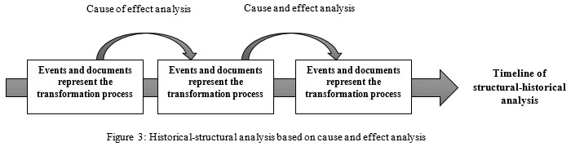

**Before 1960**: The beginning of the history of the natural environment cultural heritage management of can be traced to an international concern with the destruction of cultural heritage and monuments on a large scale caused by World Wars (1914-1919 and 1939-1945) and the significant presence of the modern movement in urban planning and architecture (1931). The need to rebuild cities and not imitate the past led to considering the physical and aesthetic values. From the mid-1940s to the late 1960s, with the formation of urban planning, special attention was paid to management and planning to address the problems of historic areas and protect cultural heritage in cities and the presence of a welfare state and prosperity after the war. The publication of the 1931 Athens Charter emphasized the need to protect historic buildings.

The founding of UNESCO in 1950 as an international organization to protect cultural heritage is also a significant step. In this regard, the drafting of the Hague Convention for the Protection of Cultural Property in the Event of War (UNESCO 1954) reflects the success of UNESCO’s concerted efforts on a series of international heritage conservation projects dating back to the 1950s. The early globalization of cultural heritage preservation shows that “endangered heritage” plays a crucial role in defining UNESCO’s mission so that at any time, this heritage as a cultural resource can play a role in rebuilding and building post-war cultural peace (Rico, 2014: 158).

**1960-1970**: In 1961, landscape values were recognized. At the UNESCO meeting, an article on preserving the beauty and character of landscapes and places was compiled. This article also referred to the cultural value of natural landscapes (Recommendation concerning the Safeguarding of Beauty, 1962). The Second Congress of Architects and Historians in Venice in 1964 also adopted 13 resolutions, one of which is the International Charter for Restoration, known as the Venice Charter. In this charter, special attention was paid to human values of heritage. The second case approved by UNESCO is the International Council on Monuments and Sites (ICOMOS) (https://www.icomos.org/en/about-icomos/), responsible for the World Heritage Site. The expansion of knowledge and the departure of purely physical planning and heritage led to the expansion of urban planning to the historical and identity areas of cultural heritage, changing the view of purely physical and conservation to urban renewal.

**1970-1980**: In 1972, due to the energy crisis and the environment, and the recognition of nature and the natural environment as cultural heritage, the UNESCO General Conference approved the Convention Concerning the Protection of the World Cultural and Natural Heritage (also known as World Heritage Convention). The rationale for the convention was that places of outstanding global value are part of all human heritage. Therefore, protecting them is a shared responsibility. The most significant result is identifying cultural and natural factors and statements about them as World Heritage Sites (WHS) (Pendlebury et al., 2009: 349). According to this statement, cultural heritage considers the environment and nature an integral part of the heritage that human beings are a part of this nature and societies.

In 1972, UNESCO defined heritage as what we live in the past, what we live in today, and what we pass on to future generations. Such a definition involves a temporal and cumulative conceptualization that must be consistent in various forms; thus, heritage is broader than cultural domains and/or processes; it is an “economic capital and social practice” and “a constantly changing dynamic product and process” (UNESCO Convention Text., 1972). The theoretical foundations of the statements and programs of this period refer to the principle of “cultural and environmental connection” and “integrated protection” in intervention plans for the environment and historic centers of cities in the form of urban development programs (Amsterdam Congress, European Architecture 1975). Emphasis on “the principle of heritage transformation and dynamism” co-occurred with the formation of the structural-strategic urban plans, emphasizing “the principle of process-oriented urban planning”.

**1980-1990**: In the 1980s, globalization and its effects on the economy and culture caused the issues of culture and cultural cohesion to attract special attention. The 1987 ICOMOS Resolution in Brazil also emphasized the care and rehabilitation of historic centers for cities’ cultural resources, with their social origin and identity, diverse functions, and the need for the participation of decision-makers and urban planners. The 1987 ICOMOS Charter of Washington called for the protection of historic cities to be included in economic and social development policies and urban and regional planning (Bonyadi, 2012: 74). Also, with the beginning of sustainable development thinking, special attention was paid to the need for urban planning in coordination with the natural environment cultural heritage, which in urban heritage planning, the view of “urban regeneration” was formed. This view was not anticipated due to the attention to environmental issues, and the sustainability of communities to respond to the “uncertainty” principle during disasters was closely linked to urban planning approaches at the time. Also, one of the concepts in this period was the “cultural landscape” in heritage studies, which was due to the attention to the dynamic and continuous trend of natural environment cultural heritage in urban planning goals (the Brazilian ICOMOS Seminar, 1987).

**1990-1990**: The 1990s is the decade of value-based approaches to natural environment cultural heritage (1994 The Nara Document on Authenticity; and The 1999 Burra Charter), emphasizing the need to recognize and interpret heritage values. According to these charters and recommendations, the role of actors and the interpretive nature of heritage in decisions affecting heritage is significant. Critical thinking is emerging in theories in the decade of transition from modernism to postmodernism. As a result, in this period, the discussion of participation in high levels of urban planning was given special attention. It emphasized the role of officials and stakeholders in planning.

**2000-2010**: In the early 21st century, in 2002, the UNESCO World Heritage Committee reaffirmed the universality of the 1972 agreement and the need to use cultural heritage as a tool for the sustainable development of all societies in a statement to its members in Budapest (Bonyadi, 2012: 74-76). In 2003, the preservation of the intangible values of the natural environment cultural heritage was emphasized in the sustainable development of cities and human societies. It paid particular attention to the intrinsic and external features of the natural environment cultural heritage. Due to the global economic crisis and the effect of the globalization process on the historical continuity in urban heritage environments and the value of living traditions, residents’ priority over tourists in heritage planning plans and projects was raised.

**2010-2021**: In the second decade of the 21st century, the UNESCO Recommendation on Historic Urban Landscape (2011) introduces a strategy to balance urban development and sustainable QOL. In this document, “urban heritage, including tangible and intangible values, is considered a major source in promoting the vitality of urban areas and promoting economic development and social cohesion in a changing global environment” (UNESCO, 2014, Art.3). besides, in cities and historic urban areas, they are living beings that are constantly changing. These changes affect all urban elements, including natural, human, tangible, and intangible. Proper management of these changes can provide a good opportunity to improve the quality of cities and historic urban areas (ICOMOS, 2011: 4). The formation of urban areas results from long processes that have been created in response to changes over time. Changes and all interventions in historic cities and urban areas must respect their tangible and intangible cultural values and improve the QOL of local people and the quality of the environment (ICOMOS, 2011: 7). According to the ICOMOS 2014 Florence Declaration, the emphasis is on the value of traditional knowledge to improve the QOL. Improving the QOL emphasizes the need for a multidisciplinary and interdisciplinary approach and the city’s cultural landscape in heritage planning.

The Global Sustainable Development Agenda affirms the link between the sustainability of urban areas and cultural heritage. Among the 17 Sustainable Development Goals (SDGs), Goal 11 aims to “create cities and human settlements that must be safe, flexible and sustainable” through “strengthening efforts to protect and preserve the world’s cultural and natural heritage.” Since adopting the 2015 United Nations Sustainable Development Agenda in the new Habitat III Urban Plan in October 2016, ICOMOS’s mission was to implement the 2030 Agenda in terms of cultural and natural heritage and work with strategic organizations. It aims to protect, preserve, function, and promote cultural heritage sites and knowledge through sustainable development (https://www.icomos.org/en). Thus, the significance of natural-cultural heritage at the local level in forming cultures, welfare, and human identity was highlighted based on the emphasis on public participation in the definition and implementation of heritage policies and the contribution of local knowledge in various concepts of heritage. However, natural and cultural heritage definitions are not clear and are constantly evolving (Jenkins, 2018: 75).

Also, in 2020, with the COVID-19 outbreak, ICOMOS declared the theme of 2020 “a common culture, a common heritage, a common responsibility.” Many people chanted this slogan because the COVID-19 spread worldwide, and all had the responsibility to prevent it. This issue acknowledges that the heritage of sites, landscapes, customs, and collections is often associated with and valued by numerous and diverse groups and communities. Paying attention to the relationships between cultures or cultural groups and their collective responsibility for caring for and preserving the characteristics, meanings, and deep values of cultural heritage is at the heart of this core issue (https://www.iranicomos.org/wp-content/uploads/2020/03/2020-ICOMOS-18th_April-Sharedcultures_EN.pdf). Thus, the late 20th century emphasized the multidisciplinary nature of heritage and the interactions of human beings and the nature, a deeper understanding of heritage formation, a complex interaction of human history and associated environmental changes in expressing the interpretive nature of heritage values, and the role of actors in the program process (Avrami et al., 2000; De la Torre, 2002; Jokilehto, 2005; ICOMOS, 2003). In the 21st century, with the introduction of new approaches such as heritage urbanism, heritage is recognized as an integral part of the sustainable development approach. The survival and future of heritage are linked to urban and spatial planning. It also considers the integrity of the space and the cultural heritage in it and considers heritage as an essential factor in the quality of the landscape and QOL (Zeayter & Mansour, 2017: 6; Tweed & Sutherland, 2007: 64; Wantzen et al., 2016: 7-8, Šćitaroc, 2015; Šćitaroc “HERU”, 2018; Šćitaroc, 2019).

According to the definitions of natural heritage from 1902 to 2020, natural heritage values are related to the human perceiver and decision-maker. Heritage is interpretive (from society’s point of view); it depends on its context, values, and perception of heritage for promoting values, and programs to preserve and develop this heritage are needed (Wallace et al., 2020: 144). Given that individuals’ participation in and perception of heritage and resource management have a fundamental role, research on the underlying values of motivation is needed to select and preserve heritage. Before any decision in management, understanding the social context is necessary and puts it in the future of heritage preservation.

A planning framework that does not interfere with social contexts should address values and seek to integrate values with different stakeholder perspectives (Marmion, 2012: 53).

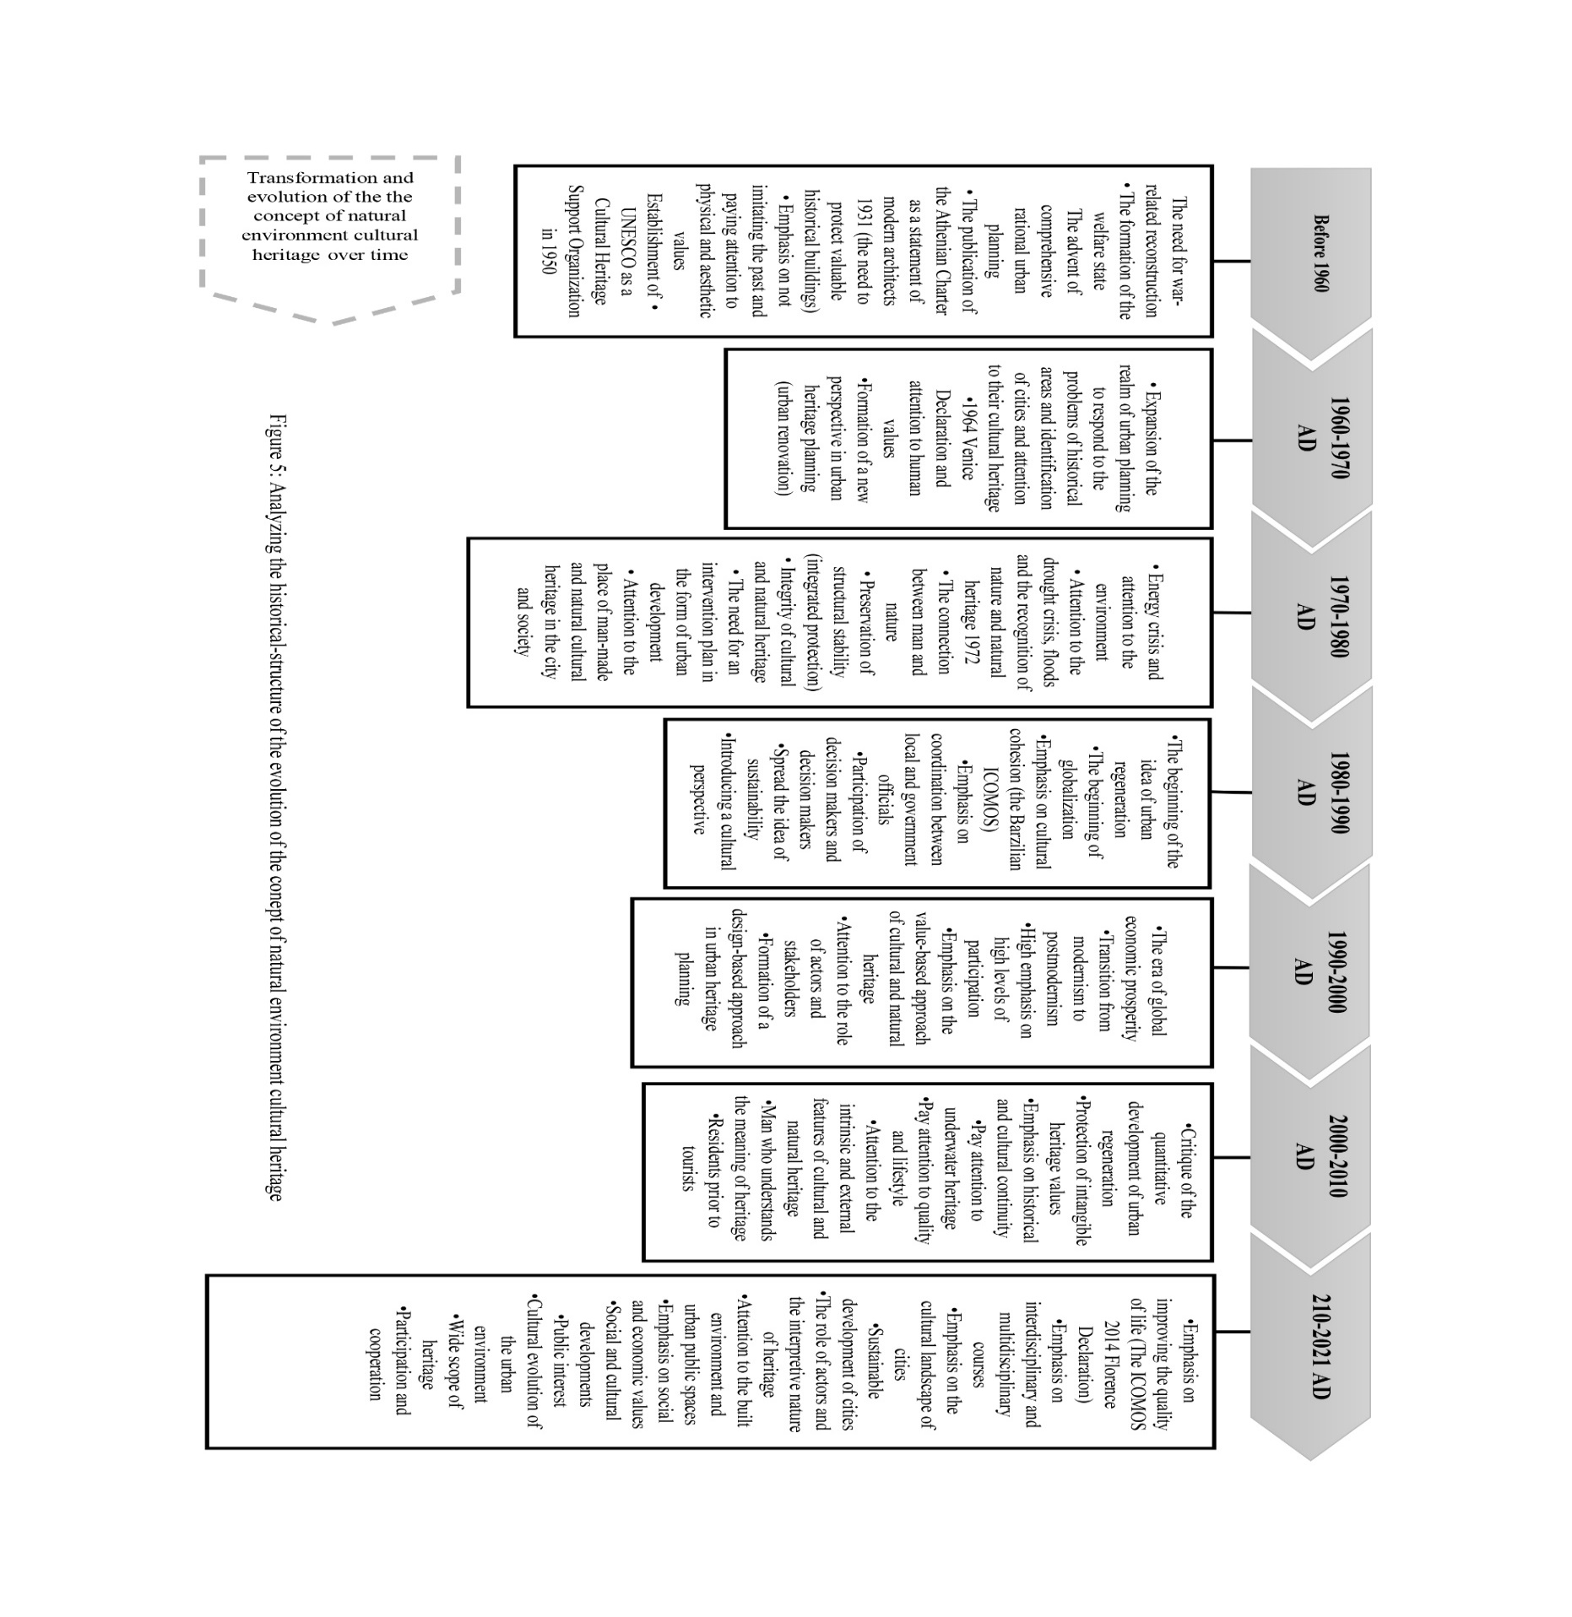

*Introducing the evolution of the concept of QOL based on historical-structural analysis*

QOL is not a new concept rooted in Greek philosophy: Aristotle referred to it in his discussion of happiness. Observed as a coherent thought of the twentieth century in the modern era, the concept of QOL has attracted the attention of philosophers such as Kierkegaard, Jean-Paul Sartre (Ghaffari & Omidi, 2009; Sameh & Akrami, 2016: 28).

**Before 1960**: Pigou first used the term QOL in 1920 in *the Economy of Welfare*. In this book, Pigou discusses government support for low-income groups and its impact on them and the national budget. It has been a popular subject with social, economic, and psychological researchers since the 1930s. Due to the post-World War II period and the need for rapid reconstruction and the formation of the welfare state, QOL was introduced as “standard of living” to achieve greater efficiency for a minimum standard, such as the need for housing. During this period, the goal of welfare states was to achieve the minimum standard of living; according to the physical view of comprehensive rational urban planning, the objective components of the standard of living can be observed.

**1960-1970**: A change in the concept of “standard” to “quality” indicates an improvement in the material conditions of life in industrialized countries in the 1960s; according to Schuessler and Fisher, “QOL” was first used in the 1960 US Presidential Commission’s report on national goals (Wood, 1999). These developments were due to dissatisfaction with the social and environmental consequences of modernization, economic transformation, and the formation of protest movements against the inefficiency of comprehensive rational and quantitative planning in urban planning. Oppositions to rational urban development (comprehensive plan and formation of social movements including those of Jane Jacobs and Alexandra) and efforts to preserve the historical fabric and revitalize worn-out textures were discussed in urban planning. Social activists and urban planners also showed that cities have an identity and cultural needs for residents. Since the 1930s, researchers have studied QOL through various methods and approaches. They have tried to determine the components and elements of QOL and compare geographical areas such as cities, states, and countries by QOL indicators (Clergy et al., 2014: 6). However, academically, the concept of urban QOL has been a field of research since the early 1960s (Schuessler & Fisher, 1985: 130).

**1970-1980**: The 1970s marked a turning point in the study of QOL, with most emphasizing the “definition of QOL”. From this date onwards, discussions on QOL focused more on the three areas of scientific discipline: medicine, psychology, and social sciences. Also discussed was QOL in individuals’ inner and mental states and attention to the concept of QOL and social welfare in development programs. The concept of “standard of living” lost its legitimacy, and another idea was formed under the concept of “QOL” related to individuals’ inner states in dealing with their needs and desires.

**1980-1990**: In the 1980s, special attention was paid to explaining the concept of QOL. The public introduced individual issues to the public. Simultaneously with the spread of the idea of ​​“sustainable development” (the World Commission on Environment and Development (WCED), Brantland, 1987) and the introduction of urban planning approaches (strategic and participatory planning), the significant attention of “urban quality” in the study of QOL and urban planning found a special place that the emphasis of the third view brought simultaneous attention to the objective and subjective components. Therefore, planners in this period emphasized providing a conceptual model for QOL, which expressed the “principle of uncertainty” in defining this concept.

**1990-2000**: In the 1990s, with the first International Conference on QOL in Cities, Singapore, March 1998, researchers consistently presented indicators to measure perceptions of QOL and residential satisfaction to analyze QOL. During this period, the discussion of participation and discourse in urban planning was raised at its highest levels. Many efforts were made to express “democracy” and “participation” as indicators of QOL and to measure QOL, social and environmental considerations, and marketing tools in economics. QOL was also mentioned as a “macro goal” in sustainable development based on improving the QOL between the dimensions of sustainability, relationship, and overlap.

**2000-2010**: Since 2000, studies on the QOL can be divided into various environmental and local perspectives such as mental perceptions of urban spaces, residential and human-made environments, neighborhoods, housing, new cities, and informal settlements in achieving a sustainable environment. In this period, the effect of the idea of QOL in the academic field can be observed. Also seen was the increase of international conferences and specialized journals related to this idea. In the experimental field in developed countries, this issue was significant, and its promotion was considered one of the projects’ primary goals. Most studies related to “life satisfaction” dimensions were considered (Sameh and Akrami, 2016: 34).

In 2006, the Journal of Applied Research in QOL was published to investigate the QOL in scientific, social, and natural disciplines. (Marans, 2012: 9). However, until the twentieth century, the concept of “QOL” was not known in urban planning (Ebrahimzadeh et al., 2016: 1). After the Industrial Revolution, new societies tended to link the urban planning process to specific QOL standards; for example, Eckersley (2000), Rezvani et al. (2012), Spinney et al. (2009), Barton and Tsourou (2013), Preuss and Vemuri (2004), Marquez and Smith (1999), Seongyeon (2005), Grigsby and Rosenburg (2012), and Massam (2002) discussed the relationship between urban planning and the quality of urban life. In the first decades of the twentieth century, however, it was based mainly on a political outlook on maintaining productivity and health and improving the individuals’ material living conditions. It also helped meet the needs of the growing middle class. However, in the last decades of the century, it focused on improving the QOL and creating better living conditions in the public sphere, serving as a tool for planning sustainable cities.

**2010-2021**: In the 21st century, planners in the social field of sustainable urban development management consider the subjective and objective indicators of QOL as essential for promoting citizens’ social life and welfare. Therefore, the issue of QOL, which has recently been raised in the literature of sustainable development and social development planning and modern management and environmental issues, has a special place in urban studies. Governments at the national and local levels and various institutions work on measuring and indexing it (Qahramani & Sayadi, 2016: 58). The concept of QOL and its evaluation in recent years have attracted the attention not only of city officials but also of many groups and individuals on a global scale, including those interested in human development (e.g., the United Nations’ Human Development Index), or social development stakeholders (e.g., the Ontario Social Development Council (OSDC)), Sustainable development stakeholders (e.g., Hamilton-Wentworth, Seattle), healthy community stakeholders (e.g., Pasadena, Ontario Coalition of Healthy Communities) and those interested in running the city (e.g., Jackson Community Council, Canadian Municipal Federation). In other words, many people and organizations pay attention to the issue of QOL and evaluate it, which shows the importance of QOL (Mohamad Mostafa, 2012: 256). Also, the QOL was proposed due to attention to the dimensions and spatial standards (social, cultural, physical, economic, political, and managerial) as a goal and tool in urban planning (both process and product).

QOL as “standard of living” and concerning the self-sufficiency level until the 1960s was studied, assuming that material welfare increases satisfaction and emphasized the objective components of QOL. However, since the 1960s, instead of “standard of living”, the “social indicators” movement led to changes in the general attitude towards QOL. They argued, however, that a more appropriate and balanced assessment of quality should combine both subjective and objective characteristics (standardization with an objective approach and satisfaction with life with a subjective approach). Indeed, an approach that combines objective and subjective indicators provides a better approach to QOL and allows them to address and complement another weakness (objective and subjective) (Muhammed & Abubakar, 2019: 5). Therefore, all three approaches emphasize the principle of “human-environment interaction” with a different perspective.

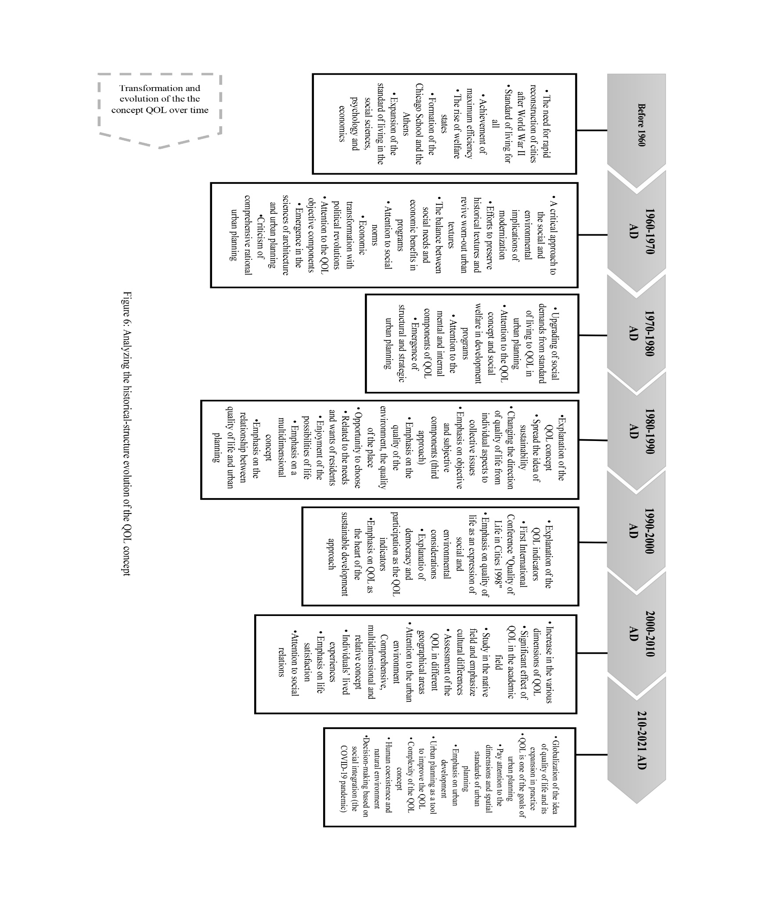Thus, the concept of QOL is general, typically found in almost all disciplines, has many interpretations, and therefore lacks a standard definition. This concept is widely used in many fields, including health, politics, public administration, urban planning, international development, and other social sciences and humanities (Muhammed & Abubakar, 2019: 2). QOL is an important concept that provides a basis for negotiating consensus on planning goals. In addition, it can help policymakers understand and prioritize the problems that societies face. Thus, QOL measures can be used to make decisions in resident communities (Zebardast & Nooraie, 2017: 2).

*Comparative and integrated analysis of the evolution of the natural environment cultural heritage and QOL*

For comparative and integrated analysis of the two concepts of natural environment cultural heritage and QOL, their common fields were organized based on a comprehensive and multidimensional process, and identical conditions and characteristics were explained as crucial points. Analysis of evidence via cause and effect analysis of each concept’s evolution and through combined explanations of the two basic concepts provides comparative and integrated analysis.

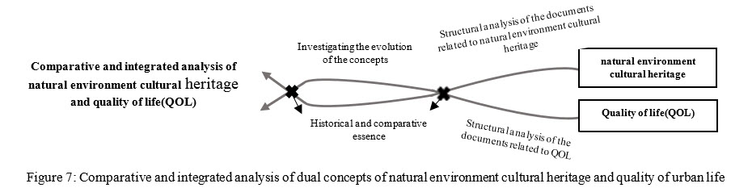

Before 1960, due to the reconstruction of cities after World War II and the presence of the welfare state, the Athens Charter as a guide for architects and planners in this period put on the agenda “the need to protect historic buildings” and “achievement of maximum efficiency and compliance.” Both concepts of the natural environment cultural heritage and QOL (the concept of “standard of living”) were put on a purely physical, aesthetic, and objective basis. Between 1960-1973, due to the critical attitude to the social and environmental consequences of the modernization of comprehensive urban planning, both concepts paid particular attention to preserving the worn-out urban texture and identifying the historical areas. They also emphasized “human values” and “social norms”.

Between 1970 and 1980, due to the environmental and energy crisis and the principle of “the link between human beings and nature”, UNESCO “identified and defined natural environment cultural heritage standards”, making them inseparable. Due to the attention to internal and perceptual components, the “standard of living” concept was changed to QOL, and “subjective and internal components” attracted attention. The need to preserve culture and environment is another point added to the measures of this period. Also, the natural environment cultural heritage expresses “integrated protection” and the “principle of heritage dynamics” as measures of intervention in the urban plans of the historic centers of cities.

In the 1980s, the QOL concept continued to focus on the principle of “uncertainty”, “multidimensionality,” and “multidisciplinarity” in an attempt to find a conceptual definition and model. With the intensification of globalization, cultural cohesion, and the emergence of new approaches to participatory planning, the need for “participation of decision-makers and decision-makers” and attention to the “needs and desires of residents” in assessing the quality of place and “human status and perception” from a cultural perspective (especially residents), the “objective and subjective components” (the third view of QOL) and the “interpretive nature” of natural environmental heritage were emphasized. During 1990-2000, theorists extended scientific and practical experiences of “sustainable development”.

Furthermore, with the holding of international conferences on “Quality of Life in the City” and attention to cultural and environmental considerations, the “democracy” and “participation” indicators in the basic concepts received increasing attention: many researchers believe that sustainable urban form is a critical element in achieving sustainable development and QOL is an essential element in sustainable urban development (Mittal et al., 2020: 3) to balance human life, improve the QOL for society, and achieve sustainable development. Paying attention to preserving natural heritage and human beings’ role in this issue is significant (Farrokhzadi & Nowruzi, 2009: 1). Also, in the Recommendation of Historic Urban Landscape (2011), urban heritage preservation is introduced as a strategy to achieve a balance between urban development and sustainable QOL (UNESCO, 2014, Art.3).

Planning aims to improve the quality of urban life. For development to be sustainable in the long run, there must be a balance among the four economic, social, environmental, and cultural dimensions, and intergenerational solidarity is emphasized. In other words, the first step in sustainable development is to identify the natural environment and protect what lies within it, namely natural environment cultural heritage (Rezvani, 2000: 9-10). Therefore, it is possible to understand the closeness of the concepts of QOL and natural-cultural heritage based on commonalities of the sustainable development approach.

There was a significant leap during 2000-2010, with a significant influence on the quality of life in academic disciplines and various dimensions. “Attention to the urban environment”, attention to “social relations”, and emphasis on its “comprehensive, multidimensional and relative aspects”, are the criteria and indicators added to the QOL. Also, the natural environment cultural heritage introduced special attention to protecting intangible heritage values, improving the QOL, and preserving the traditional way of life in natural natural environment cultural heritage values. The relationship between natural environment cultural heritage and the QOL was emphasized during this period. In the years after 2010, natural heritage theorists considered “the role of actors” and “decision-making and shared responsibility” as guarantors of heritage values and paid particular attention to urban public spaces and the cultural evolution of the urban environment in urban planning. While the QOL theorists also made decisions based on social integration (especially during the COVID-19 pandemic) and the coexistence of humans and the natural environment. They described the improvement of QOL as both a tool and a goal of urban planning in urban issues and programs.

Thus, with the comparative analysis results of the two concepts of natural environment cultural heritage and QOL extracted from the first sources, the compatibility of these two concepts was determined and stated summarily:

**First**, the integrated emphasis on the natural environment cultural heritage and the QOL on the “link between human beings and the environment”;

**Second**: “Multidimensionality” of analyzes on the natural environment cultural heritage and the QOL;

**Third**, the findings and analyzes of the two concepts on a common dual (objective and subjective) classification;

**Fourth**, the emphasis on the two concepts on the “sustainability” approach;

**Fifth**, the need to study the “role of actors and interpretive nature” in the concept of the natural environment cultural heritage with the components such as “attention to social relations” and “participation of decision-makers and stakeholders” in urban planning in terms of QOL;

**Sixth**, “Culture as an actor” in the concept of the natural-cultural heritage is also in compliance with “emphasis on indigenous context and cultural differences” in the QOL concept; and

**Seventh**, emphasis on “uncertainty and complexity” of analyzes in the basic concepts.

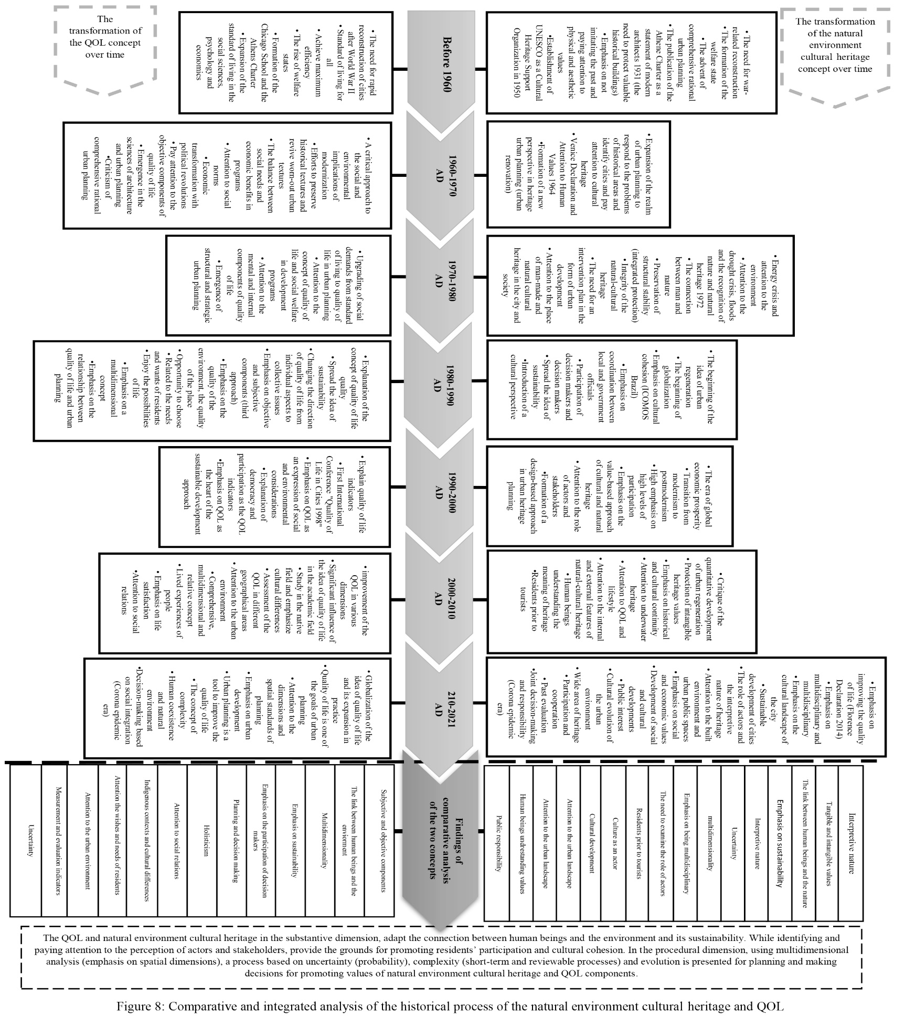

**Discussion**

A model can be proposed to link the substantive and procedural link of the two concepts of natural environment cultural heritage and QOL based on the strategic planning approach considering the compatibility of natural environment cultural heritage and QOL concepts with the principles of the strategic planning approach. The strategic planning approach can be adapted to the principles of intervention in urban planning of natural environment cultural heritage and achieve the expected results of their analysis, significantly to improve the QOL. Based on the continuous processes of collecting, describing, and analyzing the data, the strategic planning approach prescribes a planning model for intervening in problematic phenomena (problem-solving method). The essential features of this approach can be introduced in the following order:

**First**: Emphasis on the relationship between man and the environment, due to the flexibility of strategic planning, the stages and process different for each topic and phenomenon planned, and provides a new option to respond to new conditions. Short-term measures establish the connection between human beings and the environment, and this relationship is periodically analyzed and, if necessary, the program is reviewed.

**Second**: The integration of values in the planning substance can make it possible to study phenomena with an interpretive nature and depend on society’s subjective and objective measures and beliefs and the indigenous context in the planning substance to promote these values.

**Third**: Focusing on the main and strategic problems of the study area provides the possibility of guiding the issue and promoting the values of the phenomenon. By identifying and analyzing problems, program priorities are considered and provide the possibility of identifying indicators and indicators to measure and evaluate the status of programs.

**Fourth**: The ability to add social and environmental dimensions and support sustainable development in the planning system has several spatial planning (economic, social, physical, environmental, and managerial) dimensions. The multidimensional concept of natural environment cultural heritage and QOL can identify the natural environment cultural heritage values and quality of life components and be considered integrated and coordinated policies and measures of the plan.

**Fifth**: The ability to add social and environmental dimensions and support sustainable development in the planning system has several dimensions of spatial planning (economic, social, physical, environmental, and managerial). With the multidimensional concepts of natural environment cultural heritage and QOL, it is possible to identify heritage values and quality of life components and be considered in an integrated and coordinated manner in the policies and actions of the program.

**Sixth**: Emphasis on public participation and public interest in strategic planning allows the intervention of stakeholders to preserve and develop the natural environment cultural heritage and improve the QOL. It also provides the grounds for private sector participation and action on a human scale and places values through the public interest within the urban planning framework by identifying the wants and needs of residents.

**Seventh**: The process and cyclical nature of strategic planning allow data collection and analysis in different stages of urban planning. It also provides a comprehensive and integrated landscape, statement, and vision with the fundamental problems of the natural environment cultural heritage and the improvement of the QOL.

**Eighth**: Planning uncertainty in the natural environment cultural heritage and QOL components with complex, interpretative, and multidimensional natures can propose an alternative for new situations and crises to respond to new conditions by focusing on evolutions and producing different strategies.

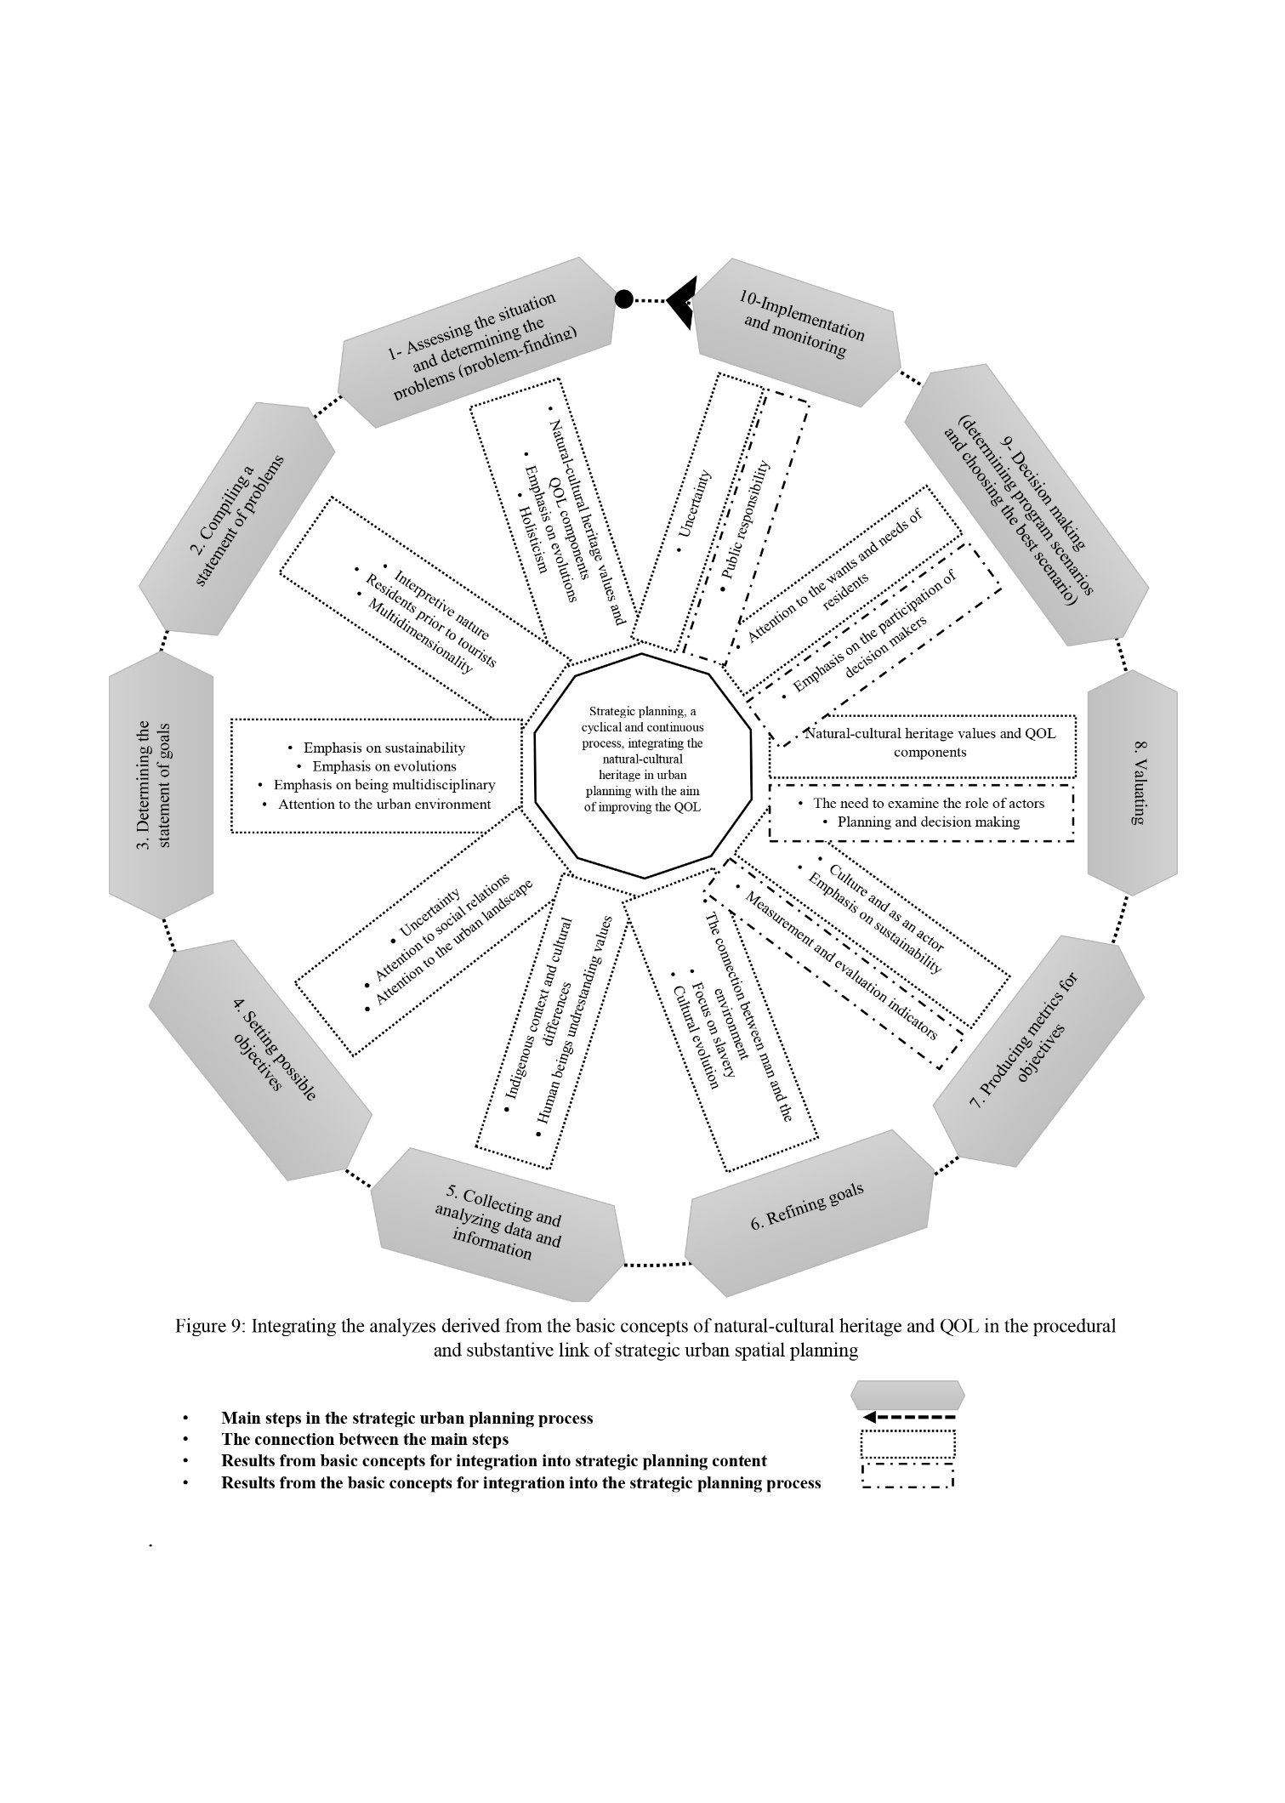The strategic planning approach works in two goal-oriented and problem-oriented directions. Based on these two directions, achieving the plan is either top-down and idealistic (goal-oriented) or bottom-up and realistic (problem-oriented) (Abdi Daneshpour, 2018: 9-10). In this paper, a 10-step process with a problem-oriented approach used to intervene based on historical evidence of the concepts of natural environment cultural heritage and QOL was introduced as the basis for integrating these two concepts in the strategic planning process.

**Conclusion**

A six-stage model is proposed based on the substantive ad procedural link of natural environment cultural heritage and QOL based on the strategic planning approach model and the ten-step strategic planning process that can be used to intervene based on historical evidence in natural environment cultural heritage and QOL.

Given the significance of process-oriented planning and decision-making, attention to the need for stakeholders’ participation and also the need for the principle of uncertainty, evolutions, the relationship between environment and humans, and emphasis on the principle of sustainability, holisticism, and multidimensionality of natural environment cultural heritage and QOL, strategic planning approach can provide a substantive and procedural link between these two basic concepts. The essential features of strategic planning include the emphasis on the principle of uncertainty in planning; the possibility of the planning process; the need to expand the scope of planning in the broader political, social, economic, and environmental fields; emphasizing the significance of paying attention to the role of various actors (stakeholders), and emphasis on the principle of sustainability and the connection between human beings and the environment. The strategic planning model for promoting the values of natural environment cultural heritage and QOL based on strategic planning has basic substantive and procedural features. However, its differences with strategic planning principles: by emphasizing the urban landscape and tangible and intangible values and subjective and objective components, it analyzed the cultural coherence and diversity of the connection between human beings and the natural environment. It then identified key actors and residents and analyzed their roles. This model analyzes the planning of crucial natural environment cultural heritage events and its effect on the QOL. Finally, a statement of problems and the formulation of macro goals were presented. Then, by examining the causes of problems and refining the goals, a model for natural environment cultural heritage planning for improving the residents’ QOL was developed (resulting from the use of fundamental ideas in strategic planning).

Based on the fundamental changes resulting from using the natural environment cultural heritage and QOL in urban strategic planning, three primary plan descriptions, analysis, and prescription stages in the form of a hexagon, including six strategic natural environment cultural heritage plans, were compiled to improve QOL. Each stage includes measures: the first stage, i.e., status assessment, consists of three steps: (1) describing human and natural environment cultural heritage interactions over time; (2) identifying and describing the values of natural environment cultural heritage; and (3) identifying and describing of QOL components.

The second stage, i.e., problem identification (problem-finding), includes one step: analyzing the evolution of natural environment cultural heritage values and QOL components. The third stage, problem identification, includes two steps: (1) analyzing the reason for reducing the quality of life of residents from value change natural environment cultural heritage and (2) analyzing the role of residents’ perceptions and recognition of cause and effect relationships in reducing natural environment cultural heritage values. The fourth stage, producing the final statement of problems and goals, includes two steps: (1) presenting statements of problems and goals based on the relationship of natural environment cultural heritage and QOL and (2) tracing the factors of cultural cohesion and the indigenous context in promoting the of natural environment cultural heritage values.

The fifth stage, presenting decision making alternatives and suggestions (problem-solving), includes two steps: (1) compiling a natural environment cultural heritage planning (physical, social, economic, and managerial) document and (2) assessing planning alternatives based on the actors’ role for promoting the natural-cultural heritage values. The sixth stage, sharing a strategic plan related to natural environment cultural heritage among critical stakeholders and residents, includes one step: developing a strategic planning model to promote the natural environment cultural heritage values to help decision making in public and private sectors.

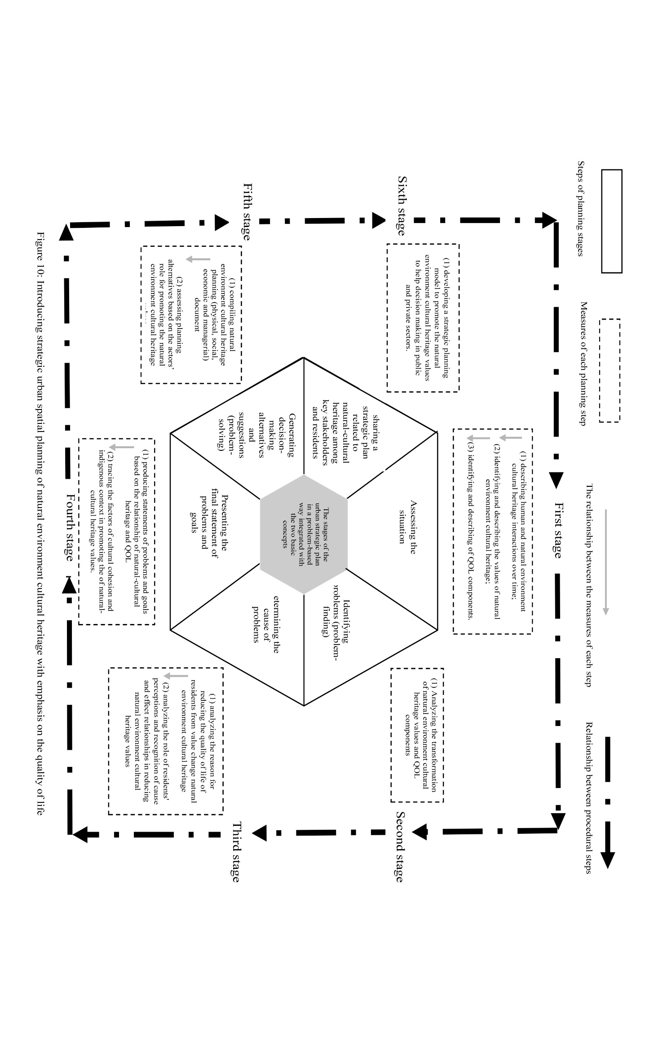

**References**

* Abdi Daneshpour, Z.(2008). Introducing the step-by-step “troubleshooting/problem-solving” approach. *Journal of Fine Arts*, No. 36, 5-16.
* Abdi Daneshpour, Z., Fallahi, A. & Moradi, D.(2015). Assessing the feasibility of using a quality of life reporting system in urban planning. *Quarterly of Spatial Planning Scientific and Research*, No. 2, 54-25.
* Abdi Daneshpour, Z.(2018). Problem tracking framework in new cities: Sue problem planning in the new city of Hashtgerd. *Journal of Architecture and Urban Planning*, Vol. 10, No. 20, 5-22.
* Albrechts, L. (2004). Strategic (spatial) planning reexamined. Environment and Planning B. *Journal of Planning and Design*, 31(5), 743-758.
* Avrami, E. (2000). Values and heritage conservation. Conservation: The Getty Conservation Institute Newsletter, 15(2), 18-21.
* Bonyadi, N.(2012). Evolution of the urban restoration idea. *Journal of Hoviat Shahr*, Vol. 6, No. 10, 67-78.
* De la Torre, M. (2002). Assessing the values of cultural heritage: Getty conservation institute.
* Ebrahimzadeh, I., Shahraki, A. A., Shahnaz, A. A., & Myandoab, A. M. (2016). Progressing urban development and life quality simultaneously. *City, Culture and Society*, 7(3), 186-193.
* Ghaffari, G.(2009). The logic of comparative research. *Iranian Journal of Social Studies*, , Vol. 3, No. 4, 1-18.
* Ghahremani, M & Sayadi, K.(2016). Assessing the quality of urban life from sustainable development in Mehr residential complexes (a case study of Mehr Shahid Beheshti houses in Hamedan). *Journal of Haft Hesar Environmental Studies*, No. 16, 53-60.
* Grout, L & Wang, D.(2007). *Research methods in architecture*. Alireza Einifar (Trans.), Second Edition, Tehran: University of Tehran Press.
* Guzmán, P., Pereira Roders, A., & Colenbrander, B. (2014). Bridging the gap between urban development and cultural heritage protection. *Paper presented at the IAIA14 Conference Proceedings*.
* Guzmán, P., Pereira Roders, A. R., & Colenbrander, B.(2018). Impacts of common urban development factors on cultural conservation in world heritage cities: An indicators-based analysis. *Sustainability*, 10(3), 853.
* Healey, p.(1997). An Institutionalist Approach to Spatial Planning. Making Strategic Plans: Innovation in Europe, 21-36.
* Hosseinpour, A., Moradi Chadegani, D., Toghyani, Sh. and Nazemi, E.(2021). Explanation of contingency planning approach to promot cultural landscape in interaction with human ecology over time. *Environmental Sciences*. 19(2):127-150.
* ICOMOS (1987). Charter on the Conservation of Historic Towns and Urban Areas:’ The Washington Charter’. ICOMOS, Paris.
* ICOMOS (2003). Towards a declaration on intangible heritage and sites, kimberley.pdf (retrieved June 10.2013).
* Jenkins, V. (2018). Protecting the natural and cultural heritage of local landscapes: Finding substance in law and legal decision making*. Land Use Policy*, 73, 73-83. doi:10.1016/j.landusepol.2017.12.056.
* Jokilehto, J. (2005). Definition of cultural heritage: References to documents in history. ICCROM *Working Group’ Heritage and Society*, 4-8.
* Mahoney, J. & Rusechemeyer, D.(2003). *Strategies of Causal Assessment in Comparative Historical Analysis in the Social Sciences*. Cambridge: Cambridge University Press.
* Marmion, M. M. (2012). *Understanding heritage: multiple meanings and values*. Bournemouth University, School of Tourism.
* Marans, RW. (2012). Quality of Urban Life Studies: An Overview and Implications for Environment-BehaviourResearch. *Asia Pacific International Conference on Environment-Behaviour Studies*, Salamis Bay Conti Resort Hotel, Famagusta, North Cyprus, 7-9 December 2011, AicE-Bs 2011 Famagusta, 9-23.
* Mehdizadeh, J.(2006). *Strategic urban development planning (recent global experiences and its place in Iran)*. Payam-e-Sima Publishing House: Tehran.
* Mirjani, H.(2010). Rational reasoning as a research method. *Soffeh*, Vo. 20, No. 50, 35-50.
* Mohamad Mostafa, A. (2012). Quality of Life Indicators in Value Urban Areas: Kasr Elnile Street in Cairo. ASEAN Conference on Environment-Behaviour Studies, Bangkok, Thailand, 16-18 July 2012(Social and Behavioral Sciences), 254-270.
* Moradi Chadegani, D. & Mahmoudpour, E.(2012). *Comparative study of Tehran comprehensive plan document with principles of strategic spatial planning approach*, Tehran: Tehran City Studies and Planning Center.
* Neuman, W.L.(2015). *Social research methods; qualitative and quantitative approaches* Volume One. Tehran: Mehraban Publications.
* Pendlebury, J., Short, M., & While, A. (2009). Urban World Heritage Sites and the problem of authenticity. *Cities*, 26, 349–358. doi:10.1016/j.cities.2009.09.003.
* Obad Šćitaroci, M. (2015). *Heritage Urbanism – Urban and Spatial Models for Revival and Enhancement of Cultural Heritage* (HERU). Paper presented at the Cultural Heritage – Possibilities for Spatial and Economic Development, Faculty of the Architecture University of Zagreb, Zagreb: e-book.
* Obad Š´citaroci, M.(2018). Heritage as an Active Space and Spatial Resource. In Quality of Life in Urban Landscapes—In Search of a Decision Support System; Cocci Grifoni, R., D’Onofrio, R., Sargolini, R., Eds.; Springer: Cham, Switzerland, pp. 341–348, ISBN1 978-3-319-65580-2, ISBN2 978-3-319-65581-9. [CrossRef]
* Obad Šćitaroci, M., & Bojanić Obad Šćitaroci, B. (2019). Heritage Urbanism. *Sustainability*, 11(9), 2669.
* Rezvani, A. A.(2000). Joint protection of cultural and natural heritage is essential for achieving sustainable development. *Journal of the Faculty of Literature and Humanities*, University of Isfahan, Vol. 2, No. 11, 1-14.
* Rico, T. (2014). The limits of a ‘heritage at risk’ framework: The construction of post-disaster cultural heritage in Banda Aceh*, Indonesia. Social Archaeology*, 14(2) 157–176, 157-176. doi:10.1177/1469605314527192.
* Sameh, R. & Akrami, Gh. (2015). Analysis of the evolution of quality of life in architecture and urban planning. *Journal of City Identity*, Vol. 25, No. 10, 27-40.
* Schuessler, K.F., Fisher, G.A. (1985). Quality of life research and sociology. *Annual review of sociology*, 11, 129-149.
* Tweed, C., & Sutherland, M. (2007). Built cultural heritage and sustainable urban development. *Landscape and Urban Planning*, 83 (2007) 62–69, 62-69. doi:10.1016/j.landurbplan.2007.05.008
* UNESCO Convention Text. Convention Concerning the Protection of the World Cultural and Natural Heritage (Paris, 1972). [online] [accessed 19 August 2015]. Available at: http://whc.unesco.org/archive/convention-en.pdf.
* UNESCO (1976). Recommendation Concerning the Safeguarding and Contemporary Role of Historic Areas. UNESCO, Nairobi.
* UNESCO (2005). Vienna Memorandum on “World Heritage and ContemporaryArchitecture – Managing the Historic Urban Landscape”. World Heritage Centre, Paris. p. 6. <http://whc.unesco.org/en/activities/48>.
* UNESCO. Bam Citadel, UNESCO, No. 1208, http://whc. unesco.org/archive/, 2005.
* UNESCO Operational Guidelines. Operational Guidelines for the Implementations of the World Heritage Center (July, 2013). WHC. 13/01 [online] [accessed 19 August 2015]. Available at: http://whc.unesco.org/en/guidelines.
* UNESCO World Heritage Centre (2011), Recommendation on the Historic Urban Landscape. Paris, Retrieved December,2012,from:http://portal.unesco.org/en/ev.phpURL_ID=48857&URL_DO=DO_TOPIC&URL_SECTION=201.html.
* UNESCO Convention Text. Convention Concerning the Protection of the World Cultural and Natural Heritage (Paris, 1972). [online] [accessed 19 August 2015]. Available at: http://whc.unesco.org/archive/convention-en.pdf.
* United Nations Educational, S. a. C. O. (2018). CULTURE FOR THE 2030 AGENDA. Retrieved from Paris.
* Wallace, N., Bernard, M., & Dennis, K. (2020). Residents’ Attitudes towards the Built Environment in Historic Parklands in Nairobi, Kenya. *Current Urban Studies*, 8(02), 141.
* Wantzen, K. M., Ballouche, A., Longuet, I., Bao, Ibrahima, Bocoum, H., Cisse, L. Zalewsk, M. (2016). River Culture: an eco-social approach to mitigate the biological and cultural diversity crisis in riverscapes. *Ecohydrology & Hydrobiology*, 16, 7-18. doi:doi.org/10.1016/j.ecohyd.2015.12.003.
* Wood, D.S (1999). Assessing quality of life in clinical research from where have we come and where are we going. *Journal of clinical epidemiology*, No 52: 355-363.
* Zeayter, Hoda & Mansour, A. M. H. (2017). Heritage conservation ideologies analysis – Historic urban Landscape approach for a Mediterranean historic city case study. *HBRC Journal*, 1-12. doi:10.1016/j.hbrcj.2017.06.001.
* Zebardast, E., & Nooraie, H. (2018). Investigating the relationship between housing satisfaction and quality of life in the decayed historic areas of Isfahan using path diagram. Indoor and Built Environment, 27(5), 645-657.
* WWW.unhabitat.org
* https://www.un.org/pga/73/event/culture-and-sustainable-development/
* https://whc.unesco.org/en/activities/810
* http://www.citylab.com/commyte/2014/04/tearingdown-urban-highway-can-give-rise-whole-new-city/8924/
* https://chrs.ca/sites/default/files/2021-06/15890-CHRS-Strat-Plan-2020-2030.pdf.
* https://www.iranicomos.org/wp-content/uploads/2020/03/2020-ICOMOS-18th_April-Sharedcultures_EN.pdf.
* https://www.icomos.org/fr/themes-dactualite/18-avril-journee-internationale-des-monuments-et-des-sites/90553-18-avril-futurs-divers.
* https://chrs.ca/sites/default/files/2021-06/15890-CHRS-Strat-Plan-2020-2030.pdf.
* https://www.iranicomos.org/wp-content/uploads/2020/03/2020-ICOMOS-18th_April-Sharedcultures_EN.pdf.
* https://www.icomos.org/fr/themes-dactualite/18-avril-journee-internationale-des-monuments-et-des-sites/90553-18-avril-futurs-divers.

1. - The term ‘heritage values’ refers to the meanings and values that individuals or groups of people bestow on heritage (including collections, buildings, archaeological sites, landscapes and intangible expressions of culture, such as traditions). These values have been a key factor in the legitimation of heritage protection and management, although the understanding of what they are has varied over time and there are nuances between one country and another (Díaz-Andreu, 2017: 2).