# Numerical study of airflow and average temperature in different canyon aspect ratios:

1. **Case study of Shiraz**

## 3

#### Shoeleh Shoara

1. Ph.D graduate, Faculty of Civil engineering, Art and Architecture, Science and Research Branch,
2. Islamic Azad University, Tehran, Iran
3. Tel: +98 9376494648 E-mail: [sshoaraa@yahoo.com](mailto:sshoaraa@yahoo.com)

## 8

#### Seyed Majid Mofidi Shemirani

1. Corresponding Author
2. Head of Urban Development Department, Iran University of Science and Technology, Tehran, Iran.
3. Tel: +98 9125116488 E-mail: [s_m_mofidi@iust.ac.ir](mailto:s_m_mofidi@iust.ac.ir)

## 13

#### Seyed Kamaleddin Shahriari

1. Assistant Professor, Faculty of Civil engineering, Art and Architecture, Science and Research Branch,
2. Islamic Azad University, Tehran, Iran
3. Tel: +98 9121131959 E-mail: [shahriari@srbiau.ac.ir](mailto:shahriari@srbiau.ac.ir)

## 18

#### Zahra Sadat Saeideh Zarabadi

1. Associate professor, Faculty of Civil engineering, Art and Architecture, Science and Research
2. Branch, Islamic Azad University, Tehran, Iran.
3. Tel: +98 9121078853 E-mail: [z.zarabadi@srbiau.ac.ir](mailto:z.zarabadi@srbiau.ac.ir)

## 23

24

#### Abstract

1. The utilization of natural ventilation in urban canyons plays a substantial role in
2. lessening energy consumption and heat island effects. Determining the appropriate
3. street canyon form is then very influential. In this study, Ansys Fluent was used to
4. numerically measure airflow, heat transfer, and solar radiation in five three-
5. dimensional urban environments with aspect ratios (3, 2, 1, 2/3, 1/3). The 𝑘 −
6. 𝜀 turbulence model was used for the initial modeling and large eddy simulation of the
7. final one. Three types of materials -gray aluminum composite, gray concrete, and white
8. stone chipping- were considered for buildings and asphalt as ground material. The
9. results showed that increasing the building surface fraction, increased the walls'
10. average temperature and decreased the walls' net longwave flux for three material
11. types. Moreover, the aspect ratio was directly related to the average wall temperature
12. and inversely related to the net long-wave flux of wall. Furthermore, the results showed
13. that eddy height tracked the street canyon height at different aspect ratios. Comparisons
14. also revealed that the magnitude of the vortices generated next to the buildings is
15. approximately the same for the three materials.
16. **Keywords:** local climatic zone; urban canyon form; large eddy simulation; surface
17. material.

## 43

#### 1. Introduction

* 1. The discussion of natural ventilation and utilization of natural resources by urban structures is a
  2. neglected topic in urban and architectural studies; And few studies have assessed the impact of urban
  3. ventilation on urban heat island effect from the perspective of the local climates (Shi et al., 2022).
  4. Moreover, early planning and urban design models can be very important for the direct or indirect
  5. use of renewable energy such as wind energy (Guo et al., 2022). On the other hand, the use of
  6. renewable energy can directly or indirectly reduce the urban heat island effects. This study is quite
  7. remarkable in several respects:

a) The need for natural ventilation to reduce thermal island effects (Ai & Mak, 2015; Guo et al., 2025; Hashemi et al., 2025);

b) The necessity of employing natural ventilation to decrease (Ai & Mak, 2015; Y. Chen et al., 2025; Muqoffa et al., 2025)

c) The necessity of utilizing natural ventilation to enhance indoor and outdoor quality (Ai & Mak, 2015; Huang et al., 2025).

* 1. On the one hand, employing non-renewable energy in developing countries such as Iran
  2. causes pollution and heat generation. Thus, the energy consumption and urban heat island effects are
  3. increased. On the other hand, blockages in the corridors impede the natural air flow as the wind
  4. patterns change. Moreover, the complexity, cost, and time consuming of urban heat island
  5. calculations and urban canyon ventilation calculations meant that interdisciplinary loop among
  6. architecture, urbanism, fluid dynamics, and geography is lost.

Shiraz is the largest city in terms of population in southern and southwestern Iran.

* 1. Additionally, Shiraz could be a good case study for climate change due to its hot and dry climate.
  2. Contrary to previous studies (Bakarman & Chang, 2015), heat transfer simulation and numerical
  3. solution of fluid flow were used to study the daily heat cycle at the city scale. In fact, in this study,
  4. unstable simulations with solar, wind and heat loads are solved simultaneously. In contrast to previous
  5. studies (Nazarian & Kleissl, 2016; Yaghoobian & Kleissl, 2012) wind speed and direction (Blunn et al., 2022) and inlet temperature were considered realistic and time-varying in this study. In addition, the use of full-scale building heights was another innovation in this study.
  6. The purpose of this study was to investigate the effects of urban canyon material type and
  7. geometry on daily average temperature and net long-wave wall flux. Therefore, the question arises of
  8. how urban canyon forms affect average daily temperatures and wall long-wave net fluxes.

In this study, five types of urban densities (compact mid-rise, compact high-rise, open low-

* 1. rise, open mid-rise, open high-rise) (Stewart & Oke, 2012) and three types of materials (aluminum
  2. gray composite, gray concrete, white stone component) were considered. Firstly, these urban models
  3. were modeled in Autocad 2021 as local climate zone classification. Then, the airflow was simulated
  4. in Ansys Fluent 2021R1. Based on the solution strategy of this study, the problem was switched to
  5. the LES method after the initial solution was obtained using the model and the final solution was also
  6. solved using this technique.

#### 2. Literature Review

* 1. In recent decades, numerous efforts have been fulfilled to link urban microclimate studies with urban
  2. design in different climate zones (Chatzidimitriou & Yannas, 2017; Li & Cheng, 2025). The urban microclimate is influenced by the urban form and its surfaces (Wang et al., 2025; Zhao et al., 2025).
  3. Cities are characterized by more impenetrable surfaces (Prabhu et al., 2025) and higher concentrations

of pollution from human activity, resulting in significantly warmer ambient air temperature (Zhang et al., 2025) and higher surface temperature compared to rural areas. This phenomenon is known as the urban heat island effect (Bakarman & Chang, 2015; Fogel & Penczykowski, 2025). Urban heat islands are associated with serious health risks (Matak & Momen, 2025), especially in tropical and subtropical regions. This is because the growing urban population has caused the replacement of the natural environment with the built environment and thus the significant release of human heat (Erell et al., 2012). The complex phenomenon of the urban heat islands arises from several aspects. First, interactions between urban surfaces absorb shortwave radiation more effectively than in rural areas (J. Chen et al., 2025) . In addition, urban surface roughness reduces average wind speeds (Sato & Takemi, 2025) and decreases convective heat removal (Eltaweel et al., 2025). Urban heat islands have been measured in various cities around the world and adversely affect the demand for building energy consumption, leading to peaks in electricity demand (Rossi et al., 2015). Microclimate and outdoor heat conditions are greatly influenced by urban geometry and building configuration (Aly et al., 2022; Guo et al., 2022; Hogan, 2019; Shareef & Abu-Hijleh, 2020; Zanon & Verones, 2013)

The distribution of air temperature within a canyon is affected by the canyon's shape (Yang et al., 2025), orientation (Fu et al., 2025), and thermal properties of building materials. The geometry of the urban canyon (Yang et al., 2025) and the thermal properties of the urban areas(Tarkhan et al., 2025) are considered to be two important parameters that influence urban climates (Pearlmutter et al., 2007). During the day, when the building facades are heated by solar radiation, the buoyancy effect enhances turbulence (Stull, 2012; Xiong & Chen, 2022), and the combination of buoyancy and inertial forces increases heat transfer from the street canyon (Li et al., 2025) . Furthermore, although the windward wall is hotter than the air, the upstream buoyancy flux contrasts with the resultant forces at the base of the building canyon, and the current structure of the urban canyon caverns is modulated by these counteractions. Varying positions of the sun and insolation throughout the day result in three-dimensional non-uniform heat flow distributions over urban surfaces (Nazarian & Kleissl, 2016).

Non-isothermal boundary layers are a common atmospheric phenomenon. Unstable conditions usually occur during the day due to anthropogenic activities and solar radiation are absorbed by the Earth. In contrast, on clear nights, there is a stable boundary layer over the ground. In contrast to neutral conditions, the buoyancy effects due to temperature differences play an important role in non-isothermal boundary layers and should not be neglected (Pearlmutter et al., 2007).

Numerous studies of urban canyons have been carried out in recent decades. The effect of surface temperature on heat exchange in flow fields and street canyons was investigated by numerical simulations (Li et al., 2012; Xie et al., 2006), wind tunnel experiments (Park et al., 2020; Uehara et al., 2000; Xiong & Chen, 2022) and field measurements (Offerle et al., 2007). Most previous computational fluid dynamics studies used simple shapes such as rectangular cubes to simplify building geometry calculations to reduce computation time and cost (Mughal et al., 2021; Xiong & Chen, 2022).

Middel et al. (Middel et al., 2014)used ENVI-Met to measure changes in wind speed

(Koutsanitis et al., 2025) and temperature in the built environment. Other software such as the Integrated Environmental Solution IES-VE and Energy-Plus focused on internal thermal parameters and performance. This software was developed primarily for simulating the microclimate parameters in urban space coverage. ANSYS-FLUENT is a high-flexibility application in airflow modeling and can take into account a wide range of parameters related to fluid flows in microclimates.

In general the LES and RANS turbulence models have been utilized simultaneously in only

* 1. a few studies (Dawood et al., 2025; Shirzadi et al., 2020). Based on research conducted by Toparlar
  2. et al. (Toparlar et al., 2017), only two of 183 studies used the LES and RANS models simultaneously.
  3. The computational cost of LES models is one of the most important reasons.
  4. The next section of this study describes the research theory, data and methods, including the
  5. overall problem, input data, boundary conditions and mesh convergence. Findings are then discussed.

#### 3. Material and Method

* 1. There were four variables in this study, including pressure, temperature, density and wind speed.
  2. Airflow was simulated by the Navier-Stokes equation. According to the solution method of this
  3. research, after obtaining the initial solution using the k-ε model, the problem was switched to the LES
  4. method, and the final solution was solved by this method. In addition, convective, conductive, and
  5. radiation flows were calculated through the governing equations of fluid dynamics. To this end, the
  6. solar radiation during the June 21st Summer Revolution was simulated by a Monte Carlo model. Note
  7. that this problem has common variables, so the equations must be solved simultaneously. The
  8. analytical methods are summarized in Table 1.
  9. **Table 1.** Summary of Analysis Methods

#### The main components of the solution

Geometry

#### Description

Geometry consists of 5 aspect ratios in the ground with dimensions 108 m by 108 m (compact arrangement) and 162 m by 162 m (wide

arrangement)

Gray aluminum composite

Solid domain White stone chipping

Gray concrete

Fluid Air ideal gas density formula

Turbulent flow model For the Initial solution is used k-ε model and for the exact solution is

utilized LES model

Radiation model Monte Carlo

Solver type Transient

Time steps 864000 time steps with 0.1 Sub-Step

100 iterations

## 17

1. Five models were simulated in this study. Each model contains a 3x3 matrix of buildings with equal
2. volumes and a cross-sectional area of 27x27 square meters. The computational domain height was
3. 6H (Nazarian & Kleissl, 2016) to achieve a fully developed flow field, where H represents the
4. building height. The range of building densities analyzed was between open mid-rise to compact
5. high-rise classified by Stewart and Oke (Stewart & Oke, 2012) (Figure 1) (Table 3). For this
6. purpose, two-building surface fractions were defined, including 56% for compact (case 1) and 25%
7. for open (case 2) (Table 3). In this study, input data based on the city of Shiraz with a hot and dry
8. climate were considered. In addition, the effects of different material on temperature were
9. investigated (Table 3). Furthermore, CFD solvers were based on the finite volume method (Versteeg & Malalasekera, 2007).
   1. **Table 2.** material Specification according to Radhi et al. 2014

|  |  |  |  |  |  |
| --- | --- | --- | --- | --- | --- |
| Materials Symbol Density | | | Conductivity | Specific heat Infrared emittance | |
|  |  | 𝑘𝑔/𝑚3 | 𝑤/𝑚𝐾 | 𝐾𝑗/𝐾𝑔𝐾 |  |
| Gray aluminum composite | Al-GY | 7680 | 45 | 420 | 0.89 |
| Gray concrete | C-GY | 2050 | 0.719 | 890 | 0.9 |
| White stone chipping | ST-CH | 2240 | 1.74 | 1686 | 0.93 |

* 1. **Table 3.** Geometric characteristics of the models

|  |  |  |
| --- | --- | --- |
| **Aspect Building**  **ratio Density type height** | **Distance**  **between buildings** | **Building Ground Building dimension dimensions surface**  **fraction** |
| 3 Compact highrise 27m  (Figure a) | 9m | 27 27 m2 108 × 108 m2 56%  × (case1) |
| 2 Compact midrise 18m  (Figure b) | 9m | 27 27 m2 108 × 108 m2 56%  × (case1) |
| 1 Open highrise 27m  (Figure c) | 27 m | 27 27 m2 162 × 162 m2 25%  × (case2) |
| 2/3 Open midrise (Figure 18m  d) | 27 m | 27 27 m2 162 × 162 m2 25%  × (case2) |
| 1/3 Open lowrise (Figure 9m  e) | 27 m | 27 27 m2 162 × 162 m2 25%  × (case2) |

## 3

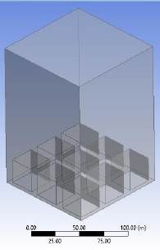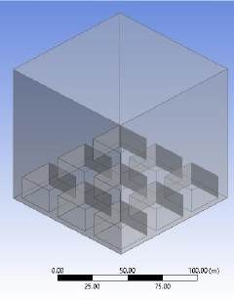

(a) (b)

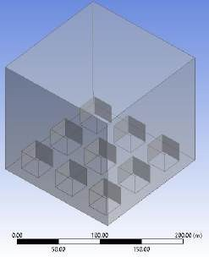 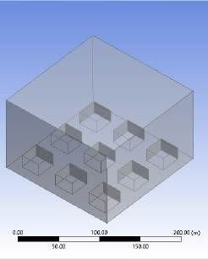

(c) (d)

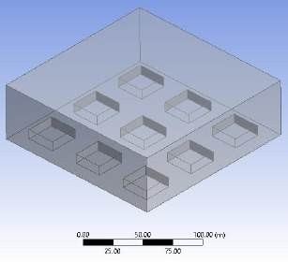

(e)

1. **Figure 1.** The geometry of five defined models (a) Compact highrise (b) Compact midrise (c) Open highrise
2. (d) Open midrise (e) Open lowrise
3. **3.1. Introducing data**

4

1. For this study, weather data for June 21 (the longest day of the year) in Shiraz was
2. selected to drive the simulation process. Climate analyses for the region were obtained from
3. [www.worldweatheronline.com,](http://www.worldweatheronline.com/) which is recognized as one of the most reliable sources for
4. weather data globally. The climate parameters necessary for modeling solar load were
5. computed over a 24-hour period starting at 7 a.m., with the solver accessing the relevant data
6. through user-defined functions (UDFs) implemented in C. The weather data for June 21
7. served as the reference for calculations, as detailed in Table 6. Given that data is available at
8. three-hour intervals, Fourier analysis was employed to facilitate averaging over periods of
9. missing information based on the defined range. Figure 2 illustrates the time-dependent
10. boundary conditions for (a)temperature, (b)velocity along the X-axis, and (c)velocity along
11. the Y-axis.

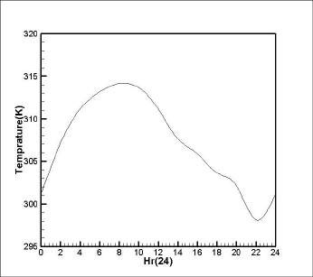 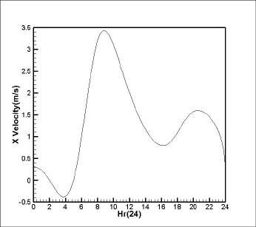

(a) (b)

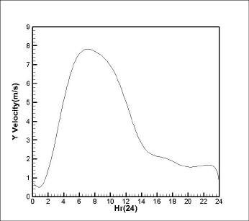

(c)

1. **Figure 2.** Time-varying boundary condition for (a) Temperature (b) velocity along the X axis (c) velocity along
2. the Y axis

#### 3.2. Boundary conditions

1. This model used symmetric boundary conditions to simulate an urban area. In addition, the
2. velocity-inlet was considered as the inlet boundary condition and the mass flow as the outlet boundary
3. condition. Furthermore, the no-slip boundary condition of the stationary wall was employed for the
4. top view. Note that the problem was resolved at 864000 time steps. Each time step had sub-steps of
5. 0.1 s. Every 0.1 seconds, this problem was solved up to 100 iterations. So the perfect solution for
6. each problem was 864 × 10^5 iterations.

#### 3.3. Grid Convergence

1. Grid convergence is one of the most important stages of any research conducted by CFD. In
2. this study, four grid models (Table 4) were designed. These models have similar y+ values but
3. different grid sizes. In the current investigation, two mesh convergence groups including, compact
4. high-rise (Figure a) and Compact midrise (Figure b) were selected. We have developed 3 types of
5. materials for each case. The mesh convergence parameter was the average daily wall temperature. As
6. can be seen in Figure 3, grids #4 and #3 converge in this problem. Based on the calculations in Table
7. 5, the average distance from the wall to the first node is 0.5 mm.
8. **Table 4.** Table of grid Providers with different 𝑦+

**Grid number**

Grid 1

Grid 2

Grid 3

Grid 4

𝐲+

200

100

40

2

4

6 **Table 5.** Calculating the distance of the first node from the wall

**Building height**

|  |  |  |  |  |
| --- | --- | --- | --- | --- |
|  | H=9m | 4.7 × 106 | 2.68 × 10−3 | 0.107 |
| H=18m | 9.4 × 106 | 2.33 × 10−3 | 0.093 |
| 7 | H=27m | 14.1 × 106 | 2.15 × 10−3 | 0.086 |
|  |  |  |  |  |

**Reynolds number**

**friction coefficient**

**shear stress**

**frictional**

**velocity** 𝒚

|  |  |  |  |
| --- | --- | --- | --- |
| 𝑘𝑔 |  | 𝑚 | 𝑦(𝑙 = 9) |
| 𝑚𝑠2  𝑘𝑔 |  | 𝑠  𝑚 | = 5.29 × 10−4𝑚  𝑦(𝑙 = 18) |
| 𝑚𝑠2  𝑘𝑔 |  | 𝑠  𝑚 | = 5.67 × 10−4𝑚  𝑦(𝑙 = 27) |
| 𝑚𝑠2 |  | 𝑠 | = 5.88 × 10−4𝑚 |

0.3

0.28

0.27

9 **Table 6**. Three-hourly weather data

**Hour Second Wind speed Wind direction**

**Components**

|  |  |  |  |  |  |  |
| --- | --- | --- | --- | --- | --- | --- |
|  | | km/h | m/s | Orientation | x | y |
| **7** | 0 | 3 | 0.833333 | WNW | 0.318903 | 0.7699 |
| **9** | 7200 | 5 | 1.388889 | W | 0 | 1.388889 |
| **12** | 18000 | 24 | 6.666667 | W | 0 | 6.666667 |
| **15** | 28800 | 30 | 8.333333 | WNW | 3.189029 | 7.698996 |
| **18** | 39600 | 24 | 6.666667 | WNW | 2.551223 | 6.159197 |
| **21** | 50400 | 11 | 3.055556 | WNW | 1.16931 | 2.822965 |
| **0** | 61200 | 8 | 2.222222 | WNW | 0.850408 | 2.053066 |
| **3** | 72000 | 8 | 2.222222 | NW | 1.571348 | 1.571348 |
| **6** | 82800 | 6 | 1.666667 | NW | 1.178511 | 1.666667 |
| **7** | 86400 | 3 | 0.833333 | WNW | 0.318903 | 0.7699 |

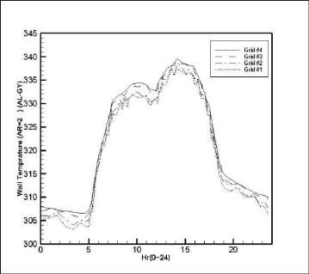 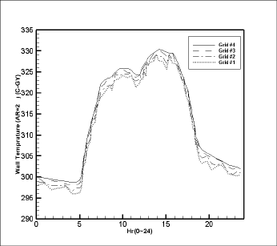

(a1)

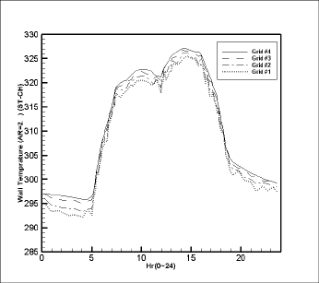

(a3)

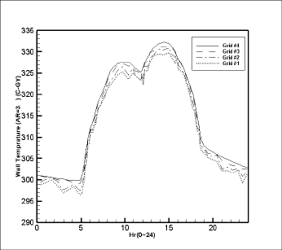

(b2)

(a2)

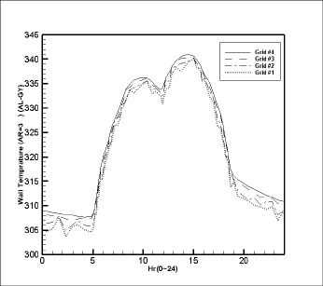

(b1)

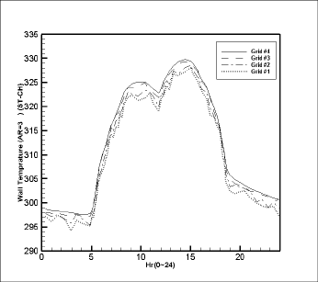

(b3)

1. **Figure 3.** Grid Convergence for (a) compact midrise (b) compact highrise (1) Gray aluminum composite (2)
2. Gray concrete (3) White stone chipping

#### 4. Analysis

1. To analyze the effect of the flow field on surface temperature and net longwave flux, we simulated
2. the daily average wall temperature (Tsides) and average net wall longwave flux (Lside)

#### 4.1. A study of the effects of different materials and aspect ratios on Tsides

1. Aspect ratio determines the penetration of direct sunlight into a street canyon. In general, the amount
2. of direct solar absorption with short-wavelength decreases as the aspect ratio increases due to mutual
3. shadows between buildings and shadows on the ground. Figure 4 shows plots of the variation of Tsides
4. for various materials and aspect ratios; As seen, in all aspect ratios from 5:00 AM to 7:00 AM, there
5. is a sharp rise in the Tsides due to the low altitude of the sun. The increase in Tsides continues until
6. about 2:00 pm and reaches its maximum value at the same time. And after 12 o'clock, the shadow
7. area is gradually enlarged. So Tsides drops sharply from 14:00 to 18:30. The decrease in Tsides then
8. continues until about 5:00 am, reaching a minimum amount for that hour. Furthermore, comparing
9. various urban canyons, we find that Tsides are directly related to aspect ratio. Furthermore, the lowest
10. value belongs to the aspect ratio of 1/3 around 5:00 AM and the highest one is related to an aspect
11. ratio of 3 about 14:00 PM. Furthermore, a comparison of the three material types shows that the
12. lowest Tsides for all aspect ratios belongs to the white stone with an average temperature of 283 K, and
13. the highest relates to the aluminum material with an average temperature of 341 K. Furthermore,
14. comparing Case 2 and Case 1, we can see that increasing the building surface area percentage
15. increases the maximum Tsides significantly. Therefore, the maximum Tsides difference between the two
16. cases and among the three materials belongs to the aluminum and is about 15 degrees.

#### 4.2. A study of the effect of varying materials and aspect ratios on Lsides

1. Figure 5 demonstrates the Lsides variation diagrams for different materials and aspect ratios; Lsides is
2. also affected by aspect ratio. For all aspect ratios, Lsides increases steeply at the beginning of the day
3. from about 6:30 AM to about 13:00 PM, and this increase continues with a gentle slope until 15:00
4. PM, reaching a maximum value at this time. Furthermore, these figures show that Lsides increases with
5. decreasing aspect ratio, with the maximum value observed for street canyons with an aspect ratio of
6. 1/3. Then, from 15:00 PM to the next morning, Lsides drops relatively steeply. However, the decrease
7. in slope during these hours is smaller than the increase in slope for Lsides during the earlier hours of
8. the day. This decrease continues at a moderate rate until 18:30 PM, reaching the lowest values for all
9. aspect ratios during this time. Lsides decreases with increasing aspect ratio, reaching a minimum at
10. street canyon with an aspect ratio of 3.
11. In this study, the effects of three material types on Lsides in five urban canyons were simulated.
12. The simulation results (Figure 5) show that the minimum Lsides associated with the aluminum material
13. at 6:30 AM is approximately equal to 23 w/m2, in contrast the maximum Lsides associated with the
14. white stone material at 15:00 PM is approximately equal to 375 w/m2. The results reveal that at both
15. day and night, the aluminum material has higher Tsides than concrete and white stone, but aluminum
16. has the lowest Lsides at all aspect ratios. It can be concluded that aspect ratio change is a more
17. significant parameter in Lsides variations than material changes. Furthermore, comparing Cases 1 and
18. 2, we can see that decreasing the building surface fraction significantly increases Lsides. Therefore, the
19. maximum Lsides difference in the two cases of the three materials belongs to the white stone material
20. and it is about 100 w/m2.

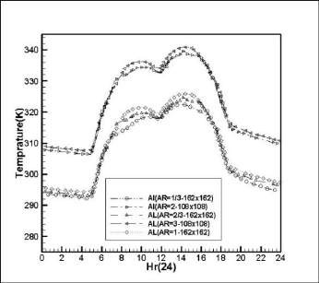 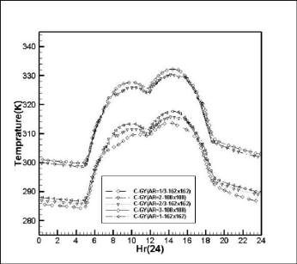

(a) (b)

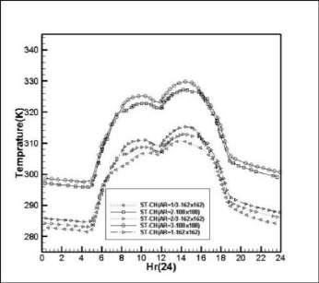

(c)

1. **Figure 4.** Comparison of Tsides changes in case 1 and case 2 with different aspect ratios for (a) Gray aluminum
2. composite (b) Gray concrete (c) White stone chipping

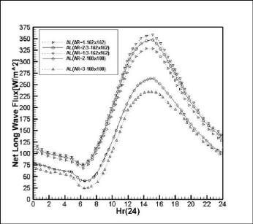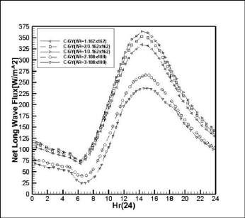

(a) (b)

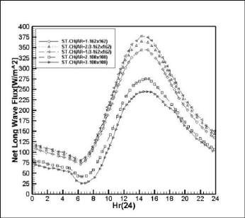

(c)

1. **Figure 5.** Comparison of Lsides changes in case 1 and case 2 with different aspect ratios for (a) Gray aluminum
2. composite (b) Gray concrete (c) White stone chipping

#### 4.3. Effects of aspect ratio variations on eddy formation

1. Changes in aspect ratio of the urban canyon bring about changes in flow structure, wind shadow, and
2. convective heat transfer. Figure 6 demonstrates the eddies formed between buildings with different
3. aspect ratios for three material types. As seen in Figure 6, changing the aspect ratio, changes the wind
4. shadow and the formation of the eddies between buildings; Interestingly, the vortex magnitude
5. follows the height of the urban canyon; Therefore, the higher the eddy height, the larger the eddy
6. usually formed. For instance, comparing Figures 6b and 6d at a height of 18 m, we can see that higher
7. densities produce stronger eddies, as the flow is not uniform. The comparison also reveals that the
8. eddies created adjacent to the buildings are approximately the identical size for the three material
9. 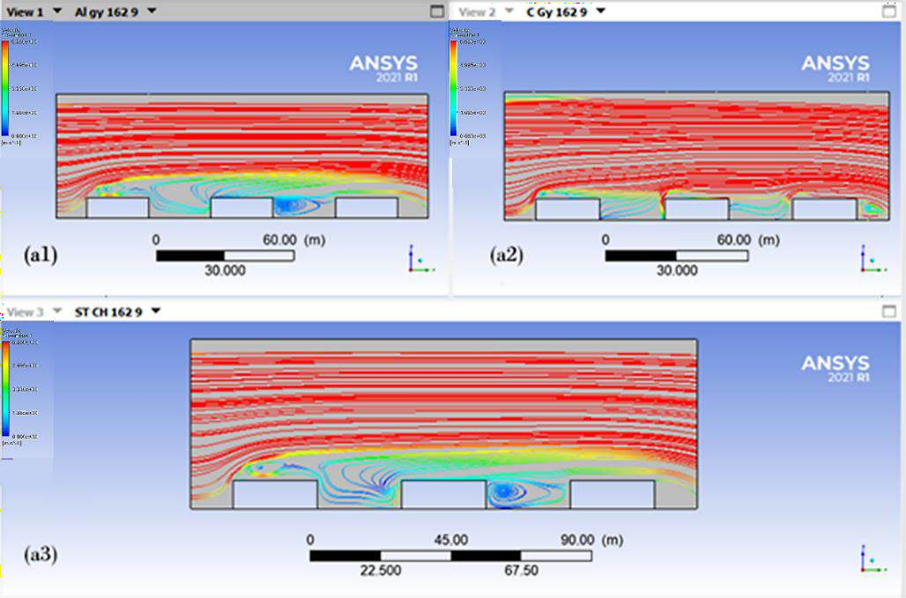types.

## 13

14 (a)

## 1

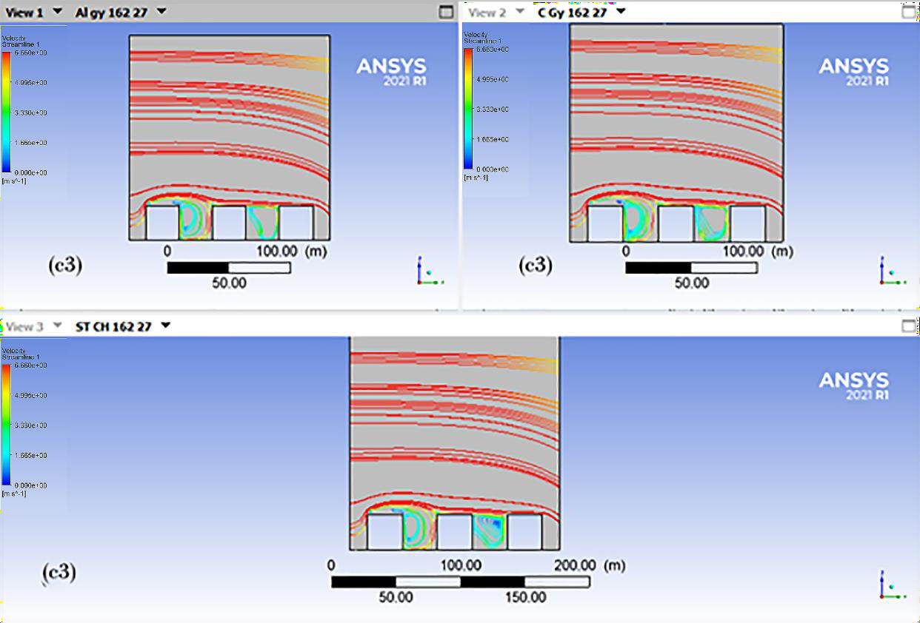2 (b)

## 3

4 (c)

## 1

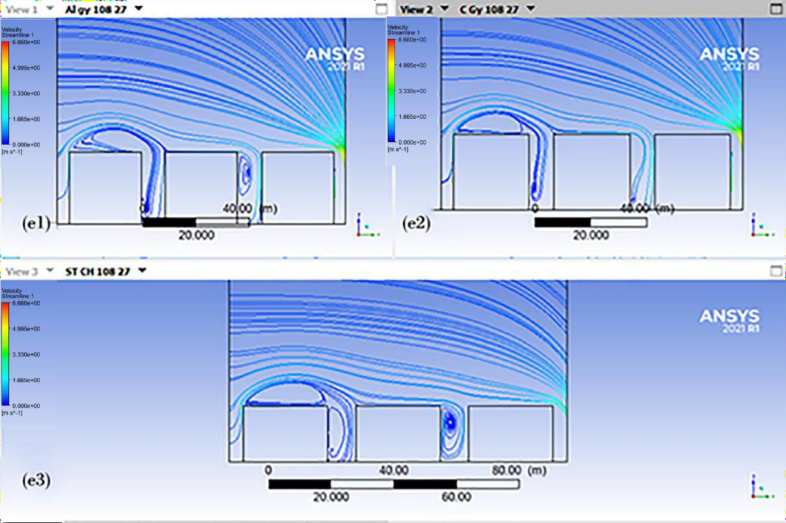2 (d)

## 3

4 (e)

1. **Figure 6.** Velocity streamline at noon for aspect ratio (a) 1/3, (b) 2/3, (c) 1, (d) 2, (e) 3 and three types of
2. materials (1) Gray aluminum composite (2) Gray concrete (3) White stone chipping

7

# 5. Results and discussions

1. This research investigated the daily average temperature and net longwave flux of walls across five
2. different geometries of urban canyons using computational fluid dynamics. The geometries were
3. based on real dimensions, encompassing five distinct urban densities: Compact Midrise, Compact
4. Highrise, Open Lowrise, Open Midrise, and Open Highrise. Three different materials were utilized
5. in the study: gray aluminum composite, gray concrete, and white stone fragments.
6. The study simulated five different aspect ratios as proposed by Stewart and Oke (2012), employing
7. the aforementioned materials. As noted by Yaghoobian and Kleissl (2012) and Nazarian and Kleissl
8. (2016), our findings demonstrate that variations in aspect ratio and building surface fraction
9. significantly influence urban surface temperatures and wall net longwave flux.
10. The results indicate that an increase in the building surface fraction leads to a notable rise in Tsides
11. while simultaneously decreasing Lsides for all three materials. Furthermore, there is a direct correlation
12. between aspect ratio and Tsides, while Lsides shows an inverse relationship with aspect ratio.
13. Specifically, the lowest Tsides was observed for the white stone material with an aspect ratio of 1/3 at
14. 283 K around 5:00 AM, whereas the highest Tsides was recorded for the aluminum material with an
15. aspect ratio of 3 at 341 K around 14:00 PM. Conversely, the lowest Lsides was associated with the
16. aluminum material (aspect ratio of 3) at 23 W/m² around 6:30 AM, while the highest Lsides was linked
17. to the white stone material (aspect ratio of 1/3) at 375 W/m² around 15:00 PM.
18. Additionally, simulations revealed that changes in aspect ratio affect wind shadowing and vortex
19. formation; Interestingly, the size of the vortices created adjacent to buildings remains consistent
20. across the three material types, aligning with the height of the urban canyon.
21. In contrast to previous studies, such as that by (Middel et al., 2014), which employed ENVI-Met
22. software to simulate outdoor thermal performance and assess variations in temperature and wind
23. speed within built environments, this research adopts a distinct approach. While Toparlar et al. (2017)
24. utilized Integrated Environmental Solution IES-VE and Energy-Plus software primarily designed for
25. simulating microclimate parameters in urban settings, our study harnesses the advanced capabilities
26. of ANSYS-FLUENT. This robust application offers significant flexibility in airflow modeling and
27. accommodates a wide array of fluid flow parameters within microclimates.
28. Moreover, prior research, such as that by Nazarian (2017), often relied on buildings with a height of
29. just 3 meters—a scale rarely seen in contemporary urban environments. In contrast, this study
30. employs real-scale buildings, enhancing the applicability of our findings to current urban landscapes.
31. Another noteworthy aspect of this research is its incorporation of actual meteorological models.
32. Unlike previous studies that treated wind speed and direction as constant (e.g., Nazarian, 2017), this
33. study accounts for temporal variations in wind speed and direction based on real meteorological data.
34. This methodological advancement contributes to a more accurate assessment of thermal performance
35. in urban settings.
36. It is also worth noting that some researchers, such as (Taha, 1997) have drawn differing conclusions,
37. indicating variability in research outcomes related to the thermal characteristics of various materials
38. and the geometric impacts on surface temperatures. This variability may arise from differing
39. environmental conditions or methodologies employed in these studies.

**6**. **Conclusion**

This study comprehensively examined the impact of urban canyon geometry, building surface fraction, and material type on wall surface temperature and net longwave heat flux using CFD simulations. By analyzing five distinct urban canyon forms with varying aspect ratios and surface materials (aluminum composite, gray concrete, and white stone), the research highlighted the strong interplay between urban morphology and microclimatic performance.

The findings revealed that increases in building surface fraction notably elevate surface temperatures while reducing net longwave flux, with this trend consistent across all materials. Aspect ratio exhibited a direct correlation with maximum surface temperature (Tsides) and an inverse relationship with net longwave flux. Among the materials studied, aluminum showed the lowest flux values, while white stone consistently recorded the highest. Additionally, diurnal variations in surface temperature emphasized the sensitivity of thermal performance to both geometry and material choice, particularly under extreme radiative conditions.

Furthermore, variations in aspect ratio were found to significantly influence wind patterns, shadow distribution, and vortex formation, although the size and structure of vortices remained largely consistent across materials. These aerodynamic characteristics, combined with thermal outcomes, underscore the critical role of canyon design in urban heat mitigation.

Overall, the study advances our understanding of how urban design parameters influence thermal behavior and longwave energy exchange. These insights provide valuable guidance for sustainable urban planning, particularly in hot-arid climates, by promoting geometries and materials that minimize heat accumulation while maintaining energy efficiency.

**7. Future suggestions**

While this study has provided valuable insights into the dynamics of urban microclimates, there are still many aspects that require deeper exploration. The findings presented here should be seen as a starting point for further work, rather than a complete solution to the challenges of sustainable urban design.

Future research should focus on evaluating the scalability and applicability of the current findings across diverse climatic and geographical contexts. Advanced modeling approaches, such as integrating computational fluid dynamics (CFD) with machine learning and AI-based optimization techniques, can improve the accuracy and predictive capability of urban microclimate simulations. Comparative studies involving different urban canyon geometries and experimental field measurements are essential to validate and refine the proposed models. Furthermore, exploring innovative urban design strategies, including the use of green infrastructure, reflective surfaces, and renewable energy solutions, would provide a holistic framework for sustainable and climate-resilient urban development.

# 8. References

Ai, Z., & Mak, C. M. (2015). From street canyon microclimate to indoor environmental quality in naturally ventilated urban buildings: Issues and possibilities for improvement. *Building and environment*, *94*, 489. <https://doi.org/https://doi.org/10.1016/j.buildenv.2015.10.008>

Aly, A. M., Goodlow, B., & Conerly, J. (2022). Urban heat island mitigation via geometric configuration. *Theoretical and Applied Climatology*, *149*(3), 1329-1355. <https://doi.org/https://doi.org/10.1007/s00704-022-04116-2>

Bakarman, M. A., & Chang, J. D. (2015). The influence of height/width ratio on urban heat island in hot-arid climates. *Procedia Engineering*, *118*, 101-108. <https://doi.org/https://doi.org/10.1016/j.proeng.2015.08.408>

Blunn, L. P., Coceal, O., Nazarian, N., Barlow, J. F., Plant, R. S., Bohnenstengel, S. I., & Lean, H. W. (2022). Turbulence characteristics across a range of idealized urban canopy geometries. *Boundary-Layer Meteorology*, *182*(2), 275-307. <https://doi.org/https://doi.org/10.1007/s10546-021-00658-6>

Chatzidimitriou, A., & Yannas, S. (2017). Street canyon design and improvement potential for urban open spaces; the influence of canyon aspect ratio and orientation on microclimate and outdoor comfort. *Sustainable cities and society*, *33*, 85-101. <https://doi.org/https://doi.org/10.1016/j.scs.2017.05.019>

Chen, J., Cao, S., Du, M., Du, M., Liu, X., Song, W., Liang, Y., He, W., Li, L., & Wang, N. (2025). Investigating the role of two-dimensional and three-dimensional urban structures in seasonal surface radiation budget. *Building and environment*, *267*, 112148. <https://doi.org/https://doi.org/10.1016/j.buildenv.2024.112148>

Chen, Y., Ozaki, A., Yang, X., Arima, Y., Li, Z., & Choi, Y. (2025). Adaptive model-based advanced natural ventilation control strategy for mixed-mode residential buildings in Japan. *Building and environment*, *273*, 112718. <https://doi.org/https://doi.org/10.1016/j.buildenv.2025.112718>

Dawood, A., Amer, A., Abumandour, R., & El-Askary, W. (2025). Simulation of cartesian cut-cell technique for modeling turbulent flow in asymmetric diffusers using various turbulence models. *Computers & Mathematics with Applications*, *182*, 84-101. <https://doi.org/https://doi.org/10.1016/j.camwa.2025.01.015>

Eltaweel, M., Mostafa, N. A., Kalyvas, C., Chen, Y., & Herfatmanesh, M. R. (2025). Optimising flywheel energy storage systems for enhanced windage loss reduction and heat transfer: A computational fluid dynamics and ANOVA-based approach. *Energy Reports*, *13*, 834-855. <https://doi.org/https://doi.org/10.1016/j.egyr.2024.12.048>

Erell, E., Pearlmutter, D., & Williamson, T. (2012). *Urban microclimate: designing the spaces between buildings*. Routledge. <https://doi.org/https://doi.org/10.4324/9781849775397>

Fogel, N. S., & Penczykowski, R. M. (2025). Belowground sensors capture spatiotemporal variation in urban heat island effect. *Urban Ecosystems*, *28*(2), 1-9. <https://doi.org/https://doi.org/10.7936/6RXS-103655>

Fu, X., Zhang, T., Tao, Y., Yan, S., Qi, F., & Shen, Y. (2025). The impact of the three-dimensional greening index on pedestrian thermal comfort in summer street canyons. Building Simulation,

Guo, B., Chen, M., Zhu, X., Wang, Z., Li, L., Pei, L., Chen, H., Chen, P., & Guo, T. (2025). Exploring the effect of the architecture morphology on urban ventilation at block scale using CFD-GIS and random forest combined method. *Sustainable cities and society*, *122*, 106241. <https://doi.org/https://doi.org/10.1016/j.scs.2025.106241>

Guo, X., Buccolieri, R., Gao, Z., Zhang, M., Lyu, T., Rui, L., & Shen, J. (2022). On the effects of urban-like intersections on ventilation and pollutant dispersion. Building Simulation,

Hashemi, F., Najafian, P., Salahi, N., Ghiasi, S., & Passe, U. (2025). Impacts of Urban Heat Island and Future Climate on Urban Buildings Energy Use in a US Midwest Neighborhood. <https://doi.org/https://> doi: 10.20944/preprints202502.1542.v1

Hogan, R. J. (2019). An exponential model of urban geometry for use in radiative transfer applications. *Boundary-Layer Meteorology*, *170*(3), 357-372. <https://doi.org/https://doi.org/10.1007/s10546-018-0409-8>

Huang, Z., Li, Q., He, Y., Ding, X., Dong, Y., & Gao, W. (2025). Coupled heat and mass transfer analysis for indoor air quality and thermal comfort in naturally ventilated offices. *Applied Thermal Engineering*, *269*, 126019. <https://doi.org/https://doi.org/10.1016/j.applthermaleng.2025.126019>

Koutsanitis, S., Sinou, M., Kanetaki, Z., Tousi, E., & Varelidis, G. (2025). Thermal Performance Investigation in Historical Urban Neighborhoods Using ENVI-Met Simulation Software. *Land (2012)*, *14*(2). <https://doi.org/https://doi.org/10.3390/land14020284>

Li, B., & Cheng, C. (2025). Integrating multiple environmental variables to identify potential urban heat island risk areas based on the maxent model. *Geo-spatial Information Science*, 1-15. <https://doi.org/https://doi.org/10.1080/10095020.2025.2459135>

Li, L., Yang, L., Zhang, L.-J., & Jiang, Y. (2012). Numerical study on the impact of ground heating and ambient wind speed on flow fields in street canyons. *Advances in Atmospheric Sciences*, *29*(6), 1227-1237. <https://doi.org/https://doi.org/10.1007/s00376-012-1066-3>.

Li, S., Han, J., Liu, T., Wang, J., & Tan, Z. (2025). Wall heating effect modelling for street canyon environment prediction: Experimental and numerical investigation. *Building and environment*, *276*, 112873. <https://doi.org/https://dx.doi.org/10.2139/ssrn.5111471>

Matak, L., & Momen, M. (2025). Enhancing air pollution forecasts in cities by characterizing the urban heat island effects on planetary boundary layers. *Atmospheric Research*, *315*, 107923. <https://doi.org/https://doi.org/10.1016/j.atmosres.2025.107923>

Middel, A., Häb, K., Brazel, A. J., Martin, C. A., & Guhathakurta, S. (2014). Impact of urban form and design on mid-afternoon microclimate in Phoenix Local Climate Zones. *Landscape and urban planning*, *122*, 16-28. <https://doi.org/https://doi.org/10.1016/j.landurbplan.2013.11.004>

Mughal, M. O., Kubilay, A., Fatichi, S., Meili, N., Carmeliet, J., Edwards, P., & Burlando, P. (2021). Detailed investigation of vegetation effects on microclimate by means of computational fluid dynamics (CFD) in a tropical urban environment. *Urban Climate*, *39*, 100939. <https://doi.org/https://doi.org/10.1016/j.uclim.2021.100939>

Muqoffa, M., Suyitno, Yaningsih, I., Rachmanto, R. A., Himawan, K., Caroko, N., & Basuki. (2025). Exploring natural ventilation strategies in Javanese vernacular houses for sustainable design. *Journal of Asian Architecture and Building Engineering*, 1-20. <https://doi.org/https://doi.org/10.1080/13467581.2024.2439348>

Nazarian, N., & Kleissl, J. (2016). Realistic solar heating in urban areas: Air exchange and street-canyon ventilation. *Building and environment*, *95*, 75-93. <https://doi.org/https://doi.org/10.1016/j.buildenv.2015.08.021>

Offerle, B., Eliasson, I., Grimmond, C., & Holmer, B. (2007). Surface heating in relation to air temperature, wind and turbulence in an urban street canyon. *Boundary-Layer Meteorology*, *122*(2), 273-292. <https://doi.org/https://doi.org/10.1007/s10546-006-9099-8>

Park, S.-J., Kim, J.-J., Choi, W., Kim, E.-R., Song, C.-K., & Pardyjak, E. R. (2020). Flow characteristics around step-up street canyons with various building aspect ratios. *Boundary-Layer Meteorology*, *174*(3), 411-431. <https://doi.org/https://doi.org/10.1007/s10546-019-00494-9>

Pearlmutter, D., Berliner, P., & Shaviv, E. (2007). Integrated modeling of pedestrian energy exchange and thermal comfort in urban street canyons. *Building and environment*, *42*(6), 2396-2409. <https://doi.org/https://doi.org/10.1016/j.buildenv.2006.06.006>

Prabhu, G. V., Nadaf, F., & Vikas, K. (2025). Decoding Urban Heat: A Decadal Analysis (1991-2021) of Land Surface Temperature and Thermal Comfort Dynamics in Coastal Taluka of Bardez, Goa, India. <https://doi.org/https://doi.org/10.25303/182da01017>;

Rossi, F., Castellani, B., Presciutti, A., Morini, E., Filipponi, M., Nicolini, A., & Santamouris, M. (2015). Retroreflective façades for urban heat island mitigation: Experimental investigation and energy evaluations. *Applied Energy*, *145*, 8-20. <https://doi.org/https://doi.org/10.1016/j.apenergy.2015.01.129>

Sato, H., & Takemi, T. (2025). Effects of the Arrangement and Height Variability of Roughness Obstacles on the Structure and Intensity of Tornado-Like Vortices. *Journal of Applied Meteorology and Climatology*, *64*(1), 99-117. <https://doi.org/https://doi.org/10.1175/JAMC-D-24-0022.1>

Shareef, S., & Abu-Hijleh, B. (2020). The effect of building height diversity on outdoor microclimate conditions in hot climate. A case study of Dubai-UAE. *Urban Climate*, *32*, 100611. <https://doi.org/https://doi.org/10.1016/j.uclim.2020.100611>.

Shi, Z., Yang, J., Zhang, Y., Xiao, X., & Xia, J. C. (2022). Urban ventilation corridors and spatiotemporal divergence patterns of urban heat island intensity: a local climate zone perspective. *Environmental Science and Pollution Research*, *29*(49), 74394-74406. <https://doi.org/https://doi.org/10.1007/s11356-022-21037-9>

Shirzadi, M., Mirzaei, P. A., & Tominaga, Y. (2020). CFD analysis of cross-ventilation flow in a group of generic buildings: Comparison between steady RANS, LES and wind tunnel experiments. Building Simulation,

Stewart, I. D., & Oke, T. R. (2012). Local climate zones for urban temperature studies. *Bulletin of the American Meteorological Society*, *93*(12), 1879-1900. <https://doi.org/https://doi.org/10.1175/BAMS-D-11-00019.1>

Stull, R. B. (2012). *An introduction to boundary layer meteorology* (Vol. 13). Springer Science & Business Media.

Taha, H. (1997). Urban climates and heat islands: albedo, evapotranspiration, and anthropogenic heat. *Energy and buildings*, *25*(2), 99-103. <https://doi.org/https://doi.org/10.1016/S0378-417788(96)00999-1>

Tarkhan, N., Klimenka, M., Fang, K., Duarte, F., Ratti, C., & Reinhart, C. (2025). Mapping facade materials utilizing zero-shot segmentation for applications in urban microclimate research. *Scientific Reports*, *15*(1), 5492. <https://doi.org/https://doi.org/10.1038/s41598-025-86307-1>

Toparlar, Y., Blocken, B., Maiheu, B., & van Heijst, G. J. F. (2017). A review on the CFD analysis of urban microclimate. *Renewable and Sustainable Energy Reviews*, *80*, 1613-1640. <https://doi.org/https://doi.org/10.1016/j.rser.2017.05.248>

Uehara, K., Murakami, S., Oikawa, S., & Wakamatsu, S. (2000). Wind tunnel experiments on how thermal stratification affects flow in and above urban street canyons. *Atmospheric Environment*, *34*(10), 1553-1562. <https://doi.org/https://doi.org/10.1016/S1352-2310(99)00410-0>

Versteeg, H. K., & Malalasekera, W. (2007). Turbulence and its modelling. *An Introduction to Computational Fluid Dynamics: The Finite Volume Method*, *3*, 40-115.

Wang, Z., Zhou, R., & Yu, Y. (2025). The impact of urban morphology on land surface temperature under seasonal and diurnal variations: Marginal and interaction effects. *Building and environment*, *272*, 112673. <https://doi.org/https://doi.org/10.1016/j.buildenv.2025.112673>

Xie, X., Liu, C.-H., Leung, D. Y., & Leung, M. K. (2006). Characteristics of air exchange in a street canyon with ground heating. *Atmospheric Environment*, *40*(33), 6396-6409. <https://doi.org/https://doi.org/10.1016/j.atmosenv.2006.05.050>

Xiong, Y., & Chen, H. (2022). Impacts of uneven surface heating of an ideal street canyon on airflows and indoor ventilation: Numerical study using OpenFOAM coupled with EnergyPlus. Building Simulation,

Yaghoobian, N., & Kleissl, J. (2012). Effect of reflective pavements on building energy use. *Urban Climate*, *2*, 25-42. <https://doi.org/https://doi.org/10.1016/j.uclim.2012.09.002>

Yang, T., Li, G., & Xu, G. (2025). Urban street canyon morphology and its effect on climate-responsive outdoor thermal environment in severe cold regions: a case study of Hohhot, China. *International Journal of Biometeorology*, 1-13. <https://doi.org/https://doi.org/10.1007/s00484-025-02877-9>

Zanon, B., & Verones, S. (2013). Climate change, urban energy and planning practices: Italian experiences of innovation in land management tools. *Land use policy*, *32*, 343-355. <https://doi.org/https://doi.org/10.1016/j.landusepol.2012.11.009>.

Zhang, Y., Zhang, J., Chen, W., Liang, S., Yi, K., & Liu, S. (2025). Synergistic effects of carbon and heat under disturbance of human activities: Evidence from a resource-based city of China. *Environmental Pollution*, *366*, 125424. <https://doi.org/https://doi.org/10.1016/j.envpol.2024.125424>

Zhao, Y., Chen, Y., & Li, K. (2025). Revealing the impacts of 3D urban morphology on surface temperature considering geometry heterogeneity, component contribution, and scale effect. *Sustainable cities and society*, *119*, 106093. <https://doi.org/https://doi.org/10.1016/j.scs.2024.106093>

#### Nomenclature

1. **Al-GY**
2. Gray aluminum composite, 9

### CFD

1. Computational Fluid Dynamics, 5, 7, 11, 25,

7 26

### C-GY

1. Gray concrete, 9

### H

1. Building height, 7, 11, 26

## 12

23

### LES

1. Large Eddy Simulation, 5
2. **Lside**
3. Average net wall longwave flux, 13

### RANS

1. Reynolds-averaged Navier–Stokes, 5

### ST-CH

1. White stone chipping, 9
2. **Tsides**
3. Daily average wall temperature, 13, 14, 15, 21