Where National Urban Policy (NUP) Stands in Urban Planning Systems? An Introduction to Framework and Content of NUP in Iran

Masoumeh Mirsafa (Ph.D)
Postdoc researcher, UNESCO Chair on Urban Resilience, University of Southern Denmark, Email: mami@iti.sdu.dk

Sara Habibi (Ph.D)
National Urban Policy Project Officer, UN-Habitat, Tehran, Iran, Email: sara.habibi@un.org

Abstract

Despite decades of experience in urban planning, Iran lacks a robust urban policy framework to guide its rapid urbanization towards sustainable and resilient development. Moreover, its existing sectoral policies have failed to operate within an integrated framework. The formulation of a National Urban Policy (NUP), as proposed by UN-Habitat, offers a unified structure to facilitate the preparation, implementation, monitoring, and evaluation of urban policies nationwide. However, there is no single approach to develop NUP and urban policymaking in each country needs to be sensitive to its socio-economic and political context. This research employs a qualitative method to define Iran’s NUP framework and develop its content based on the specific circumstances of urbanization in Iran. Drawing on 32 national and international documents, the analysis identifies key themes for creating a sustainable urban future. The findings advocate for a contextualized and localized approach to formulating the NUP, incorporating six building blocks and twenty themes. They emphasize the necessity of a forward-thinking approach to urban planning, addressing critical issues such as climate change, internal migrations, aging populations, and the environmental impact of urbanization. The study also introduces a participatory, data-driven, and integrated approach to ensure the effectiveness of proposed policies and stresses the importance of periodic policy evaluation and adaptation to address future uncertainties.

Keywords: National Urban Policy, Urban Planning, Policy Making, Resilient Cities, Sustainable Urban Development, Iran

1. INTRODUCTION
Currently, more than half of the world's population lives in cities, and it is predicted that this number will reach 70% by 2050. The number is much higher in Iran, with urban dwellers already accounting for over 76% of the total population (WorldBank, 2022). In addition to its advantages, rapid urbanization has also had an extensive impact on the quality of life of citizens in recent decades (Pilehvar, 2021) In response, the Iranian government has implemented various plans and created several institutions to direct its urban transitions towards sustainable development.
The adoption of a planning approach in Iran’s urban and territorial development dates back to 1948, when the first development plan was officially introduced. By 1977, Iran had implemented six development plans. Additionally, various national plans were developed to address the country’s major urban challenges, including the National Spatial Plan (1976), the Iran National Physical Plan (1996), the Housing Master Plan (2015), and the National Strategic Document for Regeneration, Rehabilitation, Renovation, and Empowerment of Deteriorated and Dysfunctional Urban Areas (2014) (Habibi et al., 2020). Despite these efforts, urban policymaking remains a neglected aspect in both the theory and practice of urban development in Iran (Kazemian, 2016). While policymaking and planning are interrelated, a national urban policy serves as a guidance framework to prevent sectoral planning and aims to maximize coordination among policymaking, planning, and the implementation of laws, rules, and regulations (UN-Habitat, 2022b)
These challenges are not unique to Iran; many countries face a lack of supportive policies and frameworks to leverage urbanization for greater development gains. Recognizing this, UN-Habitat has emphasized the importance of the National Urban Policy (NUP) in the development of the New Urban Agenda at the HABITAT III conference (UN-Habitat, 2016b) to support countries in the preparation, implementation, monitoring, and evaluation of their national urban policies. A NUP serves as a vital tool for governments to manage and guide rapid urbanization, harnessing its positive effects while addressing its inevitable challenges. It also creates a common vision and strengthen relationships between different national, subnational, and local levels and other stakeholders.
While the concept of NUP has been widely promoted by UN-Habitat over the past decade, its theoretical and empirical roots extend further back.(Richardson, 1987) examined the urban policies of developing countries and identified infeasible goals, poorly designed policies, and weak implementation as key reasons for the failure of most NUP efforts in these contexts. Cartwright et al. (2018) emphasize that for a NUP to achieve its intended outcomes, it must be grounded in the specific national context. There is no universal approach to NUP; instead, policy formulation in each country must be tailored to its unique socio-economic and political conditions. Urban policymaking varies widely across countries, with diverse models and methods applied by governments based on their prevailing circumstances, planning systems, historical context, and other distinctive characteristics.
This paper aims to explore the status of the NUP within Iran’s urban planning and policymaking system and to examine the specific content of NUP in light of Iran's unique urbanization dynamics. It provides a background on the evolution and practice of NUP by emphasizing international experiences. This is followed by a brief introduction of the methodology of the research that includes content analysis of UN-Habitat proposed frameworks for NUP as well as Iran’s urban development plans and programs. Ultimately, the results of the analysis discuss the major building blocks and themes to construct a NUP framework for the future development of Iran.

2. BACKGROUND AND THEORETICAL FRAMEWORK
2.1. NUP concept and themes
The substantive content of a NUP varies across countries, reflecting their specific circumstances. However, UN-Habitat’s literature and publications highlight some general and inclusive components of NUP. Certain documents focus on the NUP development process, such as the diagnostic phase (UN-Habitat, 2015) and the formulation phase (UN-Habitat, 2019). Others emphasize the levels of NUP, including national (OECD et al., 2021; UN-Habitat, 2016b; UN-Habitat & OECD, 2018) and sub-national levels (UN-Habitat, 2020b). Additionally, some publications address thematic and cross-cutting aspects of NUPs (UN-Habitat, 2016a, 2020a)
The HABITAT III policy paper, a key resource for defining NUP, identifies twelve essential policy areas to consider when developing, implementing, monitoring, and evaluating NUPs. These areas include governance, inclusion, migration, land access, urban-rural linkages, public/civic space, local economic development, housing and the informal sector, infrastructure, resilience, land-use planning, and urban design (UN-Habitat, 2016a). The 2018 and 2020 global reviews of NUPs highlighted five key themes: economic development, spatial structure, human development, environmental sustainability, and climate resilience (OECD et al., 2021; UN-Habitat & OECD, 2018). These same themes are reaffirmed in the NUP Evaluation Report, prepared under the NUP Programme, which also underscores cross-cutting issues such as public space provision, slum upgrading, climate change, disaster risk reduction, gender equality, and the inclusion of marginalized groups, including youth, the elderly, the poor, and persons with disabilities (UN-Habitat, 2022b). In addition to general frameworks, thematic guides provide targeted recommendations on specific aspects of NUPs. For instance, Addressing Climate Change in National Urban Policy offers strategies for integrating climate change considerations into NUPs, empowering national and local governments and other stakeholders.
2.2. NUP Framework and building blocks based on the countries’ experiences
The development of NUPs is being pursued by many countries worldwide. The 2018 Global State of NUP report distinguishes between explicit and implicit NUPs based on how these policies are structured at the national level (UN-Habitat & OECD, 2018). Some countries have explicit NUPs, characterized by a clearly defined policy explicitly labeled as a National Urban Policy or a similar variant. In contrast, other countries implement a collection of policies that meet the criteria or possess the features of a NUP but are not consolidated into a single, unified policy document.
A review of the existing literature identifies Africa as one of the pioneering continents in the development of explicit NUPs. Bandauko et al. (2021) analyzed the content of NUPs from eight African countries: Malawi, South Africa, Uganda, Rwanda, Ethiopia, Kenya, Ghana, and Nigeria. The emerging themes within these policies include economic development, integrated urban planning, urban governance, social inclusion, urban housing, and climate change and the environment. The analysis reveals a growing awareness of the challenges posed by rapid urbanization in Africa, with a strong focus on addressing social and economic issues. However, the study also highlights a relative lack of attention to climate change and sustainability in these policies
Among Middle Eastern country, Jordan finished its NUP formulation in 2021. Four thematic areas including urban regulations, economic development, urban planning and design, and resilience have been introduced to formulate the policies (UN-Habitat, 2021).
In the context of European countries, experiences highlight the difference between the explicit and implicit NUPs (Van Den Berg et al., 1998). For instance, France does not have an explicit NUP but operates through a suite of urban policies framed by the National Sustainable Development Strategy. As a result, the coordination of activities across tiers and functions of government is an important aspect of how urban issues are managed in France. According to the Global State of National Urban Policy 202, France’s urban policy is described as:
“… inter-ministerial, partnership-based, contractual and participatory in its approach, decentralized and deconcentrated in its implementation, in the integration of the social, urban and economic dimensions within the city contract and the setting up of citizens’ councils” (OECD et al., 2021, p. 34)
Similarly, Einem (1982) analyzed the case of West Germany, where various sectoral policies—such as housing, urban redevelopment, land use planning, environmental controls, historic preservation, transportation, economic development, and spatial planning—collectively form what might be considered a national urban policy. Germany’s NUP is better characterized as the "resultant" of numerous, often loosely coordinated, sectoral policies and decisions interacting in complex ways. Poland, on the other hand, has defined its NUP explicitly, covering ten thematic areas: spatial management, public participation, transportation and urban mobility, low-carbon economy and energy efficiency, revitalization, investment policy, economic development, environmental protection and climate adaptation, demography, and urban governance. For each theme, challenges and opportunities have been analyzed, and corresponding actions and projects have been proposed (MoEC, 2023).
Australia, one of the most urbanized countries in the world, formulated its first national urban policy, titled "Our Cities, Our Future – A National Urban Policy for a Productive, Sustainable, and Livable Future", in 2011. In April 2016, the Prime Minister of Australia introduced a new NUP called the "Smart Cities Plan". This document addresses key areas including economic development, spatial structure, human development, environmental sustainability, and climate resilience (Hu, 2020).
Friendly (2016) reviews NUP experiences globally and argues that despite many initiatives over the years that have sought to deal with the issue of cities in Canada, constitutional barriers remain and agreement about a NUP in Canada is elusive. She argues that Canada needs an explicit NUP to build a prosperous country, contribute to productivity, and build accords across sectors, as well as national leadership on pressing issues. Finally, she purposes three elements for national urban policy in Canada: Collaborative governance, Coordinating the diverse policies, and Robust policy, research, and monitoring mechanisms.
In addition to individual countries’ experiences, several comparative studies have been conducted on NUP at the global level. The 2018 and 2021 global reviews of NUPs identify five key themes: economic development, spatial structure, human development, environmental sustainability, and climate resilience. The results of the Global State of National Urban Policy 2018 identify spatial structure and economic development as the two themes most extensively discussed by NUPs. In contrast, climate resilience and environmental sustainability are the least addressed themes. Europe and North America, as well as Asia and the Pacific, have focused primarily on economic development and spatial structure, with Europe and North America placing a stronger emphasis on the former and Asia and the Pacific on the latter (UN-Habitat, 2018). Similarly, an analysis of the thematic scope across 113 NUPs with available data, as presented in the Global State of National Urban Policy 2021, reveals that spatial structure received the most attention (80%) among these five areas. Human development, economic development, and environmental sustainability followed in importance, while climate resilience was the least considered thematic area (48%) (UN-Habitat & OECD, 2018). The findings also vary by region. Spatial structure was given the most attention in Europe, North America, and Latin America and the Caribbean, while human development was more prevalent in NUPs from the Arab States and Asia and the Pacific. Economic development was most prominent in the Americas and the Caribbean, as well as Asia and the Pacific. Environmental sustainability and climate change were most discussed in Asia and the Pacific, while Africa gave the least attention to these issues.
Comparing the results of the two global reports from 2018 and 2021 indicates that recent NUPs have become more comprehensive, covering a broader range of thematic areas. Between 2018 and 2020, the proportion of NUPs giving extensive or moderate attention to four of the five themes (spatial structure, human development, economic development, and environmental sustainability) has remained high, while the data shows significant improvement in addressing climate resilience.
The National Urban Policy Programme Evaluation Report is the latest study conducted by UN-Habitat, which identifies five key themes of NUPs: economic development, spatial structure, human development, environmental sustainability, and climate resilience. The report concludes that economic development is the top priority for African respondents; environmental sustainability and climate resilience are the priorities for respondents from Asia and the Pacific, as well as Latin America and the Caribbean; while climate resilience, and to a lesser extent, economic development and environmental sustainability, are prioritized by Europe and North America. Human development is a priority for the Arab States. Respondents with global experience in the NUPP indicated that environmental sustainability should be a priority for future development (UN-Habitat, 2022a).
A review of national and international literature reveals both differences and similarities. According to the 2021 global report, 56% of cases were considered to have explicit NUPs (OECD et al., 2021), with the objectives and pillars of NUPs mostly defined within UN-Habitat guides and resources. However, the application of the proposed framework and its outcomes vary by country. The results also suggest that South Africa and Asia have the highest proportions of explicit NUPs and are more engaged with the UN-Habitat proposed framework (UN-Habitat, 2022a). In the Global South, the main themes of NUPs focus on urban, economic, and social development, rapid urbanization, and the provision of infrastructure, basic services, and housing.
Among countries with implicit NUPs, the suggested policies tend to be less strategic in outlook, with greater emphasis on engagement, participation, coordination, and implementation mechanisms. Spatial development and urban issues are embedded in national development strategies or sectoral plans across different sectors and scales, such as development plans, national spatial development policies, regional and territorial development strategies, and housing policies. Several countries indicated that they rely on a range of such policies to establish a coordinated and robust policy framework.
In conclusion, UN-Habitat’s review of various country experiences highlights six key building blocks and their defining themes that are essential for formulating a National Urban Policy. These building blocks are likely to be common across all countries, providing a foundational framework for the development of effective and comprehensive NUPs, and include urban governance, spatial sustainability, financial sustainability, economic sustainability, social sustainability, and environmental sustainability.
3. MATERIALS AND METHOD
The research employs a qualitative method with an exploratory approach to define the content of NUP based on the specific circumstances of urbanization in Iran. A purposed sampling is used to select the documents for the content analysis, which is based on a comprehensive review of nine international and twenty-three national urban development plans and policies (The full list of documents analysed for this study is provided in Annex1). The selected documents include the national meta-policies of Iran; national urban plans and regulations, some relatively important regional plans and regulation; Tehran development policies and plans; and ultimately, global and international reference documents on NUP.
To analyse the collected data, a detailed qualitative data analysis is conducted through thematic coding using MAXQDA2020 software. It adopts three category classes named basic codes, themes, and building blocks to categorise in different degrees between rather abstract and rather concrete content. Qualitative content analysis in this research is performed by deductive approach, meaning that the main categories and concepts (Hsieh & Shannon, 2005), but are borrowed from the main building blocks recommended by UN-Habitat (2019) as a primary source of categorization of the data (Table 1).
A validation process through stakeholder engagement was employed to ensure that research findings are robust, credible, and reflective of diverse perspectives. To achieve this two meetings with the project’s Steering Committee were organized. The first at the project's onset to evaluate the theoretical framework (selection of documents and review protocol), and the second at its conclusion to gather feedback on final results. Additionally, two thematic workshops were conducted during the research process to validate the findings of policy content analysis.
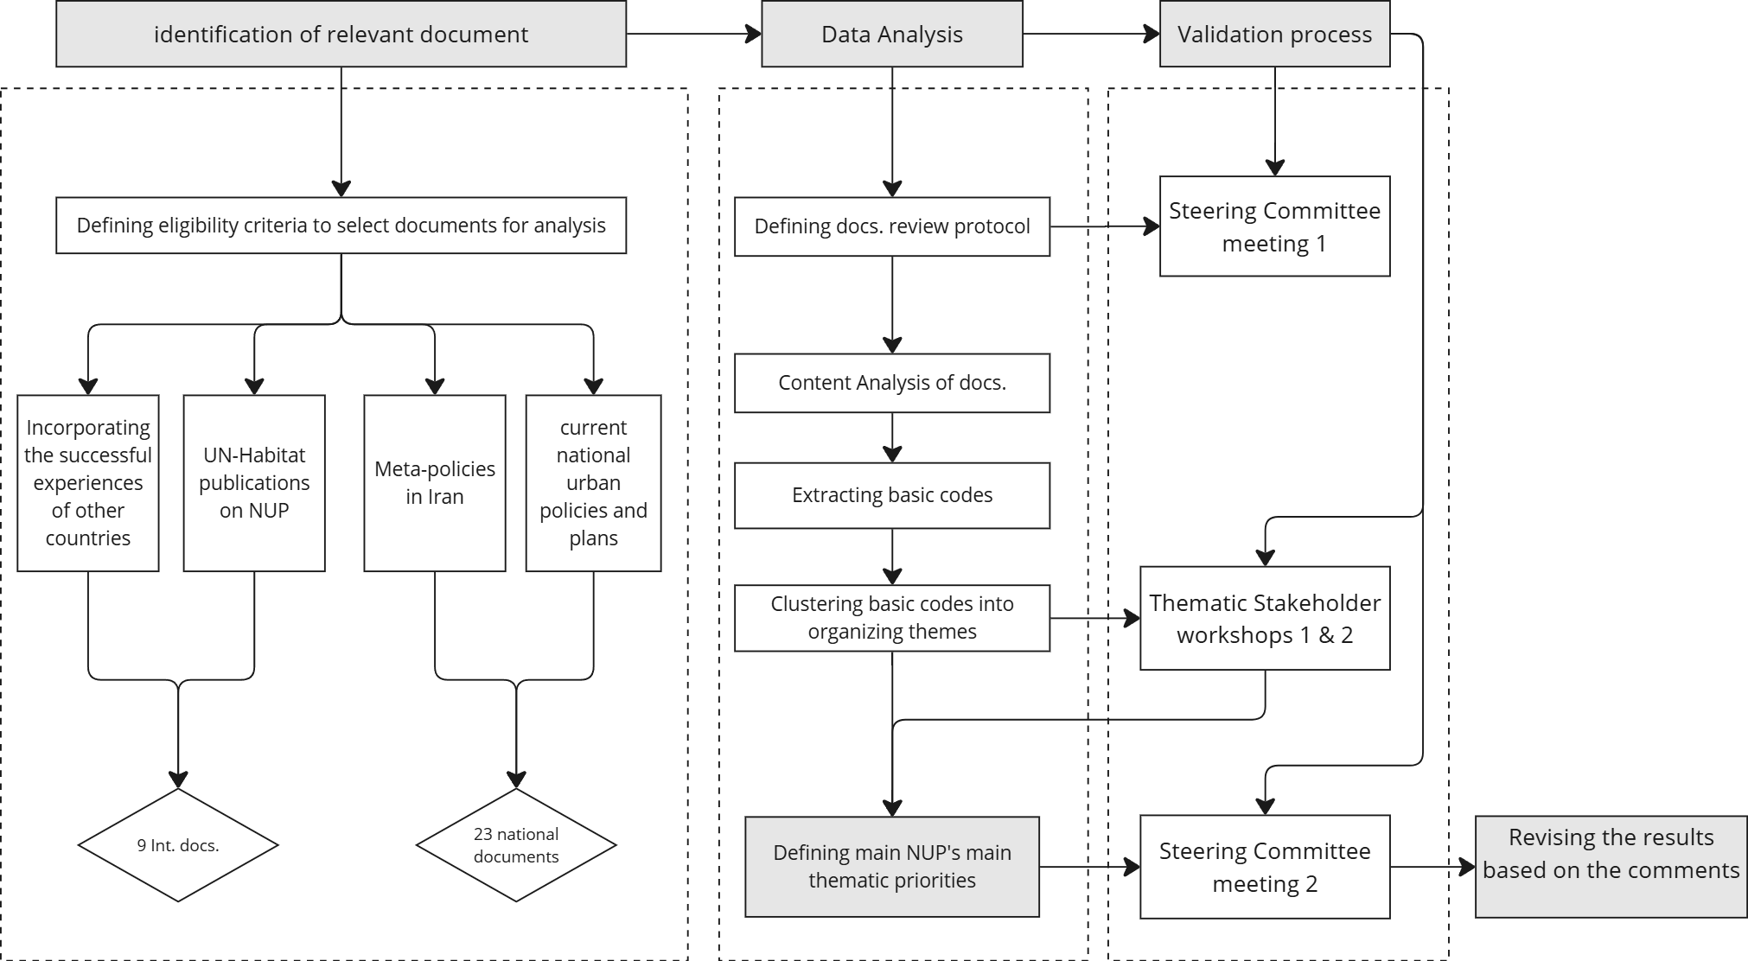
Figure 1. Research methodology (Extracted from Iran NUP document)

4. RESULTS AND DISCUSSIONS
In the first step of the content analysis, 1721 codes were derived from comprehensive review of 32 international and national documents, resulting in the generation of 244 basic codes. In the second step, the relevant basic codes were organized into clusters of similar issues and defined 25 themes. In the last step, the themes were classified under six given building blocks. Figure 2 presents the main building blocks and their corresponding themes.
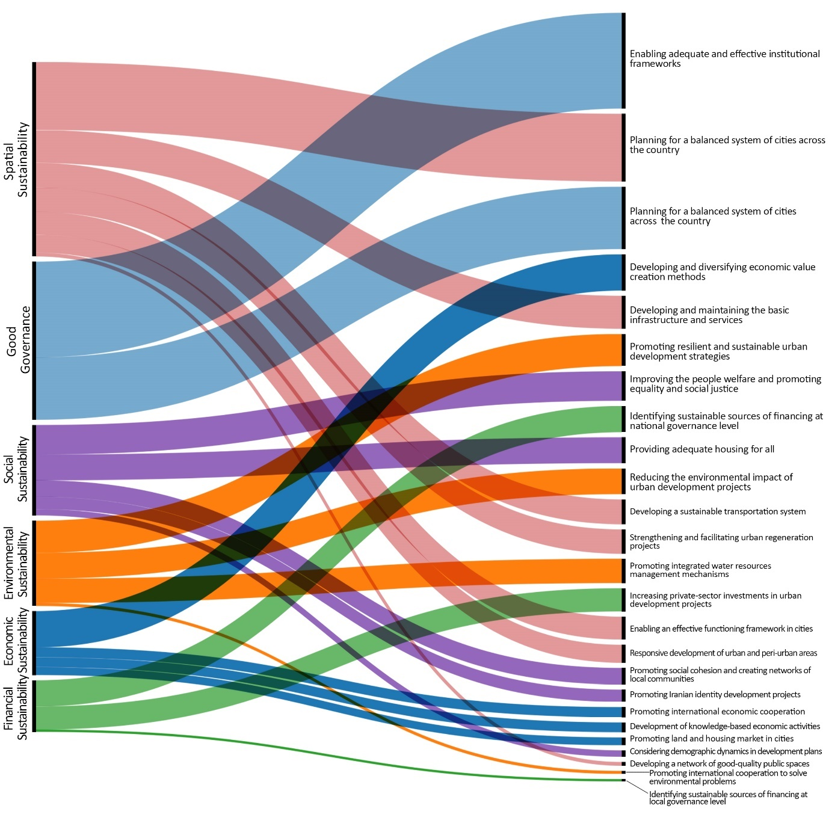
Figure 2 Main building blocks and frequency of their corresponding themes
4.1. Iran NUP building blocks and pillars
Urban Governance
Urban governance, as the most discussed subject in the documents (accounting for 24 percent of the total codes generated during the analysis), is addressed through two main themes: ‘enabling adequate and effective institutional frameworks’ and ‘enabling effective legal and regulatory frameworks.’
The content analysis results show a high frequency of codes associated with ‘institutional frameworks’ and clearly approve that “to implement urban policies and plans, it is essential to have an adequate institutional framework” (UN-Habitat, 2019, p. 14). Similarly, Turok and Parnell (2009) emphasize the technical and organizational difficulties involved in cross-cutting arrangements and the lack of state capacity to coordinate various components in specific directions, a challenge long faced by urban governance in Iran. Therefore, as raised by many documents, multi-level (vertical) and cross-sectoral (horizontal) coordination and cooperation of various influential forces are required for the implementation of urban policies and plans. An effective institutional framework that provides a well-established structure of all involved actors and clarifies their responsibilities is crucial for good urban governance.
The need for effective laws and regulations, or modifications to existing laws, in line with Iran’s urban dynamics, was frequently emphasized. UN-Habitat (2019, p. 15) argues that the absence of a functioning framework often hinders the implementation of policies. Iran's urban planning system suffers from an overabundance of poorly enforced, unenforceable, or ignored regulations that burden its effectiveness. Despite a long history of urban legislation in Iran (e.g. the municipal law adopted in 1334), many laws remain outdated and do not reflect contemporary urban realities. Moreover, the current legal frameworks do not address many emerging urban concepts and issues and still suffers from a lack of proper vision, high centralization, and non-participatory decision-making (Meshkini et al., 2021). According to the conducted analysis, the main regulations to be assessed and adjusted are ‘land use and land tenure’, ‘metropolitan governance’, ‘the right to the city with particular focus on vulnerable groups of population’, ‘municipal finance’, ‘building standards’ and ‘disaster risk reduction and crisis management’.
Financial Sustainability
The analysis results introduce three themes related to ensuring financial sustainability in Iran’s NUP: ‘identifying sustainable sources of financing at the national level of governance,’ ‘identifying sustainable sources of financing at the local level of governance,’ and ‘increasing and coordinating the private-sector investment in development-prone areas.’
At the national level, the development of effective housing finance policies and programs received the highest frequency of codes, underscoring the significant challenges Iranian cities face in providing adequate housing for their citizens. Other key topics in this section include sustaining financial resources for urban and rural development plans and ensuring the development of critical infrastructure and services.
Like many countries with centralized systems, the pursuit of good governance in Iran has focused on national level, with less attention given to the local level. As a result, financing at the local governance level was discussed less frequently in the Iranian documents—accounting for less than one percent of the total codes generated in the national documents and less than five percent in this section. Without reliable and sustainable financial instruments, the role of local governments in the context of NUP is severely limited. Local governments require predictable sources of funding to develop and maintain critical infrastructure and services. In 1980, the Iranian government introduced a municipal self-sufficiency policy to decentralize and distribute financial power, yet the lack of effective legal frameworks hindered its implementation. This has led to inadequate municipal income in many cities. To bridge the financial gap, cities have resorted to mechanisms such as charging for surplus density, which often conflicts with the city’s development plans (UN-Habitat, 2022a) and creates cascading problems for the cities and their citizens (Rahnama et al., 2012). Enabling effective legal frameworks, particularly around municipal taxes and land-based taxation, could provide municipalities with sustainable revenue streams.
Increasing and coordinating private-sector investment in development projects, with a focus on urban regeneration, tourism, knowledge-based industries, and renewable energy, was frequently discussed across multiple documents. Urban development projects offer promising investment opportunities, but their success depends on leadership from the urban management system to ensure that both investors and citizens benefit mutually.
Social Sustainability
Social sustainability in the context of Iran’s NUP is defined by five pillars including ‘improving people’s welfare and promoting equality and social justice’, ‘providing adequate housing for all’, ‘promoting social cohesion and creating networks of local communities in Iranian cities’, ‘promoting Iranian-Islamic identity in urban development plans’, and ultimately, ‘guiding and controlling urban demographic dynamics based on a forward-thinking approach to urban development.’
The theme of improving people’s welfare and promoting equality and social justice is primarily discussed in terms of ‘improving health, welfare, and quality of life for all citizens.’ Although national and international factors have negatively impacted citizens' welfare in recent years, various programs and policies have struggled to meet their goals of improving the quality of life for the Iranian population.
Providing adequate housing is another critical theme in this section that has a significant impact on citizens’ welfare and their quality of life as well. Providing housing for all, with particular attention to low income and vulnerable groups has been a focus of various governments since the Islamic revolution of Iran in 1979. Despite enactment of several policies, including subsidized home mortgage loans and construction materials, housing cooperatives, the Comprehensive Housing Plan and Mehr Housing Plan (Shahraki et al., 2020), housing affordability—for purchase or rent—and homeownership rates in Iran’s urban areas have continued to decline over the p fourast decades (Alaedini & Yazdani, 2021). According to the Comprehensive Housing Plan, the homeownership rate in Iran decreased from 77% in 1991-1992 to 64.8% in 2018-2019, while the share of housing costs in total household expenditures increased from 26% to 36% during the same period (Alaedini & Yazdani, 2021). These figures highlight the inadequacy of policies in addressing the growing housing demand in urban areas.
Taking demographic dynamics into account when planning urban policies is another crucial pillar for ensuring social sustainability in Iran. The country has been experiencing significant internal migration, with rural-urban migration driven by unequal access to resources and growing environmental challenges (Alaedini, 2015). A trend that exacerbated in the last few decades due to the growing environmental issues and the impact of the climate change, giving rise to a new social class called the low-income characterized with non-formal businesses and informal settlements in the outskirts of metropolitan areas (Pilehvar, 2021). According to the Urban Regeneration Corporation of Iran (UDRO, 2022), 1.8 million households live in informal settlements across the country. This underscores the importance of a forward-thinking approach to urban policy, anticipating demographic changes, and designing strategies for balanced urban development across the nation. Decentralization, particularly focusing on Tehran and other metropolitan areas, and climate change adaptation are closely linked to this pillar.
The promotion of social cohesion through the enhancement of social capital and the creation of local community networks has also been emphasized in many documents. Neighborhoods play a vital role in the traditional urban structure of Iranian cities, and empowering local participation in decision-making and fostering trust between citizens and urban management are key to achieving social sustainability.
Spatial Sustainability
Data analysis introduces seven pillars to construct the spatial sustainability in the context of Iran NUP. These pillars cover various topics and include territorial, regional, and urban scales. Among all, ‘planning for a balanced system of cities throughout the country’ has received the highest frequency of relevant themes and has been discussed the most by various national and international documents.
Iran faces the challenge of polarized urbanization, a result of centralized development policies that have led metropolitan areas to absorb large populations, further exacerbating the imbalance in population and activity distribution across the country. According to the Statistical Centre of Iran (2016), eight metropolitan areas house 35% of Iran’s urban population, which is equivalent to 25% of the total national population. Key themes emerging in this area include ‘planning population and activity centres in areas with potential for urban development’ and ‘improving the cohesion of the spatial structure through a polycentric network of cities.’
Decentralization policies and the creation of a balanced network of cities should be complemented by the sustainable development of peri-urban areas to ensure spatial sustainability. Effective policies for peri-urban development and governance must consider the specific dynamics and development opportunities of each area (Wandl & Magoni, 2017). Peri-urban areas in Iran are often marked by poverty, informal settlements, low mobility, and poor environmental quality. As Patti (2017) notes, governance in these areas is complicated by their extension over multiple government jurisdictions, resulting in fragmented plans and requiring significant cooperation. Peri-urban areas must be recognized as autonomous territories with clear implications in urban governance and specific policies that ensure effective legal and institutional frameworks to regulate their governance and land use management.
While peri-urban areas suffer from the expansion of informal settlements, many Iranian cities also struggle with deteriorating urban fabric in their inner areas. This issue is addressed through the themes of ‘organizing informal settlements’ and ‘revitalizing, renovating, and rehabilitating deteriorated urban areas.’ According to Urban Regeneration Corporation of Iran (UDRO, 2022), more than 11 million Iranians live in about 75000 hectares of deteriorated urban areas. Urban regeneration projects aimed at integrating these areas into the urban fabric have been part of Iran’s urban planning discussions for decades; however, effective implementation has been lacking. Conversely, the arguments that focus on the improvement of the living conditions in informal settlements are relatively new. The rapid expansion of informal settlements, housing approximately 6.6 million people in 60,000 hectares, highlights one of the main urban issues that must be addressed in Iran’s NUP. This population marginalized both physically and socio-economically, contributes to socio-spatial segregation among Iranian population and intensifies urban poverty in Iran.
Another critical theme for spatial sustainability at the local scale is the development of a network of high-quality public spaces. Despite its importance, this issue was not sufficiently addressed in the documents analyzed. The relevant themes that emerged include improving the identity of urban spaces, developing green and recreational open spaces, and promoting inclusive urban design.
Other interrelated themes identified in this section include ‘developing a sustainable transportation system,’ ‘establishing an effective functioning framework in cities,’ and ‘developing and maintaining critical infrastructure and local services.’ National documents emphasize the necessity of planning an integrated transportation management system, with a focus on internal transport corridors and connecting Iran to international routes. Additionally, promoting green transportation, with an emphasis on pedestrian-friendly and bike-friendly urban mobility, is a key priority.
Access to critical services and infrastructure, particularly decentralized renewable energy production, also emerged as important themes. Local renewable energy production, tailored to the specific capacities of each region, should be a priority in future urban development plans. The expansion of decentralized infrastructure extends beyond energy production to include water and wastewater management. Finally, the theme of ‘enabling effective functioning frameworks in cities’ stresses the importance of establishing job centres and promoting diverse activities based on regional capacities. Development plans for free zones and border regions, aimed at integrating these areas more effectively into the economic and functional structure of the country, are also emphasized (UN-Habitat, 2022b).
Economic Sustainability
The analysis introduces four themes including ‘developing and diversifying economic value creation methods’, ‘promoting international economic cooperation’, ‘development of knowledge-based economic activities’, and ‘promoting land and housing market in cities’ to construct the economic sustainability in the context of Iran NUP.
Developing and diversifying economic value creation methods emerged with the highest frequency of codes. Among these, national documents emphasize the promotion of a sea-based economy and the enhancement of the role of free zones in Iran’s economic growth. This highlights the importance of developing the northern and southern coastal zones for the sustainable economic development of the country. This also emphasize the importance of international economic cooperation which can be strengthen through Caspian Sea in the north and Persian Gulf and Omen Sea in south of Iran.
Another significant pillar of economic sustainability in Iran NUP is the land and housing market in Iranian cities. In the absence of diverse investment opportunities, housing has transformed into a form of wealth and capital for families, often leading to a high return on investment. This trend diverts investment from economically productive sectors to less productive and speculative sectors, disrupting the overall economic balance (Nasirabadi et al., 2021). To address this issue, national documents emphasize controlling housing price fluctuations, improving transparency and efficiency in the housing market, and promoting professional and mass housing production through industrial construction methods.
Environmental Sustainability
Iran is the eighth-largest emitter of greenhouse gases in the world, emitting 583 million tons of CO₂ in 2019. Between 1990 and 2018, Iran’s CO₂ emissions rose by roughly 5% annually. As one of the most vulnerable countries to the adverse effects of climate change, it is crucial to address environmental issues within the context of Iran's National Urban Policy (NUP). Despite the variety of subjects discussed by the documents, the results of the analysis introduce four interconnected themes that are necessary to construct the environmental sustainability of Iranian cities. These include ‘improving urban resilience and promoting sustainable urban development strategies’, ‘reducing the environmental impact of development projects’, ‘promoting integrated water resources management mechanisms in cities’ and ‘promoting and facilitating international cooperation to address and solve the environmental problems’.
The theme of improving urban resilience and promoting sustainable urban development strategies emerged as the most frequent in the analysis. It covers a range of topics, including the application of multi-hazard analysis, disaster risk reduction strategies in development projects, and the introduction of blue-green infrastructure and nature-based solutions to urban areas. These strategies aim to increase the resilience of Iranian cities to environmental shocks while promoting long-term sustainability.
Reducing the environmental impact of development projects primarily focuses on the energy sector. Iran’s reliance on fossil fuels for electricity generation, industrial production, and transportation, combined with a lack of public transport infrastructure, exacerbates the environmental challenges. The relatively low energy costs in the country have fostered a consumer culture that further increases the environmental footprint. Additionally, Iran’s building industry lacks the necessary standards to support sustainable and resilient development, contributing to the overall environmental impact.
Unsustainability of urban water resources is another important theme that has emerged during the analysis. Over the last few decades, many Iranian cities have rapidly expanded regardless of the availability of water resources. Consequently, a large amount of fresh water is being piped over long distances and across different water basins to meet the rising demands of the population. Despite the unsustainability of such policies, long distance water transfer projects are still present in Iran’ urban planning and policymaking system. Many cities also suffer from poor waste and sewerage management and face severe soil and water contamination. Drying lakes and rivers, declining groundwater resources, land subsidence, water contamination which contribute to forced migration, agricultural losses, salt and sand storms, and ecosystem damages shape the reality of water resources in Iran; a country with thousands of years of history in sustainable water management (Madani, 2014).
Government action is needed to meet greenhouse gas emission targets, including regulations and fiscal incentives for cities to promote low-carbon industrial production, green buildings, clean energy sources and more energy-efficient transport. Moreover, developing effective policies that facilitate environmental diplomacy and knowledge transfer from countries that are facing similar conditions is a necessity to ensure the sustainable and resilient urban development of the country.
5. CONCLUDING REMARKS
5.1. Contextualization and local thinking
The study shows that there is no one-size-fits-all framework for developing NUP in various countries. The NUP content should be tailored to national circumstances and urbanization of a given country to ensure that it is not only desirable but also feasible (Candel, 2021). Such a tailor-made process takes into consideration the available resources, institutional capabilities and political appetite of the society and improves the feasibility of the proposed policies (Rasoolimanesh et al., 2013). The significant differences between the frequencies of themes generated in international and national documents (Chart 1) presents the difference between their priorities. For instance, promoting urban resilience and sustainable urban development strategies, improving people welfare and promoting equality and social justice are among the themes with greater focus from international documents, whereas Iranian documents emphasize adequate housing for all, social cohesion, and promoting an Iranian identity in urban development plans. Regarding the environmental sustainability and resilience, the theme of water appeared the most in national documents, while international documents had greater focus on climate change adaptation and mitigation.

Chart 1 The differences between the frequency percentage of each theme to the total number of themes in national and international documents
5.2. Forward-thinking and adaptability
A review of the national documents shows that 17 out of 22 have been prepared within the last ten years. Despite their relative recency, these documents fail to adequately address some emerging and critical issues affecting Iran’s urbanization. Effective urban policies need to be both reflective of past trends and forward-thinking, considering current and future challenges. Climate change and its consequences for Iran’s urbanization, including exacerbation of migration flows and increasing population density in big cities, the increasing the likelihood of extreme weather events and potential risk to urban areas, land subsidence, water scarcity, etc. are among the examples that emphasize the importance of a forward-thinking approach in urban planning and policymaking processes. Another overlooked issue is the aging population in some Iranian cities. Despite efforts to maintain the share of youth in the population, there has been little attention to planning and designing inclusive cities that are responsive to all age groups, particularly the elderly. As Iran’s population continues to age, creating environments that cater to the needs of the elderly will become increasingly important.
Given that forward-thinking has been introduced as one of the main principles in the formulation of the NUP (UN Habitat 2016d), it is essential to adopt long-term views and projections. These should be informed by lessons learned from past policies, statistical trends, and political and cultural norms to develop policies that meet the long-term needs of urbanization in the country. Furthermore, the uncertain conditions and the rapidly changing urban landscape emphasize the necessity to consider temporal dynamics in developing NUP. Periodic monitoring and evaluation of the national policies are necessary to ensure their effectivity in responding to the contemporary urban realities.
5.3. The components of Iran NUP Framework
According to the results of the analysis, Iran NUP framework is defined by six building blocks and twenty themes (Figure 3). Despite the fact that certain pillars are categorized under a specific building block, they are interconnected and affect each other in different ways. These pillars introduce the main thematic priorities in Iran’s contemporary urban reality and should be integrated in developing national urban policies in Iran. Moreover, given the specific circumstances of Iran’s urbanization, developing effective policies in Iran requires a ‘participatory’, ‘data-driven’ and ‘integrated’ approach to ensure resilient and sustainable development of Iranian cities.
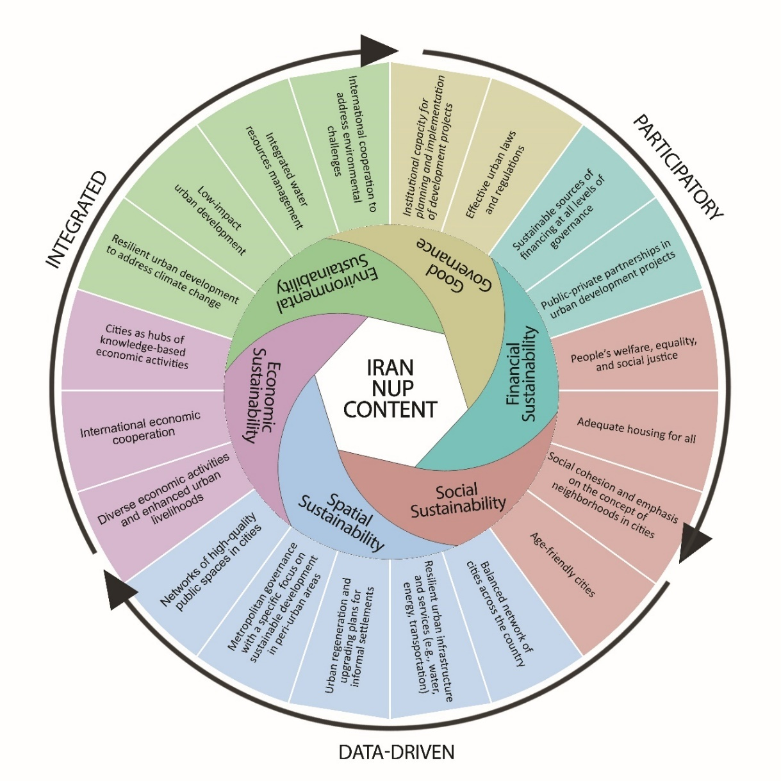
Figure 3. The proposed framework for Iran NUP content
Many documents have highlighted the necessity of greater participation of all stakeholders in developing and implementing urban policies. Taking into consideration all the actors and stakeholders such as the government sector, public sector, private organizations, NGOs, and people who work and live in the cities play a crucial role in effective policy formulation and implementation. However, participation of all stakeholders in decision-making and pluralism in formulating policies should be accompanied by adopting appropriate strategies to manage the conflict of interests of different actors.
Effective planning thrives on good data, which is essential to assess progress, evaluate outcomes and learn lessons for future urban policy making and planning. Having access to detailed data not only provides the opportunity to focus the initiatives on areas most in need, but also facilitates robust monitoring and evaluation of performed initiatives. Lack of cross-sectoral coordination and cooperation of various influential forces of Iran’s urban policy making and planning have resulted in fragmented data management, and thus, limited access to required data where needed. Therefore, increasing data adequacy and transparency and projecting mechanisms to facilitate robust data management is a key for improving the effectivity of Iran’s urban policies and plans.
Overcoming sectoral planning and applying an integrated approach are also necessary to provide a full comprehension of interlinkages and interactions among various dimensions of a complex concept like cities. Batty (2008) emphasizes the complex and cross-cutting nature of urban issues and the need for coordination between various influential forces to formulate effective policies. Lack of coordination between different levels of national and local policy-making and urban planning is one of the main obstacles to produce effective and implementable policies in Iran. Inconsistency between local needs and national planning frameworks have led to gaps in the proposed policies and resulted in unbalanced urban development throughout the country.

ACKNOWLEDGMENT
This paper is based on research conducted in order to develop the National Urban Policy and Smart City Strategy document within the framework of the National Urban Policy Programme in Iran in 2021-2022, with the cooperation of UN-Habitat and the Ministry of Roads and Urban Development in I.R. Iran funded by the Korean government.

REFERENCES
Alaedini, P. (2015). CITIES vi. Urban Informal Settlements in Modern Iran. In Encyclopedia Iranica (Online ed.).
Alaedini, P., & Yazdani, F. (2021). Iran's housing policies for low-income and vulnerable groups. In P. Alaedini & (Eds.), P. Alaedini (ed.), Social Policy in Iran: Main Components and Institutions (1st ed.). Routledge.
Bandauko, E., Annan-Aggrey, E., & Arku, G. (2021). Planning and managing urbanization in the twenty-first century: content analysis of selected African countries’ national urban policies. Urban Research & Practice, 14(1), 94-104. https://doi.org/10.1080/17535069.2020.1803641
Batty, M. (2008). The Size, Scale, and Shape of Cities. Science, 319(5864), 769-771. https://doi.org/doi:10.1126/science.1151419
Candel, J. J. L. (2021). The expediency of policy integration. Policy Studies, 42(4), 346-361. https://doi.org/10.1080/01442872.2019.1634191
Cartwright, A., Palmer, I., Taylor, A., Pieterse, E., Parnell, S., & Colenbrander, S. (2018). Developing Prosperous and Inclusive Cities in Africa-National Urban Policies to the Rescue? In Coalition for Urban Transitions. London and Washington, DC.
Einem, E. v. (1982). National Urban Policy—The Case of West Germany. Journal of the American Planning Association, 48(1), 9-23. https://doi.org/10.1080/01944368208976163
Friendly, A. (2016). National Urban Policy: A Roadmap for Canadian Cities. IMFG Perspectives, 14. https://ideas.repec.org/p/mfg/perspe/14.html
Habibi, S., Basirat, M., & Razavi, M. H. (2020). Towards National Urban Policy in I.R. of Iran. In D. Kundu, R. Sietchiping, & M. Kinyanjui (Eds.), Developing National Urban Policies (pp. 231-254). Springer Nature Singapore. https://doi.org/10.1007/978-981-15-3738-7_9
Hsieh, H.-F., & Shannon, S. E. (2005). Three Approaches to Qualitative Content Analysis. Qualitative health research, 15(9), 1277-1288. https://doi.org/10.1177/1049732305276687
Hu, R. (2020). Australia’s national urban policy: The smart cities agenda in perspective. Australian Journal of Social Issues, 55(2), 201-217. https://doi.org/https://doi.org/10.1002/ajs4.104
Kazemian, G. (2016). Urban Policy Making; The neglected layer of urban management in Iran. Theoretical Foundations in Urban Studies, 1, 121-142.
Madani, K. (2014). Water management in Iran: what is causing the looming crisis? Journal of Environmental Studies and Sciences, 4(4), 315-328. https://doi.org/10.1007/s13412-014-0182-z
Meshkini, A., Pazira, s., & Ghaedrahmati, S. (2021). Analyzing of the Institutional Capacity of Local Management for Good Governance in Urban Land of Iran. Sustainable City, 4, 15-31. https://doi.org/10.22034/jsc.2021.270240.1403
MoEC. (2023). National Urban Policy 2023. In: Ministry of Economic Development.
Nasirabadi, S., Shahnazi, R., & Samadi, A. H. (2021). Optimal Tax Rate of Housing Capital in Iran. Iranian Economic Review, 25(1), 33-44.
OECD, UN-Habitat, & UNOPS. (2021). Global State of National Urban Policy 2021: Achieving Sustainable Development Goals and Delivering Climate Action. T. O. f. E. C.-o. a. Development.
Patti, D. (2017). Metropolitan Governance in the Peri-Urban Landscape: The Tower of Babel? The Case of the Vienna–Bratislava Metropolitan Region. Planning Practice & Research, 32(1), 29-39. https://doi.org/10.1080/02697459.2016.1146431
Pilehvar, A. a. (2021). Spatial-geographical analysis of urbanization in Iran. Humanities and Social Sciences Communications, 8(63). https://doi.org/10.1057/s41599-021-00741-w
Rahnama, M. R., Javid, M. H., Shamshirband, M., & Hossein Pour, S. A. (2012). Strategic Review of Financial Structure of Iran’s Local Management (Case study: Islamic council of Tehran metropolis). International Journal of Applied Science and Technology, 2.
Rasoolimanesh, S. M., Jaafar, M., & Badarulzaman, N. (2013). Urban planning and management system in iran: A review and assessment. Middle-East Journal of Scientific Research, 18(2), 220-229. https://doi.org/10.5829/idosi.mejsr.2013.18.2.12435
Richardson, H. W. (1987). Whither national urban policy in developing countries? Urban Studies, 24(3), 227-244. https://doi.org/10.1080/00420988720080361
Shahraki, S. Z., Ahmadifard, N., Farhadikhah, H., Mehrabani, B. F., Haydari, A., Abdali, Y., Fallah, V. A., Farhadi, E., Cividino, S., Vinci, S., & Salvati, L. (2020). Spatial planning, urban governance and the economic context: The case of 'Mehr' housing plan, Iran. Land, 9(169). https://doi.org/10.3390/LAND9050169
Turok, I., & Parnell, S. (2009). Reshaping cities, rebuilding nations: The role of national urban policies. Urban Forum 20, 20, 157–174. https://doi.org/10.1007/s12132-009-9060-2
UDRO. (2022). General overview on the status of target areas.
UN-Habitat. (2015). National Urban Policy Framework for a Rapid Diagnostic. In. Nairobi: United Nations Human Settlements Programme.
UN-Habitat. (2016a). HABITAT III Policy Paper: National Urban Policy. In: United Nations Human Settlements Programme.
UN-Habitat. (2016b). The New Urban agenda. https://habitat3.org/wp-content/uploads/NUA-English.pdf
UN-Habitat. (2019). How to Formulate a National Urban Policy: A practical guide. In: United Nations Human Settlements Programme.
UN-Habitat. (2020a). Mainstreaming National Urban Policies in Urban-Rural linkage. In: United Nations Human Settlements Programme.
UN-Habitat. (2020b). Sub-National Urban Policy: A Guide. In: United Nations Human Settlements Programme.
UN-Habitat. (2021). National Urban Policies Programme in Jordan, Phase 3: formulation Report. In: United Nations Human Settlements Programme.
UN-Habitat. (2022a). National Urban Policy Programme - Evaluation Report.
UN-Habitat. (2022b). National Urban Policy Programme in Iran: Developing the National Urban Policy and Smart City Strategy Document.
UN-Habitat, & OECD. (2018). Global State of National Urban Policy. In: The Organization for Economic Co-operation and Development.
Van Den Berg, L., Braun, E., & Van Der Meer, J. (1998). National Urban Policies in the European Union. Routledge. https://doi.org/https://doi.org/10.4324/9780429445965
Wandl, A., & Magoni, M. (2017). Sustainable Planning of Peri-Urban Areas: Introduction to the Special Issue. Planning Practice & Research, 32(1), 1-3. https://doi.org/10.1080/02697459.2017.1264191
WorldBank. (2022). Iran Urban Population. https://data.worldbank.org/indicator/SP.URB.TOTL.IN.ZS?locations=IR

Annex1. Selected documents for the review and analysis

 | Type of Document | Title of the Document | Date of Approval/ Publication | Reference Institution
International documents | International Framework | New Urban Agenda | 2017 | UN-Habitat
 |  | Habitat III policy paper :National Urban Policies | 2016 | Habitat III
 | UN-Habitat Publications | How to Formulate NUP: A Practical Guide | 2019 | UN-Habitat
 |  | National Urban Policy: A Guiding Framework | 2015 | UN-Habitat
 |  | Addressing Climate Change in National Urban Policy | 2016 | UN-Habitat
 |  | The Evolution of National Urban Policies- A Global overview | 2014 | UN-Habitat
 |  | Sub-National Urban Policy: A Guide | 2020 | UN-Habitat
 | International Report | Global State of National Urban Policy | 2018 | UN-Habitat & OECD
 |  | Global State of National Urban Policy | 2021 | UN-Habitat & OECD
National Documents | Iran meta-policies | Iran meta-policies in urban planning | 2011 | EDCI
 |  | Iran meta-policies in housing | 2011 | EDCI
 |  | Iran meta-policies in spatial planning | 2011 | EDCI
 |  | Iran meta-policies in environment | 2015 | EDCI
 | National Spatial Plan | Cetiran Spatial Plan | 1976 | PBO
 |  | Iran National Spatial Plan | 2021 | SCoSP
 |  | Regional Spatial plans at a glance | 2020 | SCoSP
 |  | Regional studies and Iran Spatial plan | 2019 | IPRC
 | National Urban Plans and Regulations | Iran National Physical Plan | 1996 | MoRUD
 |  | Comprehensive Housing Plan: Consolidation Document | 2015 | MoRUD
 |  | Framework, guidelines and Terms of Reference of preparing comprehensive urban plans: a new approach and method | 2020 | MoRUD
 |  | Revision of the procedure of identifying deteriorated urban areas and neighborhoods | 2020 | MoRUD
 |  | National Document on Organizing and Empowering Informal Settlements | 2004 | Cabinet of Ministers
 |  | National Strategic Document for Tourism Development | 2020 | Cabinet of Ministers
 |  | National Strategic Document for Regeneration, Rehabilitation, Renovation, and Empowerment of Deteriorated and Dysfunctional Urban Areas | 2014 | Cabinet of Ministers
 |  | National Strategic Document for Crisis Management | 2020 | SCoCM
 |  | Evaluation of the Realization of National Physical Plan | 2016 | MoRUD
 | Regional Urban Plans and Regulations | Mokran Coastal Region Development Document | 2019 | HCoUA
 |  | Analysis of the function and position of free trade-industrial and special economic zones in the spatial planning system | 2020 | MoRUD
 | Tehran plans | Tehran Growth Boundary Strategic plan | 2016 | HCoUA
 |  | Tehran Strategic-Structural Development Plan | 2008 | Municipality  of Tehran
 |  | Tehran Metropolitan Area and Neighboring Towns Plan | 2004 | MoRUD
 |  | Draft of Policy Document of Organizing and Decentralization of Tehran | 2020 | MoRUD

https://worldpopulationreview.com/country-rankings/greenhouse-gas-emissions-by-country
The Organization for Economic Co-operation and Development
Expediency Discernment Council of Iran
Plan and Budget Organization
Supreme Council of Spatial Planning
Islamic Parliament Research Center
Ministry of Roads and Urban Development
High Council of Urbanism and Architecture

