**Developing a Novel Automated Construction Method for Façade Plastering Using Robotic Mechanism**

**Abstract**

In contemporary times, the pervasive trend towards automation is evident across various industries, including the construction sector. This paper presents a novel construction approach by automating the plastering process on flat facades, with the specific aim of eliminating cumbersome scaffolding structures and attaining additional benefits such as enhanced safety and quality. Consequently, the development of a specialized robot, designated as the façade plastering robot (FPROB), has been undertaken for this purpose. It is conjectured that the FPROB holds potential for greater efficiency and cost-effectiveness particularly in the context of mid-rise buildings, despite its limitation to flat surfaces. To conceptualize a new design paradigm, a comprehensive review of relevant literature has been conducted, aimed at discerning the merits and demerits of prior methodologies and identifying innovative solutions for the FPROB. In summation, the proposed robotic system demonstrates the capability to achieve several objectives including a 56% improvement in construction safety, attainment of more uniform finishing quality, and obviation of the need for scaffolding. It is noteworthy that the adaptability of this robot extends to multitasking functionalities, serving as a foundational model for subsequent iterations of façade robots, projected to achieve a 25% enhancement over their predecessors. Moreover, future discourse envisages the potential extension of this method and robot for analogous maintenance and painting tasks within similar contexts.

**Keywords:** Construction Method, Automation, Façade Plastering, Robotic Mechanism

**Conflict of Interest and Authorship Conformation**

Please check the following as appropriate:

* All authors have participated in (a) conception and design, or analysis and interpretation of the data; (b) drafting the article or revising it critically for important intellectual content; and (c) approval of the final version.
* This manuscript has not been submitted to, nor is under review at, another journal or other publishing venue.
* The authors have no affiliation with any organization with a direct or indirect financial interest in the subject matter discussed in the manuscript

**1. Introduction**

The construction industry stands at the precipice of a transformative era driven by Industry 4.0 technologies. This new wave, dubbed Construction 4.0 (C4.0), promises to blur the lines between production, services, and consumption, fundamentally reshaping how we build (Statsenko et al., 2022). While automation thrives in logistics, propelling industries like manufacturing and maritime (Yang & Pan, 2020), construction remains largely wedded to familiar, low-skill methods due to inertia and resistance to change (Darlow et al., 2021). However, advancements like cyber-physical systems for real-time monitoring and 3D printing for prefabrication are paving the way for a revolution (Statsenko et al., 2022).

While research has explored these promising technologies, a holistic understanding of their specific construction applications is still lacking. The COVID-19 pandemic, however, has served as an unexpected catalyst, accelerating automation in prefabrication with robotic adept at cutting, stacking, and welding materials. But the true potential of C4.0 lies beyond prefabrication. Imagine autonomous robots on-site, meticulously manipulating bricks or precisely dispensing concrete, especially in the towering heights of high-rise structures. Collaborative robots working alongside human inspectors and sorters, seamlessly integrated into robotic construction sites – these are not futuristic dreams, but possibilities on the horizon (Statsenko et al., 2022).

Unlocking the full potential of C4.0, however, requires overcoming significant challenges. Interoperability, communication, and power limitations demand innovative solutions (Statsenko et al., 2022). While "soft" information technologies like Building Information Modelling (BIM) have dominated past research, the focus is shifting towards "hard" physical robots specializing in specific tasks (Linner et al., 2020). This renewed interest, evident in the growing body of academic research (Linner et al., 2020; Yun, 2018), necessitates a generic design method that integrates the diverse needs and expertise of stakeholders from construction, robotics, and beyond (Linner et al., 2020).

The benefits of embracing C4.0 are undeniable. Studies by Morales et al. (1999) and Jung et al. (2013) highlight the potential for improved safety, precision, and productivity through automation and robotics. Japanese companies, for instance, are already pioneering the use of robots in various construction tasks (Jung et al., 2013; Morales et al., 1999). As technology advances and costs decrease, robots are poised to infiltrate even more aspects of construction, transforming the industry from the ground up.

***1.1. Construction Safety***

The construction industry, despite demonstrably improving its safety culture and adopting stricter regulations, continues to grapple with persistent safety challenges. While traditional safety practices have undoubtedly yielded progress, achieving further significant reductions in accidents and injuries necessitates venturing beyond established methods and embracing the transformative potential of digital technologies. Building Information Modeling (BIM) and Additive Manufacturing (AM) stand out as particularly promising avenues in this pursuit. BIM's capabilities for risk detection and proactive design-out, coupled with AM's potential for automation and reduced human exposure to hazards, offer exciting possibilities for creating inherently safer construction environments (Gradeci & Labonnote, 2019; Teizer, 2016).

However, simply recognizing the potential of digital solutions is not enough. The Architecture, Engineering, and Construction (AEC) industry currently faces challenges in effectively selecting and implementing these technologies, stemming from a historically low adoption rate compared to other sectors (Bosch-Sijtsema et al., 2021; Sepasgozar et al., 2016). This is particularly concerning given the industry's persistently high accident and injury rates, highlighting a critical need for innovative solutions to address this core challenge of workplace safety (Cheng et al., 2004).

Further compounding the issue is the challenge of craft worker shortages, impacting both the quality and quantity of available workforce. Insufficient worker quality often leads to less experienced individuals executing tasks, while quantity shortages can hinder projects from meeting labor demands altogether. While the impact of these issues on project cost and schedule is well-understood, the influence of craft worker shortages on safety performance remains less explored (Karimi et al., 2016). This lack of understanding is particularly concerning considering the inherent risks associated with construction activities, which can lead to serious injuries, illnesses, or even fatalities. Addressing the craft worker shortage is therefore crucial not only for project efficiency but also for demonstrably improving safety outcomes in the construction industry (Cheng et al., 2004).

Fortunately, there is optimism to be found in the growing exploration of various digital technologies for their potential to enhance different aspects of construction projects, including safety (Bosch-Sijtsema et al., 2021). Notably, recent studies have highlighted the perceived potential of these technologies for improving the working environment and safety on construction sites. Drones, for instance, were seen as valuable tools for safety assessments, accessing difficult areas, and making informed risk judgments (23% of respondents). Additionally, self-driving vehicles (19%) and robots/3D printing (15%) were viewed as promising solutions for reducing workplace risks and accidents by automating heavy lifting and other hazardous tasks. These findings offer encouraging evidence that digital technologies hold significant promise for creating not only more efficient but also demonstrably safer construction environments (Bosch-Sijtsema et al., 2021).

***1.1.1. Construction Safety Measurement***

Construction safety performance measurement encompasses various criteria, including safety regulatory compliance, hazard identification & risk assessment, safe work procedures & training, engineering controls & safe work practices, and performance monitoring & measurement (Table 1.) (Bhagwat et al., 2022; EU-ASHW, 2023; OSHA, 2023). These criteria are instrumental in evaluating the effectiveness of health and safety management systems within the construction industry. Additionally, safety performance can be assessed through indicators spanning worker safety, public safety, environmental protection, property integrity, and site-specific safety (nbspJatin Kumar et al., 2016). In the following, we assess different construction safety criteria and aspects through the next table (Table 1.).

Table 1. Construction Safety Measurement Criteria (By Authors (Bhagwat et al., 2022; EU-ASHW, 2023; nbspJatin Kumar et al., 2016; Nimo-Boakye, 2022; OSHA, 2023))

|  |  |  |  |
| --- | --- | --- | --- |
| **Criteria** | **Description** | **Considerations & Additional Aspects** | **Importance Weigh** |
| **Regulatory Compliance** | Adhere to national and regional regulations for construction safety. | Regularly review and update regulations. - Consider exceeding minimum requirements based on project risks. - Address permit requirements, inspections, and reporting obligations. | High |
| **Hazard Identification & Risk Assessment** | Proactively identify hazards and assess their associated risks through tools like JHA and What-If analysis. | Conduct regular risk assessments throughout the project lifecycle. - Consider specific hazards like falls, falling objects, electrocution, and chemical exposure. - Include near-miss reporting and analysis in risk assessments. | High |
| **Safe Work Procedures & Training** | Establish clear, documented procedures and train workers on them, emphasizing safety culture. | Develop task-specific procedures based on risk assessments. - Train workers on procedures, hazard awareness, and safe work practices. - Foster a culture of continuous learning and feedback on procedures. | Medium |
| **Engineering Controls & Safe Work Practices** | Implement guardrails, fall arrest systems, and proper ventilation alongside safe work practices. | Prioritize eliminating hazards at the source through engineering controls. - Implement safe work practices like housekeeping, proper tool usage, and communication protocols. - Address ergonomic risks and fatigue management. | High |
| **Personal Protective Equipment (PPE)** | Use appropriate PPE like hard hats, safety glasses, and gloves based on task and ANSI standards. | Select PPE based on individual needs and ensure proper fit and maintenance. - Train workers on proper PPE use and limitations. - Consider collective protective equipment (CPE) where applicable. | Medium |
| **Performance Monitoring & Measurement** | Regularly monitor key metrics like incident rates, near misses, and safety inspections for informed decision-making. | Track leading and lagging indicators of safety performance. - Analyze data to identify trends and areas for improvement. - Communicate safety performance metrics to all stakeholders. | Medium |

While lagging indicators, such as accident rates, fatalities, and compensation costs, are commonly used, they may not provide an accurate picture of safety performance due to their reactive nature (Nimo-Boakye, 2022). Therefore, the integration of robotics and automation (RA) within construction operations holds promise for enhancing safety protocols. It is acknowledged that human-robot interactions (HRIs) can introduce new hazards or escalate existing safety concerns (Liu et al., 2022). Nonetheless, empirical investigations indicate that the utilization of construction robots can mitigate repetitive tasks on site, reduce time allocated to perilous activities, minimize rework, enhance precision, and streamline project schedules and expenditures (Okpala et al., 2023).

Ensuring secure human-robot collaboration (HRC) mandates a comprehensive evaluation of both physical and psychological safety aspects. In this vein, a proposed physiological computing system aims to enable robots to discern workers' psychological states and modulate their performance accordingly (Brosque & Fischer, 2022). Furthermore, research indicates that immersive virtual reality (VR) training programs have the potential to cultivate trust in robots, bolster self-efficacy levels, and augment situational awareness among construction personnel, thereby fortifying HRI dynamics and overall safety practices at construction sites (Aghimien et al., 2022). Overall, the deployment of robotics in construction has the potential to improve safety outcomes, but it is important to address and mitigate the unique safety risks associated with HRIs.

***1.2. Our Quest for Safer Construction: Developing a Robotic Method for Facade Plastering***

The inherent hazards of construction are undeniable, with facade work at heights posing a particularly significant risk (Darlow et al., 2021). Implementing traditional façade plastering methods within this inherently dangerous environment adds another layer of complexity, necessitating a critical examination of the challenges and considerations involved. While often lauded for their cultural significance and aesthetic appeal, these methods require careful evaluation and adaptation to remain relevant in the modern construction landscape (Mishmastnehi et al., 2023). Throughout history, construction practices have utilized readily available local materials like mud bricks and stone. Plastering, a quintessential finishing step for both interior and exterior walls, transcends mere aesthetics, offering additional structural stability and environmental protection (Mousli & Semprini, 2019; Ranesi et al., 2021). However, traditional facade plastering methods, while often lauded for their cultural significance, pose several challenges in the contemporary construction landscape. The following sections delve into the specific complexities associated with traditional facade plastering, exploring issues related to labor intensity, skill depletion, material variability, durability concerns, and safety considerations (Miszczuk et al., 2019).

***1.2.1. Labor Intensity and Skill Depletion***

Traditional plastering methods inherently demand significant manual labor, potentially leading to physical strain and extended project timelines. Moreover, the intricate techniques require skilled artisans, whose population dwindles as modern construction techniques gain prominence. This poses a significant challenge in sourcing qualified professionals to execute these methods effectively (Ravi Kumar et al., 2019; Shreeranga et al., 2017; Yin & Caldas, 2022).

***1.2.2.*** ***Material Variability and Durability Concerns***

Ensuring consistent quality in traditional plaster mixes proves difficult. The lack of stringent quality control measures prevalent in modern techniques can result in inconsistencies in the mix and its application, ultimately affecting the final product's quality and durability. Additionally, some traditional plasters may exhibit reduced resilience compared to their modern counterparts, particularly in harsh weather conditions. This translates to increased maintenance and repair requirements throughout the plaster's lifespan (Pershina et al., 2017; Ranesi et al., 2021).

***1.2.3. Safety Concerns***

Scaffolding has been a fundamental part of construction practices worldwide, for centuries. The scaffolding would be erected adjacent to the building facade, allowing workers to apply plaster at various heights. Traditional scaffolding, often constructed from readily available materials like wood or bamboo, inherently poses safety risks during erection and use, especially when safety protocols are lax. Furthermore, balancing the preservation of cultural heritage with the need for modernization presents a conundrum. Traditional methods may not always comply with modern building codes, creating a complex decision-making process (Marat et al., 2016; Michał et al., 2018; Szer et al., 2018; Yin & Caldas, 2022).

In summation traditional plastering faces several challenges hindering its widespread adoption in modern construction. Firstly, the labor-intensive nature and the dwindling pool of skilled artisans make sourcing qualified professionals difficult. Secondly, achieving consistent quality and ensuring durability pose concerns due to the variability of traditional plaster mixes and their potential vulnerability in harsh environments. Lastly, safety risks associated with traditional scaffolding and potential conflicts with modern building codes add another layer of complexity. These drawbacks collectively paint a picture of a method struggling to adapt to the demands of modern construction. To address these issue, there is a need to adopt new technologies, such as robotics and automation, to improve productivity and efficiency in plastering and other construction processes.

This paper contributes to this exciting realm of C4.0 research by focusing on a specific challenge: the limitations of existing plastering robots for implementing flat facades. Plastering robots offer the potential to eliminate scaffolding and mast systems, improving safety and efficiency during façade plastering (Iturralde et al., 2015) (Ravi Kumar et al., 2019; Yin & Caldas, 2022). However, current robots often struggle with tasks requiring precise control and uniformity, hindering their adoption for flat facades. This paper will therefore:

* Discuss the implications of this work for the advancement of robotic technologies in construction and the potential impact on construction safety.
* Provide a background on the use of robots in construction and discuss related works.
* Assess the disadvantages of previous plastering robots and introduce a novel robot design specifically for plastering flat facades.

By examining this specific application and contributing to the ongoing development of advanced robotic technologies, this paper hopes to be a valuable resource for researchers, industry professionals, and anyone interested in the future of construction shaped by C4.0.

**2. Background**

The construction industry stands at a critical juncture, faced with increasing demands for efficiency, safety, and cost-effectiveness amidst a landscape of skilled labor shortages and stringent quality regulations (Prof. Pravin et al., 2022). Automation, long touted as a transformative solution, is finally gaining traction, offering the potential to address these challenges and revolutionize the built environment (Kim et al., 2015).

However, the journey towards this future has been far from smooth. Despite early attempts in the 1980s and 1990s, the widespread adoption of automated solutions remained elusive due to limited practicality and technological constraints. Notably, Japan emerged as a pioneering force, with construction giants spearheading the development of single-task robots for tasks like concrete finishing and floor installation. Additionally, automated building systems resembling on-site construction factories were introduced, drawing inspiration from established practices in manufacturing and automotive industries. These early efforts, while not achieving widespread adoption, laid the groundwork for future advancements (Daniel, 2023).

Historically, the 1980s marked a pivotal point with Japan leading the charge in automation research. They introduced remotely controlled and tele-operated robots, showcasing the potential for labor-free construction. The United States and the European Union followed suit, focusing on remote-controlled robots and large-scale masonry robots, respectively (Bock, 2006; Saidi et al., 2016). Japanese construction giants, namely Shimizu, Takenaka, Obayashi, Taisei, and Maeda, played a vital role since the 1940s. The 1980s witnessed a surge in their R&D efforts, fueled by a deep understanding of the potential of robotics. Notably, they invested heavily, allocating approximately 1% of their revenue to R&D (Morales et al., 1999). While the United States lagged behind in R&D investment, these combined efforts laid the foundation for the significant advancements witnessed in the following decades. After this initial R&D period, both Japanese and American construction companies presented various types of individual robots specifically designed for construction tasks. These included robots for delivering and handling concrete, applying fireproofing to steel structures, and even façade robots for plastering and painting (Bock, 2006).

Façade work encompasses a variety of tasks, including window installation and building exterior wall construction. These operations are inherently complex and pose safety risks due to the potential for injuries and damage to the building itself (Saidi et al., 2016). Recognizing these challenges, researchers explored and documented the use of various robots and machines for façade operations in numerous articles and books. Through a comprehensive analysis of scholarly publications, several robots and machines emerged as key areas of study.

***2.1. Related works***

Following a comprehensive literature review and data analysis, a range of robots and machines with potential applications in the construction industry were identified. Among these, autonomous plastering robots for walls and ceilings emerged as a particularly intriguing option. However, further investigation revealed several limitations associated with this technology, including susceptibility to mechanical errors and other shortcomings. To provide a more nuanced understanding, the following table (Table 2.) presents a critical assessment of these robots and machines, highlighting their key features and limitations.

Table 2 Assessment of Related Operational and Constructional Robots (By Authors)

|  |  |  |  |  |  |  |
| --- | --- | --- | --- | --- | --- | --- |
| **No.** | **Author / (Robot name)** | **Figure** | **Year / Origin Country** | **Function & Type** | **Indoor /Outdoor** | **Limitations** |
| **1** | Selen Ercan Jenny et al. / RPS (Ercan Jenny et al., 2023) |  | 2023 / Switzerland | Automating plastering / Single tasked robot | Indoor | 1) Spraying thin-layer of material  2) No further operational phases |
| **2** | Rodríguez et al. / (Nameless) (García-Rodríguez & Castillo-Castañeda, 2022) |  | 2022 / Mexico | Façade Cleaning / Single tasked robot | Outdoor | 1) Unable for plastering operation  2) Usable for low rise buildings |
| **3** | M Zulhazreen et al. / (Nameless) (Zulhazreen et al., 2021) |  | 2021 / Malaysia | Auto-Plastering Machine / Single tasked | Indoor | 1) Lack of any movement system  2) No hydration phase |
| **4** | Kouzehgar et al. / Mantis (Kouzehgar et al., 2019) |  | 2019 / Singapore | Self-reconfigurable façade-cleaning / Single tasked robot robot | Outdoor | 1) Unable for plastering operation |
| **5** | Unknown / TUPO (*PLASTERING MACHINE*, 2019) |  | 2019 / Unknown | Plastering Machine / Single tasked | Indoor | 1) Just plastering and troweling  2) No hydration phase |
| **6** | Shunsuke Nansai et al. / (Nameless) (Nansai et al., 2018) |  | 2018 / Japan | Façade Cleaning Robot / Single tasked robot | Outdoor | 1) Unable for plastering operation  2) Applicable for small surfaces |
| **7** | Xiang Li and Xin Jiang / GR (Li & Jiang, 2018) |  | 2018 / China | Applying Putty on Plastered Walls / Single tasked robot | Indoor | 1) Just applying putty |
| **8** | Yong-Seok Lee et al. / (Nameless) (Lee et al., 2018) |  | 2018 / Republic of Korea | Façade cleaning robot / Single tasked robot | Outdoor | 1) Unable for plastering operation  2) Hard Operational Phase |
| **9** | ACME Equipment SG / ACME (*Automatic Plastering Robot with Acme Equipment*, 2018) |  | 2018 / Singapore | Automatic Plastering Robot / Single tasked robot | Indoor | 1) Lack of measurement system during operation  2) Lack of any movement system |
| **10** | D. Bard et al. / Morphfaux (D. Bard et al., 2015) |  | 2015 / USA | Decorative Robotic Plastering / Single tasked robot | Indoor | 1) Decorative functions |
| **11** | Arivazhagan.B / (Nameless) (Arivazhagan.B, 2014) |  | 2014 / India | Automatic Plastering Machine / Single tasked robot | Indoor | 1) Compeletly Unpractical without any functional movement system |
| **12** | G. Pritschowa et al. / AMPA (Pritschowa et al., 2011) |  | 2011 / Germany | Plastering Machine / Single tasked | Outdoor | Significant development in automation, but it was not accepted in practice  1) Unable for plastering operation |
| **13** | Gambao & Hernand / CAFE (Gambao & Hernand, 2006) |  | 2006 / Spain | Semi-automatic Façade Cleaning Robot / Single tasked robot | Outdoor | 1) Unable for plastering operation |
| **14** | Schraft et al. / SFR (Schraft et al., 2000) |  | 2000 / Germany | Automated Façade cleaning robot / Single tasked robot | Outdoor | 1) Unable for plastering operation |
| **15** | Forsberg et al. / (Nameless) (Forsberg et al., 1995) |  | 1995 / Sweden | Plastering Robot / Single tasked robot | Indoor | Mechanical errors including:  1) distractions in the wheels or the spray gun,  2) calibration errors, and navigation errors  3) association errors |
| **16** | Warszawski & Rosenfeld / TAMIR (Warszawski & Rosenfeld, 1994) |  | 1994 / Unknown | Plastering Robot / Single tasked robot | Indoor | 1) Lack of any movement system |

**3. Autonomous Systems and Classification of Robotics in Construction**

Construction automation encompasses various aspects beyond just robots, including prefabrication and automation in industrial and civil engineering sectors (Saidi et al., 2016). Robots in construction aim to automate specific tasks or reduce safety risks. Due to the dynamic nature of construction sites, most robots are designed to be mobile or relocatable. They can be broadly categorized into on-site (specifically designed for construction sites) and off-site (used in factories) robots (Juan Manuel Davila Delgado et al., 2019). Single-task robots focus on performing a single task like concrete finishing or painting. They offer benefits like improved quality, reduced material usage, and safer working conditions (Saidi et al., 2016). Their development should prioritize increased productivity, worker safety, and cost-effectiveness. Support systems are crucial for robots to function effectively. They provide essential elements like accessibility, material handling, risk prevention, and stability (Pritschowa et al., 2011) (Iturralde et al., 2015).

Table 3 Different Classification of Robots in Construction (By Author)

|  |  |  |  |
| --- | --- | --- | --- |
| **Category** | **Description** | **Example** | **Benefits** |
| **On-site Robots** | Designed specifically for construction sites | Floor-finishing robots | Mobile, adaptable to changing environments |
| **Off-site Robots** | Used in factories for prefabrication | Brick-laying robots | Efficient, controlled environment |
| **Single-task Robots** | Perform one specific task | Plastering robot | Improved quality, reduced material use, safer working conditions |
| **Integrated Robotized Construction Site** | Multiple robots working together | Automated construction site | Increased productivity, reduced safety risks |
| **Tele-Operated Systems** | Human-controlled robots | Remote-controlled demolition robots | Precision, safety for hazardous tasks |
| **Programmable Construction Machines** | Robots with pre-programmed tasks | Automated welding machines | Consistency, efficiency |
| **Intelligent Systems in Construction** | Robots with advanced decision-making capabilities | Adaptive robots for obstacle avoidance | Flexibility, adaptability to complex environments |

**4. Research Methodology**

This research adopts a design-oriented research methodology, combining an extensive literature review, systematic data collection, and analytical evaluation to address the primary objective of mitigating risks in façade construction. The research specifically targets the elimination of scaffolding during façade execution by introducing an automated construction approach aimed at improving both accuracy and safety. Through this focus, the study contributes to advancing efficient and risk-reduced practices in façade implementation.

To address the research questions, a novel robotic system featuring a custom-designed kinematic framework was conceptualized and developed. The paper presents a detailed account of the design process and system architecture, emphasizing its potential application as a construction method. A systematic research strategy, drawing on both qualitative and quantitative techniques, was employed to evaluate the proposed solution. This approach supports a comprehensive understanding of the system's capabilities and theoretical performance, as well as its limitations.

Given the study's emphasis on method development and the extensive scope required for simulation-based validation, empirical testing, including simulations, laboratory experiments, and field trials, has been deliberately excluded from the current phase. Instead, the research prioritizes the detailed representation of the construction methodology and system design. Future work will focus on implementing simulation studies and on-site testing to validate the practical performance and effectiveness of the proposed robotic system.

**5. Design Process**

The design process commenced with the selection of a suitable façade type for construction automation. Plaster façades were identified as a promising option based on their characteristics and existing literature (Bock, 2006). Minimizing risk associated with the novel support system and eliminating scaffolding were paramount considerations. Consequently, the design of a gondolas-based hanging system underwent iterative refinement (Iturralde et al., 2015). Subsequently, leveraging the accumulated data and findings, a novel robot design was developed using “Solidworks” software. Finally, a comprehensive model was assembled to showcase the final product. This paper delves into the design and mechanism of the Façade Plastering Robot (FPROB) as a construction method, providing a detailed analysis of its technical implementation and performance across various mechanisms.

**6. Robot Platform and Mechanism**

Addressing the limitations of existing plastering robots, the Façade Plastering Robot (FPROB) is a novel mobile robot specifically designed for exterior façade applications. Unlike its predecessors, FPROB possesses climbing and plastering capabilities tailored to the unique demands of façade construction. This development draws upon insights gleaned from a comprehensive analysis of previous robots.

The core of FPROB is a modular quadrangle aluminum structure, enabling each component and equipment to operate independently based on dedicated algorithms. This modularity facilitates adaptability and future modifications. The entire structure is suspended by a kinematic system, leveraging the gondolas model for movement and climbing across the façade.

It is important to note that the final robot design may incorporate adjustments to electrical and mechanical components, such as engines and sensors, during the manufacturing stage. Subsequent sections of this paper will delve into the various mechanisms and performance characteristics that empower FPROB to successfully execute its designated tasks.

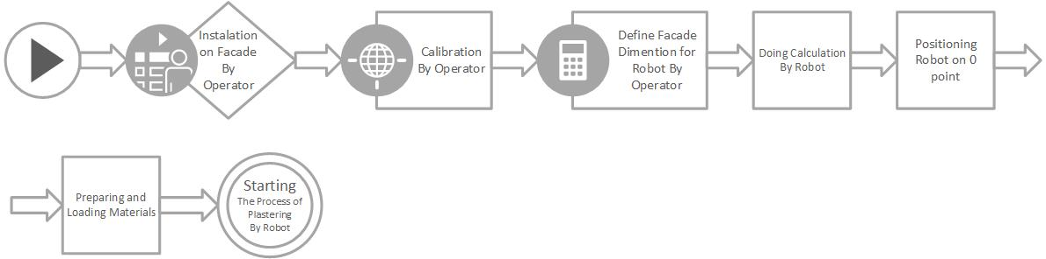

Figure 1 Robot Platform and Mechanism Flowchart (By Authors)

***6.1. Performance Mechanism***

The performance mechanism of the Façade Plastering Robot (FPROB) can be segmented into four distinct processes:

1. ***Installation and Calibration:*** This initial stage involves the physical setup and precise adjustment of the robot on the façade. This ensures proper alignment and functionality before operation commences.
2. ***Loading Process:*** This phase entails loading the necessary materials, such as plaster mix, onto the robot. The specific loading procedure might vary depending on the chosen material and robot design.
3. ***Operation and Execution:*** This core stage represents the automated plastering process. FPROB autonomously navigates the façade and applies the plaster according to the programmed instructions and sensor feedback.
4. ***Supervision and Control:*** Despite the robot's autonomous capabilities, a limited number of human operators will be present to monitor the process. Their primary role is to oversee the overall operation, intervene in case of unexpected situations, and adjust parameters as needed based on specific site conditions.

***6.1.1. Installation & Calibration Process***

The robot's operation commences with a well-defined setup procedure:

1. ***Installation and Kinematic System Deployment:*** An operator positions the Façade Plastering Robot (FPROB) onto the façade using its designated kinematic support system. This ensures safe and stable initial placement at a designated "point zero."
2. ***Manual Axis Definition:*** Utilizing a controller, the operator manually maneuvers the robot along the X and Y axes. This defines the robot's operational workspace dimensions within the façade plane.
3. ***Automated Area and Duration Calculation:*** Based on the defined workspace dimensions, the robot's onboard system automatically calculates the total façade area it needs to cover. This calculation also determines the estimated duration of the plastering process, providing valuable planning information.
4. ***Collaborative Material Estimation:*** The operator collaborates with the robot to refine the material quantity estimation. This involves utilizing the robot's integrated ultrasonic sensors to detect variations in the façade wall surface. This data, combined with the operator's expertise, helps determine the precise amount of plaster material required for the task.
5. ***Automated Task Initiation:*** Finally, the robot returns to its designated "point zero" and transitions into fully automated operation mode. It executes the plastering task based on the pre-defined parameters and sensor feedback, ensuring efficient and accurate façade coverage.

***6.1.2. Loading Process***

Following the successful calibration process, the Façade Plastering Robot (FPROB) integrates with a dedicated shotcrete engine responsible for material application onto the façade. The selection of an appropriate shotcrete engine is crucial, and its power output aligns with the specific building height to guarantee optimal material flow and control the intensity of material application. Importantly, FPROB possesses the autonomous capability to dynamically adjust the shotcrete engine's power throughout the operation based on its internal calculations. This real-time adjustment mechanism ensures adaptability to varying façade conditions and optimizes material usage.

***6.1.3. Operation and execution Process***

Following the material loading phase, the Façade Plastering Robot (FPROB) embarks on a multi-stage plastering process:

1. ***Hydration Phase:*** The robot initiates by automatically spraying water onto the façade surface. This crucial step ensures proper hydration and prepares the surface for subsequent plaster application.
2. ***Rough Plastering:*** FPROB transitions into the rough-plastering phase, meticulously applying plaster in a section-by-section manner. The robot employs a transverse motion, commencing from the top of the façade and systematically working its way downwards until the entire area is covered. Upon completion of each section, the robot re-hydrates the rough plaster with additional water spray, guaranteeing optimal adherence for the next stage.
3. ***Finishing Layer:*** For the final aesthetic touch, the robot's shotcrete tank is replenished with Benvid, a colored cement combined with fine aggregates. Utilizing the same transverse motion, FPROB meticulously applies Benvid plaster, starting from the building's summit and progressing downwards. Once a section receives its plaster coating, the robot transitions to the troweling phase, smoothing the surface to achieve a flawless and aesthetically pleasing finish.
4. ***Final Hydration:*** To conclude the process, FPROB performs a final water spray across the entire plastered façade. This ensures proper hydration, strengthens the plaster, and safeguards the long-term integrity of the façade.

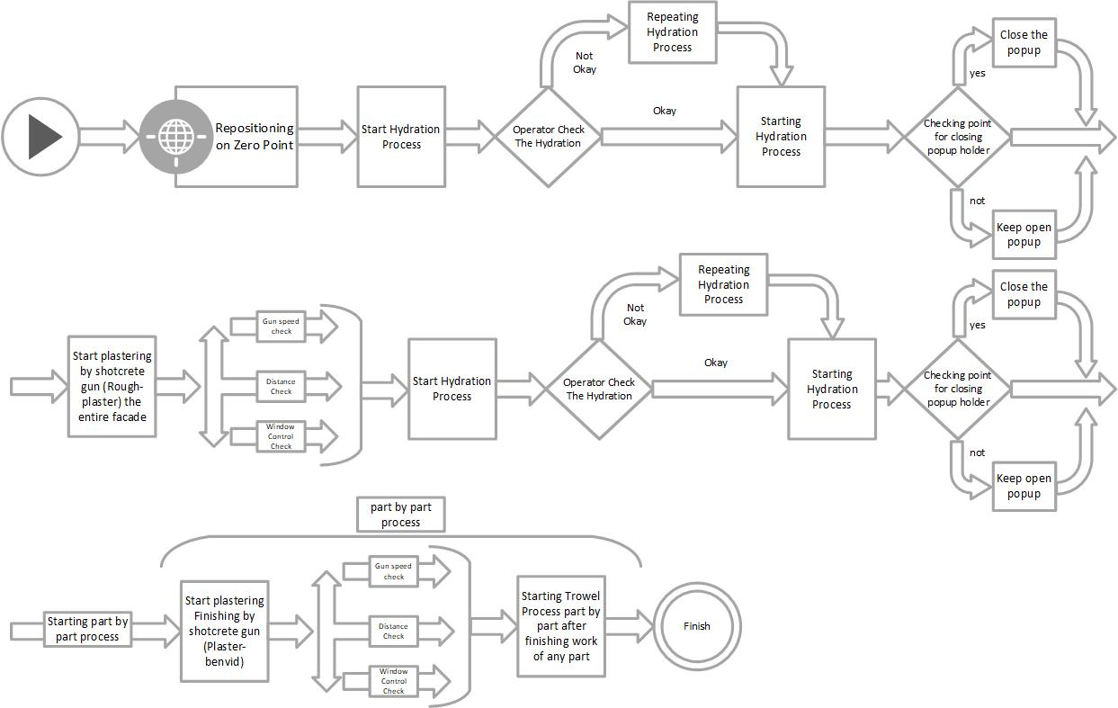

Fig 2. Operation and execution Flowchart Process (By Authors)

***6.2. Mechanical System***

To accommodate the unique demands of its façade plastering tasks, FPROB necessitates a specialized mechanical architecture. This system can be effectively segmented into three core components, each playing a crucial role in facilitating the robot's functionality:

1. Popup holder surface panel
2. Shotcrete-gun
3. Troweling and Water spray Surface

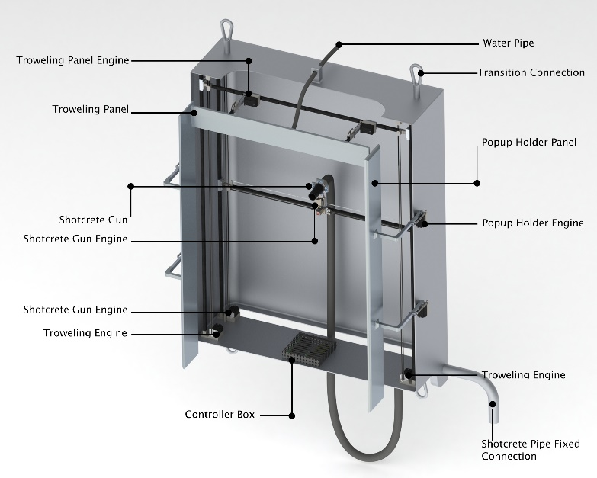

Figure 3 Mechanical System (By Authors)

***6.2.1. Popup holder surface panel***

The pop-up holder surface panel plays a pivotal role in ensuring the robot's integrity and the quality of the finished plaster during operation. Functioning as a protective barrier, it safeguards the robot from plaster debris generated by the shotcrete gun. This shielding mechanism helps maintain a clean and uniform finish along the façade edges, preventing imperfections caused by stray plaster particles.

The panel features two strategically placed servo motors that enable its rotation and closure over the targeted plastering area. This creates a confined workspace, effectively isolating the robot from external elements. Consequently, the robot can initiate its plastering tasks from a fixed position without the risk of unwanted debris affecting the application process or compromising the final outcome.

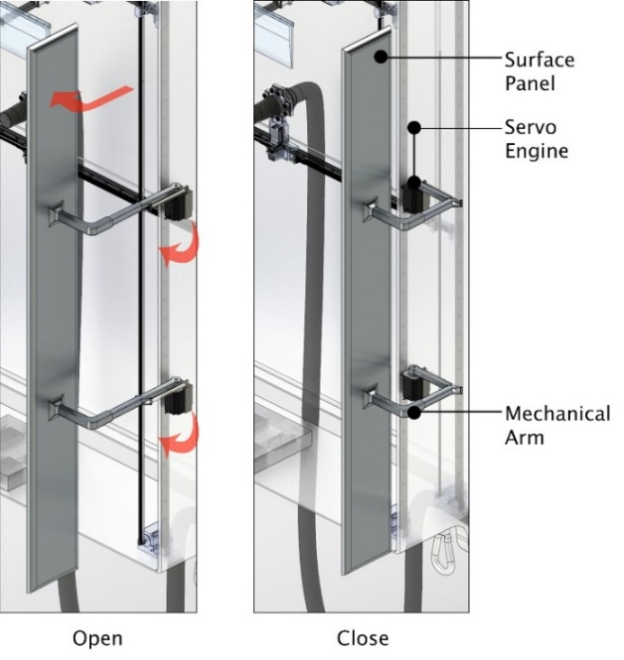

Fig. 4 Popup holder surface panel (By Authors)

***6.2.2. Shotcrete gun***

Central to the plastering process, the shotcrete gun plays a vital role in precisely directing the material towards the façade. For optimal performance, the robot fixes its position and maintains a controlled distance of approximately 45-50 cm between the gun head and the wall surface. To ensure smooth operation and address potential technical issues, the gun incorporates a panel equipped with four strategically placed ultrasonic sensors. Detailed information regarding these sensors' functionalities will be provided in subsequent sections.

Equipped with two stepper motors strategically located at its base, the shotcrete gun exhibits exceptional maneuverability across both the transverse (X) and longitudinal (Y) axes. This movement capability leverages the CoreXY system (*corexy*), where motors rotate in opposite directions for Y-axis movement (up/down) and in the same direction for X-axis movement (left/right). Additionally, the gun employs an integrated IR sensor for precise stop calculations, ensuring accurate positioning. In the event of a motor malfunction, the system's design allows for controlled diagonal movement along both axes, preventing disruptions to the operation. Further details regarding the electronic components and their functionalities will be addressed in the following section.

 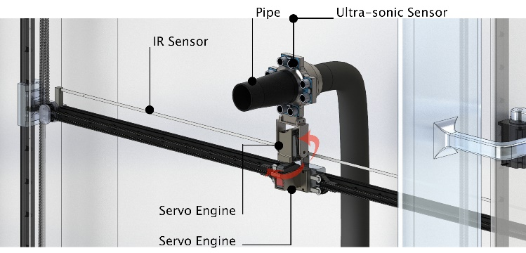

Fig. 5 Shotcrete gun Front View (By Authors) Fig. 6 Shotcrete gun isometric (By Authors)

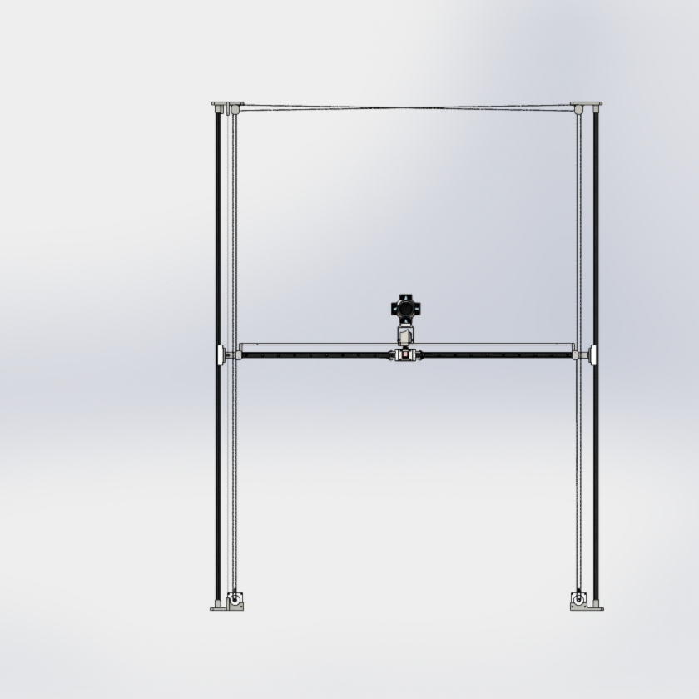 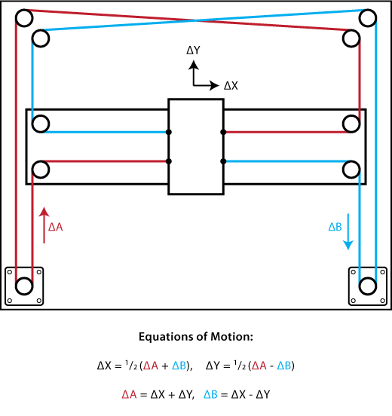

Figure 7 Shotcrete gun (By Authors) Figure 8 Shotcrete gun system (corexy)

***6.2.3. Troweling and Water spray Surface***

The troweling and water spray surface constitutes a multi-functional and vital component within the robot's design. This unique surface fulfills two distinct yet critical tasks:

1. ***Hydration Spraying:*** In its "closed mode," the surface operates as a water sprayer, facilitating the crucial hydration process during plaster application. A dedicated pipe ensures a consistent water supply for optimal plaster adherence and strength.
2. ***Final Troweling:*** Upon completion of the plastering process, the surface transitions to its "open mode" and executes the final troweling step. Its flat side, featuring an angled design, achieves a smooth and aesthetically pleasing finish, enhancing the overall quality of the plastered façade.

To achieve this dual functionality, the surface incorporates a sophisticated mechanical system driven by four motors:

1. ***Two Stepper Engines:*** These motors provide precise movement along the Y-axis, ensuring efficient coverage of the plastered area during both spraying and troweling.
2. ***Two Servo Engines:*** These motors facilitate the opening and closing of the surface through the bending and manipulation of mechanical arms. This allows for seamless transitioning between the spraying and troweling modes.

This strategic combination of design features and motor control empowers the troweling and water spray surface to effectively cater to the dynamic requirements of both hydration and finishing within the plastering process.

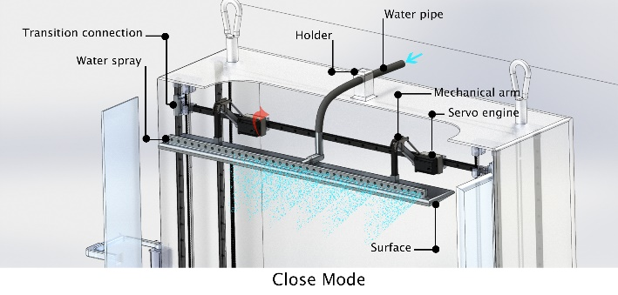

Figure 9 Water spray system By Author

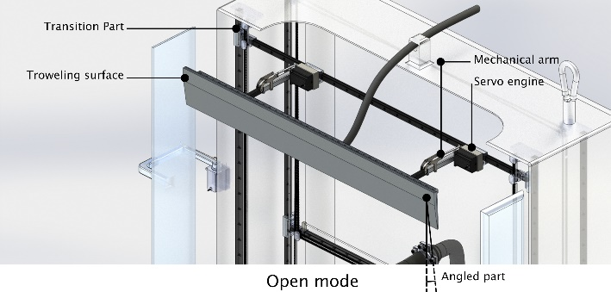

Fig. 10 Troweling surface By Author

***6.3. Kinematic System***

Navigating the façade efficiently and overcoming potential obstacles are crucial aspects of the robot's functionality. Given the assumption of a flat and unrestricted façade surface, a dedicated kinematic system has been designed. This system comprises two primary components, each consisting of five identical sections.

1. Main body
2. Rail
3. Longitudinal axis engine
4. Transverse axis engine (Rail engine)
5. Towing wire

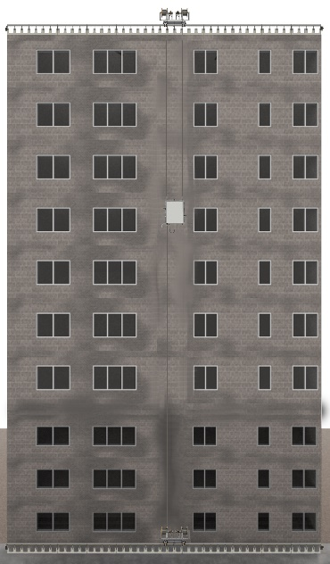

Figure 11 Kinematic system (By Authors)

The two primary components of the kinematic system operate in synchronized unison, enabling the Façade Plastering Robot (FPROB) main system to traverse both the Y and X axes of the façade. This coordinated movement ensures efficient and controlled navigation across the designated work area.

Additionally, the system employs towing wires secured at the building's top and bottom to firmly anchor the FPROB, maintaining a calibrated and stable position throughout the operation. While the transition mechanism functions autonomously based on the pre-programmed settings, an operator remains present to monitor its movement. This allows for timely intervention in unforeseen circumstances[1], potentially requiring adjustment or pause of the operation based on established tolerance thresholds[2].

***6.3.1. Main body***

The kinematic system adopts a dual-body architecture, strategically positioned at the building's apex and base. The rooftop body, located at the building's edge, anchors the system firmly. Its counterpart, situated near the façade at the building's base, facilitates direct interaction with the work surface. This strategic configuration enables coordinated movement and precise positioning of the robot across the entire façade area.

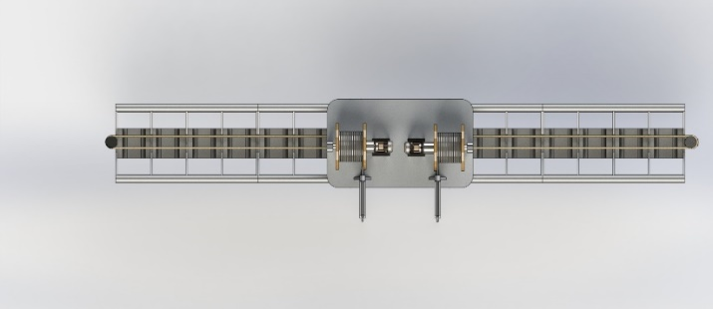

Figure 12 Main body plan view (By Author)

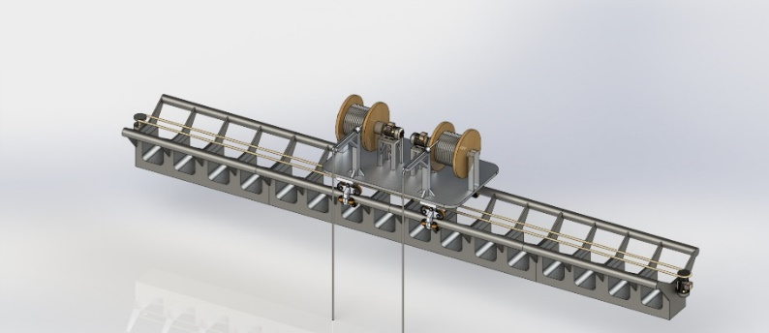

Fig. 13 Main body isometric (By Authors)

***6.3.2. Rail***

To facilitate FPROB's navigation across the façade, a dedicated guidance system is employed. This system relies on dedicated pathways for each transition body to traverse. For this purpose, rail pathways have been developed to ensure smooth and controlled movement.

 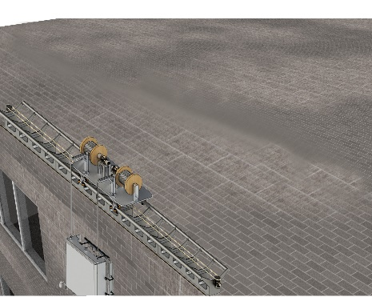

Fig. 14 Rail system (By Authors) Fig. 15 Rail system (By Authors)

***6.3.3. Longitudinal axis engines***

The transition system employs an integrated lifting mechanism to elevate the Façade Plastering Robot (FPROB) along the building façade. This mechanism utilizes two dedicated motors strategically positioned on the main body of the system. These motors operate in conjunction with towing wires, exerting controlled pulling forces to achieve vertical ascension of the FPROB.

***6.3.4. Transverse axis engine (Rail engine)***

In addition to the lifting mechanism, the transition system incorporates a dedicated propulsion system for facilitating horizontal movement of the Façade Plastering Robot (FPROB) across the façade. This system utilizes a strategically positioned motor located adjacent to the railing pathway. The motor is connected to the main body of the FPROB via steel wires, enabling controlled pulling forces that guide the robot along the designated rail tracks.

***6.3.5. Towing wire***

To ensure secure anchoring and controlled movement throughout the facade, FPROB incorporates a multi-point anchor system utilizing towing wires. These wires are strategically attached at both the top and bottom of the facade, connecting directly to the robot's body. This configuration effectively transfers the pulling force generated by the transition system's engines, enabling both vertical elevation and precise horizontal movement along the designated rail tracks.

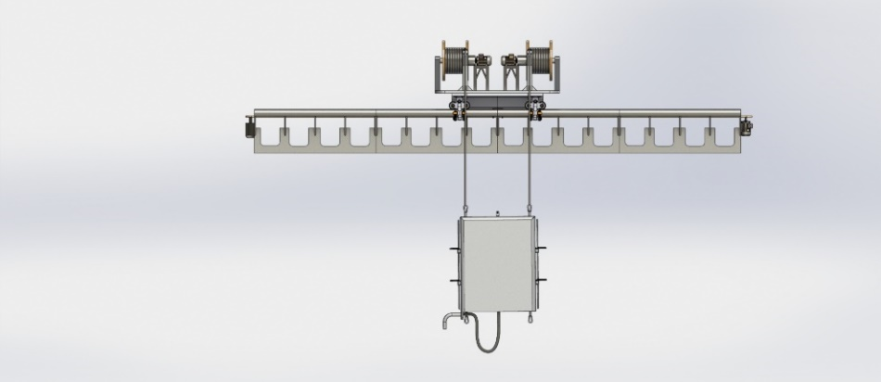 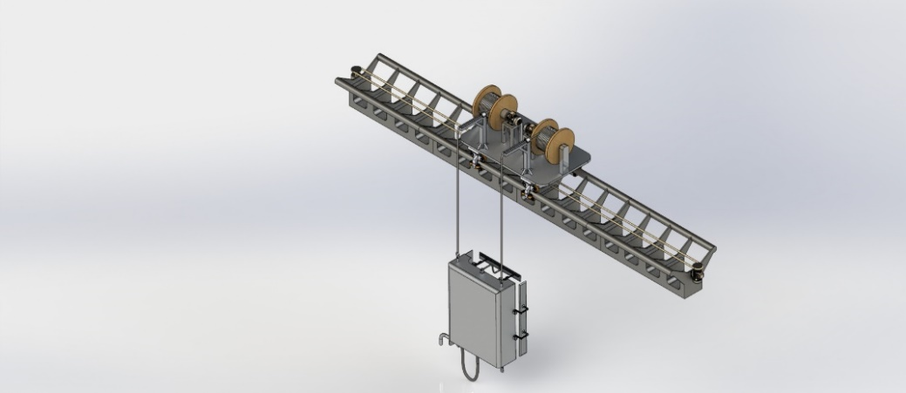

Fig. 16 Towing wire (By Authors) Fig. 17 Towing wire (By Authors)

**6.4. Electronic System**

Similar to other complex systems, the Façade Plastering Robot (FPROB) necessitates a dedicated electronic architecture tailored to its unique functional requirements. This system comprises three critical components, each playing a vital role in the overall operation:

**6.4.1. Sensors**

FPROB's sensory system comprises three distinct types of sensors, each providing critical data for accurate positioning and operation:

1. ***Ultrasonic Sensors:*** Four strategically positioned ultrasonic sensors (as illustrated in Figures 5 and 6) face upwards, downwards, left, and right of the shotcrete gun. These sensors emit ultrasonic waves towards the façade and analyze the reflected signals to calculate the distance between the gun and the surface, as well as detect the presence of windows. Utilizing the equation S = vT/2 (where S is the distance, v is the speed of sound, and T is the round-trip travel time of the wave), the controller processes this data for precise movement and obstacle avoidance (Zhmud et al., 2018).

*S*  *vt*; *t* *T* / 2*S*  *vT* / 2

1. ***Micro-switches:*** These act as limit switches, determining the start and end positions of the troweling and water spray surface. As the surface travels along its designated rail, it physically triggers the microswitches at both ends, sending signals to the controller. This feedback instructs the controller to reverse the stepper motors, thereby returning the surface to its starting point.
2. ***Linear Infrared Sensors:*** Each axis (X and Y) of the robot's movement utilizes a pair of infrared sensors comprising a transmitter and a receiver. The transmitter emits infrared light, and the receiver detects its reflection from a black linear strip mounted between them. The strip features differently colored holes at specific intervals. As the sensor detects these holes, it relays information to the controller regarding the gun's position and determines the necessary movement steps. On the X-axis, the hole positions signify start and end points, while on the Y-axis, the hole colors correspond to specific step sizes for the gun's movement.

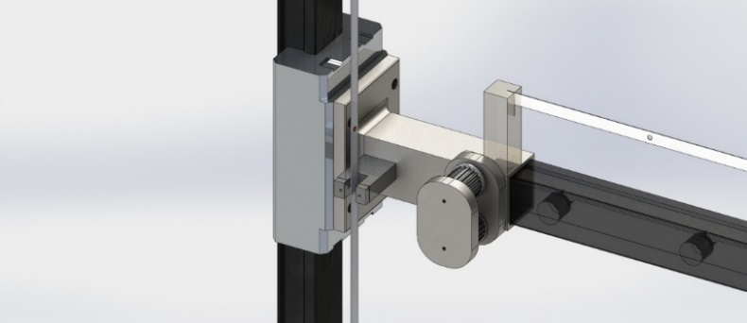 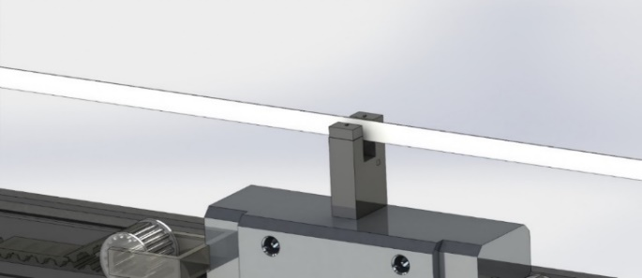

Fig. 18 IR-sensor (By Authors) Fig. 19 IR-sensor (By Authors)

***6.4.2. Driver***

Efficient and controlled operation of FPROB's motors necessitates dedicated motor drivers. These drivers function as intermediaries between the central controller and the individual motors, translating control signals into precise actuation. Each driver assumes responsibility for:

1. Power Delivery
2. Rotational Direction Control
3. Speed Regulation
4. Start/Stop Functionality

By assuming these tasks, motor drivers empower the controller to exert granular control over FPROB's movement and actions, ultimately contributing to its overall performance and safety.

***6.4.3. Controller***

The heart of the FPROB system lies in its meticulously chosen controller, and the ARM Microcontroller emerges as the optimal candidate due to its exceptional processing capabilities, robust reliability, and extensive input/output connectivity. This potent controller perfectly aligns with the processing demands of FPROB's tasks and paves the way for future advancements in the field.

The FPROB controller assumes a pivotal role within the system. Following operator setup and initialization (including robot positioning at the zero point and façade X/Y coordinate definition), the controller embarks on a series of critical calculations. These calculations encompass crucial parameters such as consumable material quantity, processing time, work step number and distance, and scheduling optimization. Armed with this information, the controller executes pre-programmed commands autonomously, seamlessly navigating tasks like rough-plastering, hydration processes, and other related functions. Furthermore, the entire sensor system seamlessly integrates with the Microcontroller, enabling the generation of a virtual representation of the entire operation. This real-time virtual image empowers the controller to make informed decisions and adjustments, ensuring efficient and precise execution of the plastering process.

**7. Technical notes of plastering**

Material selection for FPROB's plaster application is guided by several critical properties:

1. ***Adhesion:*** The plaster must exhibit strong adherence to the façade surface, ensuring long-lasting cohesion and resistance to external factors like wind and weather.
2. ***Workability:*** The mixed plaster should possess a suitable working time, allowing sufficient time for application and manipulation before hardening. This timeframe needs to be balanced with achieving optimal setting speed for efficient operation.
3. ***Rigidity:*** As defined by G. Pritschowa et al., the plaster must achieve a standardized level of rigidity upon drying. This parameter directly influences the final finish, durability, and structural integrity of the plastered façade. (Pritschowa et al., 2011)

While these characteristics represent the primary selection criteria, further details regarding the specific technical mixture of plaster materials are outlined in the following table (Table 4.).

Table 4 Technical Composition of Plastering (By Authors retrieved from Parin Plaster Brochure, Parin Beton CO.(Parin-company, 2016))

|  |  |  |
| --- | --- | --- |
| **Technical Specifications of based cement plaster** | **Rough-plaster (Lining cover(** | **Finishing cover (benvid)** |
| **Cement** | Cement type II / White | Cement type II / White |
| **Gravel** | Clean and suitable gravel with maximum size of 1.2 mm | Clean and suitable gravel with maximum size of 0.35 mm |
| **Additives** | Water preservative, approved function, increasing adhesion and durability | Water preservative, approved function, increasing adhesion and durability, Increasing water resistance |
| **Color** | Gray / White | Gray / White / Colored |
| **Thickness** | Maximum 25 mm | Maximum 3 – 6 mm |
| **Consumption** | 1.6 kg per square meter with thickness of 1 mm | 1.2 kg per square meter with thickness of 1 mm |
| **MPa** | Minimum 7 MPa | Minimum 5 MPa |
| **Tensile adhesion strength** | More than 0.5 MPa | More than 0.5 MPa |
| **Durability** | Resistant to frost and weather conditions | Resistant to frost and weather conditions |

***7.1. Technical Implementation Steps and Procedure***

FPROB's standard operation involves a four-step plastering process:

1. ***Hydration and Adhesion:*** The robot initiates by spraying water onto the surface, promoting the hydration of the substrate and enhancing the adhesion of the subsequent rough plaster layer.
2. ***Rough Plaster Application:*** Utilizing shotcrete technology, FPROB applies the rough plaster material onto the wall.
3. ***Hydration of Rough Plaster:*** Another water spray cycle ensures proper hydration of the rough plaster layer.
4. ***Benvid Plaster Application and Troweling:*** FPROB applies the Benvid plaster using shotcrete, followed by a section-by-section troweling process to achieve a smooth finish.
5. ***Finishing Hydration:*** A final water spray ensures proper hydration of the finishing layer.

However, a key challenge arises when encountering uneven surfaces or walls with significant deviations from plumb. To address this and achieve a flat, plumb finish, FPROB adopts a sophisticated sensory and control system:

1. ***Ultrasonic Distance Measurement:*** Four ultrasonic sensors strategically positioned around the shotcrete gun panel continuously measure the distance between the wall and the gun's head.
2. ***Data Integration and Processing:*** This distance data, along with other vital information like shotcrete gun pressure at various altitudes and baseline engine speed, is fed into the FPROB Microcontroller System (FPROBCS).
3. ***Real-Time Speed Optimization:*** Leveraging this combined data, FPROBCS performs continuous calculations to determine an adjusted speed for the shotcrete gun's stepper engines in real-time.

This dynamic speed control mechanism operates under a crucial principle:

1. ***Maintaining Shotcrete Pressure:*** By adjusting the engine speed, the system maintains a constant pressure within the shotcrete gun. This ensures a consistent volume of material being discharged regardless of surface variations.
2. ***Compensating for Uneven Surfaces:*** When the sensors detect a greater distance than the calibrated ideal, the engine speed is reduced, allowing more material to be applied in that specific area. Conversely, for areas closer than the ideal, the engine speed is increased, reducing the applied material volume.

Through this intelligent closed-loop system, FPROB compensates for surface irregularities in real-time, ultimately achieving a high-quality, consistent, and plumb plaster finish.

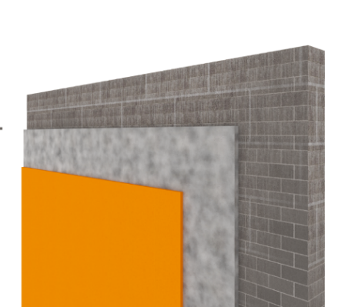

Fig. 20: The implementaton layer of the plaster benvid due to the named steps (By Authors)

**8. FPROB vs. its Predecessors**

This section embarks on a comparative analysis of FPROB, and its predecessors within the robotic realm (Table 5). Through a meticulous dissection of their respective capabilities, design philosophies, and quantifiable impacts on their abilities. This comparative framework will ultimately reveal the advancements embodied by FPROB, pushing the frontiers of automation within the construction industry.

Table 5 Comparative Analysis of FPROB Capabilities: Comparing FPROB with its predecessors (By Authors) (++ Ideally fulfilled + Well fulfilled 0 Partly fulfilled - Hardly fulfilled -- Not fulfilled)

|  |  |  |  |  |  |  |  |  |  |  |
| --- | --- | --- | --- | --- | --- | --- | --- | --- | --- | --- |
| **Robot Name** | **Façade Plastering Ability** | **Other Functionalities** | **Dependent Kinematic System for Façade Plastering** | **Suitable for Mid-rise Buildings** | **Indoor / Outdoor** | **Primary Phase** | **Maintenance Phase** | **Finishing Phase** | **Complex Facades** | **Total Score** |
| **FPROB** | ++ | 0 | ++ | + | Outdoor | ++ | + | + | - | 89 |
| **R1 (RPS) (****Ercan Jenny et al., 2023****)** | + | -- | -- | -- | Indoor | ++ | -- | -- | - | 40 |
| **R2 (****García-Rodríguez & Castillo-Castañeda, 2022****)** | -- | + | + | 0 | Outdoor | -- | 0 | -- | -- | 53 |
| **R3 (****Zulhazreen et al., 2021****)** | + | -- | -- | -- | Both | ++ | -- | 0 | -- | 41 |
| **R4 (Mantis) (****Kouzehgar et al., 2019****)** | -- | + | ++ | 0 | Outdoor | -- | -- | -- | -- | 58 |
| **R5 (TUPO) (****PLASTERING MACHINE, 2019****)** | + | - | -- | -- | Both | + | - | - | -- | 42 |
| **R6 (****Nansai et al., 2018****)** | -- | + | ++ | 0 | Outdoor | -- | -- | -- | 0 | 60 |
| **R7 (GR) (****Li & Jiang, 2018****)** | 0 | 0 | -- | -- | Indoor | ++ | - | - | - | 41 |
| **R8 (****Lee et al., 2018****)** | -- | + | ++ | + | Outdoor | -- | + | -- | - | 64 |
| **R9 (ACME) (****Automatic Plastering Robot with Acme Equipment, 2018****)** | + | - | -- | -- | Indoor | ++ | - | + | - | 46 |
| **R10 (Morphfaux) (****D. Bard et al., 2015****)** | + | - | -- | -- | Indoor | -- | -- | -- | + | 40 |
| **R11 (****Arivazhagan.B, 2014****)** | + | - | -- | -- | Both | + | - | + | -- | 44 |
| **R12 (AMPA) (****Pritschowa et al., 2011****)** | + | -- | - | - | Outdoor | + | - | - | -- | 49 |
| **R13 (CAFE) (****Gambao & Hernand, 2006****)** | -- | + | + | 0 | Outdoor | -- | -- | -- | -- | 51 |
| **R14 (SFR) (****Schraft et al., 2000****)** | + | - | + | 0 | Outdoor | + | - | - | -- | 67 |
| **R15 (****Forsberg et al., 1995****)** | + | - | - | - | Indoor | + | + | - | -- | 53 |
| **R16 (TAMIR) (****Warszawski & Rosenfeld, 1994****)** | + | - | - | -- | Indoor | + | - | - | 0 | 51 |

This analysis compares FPROB to its predecessors in the context of façade plastering. We identify key limitations of previous models and demonstrate how FPROB addresses them through significant improvements. Firstly, FPROB exhibits enhanced plastering capabilities thanks to a comprehensive understanding of its predecessors' limitations. This manifests in improved efficiency and precision during the application process. Secondly, FPROB's novel dependent kinematic system enables it to plaster mid-rise buildings, expanding its operational scope compared to previous models. This innovation represents a significant advancement in the field of robotic construction. Furthermore, FPROB boasts increased functionality across various operational phases, offering greater versatility and adaptability in diverse plastering scenarios.

While FPROB exhibits a comprehensive set of abilities, the challenge of plastering complex facades remains an area for further research and development. Addressing this limitation would unlock the full potential of FPROB and propel advancements in robotic construction technology.

**9. Improvements in Safety Factors and Measurements: Comparison with Common Procedure**

This section delves into the comparative analysis of robotic and traditional façade plastering methods through the lens of construction safety. By employing established construction safety measurement criteria, we aim to assess the inherent risks and potential benefits associated with each technique.

Table 6 Comparative Analysis of FPROB Safety: Comparing FPROB with its traditional procedure (By Authors) (++ Ideally fulfilled the safety + Well fulfilled the safety 0 Partly fulfilled the safety - Hardly fulfilled the safety -- Not fulfilled)

|  |  |  |  |  |  |  |  |  |  |  |
| --- | --- | --- | --- | --- | --- | --- | --- | --- | --- | --- |
| **Construction Method** | **Regulatory Compliance** | | | **Hazard Identification & Risk Assessment** | | **Personal Protective Equipment** | **Safe Work Procedures & Training** | **Engineering Controls & Safe Work Practices** | | **Total Score** |
| **No Permit Requirements** | **No Inspections** | **No Reporting Obligations** | **Falls** | **Falling Objects** | **Exposure to Hazards** | **Safe Work Practices** | **Ergonomic Risks** | **Fatigue Management** |
| **FPROB** | ++ | + | + | ++ | ++ | ++ | + | ++ | + | 94 |
| **Traditional Plastering** | 0 | + | - | -- | -- | - | 0 | - | 0 | 38 |

A comparative analysis of safety considerations in robotic versus traditional plastering methods reveals potential advantages offered by robotic automation. While both approaches possess inherent strengths and weaknesses regarding safety, robotic plastering presents promising avenues for enhancing safety measures within construction operations.

***9.1. Cost and safety Benefits***

Although a comprehensive cost analysis is beyond the scope of this study, a theoretical assessment suggests that the elimination of scaffolding systems and the enhancement of process efficiency through robotic façade automation may yield considerable returns on investment. Traditional plastering and façade execution methods heavily rely on manual labor and scaffolding, both of which are cost-intensive and pose substantial safety risks (Michał et al., 2018; Yin & Caldas, 2022). The implementation of robotic systems in such tasks not only addresses these issues but also offers tangible benefits in terms of labor optimization, time savings, and reduction in occupational hazards (Aghimien et al., 2022; Bhagwat et al., 2022).

By reducing or altogether removing the need for scaffolding, robotic plastering systems, such as those demonstrated by Arivazhagan (2014), Forsberg et al. (1995), and commercial solutions like Acme Equipment (2018), lower setup and dismantling time, material handling costs, and insurance premiums. These improvements translate into a more streamlined and safer construction workflow, aligning with industry calls for automation integration to achieve Construction 4.0 goals (Statsenko et al., 2022). Moreover, studies by Brosque and Fischer (2022) emphasize that façade-specific robots significantly impact not just direct costs but also enhance quality and schedule reliability, further strengthening the case for automation in high-repetition and large-scale projects.

While this study does not quantify such financial impacts empirically, future research will deploy simulation-based modeling and lifecycle cost analysis (LCC) to evaluate the economic feasibility of robotic plastering systems in comparison with conventional methods. These projections will draw from methods outlined in previous automation studies (Daniel, 2023; Linner et al., 2020) and incorporate safety performance frameworks developed in health and safety-focused research (Cheng et al., 2004; Nimo-Boakye, 2022; Okpala et al., 2023). The integration of performance indicators from robotic deployment scenarios, particularly in façade construction, will allow for a holistic financial, operational, and risk-adjusted evaluation in future empirical investigations.

**10. Conclusion**

This study presents the development of the Façade Plastering Robot (FPROB), an automated system designed for plastering flat surfaces. Building on a critical review of existing robotic solutions and their limitations, the FPROB introduces a novel kinematic design that enables autonomous operation across entire façades.

The system delivers substantial safety improvements by eliminating the need for scaffolding and addressing multiple safety dimensions, from regulatory compliance to risk mitigation and protective protocols, achieving a safety score of 94 versus 38 for traditional methods. Its design emphasizes mechanical reliability, adherence to standards, and practical functionality, demonstrating a 25% performance improvement over comparable systems.

Beyond plastering, the platform’s adaptability allows for applications in façade painting, cleaning, and maintenance. By bridging architecture, construction, electronics, and robotics, the FPROB exemplifies the transformative potential of automation in façade operations. Future research will address empirical testing and simulation-based performance validation, along with extensions to curved surface applications, sensor-enhanced adaptability, and multi-material operations. These directions aim to further solidify the FPROB’s role in advancing safety, efficiency, and quality in façade construction.

**11. Further Discussion**

Looking ahead, the FPROB represents a foundational prototype for future façade implementation robots, distinguished by its efficient approach to plastering flat surfaces. Beyond its immediate function, the FPROB’s design enables adaptability, positioning it as a versatile platform for advancing automation in construction. Its potential is further amplified through the integration of artificial intelligence (AI), which can extend its capabilities beyond plastering to support a broader range of construction tasks. AI integration may enhance decision-making processes, increase operational efficiency, and reduce both time and cost in construction workflows. Thus, the FPROB not only contributes to technical innovation but also signals a critical step toward the widespread adoption of intelligent automation in the built environment. Continued research focused on AI implementation and task expansion will be essential to fully realize its transformative potential.

**12. References**

Aghimien, D., Ikuabe, M., Aghimien, L. M., Aigbavboa, C., Ngcobo, N., & Yankah, J. (2022). PLS-SEM assessment of the impediments of robotics and automation deployment for effective construction health and safety. *Journal of Facilities Management*, *ahead-of-print*(ahead-of-print). <https://doi.org/10.1108/JFM-04-2022-0037>

Arivazhagan.B. (2014). AUTOMATIC PLASTERING MACHINE. *International Journal of Advanced Research in Electronics, Communication & Instrumentation Engineering and Development*, *2*(2), 29-35. <http://www.isrjournals.org/journals/electronics_instrumentation_journals/automaticplasteringmachine1406539797.pdf>

*Automatic Plastering Robot with Acme Equipment*. (2018). <https://www.youtube.com/watch?v=Qb8VB8-c1pg>

Bhagwat, K., Delhi, V. S. K., & Nanthagopalan, P. (2022). Construction safety performance measurement using a leading indicator-based jobsite safety inspection method: case study of a building construction project. *International Journal of Occupational Safety and Ergonomics*, *28*(4), 2645-2656. <https://doi.org/10.1080/10803548.2021.2012350>

Bock, T. (2006). Construction robotics. *Autonomous Robots*, *22*(3), 201-209. <https://doi.org/https://doi.org/10.1007/s10514-006-9008-5>

Bosch-Sijtsema, P., Claeson-Jonsson, C., Johansson, M., & Roupe, M. (2021). The hype factor of digital technologies in AEC. *Construction Innovation*, *21*(4), 899-916. <https://doi.org/10.1108/CI-01-2020-0002>

Brosque, C., & Fischer, M. (2022). Safety, quality, schedule, and cost impacts of ten construction robots. *Construction Robotics*, *6*(2), 163-186. <https://doi.org/10.1007/s41693-022-00072-5>

Cheng, E. W. L., Li, H., Fang, D., & Xie, F. (2004). Construction safety management: An exploratory study from China. *Construction Innovation: Information, Process, Management*, *4*, 229-241. <https://doi.org/10.1108/14714170410815114>

*corexy*. <https://www.corexy.com/theory.html>

D. Bard, J., Blackwood, D., Sekhar, N., & Smith, B. (2015). Decorative Robotic Plastering A Case Study of Real-Time Human Machine Collaboration in High-Skill Domains. *eCAADe 33*, *2*, 383-388.

Daniel, C. L. (2023). Construction Automation and Smart Buildings. <https://doi.org/10.1007/978-3-030-96729-1_48>

Darlow, G., Rotimi, J., & Shahzad, W. (2021). Automation in New Zealand's offsite construction (OSC): a status update. *Built Environment Project and Asset Management*, *ahead-of-print*. <https://doi.org/10.1108/BEPAM-11-2020-0174>

Ercan Jenny, S., Pietrasik, L. L., Sounigo, E., Tsai, P.-H., Gramazio, F., Kohler, M., Lloret-Fritschi, E., & Hutter, M. (2023). Continuous Mobile Thin-Layer On-Site Printing. *Automation in Construction*, *146*, 104634. <https://doi.org/https://doi.org/10.1016/j.autcon.2022.104634>

EU-ASHW. (2023). Occupational safety and health in Europe. In (pp. 164). Luxembourg: Publications Office of the European Union.

Forsberg, J., Graff, D., & Wernersson, Å. (1995). An Autonomous Plastering Robot for Walls and Ceilings. *IFAC Proceedings Volumes*, *28*(11), 301-306. <https://doi.org/10.1016/s1474-6670(17)46989-8>

Gambao, E., & Hernand, M. (2006, October). *Control System for a Semi-automatic Façade Cleaning Robot* 23 rd ISARC, Tokyo, Japan.

García-Rodríguez, G. M., & Castillo-Castañeda, E. (2022, 2022//). A Robot for Facade Cleaning Based on a Cartesian Configuration: Kinematic Analysis and Prototype Construction. Advances in Service and Industrial Robotics, Cham.

Gradeci, K., & Labonnote, N. (2019). On the potential of integrating Building Information Modelling (BIM) for the Additive Manufacturing (AM) of concrete structures. *Construction Innovation*, *ahead-of-print*. <https://doi.org/10.1108/CI-07-2019-0057>

Iturralde, K., Linner, T., & Bock, T. (2015). Comparison of Automated and Robotic Support Bodies for Building Facade Upgrading. *Chair of Building Realization and Robotics*. <https://mediatum.ub.tum.de/1484212>

Juan Manuel Davila Delgado, Lukumon Oyedele, Anuoluwapo Ajayi, Lukman Akanbi, Olugbenga Akinade, Muhammad Bilal, & Owolabi, H. (2019). Robotics and automated systems in construction: Understanding industryspecific challenges for adoption. *Journal of Building Engineering*, *26*, 100868. <https://doi.org/https://doi.org/10.1016/j.jobe.2019.100868>

Jung, K., Chu, B., & Hong, D. (2013). Robot-based construction automation: An application to steel beam assembly (Part II). *Automation in Construction*, *32*, 62-79. <https://doi.org/https://doi.org/10.1016/j.autcon.2012.12.011>

Karimi, H., Taylor, T., Goodrum, P., & Srinivasan, C. (2016). Quantitative analysis of the impact of craft worker availability on construction project safety performance. *Construction Innovation*, *16*, 307-322. <https://doi.org/10.1108/CI-10-2015-0050>

Kim, M. J., Chi, H.-L., Wang, X., & Ding, L. (2015). Automation and Robotics in Construction and Civil Engineering. *Journal of Intelligent & Robotic Systems*, *79*(3), 347-350. <https://doi.org/10.1007/s10846-015-0252-9>

Kouzehgar, M., Krishnasamy Tamilselvam, Y., Vega Heredia, M., & Rajesh Elara, M. (2019). Self-reconfigurable façade-cleaning robot equipped with deep-learning-based crack detection based on convolutional neural networks. *Automation in Construction*, *108*. <https://doi.org/https://doi.org/10.1016/j.autcon.2019.102959>

Lee, Y.-S., Kim, S.-H., Gil, M.-S., Lee, S.-H., Kang, M.-S., Jang, S.-H., Yu, B.-H., Ryu, B.-G., Hong, D., & Han, C.-S. (2018). The study on the integrated control system for curtain wall building façade cleaning robot. *Automation in Construction*, *94*, 39-46. <https://doi.org/https://doi.org/10.1016/j.autcon.2017.12.030>

Li, X., & Jiang, X. (2018, 5-8 Aug. 2018). Development of a Robot System for Applying Putty on Plastered Walls. 2018 IEEE International Conference on Mechatronics and Automation (ICMA),

Linner, T., Pan, W., Hu, R., Zhao, C., Iturralde, K., Taghavi, M., Trummer, J., Schlandt, M., & Bock, T. (2020). A technology management system for the development of single-task construction robots. *Construction Innovation*, *20*(1), 96-111. <https://doi.org/10.1108/CI-06-2019-0053>

Liu, Y., Ojha, A., Shayesteh, S., Jebelli, H., & Lee, S. (2022). Human-centric robotic manipulation in construction: generative adversarial networks based physiological computing mechanism to enable robots to perceive workers’ cognitive load. *Canadian Journal of Civil Engineering*, *50*(3), 224-238. <https://doi.org/10.1139/cjce-2021-0646>

Marat, K., Marat, K., Bulat, K., & Bulat, K. (2016). Scaffoldings for nonstandard facades. <https://doi.org/10.1051/matecconf/20168607007>

Michał, P., Pieńko, M., Robak, A., Robak, A., Błazik-Borowa, E., Ewa, B.-B., Jacek, S., & Szer, J. (2018). Safety Conditions Analysis of Scaffolding on Construction Sites. *Journal of Civil and Environmental Engineering*. <https://www.semanticscholar.org/paper/1f693de32bcca3038b1a62c1f944af5e1b579fc9>

Mishmastnehi, M., Van Driessche, A. E. S., Smales, G. J., Moya, A., & Stawski, T. M. (2023). Advanced materials engineering in historical gypsum plaster formulations. *Proceedings of the National Academy of Sciences*, *120*(7), e2208836120. <https://doi.org/10.1073/pnas.2208836120>

Miszczuk, A., Kaliszuk-Wietecka, A., & Truchan, K. (2019). Plasters on Facades, and the Possibility of Inter-layer Condensation. *IOP Conference Series: Materials Science and Engineering*, *661*(1), 012143. <https://doi.org/10.1088/1757-899X/661/1/012143>

Morales, G., Herbzman, Z., & Najafi, F. T. (1999). *Robots and Construction Automation* Proceedings of the 16th IAARC/IFAC/IEEE International Symposium on Automation and Robotics in Construction, Madrid, Spain.

Mousli, K., & Semprini, G. (2019). Passive systems in traditional houses in Middle East areas: solutions and effects of natural ventilation. *IOP Conference Series: Materials Science and Engineering*, *609*(3), 032056. <https://doi.org/10.1088/1757-899X/609/3/032056>

Nansai, S., Onodera, K., Veerajagadheswar, P., Rajesh Elara, M., & Iwase, M. (2018). Design and Experiment of a Novel Façade Cleaning Robot with a Biped Mechanism. *Applied Sciences*, *8*(12).

nbspJatin Kumar, P., nbspJatin Kumar, P., nbspNeetu, Y., nbspNeetu, Y., nbspNeeraj, S., & nbspNeeraj, S. (2016). Construction Safety Criteria Framework for Surat City. *International Journal of Engineering Development and Research*. <https://www.semanticscholar.org/paper/f2052a954f53568407fdf447ba4a701874d12dd6>

Nimo-Boakye, A. (2022). Reviewing Measuring Health And Safety Management Performance In The Construction Industry. *AFRICAN JOURNAL OF APPLIED RESEARCH*, *8*(1), 375-384. <https://doi.org/10.26437/ajar.03.2022.25>

Okpala, I., Nnaji, C., & Gambatese, J. (2023). Assessment Tool for Human–Robot Interaction Safety Risks during Construction Operations. *Journal of Construction Engineering and Management*, *149*(1), 04022145. <https://doi.org/10.1061/(ASCE)CO.1943-7862.0002432>

OSHA. (2023). Personal Protective Equipment. In (Vol. 3151-02R, pp. 46). United state of America: U.S. Department of Labor.

Parin-company. (2016). Product Guid. In P. Beton (Ed.).

Pershina, A., Ponomarenko, A., & Borodacheva, E. (2017). Modification of plaster compositions for building facade finishing with nanotechnological materials [10.1051/matecconf/201710603023]. *MATEC Web Conf.*, *106*. <https://doi.org/10.1051/matecconf/201710603023>

*PLASTERING MACHINE*. (2019). <https://www.tupomachinery.com/tupo-9-plastering-machine-p00027p1.html>

Pritschowa, G., Kurza, J., Zeihera, J., & McCormaca, S. E. (2011). On-Site Mobile Plastering Robot : A Practical Design Concept. 277-285. <https://www.semanticscholar.org/paper/f425410574683d67974ed7f3aaf3d0005ce66ef8>

Prof. Pravin, S., None Prof. Pravin, S., Prof. Vikash, A., None Prof. Vikash, A., Shivam, R., None Shivam, R., Shruti, T., None Shruti, T., Md Faisan, B., None Md Faisan, B., Md Waqar, W., None Md Waqar, W., Darshan, D., & None Darshan, D. (2022). Automation in Construction. *International Journal of Advanced Research in Science, Communication and Technology*. <https://doi.org/10.48175/ijarsct-3930>

Ranesi, A., Faria, P., & Veiga, M. D. (2021). Traditional and Modern Plasters for Built Heritage: Suitability and Contribution for Passive Relative Humidity Regulation. *Heritage*, *4*(3), 2337-2355.

Ravi Kumar, M., Abhilash, V., Chandra Sekhar, S., Mujhahid, S., & Akbar, A. (2019). Development and Fabrication of Semi-Automated Wall Plastering Machine. *Social Science Research Network*. <https://doi.org/10.2139/ssrn.3510945>

Saidi, S., Bock, T., & Georgoulas, C. (2016). *Robotics in Construction. In: Siciliano B., Khatib O. (eds) Springer Handbook of Robotics*. Springer, Cham. <https://doi.org/https://doi.org/10.1007/978-3-319-32552-1_57>

Schraft, R. D., Bräuning, U., Orlowski, T., & Hornemann, M. (2000). Automated cleaning of windows on standard facades. *Automation in Construction*, *9*(5-6), 489-501. <https://doi.org/https://doi.org/10.1016/s0926-5805(00)00060-1>

Sepasgozar, S., Loosemore, M., & Davis, S. (2016). Conceptualising information and equipment technology adoption in construction. *Engineering, Construction and Architectural Management*, *23*, 158-176. <https://doi.org/10.1108/ECAM-05-2015-0083>

Shreeranga, B., Shreeranga, B., Shreeranga, B., Nishchith, H., Nishchith, H., Kumar, U. R. A., Kumar, U. R. A., Ramith, R., Ramith, R., Mandala, N., Naveen, M. V., Jishnumohan Damodaran, N., & Jishnumohan Damodaran, N. (2017). Design and Fabrication of Wall Plastering Machine. *Journal of Mechanical Engineering and Automation*. <https://www.semanticscholar.org/paper/70ede0fff452ef2b3716c23de9a5e8a25f31efbc>

Statsenko, L., Samaraweera, A., Bakhshi, J., & Chileshe, N. (2022). Construction 4.0 technologies and applications: a systematic literature review of trends and potential areas for development. *Construction Innovation*. <https://doi.org/10.1108/CI-07-2021-0135>

Szer, I., Szer, I., Szer, J., Szer, J., Czarnocki, K., Czarnocki, K., Czarnocki, K., Krzysztof, C., Ewa, B. B., & Ewa, B.-B. (2018). Apparent Temperature Distribution on Scaffoldings during Construction Works. *World Academy of Science, Engineering and Technology, International Journal of Medical, Health, Biomedical, Bioengineering and Pharmaceutical Engineering*. <https://www.semanticscholar.org/paper/e851b6db5c2f02ea6f063dabc11f8ed7acb51b47>

Teizer, J. (2016). Right-time vs real-time pro-active construction safety and health system architecture. *Construction Innovation*, *16*(3), 253-280. <https://doi.org/10.1108/CI-10-2015-0049>

Warszawski, A., & Rosenfeld, Y. (1994). Robot for Interio Finishing Works in Building: Feasibility Analysis. *Journal of Construction Engineering and Management*, *120*(1), 132-151. <https://doi.org/doi:10.1061/(ASCE)0733-9364(1994)120:1(132>)

Yang, Y., & Pan, W. (2020). Automated guided vehicles in modular integrated construction: potentials and future directions. *Construction Innovation*, *ahead-of-print*. <https://doi.org/10.1108/CI-07-2019-0073>

Yin, Z., & Caldas, C. (2022). Scaffolding in industrial construction projects: current practices, issues, and potential solutions. *International Journal of Construction Management*, *22*(13), 2554-2563. <https://doi.org/10.1080/15623599.2020.1808562>

Yun, L. (2018, 2018/07/22). *Application of Automation and Robotics Technology in High-Rise Building Construction: An Overview* Proceedings of the 35th International Symposium on Automation and Robotics in Construction (ISARC), <https://www.iaarc.org/publications/fulltext/ISARC2018-Paper077.pdf>

Zhmud, V. A., Kondratiev, N. O., Kuznetsov, K. A., Trubin, V. G., & Dimitrov, L. V. (2018, may). *Application of ultrasonic sensor for measuring distances in robotics* Journal of Physics, <https://doi.org/10.1088/1742-6596/1015/3/032189>

Zulhazreen, M., Goh, C. H., Tan, W. J., Law, J. C., Radhwan, H., Dawi, M. S. I. M., Farizuan, M., & Asyahid, W. A. R. (2021). Design and Analysis of Auto-Plastering Machine. *Journal of Physics: Conference Series*, *2129*(1), 012031. <https://doi.org/10.1088/1742-6596/2129/1/012031>

1. Operational intervention criteria encompass instances where continuation poses safety risks exceeding established tolerances due to construction site factors. These factors primarily pertain to environmental conditions and potential external disturbances:

   *Windy Climates*: Excessive wind speeds exceeding predefined thresholds can compromise the robot's stability and potentially lead to loss of control or damage to the façade and the robot itself.

   *Inappropriate Weather*: Adverse weather conditions such as heavy rain, snowfall, or extreme temperatures can hinder sensor functionality, affect material properties, and create hazardous working conditions.

   *Earthquakes*: Seismic activity poses a significant threat to both the robot and the façade. The operator must be prepared to halt operations immediately in the event of an earthquake to safeguard against potential damage and injury.
2. Tolerance: During operation, the Façade Plastering Robot (FPR) system is programmed to maintain a predefined clearance of 5 centimeters from the façade surface. This clearance acts as a buffer zone, allowing for minor deviations due to environmental factors or operational adjustments without compromising safety or impacting plaster application quality. However, exceeding this tolerance threshold under unforeseen circumstances (e.g., strong winds, seismic activity) may trigger the operator to pause or abort the operation to ensure the safety of both the robot and the work environment.