**Investigation on Sustainable Traditional Architecture Strategies in Desert areas of Iran**

**Sanaz Litkouhi\***

Department of Art and Architecture, Payame Noor University, PO BOX 19395-3697 Tehran, Iran

slitkouhi@pnu.ac.ir

**Sanaz Esmaeili**

Payam Noor University, PO BOX 19395-3697 Tehran, Iran

**Abstract**

Climate has an important effect on operation of the traditional building architecture and its energy consumption in desert area of Iran. Absence of water and unpleasant climate of these regions compelled people to build their houses with some strategies based on effective energy expenditure. Therefore, builders try to use natural climatic strategies for confrontingwith hard situations.Narrow and droughty streets,much lofty air traps, upland walls,big water reservoirsand vaulted roofed chambersare the distinguished features of desert towns in Iran. Techniques and principles used in this architecture obviously have in themselves many new notions in sustainable architecture arena, show that considering the experiment in traditional architecture of desert regions, it is conceivable to create an ecological and sustainable architecture. The sustainable architecture that advances to a point in order to be permitted to attain its aims deems necessary the design off any building with the least detrimental effect on environment as well as design compatible with nature. It is focused on this paper the results sustainability caused by climatic elements in Iranian traditional architecture in desert regions. Iranian’s Hot-Arid zones architecture includes numerous unique features which comprehend aesthetic exigencies and environmental capacity.

**Keywords:** Sustainable architecture,Traditional strategies in Hot-Aid regions,energyefficiency,Natural environment.

**1. Introduction**

In the discussion of sustainable development and following it sustainable architecture, it is clear that each building should interact with its surrounded natural environment. The controversial and considerable part is how to interact and the type of intended measures. This is precisely something that was used years ago by Iranian people with especial skill. They have benefited from it by presenting technologies and especial principles in regard to natural resources and optimal use of energiesespeciallysolar and wind energies; and harmony with regional climate. But unfortunately, today it is forgotten and eradicated. [1]Energy is one of the highly important matters in today’s life. Through appropriate design of urban and residential spaces, energy expenditure could be minimized and at the same time, maximum use could be made of climatic factors. The significance of this mattercould be seen in hard climatic situations. The central Plateau of Iran with owns hot and dry climate is one of those regions.

Due to hard climatic situationof desert region of central part of Iran such as low humidity,high temperature in summer,unnecessary solar radiation and high differences between temperatures in the days and nights, , sandy wind, adoption of the houses with climate has become one of importantmatters in designing. Thus traditional architects have utilized simple inactive strategies to provide comfort condition in houses. [2]Builders tried to use natural climatic strategies for confrontingwith hardsituations. These strategies include distance between buildings,layout orientation, building orientation &configuration, introversion, very dense texture, climatic elements such as indigenous material, Wind catcher, Eyvan(porch), central courtyard, subterranean (Qanat) and etc.

When sustainable design and construction strategies of Iran’s traditional architecture are under survey, then it is possible to observe how traditional buildings and urban design in this region were designed in harmony with the naturalenvironment, topographical and climatic situations and how their design and construction could be integrate in today’s design methods. [3]Using natural factors in traditional architecture shows the compatibility of architectural design with natural environment. In traditional architecture of Iran, natural factors, climate and renewable energy resources have been used.It savesenergy and according the aims of sustainable architecture. Today the designers are seeking for different methods to decrease using the renewable sources and extending the natural environment in the residential complexes.In this research the principles of sustainable architecture and then climate strategies used in Iranian traditional architecturehave been specifically studied. The existence of spaces such as particular residential spaces for summer and winter, optimal use of wind and solar energy and soil thermal capacity are significant characteristics of houses in different regions of Iran and it has been attempted briefly to investigate some elements and techniques used in construction and architecture of Iranian traditional houses in hot-arid zones.

**2. Climate conditions in study area**

Iran is situated in a high-altitude plateau surrounded by connected ranges of mountains .The well-known deserts of Iran are at two major regions: Dasht-e-Kavir, and Kavir-e-Lut. They are both some of the most arid and maybe hottest areas of their kinds in the world. Kavir-e-Lut is the largest pit inside the Iranian plateau and probably one of the largest ones in the world. Kavir-e-Lut is a pit formed by broken layers of the earth .The maximum annual rainfall is about 100 mm there. The average height of this desert is almost 600 m above sea level (ASL). Dasht-e-Kavir is a geological pit almost at the north of Kavir-e-Lut. The minimum height of this desert is 400 m ASL. The main part of Dasht-e-Kavir is covered by sand and gravel and exposed to strong winds and storms that set salt-combined sand in motion like sea waves. At times, this phenomenon forms long sand hills of 40m high. The difference of temperature between days and nights during a year in Dasht-e-Kavir is between 0 and 70 degrees C. [4]Hard and cold winters, warm and dry summers, air humidity, herbal cover, very low rate of rain, so much difference between day and night temperature in salt desert and salt-desert border regions, the dusty winds are the outstanding climatic qualifications in this region. A large part of Iran suffer from hot and dry climate and the desert’s climate has made a bunch of problems for its residents but Iranians even with the limitations of that area had overcome the harsh climate situation with their creativity and innovations and had brought comfort for the residents.For example in a desert area, low humidity and high dry temperature must be considered reaching comfort zone condition. Most affordable way of dealing with such problems, is to construct compatibly to the climatic condition to make it possible to reduce the inside-buildings’ temperature by expending no money and energy.

**3. Morphology and Urban texture**

Iran's traditional architecture has been generated from a climate and the situation which it has grown on it, so that all existing spaces of these regions such as urban spaces of passages, yards and buildings are protected against the atmospheric factors especially unpleasant winds, and using pleasant winds and the sun's radiation are done according to some special arrangements.

Spiral and narrow allies with high walls in sides can reduce winds speed and provide shady area in passages. Like allies, building has enclosure too. They are surrounded by upland walls which make isolated from outside environment. These walls perform as a shell, protecting the building from intense sun ray and desert dust winds and in the cold season, from cold winds. There are few openings on the shell and in many cases the only opening is the main entrance. [5]In hot-arid region architecture of Iran the materials with heat capacity and resistance like mud, mud-brick and brick are used which are very effective in cooling and heating of internal spaces. These materials can be recycled thus, are very effective in the sustainability of Iranian architecture.

In very hot climatic conditions, the retardation is reached to infinity by constructing houses inside the hills or basements and by using this measure, the balanced thermal conditions of the depth of land are used. [6] Thermal balance between body and surrounding temperature is an important human’s health and comfort factor. The climate elements include sunlight, air temperature, humidity and airflow and considered as effective factors in desert architecture.[7] Urban texture in this climate has these factors:

1-Urban texture is very concentrative.

2- City spaces are completely surrounded.

3- Narrow irregular and some covered alleys.

4- Buildings are attached together.

5-Buildings have been located for using sunray and wind.[5]

**4. Local architecture of hot and dry climate of Iran**

**4.1 Climate design strategies**

**-Urban texture:**In those regions is dense and very compact. Urban spaces are completely enclosed and buildings are closely stuck so thermal loss is lowered.The urban morphology in hot arid regions is the cause of condensed and concentrated urban texture in which the main arteries are facing the desired wind and opposing undesired one.

**-Enclosed urban environment:**For the protection purpose and prevents high velocity winds and sand storms to penetrate into the town whole the city structure seems like a battlement fully enclosed from all directions which prevents the invasion of enemies from any side. For that reason the inside of the city is wholly differentfrom outside facing and the inside air is more static than the outside air.

- **Narrow and irregular alleys:** Alleysare narrow and with many turns, surrounded by tall walls; for, wide and direct alleys receive sunshine for long hours of day.Alleys constructed in broken lines, there is always a shadow side. Most alleys in Iran have roofs, sabot and ribs that in addition to resisting earthquake, they make shelters for passersby.Also in the desert alleys, except the entrance of the buildings, there are seldom any windows opened to the alley from houses and if there are any windows, it is very small and in height to prevent rays reflected from surface. Therefore, presence of elements such as half shelters (ribs) or difference in height, the alleys are saved from boring feature and give them special beauty.

***-* Distance between buildings:**In the design of traditional houses in the hot and dry area in Iran, there are several precautions taking against the hot climate. Houses are compressed to each other and have merged walls. This can minimize the contact of wall surfaces with air so there would be less thermal exchange between inside and outside of the buildings.[8] Houses are surrounded by high walls and isolated from the street. During the day, external walls of houses provide usually shady areas in narrow streets and especially in courtyards. By means of thick and heavy walls, coolenvironment in summer and warm environment in winter could be provided easily.

**-Building orientation & configuration:**Most of traditional houses are formed along an orientation which is near to the orientation of north to south. This allows the house to be divided into a part in the north and a part in the south of the house. Spaces located in the northern part observe more sunray and heat and become warmer where and can be used in cold seasons. In the opposite spaces located in southern part observes fewer sunrays and are shady so can provide a cooler place. They are mostly used in hot seasons.[9]The building design that is compatible with climate in relation to the sun for absorbing the maximum of heatingin winter as well as shadow in the summers and providing coolness and natural ventilation by the wind catchers andmaking the spaces in the fond of earth, has made the conditions to using the clean energies and to reduce the fossil energy consummation and consequently the environmental damage.

**4-2 Architectural design strategies**

Nowadays, most of houses were designed and constructed without enough respect to the both environmental and spiritual aspects of human being’s life. Residential architecture of these regions is an expressive sample of ecological architecture. Old architecture in hot and dry region is in accordance with region and regional factors such as desired and undesired winds, humidity, sun, etc. Planning each of the full and empty spaces like court yard with tall and shading walls, enclosed spaces, rooms in different directions, porches,wind-catchers and pond, basement and roof is for special hours of day and night of cold-average and hot season. And people can change their living space in harmony with regional changes. The houses of court yards with indicators like thick walls, porches, underground, wind catcher, vault and dome, are clear examples of architect understanding of environmental conditions. In fact, all traditional buildings of Iran, both in architectural and constructional fields, are planned in a way to have maximum of sun radiation during winter and maximum of shade during summer to use natural ventilation and to provide peace and comfort for the house residents.

The most important design parameters affecting indoor thermal comfort and energy conservation in building scale are distance between buildings, building form, building envelop, self-efficiency in building materials and optical and thermo-physical properties of the building envelope. All of these parameters are related to each other and the optimum values of each parameter should be determined depending on the values of the others and their optimum combination should be determined according to the climatic characteristic of the region.

**5. Buildings elements in hot and dry climate of Iran**

**5-1 Court yard**

One of Iranian people’s beliefs is valuing private life and its sanctity; this fact has made Iran architecture, to some extent,introverted. Introversion is a concept which has existed in Iran architecture as a principle and is observable in various forms. In the warm and dry climate of Iran, this Introversion has shown itself in terms of central courtyard.Central courtyard can be introduced as a sign of sustainable architecture and as a proper pattern for this aim. In this region the creation of court yard in the middle of building and preparing pond and flower-bed increases humidity in building environment and the mud brick and brick walls, which are made thick, due to heavy weight of arched and dome vaults, acting like a thermal condenser, decrease the variance of temperature during day and night. It causes close relation between habitants and natural elements. Net counting the beauty it provides, by shading and increasing relative humidity it helps the comfort condition of yard and is one of the major elements of natural cooling system of the house. Presence of wind and sun radiation provides convenience condition in different orientations in different seasons. Wind causes natural ventilation in hot seasons.Finally by making all openings facing to relatively humid space of yard and blocking external walls of building (except entrance door), the internal and external space connection is cut as for as possible and a suitable microclimate is constructed for human comfort in hot arid region. Almost all of the houses in this region have one courtyard or more and the rooms and other spaces of the house take place around the courtyard and have openings to it. The courtyard is functioning an element to unite the different space of the house.[1]

Embedded spaces in the central courtyard building structure are very flexible, and it is compatible with the sustainable architect principles. Most of traditional buildings have pool and area for growing plants and trees.

Pools in the traditional houses had various shapes and forms; sometimes they were six-sided and sometimes twelve-sided, but most of the times they were rectangular. Pools were often constructed along one of the main axis of the house, in a way that the length of the pool is located along the length of the house.[10] In the warm climates, pools were often made in two sections and were located in the coming and going passage, so that the wind passing above the water of these pools may provide a cool and desired weather for the residents in the warm summer days.The sonic and aquatic properties of the water are other positive and effective aspects of pools and in fact the existence of water in the pool acts as a hidden barrier and blocking against the sound passing inside and out-side the house.[11]

**5-2 Wind catcher**

Wind catcher is one of the other elements of hot & dry architecture which is used for cooling and ventilation of internal spaces. Traditional architects were obliged to rely on natural energies to render the inside condition of the buildings pleasant. Air trap was the specific feature of architecture in the majority of warm regions.

Air traps were normally in a suitable location in the house according to the size of the building, the number of air traps that was necessary to cool the summer apartment. In cities where suitable wind is blowing from a specific direction the air trap is open at one direction and closed from the other three directions. Wind-catcher is as constant complex which acts both by sucking & pulling. The basis of action is that wind blowing is used to suck the cold air to the inside of building and the reaction of it is used for sending out the hot and pollutant air from inside the building. Air trap is like a chimney whose end is in the underground and the top is set over a specific height on the roof. At the upper outlet many small openers or ducts are set. At the end of the air trap at the bottom of the door often a pool is set whose water was provided by Qanats (aqueducts).[12]

Once the wind come in contact with walls of internal wings of wind-catcher inevitably it descends and enters the building space, on the other hand the holes or vents of wind-catcher on the opposite side of wind blowing to the sucking and give the hot & pollutant air of building to the wind. In ancient times and in traditional buildings in arid and dry regions the air trap functioned like the present modern air conditioning system. As a result they cause a balance of temperature at night and bestow the attracted warmth to the cold night air. They are built with their long ventilation shafts positioned to catch any hint of a passing breeze to channel down into the house.

For traditional architects, the wind is an important factor in the design of a building. They consider the wind's effect on the thermal comfort through convection or ventilation and the penetration of air in interior spaces. This wind tower catches cool winds at a higher level, in all directions, and leads them into the interior spaces.

Wind tower influences on creating natural cooling in two ways: air movement and displacement or evaporative cooling in an overall classification. In warm and dry regions, besides warm weather, dryness and low rate of moisture are among those factors that endanger the thermal convenience. Thus, the wind towers in these regions try to optimize the cooling operation by evaporative cooling. The evaporation phenomenon takes place in the wind towers when the water surface is under the wind flow. As the water turn from liquid state to gas state, attracts a remarkable rate of heat from it’s around environment and in this way it helps to the environment cooling.[14][15]

Wind towers in the warm and dry climates can be seen in the Iranian architecture face in vertical element. This architectural element shows the compatibility of architectural design with natural environment.

Design of wind towers depends on the shape of building, speed and direction of wind, height of wind tower, air passing section and wind tower location. The most important advantage of wind towers is the air conditioning and air cooling without any use of electrical energy.[16] These element lead a desired wind to the inner spaces of the construction through their vertical pores, and apply the stable energy of the environment by connecting the architecture to its around environment and entering a dynamic and environment-based flow into the construction. Natural ventilation has become an attractive technique and important method for reducing energy consumption and cost. This environmental technique also helps traditional architect to provide acceptable indoor environmental quality and maintain a healthy, comfortable and productive indoor climate without using mechanical ventilation.[17] Wind catchers has been used in different residential, religious and service buildings and the remains still stand in hot and dry regions of Iran in central and southern cities like Yazd, Esfahan, Kashan, Boushehr, Gheshm Island, etc.

**5-3 Roof (Dome & arched roofs instead flat roofs)**

In this region to structured reasons, the dome shape roofing of buildings has some thermo-physical reasons. The domes, which were used as covering roof for mosques, water reservoirs and Bazar (shopping center), are another type of roof in hot and dry regions. Due to having convex and unbalanced surface the impact angle of sunbeam on dome and arched roof is different from one point to another, and a part of it always remainsin shade during morning and afternoon times, for this reason the curved shape is suitable for releasing and emitting sunbeams and waves during night and ithelps to the night cooling. If the flat roofs are usedin hot & dryregions it is usually paved with square shape bricks called paved bricks. These bricks receive the most radiations of sun. Early morning it starts to increase and late afternoon it decreases gradually. This action causes the change in sun radiation intensity and radiation angle.

**5-4 Porch (Eyvan)**

Porch (Eyvan), semi-open areas, is used to create shaded and cool living spaces during the day. The Eyvan, three side closed passageway in front of the ‘‘rooms’’, permits a common life inside. Usually they are oriented to the south [3]. Especially south and east oriented porches are very cool and shady places for summer afternoons. The porchsemi-open colonnade arranged in the courtyard always provides shady areas. Use of additional elements such as porches and sunshadesalong with vertical or horizontal sunlight controller blades, curtains, and latticed windows with colored glasses are the ways to control the depth and amount of sunlight into the building in summer and winter based on resident needs to solar energy.While, the proper angle of solar radiation in winter makes the penetration of sunlight possible into the building in the best way.

5-5 **Introversion**

Work on the appearance was avoided and instead work on the inside and internal estates has also been drawn in this arena by some acquaintances with architecture, as far as Iranian architecture is not seen from exterior facade something more than mud but inside has a beautiful world; and so it is called introverted architecture.One of the important and effective factors in shaping thearchitecture in an area is climate. Synchronizing with new world architecture andapplying new energies in the building and constructing in coordination with climatecansave energyand reduce environmental pollutions.[18]

**5-6 The indigenous materials consistent with climate**

The use of local materials to reduce energy expenditure during the occupation is a wise decision since it will also reduce the initial embodied energy as well as cost, especially transportation cost.[19]Those materials which are labor intensive rather than energy intensive in their extraction, dressing and erection being more environmentally friendly and equitable in terms of the distribution of resources, are more acceptable for purposes of sustainability. The used materials such as clay and mud in this region require only man’s efforts to make a structurefrom them. Due to very hot temperatures, the building materials absorb heat from the sun and make it available later when the sun goes down. In other words, this energy is retained in the walls about 8 hours and the other parts of the building envelope and is gradually transferred to the inner compartments. In cold seasons the absorbed temperature serves as an isolation barrier which protects the inside air from being affected by the chilly winter desert climate specially at nights because during daytime the temperature is absorbed by the walls and the building and although the air is cold outside, the inside of the house remains warm. Building from earth does least damage to the environment: It is close to the building site and so does not involve transport energy costs. Moreover, when no longer required, the building decomposes naturally and without pollution, return to the earth from where it comes before. Nevertheless, it can stimulate the imagination as an analogy for sustainable development.Indigenousmaterial selection, compatibility, embodied energy, application of passive energy and design environmental strategies in waste and technology management concerning the impacts in the environment are all concepts that are part of sustainable building design.[20]

**5-7 Four season housing**

The optimization of energy consumption in residential buildings is the design of four seasons housing, the most obvious form of traditional buildings in consistency with climate which have been made in hot and dry regions. These buildings have particular residential spaces for summer and winter that are the best forms and possible combinations of components in a building for climate modification. Thus, north and sunny side of courtyard which was warmer, was used in winter and was famous as particular residential space for winter. Vice versa, south side of courtyard and back to the sun was used in summer and known as particular residential space for summer.[5] There were below wind catcher spaces and throne room which had higher elevation and lighter volume than particular residential space for winter. This was because of using wind, air conditioning and better air circulation; and cooling this space in summer.Particular residential space for winter consists of three-door room, five-door room and a space that it’s coherent is cut off in the corners. It also settled on the main axis and two communication spaces which can be corridor and the upstairs in two sides of the saloon consist of three door, sash or Tehrani and two-door room.[1] This seasonal movement occurring between spaces in the house is one of the human responses to climate condition. Houses in this region are living places for all four seasons of the year. Occupants may move to a more suitable place when season changes in order to advantage a better situation.

**5-8Aqueducts (Qanats)**

The most important problem in the desert, as we all know, is water. So they had to find a way to bring water to the city, without any kind of modern technology or pumping system. A passive system "Qanat" is used there.

A mother-well was dug in a place far from the city where theycouldreachtothewatertablemaybe100meters underground,theydugotherwellstodirectwatertoward thecity,withminimum possible gradient. There arethousandsofwaterwellsconnected together byQanats. Usingtheslope oftheearththeycouldbringwaterclosetothesurfacein thecity. [21]At the presenttime, althoughtheQanatshavebeenreplacedbythemoderndeepwells,the agriculturallands ofmany Iraniancities inthecentralpart ofIransuchasYazd,Kerman,Naein,Kashan,Shiraz, andIsfahanarestillbenefitedfromtheQanats. Many residential buildings, bazaars, schools andmosqueshavealsobeenconnected tothe network of Qanatsby gutters,grooves, rivulets and ponds. Also these urban facilities arethemainwater resourceforirrigationoftheagronomicallandsofthecity and neighboring areas.Inaddition somepeople alsousedtotakeadvantages of the waterofQanats fortheir personaluse such as drinking,cleaningandirrigating their small gardens.

**5-9 Water reservoirs**

Freezing places and cisterns (water reservoirs) are among other urban elements which are often seen in desert cities. Major parts of structures of the cisterns are:[22]

1. Water reservoirs, all or a part of them are built underground; because, it first adds to the resistance of walls and second, soil as the natural insulation around the reservoirs, prevents the temperature penetration.

2. Reservoirs coating: Major coating of cisterns is dome shape so the heat ascends and the reservoir side is kept cool. On the other hand, in most hours of day, one side of the dome is in the shadow.

3. Ventilation and wind catcher: They discharge the hot water below cisterns dome and establish air flow to keep the water healthy and cool.

4. Staircase and water foots.

5. Decorative threshold.

**6. Principles of sustainable architecture**

For classifying a building in the category of sustainable buildings, some principles should be observed as follows:

1. The first principle: Energy Conservation

2. The second principle: Climate coordination

3. The third principle: To reduce use of new resources

4. The fourth principle: To meet residents needs

5. The fifth principle: Coordination with site

6. The sixth principle: Generalization[23]

**7. Results**

**7-1 Sustainable traditional elements**

Principals of sustainable urban designwould placepriorityontheconformityandre-useofexistingbuilding, infrastructure androads, togetherwiththere-use of recycledbuildingmaterandcomponent.Sustainabilityin any urban development is nodamagingtotheenvironmentandwhichcontributesto the city’s ability to sustain its social and economic structures. According to an accepted definitionof sustainabledevelopment,theobjectivesforanagendaofurbandesignina regime ofsustainabledevelopmentwouldemphasize conservation of boththenatural and built environments. Sustainable developmentplacesapremiumonthe conservationof naturalresources,wildlifeandhabitatprotection.Italso presumeshighdegreesof self-sufficiencyatalllevelsof settlement structure.Wherenew development is necessary, the pattern of such developmentanditsstructuresshouldminimizetheuse ofenergyconsumedintravelbetweennecessaryactivities andalsointheoperationofthebuildings.

**7-1-1 Reduction the Environmental Damage**

Nowadays, all new buildings cause environmental damage, no matter how carefully they are designed. Much of the atmospheric pollution is caused by the burning of fossil fuels in the creation of energy to support city life. This energy is used in the building of city structures; during the lifetime of the structure; and in the transportation of people and goods between and within cities. It is considered that two types of energy used in the building: 1)energy used to construct the building and 2)energy used to service, operate and maintain the building. The pollution causing environmental damage can be attributed directly to the building process. Moreover, using the local materials and no wasting materials by reusing them is reducing the transport between the site and the resource, making the restoration possibility of building help to reduce the environmental pollutions.

**7-1-2 Reusing and Recycling**

One of the most principles of sustainability is conservation and reuse of buildings, infrastructure and materials and also design buildings for flexibility so that a mix of uses can be accommodated under the same roof and so that floor plans are “robust”, in the sense that they can be adapted for different uses during the lifetime of the building.[24] A building, which can be used for many different purposes and is easily adapted to serve many different activities during its lifetime, has a flexibility that reduces the need for destruction and rebuilding to serve changing needs reuse and recycling of building materials and components in the construction of new building and infrastructure was the main tradition of this regional building. Nowadays, the flexibility of ancient buildings has allowed them to be re-used with the different functions such as school, office, restaurant, and hotel in the traditional textures.

**7-1-3 Correct use and utilization of the wind of any climate in the ventilation**

The rotation of the building in proper winds direction or opposite direction of the annoying winds and making wind catcher one or more ways in proper winds direction and preventing the entry of annoying winds (when winds carrying sand in the deserts) show the correct use of wind by ancients. Therefore, building orientation, proper use of wind and air circulation in many ancient traditional houses have had a useful and effective assistance for ventilation of the house and heating interior spaces in different seasons.

**8. Discussion and Conclusion**

The experiences at the 20th century showed us that we couldn’t have the today’s cities immediately and with ignoring that has happened in the past. The fact is that the most of modernists forgot by making the no time and no locality spaces. The reactions to modern architecture and modern planning have led to a new appreciation of the traditional city and its urban form. Sustainable development is more likely to occur when local communities take responsibility for their own particular environment, though to take such responsibilities seriously effective power must return to local communities. It is effective public participation that is also the foundation of good urban design.

By examining and comparing main components of sustainability with the architecture of traditional houses, it was clarified that the architecture of these houses are in full compliance with the principles of sustainable architecture. Lack of attention to sustainability foundations of traditional Iranian architecture and the factors affecting on it; have shown an unstable condition in existing architectural structure. Forgotten solutions in design of sustainable residential space should be identified and updated regarding to available technology and used in design of buildings. Sustainable strategies which gained from simultaneous intelligent design of climate and architecture are valuable from aspect of sustainability. In fact, the ecology of building emphasizes on its ability to combine with climatic factors and transform it into spatial qualities and comfort form. Using these strategies and solutions in architecture not only is a major step toward sustainable development but also will largely restore and strengthen the lost architectural and urban native structures.

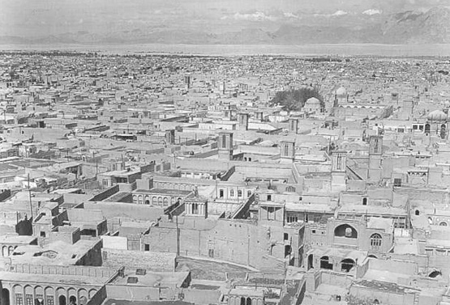

Fig. 1: Yazd city context in hot and dry region of Fig.2: Yazd city view.

Iran (From Google Earth).

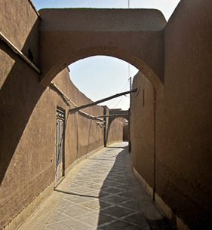

Fig. 3: Narrow and irregular street in compact texture Fig.4: Entrance of house in Kashan

OfKashan (From Google Earth).

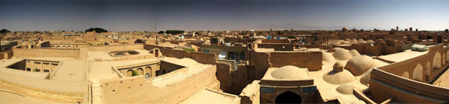

Fig. 5: View of houses in Yazd

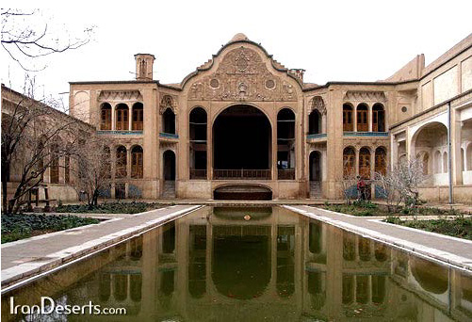

Fig. 6: Courtyard in house of Kashan

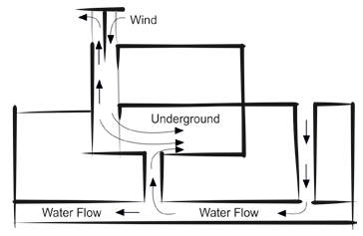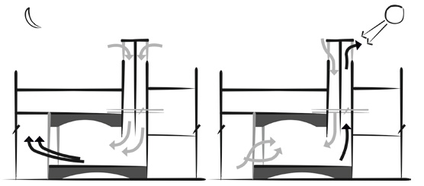

Fig. 7: The function of a wind catcher. Fig. 8: Wind catcher function during day and night[13].

Design by Author

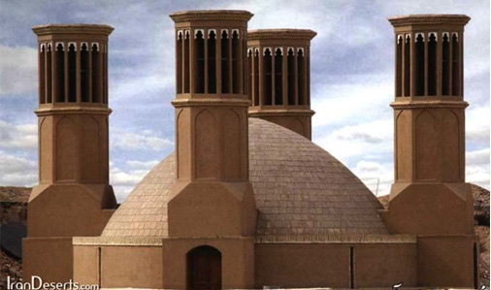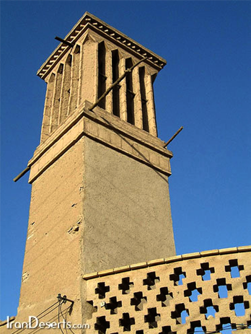

Fig. 9: Wind catchers

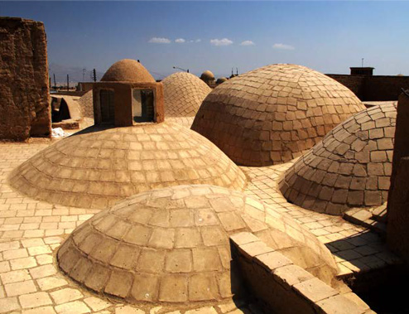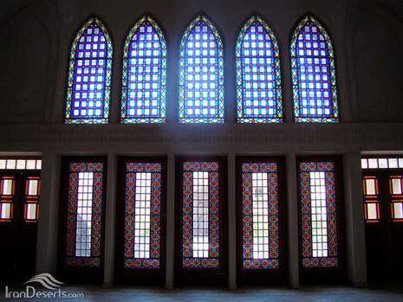

Fig. 10: The dome roof Fig. 11: hot-dry regions windows

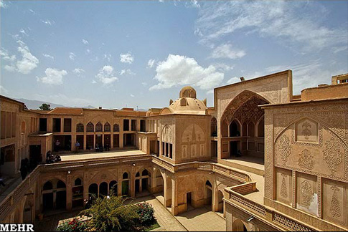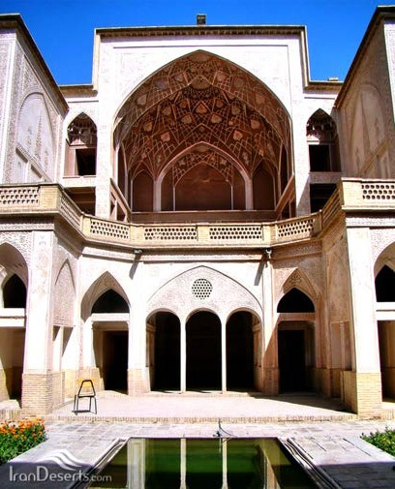

Fig.12: Porch & pool in hot-dry regions houses Fig. 13: Introversion in hot-dry region houses

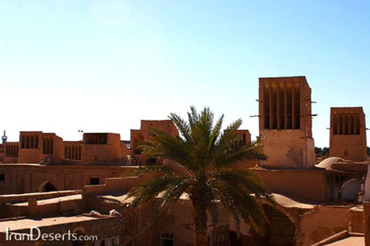

Fig. 14: Material in desert architecture

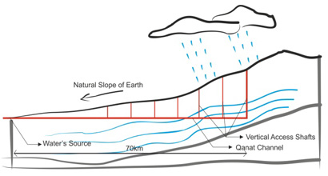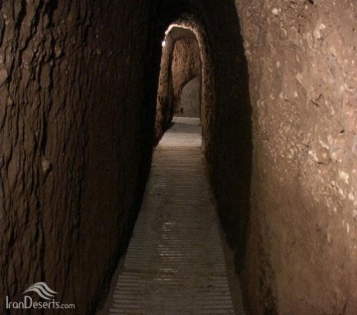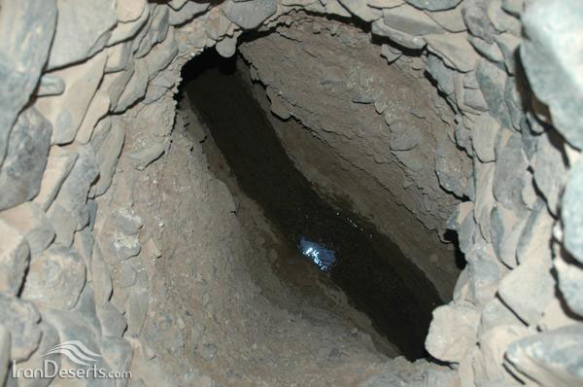

Fig. 15: Qanat's system Fig. 16: Shafts, Manholes and Tunnel of Qanat

Design by Author

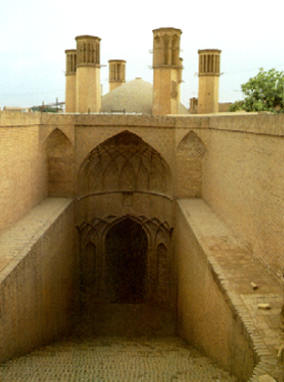

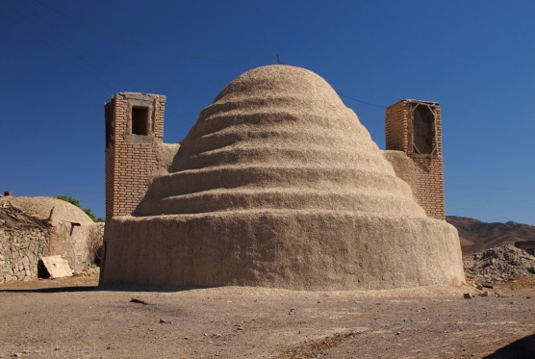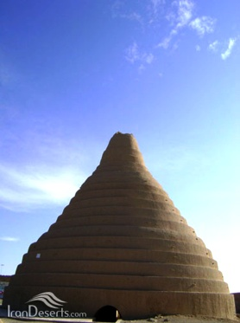

Fig. 17: six wind catcher Abanbar in Yazd Fig. 18: Yakhchal (ice maker)

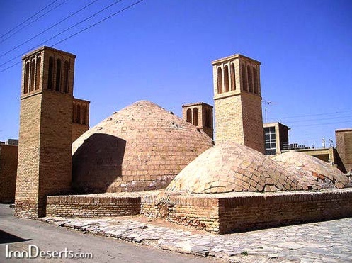

Fig. 19: Abanbar

**REFERENCES**

1. Zandieh, Mahdi and Parvardinejad, Samira,Sustainable development and its concept in Iranresidential architecture, journal of housing andrural environment, 2011.

2. Tavassoli, M., *Urban structure and architecture in the hot arid zone ofIran*, Payam and Pivand-e-no Publications, 2002.

3. Manioglu, G.,Yilmaz, Z., (2007). Energy efficientdesign strategies in the hot dry area of Turkey. The

journal of Building and Environment: Elsevier.

4. Quinn, J. A. (2008). Desert biomes.Westport, Conn., Greenwood Press.

5. Ghobadian, Vahid, Climate survey of traditionalIranian buildings, Tehran universitypublication, fifth edition, 2009, Tehran.

6. Kasmaie.M, Climate and Architecture, 2003.

7. Bahadori, M.N. Passive Cooling Systems in Iranian Architecture,Scientific American , vole, 283, No. 2, Feb. 1978.

8. A'zami A., Yasrebi S.H., &Salehipoor A., Climatic responsive architecture in hot and dryregions of Iran 2005.

9. Memarian G. &Sadoughi A. , Application of access graphs and home culture: Examiningfactors relative to climate and privacy in Iranian houses, Scientific Research and Essays Vol. 6(30),9 December 2011.

10. Tofan,S., Recognition of water’s role in Iran’ traditional courtyardhouses,Garden view, 6, 2006.

11. Nayebi, F., Life in the courtyard, Nezhat-Tehran, 2002.

12. M.N. Bahadori. (1978). “Passive cooling systems inIranian architecture”, Scientific American 2(238).

13. Azami, A. (2005). "Badgir in traditional Iranianarchitecture". 5th international conference on Passive

and Low Energy Cooling for the Built Environment.Santorini, Greece.

14. Akhtarkavan, M., Alikhani, A., Ghiasvand, J., Akhtarkavan, H., Gekas,V., Mastorakis, N., et al. ,*Assessing Sustainable Adaptive Re_Use OfHistorical Buildings*,2008.

15. Mahmody,M., Wind technology in Iran,architecture, 16,2008.

16. Mazidi, M., Dehghani, A., &Aghanajafi, C. *The study of the air flow inwind towers for the old buildings air conditioning*.

17. H. Montazeri, F. Montazeri, R. Azizian, S. Mostafavi, *Two-sided windcatcher performance evaluation using experimental, numerical andanalytical modeling*, Renewable Energy 35 (2010).

18. Memarian, GholamHossein, Familiarity with Iranresidential architecture introverted typology,

SoroushDanesh Publication, 2009.

19. Utama, A., Gheewala, S. H., (2009). Influence ofmaterial selection on energy demand in residential

houses. The Journal of Material and Design: Elsevier.

20. Vakili, Ali, Boussabaine, Abdel Halim, (2006). "Quality Concept in Persian Precedent Architecture: ALesson in Eco-Building Design", PLEA2006 – The23rd Conference on Passive and Low EnergyArchitecture, Geneva: Switzerland.

21. A. Behnia, *Qanat: Construction and Mintenance*, Tehran, TEH: University, 1988.

22.YusefKiani Mohammad, Iranian Architecture Islamic Period, Paper by Dr. ParvizVarjavand, 7th publication, 2008.

23. Ghiasvand, Javad, The interaction ofarchitecture and new energies (sustainable),journal of Rah vaSakhteman, No.38, 2007.

24. H. Fathy, “Natural Energy and VernacularArchitecture,November 1986.

25. Fig 2: [www.middleeastinfo.org](http://www.middleeastinfo.org)

26. Fig 4: www.fararu.com

27. Fig 5/ Fig 10: www.ukgser.com

28. Fig 6/ Fig. 9/ Fig 11/ Fig 12/ Fig 14/ Fig 16/ Fig 18/ Fig 19: [www.irandeserts.com](http://www.irandeserts.com)

29. Fig 13: [www.mehrnews.com](http://www.mehrnews.com)

30. Fig 17: www.arshid.ir