**Reconceptualizing the Notion of Place in Light of Hippocampal Function and Cognitive Prototypes**  
Case Study: Perception of Place Among Residents and Pilgrims in Mashhad

**Somaye Sabouri ¹[1]*, Naser Barati ²**

*1 Ph.D. Candidate in Landscape Architecture, Faculty of Fine Arts, University of Tehran, Tehran, Iran.*

2 *Associate Professor, Urban Planning Department, International soore University, Tehran, Iran.*

***Abstract***

*The concept of place has long been regarded as a foundational notion in urban design, environmental psychology, and cognitive science. Yet, the mental and neural mechanisms underlying place perception have rarely been examined through an interdisciplinary lens. This study focuses on the role of the hippocampal neural structure in the mental representation of place, exploring the links between episodic memory, emotion, lived experience, and the semantic dimensions of place. Drawing on cognitive and semantic theories, prototypes are considered as primary, central configurations that shape individual perceptions of place.*

*The research was designed at both conceptual and empirical levels. Conceptually, the notions of “place,” “hippocampus,” and “prototype” were analyzed from the perspectives of neuroscience, environmental psychology, and phenomenology. Empirically, free word-association data were collected from 60 residents and pilgrims in the vicinity of the Imam Reza Shrine in Mashhad. The data were analyzed using content analysis, with internal validity ensured through theoretical saturation.*

*Findings reveal that mental associations with the term " place" fall into four main clusters: personal spaces, sacred and spiritual spaces, functional spaces, and value concepts of place. Due to early theoretical saturation and the limited diversity of responses, place-based experiences in the contemporary urban context appear restricted, with urban spaces often failing to evoke memory, meaning, or sensory engagement—particularly among residents. Pilgrims exhibit more intense emotional engagement but a narrower spatial focus, whereas residents experience a broader spatial range with less emotional intensity.*

*In conclusion, place perception is not merely a spatial or functional phenomenon but is deeply rooted in the interweaving of memory, emotion, and daily life, underpinned by the hippocampus. By integrating concepts from cognitive neuroscience with place theory, this study opens new horizons for understanding human experience of place and for developing urban design approaches grounded in memory and perception.*

***Keywords****: hippocampus, place, prototype, spatial memory, lived experience, urban design*

**INTRODUCTION**

Place is more than a physical entity; it is a psychological and cognitive construct shaped through time, experience, and memory. Our understanding of place is not merely the result of sensory observation, but emerges from a complex interplay between perception, memory, emotion, and cultural meaning. In recent years, interdisciplinary approaches to the study of place have transcended the traditional boundaries of geography and urban design, entering the realm of cognitive neuroscience. Among the structures attracting growing scholarly attention is the **hippocampus**, known for its central role in processing episodic memory, spatial navigation, and emotional associations (Zeidman & Maguire, 2016). The hippocampus is not only responsible for storing and retrieving memories, but also serves as a core mechanism in the formation of mental representations of environments, routes, and places (Moser et al., 2017).

Concurrently, cognitive and semantic theories have introduced the concept of the **prototype** as a central cognitive schema in processes of perception and mental categorization (Rosch & LLOYD, 1978). Prototypes act as idealized mental images—cognitive reference points—against which new experiences are interpreted and integrated. When an individual encounters a place, perception occurs not in isolation but in relation to previous experiences, emotions, and memories—memories that are neurologically organized within the hippocampus and activated through these prototypical structures.

From this perspective, the perception of place is not solely determined by its physical features, but is deeply informed by lived memory, emotional resonance, and cultural-semantic significance. This is particularly evident in urban contexts imbued with historical and religious meaning, such as the **Razavi Shrine precinct** in Mashhad. Yet, most prior studies in urban design have concentrated on functional, formal, or aesthetic aspects of place, while giving relatively little attention to the mental and cognitive mechanisms that underpin the emergence of meaning and attachment to place.

This research, by focusing on the connection between the hippocampus and mental prototypes of place, seeks to analyze the spatial associations evoked by residents living near the Razavi Shrine. It aims to illuminate how memory, emotion, and lived experience contribute to the formation of place perception. The overarching goal is to reinterpret the concept of place through the lenses of cognitive neuroscience and mental semantics—an effort to uncover the processes that render place a vivid, meaningful experience within the human mind.

Such an approach opens up new possibilities for urban design—one in which spaces are conceived not only through functional or aesthetic lenses, but also in alignment with memory-driven, emotionally attuned, and experientially grounded cognitive mechanisms. This perspective enables the creation of emotionally resonant, memory-evoking, and meaningful environments—spaces that are embedded in the collective memory of residents and that become real places in their lived worlds.

**LITERATURE REVIEW**

The concept of place has long occupied a central position in fields such as philosophy, geography, psychology, and architecture, where it is approached as a lived and meaningful construct that transcends mere physical containment. From a phenomenological perspective, Relph (1976) and Tuan (1977) contrasted placeness with anonymous, placeless spaces, emphasizing the roles of memory, perception, and emotion in shaping place meaning. In a similar vein, Casey (2000) argued that places not only aid in recollection but also function as carriers of memory in lived experience, reinforcing emotional and cognitive bonds. Scannell and Gifford (2010), in their tripartite framework of place attachment, further highlighted the cognitive, affective, and social components—such as individual and collective memories—that contribute to the formation of psychological ties to place.

In cognitive theory, the notion of the prototype has been introduced as a foundational model for conceptual categorization. Rosch (1975) and Lakoff and Johnson (1980) demonstrated that human cognition organizes concepts around salient exemplars or prototypes. Expanding on this, Barsalou (1999), through his theory of perceptual symbol systems, posited that concepts are formed through the reactivation of sensorimotor experiences—a perspective that has inspired interdisciplinary work in cognitive linguistics and urban design. This approach frames place perception as a process deeply rooted in embodied and cognitive experiences, which can be linked to neural representations.

Cognitive neuroscience research has highlighted the central role of the **hippocampus** in memory processing and spatial perception. O'keefe and Nadel (1978), in introducing the concept of the cognitive map, identified the hippocampus as crucial in the mental representation of spatial environments. This finding was reinforced by Maguire et al. (2000) in their study of London taxi drivers, which showed that the hippocampus structures spatial memory. More recent studies—such as those by Zeidman and Maguire (2016) and Ekstrom and Ranganath (2018)—have demonstrated that the hippocampus integrates sensory, emotional, and spatial experiences, forming the basis for mental representations of place and time.

Theves et al. (2019), in a study published in eLife, reported that the anterior hippocampus contributes to the abstraction of prototypical concepts from empirical data, organizing conceptual similarity within a cognitive space. This suggests the hippocampus has the capacity to process not only concrete spatial data but also abstract and conceptual representations.

Beyond spatial navigation, the hippocampus has been shown to encode non-spatial dimensions as well. Aronov et al. (2017), in Nature, found that neurons in the hippocampus and entorhinal cortex can represent continuous non-spatial variables—such as auditory frequencies—in a map-like format that overlaps with the activity of place and grid cells. These findings underscore the hippocampus’s ability to encode multidimensional experiential structures that extend into the sensory and cognitive domains.

Similarly, Sridhar et al. (2023), in a comprehensive review in Frontiers in Human Neuroscience, demonstrated that the hippocampus plays a pivotal role in declarative memory by integrating new experiences into existing cognitive schemas and facilitating systems-level consolidation—the transfer of memories to the neocortex. This function is particularly relevant for understanding memory-rich, emotionally resonant experiences of place, and thus holds implications for memory-informed spatial design.

The distinctive contribution of the present study lies in its integration of semantic theories of place—particularly the concept of prototype from cognitive and linguistic frameworks—with empirical findings from neuroscience. It seeks to demonstrate how deeply embedded cognitive and mnemonic structures within the hippocampus influence the perception of place, framing it not as mere spatial presence but as a lived, affective, and memory-infused representation.

In contrast to prior research, which has largely explored the hippocampus in the context of navigation or spatial memory, this study centers on the formation of place prototypes in the human mind, drawing on lived experience, cultural context, and collective memory. Through fieldwork conducted in the socially and religiously significant setting of the Razavi Shrine precinct, the research aims to empirically validate this theoretical synthesis. This interdisciplinary approach bridges cognitive neuroscience, conceptual semantics, and place theory in urban anthropology—offering a novel framework for reinterpreting place in contemporary urban studies.

**METHODOLOGY**

This study adopts a qualitative and analytical approach to explore the relationship between cognitive memory—focusing specifically on the hippocampus—and the subjective perception of place within an urban context. The research methodology was structured at two levels: conceptual and empirical.

At the first level (conceptual analysis), an interdisciplinary perspective was employed to examine key concepts such as *prototype*, *episodic memory*, *hippocampus*, and *placeness* through the lenses of cognitive neuroscience, semantics, phenomenology, and environmental psychology. This stage involved a systematic review of theoretical literature, with an emphasis on authoritative scholarly sources indexed in databases such as **Scopus**, **PubMed**, **ScienceDirect**, and **Google Scholar**.

At the second level (field study), the **free word association** technique was applied. The study population comprised residents and pilgrims present in public spaces surrounding the Imam Reza Holy Shrine. Participants were selected through convenience sampling, with random recruitment among passersby in the shrine’s immediate vicinity. The demographic composition included men and women in roughly equal proportions, aged between 18 and 65, and representing diverse educational backgrounds (from high school diplomas to postgraduate degrees). Each participant was asked to state the first three words or images that came to mind in response to the term *place*. Responses were recorded in written form.

Data analysis was conducted using thematic content analysis. Initially, responses were manually coded based on both explicit and implicit meanings. Similar codes were then grouped into overarching themes and interpreted. To ensure internal validity, the principle of theoretical saturation was applied; that is, after analyzing approximately 60 responses, the recurrence of concepts and a decline in the diversity of associations indicated that thematic saturation had been reached. For visual representation and frequency comparison of the themes, Python programming tools and visualization libraries (**Matplotlib** and **Seaborn**) were used to generate bar and pie charts illustrating both percentage and absolute frequencies.

Finally, the empirical findings were integrated with the conceptual framework to elucidate how hippocampal memory and lived experience mediate the formation of mental prototypes of place and how these prototypes influence the quality of place perception in urban environments.

It should be noted that this study was conducted in the immediate vicinity of the Imam Reza Holy Shrine, within the cultural–religious context of Mashhad, where the city’s identity is closely tied to this spiritual center. This context plays a significant role in shaping place perception, lived experience, and mental imagery of urban spaces. Accordingly, this factor should be considered when interpreting the findings. Moreover, although efforts were made to ensure diversity in sampling, the number of participants was limited due to the attainment of theoretical saturation. Consequently, the results should not be generalized to all demographic and cultural groups, and must instead be interpreted within the specific cultural and demographic parameters of this setting.

**THEORETICAL FRAMEWORK**

**1. Place as a Subjective and Experiential Phenomenon**

The concept of *place* extends far beyond its physical or geometric coordinates; it is a mental construct that becomes embodied through human experience. People perceive place not merely through its form and structure, but through lived interactions, memories, emotional associations, and social relations. In this sense, place functions as a cognitive–affective construct that is activated through processes of perception and experience. Perspectives such as Yi-Fu Tuan’s, in *Space and Place: The Perspective of Experience* (1977), emphasize that place is not only something in which we exist, but something we actively *create* through the act of dwelling and experiencing. These mental constructions may be shaped by memories, attachments, emotional events, or even feelings of safety—factors that ultimately render place a component of one’s personal identity.

Approaching place through the lenses of phenomenology, semantics, and psychology allows for the analysis of its deeper layers—beyond physical or geographic descriptions. Phenomenologists such as Edward Relph, in *Place and Placelessness* (1976), argue that place can only be understood through lived experience. According to Relph, *placelessness* emerges when urban spaces are constructed without anchors in memory and personal experience.

A central distinction within philosophical and architectural theory is that between *space* and *place*. *Space* is often conceptualized as a neutral, abstract backdrop—devoid of emotional or human qualities—whereas *place* is space that has been endowed with meaning through lived experience and human presence. Marc Augé (1995), in *Non-Places: Introduction to an Anthropology of Supermodernity*, articulates this distinction clearly: non-places—such as airports or highways—are spaces devoid of memory, identity, or emotional connection. In contrast, places are imbued with meaning, memory, and a sense of belonging.

The notion of *placeness* has also been theorized by Christian Norberg-Schulz (1980), who, in *Genius Loci*, asserts that meaning is the very *spirit of place*. Space becomes place only when it is infused with cultural, historical, sensory, or personal significance. Meaning, therefore, is not an external attribute but the fundamental condition that transforms space into place.

In other words, place is not merely something *seen* or *occupied*; it is something *known* and *lived*. Contemporary analyses increasingly stress that place is not solely a physical phenomenon but a cognitive and cultural one as well. Understanding place requires the mind’s capacity to recognize, interpret, and store spatial patterns, elements, and relationships. Thus, the study of *place* does not remain confined to architecture, but intersects with cognitive science, environmental psychology, and cultural studies.

### 2. The Structure and Function of the Hippocampus in Relation to Memory, Experience, and Place

The **hippocampus**, a seahorse-shaped structure located deep within the medial temporal lobe of both cerebral hemispheres, plays a central role in memory formation and spatial orientation. As a core component of the **limbic system**, the hippocampus operates at the intersection of three fundamental domains—**memory**, **emotion**, and **spatial navigation**. Over recent decades, its pivotal role in organizing and integrating information through complex neural processes has been extensively documented in neuroscience research (Eichenbaum & Cohen, 2004).

Anatomically, the hippocampus comprises several key subregions: the **dentate gyrus**, **CA3**, **CA1**, and the **subiculum**. These regions are interconnected through a specialized neural circuit known as the **trisynaptic pathway**, which processes incoming information through a sequential relay—from the cerebral cortex to the dentate gyrus, then to CA3 and CA1—ultimately producing a distinct pattern of neural activity that encodes experiences in a durable, retrievable form (Figure 1)(Andersen et al., 2007).

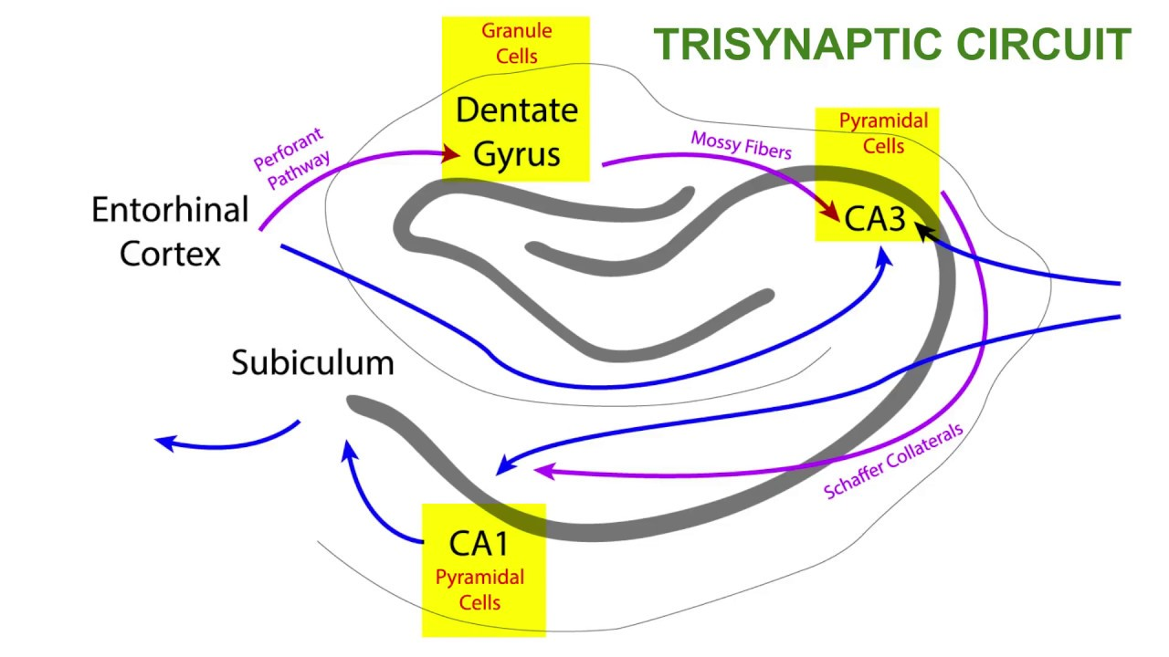

**Figure 1.** Schematic representation of the hippocampus circuit, Source: Neural Academy, 2018.

Neuroimaging studies, including functional MRI (fMRI), as well as lesion-based research, have revealed the hippocampus to be embedded in a broad network of connections with brain regions such as the **amygdala** (involved in emotional processing), the **prefrontal cortex** (involved in decision-making), and the **neocortex** (involved in higher-order perception and cognition) (Pessoa, 2017). These interconnected systems allow for the **multilayered integration of sensory, emotional, and spatial data**, enabling environments to be internalized not merely as physical coordinates but as lived, emotionally resonant experiences.

Crucially, the hippocampus plays a foundational role in the **encoding, storage, and retrieval of episodic memory**—the type of memory associated with personally experienced events and contexts. This structure not only records spatial positions, but also integrates temporal sequences and emotional tones into a unified experiential whole (Eichenbaum, 2017). In this respect, the hippocampus functions as a kind of neurological diary, organizing personal experiences within a spatial-temporal-emotional framework.

### 2.1. The Hippocampus and Spatial Representation: From Place Cells to the Cognitive Map Theory

A foundational breakthrough in understanding the spatial function of the hippocampus came with the discovery of place cells by John O’Keefe and Jonathan Dostrovsky in the early 1970s. They demonstrated that in the brains of rodents, specific neurons within the CA1 region of the hippocampus become selectively active when the animal occupies a particular location in its environment (O'Keefe & Dostrovsky, 1971). This discovery suggested that the hippocampus operates as a kind of cognitive map—a mental model that encodes and represents spatial locations and the relationships among them based on lived experience (O'keefe & Nadel, 1978).

Subsequent neuroimaging studies in humans, particularly those using fMRI, confirmed that hippocampal activity significantly increases during navigation, route recall, and the recognition of familiar environments. Moreover, structural brain imaging revealed that individuals with extensive spatial experience—such as London taxi drivers—exhibit increased hippocampal volume, offering compelling evidence for the structure’s neuroplasticity in response to environmental demands (Maguire et al., 2000).

Later discoveries further refined this model. Researchers identified several additional types of spatially responsive neurons: head direction cells, boundary cells, and most notably, grid cells in the entorhinal cortex, a region intricately connected to the hippocampus. Discovered by May-Britt and Edvard Moser, grid cells exhibit regular, hexagonally patterned firing across the environment, effectively functioning as an internal coordinate system that facilitates spatial mapping and navigation (Moser et al., 2008).

Together, these neurons—particularly place and grid cells—have revealed the hippocampus to be not only a repository for spatial memory, but also a dynamic engine for **spatial orientation**, **environmental exploration**, and even **the mental simulation of imagined or future locations**. This latter function points to a deep connection between memory, imagination, and spatial cognition. Research shows that hippocampal activation also occurs when individuals mentally simulate a route or recall a memory situated in a specific place (Addis et al., 2007), underscoring the hippocampus’s role in processing experiences that extend beyond immediate physical reality.

For instance, when a person undergoes an emotionally charged experience—such as joy or fear—in a particular location, the hippocampus encodes that event in conjunction with its spatial, temporal, and emotional context. This capacity forms the neural foundation of what is referred to as placeness—a felt sense of familiarity or attachment to specific environments that derive meaning not from geometry alone, but from personal and emotional associations.

In this sense, the hippocampus does not perceive place merely as a set of coordinates or physical boundaries. Rather, it integrates spatial memory with emotional and episodic memory to create **meaning-laden spatial representations**. This multi-dimensional synthesis is what enables the hippocampus to play a central role in the formation of place perception and spatial identity—concepts that are crucial not only for individual cognition but also for disciplines such as urban design and environmental psychology (Figure 2).

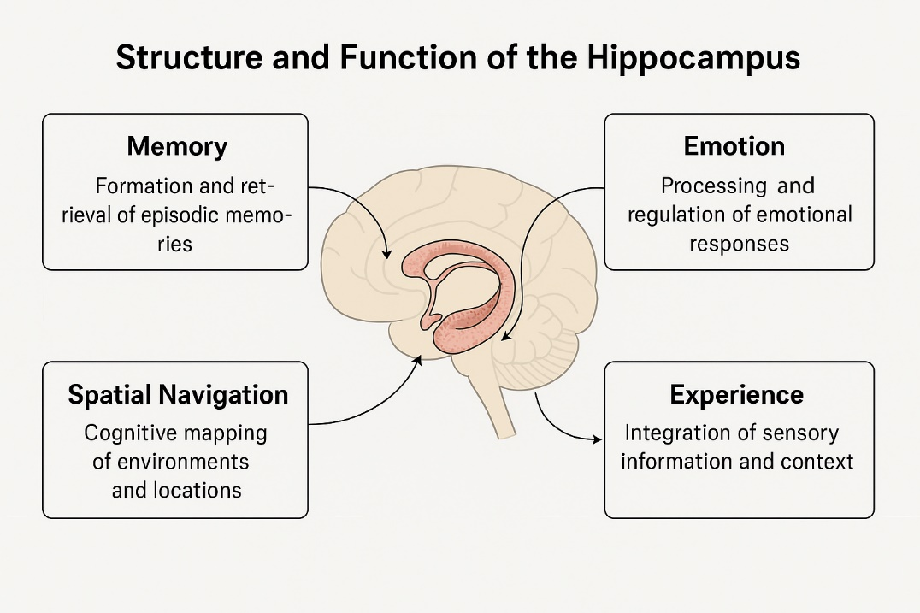

**Figure 2.** Function and Structure of Hippocampus, Source: Author.

### 3. The Concept of Prototype and Its Role in the Cognitive Mechanisms of the Hippocampus

One of the key concepts in the study of cognition and perception is the idea of the prototype—a construct that originated in cognitive psychology and conceptual linguistics and has since expanded into disciplines such as design, architecture, and place theory. At its simplest, a prototype refers to a standard exemplar or ideal type of a conceptual category, against which other members of the category are evaluated based on their degree of similarity (Rosch, 1975).

In Eleanor Rosch’s theory of conceptual categorization, prototypes are mental structures through which people classify objects, spaces, or experiences. Contrary to classical approaches that defined concepts by a fixed set of necessary and sufficient features, prototype theory emphasizes family resemblance and graded membership. In other words, within any conceptual category, some members are more central or typical than others—a distinction that plays a significant role in how we perceive and interpret environmental spaces.

In relation to place, prototypes serve as cognitive frameworks formed through experience, repetition, memory, and cultural encoding. These frameworks are activated during the recognition, comparison, and interpretation of spatial environments. Rather than relying solely on sensory perception of spatial elements, individuals comprehend place through the activation of internal conceptual structures developed through prior exposure to similar places. These structures are grounded in mental imagery, memory traces, recurring spatial patterns, and emotionally charged associations.

Bennardo (2002) study, which employed mental map-drawing techniques among participants in Tonga, illustrates that spatial representations in the mind do not mirror objective geographic maps but instead reflect internal schemas shaped by lived experience, social relations, and cultural models. Similarly, Quesnot et al. (2024), in their research on lagoon fishermen in Moorea, found that spatial mental representations were informed not only by environmental cues—such as coral reefs or water color—but also by culturally coded knowledge and selective withholding of precise fishing locations. These patterns exemplify cultural prototypes that play a decisive role in the cognitive organization of space.

This cognitive structuring aligns closely with the function of the **hippocampus**, which operates as a core mechanism in spatial navigation, episodic memory, and the construction of cognitive maps. Just as place cells and grid cells in the hippocampus organize spatial information based on prior experience (O'keefe & Nadel, 1978); (Moser et al., 2008), **prototypes** function as conceptual intermediaries between sensory perception and semantic memory. From this perspective, prototypes can be understood as cognitive templates that the hippocampus uses to encode, store, and retrieve spatial experiences.

For example, an individual who has repeatedly experienced traditional Iranian environments—such as historic bazaars, narrow alleyways, or courtyard houses—will likely interpret new environments sharing similar features more quickly and meaningfully. This is because their mental prototype for such places is already established and readily activated. The new environment is not just recognized spatially, but encoded as familiar, pleasant, or even intimate. In this way, the relationship between prototype and place forms a bridge between perception and memory, between experience and identity.

In sum, the prototype provides a cognitive mechanism for meaningful spatial perception, playing a foundational role in shaping place identity. Simultaneously, it complements the hippocampus’s role in linking memory with spatial representation. This conceptual overlap between spatial cognition and architectural perception offers a novel lens through which to understand lived experiences of place, especially in culturally and historically specific contexts.

Thus, we may conclude that the relationship between prototypes and the hippocampus constitutes a bridge between memory and meaning in the experience of place. Prototypes, as recurring conceptual units, form stabilized mental schemas that the hippocampus draws upon during spatial encoding. Conversely, the hippocampus reinforces place-based experiences and contributes to the formation of new spatial prototypes by forging sensory-conceptual associations. This bidirectional relationship suggests that experiencing place is not merely a matter of perceiving space, but rather an ongoing process of reconstructing conceptual and mnemonic structures—mediated by prototypes and enacted through hippocampal processing.

### Case Study: Perception of Place Among Residents and Pilgrims in Mashhad

To identify the underlying conceptual patterns shaping participants’ perception of place, data obtained through the free word association technique were examined using **cluster analysis** (Figure 3). This analysis grouped responses into four primary conceptual clusters based on semantic and functional similarities:

1. **Personal Place** – Encompassing spaces directly linked to daily life and individual identity, such as home, place of residence, or locations evoking memories of family and close relationships. This cluster reflects the central role of familiar and private environments in structuring individuals’ spatial memory.
2. **Sacred/Spiritual Place** – Including symbolically charged locations with religious or spiritual significance, such as the Imam Reza Holy Shrine, mosques, or other pilgrimage sites where ritual and spiritual experiences are formed. This cluster captures the sacred and ritual dimension of place perception.
3. **Functional Place** – Covering spaces perceived primarily through their practical functions or their role within the physical fabric of the city and everyday interactions, such as workplaces, shopping centers, educational and recreational facilities, as well as public urban areas like alleys, streets, the city, and neighborhoods. This cluster highlights the functional dimension of place and its connection to routine engagement with the urban context.
4. **Value Concepts of Place** – Comprising words and associations that convey the emotional or evaluative qualities of a place, such as safety, tranquility, belonging, comfort, and warmth and intimacy. This cluster reflects the affective and value-laden layers of place experience, shaped through the interplay of memory and emotion.

This four-part typology indicates that place perception in Mashhad is shaped not solely by the physical or functional attributes of space, but by an interplay of **personal**, **spiritual**, **functional**, and **value-based** dimensions. This framework provides a basis for subsequent comparative analysis of perceptual differences between pilgrims and local residents.

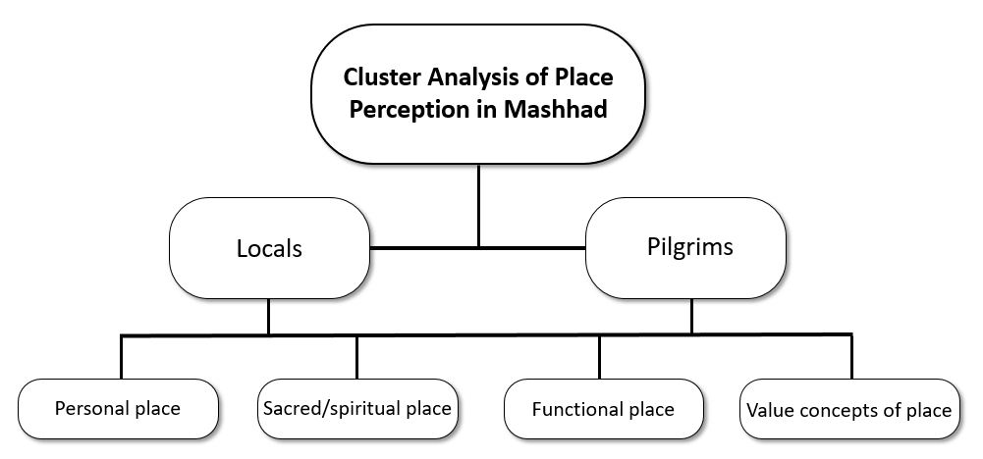

**Figure 3.** Cluster Analysis of Place Perception in Mashhad, Source: Author.

The cluster analysis results indicate that **Personal Places** accounted for the largest share of place perception, with a frequency of 55 (30.55%). **Functional Places** followed closely, with a frequency of 51 (28.33%), nearly equal to the first cluster, highlighting the significance of practical and functional aspects of space in shaping spatial experience, particularly for local residents. In third place, the two clusters **Sacred/Spiritual Places** and **Value Concepts of Place** each had a frequency of 37 (20.55%). The former reflects the prominence of religious sites—especially the Imam Reza Holy Shrine—in the minds of pilgrims, while the latter captures the emotional and value-laden qualities of place, such as safety, tranquility, belonging, and warmth of social relationships, which enrich the qualitative experience of space. This distribution suggests that although personal and functional spaces are the most frequently cited, the spiritual and value-based layers also play a crucial role in enhancing the richness of place perception (Figure 4).

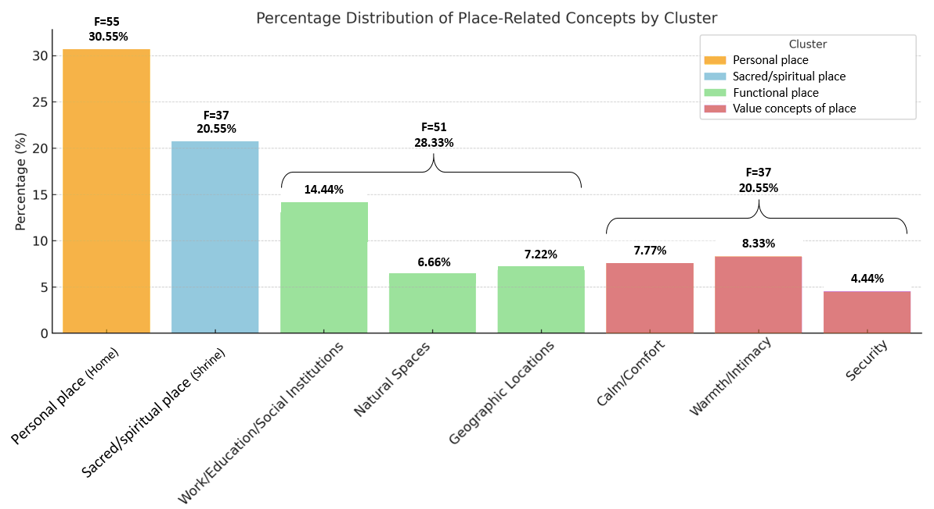

**Figure 4.** Percentage Distribution of Place-Related Concepts by Cluster, Source: Author.

**Analysis of Place Perception among Pilgrims and Local Residents within a Cultural and Temporal Context**

Mashhad, as one of the most important pilgrimage cities in the Islamic world, presents a complex cultural and social context that profoundly shapes place perception. The city simultaneously merges its religious and pilgrimage identity with residential and economic functions, evolving into a metropolis with dual roles. The presence of the **Imam Reza Holy Shrine** as both the spiritual and physical center of the city has not only created a shared cognitive anchor for all urban users but also structured the city’s spatial layout and movement flows. Mashhad’s pilgrimage-driven economy, based on services catering to pilgrims—such as hotels, markets, transportation, and access routes—directly affects the city’s spatial and functional organization, altering patterns of space usage for both pilgrims and local residents. This transformation has reduced the proportion of spaces allocated to local needs in the vicinity of the shrine and has significantly impacted the quality of daily life for residents (Sabouri & Saboonchi, 2022).

Temporal rhythms of urban experience further differentiate these two groups. Pilgrims typically visit Mashhad for a short duration with specific objectives, focusing their attention on a limited set of prominent sites. In contrast, local residents experience the city in a long-term, repetitive, and everyday manner. This variation in duration and type of engagement leads to distinct mental reference points and spatial priorities for each group (Figure 5).

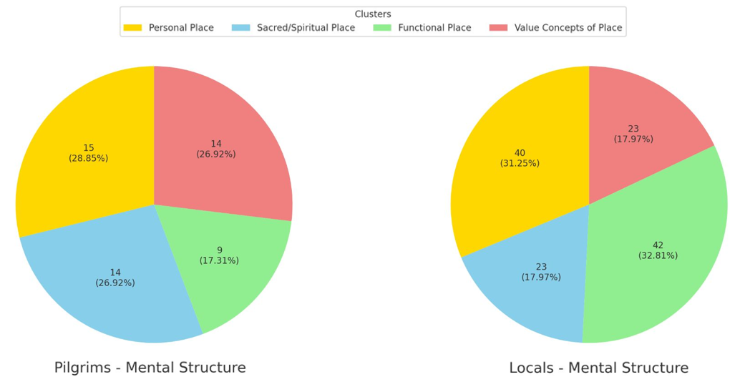

**Figure 5.** Comparison of the Mental Structures of Pilgrims and Local Residents, Source: Author.

The analysis of perceptual differences between pilgrims and local residents indicates that these differences are not merely the outcome of individual choices or personal preferences, but are rooted in the cultural and temporal context of spatial experience. Pilgrims, who usually enter the city briefly and with a ritual-oriented perspective, undergo an intense experience imbued with symbolic and sacred meaning—a perception shaped in advance by the culture and religious narratives of their home cities, previous pilgrimage memories, and anticipatory symbolic expectations. For them, locations such as the shrine are not merely physical sites but transcendental destinations charged with religious intent and emotion. In contrast, local residents have continuous, diverse, and everyday experiences of urban spaces, where homes, workplaces, schools, and daily routes serve as emotional and functional nodes of significance. This sustained presence results in a more layered mental image of places, less concentrated on a single sacred point. Graphical data further corroborate this pattern (Figure 5): pilgrims allocate most of their associations to personal, value-laden, and sacred places, assigning lower prominence to functional spaces, whereas local residents emphasize functional and personal spaces, placing sacred and value-laden places lower in priority. Consequently, pilgrims’ perceptions are characterized by higher emotional intensity but encompass a more limited spatial scope, whereas residents’ experiences are broader and more varied but carry less emotional charge. This distinction emerges from the continuous interplay between temporal patterns of experience and the cultural depth of perception, providing a multi-layered framework for the formation of mental structures in both groups. This framework can be further analyzed through cognitive and neuroscientific theories, particularly regarding the role of the **hippocampus** in consolidating episodic and spatial memories—a perspective explored in detail in the following sections.

**Mental and Emotional Representation of Place in Pilgrim and Resident Experience**

**1. Home as the Prototype of a Personal and Secure Place**

With **55 mentions**, home emerged as the most frequently cited place (Figure 4), especially among local residents (**40 cases**), suggesting its function as a **central prototype** in spatial and emotional memory (Figure 6). In this context, home is not merely a physical structure but a deeply internalized, meaningful unit associated with emotions such as comfort, ownership, safety, and the repetition of lived experiences. The hippocampus, through the repeated encoding of daily interactions within the home, transforms it into a **cognitive and emotional reference point** against which other spaces are interpreted and evaluated (Eichenbaum, 2017); (Rosch, 1975).

Thus, home is more strongly consolidated in the minds of residents than of pilgrims, playing a pivotal role in place recognition and spatial identity formation. This supports the idea that place perception is not only tied to physical exposure but is profoundly shaped by affective continuity, familiarity, and the frequency of embodied experiences—factors that reinforce the prototype of home as a stable, secure, and emotionally charged spatial anchor in the cognitive landscape.

### 2. The Relationship Between Home and the Shrine in Resident and Pilgrim Perception: Reflecting Divergent Place-Based Experiences

Among **pilgrims**, home was mentioned 15 times, and the shrine 14 times—a relatively balanced distribution that suggests both locations hold nearly equal weight in their spatial and emotional memory (Figure 5, 6). Notably, pilgrims did not refer to home as a temporary lodging in the pilgrimage city, but rather as their actual, rooted home in their city of origin. This indicates that the experience of being in Mashhad and visiting the shrine activates their spatial memory in such a way that two parallel yet contrasting spatial poles are mentally co-present: one symbolic and transcendent (the shrine), the other emotional and enduring (home).

From a neuroscientific perspective, the **hippocampus**, which is responsible for encoding and integrating spatial and emotional memories, processes this brief yet intense experience in a manner that embeds both locations as salient semantic nodes within the individual's cognitive network. In this dual structure, the pilgrim oscillates between two experiential axes: belonging (to home, family, and personal roots) and sacredness (to the shrine, spirituality, and ritual practice). The resulting memory is not only shaped by physical repetition but consolidated through its depth of meaning—creating a dual, yet mutually reinforcing, place-memory system.

In contrast, among **local residents**, home was mentioned 40 times, while the shrine appeared only 23 times—a marked imbalance that points to a divergence in place perception (Figure 5, 6). This discrepancy cannot simply be attributed to habituation or prolonged exposure. Rather, it suggests a **functional and cognitive detachment** between the shrine and the everyday life of residents. In other words, for locals, the shrine no longer functions as an integrated part of daily urban life but has assumed a static, symbolic presence within memory—less of a dynamic place and more of a ritualized landmark.

This spatial and psychological separation can be observed at both the **physical** and **perceptual** levels. Physically, the shrine’s surrounding structures—security barriers, protective walls, restricted zones, and functional buffers—have contributed to its spatial disconnection from the urban fabric. Cognitively, the shrine has gradually become an **isolated ritual space**, experienced primarily through abstract religious meanings, rather than through the routines of daily life.

Conversely, home for local residents continues to serve as the primary locus of emotion, memory, and everyday action. Within the functional structure of the hippocampus, home represents a spatial anchor for the reproduction of emotional relationships, episodic memory, and embodied experience—far more so than any other site. Thus, the higher frequency of "home" among residents' responses reflects the consolidation of deep emotional and long-term memory associated with this place. Meanwhile, the shrine appears to have receded to a more symbolic, ritualized status—detached from the context of everyday urban experience.

These findings, when interpreted through theories of placeness (Relph, 1976), affirm that the experience of place is not solely dependent on physical attributes, but is closely tied to memory systems, emotional engagement, and patterns of lived behavior. Moreover, they suggest that **symbolic religious spaces**, in order to maintain a lasting presence in both mind and community, must sustain an organic connection to the rhythms of everyday life. Otherwise, they risk being reduced to isolated ritual sites—divorced from the cultural and emotional ecosystems that give place its lasting meaning.

**3. Functional Spaces: Workplaces, Educational Institutions, and Geographical or Natural Settings**

Although less frequently mentioned, *functional spaces*—such as workplaces, educational institutions, and natural or geographical locations—were cited far more often by **residents** than by **pilgrims**, with a ratio of 42 to 9 (Figure 5). This disparity can be attributed to the broader and more diverse spatial experiences of residents in the course of their daily lives. As outlined in the theoretical framework, the **hippocampus** encodes spatial locations into cognitive maps through interaction with social and professional experiences (O'keefe & Nadel, 1978). These spaces thus form what may be termed *secondary prototypes* in the minds of residents—mental models derived from repeated engagement—whereas pilgrims, by contrast, have limited short-term exposure to such spaces during their stay.

**4. Value-Laden Spatial Concepts: Security, Tranquility, and Intimacy**

At a deeper layer of spatial experience, several **emotional and value-oriented concepts** emerged prominently in participant responses. References to *security* (8 times), *tranquility and comfort* (14 times), and *warmth, intimacy, and affection* (15 times)—a total of 37 mentions—highlight the crucial role of **affective dimensions** in shaping spatial memory (Figure 6). These themes, strongly tied to the sensory-perceptual quality of space, were more frequently invoked by **residents**, with the exception of *intimacy*, which was cited almost equally by both groups (8 by pilgrims, 7 by residents).

This divergence in perceptual patterns may be explained by the **continuity and repetition of experience** among residents. Persistent presence within a space leads to the **systematic encoding** of intangible yet fundamental elements—such as safety and calm—into the hippocampal neural networks, where they are transferred into long-term memory. In this context, the hippocampus, as the processor of spatial and emotional memory, plays a more **profound role** in the residents’ experience, contributing to a sense of place as a composite of meaning, emotion, and function.

By contrast, in the case of pilgrims, the themes of *intimacy* and *affection* were just as prevalent. This symmetry likely stems from the **ritual and communal nature of pilgrimage**, which—even in a brief encounter—places the individual in a socially and spiritually charged environment. Such contexts facilitate the emergence of empathy and a **temporary sense of belonging**, which, despite their transience, can result in intense memory encoding—especially when associated with positive emotions and spiritual arousal.

Accordingly, **value-oriented spatial concepts** such as *security*, *tranquility*, and *intimacy* may be viewed as **qualitative indicators** of place experience. When these qualities interact with **neurocognitive structures** such as the hippocampus, they contribute to the formation of emotionally charged **mental prototypes** of space. Variations in the *depth* and *nature* of engagement with space—between residents and pilgrims—thus account for differences in the **intensity and character** of these perceptual experiences.

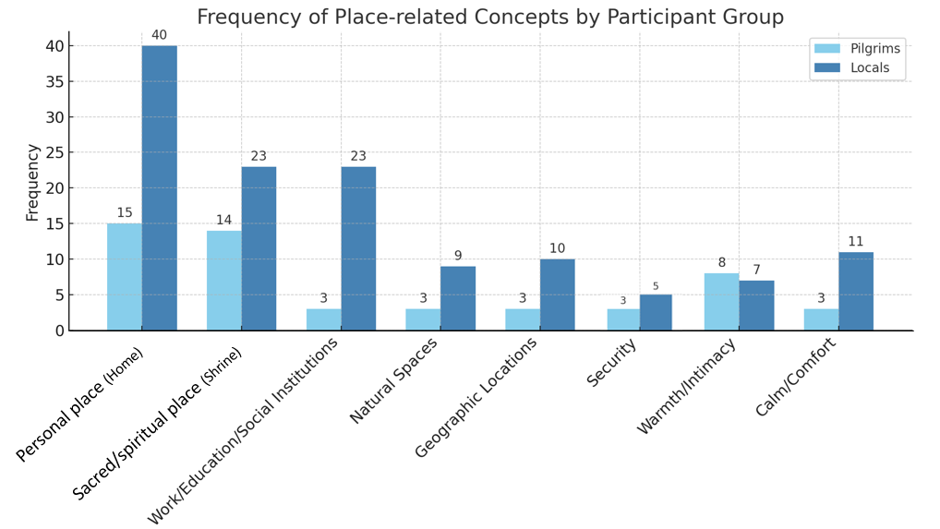

**Figure 6.** Frequency of place-related concepts in participant responses,Source: Author.

### DISCUSSION: Place Poverty and the Role of the Hippocampus in Place Perception

Although the hippocampus is traditionally recognized in neuroscience studies as a key structure for spatial navigation and the formation of cognitive maps, recent research indicates that its function extends far beyond the registration of geographic coordinates. The hippocampus, in interaction with the amygdala and prefrontal cortex, encodes spatial experiences as **episodic and emotional memories**—memories imbued with affective, semantic, and behavioral significance. From this perspective, the hippocampus is not merely a navigation center but serves as a **neural infrastructure for place perception**, where emotion, memory, and meaning are intricately intertwined. For instance, when an individual recalls a place triggered by a particular scent or a familiar image, this is not merely the retrieval of a location but the activation of a deep mental structure that **revives the sense of place**. What imparts meaning to a place is therefore not just its physical form, but the **lived experiences encoded and retrieved through the hippocampus**. This process highlights that place perception is a **multilayered and profound experience**, arising from the interplay of sensation, memory, and space. These findings demonstrate that the meaning of a place derives not merely from its physical form or function, but from the memories and emotions associated with it, which are encoded and retrieved in interaction with the hippocampus. In other words, human perception of place is profoundly influenced by hippocampal function, as this structure preserves not only a map of **“where we have been”** but also the memory of **“how we felt in that place”**, shaping decision-making, behavioral responses, and even individuals’ sense of spatial identity.

However, the interpretation of the findings of this study must be considered in light of contextual limitations. Mashhad, as a religious and pilgrimage city, offers a unique and distinctive setting for the experience of place by both pilgrims and residents, which may differ markedly from other cities in Iran or elsewhere in the world. This context tends to encode urban spaces in the minds of many pilgrims primarily in relation to religious sites, while other spaces remain peripheral. Such a unipolar semantic focus is also reflected in the perceptions of local residents, albeit layered with quotidian routines, livelihoods, and local life. Methodologically, the sample size and qualitative approach of this study were designed to provide an in-depth understanding of cognitive patterns within a specific group rather than to generate broad statistical generalizations, a factor that may influence the results.

Analysis of the data obtained from interviews with 60 residents and pilgrims revealed that responses reached a point of repetition. This early saturation at both lexical and conceptual levels is a meaningful indicator of the limited range of individuals’ cognitive prototypes of place within the urban environment of Mashhad. Despite the city’s physical complexity, at the cognitive and emotional level of its inhabitants, it is reduced to a few highly significant points—such as the home and the shrine—while failing to support diverse place-based experiences. This phenomenon can be termed “place poverty,” a condition in which the city is unable to generate spaces that fulfill fundamental human needs, such as security, tranquility, social interaction, and connection with nature. In a context where place ought to reflect human existence—with all its biological, psychological, and social dimensions—the absence of quality spaces results in the silencing of human experience at the core of the city.

According to the theory of cognitive prototypes, humans encode place not merely based on physical attributes but through perceptual, sensory, and value-laden experiences. Consequently, when spaces such as parks, streets, social institutions, or neighborhoods fail to form in collective memory—or are recalled solely in negative terms—it indicates that these environments have been unable to provide the essential foundations of place: a sense of belonging, interaction, meaning, and beauty. The hippocampus, as a structure involved in spatial and emotional memory, is activated when a place carries meaningful, emotional, and value-laden content—that is, when an individual perceives a location not merely as a physical position but as a framework for lived experience, social relationships, and meaning-making. For instance, pilgrims in Mashhad, despite their short-term stays, undergo intensive, emotionally charged, and often ritualized experiences, which strongly activate the hippocampus and result in place experiences imbued with symbolic significance and vivid memories.

Conversely, when a city lacks spaces capable of supporting such profound qualities, the human mind is similarly limited in its ability to construct stable, intimate, and secure images of place. Residents, for example, experience monotony in their living spaces and deprivation of novel and emotionally stimulating encounters due to the lack of spatial diversity. In such circumstances, the hippocampus is relegated to minimal functionality—serving merely for spatial navigation—rather than acting as a substrate for the reproduction of place-based memory, a sense of belonging, and meaningful experiences. This functional reduction not only diminishes the mind’s capacity to apprehend place but also undermines the quality of human life within urban spaces.

Therefore, place poverty is not merely the absence of physical space but the deprivation of the “human potential” of place—a deficiency that can only be addressed through approaches grounded in human cognition, lived experience, and cultural and social capital. To assess and conceptualize “place poverty” within the framework of urban-cognitive studies, it is necessary to identify indicators that reflect the quality of human perception and experience of place. From a qualitative perspective, these indicators can be analyzed at several levels:

1. **Spatial diversity in memory and language:** This reflects the dispersion and variety of places mentioned in speech and writing, indicating whether individuals’ mental representations are concentrated around a few locations or encompass a broader range of place-based experiences.
2. **Intensity and quality of emotional and semantic associations with places:** The presence of affective vocabulary, lived memories, or symbolic meanings in descriptions of space signals the richness of the mind-place relationship.
3. **Lexical breadth in place descriptions:** This reflects the cognitive-cultural depth of individuals’ engagement with urban spaces; limited or repetitive vocabulary can indicate monotony and lack of meaning in urban experience.
4. **Cognitive maps:** These reveal the structure of individuals’ spatial understanding and the boundaries of their attentional focus; excessive focus on particular points or complete omission of certain areas indicates cognitive poverty of place.
5. **Sense of belonging, security, and social interaction in public spaces:** These fundamental indicators can be used in qualitative analyses to distinguish “alive” spaces from “neutral” or inert ones.

Together, these indicators provide a conceptual framework through which place poverty can be understood not merely as a subjective impression but as a phenomenon that can be systematically analyzed and evaluated within the context of citizens’ everyday urban experiences.

From this perspective, the design of urban spaces cannot be limited to technical functions or superficial aesthetics. Rather, it must engage in dialogue with people, uncover their lived experiences, and identify their genuine and deep-seated needs, in order to create spaces that enable the full spectrum of human “living.” Such spaces should not only be habitable but also inspiring, vibrant, and meaningful. A city can foster resilience, hope, and vitality only when its places emerge organically from the lives of its inhabitants—places where individuals can tell their stories, envision their futures, and experience a sense of security, meaning, and belonging at their core. Otherwise, the urban environment becomes a neutral, fragmented, and identity-less backdrop, incapable of nurturing memory or enabling the future. This renewed understanding of the role of the hippocampus opens a new window for cognitive-spatial studies and can provide a foundation for innovative approaches in urban design, environmental psychology, place-based ethnography, and memory-focused cognitive therapies.

### Recommendations: Future-Oriented Design of Memory-Centered Spaces Based on Hippocampal Neurobiology

A deeper understanding of the hippocampus’s role in integrating **memory, emotion, and spatial perception** opens promising new directions for interdisciplinary research at the intersection of **neuroscience, urban design**, and **environmental psychology**. It is recommended that future urban design move beyond purely aesthetic or functionalist paradigms toward a **memory-centered approach**—one in which environments are shaped to support the hippocampal processes of encoding long-term memories, fostering spatial identity, and cultivating a sense of belonging. In the field of **psychotherapy**, emerging practices such as spatial autobiography—the mapping of personal place-based memories—may be integrated with neuroimaging technologies (e.g., fMRI, EEG) to visualize hippocampal activity related to spatial memory. Such methods hold potential for addressing **place-related trauma** (such as PTSD linked to specific environments), rebuilding identity after **displacement or crisis**, and designing **therapeutic cartographies** based on positive spatial recollections. In **cognitive interventions** for disorders such as Alzheimer’s disease, depression, or traumatic brain injury, virtual reality (VR) can be employed to reconstruct familiar environments, manage spatial navigation in rehabilitative settings, and map emotional-spatial associations. These strategies may strengthen **hippocampal plasticity**, improve orientation, and aid in memory retention through controlled environmental exposure. Such approaches could lead to the development of cities that function as **repositories of memory**—urban environments capable of supporting **personalized cognitive therapies** designed in alignment with individuals’ internal hippocampal maps. Through **emotional tagging** using elements such as light, sound, scent, and texture, cities can be designed not only to be livable, but also **memorable, therapeutic, and emotionally resonant**. In sum, this neurobiologically informed perspective advocates for urban spaces that are not just containers of human activity but **platforms for mental well-being**, cognitive healing, and the enduring preservation of identity through place. To further concretize the memory-centered approach in urban and architectural design, the following strategies can be proposed:

Table1: Examples of Memory-Oriented Design Interventions

|  |  |
| --- | --- |
| **Domain** | **Proposed Intervention Example** |
| **Spatial and Narrative Diversity** | Design of squares, streetscapes, and parks with varied spatial sequences (open–semi-open–enclosed) to stimulate episodic memory and prevent monotony. |
| **Cultural–Identity Markers and Memorials** | Integration of indigenous symbols, local narratives, and urban art alongside interactive memorials (e.g., narrative-driven parks) to both reinforce collective memory and transform negative experiences into positive patterns. |
| **Multisensory Experiences** | Combining lighting with varied color temperatures, tactile textures in urban furniture, auditory water features, temperature variations, and rhythmic movement patterns to enhance memory encoding. |
| **Participatory and Social Spaces** | Design of public gardens, neighborhood centers, and multifunctional cultural spaces to foster social interactions and establish new spatial prototypes within collective memory. |
| **Urban Prototyping** | Creation of experimental spaces in which citizens’ emotional and mnemonic responses can be evaluated, with final designs refined based on hippocampal–cognitive feedback. |
| **Post-Crisis Reconstruction Participation** | Direct involvement of residents in the design and construction of new housing following earthquakes or floods to restore place identity, mitigate PTSD, and enhance a sense of belonging. |
| **Therapeutic Recreation of Familiar Environments** | Application of advanced technologies (VR/AR) to reconstruct lost or familiar locations (homes, neighborhoods) in conjunction with specially designed therapeutic spaces for patients with Alzheimer’s or brain injuries (e.g., memory gardens, waymarked paths) to support recall, reduce anxiety, and strengthen spatial orientation. |
| **Flexible and Self-Expressive Architecture** | Provision for personalization in homes and workplaces (choice of color, texture, or layout) to reinforce individual memory formation and emotional attachment to the environment. |

### CONCLUSION

The findings of this study suggest that human perception of place is not merely a spatial or functional phenomenon, but rather one deeply rooted in a complex network of **memory, emotion, and experience**, encoded within the brain’s cognitive structures—most notably, the **hippocampus**. The hippocampus plays a central role not only in episodic and spatial memory, but also in the storage and retrieval of emotional and sensory associations, contributing significantly to the formation of **mental prototypes** of place.

The field data, gathered through the analysis of participants' mental associations with the concept of "place" in the area surrounding the **Razavi Shrine**, reveal that people conceptualize place less through its physical coordinates and more through **lived experience** and **sensory-cultural values**. Concepts such as home, tranquility, intimacy, and workplace appeared far more frequently than purely symbolic or functional markers.

This indicates that many urban spaces have not, in a cognitive or emotional sense, become meaningful places for citizens. The hippocampus does not appear to store or activate emotionally rich or memorable representations of these environments. Instead, the sense of place is concentrated within **private or ritual domains**—such as the home or the shrine—while **public urban spaces** have largely failed to establish a lasting presence in the minds and feelings of individuals.

Thus, we conclude that **rethinking urban design through the lens of cognitive neuroscience**—especially by focusing on the mechanisms of hippocampal function, memory, and mental association—is both timely and essential.

We recommend that future urban design shift its focus from purely **formal or functional objectives** toward the **creation of emotionally resonant spaces** that connect with **memory, feeling, and human experience**. Such spaces should support the formation of mental prototypes in active dialogue with people’s lived realities. This approach not only fosters the creation of **memorable and meaningful environments**, but also opens new avenues for **cognitive therapy**, **urban experiential mapping**, and the **reconstruction of cultural ties** within the urban fabric.

**REFERENCES**

* Addis, D. R., Wong, A. T., & Schacter, D. L. (2007). Remembering the past and imagining the future: Common and distinct neural substrates during event construction and elaboration. *Neuropsychologia*, *45*(7), 1363-1377. <https://doi.org/10.1016/j.neuropsychologia.2006.10.016>
* Andersen, P., Morris, R., Amaral, D., Bliss, T., & O'Keefe, J. (2007). *The hippocampus book*. Oxford university press, London. 10.1093/acprof:oso/9780195100273.001.0001
* Aronov, D., Nevers, R., & Tank, D. W. (2017). Mapping of a non-spatial dimension by the hippocampal–entorhinal circuit. *Nature*, *543*(7647), 719-722. <https://doi.org/10.1038/nature21692>
* Augé, M. (1995). *Introduction to an Anthropology of Supermodernity*. Verso.
* Barsalou, L. W. (1999). Perceptual symbol systems. *Behavioral and brain sciences*, *22*(4), 577-660. <https://doi.org/10.1017/S0140525X99002149>
* Bennardo, G. (2002). Map drawing in Tonga, Polynesia: Accessing mental representations of space. *Field Methods*, *14*(4), 390-417. <https://doi.org/10.1177/152582202237727>
* Casey, E. S. (2000). *Remembering: A phenomenological study* (2nd ed.). Indiana University Press. <http://www.jstor.org/stable/j.ctt16gzfjf>
* Eichenbaum, H. (2017). The role of the hippocampus in navigation is memory. *Journal of neurophysiology*, *117*(4), 1785-1796. <https://doi.org/10.1152/jn.00005.2017>
* Eichenbaum, H., & Cohen, N. J. (2004). *From conditioning to conscious recollection: Memory systems of the brain*. Oxford university press.
* Ekstrom, A. D., & Ranganath, C. (2018). Space, time, and episodic memory: The hippocampus is all over the cognitive map. *Hippocampus*, *28*(9), 680-687. <https://doi.org/10.1002/hipo.22750>
* Lakoff, G., & Johnson, M. (1980). Metaphors we live by. In: University of Chicago Press, Chicago, USA.
* Maguire, E. A., Gadian, D. G., Johnsrude, I. S., Good, C. D., Ashburner, J., Frackowiak, R. S., & Frith, C. D. (2000). Navigation-related structural change in the hippocampi of taxi drivers. *Proceedings of the National Academy of Sciences*, *97*(8), 4398-4403. <https://doi.org/10.1073/pnas.070039597>
* Moser, E. I., Kropff, E., & Moser, M.-B. (2008). Place cells, grid cells, and the brain's spatial representation system. *Annual Review of Neuroscience*, *31*(1), 69-89. <https://doi.org/10.1146/annurev.neuro.31.061307.090723>
* Moser, E. I., Moser, M.-B., & McNaughton, B. L. (2017). Spatial representation in the hippocampal formation: a history. *Nature neuroscience*, *20*(11), 1448-1464.
* Norberg-Schulz, C. (1980). *Genius loci: Towards a phenomenology of architecture*. Rizzoli.
* O'Keefe, J., & Dostrovsky, J. (1971). The hippocampus as a spatial map: preliminary evidence from unit activity in the freely-moving rat. *Brain research*, *34*(1), 171–175. <https://doi.org/10.1016/0006-8993(71)90358-1>
* O'keefe, J., & Nadel, L. (1978). *The hippocampus as a cognitive map*. Oxford university press.
* Pessoa, L. (2017). A network model of the emotional brain. *Trends in cognitive sciences*, *21*(5), 357-371. <https://doi.org/10.1016/j.tics.2017.03.002>
* Quesnot, T., Schmitter, É., Wencélius, J., & Bambridge, T. (2024). Moorea lagoon fishers’ mental maps: An exploratory analysis of Polynesian spatial knowledge. *Ethos*, *52*(1), 114-137. <https://doi.org/10.1111/etho.12416>
* Relph, E. (1976). *Place and placelessness* (Vol. 67). Pion London.
* Rosch, E. (1975). Cognitive representations of semantic categories. *Journal of experimental psychology: General*, *104*(3), 192–233. <https://doi.org/10.1037/0096-3445.104.3.192>
* Rosch, E., & LLOYD, B. (1978). Cognition and categorization Lawrence Erlbaum. *Hillsdale, New Jersey*.
* Sabouri, S., & Saboonchi, P. (2022). A Qualitative Assessment of the Peripheral Texture Development of a Holy Site (Case study: Imam Reza Street). *MANZAR, the Scientific Journal of landscape*, *14*(61), 48-59. <https://doi.org/10.22034/manzar.2022.306319.2154>
* Scannell, L., & Gifford, R. (2010). Defining place attachment: A tripartite organizing framework. *Journal of environmental psychology*, *30*(1), 1-10. <https://doi.org/10.1016/j.jenvp.2009.09.006>
* Sridhar, S., Khamaj, A., & Asthana, M. K. (2023). Cognitive neuroscience perspective on memory: overview and summary. *Frontiers in human neuroscience*, *17*, 1217093. <https://doi.org/10.3389/fnhum.2023.1217093>
* Theves, S., Fernandez, G., & Doeller, C. F. (2019). The hippocampus encodes distances in multidimensional feature space. *Current Biology*, *29*(7), 1226-1231. e1223. <https://doi.org/10.1016/j.cub.2019.02.035>
* Tuan, Y.-F. (1977). *Space and place: The perspective of experience*. University of Minnesota Press.
* Zeidman, P., & Maguire, E. A. (2016). Anterior hippocampus: the anatomy of perception, imagination and episodic memory. *Nature Reviews Neuroscience*, *17*(3), 173-182. <https://doi.org/10.1038/nrn.2015.24>

1. *\* Corresponding Author, sabouri.somaye@ut.ac.ir*