PROVISION OF A CONCEPTUAL MODEL OF THE MAIN STRUCTURE OF THE CITIES LOCATED IN A HOT ARID ZONE WITH APPLICATION OF PARAMETRIC DESIGN
flowchart of designing urban main structure
Raha Massih, Farnaz Fatahi, Manouchehr Tabibian
Abstract:
Urban design in hot–arid cities has often depended on implicit intuition rather than transparent, testable rules. This paper develops a parametric framework that translates conceptual design principles into an algorithmic flowchart, making the design of a city’s “main structure” explicit and reproducible. Through content analysis of structuralist, typological, and collective-form theories, we identified key parameters—including functional scale, durability, accessibility, connectivity, and visual legibility—and adapted them to climate-specific conditions. The results showed that connectivity, scale, and orientation thresholds were most decisive in shaping resilient urban routes, centers, and icons in the linear cities in the hot arid areas. By embedding these parameters in a stepwise, code-free algorithm, the method allows designers to evaluate alternatives systematically rather than relying on intuition. The contribution lies in operationalizing theoretical concepts into a portable design tool for hot–arid contexts, advancing both the scientific understanding of climate-adapted urban structure and the practical capacity to integrate parametric methods into early-stage planning.
Keywords: Main Structure, Hot and arid zone, Parametric Design, Algorithm, Designing Flow chart
- Introduction
Designing cities in hot–arid regions require balancing environmental challenges with cultural continuity. The “main structure” of a city—its streets, centers, landmarks, and open spaces—forms resilience and identity of that city. However, judgments about this structure are frequently made based more on intuition than on methodical approaches, which makes it challenging to test or replicate design decisions.
More thorough evaluations of urban form are now feasible because to computational and parametric design technologies. For example, Ibrahim et al. (Ibrahim, 2021) used a Grasshopper-based workflow to improve outdoor thermal comfort and energy use in hot-arid settings. Jiang et al. (Jiang, 2024) provide a broad review of generative design methods, while Sun and Dogan (Sun, 2023) show how tensor-field modeling can be used for rapid exploration of multiple urban design options. Other studies have extended computational approaches to include human perception and climate adaptation. Van Veghel developed a human-centric model that aimed to fit well-being into design decisions (van Veghel, 2024), and Abdelwahab applied parametric tools to optimize microclimates in urban parks through shading, vegetation, and photovoltaic integration (Abdelwahab, 2025). At the same time, researchers are beginning to combine artificial intelligence (AI) with parametric methods to reach the optimistic answer in the shorter time. Lamine et al. (2025) review AI-driven approaches for thermal comfort modeling (Lamine, 2025), which demonstrate how explainable AI can highlight which features of urban form matter most for visibility and sky exposure.
Despite these advances, most parametric and AI-enabled approaches focus on generating or optimizing form. Far less attention has been given to translating conceptual theories of urban structure—such as structuralist, typological, and collective-form traditions—into practical, computable frameworks. Flowcharts provide one possible solution. Instead of requiring programming knowledge, they allow the logic of design processes to be expressed in an accessible, step-by-step way. However, flowcharts have rarely been applied in urban design research.
This paper responds to that gap. We propose a parametric framework for identifying and designing the main urban structure in hot-arid cities. Using content analysis of urban design theory, we define measurable parameters such as scale, durability, accessibility, connectivity, and visual legibility, and adapt them for climate-specific conditions. These parameters are then built into a flowchart-based algorithm that allows designers to evaluate options more transparently.
Our contribution is twofold: first, we extend computational urban design by embedding theoretical principles of urban structure into a parametric framework; second, we offer a climate-sensitive tool, tested on Yazd, Iran, that can be adapted for other hot-arid cities.
Roadmap. Section 2 reviews the theoretical background on urban structure and parametric methods. By using the methods, Section 3 seeks to create a city structure flowchart that will be utilized to develop the algorithm for constructing the primary structure in hot, arid cities.

- Literature Review
  - Structure: Theoretical Foundations
The concept of "structure" in urban thought emerged with the structuralist turn of the mid-twentieth century. Lévi-Strauss (1967) in his book highlighted that meaning is derived from the system of relations, which he referred to as an "order of orders (Lévi-Strauss, 2008)." Piaget (1968) recognized three fundamental characteristics of structure: wholeness, in which elements have meaning only within the larger system; transformation, in which systems grow while maintaining coherence; and self-regulation, which provides closure and internal stability (Piaget, 2015). These ideas spread to architecture and urbanization, where structure began to represent not only the physical skeleton but also the hidden scheme that integrates components into a cohesive plan (Forty, 2000).
For urban analysis, this relational view is crucial. Tavassoli (1991) and Shearmur (Shearmur, 2011) argue that structure emerges only when relatively stable relations bind components under general rules. Thus, routes, centers, landmarks, and open spaces derive structural value not in isolation but through principles such as continuity, hierarchy, and legibility. This distinction is particularly relevant for parametric urban design: algorithms require both elements and rules, otherwise they risk generating form without coherence.
Recent studies illustrate how these abstract ideas can be operationalized. Lehner and Blaschke (Lehner, 2019) defined Urban Structure Types (USTs) from remote sensing to compress morphology into reproducible categories linked to climate. Arribas-Bel and Reades used big-data methods to classify different types of urban structure. Their work shows how indicators such as network centrality, walking distances, and visibility measures can turn the abstract relations between urban elements into quantifiable metrics (Arribas-Bel, 2021). These indicators create a practical foundation for parametric and AI-based modeling, which can then be adapted to the specific needs of hot–arid cities.

Table 1Perspectives on Structure and Their Implications for Urban Design
Thinker / Source | Core Idea of Structure | Key Concepts | Implications for Urban Design / Parametric Modeling
Lévi-Strauss (1967) | Meaning arises from systems of relations (“order of orders”) | Relations over objects | Structure depends on connectivity rules, not just physical elements → informs algorithms focusing on relational logic
Piaget (1968) | Three properties: wholeness, transformation, self-regulation | Systems evolve while preserving coherence | Provides model for adaptive algorithms that evolve yet maintain stability
Forty (2000) | Structure as hidden scheme beyond physical skeleton | Organizing logics | Encourages looking beyond form to generative rules → aligns with computational modeling
Tavassoli (1991) | Structure reducible to components and relations | Duality of elements and rules | Basis for identifying urban components (routes, centers, landmarks) + rules (continuity, hierarchy)
Shearmur (2011) | Structure emerges through stable relations | Relational binding | Highlights need for metrics such as hierarchy, connectivity, and legibility
Batty (2013, 2021) | Cities as complex, emergent systems | Complexity, emergence | Supports use of parametric and agent-based models to simulate bottom-up urban order
Lehner & Blaschke (2019) | Urban Structure Types from remote sensing | Morphological categories | Demonstrates how abstract “structure” can be made measurable through geospatial data
Arribas-Bel & Reades (2021) | Big-data taxonomy of urban structure | Data-driven classification | Provides scalable, reproducible structural categories → useful for parametric/AI-based modeling

  - Main City Structure: Components and Relations
The main structure of a city is generally understood through four key elements: routes, centers, landmarks, and open spaces. The foundation of orientation and circulation is made up of routes
(Lynch, 1960) (Bacon, 1967). In many hot–arid Iranian cities, bazaars and caravanserai
played this role, guiding movement while also providing shade and microclimatic comfort (Tavassoli G. , 1991) (Pourjafar, 2014). Centers serve as hubs for communication and activity, from Christaller’s (1933) early central place theory to more recent work on polycentric development (Hall, 2006) (Meijers, 2010). Landmarks provide orientation and symbolic identity (Lynch, 1960), and their influence can now be assessed with computational tools such as isovist analysis and skyline metrics (Conroy-Dalton, 2003). Open spaces—whether plazas, courtyards, or gardens—serve as connectors between elements, supporting both social life (Gehl, 2011) and environmental regulation through shading and ventilation (Naboni, 2019) (Ibrahim, 2021).
Different design traditions have interpreted these components in distinct ways. The Metabolists emphasized adaptability and growth along infrastructural spines, while Mega-structuralists sought unifying frameworks that created wholeness (Banham, 2020). While Alexander developed pattern languages that promoted bottom-up, self-organizing growth (Alexander, 1977), typological designers placed a strong emphasis on the continuity and durability of forms (Moudon, 1994). Notwithstanding these variations, they all emphasize that the importance of urban structure rests not only in the elements but also in the principles of continuity, hierarchy, and legibility that bind them together.

These findings have started to be executed in recent computational studies. Ibrahim et al. (2021) demonstrated how parametric workflows can maximize comfort and energy performance in hot-arid zones, whereas Arribas-Bel and Reades created a big-data taxonomy of urban structure (Arribas-Bel, 2021). Collectively, these studies show how metrics like visibility metrics, accessibility catchments, and network centrality may convert conceptual notions of structure into measurable parameters, serving as a foundation for parametric and AI-based modeling in climate-sensitive contexts.
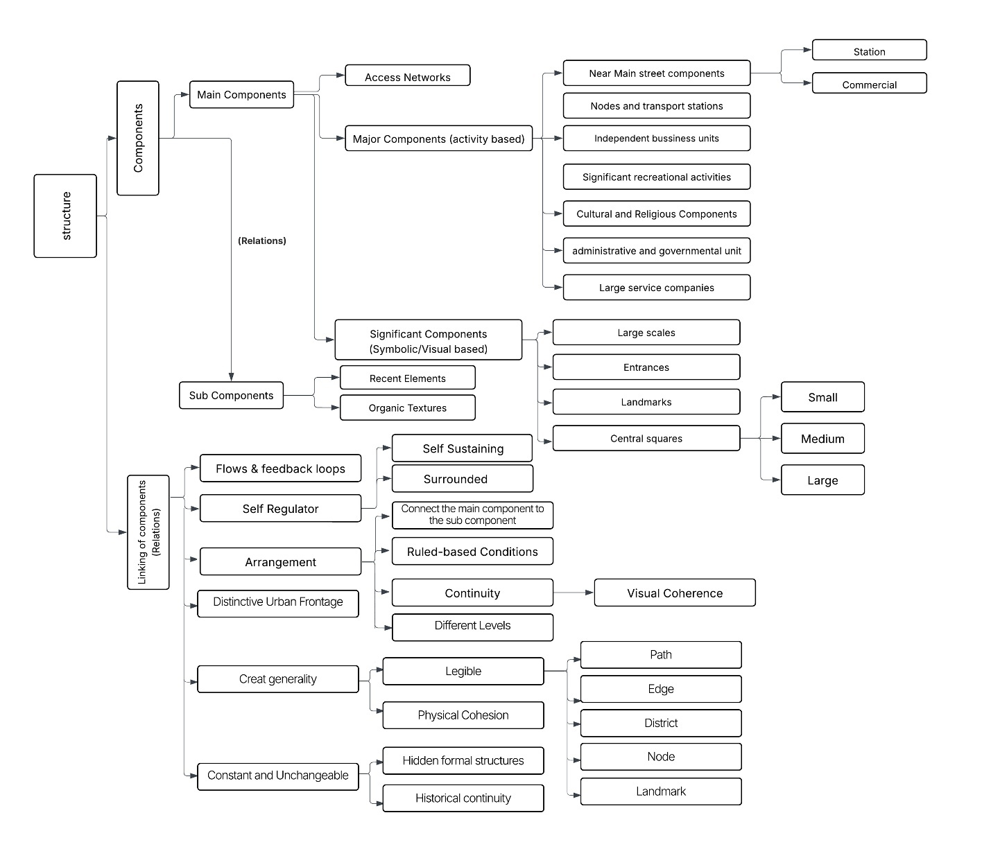
Figure 1An Initial figure to show the Main structure (Main Components and their Relationships)
The diagram illustrates the hierarchical composition of the city’s main structure. At the top level are routes and centers, which form the backbone of circulation and activity. Below them are landmarks and open spaces, which play supportive roles in orientation, identity, and environmental regulation. The rules that arrange the components' relationships—continuity, hierarchy, and legibility—are just as strong as the elements themselves. In addition to being consistent with recent computational research that measure accessibility, centrality, and visibility, this hierarchy incorporates insights from Lynch (1960), Bacon (1967), and Alexander (1977) (Lehner, 2019) (Ibrahim, 2021). The figure tackles the significance of weighting in parametric design by displaying relative priority among aspects. This makes it clear which parameters have a greater structural influence, enabling the framework to be modified to meet the environmental and cultural requirements of hot, arid towns.

  - Traditions and Foundations of Urban Structure
In the 1960s, the Metabolist movement in Japan popularized the notion of the city as a living system. Kenzo Tange (1960) and Fumihiko Maki (1964) argued that cities should grow and adapt like organisms in a body (Tange, 1960) (Maki, 1964). They proposed modular forms and infrastructural “backbones” that could expand over time. This view shifted attention from fixed master plans to flexible structures. Yet, critics have noted that many Metabolist projects overlooked the social and ecological complexity of cities, focusing too much on form and technology (Lin, 2010).
Systems theory offered a related but broader perspective. It described cities as networks of parts linked through flows of people, resources, and information, held together by feedback and regulation (Bertalanffy, 1968) (Allen, 2012). In this view, stability comes not from rigid order but from the ability of the system to adjust when conditions change. This echoes Piaget’s idea of self-regulation and connects to more recent theories of urban complexity (Batty, 2013) (Kandt, 2021).
Other traditions add further nuance. Lynch (1960) prioritized legibility, stressing that people's perceptions and navigation of cities are influenced by the clarity of roads, nodes, and landmarks (Lynch, 1960). Typological designers such as Rossi (1982) showed how resilient urban patterns continue to exist
—monuments, squares, bazaars—as structural anchors that provide continuity across time (Rossi, 1984). These perspectives complement the metabolic and systemic view by showing that structure is not only adaptive but also perceptual and historical.
These ideas are important for computational design today. Recent work has used parametric and agent-based models to test how cities grow and respond to environmental pressures (Stanilov, 2011) (Naboni, 2019) (Ibrahim, 2021). For hot–arid regions, such models help designers see how routes, centers, and open spaces can adapt to climate stress. In this sense, metabolism and systems theory do more than provide metaphors. They also guide algorithms that treat structure as flexible, measurable, and open to iteration.
Table 2 Theoretical Perspectives on Main Urban Structure and Implications for Parametric
Tradition / Thinker | Core Idea of Structure | Main Components | Relations | Algorithmic / Parametric Translation
Metabolists (Tange, 1960) (Maki, 1964) | City as a living organism with a permanent backbone and replaceable units | Transport spines, civic cores, bazaars, mega-structures, short-term housing | Dual cycles (permanent vs. temporary), hierarchical layers, symbolic network | Model backbone as fixed network; simulate growth/substitution of units; use centrality, replacement rates, and visibility indices
Bacon (1967) | Continuity of spatial experience shaped by movement systems | Primary routes, nodal squares, landmarks, terminals | Unity through continuity, visual sequence, relation to geography | Start with main axis; extend to region; analyze with space syntax, betweenness centrality, visibility graphs
Lynch (1960) | Legibility of the city through mental images | Paths, edges, districts, nodes, landmarks | Sequential visibility, perceptual hierarchy, coherence | Map five elements; calculate legibility index; test connectivity (paths + nodes)
Mega-structuralists (Soleri, 1969) (Friedman, 1980) (Cook, 1999) | Modular mega-structures with flexible growth | Modular housing, infrastructural skeletons, cultural cores | Modularity, open-ended growth, fractal patterns | Model skeleton as fixed; simulate module addition/removal; test cohesion with clustering coefficients
Typological designers (Rossi, 1984) | Continuity through persistent types (monuments, squares, bazaars) | Archetypal forms (monuments, bazaars, housing fabrics) | Historical continuity, repetition of types | Identify types; encode formal rules into parametric categories; use persistence index
Alexander (1977) | Wholeness through recurring patterns and centers | Transportation networks, activity centers, squares | Repetition of patterns, gradual growth, wholeness | Model hierarchical centers; simulate stepwise growth; test with space syntax and pattern resilience indices
Systems / Complexity (Bertalanffy, 1968) (Allen, 2012) (Batty, 2013) | Cities as adaptive, self-regulating systems | Nodes, links, clusters, flows | Feedback, emergence, adaptation | Model as network graph; apply centrality and clustering; simulate feedback and resilience

  - Toward Operationalization
Theories of urban structure show that the principles that bind cities together are equally as important as their constituent parts. Approaches based on typology and patterns emphasize adaptation and continuity
(Alexander, 1977) (Moudon, 1994), structuralist theories stress wholeness and hierarchy (Lévi-Strauss, 2008), and systems theory views cities as dynamic networks that evolve over time (Batty, 2013) (Kandt, 2021). Despite their value, these perspectives are typically too abstract to be applied immediately in design.
These concepts can be translated into quantifiable measures, as recent research shows. Visibility and skyline metrics describe the impact of landmarks (Conroy-Dalton, 2003) (Garnero, 2015), accessibility measures capture the reach of centers (Arribas-Bel, 2021), network centrality can demonstrate the role of routes (Lehner, 2019), and environmental indicators evaluate the impact of open spaces on comfort and microclimate (Naboni, 2019) (Ibrahim, 2021). Concepts like hierarchy, legibility, and flexibility become tangible and verifiable thanks to these technologies.
In this study, these insights are combined into a parametric framework. The framework brings together components—routes, centers, landmarks, and open spaces—with relational rules such as continuity and hierarchy. It is expressed as a flowchart-based algorithm that is clear, reproducible, and suited to the needs of hot–arid cities. In this way, abstract theories of structure are translated into practical parameters.

- Localized Flowchart of Main Structure in Hot-Arid Cities
  - Refinement of Components and Their Interrelations in Hot-Arid Cities
The structural organization of Iranian cities in hot-arid climates has been widely studied by Iranian scholars, who describe these urban fabrics as a coherent integration of central and peripheral elements. At the core lies the Bazaar axis, which operates as the city’s linear backbone and connects its gates, while attracting subsidiary institutions such as caravanserais, mosques, schools, and baths (Ardalan, 2001). This spine functions not only as a commercial corridor but also as the central organizer of urban life, drawing other components to it much like a magnetic field. Tavassoli (2016) further emphasizes that open courtyards of mosques and forecourts of tekyehs also belong to the city’s main structure, serving as multifunctional spaces that address both climatic challenges and socio-cultural practices. Similarly, Ahari (2016) defines the main structure as an enduring physical whole composed of major routes, open spaces, and monumental public buildings (Ahari, 2016) that have collectively maintained coherence across centuries.
Building on this tradition, Tavassoli (2016) classifies the main components of hot-arid Iranian cities into five categories:
- Religious components – mosques, musallas, and tekyehs.
- Governmental components – citadels, administrative centers, military headquarters, and squares.
- Commercial components – the Bazaar spine, caravanserais, timcheh, qaysariyah, and, in modern contexts, shopping malls.
- Neighborhoods – residential quarters with local centers and small-scale communal facilities.
- Main routes – the Bazaar axis and other major access ways.
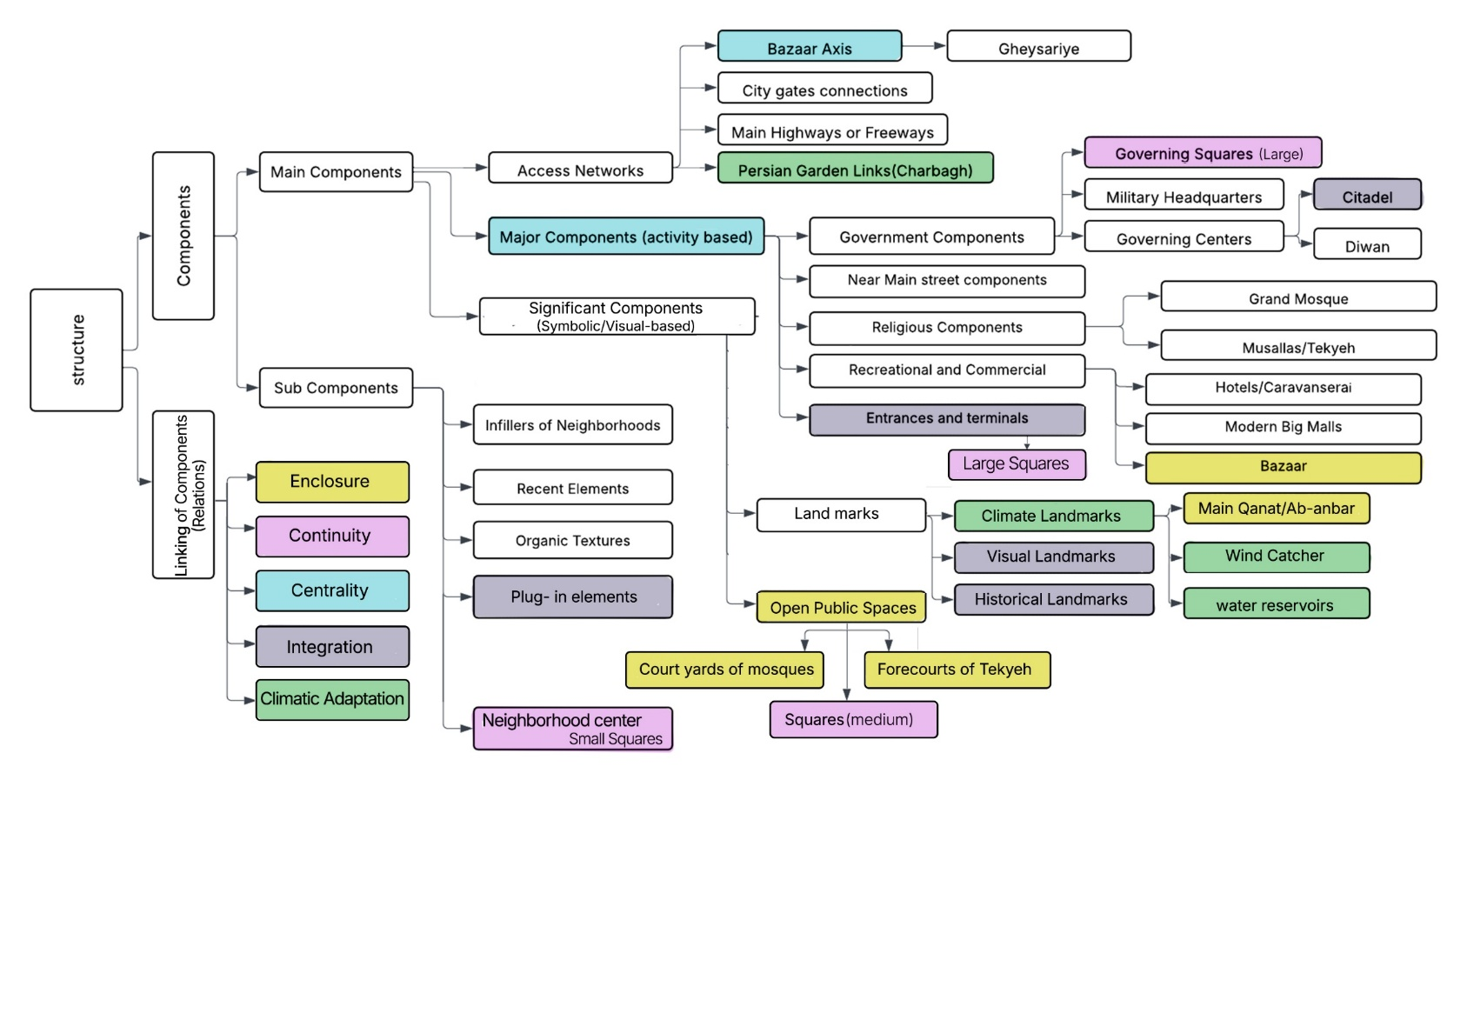
Urban resilience is strengthened by the spatial and climatic concepts that tie these components together. Five fundamental principles are identified by Tavassoli (2016): enclosure, which is demonstrated by the enclosed neighborhood forms and courtyards; continuity, which is mirrored in the Bazaar's and passageways' connecting function; centrality, which is derived from the Grand Mosque's, main squares', and the Bazaar's gravitational pull; integration, which occurs when religious, commercial, and governmental functions co-locate and reinforce one another; and climatic adaptation, which is accomplished through traditional technologies like qanats, windcatchers, water reservoirs, and shaded urban areas (Tavassoli M. , 2016).
Figure 2Main structure components and their relations in hot-arid Iranian cities

Figure 2 synthesizes this paradigm by integrating the theoretical traditions previously described in indigenous urban studies (Hamidi et al., 1997; Ardalan & Bakhtiar, 2001; Tavassoli, 2016; Ahari, 2016) and localizing them. The structural logic of hot-arid Iranian cities differs from the linear and functionalist urban models of Western modernism in that it is characterized by neighborhood orientation, introversion, and a profound ecological sensitivity that unifies culture and climate.

  - Final Algorithm for Designing the Main Structure in Hot-Arid
Designing the main structure of hot-arid cities requires an algorithm that systematically incorporates both the key components—major, significant, and subsidiary—and the principles that organize their relations, including continuity, enclosure, centrality, integration, and climatic adaptation. The proposed algorithm (Fig. 3) builds on structuralist traditions articulated by Bacon (1967), Lynch (1960), and Alexander (1977), while integrating localized parameters from Iranian scholarship, particularly Tavassoli (2016) and Hamidi (1997).
The process begins with contextual conditioning, where topography and the existence of a Bazaar axis or major accessible street establish the city’s backbone. Major elements like as city entrances and terminals, as well as economic, religious, recreational, and governmental areas, are then positioned. Important elements like historical, attractive, or climatic sites, public open areas, and water infrastructure like reservoirs, windcatchers, and qanats come next. Neighborhood centers and their hierarchical squares are then included in the algorithm, which makes sure that they are scaled suitably within the larger urban structure, visually continuous, and functionally connected.
The outcome is a flowchart-based decision-making tool that bridges traditional and contemporary design practices. By embedding culturally significant elements such as the Bazaar, mosque courtyards, and tekyeh forecourts into a systematic framework, the algorithm ensures cultural continuity, spatial coherence, and climatic responsiveness. In doing so, it translates both international theoretical insights and indigenous urban logics into a practical methodology for parametric urban design in hot-arid contexts.
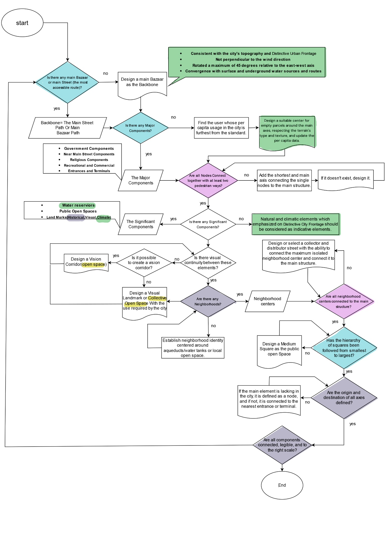
Figure 3Final algorithm for designing the main structure in hot-arid cities (localized adaptation integrating structuralist theories with Tavassoli’s principles and climatic considerations).
  - Explaining the Flowchart Pattern and Parameters
The final flowchart is operationalized through a set of parameters that translate the main structure of hot-arid cities into design practice.
- Parameter 1: Roads and Routes. Movement systems provide the backbone of the structure. The Bazaar axis and primary paths connect the city gates, while extensions such as highways or garden boulevards (e.g., Chaharbagh) reinforce the framework. Their alignment must respond to topography, respect prevailing wind directions, and intersect with surface or underground water routes (Tavassoli M. , 2016).
- Parameter 2: Main Components. Major activity centers—including citadels, mosques, caravanserais or hotels, and government offices—are essential due to their historical continuity, functional role, and symbolic significance (Alexander, 1977) (Bacon, 1967) (Tange, 1960).
- Parameter 3: Significant Components. Iconic landmarks and climatic infrastructures such as qanats, water reservoirs, and windcatchers act as structural anchors, ensuring both legibility and resilience
- Parameter 4: Neighborhood Centers. Sub-centers, including small and medium squares, mosque courtyards, and tekyeh forecourts, support enclosure and centrality while strengthening integration at the local scale.
- Parameter 5: Spatial Relations. The connections among components are governed by principles of continuity, enclosure, and visual sequence, while climatic adaptation regulates orientation, ventilation, and density.
Together, these parameters transform the algorithm into a practical design tool. They make it possible to preserve the cultural identity of traditional hot-arid cities while offering adaptive rules for contemporary and future urban design. In this way, the flowchart bridges historic continuity and ecological logic with computational and parametric approaches to city-making.

References
- Abdelwahab, R. A. (2025). The effective landscape design parameters with high reflective hardscapes: guidelines for optimizing human thermal comfort in outdoor spaces by design-a case on hot arid climate weather. Computational Urban Science.
- Ahari, Z. (2016). Concept of Structure and Methods of Its Recognition in Pre-Modern Iranian Cities. Culture of Islamic Architecture and Urbanism Journal, 2(1), 45-68.
- Alexander, C. (1977). A pattern language: towns, buildings, construction. Oxford university press.
- Allen, P. M. (2012). Cities and regions as self-organizing systems: models of complexity. London: Routledge.
- Ardalan, N. &. (2001). Sense of unity: the mystical tradition in Iranian architecture. Tehran: Khak publication.
- Arribas-Bel, D. G. (2021). Open data products-A framework for creating valuable analysis ready data. Journal of Geographical Systems, 23(4), 497-514.
- Bacon, E. (1967). Design of Cities. London: Thames & Hudson.
- Bahrainy, H. &. (2016). Toward an integrative theory of urban design. Springer International Publishing.
- Banham, R. (2020). Megastructure: urban futures of the recent past. New York: The Monacelli Press, LLC.
- Batty, M. (2013). The new science of cities. MIT press.
- Bertalanffy, L. V. (1968). General system theory : foundations, development, applications. G. Braziller.
- Conroy-Dalton, R. &. (2003). The syntactical image of the city: A reciprocal definition of spatial elements and spatial syntaxes. Georgia Institute of Technology.
- Cook, P. (1999). Archigram. Princeton Architectural Press.
- Forty, A. &. (2000). Words and buildings: A vocabulary of modern architecture (Vol. 268). London: Thames & Hudson.
- Friedman, Y. (1980). Toward a Scientific Architecture. The MIT Press.
- Garnero, G. &. (2015). Visibility analysis in urban spaces: a raster-based approach and case studies. Environment and Planning B: Planning and Design, 42(4), 688-707.
- Gehl, J. (2011). Life between buildings (Sixth ed.). The Danish Architectural Press.
- Hall, P. G. (2006). The polycentric metropolis: learning from mega-city regions in Europe. Routledge.
- Ibrahim, Y. K. (2021). On the optimisation of urban form design, energy consumption and outdoor thermal comfort using a parametric workflow in a hot arid zone. Energies, 14(13). Retrieved from https://www.mdpi.com/1996-1073/14/13/4026
- Jiang, F. M. (2024). Generative urban design: A systematic review on problem formulation, design generation, and decision-making. Progress in planning, 180.
- Kandt, J. &. (2021). Smart cities, big data and urban policy: Towards urban analytics for the long run. Cities, 109.
- Lamine, M. B. (2025). Review on the Integration of Artificial Intelligence in Parametric Urban Design and Outdoor Thermal Comfort. Smart. Design Policies Journal, 61-72.
- Lehner, A. &. (2019). A generic classification scheme for urban structure types. Remote Sensing, 11(2).
- Lévi-Strauss, C. (2008). Structural anthropology. (C. Jacobson, Trans.) United States of America: Basic books.
- Lin, Z. (2010). Kenzo Tange and the Metabolist movement: urban utopias of modern Japan. New York: Routledge.
- Lynch, K. (1960). The image of the city . Boston: MIT Press.
- Maki, F. (1964). Investigations in collective form. St. Louis, Missouri: THE SCHOOL OF ARCHITECTURE Washington University.
- Meijers, E. J. (2010). Spatial structure and productivity in US metropolitan areas. Environment and planning A, 42(6), 1383-1402.
- Moudon, V. (1994). Getting to know the built landscape: Typomorphology. Type and the Ordering of Space.
- Naboni, R. B. (2019). Multi-scale design and fabrication of the Trabeculae Pavilion. Additive Manufacturing, 27, 305-317.
- Piaget, J. (2015). Structuralism (psychology revivals). London: Psychology Press.
- Pourjafar, M. A. (2014). Role of bazaars as a unifying factor in traditional cities of Iran: The Isfahan bazaar. Frontiers of Architectural research, 3(1), 10-19.
- Rossi, A. (1984). The architecture of the city. MIT press.
- Shearmur, R. (2011). WHAT IS AN URBAN STRUCTURE? Montreal: Institut national de la recherche scientifique.
- Soleri, P. (1969). Arcology : the city in the image of man. MIT Press.
- Stanilov, K. &. (2011). Exploring the historical determinants of urban growth patterns through cellular automata. Transactions in GIS, 15(3), 253-271.
- Sun, Y. &. (2023). Generative methods for Urban design and rapid solution space exploration. Environment and Planning B: Urban Analytics and City Science, 50(6), 1577-1590.
- Tange, K. (. (1960). A Plan for Tokyo, 1960: Toward a Structural Reorganizationl. 1960 World Design Conference. Tokyo: Shikenchikusha.
- Tavassoli, G. (1991). نظریه‌های جامعه‌شناسی [Sociological theories]. Tehran: Samt. (in Persian).
- Tavassoli, M. (2016). Urban Structure in Hot Arid Environments: Strategies for Sustainable Development. Switzerland: Springer International Publishing.
- van Veghel, J. D. (2024). Human-centric computational urban design: optimizing high-density urban areas to enhance human subjective well-being. Computational Urban Science.

