*In The Name Of God*

*Article title:*

***UNISON OF THE PHENOMENOLOGICAL THEORY OF GENUIS LOCI AND ISLAMIC PHILOSOPHY***

*DISPOSITIONAL INFLUENCE OF CLIMATE AND ITS CONSEQUENCES ON THE DESIGN OF ENVIRONMENT*

*Author's name:*

Corresponding auther: [A_Noghrekar@iust.ac.ir](mailto:A_Noghrekar@iust.ac.ir)

Abdolhamid Noghrekar (Associate Professor, School of Architecture and Environmental Design, Iran University of Science and Technology, Tehran, Iran)

Mohsen DehghaniTafti (M.A, School of Architecture and Environmental Design, Iran University of Science and Technology, Tehran, Iran)

[Mohsen_Dehghani@Arch.iust.ac.ir](mailto:Mohsen_Dehghani@Arch.iust.ac.ir)

Mehdi Hamzehnejad (Ph.D. Candidate, School of Architecture and Environmental Design, Iran University of Science and Technology, Tehran, Iran)

[Hamzenejad@iust.ac.ir](mailto:Hamzenejad@iust.ac.ir)

***UNISON OF THE PHENOMENOLOGICAL THEORY OF GENUIS LOCI AND ISLAMIC PHILOSOPHY***

*DISPOSITIONAL INFLUENCE OF CLIMATE AND ITS CONSEQUENCES ON THE DESIGN OF ENVIRONMENT*

*Abstract*

Some phenomenologists have tried to interpret the cultural differences of identity in a variety of climatic and natural fields in the light of the Genius Loci theory. The theory has been verified in many studies by traditional-Islamic philosophers. Proving the closeness of these two viewpoints in extent and type of the environmental influences on disposition can open a venue for applying the theory of Genius Loci to establish a basis for environmental design in regions with Islamic and traditional cultures.

This research traces the origins of this theory to the ancient Islamic philosophy. In the first step, the relationships between environmental and cultural characters are explained in four climate-dispositional patterns using Christian Norberg-Schulz theory of Genius Loci. The second step deals with the philosophical origins of the theory within the Islamic thoughts through four patterns. Islamic philosophers have considered the types and extent of climate influences on disposition and have distinguished different faculties and behavioral affordances for various temperaments and four climates - “hot and dry”, “hot and wet”, “cold and dry” and “cold and wet”. Temperament and the hot and dry climate have shown be suitable for the moral training humankind and assume the character traits of god.

The findings of the present study the phenomenologist’s ideas concerning the character type and environmental/cultural characters in different climates, and the association environment and human, have overlaps with the theories of Islamic philosophers.

*Keywords***:** Climate, Genius Loci, Character, Disposition, Temperament, Islamic Philosophy

*1. Introduction*

Psychologists and phenomenologists of the present age have shown that sensational, mental and behavioral reactions of the individual have a logical and robust connection with one’s childhood, mental and sentimental upbringing as well as one’s living environment. However, there are still questions for the practitioners of this science about the extent and state of the mutual influence, type and quality of human behaviors in relation with the intrinsic features of the environment. This article aims to answer the current question from the perspective of phenomenologists and Islamic-traditional philosophers. Taking into account the theories, we will begin with the Genius Loci -Phenomenology of Christian Norberg-Schulz- on the type of cultural and environmental characters of the places; this will be followed by tracing these ideas back in the works of Islamic scholars; and finally implications for designing the environment will be presented.

In order to do a comprehensive investigation, an inclusive sample was selected with an extensive domain ranging from peripatetic philosophy, and Illuminationist philosophy, to gnosis and sociology. Therefore, viewpoints of Ibn-sina in peripatetic philosophy, Suhrawardi in [Illuminationist philosophy](http://en.wikipedia.org/wiki/Illuminationist_philosophy), Ibn-Arabi in gnosis and Ibn-Khaldun in sociology and history were examined. As these Islamic scholars have studied the influence of environment on disposition and behavior, divine features of this topic is considered by them.

*2. Research Questions*

1. What are the viewpoints of behavioral psychologists, phenomenologist and Islamic philosophers towards the influence of climate on disposition and behavior? (The extent of influence)
2. How do various environments and especially climates influence human disposition and behavior? (The type of influence)
3. From the Islamic philosophers’ perspective, which types of climates and temperaments are most affordance for the development of moral training of humankind toward proper behaviors and assume the character traits of god? (Transcendences)
4. How should architecture and man-made place proceed in order to organize the temperamental and environmental characteristics? (environmental and architectural design)

*3. Research Background*

This line of research can be traced back to the western and Islamic thoughts. Majority of the western studies which will be discussed briefly have employed experimental and statistical methods to evaluate the influence of man-made environments on human behavior. These can be investigated from four approach of, free-will, possibilitic, deterministic and probabilistic.

Free-will approach believes that the environment has no influence on human behavior. However, it argues that there are biological limitations for human being, which makes this approach undefended. On the other hand, theorizers of determinism have firm beliefs in certain and determined influence of the natural factors. This approach considers a causal relationship between environment and behavior [1]. Environmental designers of the theory believe that the quality of the environmental design is like the intrinsic attribute of the physical environment and exists independent of the observer. They consider the quality of the environmental design to be an identity which belongs to the environment and especially to the form [2].

Believers in possibilistic approach consider the environment to be more than the provider of uncertain patterns of human behavior. Behavioral analyses show that human beings are not freer in behavior than what possibilits believe them to be. Each individual has a series of motives and faculties a portion of which, at least, is determined by the social, geographical and cultural environment one lives in [1]. Environmental designers of the theory believe that the issue of environmental qualities is a mental and subjective one which is made by observer and makes no real sense in the structural environment [2]. Probabilistic approach believes to uncertainty of system of interaction between human behavior and man-made environment but they assume that the basis of human behavior is not variable. Finally, the probabilistic viewpoint has been the basis of most recent studies on the relationship between behavior and environment [1]. Environmental designers of this approach believe that structural characteristics of the environment as well as the patterns, cultural codes and mental abilities are effective in the identification of the environmental qualities [2].

Phenomenologists, particularly Christian Norberg-Schulz in his book named Genius Loci, have tried to introduce roots of the cultural-behavioral symbols and even of the religious doctrines in the environmental characters -a theory which is called Genius Loci- along with human-environment associate. Schulz knows Islam and all its symbols as the genius of the desert. He believes both Judaism and Christianity stem from desert, although their doctrines have become humanized by the more friendly landscape of Palestine [3]. He tries to introduce the desert character as the root of monotheism and of the Manifestation of the concept of God.

Some studies can also be found on the Islamic philosophical thoughts, which consider environments to be the divine manifestations. God has manifested in any region first through the environment and then through religion and knowledge. Human transcendence is believed to be dependent on the evolution from climate distinctions and reaching the common divine-human status, which will be discussed further in the following section.

*4. Culture and landscape characters in the phenomenological theory of Christian Norberg-Schulz (Genius Loci)*

Christian Norberg-Schulz explains three main patterns of place characters namely Romantic, Cosmic and Classic in terms of being ground/sky and the spatial characteristics of environment. Romantic landscape with cold and wet climate and cosmic landscape with hot and dry climate are two completely distinct characteristics while the classic character is located somewhere in between.

*4.1. Romantic landscape*; the ground is rarely continuous, but it is subdivided and has a varied relief; rocks and depression, groves and glades, bushes and tufts create a rich microstructure. The sky is hardly experienced as a total hemisphere, but is harrowed in between the contours of trees and rocks, and is moreover continuously modified by clouds. The sun is relatively low and creates a varied play of sports of light and shadow, which cloud and vegetation acting as enriching filters. Water is ever present as a dynamic element, both as running streams and quiet, reflecting ponds. In the Nordic landscape therefore, men encounters a host of natural force, where as general unifying order is lacking. We have already suggested that Nordic man has to approach nature with empathy; he has to live with nature in an intimate sense. Direct participation is thus more important than abstraction of elements and orders. This participation however is not social. Rather it implies that the individual finds his own “hiding-place” in nature [3]*.*

*4.2. Cosmic landscape*; in the desert complexities of our concrete life-world are reduced to a few, simple phenomena: The infinite extension of the monotonous barren ground: the immense, embracing value of cloudless sky (which is rarely experienced as a sector between rocks and tree); the burning sun which gives an almost shadow less light; the dry, warm air, which tell us how important breathing is for the experience of place. As a whole, the environment seems to make an absolute and eternal order manifest a world which is distinguished by permanence and structure [3] (Figure. 1).

*4.3. Romantic architecture*; as “romantic” we designate an architecture distinguished by multiplicity and variety. It cannot easily be understood in logical terms, but seem irrational and subjective. Romantic architecture is characterized by a strong atmosphere and may appear phantastic and mysterious, but also intimate and idyllic. In general it is distinguished by a live and dynamic character, and aims at expression, it forms seem to be a result of “growth” rather than organization, and resemble the forms of living nature. Romantic space is topological rather than geometrical [3] (Figure. 2).

*4.4. Cosmic architecture*; as “cosmic” we designate an architecture distinguished by uniformity and absolute order. It can be understood as an integrated logical system, and seems rational and abstract, in the sense of transcending the individual concrete situation. Cosmic architecture is distinguished by a certain lack of “atmosphere”, and by a very limited number of basic characters. It is neither “phantastic” nor “idyllic”, words which denote direct human participation, but remain aloof. It is forms are static rather than dynamic, and seems to be the revelation of a “hidden” order, rather than the result of concrete composition. It aims at “necessity” rather than expression. Cosmic space is strictly geometrical and is usually axes. It is uniform and isotropic, although its directions are qualitatively different. That is, the qualitative difference are not expressed as such, but are absorbed by the system. Cosmic space, however, also knows an “inversion” which we may call “labyrinthine space” [3]. The character of cosmic architecture is also distinguished by abstraction. Thus it shuns sculptural presence, and tends to dematerialize volumes and surfaces by means of “carpet-like” decoration (mosaic, glazed tile etc.), or by the introduction of intricate geometrical web. In interior space this character becomes the manifestation of an ideal world, a paradise of white, green, and blue, that is the, the color of pure light, vegetation and water, which represents the goal of man’s desert voyage [3](Figure. 3, Table 1).

*5. Climate and disposition in the doctrine of Ibn-Sina, the philosopher of peripatetic*

In order to explain the influence of climate on disposition in the viewpoint of Ibn-sina, mutual relations of soul (dispositional state) and body (physical state) should be discussed first. Ibn-Sina believes that the soul state has direct influence on body. As a physician philosopher, he was aware of the mutual influences of soul and body and had also noticed the influences of body on soul and specially temperaments as characteristics of the body. Meanwhile, he also distinguished the relationship between the five senses and objects in forming some images and habits. He wrote on behalf of Claudius Galenus that: “Hot temperament of brain is followed by delirium which will cause levity, incautious plans and instability of decisions. On the other hand, cold temperament of brain creates unintelligence and immobility which will lead to inconsideration and inaction. Dry temperament can cause insomnia and people who are watchful must be regarded as dry-tempered [4]”. Ibn-Sina explained several examples for the influence of body on soul (Table 2).

Ibn-sina like other Muslim physicians and ancient Greek as Alcmeon Croton, considers all disease, in fact, to be due to destruction of this equilibrium by the excess of some quality, and all cure an attempt to re-establish the harmony between opposites [5]. Ibn-Sina classifies individuals with equable temperament as powerful in terms of sensational and kinetic actions while modest and regular in terms of behavior. Ibn-Sina, in Iranian traditional medicine, adopted techniques to diagnose temper disorders and offered a medical solution for each of them.

Natural's philosophy in Iranian traditional medicine are said to depend on human creation and equilibrium which includes seven components and indicates levels of influence from climate to disposition [6] (Figure 4).

The four principles of which mineral, plants, and animals are comprised, constitute the human body and through their combination give rise to the humors and qualities [5]. The four elements manifest in their admixture all the qualities which the human body displays. ”The elements are simple bodies. They are the primary components of human being throughout all its part, as well as of all other bodies in their varied and diverse form. The various orders of being depend for their existence one the intermixture of the elements [4]*”*.

The temperament of each individual is unique and equable only with respect to race and geographic region to which he belongs; climate has major effect upon the human being not only in a “naturalistic” manner but also because of close relationship which exist always between man as the microcosm and cosmic milieu [5]*.* “It seems that various inhabitants of the earth have received a temperament appropriate for the conditions of their particular climate and in each case there is corresponding range between two extremes [4]”. Ibn-Sina believes that substances, limbs, seasons, times, climate and places all have temperament. Various places influence the temperament of individuals differently and the temperament of people from any region is dependent on its geography. The temperament of mountain regions is cold and dry while desert lands have hot and dry temperament. Seaside regions have cold and wet or hot and wet temperaments (Figure. 5).

Ibn-Sina attributes modest temperament of human beings to their race and home weather. Weather is effective on the temperament in terms of not only the natural but also the celestial aspects and the close correlation between human and universe. For example, the fourth climate zone, which is the most equable of all, has people whose temperament is more moderate rather other residents [4].

According to what was discussed, it can be said that temperament of the place is in agreement with human temperament. In other words, observing the physical qualities of the quadruplet elements in the environment can lead to identifying the behavioral characteristics and disposition of human beings with temperament similar to that of elements. For example, humidity and water which do not have specific shapes and take the shape of their containers are relevant to anyone who has a somewhat wet temperament, understands the perceptions quickly and forget them soon as well. One other example is a dry object which hardly is shaped, but once shaped it would be very difficult to change it; exactly like disposition and behavioral characteristics of anyone who has a somewhat dry temperament. They learn late but once they learn something, it would be rather impossible for them to forget. As humidity causes flexibility, heat can lead to mobility, dynamism and movement in objects and phenomena. In other words, intensity is arisen from hot climate and temperament. In contrast to hotness, coldness will decrease mobility and movement and gives human or other creatures with the same temperament a kind of indolence and slowness. Thus, human disposition conform to his/her natural environment.

*6. Climate and disposition in the viewpoint of Suhrawardi in* [*the Illuminationist philosophy*](http://en.wikipedia.org/wiki/Illuminationist_philosophy)

The Illuminationist doctrine of Suhrawardi has made him believe in an ideal and empyrean world due to all the climates and disposition. The existence of such a constant source for all the natural phenomena can strengthen geographical and ultra-geographical determination. Suhrawardi explores the disposition and mental roots of human in the temperament and decides to explain them through allegories and poems.

He believes that human can eventually get rid of the characteristics and properties arisen from temperament and various environments. Suhrawardi resembles human body to a combination of spirit, limbs, admixtures and fate. Spirit itself is composed of three parts namely vegetative spirit, animal spirit and soul spirit with the location of soul spirit being at the triple levels of the brain [7]. For a better understanding of the influence of temperament on soul, it is required to introduce soul faculties or soul spirits which include common sense, imaginary faculty, illusion faculty, intelligence faculty, and memorial faculty [8].

Description of ***the first level*** is that there are two ventricles in the first level of brain: the first ventricle has a throne on water, where someone rests whose temperament is prone to wetness. He explains that the throne of water is made from common sense and its temperament is prone to wetness. Amongst the characteristics of these people is their great perspicacity and forgetfulness. Suhrawardi states:”He/she can solve any problem without saving it in his/her mind”. Indeed, saving the subject is one of the positions of the imaginary faculty which is not available for them. In the second ventricle of the first level, a throne of fire is extended and someone rests whose temperament is prone to dryness. One of their characteristics is their imaginary faculty. As Suhrawardi explains: “they understand late but once understood they can hardly forget it [7]”. In other words, he/she is prone to a dry temperament. Imaginary faculty understands late since it does it sensibly, but when it does, it will hardly forget it. One of disadvantages of the imagination power is having useless imaginations so one must not follow his/her imaginary forever.

It can be concluded that the common sense is collective magazine of the five senses which attempts to perception out of human body and grows better in wet environments. Imaginary faculty is located inside the human body in the mind and will be much active in dry environments. Volatile and moving imaginary is due to its fire element while its slowness and inertia is attributed to its water base. It should be noted that the neighborhood of these two ventricles has created an interface with no clear limits and once tends towards a side, will make people with these characters tend similarly [7].

***The second or middle level*** has also two ventricles. The first ventricle has a throne on wind where someone rests whose nature is prone to coldness. Residents of this ventricle are closer to coldness with the illusion faculty being dominant in them. Thus, anyone who tends towards cold temperament will also have illusion prevalently and will be incapable of intellectual understanding. For example, the people of Turkestanthat has a cold climate have high illusion faculty and are unable to understand intelligences. The disadvantages of this kind of temperament are telling lies, accusing and talking nonsense. The second ventricle of the middle level has a throne on steam and someone rests there whose temperament is prone to heat. He/she has imagination faculty. Steam has two functions since it is composed of both fire and water; one is made of water and sensational understanding with common sense while the other is composed of fire and imaginary faculty. The temperament which tends to heat is the imagination faculty in its position [7].

The expected drawback in this temperament is its proximity with the coldness ventricle and empathy with illusion. Once this happens, the individual will employ people to prevent them from intellectual understanding. Therefore, the temperaments of the second level are looking for understanding the intelligences which oscillate between illusion and intelligence when tended toward coldness or hotness. Although, natural understandings were considered within the two ventricles of the first level, which are placed lower than the abstract understandings of the second level.

***The last level*** has one ventricle. “A throne of soil is extended and someone rests there whose temperament is close to equilibrium with his/her thoughts being dominant [7]”. The third and last level of brain is the place of memory which is located at the highest position of human understanding (Table 3).

It can be clearly seen that different natures and climates have some characteristics and tempers for disposition of human being which are classified in a hierarchical structure including common sense, imaginary, illusion, imagination and memory. It seems that the first level, dryer climate, which includes the superficial understandings, will produce stronger imaginary while the second level, the hotter climates, in which abstract human understandings are started, will make imagination faculty stronger. As a result, hotness and dryness will support “imaginary and imagination” while coldness and wetness will support “illusion and common sense” on the other hand. However, the intensity of hotness and dryness should not exceed general equilibrium which is known as the base performance of though faculty.

*7. Climate and disposition from the viewpoint of Ibn-Arabi in gnosis*

In order to study the influence of climate on disposition and human moods, one must refer to "the cycle of reasons of differences" which has been mentioned by Ibn-arabi in *Marefat* (Knowledge) chapter of his valuable book called *Al-Futūhāt al-Makkiyya*. He revolves human on the periphery of this circle in order to express reasons in diversity of the religions, divine relationships, states, times, movements, attentiveness, goals and self-closures [9] (Figure 6).

As can be observed from the diagram above, dispositions are subsets of human states which are in relation to times, movements, attentiveness and the other mentioned factors. These characteristics create climates in various places. Thus, the influence of nature, climate and place on the dispositions and relationships of all creatures, including humankind, on each one of the eight above mentioned items appears and all creatures of that region are introduced as the children of that climate.

Ibn-arabi recognizes creation of physical body as combination of four temperaments called black bile, yellow bile, phlegm and blood. He argues that God has devised a heavenly faculty in these quadruplet admixtures whose influences are obvious in the body created from them. Therefore, if the admixtures in their observable bodies tend to equilibrium or very close to it, it will lead to the appearance of good features in the human and his/her disposition. On the other hand, if the admixtures are not on equilibrium, to the extent of its deviation, some disorders in the body will be produced in addition to some improper characteristics in the soul and disposition [10]. He hoped to treat body and disposition through exercise and applying science as useful tools for treatment of any bad quality. He goes a step further and calls habit the fifth nature which influences the main nature [10]. According to the current interpretation, continuing a state and accustoming a creature will change its characteristics to the natural and intrinsic traits of it; experimental scientists have several examples of that.

Temperament which is mentioned in the works of Ibn-arabi is composed of quadruplet principles and bases of “hotness and coldness” as active and “wetness and dryness” as passive. With respect to Ibn-arabi, hotness and coldness, and wetness and dryness are natural mothers [10] which are characterized by life (hotness), knowledge (coldness), will (dryness) and omnipotence (wetness) [10]. Therefore, merging these principles and bases will produce climates and temperaments of the types: “hot and dry”, “hot and wet”, “cold and dry”, and “cold and wet”.

From the viewpoint of Ibn-arabi, dispositions and behaviors arisen from the combination of principles and admixtures create constant and invariable characteristics for human being; he considers it to be the cause of material, intrinsic and special temperament of individual or creature [10] (Table 4).

He states that: “The Arabic word Akhlaq is the plural of Khuluq, which mean both “character” and “character trait”. The word Kholuq is used twice in Koran and repeatedly in Hadith (often in plural). It is separated only by pronunciation (not in the way it is written) from the very word Khuluq is connected with Khalq, which is to say that character is rooted in creation or in actual nature of thing “[11]. Human character traits are no different from anything else. They also can never be absolutely praiseworthy or absolutely blameworthy. Rat he, they are conditioned by the situations within which people are placed. Hence, if the situations change in the appropriate way, character trait will no longer be called “base” but “noble”, even though the exact same qualities are manifesting themselves. He brings out the situational nature of ethic while explaining how the five ruling of the Shariah –obligatory, recommended, indifferent, reprehensible, and forbidden- come to by applied to thing and activities [11].

Taking into account the points noticed by Ibn-arabi, it can be concluded that existence of dispositions (character traits) are determinative for human being but the way they are used in accordance to the human will and authority is variable.

*8. Climate and dispositions in the ideas of Ibn-khaldun, the Muslim sociologist*

Method of Ibn-Khaldun in expressing his opinion and his social typology is almost similar to the works of the classic scientists [12]. It is comparative and has much experimental approach in comparison with intellectual processes. His research aims to study the communities through his phenomenological vision.

He introduced seven world climates analyzed in relation with the environment and weather influence of each one on human body and psychical in order to present his view about this issue. Ibn-Khaldun believed in geographic determinism in addition to the formation of huge civilizations within mild climates of the earth throughout history [13]. He claims that the earth can be characterized by seven climates: the first and the second climates have hot and tropical weather, while the third to the fifth climates are known by their mild weather and finally, the sixth and the seventh climates are cold. In his standpoint, residents of the zone with mild weather are much better people due to their environment. People living in Sham, Hejaz, Yemen, Iraq, Iran, India, China, Greece and Rome are located in this climate [14].

Ibn-Khaldun has also implemented some investigations on the influence of weather on the dispositions of humankind. He observed inconsideration, lightness, freshness and joviality to a large extent in Negros and their living environment [14]. He argues that the reason should be searched in the influence of temperature and temperament interactions on the human body. Residents of hot and dry deserts, who suffer from lack of food, are known to be much healthier physically and psychically than the wealthy resident of flat plains. He states that: “Bedouins are healthier and brighter than the urban people; they have more beautiful faces and their minds are much readier to learn and achieve knowledge” [14] but According to the Holy Quran: “*The Arabs of the desert are the worst in Unbelief and hypocrisy, and most fitted to be in ignorance of the command which Allah hath sent down to His Messenger... But some of the desert Arabs believe in Allah and the Last Day, and look on their payments as pious gifts bringing them nearer to Allah and obtaining the prayers of the Messenger*” [15].

Thus, it can be said that these people are prone to atheism and disobedience more than others because they live far from civilized societies and the modern values such as science and politesse. This group is much cruder, more obdurate and hard tempered than other groups and some of them believe in God and worship it though [16].

Therefore, the influence of desert on the disposition and behavior is not that as sever as discussed by Ibn-Khaldun. Finally, it can be concluded that he introduces people who live in mild climates and especially residents of hot and dry deserts as perfect humans in terms of body, psychical and disposition in comparison to other climates (Figure 7) [12].

*9. Conclusions on the viewpoints of Islamic philosophers and scholars (Theoretical discussion)*

The majority of the Islamic scholars have noticed the influence of temperament, nature and the type of creation on human dispositions, and they have explained it as a deterministic issue. However, they recognize the role of human will and authority in their method of application and presentation that would make them variable. Therefore, they have identified the existence of disposition and the influence of climate and environment on it as a deterministic fact while admitting the role of human will and treatment in its application and behavior. On the other hand, they know religion as a moderator of environmental pertinences, so ethic have two bases, natural (disposition) and divine (character traits of god).

According to this study, disposition used to have a natural base, so human transcendence required its modification based on character traits of god. In other words, ethics had a posteriori nature and was a product of nature at first but later it required to be modified on the basis of a priori divine principles.

In relation to the pertinences that various climates have on human disposition and behavior, the role of environmental affordance and facilities affected by different weathers is worth to note. It seems that by increasing the environmental affordance, human affordance and sufficiency will decrease and there would be some contexts for moral deviation; inversely, by decreasing the environmental affordance, then human affordance and motivation will be increased towards the ethical evolution. Therefore, hot and dry climate is more potentially prone to the development of moral faculty. This is strongly confirmed by the findings of some religious studies.

*10. Implications for the environmental design (Physical issues)*

Taking into account the dispositional factors, any climate can be usable from material and moral identification dimension of any place. From the material aspect, physical and behavioral consistency creates special identity-physical affordances in the design language. From the moral aspect, the creation of various characters, tastes and styles will lead to differences in the design language. It should be noted that the items below are just proposed for better understanding of the previously discussed issues, so their scientific and experimental proof would be quite beyond the scope of an article.

*10.1. Introversion in hot and dry climates and extroversion in wet climates*

Prior to this, ideas from philosopher such as Ibn-Sina and Suhrawardi indicated that dryness can act to support the imagination and may produce an introvert identity whereas wetness may create an extrovert identity by transmitting water specifications such as formability and variation (The effects of the physical introversion and extroversion of architecture on the introversion and extroversion tendencies of the identity in order to demonstrate samples and instances of this relation is much easier than proving it the other way round).

For example, architectures of hot and dry climates have mainly used static, uniform, isotropic and aloof forms which lead to the introversion of architecture and identity. The best manifestation of this approach can be observed in the Islamic architecture. Thereby, the residential textures of the Islamic cities are composed of labyrinthine spaces [3]. Houses in this pattern of architecture and urbanism have internal spaces with vast area but linked to the exterior space, they are surrounded by neighborhood walls. Walls are built such high that they have blocked the visions of all the windows [17].

The introversion body of architecture is firstly attributed to the climate requirements but it can gradually create a basis for the introversion dispositional and behavioral culture. At the same time, an introvert individual likes such architecture since being in the climate of extroversion can meet these controversial human and environment needs by creating equilibrium among the needs. Thus, it seems that climate factors have been responsible for the initial construction of introversion and extroversion houses, although some other elements including cultural and religious factors intensified them in the course of time. Prior to being modified by architecture, introversion involved concepts and meanings of being self-contained, tendency toward internal tempers and avoiding the open expression of the tempers [18] (Figure. 8, 9).

*10.2. Pure geometry, calm Color and deep signs (symbol) in cold, hot and dry climates versus topological geometry, sharp color and attractive signs in wet climates*

Two types of calm and emotional tastes can be seen in studying different nations’ arts. For examples, instances of emotional decoration and geometry can be observed in eastern countries such as India and Pakistan while there is a significant calmness in the deserts of central Iran and Saudi Arabia (the birth place of Islam). In this field, some research in relation to the colored spectrum in the four main elements of the nature namely air (hot and wet), fire (hot and dry), soil (cold and dry) and water (cold and wet) has been done whose results indicated that water occupies much wider spectrum of colors than other natural elements [19].

Art nouveau architecture can be nominated in recent architecture as an instance arisen from the northern wet and cold climates which is full of variety and emotion of color in architecture, while pure colors of light, vegetation and water, which represent the goal of man’s desert voyage, are applied to the architecture of desert cities [3]. For the Islamic architecture styles of Iran, two styles of Razi and Isfahani can be compared, the former is mono-colored while the latter is multi-colored. Cultural and climate reasons have been noticed in their analysis. The origins of Razi’s course can be found in hot and dry lands whereas Isfahan course has its origin in the mild weather of the city of Isfahan [20].

Yorg Kurt, Grutter pays attention to the influence of the cultural, social and personality factors in the definition of the colors. He believes that according to the implemented experiments, color plays a much more important role than form and geometry in influencing children’s mind. Extroverts pay more attention to the color rather than introverts [21]. Philosophical root causes of this issue have been much pronounced in the discussed philosophical thoughts. Calmness, stableness and constant dominating the hot and dry temperament does not let excitement in life in the presence of energetic and sharp colors since freshness, dynamism and variety are characteristics of wet temperaments. Thus, both hot and cold tempers may tend toward their alternative color existing in the target climate and weather conditions. However, this tendency is just mono-colored, opaque and emotionless whereas wet climate has fresh and live colors with high contrasts (Figure. 10, 11).

This issue has also been reflected in the clothing of the traditional societies. Wet climate regions such as India wear clothes in varied and exciting colors while people living in regions with hot and dry climates are characterized by their plain light colored clothes.

*10.3. Abstraction in hot and dry climates versus clearness and assertiveness (realism) in wet climates*

There have been lots of philosophical discussions on the high faculty of imagination in hot and dry climates versus clearness and decrease faculty of imagination in wet climates. It is common in dry regions to observe a kind of abstraction, intellectual symbolism and conceptual imagination in various areas of art.

Even symbolic religious and holy features in Asian and African countries are full of separation (abstraction) in dry and analogy (realism) in wet regions (e.g., compare African shrines with Indian ones). In this context, the architecture of the hot and dry climates avoids the statuesque appearance and tends to dematerialize and decorate the spaces with intricate geometrical webs while in wet or romantic climates constructions are naturally shaped [3]. It seems there are different public tastes in these two regions regarding this dominant basis of designing; it thus needs to be modified to some extent. In other words, although wet and cold environments do not have a tendency towards the abstract and imaginative symbolism, but since promoting imagination is required for the moral development and growth of human kind, this tendency must be gradually deployed in the environmental influences using adequate strategies (Figure. 12, 13).

*10.4. Emphasis on centrality of identity in hot and dry regions and freedom of identity in wet regions*

Centrality of identity has two explanations; one is about body and the other about temperament. In physical terms, dryness will cause stability in the body of architecture and urbanism, while the survival of old architecture will lead to zealotry of identity. On the other hand, wetness will make old architecture unstable and the ruin of the architectural constructions will diminish identity sensitivity.

This principle goes along with introversion and extroversion principles; given the centrality tendencies and the closed vision of people in hot and dry regions, there is always a sense of enclosure, density and limitedness in their architecture. On the other hand, the people from wet climates have little sensitivity toward their identities and are rather free to expand them. Therefore, while people living in hot, dry and cold regions would save their history with much sensitivity, the people from wet regions, due to their additional personality characteristics, have little tendency to save their identity .

Besides, according to the philosophical bases, since wetness and specifically water has qualities like formability, freeness and fluidness, the wet-tempered people have more compatibility and variability. In contrast to the wet temper, the dry temper (either cold or hot) has stable, constant and static properties, which are important in supporting the sense of identity (Figure. 14, 15).

*10.5. Limitedness, density and contraction in hot and dry climates versus freedom, openness and expansion in wet climates*

Dry climates either cold or hot lead to a kind of isolation from the environment, density and physical constriction. In wet areas, on the other hand, architecture tries to benefit from and expand into the nature. This characteristic is represented in the ratio of open to the enclosed space in architecture and urbanism and has impacts on changing the concept of territory and its boundaries. Based on some studies by Edward Hall in his book called “*The Hidden Dimension*” discussed the difference of territory between Arab (hot and dry climate) and English people (cold and wet climate). Arabs have a very small territory while English people consider even getting close to their territory to be violation of their privacy [21]. Based on the results obtained from the experiments, Arabs should always live in a culturally consistent behavioral and perpetual cycle in an environment of high density. This is because of the constant constraints of the desert and the massive density of population in Arabian cities like Cairo, Beirut and Damascus. This situation is unbearable for almost many European residents [17] (Figure. 16, 17).

*11. Conclusion*

Most of the studies in environmental psychology examine the experimental parameters of the environment on human psychical in their analysis of the relationships between environment and personality. Few studies can be found on the influences of the personality parameters on the environmental characteristics. The existing studies have mainly focused on personality typology with multiple indexes and have obtained limited experimental results in the field of environment design. The ancient doctrine of philosophical-gnosis speaks about the human temperaments and extracts bases and types of temperament from ontology. The present work examined the aspects of personality and disposition from the viewpoints of phenomenological theory of Genius Loci and Islamic scholars and discussed the implications of the results in designing the environment. Although these bases had been widely applied in the old architecture and urbanism, these have been completely neglected in recent studies and thus need to be thoroughly explored. Despite the fact that this line of research is only in its period of infancy, it can open new horizons for the study of the personality characteristics of disposition-climate issues and lead to the development of strategies and principles for climate design, not only for the sake of physical comfort but also for supplying the psychological and spiritual needs in any temperament and climate. Temperament is dependent on climate; disposition is the product of temperament; personality is product of disposition; and behavior is the product of personality and human will. The physical characteristics of architecture are the product of both climate and behavior. Verifying this relationship between climate and behavior indicates that human and environmental bases, which form the architecture and urbanism, usually go hand in hand.

*References*

*[1]* [*Lang*](http://www.barnesandnoble.com/c/jon-t-lang)*, J. T.: 1987, “Creating Architectural Theory: The Role of the Behavioral Sciences in Environmental Design”, Publisher: Van Nostrand Reinhold, June.*

*[2] Golkar, k.: 2001, “Components OF Urban Design Quality”, Soffeh journal (Iran), vol. 32, P.P:38-65.*

*[3] Norberg-Schulz, C.: 1980, “Genus loci:* [*Towards a phenomenology of Architecture*](http://www.google.com/url?sa=t&rct=j&q=christian%20norberg-schulz%20genius%20loci&source=web&cd=1&ved=0CBwQFjAA&url=http%3A%2F%2Fwww.amazon.com%2FGenius-Loci-Towards-Phenomenology-Architecture%2Fdp%2F0847802876&ei=cjTrTp2vBNTY8QPzjen-CQ&usg=AFQjCNE3Jdj4JPtEg4Q8ghoKbnvlUHsAKQ)*”, London.*

*[4] Ibn-sina, A.: 1930, “The Canon of Medicine”, Translate Gruner OC, London: Luzac.*

*[5] Nasr, S. H.: 1993, “*[*An introduction to Islamic cosmological doctrines*](http://books.google.com/books?hl=en&lr=&id=lxITpq_ZlaMC&oi=fnd&pg=PR13&dq=seyyed+hossein+nasr+nature&ots=YFiX0NNyZJ&sig=fd2nsBWmXrnna13xeysCVCCLESg)*”, State University of New York press, Albany.*

*[6] Velayati, A. A.: 2009, “Medicine in the Islamic culture and civilization”, Iran.*

*[7] Suhrawardi, S.: 1991, “Munes-Ulushshaq”, translate Imad al-Din Arabshah Yazdi, Mahmudah Hashemi and Yahya ibn Habash Suhrawardi, Persian Research Center of Iran and Pakistan.*

*[8] Ibn-sina, H.: 2006, “Sharh-e `Esharat-e Va Tanbihat-e, Translate Hasan HAsan Zade-ye `Amoli”, Publisher: Matbooat-e Dini – Qom, Iran.*

*[9] Abu Zayd, N. H.: 2002, “Thus Spoke Ibn al-‘Arabī”, Cairo.*

*[10] Ibn-arabi, M.: 2006, “Al-Futūhāt al-Makkiyya”, Iran, Publisher: Moula*

*[11] Chittick, W. C.: 1996, “Imaginal worlds: Ibn al-ʻArabī and the problem of religious diversity”, published by State University of New York press, Albany.*

*[12] Rabbani, R.: 2006, “The effect of environment on individual and social behavior from the viewpoint of Ibn Khaldun”, Journal of Islamic Revolution (Iran), vol.13, P.P: 53-72*

*[13] Ketabi, A.: 1987, “Human and Nature”. Keihan journal, vol.40, P.P: 16-20*

*[14] Ibn-khaldun, A.: 1989, “The Muqaddimah; an introduction to history”, translate Franz Rosenthal, published by Princeton University press.*

*[15] Quran,* [*Surah*](http://en.wikipedia.org/wiki/Sura) *At-Tawbah, Ayat 96-98.*

*[16] Tabatabai, S. M. H.: 1984, “AL-MIZAN Interpretation of QURAN”, Vol. 9*

*[17] Hall, E. T.: 1992, “The Hidden Dimension”, publisher Peter Smith Pub*

*[18] Memariyan, G.H.: 1994, “Introduction to House typology in Iran, Courtyard houses”, Iran University of Science and technology*

*[19] Young, I. K.: 2005, “Color and Symbolic Meaning of Elements in Nature”. Journal of Human Environment & Design, vol.31, P.P: 341- 349*

*[20]* [*Ardalan*](http://www.google.com/search?tbo=p&tbm=bks&q=inauthor:%22N.+Ardalan%22&source=gbs_metadata_r&cad=2)*, N.,* [*Bakhtiar*](http://www.google.com/search?tbo=p&tbm=bks&q=inauthor:%22L.+Bakhtiar%22&source=gbs_metadata_r&cad=2)*, L.: 1973, “The sense of unity: The Sufi tradition in Persian architecture”, University of Chicago press.*

*[21]* [*Grutter*](http://www.google.com/search?tbo=p&tbm=bks&q=inauthor:%22J%C3%B6rg+Kurt+Gr%C3%BCtter%22)*,* [*Y.*](http://www.google.com/search?tbo=p&tbm=bks&q=inauthor:%22J%C3%B6rg+Kurt+Gr%C3%BCtter%22) *K.: 1987, “Ästhetik der Architektur: Grundlagen der Architektur-Wahrnehmung”, Publisher: W. Kohlhammer*

Table1, Culture, natural and man-made characters of landscapes in the phenomenological theory of Genius Loci

|  |  |  |  |  |
| --- | --- | --- | --- | --- |
| Genius Loci  (landscape) | Natural place characters | | Cultural Characters  (Introversion, Extroversion,  Freedom, Abstraction, Zealotry of identity) | Man-made place characters |
| **Morphology & topology**  (Geometry, Ground, Sky) | **Climate** | **Topology & Morphology**  (Color, Identity, Geometry, Signs ) |
| Romantic landscape | 1- varied relief  2-water is dynamic element  3-sky is hardly experience as a total hemisphere  4- rarely continuous  5- unifying order is lacking  6-earth is dominate | 1-water is present  2- sun is relatively low  3- wet, cold air | 1-mutable  2-incomprehensive  3-approach nature with empathy  4-direct participation  5-not social  6-"hiding – place"  7- art nouveau style  8-sense of freedom  9-expression  10-phantastic and mysterious  11-dwelling: micro to the macro level  12-force of the earth  13-God is hidden | 1-multiplicity and variety  2-irrational and subjective  3-live and dynamic character  4-forms seem to be result of growth rather than organization  5-the forms of living nature  6-topological  7- free and varied row  8-irregular enclosure  9-complexity and contradiction  10-play of color  11-multiplication in member  12-variation in detailing  13-free ornament |
| cosmic landscape | 1-few, simple phenomena  2-continuous neutral  3-absolute and eternal order manifest  4- permanence and structure  5-abstract order | 1-dry, warm air | 1-shuns sculptural presence  2-monotheism  3-Islam, Judaism and  Christianity stem from desert  4-sense of belonging  5-necessity  6-eternal order  7-dwelling: macro to the micro level  8-force of the sky  9-God is absolute | 1-uniformity and absolute order  2- integrated logical system  3- rational and abstract  4-neither phantastic nor idyllic  5-static rather dynamic  6- aloof  7- revelation of a hidden order  8-uniform and isotropic  9-labyrinthine space  9-geometrical  10-intricate geometrical web  11- the color of pure light, vegetation and water |
| classical landscape | 1-neither characterize by monotony nor by multifariousness  2-simultaneously continuous and varied  3-distinct element  4-neither is absorbed by a abstract system nor has to find his private hiding – place | 1-Transparent air  2-strong and distribute light | 1-the Practical use of agriculture  2-equal partner between nature and human  3-mysterious and order  4-all dimensions are "human"  5-sense of belonging and freedom | 1-image ability and articulate order  2-the form are neither static nor dynamic  3-topological and geometrical  4-play of light and shadow |

Table2, Influence of temperament on disposition, behavior and Observable characteristics of human beings

|  |  |  |  |  |
| --- | --- | --- | --- | --- |
| Dominant quality | hotness | Coldness | Wetness | Dryness |
| disposition and Behavior  (heart temper) | Braveness,  Freshness at work,  precipitation,  Irascibility | Weariness at work | Moody, irritable, forgetful; changes opinions quickly | Pertinacious,  calm,  doesn't forgets, unless irritated |
| Observable characteristics | Big breath and fast pulse,  blushed eyes,  broad and hairy breast, light sleep | Short breath and slow pulse,  hairless breast, complete and heavy sleep | Weak pulse,  big eyes,  heavy and long sleep | Strong pulse,  small eyes,  short sleep |

Table3, Suhrawardi classifies different temperaments in three levels and five ventricles. Each of these temperaments and climates are related to each other. This causes one of their faculties to perform stronger in this climate.

|  |  |  |  |
| --- | --- | --- | --- |
| 3rd level of brain | **Temperament** | Equilibrium | |
| **Natural element** | Soil | |
| **Characteristics** | Though faculty | |
| 2nd level of brain | **Temperament** | Cold | Hot |
| **Natural element** | Wind | Steam |
| **Characteristics** | Illusion faculty, lying, accusing and talking nonsense | Imagination faculty,  memorize document, colloguing, employing people |
| 1st level of brain | **Temperament** | Wet | Dry |
| **Natural element** | Water | Fire |
| **Characteristics** | Common sense faculty, great perspicacity, forgetfulness | Imaginary faculty, save perceptions, useless imaginations |

Table4, Four main bases extracted from the thoughts of IbnʿArabī. Marriage of them will create four types of natures and elements. Each of the bases is also attributed to characters and self-disclosures. He has also classified month of the year according to the natures into four parts. A summary of the viewpoint of Ibn-Arabi about quadruplet temperaments

|  |  |  |  |
| --- | --- | --- | --- |
| Passive | Active | Natural fathers (superior world) | |
| **principles of temperament** | hotness  (life) | coldness  (knowledge) |
| Natural mothers (inferior world) | Wetness (omnipotence) | Hot and wet | Cold and wet | **Climate** | Characteristics of the resultant children |
| Life and omnipotence | Knowledge and omnipotence | **Characteristics** |
| Air | Water | **Main element** |
| June, October, February | July, November, March | **Month** |
| dryness  (will) | Cold and dry | Hot and dry | **Climate** |
| Life and  will | Will and knowledge | **Characteristics** |
| Fire | Soil | **Main element** |
| April, August, December | May, September, January | **Month** |

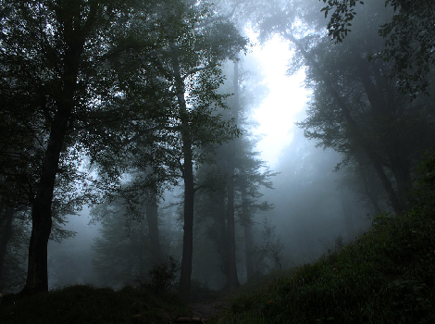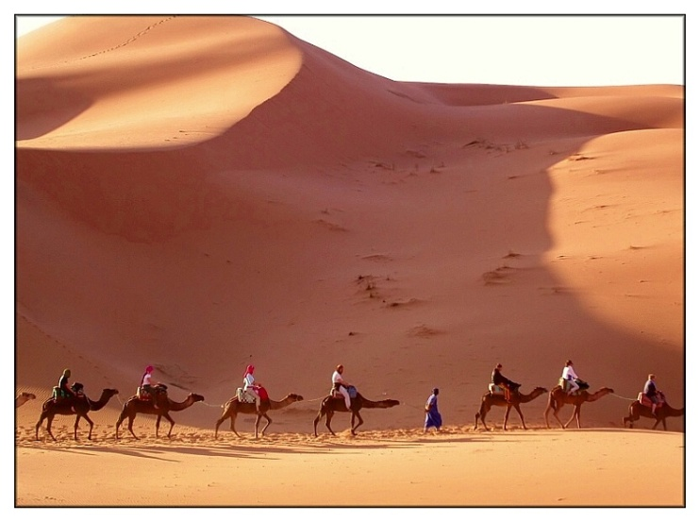

Figure1, Romantic landscape with cold and wet climate and cosmic landscape with hot and dry climate

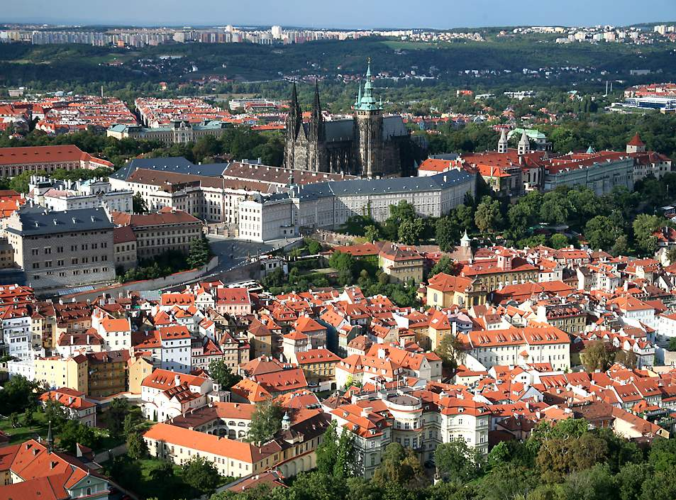

Figure2, Romantic architecture (Man-made place)

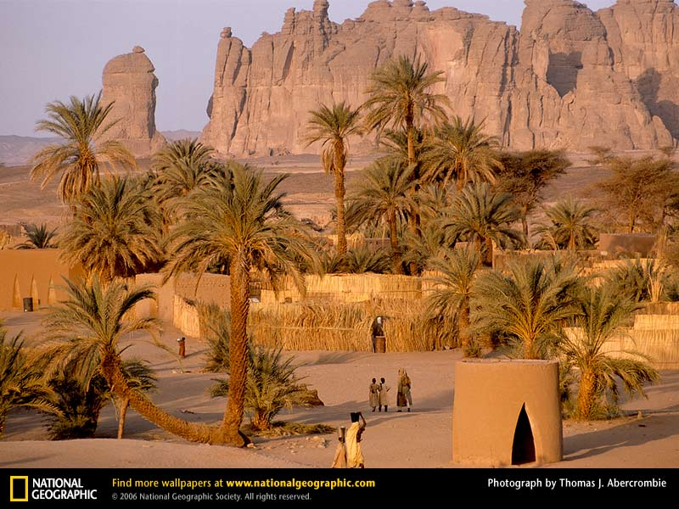

Figure3, Cosmic architecture (man-made place)

Principles

Temperaments

Admixtures

Limbs

Spirits

Faculties

Dispositions

Quadruplet climates

Quadruplet temperaments

Dispositions and behaviors

Figure4, Level of natural's philosophy in Iranian tradition medicine and influence of climate on human temperament and disposition.

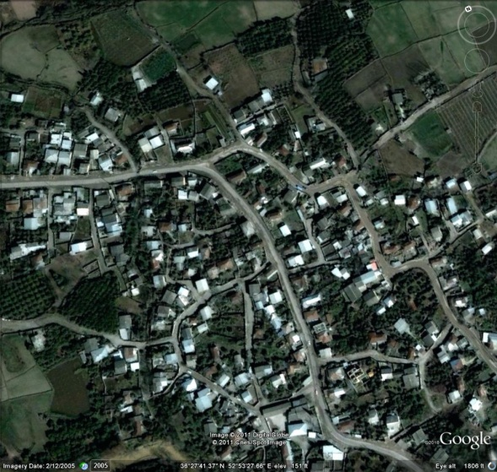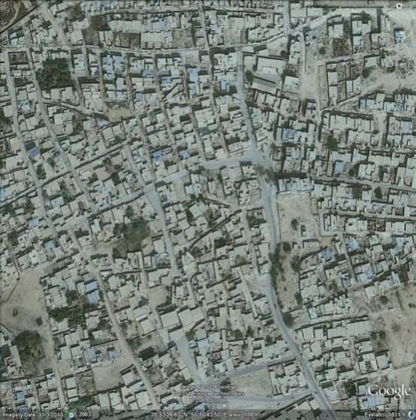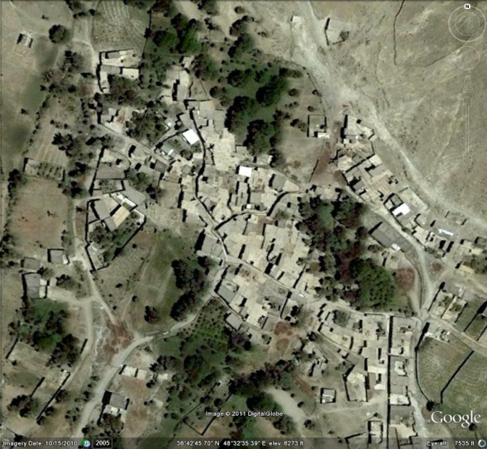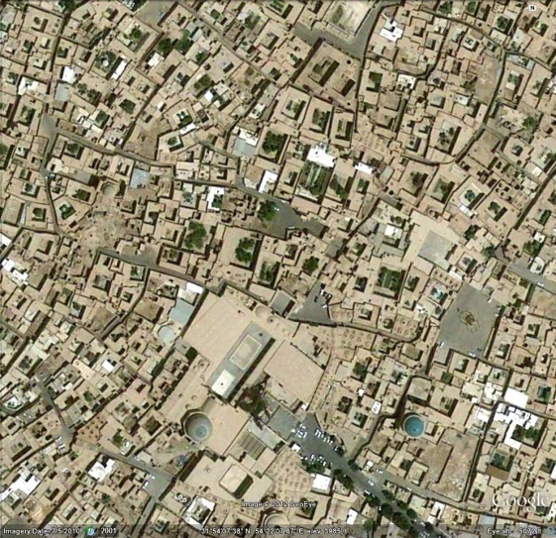

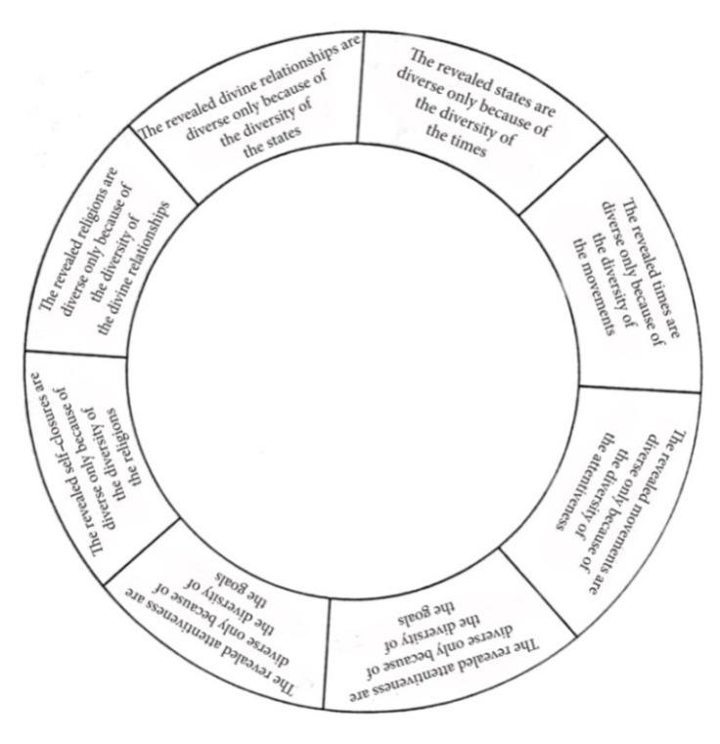Figure5. Texture of quadruplet climates according to the four tempers: From left to right: (above) scattered and free texture in cold and wet climate (One of the villages in Māzandarān), scattered and regular texture in hot and wet climate (Būshihr) - (below) massive and free texture in cold and dry climate (One of the villages in Payinkouh-Zanjan), and massive and regular texture in hot and dry climate (historical texture of Yazd).

Figure6, The circle of religious diversity

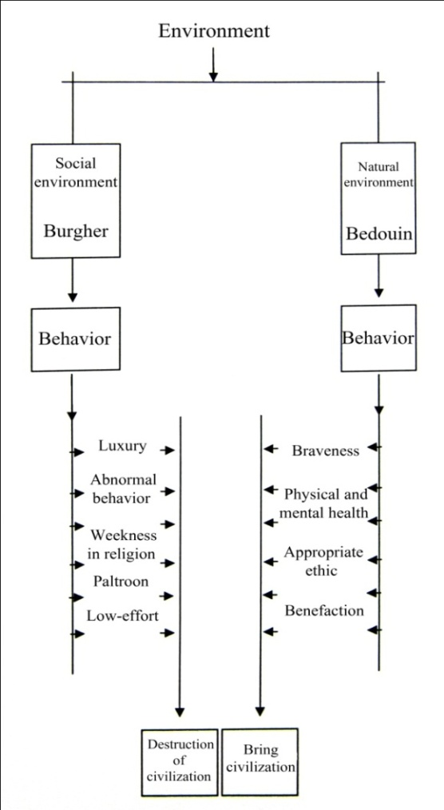

Figure7, Influence of environment on disposition from the viewpoint of Ibn-Khaldun

Dry climate

Introvert personality

Introvert architecture

Need to develop with Introvert approach

Need to modify the introversion and providing extrovert needs

Wet climate

Extrovert personality

Extrovert architecture

Need to develop with extrovert approach

Need to modify the extroversion and providing introvert needs

Figure8, Mutual interaction of wet and dry climates on the introversion and extroversion of architecture as well as temperament and identity of human being

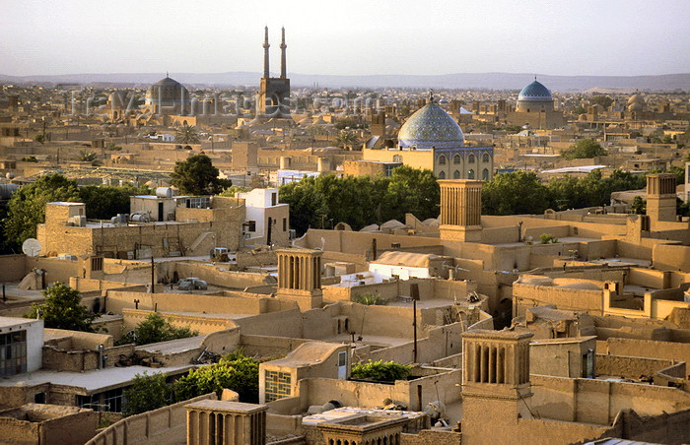

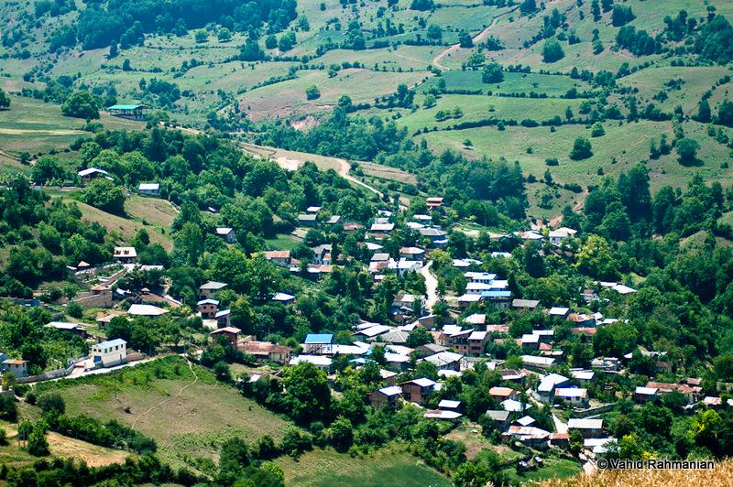

Figure9, Extroversion in wet climates (One of the villages in Māzandarān) - Introversion in hot and dry textures (Historical texture of Yazd)

Wet climate

Variety of colors in environment

Training the Non- varied and uniform tastes

Use of various colors Due to no constraints of climate

Cold, hot and dry climate

The lack of variation in color

Training the Non- varied and uniform tastes

Dark and light colors base on climat needs

Figure10, Mutual interaction of wet, dry, cold and hot climates on color of environment and Taste of human color

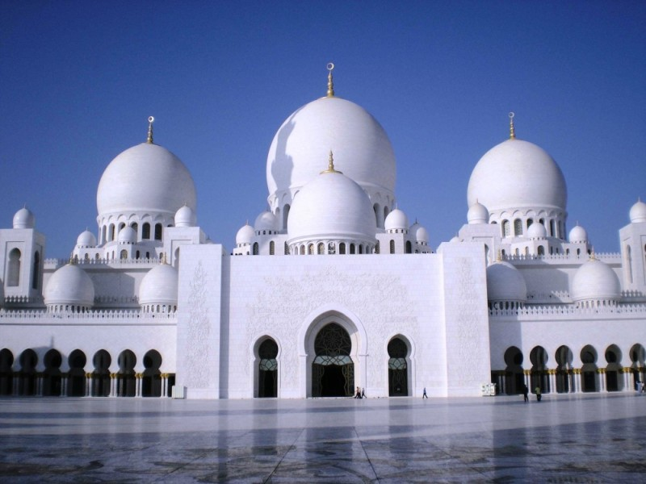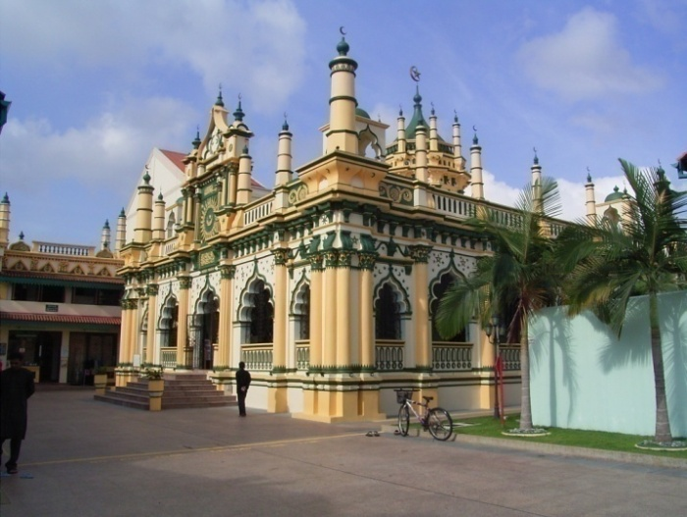

Figure11, Influences of temperaments and climates on the colors of environment and color tastes of human beings (Abdul-Gaffoor mosque in Singapore and Sheikh Zayed mosque in Abu Dhabi)

Wet temperament

Decrease the imaginary faculty

Clear and assertive signs

The need to strengthen the imaginary faculty and abstraction

Dry temperament

Increase the imaginary faculty

Abstract and reasonable symbolism

Figure12, Influence of temperament and wet/dry climate on imagination power and assertiveness

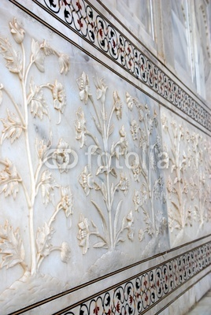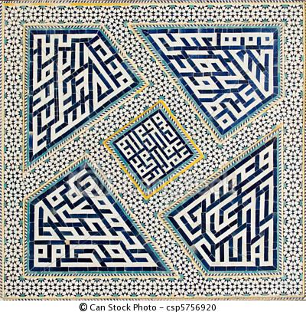

Figure13, The imagination power has adopted more of an abstraction state within dry regions and more of a realistic state within wet regions (Ornament of mosques in Iran with hot and dry climate and India with wet climate). (74)

Wetness

Gradual deterioration of body architecture due to wet climate

Freedom and fluidity of the mind due to wet temperament

Freedom of identity

Dryness

Durable of body architecture due to dry climate

Immovability andStability of the mind due to dry temperament

Centrality of identity

Figure 14, Centrality of identity in hot and dry regions vs. freedom of identity in mild regions

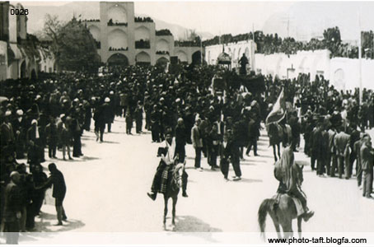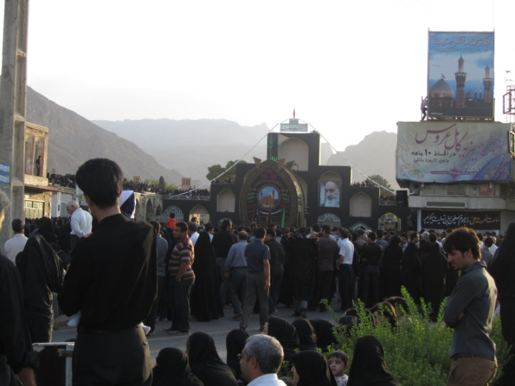

Figure15, Emphasis on centrality of identity in hot and dry regions (Religious ceremonies in the City of Taft dating back several hundred years)

Hot and cold climate

Dense urban texture

(Due to climate)

Closed spaces and contraction

Decrease in size of territory and boundaries

Wet climate

Open urban texture

(Due to climate)

Open spaces and expansion

Increase in size of territory and boundaries

Figure16, Influences of hot, cold and wet temperaments and climates in urban texture and size of territory and boundaries

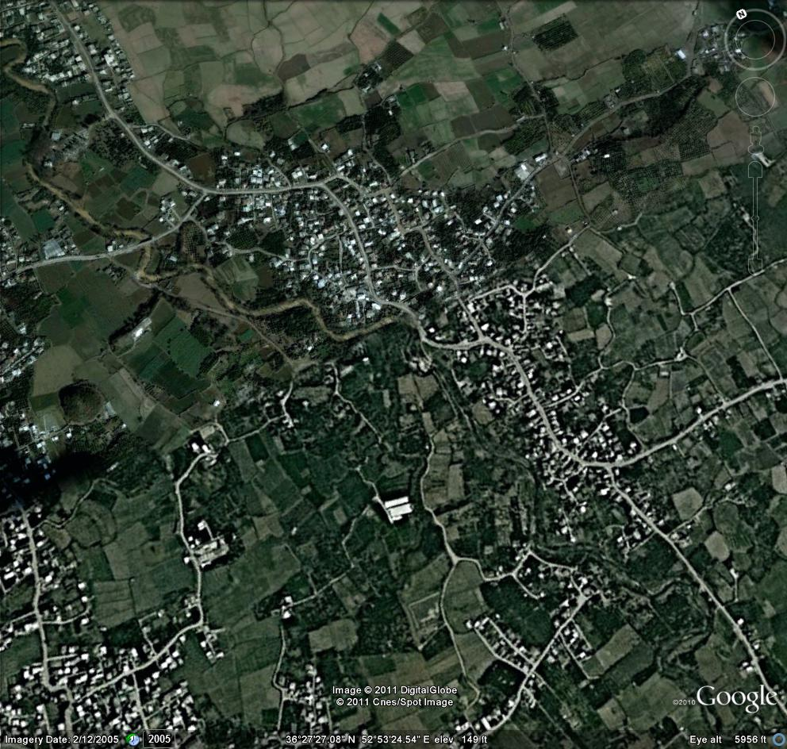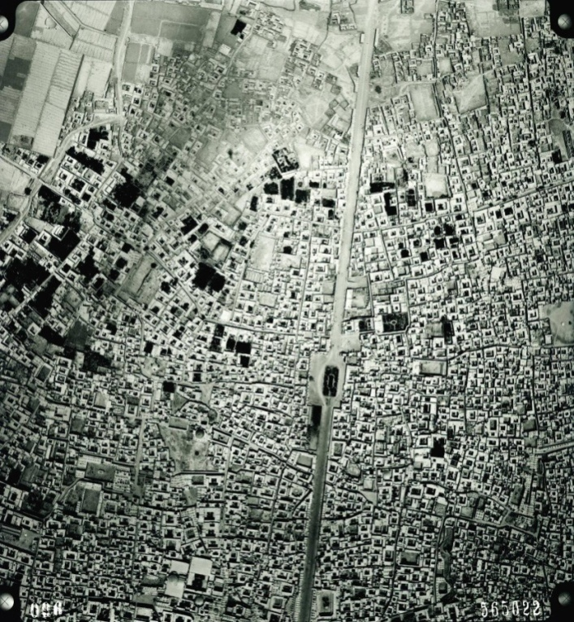

Figure17. Open urban texture in wet climate (Māzandarān texture) and dense urban texture in hot climate (Historical texture of Yazd)