**Investigation of Place Components Affecting the Child's Perception of the School environment Utilizing Q-Sort Methodology**

(Case study: Boys’ Primary school in Kerman)

Fatemeh sheikh Asadi, Isa Hojat*

**Abstract**

School environments are connected to children perceptions and emotions. The goal of this research is to explore children subjective perceptions of their school environment using “Q-sort methodology” as a unique method for environmental studies. This paper makes two main contributions. First, the research provides a study design to identify children’s perceptions of school environment that propose new information about what children prefer and can be used in the design of school spaces by designers. Second, it evaluates Q-sort methodology for gathering data directly from children concerning about their perceptions and preferences to clarify their perspectives of the environment based on these objectives. The questions that this paper addresses are: 1- What environmental components in schools do children percieve positively and prefer? And, 2- How can research with children about their place perceptions using Q-sort?

According to the purpose of the study, the respondents included 30 children (boys) from the first and second grade of two private primary schools in Kerman. The research, based on q-sort methodology, used interview as a tool for collecting data and discourse analysis for analyzing the data, and exploring the children’s perspectives. The study revealed that children interpreted spaces psychologically and had positive perceptions of and preferences for informal, personal, hiding, cozy, home-like and playground spaces and so on, likely due to affording their psychosocial needs. The result shows that future school designs should explore strategies that use connections of physical and psychosocial characteristics of child's environments to foster positive experience and perceptions.

**Key Words:** child environment, Q methodology, participatory method, school environment

Fatemeh Sheikh Asadi: **PhD Candidate, Architectural Faculty, Fine Art Department, University of Tehran; Faculty member in Higher Education Complex of Zarand, Kerman.**

Email: [Fateme.sh.asadi@ut.ac.ir](mailto:Fateme.sh.asadi@ut.ac.ir) Tel: 00989133988089

Corresponding Author: Isa Hojat, Professor at University of Tehran, Email: [isahojat@ut.ac.ir](mailto:isahojat@ut.ac.ir)

The article is the result of the first author's doctoral dissertation entitled “Continuity of childhood experience in children's educational environments”, which has been done under the supervision of Professor Issa Hojat at university of Tehran and under the advice of Professor Roger Hart.

1. **Introduction:**

After home, school is one of the most important ecological environments in which a child lives. The child spends considerable time in school and interacts consciously or unconsciously with the physical environment of the school. Even though many of the underlying processes that connect context to development are similar for physical context of human development and psychosocial environmental factors [4,5,6], most educational programs including "No Child Left Behind" (2001), aimed to achieve academic success [1], have largely ignored the physical aspects of ecological context [2] and focused on the psychosocial characteristics of child's environments [3]. In this approach, the need to pay attention to the fact that time spent in school is the time of living and learning simultaneously as well as the need to hear the child's voice in the design of the school environment, are not taken into account in designing the school environment [7]. The consequence of this neglect is: the design of schools with an organizational and standardization approach; Lack of attention to the basic and common needs of children in the same age range; Prioritize curriculum education; Lack of attention to the child's emotional relationship with the environment and as a result, the child's lack of emotional connection with the environment and a sense of belonging to the school environment.

The new approach to schools is no longer intend to primarily provide one-way delivery of knowledge and skills to students, but rather to create holistic, supportive environments for children and communities [8]. In this approach, the child's psychological needs should be supported in school environment[9], Since social, educational and psychological outcomes are interconnected (the GEM YOUth Foundation, 2013[1]).

Although Schools have been challenged to move away from traditional models of education to new ways of learning aimed at achieving goals such as cultivating social skills, emotions and appropriate behaviors, many communities are encountered with outdated school building that has not kept pace with paradigmatic shifts [10]. As architects Richard Fielden stated, “the science of designing learning environments is currently remarkably under-developed” [11] . To improve the design of school environments, there is a need to understand student’s preferences and perspectives [12,13]. Yet, little school design research has focused on bringing to light the child’s “voice” regarding their school environments.

Understanding children perspective of their environment is important and should be taken into consideration in research as well as in practice. By knowing what children think, adults and designers can understand children’s needs, interests and preferences much better and probably could offer a more meaningful learning experience to the children. In a report by Cook and Hess [14], they suggested that there is a large gap between adult observations about a child’s understanding of a situation and the child’s own perceptions. Thus, it is agreeable that adults could not actually see the world from a child’s perspective and children’s perspectives are recognized as separate to and different from those of adults.

The goal of this research is to take advantage of a participatory method to explore children subjective perceptions and preferences of their school environment utilizing “Q-sort methodology” as a unique method in environmental studies. This paper makes two main contributions. First, the research provides new information about what children prefer and how perceive their environment that can be used by designer in the design of better school spaces. Second, it evaluates Q-sort methodology for gathering information directly from children concerning their preferences to elucidate their perspectives of environment. Based on these aims, the questions of the paper are:"1- What environmental components do children in schools prefer? And, 2- How can research with children about their place perceptions using Q-sort?

In the first part of this article, a background about the effects of different views on school physical environment and then, the process of the Q method at theoretical and empirical levels are presented; next, by applying the model of Canter about Place, Gibson's environmental studies and environmental affordances and the Q method process, a theoretical model is presented which can be used to find children's perspectives in environmental studies; the second part contains an outline and discussion of the research.

1. **Background**

Designing of school physical environment is connected to children experiences, emotions and behaviors, and researchers have found that the quality of the physical, designed environment of childhood settings is related to children’s cognitive, social and emotional development [7, 15, 16, 17]

The most obvious function of the school is its teaching responsibility to develop cognitive development, to transmit information on curriculum, and to establish learning joy and excitement [18]. Studies related to this approach are the effects of light, noise, sitting and learning positions, classroom design, size and layout. " [16, 19]. A study found that several design factors, including light, temperature, and color explained 16 percent of variation in student academic progress [20]. Smaller schools are associated with greater student satisfaction, participation and better academic performance [10,11, 21]

In the second approach, the school is recognized as the main system in coordinating children with the society and allocating their position in society. Using the physical environment of school can make significant changes in children's social behaviors [22]. Studies have found that the layout of classrooms can influence not only learning behavior but also social interaction [23, 24]. For example, students show higher levels of on-task work when seated in rows [25] but exhibit higher levels of interaction with the teacher when seated in a semicircle [26]. Maxwell's study of the physical environment impact on child "self-esteem" is one of the most important studies conducted on the relationship between school physical environment, children's social-emotional development [27].

The third and most comprehensive view about the function of the school environment is to support the child's psychological needs [9] to create holistic, supportive environments for children [8]. Schools undoubtedly play an important role in a child's positive perception and experience if places are used to provide a sense of personalization or individuality, similar to what Proshansky calls "place identity". The child's sense of identity begins to grow at home, but school is an important social and psychological force that increases the child's self-sense and the interests, skills, and personal qualities that define the identity [28]. Privacy [29,30] and personalization [27] can be the environmental indicators that show "the child is relevant and important, can help to create a greater sense of being valued, and also increase the meaning of place for children." [27, 31,32]. Smallness [33] as another indicator showed that students from small, compared to large, schools had a strong sense of belonging and participation. Density also has influence on children perception, as shown by Maxwell’s study [34] that found in comparison to uncrowded setting, children in crowded centers are more likely to exhibit aggressiveness, withdrawal, and hyperactivity. Research also supports the benefits of small and private spaces to which children can retreat when they feel tired, overwhelmed or unhappy (e.g., 35,36(.

An extensive review of the work of researchers such as Altman [37], Heft, Wohlwill [38], Evans [16], Spencer [39] and Weinstein [40] shows using psychological theories to understand how to create environments that best support the child. These studies have found that children perceptions of the environment are associated with behavior. For example, children who perceive playgrounds in their neighborhood have higher activity levels [41]; yet, little is known regarding how students perceive their environment and what they prefer.

Children’s knowledge and use of physical environments emerged over the last decades as a major focus of research inquiry [33, 42, 43] but methods to understand children’s perceptions/ preferences of the environment are underdeveloped. Children’s cognitive abilities are not fully formed, which makes limitations of survey and interview [44, 45]. Interview is problematic when exploring subjective perceptions/ preferences that can be ambiguous [46]. furthermore, survey and interview methods require a relatively high level of cognitive processing, while perceptions of the environment are not always cognitively explicit. Q-sort methodology, on the other hand, are of noted utility with children who have not fully developed linguistic skills, and to explore hidden aspects of how children perceive/prefer their environments. Children and adults have different views and preferences about the environment around them, and Q- sort offers a tangible documentation and representations of children’s perception and preferences about their school environment. Briefly, this technique is to use photographs in an interview that asks children directly for their preferences and the respondent choose from the most desirable to the most undesirable image.

1. **Methodology**

**3-1-Q-sort Methodology**

Children are often regarded as a particular group of research subjects who require additional ethical attention from researchers when they are designing research tools [47, 48]. Many conventional research approaches, in both the quantitative and qualitative paradigms, require specific skills of the participants. For example, in-depth interview, requires relatively good verbal skills. Reading skills are required to participate in quantitative studies such as surveys. Quantitative researches also need a broad statistical population that can be challenging for children's studies because child participation usually requires the permission of their parents and caregivers [49]. In addition, children are often excluded from large-scale quantitative researches because few research tools consider the level of child development. The vocabulary and cognitive level of child may make it more difficult to participate in more conventional research methods designed for adult participation [50]. Researchers need to apply child-friendly approaches that can be well-designed for participatory research with children [51]. In recent years, we have witnessed the development of child-friendly research approaches, as researchers have become more aware that the deprivation of children from participation in research is unacceptable. Using the Q method is a “child-friendly” approach that uses their voices by participating children that can be used to discover children perspectives and feelings.

There are some methods can be used to gauge children preferences and perceptions for environment. In this study Q-sort methodology appears to be a valuable participatory method for accessing children’s subjective patterns. Typically, researches are designed to discover how people “talk” about a subject, while the Q method can support the researches that use visual data – how people perceive a subject [52]. The Q method is considered a link between qualitative and quantitative methods, because on the one hand, participants’ selection is not done through probabilistic sampling methods but the sample is selected small and purposefully which approximates it to a qualitative method, and on the other hand, the findings are obtained through factor analysis and quite quantitatively. Also, due to the way data is collected (sorting), the mindset of the participants can be known more deeply. The major difference between the Q method and other research methods is that in the Q method, individuals are analyzed instead of variables [53] (Fig 1).

|  |  |
| --- | --- |
| **Research objective** | The objective is identifying the relevance of ideas in a particular subject and the nature of people's mental perception about the subject [54] |
| **Study case** | Subjectivity is measured rather than empirical facts [55] |
| **Statistical population** | Small and targeted samples with sample size between 8-40 [54] |
| **Validity** **control** | Examining the research with theoretical literature and expert opinion |
| **Reliability** | Method test through multiple instruments and test-retest [55] |
| **Tools** | Interview |

Figure 1: Q method features; Source: authors

The process of Q method in a research:

1. Determine the context of the discourse/ study

2. Select Q set that can include items or pictures.

3. Respondents’ selection which was done to reflect the broadest range of views on the field of discourse.

4. Respondents are asked to examine statements or pictures from their personal opinion, based on their priorities, judgments, or feelings about the subject under consideration, and rank and place mainly in a normal distribution, in the sorting template (selection table) (Figure 2). So people express their mental views

5. At the next stage, a post-test interview with the sample is conducted and they are asked to comment on the samples provided to help interpret this table

6. Identify patterns of similarities and differences between respondents [56].

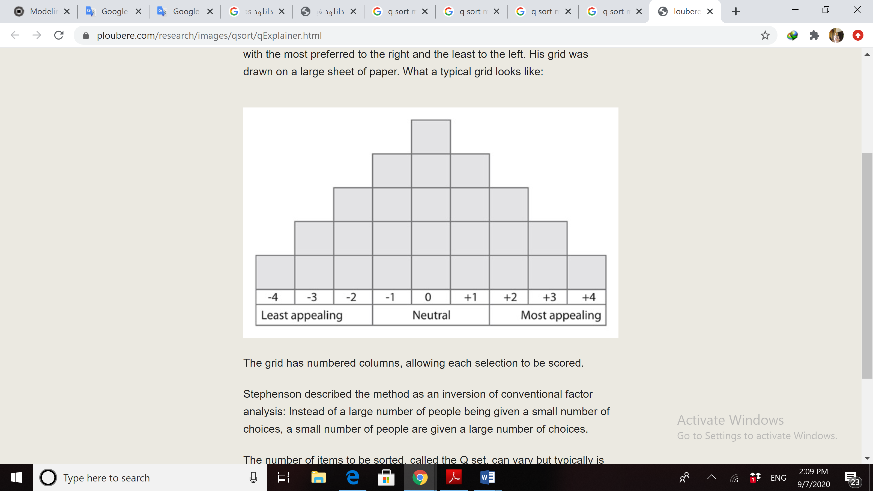

Figure 2: sample table for the distribution of statements/ pictures in the Q method process

**3-1-1-Explaining the Q data analysis pattern in child environmental studies**

**• The concept of place in environmental studies**

According to Canter, the experience of place is done through the three “physical-place system” that expresses the physical properties of space, “collective-behavioral system” that describes the behavior and human activities happening in the place and “perceptual-perception system” that expresses the concepts and descriptions of users [57].

**• The concept of environmental affordances in environmental studies**

Children respond to places according to their “potentiality” – what the environment might offer or “afford” as suggested by Gibson’s affordance theory [58]; however, affordance can be positive and negative as well as visual and function. From the perspective of environmental psychology, humans and the environment are interconnected by affordances that also have environmental properties [58]. Lang [59] argues that affordances are environmentally specific patterns obtained from the way they are designed, the materials used in it, and the way it is assigned to a specific group of people. Knowing the affordances of the environment is essential for upgrading architectural design, and providing a performance-appropriate form [60]. The concept of affordance practically provides another way in looking at the design of the environment, emphasizing the perfection of the relationship between the environment and its users, namely between the form of buildings and the behavior resulting from their residents as “functions” of the building [61]. Thus, an affordance does not represent an actual event of the behavior, but rather represents the potential for a behavior, and based on this theory, the purpose of the design of buildings is to create optimal affordances for users.

The categorization of the affordances can be as follows [60]:

1. The affordances that people need to physically interact with the environment. This physical interaction provides basic needs such as walking, sleeping, etc.

2. The affordances that people need for social interaction and interpersonal communication

3. The affordances that people need to satisfy their symbolic and mystical pleasures and interactions with cultural and spiritual properties of the environment. It’s a deeper level of communication that is expressive or symbolic importance of place.

Based on the three constitutive elements of place as well as the triple foundations of environmental affordances, this study proposes the following model as a data collection and analysis model of the Q-method (Fig 3). Accordingly, from the interviewees’ responses, three types of mentally, functional, and physical components based on their descriptions of their emotions, the environmental behaviors they predict for an image, and their desirable and undesirable place qualities and physical elements are identified. Then, from these findings, mental patterns similar to those of children are obtained. Through the mental models obtained, the place qualities and environmental indicators associated with these qualities are obtained. These findings characterize desirable and undesirable environmental qualities and indicators among children, as well as the degree of agreement/disagreement of children with regard to desirability/undesirability by scoring each picture depending on its placement in the sorting table (Fig4).

**Mental pattern obtained of respondent based on Q sort**

Meaningfulness pattern

Behavioral pattern

**place**

Physical pattern

Respondents’ affordances to symbolic and spiritual tendencies

Respondents’ affordances to interpersonal communications

Mental criteria of the respondent

place quality of the environment

Respondents’ affordances to physical interaction with the environment

Environmental index

Physical elements of space/thing/ place qualities

(Feelings and meanings of place

(Description of child on his feelings on behavior, space or thing)

Space behavior

(Activities observable in space)

**Collecting environmental data**

**Interpret and organize the findings**

Figure 3: Model of collecting and analyzing findings in environmental studies with Q method; Source: Authors

**3-2-Describing a practical example of applying the Q method in child environmental studies:**

In this section, a research is described in which the Q sort method is used. To this end, a detailed description of the method of data collection, data analysis and finally the sorting of subjective patterns found from content analysis are attempted to clarify the application of this method and its results in a key issue in the field of child environment. This method is designed to examine children's preferences for school environment experiences to identify patterns and interpret these patterns to determine the similarities between children upon entering school.

* **Introducing the field and target group:**

First, the school field was chosen as the discourse field. Then, based on theoretical literature studies and examining field research, Q photo collections were selected with the help of experts with the aim of discovering children's mental patterns about their desired place qualities and ultimately environmental indices affecting these qualities. According to the purpose of the study, the respondents included 30 children from the first and second grade children(boys) of private primary schools in the city of Kerman. Private schools were selected for this study due to providing an environment with relatively suitable facilities and environments and the presence of children from medium to high families.

* **Photograph classification:**

Respondents arranged the numbered photos, which were similar in size and quality, in the sample table according to the level they liked/dislike or considered appropriate/inappropriate. Then the final table was drawn as the research data. Children’s responses were converted to quantitative scored, using a coding system in which a numerical value of 1, 2, 3, or 4 was assigned to each picture selected by the children. The numerical score assigned to pictures reflected the child's interest or lack of interest in the image.

The interview data were analyzed during the interview, the participants were asked about each photos that they chose, such as: why they chose the picture and what elements they preferred in the scene the most, what do they think about the potential behaviors in this scene? What are their emotions about this scene? What physical element and furniture they preferred the most?

By using a content analysis method, the interview data as well as the photographs, were used for further interpretation and insight and were grouped into several classifications. Then, the score of each image was entered into the statistical package. Finally, 3 classifications (behavior, emotion, physical attributes), which were preferred in primary school by children, had been finalized (Fig 4, 5).

**3-3- Analysis and interpretation of the information:**

In the table below, the first column is about the sum of the scores obtained from each picture in the Q table, where “P” signifies respondent child, and “child labels” signifies their overall feeling about that photograph.

|  |  |  |  |  |  |
| --- | --- | --- | --- | --- | --- |
| **Score** | **Sample of Q image** | **Respondents** | **Components/key, behavioral, and meaningfulness indicators** | **Children labels about the images** | **Identified children’s perspectives** |
| **63** |  | P1, P2, P3, P4, P6, P8, P10, P12, P14, P20, P21, P22, P24, P25, P28, P29, P31 | physical components: game tools, visual relationship with the city, depth of vision, safety of the defined open space  Safe ground, transparency, openness, soft sofa, soft ground | The highest amusement | Context for imagination growth  Context related to the world, context related to the sky |
| Functional components: seeing sky, playing, lying down |
| Meaningfulness components: Imagination, communication with sky, meaningful communication with the world |
| **57** |  | P2, P3, P4, P6, P10, P11, P12, P14, P15, P16, P17, P20, P21, P24, P25, | Physical: non-official space, lots of books, colorful sign, carpet, big library, corners, and small environments, child | The most joy | A context providing a chance of loneliness  A context for the emergence of the unique identity of the child |
| Behavioral: Sitting on the ground, studying alone, a chance of being alone |
| Mental: Wide space, comfort in space |
| **53** |  | P2, P4, P5, P7, P8, P9P10, P11, P12, P13, P16, P22, P23, P25, P27,P28, | Physical: Cleanness of WC, bright color, colorful signs, mirror   Appropriate air conditioning, good smell, good design and color | Somewhere that doesn’t smell bad | A context with desired environmental quality |
| Functional: Going to WC, seeing oneself in mirror |
| Mental: value, child being respected |
| **52** |  | P1, P2, P3, P4, P8, P9, P10, P13, P16, P17, P19, P21, P23, P25, P28 | Physical: Carpet, board, color and design consistent with carpet, TV, wide empty space, colorful circles, micro environment | I choose myself | A context for free activity of child |
| Functional: Choosing the type of sitting, sitting on the ground, lying down |
| Mental: child feeling, having the right to choose, feeling of game, freedom of movement |
| **46** |  | P4, P6, P9, P10, P13, P14, P15, P16, P17, P25, P26, P29   P1, | Physical: lampshade, tent, game, game tools | Feeling of wonder | A context for the continuity of pleasant memories  A context providing a chance of loneliness |
| Functional: A chance of being alone, opportunity to sleep |
| Mental: Feeling of fun and wonder |
| **44** |  | P1, P2, P3, P8, P9, P10, P11, P12, P13, P16, P20, P28, | Physical: Pillow, stare, window, small and comfort | Appointment of me and my friends | A contest related to the sky  A context for continuing pleasant memories |
| Functional: possibility of sitting alone, playing, seeing outside, communication with the world, communication with outside, having rest, being alone with friends |
| Mental: being intimate, feeling of joy, comfort, being with intimate friends |
| **44** |  | P1, P2, P5, P6, P10, P12, P14, P17, P20, P24, P28 | Physical: Circle form, spatial corner, wood, spatial corner | Imaginative house | A context for giving a chance of loneliness |
| Functional: Working alone, studying alone |
| Mental: being cozy, possibility of making personal child world |
| **38** |  | P1, P2, P6, P9, P12, P13, P20, P24, P25, P28, | Physical: Slanted ceiling, wood wall, door connecting with the outside, corner | Imaginative game | A context providing a chance of being alone  A context for the development of imagination |
| Functional: Playing, playing hide and seek, reading books alone |
| Mental: Feeling happy, imagination |
| **37** |  | P2, P3, P9, P12, P13, P14, P17, P25, P28 | Physical: Personal closet, display sign, suitable color, painting, vase, environmental richness, wide corridor | My stuff are safe | A context providing the feeling of place ownership |
| Functional: Keeping personal stuff, displaying child works |
| Mental: Feeling of being respected and valued |
| **35** |  | P8, P11, P1, P2, P13, P14, P15, P23, | Physical: Wide corridor, bright color, children painting, wide space, cleanness, environmental richness, corners, openness |  | A context providing a feeling of place ownership |
| Behavioral: Displaying child works, moving freely |
| Mental: Feeling of ownership, freedom of movement, comfort, feeling of openness |
| **34** |  | P2, P3, P8, P10, P13, P14, P15, P17, , P22 | Physical: Furniture, carpet, pillow, softness, corners | The most peace | A context for the continuity of pleasant memories  A context for giving a chance of loneliness |
| Behavioral: sitting comfortably sitting separately from others, sitting on the ground |
| Mental: Feeling peace, being with the self |
| **26** |  | P1, P2, P3, P4, P13, P15, | Physical: high-quality corridor, window, painting, being wide, natural light, sun | Feeling of happiness and vitality | A context related to the sky  A context providing a feeling of ownership |
| Behavioral: Displaying child painting |
| Mental: Feeling of happiness and vitality |
| **24** |  | P1, P10, P4, P16, P19, P23, P29 | Physical: Vase, small desk, carpet, being ordered and sorted | A familiar place | A context for the continuity of pleasant memories |
| Behavioral: Being alone with the self, being alone with friends |
| Mental: Feeling of being home |
| **18** |  | P3, P22, P28, P15 P1, | Physical: Safety, window, seat |  | A context related with the nature  A context providing opportunities  Loneliness  Safe place |
| Functional: Sitting at somewhere isolated from others, seeing nature |
| Mental: Feeling safety, feeling connected to the nature |
| **17** |  | P3, P8, P10, P16, P20, P21, P23, P2, | Physical: Wood, toy |  | A context for the continuity of pleasant memories |
| Functional: Playing, experiencing life |
| Mental: Familiar |
| **16** |  | P3 P6, P8, P13, P17, P21, P29 | Physical: Carpet, group desk, wide space | The most learning | Giving the right to choose in using  Space  A context for learning |
| Functional: Sitting on desk and seat |
| Mental: Feeling of learning, feeling of having the right to choose |
| **16** |  | P5, P7, P9, P11, P12, P17, P18, P20,  P2, | Physical: Closet, individual desk and seat, comfortable seat, safety |  | A context providing a chance of loneliness  Safe place |
| Functional: Individual study and work |
| Mental: Being comfortable, not having interference |
| **16** |  | P18, P6, P8, P11, P13, P14, P21, P25, P28,  P2, | Physical: Being crowded, visual crowding | The most happiness | A context for child’s free activity  A context for experiencing with senses  Creating opportunities  A context for socializing |
| Functional: Group work, practical work, playing, work with hand |
| Mental: feeling happiness, feeling of discovering, involving all senses |
| **14** |  | P1, P7, P12,P13, P17, P24, | Physical: A window towards the sky, suitable light, suitable air conditioning | The most imagination | A context related to the sky  A context to develop imagination |
| Functional: Seeing outside |
| Mental: Imagination, curiosity |
| **11** |  | P1, P2, P4, P8, P12, P13, | Physical: Vase, flowers, group desk, window, ordered and arranged, clean |  | A place to study |
| Functional: Group work, seeing outside |
| Mental: Home-like feeling |
| **5** |  | P2, P7, P8, P12, | Physical: Cleanness, painting, suitable color |  | A context providing a feeling of place ownership  A context providing the opportunity to create |
| Functional: Displaying child works |
| Mental: A feeling of being creator |
| **5** |  | P1,P22 | Physical: flower, vase, window, aquarium, pillow, group desk, carpet, |  | A context for learning  A context providing the feeling of ownership |
| Functional: Seeing outside, taking care of flowers, working in groups, displaying children’s crafts, sitting alone |
| Mental: Feeling comfortable, environmental richness, having the right to choose |
| **-2** |  | ,P17 P6 | Physical component: Being crowded, individual seat and desk |  | A context with desirable environment |
| Functional component: |
| Mental component: Lack of environment readability, feeling crowding |
| **-3** |  | ,  P3 | Physical component: Open and uncontrolled closets |  | A context for the creation of a feeling of control over the environment |
| Functional component: Putting personal stuff at a place far from the child |
| Mental component: A feeling of lack of control on the belongings |
| **-5** |  | , P4, P8, P10, P11, P15,  ,P27, P29  P1 | Physical component: Inappropriate dark color, limit in the space, lack of wide scope, not being open, airy, carpet |  | A context for the creation of a feeling of control over the environment |
| Functional component: Sitting impolitely, putting hands in mouth |
| Mental component: Unpleasant feeling and non-belonging, feeling of not controlling the environment |
| **-16** |  | , P24, P1,  P9, P11, P12, | Physical component: A place to lie down on the ground |  | A context in appropriation with culture |
| Behavioral component: Lying down on the ground |
| Mental component: Feeling of abnormal behavior |

Figure 4: Example of the process of collecting and analyzing environmental findings from the Q method; Source: authors

1. **Discussion**

After analyzing and interpreting the codes obtained from child interviews, the constituent codes of the child's place experience, perspectives, qualities, and indicators about the school environment were identified. The Identified perspectives of these children (boys) show that they expect places where afford context for their imagination growth, a context related to the world, nature and sky, A context providing opportunities for privacy, a context for the creation of a sense of control over the environment, an appropriate context for their culture, a context for learning , a context that provides a sense of ownership, a context providing the opportunity for creation, a context for the free activity, a context for socializing, a context for continuity of pleasant and home-like memories, a context for the emergence of the unique identity of the child (Figure 5).

|  |  |  |  |
| --- | --- | --- | --- |
|  | **Identified children perspective** | **Quality** | **Index** |
| 1 | A context for the development of imagination | Transparency  Curiosity | Transparent fences |
| A view to the sky |
| A view to the city |
| Space corner |
| 2 | Safe place | Safety  Security | Soft floor |
| Child scale |
| 3 | A context for the continuity of happy memories | Familiarity with the components | Carpet |
| A window to the sky |
| 4 | A platform that provides a feeling of ownership | Possibility to control and update oneself | Display children's painting |
| Display sign |
| Display of children's crafts |
| A place for personal staff |
| Micro environments |
| Having the right choice in the type of space used |
| Closet with the possibility to lock |
| Closet available to child |
| 5 | A context providing a chance of loneliness | The physical separation of the child at the times of his choice    Space comfort | A space to study alone |
| Corners and quoin |
| A place to be alone with close friends |
| A space to be alone with the self |
| Informal space |
| Micro environments |
| 6 | A context related to the world | Relationship with the sky | Windows to the sky |
| Ceiling openings with the possibility to look at the sky |
| Open spaces and courtyards |
| Relationship with the nature | Natural flowers in classes |
| Greenhouse spaces in school |
| Indoor green space and open green space in the courtyard |
| 7 | A context for experiencing different senses |  | Practical workshops |
| Availability of different materials |
| Equipped and safe laboratories |
| 8 | A context for free child activity | Freedom of movement | Wide space |
| Wide corridor |
| Free space in class |
| Possibility to lie down on the ground |
| Possibility to sit on the ground |
| 9 | A context for the emergence of the single child identity | Personal identity | Library |
| Unofficial spaces |
| Space quoins |
| Single furniture and isolated from the crowd |
| 10 | A context providing the opportunity to create | Creativity | Flexible spaces |
| A place to display children's works |
| Various workshops (wood, flowers) |
| Defined spaces for painting by a child |
| 11 | A context with desirable quality of life | Environmental richness | Airy space |
| Environment readability |
| Unlimited order |
| Width and depth of vision |
| Clean bathroom |
| Pleasant smell |
| Convenient mirror in bathroom |
| Proper air conditioning |
| Natural lighting |
| Soft furniture |
| Soft floor |
| Right color |
| Colorful boards |
| 12 | Readable place[2] | Layered environment | Diverse spatial layers |
| Micro environments |
| The possibility to experience space at different times |
| Experiencing open, semi-open and closed spaces |
| Shaded spaces |
| Shade and bright in the environment |
| 13 | A context for learning | Cognitive development | Spatial diversity |
| Environment trial and error |
| Teamwork space |
| Space of study and individual work |
| Direct using of nature, sun and so on |
| Possibility to see animals and plants closely |
| Safe and rich laboratories |
| 14 | A context providing the opportunity to play | Discover and experience | Playing instrument |
| Design of quasi-game space |
| Space quoins |
| Step |
| Defined game space |
| Space width |
| Shaded spaces in courtyard |

Figure 5: children perspectives, their qualities and indicators. Source: Authors

Using Q method, several prominent features and as a result, three general categories of children's place preferences were obtained, which include the following:

1-The Desirable physical components of boys in primary school include: playgrounds, windows, corners, a place to display children's artwork, cozy furniture, color, display panel, wide corridor, wood, carpet, personal closet, (Fig 6)

2-The desirable behavior of boys in primary school include: playing imaginary games, being/working alone, going to a good and clean WC, moving freely, maintenance of personal belonging, showing artworks, sit comfortably, resting, watching the sky and outdoor, …(Fig6)

3-The desirable feeling of boys in primary schools include: fun, joy, smell good, choose what to do by myself, wonder, imagination, safe, peace, validity, happiness, (Fig7)

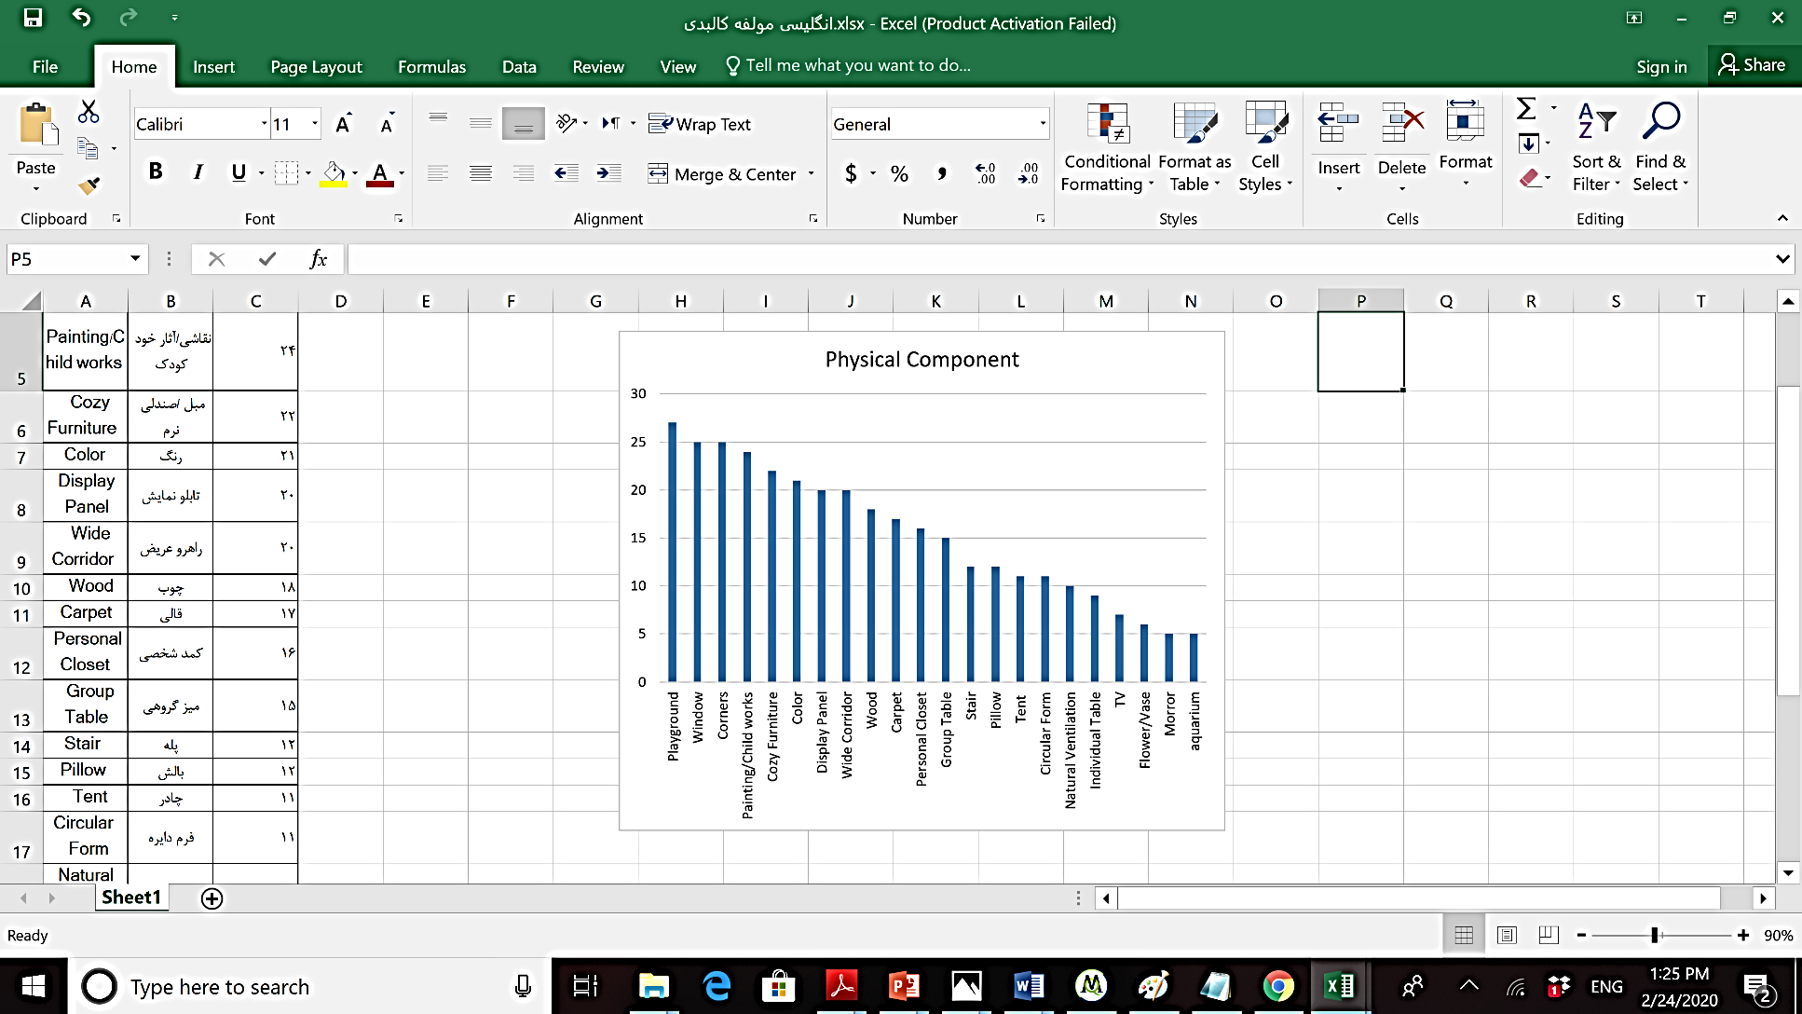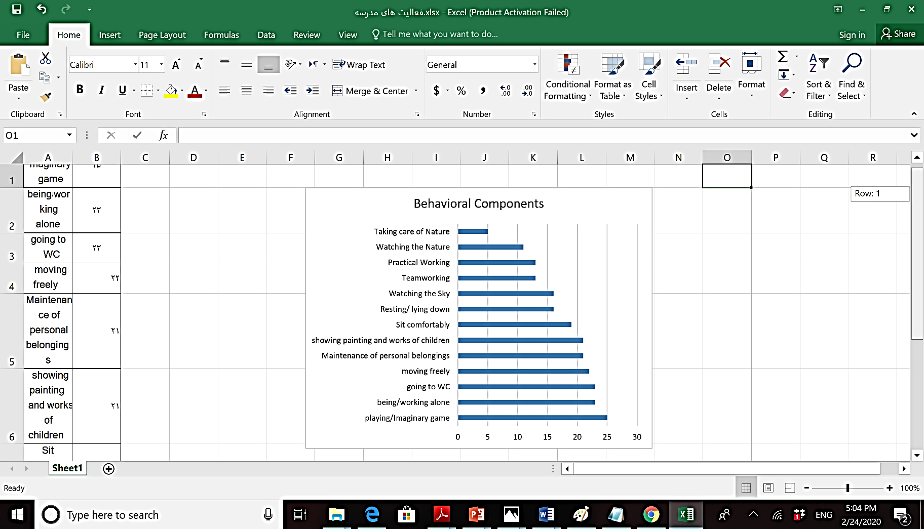

Figure 6: Assessing behavioral and physical components of school environment based on the level of desirability

|  |  |
| --- | --- |
| **The overall feeling of space** | **Space type** |
| Most fun | Game space |
| Most joy | Informal space and providing an opportunity for being loneliness |
| Where it doesn't smell bad | High-quality bathroom space |
| What I choose what to do myself | Sufficient space or micro environment |
| Feeling wonder | Space to hide and separate from others |
| Me and my friends’ appointment | Cozy space with desirable quality |
| My imagined house | Personal space with desirable quality |
| Imaginary game | Space to hide, run and sit |
| My belongings are safe | Space to store stuff |
| Most peace | Spaces and furniture like home |
| Feeling vitality and happiness | Transparent, bright and colorful corridor |
| Most learning | Class |
| Most happiness | Teamwork space |
| Most imagination | A window to the sky |

Figure7: Mental components of school based on the level of desirability among children

**Conclusion:**

Child behaviors are formed in the context of the environment, and how the environment support the behavioral patterns plays a major role in the perception of the environment. Therefore, the physical environment has an undeniable effect on the child's perception, so the purpose of this study is "to know the environmental components that provide a context for promoting children perception in the school environment." Based on the intended purpose, the paper seeks to answer these questions 1- "What are the environmental components affecting the perceptions of children among primary school children?" and 2- “How can search with children about their points of view using Q-sort?”

Investigation of preferences and perceptions is useful in identifying and filling the communication gap between children and adults and this research has both demonstrated the need and provided the methodology. Q-sort methodology in this study revealed information that likely would not have been found with other methods. Research that aims to explore themes that may not be cognitively explicit (in both children and adults) could consider this method. The study utilized this method to explore students’ perceptions/preferences of their environments and revealed new insight of how children perceive their environment and how is their subjective patterns of a good primary school environment.

The result also showed that children interpreted space socially and psychologically and have positive perceptions of and preferences for spaces such as playgrounds, informal spaces, personal and hiding spaces, cozy and home-like spaces likely due to control social interaction, privacy and other psychological consideration. These findings can be used by designers to improve school environment and these themes should carefully consider and explore strategies that use connections of physical, social and psychological environments to foster positive perceptions.

[3]

1.
2. By “readable place” like “readable book”, used by authors, is a place where an individual is eager to read and experience and is willing to read it several times and each reading time, finds a new perception of its various layers. It’s a place which is worth reading and experiencing over and over.
3. **ACKNOWLEDGMENTS**

   I thank Professor Gary Evans. Preparation of this article was based on his suggestion and was supported by his idea.

   **References:**

   1. Hursh, D. (2007). Assessing No Child Left Behind and the Rise of Neoliberal Education Policies. . *American Educational Research Journal, 44(3),* , 493–518.
   2. whippli, s. s., Evans, G., Barry, R., & Maxwell, L. (2010). An ecological perspective on cumulative school and neighborhood risk factors related to achievement. *journal of applied developmental psychology*, 422-427.
   3. Bronfenbrenner, u. (2005). Making Human being human. sage.
   4. Watches, T. (2000). necessary but not sufficient: the perspective roles of single and multiple influences on Individual Development. washington, DC.
   5. Watches, T. (2003). expanding our view of context: th bio-ecological environment and development. Adv. Child. 31, 363-409.
   6. Heft, H., & Wohlwill, J. (1987). The Physical Environment and the Development of the Child. In E. b. Altman, In Handbook of Environmental *Psychology. Vol. 1.* (pp. 281-328). New York: Wiley.
   7. Hojat, I., Sheikh Asadi, F. (2020). “Promoting and Continuity of the childhood experience in children's learning environments”. *Architectural and Urban Planning Journal. Under publishing*
   8. Baker, D., & Letendre, G. (2005). National differences, global similarities. Stanford: Stanford University Press.
   9. Armstrong, D., Henson, K., & Savage, T. (1983). Education: An Introduction. . New York: Macmillan Publishing Co.
   10. Darmody, M., Smyth, E., Doherty, C. (2010). Designing Primary Schools for the future.
   11. Higgins, S., Hall, E., Wall, K., Woolner, P., McCaughey, C. (2005). The impact of school environments: A literature review. The Centre for Learning and Teaching, School of Education, Communication and Language Science, University of Newcastle.
   12. Gee, L. (2006). Human-centered design guidelines. In D. Oblinger (Ed.), Learning spaces. Washington, D.C.
   13. Woolner, P., Hall, E., Wall, K., Dennison, D. (2007). Getting together to improve the school environment: User consultation, participatory design and student voice. Improving Schools, 10(3), 233-248.
   14. Cook, T., Hess, E. (2007) What the camera sees and from whose perspective: Fun Methodologies for Engaging Children in Enlightening Adults. Childhood, 14(1).
   15. Moore, G. T. (1987). The physical environment and cognitive development in child-care centers. In C. S. Weinstein & T. G. David (Eds.), Spaces for children: The built environment and child development (pp. 41-72). New York: Plenum.
   16. Evans, G.W. (2006). “Child Development and the Physical Environment.” Annual Review of Psychology 57: 423-451.
   17. Moore, G.T., Sugiama, T. (2007). “The Children’s Physical Environment Rating Scale (CPERS): Reliability and Validity for Assessing the Physical Environment of Early Childhood Educational Facilities.” Children, Youth and Environment 17(4).
   18. Ornestein, A., & Miller, H. (1980). Looking into Teaching. Chicago: Rand McNally College Publishing Co.
   19. Ehrenberg, R., Brewer, D., Gamoran, A., & Willms, J. (2001). Class size and student achievement. Psychol. Sci. Public Int, 21-30.
   20. Barret, P., Davies, F., Zhang, T., & Barret, L. (2015). The impact of classroom design on pupils’ learning: Final result of a holistic, multi-level analysis. Building and Environment, 59, 678-689.
   21. Moore, G. T., & Lackney, J. A. (1993). School design: Crisis, educational performance and design applications. . Children’s Environments, 10(2), 99–112.
   22. Kinsman, C. A. and Berk, L. E. (1979). Joining the block and housekeeping areas: changes in play and social behavior. Young Children, 35, 66-75.
   23. Arndt, p. (2012). Design of learning spaces: Emotional and Cognitive effects of learning environment in relation to child development. Mind, Brain and Education. 6(1). 41-48.
   24. Fernandes, A. C., Huang, J., & Rinaldo, V. (2011). Does where a student sits really matter? The impact of seating location on student classroom learning. International Journal of Applied Educational Studies, 10(1), 66-77.
   25. Wannarka, R., Ruhl, K. (2008). Seating arrangements that promote positive academic and behavioral outcomes: A review of empirical research. Support for learning, 23(2), 89-93.
   26. Marx, A., Fuhrer, U., 7 Harting, T. (1999). Effects of classroom seating arrangements on children’s question-asking. Learning Environments Research, 2(3), 249-263.
   27. Maxwell, L. E., Chmielewski, E. J. (2008). Environmental personalization and elementary school children’s self-esteem Lorraine. journal of environmental psychology, 143-153.
   28. Proshansky, H. M., & Fabian, A. K. (1987). The development of place identity in the child. In C. S. Weinstein, & T. G. Thomas, Spaces for children: The built environment and child development (pp. 21-40). New York: Plenum Press.
   29. Altman, I. (1975). The environment and social behavior: Privacy, personal space, territory, crowding. Monterey, Calif: Brooks/Cole Pub. Co.Altman, I., & Low, S. (1992). Place Attachment. New York.
   30. Weinstein, C. S. (1982). Privacy-seeking behavior in an elementary classroom. Journal of Environmental Psychology, 2, 33-35.
   31. Cooper-Marcus, C., & Sarkissian, W. (1986). Housing as if people mattered. . Berkeley: University of California Press.
   32. Killeen, J. P., Evans, G. W., & Danko, S. (2003). The role of permanent student artwork in students’ sense of ownership in an elementary school. Environment and Behavior, 35(2), 250–263.
   33. Barker, R. G., & Gump, P. V. (1964). Big School, Small School. Stanford. California: Stanford University Press.
   34. Maxwell, L.E. (1996). “Multiple Effects of home and daycare Crowding.” Environment and Behavior 28: 494-511.
   35. Kirby, M.A. (1988). “A natural place to stay: the use of refuge in a preschool pay yard.” In Lawrence, D., R. Habe, A. Hacker, and D. Sherrod, eds. Paths to Co-Existence: Proceedings of the Environmental Design Research Association 19 Annual Conference. Norman, OK: Environmental Design Research Association.
   36. Lowry, P. (1993). “Privacy in Preschool Environment: Gender Differences in Reaction to Crowding.” Children’s Environments 10(2): 130-139.
   37. Altman, I., & Wohlwil, J. (1978). Children and the Environment. New York: Plenum.
   38. Heft, H., & Wohlwill, J. (1987). The Physical Environment and the Development of the Child. In E. b. Altman, In Handbook of Environmental Psychology. Vol. 1. (pp. 281-328). New York: Wiley.
   39. Spencer, C., & Blades, M. (2006). Children and Their Environments: Learning, Using and Designing Spaces. Cambridge, UK: Cambridge University Press.
   40. Weinstein, C.S., David, T.G. (2013). The Built Environment and Children Development in Spaces for Children. New York.: Springer US.
   41. Hume, C., Jorna, M., Arnudell, L., Saunders, J., Crawford, D., & Salmon, J. (2009). Are children’s perceptions of neighborhood social environments associated with their walking and physical activity? Journal of Science and Medicine in Sport, 12(6), 637-641.
   42. Hart, R. (1979). Children's Experience of Place. New York: Irvington Publishers Inc. .
   43. Moore, G. T. (1986). “Effects of the Spatial Definition of Behavior Settings on Children’s Behavior: A Quasi- Experimental Field Study.” Journal of Environmental Psychology 6: 205-231.
   44. Borgers, n., De Leeuw, E., and Hox, J. (2000). Children as respondents in survey research: cognitive development and response quality. Bulletin of Sociological methodology, 66(1), 60-75.
   45. Greene, S., & Hill, M. (2005). Researching children's experience: methods and methodological issues. In S. Greene, & D. Hogan, Researching Children's Experiences: Approaches and Methods (pp. 1-21). SAGE publications, London, UK.
   46. De Leeuw, E. D. (2005). Surveying children. In S. J. Best& B. Radcliff (Eds.), Polling America: An encyclopedia of public opinion (pp. 831-835). Westport, CT: Greenwood Press.
   47. Thorsen, A., & Størksen, I. (2010). Ethical, methodological, and practical reflections when using Q methodology in research with young children. Operant Subjectivity, vol. 33, no. 1-2, 3-25.
   48. Literat, I. (2013). A pencil for your thoughts’: participatory drawing as a visual research method with children and youth. International Journal of Qualitative Methods, vol. 12, no. 1, 84-98.
   49. Corsaro, W. A., & Molinari, L. (n.d.). Entering and observing in children’s world: a reflection on a longitudinal ethnography of earlyeducationinItaly. In P. Christensen, & Allison, Research with Children:Perspectives and Practices (pp. 239-259). Routledg.
   50. Scott, J. (2008). Children as respondents:the challenge for quantitative methods,”. In P. Christensen, & J. Allison, Research with Children:Perspectives and Practices, (pp. 87-108). New York,NY,USA: Routledge.
   51. Kelly, B. (2007). Methodological issues for qualitative research with learning disabled children. International Journal of Social ResearchMethodology,vol.10,no.1, 21-35.
   52. Barker, H. J. (2008). Q-methodology: An Alternative Approach to Research in Nurse Education. Nurse Education Today, 28, 917–925.
   53. Shemmings, D., & Ellingsen, I. (2012). Using Q methodology in qualitative interviews. In J. Gubrium, SAGE Handbook of Interview Research:The Complexity of the Craf. SAGE.
   54. Brown, S. (1996). Q Methodology and Qualitative Research. Qualitative Health Research, 6(4), 561-567.
   55. Stephenson, W. (1953). The Study of Behavior: Q-Technique and Its Methodology. University of Chicago Press, Chicago, Ill, USA.
   56. Shinebourne, P. (2009). Using Q Method in Qualitative Research. International Journal of Qualitative Methods, 8(1), 93-97.
   57. Canter, D. (1977). The psychology of Place. Linden, The Architecture Press, LTD.
   58. Gibson, J. (1977). The Theory of Affordance. (R. Shawand, J. Bransford. eds.). Perceiving, Acting and Knowing. New York: Hastled.
   59. Lang, J. (2004). Creating Architectural theory, The Role of Behavioral Science in environmental Design( alireza einifar, Trans). Tehran: university of Tehran.
   60. Motalebi, G. (1998). A Theory of Meaning in Architecture and Urban design: An ecological Approach, Unpublished PhD dissertation. Sydney: The university of New South Wales.
   61. Maier, J. F. (2009). Affordance Based Design: a Relational Theory of Design. Research in Engineering Design, 20, 13-27.

  