**Authenticity Evaluation in Revitalization of the Atique Square of Isfahan[1]**

**Somayeh Fadaei Nezhad\***

Assistant Professor, University of Tehran, Architectural and Urban Heritage Conservation Department, School of Architecture, College of Fine Arts, University of Tehran.

Address: Enghelab Avenue, Tehran, Iran, 14155-14155, Telephone: +989125488949,

Email: [sarafadaei@ut.ac.ir](mailto:sarafadaei@ut.ac.ir)

**Parastoo Eshrati**

Assistant Professor, School of Art and Architecture, Shiraz University.

Address: Goldasht Maaliabad, School of Art and Architecture, Shiraz, Iran, 7144714646, Telephone: +989177139781, Email: [p.eshrati@shirazu.ac.ir](mailto:p.eshrati@shirazu.ac.ir)

**Dorna Eshrati**

Graduate Student of Urban Design, School of Architecture and Environmental Design, Iran University of Science and Technology.

Address: Hengam Street, School of Architecture and Environmental Design, Iran University of Science and Technology, Tehran, Iran, 1684613114, Telephone: +98917969878, Email: [dorna.eshrati@gmail.com](mailto:dorna.eshrati@gmail.com)

**Abstract**

Following development and qualitative and quantitative changes in communities, that have made substantial changes in historic environments, the authenticity concept has attracted attention in order to strike a balance between conservation and development approaches. The concept of authenticity as the transmitter of values and significance of cultural heritage, is regarded as a key criterion in the process of conservation and thus the need for clarification of its factors has been emphasized in international documents. This paper aims to refine the prioritization of authenticity factors in plans and measures of the revitalization project of Atique Square in Isfahan. To achieve this, firstly conventions and international documents related to authenticity are revisited using qualitative research methods and content analysis strategy; consequently the effective factors in measuring authenticity have been selected in three main categories of: ‘historical-evidential values’, ‘artistic values and creativity’, and ‘socio-cultural values’. After that, prioritizing these factors, in the Atique Square revitalization, is reviewed and analyzed by quantitative research method and correlation strategy. The findings indicate that the ‘historic-evidential values’, ‘socio-cultural values’ of the context and ‘artistic values and creativity’, in descending order, have the highest to the lowest contribution in explaining the concept of authenticity in the measures taken for the project of the Atique Square revitalization.

**Key words: Heritage, Authenticity, Revitalization, Evaluation, the Atique Square, Isfahan.**

**Introduction**

The concept of authenticity has a fundamental role in balancing the plans and measures of historic urban heritage revitalization. Thus, the more consistent the new developments are with the concept of authenticity, the more integrated and balanced they will be with conservation. *English Heritage* defined authenticity as “those characteristics that most truthfully reflect and embody the cultural heritage values of a place” [1].

Review and analysis of documents, conventions and theories concerning the role of authenticity in the conservation of cultural heritage show that, in recent decades, the tangible and intangible aspects of authenticity have been considered together to evaluate, conserve and manage cultural heritage. Hence, this paper aims to study the factors explaining the concept of authenticity in the conservation of historic urban heritage and to prioritize these factors by review and evaluation of revitalization measures having been taken place in *the Atique Square of Isfahan* in Iran. In order to achieve this goal and investigating the authenticity factors, the method of *Confirmatory Factor Analysis* is used.

1. **Literature Review**

Content analysis of international documents represents a universal consensus on the importance of authenticity in the conservation process of heritage sites. The *Venice Charter* (1964) is the first international document that discussed the concept of authenticity in the field of cultural heritage [2]. The topic of authenticity appeared only in the preamble of the Venice Charter as historicity and how to slow down the heritage property erosion process; especially in buildings with more durable materials (stone and brick) which have been discussed in many international charters and recommendations. Since then, lots of discussions have been raised about authenticity. *The World Heritage Committee* (1978) introduced four criteria for assessment of authenticity in heritage structures:‘Design’, ‘Materials’, ‘Workmanship’, and ‘Setting’[3].

The measure of authenticity was first used as the initial criterion for assessment of properties in *the World Heritage List*. The importance of the use of authentic criterion for guiding decisions after the registration process was first stressed in management guidelines of *UNESCO* and *Feilden* for the *World Heritage Sites* (1993), titled as ‘*Authenticity and Treatment*’. Furthermore, ‘the *Bergen* meeting in 1994 laid the groundwork for the *Nara* *conference* later that year’[4]. Gradually, *Nara* *Charter* (1994) focused on notions like ‘cultural diversity’ and ‘indigenous culture’, in a world in which diverse cultures are experiencing globalization, and verified the significance of ‘socio-cultural values’ as a main criterion for explaining authenticity and the process of conservation. ‘Japan was the first country in the world to introduce intangible heritage concepts into the heritage protection system’ [5]. The Nara Conference on Authenticity developed ‘ways and means of broadening our horizons to bring greater respect for cultural and heritage diversity to conservation practice’[6]. The Nara Charter, for the first time, considered the importance of intangible and associated aspects of heritage. *Natalia Dushkina*, representative of *Russia ICOMOS*, argued in her paper in Nara meeting (1994) that; things that have tangible and material aspects (form, setting, techniques, techniques) and things that have intangible and immaterial aspects (function, use, tradition, spirit) ‘used to be the bearers of authenticity in a monument…’ that ‘they transmitted authenticity to us and thus are relative to it…’ and that ‘authenticity is a value category of culture’[7]. Following that, the *Burra* *Charter*, by emphasizing on the significance of ‘Place’ and ‘Setting’[8], again shifted the focus on ‘socio-cultural values’ of the setting. Other events associated with authenticity and intangible aspect which can be mentioned are the 2003 *Convention for the* *Safeguarding of the Intangible Heritage* [9],and also the 2005 operational guidelines of the World Heritage Convention [10].

The 2003 Convention for the Safeguarding of the Intangible Heritage is particularly relevant for cultural landscapes based on the content presented in the 1972 World Heritage Convention. According to the 2003 Convention, the intangible cultural heritage or living heritage is a basis for our cultural diversity and its maintenance is a guarantee for continuing creativity [11].

Later, the 2005 World Heritage Convention in paragraph 82 introduced criteria for ‘test of authenticity’ in the operational guidelines to assess the measure of authenticity, these criteria are: form and design, materials and substance, use and function, traditions, techniques and management systems, location and setting, language and other forms of intangible heritage, spirit and feeling, and other internal and external factors [10]. Based on the definition provided in the Operational Guidelines of the World Heritage in 2005, the concept of authenticity can be defined as the capability of the property to transmit the cultural significance of a place. As mentioned earlier, the concept of authenticity mentioned four parameters: design, materials, workmanship and setting. The proposed parameters basically pointed the tangible and physical aspect of heritage. Consequently, ‘the Nara Document on Authenticity, which was later integrated into the Operational Guidelines (Annex IV of the Operational Guidelines of 2005), provided a practical basis for examining the authenticity of properties proposed for World Heritage Listing’[12]. Some of the documents published in recent years, including Quebec ICOMOS (2008), have expanded the scope of heritage to ‘Cultural Routs’ by developing the concept of authenticity in conservation process as well as emphasizing on preservation of the spirit and sense of place [13]. Having highlighted the ‘Spirit of Place’ in evaluating authenticity with regards to intangible heritage and significance of heritage, and having considered the definitions given for ‘Spirit of Place’; it can be concluded that, in recent years, the concept of authenticity has moved beyond the physical aspect of heritage and have been proposed as social and intellectual structures. As *Jenny Kidd* [14] has pointed out that ‘the concept of authenticity is of course socially constructed’.

Review of literature and perspectives relevant to authenticity proves that 'social-cultural authenticity' beside 'material change' and 'considering the creativity aspect while maintaining its continuity over several generations' have been effective in designation of authenticity [15]. Hence, based on definitions presented by *Jokilehto* [16], the effective components for authenticity assessment can be categorized into three main groups: 1) *‘Historical-Evidential Authentication’*; 2) *‘Artistic and Creative Value’*; 3) *‘identifying Social-Cultural Authentication of the context’*. According to the definition provided by Jokilehto [16], the tangible and intangible aspects of heritage have been taken into consideration for assessment of authenticity (Figure 1).

Historical & Evidential

Authentication

AEEvidential

**Authenticity in Cultural Heritage**

Examine authenticity of the property based on transformation of materials, transformation of historical periods and their documentation and construction and completion of the property from past to present.

Identify and assess the living traditions, collective memories and social values of the context and society.

Figure 1. Factors explaining the concept of authenticity in the domain of cultural heritage,

( Authors based on the definition provided by Jokilehto, 2007)

11

Making adaptive comparison between the effects of other similar products produced in the same cultural area and the same time period. Authenticity is evident in the quality of the artwork and thus transforms it into a masterpiece.

Social-Cultural

Authentication

AEEvidential

Artistic or Creative Value

AEEvidential

In the following sections, to prioritize the key factors of authenticity as defined by Jokilehto, the revitalization of the Atique Square in Isfahan, Iran is reviewed and evaluated.

**2- Methodology**

**2-1- Research Questions**

Generally, this paper focused on answering the following two questions:

1. What factors explain the concept of authenticity in historic urban heritage? To answer this question, theories and literature associated with the concept of authenticity are reviewed and analyzed. The following question arises afterwards:

2. Which of the factors of authenticity is mostly being focused on conservation and regeneration measures of the Atique Square?

In this step, besides studying the factors explaining the concept of authenticity, the actions that have been done in the Atique square of Isfahan are reviewed and evaluated and it becomes clear that which authenticity factors are more considered in these measures.

**2-2- Research Methods**

Reviewing research questions indicate that the dominant approach of this paper is a combination of qualitative and quantitative methods. Therefore, in the qualitative part of this paper; for studying factors explaining the concept of authenticity in historic urban heritage, the *logic reasoning* technique with content analysis and logic tool for explaining and interpreting theories and elated documents have been used. Moreover, official structured interview, observation, photography, reading and viewing documents and descriptions have been applied in this research.

In the quantitative part, in order to prioritize the authenticity factors and determine the correlation coefficient of them; the correlation strategy with multiple investigations method including official structured interview, questionnaires, observation, photography, daily notes, documents and descriptions reviewing have been used.

**2-3- Selecting the Case Study of the Atique Square, Isfahan**

In the second part of this paper, in order to clarify the concept of authenticity, the case study is being reviewed and analyzed. Review and analysis of empirical findings from case study research, approve the internal validity and to some extent the external validity. The case study is one of the distinguished projects in the historical center and near Masjed-e Jāmé of Isfahan, which is registered on the World Heritage List. The most important selection criteria for it can be mentioned as the followings:

* Being a distinguished sample of implementation of strategies, policies and plans of revitalization in Iran;
* Capable of being reviewed and analyzed based on authenticity factors; and
* Availability of information and access to the resources.

**2-4- Sources of Research Information**

For case study review and analysis, these tools have been used: 1) documentary observation and reading, 2) interviews, and 3) questionnaires. Using questionnaires besides other tools makes a substantial contribution to the clarification of the concept of authenticity and enhances its scientific credibility. To develop and validate a questionnaire, the proposed questionnaire had been reviewed by 11 managers, planners and designers associated with the project of the Atique Square revitalization through face to face interviews. In the next step, the questionnaires were randomly given out to 25 individuals of various guilds who mostly have shops around the square and their opinions were received. After some minor changes based on the feedback from the respondents[2]; a questionnaire of 21 multiple choice questions with five options in the range of very low, low, medium, high, very high on the basis of authenticity variables were organized. In order to organize a questionnaire the qualitative components of authenticity must have been converted to quantitative and measurable ones. Hence, based on the three factors of authenticity, five-choice questions were prepared. To measure ‘historical-evidential values’ six variables and to do so for the ‘socio-cultural values of the context’ four variables are determined. For measuring the ‘artistic values and creativity’ two variables were considered. Questionnaires were distributed randomly among 131 users, who were mostly have shops around the square, form November 18th of 2011 for four days between 8:40 AM to 6 PM. According to the number the independent variables of this research, the number of questionnaires are adequate and thus the results are acceptable and valid (internal validity of the study). However, for the external validity of the findings of the research and the capability of their generalization at a broader level, more case studies need to be examined.

**2-5 Data Analysis Strategy**

To analyze and evaluate information obtained from the questionnaires in this article, the method of Confirmatory Factor Analysis (CFA) is used. For this purpose, the data obtained were analyzed and interpreted by SPSS software version 17 using ‘*Spearman's correlation rho*’. Data analysis with Spearman's correlation indicates the role of each factor in explaining the concept of authenticity. Although the generalizability of the findings is limited to the selected case study, in order to expand its generalization to a larger scale, more examples of historic urban complexes in Iran should be examined.

**3-Review and analysis of the case study: the historic complex of Atique Square, Isfahan, Iran**

In historic cities of the world, there are many examples with regard to conservation and restoration of single buildings that have historical values. However, it is not easy to find a distinguished example, like revitalization of a vanished national document with the scale of Antique Square in Isfahan. Activating this project is like an open heart surgery that in addition to the special required care; the suggested plans and measures should be paid enough attention to with respect to the effects it may have on the whole complex of the Atique Square [17]. Obviously, in the process of revitalization, besides the historical retrospect, the existing problems should be considered in different dimensions.

In this section, the results of the evaluation based on authenticity factors are presented. First, the historical background and current status of the square is reviewed by studying documents and reviewing projects and plans (section 3-1 and 3-2). Then, implemented measures are evaluated based on authenticity. And the data extracted from the questionnaires are analyzed in section 3-3. Based on the findings, it becomes clear that which factors and variables have been more effective in the revitalization of Antique Square.

**3-1- Case Study: Atique Square**

Isfahan is one of the oldest cities in Iran. The city's central location in Iran led it to be the capital of two Iranian great dynasties *Seljuk* and *Safavid*. Although Isfahan used to be a more glorious capital during the Safavid era in comparison to the Seljuk period; Atique Square was constructed by Seljuk Empire. The historical complex of Atique Square reflects the cultural-historical identity of Isfahan city [18].

Hence, the present solemn mission is to recreate. In addition, the historically significant elements near it like the Atique mosque encourage and provide enough motivation in its revitalization process. Nowadays the square is located at the vertex of Isfahan historic axis, which is also the most congested traffic point of the city. This square has lost its Seljuk magnificence and considerable parts of it have been eroded. This block, following some actions in contemporary period such as constructing *Hataf Street* about seventy years ago and *Abdolrazagh Street* about fifty years ago; experienced change as well as physical and spatial rupture and subsequently functional one (Figure 2).

Figure 2. Hypothetical situation of Atique Square after *Abdolrazagh Street* construction in 1960s. Constructing *Abdolrazagh Street* led to the destruction of the historic bazaars of Isfahan and the body of Atique Square,

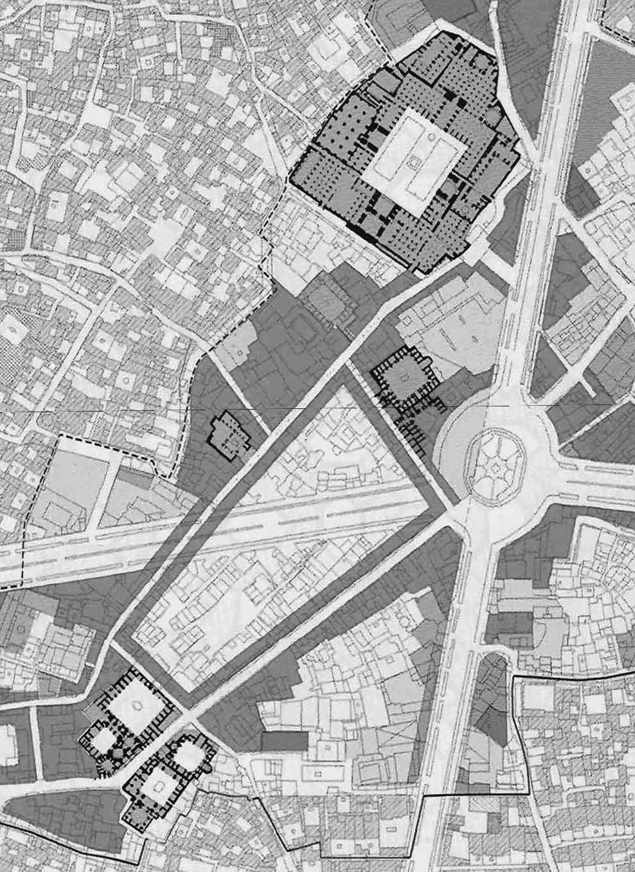

Figure 2. Hypothetical situation of Atique Square after *Abdolrazagh Street* construction in 1960s. Constructing *Abdolrazagh Street* led to the destruction of the historic bazaars of Isfahan and the body of Atique Square [19].

The inside part of the square used to be full of commercial units and simple stories and many of the surrounding historic markets were destroyed. So the importance of considering physical and social structures and economic empowerment of this complex in its revitalization project became obvious. Finally, *Renewal and Rehabilitation Organization of Isfahan Municipality* [20] with the aim of removing the exclusion of the area and flourishing the historic axis of Isfahan again; planned some measures in three phases [21]. In section 3-2 the most significant measures based on the authenticity concept are introduced.

**3-2- Analysis of Data Obtained from Observation and Documents Review**

In this part the three phases of Atique Square revitalization project are reviewed and analyzed.

**3-2-1- The First Phase: Implementation of the Underpass**

In order to start the implementation of the underpass, due to historical values of the area, the approval of *Iran Cultural Heritage, Handcrafts and* *Tourism Organization* was required. The main conditions for that were: (a) putting speculations in the area of the square, and (b) permanent presence of cultural heritage experts at all stages of implementation. The excavation investigations were carried in two phases for eighteen months (Figure 3a, 3b).

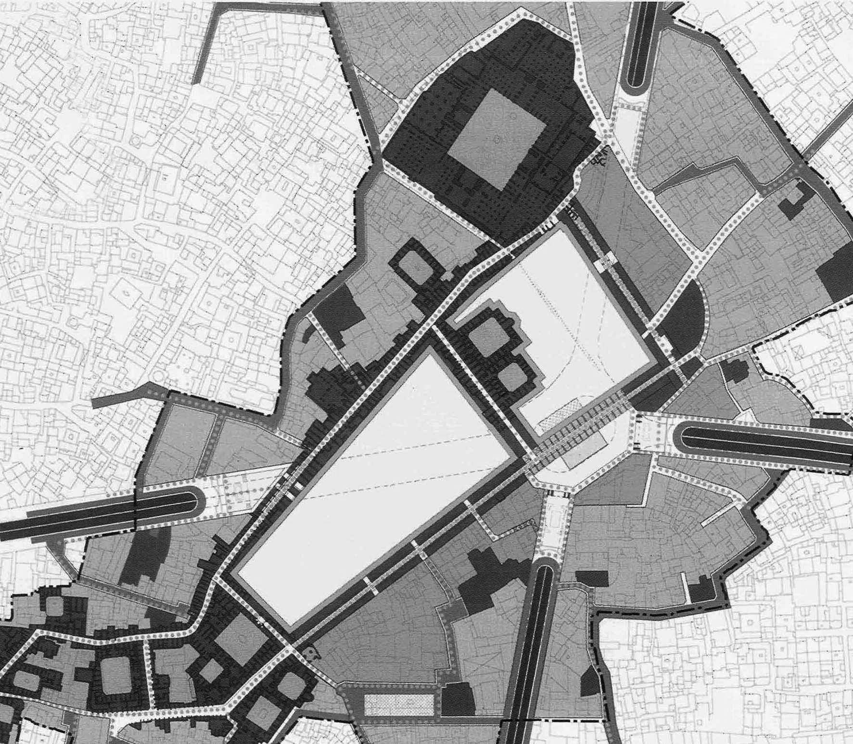

Figure 3a. *Abdolrazagh* Underpass axis, ( Authors, 2012).

Figure 3b. The situation of the square after its revitalization and construction of the underpass in 2008. Having constructed the underpass in the area of the square and transferring *Abdolrazagh Street* to underground level, structural-historic integrity in the area of Isfahan historical bazaar was provided. The square form was returned to its original one and was very effective in providing the visual integration of the area of the square and its connection to Isfahan bazaar [19].

The findings of these speculations included the floor brick of the old carpet of the square and lots of pottery and even metal objects. Some pillars were also obtained, all documented, but were known as invaluable for being maintained. Therefore, in 2008, constructing the underpass was authorized by Iran Cultural Heritage, Handcrafts and Tourism Organization. The construction lasted for fourteen months and made serious damages to the authenticity of the complex, especially to the ‘historical & evidential authentication’(Table 1).

**3-2-2- The Second Phase: The Main Square, the Forecourt of Atique Mosque and the Historic Bazaars**

The second phase of the project was to construct a multifunctional space (cultural, religious and services) and parking spaces under the square (Figure 4).

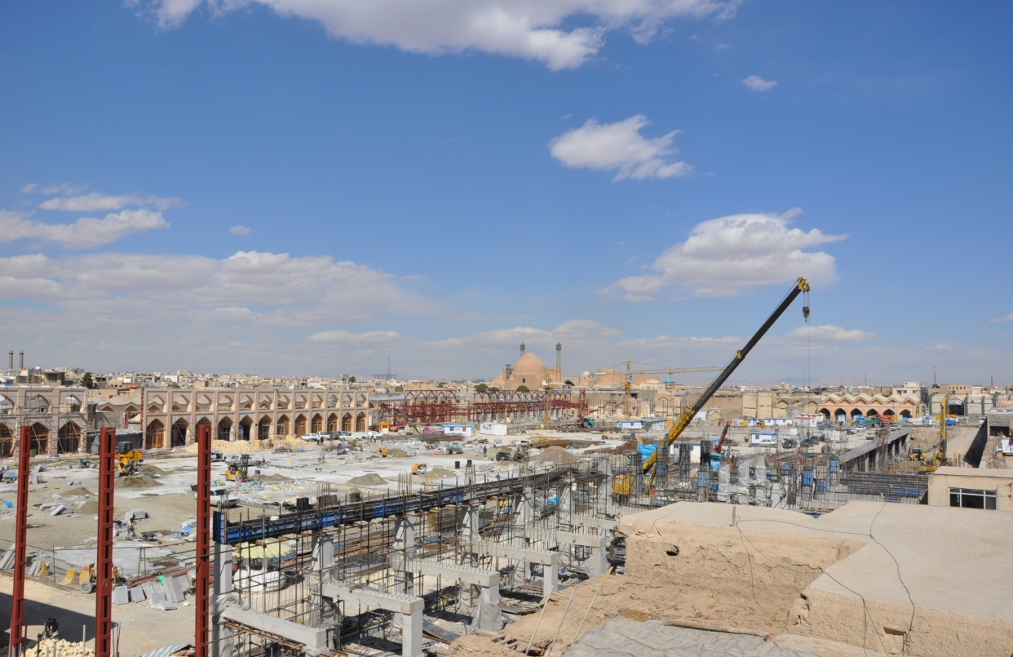

Figure 4. The Atique square under construction, ( Authors, 2012).

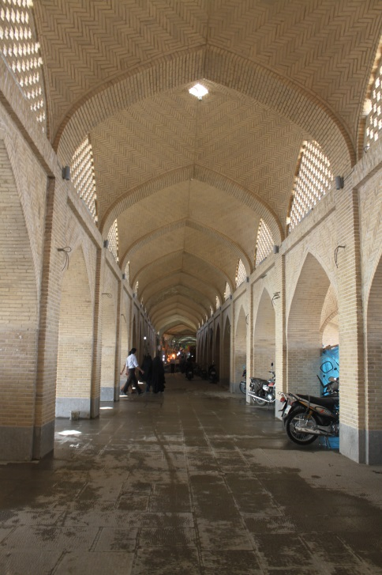Restoration and reconstruction a large part of the historic bazaars, located around the square, have been implemented with the aim of shaping the body and restoring the historic form of Atique Square (Figure 5). Implementing these measures have been effective for maintaining and revitalizing the ‘historical-evidential values’ and the ‘visual-aesthetic values’ and collectively the authenticity of the complex. In order to name one example of the restored bazaars, the intersection of *Isfahan Bazaar* with *Abdolrazagh Street* can be mentioned, which is effective in preserving and regenerating the ‘historical-structural integrity’ and ‘visual-aesthetic integrity’ of the square (Table 1).

Figure 5. The revitalized of the Isfahan Bazaar at the former intersection with Abdolrazagh Street, (Authors, 2012).

**3-2-3- The Third Phase: The Urban Design of the Surrounded Area, Functional Change of Historic Buildings and Organizing the Retails**

Twenty-two cultural, commercial and projects and services in the surrounding area of the square, organizing retails and restoration and functional changes in some of the historical buildings can be named as the measures of the third phase. Although high commercial density and traffic congestion will be the consequences of this twenty-two projects and a serious danger for the historical complex authentication; if properly organized, the businesses not only can maintain the ‘functional-social integrity’, but also can assist in achieving the ‘functional development’ and even the ‘economic vitality’. In addition, restoration and functional changes of the historic buildings can have a great role in the revitalization project being successful. Implementation of these measures, while maintaining the authenticity and integrity of the complex, can lead to the overall development and eventually the economic vitality.

In the third phase, the *Isfahan Municipality* and Iran Cultural Heritage, Handcrafts and Tourism Organization provided the context for private sector and the public sector involvement. Implementation marks the cooperation of the Isfahan Municipality and Iran Cultural Heritage, Handcrafts and Tourism Organization, as the two main authorities of the Atique Square revitalization. Collaboration of stakeholders and actors and their understanding of the cultural significance of the place have an important role in maintaining the concept of authenticity. Many of the planners and designers believe that if the third phase implemented completely, the aims of the project would hopefully become achievable. Otherwise implementation of phase one and two cannot lead to preservation of authenticity in this complex (Table 1)

.

Table 1. Evaluation of the Atique Square revitalization measures based on authenticity,

( Authors based on interviews and observations)

|  |  |  |  |
| --- | --- | --- | --- |
| Phase | The Taken Measures | Authenticity Consideration | |
| One | Underpass Implementation | |  |
| Two | The Forecourt of Atique Mosque and implementing the main design of the square | |  |
| Constructing parking and multifunctional space under the square | |  |
| Renovation and reconstruction of the surrounding historic bazaars | |  |
| Connecting Isfahan bazaar at the intersection with *Abdolrazagh Street* | |  |
| Three | Construction of twenty-two Commercial projects | |  |
| Organizing the Retails | |  |
| Restoration and functional change of valuable historic buildings | |  |

In the following, the set of measures implemented to revitalize the Atique Square based on authenticity are evaluated.

**3-3- Findings of Analysis of Interviews and Questionnaires**

The first step of this paper was to study and review the theoretical concept of authenticity and selecting its constituent factors. The result of the findings of the theoretical part provides a proper answer for the first question of this research, what factors explain the concept of authenticity in historic urban heritage. Thus, the ‘historical-evidential values’, ‘socio-cultural values’ of the context, and ‘artistic values and creativity’ were introduced as the main factors explain the authenticity concept for evaluation of the measures taken for Atique Square revitalization.

In the second session, findings of analysis of the interviews and user questionnaires based on the strategy explained in the methodology are presented. The findings show that to what extent the concept of authenticity and its indicators are considered in revitalizing Atique Square. Based on this, it is indicated that the ‘historic-evidential values’, ‘socio-cultural values’ of the context, and ‘artistic values and creativity’, in descending order, have the highest to the lowest contribution in explaining the concept of authenticity (Table 2). The overall findings of the Spearman correlation test indicate a relatively high positive correlation of the factors with the concept of authenticity.

Table 2. The correlation coefficients of each authenticity factor in Antique Square revitalization, (Authors).

| **Correlations** | | | | | | |
| --- | --- | --- | --- | --- | --- | --- |
|  | | | **Historical-Evidential values** | **Cultural-Social values** | **Artistic values** | **Authenticity** |
| **Spearman's rho** | **Historical-Evidential values** | Correlation Coefficient | 1.000 | .570** | .653** | .888** |
| Sig. (2-tailed) | . | .000 | .000 | .000 |
| N | 131 | 131 | 131 | 131 |
| **Cultural-Social values** | Correlation Coefficient | .570** | 1.000 | .465** | .839** |
| Sig. (2-tailed) | .000 | . | .000 | .000 |
| N | 131 | 131 | 131 | 131 |
| **Artistic values** | Correlation Coefficient | .653** | .465** | 1.000 | .753** |
| Sig. (2-tailed) | .000 | .000 | . | .000 |
| N | 131 | 131 | 131 | 131 |
| **Authenticity** | Correlation Coefficient | .888** | .839** | .753** | 1.000 |
| Sig. (2-tailed) | .000 | .000 | .000 | . |
| N | 131 | 131 | 131 | 131 |
| **. Correlation is significant at the 0.01 level (2-tailed). | | | | | | |

To refer to the other findings of observations and interviews with managers, designers and planners, the followings can be mentioned: lack of integrated management, lack of adequate knowledge and appropriate understanding of policy makers and actors towards the authenticity factors, and lack of interaction between conservation and development actors in the process of decision making, planning, design and implementation. Hence, authenticity recognition and understanding by the political forces, designers, planners and actors in the field of conservation and development have a key role for properly being taken of revitalization measures.

**4- Conclusion**

In this paper, having reviewed the theoretical aspect of authenticity concept by revisiting the international documents, conventions and theories in section one; the authenticity factors category presented by Jokilehto, which is more comprehensive in explaining the concept of authenticity, was selected. After that, the selected factors were being evaluated in the case study of Atique Square using correlation strategy and Confirmatory Factor Analysis method. The findings of analysis and evaluation of Atique Square revitalization measures; not only support the authenticity factors, but also prioritize them and determine the correlation coefficient for each of them. Evaluation results show that all the factors explaining the concept of authenticity, ‘historic-evidential values’, ‘socio-cultural values’ of the context and ‘artistic values and creativity’, have had effective roles in the revitalization measures of Atique Square as well as their meaningful relationships with the concept of authenticity in the taken measures. Although the overall measures have had some drawbacks; in terms of considering the concept of authenticity, the project has been, by and large, successful. The ‘historic-evidential values’ is considered as the most significant authenticity factor in the measures. This indicates that, to some extent, the measures have been successful in terms of returning the historical form of the square and revitalizing its past spatial organization.

1. The authors would like to acknowledge the financial support of University of Tehran for this research under grant number 1/29931/د.م /01.

   This paper is the result of a part of the fundamental research project titled “*Developing a conceptual framework for conservation of cultural- historical heritage, with an emphasis on recognizing the authenticity and integrity measures*”. The research has been carried out for the Fundamental Research Domain of University of Tehran.
2. **Notes:**

   . The group of “respondents” include the inhabitants, tradesmen, tourists and customers of the area.

   **Reference:**

   [1] English Heritage, Conservation Principles: Policies and Guidance for the Sustainable Management of the Historic Environment, English Heritage, London, 2008, p.71.

   [2] ICOMOS Venice Charter, International Charter for the Conservation and Restoration of Monuments and Sites (The Venice Charter), 1964, Available at:

   <http://www.international.icomos.org/centre_documentation/chartes_eng.htm>, (Accessed: May 2008).

   [3] UNESCO World Heritage Center, Operational guidelines for the implementation of the World Heritage Convention, Paris, 1978.

   [4] Rossler M, Applying Authenticity to Cultural Landscapes, 2008, In Waite, Diana. (Ed.), APT Bulletin (pp. 47-54), Vol. XXXIX, No.2-3, Published by Association for Preservation Technology International.

   [5] Inaba N, Authenticity and heritage concepts: tangible and intangible discussions in Japan, 2009, In N. Stanley-Price & J. King (eds.), conserving the authentic: essays in honour of Jukka Jokilehto (pp. 153-162), ICCROM Conservation Studies, and International Center for the study of preservation and Restoration of Cultural Property.

   [6] ICOMOS Nara Document on Authenticity, the Nara Conference on Authenticity in Relation to the World Heritage Convention,1994, Available at: <http://icomos.org/index.php/en/charters-and-texts>, (Accessed: May 2010).

   [7] Stovel H, Effective use of authenticity and integrity as world heritage qualifying conditions, City & Time, 2007, 2 (3): 3. [Online] URL: <http://www.ct.ceci-br.org>, pp. 21-36.

   [8] Burra Charter, the Australia ICOMOS Charter for Places of Cultural Significance, 1999, Available at: <http://australia.icomos.org/publications/charters/>, (Accessed: June 2010).

   [9] UNESCO World Heritage Center, Convention for the Safeguarding of the Intangible Cultural Heritage, 2003, <http://unesdoc.unesco.org/images/0013/001325/132540e.pdf>, (Accessed: December 2012).

   [10] UNESCO World Heritage Center, Operational Guidelines for the Implementation of the World Heritage Convention, Paris, 2005.

   [11] Mitchell, N.; Rossler, M.; and Tricaud, P, World Heritage Cultural Landscapes: A Handbook for Conservation and Management, World Heritage Paper 26, UNESCO World Heritage Center, Paris, 2009, p. 27.

   [12] Rossler M, Applying Authenticity to Cultural Landscapes, 2008, In Waite, Diana. (ed.), APT Bulletin (pp. 47-54), Vol. XXXIX, No.2-3, Published by Association for Preservation Technology International.

   [13] [ICOMOS Charter, Charter on Cultural Routes](http://www.international.icomos.org/charters/culturalroutes_e.pdf), 2008, Available at: <http://www.icomos.org/index.php/en/charters-and-texts>, (Accessed: May 2010).

   [14] Kidd J, Performing the knowing archive: heritage performance and authenticity, International Journal of Heritage Studies, 2011, No.17:1, pp. 22-35.

   [15] Jokilehto J, Considerations on authenticity and integrity in world heritage context. City & Time, 2006, No. 2 (1): 1. [Online] [URL:http://www.ct.ceci-br.org, pp](URL:http://www.ct.ceci-br.org,%20pp). 1-16.

   [16] Jokilehto J, International charters on urban conservation: some thoughts on the principles expressed in current international doctrine. City & Time, 2007, No.3 (3): 2. [Online] URL: <http://www.ct.ceci-br.org>, pp. 23-42.

   [17] Ravanfar H, Oral interview (in Farsi), ex-Project Manager of Square, (Wednesday, November 28, 2011), place of interview: his own office, 2011.

   [18] Danesh Nama, Revitalization of Imam Ali square (Atique), regeneration an important part of the Isfahan history (in Farsi), monthly technical journal of Danesh Nama, Construction Engineering Organization,Isfahan Province, 2010, Vol. 3, No 181-182, pp. 5-55.

   [19] Revitalization of the Atique Square Company, the Atique Square of Isfahan; Past, Present, Future (in Farsi), 2005.

   [20] The Document Center of Renewal and Rehabilitation Organization of Isfahan Municipality (in Farsi).

   [21] Jafari H, Oral interview (in Farsi), Project Manager of the Atique Square, (Monday, November 30, 2011), place of interview: Renewal and Rehabilitation Organization of Isfahan Municipality, 2011.