Investigating the Effective Indicators on the Desirable Quality of Open and Semi-Open Spaces of Contemporary Housing
Jamal-e-Din Mahdi Nejad¹ Ali Sharghi² Faezeh Asadpour ³
¹Associate Professor in Faculty of Architecture and Urban Engineering, Shahid Rajaee Teacher Training University. Tehran, Iran. , Lavizan, Shahid Rajaei Teacher Training University, P. O. Box: 16785-163, 00989121580343, Mahdinejad@sru.ac.ir
² Associate Professor in Faculty of Architecture and Urban Engineering, Shahid Rajaee Teacher Training University, Tehran, Iran. Lavizan, Shahid Rajaei Teacher Training University, P. O. Box: 16785-163, 00989121448115, Sharghi@sru.ac.ir
^{3*} Ph.D. Student of Architecture, Faculty of Architecture and Urban Engineering, Shahid Rajaee Teacher Training University, Tehran, Iran. Lavizan, Shahid Rajaei Teacher Training University, P. O. Box: 16785-163, 00989353428340, Faezeh.Asadpour@sru.ac.ir.
*E-mail: Faezeh. Faezeh.Asadpour@sru.ac.ir

Abstract
Today’s housing, as a private realm of human life, has changed in comparison with the past which was made regardless of quality, desirability, and lack of paying attention to the human needs and its psychological consequences; That is to say, residential units have turned into a set of closed spaces and their open and semi-open spaces have been merged into the urban spaces which disrupted their fundamental functions. In such a situation, reviewing and paying special attention to these spaces together with closed spaces in Tehran is really necessary. But this question is proposed that what are the indicators affecting the quality of open and semi-open spaces in contemporary housing? And how much do they affect the quality of these spaces? This research has a mixed (quantitative-qualitative) method which is applied in terms of purpose, and in terms of data collection method it is of descriptive-analytical and survey type. The statistical population includes 380 inhabitants in residential apartments in the Zafaranieh neighborhood of Tehran. After collecting field information through the questionnaire, the indicators affecting open and semi-open spaces, including: functional, behavioral, physical, environmental, social and perceptual-semantic by using statistical analysis software were analyzed. To investigate the significance of relationship between the mean difference of the scores of the effective indicators, the one sample T-test method and intragroup one-way analysis of variance have been used; the results obtained from the research showed that in the open and semi-open spaces of residential apartments in the Zafaranieh neighborhood, the physical, environmental and behavioral indicators with the mean score of 4.17, 3.52 and 3.22, respectively, have somewhat more favorable and more appropriate situation than other indicators, and currently their efficiency ratio is at moderate limit. However, the functional, social and perceptual-semantic indicators with the mean score of 2.68, 2.57 and 2.21, respectively, are in an unfavorable and inappropriate situation, and their efficiency ratio is at weak limit.
Keywords: Open space, Semi-open space, Desirable quality, Contemporary housing, Zafaraniyeh neighborhood.

Introduction
Urbanization development and population growth in recent years, consequently, the lack of space, have led to the uninterrupted expansion of apartment life and the construction of small living spaces; So that the change in the contemporary houses’ spatial organization in line with accountability and coordination with current demands has led to the transformation of spatial patterns and the role of the micro spaces which responded to the social-cultural needs of the Iranian people for centuries [1-2]. In the meantime, open and semi-open spaces were numerous instances that had experienced immense alterations because these spaces were necessary for Iranian life in traditional houses; also, as a space organizer element, these places had a major role in many activities of everyday life; Furthermore, these spaces, which allowed free communication with nature, communicating with residents, spending leisure time, providing opportunities for learning and recreation, because, one essential reason for a person using an outdoor space is to get in touch with the natural environment. Such connection has historically been a major consideration in the design of open spaces and natural [3-6]. To accommodate this both physically and psychologically, Therefore, today it is seen that these spaces, have been removed from the spatial organization of the contemporary housing or have lost their main role and function in this status, residential units will not have enough efficiency to provide comfort and relaxation for the residents.
Therefore, considering the people's lifestyle and the prevailing climatic conditions in the central provinces of Iran, the existence of open and semi-open spaces in the houses of this region is really important, in terms of functional-behavioral, physical, social, and perceptual-semantic features; hence, reviewing and paying special attention to the open and semi-open spaces of contemporary housing such as courtyards, porches, terraces and so on as spaces of Iranian housing architecture along with closed spaces in Tehran, is really vital; because in its best situation, there should be a proper and logical relationship between these spaces and the closed space to provide a suitable living environment. So many books, dissertations, articles, and numerous researches have been published about the open and semi-open spaces of residential houses; however, since the current research precisely addresses the identification and evaluation of factors affecting the quality of open and semi-open spaces of constructed apartments over the past 8 years in the Zafaraniyeh neighborhood of Tehran, it is unique in its kind; consequently, in this research which is descriptive-analytic research study using library studies and field survey methods, identifying and evaluating effective indicators on the quality of open and semi-open spaces of houses in Tehran are based on the subject, questions and the aims of the research presented as follows.
Aims:
- Identifying the functions of existing open and semi-open spaces in residential apartments in Tehran
- Investigation the changes in the pattern of forming the open and semi-open spaces in common residential apartments in order to prevent the process of modelling from undesirable experiences and avoid repeating failed experiences in future constructions to maintain the principles and values ​​of an Iranian house
Research Questions:
- What are the indicators affecting the quality of open and semi-open spaces in contemporary housing?
- How much do these effective indicators on functioning of open and semi-open spaces affect these spaces in Tehran apartments?
- Does the removal of effective indicators on open and semi-open function reduces the quality of these spaces in residential apartments and, decrease the quality of life of its inhabitants?

Problem statement
The private space of the past houses included open and semi-open spaces. Whereas, nowadays, many residential apartments in Tehran lack private open and semi-open spaces, these spaces, if existed, have undesirable quality and their usage is very limited. In most of the existing residential complexes, a yard is a place for crossing or entering the residential complex, and the balconies are often used as warehouses and installations. Thus, many functions of the open and semi-open spaces are abandoned in the apartment; so that the numerous daily life activities such as communicating, relaxing and eating meals used to occur in the terraces and balconies, which are not possible at the moment. So, the lack of open and semi-open spaces or with undesirable quality, while disrupting human’s interaction with the natural environment and greater presence of people in the closed space or in alleys, parks and similar spaces, has reduced the spatial variety of the house and eliminated some of the qualities and characteristics demanded by users while providing comfort and privacy for residents in the hectic life of Tehran is one of the most significant functions of private spaces in residential apartments. But it should be mentioned that the problems faced in these spaces also occur in the residential apartments of other cities of the country. However, but due to the fact the construction method in Tehran is a kind of construction pattern for other cities, the negative effects of undesirable quality of these spaces will be widespread. Accordingly, the current research has been done about the residential apartments in Tehran.

Research background
Community is that they provide a space for social interaction, relaxation, restoration and contact with nature and they offer opportunities for leisure activities. This is may be best summarized by Carr et al. (1992) who defined public open spaces as the common ground where people carry out their functions and leisure activities that bind a community. Open space has been studied widely in the literature [7]. Several authors have discussed open space from different perspectives such as the visual characteristics of open spaces [8]; the visual description and aesthetics of open spaces [9]; the design characteristics of open spaces that help to prevent crime [10]; pattern of people behavior and space quality [11]; and evaluation of the quality of open spaces [12].
Understanding user’s needs are a cornerstone of any well-designed open space, the design that attracts people, facilitates their activities and encourages them to spend more time when undertaking these activities [13]. The quality of the physical features of the open space has been seen as an important aspect that improves people’s satisfaction and quality of life [14], promotes better use of public spaces [11] and enhances the social, environmental and economic values of cities [14]. Similarly, the spatial structure of urban open spaces has shown to be associated with how people move, gather and socialize in these spaces as evident in space syntax theory [15-17]. Another study suggested that high-quality, functionality and safety are major needs for any well-designed open space [11]. The important issue is to provide opportunity to fulfil users’ needs equally to all members of the community. Another important issue in this context is the physical quality of the open space. In spite of the fact that green open spaces are made for people, activities carried out in these spaces differ in terms of type, quantity and duration. According to Gehl (1987), outdoor activities are classified into three categories that are common to all types of public realm: necessary, optional and social activities. In summary, necessary activities are musts; people will do them regardless of the environmental condition of the open space. Optional activities are voluntary and generally linked to enjoyment and self-fulfillment; they are remarkably influenced by the physical condition of the open space. Social activities are those activities which require the presence of other people to happen [11]. Gehl argued that, when public spaces are of poor quality, only necessary activities occur. However, when these spaces are of good quality, a broad spectrum of human activities is probable, including creative activities, such as painting and playing music. Recently, however societies have shifted from the necessary lifestyle to the optional lifestyle where the use of open spaces is not exceptional. This stresses that the quality of open spaces has become increasingly significant in facilitating the interaction between people and society, and between one person and another [18]. High quality and well managed open spaces contribute positively to the social, economic and environmental value of cities [14]. Open space designed to high standards reflects simultaneous public benefits to their users, whereas mistreated, poorly managed and maintained open spaces would influence their surrounding areas negatively [19]. Many studies have reported a strong correlation between open space Integration value and density of people in the space with more visible and more accessible spaces encourages more movement and activities, whereas segregated spaces are less inviting, see for example (Hillier, 1985), (Hillier, et al., 1993) and (Ozer & Kubat, 2007) [17, 20-21]. In fact, space syntax measures have shown to be linked to not only people behavior, but also perception [22-23].
In addition to users’ needs and the quality of open spaces, there is a growing body of literature, which focuses on how the spatial structure of the built environment influences people’s behavior in open spaces.

Open and semi-open spaces in housing
Since the beginning of the twentieth century, two contradictory visions of the residential units of Le Corbusier (AD Classics: Unite d' Habitation / Le Corbusier) and Neighborhood or district unit suggested by Clarence Perry were proposed for the neighborhood which created significant physical and social effects on the formation of the neighborhood and the residential complexes design. Clarence's pattern in the 1930s was extensively used in the planning of new residential neighborhoods of cities in the world and it has been considered as the basis of the new urban design. Le Corbusier designed Marseille Residential Building with 331 residential units in a 17-story building in a large green environment with store, kindergarten and other public facilities within it [24]. This residential complex is designed to meet the users’ needs (Figure 1). The placement of open and closed spaces together and the amount of occupied space by each area are some of the differences between these two patterns. According to Figure 2, as the number of floors increases, the per capita of open space will increase while the residents’ private space is reduced.
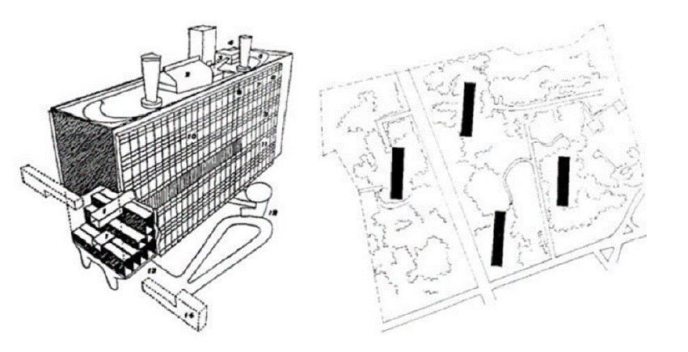
Figure 1: Marseille residential unite designed by Le Corbusier [1]
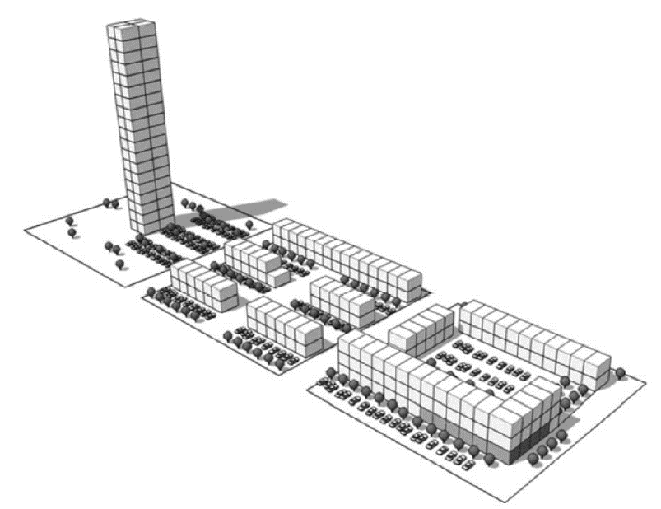
Figure 2: Different layout of 71 units per hectare [25]
In the ancient settlements, the houses were very close to each other and the body of each house had a role as a defensive wall. Due to the social situations, the private part of the house was facing its central open space (In the form of a central courtyard) [26].
The Italian researcher, Cambi (2003), classified the houses with courtyards according to the shape of filed and empty space, as shown in Figure 3 [27].
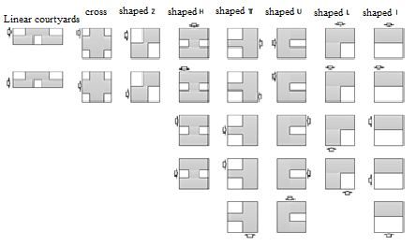
Figure 3: Typology of houses with courtyard based on courtyard position [27]
American researchers Polyzoides, Sherwood, and Tice (1992: 32) categorized the houses with courtyards in Los Angeles based on volume to single-sided, double-sided, L shaped U-shaped, and central courtyard houses (Figure 4) [28].
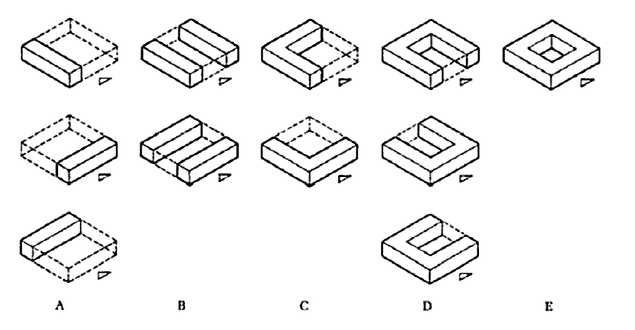
Figure 4: Typology of Los Angeles Houses [28]
German researchers, Pfeifer and Brauneck (2008) in Town Houses, A Housing Typology has divided houses into groups of houses with central gardens, L-shaped houses, houses with patio and houses with an atrium [29].
Generally, the typology of indoor spaces of houses is derived from the way of accessibility or movement in the indoor spaces [30].
The typology of high-rise residential complexes consisted of different blocks, in addition to typology based on the type of accessibility and the relations of the interior spaces, is also related to indoor or outdoor spaces placement and juxtaposition. The dominant types of these complexes are the environmental layout, freestanding blocks, linear blocks and mixed combinations of other blocks (Figure 5) [25].
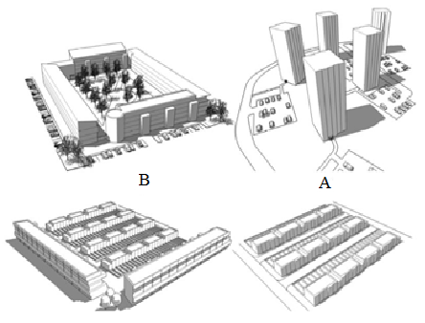
Figure 5: Residential complex layout (A) Point, (B) central, (C) Linear, (D) Mixed [25]
In traditional Iranian houses, the courtyard is considered as the main open space. Apart from the yard, as shown in Figure 6, there is an eclectic range of open spaces at different heights; also, interior and exterior spaces can be expanded and merged by interface spaces such as Sofeh (vault), Sharemi and Taromi.
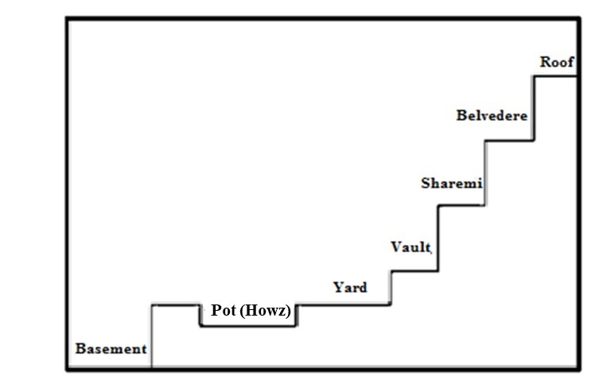
Figure 6: Types of open spaces at different altitude levels in the traditional Iranian courtyard [31]
In terms of form, space in architecture is classified into three open, semi-open, and closed categories. The term open space was probably used for the first time in 1833 in the United Kingdom. The first definitions of open space in the twentieth century are the result of a type of "empty" assumption from space or anything that can be imagined from the remnants of the filled volumes. Open space means the space between buildings, empty parts and negative spaces, without roof coverings and sometimes blocked by walls in all directions. So, in the architectural and urbanization process, these spaces are manifested along with closed, positive and filled spaces [32]. By investigating Iranian architecture, we find that the open spaces follow specific models and proportions that are effective in inducing a feeling of enclosure or openness. In traditional Iranian architecture, open space can be mentioned in two scales: First, huge open spaces that are more responsive to large gatherings, religious and military ceremonies, and second, small open space that is used in everyday life functions in small and often residential buildings; also, it is usually a supplement to the living space in the covered area which creates a special harmony in space. In line with the open spaces in residential complexes, it can be indicated that any space which is not constructed on the boundary of a residential complex area that allows users to use its social and economic benefits directly or indirectly [33]: without personal ownership and often with unite management which in serve of the inhabitants, is called residential open space. Open space is often considered as public and semi-public spaces; Only the private courtyard is private and open space at the same time [34]; according to table 1, open spaces in private area include as: the central courtyard, the backyard, sunken courtyard, and patio.
Semi-open (covered) spaces are a kind of volumetric joints that in some cases enable a soft transition from a realm to another [35]. In other words, in an analytic survey, the distance between closed and open spaces surrounding it can be defined as the connecting space between these two. In the traditional architecture, the semi-open space, as a transitional space and an interface between open and closed spaces, is responsible for integrating the interior and exterior spaces [36] which leads to gradual transition from one arena to another; so that the boundary between the different areas is not hard and obvious and is defined as delicately as possible [37]. The semi-open spaces include porch, terrace and balcony, narrow balcony, and louver chamber.
In a brief comparison of the external and internal space with traditional and contemporary apartment housing, this relationship is so interconnected in traditional housing that each one defines a different form. While in many contemporary designs, most of the outside spaces are shaped due to the placement of building next to each other, i.e. they do not have value and originality, but when the placement of the building took place in accordance with their own principles, the resulted space between them, in any form, will be called outer space. In the traditional architecture, the outside space has the same rules of the interior spaces. Any part of the inside and outside space is not planned without considering rules and regulations. As the buildings build the outside space, the square and yard, give a special order to the buildings (Figure 7) [38]. Currently, as housing moves toward mass production, these spaces have become the most vulnerable parts of today’s apartment housing. Consequently, in order to preserve the Iranian housing chain in today's housing, the indicators that continuously affect the quality of open and semi-open spaces of an Iranian housing investigated in current research as follows: functional, behavioral, physical, environmental and social, and perceptual-semantic indicators (Figure 8).
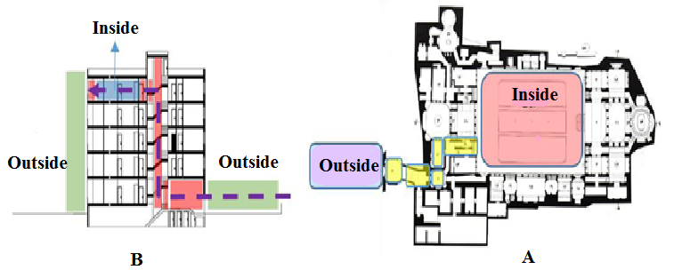
Figure 7: The structure of moving from the outside to inside in the traditional house, the Sharifian’s house (A) the new residential unit (B) [37]
Figure 8: The place of open and semi-open space in the hierarchy of residential units (apartments)

Research Area
Zaferaniyeh is one of the northern neighborhoods of Tehran in Shemiran district. This neighborhood, located in the foothills of Alborz, has a pseudo-rural fabric and is a mixture of modern and traditional fabric can be seen in this neighborhood. Zaferanyieh is one of the most expensive residential areas in Tehran. Zaferaniyeh is limited to the Tochal highlands from the north, Valiasr St. (Pahlavi) and Mahmudieh from south, Tajirish from east, and Valenjak River from west. It is one of the highest neighborhoods of the capital and it is 1650 to 1800 meters above sea level. This neighborhood is located in area 2 of Tehran Municipality District 1, and its population was 24,425 according to the latest census (Figures 9).
Figure 9: (a) location of Tehran province of Iran map (b) location of District 1 in Tehran zoning map (Tehran municipality) (c) Zoning map of District 1 of Tehran city and the location of Zaferaniyeh neighborhood (Municipality of District 1) (c) Map of the Zaferaniyeh neighborhood in Tehran (Municipality of District 1)
Prior to the establishment of apartments and high-rise buildings, the area under study had been formed based on a neighborhood system and organically over time, but the establishment and the activity of buildings have changed some of the existing neighborhood systems, so that the drawn informal boundaries of neighborhoods will no longer have meaning and sense. The high population ceiling defined in the area under study disrupted the existing order, especially with the arrival of new residents who may not have the cultural and social similarity, and harmony with the old inhabitants of the surrounding context (Figure 10).
The hierarchy of access network, the collision of riding and walking movement, the narrow passages with the function of the garden alley, the existence of traffic nodes, the lack of public parking's, and so on have made the access network in the area under study not to be compliant with urban planning criteria in many aspects.
In the area under study, the concentration of high-rise buildings in a limited space has caused severe population and building density in parts of the Zafaranieh region; this issue has led to the formation of traffic (transportation), urban service delivering nodes, and so on. The created traffic nodes have caused the waste of time, air pollution, noise pollution, overcrowding, the inefficiency of some urban uses and service delivering including the provision of green space and public open spaces, and so on (Figure 11).
Figure 10: Confrontation of New and Old Constructed Buildings in Zafaranieh Neighborhood
Figure 11: Adjacency of Buildings in Limited Spaces, Zafaranieh Neighborhood
According to Figure 12, the average height of tall buildings in Zafaranieh is 17.36 floors, which has a huge difference compared to the height of the area's form (2 or 3 floors), that regarding the concentration of tall buildings in the area of Aghabozorgi, Parsa, and Sahra streets, and the area of Golnar, Golpad and Mahroo streets, has created a wall of tall buildings inside the area, and this issue has blocked the urban view and landscape of some parts of the region.
Figure 12: The Huge Difference in the Density of Adjacent Buildings in the Zafaranieh Neighborhood

Research Method
This research is of quantitative research type in terms of nature, it is in among the applied research in terms of purpose, and in terms of data collection method is of descriptive-analytical and survey type, and in general it has a mixed (quantitative-qualitative) research method that has had 3 main parts (Figure 13).
Figure 13: Research Implementation Process
In the first part, in order to identify the current situation of open and semi-open spaces of residential buildings in the Zafaranieh neighborhood of Tehran, 10 samples of buildings with a phenomenological approach were investigated by researchers through non-intervening non-participatory observation method. In the second part, to overcome the dimensions of the subject and benefit from the experiences of previous researchers, with library studies and through tools such as receipt, table and form in a non-random method, the existing approaches and theories and knowledge about "identifying indicators affecting the desirability of open and semi-open spaces of housing” through content analysis were organized and classified that by analyzing the information collected by inductive-deductive method, the indicators affecting the desired quality ratio of open and semi-open spaces of housing were extracted. In the second part, after classifying the indicators through the target-content table and confirming it by professional university professors, questions related to each index were prepared, then the questions of each index were pre-tested by the Likert's double spectrum and the sample of 50 experts were pre-tested and reliability coefficient of Cronbach's alpha was calculated for each index and some ambiguous questions and without sufficient correlation with the other questions were eliminated. Finally, the researcher-made questionnaire including 6 indicators and 36 items according to Table 1 with the Likert's four spectrums for distribution among users was finally confirmed, that with regard to the threshold considered in the authoritative scientific sources, it has desirable reliability. In the third section, with a survey approach, the researcher-made questionnaire was also distributed among the residents of the Zafaranieh neighborhood.
Table 1: Open and semi-open space indices and its related items
Indices | Item
Behavioral | Keeping the yard, terrace/balcony clean  Hanging and drying the clothes on the terrace/balcony  Taking care of the flowers and plants in yard  Growing flowers and plants in terrace  Cooking food
Social | Interactions and familiarization with individuals in yard  Ability of holding meetings in yard  Security in open and semi-open spaces  Possibility of family members’ spending of some private time in yard/balcony  Possibility of holding sessions in yard  Children’s playing and recreation in yard  Connection between the neighboring units through yard  Connection between the neighboring units through terrace and balcony  Possibility of the residents’ gathering in open and semi-open spaces
Perceptual-semantic | Yard, terrace and balcony’s wideness  Having a view of the periphery  Yard, terrace and balcony’s attractiveness
Functional | Balcony’s adjacency to the kitchen  Balcony’s adjacency to the sitting room  Balcony’s adjacency to the bedroom  Existence of the cooling and heating installations on terrace and balcony  Fencing the terrace by the use of transparent surfaces  Specifying the limits of yard and limitations of the property’s ownership  Hierarchy (method of entering the terrace and yard through internal spaces)  Proper siting of the terraces in the building’s internal spaces
Environmental | Greenness in yard, terrace and balcony  Supply of appropriate sunlight and shading through yard, terrace and balcony  Proper ventilation and protecting the passageway against the interfering winds via yard, terrace/balcony  Spreading of the noise pollution through yard, terrace/balcony
Physical | Apparent form and shape of balcony, terrace and yard  Masonry and texture of terrace/balcony  Masonry and texture of yard  Size and dimensions of terrace/balcony  Size and dimensions of yard  Existence of handles and sills in terrace  Quality of the yard, terrace and balcony’s construction
In Table 2, the number of questions related to the measurement of each of the effective indicators, the average and standard deviation of the total scores and the reliability coefficient of Cronbach's alpha have been presented to determine the internal consistency of the questions for each of the indicators. According to the table 2, 8 questions for functional index, 5 questions for behavioral index, 7 questions for physical index, 4 questions for environmental index, 9 questions for social index and 3 questions for perceptual-semantic index were considered in order to measure these indices Cronbach’s alpha coefficient for each of the investigated indices was above 0.70., which indicates a high internal consistency between questions and the reliability of measuring instruments.
Table 2: Average and standard deviation and reliability coefficient of open and semi-open spaces indices
Indicators | Number of questions | Number of persons | Total average | SD | Cronbach's alpha  coefficient
Behavioral | 5 | 50 | 19.91 | 4.29 | 0.77
Social | 9 | 50 | 9.65 | 1.89 | 0.76
Perceptual-Semantic | 3 | 50 | 5.36 | 1.98 | 0.82
Functional | 8 | 50 | 15.42 | 4.74 | 0.84
Environmental | 4 | 50 | 33.36 | 3.95 | 0.88
Physical | 7 | 50 | 28.13 | 3.67 | 0.74
The study population included all of the citizens living in a Zaferaniyeh Neighborhood in apartments built during the past eight years. The study sample volume was obtained equal to 378 individuals using Cochran Formula in a 95% confidence level and a 5% error probability. In this study, 380 individuals were selected using simple random sampling method and subjected to questions. Based on the results obtained through data extraction from the questionnaires, it was found out that 170 (45%) and 210 (55%) out of the 380 individuals in the study sample volume are correspondingly male and female (figure 14). The indices influencing the open and semi-open spaces, namely functional, behavioral, physical, environmental, social and perceptual-semantic indices, have been analyzed using SPSS software and use was made of one-sample t-test and one-way intragroup variance analysis for investigating the significance of the relationships and differences between the mean scores of the effective indices.
Figure 14: Frequency distribution and percentage of age and gender status of the research sample (research findings)
Research Findings
In the first part and in order to pathologically study and identify the status existent in the open and semi-open spaces in the residential buildings of Tehran’s Zaferaniyeh Neighborhood, ten samples of the buildings were selected by the researchers. In general, the harms related to the open and semi-open spaces in the buildings of the neighborhood were summed up and the occurrence or non-occurrence of them were investigated as presented in table (3) in the aforesaid ten buildings.
Table 3: Damages in the open and semi-open spaces of residential buildings in Tehran
Samples’ known damages | Low area | Low width | Short length | Facing the street | Absence of desirable natural elements (plants and greenery) | Towards the neighbor’s wall | Permanent shadowing of surrounding buildings on the space | Overlooking the space | Access through the guest room and limited usage | Access through the bedroom and its exclusive application | Space occupied by equipment facility | Additional equipment warehouse | lack of motivation for gathering people in the space | Being useless most of the time | The lack of water plumbing and floor gutter | The low height of the shelter for children and elders | Flowing water from the balcony floor on the facade | Lack of flexibility and the changing space for comfortable viewing by the user in building bodies |  | Bodies which their only usage is creating buffer space | The lack of space privacy by using fences or transparent materials
S1
S2
S3
S4
S5
S6
S7
S8
S9
S10
The results obtained from the intensity of the occurrence of each of the harms in the open and semi-open spaces of the ten residential apartments have been shown according to table (3) and image (10). The followings are the most frequent harms that cause unsuitability of the open and semi-open spaces in the selected apartment buildings: overlooking the space, lack of motivation for gathering people in the space, lack of flexibility and changing space by the user in the body of the building (Figure 15).
Figure 15: The frequency of damages in open and semi-open spaces
In the second section, by using the one-sample t-test, the status of each of the indicators affecting the quality of open and semi-open spaces in the studied region were investigated. According to Table 4, the observed average of the physical, environmental and behavioral indices scores of the buildings of the Tehran city were 4.17, 3.25 and 3.22, respectively; and these values ​​are higher than the expected average of 3. Due to the fact that the level of significance of the calculated value for both indicators is lower than 0.05; consequently, the difference between the observed average and the expected average is significant (P <0.05). Therefore, with 95% confidence, it can be claimed that the environmental, physical and behavioral indices of open and semi-open spaces of residential units in Tehran are above average; however, the observed average scores of the functional, social and perceptual-semantic indices of open spaces were 2.68, 2.57 and 2.21, respectively; and these values ​​are lower than the expected average of 3. Since the significant level of the calculated value for all three indicators is less than 0.05 (Figure 16); hence, the difference between the observed average and the expected average is significant (P <0.05). Then, with 95% confidence, it can be said that the level of functional, social and perceptual-semantic indicators of open and semi-open spaces is lower than the average.
Table 4: One-sample t-test to compare the observed average of scores with an expected average
Indicators | Observed average | SD | Expected average | t | df | Sig. level
Perceptual-Semantic | 2.21 | 0.48 | 3 | 32.20 | 379 | 0.001
Behavioral | 3.22 | 0.63 | 3 | 6.65 | 379 | 0.001
Functional | 2.68 | 0.99 | 3 | 6.36 | 379 | 0.001
Social | 2.57 | 0.79 | 3 | 10.60 | 379 | 0.001
Physical | 4.17 | 0.49 | 3 | 46.13 | 379 | 0.001
Environmental | 3.52 | 0.46 | 3 | 21.92 | 379 | 0.001
Figure16: Average scores of open and semi-open space indices
To compare the indices of open and semi-open spaces of residential units, these indices were prioritized in comparison with each other by the average of the indices’ scores; then by one-way within-group ANOVA, the significance of the average differences was evaluated. According to Table 5, it can be seen that in open and semi-open spaces, environmental, physical and behavioral indices have a better status than other indicators. The average scores of these indices were 4.17, 3.25 and 3.22 respectively, and the standard deviations of these scores were 0.49, 0.46 and 0.63, respectively. In contrast, the perceptual-semantic, social and functional indicators have the lowest average score. The average scores of these indices were 2.21, 2.57 and 2.68, respectively; the standard deviations of these scores were 0.48, 0.79 and 0.99, orderly. To evaluate the difference of the averages mentioned in Table 4, one-way within-group ANOVA is used. Firstly, the equality of variances presupposition is investigated and if confirmed, one-variable F test is used and, in the case of a violation, multivariate tests are used.
Table 5: Prioritization of open and semi-open indices based on average scores
Priority | Indicators | Number of persons | average | SD
1 | Physical | 380 | 4.17 | 0.49
2 | Environmental | 380 | 3.52 | 0.46
3 | Behavioral | 380 | 3.22 | 0.63
4 | Functional | 380 | 2.68 | 0.99
5 | Social | 380 | 2.57 | 0.79
6 | Perceptual-Semantic | 380 | 2.21 | 0.48
According to Table 6, it can be seen that the sphericity assumption with a significant value of 0.001 is violated. Thus, in order to investigate the significance of the average differences, the multivariate tests are used; the results of these tests are presented in Table 7.
Table 7 represents that the obtained levels of significance in all tests are less than 0.05; though, the statistic that is usually reported is Wilks' lambda. In Table 4, the value of the Wilks' lambda is 0.09 with a probability level of 0.001, which means (P <0.05) (the significance level is less than 0.05). Consequently, the difference between the average scores of open and semi-open spaces in residential units is significant. According to Table 6, it is seen that the sphericity assumption with a significant value of 0.001 is violated. Consequently, in order to investigate the significance of the average difference, a multivariate test is used. The results of these tests are presented in Table7.
Table 6: Mauchly's sphericity test
Mauchly's W | Chi-Square | df | Sig. level
0.52 | 248.14 | 14 | 0.001
Table 7 indicates that the significance level of F values of the Wilkes lambda value is 0.09 with a probability value of 0.001, which means (P <0.05) (the significance level is less than 0.05); thus, the difference in the average scores of effective indicators on the quality of open and semi-open spaces are significant.
Table 7: The results of multivariate tests to appraise the difference in average scores
Test name | Value | F | Hypothesis df | df error | Sig. level
Pillai’s Trace | 0.91 | 788.85 | 5 | 375 | 0.001
Wilks’ Lambda | 0.09 | 788.85 | 5 | 375 | 0.001
Hotelling’s Trace | 10.52 | 788.85 | 5 | 375 | 0.001
Roy’s Largest Root | 10.52 | 788.85 | 5 | 375 | 0.001
In order to examine the significance of the difference between the averages of each pair of effective indicators on the quality of open and semi-open spaces precisely, the Bonferroni post hoc test was used. Table 8 designates that the difference of the average scores between each pair of indices is significant, because in all the differences, the significance level is less than 0.05 (P <0.05); That is to say, the prioritization model of open spaces and semi-open residential apartments indices in Zafaraniyeh district of Tehran, which was conducted in this research, are statistically significant. So, it can be indicated that in these spaces, the status of the physical index is more advantageous than other indicators and the perceptual-semantic index is more unfavorable than others. Environmental, behavioral, functional and social indicators, in terms of reduced favorable condition, are placed between the two physical and semantic perceptual indexes.
Table 8: Bonferroni post hoc test
Indicators |  | Averages difference | SD | Sig. level
Physical | Environmental | 0.65* | 0.03 | 0.001
 | Behavioral | 0.95* | 0.04 | 0.001
 | Functional | 1.49* | 0.05 | 0.001
 | Social | 1.59* | 0.04 | 0.001
 | Perceptual-Semantic | 1.96* | 0.04 | 0.001
Environmental | Behavioral | 0.30* | 0.40 | 0.001
 | Functional | 0.84* | 0.05 | 0.001
 | Social | 0.95* | 0.05 | 0.001
 | Perceptual-Semantic | 1.30* | 0.03 | 0.001
Behavioral | Functional | 0.54* | 0.06 | 0.001
 | Social | 0.65* | 0.05 | 0.001
 | Perceptual-Semantic | 1.01* | 0.04 | 0.001
Functional | social | 0.11* | 0.06 | 0.044
 | Perceptual-Semantic | 0.47* | 0.05 | 0.001
Social | Perceptual-Semantic | 0.36* | 0.05 | 0.001
* Average difference is significant.
Conclusion
In the past times’ architectural designing of the open and semi-open spaces, various functions were served depending on the cultural, climatic and religious conditions but the method of using these spaces has undergone changes in the today’s houses due to the increase in population, increase in the need for housing, transition from the traditional to modern life, macro-level municipality policies and plans in the areas of urban spaces, house construction and mass production, economic profit-seeking and dealership, increase in the price of the land and expansion of the activities and change in the human beings’ lifestyle.
It was found in the initial investigations and field studies of the residential buildings in Tehran’s Zaferaniyeh Neighborhood that there are 21 cases of harms in open and semi-open spaces (yard, balcony and terrace) as evidenced in the analyses carried out on ten of the foresaid buildings. The most important harms that cause the unsuitability of the open and semi-open spaces in housing and were observed in all of the ten cases are:
- Overlooking the space that was observed in the higher floors of the apartments so the terraces and balconies should be somehow covered. These spaces usually lack an effective definition and they are left in many of the cases in the form of a floor that reduces their appropriate efficiency. Although the tall height of some of the buildings has caused their appropriate enjoyment of light (due to the installation of long and overall windows) and enhanced the residents’ view of the peripheral favorable environments, the issue of having a view or not is a religious matter; it should be known that having a view of the others’ houses and the topics related to spatial insecurity exert adverse effects on the peripheral spaces and occasionally make the residents feel dissatisfaction and install fences, shutters to block the view of the neighboring units and this has caused changes in the function of the terrace and balcony.
- Lack of flexibility and the changing space for comfortable viewing by the user in building bodies: due to the fact that most of the houses in Zaferaniyeh neighborhood are in the form of high-rising and attached apartments that are surrounded from the sides and they also overlook the yards of the neighboring units in some of the cases, there is no possibility of changing the open and semi-open spaces for creating the proper view intended by the other residents.
- Lack of motivation for gathering people in the space: the downsizing of the areas and dimensions of the terrace and balcony and shortage of space have caused the family members’ use it; moreover, the high density of the building and the large number of the residents of each apartment and non-familiarity with one another have caused reductions in the interactions and the individuals’ gathering in the yard and their use of the common semi-open spaces between the apartments.
In the next stage and in order to find an answer to the study question, i.e. “what are the indices influencing the quality of the open and semi-open spaces in the contemporary housing?”, six perceptual-semantic, behavioral, functional, social, physical and environmental indices were extracted through analyzing the texts and the ideas’ contents; using the goal-content table, the questions related to each of these indices were confirmed by the experts. In the next stage and in order to answer the second question of the study, use was made of one-sample t-test and it was made clear that the physical indices, with a mean score of 4.17, and a standard deviation of 0.49, are the most effective amongst the six indices as viewed by the residents. This means that the residents believe that the quality of construction, form and apparent shape, used masonry, dimensions and size, existence of handles and sills in the open and semi-open spaces put the building apartments in a better situation and make them very effective in the favorability of such spaces. After the foresaid indices, environmental and behavioral indices, with mean scores of 3.52 and 3.22 and standard deviation of 3.52 and 3.22, respectively, were found having a more appropriate situation exerting a large deal of effect on the favorability of such spaces.
The investigations have shown that the perceptual-semantic, social and functional indices, with mean scores of 2.21, 2.57 and 2.68 and standard deviations of 0.48, 0.79 and 0.99, respectively, fall in the next ranks of effectiveness. Considering the notions of the residents, perceptual-semantic indices, are in an inappropriate situation in the open and semi-open spaces in comparison to the other indices hence exerting the lowest effect on the favorability of such spaces meaning that the view and overlooking of the peripheral environments have been restricted due to the surrounded nature of these spaces and compactness of the neighboring units. Having no view of any beautiful landscape through these spaces has caused reduction in their attractiveness. The investigations have shown that although the residents realized the dimensions and sizes of these buildings as being appropriate and the downsizing of the dimensions and sizes is more cost-effective from their perspectives, they also believed that this factor has negatively influenced the pleasantly wideness of the open and semi-open spaces.
Therefore, since the functional, social and perceptual-semantic functions are in an unfavorable and inappropriate situation and their efficiency is weak, they gradually leave a negative effect on the favorability of the indices that are in an intermediate level and cause their elimination from the open and semi-open spaces. In such a situation, the residential units lose their required efficiency for supplying the residents’ comfort and tranquility and bring about reductions in the quality level of the residents’ lives by changing their lifestyles.
In the past architecture, due to cultural, climatic and religious conditions, open and semi-open spaces have had diverse functions. With the passage of time, developing activities and changing lifestyle have reduced the quality of these spaces; so that in today's housing pattern, the convergence of the fields of culture, economics, politics, technology and society including increasing population, increasing the need for housing, moving from traditional life to modern life, municipal planning and policies in the areas of urban spaces, housing and mass production, mercantilism and economic expediency, increase in land prices create an endless evolutionary process. Consequently, this convergence eliminate privacy and increase the overlooking to the yard, eliminate the buildings’ introversion, and it leads to the non-exclusive and jointly usage of yard and the loss of its physical and climatic functions. In the current research, the analysis of samples showed that the highest damages that make the open and semi-open spaces inappropriate as follows: overlooking the space, lack of motivation for people’s gathering in space, lack of flexibility and changing space by the user in the building’s bodies for a proper view; furthermore, based on the conducted analysis of collected comments of residential apartments in Zafaraniyeh neighborhood of Tehran residents about the impact functional, behavioral, physical, environmental and social indicators on the quality of open and semi-open spaces it was determined that physical, environmental and behavioral indices have somewhat more favorable condition than other indicators and their efficiency is moderate, currently; however, since functional, social and perceptual-semantic indicators are in an unfavorable situation and their efficiency is poor, gradually, they affect negatively desirability of the indicators which were moderate and result in removing them from open and semi-open spaces. In such cases, residential units would lose the necessary efficiency to provide the comfort and safety of residents; also, by changing the residents’ lifestyle, they will reduce the quality of their lives.

References
[1] Ghazizadeh, N. (2011). The Effect of Open Space Design of the Residential Complex on Creating Awareness in the Location, Architecture Ph.D. thesis, University of Tehran, Iran.
[2] Masoumi, M Z., & Mirkhatib, A. (2017). Investigating the effect of designing open spaces of residential complexes in creating an attachment to the site (sample: residential complex of six hundred machines in Mashhad), Geographical Researches Quarterly Journal, 33(3), 52-73.
[3] Conzen, M.R.G. (1981). The Urban Landscape, Academic Press, London.
[4] Spim, A. (1984). The Granite Garden: Urban Nature and Human Design. Basic Books, New York.
[5] Forman, R.T.T., & Gordon, M. (1986). Landscape Ecology. Wiley, New York.
[6] Zube, E. (1987). Perceived land use patterns and landscape values. Landscape Ecol., 1, 37-45.
[7] Carr, F. S., Rivline, M. & Stone, L. (1992). Public Space. New York: University Press.
[8] Lynch, K., (1960). The Image of the City. Cambridge, Massachusetts: MIT Press.
[9] Cullen, G. (1961). The Concise Townscape. New York: Van Nostrand Reinhold.
[10] Newman, O. (1973). Defensible Space. London: Architectural Press.
[11] Gehl, J. (1987). Life between Buildings- Using Public Spaces. New York: Van Nostrand Reinhold.
[12] Cooper Marcus, C. & Francis, M., (1998). People places: Design guidelines for urban open space. Second Edition. Canada: John Wiley.
[13] Francis, M. (2003). Urban open space: designing for user needs. London: Island Press
[14] Beck, H., (2009). Linking the quality of public spaces to quality of life. Journal of Place Management and Development, 2(3), 240-248.
[15] Hillier, B. & Hanson, J. (1984). The Social Logic of Space. Cambridge: Cambridge University Press.
[16] Hillier, B. (1996). Space is the machine: A configuration theory of architecture. Cambridge: Cambridge University Press.

[17] Ozer, O. & Kubat, A. S. (2007). WALKING INITIATIVES: a quantitative movement analysis. Istanbul, s.n.
[18] Gehl, J., 2007. Public spaces for a changing public life. In: Open Space People Space. Oxon: Taylor and Francis.
[19] CABE, (2005). Decent parks? Decent behavior? The link between the quality of parks and user behavior, London: Commission for Architecture and the Built Environment.
[20] Hillier, B., (1985). The nature of the artificial: The contingent and the necessary in spatial form in architecture. Geoforum, 16(2), pp. 163-178.
[21] Hillier, B. et al., (1993). Natural movement: or, configuration and attraction in urban pedestrian movement. Environment and Planning B: Planning and Design, Volume 20, pp. 29-66.
[22] Alalouch, C., & Aspinall, P. (2007). Spatial attributes of hospital multi-bed wards and preferences for privacy. Facilities, 25(9/10), 345-362.
[23] Alalouch, C., Aspinall, P. & Smith, H. (2009). On locational preferences for privacy in hospital wards. Facilities, 27(3/4), 88-106.
[24] Aynifar, A. (2007). The dominant role of primary patterns in the design of contemporary residential buildings, Fine Arts magazine, 32, 50-39.
[25] Biddulph, M. (2007). Introductıon to Resıdentıal Layout. Oxford: Butterworth Heinemann.
[26] Pourdeihimi, Sh. (2003). Open spaces in residential complexes, Sofeh Journal, 36, 57-37.
[27] Cambi, E., Di Cristina, B., (2003). Tipologie residenziali con patio. Translated by: Hossein Mahutipour, Amin Dej Publishing. First Edition. Tehran Iran.
[28] Polyzoides, S., Sherwood, R., and Tice, A. (1992). Courtyard Housing in Los Angeles: A Typological Analysis. United States: Princeton architectural press.
[29] Pfeifer, G. & Brauneck., (2008). Row houses: a housing typology, trans. Usch Engelmann, Basel Switzerland: Birkhauser.
[30] Aynifar, A R., & Ghazizadeh, N. (2010). Typology of Tehran Residential Complex with Open Space Criterion, Armanshahr Journal, No. 5, 35-45.
[31] Haeri, M R. (2009). "House, Culture, Nature (Investigating the Architecture of Historic and Contemporary Homes for Complying Processes and House Designing Criteria)", Research Center for Urban & Architecture Research, Tehran, Iran.
[32] Ahmadi, Z. (2010). Studying the Role of Open Space in Traditional Iranian Architecture in Order to Improve and Upgrade Contemporary Architecture, Abadi 68, pp. 52-58.
[33] Rezaei Yazdi, M. (2014). Investigating the role and performance of open and semi-open spaces in sustainable residential complexes, First International Congress of New Horizons in Architecture and Urban Planning, Tehran, Iran.
[34] Nozari, Sh. (2004). Guidelines for Designing Open Residential Spaces, Building and Housing Research Center, Sofeh Publication, 39, 2004, pp. 66-45.
[35] Mahmoodi, A., Ghazizadeh, N. & Monam, A. (2011). The impact of the architectural design on the thermal comfort of the outdoor spaces in residential complexes, case study: eknatan complex, Phase III. Honarh-Ha-Ye-Ziba. 42, 59-70.
[36] Haeri, M R. (1995). Research on the Application of the Principles of the Architecture of Traditional / Historic Homes in the Design of Modern Housing, Vol. 1 & 3, Ministry of Housing and Urban Planning, Tehran, Iran.
[37] Aynifar, A R., & Ali niyay motlagh, A. (2014), Explaining the Concept of Outside-Inside in In-Between Spaces of Apartment Housing “The Case Study of Balcony in Three Types of Tehran Residential Complexes, hobar-ha-ye- ziba, 19(2), 55-56.
[38] Reza Khani, J. (2013). Detailed Architecture, Architectural thesis Ph.D., College of Fine Arts, School of Architecture, University of Tehran, Iran.

