**Design for Manufacture and Assembly (DfMA) in Industrialized Construction: A Pathway to Advanced Construction Methods**

**Mohsen Vafamehr[1]*- Nastaran Esmaeili[2]**

1. *Professor, Department of Architecture, faculty member of Mashhad Branch, Islamic Azad University Mashhad, Iran and Associate Professor and Faculty Member, Department of Architecture Ferdowsi university , Mashhad, Iran and University Of Science And Technology(IUST) ,Tehran, Iran*
2. *PhD researcher in architecture, Adjunct Professor, Department of Architecture ,faculty member in Shahrood University of Technology, Iran.*

**Abstract**

With the resurgence of building industrialization, the phrase DfMA has gained popularity, representing a new approach to future construction. Applying the DfMA principles can enhance the design process by optimizing manufacturing and assembly functions, resulting in cost and time savings. This approach could have a significant impact on product quality and, with the right strategy and guidelines, improve the performance of the construction industry. Analyzing DfMA uptake in the construction industry is crucial to understanding its current and future implementation. However, more studies are still needed on this topic. This review primarily aims to identify the factors of DfMA for advanced industrialized construction. This research aims to integrate DfMA principles into industrialized construction by leveraging advanced construction components and their connection with DfMA. This study used a multi-step research method to achieve the main research goal: creating an analytical framework for advanced industrialized construction through bibliometric analysis and using qualitative meta-analysis to identify DfMA factors and general DfMA-like concepts in advanced industrialized construction. We arrived at a conceptual model by identifying factors and elements of the DfMA for industrialized construction. Implementing automation and robotic systems into the construction process, off-site construction, construction 4.0, information communication technology and digital technologies, prefabrication, lean construction, sustainability, and virtual design and construction are DfMA factors for advanced industrialized construction. This document serves as a guide for the future direction of construction, aiming to achieve advanced industrialized construction, and can act as a foundation for further theoretical and empirical research.

**Keywords:** Design for Manufacture and Assembly (DfMA), Industrialized construction, Modern method construction (MMC), off-site manufacturing (OSM)

**1-INTRODUCTION**

The construction industry, with the support of other industries, is a significant sector that directly and indirectly affects a country's economic development (Hatema et al., 2022). At the same time, it faces challenges such as rising construction costs, extended development cycles ,and decreasing labor supply. In response, entrepreneurs and innovators in the construction sector are considering using industrialized construction (Pullen et al., 2019; Hall et al., 2019). Industrialized construction is receiving a new wave of attention and investment. According to a 2019 report by McKinsey, the construction industry could achieve annual savings of $20 billion and a 50% reduction in time through the adoption of industrialized construction (Bertram et al., 2020). In industry construction, advanced industrialization and technological progress are essential. Design for Manufacture and Assembly (DfMA), A concept that first emerged in the manufacturing industryhas been recognized as a key route for industrialized construction and a possible source of cross-disciplinary knowledge (Rehman & Kim, 2022). By optimizing manufacturing and assembly processes, DfMA principles reduce time and cost by promoting a design strategy. Customer happiness and product quality would both be significantly impacted by such a procedure (Chen & Lu, 2018). DfMA is an evolving design and production approach that emphasizes using design to optimize product performance and enhance production efficiency within the construction industry. DfMA is well-established in manufacturing (Lu et al., 2020). There is limited information on how DfMA relates to the construction sector (Gao et al., 2018; Jin et al., 2018). Our goal is to identify the factors that impact DfMA in advanced industrialized construction by examining the components of advanced construction for this method and their relationship with DfMA. We will focus on addressing the gaps in existing literature related to this topic. According to these objectives, the following questions arise in this research: Research question 1: What elements impact the properties and conditions of DfMA (Design for Manufacture and Assembly) in industrialized construction? 2: What are the key indicators for each of the components influencing DfMA in industrial construction? The structure of this research is as follows: Firstly, we outline the architecture and industrialized construction for the construction process using the VOS viewer application to do a bibliometric analysis evaluation. Then, we construct a framework On the basis of this deduced definition of this construction method to locate scientific trends and pertinent literature, assess the status of the factors with research synthesis, and identify the elements of DfMA for the framework of industrialized construction. The next phase presents the results of using research synthesis to create a conceptual framework Which focuses on identifying the indicators related to the research This essay to identify ways to develop and improve the construction industry for industrialized construction in the future.

**2-RELATED STUDIES**

The authors divided the literature review into two parts under the research objectives to introduce the proposed theoretical framework for the research.

1) industrialized construction, with appropriate emphasis placed on the inherent advantages of the industrial approach. Consequently, research was done on industrialized construction.

2) DfMA design principles, in which careful consideration was given to implementing efficient design by examining the state of progressive solutions in this area. As a result, the use of DfMA in construction with an approach to the industrialized construction process was examined.

**2.1. Industrialized construction**

Modern industrialized construction involves a structured, regulated, and standardized manufacturing process for clearly defined building systems. (Lessing, 2015). Industrialized construction refers to advancing construction work through mechanized and automated systems. This approach can help achieve various goals, such as increasing productivity, replacing human labor with machines, expediting construction timelines, enabling early project utilization, improving quality, and reducing construction costs (RIBA, 2016). The industrialized construction today extends beyond just factory production and off-site prefabrication, its main emphasis is on the system and manufacturing processes to ensure a consistent and controllable output in the production of building systems (Andersson & Lessing, 2017). It will take coordinated industry activity to move construction toward greater manufacturing usage. Clients must be receptive to innovation, and suppliers must consider future items. In addition to promoting production-oriented tools and software, designers should strive for transformative design (RIBA, 2020). This research defines industrialized construction as a set of building procedures that encourages the transition from design to construction using clever manufacturing and automation techniques (Andersson & Lessing, 2017).

**2.2. DfMA and construction**

In the late 1960s and early 1970s, formal strategies emerged to establish the guiding concept of the DfMA methodology. DfMA tools and software were created in the 1980s by Boothroyd and Dewhurst (Boothroyd et al., 2011), and DfMA is now used in a variety of manufacturing businesses and industries, including the automotive and aerospace sectors (Barbosa & Carvalho, 2013; Meeker, 2018). Today, it has developed into a sophisticated design methodology and thinking philosophy that can be used in numerous applications and sectors to reduce expenses and increase profits (BDI, 2018). In the fields of engineering, architecture, and construction (AEC), DfMA is a recognized methodology and a new technique. DfMA was developed and redesigned by several industries to better align with their specialties. One sector that has modified the DfMA's definition and scope over time to better reflect its use in the industry is the construction sector (Bao et al., 2022; Lu et al., 2021; Gao et al., 2018). DfMA is a construction industry trend where a substantial part of the work is designed and planned for off-site construction in a controlled manufacturing environment. (BCA, 2018; Tik et al., 2019). It includes a broad range of equipment and innovations (processes and finished goods) used in the AEC industry to develop building spaces and parts that are easy to manufacture and assemble (Bryden Wood, 2017; Building and Construction Authority, 2016). With the progress of automation technologies and successful applications, the use of Design for Manufacturing and Assembly in the Architecture, Engineering, and Construction (AEC) industry has been expanding. (Bao et al., 2022; Langston & Zhang, 2021; McFarlane and Stehle, 2014). The adoption of DfMA has the potential to enhance productivity in the construction industry and develop a more industrialized building system (Razak et al., 2022).

**2.3. LITRATURE REVIEW**

The literature on DfMA still needs to be improved in the construction industry because it is a new subject. The literature lacks a thorough subject analysis incorporating the most recent themes and trends (Gao et al., 2020). The article explored the implementation of DfMA principles within the construction industry, focusing on three key points. Firstly, it emphasized a holistic design process. Secondly, it examined how to improve manufacturing and assembly effectiveness. Finally, it explored how DfMA could be used as a technical tool in prefabrication ( Lu et al., 2021). In addition to its numerous benefits, DfMA can be integrated with other construction concepts, such as value management, lean construction, and other principles (Hyun et al., 2022). This integration can enhance the overall advantages of the process by incorporating DfMA considerations into the off-site construction design review. They did not discuss DfMA application factors during their review. Jin et al. (2018) explored the use of off-site construction and sustainable industrialized building systems. This article covers prefabrication technologies; however, neither of the reviews covered how to include DfMA in the procedure. Tan et al. (2020) provided five recommendations on how DfMA rules should be developed for the construction sector (Context-based design, technology-rationalized design, logistics-optimized design, components-integrated design, and material-lightened design). Lu et al. (2021) The article highlighted the direction of DfMA in the construction sector, analyzed and compared the current state of DfMA development between the manufacturing and construction industries, and examined concepts similar to DfMA (Gbadamosi et al., 2019). A method for evaluating design options was developed based on DfMA and Lean Construction principles, and optimization elements were identified. The studies did not consider the methods or the variables that affect how DfMA is applied in the building sector. The reviewed literature in the field of DfMA has not focused on understanding the factors and components involved.

**3. RESEARCH METHODOLOGY**

The study aims to develop a conceptual model for factors identified by DfMA in industrialized construction. It also seeks to specify the direction of future research, research synthesis methods, and knowledge understanding. The research plan is a staged process that addresses previously outlined research questions (Figure 1). The initial step in the research process involves creating an inventory that includes definitions for the terms industrialized construction and advanced construction, as well as conducting a bibliometric analysis (using Vos viewer) of the relevant literature to seek answers to the questions. This section will provide an overview of the research achievements thus far. In order to proceed to step 2 of the research, we will continue our investigation, which involves utilizing the research synthesis method. Based on the initial investigation (step 1) findings regarding DfMA factors for industrialized construction, we will analyze the current state of the discovered unifying and proceed to investigate step 3. At this stage, we will create a conceptual model of the DfMA with advancing technology and combined factors, serving as a guide for future design.

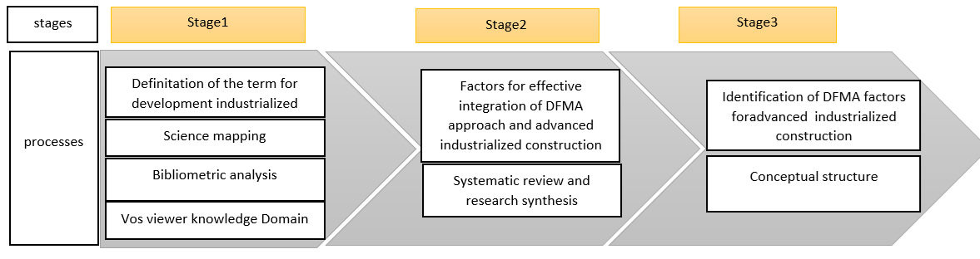

Figure1. The overview of the research methodology

**3.1. Bibliometric analysis (step 1)**

One of the research objectives has been advanced using bibliometric analysis to reach a comprehensive idea concerning industrialized construction knowledge. As illustrated in Figure 1, this is done sequentially through this step in the direction of bibliometric analysis to acquire knowledge about industrialized construction .

**3.1.1. Data curation**

As mentioned in the previous study (Esmaeili et al., 2023), the first phase of this research thoroughly examined data curation, including data management through discovery, analysis, retrieval, and structuring from various sources such as databases and repositories. This process helps maintain and preserve data quality (Miller, 2014). In the previous paper, we explored this phase in detail, and it has been used in the current study as a background for the development and extension of the research in subsequent stages. In this study, data curation was employed to retrieve information from a database of scientific studies, which is considered a reliable research database with broader coverage from WoS and Scopus (Salisbury, 2009). The search keywords used were "industrialization" or "industrialized" and "construction" or "building" or "architecture." The search was conducted between 2015 and 2023. The collected data included articles, conference papers, and review articles. Including articles from research fields such as "engineering," "construction building technology," and "architecture" helped enhance the dataset, resulting in 1,444 bibliographic records.

**3.1.2. Content analysis**

As explained in the previous study (Esmaeili et al., 2023), this study conducted a bibliometric analysis to gain a more comprehensive understanding of the knowledge domain and research trends in the field of industrialized construction (Figure 1). The data collection strategy (such as keyword generation and database selection) was initially developed to obtain a complete dataset for subsequent analyses. More detailed explanations of the data collection process are provided in Section 3.1.1 below. This scientific mapping approach is an effective and well-known method for visualizing dynamic trends in bibliographic records and databases. In this research, the VoSviewer software was used for bibliographic data analysis, which includes useful features such as (1) distance-based visualizations, (2) intelligent and dynamic clustering algorithms, and (3) full and partial counting methods (van Eck & Waltman, 2020). The data analysis in the present study was conducted based on bibliometric methods similar to those described in the (Esmaeili et al., 2023) paper.

**3.2. Systematic review (step 2)**

The authors developed the assessment procedure following the stages outlined by Denyer and Tranfield (2009), which are essential for research design and systematic analysis. This research involves the following: (1) using a set of selected articles and systematically reviewing their quality and contents using the DfMA method for industrialized construction; (2) Providing a clear and organized overview of the research process, including the chosen database, study retrieval methods, and the indicators and criteria used for selecting target articles; (3) being able to update and repeat the process; and (4) representing and integrating studies in the field of DfMA to advance industrialized construction and achieve the specified research goals (Figure 3). As a result of the bibliometric analysis conducted in stage 1, as shown in Figure 1, a qualitative analysis of the selected articles was performed. This analysis was carried out manually by the researchers. According to the research objectives, the qualitative analysis aimed to identify the factors, introduce a conceptual framework for DfMA to industrialized construction, and identify future construction needs. The current study is a developmental-applied type using qualitative research methods, specifically a research synthesis. This research synthesis involves analyzing existing research to resolve conflicts in the literature and identify key indicators for each of the components influencing DfMA in industrial construction (Coope, 2017).

**3.2.1. Data curation**

This study employed data curation to retrieve information from a database of scientific studies. The research analysis has access to several databases, including Scopus, Web of Science (WoS), Science Direct, and Google Scholar. The searched keywords are “ DfMA” OR “design for manufacture and assembly” AND “construction” OR “building” OR “architecture” in the TITLE-ABS-KEY. The search was conducted between 2015 and 2023. A meticulous selection procedure refined the results to the proper engineering field regarding the initial filtering. For example, at this stage, papers focused on other fields. According to the source, irrelevant journal or conference articles were eliminated to improve the selection of articles. A search is undertaken to find studies relevant to the study goal. As a result of the second-level filtering, we enhanced the result by "industrialized construction" (step 1). In order to choose articles, we utilized a manual method and identified genuine and valid keywords. This analysis solely looks at research in that field to further define the features, influencing factors, and usage state of DfMA in industrialized construction. The PRISMA diagram shows the article selection procedure ( Fig 3). The team reviewed the 174 selected publications and found that the research covered many topics. The titles, summaries, and key phrases of the 92 selected articles were examined to encode them. The entire text was scanned and coded if the necessary information could not be obtained from the title, abstract, and keywords. The theoretical saturation was reached attained in the 51st sample.

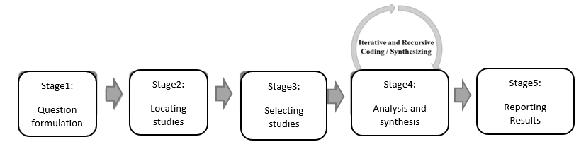

Figure. 2. Steps of qualitative research analysis (Denyer and Tranfield, 2009)

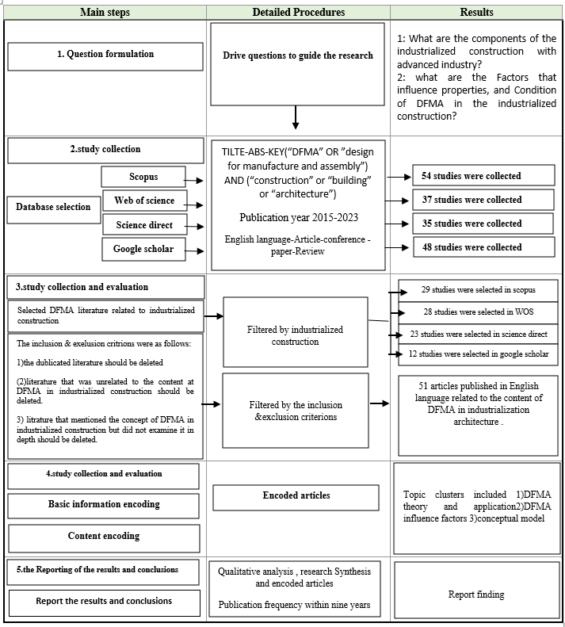

Figure 3. The PRISMA diagram for the process of selecting articles

**3.3.2. Content analysis**

Literature reviews are the foundation of the knowledge to be explored in the current research. We can improve our comprehension of our studies' subject matter by analyzing and synthesizing data from earlier investigations (Fisch & Block, 2018). We used a mechanism-based review approach in our synthetical approach to all chosen publications (Denyer et al., 2008; Van Burg & Romme, 2014; Romme & Dimov, 2021). Due to the stage 1 implementation of the bibliometric analysis, as illustrated in Figure 1, a qualitative examination of the chosen articles was conducted. Researchers performed this analysis manually. A qualitative analysis was conducted to meet the research goals of DfMA for industrialized construction and identifying future construction needs to determine the influencing factors and provide a conceptual framework. The qualitative research utilized content analysis to examine the data. The text is analyzed and organized into manageable categories for content analysis. First, the text is coded into specific categories, which are then further grouped into "code categories" to summarize the data. The types of research content analysis are conceptual and relational. The sub-themes with the most conceptual and semantic similarities were merged to create new words and meanings. These sub-themes were then categorized as the main themes. The coding, sub-themes, and primary themes have all undergone several revisions in this process.

**4. Results and Finding**

**4.1. bibliometric analysis**

This section covers the findings of the research methodology outlined in section 3.1 and Fig 1, which describes the scientometric analysis.

**4.1.1. Data evaluation in industrialized construction**

between 2015 and 2023, there was a focus on advanced construction approaches in annual journal releases. Figure 4 illustrates annual journal articles published about industrialized construction (IC) with advanced construction. The graph indicates that there has been a significant increase in journal papers on industrialized construction over the past nine years, with the most rapid growth occurring after 2018. As depicted in the figure, industrialized construction and modern method construction (MMC) received few journal papers in the early 2010s. However, in early 2015, MMC, industrialized construction, and construction 4.0 emerged significantly in industrialized countries. As a result, the field received greater attention and increased funding prospects. Consequently, there has been a surge in the publication of journal papers on (IC) and MMC construction since 2018, leading to a rise in articles in prestigious building journals (Esmaeili et al., 2023).

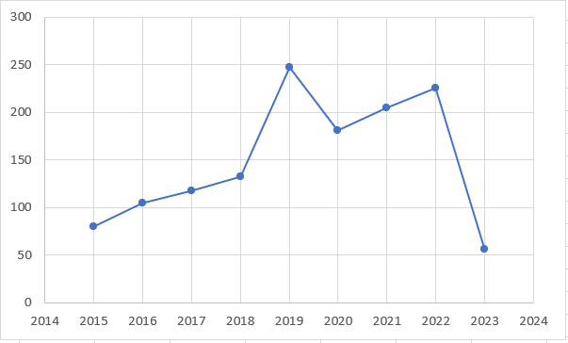

Figure. 4: Annual publications from 2015 to 2023 (Esmaeili et al., 2023)

**4.1.2. Co-occurrence resolution of author keywords in industrialized construction**

As explained in the previous study (Esmaeili et al., 2023), the methodology for selecting industrialized construction research areas was similar. A baseline number of occurrences for keywords was set to 10, with 50 of the 3,248 keywords meeting this criterion. The selection of entries was based on two factors: (1) the existing bibliometric literature review (e.g., Oraee et al., 2017a; Hosseini et al., 2018) and (2) several experiments conducted to produce optimal graphics for research clusters. The co-occurrence keywords were grouped into clusters with various colors, highlighting prominent themes such as sustainability, industrialization, automation, and industry 4.0, which have been increasingly addressed in the literature on industrialized construction .

**4.2. Pattern of DfMA for industrialized construction**

In this context, it is evident that "prefabrication" is the primary keyword in this field of study. More research has been conducted on "prefabrication" than DfMA, a more recent research topic. The larger node size indicates that more studies have been conducted on specific subjects. Based on the node's color, Figure 5 demonstrates that referred documents on prefabrication began, on average, in last-2020. Two thousand twenty-one documents look at off-site construction and DfMA. The mentioned documents examined sustainable development, feature recognition, engineering design, and policies in 2019, all related to DfMA. This demonstrates a specific development in prefabrication technology that allows DfMA to optimize construction. BIM-related documents appear to have begun in 2020 and are associated with off-site construction and modular construction.

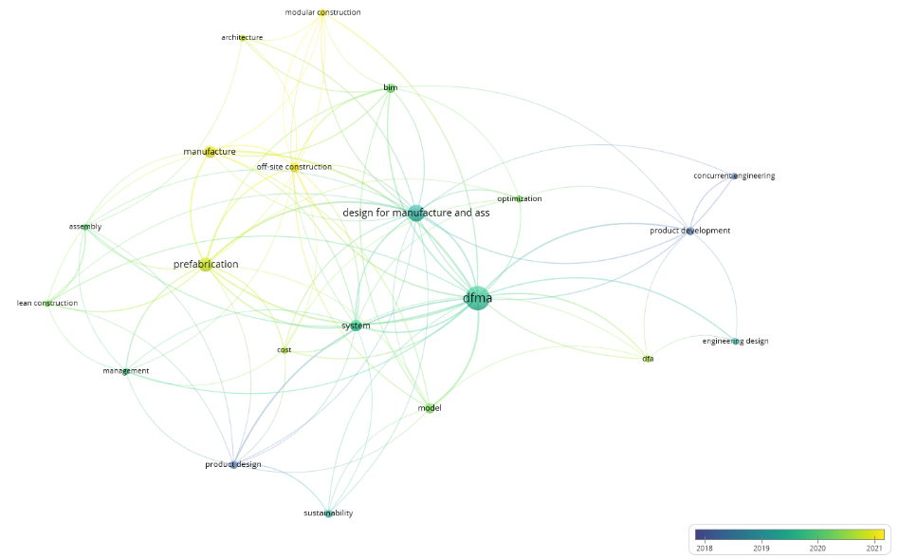

Figure 5. Science mapping of research keywords of referred papers

**4.3. Systematic review**

**4.3.1. Data evaluation in DfMA for industrialized construction**

The criteria for selecting articles for keyword research, year of publication and type of source in academic databases have been used to collect 174 articles. According to the studies that have investigated the use of DfMA in industrialized construction and based on the stated research method, 51 articles were selected as the most relevant articles for the research.The total number of research elements 78 was more than the articles chosen for the qualitative analysis. Therefore, for the qualitative analysis (synthesis analysis), the research elements had to be counted multiple times and grouped into different categories. Various DfMA factors have been studied and suggested to enhance industrialized construction. After thoroughly searching databases and carefully analyzing the gathered information, We have created a list of nine DfMA factors for industrialized construction, as shown in Table 1, along with their corresponding explanations. Under each main section, a new subsection was added to list all articles discussing the application rules for that specific area .

Table 1. Summary of research themes related to industrialized construction

|  |  |  |
| --- | --- | --- |
| Id | Research theme | Reference |
| 1 | Construction 4.0 | Cheng et al., (2023), Tan et al., (2023), Weththasinghe & Wong, (2022), Tuvayanond& Prasittisopin, (2023), O. Olawumi& Chan, (2022) |
| 2 | Off-site construction | Cheng et al., (2023), Wasim et al., (2020), Gbadamosi et al., (2020), Bakhshi et al., (2022), Shang et al., (2020), Tan et al., (2022), Baoa et al., (2022), Weththasinghe& Wong ., (2022), Alfieri et al., (2020), Gbadamosi et al., (2019), Jung& Yu, (2022), SUN& KIM , (2022), Ofori-Kuragu& Robert , (2021), Charlson& Dimka , (2021), Kalemi et al., (2020), RANKOHI et al., (2022), Hui, (2022), Cao et al., (2021). |
| 3 | prefabrication | Razak et al., (2022), Yuana et al., (2016), Wasim et al., (2020), Shang et al., (2020), Lu et al ., (2020), Gao et al., (2019), Alfieri et al., (2020), Gao et al., (2018), Rosarius& Soto, (2021), Wasim et al., (2020), Montali et al., (2019), Ofori-Kuragu& Robert , (2021), Qi& Costin , (2023), Shanmugaratna, (2019) |
| 4 | automation | Cao et al., (2022), Masters& Johnston, (2019), Tan et al., (2022), SUN& KIM, (2022), shan Ng & Mark, (2019), Tuvayanond& Prasittisopin, (2023), Jalali Yazdi et al.,(2021), O. Olawumi et al., (2022) |
| 5 | VDC (virtual design and construction) | Cheng et al., (2023), Razak et al., (2022)., Yuana et al., (2016), Gbadamosi et al., (2020), Abrishami& Martín-Durán., (2021)., Bakhshi et al., (2022)., Weththasinghe & Wong., (2022), Alfieri et al., (2020), Gbadamosi et al., (2019), SUN& KIM , (2022), Abrishami& Martín-Durán, (2021), Giuda et al., (2019), Qi& Costin, (2023), RANKOHI et al., (2022), Ur Rehmanet al., (2023), Cao et al., (2022) |
| 6 | lean construction | Lu et al., (2020), Gao et al., (2019), Gbadamosi et al., (2019), Rosarius& Soto, (2021), Langston& Zhang, (2021), Shan Ng& Mark Hall, (2019), Hui, (2022) |
| 7 | sustainability | Ahn et al., (2022), Charef et al., (2022), Abrishami& Martín-Durán ., (2021), Baoa et al., (2022), Jung& Yu , (2022), Zaman et al., (2022)., Wasim et al., (2020). Wasim et al., (2021), Langston & Zhang, (2021) |

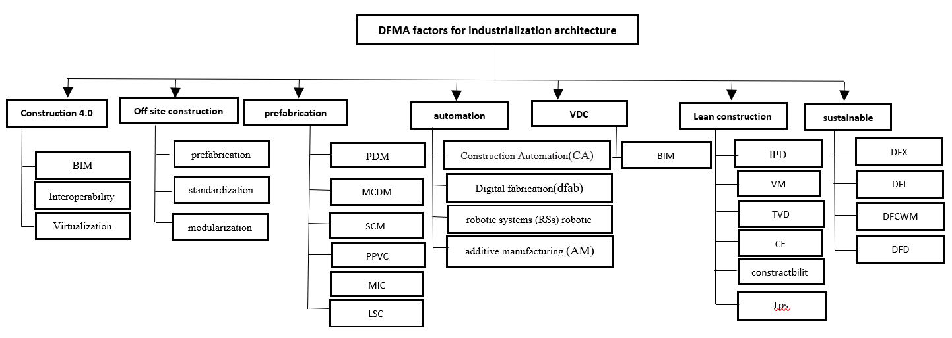

Figure 6. Classification of selected articles

Each article's study topic groups the research focus into subcategories, as illustrated in Figure 6. The seven study themes are divided into groups, with the integration of DfMA and off-site construction in industrialized construction making up the largest category (18 publications). The following top group, with 16 articles, discusses the DfMA and BIM in various contexts. More than half of the articles in the collection fall under two main categories: the implementation of DfMA for off-site building and the technology and principles that can be combined to improve the process. This indicates the significant importance of these topics in the overall process. The areas with the least research include lean automation and optimal construction 4.0. These two areas are essential for developing effective regulations to increase the appeal of DfMA concepts. We coded 5 and 8 articles, respectively, in this regard using a descriptive analysis based on the categorization of publication types and years. Figure 7 displays the descriptive results of publication categories, while Figure 8 depicts the distribution of publishing frequency by year and category. Off-site building has been the most popular construction method in the past decade. Eighteen articles, or 23% of the total, were published on this topic, with Building Information Modeling (BIM) accounting for 16 papers, 21%. BIM is a digital technology that has been discussed since 2000 and is considered one of the key technologies in the off-site construction sector. It receives much attention due to its significance. The emergence of new computer technologies, such as cloud databases and IoT, has demonstrated strong operability and compatibility, leading to numerous cross-area/cross-direction publications. There were 14 papers (18%) on prefabrication, 10 papers (13%) on sustainability, 8 papers (10%) on automation, 7 papers (9%) on lean construction, and 5 papers (6%) on construction. During 2015–2019, few papers were published on DfMA for industrialized construction industry; however, after that, the number of papers published on DfMA for industrialized construction drastically grew.

Fig 7. The percentage of publication categories

Fig 8. Distribution of publication frequency by category (sub-category) and year

It is important to consider its specific characteristics to reform the construction business completely. Based on the information gathered, a time-based research trend was developed that was restricted to and applicable to the papers cited in the current study. The development of research on DfMA principles for industrialized construction in the context of the building industry will be better understood as a result of this trend. Figure 9 displays the current research trend and the projected course for this field of research. The research trend describes themes that have emerged in the study over time, resulting in a few key research fields. Due to the novelty of this research topic, a few scholars are working on this study area.

Fig 9. .Distribution of publication frequency by year

**5. DISCUSSION**

In this article, the DfMA for Industrialized Construction principles emphasizes the importance of involvement from the beginning of the design process. This procurement strategy is the most effective way to implement industrialized construction and DfMA principles. The construction industry must combine all these elements to establish improved DfMA construction guidelines. The framework development process is divided into seven main components for discussion: 1) construction 4.0, 2) off-site construction (OSC), 3) prefabrication, 4) automation and robotic systems, 5) VDC, 6) Lean construction, and 7) sustainability.

**5.1. CONSTRUCTION 4.0**

In recent years, the manufacturing sector has successfully undergone a digital transformation (Ghobakhloo, 2020). Similarly, the global construction industry has embraced digital technology to improve productivity and efficiency, often called "Construction 4.0" (Forcael et al., 2020). characterized Construction 4.0 as a "transformative framework," with the initial transformation focusing on industrial production and construction. The construction industry is always looking for ways to work more efficiently. One way they do this is through industrialization, which involves using more machines and automation to do the job faster (Autodesk, 2022). Digital technologies for DfMA include three main categories: building information modeling (BIM), interoperability, and virtualization (Cheng et al., 2023).

1.BIM: The effectiveness of DfMA would be improved by integrating BIM. A digital and parametric platform should be used to complete the design process more quickly and adapt to changes. Building Information Modeling (BIM) is gaining traction in the construction industry (Derbe et al., 2020). The design process must take into account the assembly requirements for tower cranes or any other essential on-site machinery to ensure that Design for Manufacture and Assembly (DfMA) is effectively implemented throughout the project lifecycle. BIM could also be useful in construction (Banks et al., 2018).

2.Interoperability:Unlike internal interoperability within virtual design, interoperability for DfMA is also realized through interaction between the physical and virtual worlds. Production and assembly must adhere to design criteria and be able to provide feedback to achieve real-time synchronization. Alteration of the design plan can ensure that the original goal of DfMA is accomplished (Sun&Kim, 2022).

3.Virtualization: With the rise of digital visualization technologies, more participation is desired in projects, such as walking around and exploring. Immersive technologies (ImTs) have made significant progress and now provide a solution by allowing stakeholders to fully immerse themselves in various project phases (Zhang et al., 2020).

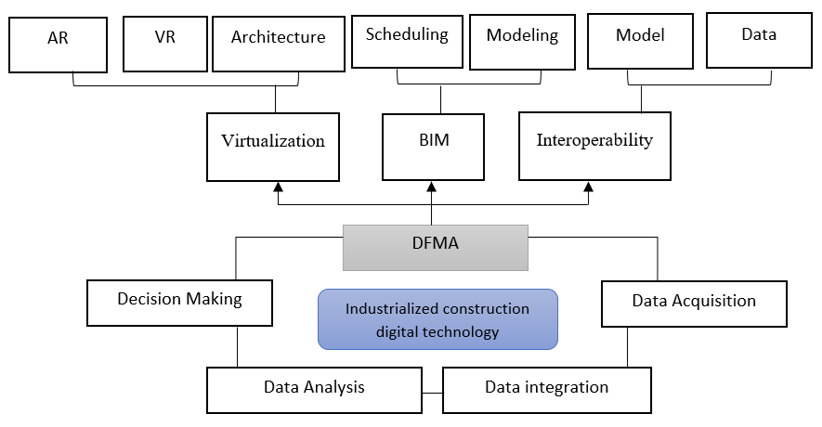

Figure 10. Digital technology for offsite construction

The advanced technologies in Table 2 could enhance the collaborative working environment and overall work quality throughout the project, from its inception to the construction and utilization phases. The success of DfMA relies on the adoption of these practices. Furthermore, digital transformation largely depends on tools and processes and will influence future construction. To embrace DfMA, one must be open to advanced technology.

Table 2. Construction 4.0 in DfMA for industrialized construction

|  |  |  |
| --- | --- | --- |
| Factors | References | Research themes |
| construction 4.0 | Cheng et al., (2023), Tan et al., (2023), Weththasinghe& Wong, (2022), Tuvayanond& Prasittisopin, (2023), Olawumi& Chan, (2022), Sawhney et al., (2020), Abbas et al., (2019), Alizadehsalehi et al., (2020), tan et al., (2020), Bakhshi et al., (2022) | -radio frequency identification (RFID)  -BIM (building information modeling)  -robotics  -augmented reality (AR)  - virtual reality (VR)  -blockchain  - digital twinning  - laser scanners  -Three-dimensional printing  -Auto ID  - QR/bar codes  - IoT (Internet of Things)  -photogrammetry technology  -global positioning systems (GPSs) |

**5.2. Off-site construction**

Off-site construction and DfMA are gaining more attention as process innovations increase productivity (Bao et al., 2022; Hyun & Kim, 2022). Prefabrication and off-site construction, major drivers of DfMA, offer benefits in shorter overall construction schedules, program predictability, safety, quality, sustainability, and procurement ( Hui, 2022; Boon & Doig, 2019; CIC, 2022). This opens up new possibilities for further automation, optimization, and integration. Construction industrialization commences with the DfMA stage, ensuring designs are suitable for off-site and prefabricated construction methods. Using the principles of standardization and modularization at this stage will result in higher production, efficiency, and scale economies (Ofori-Kuragu & Robert, 2021). However, research on how to adapt DfMA production methods with off-site construction is still in its infancy (table 3).

Table 3. Off-site construction in DFMA for industrialized construction

|  |  |  |
| --- | --- | --- |
| Factors | Reference | Research theme |
| Off site construction | Razak et al., (2022), Yuana et al., (2016), Wasim et al., (2020), Shang et al., (2020), Lu et al ., (2020), Gao et al., (2019), Alfieri et al., (2020), Gao et al., (2018), Rosarius& Soto, (2021), Wasim et al., (2020), Montali et al., (2019), Ofori-Kuragu& Robert , (2021), Qi & Costin , (2023), Shanmugaratna, (2019) | prefabrication |
| Goulding et al., (2015), Abrishami,& Martín-Durán, (2021), Arashpour et al., (2018), Kim et al., (2016), Said, (2015), Sutrisna & Goulding , (2019), Tan et al., (2020) | standardization |
| Parraguez et al ., (2019Gharbia , (2020), AIA,(2019), Peterseim, (2016), HKHA, (2019), Pasco et al, (2022), Tan et al., (2022) | modularization |

**5.3. Prefabrication**

Design for Manufacturing and Assembly (DfMA) has been developed for prefabricated building components (Serra et al., 2019; Gao et al., 2019). DfMA can be used as a revolutionary construction philosophy that includes prefabrication and modular building techniques (Gao et al., 2020). Greater automation in a regulated setting boosts construction productivity and quality by employing individuals with higher skill sets. Diverse aspects are considered in the DfMA, a relatively modern prefabrication building design process, to ensure that Prefabrication buildings are effectively designed (Lu et al., 2021). BIM and Product Data Management (PDM) are proven advantageous for prefabrication and DfMA. However, as the design progresses, data updating should be automated to prevent problems with a deluge of design data that would defeat **Project Delivery Methods** objectives ( Razak et al., 2022). Using library data and tools, such as the weighted sum method, analytic hierarchy process, and approach for ordered preference, could expedite and simplify the multi-criteria decision-making (MCDM) iterations involved in the design process (tan et al., 2019). Prefabricated Prefinished Volumetric Construction (PPVC), DfMA technique, is another striking example. Similar to MiC, where building modules are produced in a factory setting and then transported to a construction site for assembly, this idea involves the completion of internal finishes and fittings (table 4).

Table 4. Prefabrication in DfMA for industrialized construction

|  |  |  |
| --- | --- | --- |
| Factors | Reference | Research theme |
| prefabrication | Merja & Harri., (2018), Langston & Zhang., (2021), Trinder et al., (2018), Razak et al., (2022) | product data management (PDM) |
| Tan et al., (2019) | multi-criteria decision making(MCDM) |
| Sharma et al., (2021), Rajesh, (2020), Ahmed, (2019), Luo et al., (2019), BCA, (2016). | Supply chain management (SCM) |
| Weththasinghe & Wong, (2022), Gao et al., (2019), Malleswari et al., (2020), BCA, (2021) | Prefabricated Prefinished Volumetric Construction (PPVC) |
| CIC, (2019), Yin et al., ( 2019), mic.cic.hk, (2021), Langston,&Zhang, (2021), Yuan et al., (2018), Lu et al., (2020), Razak et al., (2022). | Modular integrated Construction (MIC) |
| Boothroyd, (2005), Gbadamosi et al., (2018), Kim et al., (2016), Banks et al ., (2018) | the downstream logistics and supply chain (LSC) |

**5.4. Automation and robotic system**

DFMA goes beyond being a modern construction method focused on improving the efficiency of building components. It also prioritizes the entire construction process, improving the effectiveness of utilizing established and proven construction techniques (BCA, 2020; RIBA, 2021). As a new design method, DfMA is anticipated to use digital fabrication to address OSC issues (Tan et al., 2022). DfMA is emerging as a methodical innovation in the AEC industry that encourages automation and improves productivity. Manufacturing expertise must be incorporated early in the design process (Bao et al., 2022). Design quality, production efficiency, and labor demands have all greatly grown due to building information modeling (BIM) and robotic manufacturing technology. Automated production tools make the exchange and updating of design data possible. This happens at a specific stage in the process. There are some new design characteristics that designers need to keep in mind. To ensure successful outcomes, manufacturers and designers must collaborate closely, understanding material properties and manufacturing capabilities to bring DfMA to life (Tan et al., 2022). DfMA and AM technology are still relatively new, so extensive research and development have been undertaken. Currently, the main focus is ensuring that materials perform well, construction is efficient, automation and machines are user-friendly, and everything is implemented legitimately (table 5).

Table 5. Automation in DfMA for industrialized construction

|  |  |  |
| --- | --- | --- |
| Factors | Refrence | Research theme |
| Automation and Robotic systems | Cao et al., (2022), Masters & Johnston , (2019), Tan et al., (2022), SUN & KIM , (2022), shan Ng & Mark (2019), Tuvayanond & Prasittisopin (2023), Jalali Yazdi et al., (2021), Olawumi et al., (2022) | 1) Construction Automation(CA):  a)robotic systems (RSs)  b)modeling and mimulation(BIM)  c)digitization and virtualization (DV)  d)sensing systems  e)artificial intelligence(AI)  2) Digital fabrication(dfab)  additive manufacturing (AM) |

**5.5. Virtual design and construction**

Another advancement is the integration of Design for Manufacture and Assembly (DfMA) with Virtual Design and Construction (VDC) tools, such as Building Information Modeling (BIM). BIM is a building representation that utilizes parametric objects to depict each architectural component (Eastman et al., 2011). The implementation of DfMA is made easier with BIM from two perspectives. DfMA requires an analytical platform to improve manufacturing and assembly processes in the design phase. BIM objects containing comprehensive information about actual building components are ideal. Applying DfMA principles to the design can make it more conducive to production and construction.

Furthermore, the information can be utilized to evaluate the manufacturing and assembly of the components. Automated factory monitoring methods, such as the one proposed by Panahi et al. (2023), can monitor the production process automatically and ensure alignment with the DfMA principles (Panahi et al., 2023). Moreover, BIM builds an efficient platform for collaboration. Designers, engineers, suppliers, and contractors can share knowledge and ideas using the digital model (Chen et al., 2017; Zhong et al., 2017). Once the design is finalized, the BIM model can be directly sent to suppliers or manufacturers for mass production.

Additionally, BIM may connect upstream activities such as briefing, assessments, and conceptual design to downstream DfMA operations like procurement, fabrication, transport, and installation. This improves contact and cooperation with stakeholders (BCA, 2021).

Table 6. VDC in DfMA for industrialized construction

|  |  |  |
| --- | --- | --- |
| VDC | Cheng et al., (2023), Razak et al., (2022)., Yuana et al., (2016), Gbadamosi et al., (2020), Abrishami& Martín-Durán ., (2021)., Bakhshi et al., (2022)., Weththasinghe & Wong., (2022)., Alfieri et al., (2020)., Gbadamosi et al., (2019), SUN& KIM , (2022), Abrishami& Martín-Durán , (2021), Giuda et al., (2019), Qi& Costin , (2023), RANKOHI et al., (2022), Ur Rehmanet al., (2023), Cao et al., (2022) | BIM |

**5.6. Lean construction**

The concepts of lean construction and DfMA are interconnected and collaborate. DfMA can help lean construction processes focus on reducing waste, which is labeled as a "non-value-added" action in lean construction (Koskela, 1992). This matches fundamental DfMA principles, that is, reducing the amount of components and optimizing convenience of handling and construction (Gerth et al., 2018). lean construction can use own concepts to enhance Design for Manufacture and Assembly philosophy. Utilizing DfMA and lean construction can generate mutual advantages to the AEC sector. In Agreement to reach an optimal shared value like Lowering the cost of construction and efforts , and augmenting construction efficiency (Ogunbiyi, Goulding, & Oladapo, 2014). traditional construction practices compared to, Prefabrication/MiC is a great time-saver, helping to reduce costs and cut down on waste during the building process (Yuan et al., 2018). Gbadamosi et al. (2018) confirmed that the construction sector becomes more efficient through successful practices and manufacturing methods such as DfMA and lean concepts. Concurrent Engineering (CE) facilitates collaboration in product development for design-to-cost and design-to-target. Total Value Design (TVD) is an integrative project management tool that ensures costs and design align with the client's target throughout the design process (Kim & Lee, 2010; Ballard, 2011, Jung et al., 2012; Miron et al., 2015). There is a growing awareness of the relationship between BIM, integrated project delivery (IPD), and lean construction (LEAN) in Australia and the US. It is now understood that all three are necessary to collaborate on significant and complex projects (Nguyen& Akhavian, 2019 ; leanipd, 2021). The increasing need for more integrated project delivery and value development strategies will lead to a rise in the popularity of DfMA. To maximize project performance, VM and integrated project delivery (IPD) work together to coordinate the objectives and strategies of all relevant parties (Lu et al., 2020).

Table 7. Lean construction in DfMA for industrialized construction

|  |  |  |
| --- | --- | --- |
| Factors | Reference | Research theme |
| Lean construction | Nguyen & Akhavian, (2019), Lean IPD, (2021), Lu et al., (2020),  [Charlson &](https://www.emerald.com/insight/search?q=Jennifer%20Charlson)  [Dimka](https://www.emerald.com/insight/search?q=Nenpin%20Dimka), (2021) | integrated project delivery (IPD) |
| Lu et al., (2020), Chen & Lu, (2018), Gao et al., (2019), Newton et al., (2018) | value management (VM) |
| Ballard, (2011), Miron, (2015), Jung, (2012), Kim et al., (2010), Mark Hall, (2019) | Target Value Design (TVD) |
| Charef et al., (2021), European Commission, (2019), Lu et al., (2018), Gao et al., (2019) | Concurrent Engineering (CE) |
| Gao et al., (2019), Yuan et al., (2018), Gao et al., (2018) Lu et al., (2020) | constructability |
| Ćwik & Rosłon, (2017) | Last Planner System( LPS) |

**5.7. Sustainability**

DfMA's advantages include a shorter product development cycle, higher productivity, better product quality, improved design reliability, reduced resource waste, and higher profitability ( Charef et al., 2022). Design for Environment (DfE), Design for Safety (DfS), and Design for Construction Waste Minimization (DfCWM) have been added to Design for Manufacturing and Assembly (DfMA) (Laovisutthichai et al., 2020). Design for Excellence (DFX) is another name for the DfMA that refers to a design for all fields. The construction industry's sustainability can be increased using the Design for Excellence (DfX) process, which prioritizes the environment, recycling, disassembly, and life cycle evaluation. Testability, compliance, recyclability, manufacturability, dependability, maintainability, and variability are just a few of the aspects. In response to the discussion on Design for Manufacture and Assembly (DfMA), several research projects have begun to explore the application of this strategy at the end of an asset's lifecycle, particularly for deconstruction, disassembly, and disposal. DfMA can also encompass deconstruction/disassembly and decommissioning procedures; parts or whole buildings can be reverse-engineered to facilitate dismantling (Build offsite, 2020). DfD is widely used to encourage designers to consider practices that assist reuse and recycling, including taking preventive measures to reduce unnecessary waste (table 8).

Table 8. Sustainability in DfMA for industrialized construction

|  |  |  |
| --- | --- | --- |
|  | Reference | Research theme |
| sustainability | Ahn et al., (2022), Charef et al., (2022), Abrishami & Martín-Durán, (2021), Baoa et al., (2022), Jung & Yu , (2022) | Design for Excellence (Dfx )  DfL  Design for Construction Waste Minimization (DfCWM)  Design for deconstruction ( DfD) |

**6. CONCEPTUAL MODEL**

Based on the information from Section 5, Figure 12 presents a conceptual framework summarizing the recommended steps and necessary actions to improve the effectiveness of DfMA application in industrialized construction and the future construction sector. Consequently, the adopted conceptual model also categorizes DfMA into seven levels: off-site construction, construction 4.0, prefabrication, sustainability, lean construction, virtual design construction, and automation. Industrialized construction combines the construction site with the supply chain (factory). Off-site construction is a common form of industrialized construction, but it cannot solve all the challenges the construction industry faces alone. A partnership with an integrated design process like DfMA must address these challenges. Therefore, the relatively mature industrial theories, frameworks, and techniques that have emerged from Industry 4.0 are applied to off-site construction under fourth manufacturing. As a result, off-site construction is mutually influential with fourth construction. Since DfMA encompasses various levels of component manufacturing, including non-volumetric pre-assembly, volumetric pre-assembly, and modular buildings, prefabrication is a fundamental pillar of the model, directly related to other components. Moreover, adopting DfMA in manufacturing drives the desired goal for standardized construction processes and the increased use of pre-fabricated parts, interacting with off-site construction in a modular manner. On the other hand, the principles of lean construction and DfMA are related and mutually supportive. Designers can help improve these principles by utilizing the components of lean construction to identify inefficient movements and operations in manufacturing and assembly. This aligns with the key principles of DfMA: minimizing the number of parts and maximizing ease of transport and assembly. DFMA considers product design improvement while also considering production and assembly processes. Simplifying products through DfMA can reduce production costs, improve quality, and decrease production time, ultimately increasing efficiency in line with sustainability requirements and the separation and recycling process. The concept of "circular approaches" to sustainability encompasses several ideas that aim to close the loop of the material cycle. This includes supply chain management, material chain optimization, and recycling. These concepts directly relate to prefabrication processes in industrialized construction and lean construction principles. Another trend that is based on the conceptual model of integrating DfMA and virtual design and construction (VDC) technologies is BIM. BIM can facilitate DfMA implementation from two perspectives. DfMA needs an analytics platform to identify opportunities to improve manufacturing and assembly processes through design and enable a seamless collaboration environment through automation and Building Information Modeling (BIM). Other DMFA components are influential and interrelated in improving the design and prefabrication process. In addition, digital models contribute to DfMA analysis to simplify the manufacturing and assembly process. Design for Manufacture and Assembly (DfMA) has the potential to enhance digital manufacturing techniques and accelerate OSC implementation. Robotic manufacturing and building information modeling (BIM) technologies have greatly improved design quality and production efficiency and reduced labor demand. These characteristics pose new requirements for designers, who must communicate closely with manufacturers to understand material properties, processability, and manufacturing characteristics to fulfill DfMA. Therefore, based on the research's conceptual model, the decision to implement DfMA involves considering the design requirements, planning, adaptation/optimization of designs, and level of automation, particularly in the initial stages, until the potential for integrated production of its components for subsequent assembly on-site can be established. this model for DFMA has made a major contribution to the technological advancement of the manufacturing industry through the introduction of advanced tools. Automation, improved planning systems and 3D simulation have been added to the design process with the introduction of Artificial Intelligence, which has had a significant effect on intelligent production, manufacturing, and maintenance. It's essential for industrial growth to have innovative. Creative innovation for design are pushing the boundaries of how we design and monitor sites. The proposed model includes specific features that bring new capabilities in integration with construction 4.0 technologies, automation, and robotics, which have not been addressed in any previous models. On the other hand, considering the characteristics of industrialization and technological advancements, the model can provide scalability, applicability to various projects, efficiency in reducing costs or time, waste reduction, and integration with modern technologies. This model has uniquely improved the efficiency of design and manufacturing processes.

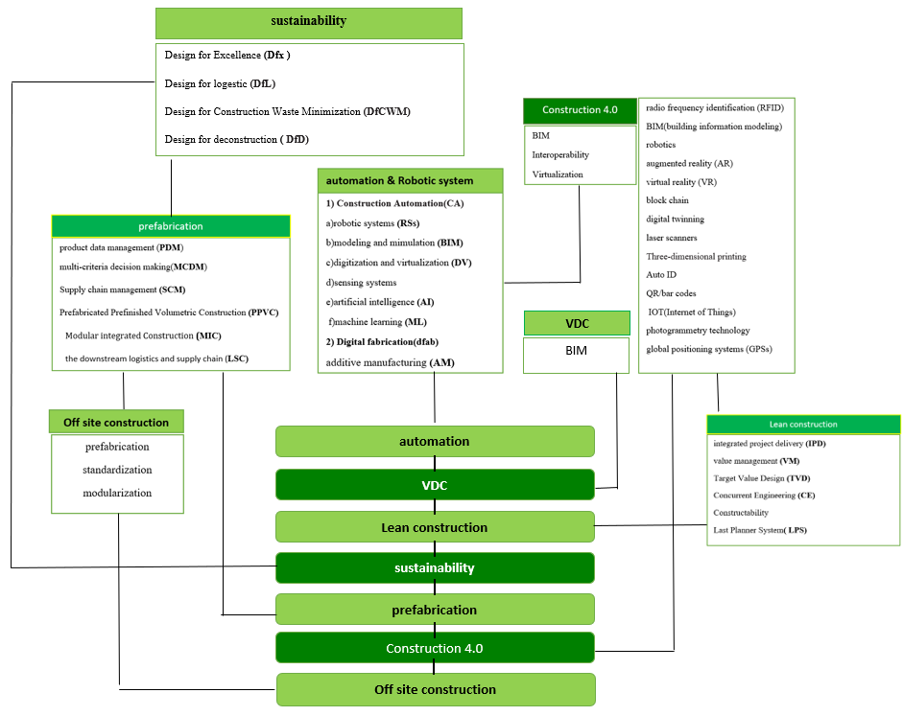

Figure 11. Conceptual model DfMA for industrialized construction

**7. CONCLUSION**

According to the main research goal, the identification of components of advanced industrialized construction has been done using the bibliographic method and the VOSviewer software.  Through qualitative meta-analysis and systematic review, DfMA (Design for Manufacture and Assembly) factors and related concepts have been identified in advanced industrialized construction. This has resulted in developing a conceptual model encompassing principles of off-site construction techniques, Construction 4.0, information and communication technology, digital technologies, prefabrication techniques, lean construction, sustainability, and virtual design and construction. From the studies conducted, 46 governing principles based on DfMA for industrialized construction have been classified and defined into seven categories. These principles are used to design and produce advanced construction to implement the principles of DfMA. They provide what is needed to improve the effectiveness of DfMA's application in industrial construction and the future construction sector. The research findings indicate that the components are synchronized to optimize construction according to DfMA principles, with mutually determined two-way effects in the conceptual model. The study provides an excellent dataset for implementing DfMA in the construction industry. With the conceptual framework presented, we can develop strategies and guidelines for the best possible implementation of DfMA in construction projects, which will improve the construction sector in the future in terms of quality, time, and cost through technology integrations and DfMA expertise. Applying DfMA in the construction industry would also increase its ability to be transformed into an automated industry, especially during the manufacturing process. Enhanced with integration with technologies, depend on model , DfMA has the potential to bring the construction industry into the digital world. This will lead to more effective and sustainable constructions. Despite the clear advantage of applying DfMA in the construction industry, more research needs to be done. , DfMA is still very vague. There is very little research performed on strategizing and developing guidelines for the application of DfMA in the construction industry. This study could help the construction industry analyse and evaluate the optimal ways of adopting new innovative solutions such as DfMA. From the previous studies, the identified benefits of DfMA should be reason enough to apply it in the construction industry. Using the data compilations presented in this study, we can identify what is required to apply DfMA in the construction industry. From the conceptual framework produced in this study, strategies and guidelines could be developed for the optimal application of DfMA. Despite the obvious benefits of using DfMA in industrialized construction, further research is needed. According to the research, there are suggestions for future research and practical implementation, including Comparing the model in the construction industry with other industries such as automotive or manufacturing can reveal whether the principles of the DfMA model are applicable in these industries as well. Secondly, Simulating the model on small and large scales in real-world projects can help to better understand its impact on construction costs and time. Moreover Future research could focus on legal obstacles, stakeholder resistance, or technical limitations in implementing the DfMA model in real-world projects, finally Testing the model in pilot projects can provide detailed results on the extent of cost and time reductions in projects. The authors hope this understanding of research needs and the resulting recommendations can be used to further research and advance DfMA for industrialized construction.

**REFERENCE**

Abbas, A., Choi, M., Seo, J., Cha, S.H., Li, H. (2019). Effectiveness of immersive virtual reality-based communication for construction projects. *KSCE J. Civ. Eng.23*, 4972–4983

Abrishami, S., Martín-Durán, R. (2021). BIM and DfMA: A Paradigm of New Opportunities. *Sustainability* 2021, *13*, 9591. https://doi.org/10.3390/su13179591

Ahmed, W., Najmi, A., Arif, M., Younus, M. (2019). Exploring firm performance by institutional pressures driven green supply chain management practices, Smart and Sustainable Built Environment 8 (5) , pp. 415-437. doi: 10.1108/SASBE-04-2018-0022

Ahn, N., Dodoo, A., Riggio,M., Muszynski, L., Schimleck, L., Puettmann, M. (2022). Circular economy in mass timber construction: State-of-the-art, gaps and pressing research needs. Journal of Building Engineering 53 (2022) 104562. https://doi.org/10.1016/j.jobe.2022.104562

Ali, K.N., Alhajlah, H.H., Kassem, M.A. (2022). Collaboration and Risk in Building Information Modelling (BIM): A Systematic Literature Review. *Buildings* 2022, *12*, 571

Alizadehsalehi, S., Hadavi, A., Huang, J.C. (2020). From BIM to extended reality in AEC industry. *Autom. Constr. 116*, 103254

Alfieri, E., Giuda, G,M,D., Seghezzi, E., Masera, G. (2020). A BIM-based approach for DfMA in building construction: framework and first results on an Italian case study. Architectural Engineering and Design Management*..http://www.tandfonline.com/10.1080/17452007.2020.1726725*

American Institute of Architects. (2019). Design for modular construction: An introduction for architects.

Andersson, N., Lessing, J. (2017). The Interface between industrialized and project based construction,(2017), Creative Construction Conference 2017, CCC 2017, 19-22 June 2017, Primosten, Croatia. doi: 10.1016/j.proeng.2017.07.193.(http://creativecommons.org/licenses/by-nc-nd/4.0/)

Arashpour, M., Miletic, M., Williams, N., Fang, Y. (2018). Design for manufacture and assembly in off-site construction: Advanced production of modular façade systems. In ISARC. Proceedings of the International Symposium on Automation and Robotics in Construction (Vol. 35, pp. 1–6). IAARC Publications.

Autodesk. Industrialized Construction in Academia. (2022). Available online: https://damassets.autodesk.net/content/dam/autodesk/  
www/pdfs/autodesk-industrialized-construction-report.pdf

Banks, C., Kotecha, R., Curtis, J., Dee, C., Pitt, N., Papworth, R.(2018). Enhancing high-rise residential construction through design for manufacture and assembly a—UK case study. *Proc. Inst. Civ. Eng.-Manag. Procure* , *171*, 164–175.

Baoa, Z., Laovisutthichai, V., Tan, T., Wang, Q.,Lu, W.(2022). Design for manufacture and assembly (DfMA) enablers for offsite interior design and construction. BUILDING RESEARCH & INFORMATION 2022, VOL. 50, NO. 3, 325–338 <https://doi.org/10.1080/09613218.2021.1966734>

Bao, Z., Laovisutthichai, V., Tan, T., Wang, Q., Lu, W. (2022).Design for manufacture and assembly (DfMA) enablers for offsite interiordesign and construction. *Build. Res. Inf.* 2022, *50*, 325–338.

Barbosa G. F & Carvalho J.(2013) . Design for Manufacturing and Assembly methodology applied to aircrafts design and manufacturing, *IFAC Proceedings Volumes*, 46 (7) 116-121

Barrit, J. (2016). An Overview on Recycling and Waste in Construction. *Constr. Mater.*  *169*, 49–53.

Bakhshi, S., J. Edwards,D., Rahimian, FP. (2022). Integrated BIM and DfMA parametric and algorithmic design based  
collaboration for supporting client engagement within offsite construction. Automation in Construction · January 2022, DOI: 10.1016/j.autcon.2021.104015

BCA . (2020) . Design for Manufacturing and Assembly Guidelines. BCA, Singapore.

BCA. (2021) . Available online: https://www1.bca.gov.sg/buildsg/productivity/design-formanufacturing-and-assembly-DfMA (accessed on 26 June 2021).

BCA . (2018) . Design for Manufacturing and Assemble (DfMA) – Prefabricated Prefinished Volumetric Construction. BCA, Singapore.

Building and Construction Authority. (2016). *BIM for DfMA (Design for Manufacturing and Assembly) Essential Guide*. Retrieved from [https://www.corenet.gov.sg/media/2032999/bim_essential_guide_DfMA.pdf](https://www.corenet.gov.sg/media/2032999/bim_essential_guide_dfma.pdf).

BDI. (2018). *DFMA Design for Manufacture & Assembly: Reduce Costs Increase Profits, a White Paper for Corporate Management*, Boothroyd Dewhurst, Inc., Wakefield, RI. [https://www.DfMA.com/resources/DfMAwp.asp](https://www.dfma.com/resources/dfmawp.asp)

Bertram, N., Fuchs, S., Mischke, Palter, R., Strube, G., Woetzel, J., 2019. Modular construction: from projects to products. In: McKinsey & Company: Capital Projects & Infrastructure, pp. 1–34. 〈https://www.ivvd.nl/wp-content/uploads/2019/12/ Modular-construction-from-projects-to-products-full-report-NEW.pdf〉.  
(Accessed 8 March 2020)

Bogue, R. (2012) . Design for manufacture and assembly: background, capabilities and applications, Assembly Automation, 32 (2) 112-118

Boon, K. S. & Doig, L. ( 2019). DFMA for Prefabricated Mechanical, Electrical and Plumbing (MEP) Systems, Arcadis Insights, Issue 2/2019 - March 2019

Boothroyd, G. (2005). Assembly automation and product design. CRC Press

Boothroyd, G., Dewhurst, P., Knight, W. A., Anthony, W. (2011). *Product Design for Manufacture and Assembly*, 3rd ed, CRC Press, Boca Raton, FL

Bryden Wood. (2017). *Delivery Platforms for Government Assets - Creating a marketplace for m anufactured s paces*

Building and Construction Authority. (2016). *BIM for DfMA (Design for Manufacturing and Assembly) Essential Guide*. Retrieved from [https://www.corenet.gov.sg/media/2032999/bim_essential_guide_DfMA.pdf](https://www.corenet.gov.sg/media/2032999/bim_essential_guide_dfma.pdf)

Buildoffsite. (2021). BIM and DfMA. Available online: https://www.buildoffsite.com/publicationsguidance/bim-DfMA

Cao, J ., Vakaj, E ., K. Soman , R ., M. Hall, D . (2022). Ontology-based manufacturability analysis automation for  
industrialized construction. Automation in Construction 139 (2022) 104277. <https://doi.org/10.1016/j.autcon.2022.104277>

Cao, J., F. Bucher, D., M. Hall, D., Eggers,M. (2022). A graph-based approach for module library development in  
industrialized construction .Computers in Industry 139 (2022) 103659. https://doi.org/10.1016/j.compind.2022.103659

Cao, J., F. Bucher , D., M. Hall , D., Lessing, J. (2021). Cross-phase product configurator for modular buildings using kit-of-parts. Automation in Construction 123 (2021) 103437. <https://doi.org/10.1016/j.autcon.2020.103437>

Charef, R., Ganjian, E., Emmitt, S. (2021). Socio-economic and environmental barriers for a holistic asset lifecycle approach to achieve circular economy: a patternmatching method. Technol. Forecast. Soc. Change 170, 120798. <https://doi.org/> 10.1016/j.techfore.2021.120798

Charef, R., Lu,W., Hall, D . (2022). The transition to the circular economy of the construction industry: Insights into sustainable approaches to improve the understanding., Journal of Cleaner Production 364 (2022) 132421.<https://doi.org/10.1016/j.jclepro.2022.132421>

[Charlson, J.,](https://www.emerald.com/insight/search?q=Jennifer%20Charlson)  [Dimka](https://www.emerald.com/insight/search?q=Nenpin%20Dimka), N. (2021). Design, manufacture and construct procurement model for volumetric offsite manufacturing in the UK housing sector. [Journals](https://www.emerald.com/insight/sitemap/publications#journals) [Construction Innovation](https://www.emerald.com/insight/publication/issn/1471-4175) [Volume 21 Issue 4](https://www.emerald.com/insight/publication/issn/1471-4175/vol/21/iss/4). doi/10.1108/CI-10-2019-0108/full/html

Cheng, Z., Tang, SH., Liu,H., Lei,Z . (2023). Digital Technologies in Offsite and Prefabricated Construction: Theories and Applications. *Buildings* 2023, *13*, 163. https://doi.org/ 10.3390/buildings13010163

Chen, K., & Lu, W. (2018). Design for manufacture and assembly oriented design approach to a curtain wall system: A case  
study of a commercial building in Wuhan, China. Sustainability, 10(7), 2211

Chen, K., Xu, G., Xue, F., Zhong, R. Y., Liu, D., & Lu, W. (2017). A physical internet-enabled BIM system for prefabricated  
construction. International Journal of Computer Integrated Manufacturing, 31(4-5), 349–361. Retrieved from https://  
bit.ly/2PLRAM3

CIC. (2022). Reference Materials on Adopting DfMA for MEP Works (A Concise Guide), Construction Industry Council, Hong Kong

Cobo, M.J., Lopez-Herrera, A.G., Herrera-Viedma, E., Herrera, F.(2011). Science mapping software tools: review, analysis, and cooperative study among tools, J. Am. Soc. Inf. Sci. Technol. 62 (2011) 1382–1402, <https://doi.org/10.1002/asi.21525>

Construction Industry Council (CIC). (2019). What is CIC? Retrieved from <https://bit.ly/2vBWLVI>

Coope, Harris.(2017). Research Synthesis and Meta-Analysis, A Step-by-Step Approach, Fifth Edition. Printed in the United States of America,chapter1. ISBN 978-1-4833-3115-7 (pbk. : alk. paper)

Craveiro, F., Duarte, J.P., Bartolo, H., Bartolo, P.J.(2019). Additive manufacturing as an enabling technology for digital construction:  
A perspective on Construction 4.0. Autom. Constr. 2019, 103, 251–267.

Ćwik, k, Rosłon, J .(2017). Last planner system in construction, Seminar 2017, Theoretical Foundation of Civil Engineering. DOI: 10.1051/ matecconf/201 711700032

Denyer, D., Tranfield, D., Van Aken, J. E. (2008). Developing design propositions through research synthesis. Organ. Stud. 29 (3), 393–413

Derbe, G., Li, Y., Wu, D., Zhao, Q. (2020). Scientometric Review of Construction Project Schedule Studies: Trends, Gaps and Potential Research Areas. *J. Civ. Eng. Manag.* **2020**, *26*, 343–363.

Design for Manufacturing and Assembly (DfMA).(2021). Available online:https://www1.bca.gov.sg/buildsg/productivity/design-formanufacturing-and-assembly-DfMA .

Eastman, C., Teicholz, P., Sacks, R., Liston, K. (2011). BIM handbook: A guide to building information modeling for owners,  
managers, designers, engineers and contractors. Wiley.

Esmaeili,N., Vafamehr,M., Rezaei,H., Khaki,A.(2023). An Integrated Model of Lean Construction and Off-Site Cons truction for Industrialization Architecture: Review and Future Directions, International Journal of Architecture and Urban Development. DOI: 10.30495/IJAUD.2023.22185

European Commission, 2019. The European Green Deal [WWW Document]. URL. https://ec.europa.eu/info/sites/info/files/european-green-deal-communication_en.pdf, 7.8.20

Fisch, C., Block, J. (2018). Six tips for your (systematic) literature review in business and management research. *Manag. Rev. Q.* 2018, *68*, 103–106.

Forcael, E., Ferrari, I., Opazo-Vega, A., Pulido-Arcas, J.A.(2020). Construction 4.0: A literature review. *Sustainability*, *12*, 9755

Gao, SH., Jin, R., & Lu, W. (2019). Design for manufacture and assembly in construction: a review, Building Research & Information. BUILDING RESEARCH & INFORMATION .2019 .https://doi.org/10.1080/09613218.2019.1660608

Gao ,S., Low, SP., Nair , K. (2018). Design for manufacturing and assembly (DfMA): a preliminary study of factors influencing its adoption in Singapore. Architectural Engineering and Design Management 14: 440–456, <https://doi.org/10.1080/17452007.2018.1502653>

Gao, S., Jin, R., Lu, W. (2020). Design for manufacture and assembly in construction: A review. *Build. Res. Inf.*  *48*,  
538–550

Garcia de Soto, B., Skibniewski, M. J. (2020). Future of robotics and automation in construction. Chapter 15. In: Sawhney, A.,  
Riley, M., & Irizarry, J. (eds.), *Construction 4.0: An Innovation Platform for the Built Environment*, 1st Edn. Routledge, London,  
pp. 289-306. ISBN-13: 978-0367027308. doi: 10.1201/9780429398100-15

Gbadamosi, A. Q., Mahamadu, A. M., Manu, P., Akinade, O., Sierra, F., Lam, T. T., & Alzaatreh, A. (2018). A BIM based approach for optimization of construction and assembly through material selection. In M. Skibniewski & M. Hajdu (Eds.), Creative construction conference 2018 (CCC 2018).

Gbadamosi, A.-Q., Mahamadu, A.-M., Oyedele, L.O., Akinade, O.O., Manu, P., Mahdjoubi, L., Aigbavboa, C. (2019). Offsite construction: Developing a BIM-based optimizer for assembly. *J. Clean. Prod.* 2019, *215*, 1180–1190.   
Gbadamosi, A,Q., Oyedele, L., Mahamadu,A.M., Kusimo,H., Bilal,M., Delgado, J. M. D ., Muhammed-Yakubu,N.(2020). Big data for Design Options Repository: Towards a DFMA approach for offsite construction. Automation in Construction 120 (2020) 103388. <https://doi.org/10.1016/j.autcon.2020.103388>

Giuda, G.M.D., Giana1, P.E., Masera, G., Seghezzi1, E., & Villa,V.(2019). A Bim-based approach to façade cladding optimization:geometric, economic and production control in a DfMA perspective. European Conference on Computing in Construction Chania, Crete, Greece, DOI:10.35490/EC3.2019.156

Gharbia, M., Chang-Richards, A., Lu, Y., Zhong, R. Y., & Li, H. (2020). Robotic technologies for on-site building construction: A systematic review. Journal of Building Engineering, 101584

Ghobakhloo, M. (2020). Industry 4.0, digitization, and opportunities for sustainability. *J. Clean. Prod.*, *252*, 119869

Goulding, J. S., Rahimian, F. P., Arif, M., Sharp, M. D. (2015). New offsite production and business models in construction: Priorities for the future research agenda. Architectural Engineering and Design Management, 11(3), 163–184

Hall, D.M., Whyte, J.K., Lessing, J. (2019). Mirror-breaking strategies to enable digital manufacturing Silicon Valley construction firms: a comparative case study, Constr. Manag. Econ. 0 (2019) 1–18, <https://doi.org/10.1080/> 01446193.2019.1656814

Hatema, Z.M., Kassemc, M.A., Alic, K.N., Khoiryd, M.A. (2020). A New Perspective on the Relationship Between the Construction Industry Performance and The Economy Outcome-A Literature Review. J. Kejuruter, 34, 191–200.

Hong Kong Housing Authority. (2019). Building information modelling and geographic information system. https://www.  
housingauthority.gov.hk/en/business-partnerships/resources/ building-information-modelling

Hosseini, M. R., Asce, M., Maghrebi, M., Akbarnezhad, A., Martek, I., Arashpour, M. (2018).  
1123 Analysis of citation networks in building information modeling research. *Journal of* 1124 *Construction Engineering and Management*, *144*(8), 04018064. 1125 https://doi.org/10.1061/(ASCE)CO.1943-7862.0001492

Hui, S. C. M. (2022). Apply design for manufacture and assembly (DfMA) thinking and offsite techniques to building services systems to enable future lean construction. City of the Future – Journey to Carbon Neutral Building, Kowloon Shangri-la, Hong Kong

Hyun H., Kim H.-G. & Kim J.-S. (2022). Integrated off-site construction design process including DfMA considerations, Sustainability, 14 (7) 4084

Jalali Yazdi, A., Ahmadian Fard Fini, Alireza., Forsythe , P.(2021). Mass-customisation of cross-laminated timber wall systems at early design stages. Automation in Construction 132 (2021) 103938. <https://doi.org/10.1016/j.autcon.2021.103938>

Jin, R., Gao, S., Cheshmehzangi, A., Aboagye-Nimo, E. (2018). A holistic review of off-site construction literature published between 2008 and 2018. *J. Clean. Prod.*  *202*, 1202–1219

Jung, W., Ballard, G., Kim, Y.W., Han, S.H. (2012). “Understanding of Target Value Design for Integrated Project Delivery with the Context of Game Theory.” *Construction Research Congress 2012: Construction Challenges in a* FlatWorld, 556- 563.

Jung, S., Yu, J. (2022). Design for Manufacturing and Assembly (DfMA) Checklists for Off-Site Construction (OSC) Projects. *Sustainability* 2022, *14*, 11988. <https://doi.org/10.3390/su141911988>

Kalemi, E.V., Cheung1, F., Tawil1, AR., Patlakas, P., Alyania, K.(2020). ifcOWL-DfMA a new ontology for the offsite construction domain. Proceedings of the 8th Linked Data in Architecture and Construction Workshop - LDAC2020

Kim, Y and Lee, H.W. (2010). “Analyzing User Costs in a Hospital: Methodological Implication of Space Syntax to Support Whole-Life Target Value Design.” In: *Proc*. *18th Ann. Conf. of the Int’l. Group for Lean Construction*, Haifa, Israel, 93-102

Kim, M. K., McGovern, S., Belsky, M., Middleton, C., & Brilakis, I. (2016). A suitability analysis of precast components for standardized bridge construction in the United Kingdom. Procedia Engineering, 164, 188–195. <https://doi.org/10.1016/j.proeng.2016.11.609>.

Koskela, L. 1992. Application of the new production philosophy to construction. (Vol. 72). CIFE Technical Rep. Stanford, CA: Stanford University.

Langston, C., Zhang, W. (2021). DfMA: Towards an Integrated Strategy for a More Productive and Sustainable Construction Industry in Australia. *Sustainability* 2021, *13*, 9219. <https://doi.org/10.3390/su13169219>

Laovisutthichai, V., Lu, W., & Bao, Z. (2020). Design for construction waste minimization: guidelines and practice.  
Architectural Engineering and Design Management, 1–20. <https://doi.org/10.1080/17452007.2020.1862043>

Lean IPD. (2021). Available online: <https://leanipd.com>

Lessing, J. (2015). Industrialised House-Building, Conceptual Orientation and strategic perspectives, Faculty of Engineering, Lund University,Lund, 2015.

Lewis, G. (2014). Product design for manufacturing and assembly, Mech. Eng. Handb. (2014 Dec 22) 1–9

Li, X., Shen, G.Q., Wu, P., Yue, T. (2019). Integrating Building Information Modeling and Prefabrication Housing Production. Autom.Constr , 100, 46–60.

Lopez, D., Froese, T. (2016).M. Analysis of Costs and Benefits of Panelized and Modular Prefabricated Homes. Procedia Eng. 2016, 145, 1291–1297.

Luo, L., Shen, G. Q., Xu, G., Liu, Y., Wang, Y. (2019). Stakeholder-Associated Supply Chain Risks and Their Interactions in a Prefabricated Building Project in Hong Kong, Journal of Management in Engineering 35 (2), p. 05018015. doi: doi:10.1061/(ASCE)ME.1943-5479.0000675

Lu, W., Chen, K., Xue, F., & Pan, W. (2018). Searching for an optimal level of prefabrication in construction: An analytical framework. Journal of Cleaner Production, 201, 236–245.

Lu,W., Tan ,T., Xu, J., Wang, J., Chen, K., Gao, SH .,& Xue, F. (2020). Design for manufacture and assembly (DfMA) in  
construction: the old and the new. Architectural Engineering and Design Management. <https://doi.org/10.1080/17452007.2020.1768505>

Malleswari, VN., Surendra, Babu, B., Praneeth, C. (2020). Redesigning of electric plug for assembly time reduction using DFA. In: Advances in applied mechanical engineering. Singapore: Springer; p. 1179–1187.

Masters, k​,. Johnston, J. (2019). Automated construction: boosting on-site productivity using a  
platform-based approach. Proceedings of the Institution of Civil Engineers - Civil Engineering. <https://doi.org/10.1680/jcien.19.00009>

McFarlane, A ., Stehle, J . (2014) .DfMA: engineering the future. In Future Cities: Towards Sustainable Vertical Urbanism: A Collection of State of-the-art, Multi-disciplinary Papers on Tall Buildings and Sustainable Cities (Wood A, Zheng S and Johnson T (eds)). Council on Tall  
Buildings and Urban Habitat, Chicago, IL, USA, pp. 508–516.

Meeker , D. (2018). DFMA Back To Its Roots: The Evolution and Application of DFMA, paper& presentation at the *2018 International Forum on DFMA*, Boothroyd Dewhurst, Inc.,Providence, RI.

Merja, P., Harri, E. (2018). Challenges of manufacturability and product data management in bending. *Int. J. Adv. Manuf. Technol.99*, 2137–2148.

Mesa, J., Maury, H., Arrieta, R., Corredor, L., Bris, J. (2018). A novel approach to include sustainability concepts in classical DFMA methodology for sheet metal enclosure devices. *Res. Eng. Des. 29*, 227–244.

What Is MiC? Available online: https://mic.cic.hk/en/AboutMiC (accessed on 26 June 2021).

Miller, R. J. (2014). Big data curation, in: Int Conf. Manag Data, COMAD, Hyderabad, India 17–19, 2014, p. 4. December

Miron, L. I. G., Kaushik, A. and Koskela, L. (2015). “Target Value Design: The Challenge of Value Generation.” In: *Proc. 23rd Ann. Conf. of the Int’l. Group for Lean Construction,* Perth, Australia, 815-825.

Montali, J., Sauchelli, M., Jin, Q., Overend, M. (2019). Knowledge-rich optimisation of prefabricated façades to support conceptual  
design, Automation in Construction 97 (2019) 192–204. <https://doi.org/10.1016/j.autcon.2018.11.002>

National Archives of Singapore, (2017), 2nd Construction Productivity Roadmap, Building and Construction Authority, Singapore

Newton, C., Backhouse, S., Aibinu, A., Cleveland, B., Crawford, R., Holzer, D., Kvan, T. (2018). Plug n play: Future prefab  
for smart green schools. Buildings, 8(7), 88.

Nguyen, P., Akhavian, R. (2019). Synergistic effect of integrated project delivery, lean construction, and building information modeling on project performance measures: A quantitative and qualitative analysis. *Adv. Civ. Eng*

Ofori-Kuragu, JK., Robert,O.K. (2021).Mainstreaming pre-manufactured offsite processes in construction – are we nearly there?. Construction Innovation · January 2021 .DOI: 10.1108/CI-06-2020-0092

Ogunbiyi, O., Goulding, J. S., & Oladapo, A. (2014). An empirical study of the impact of lean construction techniques on  
sustainable construction in the UK. Construction Innovation, 14(1), 88–107.

Olawumi, O .,Chan, D, W.M ., Ojo, S ., Yam M. C.H . (2022). Automating the modular construction process: A review of digital technologies and future directions with blockchain technology. Journal of Building Engineering 46 (2022) 103720. <https://doi.org/10.1016/j.jobe.2021.103720>

Olawumi, T.O., Chan, D.W.M., Wong, J.K.W. (2017). Evolution in the intellectual structure of BIM research: a bibliometric analysis, J. Civ. Eng. Manag. 23 (2017)  
1060–1081, <https://doi.org/10.3846/13923730.2017.1374301>

Oraee, M., Hosseini, M. R., Papadonikolaki, E., Palliyaguru, R., & Arashpour, M. (2017a).Collaboration in BIM-based construction networks: A bibliometric-qualitative literature review. International Journal of Project Management, 35(7), 1288–1301. <https://doi.org/10.1016/j.ijproman.2017.07.001>.

Panahi, R., Lous, J., podder, A., pless, SH. (2023). Automated progress monitoring in modular construction factories using computer vision and building information modeling. In ISARC. 40th International Symposium on Automation and Robotics in Construction. Pages 1-8 DOI: [10.22260/ISARC2023/0003](http://dx.doi.org/10.22260/ISARC2023/0003)

Pan, M., Pan, W. (2019). Determinants of Adoption of Robotics in Precast Concrete Production for Buildings. J. Manag. Eng. 2019,35, 05019007.

Parraguez, P., Piccolo, S. A., Perišić, M. M., Štorga, M., & Maier, A. M. (2019). Process modularity over time: Modeling  
process execution as an evolving activity network. IEEE Transactions on Engineering Management, 68, 1867–1879

Pasco, J., Lei, Z. & Aranas, C. Jr. (2022). Additive manufacturing in off-site construction: review and future directions, Buildings, 12: 53.

Peterseim, J. H., White, S., & Hellwig, U. (2016). Novel solar tower structure to lower plant cost and construction risk. In AIP Conference Proceedings (Vol. 1734, No. 1, p. 070025). AIP Publishing LLC.

Pullen,T., Hall, D.M.,Lessing, J. (2019). White Paper: A Preliminary Overview of Emerging Trends for Industrialized Construction in the United States, 2019, pp. 1–24, <https://doi.org/10.3929/ethz-b-000331901>

Qi, B., Costin, A. (2023). BIM and Ontology-Based DfMA Framework for Prefabricated Component. *Buildings* 2023, *13*, 394. https:// doi.org/10.3390/buildings13020394

Rajamani, M. R., & Punna, E. (2020). Enhancement of design for manufacturing and assembly guidelines for effective application in aerospace part and process design (No. 2020-01-6001). SAE Technical Paper

Rajesh, R. (2020). Exploring the sustainability performances of firms using environmental, social, and governance scores, Journal of Cleaner Production 247 ,p. 119600. doi: <https://doi.org/10.1016/j.jclepro.2019.119600>

RANKOHI1, S., CARBONE,C., IORDANOVA, I., & BOURGAULT, M. (2022), Design-for-Manufacturing-and-Assembly (DfMA) for the Construction Industry: A Review, [2022 MOC Summit: Edmonton, Alberta, Canada](https://journalofindustrializedconstruction.com/index.php/mocs/issue/view/11) /Proceedings .[https://doi.org/10.29173/mocs255](https://doi.org/10.29173/mocs255%20)

Razak, M,I,A., Khoiry, M. Z ., Wan Badaruzzaman,W. H., & Husairi Hussain, A. (2022). DfMA for a Better Industrialised Building System, *Buildings* 2022, *12*, 794. <https://doi.org/10.3390/buildings12060794>

Rehman, S., Kim, I . (2022). An Analysis and Consolidation of DfMA Based Construction Guidelines and Its Validation Through a Korean Case Study, ICGG 2022 - Proceedings of the 20th International Conference on Geometry. [https://doi.org/10.1007/978-3-031-13588 0_65](https://doi.org/10.1007/978-3-031-13588%200_65)

RIBA, (2016), RIBA Plan of Work 2016. Designing for Manufacture and Assembly, RIBA Publishing, London

RIBA (2020), RIBA Plan of Work 2020 Overview, Royal Institute of British Architects, London

RIBA (Royal Institute of British Architects) . (2021). DfMA Overlay to the RIBA Plan of Work, 2nd edn. RIBA, London, UK

Romme, A. G. L., Dimov, D. ( 2021). Mixing oil with water: framing and theorizing in management research informed by design science. Designs 5 (1), 13

Rosarius, A., Soto, B, J, D. (2021). On-site factories to support lean principles and industrialized construction. Organization, Technology and Management in Construction 2021; 13: 2353-2366. DOI 10.2478/otmcj-2021-0004

Said, H. (2015). Prefabrication best practices and improvement opportunities for electrical construction. Journal of Construction Engineering and Management, 141(12), 04015045. <https://doi.org/10.1061/(ASCE)CO.1943-7862>. 0001018

Saka, A.B., Chan, D.W.M. (2019). A scientometric review and metasynthesis of building information modelling (BIM) research in Africa, Buildings 9 (2019), https://doi.org/10.3390/buildings9040085. Article Number 85, 21 Pages

L. Salisbury . (2009). Web of science and Scopus: a comparative review of content and searching capabilities, Charlest. Advis. 1–14. <http://www.bio.unipd.it/> seminari/SCOPUSversusWoS.pdf

Sarvari, H., Chan, D.W.M., Rakhshanifar, M., Banaitiene, N., Banaitis, A.(2020). Evaluating the impact of building information modeling (BIM) on mass house building projects. *Buildings*, *10*, 35

Sawhney, A., Riley, M., Irizarry, J. *Construction 4.0—An Innovation Platform for the Built Environment*; Routledge: Oxford, UK, 2020

Schmidt, R., Möhring, M., Härting, R.-C., Reichstein, C., Neumaier, P., Jozinovi´c, P. (2015). Industry 4.0-Potentials for Creating Smart Products: Empirical Research Results. In *Business Information Systems*. Abramowicz, W., Ed., Springer International Publishing: Berlin/Heidelberg, Germany. pp. 16–27

Serra, P.V., Marfella, G., Egglestone, S.(2019).Implications of flat-pack plumbing systems for high-rise construction efficiency, CTBUH J. 1 (3) (2019 Jul)

Shang, G., Pheng, L.S., & Tian Gina, O. L. (2020). Understanding the low adoption of prefabrication prefinished volumetric construction (PPVC) among SMEs in Singapore: from a change management perspective. International Journal of Building NPathology and Adaptation Vol. 39 No. 5, 2021 pp. 685-701. DOI 10.1108/IJBPA-08-2020-0070

Shan Ng, M ., Mark Hall, D.(2019). Toward Lean Management for Digital Fabrication: a Review of the Shared Practices of Lean, DfMA and dfab. In: *Proc. 27th Annual Conference of the International. Group for Lean Construction (IGLC), Pasquire. C and Hamzeh FR. (ed.)*, Dublin, Ireland, pp. 725-736 DOI: https://doi.org/10.24928/2019/0204. Available at: <www.iglc.net .

Shanmugaratna, T. (2019). DEVELOPING THE DFMA ECOSYSTEM IN SINGAPORE’S CONSTRUCTION INDUSTRY. Speech at Singapore Contractors Association (SCAL) 75th Anniversary Dinner”

Sharma, M., Kamble, S., Mani, V., Sehrawat, R., Belhadi, A., Sharma, V. (2021). Industry 4.0 adoption for sustainability in multi-tier manufacturing supply chain in emerging economies, Journal of Cleaner Production 281, p. 125013. doi: <https://doi.org/10.1016/j.jclepro.2020.125013>

Sun, H., Kim, I. (2022). Automated Checking System for Modular BIM Objects. *J. Civ. Eng. Manag. 28*, 554–563.

Suresh, P., Ramabalan, S., & Natarajan, U. (2016). Integration of DFE and DFMA for the sustainable development of an automotive component. International Journal of Sustainable Engineering, 9(2), 107–118. <https://doi.org/10.1080/19397038.2015.1096313>

Sutrisna, M., & Goulding, J. (2019). Managing information flow and design processes to reduce design risks in offsite construction projects. Engineering, Construction and Architectural Management, 26(2), 267–284. <https://doi>. org/10.1108/ECAM-11-2017-0250

Tan, T., Lu, W., Tan, G., Xue, F., Chen, K., Xu, J., Wang, J., & Gao, S. (2020). Construction-oriented design for manufacture and assembly guidelines. Journal of Construction Engineering and Management, 146(8), 04020085. https:// doi.org/10.1061/(ASCE)CO.1943-7862.0001877

Tan, T., Chen, K., Xue, F., Lu, W. (2019). Barriers to Building Information Modeling (BIM) implementation in China’s prefabricated construction: An interpretive structural modeling (ISM) approach. *J. Clean. Prod.*, *219*, 949–959.

Tan, T., Mills, G., Papadonikolaki, E., Li, B., & Huang, J. (2022). Digital-enabled Design for Manufacture andAssembly (DfMA) in offsite construction: A modularity perspective for the product and process integration. Architectural Engineering and Design Management. <https://doi.org/10.1080/17452007.2022.2104208>

Tik, L. B., Jhun, K.K., Tatt, S.L., Lin, A.F., Min, T.S. (2019). Design for manufacturing and assembly (DFMA) for Malaysia construction industry. *Malays. Constr. Res. J.7*, 190–193

Trinder, L. (2018). Design for manufacture and assembly: Its benefits and risks in the UK water industry. Proceedings of the Institution of Civil Engineers - Management, Procurement and Law, 171(4), 152–163.

Tuvayanond, W., Prasittisopin, L. (2023). Design for Manufacture and Assembly of Digital Fabrication and Additive Manufacturing in Construction: A Review. *Buildings* 2023, *13*, 429. <https://doi.org/10.3390/> buildings13020429  
Ur Rehman,S., Ryu,S., Kim,I.(2023). An Analysis and Consolidation of DfMA Based Construction Guidelines and Its Validation Through a Korean Case Study. CGG 2022, LNDECT 146, pp. 749–759, 2023 https://doi.org/10.1007/978-3-031-13588-0_65

Van Burg, E., Romme, A.G.L.( 2014). Creating the future together: toward a framework for research synthesis in entrepreneurship. Enterpren. Theor. Pract. 38 (2), 369–397.

van Eck, N. J., Waltman, L. (2020). VOSviewer Manual - Manual for VOSviewer, vol. 15, 2020, p. 53, version 1.6

Wasim, M ., Han, T, M ., Huang, H ., Madiyev, M ., Ngo,T,D. (2020). An approach for sustainable, cost-effective and optimised material design for the prefabricated non-structural components of residential buildings, Journal of Building Engineering 32 (2020) 101474, <https://doi.org/10.1016/j.jobe.2020.101474>

Wasim, M., VazSerra, P., Ngo,TD. (2020). Design for manufacturing and assembly for sustainable, quick and cost-effective prefabricated construction – a review, INTERNATIONAL JOURNAL OF CONSTRUCTION MANAGEMENT<https://doi.org/10.1080/15623599.2020.1837720>

Weththasinghe, k, k., Wong, P. S. P. (2022). Towards developing partnership models for leveraging design for manufacture and assembly for school buildings. Proceedings of the Institution of Civil Engineers – Management, Procurement and Law, <https://doi.org/10.1680/jmapl.22.00042>

Wuni, I.Y., Shen, G.Q.P., Mahmud, A.T. (2019). Critical risk factors in the application of modular integrated construction: A systematic review. *Int. J. Constr. Manag.*  1–15. DOI:[10.1080/15623599.2019.1613212](http://dx.doi.org/10.1080/15623599.2019.1613212).

Yin, X., Liu, H., Chen, Y., Al-Hussein, M.(2019). Building information modelling for off-site construction: review and future directions, Autom. ConStruct. 101 72–91, <https://doi.org/10.1016/j.autcon.2019.01.010>.

Yuan, Z., Sun, C., & Wang, Y. (2018). Design for manufacture and assembly-oriented parametric design of prefabricated  
buildings. Automation in Construction, 88, 13–22

Yuana, Z., Sunb, c, d, CH., Wang,Y. (2016). Design for Manufacture and Assembly-oriented parametric design of  
prefabricated buildings. Automation in Construction 88 (2018) 13–22. <https://doi.org/10.1016/j.autcon.2017.12.021>

Zhang, C., Zayed, T., Hijazi, W, & Alkass, S.(2016). Quantitative assessment of building constructability using BIM and 4D simulation. *Open journal of civil engineering,* Volume 6, pp. 442-461

Zhong, R., Peng, Y., Xue, F., Fang, J., Zou, W., Luo, H., … Huang, G. Q. (2017). Prefabricated construction enabled by the  
internet-of-things. Automation in Construction, 76(4), 59–70

Zhang, Y., Liu, H., Kang, S.C., Al-Hussein, M.(2020). Virtual reality applications for the built environment: Research trends and  
opportunities. *Autom. Constr.* 2020, *118*, 103311

Zhao, N., Kam, C., TY Lo, J., Kim, J.I., Fischer, M. (2018). Construction Parts in Building Projects: Definition and Case Study. *J. Manag. Eng. 34*, 11.

Zaman , A., Chan ,Y.Q., Jonescu, E., & Stewart,I .(2022). Critical Challenges and Potential for Widespread Adoption of Mass Timber Construction in Australia—An Analysis of Industry Perceptions. Perceptions. *Buildings* 2022, *12*, 1405. <https://doi.org/10.3390/> buildings12091405

1. [1.](mailto:1.smaeili.nastaran@yahoo.com) Vafamehr@Iust.ac.ir /Corresponding author’s /mobile:09128730257

   2.smaeili_nastaranun@mshdiau.ac.ir/09128730257
2.