**Research Paper**

**A COMPARATIVE IN INVESTIGATION INTO THE SOCIAL STABILITY AND SOCIABILITY OF PUBLIC GREEN SPACE IN SOCIAL HOUSING IN NIAYESH DISTRICT OF BUSHEHR PROVINCE.**

Fatemeh Behfar[1], *, Maria Yolanda Perez Albertb2, Roger Miralles Jori3

1Faculty of Tourism and Geography, ROVIRA I VIRGILI, Tarragona, Spain.

**A COMPARATIVE IN INVESTIGATION INTO THE SOCIAL STABILITY AND SOCIABILITY OF PUBLIC GREEN SPACE IN SOCIAL HOUSING IN NIAYESH DISTRICT OF BUSHEHR PROVINCE**

**ABSTRACT:**

The provision of social housing represents a fundamental objective for any government, shaped by prevailing circumstances and capabilities, and aligned with the goal of enhancing social welfare. In contexts where housing is regarded as a valuable economic asset and an integral component of the economy, the principal objective frequently becomes the reduction of land acquisition costs. It is regrettable that this exclusive focus on economic considerations frequently results in the marginalization of social, local and cultural values in urban planning and design. The absence of social interaction in such developments impedes the formation of social cohesion among individuals from diverse cultural backgrounds. In order to achieve comprehensive urban sustainability, it is imperative to reinforce social connections and to gain an understanding of the significance of social sustainability. One of the most effective strategies for achieving this is the creation of local green public spaces, which act as catalysts for social capital and play a pivotal role in the development of new cities. This research investigates the role of green spaces in strengthening social relations within the Niayesh district of Bushehr Province. The study aims to provide a deeper understanding of the impact of public green spaces on people's satisfaction and social interactions in this area. Ultimately, the findings demonstrate that urban green spaces can serve as effective tools for enhancing social sustainability and improving the overall quality of life in new cities.

**Keywords:** Green space, Socializing, Public space, Social dwelling, Neighborhood park.

1. **INTRODUCTION**

One of the most significant developments of the 21st century on a global scale is the quantitative expansion of urban areas. In less than a century, the proportion of the population residing in rural areas in Iran declined to below two-thirds, as a consequence of the population transformation from an agrarian to an industrial and service-based society. This ratio shifted in favor of urban areas, giving rise to challenges such as a shortage of housing and the expansion of marginalized communities within cities. In response to these challenges, urban planners have initiated the construction of new towns to address the issues associated with rapid urbanization. In light of these developments, the housing development policies in Iran have shifted towards the construction of dwellings. However, a significant issue persists in the form of a lack of consideration for the social dimension of human life in these new designs of town. The construction of these new cities, coupled with a lack of attention to their physical and social identity, has resulted in a sense of social isolation. This is particularly evident in these new towns, which have experienced what might be termed a "relative identity crisis (Pazhuhan et al. 2015). It is thus evident that a re-evaluation of the social concepts inherent to these new cities is imperative.

The concept of sociability relates to fostering positive social relationships and enhancing opportunities for both individual and group interactions. This focus stems from the strong link between social interactions and constructed social environments. Therefore, urban public spaces designed to support connections and facilitate social interactions must prioritize sociability (Gehl 2012). These social spaces serve as the foundation of daily life, accommodating a range of user activities and fostering social cohesion among individuals(mansuri and Jahanbakhsh 2016).

Urban spaces belong to all citizens and are not limited to their physical aspects; these spaces gain meaning through human presence and activities. Cities are complex socio-environmental systems where the relationships between space and place are understood through the characteristics of their inhabitants' lives. Urban public spaces play a significant role in enhancing vitality and increasing social interactions among citizens. However, as people distance themselves from these spaces, the fragmentation of social relationships and social weaknesses can lead to psychological harm and further isolation among individuals. This underscores the necessity of creating a suitable environment that addresses the social and recreational needs of people in their living spaces (Herzele 2004; Nguyen, Lin, and Chan 2019; Pachucki et al. 2015; Cabrera-Barona and Merschdorf 2018).

Public spaces in cities should serve as a manifestation of life, diversity, and variety, providing a place for exploration, leisure, and entertainment, as well as opportunities for seeing and being seen, learning, and enjoying. Moreover, they should possess all four characteristics of sociability (Campbell 2018).

The question of satisfaction with a city public green space has been important and studied quite a bit. More specifically, pre-existing studies typically focus on public green spaces in the city, their form or maintenance, and much less other important characteristics of the urban space, such as its cultural or social profile. The study of Anastasiou, and Manika (2020), was by aimed to framework identified the characteristics that the quantitative approach of satisfaction that the visitor draws from these spaces can be used by policymakers to identify the characteristics that make this area more attractive and improve the inhabitants’ quality of life(Anastasiou and Manika 2020).

1. **METHODOLOGY**

The initial stage of this research involved a literature review focusing on public spaces, the significance of green spaces for urban residents, and the formation of new urban design in Iran, establishing a foundation for examining social interactions. Following this, face-to-face interviews were conducted with 100 residents of the Niayesh district, aged 20 to 35. The data from these interviews were then categorized to compare residents' satisfaction levels regarding the space's social integration and social sustainability, with a focus on the public green space in Niayesh. During a consecutive week in November 2023, this green space was observed daily from 12 p.m. to 5 p.m. Residents rated their satisfaction based on variables related to socialization and social sustainability, using a five-point scale: poor, average, good, very good, and excellent. In the second stage, the research included an analysis of Bushehr Province and the formation of the Niayesh district, using city maps to gain a deeper understanding of the area's urban structure and its influence on social interactions within public spaces. Finally, a comparative analysis was conducted to assess social stability and sociability within the district. In the second stage, the research included an analysis of Bushehr Province and the formation of the Niayesh district, using city maps to gain a deeper understanding of the area's urban structure and its influence on social interactions within public spaces. Finally, a comparative analysis was conducted to assess social stability and sociability within the district.

The objective is to analyze the role of public spaces in this residential area in either facilitating or hindering social sustainability. A qualitative research approach is employed to address two key questions:

1. What is the current status of social sustainability in the Niayesh Bushehr residential complex?
2. What factors contribute to the significance of public spaces in advancing sustainable urban development?

The development of new cities in Iran has followed two distinct approaches (fig 1):

* “Pre-Revolutionary Development”: Before the revolution, new cities were welcomed by the population, with livelihoods concentrated within a single urban center. These cities were designed to meet fundamental needs, including economic, commercial, defense, and agricultural requirements, while prioritizing collective and environmental values. This approach resulted in a rich diversity of architectural styles and urban structures.
* “After revolution”: Globalization and Homogenization The onset of globalization in the early 20th century marked a shift toward homogenization in urban areas. This new perspective emphasized functionalism in urban planning, aiming to decentralize large-scale projects and absorb surplus collective wealth. (ziyari 2017u).

Fig 1: Urbanism's functional development in Iran across time. Author.

However, this monolithic approach, driven by population growth, often leads to the neglect of urban identity and the alienation of individuals from their surrounding environment (ziyari 2017u).

1. **SOCIABILITY OF SPACE:**

To achieve social sustainability, it is necessary to increase the frequency of social interactions, reduce tension, and enhance the sense of belonging within communities” Creating opportunities for collective participation, encouraging human interactions, elevating the level of responsibility, utilizing human and physical-spatial capacities, and fostering motivation can strengthen social cohesion, leading to the creation of collective events (mansuri and Jahanbakhsh 2016). The sociability of urban spaces is initially an objective factor, influenced by the quality of the physical appearance. The urban environment is initially apprehended through its physical structure. However, it is the emotional and psychological disposition of the people that imbues it with meaning (Bonaiuto and Bonnes 2000). The emotional and transient dimensions of individuals within their environment are inextricably linked with the interactions they have with that environment. This demonstrates the continuity of people's lived experiences and their understanding of those experiences (enric 2001).

In public urban areas, the patterns of social interaction and spatial capabilities are of particular importance. The formation of social networks within public spaces facilitates the integration of diverse groups, thereby establishing these locations as hubs of collective life and identity (Lang, n.d.). The presence of social and collective behaviors is fostered and motivated in sociable environments, whereas antisocial environments impede social development(Osmond 1957).

In this context, the creation of public spaces that are suitable for the climate and site capabilities, and which take into account cultural characteristics and the social and economic context, encourages active public participation and strengthens collective life. Otherwise, it may result in unmet resident demands, which could give rise to significant issues. In order to provide the social dimension of public spaces in residential complexes, it is necessary to gain an understanding of both the residents' space-related needs and the physical features of the space, by examining the related theoretical foundations and the insights of experts. It can therefore be posited that the sociability of a space is comprised of physical, human and social dimensions that are mutually reinforcing(Ash 2002). The sociability of a space is determined by several factors, but the main ones (fig 2) in this paper are:

1. Environmental comfort: can be defined as the level of comfort and ease with which different ages groups are able to engage in activities and utilize public spaces.
2. Playability: The set of social activities that encompass an individual's social development.
3. Multi-functionality: A place that serves multiple purposes or functions and is adaptable.
4. Identity: Identity in public space can be defined as the set of distinctive characteristics and qualities that make a particular public space unique and recognizable, influencing how people perceive and interact with it.
5. Accessibility: This aspect concerns the location of the social space and the means of accessing the public space.
6. Security: This term refers to the provision of safe spaces that facilitate social and public enjoyment without the fear of harm or criminal activity.

Fig 2: The interrelationship between the physical components of sociability in space.

1. **SOCIAL STABILITY**

Woodcraft identifies the social sustainability factors of a city as participation, local democracy, health, quality of life, well-being, the eradication of social exclusion, social capital, social interaction, safety, fair income distribution, social order, a sense of social belonging, cultural traditions, and social organizations (Woodcraft 2012). Tien and his Colleagues in paper prepared for DFID and the World Bank, DFID, mimeo; introduce sustainable social development, including four main criteria: social justice, social solidarity, participation, and security. In summary, the social dimensions of human beings are fundamental indicators for evaluating social sustainability.

In 1992, at the Rio Conference, three factors: environmental, economic, and social were defined for sustainable development. Therefore, "social stability" is recognized as the right to lead a suitable life for both present and future generations, to create wellbeing and promote social participation, and to maintain the stability of social components to enhance integration and cohesion. However, most of the dimensions considered for social sustainability encompass aspects of human desires and needs, requiring interaction and communication among individuals and the collective growth of human societies (Caribbean, n.d.).

At this manner, the components that contribute to satisfaction for both individuals and the environment are classified into four categories. These components contribute to satisfaction in the context of social belonging, social identity, social sense, social interaction and social participation. In examining the components of participation and social interaction, it becomes evident that communication between individuals is inextricably linked to collective growth and the manifestation of social solidarity, therefore elements are regarded as indispensable aspects of social stability (Rabbani, Karimi zadeh Ardakani, and Nazari 2010) (fig 3).

Fig: The social sustainability components in fostering satisfaction among individuals and in protecting the environment has explained.

The concept of social sense can be defined as a member of a social group and the creation of mutual relationships with other members of the group. The formation of social belonging is contingent upon the strengthening of social sense and mutual understanding. This is a pivotal factor in assessing the extent of social stability, indicating the degree to which an individual is reliant on society. Conversely, social identity is contingent upon the cultural, social, and personality characteristics of the individual, as well as the human and physical environment. The coexistence of these dimensions is conducive to urban sustainability.(ziyari 2017u)

1. **STUDY EREA**

The city of Bushehr is situated at a geographical coordinate of 28 degrees, 59 minutes, and 3 seconds latitude and 50 degrees, 51 minutes, and 15 seconds east longitude, relative to the Greenwich Meridian. According to the most recent statistics from the country's Population Organization, the population of the city is approximately 1,201,900 people. The province of Bushehr is located on a peninsula, with only one point of access from the east. Consequently, the city's development and expansion are contingent upon growth from the eastern side. In 2016, the law for organizing and supporting housing production and provision was introduced, marking the commencement of one of the city's most significant construction projects. The project was initiated in the eastern part of the city in 2017.

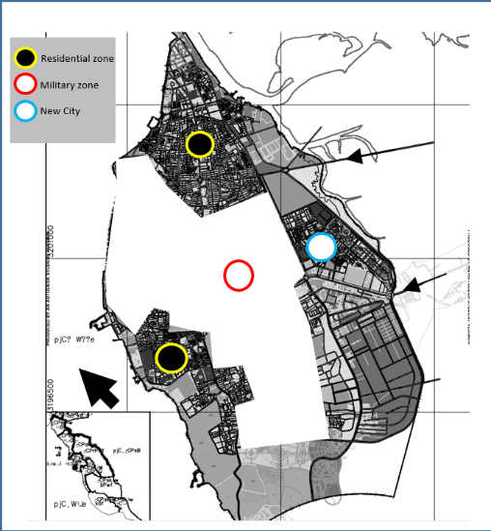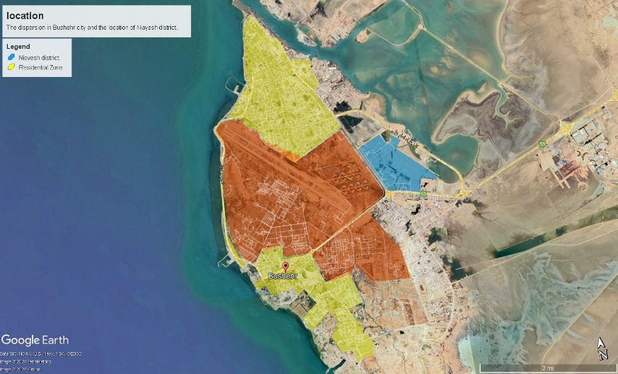

Fig 4: Geographical analysis of the distribution of residential in Bushehr province.

The Niayesh district was designed in two phases, with the objective of accommodating 3,190 residential units (approximately 12,000 people).(“Bushehr Management and Planning Organization,” n.d.) The initial phase has already been concluded, with a population of over 2,300 individuals and 440 unit of social housing. As shown in Figure 4, the initial phase of the social housing in Niayesh district development comprises a public green space. The form of a square, surrounded by residential buildings on three floors pic,1.

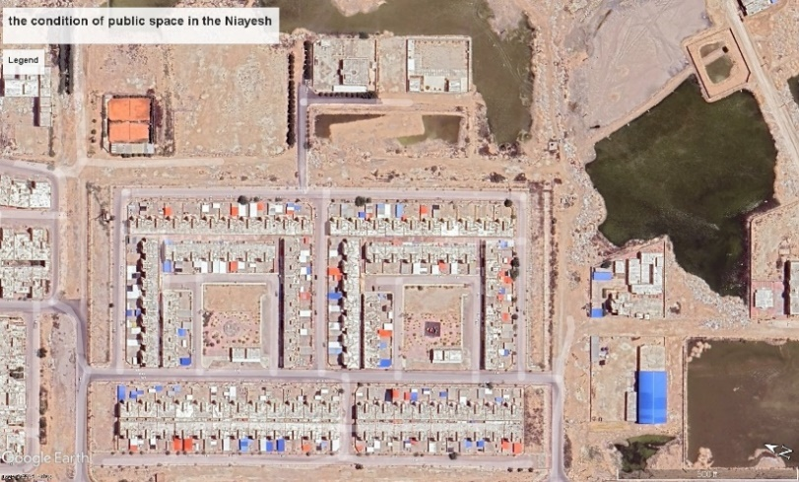 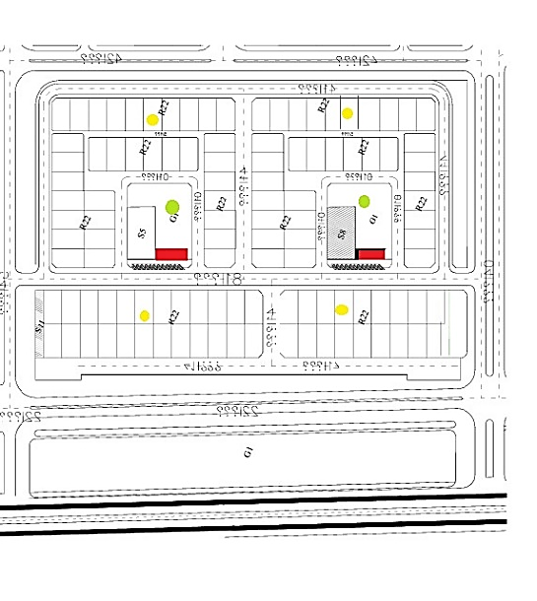

Fig 5: the condition of public space in the Niayesh

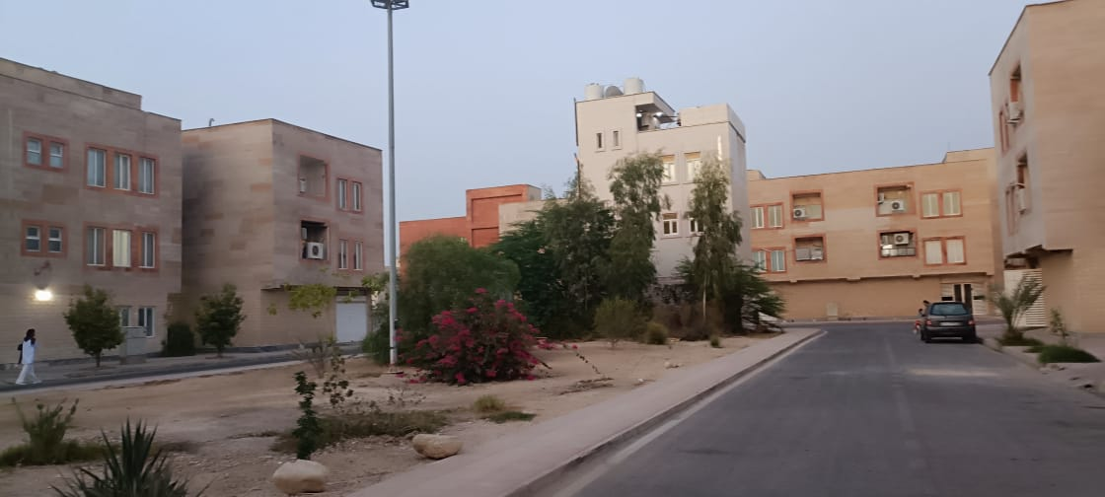 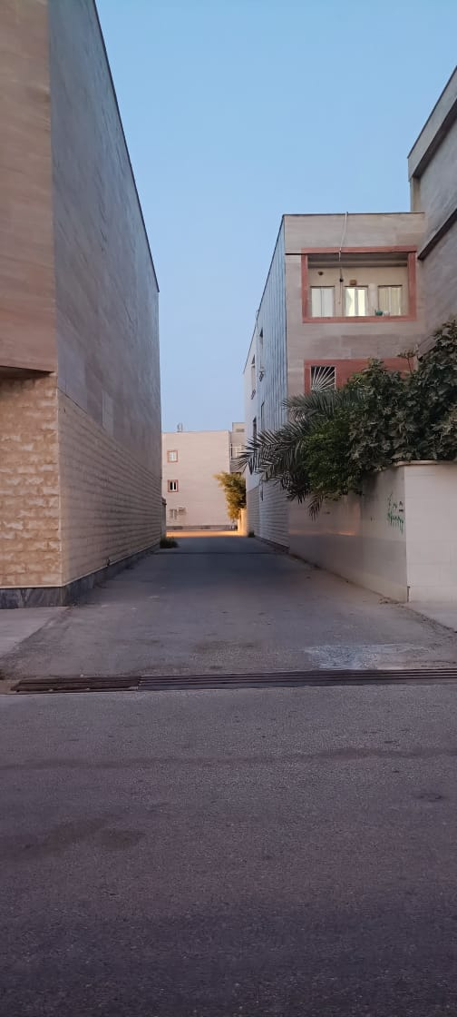

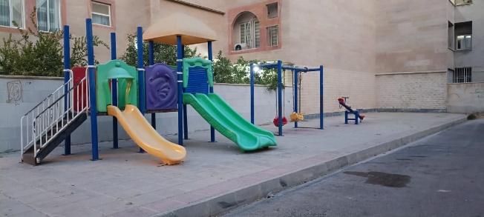

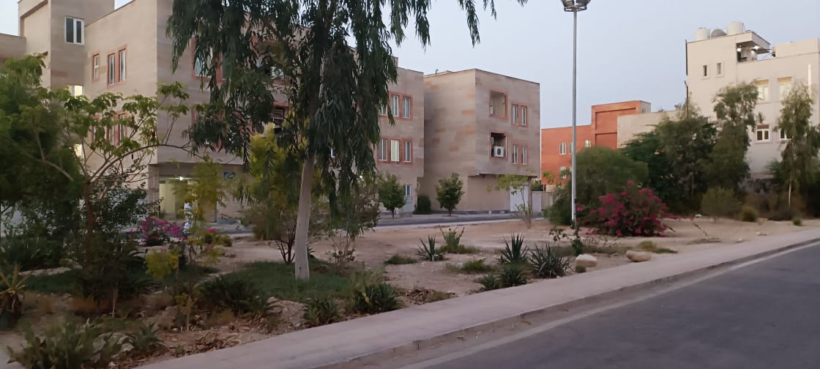

Fig 6: location of the public space in Niayesh district.

One potential solution to the aforementioned concerns is the development of green spaces as common social areas. It is, however, important to note that the current density of green spaces for residential units, whether private or public, in Iran is between 7 and 12 square meters per person. Jacobs posits that green spaces should be integrated into the fabric of urban life, where culture, commerce, and residential activities flourish. In accordance with Jacobs' principles of 'centrality, hierarchy, and access', green spaces should be situated in a central location within neighborhoods, districts, or urban areas and adapted to their corresponding physical structures.

A further pivotal aspect to be taken into account with regard to green spaces is that of accessibility. It is recommended that urban public spaces be accessible from all four directions via the communication network, thus enhancing usability, social monitoring, and security. Such a design permits the visual appreciation of the space's aesthetic qualities by passers-by from all directions.

The physical and social aspects of public spaces are inextricably linked to the psychological experience of those who utilize them. The proximity of residential blocks to human-scale public spaces has facilitated the use of these areas as pedestrian crossings, thereby fostering a sense of readability and belonging. It is therefore evident that the role of socialization in the context of space is of significant importance in achieving social sustainability.

1. **RESULT**

As a recently developed area, Niayesh has experienced a significant influx of people, which may potentially give rise to urban issues due to the absence of a well-established cultural framework. It is therefore essential to evaluate the level of public satisfaction with the physical aspects of social interaction and the variables of the social space within this green space. The satisfaction levels of each variable were calculated based on the statistical population, 54 women and 46 men, and expressed in fig 6.

Fig 7: level of sociability of space.

It is evident that improvements are required in order to enhance the environment and comfort of users. The ability to play and be multipurpose is currently at an average level and requires further development and improvement. Identity and recognition are at an average level and should be strengthened. Access is satisfactory, however, security must be evaluated. In conclusion, it can be stated that the performance of the green space requires improvement and further development in order to fully satisfy the residents.

The level of sociability in the Niayesh residential complex is in a state of weakness with regard to spatial sociability. Furthermore, the complex fails to adequately address the social needs of its residents with regard to the provision of appropriate space. Given the relatively brief history of social interaction in this district, it is probable that social interactions are limited and that residents do not feel a sense of attachment or a positive identity with the public spaces of the complex.

In order to assess the social sustainability of the Niayesh residential complex, we also examined the current situation using the social identity criterion. The results in terms of the satisfaction level of residents based on social variables are presented in Fig 7.

Fig 8: level of social stability.

The graph illustrates that a considerable proportion of the population exhibits a low level of social stability, which represents a significant concern within this society.

The Niayesh district, as a newly developed area, has witnessed a significant influx of residents. However, this rapid growth has not been accompanied by a corresponding development of social cohesion and identity. The lack of established public spaces and community-oriented activities has resulted in constrained social interactions among residents. Many individuals report a diminished sense of attachment to their environment, which can hinder the formation of a strong community identity.

The decline in stable social connections has led to insufficient cooperation among neighbors in collective activities. Residents find it challenging to collaborate and work toward shared goals. The constant movement of new families into the area disrupts existing social networks, making it difficult for long-term relationships to develop. Consequently, a pervasive sense of belonging is lacking, and the social identity of the community remains incomplete.

Despite these challenges, the introduction of activities in green public spaces presents an opportunity to enhance social stability. Green spaces can act as catalysts for interaction, offering residents a place to gather, relax, and engage with one another. By organizing community events, workshops, and recreational activities, these spaces can facilitate connections among residents, fostering a sense of community and belonging.

However, the current distribution of public space in Niayesh does not adequately account for the principles of social sustainability, which is crucial for improving quality of life. The emphasis has been largely placed on residential areas as social housing, without considering how public spaces can enhance sociability. The connection between sociability and social sustainability underscores the importance of well-designed public spaces that support social interactions.

Typically, residents of Niayesh view their homes primarily as places of rest at night, while their daytime activities-work, leisure, shopping, and social interactions-often occur in the city center. To promote social sustainability, there needs to be a focus on improving living conditions and increasing satisfaction with the environment. This includes fostering social interactions and participation in the community.

To achieve this, it is essential to create public spaces of appropriate size that encourage presence and engagement in collective activities. Initiatives such as cultural events can actively involve residents and promote social connections. Furthermore, in new cities that lack historical legacies, the process of forming identity and collective memories can establish a stable sense of belonging for future generations, enhancing overall social cohesion in the Niayesh district.

1. **CONCLUSION:**

The Niayesh district, a rapidly developing urban area, is confronted with significant challenges in fostering social cohesion and in the construction of a robust community identity. The dearth of activities oriented towards the community has resulted in a notable restriction of social interactions, thereby impeding the formation of meaningful social connections. While public green spaces have the potential to serve as venues for social interaction, their current state requires substantial improvement to enhance user satisfaction and promote wider usage. Additionally, many residents lack a strong sense of attachment to their neighborhood, which negatively impacts community cohesion and limits the effectiveness of public spaces in fostering social interaction and community building. Insufficient social sustainability, coupled with an inequitable distribution of public spaces, exacerbates these challenges. To address these issues in this region, the following strategies are recommended:

Strengthening public green spaces: It is recommended that the physical environment and functionality of public green spaces be enhanced in order to increase user comfort and satisfaction. It is recommended that creative and inclusive designs be incorporated to encourage social interaction and community engagement. For example, the incorporation of interactive features or innovative layouts has the potential to inspire residents to explore and utilize these spaces in a more effective manner.

It is recommended that community activities be promoted. It is recommended that residents' sense of belonging be strengthened by the organization of cultural events, workshops, and recreational activities. Such initiatives have the potential to reinforce the bonds between community members, thereby facilitating the formation of a collective neighborhood identity. It is recommended that physical or mental activities be provided, including sports tournaments, family-friendly competitions, yoga sessions, and art programs such as painting workshops.

By implementing these targeted strategies, the Niayesh district can transform into a vibrant, cohesive, and socially sustainable community, offering an enhanced quality of life and a stronger sense of belonging for its residents.

**REFERENCES:**

1. Anastasiou, Evgenia, and Stella Manika. 2020. “Perceptions, Determinants and Residential Satisfaction from Urban Open Spaces.” *Open Journal of Social Sciences* 8 (6): 1–18. https://doi.org/10.4236/jss.2020.86001.
2. Ash, Amin. 2002. “Multimedia - PublicSpace.” 2002. https://www.publicspace.org/multimedia/-/post/collective-culture-and-urban-public-space.
3. Bonaiuto, Marino, and Mirilia Bonnes. 2000. “Social-Psychological Approaches in Environment-Behavior Studies,” January, 67–78. https://doi.org/10.1007/978-1-4615-4701-3_7.
4. “Bushehr Management and Planning Organization.” n.d. Accessed July 23, 2024. https://www.mpob.ir/?lang=en.
5. Cabrera-Barona, Pablo F., and Helena Merschdorf. 2018. “A Conceptual Urban Quality Space-Place Framework: Linking Geo-Information and Quality of Life.” *Urban Science* 2 (3): 73. https://doi.org/10.3390/urbansci2030073.
6. Campbell, Nichole Marie. 2018. “(2) There’s No Place like Third Place: Starting to Generalize the Qualities and Value of Third Places | Request PDF.” 2018. https://www.researchgate.net/publication/323249248_There's_no_place_like_third_place_starting_to_generalize_the_qualities_and_value_of_third_places.
7. Caribbean, Economic Commission for Latin America and the. n.d. “About Sustainable Development.” Text. Economic Commission for Latin America and the Caribbean. Accessed October 30, 2024. https://www.cepal.org/en/topics/sustainable-development/about-sustainable-development.
8. enric, pol. 2001. “The Theoretical Background of the City-Identity-Sustainability Network.” 2001. https://www.researchgate.net/publication/258132523_The_Theoretical_Background_of_the_City-Identity-Sustainability_Network.
9. Gehl, Jan. 2012. *Life Between Buildings: Using Public Space*. Island Press.
10. Herzele, Ann Van. 2004. “Local Knowledge in Action: Valuing Non-Professional Reasoning in the Planning Process.” https://www.academia.edu/4092809/Local_knowledge_in_action_valuing_non_professional_reasoning_in_the_planning_process.
11. Lang, jon T. n.d. “Creating Architectural Theory : The Role of the Behavioral Sciences in Environmental Design.” Accessed October 19, 2024. https://search.worldcat.org/title/creating-architectural-theory-the-role-of-the-behavioral-sciences-in-environmental-design/oclc/14588016.
12. Lennard, Suzanne H. Crowhurst, and Henry L. Lennard. 1984. *Public Life in Urban Places: Social and Architectural Characteristics Conducive to Public Life in European Cities*. Gondolier Press.
13. mansuri, seyed tajjodin, and Heydar;f Jahanbakhsh. 2016. “سنجش مؤلفه‎های مؤثر بر ارتقای تعاملات اجتماعی و اجتماع‎پذیری در فضای‎شهری (مطالعه موردی:خیابان مدرس کرمانشاه).” *معماری و شهرسازی ایران(JIAU)* 7 (1). https://doi.org/10.30475/isau.2017.62017.
14. Nguyen, Thi, Tang-Huang Lin, and Hai-Po Chan. 2019. “The Environmental Effects of Urban Development in Hanoi, Vietnam from Satellite and Meteorological Observations from 1999–2016.” *Sustainability* 11 (6): 1768. https://doi.org/10.3390/su11061768.
15. Osmond, Humphry. 1957. “Function as the Basis of Psychiatric Ward Design.” *Psychiatric Services* 8 (4): 23–27. https://doi.org/10.1176/ps.8.4.23.
16. Pachucki, Mark C., Emily J. Ozer, Alain Barrat, and Ciro Cattuto. 2015. “Mental Health and Social Networks in Early Adolescence: A Dynamic Study of Objectively-Measured Social Interaction Behaviors.” *Social Science & Medicine* 125:40–50. https://doi.org/10.1016/j.socscimed.2014.04.015.
17. Pazhuhan, musa, Zayyari, Keramatolah, ; Ghasemzadeh, Behnam, and ; Qurbani, Hamid. 2015. “URBAN IDENTITY AND IRANIAN NEW TOWNS - ProQuest.” 2015. https://www.proquest.com/openview/b2e835117624058659ff256513999798/1?pq-origsite=gscholar&cbl=506347.
18. Rabbani, Rasoul, Somayeh Karimi zadeh Ardakani, and Javad Nazari. 2010. “بررسی عوامل مؤثر بر هویت اجتماعی شهرهای جدید - مطالعه موردی شهر پردیس تهران -.” *مطالعات ملی* 43 (11): 101–28.
19. Stodolska, Monika, Kimberly Shinew, Juan Acevedo, and Dina Izenstark. 2011. “Perceptions of Urban Parks as Havens and Contested Terrains by Mexican-Americans in Chicago Neighborhoods.” *Leisure Sciences - LEISURE SCI* 33 (February):103–26. https://doi.org/10.1080/01490400.2011.550220.
20. Woodcraft, Saffron. 2012. “Social Sustainability and New Communities: Moving from Concept to Practice in the UK.” *Procedia - Social and Behavioral Sciences* 68 (December):29–42. https://doi.org/10.1016/j.sbspro.2012.12.204.
21. ziyari, kerametallah. 2017u. “Book برنامه ریزی شهرهای جدید - سمتا.” 2017u. https://samta.samt.ac.ir/product/13301/%D8%A8%D8%B1%D9%86%D8%A7%D9%85%D9%87-%D8%B1%DB%8C%D8%B2%DB%8C-%D8%B4%D9%87%D8%B1%D9%87%D8%A7%DB%8C-%D8%AC%D8%AF%DB%8C%D8%AF?lang=en.

1. Corresponding author: [Fatemeh.behfar@estudiants.urv.cat](mailto:Fatemeh.behfar@estudiants.urv.cat) (F.Behfar)

   E-mail address: [Behfarfa@gmail.com](mailto:Behfarfa@gmail.com) (+34)672482488