**Evaluating the effects of residential building orientation on**

**energy consumption**

**Z. Barzegara , Sh. Heidarib, M. Zareic,**[1]

a Department of art and Architecture, Science and Research Branch, Islamic Azad University (IAU), Tehran, Iran

b Faculty of Architecture, University of Tehran, Tehran, Iran

c Department of Industrial Engineering, Shiraz Branch, Islamic Azad University, Shiraz, Iran

**Abstract**

Nowadays with the development of the economy, the demand for energy is increasing very fast while the energy supply is going short. Researches indicate that energy consumption in residential sector is one of the main parts of the total consumption. This paper evaluates the effect of building orientation on achieved solar radiation in a NE-SW orientated case of urban residence in semi-arid climate. SW envelope with annually 13.52 percent lonely improves the thermal comfort of the house because of its annually climatic radiation trend. For vertical NE surface with insufficient winter radiation (0 %) and cool summer radiation (3.38 %), it could be resulted that NE elevation in summer is demanded and in winter is not. Total annuallyhorizontal solar radiation percentage (83.04%) indicates the inappropriate huge non- climatic roof radiation should be omitted. Finally, the effects of envelopes solar radiation on electricity and natural gas consumption were completely discussed.

**Keywords:** Building orientation; Energy consumption; Residential sector; Solar radiation.

1. **Introduction**

Energy is a vital input for social and economic development of any nation. The residential sector is a significant consumer of energy, and therefore a focus for energy consumption efforts. Considering the limited sources of energy, low energy buildings have attracted lots of attention in recent years. Like many other countries in the world, energy consumption in Iran in residential sector is one of the main parts of total consumption. Therefore a focus for energy consumption efforts is of great importance.

The residential energy consumption depends strongly on the climate of a region [1]. Arid climate is identified by two substantial characteristics: high temperature and low humidity [2]. In these regions type's solar direct radiation on horizontal surface is between 700 to 800 kcal/h/m2 [3]. Tabari and Hosseinzadeh Talaee investigated trends in maximum (Tmax) and minimum (Tmin) air temperatures for 19 synoptic stations in the arid and semi-arid regions of Iran during 1966-2005 [4]. Results indicate that the majority of the trends in T max and T min time series show increasing tendency during the last decades. The T max and T min warming trends were more obvious in summer and winter than autumn and spring. Therefore it is essential to restraining the mentioned climate solar radiation.

Shiraz (Fars province centre) that is located on 29° 33′ latitude and 52° 33′ longitude is an outstanding instance of arid climatic city in Iran. With the increasing of population, Shiraz has high amount of residential buildings energy consumption [5]. This city possesses a relatively high abundance of sunshine [6], and therefore a high capacity of solar energy utilization which can provide some part of the required energy in residential sector. The average cumulative annual irradiation, the average daily irradiation, and the percentage of frequency of clear sky days are 7250 MJ/m2, 19.9 MJ/m2, and 59%, respectively. Yaghoubi et.al demonstrated a decrease in solar radiation on horizontal surface in the 1960s and 1970s for Shiraz [7]. The statistics reveals the accuracy of high capacity of the solar energy utilization in Shiraz. Also to provide greater thermal comfort and to decrease energy consumption due to its growing cost in Iran (omitting energy subsides), the need to control the radiant energy is evident. By understanding the profile of climate, Shiraz last architects were created the works that the primary design criteria were thermal comfort; as Naranjestan Ghavam historic home [8].

This study evaluates the effect of building orientation on achieved solar radiation in a NE-SW orientated case of urban residence in semi-arid climate. The remainder of the paper is organized as follows. Section two, presents background of [energy consumption in residential sector](http://www.sciencedirect.com/science/article/pii/S0378778811001022?_rdoc=1&_fmt=full&_origin=&md5=22543fb95e34d36391c44b9d9cd72533#sec0010) as well as the orientation effects on energy consumption in buildings. In Section three, the methodology is presented, and in section four the detailed description of the house is explained. Results and discussion are presented in Section five. Finally, the last Section includes the concluding remarks.

**2. Backgrounds**

An up-to-date review of the various modeling techniques was presented by Swan and Ugursal, used for modeling residential sector energy consumption [9]. A critical review of each technique, focusing on the strengths, shortcomings and purposes, was provided along with a review of models reported. Lee and Kung in their paper proposed an adjustment to the traditional approach by using climate classification and data envelopment analysis (DEA) [10]. The study first adopted group analysis to classify the evaluated buildings into different climate groups. Secondly, scale factors (temperature and rain hour) were identified by regression analysis. DEA was then employed to assess the energy management efficiency of the evaluated buildings. In another research, Michalik et al. used fuzzy inference system approach in order to forecast the energy demand in residential sector [11]. By using residential energy consumption survey data from the Energy Information Administration, Kaza used quintile regression analysis to tease out the effects of various factors on entire distribution on the energy consumption spectrum instead of focusing on the conditional average [12]. Results showed that while housing size matters for space conditioning, housing type had a more nuanced impact. Dong et.al used support vector machines (SVM), a neural network algorithm, to forecast building energy consumption in the tropical region [13]. The objective of the paper was to examine the feasibility and applicability of SVM in building load forecasting area. Four buildings in Singapore were selected randomly as case studies. All prediction results were found to have coefficients of variance less than 3% and percentage error within 4%.

The amount of available researches which have been conducted to study the effect of building orientation on received solar radiation is not sufficient. Jaber and Ajib discussed an assessment of best orientation of the building, windows size, and thermal insulation thickness from energetic, economic and environmental point of view for typical residential building located in Mediterranean region [14]. The results showed that about 27.59% of annual energy consumption can be saved by choosing best orientation, optimum size of windows and shading device, and optimum insulation thickness. Yu et.al employed EQUEST software to analyze the effects of energy saving strategies on air conditioner electric consumption of different orientation rooms in hot summer and cold winter zone in China [15].

***2.1. Building solar radiation gain***

Different architectural characteristics influences on energy consumption in a building; for instance envelope construction, roof material, building shape, building story, window, infiltration, relationship to ground. As a result of major affect of building envelope on reducing cooling and heating need, case study parameters are investigated in one orientation (NE-SW). Other influential characters involve consumer behavior, envelope thermal transfer value, occupants, window to wall ratio, step no., equipment, lighting, length to width ratio, longevity and etc.

To avoid solar radiation in hot summers, shading and thermal insulation are important considerations in vernacular house design [16]. Moreover, window ratio and thermal mass have principled attention in vernacular house construction method to absorb solar radiation in cold winter. Significantly in modern design, attention has not given into climate characteristics as solar radiation on envelopes. Parker et.al monitored six homes in Florida, before and after coatings on their roofs. Reduction in air-conditioning electricity consumption was reported between 11% and 43% [17]. Jafarpour and Yaghoubi estimated monthly and annual radiation for only one location in Shiraz (Iran) [6]. In another research, Yaghoubi and Sabzevari calculated the monthly clearness index for Shiraz, Iran [18]. Partridge and Proctor employed a model to predict solar radiation at the earth’s surface [19]. Although the suggested models can easily be used for any location in Iran, the solar radiation on vertical surfaces with different angles, which is more beneficial in architecture, have not yet considered in the researches.

**3. Methodology**

Selected house were chosen from all the 40 years ago houses in the city, due to Shiraz development at different periods. The basic characteristic of this period architecture is entering modernism. In this time, imported house parts were common and also energy type has changed from oil to gas, and electricity. Primary hundred quite accidental selection leads to choosing only one high percent house orientations; North East- South West (NE-SW). So the study can provide new model and will improve residential building energy situation by offering positive or negative notes. A variety of factors are related to energy consumption. In this research, two major ones, i.e. building characteristics, and energy consuming part were investigated in the presented sample.

For obtaining horizontal and vertical surface radiation in computational method, many soft wares have employed as Energy plus, Eco tech, Transys, Radiation on solar collectors, Ret screen, etc., but Shiraz climate characteristics leakage is the main problem in the mentioned soft wares. For achieving the research aim, Victor Olgyay method is applied to calculating solar radiation on both horizontal and vertical surfaces and their parts (window, door, terrace and wall).

***3.1. Energy consuming parts of the building***

There is a close connection between energy use in buildings and the resulted environmental damage. This is because of energy intensive solutions that are employed in buildings to attain comfort conditions in terms of mechanical cooling, forced ventilation and artificial lighting. In order to achieve thermal comfort, the utilization of passive methods and techniques in modern buildings are required [20]. Due to Shiraz used energy (electricity and gas), for calculating energy consumption, electricity energy divided into 4 sectors including cooling, lighting, heating, and equipments. Cooling energy consumption in hot season is the main Shiraz electricity consumption. In mid-life houses and selected house, the primary and common cooling system is water cooler, and the additional system is fan. As well as electricity, gas energy classified into heating and equipments, and heating energy consumption in cold season is main gas consumption. In mid-life houses and selected house, the primary and common heating system is gas heater.

**4. Detailed description of the house**

Descript by details case study has NE-SW orientation (Fig. 1). Some of important effective parameters on solar gain are: total occupants 4; Land area and built area 102 and 78.2 m2; 2 side; 1 step; Length to width ratio1.07; Proximity degree 52.5 and Window to wall ratio 0.061 SW and 0.21 NE. This house, which is located in mid- life city part, is 40 years old and solar radiation receives on SW envelope, NE envelope and roof (Table 1). Energy consuming equipment types (natural gas and electricity sectors) are explained in Table 2.

Please insert Tables 1 & 2 and Fig.1 about here

**5. Results and discussion**

The received solar radiation depends on direction. If the angle between surface and radiation be orthogonal, then highest radiation is received. In this paper for the case study direction, the hourly and daily radiation on vertical (NE 30°, SW 30°) and horizontal (roof) surfaces for square per meter are calculated (table 3). As illustrated in Fig. 2:

* Vertical NE 30° surface has minimum amount and its volatility is the same as horizontal one to some extent, but the amount are opposite. In warm months only few radiations absorbed and in cold ones no direct radiation exists. This cold direction is not suitable for cold season.
* Vertical SW 30° surface is the strongest climatic direction, due to its climatic solar radiation absorption. This high quality direction gains the most radiation on cold seasons (January) and the lowest one in warm season (July), therefore in summer is cool and in winter is warm. This makes the SW 30° surface more appropriate than others for energy behavior.
* Horizontal envelopes has the highest amount and it's volatility for square per meter and day implies the maximum received radiation in warm months (June, July, August), and the minimum ones in cold months (January); this represents that the roof direction is non-climatic. Because in peak summer cooling demand, maximum solar energy is received and in peak winter heating demand, minimum solar energy is obtained.

Please insert Table 3 and Fig.2 about here

***5.1. Solar radiation in case study envelopes***

Due to the calculated radiation for square per meter and surfaces area of the SW-NE case study, from evaluation of  **Evr –SW,**  **Evr-NE**, **Ehr**, **Er** it is concluded that (Table 4):

* Vertical building envelopes are one of the envelopes for receiving climatic solar radiations. By absorbing solar radiation in the mentioned surfaces, energy demands of lighting, cooling and heating are fulfilled and building energy efficiency is improved, provided that a proper building orientation (BO) exists. Vertical envelopes in the house are including SW and NE, therefore the radiation received to both envelopes. In SW envelope, the annual Evr –SW trend on the SW vertical envelope is contrary with the horizontal one, which in cold seasons is maximum amount and in warm ones is minimum one. Therefore it can be stated that if the radiation from roof omitted, the climatic and low energy consuming house is the one has the more climatic radiation on its vertical envelopes and finally, South vertical building envelopes are the best envelope for receiving climatic solar radiation**.** Despite annually Evr –SW trend, annually Evr-NE trend is the same as roof one. In addition, low received radiation in present elevation leads to high heating need in winter (Fig. 3).
* The annual amount of solar radiation received by the horizontal roof (Ehr) is relevant to the one of atmospheric solar radiation; so it’s high in the warm season, while is low in the cold one. Due to the mismatch of this received energy with seasonal heating and cooling energy demands, houses that receive more energy by the roof, have a higher level of energy consumption. The highest level of received energy by envelopes is related to the roof; by its’ non-climatic radiation, it would be effective in reducing the energy efficiency of the buildings.
* The total received radiation on surfaces (Er) is not suitable; due to high energy receive in summer and opposite this in winter.

The case study window to wall ratio in NE elevation is inappropriately high (0.21), thus in cold season the heat transfer from the windows is undesirable. As well as NE elevation windows, the SW windows are not perfect, because the window to wall ratio is insufficient. So the windows that can achieve climatic solar radiation are small. The window condition is not perfect due to energy consumption. Although in 2- side house energy behavior in summer is efficient, the extra elevation NE side in winter affect on energy consumption meanly, depends on their window areas. Length to width ratio (1.07) in this house is almost 1 and consequently the square plan causes non-climatic surfaces both vertical and horizontal one.

Please insert Table 4 and Fig.3 about here

**6. Conclusion**

The received solar radiation has divided into three main parts; horizontal envelope (roof), main vertical envelope (SW elevation) and NE envelope. Each of the mentioned envelopes has an effective role in annually and monthly energy consumption behavior. The percentage of each envelope solar radiation from whole shows its effect on energy consumption. Total annuallyEhr percentage (83.04%) indicates the inappropriate huge non- climatic roof radiation should be omitting. The external and internal devices may be used to reduce this radiation; shading devices and insulation materials are the samples of the available solutions (Table 6).

For vertical NE surface with insufficient winter radiation (0 %) and cool summer radiation (3.38 %), it could be resulted that NE elevation in summer is demanded and in winter is not. Therefore shading devices should be avoided in this part and the window area should be low enough to decrease heat loss in winter. Double window and insulation prove the surface thermal resistant in winter.

In addition, SW envelope with annually 13.52 percent lonely improves the thermal comfort of the house because of its annually climatic radiation trend. Vertical building envelopes are the ones that receive climatic solar radiations. By absorbing solar radiation in the mentioned surfaces, energy demands of lighting, cooling and heating are fulfilled and building energy efficiency is improved, provided that a proper building orientation (BO) exists. Although SW envelope is not so perfect direction than SE, but has many beneficial points (i.e. high winter solar gain and low summer one). The only advantage of SE direction is for morning radiation which is better than evening hot radiation in SW direction. Vertical shading devices and insulation complete this elevation climatically (Fig. 4).

Please insert Table 5 and Fig.4 about here

***6.1. Annual energy consumption***

By energy consumption bills in electricity and natural gas part, it is cleared that energy consumption is related to solar radiation. Cooling load due to summer afternoon SW radiation gain increases; also, heating load due to NE big windows heat loss and SW small window gain increases (Table 6 and Fig. 5)

Please insert Table 6 and Fig.5 about here

**References**

[1] Zhang, Q.: 2004, Residential energy consumption in China and its comparison with Japan, Canada, and USA, [Energy and Buildings](http://www.sciencedirect.com/science/journal/03787788) [36(12](http://www.sciencedirect.com/science?_ob=PublicationURL&_tockey=%23TOC%235712%232004%23999639987%23522394%23FLA%23&_cdi=5712&_pubType=J&view=c&_auth=y&_acct=C000050221&_version=1&_urlVersion=0&_userid=10&md5=76bf9103ba69aa31dd60088f7f1df24e)), 1217-1225.

[2] Kasmai, M.: 2005, Climate and architecture, fourth edition, Tehran, Iran.

[3] Moradi[a](http://www.sciencedirect.com/science/article/pii/S0341816210001487#af0005), H.R. , Rajabi[b](http://www.sciencedirect.com/science/article/pii/S0341816210001487#af0010), M. and Faragzadeh, M.: 2011, Investigation of meteorological drought characteristics in Fars province, Iran, [CATENA](http://www.sciencedirect.com/science/journal/03418162) [84(1-2](http://www.sciencedirect.com/science?_ob=PublicationURL&_tockey=%23TOC%235954%232011%23999159998%232729760%23FLA%23&_cdi=5954&_pubType=J&view=c&_auth=y&_acct=C000228598&_version=1&_urlVersion=0&_userid=10&md5=fbad03cc27eab15a4f1d358f7814927d)), 35-46.

[4] Tabari, H.and Hosseinzadeh Talaee, P.: Article in Press, Analysis of trends in temperature data in arid and semi-arid regions of Iran, [Global and Planetary Change](http://www.sciencedirect.com/science/journal/09218181).

[5] [www.amar.org.ir](http://www.amar.org.ir)

[6] Jafarpur, K. and Yaghoubi, M.A.: 1989, Solar radiation for Shiraz, Iran, Technology, 177-179.

[7] Yaghoubi, M.A. and Sabzevari, A.: 1993, Solar radiation for Shiraz, Iran: a comparative study for two periods, [Renewable Energy](http://www.sciencedirect.com/science/journal/09601481) [3(6-7](http://www.sciencedirect.com/science?_ob=PublicationURL&_tockey=%23TOC%235766%231993%23999969993%23440016%23FLP%23&_cdi=5766&_pubType=J&view=c&_auth=y&_acct=C000228598&_version=1&_urlVersion=0&_userid=10&md5=80b0293f7e3e8677d05ed438f2d43714)): 725-729.

[8] Ghobadian, V.: 2008, Climate analysis of traditional buildings in Iran, fifth ed., Tehran University, Tehran, Iran.

[9] Swan, L.G. and Ugursal, V.I.: 2009, Modeling of end- use energy consumption in the residential sector: A review of modeling techniques, Renewable and sustainable energy reviews, 13, 1819–1835.

[10] Lee, W. and Kung, C.: 2011, Using climate classification to evaluate building energy performance, [Energy](http://www.sciencedirect.com/science/journal/03605442) [36(3](http://www.sciencedirect.com/science?_ob=PublicationURL&_tockey=%23TOC%235710%232011%23999639996%232952749%23FLA%23&_cdi=5710&_pubType=J&view=c&_auth=y&_acct=C000050221&_version=1&_urlVersion=0&_userid=10&md5=e2817e68d5388eaaf9561e5b78927dc9)), 1797-1801.

[11] Michalik, G., Khan, M.E. Bonwick, W.J. and Mielczarski, W.: 1997, Structural modeling of energy demand in the residential sector: 2. The use of linguistic variables to include uncertainty of customer’s behavior, Energy 22, 949–58.

[12] Kaza, N.: 2010, Understanding the spectrum of residential energy consumption: A quintile regression approach, [Energy Policy](http://www.sciencedirect.com/science/journal/03014215) [38(11](http://www.sciencedirect.com/science?_ob=PublicationURL&_tockey=%23TOC%235713%232010%23999619988%232418736%23FLA%23&_cdi=5713&_pubType=J&view=c&_auth=y&_acct=C000050221&_version=1&_urlVersion=0&_userid=10&md5=78006c8fee10b806000e1f2798310af6)), 6574-6585.

[13] Dong, C., Cao, S. and Eang, L.: 2005, Applying support vector machines to predict building energy consumption in tropical, [Energy and Buildings](http://www.sciencedirect.com/science/journal/03787788) [37(5](http://www.sciencedirect.com/science?_ob=PublicationURL&_tockey=%23TOC%235712%232005%23999629994%23565143%23FLA%23&_cdi=5712&_pubType=J&view=c&_auth=y&_acct=C000050221&_version=1&_urlVersion=0&_userid=10&md5=185122d58c749ea42586fcf722689f11)), 545-553.

[14] Jaber, S. and Ajib, S.: 2011, Optimum, technical and energy efficiency design of residential building in Mediterranean region, [Energy and Buildings](http://www.sciencedirect.com/science/journal/03787788) [43(8](http://www.sciencedirect.com/science?_ob=PublicationURL&_tockey=%23TOC%235712%232011%23999569991%233251801%23FLA%23&_cdi=5712&_pubType=J&view=c&_auth=y&_acct=C000050221&_version=1&_urlVersion=0&_userid=10&md5=7b00c902070a9b3c9a83312269d1748d)), 1829-1834.

[15] Jinghua, Y. Yang[a](http://www.sciencedirect.com/science/article/pii/S0378778808000418#implicit0), C. and Tian[a](http://www.sciencedirect.com/science/article/pii/S0378778808000418#implicit0), L.: 2008, Low-energy envelope design of residential building in hot summer and cold winter zone in China, [Energy and Buildings](http://www.sciencedirect.com/science/journal/03787788) [40(8](http://www.sciencedirect.com/science?_ob=PublicationURL&_tockey=%23TOC%235712%232008%23999599991%23689003%23FLA%23&_cdi=5712&_pubType=J&view=c&_auth=y&_acct=C000055331&_version=1&_urlVersion=0&_userid=1913507&md5=08f10206e9d82abbf36c8b7275430e5d)), 1536-1546.

[16] Borong, L., Gang, T., Peng, W., Ling, S., Yingxin, Z. and Guangkui, Z.: 2004, Study on the thermal performance of the Chinese traditional vernacular dwellings in summer, Energy and Building 36, 73-79.

[17] Parker, D.S., Barkaszi, S.F. and Sonne, J.K.: 1994, Measured cooling energy savings from reflective roof coatings in Florida, Phase II report, Report No. FSEC-CR-699-94, Florida Solar Energy Center, Cape Canaveral, FL.

[18] Yaghoubi, MA. and Sabazevari, A.: 1996, Renewable Energy 4, 393–9.

[19] Paltridge, GW. and Proctor, D.: 1976, Monthly mean solar radiation statistics for Australia, Sol Energy 18, 235–43.

[20] Dili, A.S. Naseer, M.A. and Zacharia Varghese, T.: 2010, Passive control methods of Kerala traditional architecture for a comfortable indoor environment: A comparative investigation during winter and summer, Building and Environment 45(10), 2218-2230.

**Captions for figures:**

**Fig. 1.** Plan, elevation and section of case study

**Fig. 2.** Solar radiation on case study direction for square per meter (BTU/m2)

**Fig. 3. C**omparison of received solar radiation on building envelopes

**Fig. 4. C**omparison of annual received solar radiation on building envelopes

**Fig. 5.** Monthly and annual energy consumption by sector in case study

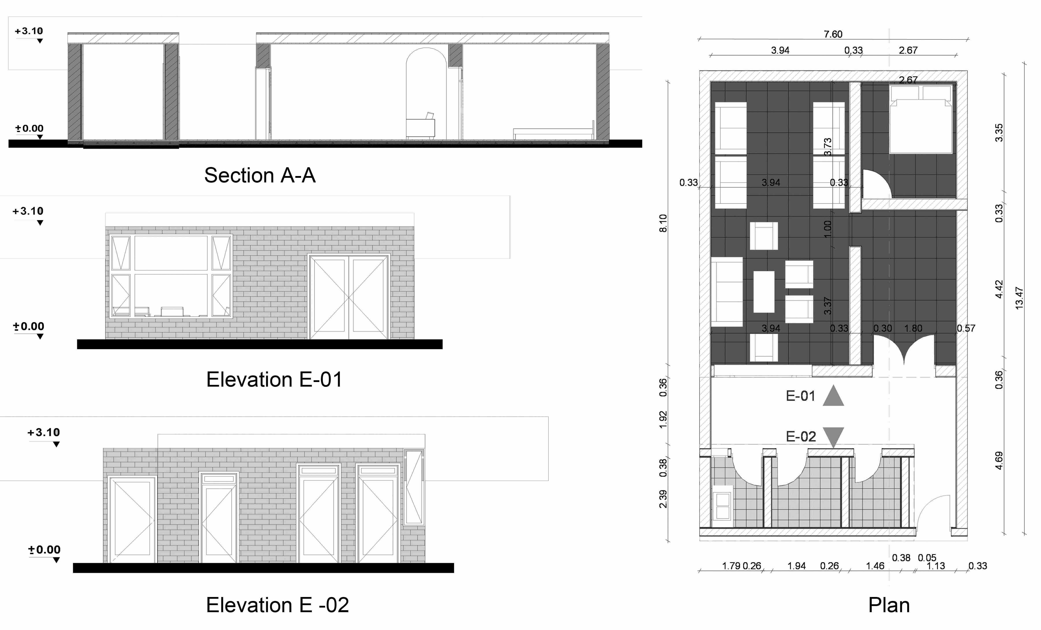

**Fig. 1.** Plan, elevation and section of case study

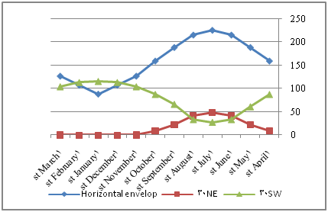

**Fig. 2.** Solar radiation on case study direction for square per meter (BTU/m2)

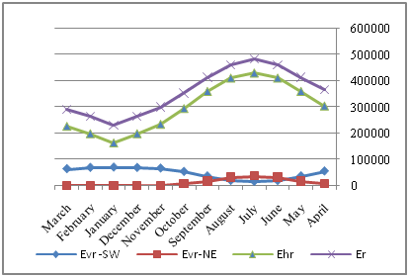

**Fig. 3. C**omparison of received solar radiation on building envelopes

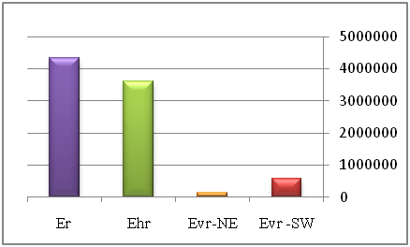

**Fig. 4. C**omparison of annual received solar radiation on building envelopes

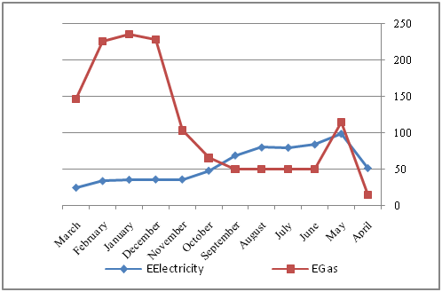

**Fig. 5.** Monthly and annual energy consumption by sector in case study

|  |  |  |
| --- | --- | --- |
| **Table 1. S**olar radiated envelopes and theirs parts in case study | | |
| **Row** | **Orientation of**  **Radiated envelope** | **Total** |
| 1 | SW envelope | 25.84 |
| 2 | NE envelope | 24.32 |
| 3 | Roof | 68.74 |

|  |  |  |
| --- | --- | --- |
| **Table 2**. main energy consuming parts in case study (cooling and heating characteristics) | | |
| **Main energy**  **consuming parts** | **System** | **Number** |
| **Cooling** | Water cooler | 1 |
| fan | 2 |
| **Heating** | Gas heater | 2 |

|  |  |  |  |
| --- | --- | --- | --- |
| **Table 3**. Solar radiation on case study direction for square per meter (BTU/m2) | | | |
| **Month** | **Horizontal envelop** | **Vertical envelope** | |
| **Roof** | **NE 30°** | **SW 30°** |
| **1st April** | 158.859 | 9.0113 | 87.093 |
| **1st May** | 188.1225 | 22.3889 | 60.62 |
| **1st June** | 214.83125 | 41.1547 | 32.98 |
| **1st July** | 225.05025 | 48.44735 | 27.22 |
| **1st August** | 214.83125 | 41.1547 | 32.98 |
| **1st September** | 188.1225 | 22.3889 | 65.96 |
| **1st October** | 158.859 | 9.0113 | 87.093 |
| **1st November** | 126.344 | 0.6503 | 103.58 |
| **1st December** | 106.835 | 0 | 112.69 |
| **1st January** | 87.6047 | 0 | 114.96 |
| **1st February** | 106.835 | 0 | 112.69 |
| **1st March** | 126.344 | 0.6503 | 103.58 |

|  |  |  |  |  |
| --- | --- | --- | --- | --- |
| **Table 4**. Solar radiation on vertical and horizontal building envelopes in case study | | | | |
| **Month** | **Evr -SW** | **Evr-NE** | **Ehr** | **Er** |
| **April** | 56158.77 | 6785.28 | 304637.62 | 367581.67 |
| **May** | 37779.54 | 16858.42 | 360755.06 | 415393.02 |
| **June** | 20713.1 | 30988.84 | 411973.26 | 463675.2 |
| **July** | 17095.61 | 36480.49 | 431569.6 | 485145.7 |
| **August** | 20713.1 | 30988.84 | 411973.26 | 463675.2 |
| **September** | 37779.54 | 16858.42 | 360755.06 | 415393.02 |
| **October** | 54347.2 | 6566.4 | 294810.6 | 355724.2 |
| **November** | 66910.57 | 474 | 234469.2 | 301853.77 |
| **December** | 69338.55 | 0 | 198264.3 | 267602.85 |
| **January** | 70439.64 | 0 | 162576.9 | 233016.54 |
| **February** | 69338.55 | 0 | 198264.3 | 267602.85 |
| **March** | 64680.22 | 458.2 | 226653.56 | 291791.98 |

|  |  |  |  |  |
| --- | --- | --- | --- | --- |
| **Table 5**. Solar radiation percentage on vertical and horizontal building envelopes in case study | | | | |
|  | **Evr -SW** | **Evr-NE** | **Ehr** | **Er** |
| **Annual** | 585294.4 | 146458.9 | 3596703 | 4328456 |
| **Percent** | 13.52 | 3.38 | 83.09 | 100 |

|  |  |  |  |
| --- | --- | --- | --- |
| **Table 6**. Monthly and annual energy consumption by sector in case study | | | |
| **Month** | **System load** | **E Electricity** | **E Gas** |
| **April** | Cooling load | 51 | 15 |
| **May** | 98 | 115 |
| **June** | 83.34 | 50 |
| **July** | 79 | 50 |
| **August** | 79.3 | 50 |
| **September** | 68.36 | 50 |
| **October** | Heating load | 47.49 | 65.5 |
| **November** | 35.5 | 103.2 |
| **December** | 35.5 | 228.3 |
| **January** | 35.12 | 235 |
| **February** | 33.33 | 225.6 |
| **March** | 24.22 | 146.45 |
| **Annual** |  | 670.16 | 1334.05 |

1. Corresponding author: Department of Industrial Engineering, Shiraz Branch, Islamic Azad University, Shiraz, Iran

   Tel.: +9177161298; fax: +987116251810. E-mail address: [delbina.zarei@gmail.com](mailto:delbina.zarei@gmail.com) (M. Zarei).