Wellbeing Through Participatory Cycles: Insights from a Causal Model of Housing Complex Design for Self-Actualization

Elahe Mohajer*
Department of Architecture, Faculty of Art and Architecture, Shiraz Branch, Islamic Azad University, Shiraz, Iran
E.mohajer@iau.ac.ir
0000-0002-3255-0504
https://www.linkedin.com/in/ellie-mohajer/

Hamidreza Azemati
Department of Architecture, Faculty of Architecture and Urban Design Engineering, Shahid Rajaee Teacher Training University, Tehran, Iran
Azemati@sru.ac.ir
0000-0002-1908-721x

Khosro Movahed
Department of Architecture and Urban Sustainability, University of the District of Columbia, Washington DC, USA.
khosro.movahed@udc.edu
0000-0003-0609-1815

Abstract
This paper aims to identify the design cycles through which housing complex environments may support residents’ self-actualization and well-being. A mixed-methods design was employed across three sequential phases: Delphi analysis, user surveying, and correlation-based modeling. In the first phase, a literature review and expert interviews were analyzed using Grounded Theory in conjunction with the Delphi method to extract key dimensions of residential design associated with self-actualization. In the second phase, expert and user survey data were analyzed using factor analysis to identify the structural components of the proposed design model. In the final phase, structural relationships among these components were examined using causal modeling to develop an integrated framework of housing design components associated with self-actualization. The analysis identified four participatory cycles: Creative Participation in Space, Interactive Spatial Events, Environmentally Participatory Events, and Collaborative and Discoverable Space. These cycles demonstrate how spatial, social, and perceptual characteristics of housing environments interact to structure opportunities for both individual and collective engagement. The findings suggest that self-actualization in housing environments can be understood as an emergent, spatially mediated process shaped by recursive interactions between design components, social participation, and environmental experience. By integrating architectural configuration with patterns of interaction and perception, the study offers a causal framework for understanding how participatory and adaptive spatial systems may contribute to residents’ well-being and self-actualization.
Keywords: Self-Actualization, Housing Complexes, Participatory Design Cycles, Well-being, Housing Design, Causal Modeling.

Introduction
In contemporary industrial societies, tensions and pressures arising from work, urban life, and social expectations often lead to mental exhaustion and a sense of alienation. These conditions often lead individuals to seek meaning, personal growth, and psychological fulfillment, positioning self-actualization as a potential response to perceived lack of meaning and existential strain. Self-actualization has been associated with personal development, greater engagement with life, and a stronger sense of fulfillment, and is widely regarded as a core principle of mental health and personal excellence (Frankl, 2021). Philosophers such as Jean-Paul Sartre similarly view self-actualization as a pathway to finding meaning and purpose in life (Yalom, 2023). Self-actualization is closely linked to overall well-being and quality of life, influencing psychological health, resilience, and productivity (Bradley et al., 2016). Its significance is further emphasized in international policy frameworks, including the United Nations’ Sustainable Development Goals (SDGs), particularly Goal 3: "Ensure healthy lives and promote well-being for all at all ages" (UnitedNations, 2015).
Within this broader context, the built environment, particularly housing, plays a significant role in shaping everyday experiences and quality of life. Empirical evidence suggests that housing conditions exert a substantial influence on subjective well-being, both directly through environmental comfort and indirectly through social and contextual factors such as community cohesion and access to natural elements (Altomonte et al., 2020). However, the potential of housing to support higher-order human development becomes more pronounced when residents are able to actively engage with and influence their living environment (Kamata & Kawakubo, 2024). This shifts the focus from housing as a static provision to housing as an interactive and participatory system.
Despite extensive research addressing housing performance in relation to physiological safety and social belonging, relatively limited attention has been given to self-actualization as a design-relevant outcome, and to the spatial mechanisms through which it may be supported. Existing studies have largely emphasized functional adequacy, comfort, and social interaction, while the role of participatory spatial configurations in enabling personal growth and meaning-making remains underexplored.
To address this gap, the present study investigates participatory design cycles embedded within a causal model of housing design components. These cycles conceptualize residential environments as relational systems in which spatial attributes interact to shape both individual and collective forms of engagement. In this framework, residents are not passive recipients of space but active agents who shape, interpret, and transform their environments through everyday use. The study therefore examines how adaptive, interactive, and event-responsive spatial conditions may collectively support experiences associated with self-actualization, including agency, identity formation, creativity, and social participation.
The novelty of this research lies in extending an existing causal model by identifying recursive participatory cycles within the relationships among housing design components. Unlike approaches that treat design attributes in isolation, the proposed framework reveals how self-actualization emerges through interdependent spatial processes. This provides a structured explanation of how architectural configurations may simultaneously support individual development and collective engagement. Accordingly, the study addresses the following research questions:
Q1: How can expert perspectives on housing complex design be classified in terms of their potential to support residents’ self-actualization?
Q2: What participatory design cycles may support self-actualization within a causal model of housing complex design components?
Policy Implications
The findings have practical implications for urban planning and sustainable housing policies. By considering participatory design cycles, policymakers and planners may use these insights to inform the design of residential environments that better support well-being and experiences associated with self-actualization, aligning with the United Nations’ Sustainable Development Goal 3 on promoting well-being for all. Implementing such principles may contribute to improved mental well-being, stronger community engagement, and a higher perceived quality of life. This framework may provide insights for future housing design guidelines and planning strategies, emphasizing environments that may encourage meaningful interactions, creativity, and personal expression.
Research Background
The concept of self-actualization traces its origins to foundational Western philosophical thought. The Socratic injunction, “Know yourself,” remains a pivotal maxim underpinning the pursuit of personal growth and self-understanding (Marias, 2012). This notion evolved in Aristotle’s philosophy, where the idea of telos embodies the full realization of one’s inherent potential and flourishing (Yalom, 2023). Aristotle’s ethical framework not only celebrates individual excellence but also situates collective prosperity as an important dimension of societal well-being (Leopold, 2007). In psychological discourse, self-actualization emerged as a formal concept within the evolution of humanistic and positive psychology, disciplines concerned with human potential, well-being, and personal growth (D’Souza, 2018). Building on the work of Goldstein (1993), Maslow (1954, 2008, 2022), Rogers (1995, 2022), Fromm (1947), and other humanistic and existential theorists, self-actualization has been conceptualized as the realization of human potential and the pursuit of meaning, fulfillment, and psychological growth. Although these perspectives differ in emphasis and terminology, they converge in viewing self-actualization as a higher-order process of personal growth and an important pathway toward meaning and fulfillment in life.
While these psychological and philosophical frameworks provide a robust understanding of self-actualization, recent research suggests that physical environments, particularly housing environments, may play an important role in shaping individuals’ potential for self-actualization and well-being. Kyttä et al. (2013) demonstrated through socio-spatial mapping that residents’ perceptions of housing quality were associated with life satisfaction and self-fulfillment, highlighting the link between spatial quality and experiential well-being. O'Sullivan et al. (2023) critique market-driven housing systems that perpetuate inequalities in access to quality housing and health-supportive infrastructures. Their case studies from Aotearoa New Zealand and Sweden advocate for people-centered housing approaches to unlock potential improvements in health and well-being.
Al-Tarazi et al. (2024) emphasized the importance of personalization and “transformability” in home design, suggesting that flexible and adaptable spaces may contribute to occupants’ well-being, a need especially highlighted during the COVID-19 pandemic. Kamata and Kawakubo (2024) further investigated housing hierarchies of need, showing that satisfaction of safety, health, comfort, convenience, and sustainability are associated with higher levels of residents’ well-being.
Collectively, these studies indicate a growing recognition of housing as an active determinant of well-being rather than a static physical setting. Building on this perspective, recent research has begun to identify specific housing design components associated with higher-order psychological outcomes. In this line of research, Mohajer et al. (2021, 2024a, 2024b) developed and validated a set of spatial and environmental factors associated with self-actualization in housing environments and examined their interrelationships using a causal modeling approach. While this work advances understanding of structural associations among design variables, it provides limited insight into how these variables operate as dynamic, interdependent systems shaping residents’ lived experiences.
Existing research has not sufficiently addressed how housing design components interact as recursive participatory cycles that shape residents’ lived experiences over time. In particular, the relational and process-oriented mechanisms through which spatial configurations collectively generate conditions for self-actualization remain underexplored. Building on this gap, the present study extends previous causal modeling work by identifying participatory design cycles embedded within housing design components. It further develops existing causal frameworks of housing environments associated with self-actualization by explicating their recursive and process-oriented structure. In doing so, the study demonstrates how spatial configurations operate as interconnected participatory cycles that shape residents’ lived experiences, encompassing engagement, well-being, and self-actualization.
Theoretical Foundation

The concept of home is multifaceted, encompassing a wide range of meanings, dimensions, and manifestations (Mallett, 2004). Fundamentally linked to human existence, dwelling occupies a central role in defining the notion of home (Heidegger, 2022). As a physical infrastructure, housing significantly influences the well-being of its residents (Klepeis et al., 2001). Empirical evidence shows that individuals spend approximately 60% to 70% of their daily lives within their homes (Hodson, 2015; Kamata & Kawakubo, 2024; Klepeis et al., 2001), highlighting the home’s importance not only as an emotional refuge but also as a subjective, evolving entity shaped by factors such as time, aging, location, and migration (Fox, 2002; Kylen et al., 2019). Moreover, the home is intimately tied to life reproduction and social functioning (Stretton, 1976). Although “home” can broadly refer to one’s neighborhood or hometown (Sixsmith, 1986), this research specifically considers housing as the physical space inhabited by a household.
Architecture plays a pivotal role in supporting human well-being beyond the mere fulfillment of basic survival needs. Architectural spaces should facilitate transcendence, meaning-making, and personal growth (Weaver, 2010). Housing environments impact well-being through various dimensions, from providing safety and comfort to fostering identity and purpose (Asami, 2001, 2004). From Alexander’s (2021) perspective, a home functions as a “living system,” requiring responsiveness to the evolving needs of its occupants.
Humans exhibit an intrinsic tendency toward personal growth and self-development, and housing environments are often expected to provide opportunities for self-expression and the realization of individual potential (Karimi et al., 2018). Within this context, self-actualization in residential settings can be understood as emerging when the home aligns with residents’ envisioned lifestyles and personal aspirations, functioning as a medium through which individuals construct and reflect their identities (Estaji, 2014). When such alignment occurs, the home may act as a “workshop of imagination,” supporting creativity, self-reflection, and ongoing personal development (Karimi et al., 2018).
From this perspective, addressing higher-order human needs, including self-actualization, becomes an important consideration in housing research and design discourse. Rather than being limited to functional or physiological requirements, housing environments may also be understood as contexts that contribute to personal growth and subjective well-being. In this regard, self-actualization can be conceptualized as a higher-order outcome that potentially influences residents’ perceptions of housing quality, as well as their overall sense of well-being and personal development.
Housing complexes, therefore, have the potential to significantly influence self-actualization through their spatial dimensions. Every spatial scale and territory within a housing complex can contribute to this influence. Consequently, beyond identifying individual design components, it is important to understand how these components interact within broader participatory cycles that may support residents’ engagement and experiences associated with self-actualization. The theoretical framework underpinning this research, which clarifies the scope and foundational concepts of the study, is illustrated in Figure 1.

Dimensions of housing complexes based on the self-actualization of residents

Environmental Wellbeing in Housing Spaces

Housing

Spaces

Interaction between human and environment

Responding to human needs in the context of architecture

Responding to the need for self-actualization in architecture

Existence needs

Relatedness needs

Growth needs

Self-actualization

Mental Health

Well-being

Creativity development

Physical capabilities

Activity capabilities

Social capabilities

Individual development
Causal model of the housing complexes’ components based on the wellbeing of residents

Extracting cycles from causal model

perception

Sensory

data

Behavior formation

Figure 1. The theoretical framework of the research
Research Method
Phase 1: Delphi Method (Qualitative)
In the first phase, document mining was conducted to systematically review theoretical frameworks, spatial attributes, and architectural factors associated with self-actualization in residential environments. Relevant literature was identified through a targeted review of studies addressing self-actualization, housing environments, and residential design. The Delphi method was then employed to refine and validate the extracted factors through three rounds with 21 experts in architecture, urban planning, and environmental psychology. Participants were initially selected through theoretical sampling and subsequently expanded via snowball sampling until theoretical saturation was reached, indicated by the absence of new conceptual codes. Qualitative data from the Delphi rounds were analyzed using Grounded Theory through open and axial coding, resulting in the identification of key categories and relationships. These categories were organized into an initial goal-content matrix. This matrix was subsequently reviewed and refined by experts to improve clarity, relevance, and conceptual validity. Based on the revised goal-content matrix, an expert questionnaire was developed to capture the underlying cognitive foundations of experts regarding the dimensions of housing design associated with self-actualization. Although 21 experts were interviewed, 20 completed the questionnaire. The responses were analyzed using Q-factor analysis to identify dominant patterns in expert perspectives and to extract the primary design dimensions.
Phase 2: User Surveying (Quantitative)
The validated goal-content matrix, refined through expert feedback, was used to develop the user questionnaire. The questionnaire was designed using a 4-point Likert scale ranging from “strongly agree” to “strongly disagree”. The statistical population consisted of residents living in housing complexes. Five housing complexes in Shiraz, Iran (Derak, BooAli, Jannat, Mabaas, and Modarres) were selected using cluster sampling, and participants were randomly selected within each cluster. The final sample included 290 respondents, based on Kline’s recommendation of a minimum ratio of five respondents per item. Data collected from the user survey were analyzed using SPSS-23, and R-factor analysis was conducted to identify factors in residents’ perceptions of housing design components.
Phase 3: Correlation Method (Quantitative)
In the third phase, correlation analysis was performed, followed by structural equation modeling using AMOS software. Covariance-based structural equation modeling (CB-SEM) was applied to assess model fit and to examine relationships among housing design components in relation to self-actualization. Finally, interconnected design cycles were identified through systematic analysis of statistically significant direct, indirect, and bidirectional relationships within the structural model. These relational patterns were interpreted as feedback structures among design components, providing the basis for conceptualizing participatory spatial cycles. The overall research process is illustrated in Figure 2.

Going to the library and doing internet searches

Reviewing the sources related to the research topic

Compilation of subject literature

Classification of concepts related to research
Presenting spatial attributes related to the research topic in the form of theoretical foundations and a table of qualities affecting self-actualization

First step: Document Mining
Qualitative

Experts’ Interviews

Open and
axial coding

Designing experts' questionnaires

Presenting the common intellectual roots among experts as dimensions of designing housing complexes based on self-actualization

Preparation of the goal-content table

Implementation of questionnaires between experts in two rounds

Conducting Q-factor analysis

First phase: Delphi Method

Second step: Delphi Method
Quantitative and Qualitative
Compilation of the goal-content table of users

Compilation of user questionnaires
Distributing questionnaires among the residents of housing complexes

Conducting R-factor analysis
Exploring and introducing the design components of housing complexes based on residents' self-actualization
pilot study
Second phase:
User Surveying
Quantitative
Extracting of effective cycles on self-actualization from the presented model

Explaining the relationship patterns of the design components of housing complexes based on self-actualization

Examining the fit and acceptability of the model GFI-CFI-RMSEA-CMIN-P
Presenting a compiled model of the design components of housing complexes based on self-actualization

Developing causal model using Amos
software
Third phase:
Correlation Method Quantitative

Figure 2. The process of conducting the present research study

Validation of Research Tools
The reliability of both the expert and user questionnaires was assessed using Cronbach's alpha to measure internal consistency. A pilot study was conducted, and the data were entered into SPSS-23. Cronbach's alpha values for the items of the experts’ questionnaire are presented in Table 1, indicating excellent reliability.
Table 1. Reliability confirmation of experts' questionnaire by calculating Cronbach's alpha
Cronbach's Alpha | Number of questions
.973 | 89
Specifically, the user’s questionnaire achieved a Cronbach's alpha of 0.969, confirming the high reliability of the researcher-developed instrument. The validity of the questionnaires was evaluated through both face validity and content validity. Face validity was established by consulting experts with relevant expertise in the research topic, and consensus was reached among the panel. Content validity was examined using the goal-content matrix (Table 2), which is considered an effective method for assessing how well the questionnaire items represent the research objectives and content (SalehSadeghpour, 2013; Seif, 2021). Furthermore, structural validity of the research tools was investigated through factor analysis, ensuring the construct validity of the questionnaires.
Table2. goal-content table of users
goal | Natural and Attractive Space | Social Event-configurable Space | Psychological-environmental Security and Comfort | Collaborative Space | Searchable Space | Spatial Vitality and Creativity
content | Safe furniture with optimal arrangement | Engagement space and geometry | Provision of territory for solitude | The possibility of intervention in the space | Encryption and discoverability | Creative and enjoyable activities
content | Formation of the platform for events | Intimate communal space | Supervised and relaxing space | Freedom of action and movement in the space | Symbolic and meaningful space | Formation of the platform for events
content | Dynamic and lively space | Formation of the platform for events | Attention to the geometric standard | Symbolic and meaningful space | explorable space | Optimal interaction with nature
content | A memorable and meaningful space | A memorable and meaningful space | Separation of privacy and arena | The possibility of people's participation in the space | The possibility of continuous learning in the space | Dynamic and lively space
content | Desirable and natural scenery | A memorable and meaningful space | Readable and understandable space | Multi-functional features of the space | Movable space | Movable space
content | Open and inviting space | A memorable and meaningful space | Inclusive and responsive space | Personalization of the space | The possibility of meditation and concentration in the space | Experiential space
content | Spatial sensory stimuli | A memorable and meaningful space | Inclusive and responsive space | Formation of the platform for events | The possibility of meditation and concentration in the space | Positive and exciting social activities
content | Proportion and coherence in the organization of space | A memorable and meaningful space | Inclusive and responsive space | Ease of movement and space performance | The possibility of meditation and concentration in the space | Positive and exciting social activities
 |  |  |  | Spatial sensory stimuli | The possibility of meditation and concentration in the space | Positive and exciting social activities
 |  |  |  | Creative and enjoyable activities | The possibility of meditation and concentration in the space | Positive and exciting social activities
Findings
In order to examine the findings, the first phase focused on the qualitative results of the initial phase of the research. The data obtained from expert interviews were collected through the Delphi method and subsequently analyzed using Grounded Theory through open and axial coding. The results of this analysis led to the identification of the main categories and subcategories influencing self-actualization in housing complexes. The final axial categories are presented in Table 3.
Table 3. Categories resulting from axial coding
Horizontal Concepts | Vertical Concepts | Categories resulting from axial coding
9 | 13 | Natural and Attractive Space
11 | 10 | Social Event-configurable Space
1 | 8 | Psychological-environmental Security and Comfort
2 | 3 | Searchable Space
6 | 5 | Collaborative Space
7 | 14 | Spatial Vitality and Creativity
The expert questionnaires were subsequently distributed and completed, and the responses were analyzed using Q-factor analysis to identify dominant patterns of expert viewpoints. The KMO value was 0.783, indicating sampling adequacy for factor analysis. Bartlett’s test of sphericity was significant (Sig = 0.000), confirming the suitability of the data for factor analysis and the application of Varimax rotation. The results are presented in Table 4.
Table 4. KMO and Bartlet for measures of sampling adequacy
Kaiser-Meyer-Olkin measure of sampling adequacy |  | .783
Bartlet’s test of sphericity | Approx Chi-Square | 470.191
Bartlet’s test of sphericity | Df | 190
Bartlet’s test of sphericity | Sig. | .000
The variance analysis of the data after rotation (Table 5) indicates that six significant factors were extracted from the responses of the 20 experts. These six factors explained 61.15% of the total variance, reflecting a moderate level of agreement among participants and capturing the main shared perspectives regarding housing design components related to self-actualization.
Table 5. Data variance after factor analysis rotation
Component | Initial Eigenvalues |  |  | Rotation Sums of Squared Loadings
Component | Total | % of Variance | Cumulative % | Total | % of Variance | Cumulative %
1 | 5.220 | 26.098 | 26.098 | 3.478 | 17.392 | 17.392
2 | 1.923 | 9.615 | 35.713 | 2.168 | 10.838 | 28.230
3 | 1.469 | 7.345 | 43.058 | 1.912 | 9.562 | 37.792
4 | 1.358 | 6.790 | 49.848 | 1.741 | 8.704 | 46.496
5 | 1.205 | 6.024 | 55.872 | 1.549 | 7.746 | 54.242
6 | 1.055 | 5.275 | 61.147 | 1.381 | 6.905 | 61.147
Table 6 presents the rotated component matrix and the factor loadings for each expert. Factor loadings greater than ±0.3 were considered meaningful for interpretation. Based on the loading patterns, experts were assigned to the factor on which they exhibited the highest meaningful loading.
Table 6. Rotated Component Matrix
 | components
 | 1 | 2 | 3 | 4 | 5 | 6
Expert No. 9 | .764 | .008 | .068 | .025 | .166 | -.140
Expert No.12 | .671 | .063 | .026 | .112 | .155 | .133
Expert No.10 | .611 | .312 | -.066 | .277 | -.160 | .051
Expert No. 8 | .609 | .079 | .446 | -.042 | -.184 | -.061
Expert No. 5 | .604 | .192 | .118 | .461 | -.036 | -.204
Expert No. 13 | .537 | .150 | .279 | .059 | -.146 | .101
Expert No. 3 | .433 | .302 | .263 | -.194 | .026 | -.308
Expert No. 19 | .031 | .686 | .162 | .283 | .006 | .218
Expert No. 1 | -.090 | .632 | .437 | -.199 | .195 | -.165
Expert No. 4 | .379 | .604 | -.043 | .259 | .017 | -.138
Expert No. 6 | .362 | .585 | -.165 | .030 | .018 | -.181
Expert No. 11 | .045 | .122 | .770 | .139 | -.215 | -.150
Expert No. 17 | .296 | -.214 | .563 | -.099 | .146 | .284
Expert No. 2 | .250 | .137 | .505 | .370 | -.014 | -.162
Expert No. 7 | .034 | .062 | .045 | .777 | .111 | -.025
Expert No. 14 | .477 | .206 | .100 | .591 | -.028 | -.261
Expert No. 20 | -.141 | .092 | .059 | .208 | .800 | .203
Expert No. 18 | -.116 | .019 | .331 | .113 | -.659 | .230
Expert No. 16 | .401 | .441 | .033 | .035 | .470 | -.119
Expert No. 15 | .000 | -.057 | -.082 | -.173 | -.016 | .870
Using the statistics presented in Table 6, six factors were initially extracted; however, the sixth factor was excluded from further interpretation due to its single-expert loading and insufficient representativeness. Accordingly, five interpretable factors were retained, representing the dominant shared perspectives of experts regarding housing complex design in relation to residents’ self-actualization. These factors were labeled Functional-Activity, Interactive, Physical, Semantic, and Perceptual-Experiential dimensions. Table 7 presents the mean scores of these dimensions alongside the contributions of axial-coding categories to each identified dimension.
Table 7. The contribution of each of the concepts resulting from axial coding in the dimensions of the design of housing complexes based on the response to the need for self-actualization
Concepts  Dimension | Psychological-Environmental Security and Comfort | Natural and Attractive Space | Social Event-configurable Space | Searchable Space | Collaborative Space | Spatial Vitality and Creativity
Functional-Activity | 7.82 | 7.68 | 7.78 | 7.81 | 7.89 | 8.22
Interactive | 7.50 | 7.75 | 7.97 | 8.28 | 8.31 | 8.56
Physical | 8.15 | 8.11 | 7.80 | 8.16 | 8.07 | 8.40
Semantic | 6.50 | 6.25 | 6.60 | 6.93 | 6.75 | 7.22
Perceptual-Experiential | 6.72 | 7.69 | 7.58 | 7.29 | 7.26 | 7.33
The conceptual model of the five dimensions of designing housing complexes based on self-actualization is presented in Figure 3:
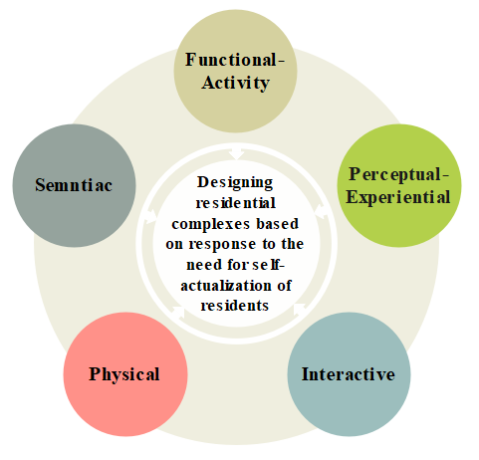
Figure 3. Model of design dimensions of housing complexes based on self-actualization based on experts' points of view
In the following, data obtained from 290 residents were subjected to R-factor analysis. At first, the measurement adequacy indicators are checked, and the value of the KMO index at this stage of the research has been calculated at 0.928, so the adequacy of the sample size is very appropriate. The significance level of Bartlett's test is also equal to 0.000, and the ability of the data to be a factor is confirmed. According to the rotated data matrix, among the 11 identified factors, factors containing three questions and more can be interpreted; thus, factors 1 to 7 have specific meanings and can be defined. At this stage, after identifying the significant factors and the questions that include them, each factor is defined and named. The labeling of the concepts has been approved and revised by six experts. Table 8 shows the content of the questions for each component:

Table 8. The content of the questions about the components resulting from the R-factor analysis
Group Number | Question Number | Content of the Questions
No.1  Creative space | 24, 22, 25, 1, 30, 26, 20, 29, 2, 33, 7, 6, 41, 9, 27, 12, 5, 10 ,48 | Possibility of personalizing the space- Use of flowers and fragrant plants- Memorability of spaces- Diverse colors- Attractive space- Social learning space- Natural view- Participation in spatial events- Creative and lively space- Formation of solitude- Space for teamwork- Diversity in lighting- Freedom in shaping the space- Exploration of spaces- Natural space- Symbolic and meaningful artworks- Attention to the needs of residents in the design- participation in the community
No.2  Event-configurable space | 57, 58, 56, 21, 16, 46, 11, 18, 23 | Playground for sports and team games- Sports equipment, walking, and cycling paths- Spaces for celebrations- Formation of happy events- small library and reading room- Attractive open space- Formation of ritual activities- Meeting Hall for collective events
No.3  Adaptive Space | 36, 38, 39, 42, 37, 55, 35 | A natural space with desirable furniture- a terrace facing the natural view- the formation of adaptive environmental functions- roof garden design intended to encourage people's presence- various uses and activities- tables, benches, and chairs in various models.
No.4  Collaborative space | 50, 51, 52, 53, 49, 54 | Flexible furniture- convenience in working with spatial equipment- collaborative garden- freedom for activity in the space- multifunctional spaces- hosting participatory events.
No.5  Engagement space | 43, 44, 45, 19 | Spaces with benches and seats arranged closely together- beautiful lobbies with multiple seating options- memorable and meaningful collective events.
No.6  Safe environment | 32, 31, 40, 28 | Visibility of routes and ease of navigation- the ability to monitor spaces- protection of people's privacy- provision of psychological comfort- freedom of movement without hindrance.
No.7  Discoverable space | 15, 13, 47, 14 | Ambiguity and mystery of spaces- explorability of spaces- use of symbolic art-designing complex open spaces in an organic and natural way.
The factors mentioned in the design components of the housing complexes that can affect the self-actualization of the residents according to the dimensions and indicators included are given in Figure 4:
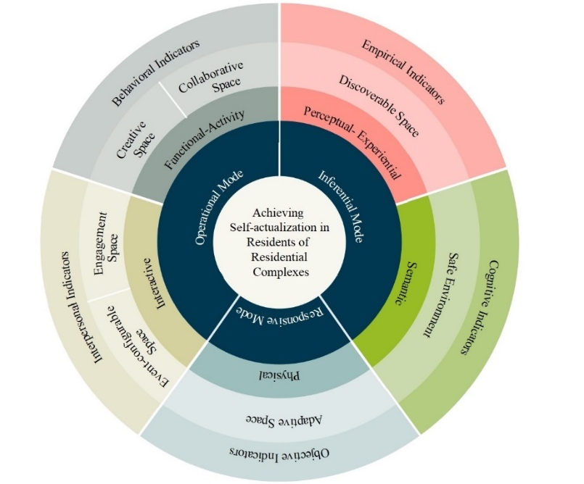
Figure 4. Classification of housing complex design components based on residents' self-actualization according to dimensions and characteristics
In the third phase of the research, modeling of the causal relationships among the design components of housing complexes based on the response to the self-actualization needs of the residents has been done. For this purpose, after formulating the theoretical model, Amos software is used to measure the Model Fit Indices, Acceptance of the Model, the significance of the relationships between the factors, and the effect value of each variable. In order to check the suitability and acceptability of the presented model, the fit and acceptability indices of the model are mentioned. First, the absolute fit indices of the model were examined. The Goodness of Fit Index (GFI) and Adjusted Goodness of Fit Index (AGFI) were estimated at 1.000 and 0.999, respectively. The model chi-square probability value was 0.981, suggesting no statistically significant discrepancy between the observed covariance matrix and the model-implied covariance matrix. The CMIN/DF value was 0.019, while the Comparative Fit Index (CFI) and Root Mean Square Error of Approximation (RMSEA) values were 1.000 and 0.000, respectively. Collectively, these indices indicate that the proposed model demonstrates a very good fit to the observed data and provides a suitable basis for examining the relationships among the design components. The details of the relationships between the components in the model of causal relationships developed in the current research are presented in Table 9:

Table 9. Regression Weights of the relation between the components
Path | Estimate | S.E. | C.R. | P
Adaptive space ← Collaborative space | .151 | .079 | 1.913 | .056
Creative space ← Discoverable space | 1.012 | .254 | 3.980 | ***
Engagement space ← Event-configurable space | .201 | .051 | 3.919 | ***
Discoverable space← Environmental Safety | -1.064 | .592 | -1.797 | .072
Discoverable space← Adaptive space | -1.042 | .793 | -1.313 | .189
Environmental Safety ← Collaborative space | .687 | .099 | 6.952 | ***
Adaptive space ← Creative space | .176 | .034 | 5.128 | ***
Collaborative space← Event-configurable space | -.305 | .107 | -2.836 | .005
Creative space← Event-configurable space | 1.398 | .164 | 8.545 | ***
Event-configurable space← Discoverable space | 1.812 | .349 | 5.190 | ***
Creative space← Collaborative space | -.628 | .239 | -2.628 | .009
Collaborative space← Engagement space | 1.907 | .269 | 7.080 | ***
Adaptive space ← Event-configurable space | .720 | .087 | 8.310 | ***
As shown in Table 9, most of the relationships in the model were positive and statistically significant, reflecting the supportive interactions among housing design components. Two paths, however, between Environmental Safety and Discoverable Space (p = .072) and between Adaptive Space and Discoverable Space (p = .189), were not statistically significant, indicating that these relationships may be weaker or context-dependent. In addition, significant negative relationships were observed between Collaborative Space and Creative Space (β = -0.628, p = .009) and between Event-Configurable Space and Collaborative Space (β = -0.305, p = .005), suggesting potential inhibitory or compensatory interactions among these spatial components.
Six feedback cycles were derived from the structural equation model by tracing statistically significant directional paths in the AMOS path diagram, identifying closed-loop configurations of interrelated housing design components that indicate recursive interaction patterns within the system. These cycles, Creative Participation in Space, Interactive Spatial Events, Environmentally Participatory Events, Adaptive and Discoverable Space, Creative and Discoverable Space, and Collaborative and Discoverable Space, represent recurring interaction patterns among housing design components, illustrating how spatial characteristics are structurally interconnected within the proposed framework and collectively support residents’ self-actualization. Table 10 presents the extracted cycles from the causal model.

Table 10: Extracted Cycles from the Housing Complex Design Model
Cycle 1. Creative participation in the space | Cycle 2. Interactive spatial events | Cycle 3. Environmentally Participatory Events
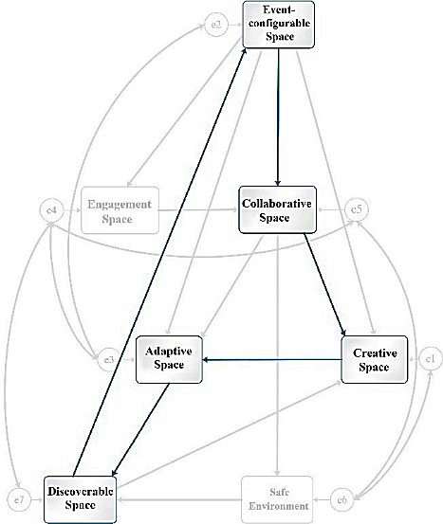 | 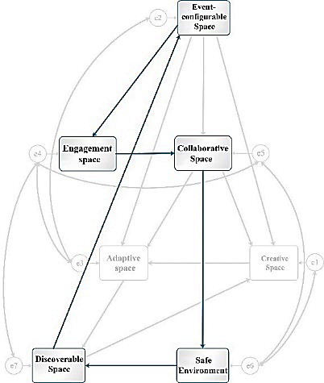 | 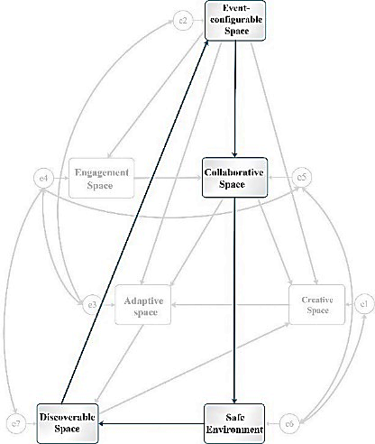
Cycle 4. Adaptive and discoverable space | Cycle 5. Creative and discoverable space | Cycle 6. Collaborative and discoverable space
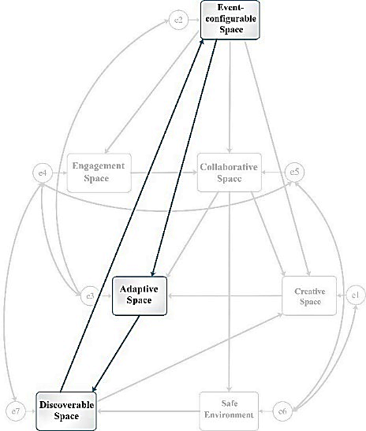 | 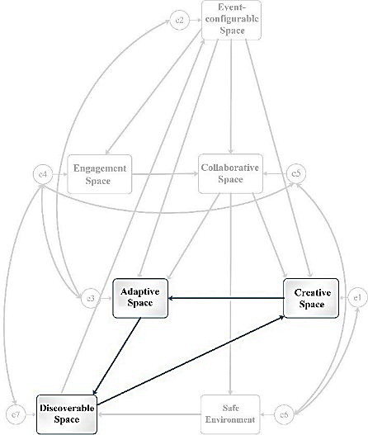 | 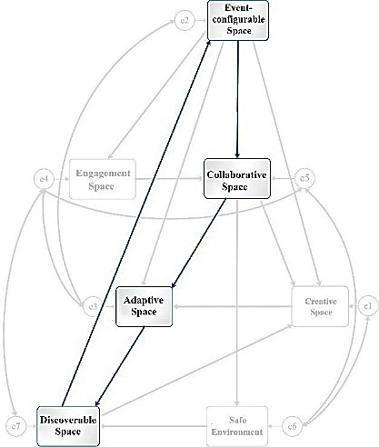
Cycle 1: Creative Participation in Space: This cycle consists of five interrelated components: Adaptive Space, Creative Space, Collaborative Space, Event-Configurable Space, and Discoverable Space. The R² values indicate the proportion of variance explained within the model, including Adaptive Space (R² = 0.478), Creative Space (R² = 0.317), Collaborative Space (R² = 0.164), Event-Configurable Space (R² = 0.154), and Discoverable Space (R² = 1.000). The latter indicates that the variance of this construct is fully accounted for within the specified structural configuration, reflecting a highly interdependent model structure.
Cycle 2: Interactive Spatial Events: This cycle is composed of Adaptive Space, Discoverable Space, Creative Space, and Engagement Space. The R² value for Engagement Space is 0.420, indicating that 42.0% of the variance in this component is explained by the other elements in the model. The corresponding R value is 0.650.
Cycle 3: Environmentally Participatory Events: This cycle comprises Event-Configurable Space, Collaborative Space, Safe Environment, and Discoverable Space, with Safe Environment as a key component. The R² value for Safe Environment is 0.210, indicating that 21.0% of the variance in this component is explained by the other elements of the cycle. The corresponding R value is 0.460.
Cycle 4: Adaptive and Discoverable Space: This cycle is composed of Event-Configurable Space, Adaptive Space, and Discoverable Space, with Adaptive Space as a key component. The R² value for Adaptive Space is 0.478, indicating that 47.8% of the variance in this component is explained by the other elements in the model. The corresponding R value is 0.690.
Cycle 5: Creative and Discoverable Space: This cycle emerges from the interaction of Adaptive Space, Discoverable Space, and Creative Space, with Creative Space as a key component. The R² value for Creative Space is 0.317, indicating that 31.7% of the variance in this component is explained by the other elements of the cycle. The corresponding R value is 0.560.
Cycle 6: Collaborative and Discoverable Space: This cycle comprises Event-Configurable Space, Collaborative Space, Adaptive Space, and Discoverable Space, with Event-Configurable Space as a key component. The R² value for Event-Configurable Space is 0.154, indicating that 15.4% of the variance in this component is explained by the other elements within the cycle. The corresponding R value is 0.390.
Discussion
To address the first research question, Q-factor analysis was conducted on questionnaires completed by experts in urban planning, architecture, and psychology. The findings indicate that, from the experts’ perspective, the Functional-Activity dimension represents one of the pathways through which self-actualization may be supported in housing complexes. In other words, residents’ self-actualization can be facilitated through the activities and functions that emerge within the residential environment. This finding is consistent with Csikszentmihalyi and Nakamura (2010), who argue that engagement in meaningful activities constitutes an important pathway toward self-actualization. This finding suggests that housing complexes may support self-actualization when their spatial organization enables residents to engage in diverse, meaningful, and self-directed activities within everyday residential life.
Experts also identified the “Interactive” dimension as one of the dimensions of housing design for promoting self-actualization. This finding suggests that residents’ self-actualization may be supported through the interactive capacities of housing environments and the social relationships that develop within them. In this regard, Purdeihimi et al. (2011) argue that social design elements can contribute to the satisfaction of higher-order needs, including security and self-actualization, by fostering meaningful interpersonal connections. Accordingly, housing environments that encourage everyday encounters, social interaction, and community participation may provide conditions that support residents’ self-actualization.
The “Physical” dimension also emerged as an important pathway through which self-actualization may be supported in housing complexes. This finding suggests that the physical characteristics of residential environments can contribute to residents’ experiences of personal growth and development. In this regard, Toby (2003) emphasizes the influence of the sensory and informational qualities of the physical environment on human development. Therefore, the design of housing complexes may support self-actualization by providing environments that offer sensory richness, environmental comfort, visual interest, and opportunities for meaningful engagement with space.
Similarly, the “Semantic” dimension highlights the role of meaning through which self-actualization may be supported in housing complexes. This finding suggests that the meanings and symbolic significance that residents attach to their living environments may contribute to experiences of personal growth and fulfillment. In this regard, Karimi et al. (2018) emphasize that the meanings individuals derive from their residential environments can nurture human excellence and self-actualization. Therefore, housing design should not be limited to functional and physical considerations but should also create opportunities for residents to develop attachment, identity, and meaningful relationships with their living environment.
The “Perceptual-Experiential” dimension emphasizes sensory engagement through which self-actualization may be supported in housing complexes. This finding highlights the role of residents’ sensory experiences and perceptions of the built environment in shaping personal development. Weaver (2010) argues that architecture can support self-actualization by facilitating sensory experiences and strengthening connections between individuals and their environment. Accordingly, housing environments may support self-actualization when they provide rich sensory experiences, visual diversity, opportunities for exploration, and meaningful engagement with everyday spatial settings.
Taken together, these findings suggest that self-actualization in housing complexes is a multidimensional phenomenon shaped by five interconnected dimensions: Functional-Activity, Interactive, Physical, Semantic, and Perceptual-Experiential. Rather than operating independently, these dimensions appear to complement one another in shaping how residents act, interact, perceive, and derive meaning from their residential environment. From this perspective, self-actualization may emerge from the combined influence of functional opportunities, social relationships, physical qualities, meaningful experiences, and sensory engagement within everyday residential life.
To address the second research question, the cycles identified through the causal model highlight the potential role of spatial organization in housing complexes in supporting residents’ self-actualization, well-being, and social participation. Although six design cycles were identified, the present discussion focuses on four participatory cycles, Creative Participation in Space, Interactive Spatial Events, Environmentally Participatory Events, and Collaborative and Discoverable Space, as these are most directly related to the study’s objective of examining how spatial design may facilitate resident participation and experiences associated with self-actualization. For instance, the “Creative Participation in Space” cycle highlights the interrelationship among Adaptive Space, Creative Space, Collaborative Space, Event-Configurable Space, and Discoverable Space. This cycle resonates with Madanipour’s (2013) concept of event-configurable spaces, which emphasizes the role of participation in shaping spatial experiences. The results suggest that adaptive and event-configurable environments may encourage exploration and engagement with space, which in turn can support creative spatial experiences. This interpretation is consistent with the arguments of Duncan and Duncan (1976) and Sixsmith (1986) who emphasize the role of personal engagement in transforming residential environments into meaningful places. The findings therefore suggest that creativity, participation, and discoverability may operate as interconnected aspects of residents’ experiences within housing complexes. From a design perspective, this cycle suggests the value of flexible communal areas, multi-functional open spaces, adaptable furniture systems, and spatial layouts that allow residents to modify or appropriate space according to changing needs and activities. Examples may include flexible community spaces and equipment, movable seating arrangements, and participatory environments that facilitate both individual and collective engagement, such as community gardens or platforms for collaborative artistic production, alongside informal events that encourage resident interaction and participation. Such spatial configurations can accommodate a range of social, recreational, and creative uses, and support opportunities for participatory engagement, lived experience, and personal interaction with the residential environment.
The “Environmentally Participatory Events” cycle highlights the role of spatial safety and accessibility in supporting participation within housing complexes. As noted by Smith (1994), spatial events can stimulate collective engagement and create opportunities for residents’ involvement in community life. The findings suggest that highly controlled and predictable environments may reduce opportunities for exploration by limiting ambiguity, spatial complexity, and uncertainty, which are often associated with discoverability. Accordingly, the relationship between environmental safety and discoverability appears to involve a balance between security and exploratory potential rather than a unidirectional association. Given the positive association between discoverability and participatory engagement, housing complexes may benefit from branching circulation systems, visual corridors, partially concealed destinations, layered landscape sequences, interconnected pathways, and gradations of enclosure that support exploration while maintaining passive surveillance.
Similarly, the “Interactive Spatial Events” cycle emphasizes the role of social interaction in shaping residents’ experiences within housing complexes. Event-configurable spaces may provide opportunities for engagement and interaction among residents, as highlighted by Yahan and Wise (2019). The findings suggest that environments that are highly adaptable to users’ needs do not necessarily stimulate curiosity or exploratory behavior. Accordingly, adaptability alone may be insufficient to promote discoverability unless it is integrated with spatial complexity, visual diversity, and opportunities for unplanned encounters. This highlights the need to complement flexible spatial configurations with design strategies that support both functional responsiveness and exploratory potential. Potential design responses may include interconnected circulation networks, shared transition zones, visual focal points, and multi-purpose gathering spaces that support both adaptive use and exploratory engagement within residential environments.
Finally, the “Collaborative and Discoverable Space” cycle highlights the relationship between participation, collaboration, and spatial exploration within housing complexes. This interpretation is consistent with Weaver’s (2010) emphasis on discovery in architectural environments and Rapoport’s (1990) discussion of participatory housing design as a context for meaning-making and identity formation. However, the negative relationship between Event-Configurable Space and Collaborative Space suggests that, while event-configurable spaces may provide opportunities for gathering, they do not necessarily ensure the development of collaborative relationships. In residential environments, participation often emerges through informal, spontaneous, and everyday interactions rather than structured collective activities. Accordingly, housing design should also support informal encounters through shared circulation areas, semi-public spaces, communal gardens, and everyday meeting points that facilitate unplanned social interaction. Examples may include participatory gardens, internal courtyards, seating nodes along circulation routes, and transitional spaces between private dwellings and communal areas that encourage resident interaction within an open and exploratory spatial setting.
The findings suggest that self-actualization in housing complexes emerges through a network of interacting spatial processes rather than isolated design attributes, operating across both individual (exploratory, creative, perceptual) and collective (interactive, collaborative, participatory) modes of engagement with space. From this perspective, housing environments may support self-actualization through spatial configurations that integrate opportunities for both personal exploration and collective participation. These configurations include flexible communal spaces, semi-public transitional areas, event-configurable settings, shared green spaces, and circulation networks that facilitate movement and social encounter, collectively supporting everyday engagement with the residential environment.
Overall, the findings indicate that housing design should be understood as a set of spatial conditions that enable both agency and interaction, rather than as prescriptive solutions. Within this framework, a balance between environmental safety and spatial diversity may further enhance opportunities for discovery, participation, and meaning-making in residential settings.
Conclusion
This study aimed to identify and explain the cycles through which architectural and spatial design components in housing complexes may support residents’ self-actualization. Using a mixed-method approach, the research integrated document mining, the Delphi method, user surveys, and correlation analysis to develop a causal model of self-actualization in residential environments. The findings identified five design dimensions, Perceptual-Experiential, Semantic, Interactive, Physical, and Functional-Activity, that appear to shape the spatial conditions associated with self-actualization. The results suggest that self-actualization in housing complexes may be understood not only as an individual psychological phenomenon but also as a spatially mediated and participatory process. Functional activities and collective events, interactive relationships between individuals, space, and others, physical spatial characteristics, semantic meanings, and perceptual experiences collectively appear to contribute to the spatial conditions associated with personal growth and well-being. Participation, both individual and collective, emerged as a prominent mechanism through which residents engage with space, express identity, and construct meaning within their living environments.
The study also identified four participatory cycles, Creative Participation in Space, Interactive Spatial Events, Environmentally Participatory Events, and Collaborative and Discoverable Space, that illuminate how spatial design components interact within the proposed causal framework. These cycles suggest that adaptability, discoverability, participation, and social interaction are interconnected processes associated with residents’ sense of belonging, creativity, and well-being. The findings further highlight the importance of participatory and event-configurable spaces in shaping opportunities for both personal and collective engagement within housing complexes. Overall, the findings suggest that experiences associated with self-actualization in residential contexts emerge through ongoing interactions among individuals, spatial structures, and social relationships. The proposed model provides a conceptual and empirical framework for understanding how architectural design may support human potential and well-being through participatory and adaptive spatial strategies.
Several limitations should be acknowledged. The study was geographically limited to housing complexes in Iran, which may restrict the generalizability of the findings to other socio-cultural contexts. Additionally, constraints in participant access and cooperation affected the scope of data collection. Future research should examine diverse urban contexts and demographic groups, including different age cohorts and functional urban settings, to further evaluate and extend the proposed model. Expanding this line of inquiry may contribute to a deeper understanding of how spatial design relates to processes associated with self-actualization across different social and cultural environments.

Wellbeing through Participatory Synergy Cycles
Environmentally Participatory Events
Creative and Discoverable Space
Creative Participation in Space

Adaptive and Discoverable Space

Cycles Affecting Self-actualization

Design Dimensions

Design Strategies

Perceptual Modes
Interactive spatial Events
Collaborative and Discoverable Space
- The formation of opportunities for the creative process
- The concentration and accumulation of energy for creative activity
- The creative art process
- The possibility of participating in creating spatial changes
- Participation in creating the meaning of the space
- Participation in public events and occasions
- Events, ceremonies, and cultural activities
- Temporary events in spaces
- Defining spaces through events
- An intimate atmosphere for positive interaction with others
- A platform for dynamic and ongoing social interactions

- A sense of psychological security
- Environmental safety and physical comfort
- A feeling of peace, spatial freedom, and comfort

- Search and revelation
- Encouraging people to search and explore the space

- Spatial and activity diversity
- adaptability in design, performance, and application
- Variety in form, meaning, materials, and colors
Physical
Functional-Activity
Semantic
Perceptual-Experiential
Interactive

Inferential Mode
Operational Mode
Responsive Mode
Interpersonal Indicators
Objective Indicators
Cognitive Indicators
Behavioral Indicators
Empirical Indicators

Figure 5. Layered diagram illustrating pathways to residents’ wellbeing through self-actualization cycles in housing complexes
Funding
No funds, grants, or other support was received.
Author Contributions
The authors contributed equally to the conceptualization and writing of the article. All of the authors approved the content of the manuscript and agreed on all aspects of the work, with no declaration of competing interests.
Conflict of interest
All authors certify that they have no affiliations with or involvement in any organization or entity with any financial interest or non-financial interest in the subject matter or materials discussed in this manuscript.
Acknowledgments
We are grateful to all the scientific consultants for this paper.
Ethics Approval and Consent to Participate
The study was approved by Research Ethics Committees of IAU-Arsanjan Branch (IR.IAU.A.REC.1403.135). Informed consent was obtained from all participants in the study.
Data Availability Statement
The data supporting the findings of this study are available from the corresponding author upon reasonable request. Due to confidentiality agreements with study participants, some data may be restricted to protect privacy. The datasets generated and analyzed during the current study are not publicly available but can be shared with qualified researchers upon request and with permission from the institutional review board.

References
Al-Tarazi, D., Sara, R., Redford, P., Rice, L., & Booth, C. (2024). An architectural insight into the role of personalisation of homes and its effects on residents’ psychological well-being. International Journal of Architectural Research. https://doi.org/10.1108/ARCH-11-2023-0304
Alexander, C. (2021). Architecture and the Secret of Permanence: A Timeless Way of Building (6 ed.). Shahid Beheshti University.
Altomonte, S., Allen, J., Bluyssen, P. M., Brager, G., Heschong, L., Loder, A., Schiavon, S., Veitch, J. A., Wang, L., & Wargocki, P. (2020). Ten questions concerning well-being in the built environment. Building and Environment, 180(106949). https://doi.org/10.1016/j.buildenv.2020.106949
Asami, Y. (2001). Urban housing. Sci., 33, 39–44.
Asami, Y. (2004). Acad Trends(9), 17–22.
Bradley, C. J., Grossman, D. C., Hubbard, R. A., Ortega, A. N., & Curry, S. J. (2016). Integrated Interventions for Improving Total Worker Health: A Panel Report from the National Institutes of Health Pathways to Prevention Workshop: Total Worker Health, What's Work Got to Do with it? Ann Intern Med, 165(279). https://doi.org/10.7326/M16-0740
Csikszentmihalyi, M., & Nakamura, J. (2010). Effortless attention in everyday life. In B. Bruya (Ed.), Effortless Attention: A New Perspective in the Cognitive Science of Attention and Action (pp. 179–189). MIT Press. https://doi.org/10.7551/mitpress/9780262013840.003.0009
D’Souza, J. F. (2018). Self-Actualization. The SAGE Encyclopedia of lifespan human development, 1921–2922. https://doi.org/10.4135/9781506307633
Duncan, J. S., & Duncan, N. G. (1976). Social worlds, status passages, and environmental perspectives. In G. T. Moore & R. G. Golledge (Eds.), Environmental Knowing. Dowden, Hutchinson, & Ross, Stroudsburg, PA. .
Estaji, H. (2014). Flexible spatial configuration in traditional houses. International Journal of Contemporary Architecture, 1(1), 26–35.
Fox, L. (2002). The meaning of home: a chimerical concept or a legal challenge? Law and Society, 29(4), 580–610. https://doi.org/10.1111/1467-6478.00234
Frankl, V. E. (2021). The Unheard cry for meaning. fararavan.
Fromm, E. (1947). Man for himself. Rinehart.
Goldstein, K. (1993). The Private self. MA: Harvard University Press.
Heidegger, M. (2022). Being and Time. Ghoghnoos.
Hodson, H. (2015). No one in control. New Scientist, 225(3007), 30–33. https://doi.org/10.1016/s0262-4079(15)60260-3
Kamata, T., & Kawakubo, S. (2024). Housing hierarchy of needs that contribute to the well-being of residents IOP Conf Ser Earth Environment Sci,
Karimi, M., Hojjat, I., & Shahbazi, B. (2018). The Relationship between the dweller and the dwelling Revisited. Bagh-e Nazar, 15(61), 5–16. https://doi.org/10.22034/bagh.2018.63859
Klepeis, N. E., Nelson, W. C., OTT, W. R., Robinson, J. P., Tsang, A. M., Switzer, P., Behar, J. V., Hern, S. C., & Engelmann, W. H. (2001). The National Human Activity Pattern Survey (NHAPS): a resource for assessing exposure to environmental pollutants. Journal of Exposure Science & Environmental Epidemiology 11(3), 231–252. https://doi.org/10.1038/sj.jea.7500165
Kylen, M., Leofqvist, C., Haak, M., & Iwarsson, S. (2019). Meaning of home and health dynamics among younger older people in Sweden. European Journal of Ageing, 16(3), 305–315. https://doi.org/10.1007/s10433-019-00501-5
Kyttä, M., Broberg, A., Tzoulas, T., & Snabb, K. (2013). Towards contextually sensitive urban densification: Location-based softGIS knowledge revealing perceived residential environmental quality. Landscape and Urban Planning, 113, 30–46. https://doi.org/10.1016/j.landurbplan.2013.01.008
Leopold, D. (2007). The young Karl Marx: German philosophy, modern politics, and human flourishing. Cambridge University Press.
Madanipour, A. (2013). Urban space design: a perspective on the social and spatial process. Urban Processing and Planning Company.
Mallett, S. (2004). Understanding home: a critical review of the literature. The Sociological Review, 52(1), 62–89. https://doi.org/10.1111/j.1467-954x.2004.00442.x
Marias, J. (2012). History of philosophy (22 ed.). Dover Publications.
Maslow, A. H. (1954). Motivation and Personality. Harper & Row.
Maslow, A. H. (2008). The Farther Reaches of Human Nature. Penguin Books.
Maslow, A. H. (2022). Toward a Psychology of Being. Martino Fine Books.
Mohajer, E., Azemati, H. R., & Movahed, K. (2021). Dimensions Affecting Self-Actualization in Residential Complexes from the Perspective of Experts. CIAUJ, 6(2), 191–210. https://doi.org/10.52547/ciauj.6.2.191
Mohajer, E., Azemati, H. R., & Movahed, K. (2024a). Explaining the Design Components of Residential Complexes Based on Responding to the Need for Self-Actualization. GUPR, 12(1), 43–61. https://doi.org/10.22059/jurbangeo.2024.369557.1893
Mohajer, E., Azemati, H. R., & Movahed, K. (2024b). Presenting a Causal Model for the Design Components of Residential Complexes Based on Addressing the Need for Self-actualization. IJAUP, 34(3). https://doi.org/10.22068/ijaup.826
O'Sullivan, K., Olin, C., Pierse, N., & Howden-Chapman, P. (2023). Housing: the key infrastructure to achieving health and wellbeing in urban environments. Oxford Open Infrastructure and Health, 1. https://doi.org/10.1093/ooih/ouad001
Purdeihimi, S., Zamani, B., & Negintaji, S. (2011). A Human Approach to Housing. Soffeh, 54, 5–14. https://doi.org/20.1001.1.1683870.1390.21.3.1.3
Rapoport, A. (1990). The Meaning of the Built Environment. The university of Arizona press.
Rogers, C. R. (1995). Freedom to learn. Merrill.
Rogers, C. R. (2022). The Art of Being Human. Farhang Nashr Now.
SalehSadeghpour, B. (2013). Learning evaluation, class booklet.
Seif, A. A. (2021). Measurement, Assessment, and Educational Evaluation. Doran Publishing.
Sixsmith, J. (1986). The meaning of home: an exploratory study of environmental experience. Environmental Psychology, 6(4), 281–298. https://doi.org/10.1016/S0272-4944(86)80002-0
Smith, S. (1994). The essential qualities of a home. Environmental Psychology(14), 31–46. https://doi.org/10.1016/S0272-4944(05)80196-3
Stretton, H. (1976). Capitalism, Socialism and the Environment. CUP Archive.
Toby, I. (2003). Some Place Like Home. Academy Press.
UnitedNations. (2015). Transforming Our World: The 2030 Agenda for Sustainable Development. Retrieved 25 Nov from https://sdgs.un.org/2030agenda
Weaver, S. R. (2010). Discovering self-actualization through the experience of architecture Montana State University].
Yahan, Z., & Wise, N. (2019). Events and sense of community. Community Psychology, 14(1), 6–23.
Yalom, I. D. (2023). Existential psychotherapy (21 ed.). ney.

* Corresponding Author: Ellie.mohajer@gmail.com

