Investigating the Adverse Effects of Noise Pollution on the Psychological Quality of Iranian Architectural Heritage Using EEG: A Case Study of Agha Bozorg Mosque in Kashan

Ali Sadeghi habibabad *
Assistant Professor, Architectural Engineering Department, Faculty of Technical and Engineering, Yasouj University, Yasouj, Iran.
E-mail address: AliSadeghi@yu.ac.ir
Tel: +989173432927
https://orcid.org/0000-0001-9451-4907

Abstract
The present study aims to investigate the impact of unwanted sounds (noise pollution) on the minds of users using the architectural spaces and environments of Islamic mosques by measuring brain waves. As we know, safe Islamic spaces must have unique characteristics to provide a degree of tranquility and spiritual sense for people who enter these environments and make them away from the urban noise and daily worries so that they can devote part of their time to worship. To provide such a spiritual place, it is required to satisfy and pay attention to special conditions according to the environmental psychology of its architectural space. Various physical and sensory factors are involved in the creation of such a feature for the space of mosques, one of which is the sound component with both positive and negative effects on the users' minds. By selecting "Agha Bozorg Mosque" in Kashan as a successful architectural example, the present study examines the following hypothesis: There is a significant relationship between the sensory factor of the unpleasant sound and the spiritual sense created in the space of Islamic religious places. The present research is carried out using field studies and a laboratory method (brain wave recording). In the present study, the "urban traffic noise" is prepared as an unpleasant sound through simulation and then, its effects on users' minds are investigated. The sample size is estimated to be 20 people. The overall results showed that noise pollution directly plays a key role in reducing the spiritual sense of the users using the interior space of mosques, and paying attention to the location of these places in the city considering such sounds can improve the sensory quality of the architecture of mosques. Even the best type of mosque architecture is significantly influenced by such noise and its quality is reduced. Therefore, it is very necessary to pay attention to this important issue in the location of mosques.

Keywords: Environmental psychology, Islamic architecture, cognitive science, spiritual sense, mosques

Introduction
Iranian architectural heritage, particularly historic mosques, represents a unique synthesis of material, aesthetic, and spiritual values that profoundly influences users’ environmental perception and psychological experiences (Nejad, Azemati, & Sadeghi HabibAbad, 2019; A. Sadeghi habibabad, 2026)The architectural qualities of Iranian mosques (including spatial organization, brick ornamentation, geometry, light, and sensory attributes) have been shown to enhance spirituality, tranquility, and emotional well-being (Nejad, Azemati, & Habibbad, 2019; A. Sadeghi HabibAbad, 2020; A. Sadeghi Habibabad, Matracchi, P, 2021; Zomorshidi & Sadeghi, 2018). Recent studies in cognitive neuroscience and environmental psychology further indicate that physiological and neural responses can objectively reveal how architectural environments affect human cognition and emotions (A. Sadeghi Habibabad, MahdiNejad, Azemati, & Matracchi, 2021; A. Sadeghi Habibabad & Matracchi, 2025) In particular, variations in sensory stimuli, including sound intensity, have been associated with measurable changes in brain-wave activity and the perception of spirituality and environmental quality (A. Sadeghi habibabad, De Cesaris, A, 2023). Moreover, EEG-based investigations have demonstrated that architectural features such as geometric patterns can significantly influence mental states and environmental perception (A. Sadeghi habibabad & Ehsani Oskouei, 2026). Despite these advances, the adverse psychological consequences of noise pollution in Iranian historic religious heritage remain largely unexplored. Therefore, this study employs EEG measurements to investigate the effects of noise pollution on the psychological quality of users in the Agha Bozorg Mosque of Kashan, providing new evidence on the relationship between acoustic conditions and human experience in heritage architecture.
Noise pollution is a type of environmental pollution, that threatens the health of society and the survival of living organisms (Kim & Van den Berg, 2010). Urban traffic is the main cause of air and noise pollution. Noise pollution is one of the urban problems of citizens. It is a growing issue and has potential effects on people's health. For example, one can refer to the noise of public transportation in cities and residential environments (Marathe, 2012). In most of the developed and developing countries of the world, the issue of noise pollution has been significantly considered and many measures have been taken to formulate and enforce noise control and ordinance laws (Agarwal & Swami, 2011). Vehicle traffic is a common source of air pollution, accidents, and noise pollution. Noise pollution is an important factor influencing the quality of life in urban areas (Monavvari, 1994). This issue is a growing problem with great effects on people's health (Farcaş & Sivertunb, 2010). Noise pollution can be defined as the feeling of dissatisfaction induced by sound (De Kluijver & Stoter, 2003). Identifying traffic noise pollution as one of the most important environmental pollutants has led to the development of models with the ability to predict sound levels from basic sources(Katorani, 2019; Kim & Van den Berg, 2010)
Noise pollution plays a significant role in dissatisfaction with space (Parkes, Kearns, & Atkinson, 2002; Savasdisara, 1988) Acoustic comfort is defined as the reduction of noise pollutants in the open space in a way that becomes desirable for the majority of users (Oral, Yener, & Bayazit, 2004) and its level in architectural and urban spaces is one of the factors defining the quality of architecture and urban and architectural space. In most cases, the dissatisfaction resulting from the sounds is not only determined by the sound frequency, but the quality of the sound type also affects it, in other words, noise reduction in architectural and urban environments does not necessarily refer to an increase in acoustic comfort (Yang & Kang, 2005) So far, many studies have been carried out on the effects of unpleasant urban sounds on the acoustic comfort of users, emphasizing the importance of the issue (FATHI, NASSIRI, MONAZZAM, MANSOURI, & RAZZAGHI, 2015; Kiani Sadr, Nassiri, Sekhavatjo, & Abbaspour, 2009; Lam, Ng, Hui, & Chan, 2005; SADEGI, Kheyri, JAFARI, & Shahrani, 2007; Sazgarnia, Bahreyni Toossi, & Moradi, 2005; Szeremeta & Zannin, 2009). Noise pollution is defined as unwanted sounds that have harmful effects on the quality of the human living environment(Mohamad Zadeh, 2010). In some cases, noise pollution is considered to be sounds that are only harmful to human health, but according to the World Health Organization, which considers not only the absence of pain but also the presence of mental and social peace to be necessary for maintaining health, all annoying sounds should be considered noise pollution (Bahram, 1986). Most of the sounds in urban areas are caused by three sources: motor vehicles, manufacturing, and industrial units, and social and cultural factors (Mohamad Zadeh, 2010). Table 1 presents the levels and intensities of some everyday sounds. In this table, noise above 70 dB is defined as noise pollution, and the noise created by jet plane takeoff is characterized by the painful level.
Another factor influencing the perception of sounds in the environment is the density of the population present in the environment because the crowd is a specific type of sound source (Crisler, 1976). In addition, the human population also plays a role as a sound absorber (Long, 2005). Therefore, the number of people present in the space can affect the perception of the sound environment and the quality of the soundscape (Meng & Kang, 2015). Many studies have shown that there is a strong relationship between population size and noise level in architectural and urban spaces (Hayne, Rumble, & Mee, 2006; Hayne, Taylor, Rumble, & Mee, 2011).

Table 1. The levels of some everyday noises (Mohamad Zadeh, 2010; Owen, 1971)
Type of sound | Noise level (dB) | Comment
Normal breathing, hearing threshold | 0-10 | Audible
Leaves rustling in the wind | 20-30 | Very quiet
Library, quiet restaurant | 40-50 | Soft
Studying loudly, vacuum cleaner | 60-70 | Moderate
Mixer, heavy traffic | 80-90 | Very loud
Train, gun shot | 100-120 | Uncomfortable
Jet plane take-off | 150 | Painful

In the present research, it was attempted to investigate the mental and spiritual effects of sound on the users of the Agha Bozorg Mosque in Kashan according to cognitive science through field studies. To this end, a space with the most impact on the spiritual sense in the users' minds was selected, and noise pollution, which was urban traffic noise in the present study, was created. Next, this sound was By creating noise pollution, played for users, and its effect on the user's mind was recorded and investigated. The research hypothesis states that noise pollution can affect the spiritual sense created in the minds of the users of mosque space and reduce the psychological quality of the environment. Therefore, it is very important to locate religious places far from noise pollution. Moreover, it is required to take architectural measures to keep these places far from noise pollution.

Research background
There are many studies on the effects of sound in the urban and architectural fields, most of which have addressed urban traffic, noise pollution, and the identification of the perceptual and physical characteristics of acoustic behaviors in religious places through surveys and simulations. Also, the mental effects of sounds can be seen in most humanities and medical research, where the effect of the type of sound and its characteristics on the user's mind have been measured and investigated. Table 2 presents some of these studies. It seems that no study has been carried out in the field of mosque architecture and the mental effects of noise pollution on the users' spiritual sense so far.

Table 2: Past research on sound measurement and effects
Researchers | Research title | Description
Effects and features of sound by simulation and survey method
(Nowoświat, Olechowska, & Marchacz, 2020) | The effect of acoustical remedies changing the reverberation time for different frequencies in a dome used for worship: A case study |  | Acoustic evaluation to assess timbre
(Carvalho, 2009) | Comparison of the acoustics of mosques and catholic churches |  | Comparison and investigation of mosque and church in acoustics
(Alberdi, Martellotta, Galindo, & León, 2019) | Dome sound effect in the church of San Luis de los Franceses |  | Study of the acoustic behavior in the dome
(Hamadah & Hamouda, 1998) | Assessment of speech intelligibility in large auditoria case study: kuwait state mosque |  | Acoustic Measurements for Evaluation (MPH)  State Mosque of Kuwait
(Othman & Mohamed, 2012) | Influence of Proportion towards Speech Intelligibility in Mosque's Praying Hall |  | Examining the proportions and acoustic quality of the mosque
(R Suárez, Sendra, Navarro, & León, 2005) | The sound of the cathedral-mosque of Córdoba |  | Investigation of sound in the architectural space of religious places
(Rafael Suárez, Alonso, & Sendra, 2018) | Virtual acoustic environment reconstruction of the hypostyle mosque of Cordoba |  | Acoustic evaluation of the interior space of religious places
(Gül & Çalışkan, 2013) | Impact of design decisions on acoustical comfort parameters: Case study of Doğramacızade Ali Paşa Mosque |  | Acoustic evaluation of the interior space of religious places
(Weitze, Rindel, Christensen, & Gade, 2002) | The acoustical history of Hagia Sophia revived through computer simulation |  | Acoustic evaluation of Hagia Sophia mosque through simulation
(Al Shimemeri & Patel, 2011) | Assessment of noise levels in 200 Mosques in Riyadh, Saudi Arabia |  | Investigating the noise in the interior and outside of the mosque and comparing them in noise tolerance level
(Elkhateeb, Adas, Attia, & Balila, 2016) | Absorption characteristics of masjid carpets |  | Investigating the effect of the type of carpet on the acoustics of the interior architecture of the mosque
(Ghaffari & Gholizadeh, 2022) | Analysis of impact of volume changes on acoustic behavior in mosques (Case study: Historic masques of Tabriz) |  | Investigating the space of sound and reverberation in mosques
(Cain, Jennings, & Poxon, 2013) | The development and application of the emotional dimensions of a soundscape |  | Investigation of sound perception indicators
(Stevens, 2018) | Strategies for Environmental Sound Measurement, Modelling, and Evaluation |  | Investigation of sound perception indicators
(P. J. Lee & Kang, 2015) | Effect of height-to-width ratio on the sound propagation in urban streets |  | Investigating the physical indicators affecting the sound
(Hao, 2014) | Effects of urban morphology on urban sound environment from the perspective of masking effects |  | Investigating the physical indicators affecting the sound
(S. C. Lee, Lee, & Jeon, 2012) | Assessment of annoyance caused by different types of construction noises |  | Investigating annoying noises induced by various construction activities
(Sudarsono, 2017) | Soundscape composition and relationship between sound objects and soundscape dimensions of an urban area |  | Investigation of sound perception indicators
(Sheikh & Mitchell, 2018) | Design strategies for perceived acoustic comfort in urban environments–A literature review |  | Investigating the physical indicators affecting the sound
(Jeon, Jo, & Polack, 2019) | Evaluation of soundscape and audio-visual factors in VR environment for quiet urban park |  | Investigation of sound perception indicators
(P. J. Lee & Jeon, 2013) | Relating traffic, construction, and ventilation noise to cognitive performances and subjective perceptions |  | Investigating cognitive performance and mental perception in the field of urban traffic
(Ghaffari, Mirgholami, & Shafaei, 2021) | Explaining the acoustical behavior and the soundscape quality of Tabriz Bazaar based on the objective and subjective assessments |  | Investigating environmental characteristics and their effects on the quality of soundscapes
(Jeon, Lee, & Hong, 2011) | Effects of contexts on perception of urban soundscape |  | Investigating the effect of contexts on the perception of the soundscape in urban space
(Gholizadeh, Ghaffari, & Keynejad, 2022) | The Effect of Plan and Formal Geometry of Mosques on the Acoustic Quality of Architecture Case Study: Historical Mosques of Tabriz |  | Examining the effects of the geometry of mosques on the acoustic quality of architecture
(Jeon, Ryu, & Lee, 2010) | A quantification model of overall dissatisfaction with indoor noise environment in residential buildings |  | Presenting a model of dissatisfaction caused by construction noise
The effects and characteristics of the sound using the cognitive science
(Schmidt & Trainor, 2001) | Frontal brain electrical activity (EEG) distinguishes valence and intensity of musical emotions |  | Investigating brain emotions as a theoretical framework
(Blood, Zatorre, Bermudez, & Evans, 1999) | Emotional responses to pleasant and unpleasant music correlate with activity in paralimbic brain regions |  | Examining emotions and neural correlates of emotional reactions in a face of music
(Field, Martinez, Nawrocki, & Pickens, 1998) | Music shifts frontal EEG in depressed adolescents |  | Investigating the effects of music on mood and right frontal EEG activation
(Hwang, Jebelli, Lee, Chung, & Lee, 2020) | Measurement of Individuals’ Emotional Stress Responses to Construction Noise through Analysis of Human Brain Waves |  | Impact of construction noise and quality of life
(Frescura, Lee, Jeong, & Soeta, 2021) | Electroencephalogram (EEG) responses to indoor sound sources in wooden residential buildings |  | Investigating the impact of sound on interior architecture

Method
The research method in this study is divided into four parts, as follows:
First part: In the first part, the past studies and literature on the characteristics of sound, the effects of noise pollution, and how to investigate and measure sound were reviewed descriptive;y and analytically.
Second part: In this stage, the case study of Agha Bozorg Mosque, Kashan, Iran was selected. The reason for choosing this mosque was to avoid noise pollution and to have the least noise during the test. Also, it is a building with most of the spaces of a complete mosque. In four parts of the mosque, i.e. 1- the courtyard, 2- the entrance porch to the mosque, 3- the entrance porch to the Gonbadkhane, and 4- the Gonbadkhane were selected for performing tests, as shown in Figure (1).

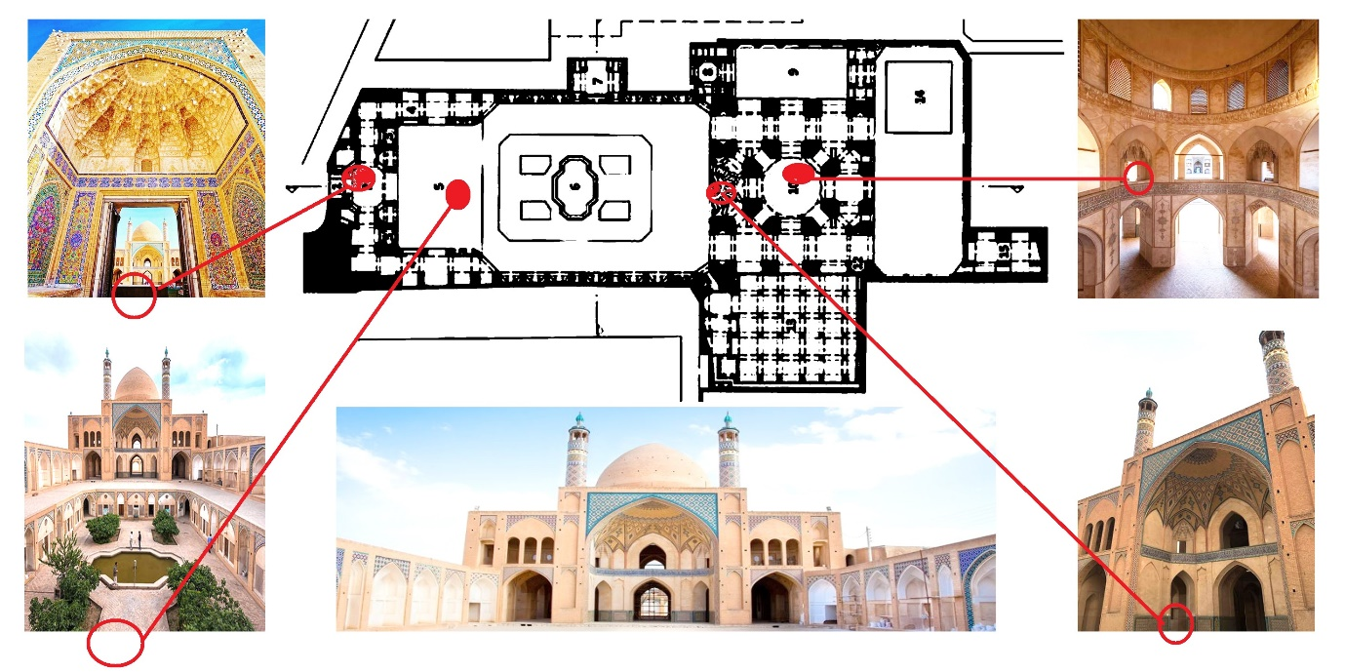
Figure 1: The place determined in the Agha Bozorg Mosque for performing the tests and recording users' brainwaves

Third part: In this stage, an annoying sound (urban traffic and noise) with SPL of 76 to 86 decibels was chosen to use in the tests. This sound was played to users through headphones and its effects were investigated (Figure 2).

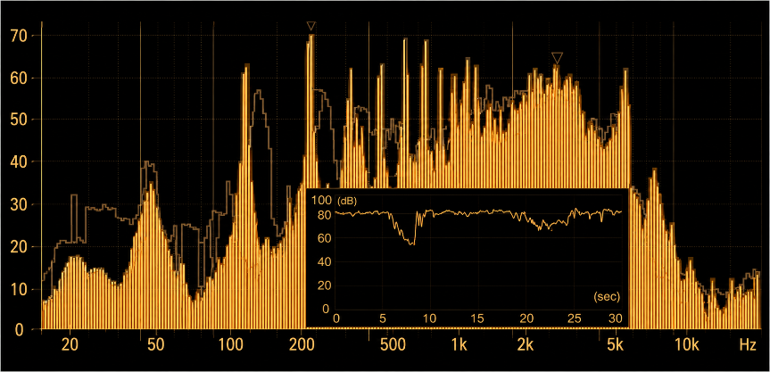
Figure 2: Sound Pressure Level (SPL) (dBC) of the sound (urban noise) used in the test

Fourth part: Sampling was conducted using a purposive convenience sampling method based on visitor availability during the field survey period. A preliminary visitor count was carried out during different visiting hours of Agha Bozorg Mosque to estimate the average number of users present in the mosque. From this population, twenty male participants who voluntarily agreed to participate and met the inclusion criteria (normal hearing ability, absence of neurological disorders, and willingness to complete the experiment) were selected. Because the EEG recording process required controlled experimental conditions and individual measurements of approximately 45 minutes per participant, a limited sample size was considered appropriate for this exploratory case study. The geographical scope of this study was limited to Agha Bozorg Mosque in Kashan, Iran. Therefore, the findings should be interpreted within the environmental and architectural context of this historical mosque and may not be directly generalized to other religious buildings with different spatial, acoustic, and cultural characteristics.
The samples were 20 men. They were the users of the mosque who cooperated in the present study voluntarily. Some were colleagues and some were tourists who came to see the building. The samples' brain waves were recorded using a portable brain wave recording device made by the Medicom Co. in Russia. It was used as follows: at 4 predetermined points, users were asked to sit on a chair in the environment and space, and their brain waves were recorded. Before entering the experiment, they were asked to fill out a consent form and a general health questionnaire. Data analysis was carried using Neuroguide and MATLAB software. A 10-20 System of Electrode Placement was also used (Figure 3). In the first stage of recording brain waves, the users' spiritual sense was recorded after being in the space and environment of the mosque. In the next stage, their spiritual sense was recorded again when being in the space of the mosque and hearing the sound (noise pollution) through headphones. The purpose of this work was to know the effectiveness of each part and compare them with each other (Figure 4).

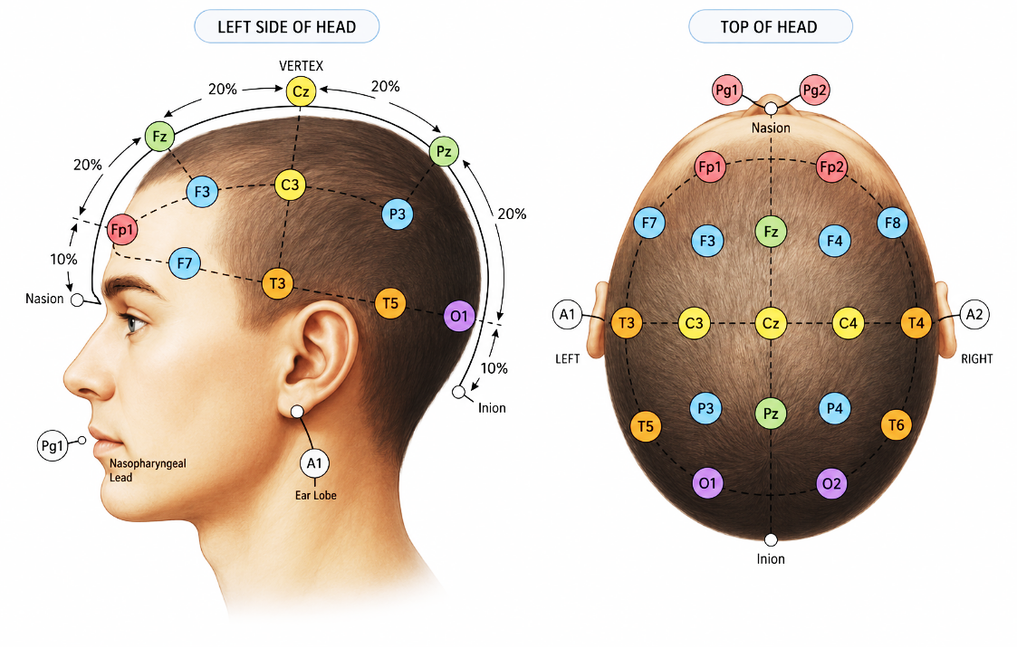
Figure 3: Standard 10-20 system
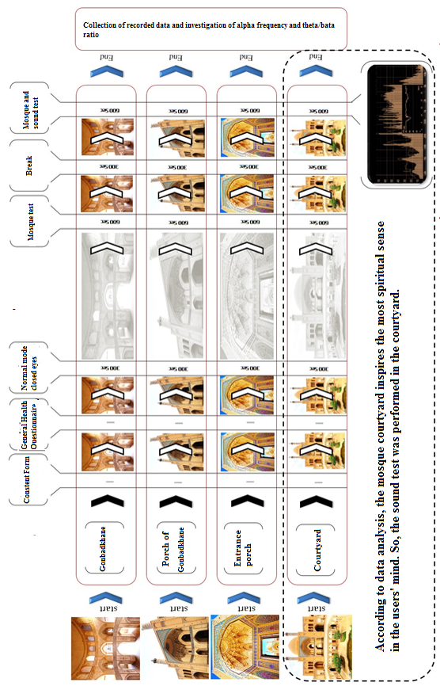
Figure 4: Test steps

Research literature
The impact of sound on emotions
The sense of hearing (audition) is related to feelings and emotions, and this sense affects people's experiences and perceptions (Sweeney & Wyber, 2002). We often express our identity through sounds and verbally tell others who we are, what we believe, and what our feelings are (Gobe, 2010). Our environment is full of different sounds and these sounds can have a strange power. Today, sound has many applications that may seem unbelievable to us. However, in some cases, the positive and negative effects of sound are quite tangible for us. In the experience of understanding space, audition provides different capabilities due to the extent and definition of its separate phonetic space (Lotfi, Hariri, & SHAHABI, 2017). The phonetic space is less limited and shapes the space (Carmona, 2021).
In research conducted on the effect of sounds on organisms, it has been found that sounds have a direct effect on cells and tissues in such a way that they play a role in the beauty of their shapes. According to a study in America, it has been proven that listening to the sound of recitation of the Holy Quran creates physiological changes in the human nervous system and reduces intense mental tension. God says in the Holy Qur'an: " When the Quran is recited, listen to it and be silent, maybe you will receive [Allah’s] mercy" (Surah Al-A'raf, verse 204).
In medical science, the use of sound to treat patients can be seen in various research, these researches also show the effectiveness of music therapy in reducing the anxiety and restlessness of patients with Alzheimer's disease (Zare & Birashk, 2009), and cancer (YousefinejadOstadkelayeh et al., 2005), patients under surgery (Rafieeyan, Azarbarzin, & Safaryfard, 2009), and those hospitalized in the intensive care unit (Majidi, 2003) and emphasized the effectiveness of the sound of the Quran and the instrumental music in the reduction of anxiety in endoscopy patients (M. Heidari, & Shahbazi, S, 2013).
The sounds and songs played in the religious space during religious ceremonies can affect the spirit of the praying person. "Sacred music is in a more holy and closer connection with the acts of worship, it makes the worshipers more cheerful, promotes the unity of the mind, and brings a better formality to the religious ceremonies. In the architecture of churches: the sound of music and Christianity created a pleasant outcome, called Christian music. This music includes musical notes on the one hand and indicates heavenly teachings on the other hand (MahdaviNejad, 2003). The same thing can be seen in the architecture of mosques, i.e. the two-way discourse between the pleasant Qur'an recitation and the connection to the heavenly world.

Sound and mind
The effect of sound on increasing brain power is one of the most interesting results obtained from the experiments on the effect of sounds. Another interesting result is the effect of some types of sounds on the IQ of the listener, and it is also observed that the creators of these types of sounds are geniuses. For example, experiments have shown that listening to Mozart's musical works increases the listener's IQ. Now, considering that Mozart himself had an astonishing IQ, it seems very interesting that the artwork of a person with a high IQ has a positive effect on the IQ of other people. The works of Tchaikovsky, Chopin, Beethoven, and even Maurice Jarre have the same interesting effect on the listener in the field of film music (Yousefi Bile Savar, 2012). So, a pleasant sound will positively influence people's minds and vice versa.
Regarding the comparison of the brain and the voice heard by it, researchers led by Professor Zatore at the University of Quebec, Canada conducted a series of important experiments. They tested sever volunteers in such a way that their brains and brain reactions were also examined by scans while listening to different types of sounds. In studying the abovementioned reactions, the researchers found a very interesting and unexpected issue, which was the effect of a happy sound on brain waves. In fact, brain waves showed more activity when listening to happy music, and this is contrary to the claims of many psychologists who consider the soul and spirit apart from brain simulations and its waves. In the meantime, by observing the computerized drawing of the brain and the places where the brain is affected by a happy sound or a quiet sound, it is found that brain waves are completely involved in the design of human reactions to sounds (Yousefi Bile Savar, 2012).

Effects of unwanted sounds
Noise pollution is considered one of the most important physical harmful factors in working environments in developed and developing countries. In recent years, noise pollution has been one of the factors affecting the quality of life of people all over the world. According to the reports of the World Health Organization (WHO), psychological disorders caused by sound have unpleasant effects on health-related quality of life. Today, noise pollution is one of the important environmental and health aspects, and from the health point of view, noise pollution leads to the creation of psychiatric and psychological disorders, in addition to causing various physiological effects. The physiological and psychological effects of exposure to noise on humans often appear gradually, and in the long term, its negative psychological consequences such as aggressive behavior, physical-mental fatigue, stress, dizziness, headache, anger, distraction, sleep disturbance, and reduced work efficiency appear (Ahmadi Kanrash, Alimohammad, Abolaghasemi, & Rahmani, 2019; Bani Asadi, 2019).
According to medical research, symptoms of hearing loss were observed in people who have been exposed to a sound with a sound pressure level of 80dB for some time (Shahi, 2010). Examining the hearing threshold of teenagers aged 9-19 years who were exposed to loud sounds showed that these people have hearing problems. Hence, children who watch loud movies or engage in loud sports activities are unwittingly exposing themselves to the dangers of loud noises (Stansfeld, Haines, & Brown, 2000). A busy street in a city produces noise pollution of at least 80 to 90 dB. Living in such streets for 15 consecutive years reduces a person's hearing ability by 50% on average (Tolaei, 2004). Egunjobi adds: "Today, noise pollution is considered a serious public problem in the developed societies of the world, and it is estimated that in North America, more than 100 million people are gradually becoming deaf due to daily urban noise" (Egunjobi, 1986).
Studies show that sound also affects the nerves, and this consequently leads to other physical effects. For example, the circulatory system fails, muscle contraction increases, and other complications such as headache, dizziness, irritability, indigestion, anxiety, aversion to food, sensitivity, mental and physical fatigue, etc. (Mohamad Zadeh, 2010) Also, lighter sleep, reduced duration of deep sleep, and sleep myoclonus are other negative factors of noise pollution. The impact of sound on people can be related to the following factors: the nature and intensity of the sound, the distance of the person from the main sound source, the continuation of the sound, the person's physical conditions, and accepted values, tolerance level, and expectations (Mohamad Zadeh, 2010).
It should be said that noise pollution does not necessarily include loud noises. For example, while resting at night, the sounds of the airplane, television, or the neighbor's tape recorder are annoying and their continuation can be quite stressful. Research shows that a lot of noise causes a decrease in the quality of life, especially in children. Also, studies reveal that children and teenagers living in homes that are exposed to constant noise have a lower level of cognitive and verbal development. In addition, if children live and study near highways, railways, or airports, they will experience academic failure. Some children who live or study in the vicinity of the airport also suffer from high blood pressure (ibid).

Brain Waves
In many studies, Electroencephalography (EEG) has been used as a primary method to assess brain emotions. Different brain waves are including delta, theta, alpha, beta, high beta, gamma, and high gamma, as described below (Ghafari, 2016).
Delta (0.5-3 Hz): it is the slowest brain wave and it is observed when a person is in deep sleep (without dreams), solves complex problems, and experiences deep anesthesia. It adjusts the biological clock. It accelerates tissue repair and leads to the secretion of the growth hormone.
Theta (4-7 Hz): it is observed when there are a sense of calm, great learning, mind reprogramming, daydreaming, thinking without self-censorship, recalling of painful and distressing memories stored in memory, creativity, insight, deep thinking, anesthesia, favorable meditative state, depression, anxiety, anger and excitement, excellent learning (children tend to activate their theta while learning), and high receptivity.
Alpha (8-12 Hz): It is observed when a person has fun and enjoys the surrounding environment, and there are low anxiety, positive thinking, mind-body integration, intuition, introspection, emotional balance, meditation, high interest, memory, optimal cognitive function, deep calm, inner awareness with alertness and no much mental information processing. When the eyes are closed, the brain produces a lot of alpha waves, especially in the occipital region of the head. When this wave prevails, the secretion of serotonin increases, leading to the strengthening of the immune system.
Beta (12-25 Hz): It is observed when a person does complex mental actions such as speaking, discussing, highly abstract thinking, alertness, emotional stability, mathematical calculations, thinking, concentration, sustained attention, tension, and excitement. During the discharge of this wave, the metabolism increases
SMR (sensorimotor rythhm) waves (beta waves with a wavelength of 12-18 Hz): it is the dominant wave when a person is relaxed and experiences mental alertness and physical relaxation. The dominance of this wave strengthens the mind and body, creates harmony between the environment and the person, and helps to sleep and regulate body movements.
High Beta (25-30 Hz): it is observed when a person experiences stress, aggression, and anxiety. It increases metabolism.
Gamma wave (30-40 Hz): this wave organizes the brain and coordinates and integrates information from different parts of the body. The dominance of this wave is associated with brain activity, learning, mental sharpness, cognitive processing, and enhancement of problem-solving ability (Marzbani, Marateb, & Mansourian, 2016).

The effect of sound on brain waves
Sounds can affect our emotions in different ways. Listening to pleasant sounds while doing housework or doing sports stimulates the person and induces relaxation. Nowadays, our living environment is associated with anxiety and pressure, and we often cannot choose our criteria freely. Many of us get angry easily and have many preoccupations. Amidst all these problems, a good sound helps to relax more.
Scholars have always tied to know how sound affects the brain since ancient times. The beginning of thinking about the processing of sounds can be attributed to the beginning of Gestalt psychology. In the 19th century, psychologists and comparative musicologists, such as Carl Stumpf, investigated the effect of music in terms of different levels of sensory processing and mental representation. Neuroscientists such as August Knoblach also debated and speculated about different levels of music processing based on ideas about language processing. Other neuroscientists, such as John Hughlings Jackson, discussed music as an affective system and language as an intellectual system. Richard Wallaschek combined musicology, psychology, and neurology. He used ideas from psychology to explain music processing and audience response and used case studies of the brain and nerves to support his argument about the nature of music (Ghafari, 2016; Graziano & Johnson, 2015).

Agha Bozorg Mosque in Kashan
Agha Bozorg Mosque in Kashan was built in 1268 AH and belongs to the second period of Isfahani style (Figures 5 and 6). This building has several important features, in addition to very beautiful karbandi and Yazdibandi. First, its dome is located on a set of columns that don't have any wall on 3 sides, so its Gonbadkhane includes a very open space. Second, due to the placement of the mosque and the madrasa on top of each other (and not next to each other), this building is unique among the types of Iranian mosque-madrasa (A. A. Heidari, Peyvastehgar, & Heydari, 2018).
The construction of the Agha Bozorg mosque-madrasa began during the reign of Muhammad Shah Qajar and was completed at the beginning of Naser al-Din Shah's reign (Kheradpisheh, 2015). Dated inscriptions in the building show the period 1248 to 1272 A.H. (Naraqhi, 1969) and present some builders of this building, for example, calligraphers such as Master Asadullah, Master Muhammad Hassan and Master Hossein, masters such as Ostad Asadollah, Ostad Mohammadhassan, Ostad Hussain, craftsmen of Ostad Baqer and Ostad Hussain, and the painting is attributed to Ostad Mohammad Baqer Qamsari (Farrokh Yar, 1991). This complex was apparently built on the remnants of the great earthquake in 1192 A.H. with the capital of Haj Mohammad Taqi Khanban (Alaghmand, Salehi, & Mozaffar, 2017) for the prayer and teaching by his son-in-law Haj Mollamahdi Naraghi nicknamed Agha Bozorg, and the northern Shabistan of the mosque was probably built before the construction of the Gonbadkhaneh on the remains of Khwaja Tajuddin's complex built in the 9th century A.H. (Deimary, Goli, & Touranpour, 2021).
The components of the Agha Bozorg Mosque-Madrasa include the portal, forecourt, court, two upper and lower courtyards, loggia, corridor, gooshvareh, chamber, gonbadkhaneh, minaret, a large madrasa, several storehouses in the corners, twelve chambers with a closet and a separate corridor, a large cellar with two wind catchers, stairs to the lower floor, eleven Cheshmeh portico, a backyard and a water tank (Kheradpisheh, 2015). In other parts of Iran, at the same time as the Agha Bozorg mosque-madrasa and during the dynasty of Fath Ali Shah, four other royal mosques and madrasas were built in the cities of Borujerd, Tehran, Qazvin, and Semnan, among which only the royal complex in Semnan was built as a mosque-madrasa. (Moradi Nasab, 2014) which is also fundamentally different from the Agha Bozorg Mosque. Despite the fundamental differences between Agha Bozorg Mosque-madrasa and other historical mosques and schools of Iran, many similarities can be seen between them in the design method and the use of the traditional residential architecture pattern used in Kashan city (Deimary et al., 2021).

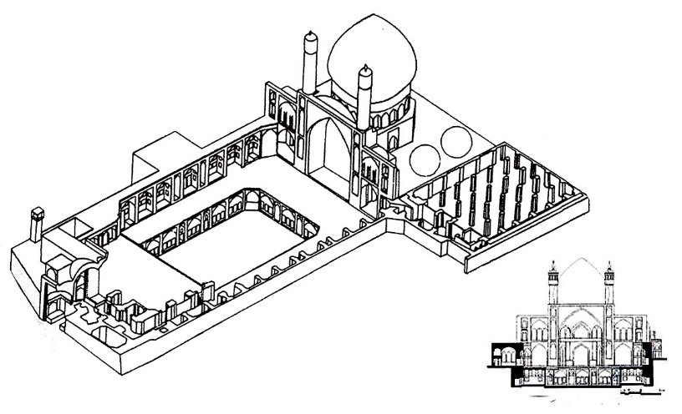
Figure 5: 3D view of Agha Bozorg Mosque, Kashan city, Iran (Haji Ghasemi, 1996)
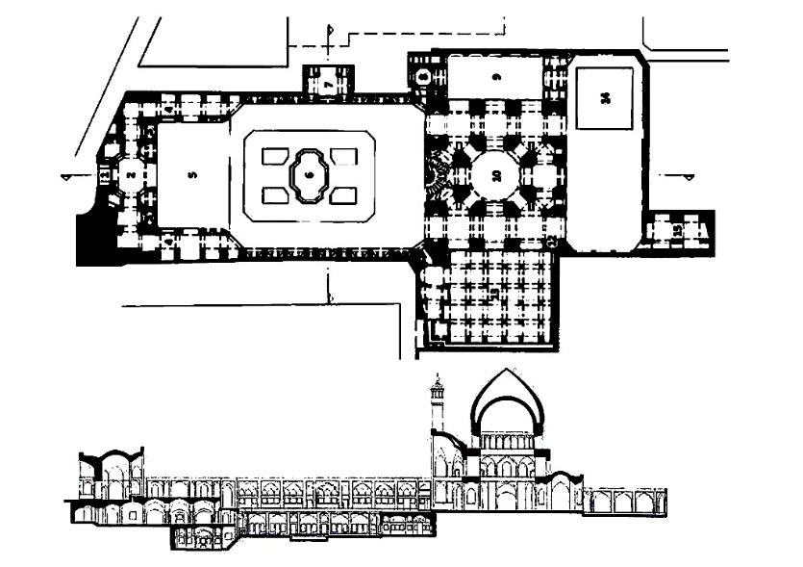
Figure 6: Plan and section of Agha Bozorg Mosque, Kashan city, Iran (Haji Ghasemi, 1996)

If the evolution of the decoration of Iranian mosques is considered from adobe to clay to faience mosaic and seven-color tiles, in the Agha Bozorg Mosque-madrasa, no attempt was made to cover the vast brick surfaces and even the dome - which is the main element giving identity to the mosque and one can see the dominant use of bricks throughout this building. The various decorations used in this building include Bannai script, seven-color tiles, brickwork, plaster and tile cornices, Moqarans, Thuluth script, Nastaliq script, painting, girih tiles, wood carvings, Rasmibandi, and Yazdibandi, among which the presence of Yazdibandi, which is rarely seen in non-residential and official buildings, such as mosques and schools, makes this building similar to the houses in Kashan in terms of decorations. Yazdibandi can be seen on both main sides of the building. Also, in the past, like all the sedaries in houses in Kashan, there were qavareh-bori sun motifs in the windows of this building, which were apparently removed due to their deterioration, and now, their empty locations can be seen in the gooshvarehs on both sides of the building (Deimary et al., 2021)(Figure7).

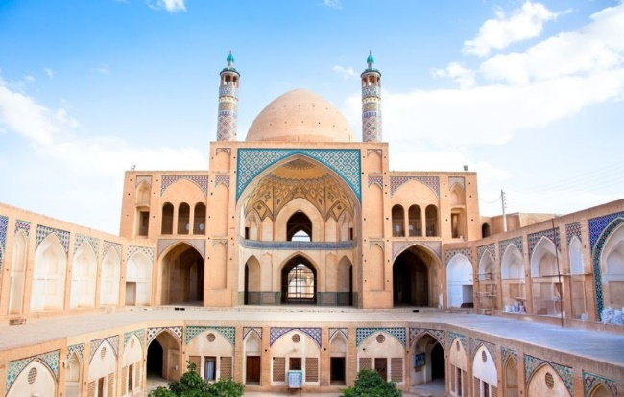
Figure 7: Image of Agha Bozorg Mosque, Kashan city, Iran.

Discussion and analysis
Many studies on the occurrence of spiritual emotions and states, as reviewed by Cahn and Polich in 2006, have related low-frequency alpha waves and theta waves to meditation (Cahn & Polich, 2006). Other research shows that in a spiritual state, a person is more relaxed but maintains his intense awareness (Kasamatsu & Hirai, 1966; A. Sadeghi habibabad & Ehsani Oskouei, 2026). However, statistical analysis in some studies shows that there is an increase in the activities of alpha and theta waves in spiritual states (Cahn & Polich, 2006; Chiesa & Serretti, 2010; Essawy, Kamel, & El-Sawy, 2014; A. Sadeghi habibabad & Ehsani Oskouei, 2026; A. Sadeghi Habibabad, Matracchi, P, 2021) (Figure 8).
In the present study, according to the investigations and recommendations presented in previous studies (Essawy et al., 2014; MahdiNejad, Azemati, Sadeghi Habibabad, & Matracchi, 2021; A. Sadeghi habibabad, De Cesaris, A, 2023; A. Sadeghi habibabad & Ehsani Oskouei, 2026; A. Sadeghi Habibabad et al., 2021; A. Sadeghi Habibabad, MahdiNejad, Azemati, & Matracchi, 2022; A. Sadeghi Habibabad, Matracchi, P, 2021), reaching the spiritual sense is examined with two factors: 1- The alpha wavelength 2- The theta /beta ratio.

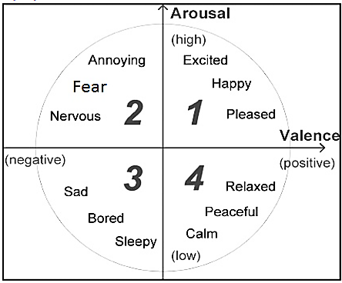
Figure 8. Circumplex model of affection (Russell, 2003)

To investigate the mental effects of the architectural space of the Agha Bozorg Mosque on its users, the data of the users' apha frequency and theta/beta ratio in four spaces of the mosque are discussed and investigated: 1- the courtyard, 2- the entrance porch, 3- the porch of the Gonbadkhane, 4- the Gonbadkhane of the mosque (Figures 9-16). As seen in the figures, the required data were recorded through three tests: 1. Normal mode test (recording the users' brain waves before entering the mosque), 2. Mosque test (recording the users' brain waves when they were in the mosque and there was no noise pollution), and 3. Mosque and sound test (recording the users' brain waves when they were in the mosque and exposed to noise pollution). Each test lasted 10 min and a 5-min break was considered between the tests to eliminate the effects of previous tests.
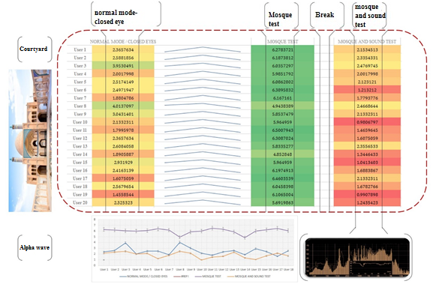
Figure 9: The results of recording alpha brain waves in the courtyard of the Agha Bozorg Mosque in Kashan
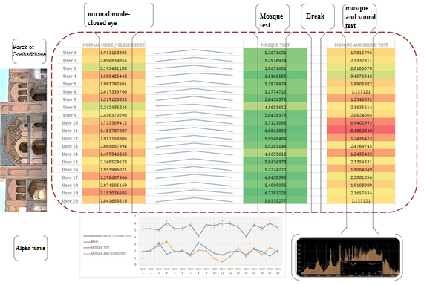
Figure 10: The results of recording alpha brain waves in the porch of the Gonbadkhane of the Agha Bozorg Mosque in Kashan
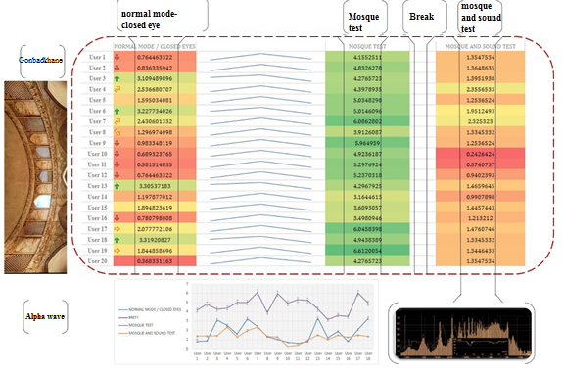
Figure 11: The results of recording alpha brain waves in the Gonbadkhane of the Agha Bozorg Mosque in Kashan

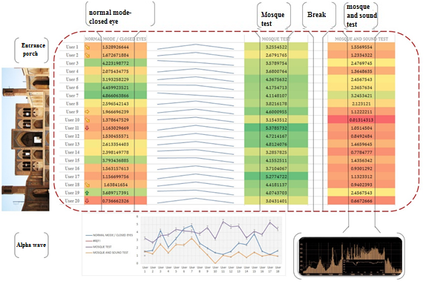
Figure 12: The results of recording alpha brain waves in the entrance porch of the Agha Bozorg Mosque in Kashan
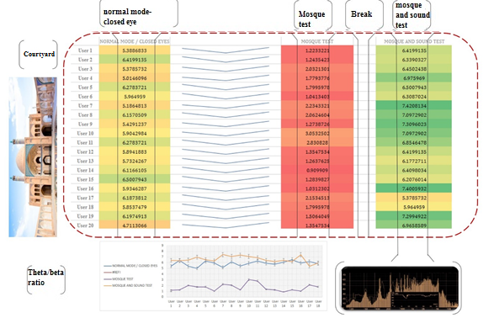
Figure 13: The results of recording the theta/beta ratio in the courtyard of the Agha Bozorg Mosque in Kashan

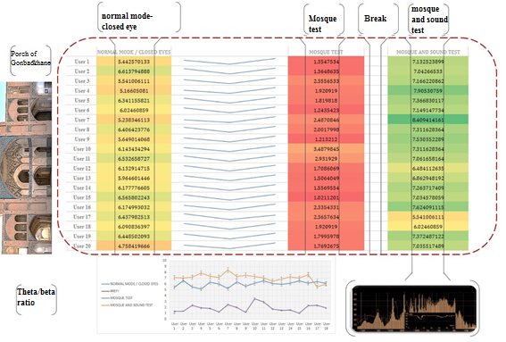
Figure 14: The results of recording the theta/beta ratio in the porch of the Gonbadkhane of the Agha Bozorg Mosque in Kashan.
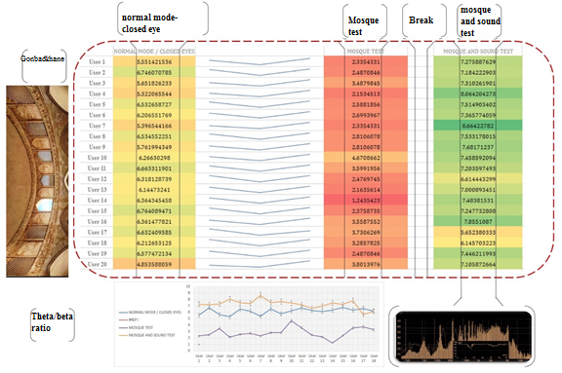
Figure 15: The results of recording the theta/beta ratio in the Gonbadkhane of the Agha Bozorg Mosque in Kashan.

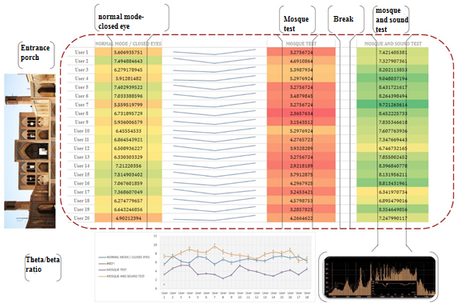
Figure 16: The results of recording the theta/beta ratio in the entrance porch of the Agha Bozorg Mosque in Kashan.

Analysis of data related to the space of the Agha Bozorg Mosque:
- In the case of the courtyard of the mosque, the results show an ascending trend for changes in alpha brain waves and average alpha for 92.17% of the users and a descending trend for 7.83% of the users. Also, the average theta/beta ratio had a descending trend among the majority of users (85.61%).
- In the case of the porch of the Gonbadkhane of the mosque, the results show an ascending trend for changes in alpha brain waves and average alpha for 87.93% of the users and a descending trend for 12.07% of the users. Also, the average theta/beta ratio had a descending trend among the majority of users (81.74%).
- In the case of the courtyard of the mosque, the results show an ascending trend for changes in alpha brain waves and average alpha for 81.03% of the users and a descending trend for 18.97% of the users. Also, the average theta/beta ratio had a descending trend among the majority of users (78.44%).
- In the case of the courtyard of the mosque, the results show an ascending trend for changes in alpha brain waves and average alpha for 72.39% of the users and a descending trend for 27.61% of the users. Also, the average theta/beta ratio had a descending trend among the majority of users (75.90%).

Figures (17-18) compare different spaces of the mosque in alpha waves and the theta/beta ratio. Also, according to the data analysis, the courtyard of the mosques has the greatest impact on the spiritual sense in the minds of the users, followed by the porch of the Gonbadkhane, Gonbadkhane, and entrance porch.

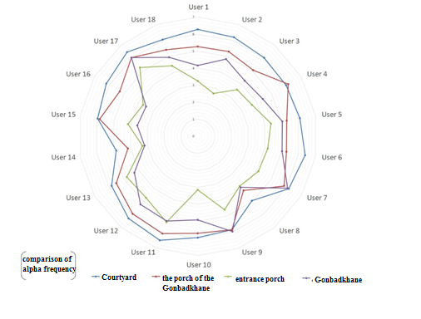
Figure 17: Comparison of different spaces of the Agha Bozorg Mosque mosque in changes in alpha frequency
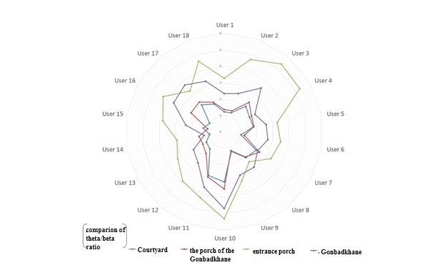
Figure 18: Comparison of different spaces of the Agha Bozorg Mosque mosque in the theta/beta ratio

Analysis of the data related to the playing of the undesirable urban sound (noise pollution) in the Agha Bozorg Mosque:
- In the case of the courtyard of the mosque along with playing an undesirable urban sound, the results show an ascending trend for changes in alpha brain waves and average alpha for 9.34% of the users and a descending trend for 90.66% of the users. Also, the average theta/beta ratio had an ascending trend for 81.40% of the users.
- In the case of the porch of the Gonbadkhane of the mosque along with playing an undesirable urban sound, the results show an ascending trend for changes in alpha brain waves and average alpha for 12.02% of the users and a descending trend for 87.98% of the users. Also, the average theta/beta ratio had an ascending trend for 88.41% of the users.
- In the case of the Gonbadkhane of the mosque along with playing an undesirable urban sound, the results show an ascending trend for changes in alpha brain waves and average alpha for 16.39% of the users and a descending trend for 83.61% of the users. Also, the average theta/beta ratio had an ascending trend for 91.21% of the users.
- In the case of the entrance porch of the mosque along with playing an undesirable urban sound, the results show an ascending trend for changes in alpha brain waves and average alpha for 19.72% of the users and a descending trend for 80.28% of the users. Also, the average theta/beta ratio had an ascending trend for 96.04% of the users.
The results of the data prove that the mentality of the majority of users is influenced and the spiritual sense is greatly reduced, which is a very important point when an unwanted urban sound (noise pollution) is played. This is a very important issue. Before playing the sound, the significant effects of the quality of environmental psychology on the users' minds in the architecture of the Agha Bozorg Mosque were observed while the introduction of a sensory component (i.e. noise pollution) made the results reversed (Figure19).
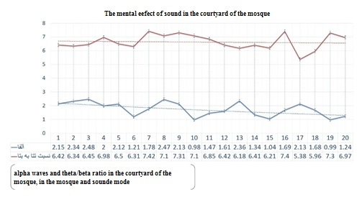
Figure 19: The results of the data on the alpha frequency and the theta/beta ratio in different spaces of the Agha Bozorg Mosque, Kashan, and the impact of noise pollution on the users of the mosque.

Conclusion
noise pollution directly plays a key role in reducing the spiritual sense of the users using the interior space of mosques, and paying attention to the location of these places in the city considering such sounds can improve the sensory quality of the architecture of mosques. Even the best type of mosque architecture is significantly influenced by such noise and its quality is reduced. Therefore, it is very necessary to pay attention to this important issue in the location of mosques. Noise pollution affects the mental state and spirit of individuals and causes a decrease in the psychological quality of architecture, especially in religious-cultural spaces. If the duration of exposure to noise pollution increases, it can increase the mental health of people using architectural and urban spaces and environments.
It is evident to all that religious places are the most important places formed to relax and communicate with absolute power. On the other hand, the health of the soul, peace of mind, and a life free from worries and troubles are considered the basic needs of humans. Attending the mosque and religious places brings mental and psychological comfort, peace, and divine mercy to individuals. Being in the mosque is a source of mental and psychological peace for individuals. Considering the importance of the mosque and religious places, it is very important to pay attention to the architecture of these buildings, i.e. attention to all physical components and sensory features with positive or negative effects on the minds of the users. The present research showed that the sensory component of sound, which was an undesirable sound in the present study, greatly influences the quality of the environment and changes the users' spiritual sense. Therefore, it is important to pay attention to and deal with annoying sounds and noise pollution in such buildings, and it is considered important to pay attention to the successful location and acoustic features of these buildings and use new construction technologies in this field provided that spiritual concepts and sacred arts are preserved in the architecture of the building.

Limitations
The present study has several limitations. First, the investigation was limited to a single case study, namely Agha Bozorg Mosque in Kashan, Iran. Therefore, the findings should be interpreted within the environmental and architectural context of this historical mosque and cannot be directly generalized to all religious buildings. Second, due to the time-consuming nature of EEG recording and the necessity of maintaining controlled experimental conditions, the sample size was limited to twenty voluntary participants selected through purposive convenience sampling. Finally, only one type of undesirable sound source, namely urban traffic noise, was examined. Other environmental sounds may produce different psychological and neurophysiological responses.

Future Research Directions
Future studies are recommended to investigate larger and more diverse samples, including participants of different genders and age groups. Comparative analyses among historical mosques and other religious buildings in different geographical and cultural contexts may provide a broader understanding of the relationship between acoustic environments and spiritual perception. In addition, future research could examine the effects of various sound sources, such as natural sounds, Quranic recitation, and human activities, on users' psychological and spiritual responses using EEG and other physiological measurement techniques. Longitudinal studies are also recommended to evaluate the long-term influence of noise exposure on the perceived quality of religious architectural environments.

Compliance with Ethical Standards
Disclosure of potential conflicts of interest: The authors declare that no financial support or funding was received for this study. The research was conducted independently, and no funding body had any role in the study design, data collection, analysis, interpretation, or manuscript preparation.
Ethics Statement: At the time the study was conducted, the authors’ affiliated institution did not maintain a formal Institutional Review Board (IRB) or research ethics committee responsible for reviewing non-clinical human-participant research projects of this type. Therefore, no formal ethics approval number was available for this study. Nevertheless, the research was conducted in full accordance with internationally accepted ethical principles for human-participant research. All participants were fully informed about the objectives of the study, the experimental procedures, the voluntary nature of participation, and the use of anonymized data for academic research and publication purposes. Written informed consent was obtained from all participants prior to participation. Participants were informed that they could withdraw from the study at any time without any negative consequences. The EEG recording procedure used in this study was entirely non-invasive and involved minimal risk. All participants were healthy adult volunteers. No personally identifiable sensitive information was collected, and confidentiality and anonymity were maintained throughout all stages of the research process and data analysis.

References
Agarwal, S., & Swami, B. L. (2011). Road traffic noise, annoyance and community health survey-a case study for an Indian city. Noise and health, 13(53), 272-276. doi:10.4103/1463-1741.82959
Ahmadi Kanrash, F., Alimohammad, I., Abolaghasemi, J., & Rahmani, K. (2019). A Study of Mental and Physiological Effects of Chronic Exposure to Noise in an Automotive Industry. Iranian Journal of Ergonomics, 7(1), 54-62. doi:10.30699/jergon.7.1.54
Al Shimemeri, S., & Patel, C. B. (2011). Assessment of noise levels in 200 Mosques in Riyadh, Saudi Arabia. Avicenna journal of medicine, 1(02), 35-38. doi:10.4103/2231-0770.90914
Alaghmand, S., Salehi, S., & Mozaffar, F. (2017). A comparative study of architecture and content of Iran’s schools from the traditional era to the modern era.
Alberdi, E., Martellotta, F., Galindo, M., & León, Á. L. (2019). Dome sound effect in the church of San Luis de los Franceses. Applied acoustics, 156, 56-65. doi:10.1016/j.apacoust.2019.06.030
Bahram, S. (1986). An introduction to the knowledge of the environment. Department of Environment Press(Tehran).
Bani Asadi, b. (2019). Noise pollution and its effects on human health. Shiraz E-Medical Journal, 90.
Blood, A. J., Zatorre, R. J., Bermudez, P., & Evans, A. C. (1999). Emotional responses to pleasant and unpleasant music correlate with activity in paralimbic brain regions. Nature neuroscience, 2(4), 382-387. doi:10.1038/7299
Cahn, B. R., & Polich, J. (2006). Meditation states and traits: EEG, ERP, and neuroimaging studies. Psychological bulletin, 132(2), 180. doi:10.1037/0033-2909.132.2.180
Cain, R., Jennings, P., & Poxon, J. (2013). The development and application of the emotional dimensions of a soundscape. Applied acoustics, 74(2), 232-239. doi:10.1016/j.apacoust.2011.11.006
Carmona, M. (2021). Public places urban spaces: The dimensions of urban design: Routledge.
Carvalho, A. P. (2009). Comparison of the acoustics of mosques and catholic churches. Paper presented at the Proceedings of the 16th….
Chiesa, A., & Serretti, A. (2010). A systematic review of neurobiological and clinical features of mindfulness meditations. Psychological medicine, 40(8), 1239-1252. doi:10.1017/S0033291709991747
Crisler, B. C. (1976). The Acoustics and crowd capacity of natural theaters in Palestine. The Biblical Archaeologist, 39(4), 128-141. doi:10.2307/3209424
De Kluijver, H., & Stoter, J. (2003). Noise mapping and GIS: optimising quality and efficiency of noise effect studies. Computers, environment and urban systems, 27(1), 85-102. doi:10.1016/S0198-9715(01)00038-2
Deimary, N., Goli, B. M. N., & Touranpour, M. (2021). Investigating architectural patterns of Kashan traditional houses in the design of Aghabozorg mosque-school.
Egunjobi, L. (1986). Urban environmental noise pollution in Nigeria. Habitat International, 10(3), 235-244.
Elkhateeb, A., Adas, A., Attia, M., & Balila, Y. (2016). Absorption characteristics of masjid carpets. Applied acoustics, 105, 143-155. doi:10.1016/j.apacoust.2015.12.005
Essawy, S., Kamel, B., & El-Sawy, M. S. (2014). Sacred buildings and brain performance: The effect of Sultan Hasan Mosque on brain waves of its users.
Farcaş, F., & Sivertunb, Å. (2010). Road traffic noise: GIS tools for noise mapping and a case study for Skåne region. Sweden: Citeseer.
Farrokh Yar, H. (1991). A look at historical monuments (Kashan). Tehran: Moalef Publications.
FATHI, S., NASSIRI, P., MONAZZAM, E. P. M., MANSOURI, N., & RAZZAGHI, B. F. (2015). Study of noise pollution in the district 5 of tehran municipally.
Field, T., Martinez, A., Nawrocki, T., & Pickens, J. (1998). Music shifts frontal EEG in depressed adolescents. Adolescence, 33(129), 109.
Frescura, A., Lee, P. J., Jeong, J.-H., & Soeta, Y. (2021). Electroencephalogram (EEG) responses to indoor sound sources in wooden residential buildings. Paper presented at the INTER-NOISE and NOISE-CON Congress and Conference Proceedings.
Ghafari, H. P. A., A. (2016). Investigating the effect of music on brain waves: a quantitative electroencephalography study. Shabak Journal, 3(10), 71-83.
Ghaffari, A., & Gholizadeh, F. (2022). Analysis of the Impact of Volume Changes on Acoustic Behavior in Mosques; Case Study: the Historic Mosques of Tabriz. Journal of Iranian Architecture & Urbanism (JIAU), 13(2), 197-210. doi:10.30475/isau.2021.230007.1410
Ghaffari, A., Mirgholami, M., & Shafaei, B. (2021). Explaining the acoustical behavior and the soundscape quality of Tabriz Bazaar based on the objective and subjective assessments. Motaleate Shahri, 10(39), 83-98. doi:10.34785/J011.2021.714
Gholizadeh, F., Ghaffari, A., & Keynejad, M. (2022). The Effect of Plan and Formal Geometry of Mosques on the Acoustic Quality of Architecture Case Study: Historical Mosques of Tabriz. Journal of Architecture and Urban Planning, 14(35), 95-110.
Gobe, M. (2010). Emotional branding: The new paradigm for connecting brands to people: Simon and Schuster.
Graziano, A. B., & Johnson, J. K. (2015). Music, neurology, and psychology in the nineteenth century. Progress in Brain Research, 216, 33-49. doi:10.1016/bs.pbr.2014.11.002
Gül, Z. S., & Çalışkan, M. (2013). Impact of design decisions on acoustical comfort parameters: Case study of Doğramacızade Ali Paşa Mosque. Applied acoustics, 74(6), 834-844. doi:10.1016/j.apacoust.2012.12.006
Haji Ghasemi, K. (1996). Ganjnameh Mansions of Kashan. Tehran: Shahid Beheshti University.
Hamadah, H. A., & Hamouda, H. M. (1998). Assessment of speech intelligibility in large auditoria case study: Kuwait State Mosque. Applied acoustics, 54(4), 273-289. doi:10.1016/S0003-682X(97)00095-9
Hao, Y. (2014). Effects of urban morphology on urban sound environment from the perspective of masking effects. University of Sheffield, Retrieved from https://etheses.whiterose.ac.uk/id/eprint/7775/1/thesis-yiying-final%20submission.pdf
Hayne, M., Rumble, R., & Mee, D. (2006). Prediction of crowd noise. Paper presented at the Proceedings of the first australasian acoustical societies conference.
Hayne, M., Taylor, J., Rumble, R., & Mee, D. (2011). Prediction of noise from small to medium sized crowds. Proceedings of ACOUSTICS 2011, 1-7.
Heidari, A. A., Peyvastehgar, Y., & Heydari, F. (2018). Interpretation of Islamic beliefs and thoughts implementations in masque and school architecture of Agha Bozorg Kashan. Journal of Architectural Thought, 2(3), 15-28.
Heidari, M., & Shahbazi, S. (2013). Effect of Quran and music on anxiety in patients during endoscopy. Knowledge and health, 8(2).
Hwang, S., Jebelli, H., Lee, S., Chung, S., & Lee, S. (2020). Measurement of Individuals' Emotional Stress Responses to Construction Noise through Analysis of Human Brain Waves. Paper presented at the International conference on construction engineering and project management.
Jeon, J. Y., Jo, H. I., & Polack, J.-D. (2019). Evaluation of soundscape and audio-visual factors in VR environment for quiet urban park. Paper presented at the INTER-NOISE and NOISE-CON Congress and Conference Proceedings.
Jeon, J. Y., Lee, P. J., & Hong, J. Y. (2011). Effects of contexts on perception of urban soundscape. The Journal of the Acoustical Society of America, 129(4_Supplement), 2570-2570. doi:10.1121/1.3588481
Jeon, J. Y., Ryu, J. K., & Lee, P. J. (2010). A quantification model of overall dissatisfaction with indoor noise environment in residential buildings. Applied acoustics, 71(10), 914-921. doi:10.1016/j.apacoust.2010.06.001
Kasamatsu, A., & Hirai, T. (1966). An electroencephalographic study on the Zen meditation (Zazen). Psychiatry and Clinical Neurosciences, 20(4), 315-336. doi:10.1111/j.1440-1819.1966.tb02646.x
Katorani, S. (2019). Evaluation of the noise pollution caused by urban traffic and its effect on the level of anxiety of citizens in the city of Sanandaj. Motaleate Shahri, 8(32), 117-127. doi:10.34785/J011.2019.756
Kheradpisheh, A. a. E. N., A. (2015). Manifestation of Shi'ia thought in architectural decorations and urban planning (Agha Bozorg Mosque, Kashan). The First Specialized Conference on Architecture and Urban Planning in Iran, Shiraz.
Kiani Sadr, M., Nassiri, P., Sekhavatjo, M. S., & Abbaspour, M. (2009). Noise pollution assessment in Khoramabad to presenting executive strategies to control or reduce it. Journal of Environmental Studies, 35(51). doi:20.1001.1.10258620.1388.35.51.9.1
Kim, R., & Van den Berg, M. (2010). Summary of night noise guidelines for Europe. Noise and health, 12(47), 61-63.
Lam, K.-C., Ng, S.-L., Hui, W.-C., & Chan, P.-K. (2005). Environmental quality of urban parks and open spaces in Hong Kong. Environmental monitoring and assessment, 111(1), 55-73. doi:10.1007/s10661-005-8039-2
Lee, P. J., & Jeon, J. Y. (2013). Relating traffic, construction, and ventilation noise to cognitive performances and subjective perceptions. The Journal of the Acoustical Society of America, 134(4), 2765-2772. doi:10.1121/1.4818776
Lee, P. J., & Kang, J. (2015). Effect of height-to-width ratio on the sound propagation in urban streets. Acta Acustica united with Acustica, 101(1), 73-87. doi:10.3813/AAA.918806
Lee, S. C., Lee, P. J., & Jeon, J. Y. (2012). Assessment of annoyance caused by different types of construction noises. The Journal of the Acoustical Society of America, 131(4_Supplement), 3502-3502. doi:10.1121/1.4709235
Long, M. (2005). Architectural acoustics: Elsevier.
Lotfi, S., Hariri, G., & SHAHABI, S. M. (2017). Examining the Role of Olfactory and Auditory Perceptual Expectations in Urban Planning and Design, Case Study: Babol.
MahdaviNejad, M. J. (2003). The interaction of Iranian music and Christian music. Honar-ha-ye Ziba, 14(14).
MahdiNejad, J.-e.-D., Azemati, H., Sadeghi Habibabad, A., & Matracchi, P. (2021). Investigating the effect of age and gender of users on improving spirituality by using EEG. Cognitive Neurodynamics, 15(4), 637-647. doi:10.1007/s11571-020-09654-x
Majidi, S. (2003). The effect of Quran on stress level in patients before angiography. Journal of Maarefat, 60, 18-21.
Marathe, P. (2012). Traffic noise pollution. Ijed, 9(1), 63-68.
Marzbani, H., Marateb, H. R., & Mansourian, M. (2016). Neurofeedback: a comprehensive review on system design, methodology and clinical applications. Basic and clinical neuroscience, 7(2), 143. doi:10.15412/J.BCN.03070208
Meng, Q., & Kang, J. (2015). The influence of crowd density on the sound environment of commercial pedestrian streets. Science of the total environment, 511, 249-258. doi:10.1016/j.scitotenv.2014.12.060
Mohamad Zadeh, R. (2010). The Role of Physical Planning in Reduction of Noise Pollution. Human & Environment, 8(13), 21-28.
Monavvari, M. (1994). Guidelines for Assessing of Effects of Highways’ Environmental Ecosystems. Tehran: The Organization of Conservation of Environment Press. 1999 (In Persian). 23. Dabiri M. Environmental Pollution. Tehran: Tehran University Press.
Moradi Nasab, H. a. M., A. (2014). Spatial creativity of the urban landscape of Iranian architecture in the Qajar mosque-madrasa. National Conference on Sustainable Urban Landscape and Architecture, Mashhad.
Naraqhi, H. (1969). Historical monuments of Kashan and Natanz cities. Tehran: Society for the National Heritage of Iran.
Nejad, M., Azemati, H., & Sadeghi HabibAbad, A. (2019). Strategic explanation of the components of spirituality in Iranian mosques architecture. National Studies Journal, 20(78), 77-94.
Nejad, M., Azemati, H. R., & Habibbad, A. (2019). Ranking of Spiritual Tranquility Indicators in Traditional Mosque Architecture Based on Perception of. Journal of Ontological Researches, 7(14), 59-82.
Nowoświat, A., Olechowska, M., & Marchacz, M. (2020). The effect of acoustical remedies changing the reverberation time for different frequencies in a dome used for worship: A case study. Applied acoustics, 160, 107143. doi:10.1016/j.apacoust.2019.107143
Oral, G. K., Yener, A. K., & Bayazit, N. T. (2004). Building envelope design with the objective to ensure thermal, visual and acoustic comfort conditions. Building and Environment, 39(3), 281-287. doi:10.1016/S0360-1323(03)00141-0
Othman, A. R., & Mohamed, M. R. (2012). Influence of Proportion towards Speech Intelligibility in mosque's praying hall. Procedia-Social and Behavioral Sciences, 35, 321-329. doi:10.1016/j.sbspro.2012.02.094
Owen, O. S. (1971). Natural Resource Conservation: An Ecological Approach.
Parkes, A., Kearns, A., & Atkinson, R. (2002). What makes people dissatisfied with their neighbourhoods? Urban studies, 39(13), 2413-2438. doi:10.1080/0042098022000027031
Rafieeyan, Z., Azarbarzin, M., & Safaryfard, S. (2009). The effect of music therapy on anxiety, pain, nausea and vital signs of caesarean section clients in Dr. Shariatee hospital of Esfahan in 2006. Medical Science Journal of Islamic Azad Univesity-Tehran Medical Branch, 19(1), 25-30.
Russell, J. A. (2003). Core affect and the psychological construction of emotion. Psychological review, 110(1), 145. doi:10.1037/0033-295X.110.1.145
Sadeghi HabibAbad, A. (2020). Explaining and Measuring the Factors Affecting the “Sense of Spirituality” in the Mosques Based on Improving the Architectural Quality Using Cognitive Neuroscience. Doctoral thesis, Shahid Rajaee Teacher Training University, Architecture Department, Tehran, Iran. doi:10.13140/RG.2.2.15645.74725/
Sadeghi habibabad, A. (2026). Identity and Nature of Islamic Sacred Architecture. Ethics International Press(Cambridge, UK), 1-218.
Sadeghi habibabad, A., De Cesaris, A. (2023). Psychological Study Of Brain Waves In The Face Of Sound Intensity In The Architecture Of Cultural-Religious Spaces With Emphasis On The Quality Of Environmental Psychology And Creating A Sense Of Spirituality. Postdoctoral dissertation in Architectural Engineering, Sapienza University of Rome, Italy. doi:10.13140/RG.2.2.20331.92961
Sadeghi habibabad, A., & Ehsani Oskouei, S. F. (2026). Assessing environmental psychology and the mental effects of geometric patterns in architecture using EEG. npj Heritage Science. doi:10.1038/s40494-026-02674-6
Sadeghi Habibabad, A., MahdiNejad, J.-e.-D., Azemati, H., & Matracchi, P. (2021). Examination of the psychological impact and brainwaves functioning of the users of buildings and environments built based on promoting relaxation and spiritual sense. Journal of spirituality in mental health, 23(4), 363-380. doi:10.1080/19349637.2020.1738311
Sadeghi Habibabad, A., MahdiNejad, J.-e.-D., Azemati, H., & Matracchi, P. (2022). Using neurology sciences to investigate the color component and its effect on promoting the sense of spirituality in the interior space of the Vakil Mosque of Shiraz (using quantitative electroencephalography wave recording). Journal of Religion and Health, 61(3), 2398-2415. doi:10.1007/s10943-019-00937-0
Sadeghi Habibabad, A., & Matracchi, P. (2025). Analysis of Environmental Factors Influencing the Sense of Tranquility in the Architecture of Religious Spaces through Biofeedback Measurement of Users’ Physiological Responses. Naqshejahan-Basic studies and New Technologies of Architecture and Planning, 15(4), 47-70. doi:10.48311/bsnt.2025.116684.82878
Sadeghi Habibabad, A., Matracchi, P. (2021). Explaining and Evaluating the Effects of light on Creating Spirituality in Architecture of Cultural and Religious Environments with an Emphasis on Environmental Psychology Quality using (EEG) (Case study: Churches and Islamic Mosques). Postdoctoral dissertation in Architectural Engineering, University of Florence, Italy. doi:10.13140/RG.2.2.26203.28968/1
SADEGI, M., Kheyri, S., JAFARI, D. A., & Shahrani, M. (2007). Sound level in a ten year period in Shahrekord City.
Savasdisara, T. (1988). Resident's satisfaction and neighbourhood characteristics in Japanese urban communities. Landscape and Urban Planning, 15(3-4), 201-210. doi:10.1016/0169-2046(88)90045-X
Sazgarnia, A., Bahreyni Toossi, M., & Moradi, H. (2005). Noise pollution and traffic noise index on mashhad main streets during the busiest hours of summer. Iranian journal of medical physics, 2(3), 21-30.
Schmidt, L. A., & Trainor, L. J. (2001). Frontal brain electrical activity (EEG) distinguishes valence and intensity of musical emotions. Cognition & Emotion, 15(4), 487-500. doi:10.1080/02699930126048
Shahi, J. (2010). Traffic Engineering. Tehran: Daneshgahi Publications.
Sheikh, M., & Mitchell, A. (2018). Design strategies for perceived acoustic comfort in urban environments–A literature review. Paper presented at the Proceedings of ACOUSTICS.
Stansfeld, S., Haines, M., & Brown, B. (2000). Noise and health in the urban environment. Reviews on environmental health, 15(1-2), 43-82.
Stevens, F. (2018). Strategies for Environmental Sound Measurement, Modelling, and Evaluation. University of York, Retrieved from https://etheses.whiterose.ac.uk/id/eprint/22661/
Suárez, R., Alonso, A., & Sendra, J. J. (2018). Virtual acoustic environment reconstruction of the hypostyle mosque of Cordoba. Applied acoustics, 140, 214-224. doi:10.1016/j.apacoust.2018.06.006
Suárez, R., Sendra, J., Navarro, J., & León, A. (2005). The sound of the cathedral-mosque of Córdoba. Journal of cultural heritage, 6(4), 307-312. doi:10.1016/j.culher.2005.03.005
Sudarsono, A. S. (2017). Soundscape composition and relationship between sound objects and soundscape dimensions of an urban area: University of Salford (United Kingdom).
Sweeney, J. C., & Wyber, F. (2002). The role of cognitions and emotions in the music‐approach‐avoidance behavior relationship. Journal of services marketing, 16(1), 51-69. doi:10.1108/08876040210419415
Szeremeta, B., & Zannin, P. H. T. (2009). Analysis and evaluation of soundscapes in public parks through interviews and measurement of noise. Science of the total environment, 407(24), 6143-6149. doi:10.1016/j.scitotenv.2009.08.039
Tolaei, S. (2004). The city and its environmental consequences. Geographical Research(33).
Weitze, C. A., Rindel, J. H., Christensen, C. L., & Gade, A. C. (2002). The acoustical history of Hagia Sophia revived through computer simulation. Paper presented at the Forum Acusticum.
Yang, W., & Kang, J. (2005). Acoustic comfort evaluation in urban open public spaces. Applied acoustics, 66(2), 211-229. doi:10.1016/j.apacoust.2004.07.011
Yousefi Bile Savar, S. (2012). Investigating the role of music in the effectiveness of health issues in Radio Salamat (from the point of view of experts and audiences). Institute for Humanities and Cultural Studies, 10(60).
YousefinejadOstadkelayeh, A., Madadi, A., Majedzadeh, S., Shabannia, R., Sadeghian, N., Zarinara, A., . . . Jaddian, A. (2005). The effect of music therapy on chronic pain in patients with cancer. Journal of Inflammatory Diseases, 9(9), 39-42. e155113.
Zare, M., & Birashk, B. (2009). The Effect of Music Therapy on Reducing Agitation in Patientswith Alzheimer’s Disease in Shahryar City Nursing Home. Advances in Cognitive Science, 11(2), 55-62.
Zomorshidi, H., & Sadeghi, H. A. (2018). Brick and art of brickwork since ancient times to now.

This article is derived from a research project conducted by the author in 2022 at Sapienza University of Rome, Italy, under Contract No. [n. 476 – III/14]. The project provided the scientific framework and experimental basis for the present study.

