A Process-Generating Framework for Curriculum Planning in Architectural Foundation Studio
Devising a Morphological Matrix at the Iran University of Art

Abstract
Architectural foundation studios operate within complex educational environments where curriculum planning must reconcile disciplinary traditions, institutional priorities, professional expectations, and rapidly evolving societal and technological conditions. Although previous research has substantially advanced studio pedagogy, competency development, and first-year architectural education, transferable frameworks that systematically support curriculum generation, planning, and evaluation remain limited. Addressing this gap, this study develops a process-generating framework for architectural foundation studio curriculum design. A qualitative hybrid methodology, combining conceptual framework development and educational action research, was adopted and demonstrated through the first-year architecture program at the Iran University of Art as a locally grounded case. The proposed workflow comprises five phases: context mapping; identification and validation of curriculum criteria through cross-domain triangulation and expert consensus; operationalization of the criteria into educational purposes, methods, and cases; modeling through a three-dimensional morphological matrix; and demonstration through application within the studio curriculum. The study identifies seven core curriculum criteria—arts, senses, attachment, design domains, volumetric languages, skills, and approaches—and demonstrates how they can be systematically translated into coherent, adaptable, and context-responsive semester programs. Rather than prescribing a fixed curriculum or promoting a particular pedagogical philosophy, the proposed framework provides a transparent decision-support methodology for generating and refining architectural foundation studio curricula. Its principal contribution is a transferable methodological workflow that explicitly distinguishes between a general curriculum-generation framework and its case-specific implementation, bridging curriculum theory and the practical planning requirements of architectural education while remaining adaptable to diverse institutional and cultural contexts.
Keywords: Architectural education, Conceptual framework, Process generating framework, First year studio, Iran University of Art

Introduction
Architectural education operates within a rapidly evolving environment shaped by changing professional practice, educational theories, technological developments, institutional policies, and local socio-cultural conditions. Designing a coherent curriculum for the architectural foundation studio therefore requires balancing numerous interacting variables rather than following a fixed sequence of topics.
Historically, architectural education was shaped by enduring paradigms such as the Bauhaus, whose modern principles influenced education for over a century. Today, however, the educational landscape has become far more dynamic and complex. Architectural education now requires the simultaneous integration of artistic, technical, contextual, and professional considerations, making explicit curriculum decision-making particularly important. Despite this complexity, empirical research indicates that architectural educators rarely employ structured pedagogical principles or curriculum frameworks, instead relying on intuition and personal practice (Johannes, 2005; Salama, 2015). They also often lack formal pedagogical training and tend to replicate the methods through which they were taught (Webster, 2008).
Contemporary curriculum theory recognizes curriculum design as a systematic process that organizes educational intentions into coherent learning experiences rather than merely compiling course content (Fink, 2003; Ornstein and Hunkins, 2018). Consequently, increasing attention has been given to flexible planning frameworks that support informed educational decision-making while remaining adaptable to different institutional contexts (McKenney and Reeves, 2018; Plomp and Nieveen, 2013).
This challenge becomes particularly significant within centralized educational systems such as Iran, where nationally prescribed curricula, institutional priorities, disciplinary traditions, and rapidly changing professional demands must all be negotiated simultaneously. As studies show, standardized architectural curricula frequently struggle to align with professional practice demands or postgraduate entry requirements, creating an operational gap that independent educational centers increasingly seek to fill (Simoni and Abbasi, 2020).
Consequently, it is vital to shift toward process-generating planning frameworks that integrate macro-contextual determinants while actively empowering instructors. A resilient curriculum framework must allow studio coordinators to satisfy mandatory national programs and institutional criteria while remaining free to think, decide, and design innovative exercises tailored to real-time classroom dynamics. To address this gap, this study develops and validates an adaptable, process-generating framework for curriculum decision-making in first-year undergraduate architectural design studios, using the foundational curriculum mapping conducted at the Iran University of Art as a contextual baseline to demonstrate its practical applicability.

1. Literature Review
Curriculum design in higher education has evolved from compiling static syllabi into a systematic domain of instructional architecture (Ornstein and Hunkins, 2018). Modern design rejects linear, isolated teaching methods, favoring relational frameworks that integrate underlying values, instructional strategies, and institutional constraints (Fink, 2003; Toohey, 1999). Biggs and Tang (2011) emphasize that quality learning requires the precise operationalization of educational intentions, aligning pedagogical objectives directly with active learning formats.
To achieve this systemic coherence, curriculum theory mandates that a thorough situational evaluation logically and systematically precede specific curriculum decision-making (Print, 1993). This contextual requirement is anchored in Skilbeck’s (1976) situational model, which dictates balancing external curriculum determinants (national standards, professional requirements) against internal frame factors (department resources, workgroup capabilities). When developed as deliberate educational interventions, these planning structures require strong theoretical and empirical grounding to ensure long-term viability (McKenney and Reeves, 2018; Plomp and Nieveen, 2013). Consequently, tertiary educational research values the generation of process-oriented design principles that provide transferable, procedural workflows rather than rigid, unchangeable blueprints (Khamidova, 2024; McKenney and Reeves, 2018).
In architecture education, studio pedagogy has evolved from instructor-centred models emphasizing formal composition, technical drawing, and disciplinary knowledge, such as the Beaux-Arts and Bauhaus traditions, toward increasingly learner-centred, collaborative, and context-responsive approaches. From the 1970s onward, diverse pedagogical models introduced experimentation, analogy, community engagement, pattern languages, concept testing, exploratory learning, and interactive design processes, shifting the focus from predetermined solutions to critical inquiry and iterative problem-solving. Since the 2000s, this evolution has further expanded to include process-based learning, digital technologies, design-build education, live projects, and socially engaged pedagogies that emphasize collaboration, making, and real-world engagement. More recently, the COVID-19 pandemic accelerated the integration of online learning, virtual collaboration, and digital assessment methods, reinforcing flexibility, resilience, and hybrid educational practices within architectural design studios (based on Salama and Osborne Borton, 2022). As this historical progression demonstrates, substantial variations have emerged in design processes, educational models, teaching and learning techniques, dominant architectural theories, and studio content, reflecting continuous developments in architectural theory and practice, educational theories and pedagogical approaches, as well as broader social, theoretical, and technological transformations.
In architectural education, curriculum design challenges multiply due to the field's highly multidisciplinary, multi-criteria nature, which resists single-theory frameworks (Kadhim, 2024). Historically centered around the design studio, architectural curriculum design must explicitly bridge abstract academic aims and practical, real-world execution (Djurić et al., 2026). Djurić et al. (2026) establish that contemporary studio pedagogy requires responsive planning models that intentionally link localized educational objectives with long-term professional readiness and spatial competencies.
This continuous friction between traditional academic structures and evolving professional demands has driven a global movement toward pedagogical innovation and structural transformation within architectural schools (Parrales Rodríguez and Coto Alfaro, 2025). Modern architectural curricula must move away from content-heavy schedules to focus on futures-oriented competencies that prepare students for emerging socio-technical disruptions (Parrales Rodríguez and Coto Alfaro, 2025).
To navigate this fluid landscape, programs are increasingly restructured around comprehensive graduate capabilities, allowing design tasks to systematically scaffold student development from simple, experiential spatial projects to complex, analytical tectonic systems (Ng, 2020). This systematic organization is vital for cultivating advanced project-based thinking within the studio, where the curriculum acts as a dynamic planning matrix that balances collaborative problem-solving, volumetric languages, and technical precision (Xalmamatova and Mardov, 2026).
There are plenty of studies on first-year architectural education, but most of them showcase a studio, while others defend or evaluate a specific theory or method. Few studies are similar to ours, contributing a model, framework, or similar tool. Baum (2013) researched architecture schools in the United States, focusing on the goals, methodology, and content of a first-year design course that applies educational theory and practice, including a hierarchical structure of goals based on the idea of scaffolding. At the Istanbul Technical University Faculty of Architecture, Erkök et al. (2005) investigate a novel approach to first-year design education in terms of concepts, values, and techniques. This approach merges various courses into a single studio. Thompson et al. (2021) present a study that introduces a model for the first year of architecture, drawing on the experience of a UK architecture school, where teamwork is emphasized throughout various course modules and projects.
Many resources in Iran explore the history and theoretical foundations of architectural education (Qayyoomi Bidhendi and Sepehri, 2016; Gharavi Alkhansari, 2022; Ansari, 2016; Nadimi, 2005; Akrami, 2003; Hojjat, 2003). Other notable sources are the programs regulated by the Supreme Council of Planning (SCP, 1996; SCP, 1998) and top-tier universities, mandated for implementation by the Ministry of Science, reflecting national architectural education policies and aspirations from the 1979 Islamic Revolution onwards. Other resources include recent articles by architectural educators and experts that discuss the experiences and criticisms of architectural education today, especially the proceedings of "The Conference on Architecture Education" hosted by the University of Tehran (School of Architecture, 2009; School of Architecture, 2014b).
References on architectural first-year education typically cover the first three semesters, known as the Foundational Period. A PhD dissertation from Shahid Beheshti University examines the gap between theory and practice in this period (Vahidi, 2004). Motiei et al. (2019) study this period and advocate for combined education. Talischi et al. (2013) recommend a constructivist instructional design approach to foster design ability in novice architecture students. Constructivist education has implications such as role redefinition, skill enhancement, individualized attention, active engagement, mental construction, reflection, and evaluation (Vahabi and Hojjat, 2023). Additional research compares the curricula of international and Iranian universities and introduces foundational courses in three categories: core skills, complementary skills, and specialized fundamental knowledge (Gharibpour and Toutounchi, 2016). The term "model" in architectural education appears in research by Moosavi et al. (2019), who present an interactive method, and in a survey by Zoorvarzi et al. (2022), which examines master's students' opinions based on Salama's ten categories.
As seen, much of the curriculum design literature emphasizes the importance of conceptual frameworks, yet the architectural education literature, both internationally and in Iran, lacks studies that develop such tools. Most studies present a studio model or a pedagogical method, while only a few propose conceptual models. Even fewer generate curriculum design processes that can accommodate different educational philosophies and contexts. In Iran, where this study is situated, no comparable study has been conducted to the best of our knowledge.

2. Materials and Methods

2.1. Research Methodology
This inquiry is situated within the qualitative research paradigm. It seeks to generate a transferable and systematic procedural workflow through which curriculum planning decisions can be progressively formulated, justified, and organized. This approach aligns with the fundamentally interactive and systemic nature of qualitative research design (Maxwell, 2005).
The methodology synthesizes two major qualitative traditions: conceptual framework development and educational action research. Drawing on grounded theory traditions, Jabareen (2009) argues that a conceptual framework is not merely a collection of variables but rather "a network, or 'a plane,' of interlinked concepts that together provide a comprehensive understanding of a phenomenon or phenomena" (p. 51). Likewise, educational action research is defined as "a collaborative process of planning, acting, observing, and reflecting" designed to "help practitioners understand, improve, and reform their own practice" (Kemmis and McTaggart, 2005, p. 56). As McTaggart (1996, p. 248) further explains, action research is not a single method or procedure but a series of commitments to observing, problematizing, and improving practice through systematic inquiry.
The operationalization of this hybrid methodology to develop the conceptual framework process was carried out through five sequential phases employing specialized qualitative techniques.
Step 1: The development process began with the initial identification of curriculum criteria, or thematic areas of interest, but proceeded with an additional step to establish their legitimacy. The preliminary domains emerged through reflective group discussions among studio instructors after the authors had undertaken a retrospective, non-systematic review of previous semester programs as a step consistent with action research. Yet an additional step was required to transform these preliminary observations into theoretically grounded categories, since educational frameworks require "theoretical and empirical grounding that gives them shape" (McKenney and Reeves, 2018, p. 82).
However, from the perspective of conceptual framework development, an additional step was required to transform these preliminary observations into theoretically grounded categories. Accordingly, the study traced the origins of the selected criteria. Nevertheless, curriculum studies also suggest that "a thorough situational analysis or contextual evaluation must logically and systematically precede curriculum decision-making" (Print, 1993, p. 81), describing these contextual forces as curriculum determinants—the fundamental social, professional, and institutional influences that shape educational design (Toohey, 1999; Ornstein and Hunkins, 2018). Thus, a contextual mapping was undertaken using conceptualization and triangulation to verify the identified domains. Triangulation, as defined by Denzin (1978), involves examining the consistency of findings across multiple independent data sources.
Step 2: In the second step, the study verified the eligibility of the previously identified criteria by situating them within the influential contextual domains through another triangulation procedure. Here, verification relied not simply on three independent sources but on evidence originating from three distinct influential axes. This rigorous procedure also revealed gaps in the initial list. Consequently, the workgroup re-examined both the confirmed and the newly identified criteria. These criteria subsequently functioned as structural "filtering mechanisms" guiding content selection and the systematic organization of learning activities (Print, 1993, p. 122).
Step 3: Although a verified set of criteria had been established in the previous step, it was not yet directly applicable to semester planning. A clear operational mechanism was therefore required to facilitate the "translation of abstract educational intentions into tangible curriculum structures" (Toohey, 1999, p. 44). In this phase, traditional curriculum theory identifies three central questions: What educational purposes should the school seek to attain? What learning experiences should be provided to achieve these purposes? How can these educational experiences be effectively organized? (Tyler, 1949). More recent curriculum studies also claim that educators should first define clear learning outcomes, then select content and teaching methods that support these goals (Selvakumar et al., 2025), reformulating these questions as: Why is the curriculum being designed (purpose or educational vision)? What content is being taught? How is it taught? (Reis, 2018).
Accordingly, each criterion was systematically operationalized through three guiding questions: Why? (the educational purpose, orientation, and pedagogical intent); How? (the instructional method, tool, or pedagogical strategy through which it is implemented); and What? (the curricular content, project typology, or case assigned to architecture students). Since answering these questions generated numerous possible outcomes, qualitative coding was independently conducted by the authors to categorize and consolidate the results. The final coded output consisted of three operational curriculum dimensions, referred to simply as the purposes, methods, and cases of an architecture studio program.
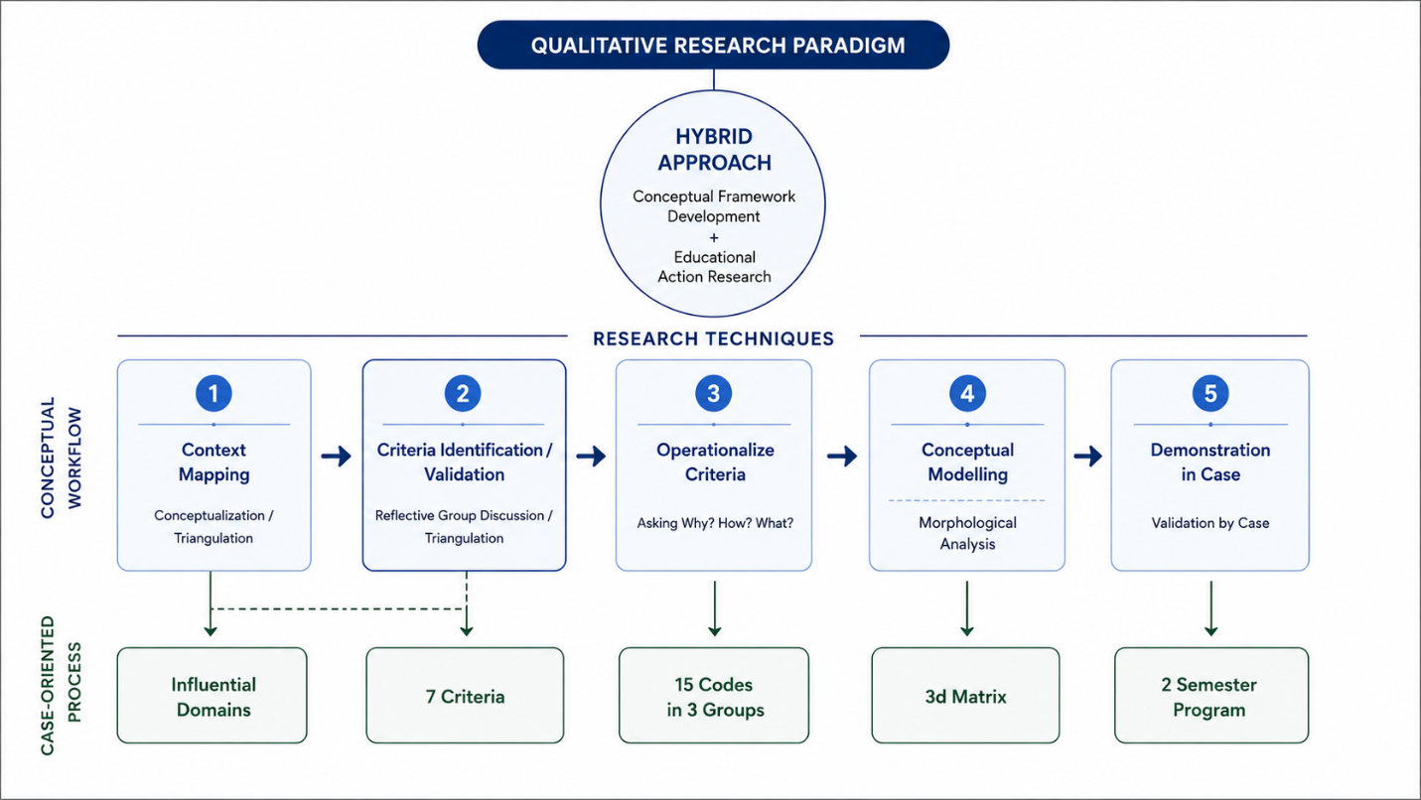
Step 4: To visualize, structure, and navigate this highly intersecting, multifactorial design space, the operationalized codes were synthesized using General Morphological Analysis, a non-quantified modelling approach that maps the possible relationships and intersections within a multidimensional problem space through a structural device known as the morphological box (Zwicky, 1969). Within the proposed morphological box, the parameters consist of layers distributed across the three dimensions of the matrix model, representing the three operational curriculum categories identified in the previous step.
Figure 1. The overall research methodology structure and steps, with the corresponding results shown in the case-oriented process.
Step 5: Finally, the proposed workflow and morphological box from the previous step were demonstrated through their application to the First-Year Architecture Studio at the Iran University of Art. Following the curriculum design paradigms of Plomp and Nieveen (2013) and Jabareen (2009), this case application does not constitute statistical validation or universal empirical proof. Rather, it serves as an educational intervention demonstrating the framework's ecological validity within a real educational context.
All layers of the research methodology are summarized and visualized in Figure 1. The workflow also shows the purpose of each step, the techniques utilized, and the outcomes of this specific process.
The scope of this study is contextually bounded to first-year undergraduate architectural design studios and geographically to Iran, while methodologically restricted to generating a transferable procedural workflow and decision-making framework. Crucially, this research is not a case study, a curriculum evaluation, a content proposal, or a defense of a particular pedagogical or philosophical approach; the presented programs and semester timetables represent merely one contextual application of the framework. This implementation also serves as validation, since ecological validation evaluates pragmatic viability by using the active studio program to demonstrate that practitioners can use the matrix in real-world settings to record tasks, monitor curriculum balance, and make targeted corrections. Conceptual validation, as qualitative research, establishes internal consistency by assessing whether the procedural steps remain logically cohesive, structurally sound, and capable of addressing multidisciplinary planning challenges under Jabareen's framework. Ultimately, the primary limitation is that the framework has only been implemented through a single institutional case, meaning its documented performance is inevitably shaped by those localized circumstances. A second limitation is that the conceptual framework requires considerable group activity among educators when used as a criteria extraction tool. Furthermore, the criteria and their operational outcomes require an instructor group with particular expertise, which may limit implementation in other contexts.

2.2. Case Introduction
The case study is the main studio for first-year architecture students at the IUA. The university has admitted undergraduate architecture students since 2000. The main objective of this degree is to train professionals for architectural practice (SCP, 1998), which is also emphasized by the faculty (Simoni and Abbasi, 2019). The program includes three foundational, three core, and three specialized semesters (DA, 2024). In each semester, a main studio serves as the curriculum backbone, focusing on Architectural Design in the core and specialized semesters and Introduction to Architectural Design in the foundational semesters (FD, 2018).
The case study presents the studio format for this introductory course, which, according to the national program, aims to improve imagination, spatial visualization, expressive skills, creativity, and self-confidence. The program also states that, to fully understand the physical and conceptual aspects of architectural design and their integration into the design process, students should participate in brief and focused exercises (SCP, 1998).
The instructor workgroup consists of five architecture instructors, two guest instructors from other disciplines, and two graduate assistants. The workgroup purposefully incorporates diverse disciplinary backgrounds, generations, and genders to foster a non-hierarchical, collaborative environment. More detailed information and the complete annual program are presented in the demonstration step, where the case is used to illustrate the framework.

3. Framework Development
To clarify the starting point of the framework development, it is necessary to explain what each criterion represented within the workgroup's shared understanding.
The criterion of art means allocating balanced attention to artistic disciplines according to their contribution to architectural education, fostering students' creative literacy. The criterion of senses refers to studio exercises that engage all five senses, broadening students' understanding of human perception as a foundation for architectural design.
The criterion of languages refers to exposing students to diverse approaches to generating three-dimensional forms and architectural space, including compositional, force-driven, parametric, inductive, deductive, abstract, accidental, and other form-generation strategies. Design domains refer to the principal areas of architectural knowledge and inquiry, including functional, contextual, conceptual, perceptual, structural, and construction-related considerations. The criterion encourages students to address each domain individually while understanding their relationships throughout the design process.
Finally, the criterion of attachment refers to multiple forms of belonging, including geographical, cultural, historical, national, international, and other contextual relationships, strengthening students' contextual awareness and sense of responsibility.
Collectively, these criteria address the major dimensions of contemporary architectural education, balancing architecture as an art, a design discipline, and a profession while responding to evolving educational, societal, and technological contexts. More fundamentally, they reflect the workgroup's shared belief that architecture students should understand each step and manage the design process rather than focus exclusively on final design outcomes.

3.1. Step One: Context Mapping
A review of previous research shows that many studies categorize the diverse influences into distinct internal and external domains (Skilbeck, 1976; Marsh, 1984). Lindsten et al. (2019) highlight that curriculum design must balance the demands of both internal stakeholders (faculty, students, and educational communities) and external stakeholders (policy makers and labor markets) to maximize curriculum effectiveness. Within this dual categorization, Colin J. Marsh (1984) conceptualizes "outside-in" curriculum development, referring to top-down or external-to-internal trajectories of educational reform, while L. Dee Fink (2003) groups these factors into learning objectives, instructional or pedagogical activities, and feedback mechanisms.
Other studies structure these influences across distinct organizational levels (Ramdass and Mokgohloa, 2023; van den Akker, 2004, 2013). Van den Akker (2004, 2013) proposes a five-tier hierarchy consisting of the supra (international frameworks), macro (national policies and national guidelines), meso (school or institutional contexts), micro (the studio level), and nano (personal student experience) levels. Others distinguish the macro (global and national influences), meso (institutional and departmental influences), and micro (individual beliefs and knowledge of academics) levels (Ramdass and Mokgohloa, 2023).
Accordingly, this study synthesized these categorizations and organizational levels into a unified conceptual structure divided into local and global factors, with three levels of influence within the local domain and influential themes of architectural discipline and education, together with temporal factors within the global domain. Because the global factors were synthesized from the literature, a triangulation threshold was established to justify their inclusion as influential factors in the architectural curriculum. The findings further refined the classification of architecture as an academic discipline by dividing it into the distinct sub-domains of art and design.
Architecture as a discipline: Scholarly discourse positions architecture as both an art and a design discipline. As an art, it is grounded in the shared exploration of form, meaning, and aesthetic experience, reflecting the long-standing conceptual merger and fluid intersections between architecture and fine art (Macarthur, 2024; Kozłowski, 2018; Zambelli, 2011). Accordingly, spatial design functions as a vehicle for visual and creative communication beyond utilitarian shelter (Chawla, 2023). At the same time, architecture is recognized as a cohesive multi-disciplina with an epistemological orientation that integrates technical, scientific, and humanistic knowledge through a unified design methodology (Inacio-Ceres, 2022). This integration depends on the complementary relationship between creative intent and material parameters (Ochshorn, 2014) and on ouverture disciplinaire and cross-boundary collaboration, enabling architecture to respond to contemporary socio-technical challenges and pluralistic cultural identities (El Jaouhari et al., 2022; Elkadi and Lozanovska, 2011).
Architecture as a profession: Another group of studies shows that redesigning the architecture curriculum is increasingly structured through the lens of graduate capabilities (Ng, 2020). In professional practice, educators highlight the necessity of aligning curriculum goals directly with industry standards (Khadimova, 2024). To meet these changing professional demands, architectural curricula must balance generic competencies with discipline-specific skills, shifting design exercises from abstract expression to tectonic execution, hand drafting, and digital modelling (Nicol and Pilling, 2000). Ultimately, comparative studies of pedagogical models in architectural education are used to bridge the gap between theory and practice (Zagora et al., 2025).
Education: Other studies suggest that instructional methodologies within architectural education should evolve in response to pedagogical changes (Djurić et al., 2026). These pedagogical approaches encompass specific instructional design models alongside established learning theories, a combination that remains essential for addressing the contemporary learning challenges of design programs in the early twenty-first century (Hammadamin and Nordin, 2024). Other studies argue that educators must deliberately tailor instructional methods within their design programs to accommodate diverse learning styles, showing that such adaptation enhances student engagement and understanding and thereby promotes deeper learning throughout the curriculum (Khadimova, 2024).
Current issues: Studies also discuss that architectural education in the early twenty-first century faces significant learning challenges requiring active adaptation to evolving educational demands and sustainability concerns (Hammadamin and Nordin, 2024; Galieva and Ambika, 2025). To address these current demands, scholars suggest rethinking architectural education by conceptualizing the curriculum through the lens of twenty-first-century graduate attributes (Ng and Chia, 2022).
The resulting conceptual structure of the mapped domains is visualized in Figure 2. These domains, together with the categorization of global and local factors, are not intended to represent universally accepted categories but rather the conceptual structure revealed through the context mapping conducted in this study.

3.2. Step two: Criteria Verification
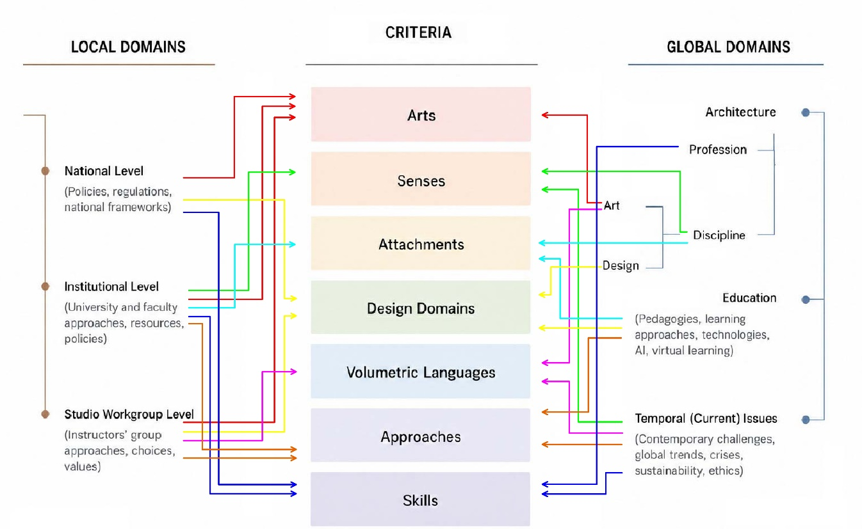
In the second step of the research process, the study proceeded to locate and validate the curriculum criteria. In this phase, rather than relying on simple source triangulation, a more rigorous two-tier validation mechanism was established to confirm each concept as an established criterion. First, it had to be supported by literature or data from at least three distinct influential domains mapped above, rather than merely appearing in three separate sources. Second, it had to be explicitly addressed by sources across both the local and global domains to maintain balance. This process shaped the discussion of each criterion, presented in the following sections and visualized together with its relationships to the contextual domains in Figure 2.
Figure 2. Synthesized structure of the contextual domains identified in the previous steps, the final criteria, and their validation links.

Arts: Globally, conceiving architecture as an artistic discipline remains a foundational pillar; as Macarthur (2024) observes, evaluating the aesthetic foundations of the built environment reveals a deep, historical conceptual merger in which architecture and fine art mutually enrich one another. This integration has consistently held immense pedagogical significance, with traditional models such as the École des Beaux-Arts and the Bauhaus strongly emphasizing its role (Ghom & George, 2020). Although the Faculty of Fine Arts at the University of Tehran, and consequently the Iran University of Art, inherited this tradition, where architecture is categorized as an artistic discipline, these integrated university structures must contend with systemic national-level deficiencies. The poor state of pre-university art education in Iran, combined with mathematics-based university entrance examinations, presents a major barrier to architectural education (Simoni & Abbasi, 2019). Consequently, academics advocate a swift, intensive orientation to introduce incoming students to the artistic and architectural environment during a brief "foundational" period (Hojjat, 2010). This position translates into collaborative, interdisciplinary teaching practices at the departmental level, where faculty from diverse artistic disciplines actively participate as permanent and guest lecturers (ADA, 2013–2023).
Senses: Globally, within the architectural discipline, contemporary theorists and designers increasingly champion multisensory considerations in contrast to the historical priority given to visual perception in architectural tradition and modernism (Spence, 2020). Heavily influenced by modern educational pedagogy (Salama & Osborne Borton, 2022), architectural education has historically favored the ocular. However, establishing a deeper interaction between the user and the built environment has emerged as a vital concern, particularly through perception-oriented approaches to design such as Juhani Pallasmaa's (2005). As recent scholars such as Navarro Jover (2018) argue, architectural and artistic experience is not exclusively a visual matter but a "tangled experience" in which tactile, auditory, and olfactory senses actively intertwine. This shift has been further accelerated by contemporary global currents, where concerns about the degradation of natural environments and the screen-mediated effects of the electronic age have raised critical questions about the erosion of human sensory engagement (Velasco & Obrist, 2020). It is also strongly critiqued by those who warn against the visual dominance exacerbated by modern digital tools at the expense of rich experiential learning (Crouch, 2015).
Locally, this ocularcentric bias manifests as a legacy of modernism within Iranian architectural education, which remains heavily dedicated to developing visual skills. This systemic visual dominance is illustrated by the reliance on perspective drawing and sketching within foundational programs and design studios for both training and evaluating students (Simoni & Abbasi, 2019). Conversely, at the institutional and instructor-group levels of this study, the opposite approach is embraced; departments actively counter this legacy by prioritizing rich, multisensory student experiences to restore a balanced perceptual framework in design (FD, 2017).
Attachment: Within the global educational domain, transformative pedagogical models increasingly prioritize a sense of belonging and environmental responsibility, contrasting with the detached frameworks of traditional instruction (Salama, 2012). More broadly, this reflects the contemporary university's evolution into an active, problem-solving entity for society (Atta-Owusu & Fitjar, 2022) with a commitment to social responsibility (Sambare & Saggu, 2016). This educational shift aligns with developments in the global architectural discipline; in response to critiques of standardized modernism, such as Frampton's (1983), contextual theories underscore the role of human cognition and place attachment in experiencing the built environment. This discourse is also reflected in recent studies through the concepts of the "architecture of belonging" (Bašić, 2025) and the integration of human-centered design to foster well-being (Li, 2025). At the local institutional level, the faculty actively values a deep connection to the Iranian context, adopting a dedicated contextual approach and supporting this commitment through graduate thesis topics, aligned coursework, student expeditions introducing indigenous architecture, and the formal establishment of Iranian Architecture Studies (Mashq_e_Honar, n.d.).
Design domains: Globally, evaluating architecture as a design discipline underscores the fundamental significance of design processes and specialist expertise across various design domains. This shift echoes long-standing developments in the global architectural discipline, which has increasingly prioritized design methodologies and processes over rigid typologies (Cross, 1986; Jones, 1992). This multi-domain perspective directly contradicts the limiting functionalist approach traditionally encapsulated by the modernist dictum "form follows function." Instead, contemporary design theories emphasize the systemic, simultaneous consideration of diverse design parameters—including site, program, concept, and structural considerations (Plowright, 2014). Decades of process-oriented pedagogical research also emphasize how vital this foundational framing is for novice architects navigating complex problem-solving environments (Fernando, 2007; Salama, 2012). Dash (2021) emphasizes that a structured exploration of design stages is essential to unlocking architectural creativity, demonstrating that treating design as an active progression rather than an immediate result expands students' formal and spatial potential.
Locally, this paradigm clashes with a lingering modernist legacy at the national level. The historical influence of modern functionalism remains firmly embedded in Iranian architectural education through traditional design methodologies introduced during the foundational period (Gharibpour & Toutounchi, 2016) and is reflected in the function-oriented categorization of architectural design studios. In contrast to this static typological tradition, and by actively drawing on progressive national program directives, the studio workgroup has chosen to pay close attention to the design process and its multifaceted domains (FD, 2022). This approach perceives architectural design as an integrated process driven by critical self-awareness, highlighting the pedagogical importance of maintaining a balanced focus across different design domains through highly focused, short, and targeted exercises (SIG, 2018; SIG, 2023).
Volumetric languages: Globally, previous research argues that the active teaching of morphology is essential in architectural education, anchoring design principles within the context of contemporary formal freedom (Chassagnoux et al., 2002), while emphasizing experimental form-finding methods to expand this pedagogical framework (Baroš et al., 2022). This paradigm challenges the long-standing dominance of the modernist "composition of simple forms" popularized by the Bauhaus model (Casciato et al., n.d.), in which "simplified form languages using industrial forms and materials proliferated in the 20th century, replacing form languages that were adaptive—hence more complex" (Salingaros, 2013, p. 44). Scholars further argue that beginners should become familiar with diverse approaches to volume generation and form finding, together with their potentials, limitations, and theoretical foundations (Salingaros, 2013). Contemporary digitalization has also drawn both positive (Kourkoutas, 2007) and critical attention, requiring a more balanced pedagogical examination of volumetric languages.
Locally, this tension is reflected in the historical legacy of Iranian architectural education, where the foundational ateliers were designated as "Composition Ateliers," focusing primarily on visual elements, color theory, and simple volume composition (Gharibpour & Toutounchi, 2016). Although the Ministry replaced this title with "Introduction to Architecture" in 1998 (SCP, 1998), the modernist concept of composition remained embedded in national programs (SCP, 1996) and continues to dominate architectural literature and academic discourse (Gharibpour & Toutounchi, 2016; FD, 2017). In contrast, the studio workgroup treats architecture as a multi-language discipline, emphasizing diverse form-finding approaches rather than a single compositional tradition (FD, 2017; FD, 2022).
This systematic triangulation not only validated the initial criteria but also revealed critical gaps. As a result, two additional emergent criteria—Skills and Approaches—were introduced, reflecting weaker attention to the educational and professional domains. Nevertheless, the criteria are not intended to represent universally accepted or verified categories.
Skills: Within the global professional domain, studies indicate that the market value of specialized skills has risen steadily since well before the digital age (Crysler, 1995). To address these changing demands, educators increasingly align curriculum frameworks with industry standards (Khadimova, 2024), evaluating curriculum through the progressive lens of graduate capabilities (Ng & Chia, 2022). This requires beginners to develop proficiency in essential physical and digital tools (Elshanwany et al., 2020), a need made increasingly critical by digitalization and artificial intelligence.
Locally, a significant mismatch exists in how professional competencies are classified. Although the national program defines the primary objective of the architecture degree as preparing professionals for architectural practice (SCP, 1998), studies show that graduates often fail to meet professional requirements, creating a gap increasingly filled by private architectural institutes (Simoni & Abbasi, 2020). Research in Iran also suggests that, alongside technical skills (Gharibpour & Toutounchi, 2016), personal and interpersonal competencies—including self-management, accountability, analytical thinking, self-assessment, teamwork, and collaboration—strongly influence student achievement but remain largely absent from standardized national curricula (Simoni & Abbasi, 2019). Nevertheless, preparing students for professional practice remains a departmental priority (DA, 2017), reflected in skill-based extracurricular courses (AOC, 2020) and research addressing educational quality, professional requirements, and the theory–practice gap (Simoni & Abbasi, 2019).
Approaches: As observed within the global discipline domain, architectural education is informed by the interplay of educational paradigms, pedagogical theories, studio techniques, and context-specific teaching methods. The literature reveals a wide variety of architectural education models and design methods that shape contemporary training. Current global disruptions continue to reshape these approaches, with the digital age, online education, and artificial intelligence driving major pedagogical changes. To address these developments, recent research has explored AI-based architectural education (Papamanolis & Geropanta, 2018) and educational frameworks for effective online architectural education (Saleh et al., 2023). Beyond these global influences, pedagogical strategies are further shaped by local institutional and studio-level approaches. At the faculty level, the emphasis is on collaborative curriculum development and a holistic pedagogical approach (DA, 2017). At the foundational studio level, the workgroup adopts an interactive, conversational framework emphasizing diverse learning experiences (FD, 2018).

3.3. Step Three: Criteria Operationalization
As detailed in the research methodology, during this third phase, the authors independently addressed the seven validated curriculum criteria by answering structured "why," "how," and "what" questions, generating a total of 54 qualitative responses. Given the volume and density of these responses, the authors independently performed manual qualitative coding to establish a coherent interpretive structure. This analysis grouped concepts according to semantic similarity and thematic convergence while keeping the responses to each question separate. The resulting codes were subsequently refined through an iterative consensus-seeking process, producing 15 finalized codes.
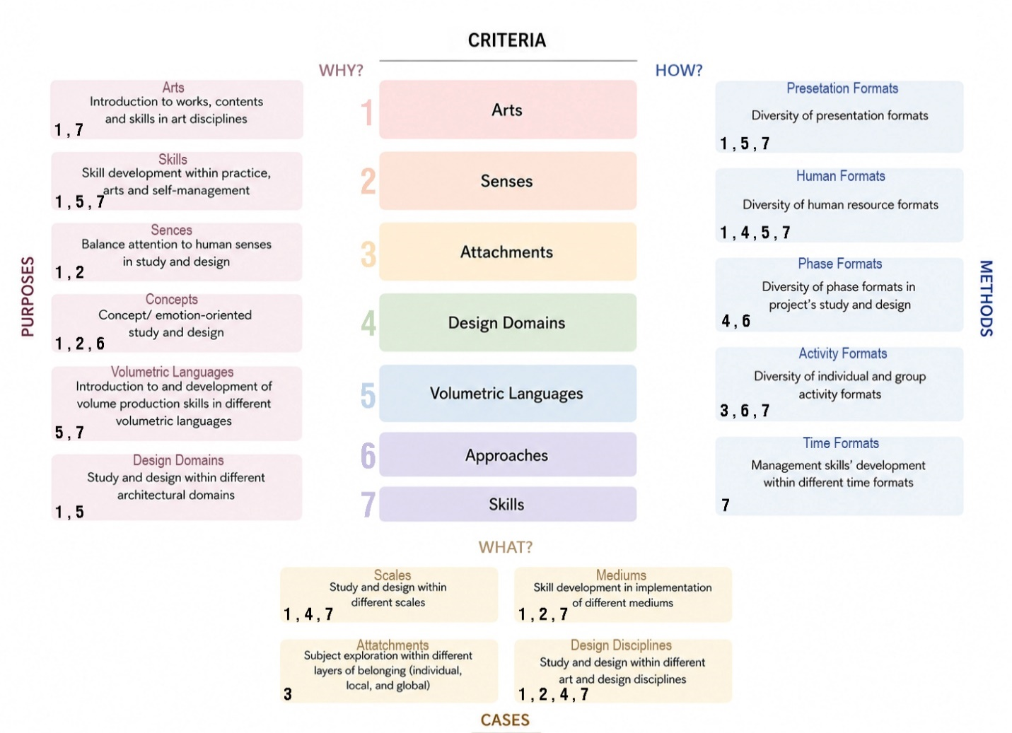
The codes naturally coalesced into three primary categories corresponding directly to the three guiding questions. The final configuration yielded three thematic groups: Purposes (6 codes: Arts, Skills, Senses, Concepts, Volumetric Languages, and Design Domains), Methods (5 codes: Presentation Formats, Human Formats, Phase Formats, Activity Formats, and Time Formats), and Cases (4 codes: Scales, Attachments, Design Disciplines, and Mediums). The secondary coding, grouping, the final codes and their relationships with the foundational curriculum criteria are illustrated in Figure 3.
Figure 3. Relationship between the final codes and criteria identified in the previous step through the "Why?", "How?", and "What?" questions, with the grouped secondary codes.
Crucially, this structured typology does not prescribe rigid curriculum content or specific case studies; rather, it functions as an objective tool to guide educational decision-making.

3.4. Step Four: Conceptual Modelling (the Matrix)
Although the overall research process is structured as a qualitative approach to conceptual framework development, this phase represents the first stage at which the operationalized criteria are visually consolidated to demonstrate their systemic relationships. To map and analyze these multifaceted parameters through formal morphological analysis, the framework employs a three-dimensional matrix. This spatial model organizes the three structural aspects across three distinct dimensions.
Crucially, the matrix is designed to be both layered and stringed. It is layered because each code accommodates the translated curriculum criteria within a dimension, and stringed because the codes do not represent isolated variables. Instead, each string represents a subset of homogeneous structural options that can be selectively activated according to their simultaneous, intersecting relationships with the other parameters.
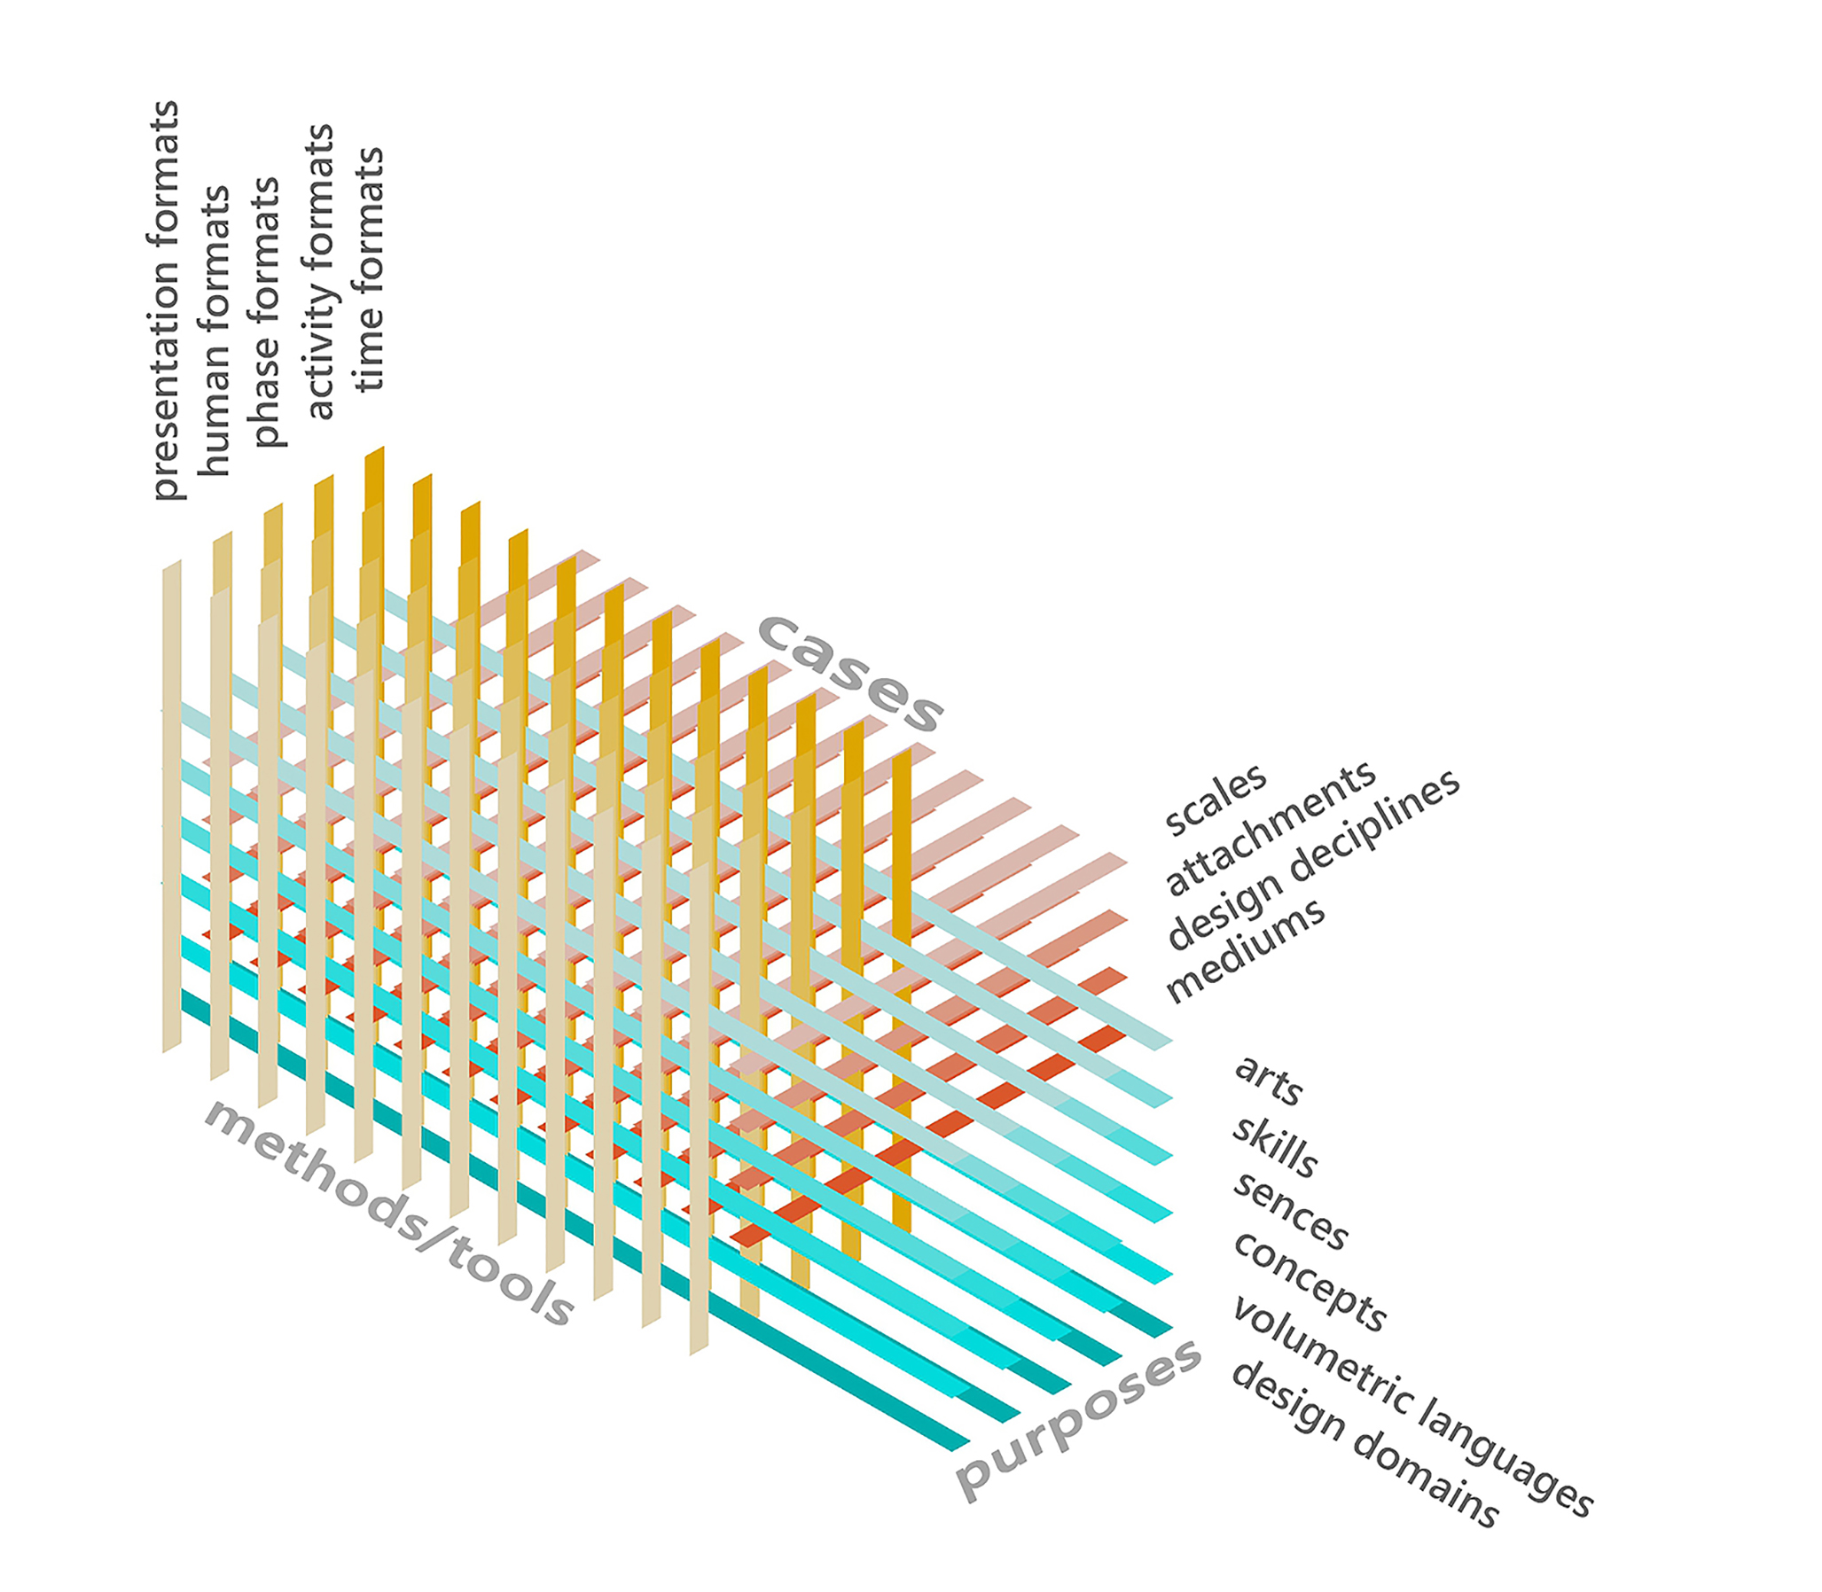
The resulting structural configuration is illustrated in Figure 4. Within this model, each layer corresponds to an operationalized criterion. For instance, the Arts layer under the Purpose dimension encompasses diverse artistic disciplines, each assigned its own structural string. Similarly, the Presentation Format layer under the Methods dimension contains various execution media, such as architectural drawing, freehand sketching, physical modelling, photography, videography, and other presentation formats. Within the Cases dimension, layers such as Scales contain a graduated continuum of project contexts, ranging from the micro-object to the macro-universal scale. To avoid unnecessary visual complexity, the matrix is illustrated with an equal number of structural strings across all layers, while the actual number and content of the strings used in this case are presented in the subsequent demonstration section.
Figure 4. The morphological box (matrix) with the final codes in three groups from the previous step organized as layers across three dimensions.
3.5. Step Five: Demonstration
To use the matrix for planning the one-year program, the workgroup proceeded through different phases.
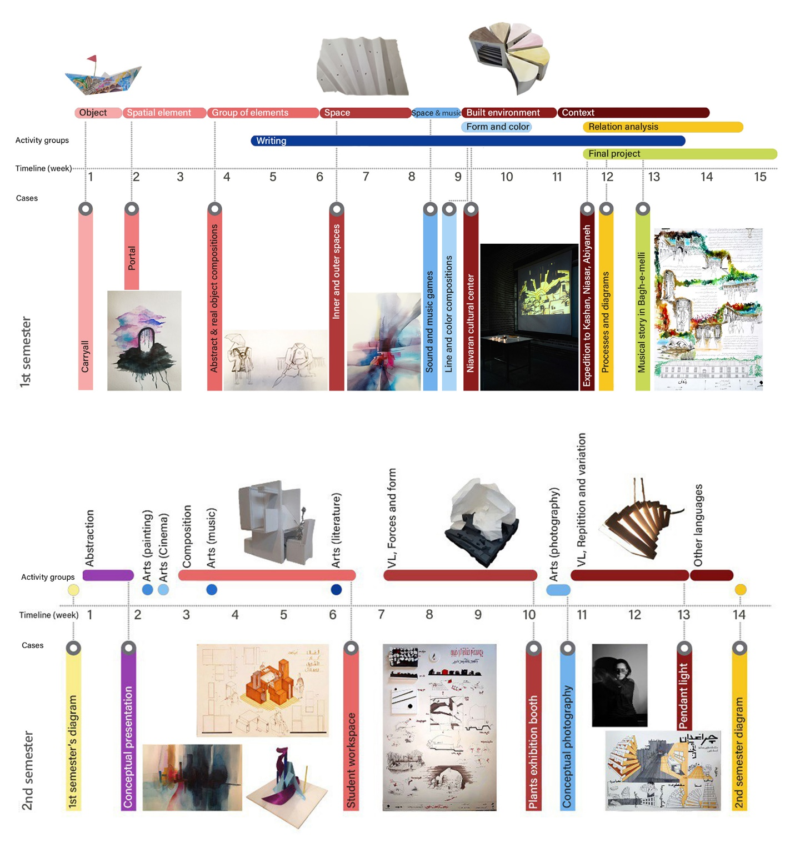
Figure 5. The complete first- and second-semester programs, including activity groups and cases displayed on the timeline, with the selected sample project used for detailed demonstration highlighted.
General phase (first meeting): At the beginning of the academic year, during the initial planning session, the workgroup first determined how the criteria would be distributed between the two semesters. Taking into account the students' developmental maturity and skills, greater emphasis was placed on sensory experiences and attachment during the first semester, while design domains and volumetric languages were addressed more extensively in the second. Some criteria, however, were distributed across both semesters. For example, the Arts criterion received continuous attention throughout the academic year but with different emphases: in the first semester, students were introduced to diverse artistic disciplines, whereas in the second they became familiar with specific artworks through analytical and conceptual exploration.
Semester phase (semester opening meeting): These decisions directly governed the structure of each semester, defining how different layers and strings of the matrix would be combined. In the first semester, the Arts layer was primarily associated with accessible and intuitive presentation formats, such as sensory drawings, simple photographs, ordinary objects, elementary sound productions, unrestricted volumetric presentations, storytelling, creative writing, and realistic and abstract painting. These expressive formats were systematically combined with project cases emphasizing immediate personal or local attachment. In the second semester, this configuration was reoriented: the same Arts layer was instead combined with universally recognized masterpieces within the Attachment layer, more advanced components of the Skills layer, and more mature presentation formats, including analytical drawings and conceptual diagrams.
The first semester followed a clear progressive trajectory, exemplified by the contrast between its introductory and final exercises. As illustrated in Figure 5, the introductory exercise, "A Carryall,"—which could range from the students' own backpack to any other container—began with students' personal experiences, encouraging the freest possible forms of expression through various media and raw sensory impressions to build initial confidence. As the semester progressed, the projects systematically expanded in physical and conceptual scale (visible in the upper line of the semester diagram), culminating in an immersive end-of-semester expedition to historic Iranian cities and villages. During this final exercise, students explored a specific ecological and socio-historical environment as a whole, documenting their field observations and presenting their findings through more advanced formats. These included photography, perspective drawings, three-dimensional analytical models, video art, and other combinations of artistic disciplines, clearly reflecting the gradual increase in scale throughout the first semester.
In contrast to the sequential progression of the first semester, the second prioritized a balanced distribution of criteria, rejecting linear progression in favor of more dynamic movement. The Scale layer was distributed freely across assignments, covering object-scale projects, micro-spaces designed through furniture, and larger spaces such as pavilions and exhibition booths (shown as the main exercises in Figure 5). Furthermore, the second semester concentrated on the more complex criteria intentionally deferred from the first semester to match the students' growing academic maturity. In particular, Volumetric Languages and Design Domains became the primary focus of the studio.

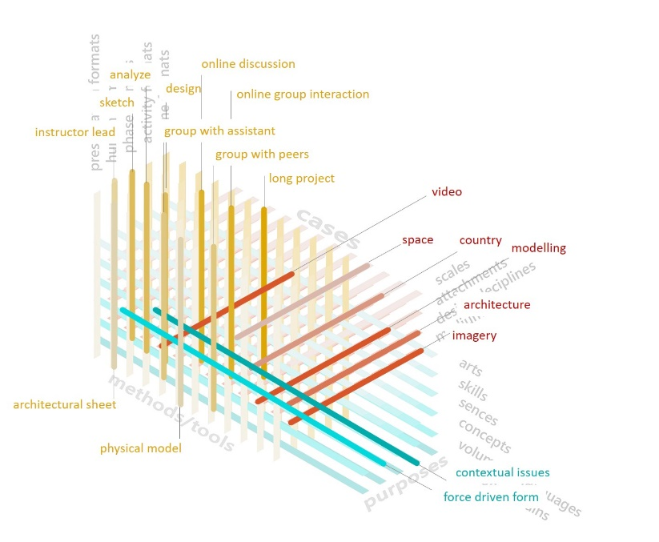
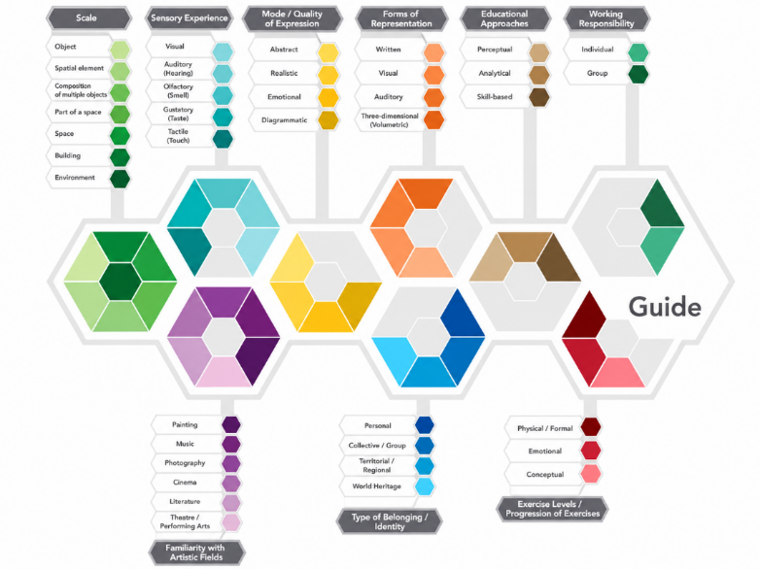
Individual exercise design (2–3 weekly meetings): Designing each studio assignment within this framework required combining selected strings from the different layers of the Purposes dimension and intersecting them with the other matrix dimensions. For instance (Figure 6 (a)), a single exercise might combine force-driven form as a Volumetric Language with contextual issues as a Design Domain, together with professional skills such as architectural drawing, model making, and rendering. These combinations then intersected with specific strings from the remaining dimensions, such as selecting a project scale and a type of attachment from the Cases dimension, for example, a public space for a plant exhibition booth at the space scale combined with a country-related attachment.
Figure 6 (a). Demonstration of matrix utilization through the “plant exhibition booth” case from the second semester. Figure 6 (b). The exact number and names of parameters represented as matrix strings for the first semester.
To complete the assignment structure, presentation formats appropriate to the intended skills were selected, such as a volumetric model paired with a drawing sheet. These were further combined with logistical parameters, including individual or group work, different instructional phases, and varying combinations of instructors, assistants, peers, and guest professionals. Since this exercise corresponded to the Long Experience string of the Time Format layer, it incorporated multiple activity formats and micro-exercises of varying duration. For instance, all architectural analysis and design studies were intentionally organized into three sequential phases—Sketch, Analysis, and Design—which the instructional workgroup regarded as distinct yet complementary stages of architectural inquiry, each cultivating a different aspect of architectural thinking: experiential sketches for unrestricted exploration; theory-oriented precedent analysis; and integrative design through trial, error, and pattern critique.
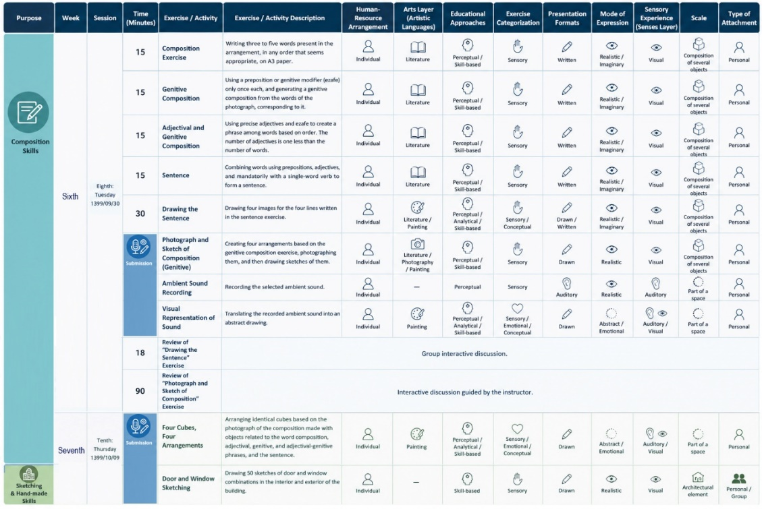
Monitoring and refinement (session records + biweekly meetings): To ensure the overall balance of the program and evaluate its implementation, systematic recording tables were prepared for every exercise and classroom activity to register the selected matrix strings from each layer and continuously monitor their distribution throughout the semester. The objective of this tracking system was not to give equal emphasis to every string, but to ensure that the intended pedagogical priorities—for example, giving greater attention to functional and contextual design domains or prioritizing group activities over individual ones—were consistently maintained. Consequently, periodic qualitative reviews of the completed exercises revealed, at one point during the semester, that the intended coverage of different design disciplines had not been fully achieved: construction-oriented and structural aspects had received less attention than abstract conceptual ones, group activities had been used more frequently than planned, and drawing presentations had been overrepresented.
Figure 7. Sample of the detailed record of studio activities and assignments.
These observations directly informed the design of the following exercise, which was formulated as a targeted corrective assignment requiring students to design and construct a functional object—a lamp—at a scale that could be physically built. This exercise shifted the pedagogical emphasis toward construction, requiring students to consider structural behavior, material properties, and joint details. At the same time, the form had to be generated through the repetition of a single element, functioning as a mathematical form-finding exercise in contrast to the more abstract artistic experiences developed previously, while introducing a parametric volumetric language as one of the remaining strings of that layer. The project also confronted students with practical design issues, including lighting requirements and the spatial relationship between repeated linear elements and the resulting patterns of light and shadow. To support these tectonic objectives, the presentation requirements emphasized technical precision over abstract expression. Instead of expressive sketches or rendered views, students prepared hand-drafted drawings resembling technical construction documentation, with accurate perspective and shadow representation. More time was allocated to modelling and construction than to drawing within the intersection of the Presentation Format and Time Format layers, and the assignment was conducted individually to restore balance.
The final presentations of each semester combined data on both general and specific issues (Figure 6(b)), demonstrating that systematically collected records can also support comprehensive end-of-semester evaluations and, more importantly, provide continuity between consecutive semesters. However, such evaluations depend on maintaining detailed records of every studio session (Figure 7).

4. Discussion
The workflow can be discussed across two separate layers. For clarity, the following discussion distinguishes between the framework layer, which represents the transferable methodology, and the process layer, which represents the case-specific implementation developed for the first-year design studio at the Iran University of Art.
At the first step of this specific study, the workgroup utilized pre-identified interest parameters to formulate foundational criteria. While alternative institutions or faculties may begin with different primary concepts, this phase establishes a clear utility for any case. At the process layer, this phase maps the global and local domains and sub-divisions identified for architectural education within the case context. At the framework layer, it defines a qualitative mapping and verification process implemented through selected techniques. Consequently, curriculum designers may either adopt the exact mapping developed in this study where institutional parameters are comparable, apply the same mapping and verification process to identify context-specific domains and parameters of their own, or substitute the qualitative techniques employed here with alternative context-mapping and verification approaches, ranging from systematic literature reviews to quantitative questionnaires.
The same principle applies to all subsequent steps. In the second step, this study identified seven verified curriculum criteria through multiple trans-domain verification techniques at the process layer. At the framework layer, this step is defined as the extraction and confirmation of primary educational parameters from context-driven influential domains. Tuture users may directly adopt the seven criteria established here, re-evaluate them through a modified selection of domains, or employ entirely different qualitative methodologies to verify or derive criteria appropriate to their own educational contexts.
The third step operationalizes the validated criteria by exploring their underlying purposes, methods, and cases. This tripartite inquiry is grounded in classical and contemporary curriculum design theory and is broadly transferable across educational contexts. However, both the formulation of these inquiries and the qualitative techniques used to elaborate them remain flexible, allowing different educators to generate different numbers of questions and operational codes. The specialized contribution at the process layer is the finalized typology consisting of fifteen operational codes. Another institutional context applying the same methodology, whether using identical questions or alternative formulations, may produce different requirements or categorization systems based on its own educational priorities.
As the most visible model-like asset, the resulting three-dimensional matrix represents the principal outcome of the fourth step. At the process layer, the matrix axes are directly aligned with the code list generated in the previous step. At the framework layer, however, this phase simply defines the development of a morphological or combinatorial curriculum model based on the operational parameters identified earlier. Accordingly, another user may directly adopt the proposed matrix, adapt the same structure by incorporating context-specific parameters, or, as discussed in the previous step, develop a model with different dimensions, structures, or even forms other than a three-dimensional matrix depending on the formulation and application of the guiding inquiries and the resulting operational parameters.
The fifth phase, comprising the studio implementation and layout, serves only to demonstrate the framework's viability and ecological validity. Rather than prescribing a fixed studio structure, it illustrates one possible outcome. Accordingly, even under identical institutional conditions, future applications would not necessarily reproduce the same assignments or schedule, reflecting the framework's open, dynamic, and flexible nature. The framework enabled the explicit implementation of our pedagogical intentions to counter the negative effects of modernist architectural education discussed earlier, including the prioritization of visual qualities, composition as the dominant language of form-making, functionalism as an implicit norm, and globalization and standardization that suppress contextual characteristics. The matrix also maintained a shared educational direction by emphasizing the design process over final products while facilitating collaboration within the instructional workgroup. Although the matrix was not designed for online learning, its flexibility was immediately demonstrated when the second semester was delivered entirely online due to COVID-19. Its successful application showed that the framework was not dependent on a particular mode of delivery and could readily adapt to changing educational conditions.
While the core contributions of this study operate at two structural levels, several latent characteristics of the process-generating framework and its morphological matrix warrant separate attention. Although some of these capabilities remain beyond the scope of the present case application, they suggest valuable directions for future research and educational implementation.
Beyond serving as a structured yet open-ended decision-making system with extensive combinatorial potential for generating studio exercises, the framework is expandable both longitudinally and horizontally. Longitudinally, it can support planning and coordinating an entire architectural degree program by maintaining curricular continuity, balancing competencies, and reducing programmatic drift across successive instructor workgroups. Horizontally, it enables the integration of parallel courses, such as structures, history, or visual arts, within a shared planning framework. Although this capability has been explored in the foundational courses at the Iran University of Art, it falls outside the scope of the present study. The matrix also supports coordination among instructors by providing a common formal vocabulary for curriculum planning, helping departments maintain pedagogical coherence while remaining responsive to evolving educational priorities.
A further characteristic of the proposed matrix is its capacity to accommodate large numbers of interconnected educational variables while maintaining a clear conceptual structure. As this complexity increases, computational implementation may further enhance the framework by facilitating the visualization, management, and exploration of extensive combinatorial relationships, although it is not required for its application. Such digital support aligns naturally with the increasing use of computational tools in both architectural practice and higher education management.
To illustrate this future potential, the study presents generative AI-based conceptual visualizations. The first depicts a network optimized for a single academic semester, while the second illustrates how the framework could be expanded to coordinate and evaluate an entire multi-year architectural degree program.

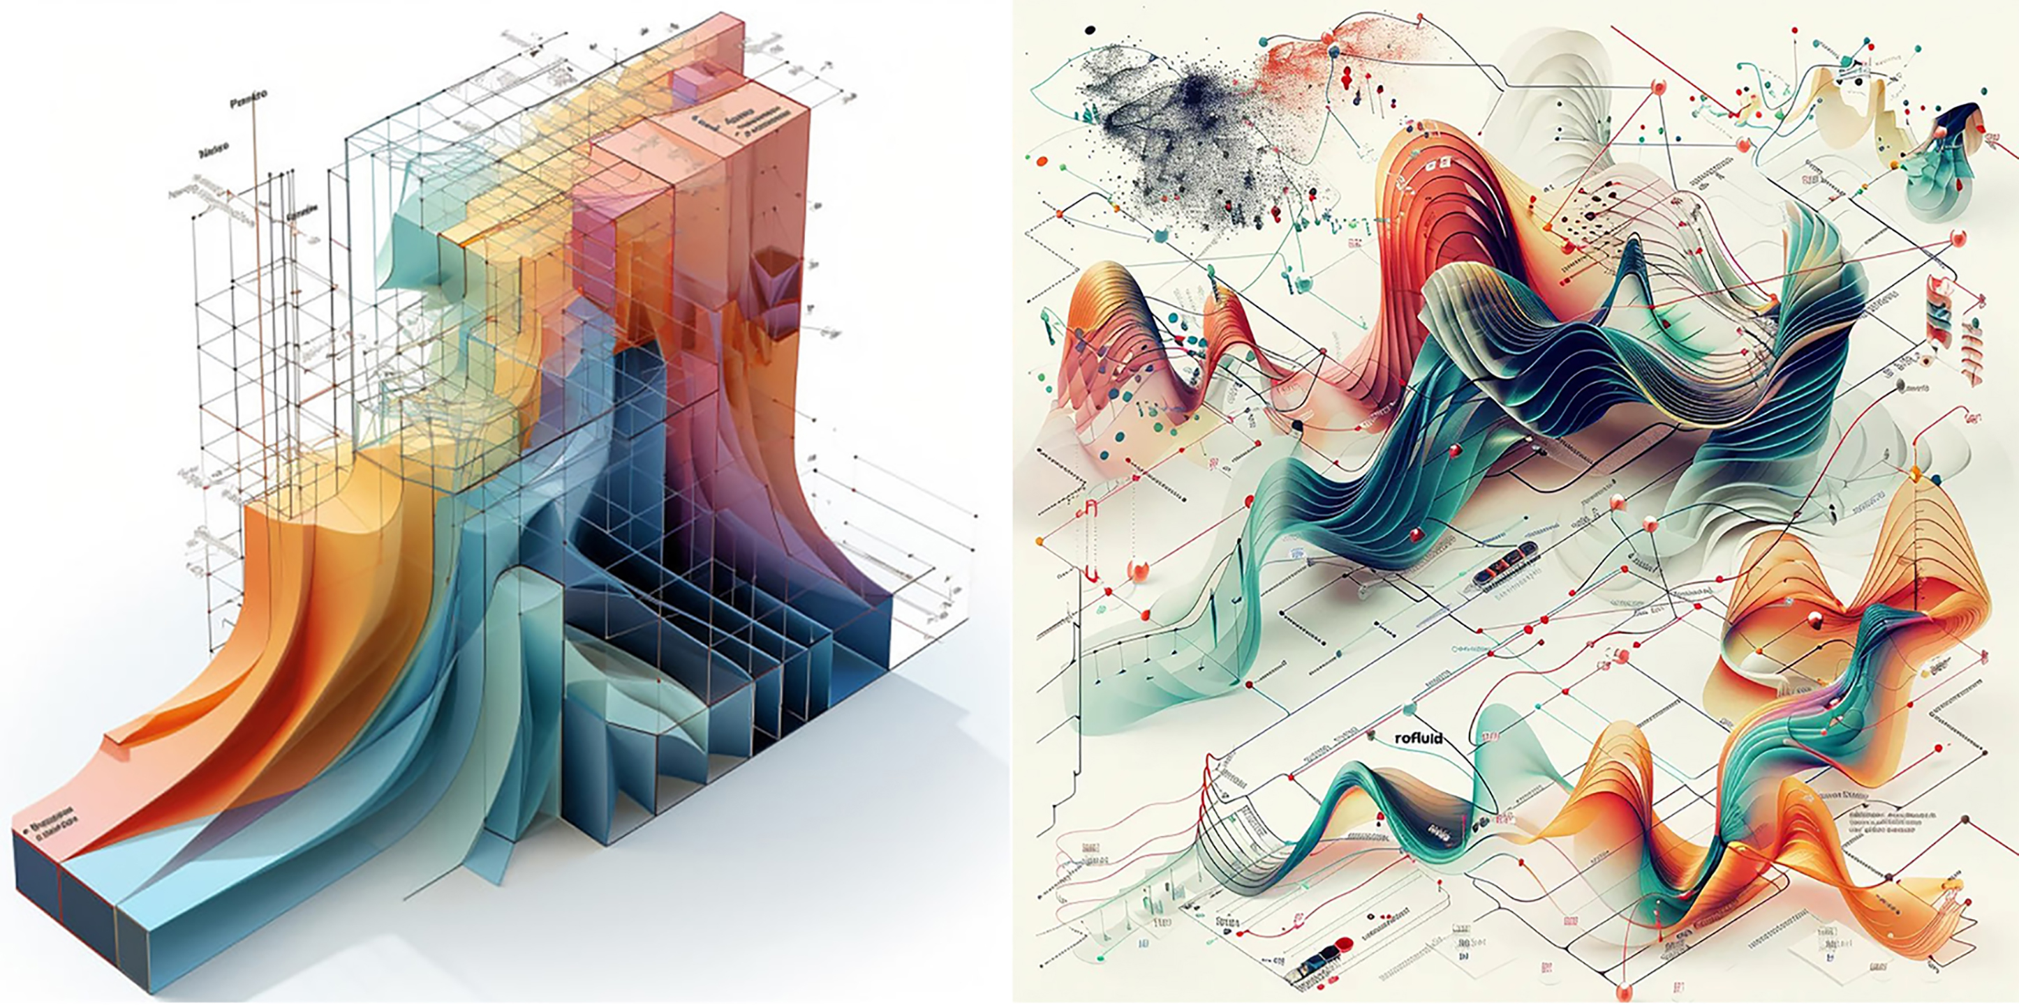
Figure 8. Generative AI-based conceptual visualizations illustrating the future scaling potential of the proposed framework: (a) a single academic semester; (b) an entire architectural degree program.
5.Conclusion
Previous research in architectural education has made substantial contributions to first-year studio pedagogy by proposing teaching approaches, curriculum models, competency frameworks, collaborative learning strategies, and educational reforms. These studies have significantly advanced our understanding of what should be taught and how students should learn within architectural studios. However, a gap remains in flexible, content-independent, process-oriented frameworks capable of designing, evaluating, and managing entire semesters and educational programs. Such frameworks are needed to support young educators in developing coherent studio curricula, help experienced instructors maintain pedagogical diversity while avoiding repetitive teaching patterns, and enable faculties to coordinate, monitor, and continuously refine the educational process.
In contrast, to the most previews studies the present study addresses a different but complementary question in architecture education: how an architectural curriculum itself can be systematically generated, justified, and managed. Rather than proposing a new fixed curriculum or advocating a particular pedagogical philosophy, this research introduces a transferable procedural workflow. Beginning with initial interest factors derived from studio experience and professional insight, the methodology establishes a process-generating framework for architectural curriculum design. It maps the influential domains affecting architectural education, employs cross-domain triangulation to verify the foundational criteria, and further validates them through expert consensus within the instructional workgroup. To transform these abstract criteria into actionable parameters, the framework operationalizes them through the structured questions of why, how, and what. The resulting qualitative responses are organized into educational purposes, methods, and cases, which are then synthesized into a three-dimensional morphological matrix composed of interconnected layers and structural strings.
The primary contribution of this paper is methodological, while also carrying theoretical and practical implications. It lies in its dual-layered architecture, which explicitly distinguishes between the framework layer, functioning as the transferable methodology, and the process layer, representing the localized implementation developed for the first-year design studio at the Iran University of Art. Accordingly, the principal novelty of this study lies not in introducing new educational content or replacing existing pedagogical approaches, but in providing an explicit decision-making framework through which diverse educational philosophies, institutional priorities, and contextual conditions can be systematically translated into coherent and adaptable architectural foundation studio curricula.
Although demonstrated through a single institutional case, the proposed workflow is intentionally transferable rather than prescriptive. Future studies may apply, adapt, and evaluate the framework across different schools of architecture, educational systems, and cultural contexts, or extend it to later years of architectural education and other design disciplines. In this way, the framework should be understood not as a finalized curriculum model but as an open methodological platform that supports continuous curriculum development, critical reflection, and collaborative educational innovation.

Refeneces
ADA (Administration of the Department of Architecture). (2013-2023). Semester programs’ archive. Tehran, Iran: IUT (Iran University of Art).
Ansari, H. (2016). Honar-ha-ye-Ziba 1319-1348 (Fine Arts 1940-1969). Tehran, Iran: Honar-e Memari-e Qarn.
AOC (Administratory of Open Classes). (2020). Yearly report. Tehran, Iran: IUA, DA Archive.
Bani Masoud, A. (2009). Memari-e Moaser-e Iran (Contemporary architecture of Iran). Tehran, Iran: Honar-e Memari-e Qarn.
Baroš, T., Ford, H., Qiu, S. L., Elshanwany, H., El-sayad, Z., & Nasser, H. (2022). Experimental form-finding: A review. IOP Conference Series: Materials Science and Engineering, 1252(1), Article 012093. https://doi.org/10.1088/1757-899X/1252/1/012002
Bašić, N. (2025). The architecture of belonging. Acta Architectonica et Urbanistica, 1(1), 16–31. https://doi.org/10.65262/9vqqxx34
Baum, E. M. (2013). Comparative anatomy: A beginning course in architectural design. Journal of Architectural Education, 67(2), 195-204. https://doi.org/10.1080/10464883.2013.817158
Biggs, J., & Tang, C. (2011). Teaching for quality learning at university (4th ed.). Open University Press. https://doi.org/10.18538/lthe.v13.n2.239
Casciato, M., Fox, G., & Rochester, K. (n.d.). Primary forms; Bauhaus: Building the new artist. Getty Research Institute. Retrieved March 20, 2024, from https://www.getty.edu/research/exhibitions_events/exhibitions/bauhaus/new_artist/form_color/form/
Chassagnoux, A., Dudon, M., Aubry, D., et al. (2002). Teaching of morphology. International Journal of Space Structures, 17(2-3), 221–227. https://doi.org/10.1260/026635102320321842
Chawla, A. (2023). Is architecture a form of art? International Journal of Social Science and Economic Research, 8(5), 920–931. https://doi.org/10.46609/IJSSER.2023.v08i05.010
Cross, N. (1986). The development of design methodology in architecture, urban planning and industrial design. In R. Trappl (Ed.), Cybernetics and systems ’86 (pp. 173-180). Dordrecht, Netherlands: Springer. https://doi.org/10.1007/978-94-009-4634-7_23
Crotch, J. (2015). An architecture of experience. In LearnxDesign: Proceedings of the 3rd International Conference for Design Education Researchers (Vol. 4, pp. 1599–1611). Aalto University. https://radar.gsa.ac.uk/4339/
Crysler, C. G. (1995). Critical pedagogy and architectural education. Journal of Architectural Education, 48(4), 208-217. https://doi.org/10.1080/10464883.1995.10734644
DA (Department of Architecture). (2017). Meeting report, 24 December. IUA, DA Archive.
DA. (2024). Meeting report, 3 June. IUA, DA Archive.
Dash, S. P. (2021). An exploratory study on design process in architecture: Perspective of creativity. Creativity Studies, 14(2), 346–361. https://doi.org/10.3846/cs.2021.12989
Denzin, N. K. (1978). The research act: A theoretical introduction to sociological methods (2nd ed.). McGraw-Hill.
Djokić, V., Milovanović, A., Pešić, M., Ristić Trajković, J., Milojević, M., Nikezić, A., & Krstić, V. (2026). A comparative evaluation model for design studio pedagogy: Linking educational objectives and professional readiness in architectural higher education. Architecture, 6(1), Article 7. https://doi.org/10.3390/architecture6010007
El Jaouhari, K., Kharmich, H., & Basset, A. (2022). Ouverture disciplinaire et collaboration : Le design architectural à l’épreuve des tendances contemporaines. African and Mediterranean Journal of Architecture and Urbanism, 4(1). https://doi.org/10.48399/IMIST.PRSM/amjau-v4i1.33300
Elkadi, H., & Lozanovska, M. (2011). Diversity and architecture. In S. Knotter, R. de Lobel, L. Tsipouri, & V. Stenius (Eds.), Diversity research and policy: A multidisciplinary exploration (pp. 99–116). Amsterdam University Press. https://hdl.handle.net/10536/DRO/DU:30043141
Elshanwany, H., El-sayad, Z., & Nasser, H. (2020). Various classifications for architectural form finding process. The Egyptian International Journal of Engineering Sciences and Technology, 32, 32-42. https://doi.org/10.21608/EIJEST.2020.47216.1022
ERKÖK, F., Eren, Ç., Uz Sonmez, F., & Aydinli, S. (2005). A paradigm shift in the first year design education. A|Z ITU Journal of the Faculty of Architecture, 1(1-2), 62-78. https://doi.org/https://www.az.itu.edu.tr/
FD (Foundational Department). (2017). Meeting report, 27 August. IUA, DA Archive.
FD. (2018). Meeting report, 3 September. IUA, DA Archive.
FD. (2022). Meeting report, 15 December. IUA, DA Archive.
Fernando, N. (2007). Decision making in design studios: Old dilemmas—new strategies. In A. M. Salama & N. Wilkinson (Eds.), Design studio pedagogy: Horizons for the future (pp. 143-152). London, UK: Urban International Press.
Fink, L. D. (2003). Creating significant learning experiences: An integrated approach to designing college courses. Jossey-Bass.
Frampton, K. (1983). Towards a critical regionalism: Six points for an architecture of resistance. In H. Foster (Ed.), The anti-aesthetic: Essays on post-modern culture (pp. 16-30). Washington, DC: Bay Press.
Galieva, E., & Ambika, G. M. (2025). The importance of modern approaches to sustainability in the architecture curriculum. In International Scientific and Practical Conference “Emerging Trends in Green Economy”. Zenodo. https://doi.org/10.5281/zenodo.17411654
Gharavi Alkhansari, M. (2022). A comparative study of pre-cultural-revolution architectural education in the faculty of Fine Arts, University of Tehran, before and after 1967. Soffeh, 32(1), 41-56. https://doi.org/10.52547/SOFEH.32.1.41
Gharibpour, A., & Toutounchi Moghaddam, M. (2016). Comparative revising the curriculum of basic design studios in undergraduate studies of architecture. Honar-ha-ye-Ziba, 20(4), 59-72. https://doi.org/10.22059/JFAUP.2016.59673
Ghom, P. V., & George, A. (2020). Pedagogy for basic design studio in learning architecture: A qualitative exploration. Journal of Education and Practice, 11(3), 173-180. https://doi.org/10.7176/JEP/11-3-18
Hammadamin, A. B., & Nordin, J. (2024). Learning challenges of architectural education in the early twenty-first century: A systematic literature review. Al-Qadisiyah Journal for Engineering Sciences, 14(9), 339–351. https://doi.org/10.30772/qjes.2024.149312.1220
Hojjat, I. (2003). Architecture education and the devaluation of values. Honar-ha-ye-Ziba, 14, 63-70.
Hojjat, I. (2010). Mashgh-e Memari (Architecture lessons). Tehran, Iran: University of Tehran Press.
Inacio-Ceres, S. (2022). La arquitectura como una multi-disciplina: Mario Bunge en la epistemología del diseño en Argentina [Architecture as a multi-discipline: Mario Bunge in the epistemology of design in Argentina]. Metatheoria – Revista de Filosofía e Historia de la Ciencia, 12(2), 1–15. https://doi.org/10.48160/18532330me12.344
Jabareen, Y. (2009). Building a conceptual framework: Philosophy, definitions, and procedure. International Journal of Qualitative Methods, 8(4), 49–62. https://doi.org/10.1177/16094069090080406
Johannes, R. (2005). The model for architectural design education (MADE). Projetar: II Seminário Sobre Ensino E Pesquisa Em Projeto De Arquitetura, 8-11 Nov., Rio de Janeiro, Brazil.
Jones, J. C. (1992). Design methods (2nd ed.). London, UK: Van Nostrand Reinhold.
Kadhim, M. K. (2016). المعايير الأساسية لتطوير برامج التعليم المعماري [The basic criteria for the development of architectural education programs]. Iraqi Journal of Architecture and Planning, 12(1), 151–168. https://search.emarefa.net/detail/BIM-683207
Kemmis, S., & McTaggart, R. (2005). Participatory action research: Communicative action and the public sphere. In N. K. Denzin & Y. S. Lincoln (Eds.), The SAGE handbook of qualitative research (3rd ed., pp. 559–603). SAGE Publications.
Khamidova, Y. K. (2024). Curriculum design principles: A guide for educators, Designing effective curriculum. European Journal of Innovation in Nonformal Education, 4(10), 143–155. https://inovatus.es/index.php/ejine/article/view/4252
Kourkoutas, V. (2007). Parametric form finding in contemporary architecture [Diploma thesis, Technische Universität Wien]. http://hdl.handle.net/20.500.12708/14221
Kozłowski, T. (2018). Architektura a sztuka [Architecture and art]. Krakow University of Technology Publishing House.
Kwadwo Atta-Owusu, & Fitjar, R. D. (2022). What motivates academics for external engagement? Exploring the effects of motivational drivers and organizational fairness [The nature of academic entrepreneurship in the UK: Widening the focus on entrepreneurial activities]. Science and Public Policy, 49(2), 201–218.
Lang, J. (1987). Creating architectural theory: The role of the behavioral sciences in environmental design. New York, NY: Van Nostrand Reinhold.
Li, R. (2025). Fostering emotional well-being through human-centered design: Transforming architecture for dignity and belonging. Scholarly Review. https://doi.org/10.70121/001c.145107
Lindsten, H. H., Auvinen, P. J., & Juuti, T. S. (2019). Internal and external stakeholders' impact on product development curriculum design. In Proceedings of the 21st International Conference on Engineering and Product Design Education (E&PDE 2019). The Design Society. https://doi.org/10.35199/epde2019.64
Macarthur, J. (2024). Is architecture art?: An introduction to the aesthetics of architecture. Bloomsbury Visual Arts. https://doi.org/10.5040/9781350147744
Mashq_e_Honar. (n.d.). Educational achievements exhibition [Instagram profile]. Retrieved May 2, 2024, from https://www.instagram.com/mashq_e_honar/
Maxwell, J. A. (2005). Qualitative research design: An interactive approach (2nd ed.). SAGE Publications.
McKenney, S., & Reeves, T. C. (2018). Conducting educational design research (2nd ed.). Routledge. https://doi.org/10.4324/9781315105642
Moosavi, S. M., Saghafi, M. R., & Mozaffar, F. (2019). Achieving an effective teaching model in architectural education; Case study: Architectural design basics two. Armanshahr Architecture and Urban Development, 12(28), 103-114. https://doi.org/10.22034/AAUD.2019.97364
Nadimi, H. (2005). Strategic planning for architectural schools, why and how? Soffeh, 15(2), 126-141. https://doi.org/20.1001.1.1683870.1384.15.4.7.9
Navarro Jover, L. (2018). The presence of the visible: Multisensory experience in art and architecture. In Graphic Imprints: The Influence of Representation and Ideation Tools in Architecture (pp. 1533–1540). Springer. https://doi.org/10.1007/978-3-319-93749-6_127
Ng, V. (2020). Re-designing the architecture curriculum through the lens of graduate capabilities. In Preparing 21st Century Teachers for Teach Less, Learn More (TLLM) Pedagogies (pp. 221–242). IGI Global. https://doi.org/10.4018/978-1-7998-1435-1.ch013
Ng, V., & Chia, L. L. (2022). Re-thinking architecture education: Conceptualising curriculum through the lens of 21st century graduate attributes. Journal of Design and Built Environment, 22(2), 85–92. https://doi.org/10.22452/jdbe.vol22no2.6
Nicol, D., & Pilling, S. (Eds.). (2000). Changing architectural education: Towards a new professionalism. Spon Press. https://doi.org/10.4324/9780203992340
Ochshorn, J. (2014). Architecture's dysfunctional couple: Design and technology at the crossroads. The International Journal of Design Education, 7(4), 35–46. https://doi.org/10.18848/2325-128X/CGP/v07i04/57910
Ornstein, A. C., & Hunkins, F. P. (2018). Curriculum: Foundations, principles, and issues (7th ed.). Pearson.
Pallasmaa, J. (2005). The eyes of the skin: Architecture and the senses. London, UK: Academy Press.
Papamanolis, A., & Geropanta, V. (2018). Information technologies in architectural pedagogy: From “tool” to a comprehensive educational strategy. Emerging Trends in Education, 1(1), 1-12. https://doi.org/10.19136/etie.a1n1.2788
Papamanolis, A., & Geropanta, V. (2018). Information technologies in architectural pedagogy: From “tool” to a comprehensive educational strategy. Emerging Trends in Education, 1(1), 1-12. https://doi.org/10.19136/etie.a1n1.2788
Parrales Rodríguez, S., & Coto Alfaro, M. (2025). Innovación pedagógica en la Arquitectura: Transformando el Currículum para enfrentar los retos del futuro [Pedagogical innovation in architecture: Transforming the curriculum to face the challenges of the future]. Rev. Spirat, 3(NE1), Article e5507. https://doi.org/10.20453/spirat.v3iNE1.5507
Parush, A. (2015). Conceptual design for interactive systems. Amsterdam, Netherlands: Elsevier.
Plomp, T., & Nieveen, N. (Eds.). (2013). Educational design research. SLO. Netherlands Institute for Curriculum Development.
Plowright, P. D. (2014). Revealing architectural design: Methods, frameworks & tools. London, UK: Routledge.
Print, M. (1993). Curriculum development and design (2nd ed.). Allen & Unwin.
Qayyoomi Bidhendi, M., & Sepehri, Y. (2016). A history of architectural design in Shahid Beheshti (National) University: The evolution phase. Soffeh, 26(3), 25-40. https://doi.org/20.1001.1.1683870.1395.26.3.2.9
Ramdass, K. R., & Mokgohloa, K. (2023). Curriculum design in higher education: A reflection. In Proceedings of the 22nd European Conference on e-Learning, 22(1), 252–260. https://doi.org/10.34190/ecel.22.1.1883
Reis, S. (2018). Curriculum reform: Why? What? How? And how will we know it works? Israel Journal of Health Policy Research, 7(1), Article 30. https://doi.org/10.1186/s13584-018-0221-4
Salama, A. M. (1995). New trends in architectural education: Design the design studio. Raleigh, NC: Tailored Text & Unlimited Potential Publishing.
Salama, A. M. (2012). Knowledge and design: People-environment research for responsive pedagogy and practice. Procedia - Social and Behavioral Sciences, 49, 8-27. https://doi.org/10.1016/j.sbspro.2012.07.002
Salama, A. M., & Osborne Burton, L. (2022). Defying a legacy or an evolving process? A post-pandemic architectural design pedagogy. Proceedings of the Institution of Civil Engineers - Urban Design and Planning, 175(1), 5-21. https://doi.org/10.1680/jurdp.21.00023
Saleh, M. M., Abdelkader, M., & Hosny, S. S. (2023). Architectural education challenges and opportunities in a post-pandemic digital age. Ain Shams Engineering Journal, 14(8), 102027. https://doi.org/10.1016/j.asej.2022.102027
Saleh, M. M., Abdelkader, M., & Hosny, S. S. (2023). Architectural education challenges and opportunities in a post-pandemic digital age. Ain Shams Engineering Journal, 14(8), 102027. https://doi.org/10.1016/j.asej.2022.102027
Salingaros, N. A. (2013). Unified architectural theory: Form, language, complexity. Portland, OR: Vajra Books.
Sambare, P., & Saggu, H. K. (2016). Model of teaching in architecture education: Implementing participatory model in architecture design studio. International Journal of Research in Civil Engineering, Architecture and Design, 4(1), 111-116.
School of Architecture. (2009). The third conference on architecture education. Faculty of Fine Arts, University of Tehran, Tehran, Iran.
School of Architecture. (2014a). From studio to exhibition. Retrieved May 2, 2024, from https://arch.ut.ac.ir/en/-/نمایشگاه-از-کارگاه-تا-نمایشگاه-1
School of Architecture. (2014b). The fifth conference on architectural education. Faculty of Fine Arts, University of Tehran, Tehran, Iran.
SCP. (1996). General specifications, program and syllabus for the master's degree in architecture. Tehran, Iran: Ministry of Culture and Higher Education.
SCP. (Supreme Council of Planning) (1998). General specifications, program and syllabus for the bachelor's degree in architectural engineering. Tehran, Iran: Ministry of Culture and Higher Education.
Selvakumar, P., Sameer, B. M., Portia, R., Das, A., & Pachar, S. (2025). Curricula design and accreditation. In Â. Jesus (Ed.), Instructional Approaches for Health Professions Education (pp. 431–458). IGI Global Scientific Publishing. https://doi.org/10.4018/979-8-3693-4334-0.ch015
SIG (Studio Instructors Group). (2018). Meeting report, 10 December. IUA, DA Archive.
SIG. (2023). Meeting report, 8 September. IUA, DA Archive.
Simoni, P., & Abbasi, M. (2019). Developing a demand-oriented content for extracurricular programs at the FAUP (Faculty of Architecture and Urban Planning), IUA. IUA, Tehran, Iran.
Simoni, P., & Abbasi, M. (2020). Evaluating the relationship between education and professional activity in architecture and urban planning detailed study: FAUP, IUA. Honar-ha-ye-Ziba, 25(1), 43-54. https://doi.org/10.22059/JFAUP.2021.307181.672505
Skilbeck, M. (1976). School-based curriculum development. In J. Walton & J. Welton (Eds.), Rational curriculum planning: Four case studies (pp. 154–166). Ward Lock Educational.
Spence, C. (2020). Senses of place: Architectural design for the multisensory mind. Cognitive Research: Principles and Implications, 5, 46. https://doi.org/10.1186/s41235-020-00243-4
Tabibzadeh, A. (2021). Kankash: Daneshkade-ye Honar-haye Ziba dar dore-ye riasat-e Andre Godar [Exploration: The Faculty of Fine Arts during André Godard’s leadership]. Tehran, Iran: Mirmah.
Talischi, G., Izadi, A. A., & Einifar, A. (2013). Nurturing design ability of novice architecture designers: Designing, implementation and testing a constructivist learning environment. Honar-ha-ye-Ziba, 17(4), 1-18. https://doi.org/10.22059/JFAUP.2012.36362
Thompson, J., Teba, T., & Braglia, R. (2021). Qualified satisfaction: First-year architecture student perceptions of teamwork. International Journal of Art & Design Education, 40(1), 146-164. https://doi.org/10.1111/jade.12342
Toohey, S. (1999). Designing courses for higher education. Society for Research into Higher Education & Open University Press.
Tyler, R. W. (1949). Basic principles of curriculum and instruction. University of Chicago Press.
Vahabi, S. H., & Hojjat, I. (2023). Assessing the possibility of using constructive educational implications in teaching basic architectural design courses. Honar-ha-ye-Ziba, 27(1), 35-50. https://doi.org/10.22059/JFAUP.2022.311150.672534
Vahidi, T. (2004). A study on the factors of disconnection in theoretical and practical teaching of basic architectural courses (Doctoral dissertation, Shahid Beheshti University, Tehran, Iran).
van den Akker, J. (2004). Curriculum perspectives: An introduction. In J. van den Akker, W. Kuiper, & U. Hameyer (Eds.), Curriculum landscapes and trends. Springer. https://doi.org/10.1007/978-94-017-1205-7_1
van den Akker, J. (2013). Curriculum design research. In T. Plomp & N. Nieveen (Eds.), Educational design research (pp. 53–71). SLO. Netherlands Institute for Curriculum Development.
Velasco, C., & Obrist, M. (2020). Multisensory experiences: Where the senses meet technology. Oxford, UK: Oxford Academic. https://doi.org/10.1093/oso/9780198849629.001.0001
Velasco, C., & Obrist, M. (2020). Multisensory experiences: Where the senses meet technology. Oxford University Press.
Xalmamatova, L. A., & Mardov, S. Kh. (2026). Trends in developing project-based thinking in architectural education. Science and Innovation, 5(1). https://doi.org/10.5281/zenodo.18374102
Zagora, N., Avdić, D., & Ibrišimbegović, S. (2025). Bridging theory and practice: A comparative study of pedagogical models in architectural education. Inżynieria Mineralna, 30(2), 55–68. https://doi.org/10.29227/IM-2025-02-02-058
Zambelli, A. (2011). Scandalous practice: Between architecture and art. The International Journal of the Arts in Society: Annual Review, 5(6), 163–174. https://doi.org/10.18848/1833-1866/cgp/v05i06/35944
Zoorvarzi, S., Raiesi, I., & Armaghan, M. (2022). Investigating architectural design training models with emphasis on learning styles (Analysis of architectural education models based on VARK learning style). Political Sociology Research, 5(11), 5446-5463. https://doi.org/10.30510/PSI.2022.291554.1852
Zwicky, F. (1969). Discovery, invention, research through the morphological approach. Macmillan.

