Assessment of Energy Loss in Exterior Building Envelopes Using Conventional Materials Compared to Insulating Materials in the Extremely Hot and Humid Climate of Abadan
Ali mardani*
¹Department of Architecture, Arv.C., Islamic Azad University, Abadan, Iran
Abstract: In hot and humid climates such as the city of Abadan, a significant portion of building energy consumption is allocated to cooling systems. One of the main contributing factors to this high energy demand is thermal loss through the exterior building envelopes. This study aims to evaluate and compare the amount of energy loss in external walls constructed with conventional materials (such as brick and cement block) and those incorporating thermal insulation materials, including Expanded Polystyrene (EPS), Extruded Polystyrene (XPS), rock wool, glass wool, and Autoclaved Aerated Concrete (AAC or Hebel blocks), under the climatic conditions of Abadan. The research methodology is based on a prescriptive approach to analyzing the thermal behavior of building envelopes using the balance-based prescriptive design software developed by the Iranian Ministry of Roads and Urban Development, according to the 2019 (1399) edition of the National Building Code, Part 19. The climate conditions were defined using meteorological data from Abadan Meteorological Organization. The results indicate that while the use of the aforementioned thermal insulation materials in the outer layer of walls does not entirely prevent heat transfer, it significantly reduces it and substantially improves the building’s thermal performance. Among the evaluated insulation materials, comparative analysis revealed that glass wool exhibited the best performance in terms of thermal behavior.
Keywords: Energy - Thermal Performance - Insulation Materials - Building Envelopes – Abadan.

1. Introduction
In recent decades, rising energy prices, environmental concerns, and climate change have led to growing attention toward energy optimization in the building sector. In hot and humid regions — which cover a large part of southern Iran, including the city of Abadan — the need for cooling during most of the year results in high electricity consumption for air conditioning. One of the key factors influencing the cooling load is the type and thermal quality of building envelopes, as these external walls are directly exposed to solar radiation, ambient humidity, and high temperatures. In this region, building developments are often carried out without consideration of climatic design principles and energy efficiency standards, leading not only to excessive energy losses and increased operational costs but also to considerable environmental impacts. In many construction projects, conventional non-insulating materials such as fired clay bricks, cement blocks, or hollow clay blocks are still used due to economic constraints or traditional practices. However, numerous studies have shown that the use of insulating materials can significantly reduce thermal energy losses. Common building materials such as solid bricks, cement blocks, hollow clay blocks, and cement-based mortars typically lack adequate thermal insulation properties. Their use in such a climate leads to increased heat penetration into indoor spaces, raising the load on cooling systems and, consequently, energy consumption. Despite the climatic challenges of cities like Abadan, field-based and data-driven investigations on the actual impact of different construction materials on building energy performance remain limited. Given the importance of the issue, this study aims to provide a comparative evaluation of the thermal performance of conventional and insulated wall materials used in external building envelopes under the climatic conditions of Abadan. The results of this study can serve as a decision-making foundation for architects, engineers, and policymakers toward energy-efficient design strategies in the hot and humid regions of the country
2.Questions
- To what extent can the use of thermal insulating materials in external building envelopes improve thermal performance compared to conventional building materials in the hot and humid climate of Abadan?
- Which types of thermal insulating materials (such as glass wool, rock wool, expanded and extruded polystyrene, or AAC blocks) perform better in reducing heat transfer through external building envelopes in the hot and humid climate of Abadan?
3. Problem statement
In extremely hot and humid climates such as Abadan, one of the main sources of energy loss in buildings is unwanted heat transfer through the external building envelopes. In such climates, the average daily temperature during the warm months can exceed 45°C, and relative humidity often remains above 70%, conditions that lead to a heavy reliance on cooling systems. However, in many buildings in the region, walls are still constructed with traditional materials lacking thermal insulation properties, such as fired clay bricks, cement blocks, or hollow clay blocks, which have relatively high thermal transmittance and significantly contribute to the penetration of external heat. Despite the approval of the national building regulations, including Part 19, which emphasizes the necessity of using insulation in envelope design, field studies and practical experiences in southern cities indicate that these requirements are either inadequately implemented or frequently ignored altogether (Dehghan & Porras Amores, 2025). More importantly, precise and quantitative evaluations of the effectiveness of insulating materials under Abadan’s specific climatic conditions, based on local data, have been scarce to date. Studies conducted in similar hot and humid climates, such as Mecca, Saudi Arabia, have observed that buildings with insulated walls experienced up to a 50% reduction in cooling loads compared to non-insulated buildings; this finding highlights the significant impact of thermal envelope design on reducing energy consumption and improving cooling system efficiency (Alaboud & Gadi, 2020).However, such results lack sufficient generalizability without evaluating the unique climatic conditions, local material characteristics, and indigenous construction methods. Therefore, the core issue is that in designing external walls for buildings in the extremely hot and humid climate of Abadan, material selection is not based on energy-efficient and climate-responsive criteria, and there is insufficient scientific and quantitative evidence to support the necessity of thermal insulation use in this region. This research gap has led to unscientific decision-making, non-standard implementation, and increased cooling loads in a significant portion of urban and rural buildings in Abadan.
4.Literature review
Shaeri and colleagues, in their article titled "The Impact of Materials on Energy Consumption, Carbon Emissions, and Thermal Comfort in Office Buildings Across Warm-Humid, Warm-Dry, and Cold Climates in Iran", considered a sample building with various materials and thermal properties in 18 configurations for the roof, floor, external, and internal walls. Thermal simulations were conducted for one representative year in three cities — Bushehr, Shiraz, and Tabriz — using Design Builder software. Results indicated that the best and worst combinations in terms of energy consumption and carbon emissions were consistent across all three cities regardless of climate, yet they did not correspond with discomfort hours. This discrepancy was attributed to the varying cooling and heating loads across different climates. The difference between best and worst cases ranged from 24% to 46% in energy consumption, 25% to 43% in carbon emissions, and 6% to 134% in discomfort hours depending on the climate (Shaeri et al., 2019) Naseri and Mehrgan, in their study titled "Investigating the Impact of Physical Characteristics of Residential Buildings on Energy Consumption: A Case Study of Khorramabad City", aimed to propose solutions to reduce energy consumption in residential homes. They selected seven house plans with different proportions but equal floor area, and considered factors such as plan dimensions (length-to-width ratio), window area, wall transparency ratio versus opaque surfaces, and building orientation relative to cardinal directions as effective parameters on energy use. Results showed that in this climate and for the given building type, a square plan with a 1:1 length-to-width ratio had the lowest energy loss compared to other samples. The optimal window transparency was about 34.5%, and the ideal orientation was 8 degrees east. Furthermore, after determining building dimensions, calculating the optimal window area and orientation can further reduce energy loss (Naseri & Mehrgan, 2017) .Sadati and colleagues, in their paper titled "Energy Evaluation, Economic Analysis, and Environmental Study of an Iranian Building: The Effect of Wall Materials and Climate Conditions", examined the selection of external wall materials and their thermal performance using simulation software in three different climatic regions of Iran (hot desert, semi-arid cold, and Mediterranean continental). Six common wall materials, including AAC blocks, Leca blocks, and extruded polystyrene, were investigated. Their findings revealed that appropriate wall material selection according to climate could reduce annual heating and cooling loads and CO₂ emissions by 23.2%, 26.4%, and 18.5%, respectively (Sadati, Rahbar, & Kargarsharifabad, 2023). Saebi Safa et al., in the article "Energy Audit of Energy Losses through Building Envelopes and the Effect of Thermal Insulation Using Design Builder Simulation: Case Study of an Office Building in Tehran", simulated a four-story office building in Tehran with Design Builder software to calculate annual heating and cooling loads. The results showed that the efficiency and effectiveness of insulation layers in external envelopes, as demonstrated by energy audit modeling and simulation, were clearly evident (Saebi, Heidari, & Soleimanpour, 2020). Momeni and Tanvorsaz, in their study "Comparative Study of the Effect of External Wall Materials on Thermal Comfort and Optimal Material Selection in Hot and Semi-Arid Climates: Case Study of Dezful City", investigated the thermal behavior of materials used in external walls of residential buildings in Dezful. Simulation results indicated that under transient (non-steady-state) conditions, the behavior contrasts with that in steady-state conditions for hot and semi-arid climates. According to steady-state calculations, walls with lower thermal conductivity exhibit better thermal performance. However, under transient conditions, walls with higher thermal mass play a more effective role in achieving thermal comfort for occupants (Momeni & Tanoorsaz, 2023). Mahdavinia and Khayyat, in their article "Analytical Study on the Effect of Type and Thickness of Insulation on External Envelopes in High-Rise Office Buildings in Tehran Metropolis", extracted architectural features of a base model building in Tehran through literature and field studies. A 3D model was simulated in Ecotect 2011, with thermal simulation performed in Energy Plus version 2.8. Various common external wall types constructed with insulated blocks were considered as variables, and their impacts on temperature variations and heating and cooling loads of floors were analyzed. The results indicated that internal insulation had a greater effect on reducing heating and cooling loads compared to external insulation. Furthermore, with a constant wall thickness, increasing insulation thickness had a larger impact on energy consumption reduction than increasing the block thickness (Mahdavinia & Khayat, 2018).
5. The Significance of Energy Loss through Building Exterior Walls
The external envelopes of buildings, including walls, roofs, floors, and openings, serve as the primary defense layer against outdoor temperature fluctuations. Among these elements, exterior walls have the largest surface area exposed to the outside air and typically play a significant role in thermal exchange between the indoor and outdoor environments. Particularly in extremely hot and humid climates such as Abadan, unwanted heat transfer through these walls can considerably increase cooling loads and directly raise energy consumption. When the temperature difference between outside and inside is large, such as during summer in Abadan where air temperatures can exceed 50°C, uninsulated walls transfer substantial heat into indoor spaces. Brick walls without adequate insulation suffer from moisture accumulation, leading to thermal performance degradation, material damage, and long-term changes in thermal resistance parameters (Mohammadi & Daraio, 2020). Studies indicate that energy loss through non-insulated walls can account for up to 35% of the total cooling load of a building. This percentage can be even higher in buildings with high envelope-to-volume ratios and poor design (Sadineni, Madala, & Boehm, 2011). In hot and humid climates, the combined effects of direct solar radiation, high temperatures, and elevated relative humidity cause external walls not only to transfer heat but also to act as secondary heat sources. Under such conditions, failure to use materials with high thermal resistance leads to significant increases in cooling equipment loads, decreased efficiency, and higher operational costs (Boostani & Hancer, 2018; Li et al., 2021). From an architectural design perspective, Part 19 of Iran’s National Building Regulations emphasizes that exterior envelopes in hot climates should have a thermal transmittance (U-value) below 0.5 W/m²·K. However, many traditional walls in southern regions have U-values ranging from approximately 1.2 to 1.5, effectively violating these requirements (Housing & Urban Development Research Center, 2023).Finally, the importance of this issue is further underscored by data from 2022 indicating that residential buildings in Iran consume on average over three times the global standard energy levels, with energy loss through walls being a key factor in this inefficiency (IEA, 2023).
6. The Role of Building Materials in Heat Transfer
Building materials, as one of the main structural components, not only provide stability and support but also directly influence the thermal behavior of buildings and the amount of energy exchanged with the surrounding environment. The thermal performance of a wall is not determined solely by its thickness, but also by the type of material, thermal capacity, thermal conductivity, color, and even the construction method. These characteristics govern the rate and amount of heat transfer from the outside to the interior space and vice versa (Sadineni, Madala, & Boehm, 2011). In extremely hot and humid climates like Abadan, the prevailing temperature pattern results in a nearly year-round positive heat load from outside to inside; that is, the walls are exposed to intense solar radiation, high ambient temperatures, and heavy relative humidity. Under such conditions, materials without controlled thermal properties effectively become conduits for unwanted heat energy infiltration into the building. From a thermal perspective, building materials are analyzed based on two key factors: thermal transmittance (U-value) and thermal resistance (R-value). Thermal transmittance is the key measure of the amount of heat passing through materials per unit time, surface area, and temperature difference. It is inversely related to thermal resistance by the relation U = 1/R. Therefore, materials with lower thermal transmittance perform better. Materials with high thermal transmittance rapidly transfer heat from outside to inside. Walls made of conventional materials such as brick, cement block, or clay block, in the absence of insulating layers, perform poorly against heat flow and waste a significant portion of the cooling energy consumed indoors. This issue is especially pronounced during midday hours when outdoor temperatures peak, causing indoor temperatures to rise even with ventilation. According to Part 19 of the National Building Regulations, the thermal transmittance value of walls should be less than 0.5 W/m²·K. However, many existing walls in southern regions like Abadan have U-values ≥ 1 W/m²·K, which is more than twice the standard thermal transmittance (Building et al., 2023). High thermal mass materials such as brick and concrete can store heat and delay its transfer indoors. While this property may be beneficial in hot and dry climates by contributing to diurnal temperature balancing, in hot and humid climates with minimal day-night temperature variation, it loses its effectiveness. In fact, under high humidity conditions, walls with high thermal mass but without insulation not only fail to prevent heat transfer but become unwanted heat storage sources themselves (Omar & Rehumaan, 2022).
7. The Role of Insulation Placement in External Walls
In evaluating the thermal behavior of external walls, merely selecting the type of insulation or construction materials is insufficient; the arrangement and placement of these layers—especially the position of the insulation layer within the wall assembly—play a crucial role in determining the wall’s thermal performance quality. This issue gains particular importance in extremely hot and humid climates like Abadan, where intense solar radiation, high air temperatures, and consistently high relative humidity prevail. The exterior wall, as a thermal mediator, is constantly involved in energy exchange between the indoor and outdoor environments. When the thermal insulation is placed on the outer side of the wall, the insulation layer effectively protects the building from direct exposure to external thermal shocks. In this case, the entire mass of the wall (e.g., brick, concrete, or clay) is located inside the insulation layer, thus it can absorb, store, and gradually release thermal energy to the interior space. This process, known as thermal lag or thermal delay, plays a significant role in stabilizing indoor temperatures. Studies conducted in southern Iran have shown that this thermal lag can last approximately 4 to 6 hours, which helps reduce peak cooling loads during the hottest hours of the day (Rodrigues et al., 2024). Conversely, if the insulation is placed on the interior side of the wall, external heat penetrates directly into the wall materials. Although the insulation layer prevents this heat from entering the indoor space, the heat becomes trapped within the wall’s mass and can be released back to the external environment during nighttime when the cooling system is off. In this scenario, while heat transfer into the interior decreases during the day, the wall’s thermal behavior lacks effective stability and thermal delay. Moreover, in a humid climate like Abadan, water vapor condensation on the internal surface of the wall can lead to issues such as mold growth, degradation of finishing layers, and increased risk of structural damage. An intermediate insulation placement—between two layers of materials—creates a hybrid condition. Part of the wall remains in direct contact with the external environment, and another part is on the interior side. This combination can balance thermal resistance and active thermal mass but its effectiveness depends on proper insulation installation and precise moisture management. If vapor barriers are not properly designed, the insulation may become exposed to moisture accumulation, reducing its performance over time (Mohammadi & Daraio, 2020). From a thermodynamic perspective, insulation placement determines which part of the wall acts as an energy storage medium and which part resists energy flow. In climates with low diurnal temperature variation, like Abadan, any strategy that helps reduce daytime cooling loads can play a vital role in lowering energy consumption and improving thermal comfort.
8. The Position of Insulation in Iran’s National Building Regulations (With Emphasis on Exterior Walls in Hot and Humid Climates)
The Iranian National Building Regulations, particularly Part 19, establish the regulatory framework for improving energy efficiency in buildings through the control of heat transfer across the building envelope. In hot and humid regions such as Abadan, where cooling demand dominates annual energy consumption, the thermal performance of exterior walls plays a critical role in reducing heat gain and improving indoor thermal comfort. Part 19 classifies different regions of the country according to their climatic characteristics and specifies thermal performance requirements for building envelope components. These requirements are expressed through reference thermal performance criteria that are incorporated into the official Prescriptive–Equilibrium Design Method Software developed by the Building and Housing Research Center (BHRC). The software evaluates the thermal performance of walls, roofs, floors, and other envelope elements based on climatic conditions, building category, energy class, dominant thermal demand, and assembly configuration. In practice, compliance with Part 19 is assessed by comparing the calculated thermal characteristics of a building assembly with the corresponding reference values generated by the software. These assessments consider the thermal properties of construction materials, insulation layers, assembly configuration, and the thermal resistance values used within the software calculation framework. Consequently, the software serves as the official tool for determining whether a particular envelope assembly satisfies the thermal performance requirements prescribed for a specific climate zone and building category. In the case of Abadan, which is characterized by extremely high summer temperatures and elevated humidity levels, the implementation of thermal insulation within exterior wall assemblies is particularly important. Buildings constructed solely with conventional wall materials often exhibit higher rates of heat transfer, resulting in increased cooling loads and greater energy consumption. The incorporation of thermal insulation materials improves the thermal resistance of wall assemblies and contributes to reducing unwanted heat gain from the outdoor environment. Accordingly, the present study employs the official Part 19 software framework to evaluate and compare the thermal performance of conventional and insulated wall assemblies under the climatic conditions of Abadan. The objective is not to reproduce the regulatory calculations manually, but rather to assess the relative performance of different wall systems using the acceptance criteria and thermal evaluation procedures embedded within the official software platform. The findings provide practical insights for architects, engineers, and decision-makers involved in building design in hot and humid climates, while remaining consistent with the thermal assessment procedures prescribed by Part 19 of the Iranian National Building Regulations.
9. The Unique Climatic Conditions of Abadan
Abadan city, located in southwestern Iran near the Iran-Iraq border, lies at the confluence of the Arvand and Bahmanshir rivers. Its geographical position (approximately 30 degrees’ north latitude) places it in one of the hottest and most humid regions of Iran. Abadan’s climate can be accurately classified as "very hot and humid" (Iran, Meteorological, & Organization, 2023). The average annual temperature in Abadan ranges between 25 to 27 degrees Celsius; however, during the hot months (June to September), temperatures often exceed 50 degrees Celsius. In July and August, the daily average temperature consistently registers between 46 to 49 degrees Celsius (Chart 1), making it one of the highest recorded temperatures in the country. Relative humidity in Abadan is particularly high during the summer months. In July and August, daily average relative humidity fluctuates between 60% and 95% (Chart 2). This combination of high temperature and severe humidity leads to a phenomenon known as “sharqi,” which severely disrupts human thermal comfort and reduces the efficiency of air conditioning systems. From the perspective of heat transfer through walls, the moisture in the air increases the thermal conductivity of wet materials compared to their dry state. In other words, in humid climates, traditional materials such as brick or concrete perform significantly worse under saturated thermal and moisture conditions than when dry (Wang et al., 2022). The solar radiation received in Abadan is very high, averaging about 5.8 to 6.2 kilowatt-hours per square meter per day. The angle of solar incidence in summer, especially at noon, is almost perpendicular to the southern and western facades of buildings, causing these walls to receive the highest amount of solar heat gain. Under such conditions, the use of materials with low reflectance (dark colors, rough textures, high absorption) can raise the external surface temperature of walls to over 65 to 70 degrees Celsius, resulting in intense heat transfer to the inner layers and increased cooling load. Unlike arid regions, in hot and humid climates the diurnal temperature variation is low; in summer, the average daily temperature swing is about 8 to 12 degrees Celsius. Therefore, unlike hot and dry climates where night cooling can somewhat balance indoor temperatures, in Abadan buildings still require cooling even during nights. This reduces the effectiveness of thermal mass materials and shifts the design focus toward effective insulation with high thermal resistance (Sadineni, Madala, & Boehm, 2011). The prevailing wind in Abadan blows from the northwest (northern Iraq) and is typically hot and dry. However, in summer, due to the high ambient temperatures, these winds usually provide little cooling effect and mainly aid in transferring heat rather than moderating it. Furthermore, evaporative cooling, which works well in many parts of Iran, faces serious limitations in Abadan due to the high humidity. Consequently, relying on active architectural solutions and suitable materials becomes critically important in controlling energy losses.

Chart 1- Abadan Weather Conditions
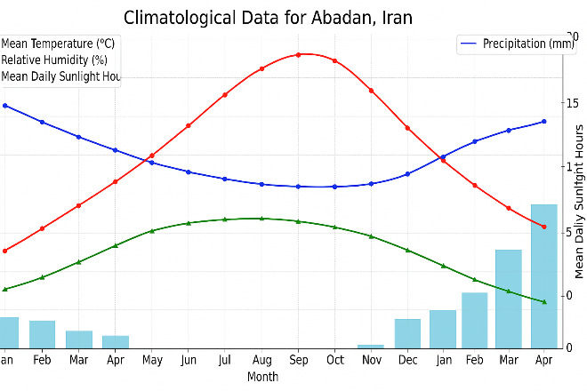
Chart 2- Average Relative Humidity
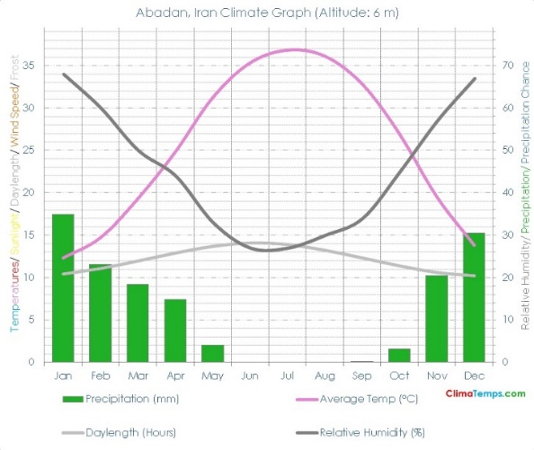
10. Common Wall Materials in the External Envelopes of Residential Buildings in Abadan City
Despite the significant importance of material selection for the external walls of residential buildings in Abadan, limited attention has been given to the application of traditional and modern materials in this context. Field surveys conducted in various areas of the city, along with interviews with experts and professionals in the construction sector, indicate that [materials] are commonly used, which are typically covered with layers of plaster or rendering (Figures 1 and 2).

Figures 1- Wall Layers Related to Outdoor Space
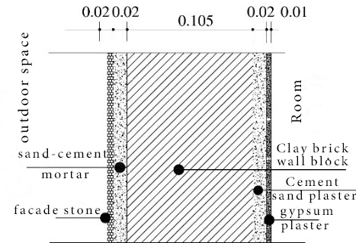
Figures 2 - Floor Layers Related to Outdoor Space
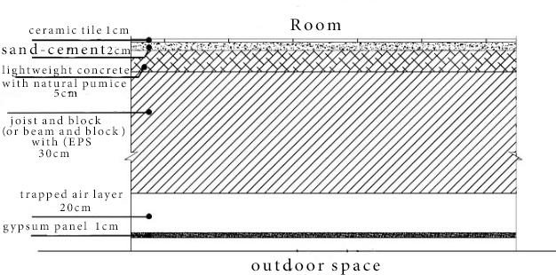
11.Methodology
This research adopts a prescriptive approach for evaluating the thermal performance of building envelope components in accordance with Part 19 of the Iranian National Building Regulations. The prescriptive method is one of the most widely used approaches for assessing the energy performance of building envelopes because it relies on predefined thermal criteria and reference values established for different climate zones and building categories. In this method, the thermal characteristics of building components such as walls, roofs, floors, and openings are evaluated against reference thermal performance requirements without the need for dynamic energy simulations. The study area is the city of Abadan, located in southwestern Iran and classified as a very hot and humid climate zone. Climatic conditions were defined using meteorological data obtained from the Iranian Meteorological Organization and implemented within the thermal assessment framework of Part 19. The selected building represents a conventional residential building classified as Group 1 according to Article 19-2-2-1-2 and Appendix 3 of Part 19, characterized by high energy demand with a dominant cooling load. For the thermal evaluation of wall and roof assemblies, the “Prescriptive-Equilibrium Design Method Software for Part 19,” developed by the Building and Housing Research Center of Iran, was employed. This software is an official calculation tool designed to assess the compliance of building envelope components with the thermal requirements specified in Part 19. The software performs calculations based on climate zone, building category, energy class, dominant thermal demand, construction assembly configuration, and material properties. The input parameters included geographical location (Abadan), building use type, wall and roof assembly composition, layer arrangement, material thermal properties, insulation type, insulation thickness, and the corresponding climatic requirements defined by the software. Various wall and roof configurations were modeled using both conventional construction materials and thermal insulation materials commonly used in Iranian building practice. The evaluated insulation materials included Expanded Polystyrene (EPS), Extruded Polystyrene (XPS), Rock Wool, Glass Wool, and Autoclaved Aerated Concrete (AAC) blocks. These materials were selected due to their widespread application in building construction and their suitability for thermal performance improvement in hot climatic conditions. For each assembly, the software calculates the thermal resistance of the construction layers (R), the total thermal resistance of the assembly (R_{t}), and the overall thermal transmittance coefficient (U-value). The parameter R represents the cumulative thermal resistance of the construction materials forming the assembly, whereas R_{t} represents the total thermal resistance including both the resistance of the construction layers and the interior and exterior surface resistances considered by the software. The overall thermal transmittance coefficient (U-value) is calculated based on the total thermal resistance of the assembly. In addition to the calculated values, the software generates reference thermal performance criteria, including the reference thermal resistance (R_{ref}) and reference thermal transmittance coefficient (U_{ref}), according to the selected climate zone, building category, energy class, and dominant thermal demand. Therefore, the thermal performance of each wall and roof assembly was evaluated by comparing the calculated values of U and Rt with the corresponding software-generated reference values (U_{ref} and R_{ref}). Assemblies meeting the software acceptance criteria were classified as acceptable, while assemblies failing to satisfy the required thermal performance thresholds were classified as unacceptable. The comparative analysis was subsequently performed to determine the relative effectiveness of different insulation materials in reducing heat transfer through the external building envelope under the climatic conditions of Abadan. The results obtained from the software outputs were then analyzed and compared in terms of thermal resistance, thermal transmittance, and compliance with the thermal performance requirements of Part 19. Particular attention was given to the effectiveness of insulation materials in improving the thermal behavior of external walls and reducing heat transfer in the extremely hot and humid climate of Abadan. (Figure 3).
Figure 3 – Interface of the Housing Research Center Software
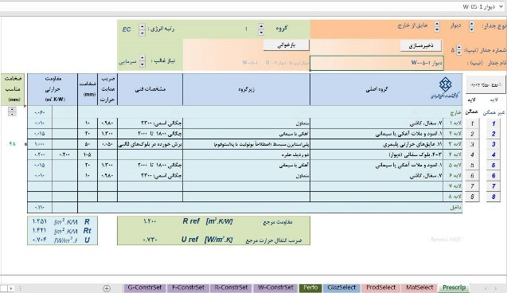
The research's assumed building is a conventional construction based on Article (19-2-2-1-2) and Appendix 3 of Topic 19. It has high energy demand with a predominant cooling thermal load, and belongs to Group 1 of the four building categories, which has high priority in terms of energy saving (Table 1).

12. Discussion and Research Findings
The evaluation criteria for the layers of external walls using conventional materials in this building model involve the use of commonly applied materials such as clay brick, concrete masonry units (CMU), stone cladding, and standard cement and gypsum plasters for walls; as well as joist-and-block (beam and block) roofs, concrete slabs, ceramic floor tiles, and suspended ceilings for floors exposed to the outdoor air.In contrast, the assessment criteria for insulated external wall assemblies focus on the placement and thickness of insulation layers within the wall composition. The insulation materials used include both standard insulations defined in the simulation software and readily available types such as expanded polystyrene (EPS), extruded polystyrene (XPS), rock wool, glass wool, and Autoclaved Aerated Concrete (AAC) blocks, also known as Hebel blocks (Table 2).

Table 1 - Research Assumptions
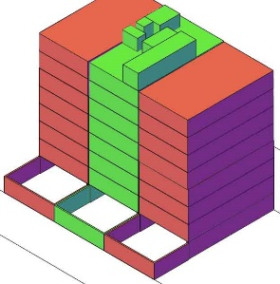 | Physical Status of the Property  - Stories above parking: 7 stories  - Land area: 240 square meters  - Parking area: 141.89 square meters  - Floor area: Each floor is 130.05 square meters, totaling 910.35 square meters  - Stairwell, bulkhead, and elevator shaft area: 206.88 square meters  - Balcony area: 86.80 square meters  Neighborhood Status  - North and South sides: Facing the street  - West and East sides: Adjacent to neighbors
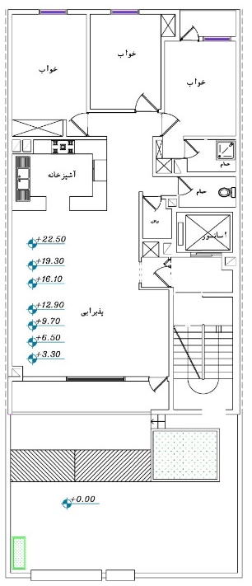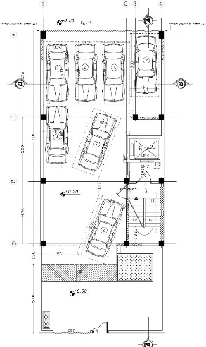
Floor Plans Ground Floor Plan

Table 2 - Thermal Properties of Conventional and Insulation Materials Used in the Study
Heat Transfer Coefficient  U-value[W/m²·K] | Thermal Resistance  R-value [m²·K/W] | Shape | Dimensions  (cm) | Non-Insulating and Insulating Materials Used in Envelopes
1.35 | 0.20 | 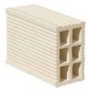 | 20*20*10 | clay brick
1.40 | 0.09 | 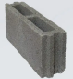 | 39*19*10 | concrete block
0.36 | 2.78 |  | 10 | Expanded Polystyrene (EPS) insulation
0.30 | 3.33 | 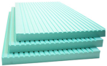 | 10 | Extruded Polystyrene (XPS)
0.70 | 1.43 | 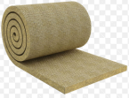 | 5 | rock wool
0.40 | 1.5 | 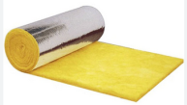 | 5 | glass wool
0.30 | 1.53 | 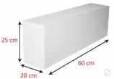 | 20 | AAC block

Five experimental models with detailed layer compositions were studied in two groups — with and without insulation — for floors exposed to outdoor air (Table 3), and seven experimental models with detailed wall compositions in two groups — with and without insulation — for walls exposed to outdoor air (Table 4) were analyzed using the simulation software. The input data included the layer sequence, especially the placement of the insulation layer, based on the guidelines of Part 19 of the Iranian National Building Regulations for residential buildings, and the determination of insulation thickness. The insulation thicknesses were selected iteratively using the official Part 19 software until the thermal performance requirements defined by the software for the selected climate zone and building category were satisfied.

Table 3 - Determination of Thermal Resistance and Heat Transfer Coefficient for Floors Exposed to Outdoor Air
Acceptable / Unacceptable | R_{T} | U | R | U ref [w/ m²k] | R ref [m².k/w] | Layer Order from Outside to Inside | Layers | Code
Unacceptable | 2.41 | 0.78 | 2.19 | 0.41 | 2.30 | - Gypsum panel 1 cm  - Trapped air 20 cm  - joist and block slab 30 cm  - Lightweight aggregate concrete 5 cm  - Sand-cement mortar 2 cm  - Ceramic tile 1 cm | 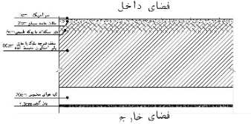 | F0
Acceptable | 3.17 | 3.17 | 2.95 | 0.41 | 2.30 | - Gypsum panel 1 cm  - Trapped air 20 cm  - EPS 5cm  - joist and block slab 30 cm  - Lightweight aggregate concrete 5 cm  - Sand-cement mortar 2 cm  - Ceramic tile 1 cm | 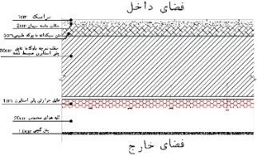 | F1
Acceptable | 3.50 | 0.28 | 3.28 | 0.41 | 2.30 | - Gypsum panel 1 cm  - Trapped air 20 cm  - XPS 5cm  - joist and block slab 30 cm  - Lightweight aggregate concrete 5 cm  - Sand-cement mortar 2 cm  - Ceramic tile 1 cm | 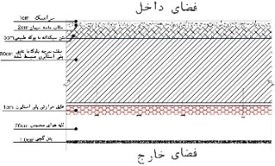 | F2
Acceptable | 2.68 | 0.37 | 2.46 | 0.41 | 2.30 | - Gypsum panel 1 cm  - Trapped air 20 cm  - rook wool 2cm  - joist and block slab 30 cm  - Lightweight aggregate concrete 5 cm  - Sand-cement mortar 2 cm  - Ceramic tile 1 cm | 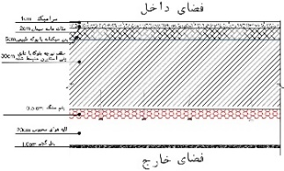 | F3
Acceptable | 2.64 | 0.37 | 2.42 | 0.41 | 2.30 | - Gypsum panel 1 cm  - Trapped air 20 cm  - glass wool 0.5cm  - joist and block slab 30 cm  - Lightweight aggregate concrete 5 cm  - Sand-cement mortar 2 cm  - Ceramic tile 1 cm | 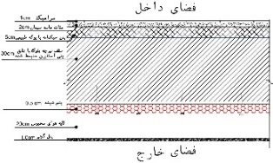 | F4
Table 4 - Determination of Thermal Resistance and Heat Transfer Coefficient for Walls Exposed to Outdoor Air - Source (Author)
Acceptable / Unacceptable | R_{T} | U | R | U ref [w/ m²k] | R ref [m².k/w] | Layer Order from Outside to Inside | Layers | Code
Unacceptable | 0.39 | 2.51 | 0.22 | 0.73 | 1.2 | - Facade stone 1 cm  - Cement grout 3 cm  - Clay brick wall 20 cm  - Sand-cement mortar 2 cm  - Gypsum plaster 1 cm | 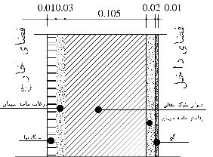 | S0
Unacceptable | 0.63 | 1.56 | 0.46 | 0.73 | 1.2 | - Facade stone 1 cm  - Cement grout 3 cm  - Concrete Block Wall 20 cm  - Sand-cement mortar 2 cm  - Gypsum plaster 1 cm |  | S1
Acceptable | 1.74 | 0.57 | 1.57 | 0.73 | 1.20 | - Facade stone 1 cm  - Cement grout 3 cm  - EPS 5cm  - Concrete Block Wall 20 cm  - Sand-cement mortar 2 cm  - Gypsum plaster 1 cm | 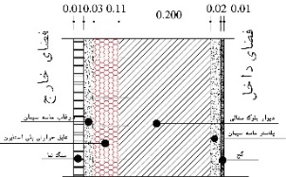 | S2
Acceptable | 1.64 | 0.60 | 1.47 | 0.73 | 1.20 | - Facade stone 1 cm  - Cement grout 3 cm  - XPS 5cm  - Concrete Block Wall 20 cm  - Sand-cement mortar 2 cm  - Gypsum plaster 1 cm | 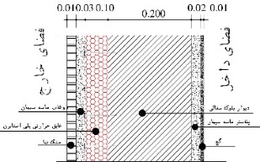 | S3
Acceptable | 1.56 | 0.64 | 1.39 | 0.73 | 1.20 | - Facade stone 1 cm  - Cement grout 3 cm  - Rock wool 5cm  - Concrete Block Wall 20 cm  - Sand-cement mortar 2 cm  - Gypsum plaster 1 cm | 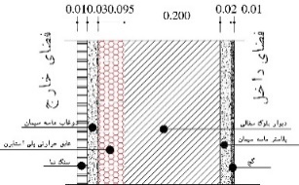 | S4
Acceptable | 1.64 | 0.60 | 1.47 | 0.73 | 1.20 | - Facade stone 1 cm  - Cement grout 3 cm  - Glass wool 5cm  - Concrete Block Wall 20 cm  - Sand-cement mortar 2 cm  - Gypsum plaster 1 cm | 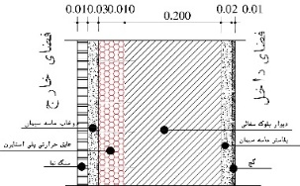 | S5
Acceptable | 2.22 | 0.45 | 2.05 | 0.73 | 1.20 | - Facade stone 1 cm  - Cement grout 3 cm  - AAC block 20cm  - Sand-cement mortar 2 cm  - Gypsum plaster 1 cm | 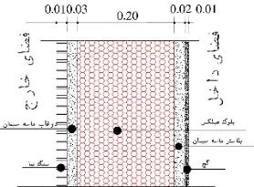 | S6

The analysis of Tables 3 and 4 demonstrates that building envelope assemblies exposed to outdoor conditions in the extremely hot and humid climate of Abadan exhibit inadequate thermal performance when constructed solely with conventional materials (models F0, S0, and S1). The results indicate that replacing clay brick with concrete block did not produce a substantial improvement in thermal behavior, as both wall systems remained thermally inefficient according to the software evaluation criteria.A comparison between conventional and insulated envelope systems revealed that the incorporation of thermal insulation significantly increased the thermal resistance of the assemblies while reducing their thermal transmittance coefficients. Consequently, insulated wall and roof assemblies exhibited substantially improved thermal performance compared with conventional construction systems.Among the investigated insulation materials, EPS, XPS, rock wool, glass wool, and AAC blocks all improved the thermal performance of the envelope assemblies to varying degrees. However, the differences in thermal behavior among the insulation alternatives were relatively limited, indicating that all investigated insulation systems can contribute effectively to reducing heat transfer through the building envelope under the climatic conditions of Abadan. Therefore, when selecting an insulation material, factors such as required thickness, installation complexity, cost, moisture resistance, acoustic performance, fire resistance, environmental sustainability, and material weight should also be considered in addition to thermal performance (Table 5).
Table 5 - Comparative Characteristics of the Investigated Insulation Materials - Source (Author)
Features | EPS | XPS | glass wool | Rock wool | AAC (Hebel Block)
Thickness (cm) | 5 | 5 | 5 | 5 | 20
Cost (Relative) | cheap | expensive | cheap | relatively expensive | Medium
Ease of implementation | Very easy | relatively hard | relatively easy | relatively difficult | relatively easy
Moisture Resistance | Moderate | High (nearly impermeable) | low | High | Moderate
Acoustic Insulation | Weak | Weak | Good | Excellent | Good
Fire Resistance | Very weak (flammable) | Relatively weak (flammable) | relatively good | Excellent (non-flammable) | Excellent
Environmental Sustainability | low | low | Moderate | Good | Good
Specific Weight | Light | lighter | Very light | relatively heavy | Very light

13. Conclusion

The results of this study demonstrate the significant impact of exterior wall insulation on the thermal performance of building envelopes in the extremely hot and humid climate of Abadan. The comparative analysis showed that conventional wall assemblies constructed with commonly used materials such as clay brick and concrete block exhibit inadequate thermal performance and fail to satisfy the thermal requirements defined by the Part 19 assessment software. The incorporation of insulation materials substantially improved the thermal resistance of wall and roof assemblies while reducing their thermal transmittance coefficients. Consequently, insulated assemblies achieved considerably better thermal performance than conventional construction systems and contributed to reducing heat transfer through the building envelope. Among the investigated alternatives, Expanded Polystyrene (EPS), Extruded Polystyrene (XPS), Rock Wool, Glass Wool, and AAC (Hebel) blocks all enhanced the thermal behavior of the building envelope compared with conventional materials. However, the differences in thermal performance among the insulation alternatives were relatively small, indicating that several insulation systems can effectively satisfy the thermal requirements of buildings located in Abadan’s climatic conditions. Therefore, the selection of insulation materials should not be based solely on thermal performance. Additional criteria including installation requirements, moisture resistance, acoustic insulation, fire safety, environmental considerations, material weight, and economic factors should also be considered in practical applications. Based on the combined evaluation of thermal performance and practical characteristics presented in this study, glass wool and rock wool were found to offer a favorable balance between thermal and practical performance criteria for exterior wall insulation in Abadan due to their favorable balance between thermal efficiency, fire resistance, acoustic performance, and overall applicability. The findings of this research confirm that the use of thermal insulation in exterior building envelopes is an effective strategy for reducing heat transfer, improving thermal performance, decreasing cooling energy demand, and supporting compliance with the energy-efficiency objectives of Part 19 of the Iranian National Building Regulations in hot and humid climates.

REFERENCES
Alaboud, M., & Gadi, M. (2020). The Effect of Thermal Insulation on Cooling Load in Residential Buildings in Makkah, Saudi Arabia. Future Cities & Environment, 6(4). https://doi.org/10.5334/fce.87
Boostani, H., & Hancer, P. (2018). A model for external walls selection in hot and humid climates. Sustainability, 11(1), 100. https://doi.org/https://doi.org/10.3390/su11010100
Building, and, Housing, & ResearchCenter. (2023). Topic 19 of Iran National Building Regulations, New Edition. Retrieved from https://www.bhrc.ac.ir
Dehghan, F., & Porras Amores, C. (2025). Simulation-Based Multi-Objective Optimization for Building Retrofits in Iran: Addressing Energy Consumption, Emissions, Comfort, and Indoor Air Quality Considering Climate Change. Sustainability, 17(5), 2056. https://doi.org/https://doi.org/10.3390/su17052056
IEA. (2023). Energy Efficiency 2023: Building Sector Report. International Energy Agency. https://www.iea.org/ search ? q =Energy%20Efficiency %2020 2 3%3A%20Building%20Sector%20Report
Iran, Meteorological, & Organization. (2023). Iran Climatology Data Center. Abadan Synoptic Station Data. https://www.irimo.ir/far/index.php
Mahdavinia, M., & Khayat, I. (2018). An Analytic Study of the Effect of Envelope Insulation on Annual Energy Consumption in Tall Office Buildings of Tehran Metropolitan City. Journal of Architecture and Urban Planning, 10(20), 147-160. https://doi.org/10.30480/aup.2018.594
Mohammadi, A., & Daraio, J. (2020). Improving the energy efficiency of existing residential buildings by applying passive and cost-effective solutions in the Hot and humid region of Iran. Space Ontology International Journal, 9(4), 77-96.https://doi.org/10.22094/soij.2020.68 0277
Momeni, K., & Tanoorsaz, M. (2023). Comparison of the influence of exterior walls on the thermal comfort of dwellers and selection of optimal materials in hot and semi- arid climates (case study: Dezful). Journal of Architecture in Hot and Dry Climate, 11(17), 211-227. https://doi.org/10.22034/ahdc.2023.20068.1737
Naseri, A., & Mehrgan, A. (2017). Investigating the Effect of Physical Characteristics of Residential Buildings on Energy Consumption (Case Study: Khorramabad City). Iranian Architecture and Urban Planning, 8(2), 59-73. https://doi.org/https://doi.org/10.30475/isau.2018.62065
Omar, R., & Rehumaan, S. (2022). Preliminary Study to Show the Effect of Building Envelope Materials on Thermal Comfort of Buildings Located in Hot Humid Climate. World J. Eng. Technol, 10, 264-271. https://doi.org/10.4236/wjet.2022 .102017
Rodrigues, E., Fereidani, N. A., Fernandes, M. S., & Gaspar, A. R. (2024). Diminishing benefits of thermal mass in Iranian climate: Present and future scenarios. Building and Environment, 258, 111635. https://doi.org/10.1016/j.buildenv.2024.111635
Sadati, S. E., Rahbar, N., & Kargarsharifabad, H. (2023). Energy assessment, economic analysis, and environmental study of an Iranian building: The effect of wall materials and climatic conditions. Sustainable Energy Technologies and Assessments, 56, 103093. https://doi.org/10.1016/j.seta.2023.103093
Sadineni, S. B., Madala, S., & Boehm, R. F. (2011). Passive building energy savings: A review of building envelope components. Renewable and sustainable energy reviews, 15(8), 3617-3631. https://doi.org/https://doi.org/ 10.1016/j.rser.2011.07.014
Saebi, S. B., Heidari, F., & Soleimanpour, N. (2020). Audit of energy loss through exterior walls of buildings and impact of thermal insulation with simulation in design builder software (Case study: Office building in Tehran). Journal of Engineering Sciences Elites, 5(3). https://doi.org/https://sid.ir/paper/367436/en
Shaeri, J., Vakilinejad, R., Yaghoubi, M., & Aliabadi, M. (2019). Impact of Materials on Energy Consumption, Carbon Production, and Thermal Comfort in Office Buildings in Hot and Humid, Hot and Dry, and Cold Climates of Iran. Iranian Journal of Mechanical Engineering, 21(4), 6-33. https://doi.org/20.1001.1.25384775.1398.21.4.1.2

*Corresponding author: ali.mardani@iau.ac.ir
-Author's compilation based on manufacturers’ technical datasheets, literature review, and field interviews with construction professional’s Thermal performance values were obtained from the software analysis, whereas the remaining characteristics were compiled from technical literature, manufacturers’ specifications, and field observations
-Relative cost assessment is based on local market observations and interviews with construction practitioners in Abadan

