“The journey of light”: Qualitative and quantitative analysis of natural light in Seikh Lutfallah Mosque
Corresponding Author:
Sadegh Panahiazar, Ph.D.
128,block E, Seamount Apartments, Fosterbrook, Stillorgan Road, Dublin, Ireland
Tel: 00353 871178840
Email: sadegh.pa@gmail.com

Abstract
The Sheik Lutfallah mosque, built in Isfahan, Iran, between 1603 and 1618, is renowned for the quality of its interior light, which was intended both to glorify the shah, originally the principal worshipper in the space, and evoke heaven. While a careful analysis of the form, achieved through photography as well as plan and section drawings, enables a partial understanding of how these effects were achieved, HDR imaging allows a more rigorously scientific understanding of exactly how light is distributed in the corridor leading to the domed interior hall and in that hall itself. Having a more rational explanation of how those who designed and built this mosque achieved this evocation only inspires greater respect for their deft combination of ingenuity and piety and for the ways in which light continues to be a persuasive metaphor for the divine.

Key Word:
HDM Imaging, Architecture, History of Architecture, Sheikh LotfAllah, Light in Architecture, Lighting Analysis

Introduction
The Sheikh Lutfullah Mosque in Isfahan, Iran, built between 1603 and 1618, stands on the city’s Maidan directly opposite the Ali Qapu Palace. Both were erected by Shah Abbas I (reigned 1588-1629) as part of his transformation of the city of Isfahan to serve as the Safavid capital. Sussan Babaie (2008) has highlighted the degree to which these and Shah Abbas’s other interventions in the city, including the creation of the Maidan itself, were prompted by Abbas’s desire to express kingship in ways that enhanced support for the Safavid’s adoption of Shi’ism as the state religion. Sheikh Lutfullah, the mosque’s original imam, was the Shah’s father-in-law. As one of the leading clerical supporters of the regime, he propagated an understanding of Shi’ism that buttressed the king’s authority, including the institution of a requirement to attend Friday prayer (Babaie, 2008). identifies the unusual design of the mosque, whose principal interior space consists of a single domed unit, as “a singularly creative refashioning of the maqsura feature of congregational mosques associated with the patronage of Sunni kings.” “The maqsura, she continues, “constituted an especially sanctified zone at or in the vicinity of the mihrab occupied by the ruler when he attended Friday prayer”(Babai, 2008, p. 96). The Sheikh Lutfullah Mosque was thus built to serve as a royal chapel and belongs to an entirely different – and more unusual -- type of mosque than the new congregational Shah (now Imam) mosque Shah Abbas contributed to the south end of the Maidan, which is, like the city’s older Friday mosque, organized instead around a large courtyard that can accommodate thousands of worshippers.
Reconstructing this political and religious context is crucial to understanding of why the Sheikh Lutfullah mosque was built and how its form, like the Sheikh’s preaching, enhanced Shah Abbas’s mutually supportive refashioning of Shi’ism and Persian kingship. They do little, however, to explain the building’s extraordinary experiential qualities as a place where the presence of light is manifested physically, psychologically, and artistically. Light in this mosque is not only something that adds beauty but is the basis of its formation and existence. The challenge for scholars is to move beyond the combination of physical description and emotive language Arthur Upham Pope (1965), the American art historian who encouraged Reza Shah to restore the building, employed when he wrote:
The drum of the dome is pierced at regular intervals by windows. These are filled with a pair of grilles, an exterior and an interior grille, each composed of powerful arabesque patterns in an equal proportion of solids and voids, so that the light is doubly broken and filtered across the edges of cool blue faience. Thus, softened and clarified, reflected on innumerable littering facets of the wall and dome, light is shed over the shadowless interior like sparkling dew, revealing a perfection of unearthly beauty. No one in a receptive or contemplative mood can enter without a shock and the sense of being received into a Presence. For all its elegance and finish it has no weakness: the scale is too ample, the patterns too strong. Like the inspired architecture it is, it imposes its own mood” (Pope, 1965, p. 215).
Ustad Mohammad Reza Isfahani, the chief architect and designer of Sheikh Lutfullah mosque, was influenced by the teachings of Sheikh Baha’i, a well-known mathematician, astronomer, and poet and the most important philosopher of the Safavid period, who was the co-founder of the Isfahan school of Islamic philosophy. He was well known for his teachings on ‘the school of illumination’ established in the twelfth century by Suhrawardy (1154-1191) (Babai, 2018). The implications of his philosophy of illumination upon the design of the Sheikh Lutfullah mosque are obvious.
Although light is always the dominant feature in discussions of the building, there remains a paucity of quantitative analysis based on objective data. Previous scholars have often written from the perspective that the majesty of Sheikh Lutfallah mosque could only be adequately conveyed by recourse to metaphors for transcendency. The travel writer Robert Byron famously said of it that it “hides any symptom of construction or dynamic form beneath a mirage of shallow curving surfaces, the multitudinous offsprings of the original squinch. From there is and must be; but how it is created, and what supports it, are questions of which the casual eye is unconscious, as it is mean to be, lest its attention should wander from the pageant of colour and pattern” (Byron, 1937, p. 198). New techniques, however, enable an objective analysis of natural light in Sheikh Lutfallah Mosque that can assist in better understanding how such apparently other worldly effects were created.
As demonstrated by an earlier analysis undertaken by one of the authors of another seventeenth-century place of royal worship, San Lorenzo in Turin, the behaviour of natural light in such spaces can be understood in ways that overcome the limitations of purely visual analysis (Panahiazar& Matkan, 2018). Luminance mapping via HDR imaging, which provides numeric data by using quantitative luminous measurements techniques to understand the behaviour of light, can effectively be paired with conventional architectural analysis, particularly the preparation of section drawings, in order to identify with new precision exactly how specific lighting conditions were created. These objective results should be underpinned by an awareness of the scholarly literature that explicates the design philosophy and the iconography of the building, which in the case of the mosque includes its many inscriptions. This combination of quantitative and qualitative analysis supports a better understanding of how the emotional experiences that encourage piety have been engendered in specific cultural and theological contexts.

What the Eye Can See
A visitor’s experience of the building usually begins with a glimpse of the dome, one of the few single-shell domes erected in Iran during the Safavid era. The arabesque floral design of the tile ornamentation cladding its exterior surface is justly celebrated. Already here, light matters. The ever-observant Bryon, although no scholar, captured its distinctiveness when he wrote:
Here and there, at the junction of the branches or in the depths of the foliage, ornaments of ochre and dark blue mitigate the harshness of the black and white tracery and bring it into harmony with the soft golden pink of the background; a process which is continued by a pervading under foliage of faint light blue. But the genius of the effect is in the play of surfaces. The inlay is glazed. The stucco wash is not. Thus, the sun strikes the dome with a broken highlight whose intermittent flash, moving with the time of day, adds a third texture to the pattern, mobile and unforeseen (Bayron, 1937, P. 199).
Our analysis, however, focuses on explicating the lighting of the interior. In four stages we will describe first what the eye can see in the corridor and the dome before layering on what can be learned from HRD analysis, again first of the corridor and then of the dome. The path through which natural light guides the worshippers from the entrance hall to the dome chamber and towards the mihrab is explained in Figure 10. The dotted arrow shows the path worshippers take in the mosque; the yellow arrow shows the way in which openings lead the worshippers from the entrance to the dome hall; and the orange arrow shows the direct light which points at the Mihrab.
Like the larger Shah Mosque that anchors the south end of the Maidan, the Sheikh Lutfullah’s entrance is not on axis with its mihrab niche, which necessarily faces towards Mecca, with which the Maidan is not aligned. This situation prompts complex entry routes into both buildings that realign the visitor from the secular to the sacred realm. One enters the Sheikh Lutfullah mosque from the Maidan into an octagonal vestibule, which acts as a pivot into a corridor that snakes around two exterior sides of the central mosque volume and leads to a door on axis with the mihrab. In the vestibule there is a sudden and dramatic reduction of daylight. The entrance door is very small and short in height in comparison to the Iwan, and it is the only source of light for the vestibule.
As demonstrated in Figure 1, due to the depth of the Iwan niche and the low entrance gate, only a small amount of daylight penetrates through to the vestibule. This light mainly illuminates the underground rooms through the grilled openings on the entrance hall floor, as shown by the yellow arrow in the section drawing. The immediate darkness experienced here creates a sudden but not uncomfortable blindness. The contrast in illumination between the brightness of the Maidan and the dark vestibule widens the pupil of visitors’ eyes which enables them later to better observe the corridor. This suggests the architect was aware of the mechanism of adaptation via the pupillary light reflex in the human eye, which adjusts the amount of light that reaches the retina. In response to varying ambient light levels, rods and cones of the eye function both in isolation and in tandem to accomplish this. It would be impossible for the eye to appreciate the decoration of the dome hall if one was to enter it directly from the Maidan; as the adaptation mechanism of the eye takes several minutes, the hall would look significantly dim compared to the very bright outdoor area.
The corridor is illuminated by four sources. Small volumes of light come from the entrance hall, and a far lesser amount from a small grilled window at the very beginning of the corridor which connects the corridor to the dome hall. The third is where the corridor turns 90 degrees and a fourth is placed on the opposite side of the entrance to the dome hall. These openings are illustrated in Figure 2.
None of these four sources of light are sufficient, however, to illuminate the entire corridor, hence there are relatively dim areas between the illumination ranges of the openings. The grilled window at the beginning of the corridor is made from turquoise glazed bricks which are placed in a way to create an equal-armed cross as a negative space. The bricks have a relatively long width in comparison to other lattices in Sheikh Lutfallah. The width of the glazed bricks limits the amount of light that penetrates from the dome hall and creates a strong perspective towards the dome hall when one approaches the lattice. This can be seen in Figure 3. The wall between the dome hall and the corridor is 1.1 meters wide. The lattice is placed on the dome hall side of this wall. Considering the 1.1-meter-deep opening and the brick lattice, which is relatively wide, only a small volume of light penetrates towards the corridor here, yet this particular opening catches the eyes due to its glazed tile surface. The amount of light penetration from this opening is so small that it seems it was designed to illuminate the glazed surface of the lattice rather than the corridor, in order to draw the attention of visitors towards that which lies beyond the lattice. The second opening is placed at a 45-degree angle to the corridor (Figure 4). It filters the exterior light by diffusing light towards both sides of the corridor. It, in fact, comprises two openings; an arch opening filled with an equal-armed cross lattice sits atop top of a rectangular opening with an arabesque lattice infill. Together, they filter just the right amount of natural light. Their angled position is key to their effectiveness as they evenly illuminate both sides of the passage leading to them. The final opening on the approach to the dome chamber is set right in front of the entrance to the chamber. It illuminates the entrance. This opening is similar in design to the previous opening with an equal-armed cross lattice on top of a rectangular opening with arabesque and floral lattice. Both let enough daylight penetrate to draw attention away from the rest of the corridor and instead push the visitor towards the entrance to the domed heart of the building. (Figure 5)
The entire corridor is astonishing in design and decoration, but it is the light which gives a special characteristic to what would otherwise be simply a beautiful and well decorated passageway. The majestic presence of daylight breathes life into the corridor, without which the visitor would experience a completely different atmosphere. Nader Ardalan and Laleh Bakhtiar (1973) describe this smooth transition best. They write that the orchestration of daylight is such that “by the time one has penetrated the entrance and the three subsequent turns of the entrance corridor, the spectator is unaware of any imbalance” (Fisherman & Khan, 1994, p. 128). They conclude that for the devout it provides “steps of preparation towards the divine truth” (Ardalan & Bakhtiar, 1973, p. 3). If we consider the whole experience as a symbolic journey, in which one is taken from the outside world into a passage for a higher realisation of life, and if the openings act as the prophet for this spiritual transition, then the domed hall is the promised heaven.
Entering the mosque proper from the corridor one feels a sense of relief, as the pressure of the low, dim corridor, decorated with blue-green based ornamented faience and glazed tiles, is suddenly released into a tall, broad open space, flooded in light and ornamented with a palette tending to yellow-gold, which, thanks to the enormous amount of light reflected on the satiny tile surfaces, creates a warm and welcoming yet dazzling environment. (Figure 6) There are few light sources in this space. The most significant ones are the sixteen openings on the drum under dome (Haji Ghasemi, K. 1996, p. 198). These are filled with pairs of grilles, with a 90cm gap between them. Each is composed of arabesque patterns in an equal proportion of solids and voids, so that the light is doubly broken and filtered across the edges of cool blue faience. Thus, softened and clarified, reflected on innumerable glittering facets of the wall and dome, light is shed over the shadowless interior like sparkling dew. (Figure 7) The subtle beauty of the lavishly decorated interior of the dome would not be visible without this type of illumination. Instead of an oculus, geometrical forms diminish as they approach the top to create perspective towards the apex, while to ensure its brightness the colour of its surface changes. The glazed and satiny faience used to cover the interior of the dome also diffuses the light from the drum across the entire ceiling, adding to its brightness.
The smallest opening which filters outside light into the dome chamber is located on the east wall, which is 2.8 meters wide and hence, despite the size of the opening, not much gets through the double grilled surface. Like the first opening in the corridor, this opening seems to be self-illuminating rather than actually contributing to the illumination of the dome hall. (Figure 8)
The last opening to be investigated in the mosque, has a completely different characteristic. Not only it is by far the biggest in the entire edifice, but it is also the only one with no lattice to filter the daylight. As a result, direct daylight penetrates through it. It consists of a massive arch, 3.4 meters tall at its apex with a depth of 5.1 meters. This depth ensures that light enters at the correct angle to perform an essential task. (Figure 9) Located opposite the mihrab, on top of the entrance to the dome hall, it ensures that the highest volume of light entering the space light passes through the dome hall and hits the mihrab, which thus becomes one of the brightest surfaces in the space. Moreover, this light can be clearly seen regardless of the position one occupies within the dome hall.
What the Eye Cannot See
HDRI analysis adds nuance to this analysis and provides a more complete understanding of the presence of natural light in the mosque. One of the ways to study light numerically is by measuring its luminance. Luminance is the intensity of light emitted from a surface per unit area. Brightness is the perception elicited by the luminance. There are different ways in which the luminance of a scene can be calculated. Photography based photometry captures the luminance within a large field of view at a high resolution. High Dynamic Range (HDR) photography can capture luminance values. In the HDRI luminance mapping technique, photographs of a scene are captured multiple times with different exposure values via a SLR digital camera. Taking multiple exposures ensures that each image will contain properly exposed pixels in addition to over-and-under exposed ones. This guarantees that each pixel will be properly exposed in one or more images in the sequence. (Reinhard et al., 2010) It is possible to discard extremely under- and over-exposed pixels through specific HDR construction software, where all the multiple exposure images will be merged into a single 32-bit image file containing an exponent value acting as an extra 8-bit channel storing the luminance information (Jacobs, 2007).
The HDR luminance mapping technique for this study was based on guidelines provided by M. N. Inanici (Inanci, 2006) and Axel Jacobs (Jacobs, 2007). For this study, multiple LDR (low dynamic range) photographs were taken with a Nikon digital SLR camera. These images were taken on the 6th of April 2015, from 12:00 to 13:00. The Photosphere software (Trentacoste et al., 2007) was utilised to create the HDR images and also the luminance maps. Such maps represent levels of luminance calculated on the HDR image and can provide useful information on the quality of light and the luminance distribution of the scene. The luminance maps were later converted to false colour images where each colour represents a luminous value. Hdrscope software was used to compare the luminance values of specific areas within a scene. This programme is useful for obtaining the ALV (Average Luminance Value), and interactive image analysis of each HDR image ( Kumaragurubaran & Inanci, 2013). To calculate the ALV of specific areas within the interior Sheikh Lutfallah, several different image filters were applied to the HDR image. These filters isolate unwanted pixels. Figure 11 graphically explains the process.
Upon entering the mosque, the first opening is on the right side of the corridor. As it is displayed in the false colour map in Figure 12, the depth of the opening and the width of the lattice dramatically reduced the volume of light penetration from the dome hall. The first row in Figure 12 demonstrates the low volume of illumination at the beginning of the corridor with an average luminance value of 2.03 cd/m². Row two displays the ALV of the opening alone which is almost four times more. This suggests that this single opening is responsible for most of the illumination at the early stage of the corridor.
Figure 13 demonstrates the corridor after the first opening. The corridor is still relatively dark with an (ALV) of 3.41 cd/m². The opening in this image on the other hand has a high ALV. The first opening in the corridor had the ALV of 7.8 cd/m² whereas the opening at the turn of the corridor has the ALV of 23.6 cd/m², almost three-time higher ALV. This is the reason behind the strong visual pull exerted by this particular opening. Like a candle at the end of a cave, it is considerably brighter than the rest of the corridor and thus automatically becomes the visual focus of attention. Surely it would not have the same effect if the first opening had a higher ALV. No wonder most visitors do not even see the door on the left side of the corridor as it is almost hidden in the dark. The ALV of this opening is seven times brighter than the AVL of the entire scene which causes an immense contrast and thus directs the visitor’s attention towards the end of the corridor. This analysis also provides insight into the angled opening at the turn of the corridor, which serves to attract visitors and guide them further toward the dome hall. The angle at which the light falls is central to this effect. If the opening were perpendicular to the corridor, it would grab more attention from the entrance but then it could not push visitors towards the end of the corridor.
Figure 14 illustrates the way this opening illuminates the second part of the corridor. Upon approaching the corner, visitors face a bright wall on the right-hand side, which has a much higher ALV in comparison to the left side of the corridor. The same size filters were applied in five different spots in this image to show the immense ALV difference within this space. Looking at the numerical values, it seems the angled opening acts as a spotlight similar to those used in a theatre. Filters 1 and 5 have almost similar locations on opposite walls. Yet the ALV in filter 1 is sixty-five times more than the ALV in filter 5. The spotlight effect on the right-side wall is what makes one assume there is something to be expected on this side of the corridor and are consequently guided towards the dome hall. Figure 14 also suggests that the second part of the corridor is more illuminated that the first part which explains how the corridor acts to prepare visitors for the experience of the dome hall. At the entrance there is a dramatic fall of illumination, then step by step the ALV increases but only gradually so that, when one enters the dome hall, there is no unpleasant sense due to the sudden increase of ALV, and yet the significantly brighter environment evokes astonishment within the visitor.
Figure 15 demonstrates what happens upon immediately entering the dome hall. There are two fundamental changes at this stage. The first is the change in the size of the space and the second is in the level of the ALV. Upon entering the dome hall, visitors experience a breath-taking moment. From a dim and low corridor, suddenly one steps into a large, bright space that rises to a much greater height. The change in scale is indeed dramatic. But in terms of ALV the numbers suggest the increase is not, however, as large as it feels. Indeed, if it were greater, it would be unpleasant and even potentially painful to the eyes. A third factor, the change of colour, helps to create this sense of surprise and exhilaration many experiences here. Byron, who noted that he had “never experienced such splendour before,” described the contrast between the relatively dark walls and the dome that floats above them as well as the way in which he experienced the light:
The dome is inset with a network of lemon-shaped compartments, which increase in size as they descend from a formalized peacock at the apex and are surrounded by plain bricks; each is filled with a foliage pattern inlaid on plain stucco. The walls, bordered by broad white inscriptions on dark blue, are similarly inlaid with twirling arabesques or baroque squares om deep ochre stucco. The colours of all this inlay are dark blue, light greenish blue, and a tint of indefinite wealth like wine. Each arch is framed in turquoise corkscrews. The mihrab to the west wall is enamelled with tiny flowers on a deep blue meadow.
Each part of the design, each plane, each repetition, each separate branch or blossom has its own sombre beauty. But the beauty of the whole comes as you move. Again, the highlights are broken by the play of glazed and unglazed surfaces; so that with every step they rearrange themselves in countless shining patterns; while even the pattern of light through the thick window traceries is inconstant, owning to outer traceries which are several feet away and double the variety of each varying silhouette (Byrone, 1937, pp. 199-200).
The brightness of the dome in comparison to the supporting walls draws the visitor’s gaze upwards. The first row in Figure 16 shows the ALV when one looks up towards the dome while standing right beneath the centre of the dome. It is almost twice that of the AVL shown on the first row of Figure 15. Different filters were applied to investigate different parts of the scene. The second row concerns the area around the dome excluding the openings and the drum with the ALV of 23.4 cd/m2. The third row shows the ALV of the dome plus the drum and the openings. The fourth row has a focus only on the dome with an ALV of 23.6 cd/m2. What is interesting is the similar ALV of the dome and its surrounding area when the openings on the drum are excluded. This shows how evenly light is distributed on the ceiling of the dome hall.
Row six in Figure 16 demonstrates that the openings on the drum individually have the ALV of 87.4 cd/m2 which is very high in comparison to the rest of the dome. This creates a ring of light around the drum, allowing the dome to appear to float rather than being clearly supported on the pendentives below it. Filtering the sixteen openings, the ALV of the rest of the image is 22.9 cd/m2 (row 7) which is almost similar to the ALV of 23.6 cd/m2 in the dome and the ALV of 23.4 underneath the drum. This is almost four times less than the ALV of the sixteen openings.
Although light seems to be the key element in Sheikh Lutfallah, the architects combined illumination and coloured surfaces to achieve their design intention, rather than focusing exclusively on light penetration. The apex of the Sheikh Lutfallah dome appears much brighter than the rest of the dome’s interior surface. The numbers in the fifth row in Figure 16 suggest otherwise. Not only is it not the brightest spot but the apex ALV is almost 2 cd/m2 darker than the ALV of the rest of the dome. This demonstrates that the sense of brightness at the apex is simply due to the change of the surface faience colour rather than an increase in illumination.
Despite the existence of other openings in the dome hall, the drum openings are the main source of illumination in the hall. Figure 17 examines each opening’s ALV to confirm that they filter the daylight evenly. While the ALV of the sixteen openings together is 88.4 cd/m2 in Figure 17 the ALV of each opening is measured individually to compare the brightness between the openings. As Figure 17 demonstrates, the brightest opening has the ALV of 93.6 cd/m2 and the darkest one is 79.4 cd/m2 while they are on the opposite sides from one another. From the darkest opening, the average luminance value gradually increases towards the brightest opening and then reduces again towards the darkest opening. The increase/decrease in ALV between two openings next to one and other is between two to three cd/m2. The unequipped eye cannot sense the changes in ALV between the openings as it happens smoothly, as demonstrated by the graph in Figure 18.
Figure 19 considers the four side walls. The southern (first row), eastern (second row), and western (third row) walls are similar in terms of the number and size of their openings. But the ALV is not similar amongst the three of them. The eastern and western walls have almost the similar ALV, 12.6 cd/m2 and 12.1 cd/m2. The southern wall on the other hand has a relatively higher ALV although it has the same opening as the other two. The north wall (fourth row), unlike the other three has a gigantic opening which is also the only opening with no lattice in the entire edifice. Hence it is the brightest wall with an ALV of 17.3 cm/m2. The sole purpose of the very large opening on this wall is to illuminate the Mihrab niche set into the Qibla wall and thus to orient the worshipper towards Mecca. Light more than the relatively simple design of the Mihrab accomplishes this task. The impact of the lack of a lattice filtering this light accounts for the relatively higher ALV in southern wall in comparison to the western and eastern walls. The false colour map of the southern wall (row one Figure 19), demonstrates a bright area on top of the Mihrab niche. Figure 20 demonstrates how this large opening achieves its design goals. The false colour map clearly shows the Mihrab appears to have the same brightness as the opening above it. The strong line of light in the centre of the image, which points directly at the Mihrab, also proves that the opening above the entrance not only illuminates the Mihrab but also directs the view of the visitor entering the space towards the Mihrab, emphasising its importance.
The impact of the northern opening upon the Qibla wall is investigated in more detail in Figure 20, where the same size square filters in various locations along it. This demonstrates that the opening above the mihrab has the AVL of 61.8 cd/m2 but the top part of the mihrab which has no source of illumination also has a high ALV of 33.1 cd/m2. This is particularly interesting when comparing it with filter 3 which is not far from filter 2, yet it has the AVL of 5.4 cd/m2, almost six times less. This level of illumination contrast is caused by the direct beam of light which comes from the gigantic opening above the entrance. What is also interesting is the data of filter 4 where the ALV rises again to 12.26 cd/m2 which shows how bright the light line on the floor is. As the filters move away from the central axis the ALV drops. In filter 8 the ALV drops dramatically to 0.5 cd/m2, almost twenty-four times less than filter 4. While the ALV of the entire scene is 12.8 it is clear that the main illumination happens at the central axis, which clearly causes a strong visual pull towards the mihrab.
Conclusion
The Sheikh Lutfullah Mosque is rightly celebrated as a masterpiece of Safavid architecture and the built crystallization of its Perso-Shi’i philosophy. Its uniqueness comes from the degree to which it was designed to enhance daylight’s emotional impact upon a relatively small number of worshippers, above all the Shah himself but also including his principal courtiers. Every form, material, and colour were scrupulously selected for this purpose. The entire edifice appears to be a tool to crystalize light’s numerous characteristics into a physical form. The central space is the tangible manifestation of the promised paradise. The effectiveness of this carefully constructed experience depends on the degree to which the way in which it is staged is not immediately apparent to the visitor. Even photographs, plans, and section drawings are inadequate to capture completely the nuance of how these other worldly effects has been achieved. HDRI luminance maps can, however, convey much of this subtlety, adding new insight into how architecture has been used to enhance spiritual experience. In the end, having a more scientific understanding of how those who designed and built this mosque only inspires greater respect for their deft combination of ingenuity and piety, and for the ways in which light continues to be a persuasive metaphor for the divine.
One of architecture’s most important qualities, and one which has been too often overlooked in a by modernist advocates of a strict functionalism, is its ability to generate strong emotional responses, many of which individuals experience as enhancing their religious faith. Long after the fall of the Safavid dynasty, visitors to the Sheikh Lutfullah mosque, regardless of whether they espouse the Shi’ite Islam it was created to support, often understand it to be an extraordinary place. And while the philosophies of light that inspired its creation are specific to Persian Islam, the metaphoric association of light with religious faith transcends denomination and culture. While faith itself remains outside of science, HDRI analysis provides an objective means of understanding how architecture can enhance such seemingly otherworldly experiences. Thus, although this is a unique building designed with a very specific political as well as religious purpose, it can help instruct architects in how to continue to create places that are deeply meaningful to many of those who use them.
References

- Ardalan, N., & Bakhtiar, L. (1973). The sense of unity: The Sufi tradition in Persian architecture. Chicago and London: University of Chicago Press.
- Babaie, S. (2008). Isfahan and its Palaces: Statecraft, Shi’ism and the Architecture of Conviviality in Early Modern Iran. In R. Hillenbrand (Ed.), Edinburgh Studies in Islamic Art Series (pp. 84-99). Edinburgh, UK: Edinburgh University Press.
- Babaie, S. (2018). Chasing after Muhandis: Visual Articulation of the Architect and Architectural Historiography. In K. Rizvi (ed), Affect, Emotion, and Subjectivity in Early modern Muslim Empires (pp. 21-44) Leiden, Netherlands: Brill.
- Byron, R. (1937). The Road to Oxiana. London, Uk: Macmillan.
- Fisherman, M., & Khan, H. U. (1994). The mosque “history, architectural development and regional diversity. London, Uk: Thames and Hudson.
- Haji Ghasemi, K. (1996). Masājed e Esfahān (مساجد اصفهان). Tehran, Iran: Shahid Beheshty.
- Inanici, M. N. (2006). Evaluation of high dynamic range photography as a luminance data acquisition system. Lighting Research & Technology, 38(2), 123–134. doi:10.1191/1365782806li164oa
- Jacobs, A. (2007). High dynamic range imaging and its application in building research. Advances in Building Energy Research, 1(1), 177-202.
- Kumaragurubaran, V., & Inanici, M. (2013, August). Hdrscope: high dynamic range image processing toolkit for lighting simulations and analysis. In Proceedings of the BS2013: 13th Conference of International Building Performance Simulation Association (pp. 25-28).
- Panahiazar, S., & Matkan, M. (2018). Qualitative and quantitative analysis of natural light in the dome of San Lorenzo, Turin. Frontiers of Architectural Research, 7(1), 25-36. doi: 10.1016/j.foar.2017.11.005
- Pope, A. U. (1965). Persian Architecture: The Triumph of Form and Color. New York, USA: George Brazille.
- Reinhard, E., Heidrich, W., Debevec, P., Pattanaik, S., Ward, G., & Myszkowski, K. (2010). High dynamic range imaging: Acquisition, display, and image-based lighting. San Francisco, USA: Morgan Kaufmann.
- Trentacoste, M., Heidrich, W., Whitehead, L., Seetzen, H., & Ward, G. (2007). Photometric image processing for high dynamic range displays. Journal of Visual Communication and Image Representation, 18(5), 439-451. doi:10.1016/j.jvcir.2007.06.006

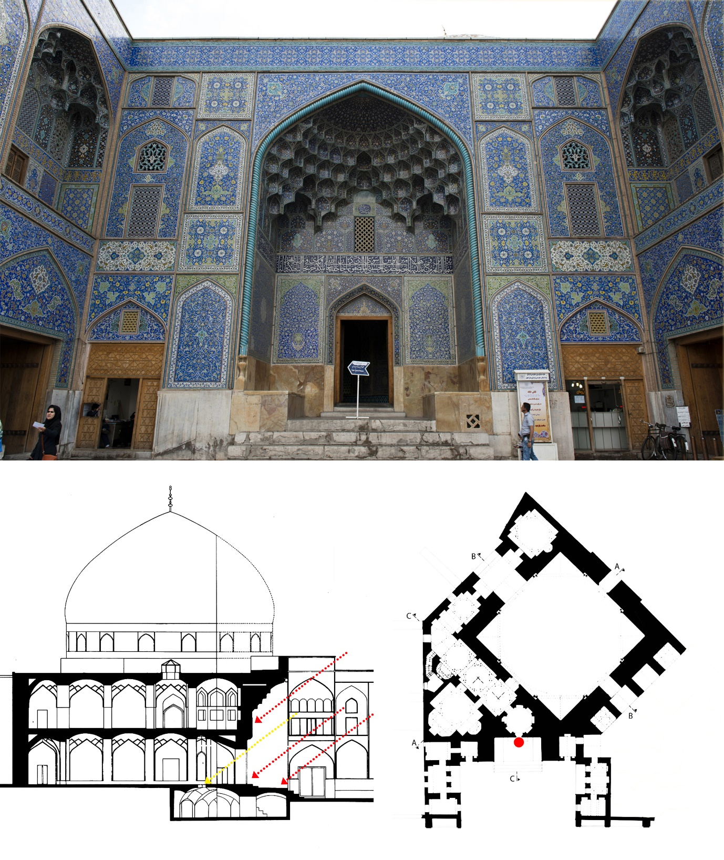
Figure 1: Sheikh Lotf Allah main entrance Iwan, red arrows demonstrate the lights which are blocked by the small entrance, yellow arrow shows the light beams which get through to the interior.

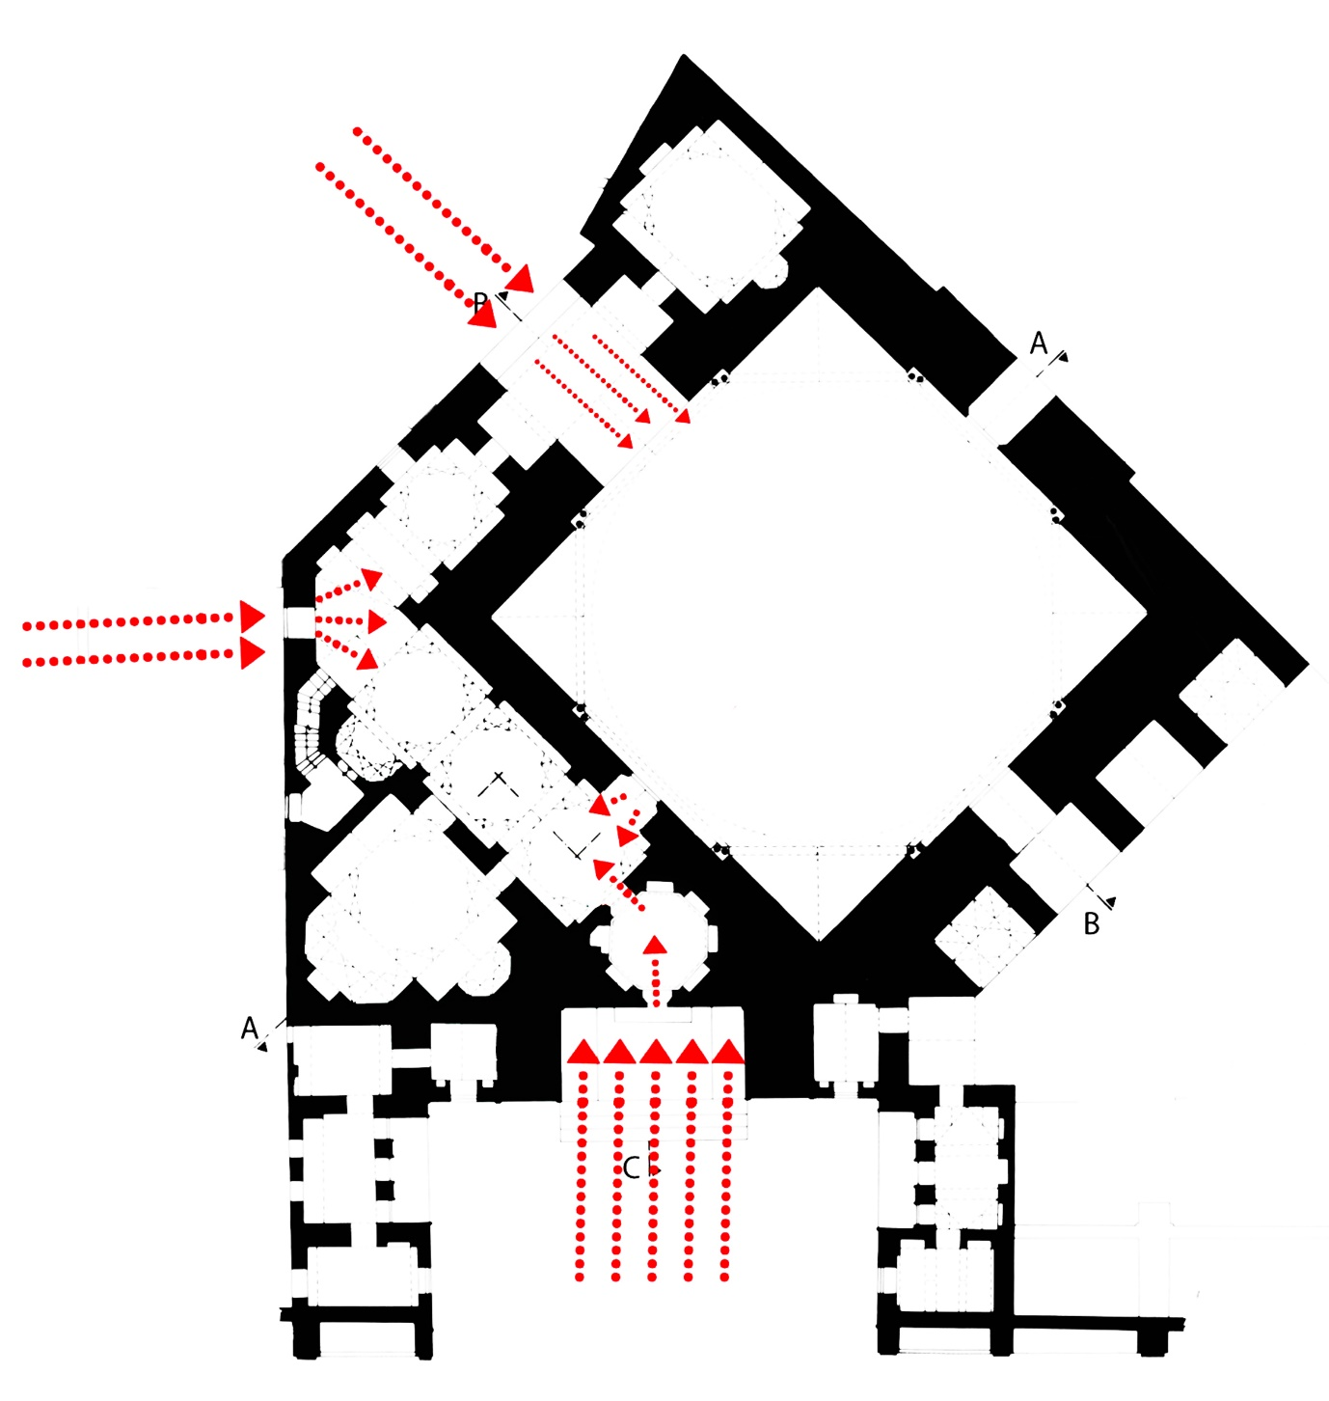
Figure 2: Sources of illumination for the corridor

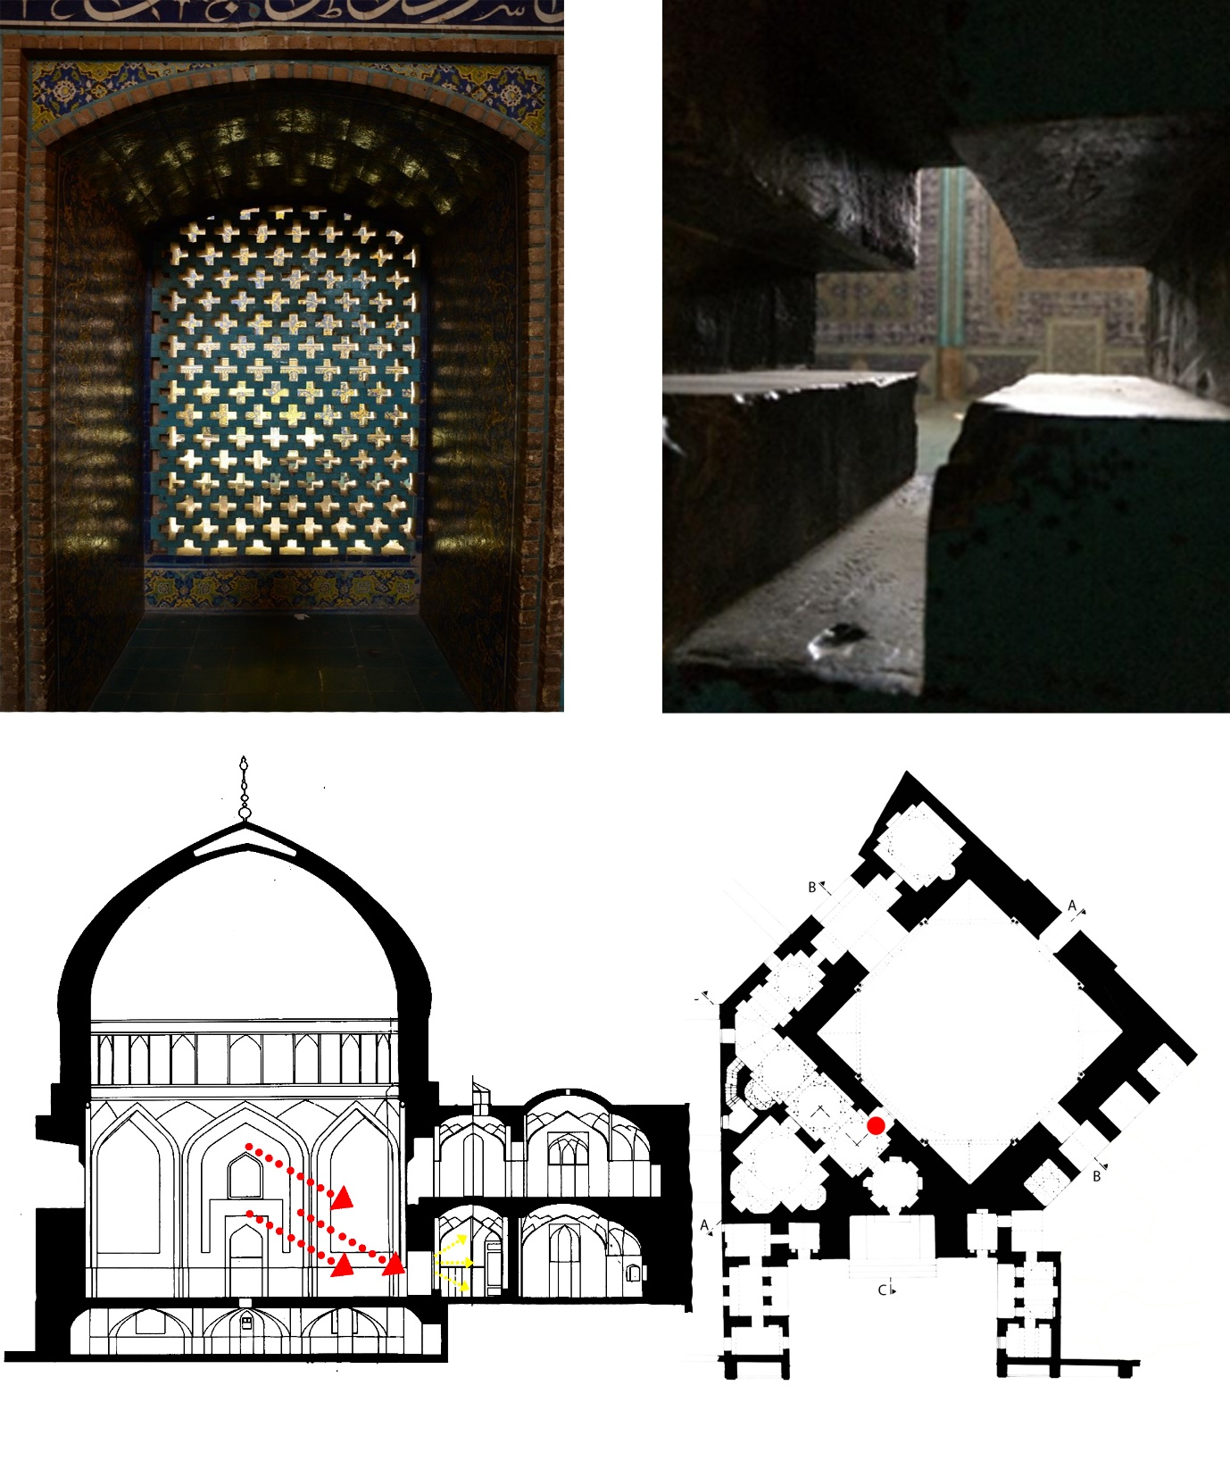
Figure 3: First opening in the corridor

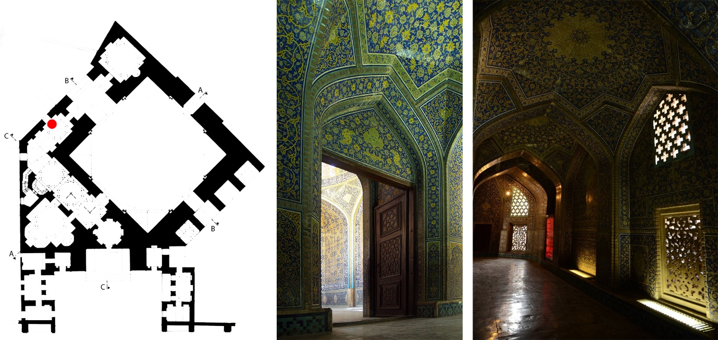
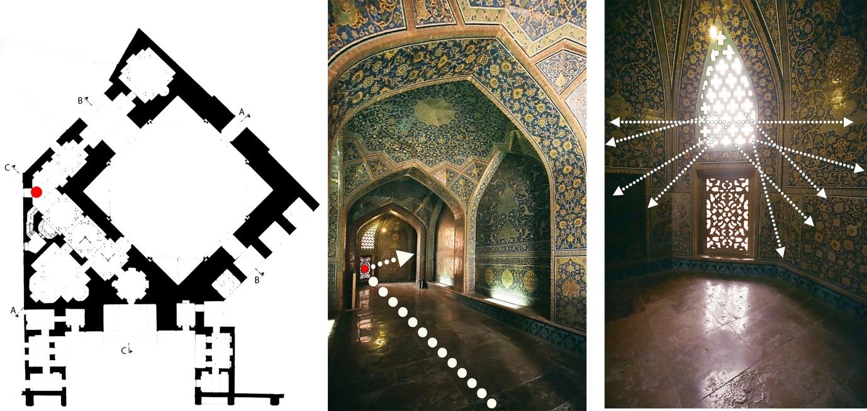
Figure 5: Last opening in the corridor facing the entrance to the dome-hall.

Figure 4: Second opening in the corridor with the 45-degree bend

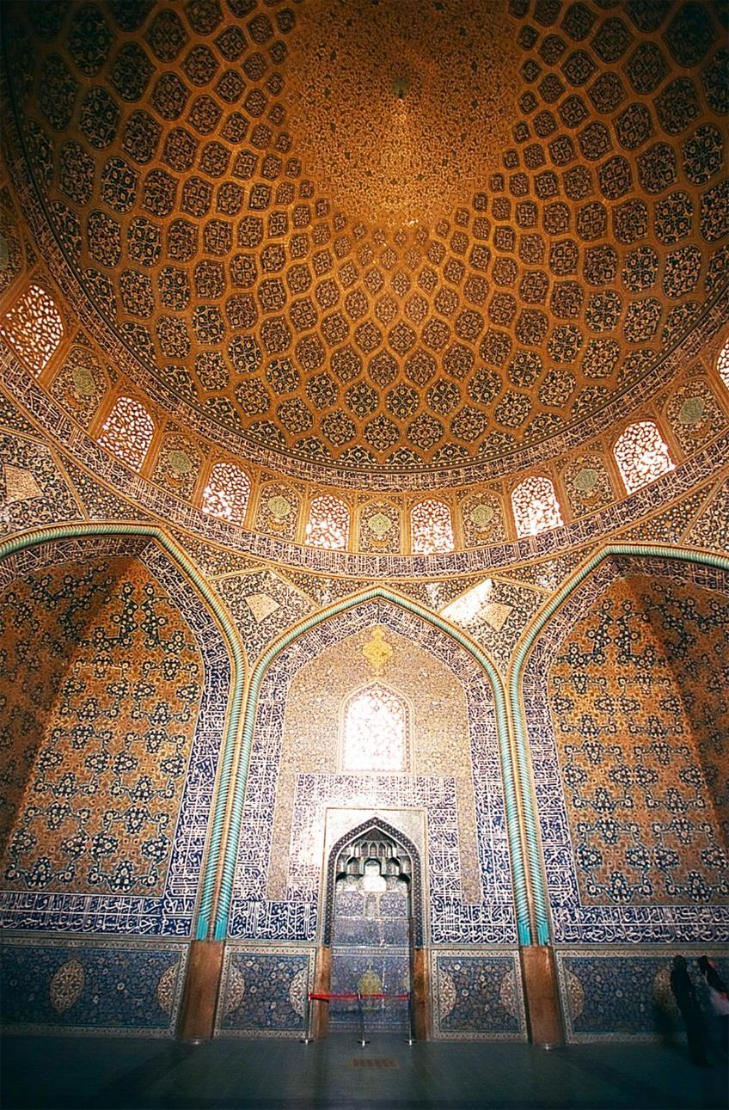
Figure 6: First view from the dome hall entrance

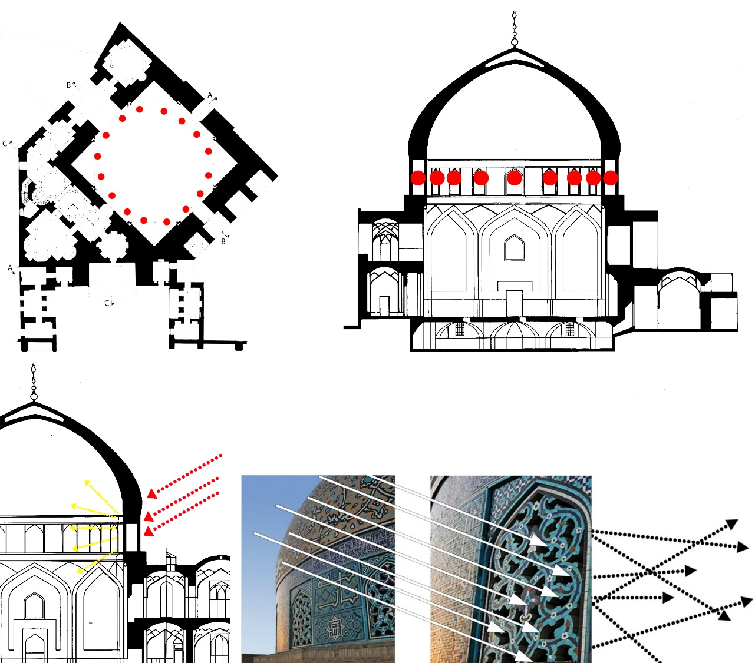
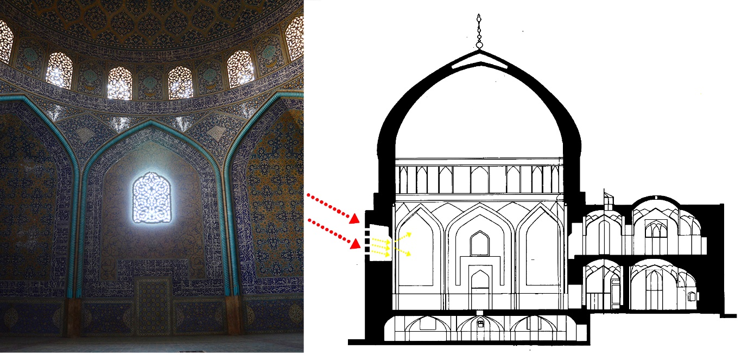
Figure 8: Opening on the eastern wall of the dome hall

Figure 7: The sixteen openings perforated on the drum

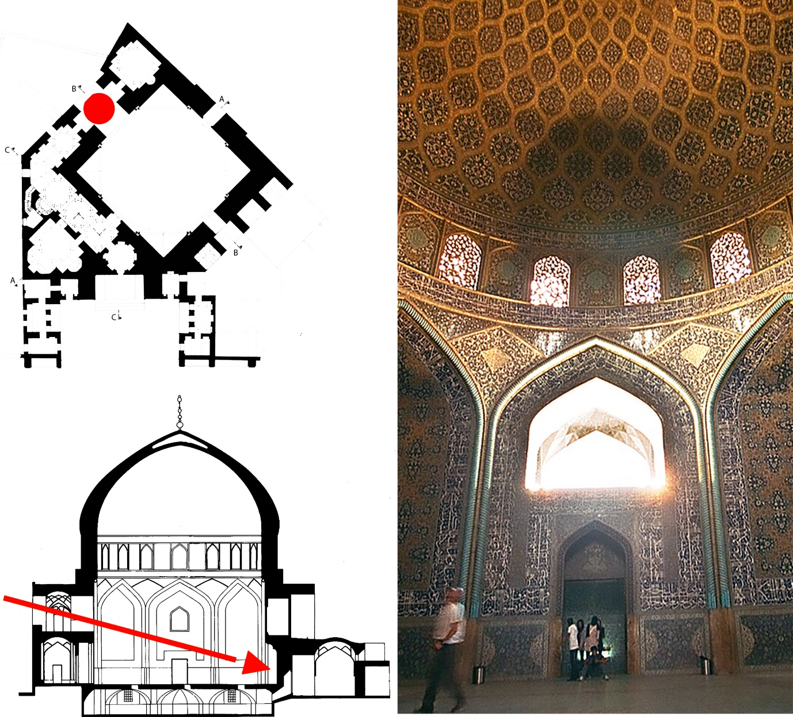
Figure 9: The gigantic opening on the northern wall of the dome hall

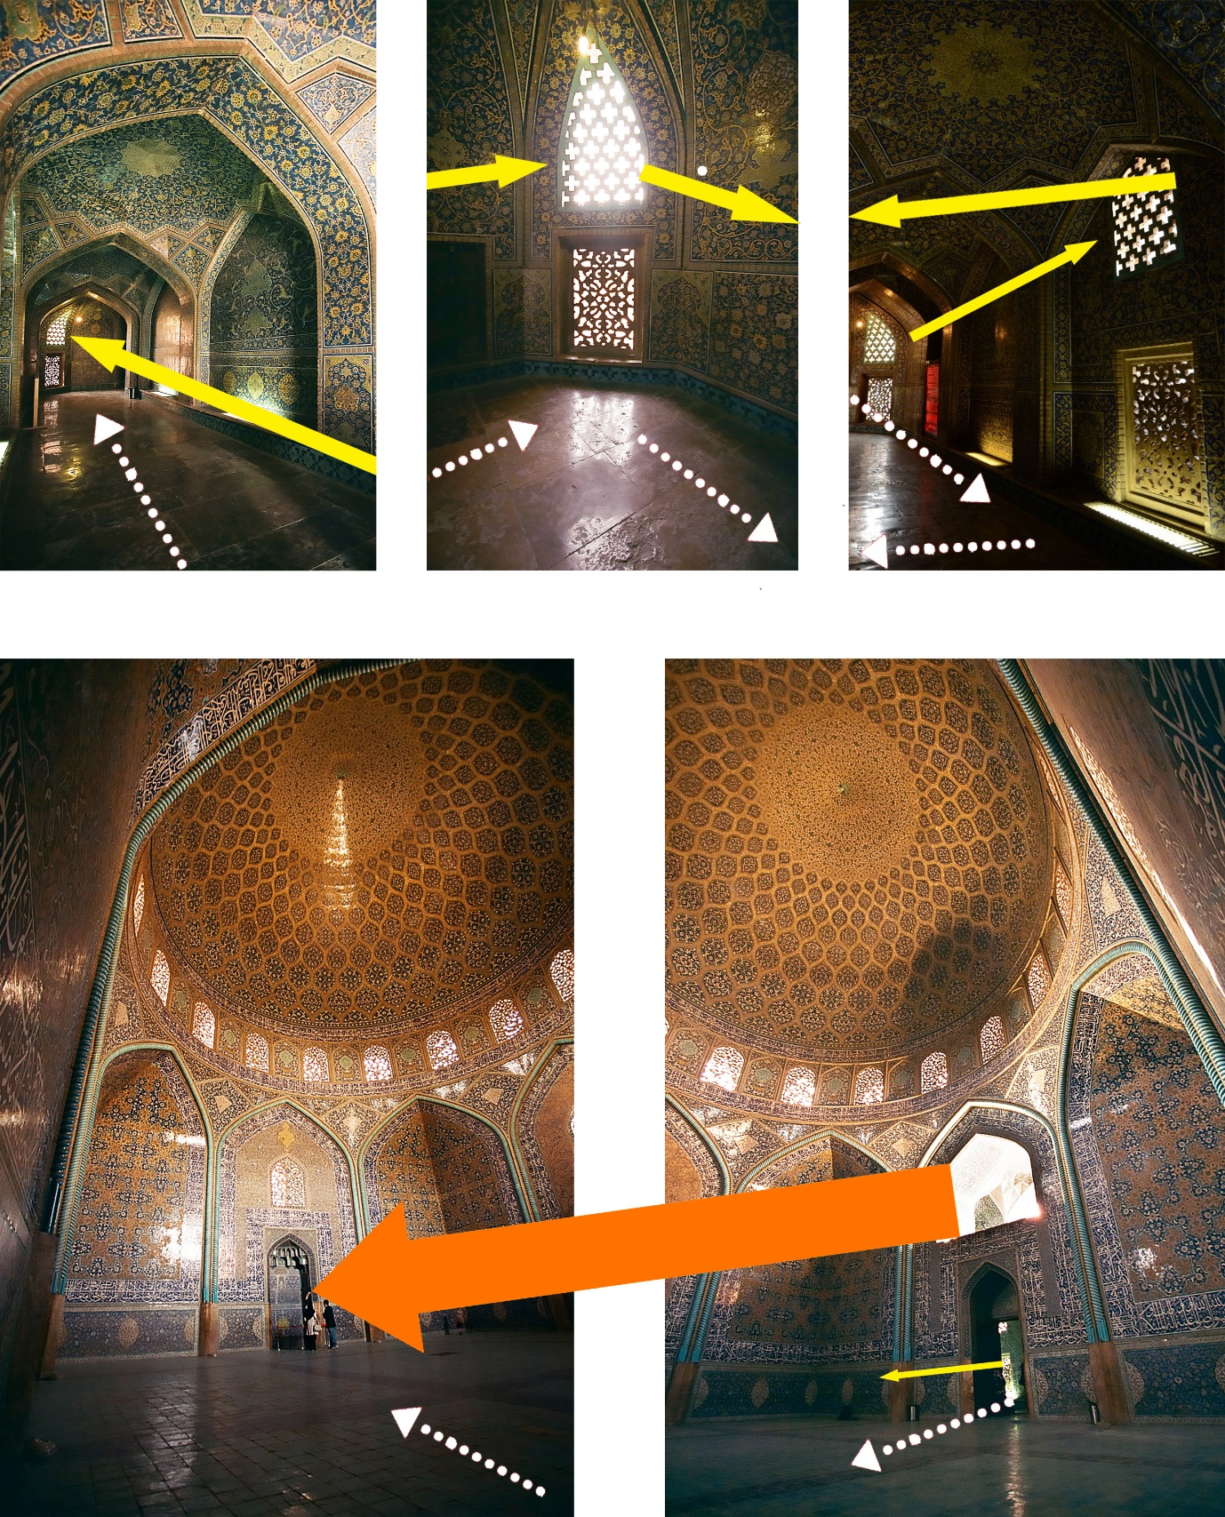
Figure 10: The path from the entrance of the mosque to Mihrab, guided by natural light

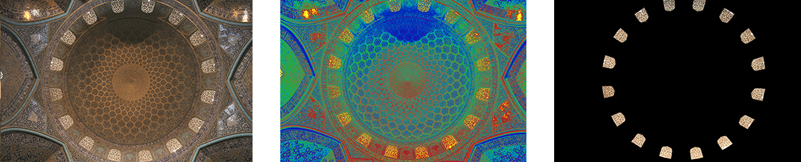
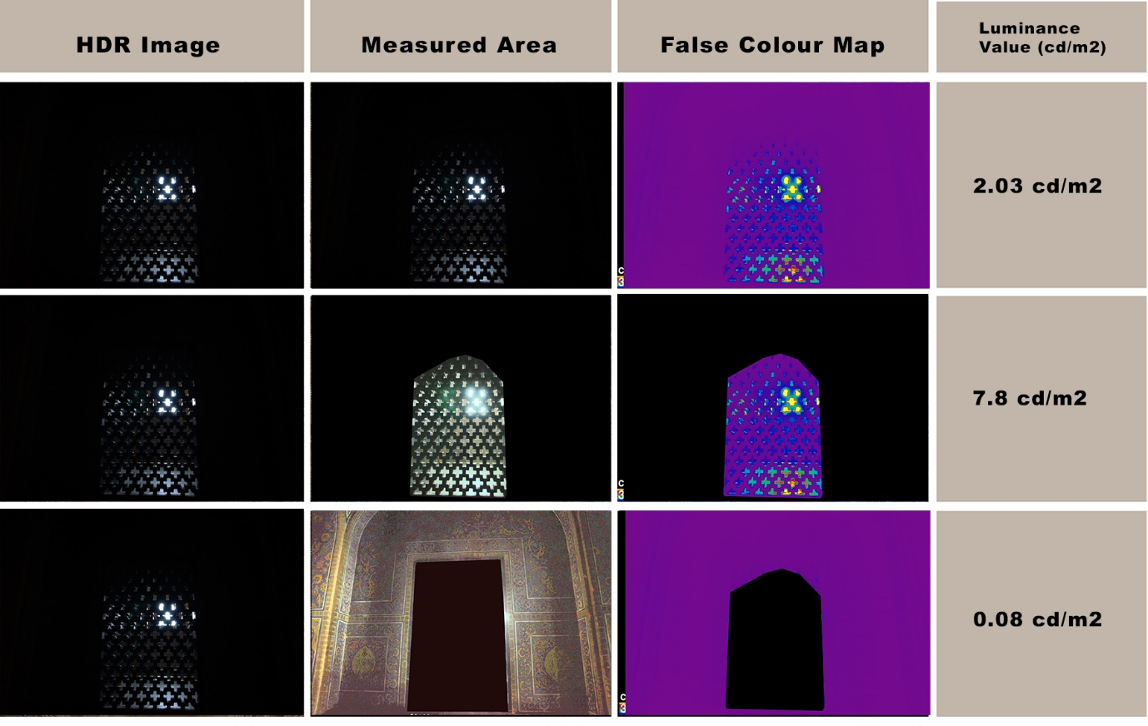
Figure 12: Luminance map (False Colour) and ALV of the first opening in the corridor

Figure 11: Sample Luminance map (centre), Sample image mask to isolate unwanted pixels for luminance analysis (right)

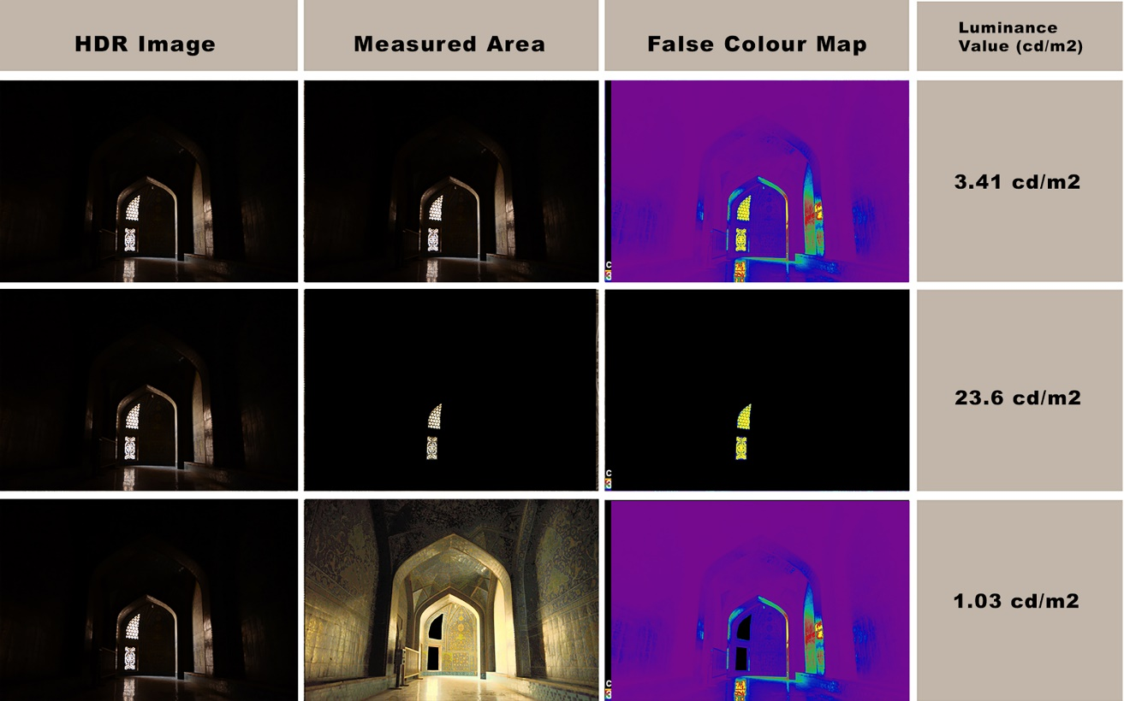
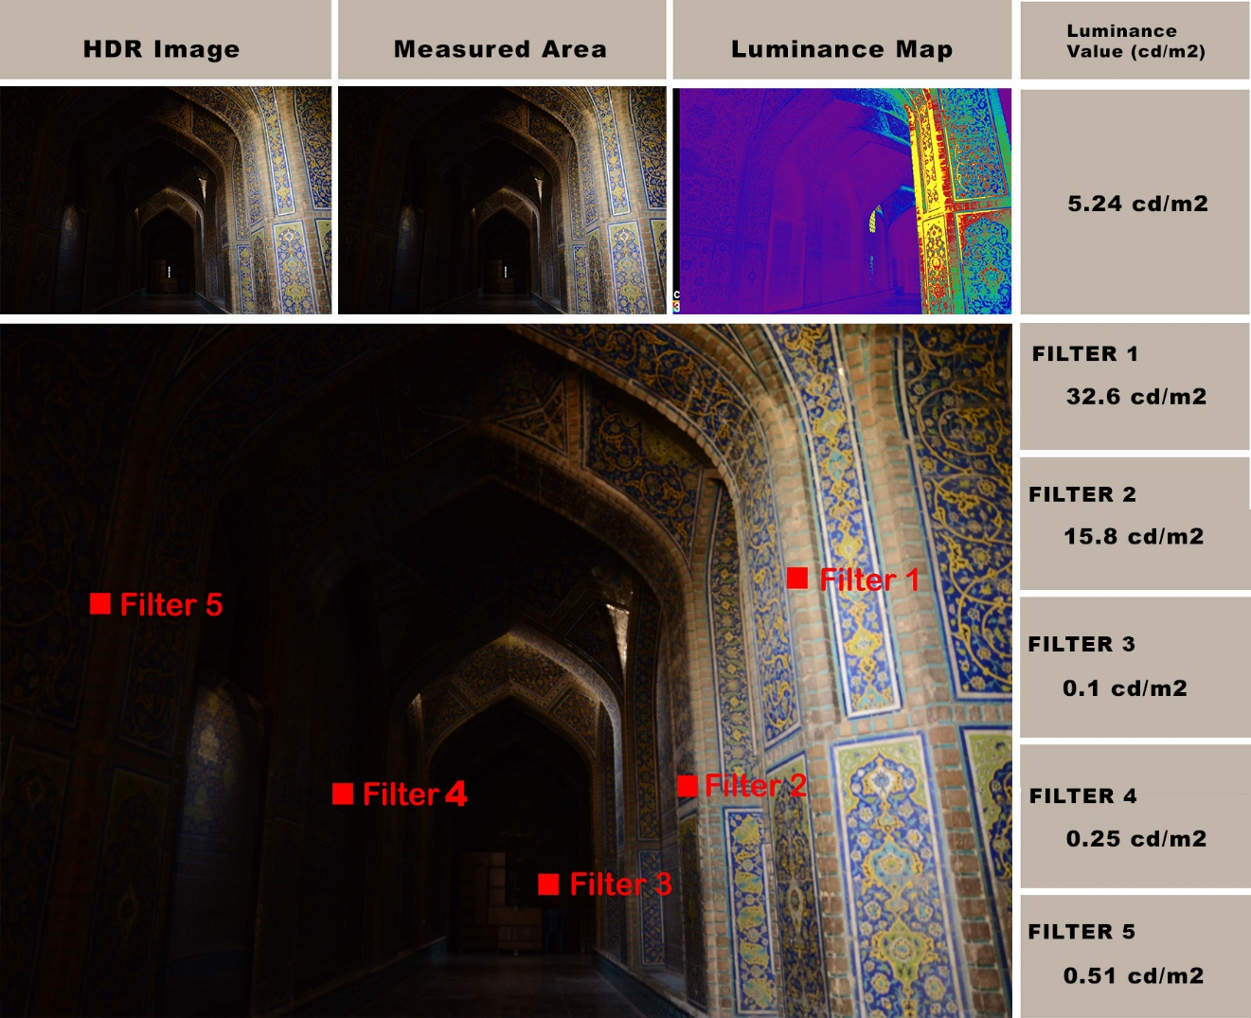
Figure 14: Luminance map (False Colour) and ALV of different spots in the second part of the corridor

Figure 13: Luminance map (False Colour) and ALV of the second opening in the corridor

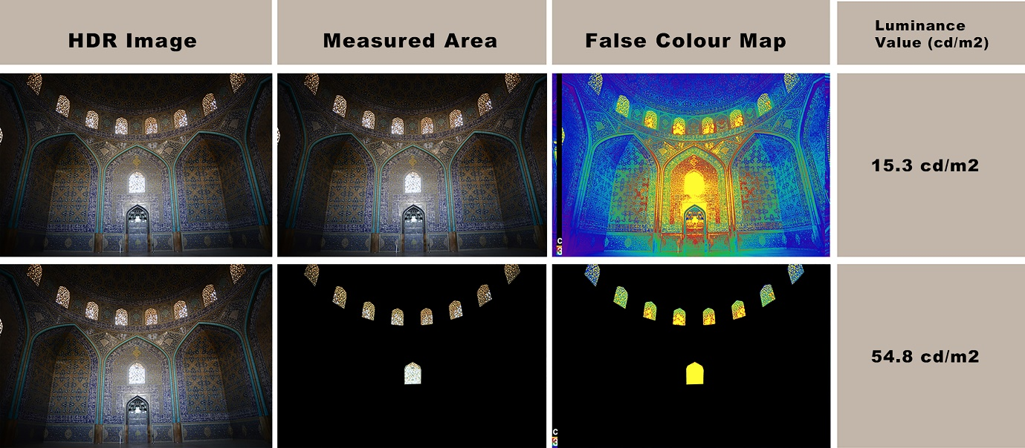
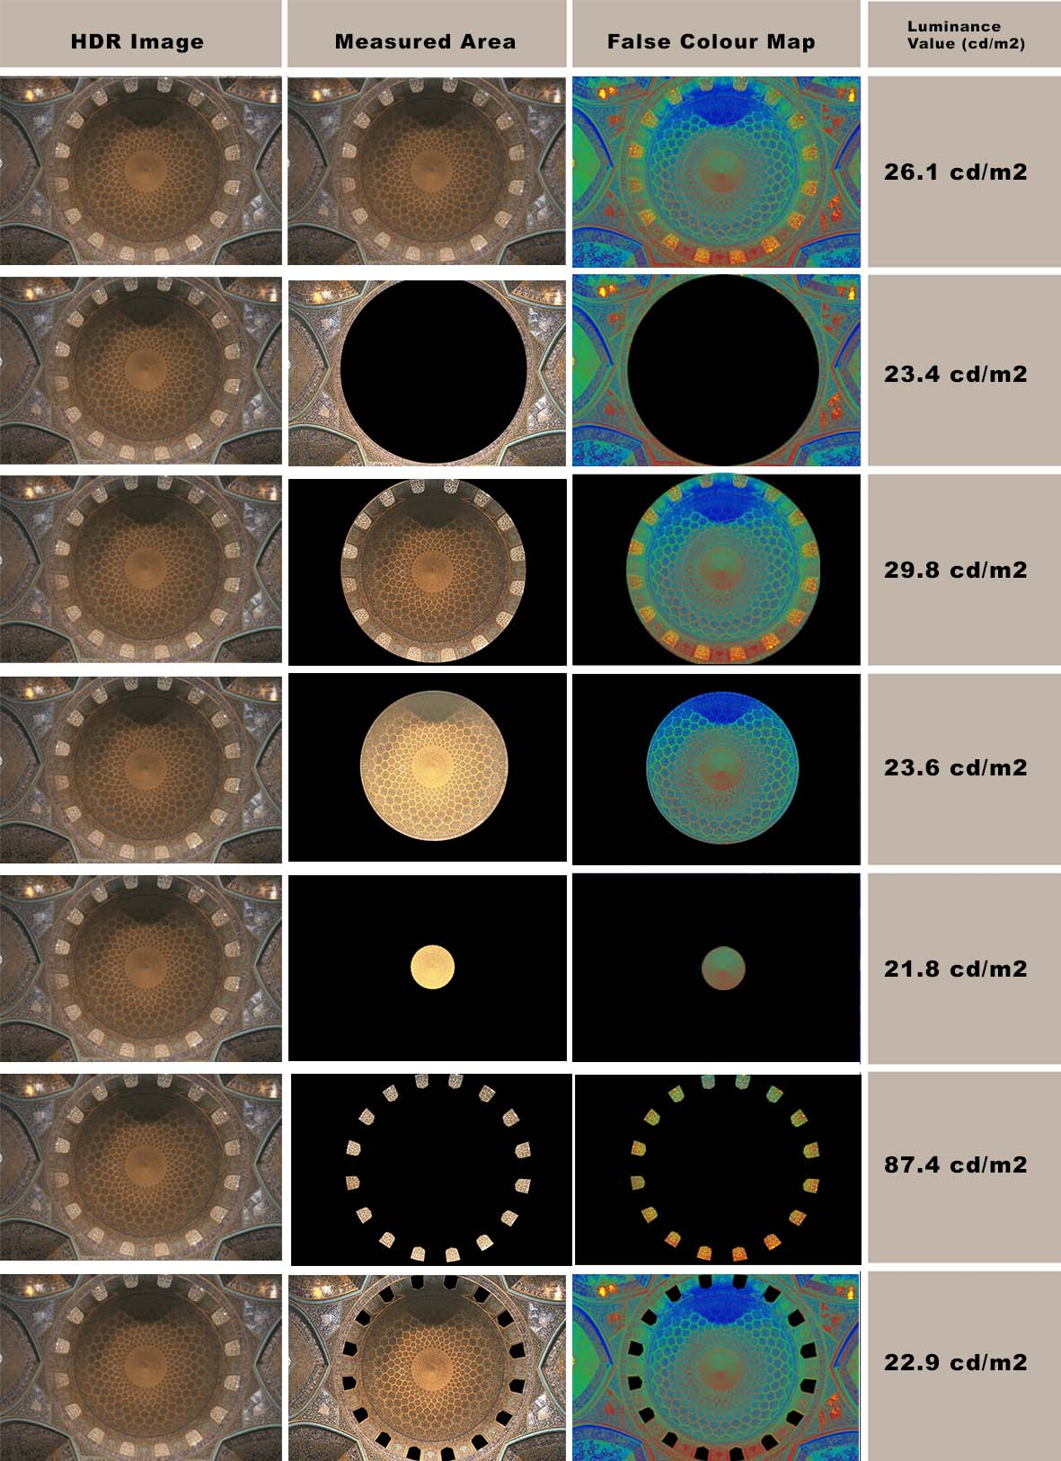
Figure 16: Luminance map (False Colour) and ALV of the dome and pendentives. View from beneath the dome

Figure 15: Luminance map (False Colour) and ALV of the dome hall, first view from the dome hall entrance

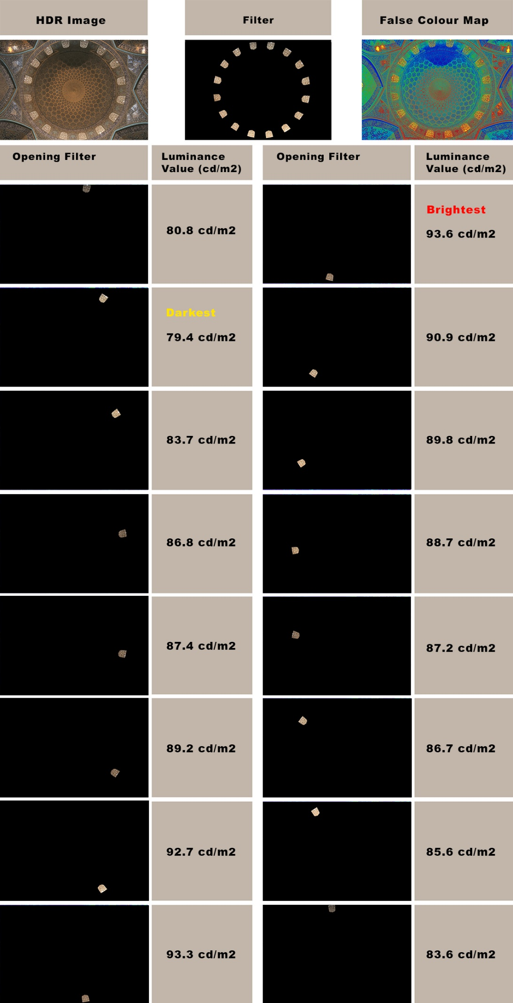
Figure 17: ALV of each of the sixteen openings on the drum

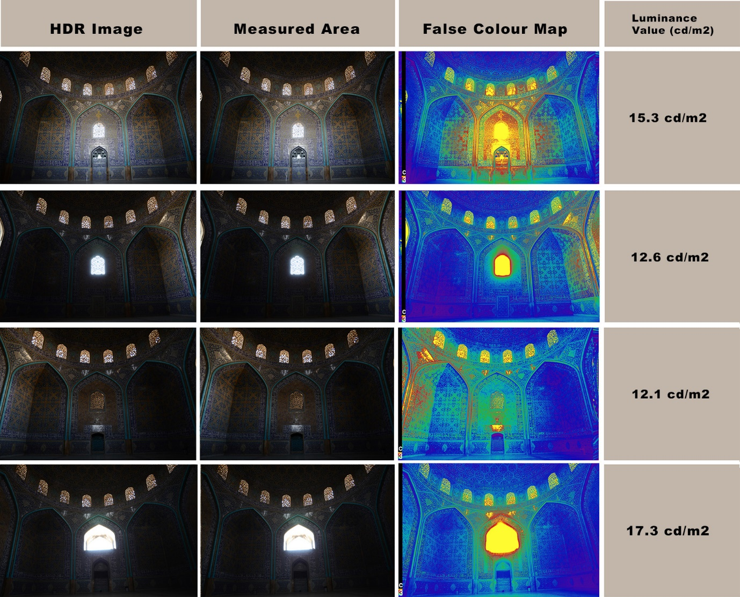
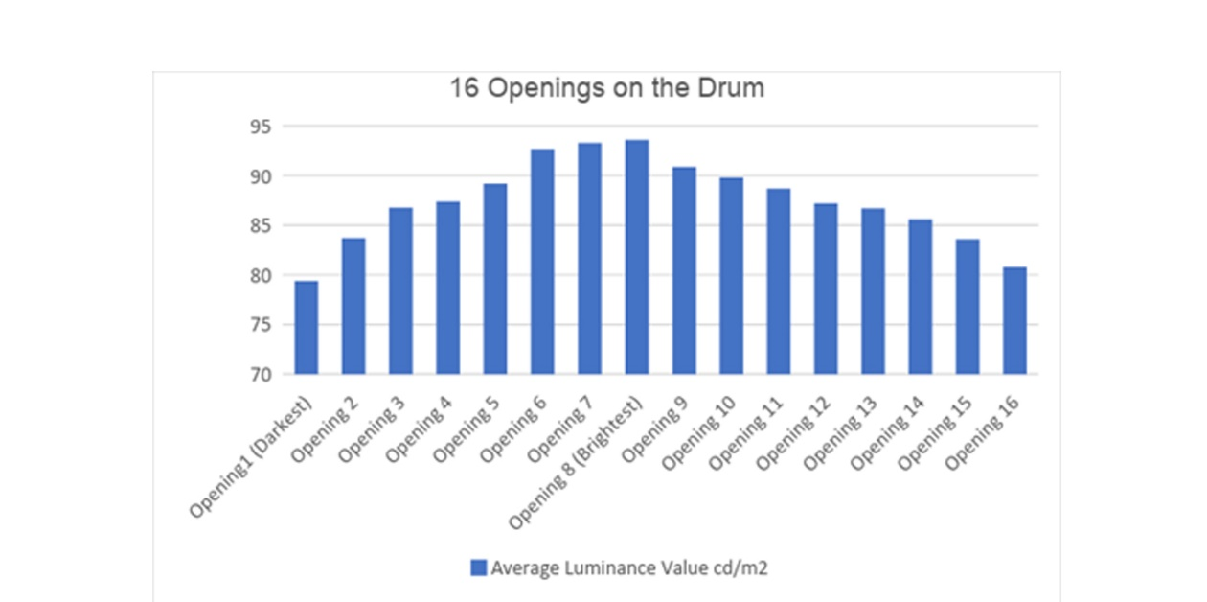
Figure 19: Luminance map (False Colour) and ALV of all four sides of the dome hall.

Figure 18: ALV of each opening on the drum as a graph. Data from figure 17

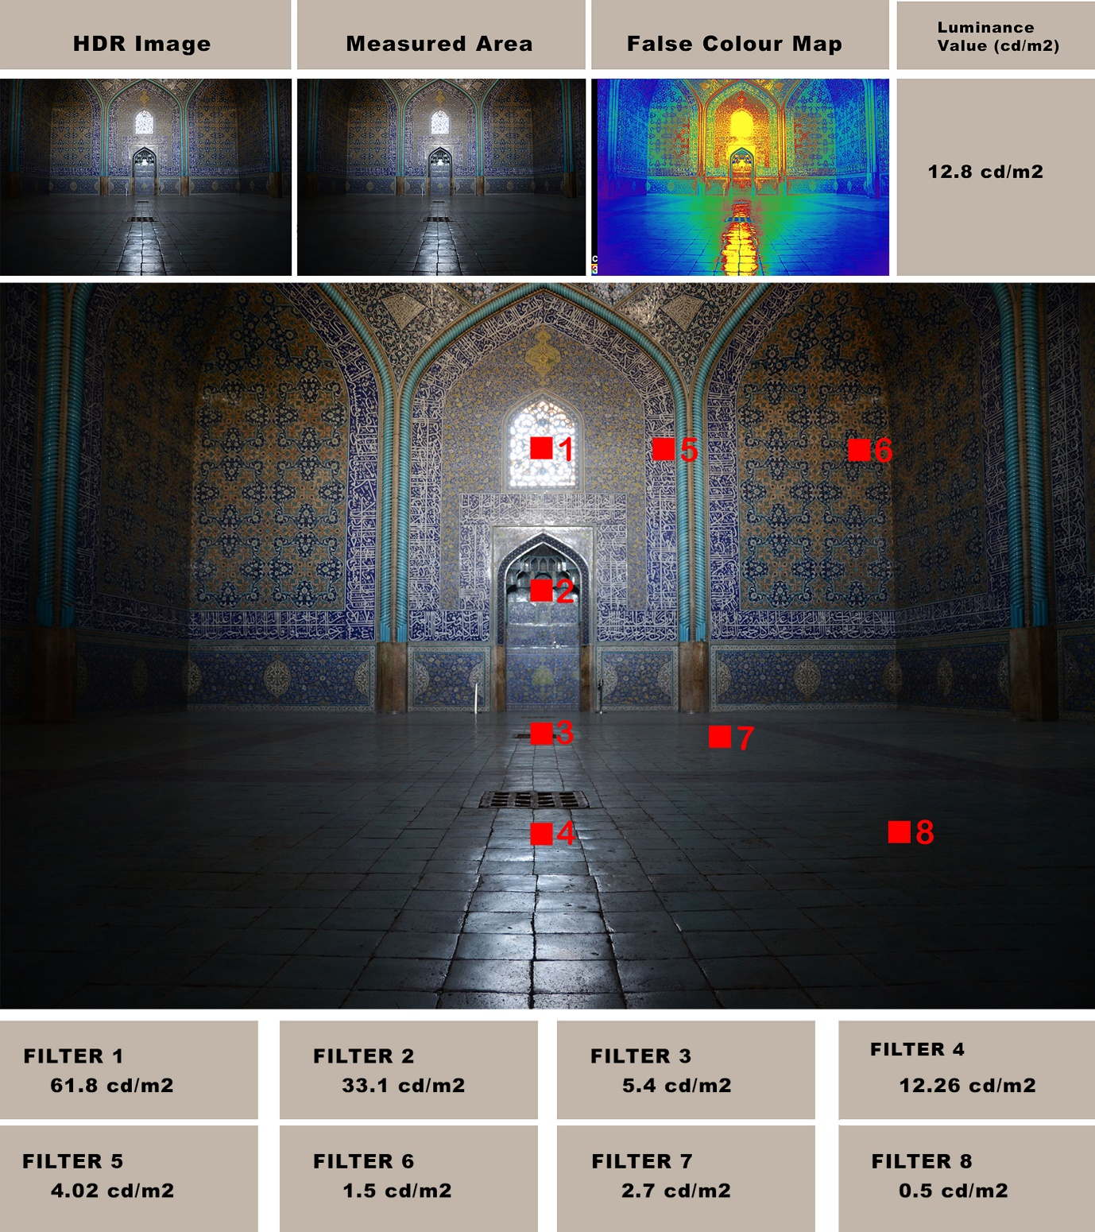
Figure 20: Luminance map (False Colour) and ALV of different spots in the view towards Mihrab

This research described in this paper was conducted by the first author while he was completing a doctorate under the supervision of the second. The second author has agreed that her editorial contributions to the paper, which is not identical with the dissertation, be acknowledged through second authorship in order that the paper may meet the standards of the Ministry of Education of Iran for certifying the first author’s doctorate, as these require co-authorship with the doctoral supervisor. Thanks as well to Dr Mahdi Hodjat, who the first author interviewed on May 21, 2015.
For more on this method see: Panahiazar, S., & Matkan, M. (2018). Qualitative and quantitative analysis of natural light in the dome of San Lorenzo, Turin. Frontiers of Architectural Research, 7(1), 25-36.

