A Bionic Approach to Regulate Building Temperature in a Hot-Arid Climate

Hossein Ghazvinian¹, Mostafa Gholipour Gashniani¹*
1. Department of Architecture, Arts and Architecture, University of Mazandaran, Babolsar, Iran
(Corresponding author, Email: m.gholipour@umz.ac.ir (

Abstract
The surface temperature reduction and airflow improvement of the building is regarded as one of the main components in architecture science. Inspired by nature and the principles of bionic science, this research seeks to design a façade based on the scale of a residential building in the city of Semnan, Iran. Given that animals use optimal methods in various fields, especially regulating their body temperature, to continue living, it seems that we can extract the hidden mechanisms in animals and use them in the design of an adaptive building facade. Thus, living organisms have been examined to select the most suitable species and to find the answer to the question of how to extract the natural principles and foundations in animals and apply them in an adaptive architectural façade, After selecting the species and studying the behavioral patterns and physical mechanisms of the silver ant, zebra, and lizard, we extracted the physical and natural principles of these creatures and then, used them in the design of the secondary facade. To understand the improvement in thermal comfort of the nature-inspired facade compared to the simple facade, after designing and modeling the facade in Rhinoceros® software with the Grasshopper plugin, the temperature of the façade surfaces was calculated and the air flow on the façade surface was simulated using fluent software. Based on the results, a favorable air flow was observed on the facade, and the temperature of the building's primary facade, in front of which the secondary facade was designed, decreased by nearly 20 K in the simulated case.
Keywords: Adaptive façade, Temperature regulation, Bionic design, Hot-arid climate

1. Introduction
The main contribution of this study lies in the integrated synthesis of three thermoregulatory patterns from the Saharan silver ant, zebra, and desert lizard into a single adaptive facade system. The novelty of the study is therefore conceptual and biomimetic rather than methodological. Buildings have the highest rate of energy consumption, by consuming more than one-third of the Earth's energy. On the other hand, buildings are the main source of carbon dioxide emission, along with its hazards ((IEA), 2013). The energy consumption of buildings in developed countries, including the UK, the US, and Australia, reaches between 20 and 40% of the world's total energy consumption, while the production of carbon dioxide gas in the construction industry is close to 40% of the total carbon dioxide produced worldwide (Pérez-Lombard et al., 2008; Sayed & Fikry, 2019; Zhao et al., 2015). Concerning hot and desert regions, the sun's radiation on hot days of the year increases the temperature and disturbs the thermal comfort in the interior of the building. Therefore, it is necessary to develop a different and new solution as the new texture and land parcels of urban density do not allow to fully use the principles of traditional houses in the designing process. The passive design of buildings considers orientation, geometry, shape, layout compactness, opening features, and materials as factors that affect the comfort of residents (Caruso et al., 2013; Chen et al., 2018; Gholipour Gashniani, 2020; Kämpf & Robinson, 2010; Konis et al., 2016; Muhaisen & Gadi, 2006; Stevanović, 2013; Tian et al., 2017). Designing the facade of a building according to climatic conditions and using renewable energy can provide comfortable conditions for residents in the indoor environment (Ferrante, 2012; Marszal et al., 2011).
Moreover, the interior space depends on sunlight, and the light must enter the interior space for lighting during the day. However, the heat from the sun's radiation enters along with the light and overheats the space, which forces people to use cooling devices(Wang et al., 2020). These devices use electrical energy and, in some cases, water, although water shortage is a serious problem, especially in hot and desert areas (Alshahrani & Boait, 2018). In this regard, an optimal design based on the sun's path and the control of incoming light can reduce the heat from the light and improve the comfort conditions of the residents. Therefore, intelligent functions in the building can be a suitable method to realize this goal (Grynning et al., 2014; Kim et al., 2012; Kumar et al., 2005; Wang et al., 2009). On the other hand, the use of animated, responsive, adaptable, intelligent, and automatic facades is the other method used in various projects to ensure the comfort of residents(Addington, 2012; Bohnenberger et al., 2012; Pesenti, Masera, & Fiorito, 2015; Pesenti, Masera, Fiorito, et al., 2015). For example, in Al-Bahar Towers (AHR, 2019), a responsive facade is embedded in the environment to ensure visual comfort by controlling the incoming sunlight and regulating heat received during the day by using three-dimensional deformations (Fig. 1-a).
Generally, bionic architecture attempts to create harmony between the building and the natural environment, maintain the ecological balance, and achieve the sustainable development of the building (Yuan et al., 2017). Bionic architecture can be used in the field of building, structure, and material performance, which is a step towards improving energy consumption and green architecture. Nature allows us to be inspired by the natural mechanism of air ventilation in the termite nest and apply it in the building to reach optimal ventilation (Abensperg-Traun, 1991; French & Ahmed, 2010; Mando et al., 1996; Scott Turner, 1994; Turner, 2008). Further, nature helps us to adjust and use sunlight with inspiration from the external structure and body of plants or animals in the structure and form (Chen et al., 2012; Pedersen Zari, 2007), and imitate the organization and ecological functions of a living organism for designing and producing green building materials to reduce resource consumption and carbon emissions during their production (Bohnenberger et al., 2012; Das et al., 2015; Dunlop & Fratzl, 2013; Marguet et al., 2012; Yu et al., 2013). For example, inspired by the flexible and reversible deformation of the Strelitzia Reginae flower in the one ocean thematic pavilion project at Yeosu Expo 2012, a moving facade was designed to adjust the received sunlight and highlight the aesthetic aspect of the responsive facade (Fig. 1-b) (Lienhard et al., 2011; Megahed, 2016; Schleicher et al., 2014).
A changeable factor that overheats the space is the amount of sunlight entering the house and the color of the building (Hernández-Pérez et al., 2014; Sayed & Fikry, 2019; Suehrcke et al., 2008), which regulates the heat from the sun and results in less energy consumption. However, creating these changes requires using materials and movement (Imani et al., 2019) in architectural projects, including building facades. Moreover, nature's response and adaptation to different climatic conditions occur in different ways, which inspires methods and mechanisms that can be used in building and designing a responsive and adaptable facade to reduce energy consumption. For example, inspired by the structure and behavior of the tree, a moving shading facade was designed in the Council House2 project in Melbourne (Fig 1-c), which could save up to 82% of energy and reduce the consumption of artificial light and mechanical ventilation by 65% (Ramzy & Fayed, 2011).
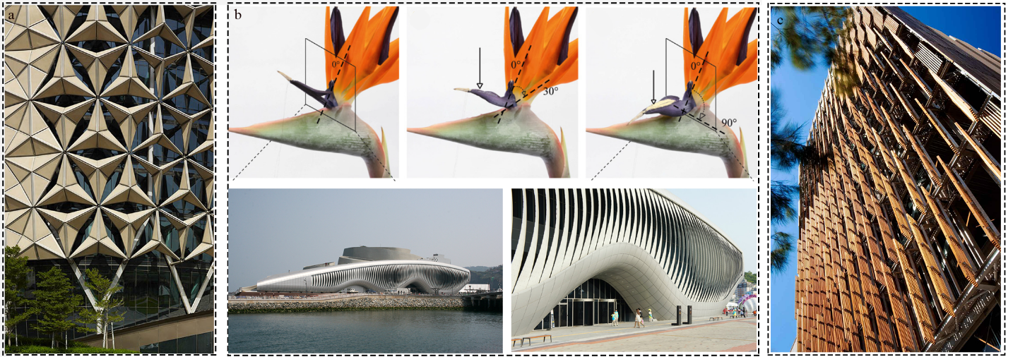
Fig.1. Fig. 1. (a) Al Bahar Towers façade (AHR, 2019), (b) Thematic pavilion with kinetic facade and its inspiration (Megahed, 2016), (c) Council House 2 façade (Ramzy & Fayed, 2011)

In nature, there are various living things, including plants, animals, and humans, which adopt different methods to adapt themselves to the conditions. Movement is an integral part of this adaptation. Meanwhile, plants are considered very similar to an architectural building because they are fixed in a specific place and do not move to another place. However, plants have mobile and flexible parts such as leaves and petals (Nagy & Osama, 2016), the movements of which may happen for various reasons such as the desire or unwillingness to receive sunlight, which is a source for extracting sun-compatible methods (Lopez et al., 2017; Nour el Houda & Mohamed, 2018).
Note that the similarity of plants and buildings does not undermine the consideration of animals, as they can provide more complex, unique, and different methods and strategies that can be used to solve different problems. For example, termites use an intelligent method to create air flow and provide thermal comfort in their nest, which has been the source of inspiration for several architectural projects to create natural ventilation. In addition to controlling sunlight, ventilation and air flow in the building can be effective in creating thermal comfort. Thus, this article seeks to design a moving facade inspired by animals that provides thermal comfort for the residents of a five-story apartment on the hot days of the year. Further, this article attempts to address questions such as how to extract the natural principles and foundations found in animals and translate them into an adaptive facade of architecture, and what is the improvement in creating thermal comfort of a facade inspired by nature compared to a simple façade.
In addition to the benefits of adaptive façade, it is necessary to consider the challenges and limitations of this type of façade. It can be said that the industry is still not ready to accept adaptive façades. Despite the existence of successes with smart sensors and dynamic shading control, few proven systems perform as expected. For example, serious concerns during the operation of the adaptive facade in relation to excessive heat, glare, and personal control make many users and architects unreliable in the automatic movements of the adaptive facade. While control solutions are limited to shading control, there is no constant solution that goes beyond shading. Control strategies for comfort factors fail to consider user interaction and focus more on saving energy (Attia, 2018).
Other issues that can be mentioned about adaptable facades are as follows:
-High investment cost and consequently, increased operating cost.
-Lack of common and standardized assessment framework, criteria, and delivery processes, which finally may turn into custom solutions that are time-consuming and require highly skilled professionals.
-The necessity of training users and facility managers to optimally use complex systems with advanced technology, which require intelligent and flexible automation and predictive control.
Regarding the above-mentioned content, this article seeks to improve the performance of adaptive facades inspired by nature. The main novelty lies in the integrated biomimetic synthesis of three thermoregulatory patterns from the Saharan silver ant, zebra, and desert lizard into a single adaptive facade system. We therefore emphasized that the contribution is primarily conceptual and biomimetic rather than methodological.
2. Research background
2.1. Bio inspired Facade
As mentioned, natural mechanisms can be a source of inspiration for many issues in the field of architecture. This study focuses on designing a facade and its effect on building energy consumption to create thermal comfort. Table 1 presents various designs developed in this regard based on the year. Considering the hot and dry climate considered in this article, an attempt has been made to introduce the projects and designs carried out in this type of climate. The designs have been developed through bionic science and Table 1 provides the source of inspiration, the performance of the façade, and its impact on environmental conditions.
Table 1. Examining facades inspired by nature to create thermal comfort for the building
Result | Function | Design | Inspired by | Climate | Year | Project
a simulation on the same breathing model was carried by an aerodynamic simulation software called “Vaseri” created by “Autodesk inc”. The results showed different types of air fountains according to wind speed and direction and a reduction of internal temperatures from about 5 C° to 8 C°. | Airflows and evaporation | 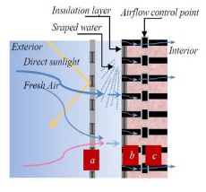 | Biological skins | Hot | 2006 | Breathing wall (‘Elghawaby, 2006)
fur-lined façade was compared with a conventional lightweight façade under sunny summer conditions and heat gains reduced by up to 50%. During a winter scenario, heat losses to the external environment were reduced by at least 50%. | Lowers Thermal conductivity and dissipates and scatters incoming solar radiation | 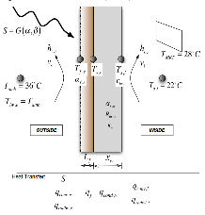 | Animal fur | All | 2011 | Modelling and optimization of a biomimetic façade based on animal fur (Webb et al., 2011)
This Double Flectofin is a further development of the initially proposed facade component, which has an increased shading efficiency and higher wind stability. Having placed two wings on one slender profile thereby doubles the shaded area per backbone while hardly affecting the view. | Shading | 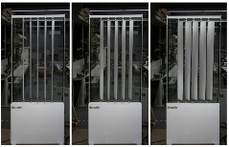 | Strelitzia reginae flower | All | 2011 | Flectofin: a hingeless flapping mechanism(Webb et al., 2011)
The results showed that the fractal roofs were effective in reducing surface temperatures in sunlight. The ground surface temperatures under the fractal roofs were also significantly reduced even though they did not provide complete shade. | Blocking sunlight | 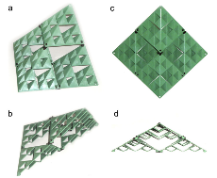 | fractal shapes | Hot | 2012 | Sierpinski’s forest (Sakai et al., 2012)
 |  |  |  |  |  | Continue
The presence of this façade had a positive eﬀect on cooling loads as they decreased by 15%. However, it had a negative result on Daylight Autonomy which decreased to 45.2% of the space. | Air ﬂow and reduces heat gained by solar radiation due to self-shading | 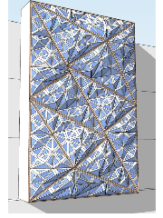 | Termite mound | Hot | 2015 | A Porous Folded Façade for Oﬃce Buildings (El Ahmar & Fioravanti, 2015)
The ﬁndings of the laboratory experiments with the scaled models of one running meter of the adaptable facade design concept and the initial, simpliﬁed calculations showed that its use can enhance the speed of the continuous airﬂow within the ventilation slot. | Air ﬂow and reduce exterior wall temperature | 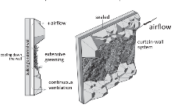 | prairie dog burrow | Hot | 2017 | natural ventilated  façade (Paar & Petutschnigg, 2017)
The results showed that micro-eddy convection created over the chilled wall panels installed on indoor walls in vertical, horizontal and grid for-mats has an effect on indoor comfort level and cooling system response speed. CFD simulation was performed with three environmental factors i.e. air current, air temperature and air velocity which affect cooling performance and comfort. | Air flow | 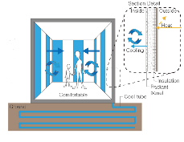 | zebra stripes | - | 2017 | CFD modelling of air temperature reduction and  airflow induced by the use of chilled wall panels(Shon et al., 2017)
The total number of discomfort hours are reduced according to the adaptive thermal comfort model by ASHRAE 55-2010. The discomfort hours for Acceptability Limits 90% are reduced from 1112.50 to 540.50 (51.5%) and for Acceptability Limits 80% are reduced from 865.50 to 282.00 hours (67.5%). | Shading and natural ventilation | 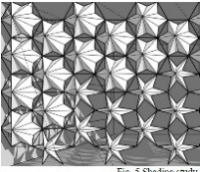 | barrel cactus (Echinocactus grusonii) | Hot | 2018 | Multi-functional biomimetic adaptive façades(Kuru et al., 2018)
after retroﬁtting of the designed facade, the building’s existing energy load decreases by 32%. Moreover, 50% of the interior space (as opposed to 55% before the retroﬁtting) still has lighting level within the recommended range of 500e750 lux. | Shading | 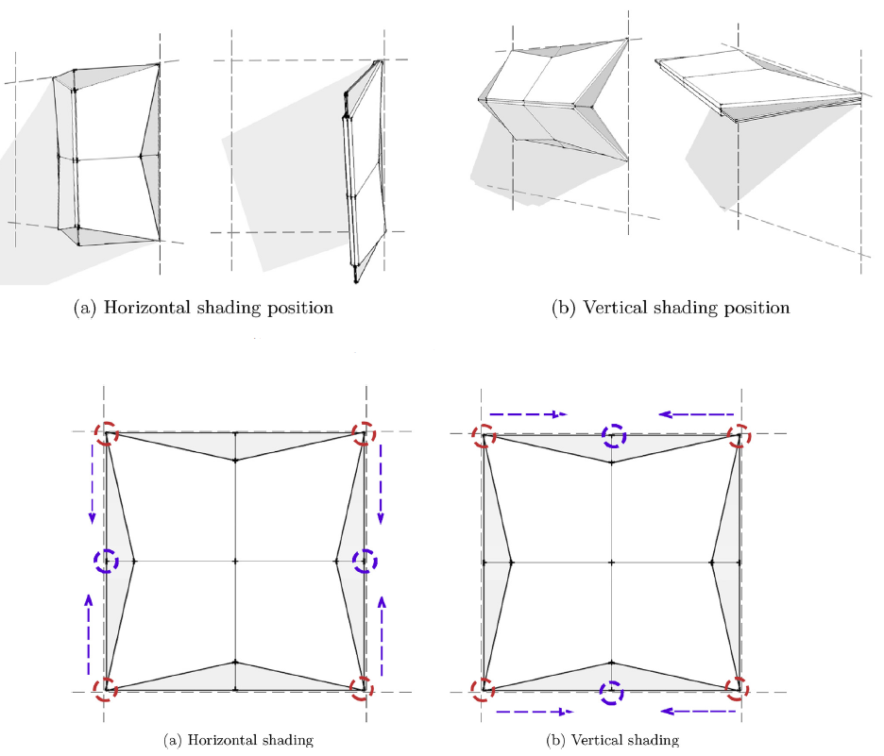 | Oxalis oregana | Hot and Humid | 2019 | Adaptive biomimetic façade (Tariq Sheikh & Asghar, 2019)

Unlike many previous biomimetic facade studies that are based on a single natural source, the present study integrates three biological mechanisms into one facade logic. Regarding the bionics-based research in the above table, thermal comfort has been mostly achieved by the facade through shading and creating air flow, such that only one or both methods have been used simultaneously in some cases. The present study attempts to use the two mentioned methods together. The difference between the designs is the way of shading and air flow, which makes each design unique. For example, different geometrical shapes, used materials, ways of moving, and deformations create different mechanisms. Compared to the other designs, the proposed design uses the mechanisms of three animals and their combination, and translates them into a design, such that the facade works as a single system. This system is such that a rotating movement causes a change in the geometrical shape and materials to create air flow and adjust the amount of incoming light. For this reason, this design considers the characteristics of the materials used for each part, in addition to addressing the geometrical shape and its deformation. The following sections elaborate on the functions and features of this design.
2.2. Fluent Validation
In this article, the CFD results were validated using the laboratory results of temperature and air dynamics presented in the article of (Sánchez et al., 2019), which was carried out to optimize the facade design in minimizing the heat exchange between the building and the environment and explaining the role of air conditioning on the building facade. For this purpose, a three-dimensional CFD modeling was conducted and confirmed experimentally.
The experimental results confirmed the numerical simulation of the open-joint ventilated façade (OJVF) facade using Fluent software. In the first step, the performance of the facade was evaluated in a laboratory model to determine the temperatures in the panels and the air gap and measure the flow field in the gap using particle image velocimetry (PIV) techniques. In the second step, a numerical model was made using advanced Computational Fluid Dynamics (CFD) simulation tools. Finally, the experimental validation of the numerical model was carried out and the experimental and numerical results were compared at different levels inside the ventilated hole. In summary, the largest temperature difference between the experimental and simulation results was 0.09 degrees while the greatest air velocity difference was 0.05 m/s (Sánchez et al., 2019). This validation is used here to confirm the general reliability of the Fluent solver; however, it does not directly validate the specific geometry and boundary conditions adopted in the present study.
3. Research method
This research aims to design a nature-inspired adaptive facade based on bionics science. To design the mentioned façade, a problem-oriented approach or, in other words, a top-down approach (Badarnah, 2017) (fig 2) has been used to prevent an excessive increase in the temperature of the interior of the residential building in the hot seasons of the year. At first, various organisms were considered to study their different behaviors against heat (fig 3).
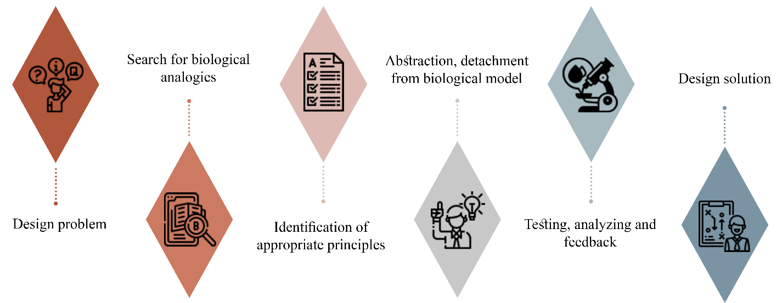
Fig.2. Biomimcry Top – down approach(Badarnah, 2017).

After a general review of the organisms, some categories were removed from the initial list for two reasons.
1. The non-compliance of the living environment with the current problem, which includes fishes, cnidarian, echinoderm, and these categories, which are found in the seas and oceans, cannot meet the needs of the problem, due to the lack of direct or little connection with the sun's radiation.
2. The non-compliance of the environmental conditions for the organism with the problem, which includes amphibians and annelid. These categories are not a good solution for the problem as they require moist environments such as ponds, marshes, or wet parts of the soil and their body temperature regulation mechanism depends on water.
The above-mentioned reasons reveal that the body temperature regulation mechanisms of these types of organisms cannot be translated into an architectural design with this type of problem and thus, they have been removed at this stage. Ultimately, animals with unique mechanisms were selected by studying different types of the remained categories and considering available scientific resources, the degree of influence of natural solutions, and the translatability of the mechanisms to the architectural design and the problem.
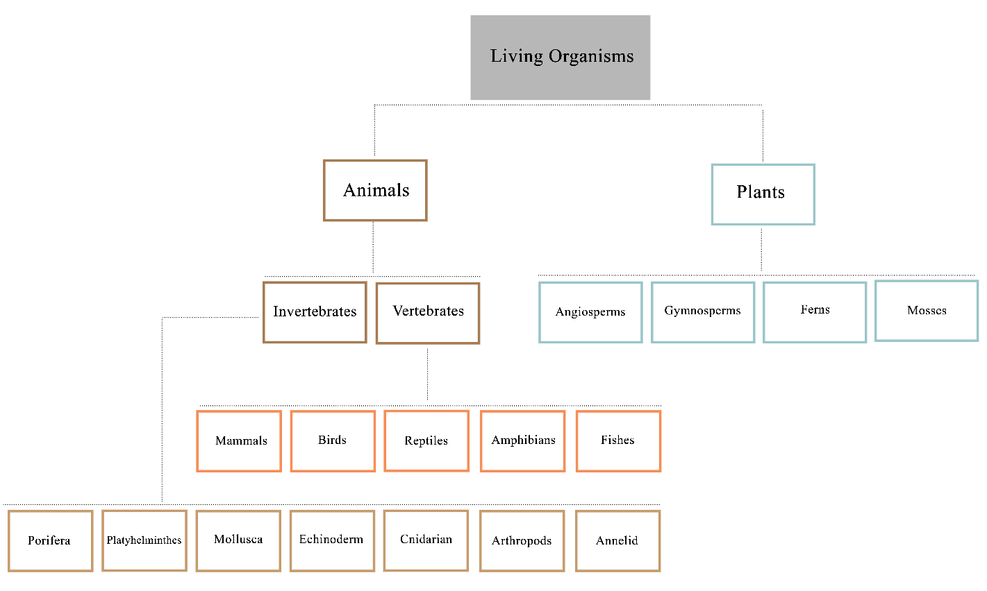
Fig.3. Diagram of the examined organisms
As mentioned in introduction plants are similar to buildings because of their lack of movement to another place and in many cases, Designers use plants as their inspiration. But as the article focused on animals, three animals from different categories were selected and carefully studied to understand their behaviors and body structure. The selected animals were the zebra from the mammal category, the silver-haired ant from the arthropod category, and the lizard from the reptile category. Then, the mechanisms, characteristics, and principles in their bodies were extracted and analyzed to design the facade. Ultimately, the designed facade is analyzed in terms of air flow and temperature using Ansys fluent software.
4. Analyzing natural solutions and examining the mechanisms used in selected organisms
4.1. The study of living organisms
Deserts create intolerable conditions for living organisms in the hot seasons of the year, and the sun's radiation is the main problem in the mentioned areas. However, the ambient temperature drops drastically on some nights and animals experience extreme cold in cold seasons. Various creatures, including plants, mammals, reptiles, birds, and insects live in the desert, which adapts themselves well to the heat caused by the sun's rays and keeps their body temperature constant. As a result, examining the behaviors and structures of these types of organisms allows us to specify their answer to the problem of temperature regulation. Given the diversity of animals, we selected and examined arthropods, mammals, and reptiles. Specifically, the Saharan silver ant, zebra, and lizard were selected from arthropods, mammals, and reptiles, respectively.
4.1.1. Saharan Silver Ant
The Saharan silver ant inspired the use of highly reflective surfaces and geometry that promotes heat dissipation. These Cataglyphis bombycine insects, which are also known as Saharan ants, live in one of the hottest environments on earth (Wehner & Wehner, 2011). These ants come to the surface of the earth to find the corpses of insects and other arthropods that succumbed to the harsh desert conditions and use them as food, while they survive well under these conditions. On hot summer days, their activity to find food increases and the surface temperature of the desert reaches 60 to 70 degrees Celsius, while their body temperature should be between 48 and 51 degrees Celsius. To survive in these conditions, ants sometimes have to dissipate excess heat by stopping on top of rocks or dry vegetation, where they face much lower temperatures due to the intense heat flux above the surface of the sand. Under the midday sun of a summer day, ants may resort to this thermal rest (cooling down) for up to 70% of their total explore time (Wehner et al., 1992). By keeping their body temperature below their critical thermal maximum, i.e. 53.6 °C(Gehring & Wehner, 1995), ants must not only reduce heat absorption from the environment, but must also be able to dissipate excess heat effectively in order to minimize the time spent in the thermal shelters.
The body covered with hair on the top and sides is effective in reducing ants’ body temperature. By examining ant hairs, researchers have concluded that the shape of each strand of hair is like an elongated triangular prism with two wrinkled surfaces and one smooth surface. The hairs are bent at a 90 degrees angle from the root and are at a short distance without contact with the body (Shi et al., 2015).
These hairs show highly reflective characteristics under visible and near-infrared light, i.e., in the region of maximum solar radiation. Further, hairs act as radiation in the mid-infrared part of the electromagnetic spectrum, where they act as an anti-reflective layer that increases the ants' ability to dissipate excess heat through thermal radiation from the ant's hot body to the environment.
According to researchers’ views, the ant's body reflects nearly 67% of sunlight, which is reduced to 41% without hair. The prismatic structure of the hair, which is parallel to the body of the ant, but does not contact the body, increases the light reflection by trapping the incoming light and scattering it in all different directions and outwards (Fig 4) (Shi et al., 2015).
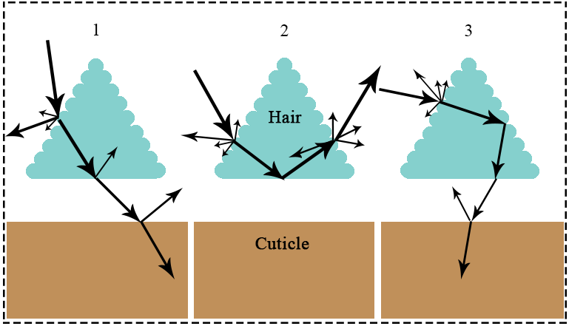
Fig.4. Schematic diagram of the angle of incidence of visible and NIR light with hair in small 1, intermediate 2 and large 3 angles (Shi et al., 2015).

4.1.2. Zebra
Zebra is one of the strong and large herbivorous mammals belonging to the horse family, whose special and unique appearance has made it one of the most amazing animals on the planet. Zebra is the largest and most distinctive species of African wild horses. The skin color and its design play important roles, including a kind of camouflage, disrupting the attack of a predator by visually confusing the carnivore, social function and their identification in the herd, getting away from the attack of insects such as biting flies, and heat management mechanism (Caro et al., 2014). The zebra pattern was used as a conceptual arrangement logic for module rotation, rather than as a claim of parametric superiority over other binary arrangements.
In Kenya, researchers examined zebras in their natural habitat to explore the role of their body stripe pattern. They obtained their information from two male and female zebras, as well as an artificial horse as a control agent, which was surrounded by zebra skin. The results indicated that the temperature difference between the white and black parts increases when the temperature rises during the day. This difference reaches 12 to 15 degrees Celsius in the middle seven hours of the day on live zebras. In other words, this difference in the zebra's skin causes the creation of a microclimate in the area of ​​the animal's skin, and the air flows over its body (Fig. 5) so ​​that the body's temperature decreases with the zebra's sweating and better evaporation(Cobb & Cobb, 2019).
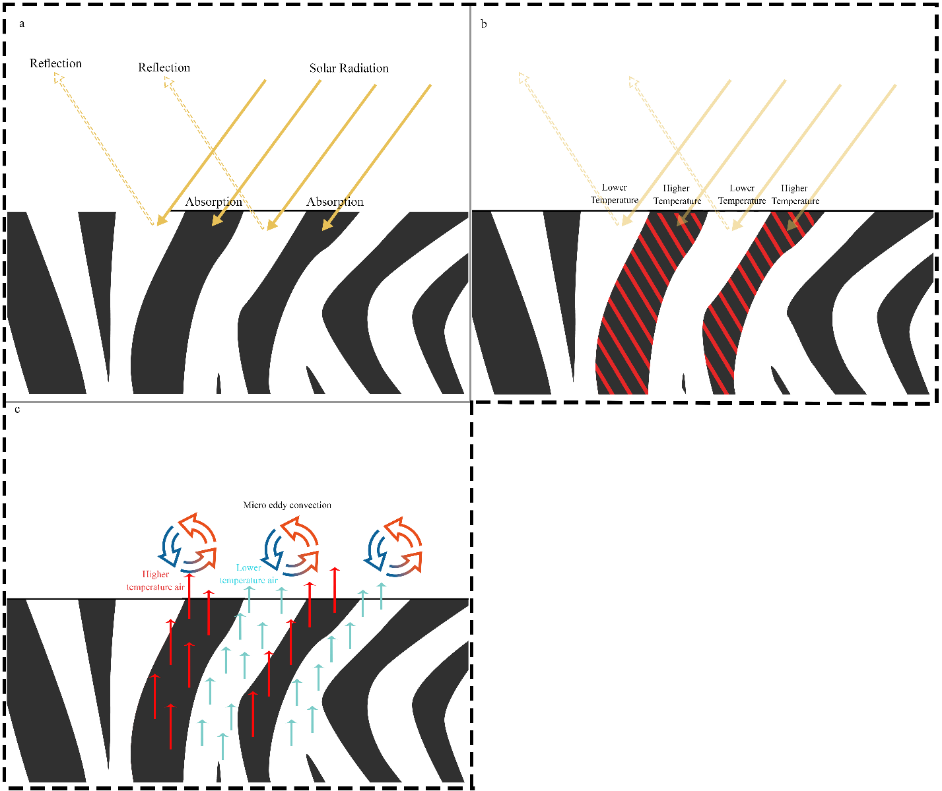
Fig.5. The method of cooling effect induced by zebra stripes . a) Absorption an reflection of light by stripes color. b) Temperature difference of Stripes. c) Generation of micro eddy Convection
On the other hand, researchers noticed that zebras can increase the length of their black hair, resulting in increased temperature difference between the black and white parts during the day, and better-transferring heat from the skin to the surface of the hair. Further, when there is no high temperature difference and air flow, the air is trapped in that part and reduces body heat loss (Cobb & Cobb, 2019).
4.1.3. Desert lizard
Lizard is the general name of a very large group of reptiles that are distributed all over the globe except the Antarctic and the Arctic. Most lizards have four limbs, external ears, and a tail. Lizards have an advanced vision and can see colors, in addition to having a strong sense of smell. The remarkable thing about this creature is living in harsh desert conditions. The lizard adopts different methods to adapt to the conditions in the desert (Pianka & Vitt, 2003). Using the shadow of objects, digging the ground, changing the direction of the body in relation to the sunlight, and changing the color and the physical properties of flakes are among these methods (Fan et al., 2014; Pianka & Vitt, 2003). Researchers point out that lizards react to different temperatures and lights and change their body color to control the energy received from the sun. They use bright colors to reflect and darker colors to absorb energy, which helps regulate their body temperature. The body of reptiles, including lizards, consists of scales, which are made of hard keratins, and the shape and their connection to the body vary in different lizards. These scales protect the lizard's skin from being injured and cause the animal's body to lose less water and repel the sun's ultraviolet waves (Rutland et al., 2019). The lizard inspired the use of color contrast as a passive thermal principle rather than literal dynamic color change.
5. Extracting principles and foundations and imitating
After examining the silver ant, zebra, and lizard, we derived four physical principles involved in the regulation of the body temperature of these creatures, which were the principle of absorption of solar thermal energy by colors, the principle of gas thermal conduction, the principle of light reflection on surfaces, and the principle of gases displacement due to temperature difference. These principles may exist in other animals in different ways, which can also be a source of inspiration for other designs.
6. Applying the principles and basics to design an adaptable façade
6.1. Design Process
In the first place, the design of the facade was considered as a shading object on the building, which was in the form of rhombus-shaped modules and placed in front of the primary facade of the building at a certain distance to prevent light from entering directly (Fig. 6). There was a distance between the modules so that the natural daylight could enter the interior space (In this design, a residential apartment was considered).
In the following, the principles were examined so that they can be applied. As mentioned, the principles include light reflection by the physical properties of surfaces, light absorption by color, gas displacement due to temperature difference, and gas thermal conductivity. To reach the third principle in the design, it is possible to utilize the first two principles. In other words, the first and second principles can be the cause of the emergence of the third principle. For this reason, an attempt was made to realize the first two principles.
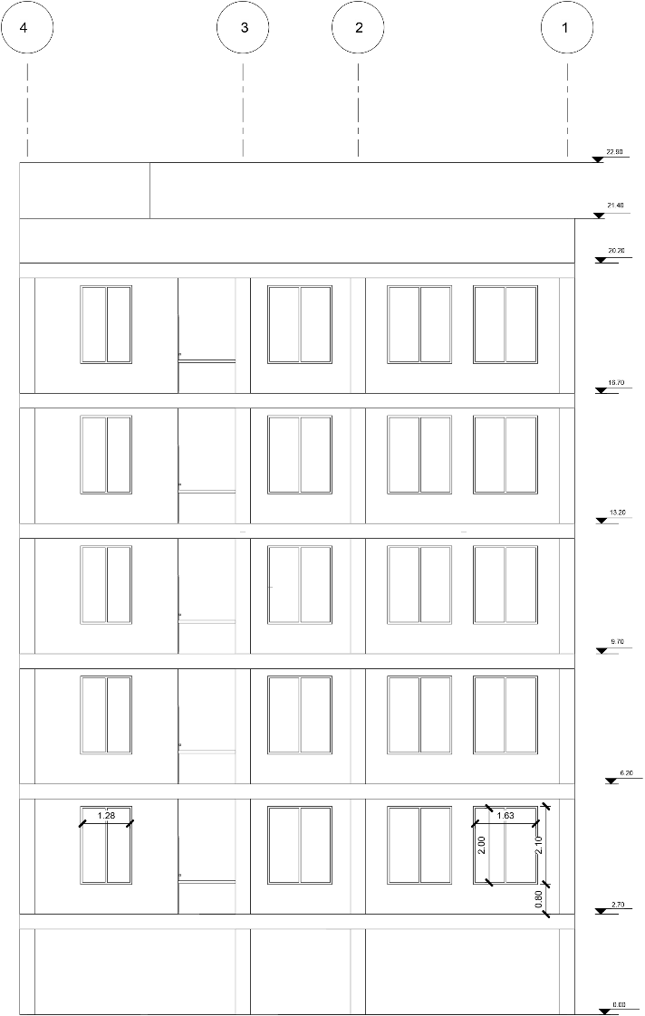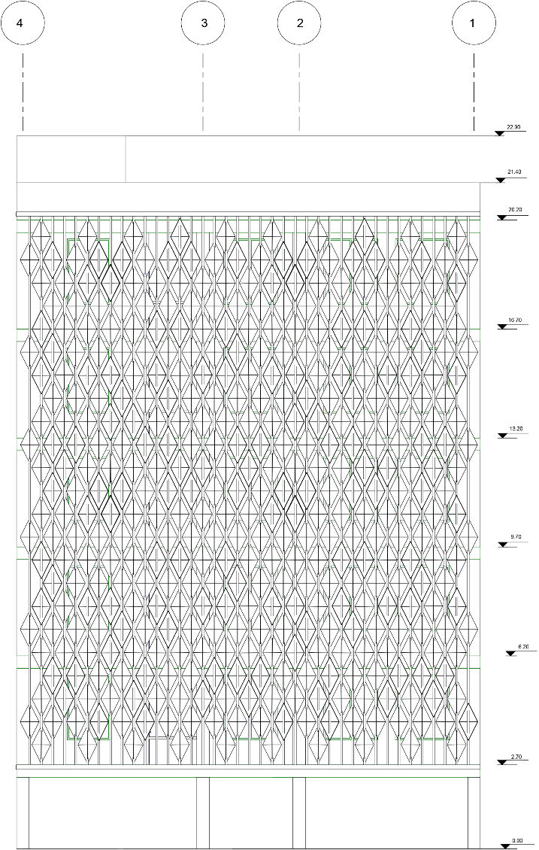
Fig.6.intial façade and designed façade

6.1.1. The principle of light reflection by the physical properties of surfaces
The physical shape of the surface plays an important role in the reflection kind of light. As discussed, light can have regular or irregular reflections. For example, convex spherical surfaces cause outward light reflection while concave spherical surfaces cause inward light reflection to the inside of the volume. To facilitate the construction and maintain the function of the spherical surfaces mentioned to control the light reflection, the rhombic modules were divided into four flat triangles and folded to form a concave volume on one side and a convex volume on the opposite side. Concerning the concave volume, the light was completely trapped in the module because multiple reflections can occur in this volume, while in the convex volume, the light was freely reflected and returned to the environment (Fig. 7).
Fig.7. a) Four parts of folding b) Section of a module c) Light Reflection of different parts of a module

6.1.2. The principle of light absorption by colors
Generally, different color spectrums have different capabilities in absorbing or reflecting light. Among these colors, black and white colors can absorb and reflect the highest amount of light, respectively. In addition to brightness, colors also absorb or reflect the thermal energy of the sun. Moreover, the physical and thermal properties of different materials and their dull and shiny colors affect the reflection and absorption of light, which causes the temperature difference between the modules. As a result, black color was considered for the concave part of the modules and white color was considered for the convex part (Fig 8).
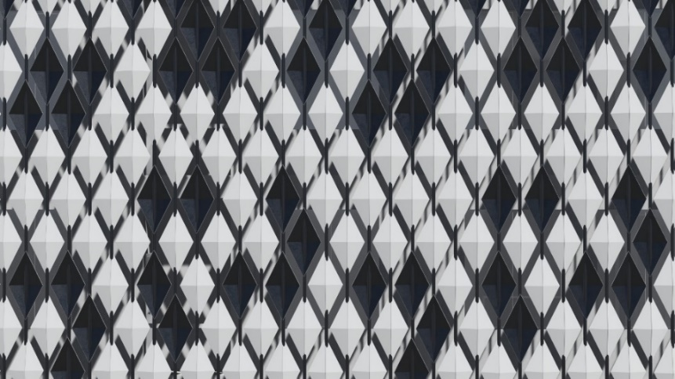
Fig.8.Color selection of concave and convex parts of modules

6.1.3. Principle of gas displacement due to the temperature difference
Gas displacement generally occurs due to the temperature difference in such a way that the temperature difference causes the density difference and the gas moves. To achieve this goal, each of the modules was given the possibility to rotate in its vertical axis separately, aiming to use the properties of surfaces and colors for absorbing or reflecting sunlight (Fig. 9- a). By creating rotation in the modules separately, the black concave or white convex part for each module could face the sun. When the sun is in front of the black concave part, it heats the part, increases the temperature, and then, transfers this heat to the surrounding air. In the other module, however, the white convex part is facing the sun and gets warm less compared to the previous module and consequently, heats the surrounding air less. This temperature difference in the air around the modules causes air movement and natural convection and creates a microclimate on the facade of the building (Fig. 9-b).
6.1.4. The principle of gas's thermal conductivity
Thermal energy can be transferred through matter, the rate of which depends on the time of heat exchange, physical state, and material type. Heat transfer occurs more in solids and liquids, due to the higher density of molecules compared to gas. Thus, gas can be a suitable natural thermal insulation. To achieve this goal, the concave volume of the modules causes air entrapment to some extent. Furthermore, the existence of a distance between the set of modules and the initial facade of the building (fig. 9-c) and the lack of direct connection with the facade causes air insulation and the ambient temperature is less transferred to the interior space.
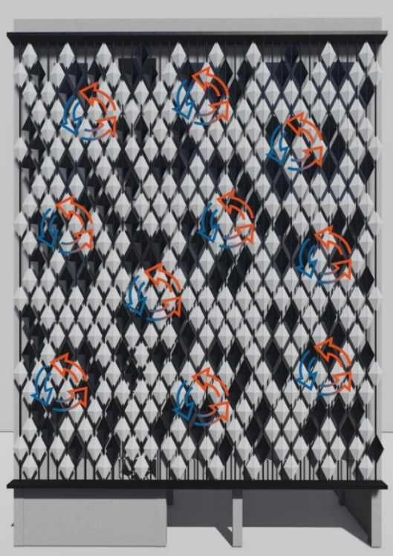
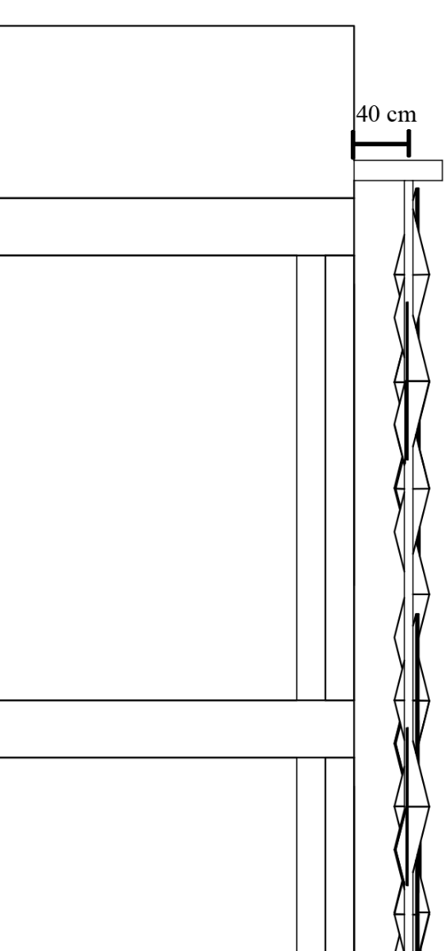
a
c
b
Fig.9. (a) Rotation axis of a module, (b)Possible convection on the façade, (c) Distance between initial façade and modules

7. Proving air displacement due to the temperature difference of the modules
To this aim, the secondary façade was first modeled in Rhino software using the Grasshopper plugin. In this modeling, the modules were rotated regarding the written algorithm for their rotation in the form of a zebra body pattern (Fig. 10) and then, Ansys fluent software was used to simulate air displacement.
External wind was intentionally excluded in this first-stage analysis to isolate the effect of the facade; however, this simplification should be considered a limitation of the present study. Accordingly, the use of as a validation reference should be considered a methodological limitation (Sánchez et al., 2019), because the validation case differs from the present facade geometry and boundary conditions. The turbulence model and mesh independence study were not included in this preliminary design-oriented analysis and should be addressed in future work.

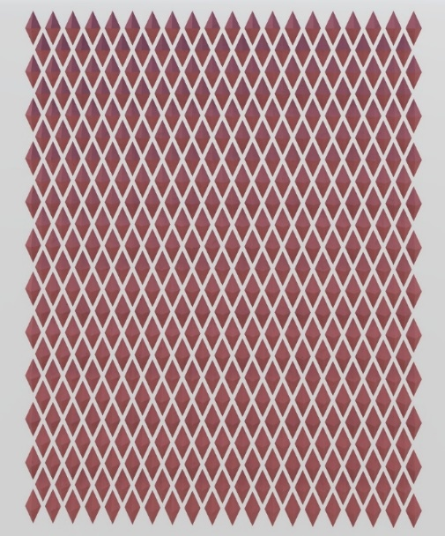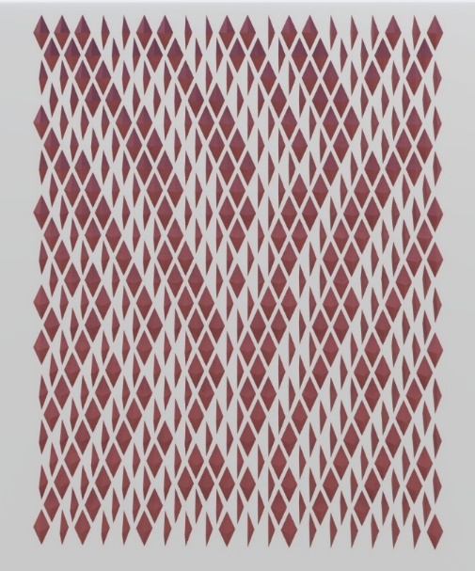
Fig.10. modeled Modules in Rhino and 90 degree rotation of modules based on zebra skin pattern

Next, the physical and thermal characteristics of the modules were determined to simulate the movement and air flow on the desired façade in the Ansys fluent software. According to the mechanisms analyzed in the previous section, two metals that can be used in the construction industry were selected to create a temperature difference between the modules. Considering the physical and thermal characteristics of the selected materials, copper and aluminum metals were selected for the convex and concave parts of the modules, respectively (Table 2). Then, the sun conditions and the ambient temperature on July 12, 2022, at 13:00 in the city of Semnan were considered as it was hot compared to other days of the year. under this condition, the ambient temperature reached 308 Kelvin and the sun's radiation angle was 76.38 degrees. It is worth mentioning that no external air flow was considered so that the direct effect of the facade on the air flow can be observed. Behind the facade, a wall was assumed as the primary facade of the building to show the effect of the designed facade on reducing its temperature.
Table 2. Thermal properties of selected materials
Copper | Aluminum | Material
8940(Thermtest, 2022) | 2698 (Thermtest, 2022) | Density (kg/m^3)
385(Thermtest, 2022) | 900 (Yao et al., 2005) | Specific Heat (j/kg-k)
397.48(Thermtest, 2022) | 117 (Kaufman, 2016) | Thermal conductivity (w/m-k)
5.9526e+5(Polyanskiy, 2008) | 1.5075e+6(Polyanskiy, 2008) | Absorption coefficient (cm^ -1)
0.63660(Polyanskiy, 2008) | 1.1978(Polyanskiy, 2008) | Refractive index

After selecting the materials and determining the environmental conditions, the temperature of the modules was calculated after a 180-degree rotation with a zebra skin pattern, which resulted in an average temperature difference of 13 degrees between the convex and concave parts (Fig. 11).
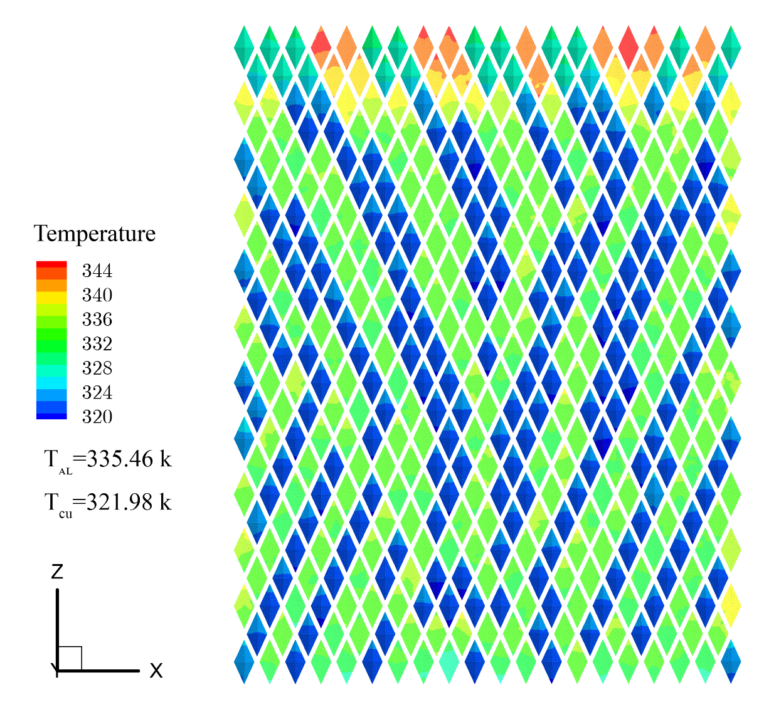
Fig.11. Temperature of the modules

After calculating the temperature of the modules, air marginalization was conducted on the facade so that the air flow can be simulated in a certain range. Further, the radiation flux of the primary wall, which has dimensions of 68 m × 19 m, was considered$1200\frac{w}{m^{2}}$. The designed façade was placed on the origin of the coordinates while the primary wall was considered at a distance of +0.40 m along the $y$ axis (Fig. 12). The radiation flux of 1200 W/m² was used as a design-case boundary condition representing a severe summer scenario in Semnan.

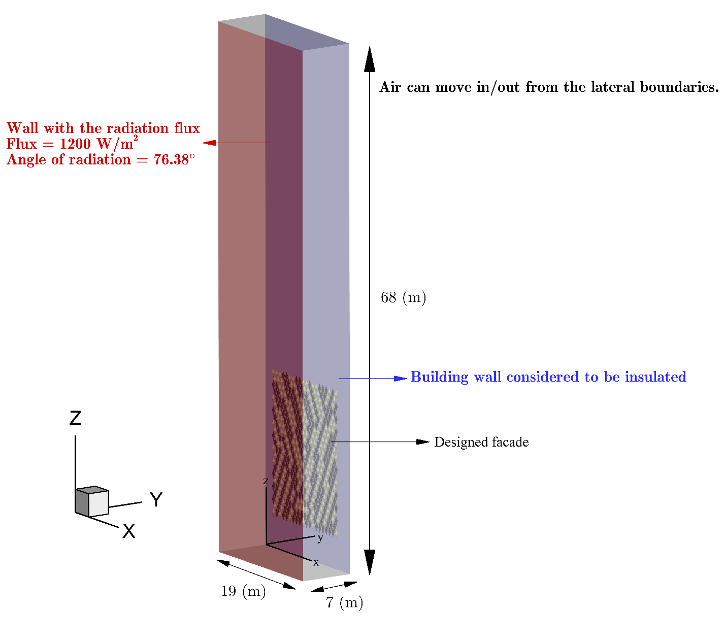Fig.12. The boundary of air movement.
After marginalization, flow lines (Figs. 13, 14), speed (Fig. 15), and air temperature around the designed facade (Fig. 16) were simulated. To display the results, we addressed different cuts along the $y$ direction (according to Figure 12) and in three dimensions.
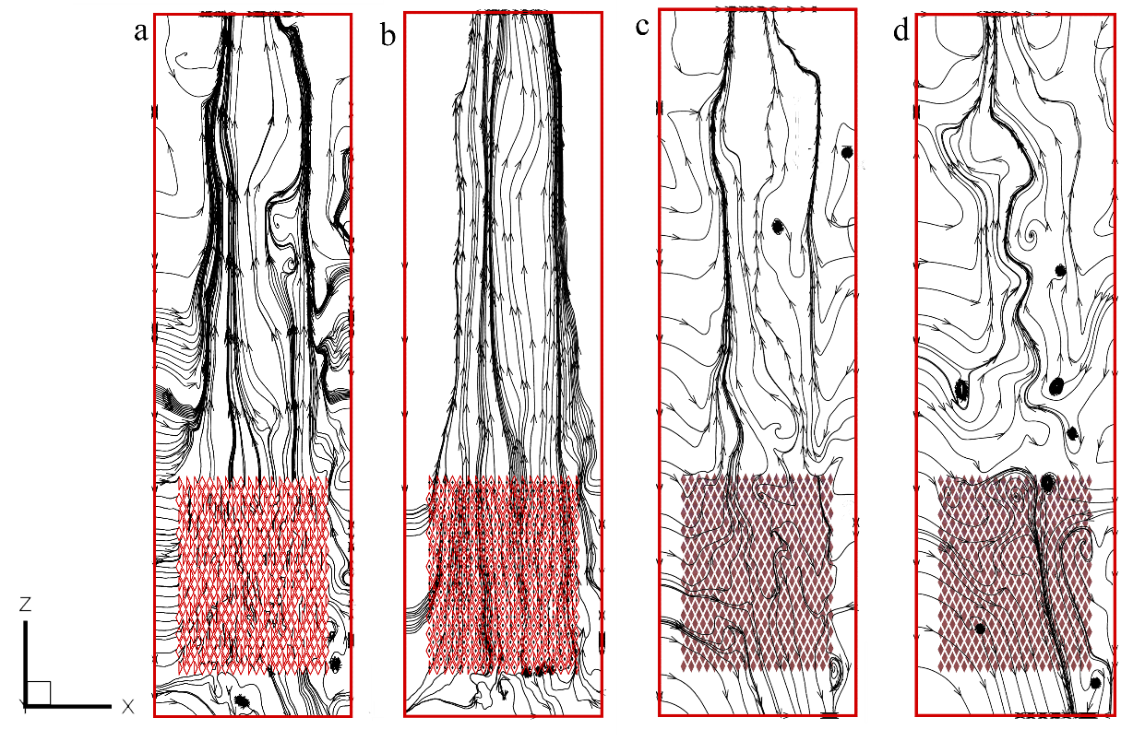
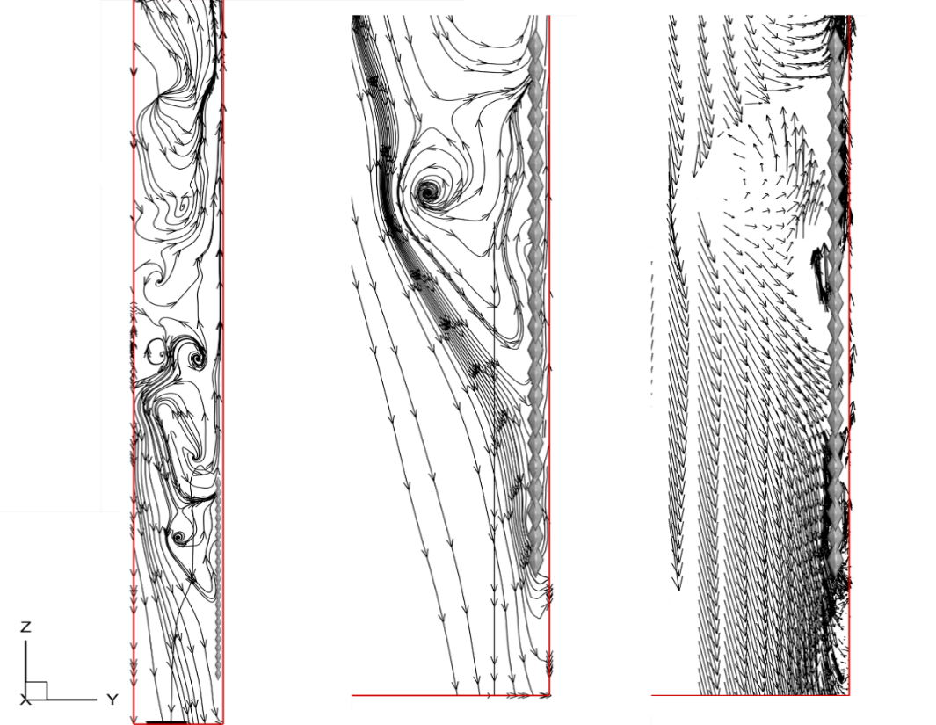
Fig.13. Air movement and streamline at a) y=0.00 m, b) y=0.20 m, c) y= -0.40 m, d) y= -1.20 m
Fig.14. Air movement and streamline at x= 7.50 m
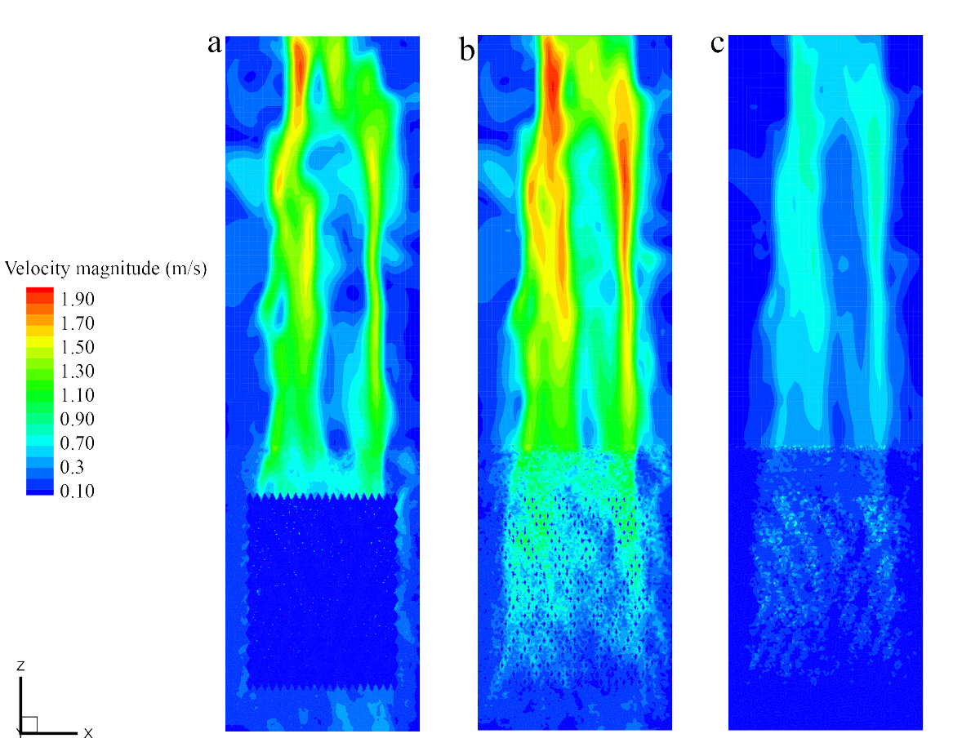
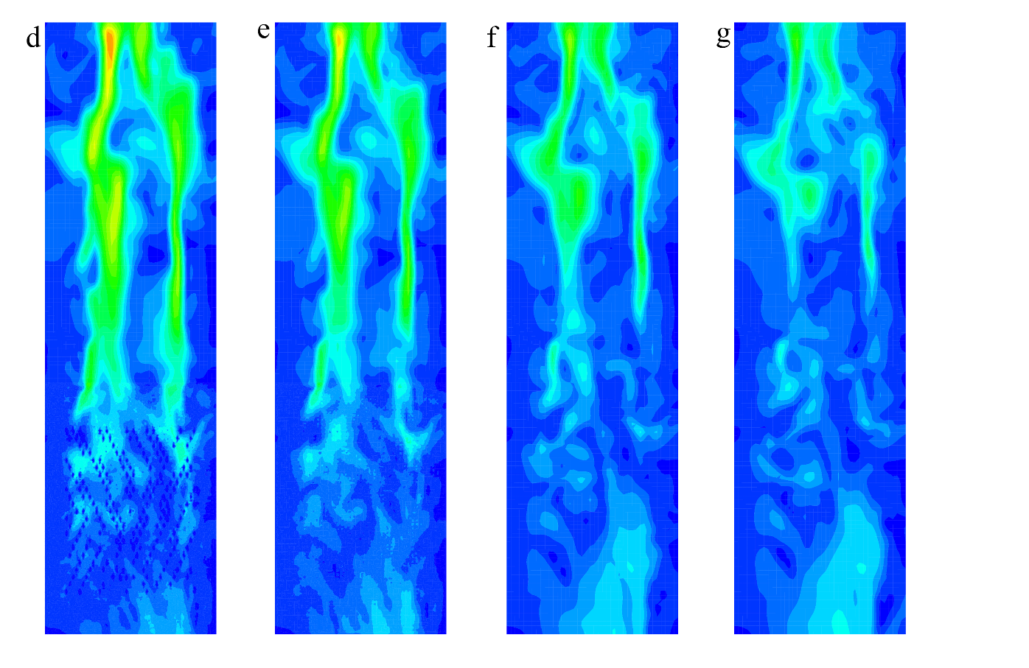
Fig.15. Air velocity at a) y= 0.00 m ,b) y= 0.20 m , c) y= 0.35 m , d) y= -0.20 m, e) y= -0.40 m, f) y= - 0.8 m,

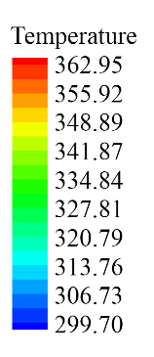
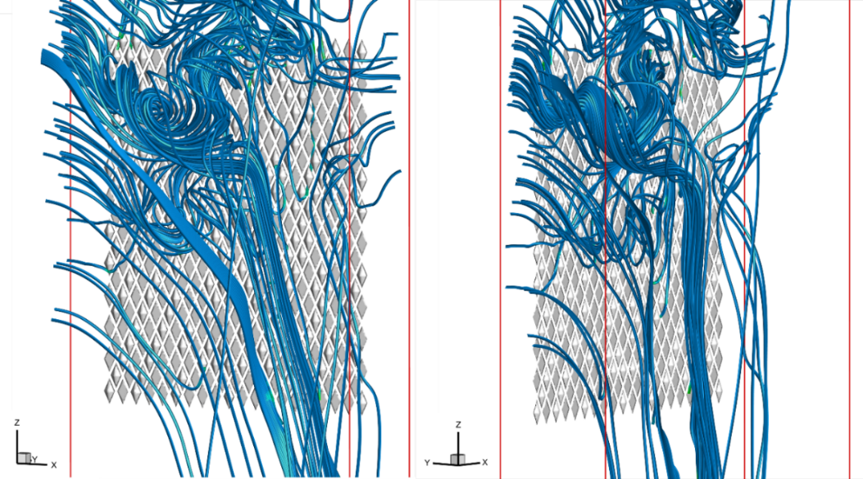

Fig.16. Air movement and its temperature in 3d

Concerning the simulation, it was first assumed that the entire studied volume is filled with air at a temperature of 308 Kelvin (Fig. 17-a). The molecules closer to the modules become warmer by contacting the surface of these modules, and thus, their density decreases and they move to a higher altitude until the colder and heavy air is replaced. For this reason, an upward flow and a flow with rotating patterns are created due to the local temperature difference of the modules. As a result of this displacement, the colder air flow in the areas away from the building moves downwards and a flow closer to the building and modules moves upward due to the heat absorption from the modules. It is not assumed that the surrounding environment is closed and a new air volume may enter this space from the boundaries while its temperature is 308 Kelvin. As shown in Fig 17-b, a clear temperature difference can be seen on the primary wall. For example, a part of the primary wall that was placed behind the designed facade reached an average temperature of 320 K while the parts that were not covered by the designed facade reached an average temperature of 340 K. This temperature difference illustrates that using this type of shading combined with ventilation can help cool the outer wall of a building.
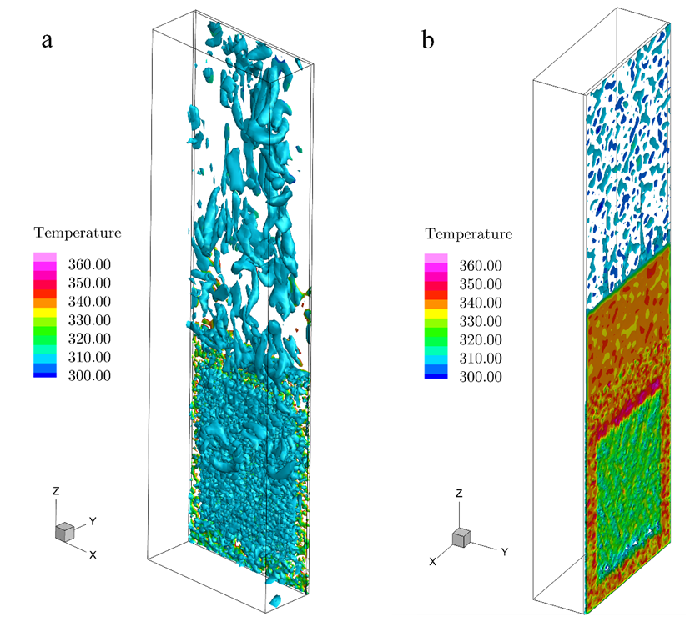
Fig.17. a) Air turbulence effect caused by façade. b) Temperature of the initial wall.
As mentioned, the sun conditions on July 12, 2022, at 13:00 in the city of Semnan were considered in this research as it was hot compared to other days of the year, when the ambient temperature reached 308 Kelvin. Table 3 provides the temperature of different parts of the project, according to the simulation made by Ansys Fluent software. The temperature information is expressed as the lowest and highest temperature obtained in the software for each part, which can be observed in Figures (11, 16, and 17).
Table 3. The ambient temperature compared to the air temperature around the facade, the temperature of the primary wall, and the temperature of the modules obtained through simulation in Ansys Fluent
Object | Minimum Temperature (k) | Average Temperature (k) | Maximum Temperature (k)
Ambient | 308 | 308 | 308
Air near the facade | 310 | 313.76 | 320
Initial wall without second facade | 335 | 340 | 345
Initial wall with second facade | 315 | 320 | 325
Al modules | 328 | 335.46 | 344
Cu modules | 320 | 321.98 | 326

8. Discussion
In the current research, the natural ventilation of double façade skin and the temperature of the facade are analyzed using shading, and the construction features such as the geometric shape, shading position, the placement angle of the modules, and the properties of the materials in light scattering and absorption are taken into consideration. Some sources have also considered this type of construction features (Ahmed et al., 2015; Choi et al., 2019; Hong et al., 2019; Li et al., 2019; Parra et al., 2015).
As mentioned, in this research, inspired by nature, a facade on the scale of a residential building in the city of Semnan, Iran, has been designed so that thermal comfort can be achieved with less energy consumption. Using the Ansys fluent software, the temperature of the facade surfaces has been calculated and the air flow on the facade surface has been simulated. This CFD software has been used in many researches and its validity is confirmed (Kim et al., 2012; Sánchez et al., 2019).
In the analysis, the rotation angle of the modules, the color and the type of materials used in the facade can be changed momentarily to adjust the amount of light entering inside. Copper metal was chosen for the convex part and aluminum metal was chosen for the concave part of the modules, which can be used in the construction industry. These two metals cause a temperature difference due to the difference in energy absorption. Other studies have also mentioned the energy absorption of materials (Colombo et al., 2017; El-Sadi et al., 2010).
The temperature difference between the modules causes the air temperature difference around them, which in turn causes the rotation of the air flow. Also, the air movements in the areas far from the building, the air flow which is colder moves down and the flow closer to the building and modules moves up due to the heat gain from the modules. According to the results, a favorable air flow can be seen on the facade. The primary facade of the building, in front of which the secondary facade is designed, has an average temperature drop of nearly 20 degrees. In short, in the current research, the temperature and air velocity, and the temperature of the surface of the modules and the initial facade have been investigated at the same time. In other studies, the performance of double skin facades and its effectiveness in creating thermal comfort have been investigated based on other parameters, and the goals and results have been investigated in a different way. Souza and et al. (2018) have performed a CFD analysis on the thermal behavior of a natural opaque double skin facade and compared it with the thermal behavior of a standard one skin wall.The measurement of facades shows that the temperature reaches its maximum at 16:00. These values are equal to 25.6 °C on the inner face of the facade and 23.6 °C on the inner surface of the test cell, while the external temperature gives values equal to 23.1 °C at this time. The results show that the presence of the double skin facade helps to reduce the temperature inside the environment because it blocks the direct sunlight which is also mentioned in the present research (C. O. Souza et al., 2018).
In another study, Iken and et al, (2019) in their research, have analyzed the natural ventilation of the double skin facade with a opaque interior (with AlN coating) using Ansys Fluent software. The aim of the simulations is to investigate the thermal performance of a double skin facade that integrates tungsten (W) doped vanadium dioxide (VO2) as an optically smart material on the outer glazing and a highly absorbing aluminum nitride (AIN) coating on the inner façade [90]. In the current research, the selection of suitable materials to achieve the goal has been considered. Then, a parametric study was conducted to analyze the effect of air cavity thickness on thermal behavior. The results have shown that the intelligent configuration significantly reduces the heating and cooling loads. The indoor surface temperature decreased by about 2°C during summer and increased by about 3°C on a sunny winter day. The results of air velocity have shown that the convection-natural radiation interaction in winter is higher than summer (Iken et al., 2019). In the current research, the movement behavior of air on the facade, which is caused by the convection-radiation interaction, has been investigated. Compared with previous adaptive and double-skin facade studies, the present design is distinguished by the simultaneous use of three biomimetic sources, coordinated geometric modulation, and integrated material logic. While earlier studies often emphasize a single inspiration or a single thermal mechanism, the proposed facade combines reflectivity, pattern-based arrangement, and airflow-oriented geometry within one system.
9. Conclusion
This study demonstrated that the integrated use of Saharan silver ant, zebra, and desert lizard principles can reduce facade surface temperature and support favorable airflow around the facade. However, the present study is a preliminary CFD-based investigation and does not include external wind, mesh independence, or a thermal comfort index.
Nature and its unrevealed mechanisms can present solutions to various problems in architecture. The creation of thermal comfort with less energy consumption is one of these problems, the examples of which were mentioned in this article. In tropical areas such as Semnan city, it is possible to achieve thermal comfort by creating shading and natural ventilation, utilizing methods developed by bionic science or nature-inspired ones, as well as applying modern technologies such as adaptive intelligent systems. This article sought to design a secondary facade for a five-story residential building in Semnan city, in order to achieve thermal comfort optimally. By using bionic science and after examining the animals, three species were selected and their mechanisms to cool their bodies were combined to design the façade. This facade causes air circulation by creating a local temperature difference inspired by the zebra skin pattern, and can change its color like a lizard. This color change can happen according to environmental conditions such as the position of the sun, ambient temperature, wind, and the like. In this article, only one zebra pattern was examined to understand that the result of the color change and facade materials will create a local temperature difference and then, generate air flow. Nevertheless, the simulation revealed that the presence of the secondary facade a temperature difference of nearly 20 K was observed between the covered and uncovered portions of the same wall in the simulated case. These results should be interpreted as a facade-surface temperature reduction study rather than a full thermal comfort assessment.
Regarding the necessity to reduce the amount of incoming light and create air conditioning in the hot months of the year, the modules rotate in such a way that the entire surface of the module faces the sun and moves along with the change of the sun's radiation angle. The angulation value of the module surface against the sun radiation angle is based on the need for lighting and heat regulation in the interior space at any moment. Further, the difference in color and materials between adjacent modules, which are formed based on the pattern of the zebra's body, creates the possibility of creating ventilation and air flow.
Concerning the lack of need to create air flow and the requirement of more heat in the cold months of the year, the modules’ surface angle against the sun's radiation is such that the least surface is in front of the light so that a greater amount of heat enters the interior space. Moreover, no difference should be created in color and materials between adjacent modules to reduce the amount of air flow.
Given the hot and dry climate of Semnan, which is hot in most months of the year, the analysis in this research was performed during the extreme heat of the day, which required a lot of shading and ventilation.
In terms of residents' interaction with the outside environment, the designed facade could provide acceptable communication. Considering the modular and movable design of this facade, each of the modules can have a separate rotation, so that the modules facing the windows cover a smaller area if the residents need to see and interact with the outside (Fig.18). Ultimately, these modules or some of their geometrical aspects can be removed in parts without damaging the overall façade from an aesthetic point of view.

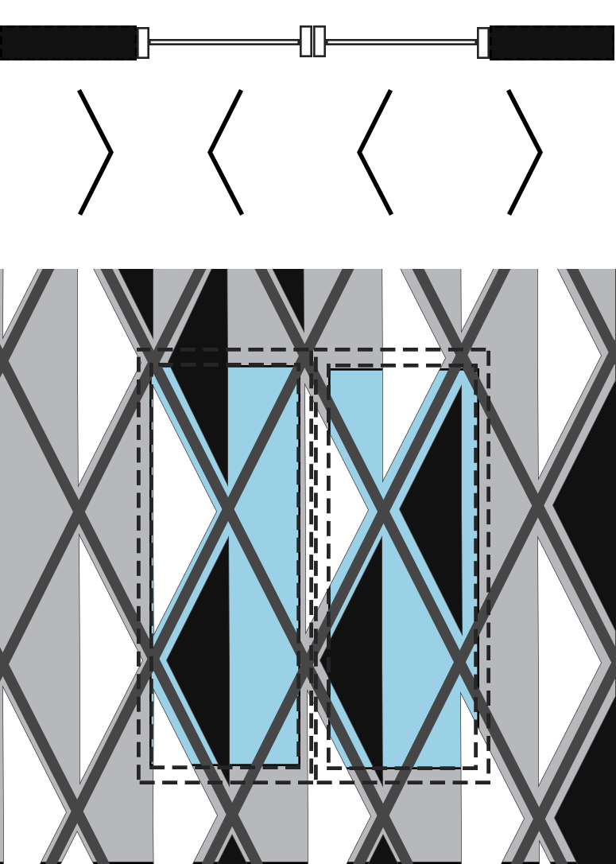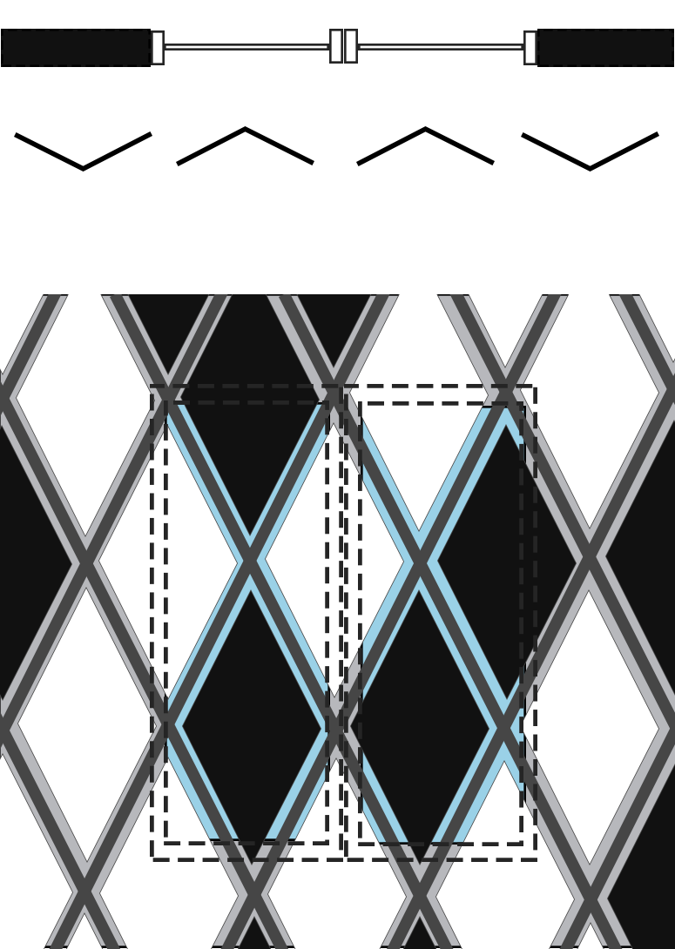
Fig .18. The rotation of modules in order to make interaction possible to residents.
By using intelligent and computer systems to address environmental conditions, it is possible to consider the modules’ rotation angle, color change, and façade materials instantaneously to adjust the amount of incoming light, select the best and most optimal façade, greatly affect creating air flow, and as a result, provide the highest thermal comfort in the internal environment of the building. Future studies should conduct a full CFD validation, perform comfort-index analysis, and compare the proposed arrangement with alternative facade patterns.

References
(IEA), I. E. A. (2013). Transition to Sustainable Buildings: Strategies and Opportunities to 2050. OECD Publishing / International Energy Agency. https://doi.org/10.1787/9789264202955-en
Abensperg-Traun, M. A. X. (1991). Seasonal changes in activity of subterranean termite species (Isoptera) in Western Australian wheatbelt habitats. Australian Journal of Ecology, 16(3), 331-336. https://doi.org/https://doi.org/10.1111/j.1442-9993.1991.tb01061.x
Addington, D. M. S., Daniel L. (2012). Smart Materials and Technologies in Architecture: For the Architecture and Design Professions (1 ed.). Routledge. https://doi.org/10.4324/9780080480954
Ahmed, H., Ameghchouche, M., & Bougriou, C. (2015). A numerical analysis of the air ventilation management and assessment the behavior of double skin facades. Energy and Buildings, 102. https://doi.org/10.1016/j.enbuild.2015.05.057
AHR. (2019). Al Bahr Towers. AHR. Retrieved 2019,05,20 from https://www.ahr.co.uk/projects/al-bahr-towers
Alshahrani, J., & Boait, P. (2018). Reducing High Energy Demand Associated with Air-Conditioning Needs in Saudi Arabia. Energies, 12, 87. https://doi.org/10.3390/en12010087
Attia, S. (2018). Challenges and Future Directions of Smart Sensing and Control Technology for Adaptive Facades Monitoring.
Badarnah, L. (2017). Form Follows Environment: Biomimetic Approaches to Building Envelope Design for Environmental Adaptation. Buildings, 7, 40. https://doi.org/10.3390/buildings7020040
Bohnenberger, S., Khoo, C., Daniel, D., Thomsen, M., & Karmon, A. (2012). Sensing Material Systems - Novel Design Strategies. International Journal of Architectural Computing, 10, 361-376. https://doi.org/10.1260/1478-0771.10.3.361
C. O. Souza, L., A. Souza, H., & F. Rodrigues, E. (2018). Experimental and numerical analysis of a naturally ventilated double-skin façade. Energy and Buildings, 165, 328-339. https://doi.org/https://doi.org/10.1016/j.enbuild.2018.01.048
Caro, T., Izzo, A., Reiner, R., Walker, H., & Stankowich, T. (2014). The function of zebra stripes. Nature communications, 5, 3535. https://doi.org/10.1038/ncomms4535
Caruso, G., Fantozzi, F., & Leccese, F. (2013). Optimal theoretical building form to minimize direct solar irradiation. Solar Energy, 97, 128-137. https://doi.org/10.1016/j.solener.2013.08.010
Chen, K., Janssen, P., & Schlueter, A. (2018). Multi-objective optimisation of building form, envelope and cooling system for improved building energy performance. Automation in Construction, 94, 449-457. https://doi.org/10.1016/j.autcon.2018.07.002
Chen, P.-Y., McKittrick, J., & Meyers, M. A. (2012). Biological materials: Functional adaptations and bioinspired designs. Progress in Materials Science, 57(8), 1492-1704. https://doi.org/https://doi.org/10.1016/j.pmatsci.2012.03.001
Choi, H., An, Y., Kang, K., Yoon, S., & Kim, T. (2019). Cooling energy performance and thermal characteristics of a naturally ventilated slim double-skin window. Applied Thermal Engineering, 160, 114113. https://doi.org/10.1016/j.applthermaleng.2019.114113
Cobb, A., & Cobb, S. (2019). Do zebra stripes influence thermoregulation? Journal of Natural History, 53, 863-879. https://doi.org/10.1080/00222933.2019.1607600
Colombo, E., Zwahlen, M., Frey, M., & Loux, J. (2017). Design of a glazed double-façade by means of coupled CFD and building performance simulation. Energy Procedia, 122, 355-360. https://doi.org/10.1016/j.egypro.2017.07.337
Das, S., Bhowmick, M., Chattopadhyay, S., & Basak, S. (2015). Application of biomimicry in textiles. Current Science, 109, 893. https://doi.org/10.18520/v109/i5/893-901
Dunlop, J., & Fratzl, P. (2013). Multilevel architectures in natural materials. Scripta Materialia, 68, 8–12. https://doi.org/10.1016/j.scriptamat.2012.05.045
El-Sadi, H., Haghighat, F., & Fallahi, A. (2010). CFD Analysis of Turbulent Natural Ventilation in Double-Skin Façade: Thermal Mass and Energy Efficiency. Journal of Energy Engineering, 136(3), 68-75. https://doi.org/10.1061/(ASCE)EY.1943-7897.0000026
El Ahmar, S., & Fioravanti, A. (2015). Biomimetic-Computational Design for Double Facades in Hot Climates: A Porous Folded Façade for Office Buildings. https://doi.org/10.52842/conf.ecaade.2015.2.687
Fan, M., Stuart-Fox, D., & Cadena, V. (2014). Cyclic Colour Change in the Bearded Dragon Pogona vitticeps under Different Photoperiods. PloS one, 9, e111504. https://doi.org/10.1371/journal.pone.0111504
Ferrante, A. (2012). Zero and low-energy housing for the Mediterranean climate. Advances in Building Energy Research, 6, 1-38. https://doi.org/10.1080/17512549.2012.672003
French, J. R. J., & Ahmed, B. M. (2010). The challenge of biomimetic design for carbon-neutral buildings using termite engineering. Insect Science, 17(2), 154-162. https://doi.org/https://doi.org/10.1111/j.1744-7917.2009.01306.x
Gehring, W., & Wehner, R. (1995). Heat shock protein synthesis and thermotolerance in Cataglyphis, an Ant from the Sahara Desert. Proceedings of the National Academy of Sciences of the United States of America, 92, 2994-2998. https://doi.org/10.1073/pnas.92.7.2994
Gholipour Gashniani, M. (2020). Decision Making Criteria for Optimal Selection of Innovative Daylighting Systems in Buildings, Using Integrated Delphi/Dematel/AHP Approach. 7, 7, 27-36. https://doi.org/DOI: 10.18415/ijmmu.v7i7.1632
Grynning, S., Time, B., & Matusiak, B. (2014). Solar shading control strategies in cold climates – Heating, cooling demand and daylight availability in office spaces. Solar Energy, 107, 182-194. https://doi.org/https://doi.org/10.1016/j.solener.2014.06.007
Hernández-Pérez, I., Álvarez, G., Xamán, J., Zavala-Guillén, I., Arce, J., & Simá, E. (2014). Thermal performance of reflective materials applied to exterior building components—A review. Energy and Buildings, 80, 81-105. https://doi.org/https://doi.org/10.1016/j.enbuild.2014.05.008
Hong, X., Leung, M. K. H., & He, W. (2019). Effective use of venetian blind in Trombe wall for solar space conditioning control. Applied Energy, 250, 452-460. https://doi.org/https://doi.org/10.1016/j.apenergy.2019.04.128
Iken, O., Fertahi, S. e.-D., Dlimi, M., Agounoun, R., Kadiri, I., & Sbai, K. (2019). Thermal and energy performance investigation of a smart double skin facade integrating vanadium dioxide through CFD simulations. Energy Conversion and Management, 195, 650-671. https://doi.org/https://doi.org/10.1016/j.enconman.2019.04.070
Imani, M., Donn, M., & Balador, Z. (2019). Bio-inspired materials: Contribution of biology to energy efficiency of buildings. In (pp. 2213-2236). https://doi.org/10.1007/978-3-319-68255-6_136
Kämpf, J., & Robinson, D. (2010). Optimisation of building form for solar energy utilisation using constrained evolutionary algorithms. Energy and Buildings, 42, 807-814. https://doi.org/10.1016/j.enbuild.2009.11.019
Kim, G., Lim, H. S., Lim, T., Schaefer, L., & Kim, J. (2012). Comparative advantage of an exterior shading device in thermal performance for residential buildings. Energy and Buildings, 46, 105–111. https://doi.org/10.1016/j.enbuild.2011.10.040
Konis, K., Gamas, A., & Kensek, K. (2016). Passive performance and building form: An optimization framework for early-stage design support. Solar Energy, 125, 161-179. https://doi.org/https://doi.org/10.1016/j.solener.2015.12.020
Kumar, R., Garg, S., & Kaushik, S. C. (2005). Performance evaluation of multi-passive solar applications of a non air-conditioned building. International Journal of Environmental Technology and Management, 5, 60-75.
Kuru, A., Fiorito, F., Oldfield, P., & Bonser, S. (2018). Multi-functional biomimetic adaptive facades: A case study.
Li, Y., Darkwa, J., Kokogiannakis, G., & Su, W. (2019). Phase Change Material Blind System for Double Skin Façade Integration: System Development and Thermal Performance Evaluation. Applied Energy, 252. https://doi.org/10.1016/j.apenergy.2019.113376
Lienhard, J., Schleicher, S., Poppinga, S., Masselter, T., Milwich, M., Speck, T., & Knippers, J. (2011). Flectofin: A hingeless flapping mechanism inspired by nature. Bioinspiration & biomimetics, 6, 045001. https://doi.org/10.1088/1748-3182/6/4/045001
Lopez, M., Rubio, R., Croxford, B., & Martín, S. (2017). How plants inspire façades. From plants to architecture: Biomimetic principles for the development of adaptive architectural envelopes. Renewable and Sustainable Energy Reviews, Volume 67, Pages 692–703. https://doi.org/10.1016/j.rser.2016.09.018
Mando, A., Stroosnijder, L., & Brussaar, L. (1996). Effects of termites on infiltration into crusted soil. Geoderma, 74(1), 107-113. https://doi.org/https://doi.org/10.1016/S0016-7061(96)00058-4
Marguet, M., Bonduelle, C., & Lecommandoux, S. (2012). ChemInform Abstract: Multicompartmentalized Polymeric Systems: Towards Biomimetic Cellular Structure and Function. Chemical Society reviews, 42. https://doi.org/10.1039/c2cs35312a
Marszal, A., Heiselberg, P., Bourrelle, J., Musall, E., Voss, K., Sartori, I., & Napolitano, A. (2011). Zero Energy Building - A review of definitions and calculation methodologies. Lancet, 43, 971-979. https://doi.org/10.1016/j.enbuild.2010.12.022
Megahed, N. (2016). Understanding kinetic architecture: typology, classification, and design strategy. Architectural Engineering and Design Management, 13, 1-17. https://doi.org/10.1080/17452007.2016.1203676
Muhaisen, A., & Gadi, M. (2006). Effect of courtyard proportions on solar heat gain and energy requirement in the temperate climate of Rome. Building and Environment - BLDG ENVIRON, 41, 245-253. https://doi.org/10.1016/j.buildenv.2005.01.031
Nagy, G., & Osama, N. (2016). Biomimicry, an Approach, for Energy Effecient Building Skin Design. Procedia Environmental Sciences, 34, 178-189. https://doi.org/10.1016/j.proenv.2016.04.017
Nour el Houda, A., & Mohamed, D. (2018). Advanced Building Skins Inspired From Plants Adaptation Strategies to Environmental Stimuli: A Review. https://doi.org/10.1109/ICASS.2018.8651949
Paar, M., & Petutschnigg, A. (2017). Biomimetic inspired, natural ventilated façade – A conceptual study. Journal of Facade Design and Engineering, 4, 131-142. https://doi.org/10.3233/FDE-171645
Parra, J., Guardo-Zabaleta, A., Egusquiza, E., & Alavedra, P. (2015). Thermal Performance of Ventilated Double Skin Façades with Venetian Blinds. Energies, 8, 4882-4898. https://doi.org/10.3390/en8064882
Pedersen Zari, M. (2007). Biomimetic approaches to architectural design for increased sustainability The SB07 NZ Sustainable Building Conference,
Pérez-Lombard, L., Ortiz, J., & Pout, C. (2008). A review on buildings energy consumption information. Energy and Buildings, 40(3), 394-398. https://doi.org/https://doi.org/10.1016/j.enbuild.2007.03.007
Pesenti, M., Masera, G., & Fiorito, F. (2015). Shaping an Origami Shading Device through Visual and Thermal Simulations. Energy Procedia, 78, 346-351. https://doi.org/https://doi.org/10.1016/j.egypro.2015.11.663
Pesenti, M., Masera, G., Fiorito, F., & Sauchelli, M. (2015). Kinetic Solar Skin: A Responsive Folding Technique. Energy Procedia, 70, 661-672. https://doi.org/https://doi.org/10.1016/j.egypro.2015.02.174
Pianka, E., & Vitt, L. (2003). Lizards, Windows to the Evolution of Diversity.
Ramzy, N., & Fayed, H. (2011). Kinetic systems in architecture: New approach for environmental control systems and context-sensitive buildings. Sustainable Cities and Society, 1, 170-177. https://doi.org/10.1016/j.scs.2011.07.004
Rutland, C., Cigler, P., & Kubale, V. (2019). Reptilian Skin and Its Special Histological Structures. In. https://doi.org/10.5772/intechopen.84212
Sakai, S., Nakamura, M., Furuya, K., Amemura, N., Onishi, M., Iizawa, I., Nakata, J., Yamaji, K., Asano, R., & Tamotsu, K. (2012). Sierpinski's forest: New technology of cool roof with fractal shapes. Energy and Buildings, 55, 28–34. https://doi.org/10.1016/j.enbuild.2011.11.052
Sánchez, M., Giancola, E., Blanco, E., Soutullo, S., & Suárez López, M. J. (2019). Experimental Validation of a Numerical Model of a Ventilated Façade with Horizontal and Vertical Open Joints. Energies, 13, 146. https://doi.org/10.3390/en13010146
Sayed, M., & Fikry, M. (2019). Impact of glass facades on internal environment of buildings in hot arid zone. Alexandria Engineering Journal, 58, 1063-1075. https://doi.org/10.1016/j.aej.2019.09.009
Schleicher, S., Lienhard, J., Poppinga, S., Speck, T., & Knippers, J. (2014). A methodology for transferring principles of plant movements to elastic systems in architecture. Computer-Aided Design. https://doi.org/10.1016/j.cad.2014.01.005.
Scott Turner, J. (1994). Ventilation and thermal constancy of a colony of a southern African termite (Odontotermes transvaalensis: Macrotermitinae). Journal of Arid Environments, 28(3), 231-248. https://doi.org/https://doi.org/10.1016/S0140-1963(05)80060-6
Shi, N., Tsai, C.-C., Camino, F., Bernard, G., yu, N., & Wehner, R. (2015). Thermal physiology. Keeping cool: Enhanced optical reflection and radiative heat dissipation in Saharan silver ants. Science, 349, 298-301. https://doi.org/10.1126/science.aab3564
Shon, D., Piao, G., Kim, Y., & Lee, J. (2017). CFD modelling of air temperature reduction and airflow induced by the use of chilled wall panels based on the biological principles of zebra stripes. Architectural Science Review, 60(6), 507-515. https://doi.org/10.1080/00038628.2017.1387095
Stevanović, S. (2013). Optimization of passive solar design strategies: A review. Renewable and Sustainable Energy Reviews, 25, 177-196. https://doi.org/https://doi.org/10.1016/j.rser.2013.04.028
Suehrcke, H., Peterson, E., & Selby, N. (2008). Effect of roof solar reflectance on the building heat gain in a hot climate. Energy and Buildings, 40, 2224-2235. https://doi.org/10.1016/j.enbuild.2008.06.015
Tariq Sheikh, W., & Asghar, Q. (2019). Adaptive biomimetic facades: Enhancing energy efficiency of highly glazed buildings. Frontiers of Architectural Research, 8. https://doi.org/10.1016/j.foar.2019.06.001
Tian, Z., Zhang, X., Jin, X., Zhou, X., Si, B., & Shi, X. (2017). Towards adoption of building energy simulation and optimization for passive building design: A survey and a review. Energy and Buildings, 158. https://doi.org/10.1016/j.enbuild.2017.11.022
Turner, S. (2008). Beyond biomimicry: What termites can tell us about realizing the living building. Proceedings of 1st International Conference on Industrialized, Intelligent Construction.
Wang, F., Yang, W.-J., & Sun, W.-F. (2020). Heat Transfer and Energy Consumption of Passive House in a Severely Cold Area: Simulation Analyses. Energies, 13, 626. https://doi.org/10.3390/en13030626
Wang, L., Gwilliam, J., & Jones, P. (2009). Case Study of Zero Energy House in UK. Energy and Buildings. https://doi.org/10.1016/j.enbuild.2009.07.001
Webb, M., Hertzsch, E., & Green, R. (2011). Modelling and optimisation of a biomimetic façade based on animal fur. Proceedings of Building Simulation 2011: 12th Conference of International Building Performance Simulation Association.
Wehner, R., Marsh, A. C., & Wehner, S. (1992). Desert ants on a thermal tightrope. Nature, 357, 586-587. https://doi.org/10.1038/357586a0
Wehner, R., & Wehner, S. (2011). Parallel evolution of thermophilia: Daily and seasonal foraging patterns of heat-adapted desert ants: Cataglyphis and Ocymyrmex species. Physiological Entomology, 36, 271-281. https://doi.org/10.1111/j.1365-3032.2011.00795.x
Yu, K., Fan, T., Lou, S., & Zhang, D. (2013). Biomimetic optical materials: Integration of nature’s design for manipulation of light. Progress in Materials Science, 58, 825–873. https://doi.org/10.1016/j.pmatsci.2013.03.003
Yuan, Y., Yu, X., Yang, X., Xiao, Y., Xiang, B., & Wang, Y. (2017). Bionic building energy efficiency and bionic green architecture: A review. Renewable and Sustainable Energy Reviews, 74, 771-787. https://doi.org/https://doi.org/10.1016/j.rser.2017.03.004
Zhao, D.-X., He, B.-J., Johnson, C., & Mou, B. (2015). Social problems of green buildings: From the humanistic needs to social acceptance. Renewable and Sustainable Energy Reviews, 51, 1594-1609. https://doi.org/https://doi.org/10.1016/j.rser.2015.07.072

This paper was extracted from a master thesis titled: Feasibility Study of Adaptive Façade Design Inspired by Animal Skin to Thermoregulate the Temperature of the Interior Space; Design of Residential Building Façade in Semnan Under supervision of the second author at University of Mazandaran.

