Performance Evaluation of Passive Heating and Cooling Systems in Zero-Energy Educational Buildings in the Humid Climate of Guilan Province: Implications for Student Comfort
Saeed Azemati

Abstract
Minimizing thermal energy demand has become a key objective in sustainable building design. Indoor environmental quality is closely linked to occupants’ health and productivity, making zero-energy buildings an increasingly prominent research focus. Thermal comfort is defined as the condition in which individuals do not feel the need to take any action to modify the surrounding temperature. Passive systems, which harness renewable energy and natural resources, utilize building elements as design solutions tailored to specific climates. This study aims to identify optimal passive strategies for educational buildings in the temperate and humid climate of Guilan province and evaluate their impact on thermal performance. The analysis focuses on specific passive systems, including floor and roof insulation, double-glazed windows, shading devices, and natural ventilation. Using a combination of library research, document analysis, and software simulation, the study investigates the key factors affecting energy consumption in educational buildings. Climate Consultant software was used to assess the climatic parameters of Rasht city, while TRNSYS v18 simulated the performance of the combined passive systems under realistic building and environmental conditions. The simulation results indicate that floor insulation effectively reduces heating energy demand, although it slightly increases cooling loads. Consequently, the Predicted Mean Vote (PMV) index moves closer to the comfort range, indicating improved thermal satisfaction for building occupants.

Keywords: Zero-energy building, educational spaces, passive heating and cooling, thermal comfort

1. Introduction
One of the most important aspects of building design is ensuring thermal comfort. Thermal comfort refers to a state where an individual does not take any behavioral action to alter the ambient temperature conditions. According to the ASHRAE standard definition, thermal comfort is a subjective condition that conveys satisfaction with the thermal environment. In past centuries, ensuring the comfort of building occupants, along with other executive aspects, was carried out by architects. This concept, however, was neglected following the industrialization of the global community in the 20th century, under the belief that such needs should solely be met through mechanical systems powered by fossil fuels(Ahadi, 2013). Reducing thermal energy consumption has become a significant challenge faced by the building industry today. The indoor environment of buildings has a close relationship with the health and productivity of occupants. Hence, the development of zero-energy buildings is emerging as a prominent research topic. Importantly, minimizing energy consumption should not come at the expense of the health and comfort of indoor environments (Razmi, 2023). Humankind has continually strived to create optimal thermal conditions for themselves while conserving resources for heating, cooling, and lighting in their living spaces. The pursuit of comfort has been tied to the use of sustainable patterns, forms, and spaces in traditional architecture. However, in the modern era, with the industrialization of urban societies and the accompanying challenges, humanity has reached a point where reducing energy waste and environmental pollution is no longer just a matter of comfort but also survival. This urgency has led to the emergence of sustainable architecture. To address the issues and crises brought about by industrialization, sustainable methods-such as passive systems-have been adopted, which reduce the use of non-renewable energy and fossil fuels (Valizadeh Oghani, 2019). Passive systems utilize renewable energy and natural resources, leveraging building elements as design solutions suitable for various climates. Systems like Trombe walls and solar spaces are used for passive heating, while techniques like radiant cooling and ventilation-based cooling are employed for passive cooling. Additionally, diverse strategies exist for passive lighting, all of which are integral to modern passive systems. High levels of non-renewable energy consumption in the educational sector and a lack of adoption of passive techniques-often grounded in traditional architecture concepts and climate principles-have led to energy waste and increased costs. The goal of this study is to develop an optimal passive system tailored to the temperate and humid climate of Gilan Province, focusing on the thermal performance of educational buildings. The novelty of this research lies in addressing the humid climate of Gilan Province, where high moisture levels critically affect building energy performance. Unlike most previous studies that mainly focused on dry or temperate regions, this work (i) integrates simulation outcomes from both Transys and DesignBuilder for cross-validation, (ii) develops a comparative framework for evaluating multiple passive strategies under humid conditions, and (iii) provides climate-specific design recommendations for educational facilities in northern Iran. Thus, it is essential to clearly understand passive systems and analyze their various types. The research questions include: To what extent can passive systems reduce energy consumption in educational spaces? How will changes in characteristics (thermal coefficients, system spacing, construction materials, etc.) affect the performance of passive systems during summer and winter in terms of energy consumption? The research process begins with a review of prior studies, evaluating passive systems, their design methods, and performance metrics. In the next step, simulations and modeling will be conducted using Transys and DesignBuilder software to assess the effectiveness and performance of passive systems in heating and cooling energy production and to determine the extent of energy savings achieved.

Figure 1: Achieving Energy Consumption Reduction Through Passive Systems. Source: Author.
Thermal Comfort

Passive Systems

Passive Heating

Passive Cooling

Windows

Insulation
Shading Devices

Evaporative Cooling

Passive Ventilation

Night Cooling

Orientation
Building Form

Energy Consumption Reduction
2. Literature Review and Research Background
Given the critical importance of education and the energy crisis that the modern world is grappling with, numerous studies have been conducted in the areas of renewable energy alternatives, sustainable architecture, and energy-efficient architectural designs. As the environmental impact of buildings becomes more apparent, a new field known as zero-energy architecture is also gaining prominence. Zero-energy or green buildings are designed, constructed, renovated, operated, maintained, and demolished using healthier and more resource-efficient models. Creating a conceptual framework for implementing sustainability principles and strategies in educational building construction is one of the long-term visions for promoting sustainable development(Amini, 2024). This framework rests on three fundamental principles: resource management, design, and the integration of human life with the environment. Among these, solar energy has garnered significant attention from researchers worldwide as a free, clean, and sustainable energy source for electricity generation(Jahangir, 2024). The European Parliament and Council, in their energy performance directives for buildings, stipulated that by December 2020, all new buildings should operate as nearly zero-energy buildings using renewable energy to disconnect from the centralized energy grid. Similarly, the U.S. Department of Energy has set the goal to achieve zero-carbon homes by 2020 and zero-carbon commercial buildings by 2025 (2010 IEA). Extensive studies have highlighted the advantages of ZCBs, and numerous technical designs and solutions have been proposed to achieve ZCB goals (yarmohammad, 2022). Research related to the utilization of passive systems and renewable energies in architecture includes the following notable studies:
Ariki et al. (2015) analyzed the impact of the number of glass layers on heat transfer through numerical analysis and found that increasing the number of layers reduced heat transfer by 50% to 67%. Dias et al. (2016) investigated sustainable architecture and its role in reducing energy loss, emphasizing that it serves as a rational response to the issues stemming from industrialization. Their research also introduced the LEED standard and its ranking methods, along with the benefits of sustainable building practices(Shaari, 2019). Rasouli et al. (2019) studied the performance of movable horizontal and vertical louver shading systems on double-skin facades in office buildings using parametric simulations(attahi, 2021). Valizadehoghani and Movadeh (2020) examined static and passive solar systems for achieving thermal comfort in traditional Tabriz houses. Yang et al. (2020) demonstrated that green roofs in Shanghai, China, could lower external roof temperatures by up to 2.9°C during summer. Shamsnosrati et al. (2021) analyzed the optimal thermal resistance design for residential building shells in Rasht, Iran. Fanghai et al. (2021) proposed a new air-based ventilation device for passive dual heating and cooling systems in residential buildings in China to enhance energy efficiency. Rahsepar Monfared and Azemati (2022) focused on wind behavior in natural ventilation to reduce energy consumption in Amol's indigenous architecture (Rahspar Monfared, 2022). Yarmohammad and Mahdizadehseraj (2022) explored strategies for optimizing office building envelopes in temperate regions of Iran, using examples of zero-energy buildings implemented in similar climates(yarmohammad, 2022). Zhang et al. (2023) examined thermal comfort in rural Chinese homes, highlighting the need for further investigation into wind speed and humidity. Ahadi (2023) evaluated the optimization of energy consumption in residential building facades in Tehran. Zichen and Kalawatit (2023) analyzed low-temperature heating systems combined with passive thermal mass storage and photovoltaic systems, focusing on occupancy patterns and climate changes. Azmati et al. (2023) assessed the effectiveness of water heater collectors and solar cells in reducing energy consumption in primary schools in Urmia(Azemati, 2023). Zhou et al. (2024) reviewed the research on photovoltaic systems and identified current challenges and future research directions to expand the application of photovoltaic technology. Savaj and Dehghan (2024) evaluated the efficiency of vertical green systems on the thermal performance of residential buildings in Isfahan, emphasizing the direct relationship between leaf area index and building thermal performance(Savaj, 2024). Figure 2 summarizes recent studies from the past four years, providing a foundation for this research.
Passive Systems

Thermal Comfort

2021
2022
2023
2024
2021
2022
2023
2024
Savoj and Dehghan

Zhang et al

Rahsepar, Monfared, and Azmati
Shaeri et al
Fangai et al
YarMohammad and Mahdizadeh Seraj

Zhichen and Calautit

Zhou et al
The height of plants on upper floors, compared to the ground floor, reduces the penetration of heat into the indoor environment.

Wind speed and humidity are two aspects that require further research in rural thermal comfort.

Reducing energy consumption in a residential building based on vernacular architecture, opening to natural ventilation.
Using double and triple-paned windows reduces the cooling and heating load.
Providing a theoretical foundation for the scientific generalization of photovoltaic systems and forward-looking research orientations.

Passive thermal mass energy and photovoltaic systems have addressed the impact of occupancy patterns and climate change.

They proposed solutions to enhance efficiency and reduce energy consumption in buildings.

A hydraulic ventilation device was designed as an air-driven unit for the proposed passive system.

Figure 2: Summary of Recent Studies Conducted in Recent Years. Source: Author.

2-1-Passive Systems
Providing heating, cooling, and lighting to ensure comfort conditions inherently requires energy, which can be sourced from various origins. Today, due to design inefficiencies, a significant percentage of primary energy is consumed for heating, cooling, and lighting buildings(Valizadeh Oghani, 2019). Considering the finite nature of fossil fuel resources and the environmental pollution caused by their use, societies have been compelled to reduce energy consumption in buildings by employing climate-compatible design principles and renewable resources. One notable approach is the utilization of passive solar systems. In passive systems, buildings are designed to naturally and harmoniously meet their heating, cooling, and lighting needs, minimizing the operation of active heating and cooling equipment(Rezaei Nasab, 2023). Certain passive building elements are inherently synergistic and can be combined to enhance energy performance and comfort levels. However, improper combinations of these elements can negatively impact thermal comfort and building energy efficiency. For instance, large south- and west-facing windows, beneficial for passive solar heating, should be paired with high-performance windows and exterior shading to prevent excessive solar heat gain during summer, ensuring the building’s optimal efficiency. It is crucial to distinguish between cooling and ventilation in these systems(Samadpour Shahrak, 2023). In traditional HVAC systems, forced air combines ventilation with space temperature control. However, separating temperature control from ventilation offers several advantages, especially when optimizing for passive performance. This separation allows for the selection of hydronic heating and cooling systems that utilize water instead of air for energy transfer(Bafghizadeh, 2022). Water has over 3,000 times the energy-carrying capacity of air, significantly increasing system efficiency. This separation also enables the use of independent ventilation systems that provide 100% fresh air. Passive solar systems are generally classified into two categories:
- Direct Gain Systems: The most common passive solar system is direct gain, which pertains to sunlight entering the building through windows, skylights, and similar openings to heat the interior spaces. Utilizing natural light is one of the most efficient ways to harness solar energy in buildings(Nasim Sobhan, 2015).
- Indirect Gain Systems: Most passive solar systems rely on thermal mass or materials with high heat absorption and storage capacity. In an indirect gain system, thermal mass is placed between the building’s interior and sunlight. It absorbs solar radiation and transfers the heat to the interior through conduction. Examples of indirect gain methods include Trombe walls, water walls, greenhouse methods, solar chimneys, and rooftop pools or basins(Nasim Sobhan, 2015).
2-2- Thermal Comfort
Thermal comfort can simply be defined as the feeling of satisfaction with the environment. Key factors influencing thermal comfort include activity levels, clothing, and microclimate components such as air temperature, humidity, and wind. In other words, thermal comfort is a subjective state reflecting satisfaction with the thermal conditions of the environment. It plays a critical role in residential construction and workplace environments(Rasouli Masoud, 2019). Thermal comfort in a given space is regulated by ASHRAE standards, which offer various methodologies to improve environmental temperature management effectively. According to the definition, most people achieve thermal comfort when their bodies are in a state that neither requires heat rejection nor heat absorption. Thermal comfort generally depends on eight factors: air temperature, humidity, vapor pressure, air velocity, radiation from internal surfaces (mean radiant temperature), individual characteristics (age and gender), type of activity, and clothing type (Jahangir, 2024). Two primary approaches for evaluating thermal comfort have been proposed:
- Thermal Balance Approach: Based on Fanger's research (1970) conducted under laboratory conditions, this approach emphasizes the close relationship between thermal sensations and the human body's thermoregulation system. It evaluates thermal comfort using specific thermal comfort indices. The PET (Physiological Equivalent Temperature) index calculates thermal comfort based on four environmental parameters (air temperature, mean radiant temperature, air velocity, and relative humidity) and two individual parameters (metabolic rate and clothing insulation).
- Adaptive Approach: Developed by Humphreys in 1973 through field studies, this approach involved surveying users' thermal sensations in various global contexts and applying meta-analysis to propose a linear relationship for determining comfort temperatures(Mofidi Shemirani, 2024).

Figure 3: Factors Influencing Thermal Comfort for Users. Source: Author.
Comfort
Psychological/Mental

Physical/Bodily

Cultural and Social Factors / Tranquility

Dimensions, Size / Function

Heating

Cooling
Light and llumination

- Research Methodology
This study employs software simulation to examine factors influencing energy consumption reduction in educational buildings. Initially, the main goal of this research—to achieve an optimal passive system tailored to the temperate and humid climate of Gilan Province for improving the thermal performance of educational buildings—is addressed through document and library-based studies to extract relevant variables. Based on the identified factors in the first stage, the Climate Consultant software will be utilized to assess Rasht's climatic factors. Using this tool, and leveraging Rasht's meteorological data, annual solar radiation charts, relative humidity levels, airflow patterns, and annual precipitation will be evaluated.In the humid climate of Guilan, humidity control is critical for both occupant comfort and building durability. Indoor relative humidity is monitored using simulation data from Transys and DesignBuilder, taking into account building envelope characteristics, ventilation rates, and internal moisture generation. Although mold growth and extreme humidity scenarios are not explicitly simulated, the proposed passive system includes shading devices, optimized natural ventilation, and appropriate insulation levels to mitigate excessive moisture accumulation. These design strategies collectively maintain indoor relative humidity within the recommended comfort range (40–60%), ensuring occupant comfort and minimizing potential mold-related risks. By acknowledging this approach, the study clarifies the scope and limitations regarding humidity control while emphasizing that the adopted passive strategies inherently contribute to maintaining indoor air quality (IAQ) and thermal comfort in a temperate and humid climate. Subsequently, considering building specifications such as physical structure, occupants, hourly annual weather data, and building location—alongside the accuracy and reliability of algorithmic outputs—this research opts for Transys (Version 18) software to simulate the performance of the integrated system. Transys is selected due to its capability to model detailed thermal and energy flows, allowing accurate assessment of passive systems under diverse climatic conditions. DesignBuilder is additionally employed for cross-validation because of its user-friendly interface, comprehensive library of building materials, and ability to simulate both heating and cooling loads. This dual-software approach ensures that the simulation results are robust, reliable, and provide comprehensive insights for the temperate and humid climate of Rasht. All scenarios will be assessed separately for the first and second six months of the year (winter and summer) and for day and night temperatures in Rasht, examining solar energy intake and presenting the results in distinct graphs. The findings will be analyzed and simulated as guiding principles for reducing energy consumption in educational buildings in temperate and humid climates through the use of passive solar systems.
3-1 Building Specifications
The case study is conducted in the city of Rasht, located at 49°35′ eastern longitude. The city typically experiences hot and humid summers and mild and humid winters (Table 1). Simulation programs generally perform hourly calculations to determine the building's internal conditions. The building under study is a two-story educational facility in Rasht. Due to its conventional construction and being recently built, it can be considered a modern example with high performance. For the purposes of this study, the mentioned building has been designated as the reference building configuration (RB).
Table 1: Climatic Specifications of Rasht City. Source: Author.
Latitude | 37 | Optimal Summer Angle | 33
Average Minimum Temperature | ۱۱٫۱ | Optimal Winter Angle | 30
Average Maximum Temperature | ۲۰٫۵ | Average Humidity | ۸۱٫۱
Average Minimum Radiation | 136 | Annual Thermal Comfort | 20%
Average Maximum Radiation | 250 | Prevailing Wind | Northeast

In temperate and humid climates like Gilan, adaptive thermal comfort models are often more appropriate than static models because they account for occupants’ behavioral and physiological adjustments to changing environmental conditions. In this study, although a standard PMV model was primarily employed, the adaptive approach was considered in evaluating natural ventilation strategies, shading devices, and passive system performance. By integrating adaptive principles, the simulation can reflect occupants’ tolerance to temperature fluctuations, clothing adjustments, and window operation behaviors, providing a more realistic representation of indoor thermal comfort under varying seasonal and daily conditions. This approach ensures that the designed passive solutions not only minimize energy consumption but also align with users’ adaptive responses, which is crucial for maintaining thermal comfort in temperate and humid climates. Therefore, the adaptive model was specifically chosen in this research to reflect actual occupant behavior and enhance the reliability of thermal comfort assessment.
3-2- Model Validation
To ensure the accuracy of the simulation model and the reliability of its results, a model validation process was conducted. In this stage, the outputs of the base model were compared with thermal data reported in previous studies conducted in similar humid-temperate climates of northern Iran. The comparison showed that the deviation in annual heating and cooling loads was less than 5%, and the pattern of indoor temperature variation fell within the acceptable range defined by ASHRAE Standard 140. In addition, to assess the model’s stability and sensitivity to climatic variations, a limited sensitivity analysis was performed. In this analysis, the outdoor air temperature was varied by ±2 °C and the air infiltration rate by ±10%. The simulation results showed no significant deviations (less than 3% variation in heating load), indicating the robustness and reliability of the model against climatic fluctuations and potential input uncertainties. Finally, due to the good agreement between the model results and reference studies, as well as the stability of the output parameters under different conditions, the TRNSYS v18 software model was confirmed and used for further analysis of optimal passive system scenarios in educational buildings.
Table 2: Physical and Thermal Characteristics of the Studied Building
Building Component | Material Composition | Thickness (cm) | Thermal Resistance (R) (m²K/W) | Thermal Transmittance (U) (W/m²K) | Additional Notes
Exterior Wall | Concrete block + thermal insulation | 20 | 6.14 | 0.16 | Compliant with Passivhaus standards
Wooden Roof | Wooden structure + 40 cm thermal insulation | 40 | 12.81 | 0.08 | Thick insulation to reduce heat loss
Floor (Floating Slab) | Concrete + 30 cm thermal insulation | 30 | 10.92 | 0.09 | Reduces heat transfer to the ground
Windows | Double-glass unit (4/16/4/16/4) | — | — | 0.70 | SHGC = 0.5, compliant with Passivhaus standards (U < 0.8)
Surface-to-Volume Ratio | — | — | — | — | 10.43 m⁻¹ (compact form to minimize energy losses)
Ventilation System | Mechanical double-flow ventilation + cross-flow heat exchanger + reversible air-to-air heat pump | — | — | — | Equipped with geothermal preheating and automatic operational control
Data Source | Climate data of Rasht, TRNSYS v18 software | — | — | — | Seasonal analysis for two 6-month periods (summer and winter)

- Research Findings
The examined building features a compact design, minimizing the exchange surface between its interior and exterior, resulting in a surface-to-volume ratio of 10.43 m. The ground floor area is 260 square meters (Figure 4). The external walls (overall thermal resistance R = 6.14 m²K/W) consist of 20 cm concrete blocks (thermal resistance R = 1 m²K/W). The wooden roof (overall thermal resistance R = 12.81 m²K/W) incorporates 40 cm of insulation (R = 12.5 m²K/W), while the floating slab (overall thermal resistance R = 10.92 m²K/W) includes 30 cm of insulation. All windows are double-glazed with a thickness of 44 mm (4/16/4/16/4), a solar factor of 0.5, and a total thermal transmittance (Uw) of 0.7 W/m²K for the entire opening (glass and frame). These values fully comply with Passivhaus standards, which require all opaque building envelope components to have a U-value below 0.15 W/m²K, and windows to have a U-value below 0.8 W/m²K. The studied building is equipped with a two-flow mechanical ventilation system integrated with a cross-flow heat exchanger and a reversible air-to-air heat pump. Before entering the cross-flow heat exchanger, the air is preconditioned using a geothermal heat exchanger. Once the desired indoor set-point temperature is reached, the system can adjust its operational mode, managing comfort levels by controlling airflow streams. This ensures internal comfort, regardless of the season, while maintaining efficient ventilation.
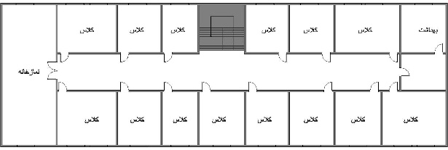
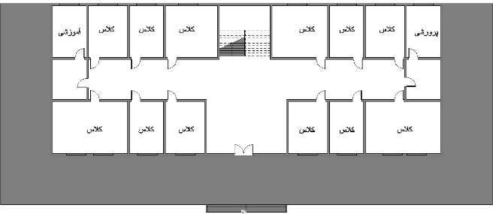
Ground Floor

First Floor

Figure 4: Plan Details of the Studied Building. Source: Author.
In Winter During the winter season, the temperature control system is generally set to heating mode, with the heat pump in operation. The cross-flow heat exchanger is capable of recovering approximately 60% of the heat from the extracted air. The heating/cooling capacity of the heat pump varies depending on external temperature, desired indoor temperature, and airflow rate. Different capacity levels are adjusted by varying the speed of the heat pump compressor. The global coefficient of performance (COP - Table 2), which accounts for both the efficiency of the heat pump and heat recovery from exchangers and air recirculation, also changes based on the combination of these parameters, reaching a value of up to 7.6.
Table 3: Global COP of the Energy System in the Studied Building - Heating and Cooling Modes. Source: Author.
Heating Mode | Outdoor Air Temperature | Indoor Air Temperature | Airflow Rate [m³/h] | Heating Capacity [W] | Global COP
Heating Mode | -7°C | 20°C | 160 | 1653 | 7.6
 |  |  |  | 2741 | 4.2
 |  |  |  | 3201 | 3.4
Heating Mode | 7°C | 20°C | 160 | 1165 | 5.1
 |  |  |  | 2854 | 3.4
 |  |  |  | 3362 | 2.8
Cooling Mode | Outdoor Air Temperature | Indoor Air Temperature | Airflow Rate[m3/h] | Heating Capacity[W] | Global COP
Cooling Mode | 35°C | 27°C | 160 | 961 | 2.9
 |  |  |  | 1631 | 2.0
 |  |  |  | 1803 | 1.4

The hourly meteorological data files used in the simulations are in TM2 format, created using Meteonorm software version 7. To calculate Heating Degree Days (HDD) and Cooling Degree Days (CDD), a base temperature of 18°C was selected. However, for simulations in TRNSYS, the indoor set-point temperatures were defined as 24°C for cooling and 20°C for heating, utilizing the ideal heating and cooling option. No specific control for indoor relative humidity was defined in any of the systems within this study. Shading control was primarily based on façade solar radiation. In the simulations, the behavior of various retrofitting measures was analyzed for scenarios involving heating and cooling demands of the building. The improvement in the building layer is illustrated in Figures 5 and 6, while the effects of infiltration changes are presented in Figure 7. In this study, the building model was modified to evaluate the behavior of each retrofit combination in a temperate and humid climate. Consequently, simulations were conducted after each modification. The potential energy savings for various retrofitting measures in Figures 5 and 6 indicate that roof insulation (Case C) has the potential to achieve over 15% of total energy savings, depending on location (climatic condition). Replacing high U-value windows with low U-value windows is an effective energy-saving solution for reducing heat gain. Since windows are the primary source of heat gain due to solar radiation, shading plays a critical role in controlling the amount of solar radiation entering through the windows.

Figure 5: Impact of Various Retrofit Combinations on Heating Demand (A–H: Retrofit Combinations). Source: Author.

Figure 6: Impact of Various Retrofit Combinations on Cooling Demand (A–H: Retrofit Combinations). Source: Author.

Figure 7: Impact of Infiltration on Heating and Cooling Energy Demand (HED: Heating Energy Demand, CED: Cooling Energy Demand, I, J, K: Retrofit Combinations). Source: Author.

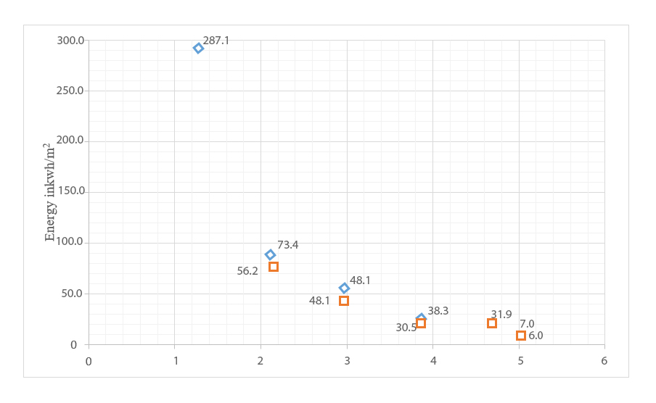

For temperate climates, specific solutions show an energy-saving potential exceeding 50% for cooling energy demand (Figure 8). Thermal insulation for the mentioned climate, combined with other retrofitting strategies such as airtight construction (low infiltration), shading control, and low U-value windows, was analyzed. The fluctuation of the PMV index over time for both the actual and improved building scenarios was derived from simulation results and is illustrated in Figure 10. Enhanced thermal concepts improve building comfort as well. It was determined that thermal insulation coverage for buildings is crucial for temperate climates. Insulated thermal coverings can reduce heating requirements by more than 70%. The effects of insulation, infiltration, and low U-value windows were confirmed in quantifying their impact on the building's heating and cooling energy demand. Retrofitting behaves differently in temperate and humid climates. Airtight construction offers up to 30% energy-saving potential across all five climatic conditions. Moreover, replacing single-glazed windows with double- or triple-glazed windows is highly effective, with nearly 20% energy-saving potential during the cold season. Roof insulation can save up to 15% of energy demand depending on the climate. Finally, retrofitting combinations also play a key role in creating greater thermal comfort inside the building (Figure 10).
igure 8: Initial and Improved Heating Energy Demand (HED: Heating Energy Demand, CED: Cooling Energy Demand). Source: Author.

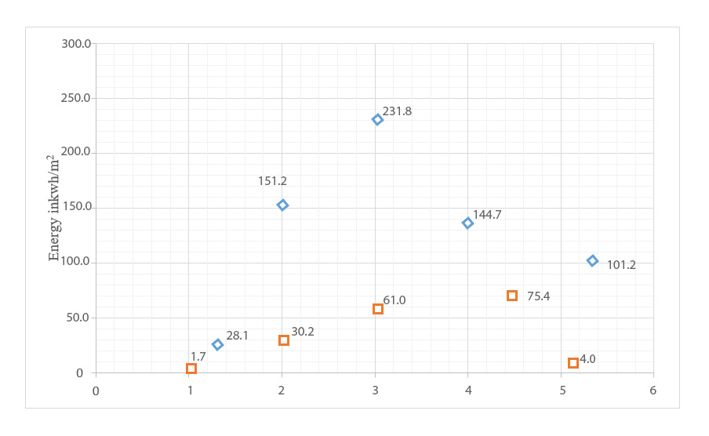
Figure 9: Initial and Improved Cooling Energy Demand (HED: Heating Energy Demand, CED: Cooling Energy Demand). Source: Author.

Figure 10: Variation in the PMV Thermal Comfort Index for Actual (Reference) and Improved Scenarios in the Climate. Source: Author.
In this study, to ensure students’ thermal comfort and reduce building energy consumption, the demand for heating and cooling was targeted for reduction. As shown in Table 3, across all spaces analyzed, the use of floor and roof insulation, shading devices, and optimized window design resulted in decreased heating and cooling energy requirements. Moreover, as illustrated in Figures 11 and 12, changes in energy demand and the PMV index are presented graphically. The results indicate that floor insulation had the greatest impact on reducing winter heating demand and improving PMV values, whereas shading devices and window configurations had the most significant effect on lowering cooling loads and maintaining thermal comfort during summer. In addition, natural ventilation played a complementary role in moderating indoor temperatures and enhancing overall occupant thermal satisfaction. These effects can be explained by heat transfer mechanisms: reduced conductive heat loss through the building envelope due to floor insulation and limited solar gains in summer through shading devices help maintain indoor temperatures within the comfort range, thereby improving PMV values.
Table 4: Energy Consumption Levels After Retrofitting. Source: Author.
Final Value  Vf [€] | Replacement  Cost CR [€] | Disc. Rate  Rd | Lifespan  [years] | CI [€] | Unit number | Unit cost CU [€] |  | Description
1021 | 3301 | 0.43 | 10 | 7178 | 1 | 7178 | Supply | All-in-one system
334 | 1011 | 0.43 | 10 | 2310 | 5 (workdays) | 430 | Installation | All-in-one system
Total cost in 30 years [€] |  |  |  | Unit cost |  |  |  | Description
Var = CIboiler+floor+fan*0.02*17.29 |  |  |  | 2.0% CI [€] |  |  |  | Maintenance
Var = Qelectricity_night*0.0567*17.29  Var = Qelectricity_day*0.0916*17.29  Var = Qelectricity_tot*0.0228*17.29 |  |  |  | 0.0567 [€/kWh]  0.0916 [€/kWh]  0.0228 [€/kWh] |  | Night (10pm – 7am)  Day (7am – 10pm)  Contract and taxes |  | Energy cost: Electricity

Figure 11: Variations in Cooling Demand Across Examined Areas. Source: Author.
Figure 12: Variations in Heating Demand Across Examined Areas. Source: Author.

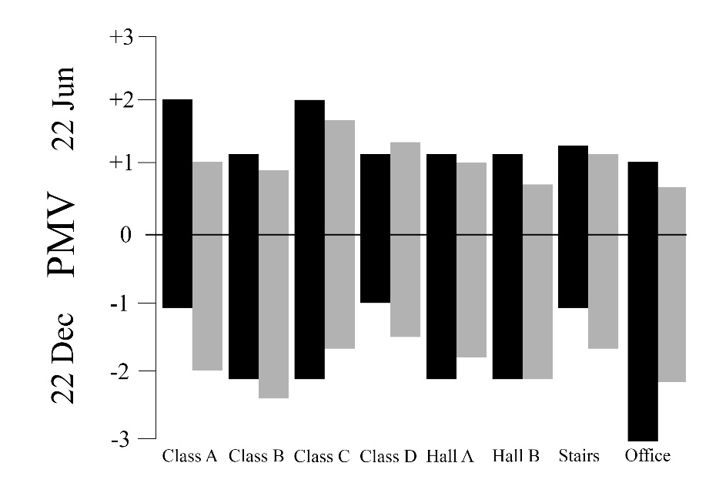
Figure 13: Variations in PMV Levels Across Examined Areas – Hottest and Coldest Day of the Year. Source: Author.
As shown in Figure 13, the variations in PMV levels across the examined areas are presented for the hottest and coldest days of the year. The sensitivity analysis conducted for key parameters, including insulation thickness, window U-values, and shading control, indicates that the simulation results are stable under varying conditions. These findings highlight the reliability of the proposed passive system in the temperate and humid climate of Gilan and its ability to maintain thermal comfort for occupants under changing environmental conditions.
- Conclusion
To achieve dynamic and desirable indoor conditions, it is crucial to propose solutions that ensure occupants’ thermal comfort. This study examined the feasibility of designing zero-energy educational buildings in Rasht while adhering to all existing legal and technical requirements. The article aimed to develop an optimal passive system tailored to the temperate and humid climate of Gilan province, focusing on the thermal performance of educational buildings. For this purpose, thermal comfort was evaluated by incorporating appropriate thermal insulation, shading devices, and openings. Two main factors—cooling demand and heating demand—were analyzed to provide occupants with optimal thermal conditions. The PMV (Predicted Mean Vote) index was utilized to assess and quantify indoor thermal comfort. For temperate and humid climates, heating energy demand accounted for only 1.5% of the total annual cooling energy demand, highlighting the primary need to reduce cooling loads. A key observation from the simulation results is the nuanced behavior of thermal insulation across different building elements and climate scenarios. Enhanced wall insulation significantly reduced cooling energy demand, contributing to a total energy demand reduction of up to 70% relative to the baseline scenario, while simultaneously increasing heating energy demand during winter, in some scenarios up to 15 times the initial heating load. This occurs because insulation reduces heat transfer, which is beneficial for cooling but may limit passive solar gains in colder periods. Similarly, floor insulation demonstrated high potential in reducing heating demand but could increase cooling loads. Therefore, adaptive surface treatments, such as seasonal floor coverings, may offer a more effective and flexible alternative to permanent insulation during winter months. These observations reconcile apparent discrepancies in energy performance: reductions or increases in heating and cooling demands are context-dependent, influenced by climate, building orientation, and specific retrofitting measures. By clarifying the mechanisms behind these outcomes, the study provides a coherent understanding of passive system performance in temperate and humid climates. Comparative analysis of simulation results indicated that insulated walls and shading control could reduce total energy demand (heating and cooling combined) by up to 70% relative to the baseline scenario. In the initial scenario, the annual average dissatisfaction percentage of occupants exceeded 30%, but retrofitting solutions reduced this to 5%. On average, dissatisfaction decreased to approximately 10% with improved retrofitting measures. Shading control was activated based on solar radiation on the glazing and was effective only during summer days. Furthermore, replacing single-glazed windows with triple-glazed units reduced the building’s total energy demand by over 82% compared to the baseline scenario. Additionally, floor insulation significantly reduced heating demand but slightly increased cooling energy demand, indicating that adaptive, seasonal floor treatments could provide a more flexible and cost-effective solution than permanent insulation. Based on the observed reductions in heating and cooling requirements, PMV values also moved closer to the comfort range, reflecting improved thermal satisfaction for occupants. Figure 13 presents the variations in PMV levels, illustrating how the proposed interventions affect indoor thermal comfort. Future research may include lifecycle cost analysis and payback assessment of retrofitting strategies, along with the utilization of real-time and location-based databases. Moreover, indoor air quality can be analyzed for different retrofitting scenarios to further optimize thermal comfort in educational buildings. Figure 14 shows the set of optimized parameter values.

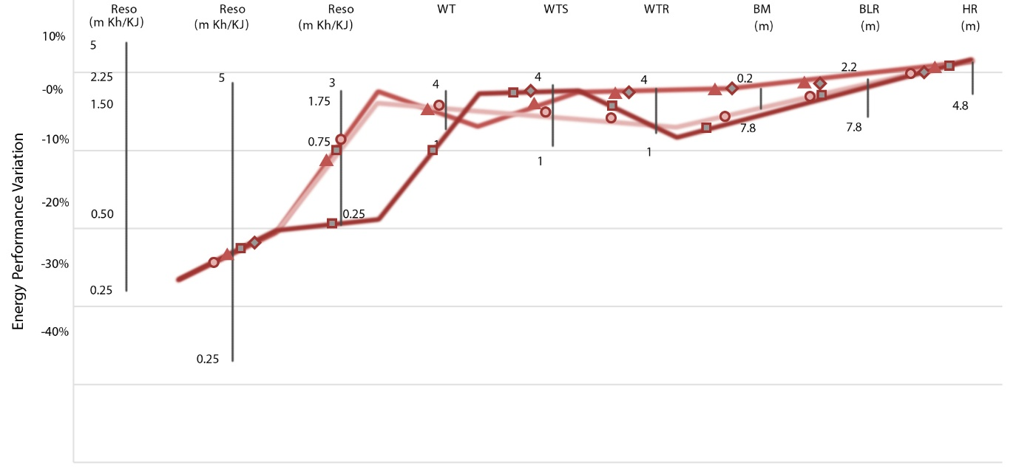
Figure 14, set of optimal parameter values, source: author
- References and Sources
Ahadi, A. (2013). Evaluation of the impact of common methods of implementing the facade of residential buildings in Tehran on energy consumption tehran. https://civilica.com/doc/1764709
Amini, M., Minaei, Asgar and Moalemi-Khiavi, Negin. (2024). Numerical evaluation of thermal comfort and air quality in an office space equipped with a ceiling radiant cooling system and a combined radiant and convection system. Modeling in Engineering, 22(77), 37-56. https://doi.org/10.22075/jme.2023.31022.2478
attahi, K., Nasrollahi, Nazanin , Ansarimanesh, Maryam , Khodakarami, Jamal and Omranipour, Ali. (2021). Investigating the role of geometry and type of urban open space on thermal comfort and environmental quality (case study of the historical fabric of Kashan). Quarterly Journal of Urban Studies, 10(39), 69-82. https://doi.org/10.34785/J011.2021.138
Azemati, S., Haji Razzaghi, Shahrzad and Tahersima, Sara. (2023). he effectiveness of hot water collectors and solar cells on heating and reducing energy consumption in Urmia elementary schools, case study: Girls' elementary school in Urmia city. Arman Shahr Architecture and Urban Planning, 16(43), 153-176. https://doi.org/https://doi.org/10.22034/aaud.2023.338109.2651
Bafghizadeh, M. (2022). Measuring the comfort desirability of public elementary schools in Karun city based on bioclimatic indicators. Physical Development Planning, 10(4), 89-110. https://doi.org/10.30473/psp.2024.57641.2437
Jahangir, M. H. a. F., Armita. (2024). Assessment of building thermal comfort using green roof enhanced with phase change materials. Journal of Sustainable Energy Systems, 2(4), 313-328. https://doi.org/10.22059/ses.2024.374038.1060
Mofidi Shemirani, S. M., Etemad Sheikh-ul-Islami, Seyyedeh Faezeh and Seif, Asghar. (2024). Analysis of the effect of the structure of the local neighborhood center on the thermal comfort of its users, case study: local neighborhood open spaces in Hamadan city. Quarterly Journal of Urban Ecology Research, 3 (36), 71-90. https://doi.org/10.30473/grup.2024.45772.2335
Nasim Sobhan, L., and Khan Mohammadi, Mohammad Ali. (2015). Priorities for using active and passive solar systems in cold climate buildings
International Conference on Modern Research in Civil Engineering, Architecture and Urban Planning. https://doi.org/SID. https://sid.ir/paper/855393/fa
Rahspar Monfared, R. a. A., Saeed. (2022). Analysis of wind behavior in natural ventilation and reduction of energy consumption in a residential building based on vernacular architecture, case study: The effect of opening dimensions and placement on natural ventilation in the city of Amol. Arman Shahr Architecture and Urbanism, 14(35), 103-114. https://doi.org/10.22034/aaud.2020.210648.2058
Rasouli Masoud, S. Y., Matini Mohammad Reza. (2019). Performance of movable horizontal and vertical shutters in double-skin facades of office buildings; Parametric evaluation and simulation. Role of the World - Theoretical Studies and New Technologies of Architecture and Urban Planning, 9 (2), 135-144.
Razmi, A., Torkashvand, Abbas , Rahbar, Morteza and Ekhlasi, Ahmad. (2023). Integrated design of the canopies of the southern shell of a dormitory building in Tehran; Multi-faceted study of cooling, heating, lighting and rainwater harvesting. Journal of Fine Arts: Architecture and Urban Planning, 27(1), 63-74. https://doi.org/https://doi.org/10.22059/jfaup.2022.291603.672359
Rezaei Nasab, S. S., Taifi Nasrabadi, Abbas Ali, Asadi, Somayeh and Haj Seyed Taghia, Seyed Ali. (2023). nvestigating the possibility of achieving a building with net zero energy consumption using photovoltaic systems and considering the requirements of urban development plans. erdowsi Civil Engineering, 36(1), 51–68. https://doi.org/https://doi.org/10.22067/jfcei.2023.79510.1190
Samadpour Shahrak, M. a. K. M., Mehrdad. (2023). Evaluation of the effect of tree planting pattern on thermal comfort around residential blocks. Quarterly Journal of Urban Studies, 12(47), 105-114. https://doi.org/10.34785/J011.2023.002
Savaj, N. a. D., Narges. (2024). Evaluation of the efficiency of vertical green system on thermal behavior of conventional residential buildings in hot and dry climate, Isfahan city. Arman Shahr Architecture and Urban Planning, 17(46), 1-22. https://doi.org/10.22034/aaud.2024.376179.2742
Shaari, J., Vakilinejad, Rosa, and Yaghoubi, Mahmoud. (2019). The effect of the type of intermediate gases of double and triple glazed windows on the cooling and heating load of office buildings in hot and humid, hot and dry and cold climates of Iran. Iranian Architecture and Urban Planning,, 10(18), 211-225. https://doi.org/SID. https://sid.ir/paper/250915/fa
Valizadeh Oghani, M. B., and Movahedi, Naser. (2019). The use of static and passive solar systems to create thermal comfort in the architectural design of traditional houses in Tabriz. Renewable and New Energies, 6(1), 26-37. https://doi.org/SID. https://sid.ir/paper/374225/fa
yarmohammad, F. a. M. S., Fatemeh. (2022). Feasibility study of using solutions for optimizing the shell of office buildings in temperate regions of Iran using examples of zero-energy buildings implemented in similar climates. iranian Architecture and Urbanism (JIAU), 13(2). https://doi.org/https://doi.org/10.30475/isau.2022.225316.1384

Department of Architecture, Et.c, Islamic Azad University, Tehran, Iran.,(Corresponding author). Saeed.azemati@iau.ac.ir

