The Theory of Relativity and Spatial Impacts in Sustainable Urban Planning: A Case Study of Shahr-e Rey
^{1,2} Ali Amirrahimi, ^{1,2} Zeinab Talebi*, ^{1,2} Elham Nazemi, ^{1,2} Amirhosein Shabani Shahreza
1. Department of Urban Planning, Na.C., Islamic Azad University, Najafabad, Iran
2.Advancement in Architecture and Urban Planning Research Center, Na.C., Islamic Azad University, Najafabad, Iran
*Corresponding author’s email: z.talebii@iau.ac.ir

Abstract
This study aims to regenerate the urban identity of Shahr-e Rey by proposing an analytical model for sustainable urban planning. In this context, the ‘theory of Relativity’ refers to the idea that urban identity is shaped by the relative relationships among cultural, social, and natural forces, and the ‘principle of biocentrism’ emphasizes the central role of ecological considerations in planning. Building on these theoretical foundations, this model guides urban regeneration by identifying and evaluating the dynamic interactions among cultural, social, and natural forces affecting the city. Regarding methodology, the study uses both historical and analytical data, integrating qualitative and quantitative approaches. In the first stage, historical and documentary information on Shahr-e Rey is gathered from written sources and semi-structured interviews with professors atTehran University. In the second stage, spatial and functional analyses were conducted using satellite imagery and analytical tools. The findings led to the development of a two-part framework: the Observer Model and the Functional Model. The Observer Model serves as the theoretical and analytical foundation, focusing on how urban phenomena are perceived and interpreted. In contrast, the Functional Model outlines the proposed spatial system, based on empirical data and biocentric indicators. Functional relationship matrices enabled the evaluation of convergence or divergence among urban spaces. This approach allowed for a redefinition of the city’s essential urban functions. The results demonstrate that applying the theory of Relativity in urban planning makes possible a flexible, context-sensitive, and localized design approach. Accordingly, urban policy should move away from dependence on capitalist paradigms and imitation of global models, and instead, through relative and data-driven analyses, advance toward the development of a sustainable and identity-based city. To achieve this, biocentrism must be prioritized as a higher-order indicator in analyses and decision-making, with its relationship to other areas, particularly the built environment, redefined. Such an approach enables Shahr-e Rey to progress toward self-sufficiency and to stabilize at a sustainable level consistent with its historical identity and natural setting.
Keywords: Urban Sustainability, Theory of Relativity, Urban Design, Historical Identity, Sustainable Development, Shahr-e Rey.

INTRODUCTION
A sustainable city has a natural identity. Residents use intelligence, creativity, and determination to guide their growth and prosperity. Throughout history, societies chose settlement sites with favorable natural conditions. These decisions satisfied biological needs and shaped the environment (Mehdizadeh, 2019). Today, sustainability is even more important due to climatic, environmental, economic, and political changes. It is now central in academic research and curricula (Jabłońska & Ceylan, 2021). A sustainable place functions as a self-sufficient system, meeting its basic needs first, and then growing through exchange and interaction with other regions. In the past, people used creativity and intelligence to solve problems and help their communities progress. On the other hand, a city without unity or a clear purpose can become merely a collection of buildings with little influence over shaping its future or surroundings.
At this point, the theory of Relativity functions as both a metaphor and an analytical tool. In physics, time and space depend on the observer’s frame of reference, rather than existing as absolutes. In parallel, urban sustainability and identity are shaped by interactions with social, economic, and cultural forces, rather than having fixed meaning. Special Relativity demonstrates that measurements of time and length shift with the observer; analogously, urban identity is perceived differently by residents depending on their local, national, or global perspective. In this analogy, a sustainable city achieves a balance between material needs (comparable to mass) and cultural-social capacities (analogous to energy), echoing the E=mc² equation of mass and energy in physics.
In the history of Iran, structures such as qanats, caravanserais, and postal relay stations (chapar) show sustainable resource management. They also reflect the integration of time, space, and human needs. The rise of historical materialism and the spread of global capitalism disrupted this climate-adapted path. On a global scale, thinkers like Henry Kissinger (2014; 2022), using a capitalist perspective, divided the world into regions with assigned economic roles (Kissinger, 2015),(Boyle, 2015). The reflection of this perspective in urban planning emerged in the form of zoning, as seen in Le Corbusier and the CIAM movement (1937), which offered economically oriented models for cities but left profound negative consequences on urban livability and identity. Today, in order to achieve a sustainable city, it is necessary—drawing upon the insights of special Relativity—to abandon absolute conceptions of time and space, and instead focus on the dynamism of relations, the Relativity of meanings, and the necessity of balancing opposing forces. Urban sustainability requires the effective protection of the environment, intelligent management of natural resources, and, at the same time, the preservation of pathways for economic growth and innovation (Tahsildoost, 2012).
SIGNIFICANCE AND NECESSITY OF THE RESEARCH
An examination of Iranian cities, particularly Shahr-e Rey, reveals that unadapted importation of global paradigms, at the expense of traditional models, has compromised the quality of urban life. Foroutan et al. (2020) found as shown in Table 1 and Figure 1, that between 1988 and 2006, 213.8 hectares of agricultural land and 211.5 hectares of barren land were converted to urban use, resulting in reduced productive capacity and depletion of natural resources. This shift from “productive” to “consumptive” land use conflicts with sustainable development and biocentric values. Lacking adaptation, cities lose their self-sufficiency and resilience to crises. This research presents the central argument: urban design must deliberately balance local traditions, modern innovations, and sustainable priorities.
Table 1. Land Use Changes in Shahr-e Rey (1988–2006)
Land Use Type | Change (hectares) | Description
Urban Lands | +369.7 | Significant increase due to construction and urban expansion
Urban Green Spaces | +55.6 | Increase within newly developed urban areas
Agricultural Lands | –213.8 | Decrease due to conversion into residential or industrial zones
Barren Lands | –211.5 | Partly converted into residential areas or green spaces

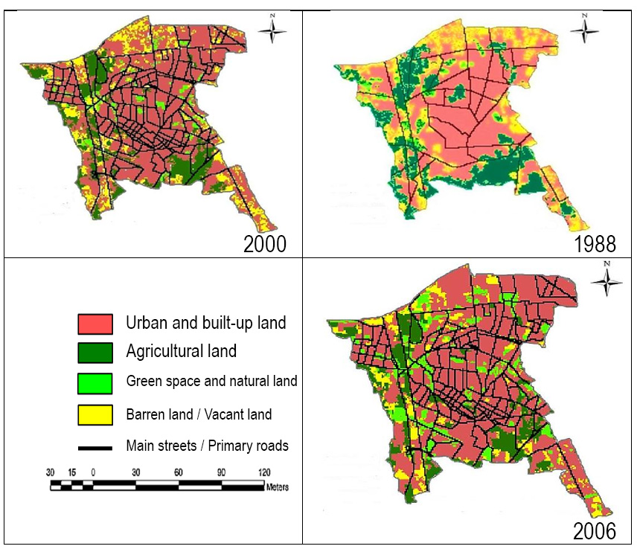
Figure 1- Land Use Map of Shahr-e Rey in Different Periods (Foroutan, 2020)
RESEARCH QUESTION
The central research question of this study is: How can the theory of Relativity, when integrated with a biocentric approach, be applied to formulate a sustainable urban planning model for Shahr-e Rey that simultaneously preserves its historical identity and responds to current environmental and social challenges? More specifically, the study investigates whether a Relativity-based analytical framework can establish stronger linkages between theoretical modeling and empirical spatial data, thereby providing a context-sensitive and data-informed strategy for urban regeneration in Shahr-e Rey.
RESEARCH BACKGROUND
Theories of Relativity and Field in Dynamic Hypotheses
The theory of Relativity, with its emphasis on dynamism, contextuality, and the absence of absolute frameworks, offers a useful analytical model for contemporary urban design. Within this perspective, space and time are perceived as variable and observer-dependent; similarly, understanding urban spaces requires attention to their historical, cultural, and environmental contexts. This approach underscores that design models cannot be absolute or uniform; instead, they must be relative, adaptive, and responsive to the forces shaping the environment. This conceptual shift is clearly reflected in the work of Christopher Alexander, particularly in his work A City is Not a Tree. In this book, Alexander moves beyond rigid hierarchical (tree-like) structures toward network-based, dynamic, and overlapping models, in which the relationships among functions and spaces are flexible, reciprocal, and constantly evolving. Such a shift aligns with the principles of Relativity theory, suggesting that sustainable urban design must account for systemic interdependencies and the complex realities of urban life, rather than reducing them to simplistic and static formulas (Alexander, 1965/2011).
Henri Lefebvre’s theory of space similarly provides a tripartite and dynamic perspective on space, consistent with the principles of Relativity. According to Lefebvre, space is a social construct experienced at three levels: perceived space (physical), arising from everyday practices and direct perceptions of the environment; conceived space (conceptual), produced by scientific concepts, urban plans, and designs; and lived space (social), experienced through images, symbols, and social meanings. This triadic framework demonstrates that space is not absolute, and our understanding of it depends on different reference frames—physical, conceptual, and social. Hence, successful urban design must address all three levels, ensuring a balance that responds simultaneously to functional needs, design concepts, and citizens’ lived experiences (Lefebvre, 2014).
The connection between the Relativity theory and sustainability is clarified through these principles:
- Dynamism and change: As space and time in the Relativity theory are perpetually shifting, sustainability must remain agile and responsive to environmental and social evolution.
- Interdependence: In the Relativity theory, all elements within a system affect each other; likewise, urban sustainability arises from the interplay among nature, humanity, and technology.
- Absence of fixed models: The Relativity theory rejects universal, unchanging patterns; so, urban design models should be adaptable, revisable, and tailored to the circumstances of each city (Chakraborty & Banerjee, 2020).
INTERACTION OF SYSTEMS AND INFLUENCING FACTORS
Systems theory views the environment as a complex structure with multiple layers. It is composed of various subsystems that work together as a single unit. Each subsystem affects and is affected by the others. To analyze this system, input from many fields is needed. For example, components in the biosphere interact based on probability and statistics, which influences design decisions. Architects and urban planners must study how these subsystems interact and how they shape our built environment. Indicators such as public health, political stability, job security, civil liberties, and gender justice demonstrate the extent to which the system supports social well-being and satisfaction.
Sustainable urban design is grounded in both theoretical and practical foundations. In this approach, modeling emphasizes the integration of mechanisms and the interrelations among plant, animal, and human domains. Although this design process advances through both theoretical and practical models, in practice, applied models typically take precedence (Crampton & Elden, 2006)
RESEARCH METHODOLOGY
The theoretical part of this study employs a flexble and adaptable model. This model offers a basic starting point for analysis. Most of the data used in this model (except for the historical and document data) was selected in a general and tentative manner to help establish early analysis tools. Ultimately, by combining historical data, spatial analysis, expert opinions, and theory, the study proposes a relative-biocentric model for regenerating Shahr-e Rey. This model can also be adjusted for use in other areas.
In the subsequent stage, recent satellite imagery and spatial data from the Iranian Information Geographic Center were used to conduct a comparative analysis of Shahr-e Rey’s historical form and its present condition. ArcGIS software was employed to align historical maps with contemporary ones, facilitating an analysis of the city’s spatial structure.
This study uses a flexible conceptual model tailored to local conditions. Most data sources, except for historical and documentary materials, were selected based on specific criteria. This supports early creation of metrics—tables used to recognize and compare data—and coding for spatial analysis, which examines the graphic relationships between different features. The research combines historical data, spatial analyses, expert interviews, and theoretical modeling to provide a comprehensive view. The study presents a relative–biocentric model—an approach that places biological and environmental factors at the center of planning—for regenerating Shahr-e Rey, which can be adapted to other local contexts.
The research methodology centers on two models: the Observer Model and the Functional Model. Both emphasize spatial Relativity, system dynamism, and adaptability to environmental and cultural conditions. Instead of replicating static patterns, these models aim to clarify how space, meaning, and functional structures develop in changing temporal and spatial contexts.
Accordingly, the Observer Model analyzes phenomena based on a set of key questions regarding the structure, relationships, and needs of urban systems. These questions include:
- What sets and subsets constitute the reference system?
- What phenomena comprise these subsets?
- On what basis is the hierarchy formed?
- How are the sets combined?
- Where is each phenomenon located within the space of the subset?
By addressing these questions, a conceptual model is formed. This model incorporates three primary relationships:
- R1: The design must address the needs of the “specific case”.
- R2: The design must align with the “specific case”.
- R3: Transformations in the “specific case” result in changes to its very essence.
These three hypothetical components, derived from the responses to the above questions, are then placed into a relationship-analysis matrix to examine the interrelations among spaces.
After establishing the Observer Model, the Functional Model is developed, with its stages of outlined below. The construction of these two models follows an analytical process, and their overall framework, components, and interrelationships are summarized in Figure 2.
The Functional Model consists of the following stages and principles:
- Functional points: identifying and defining the primary functions.
- Physical requirements: determining dimensions, volumes, and surfaces based on the user’s physical needs.
- Biological organization: arranging functions in relation to one another, guided by the user’s biological perspective and the interconnections among them.
- Spatial placement: positioning the model within space in relation to its physical context (natural or artificial).
- Spatial structure: defining the overall form and organizational system of space.
The details of the model will be elaborated in the following section. If the present condition of the world is regarded as an “Establishment,” this article has been written based on the concept of “Anti-Establishment”. It appears that the system of “Establishment,” which has repeatedly reformed itself throughout history, has now lost its effectiveness.
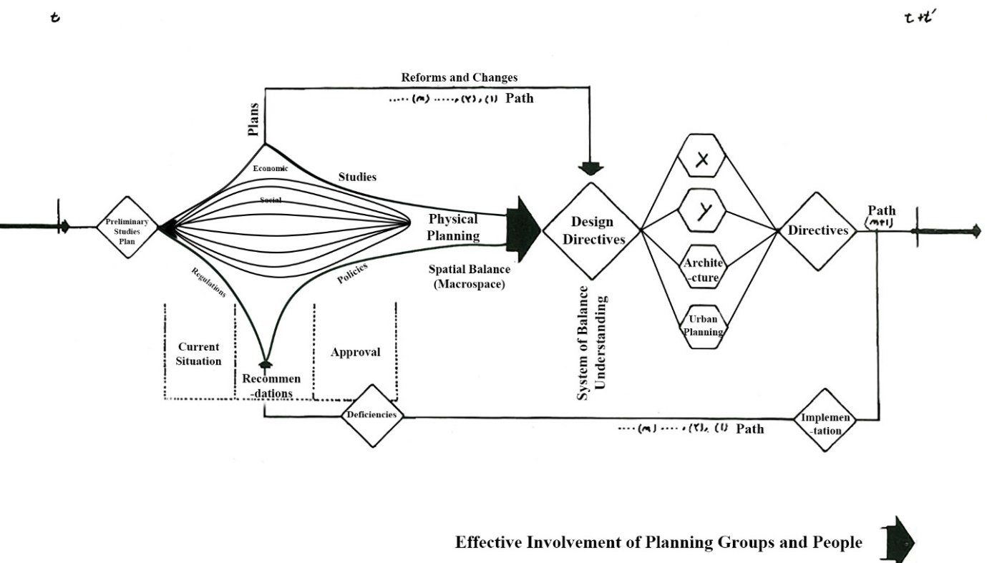
Figure 2. Urban Design as an Analytical Process
Relativity in the positioning of urban elements means no single part of the city has meaning on its own. Each element’s value and function depend on its relationship to other elements, the surrounding environment, and the observer’s perspective. Unlike rigid or top-down design, this approach stresses the interdependence of urban components. In other words, the location of a square, alley, or green space must be analyzed not only geographically, but also socially, historically, functionally, and aesthetically, in relation to other elements. Al-Ani (2013), with an emphasis on the concepts of place identity and time memory, demonstrates that architecture and urban spaces must operate beyond their physical structures and serve as settings for inscribing experiences, memories, and collective identity. Inspired by the concept of space-time in Relativity theory, he believes that architectural and urban design should allow time and events to coexist in space, creating a living connection between past, present, and future. From this perspective, urban design becomes a dynamic and flexible. The arrangements of elements shifts based on context, experience, and changing needs. This idea resonates both with Einstein’s theory and modern systems-oriented theories (Al Ani, 2013).
STUDY AREA
When the city comprised the inner district (Shar-e Miyani), the outer district (Shar-e Biruni), and the royal citadel, the physical transformations of Rey to the Achaemenid period can be traced back. Moving into the Seleucid era, the city structure included walls or a citadel, assembly buildings, a sports field, and schools. Subsequently, during the Parthian and Sassanian periods, the city reverted to its earlier structure, compromising the citadel, inner district, and outer district, with the addition of a bazaar and a central square (Mohedd, 2012).
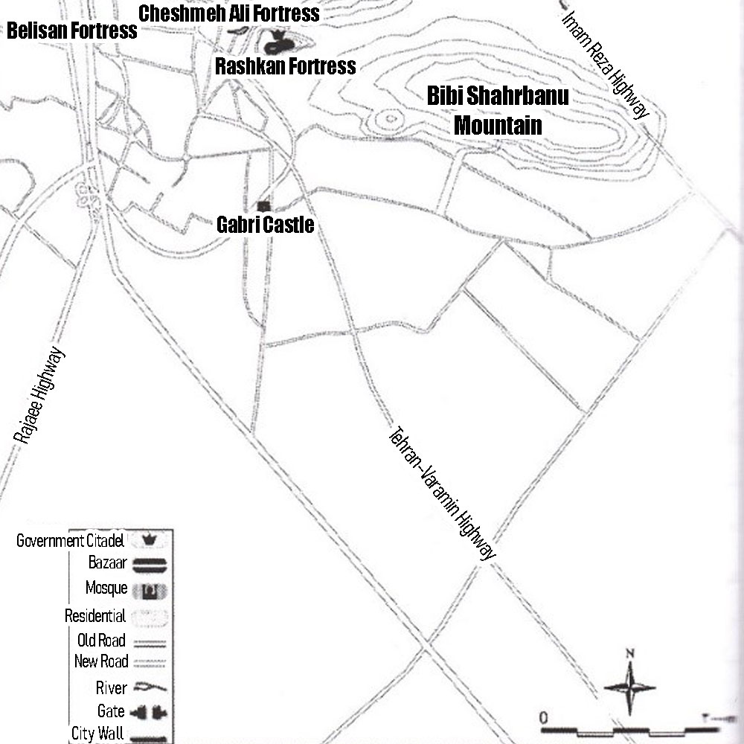
Figure 3. The City of Rey in the Parthian Period (Obtained from the Faculty of Archaeology, University of Tehran)
With the advent of the Islamic period, mosque construction became widespread in Rey. In contrast, during the Ghaznavid and Timurid periods, Mongol invasions and earthquakes pushed the city to the brink of destruction. Nevertheless, Rey retained its population due to its strategic importance. In the more recent era, its transformation into an industrial hub, coupled with the expansion of communication networks, has had a significant impact on the natural environment, as illustrated in Figures 3 and 4.
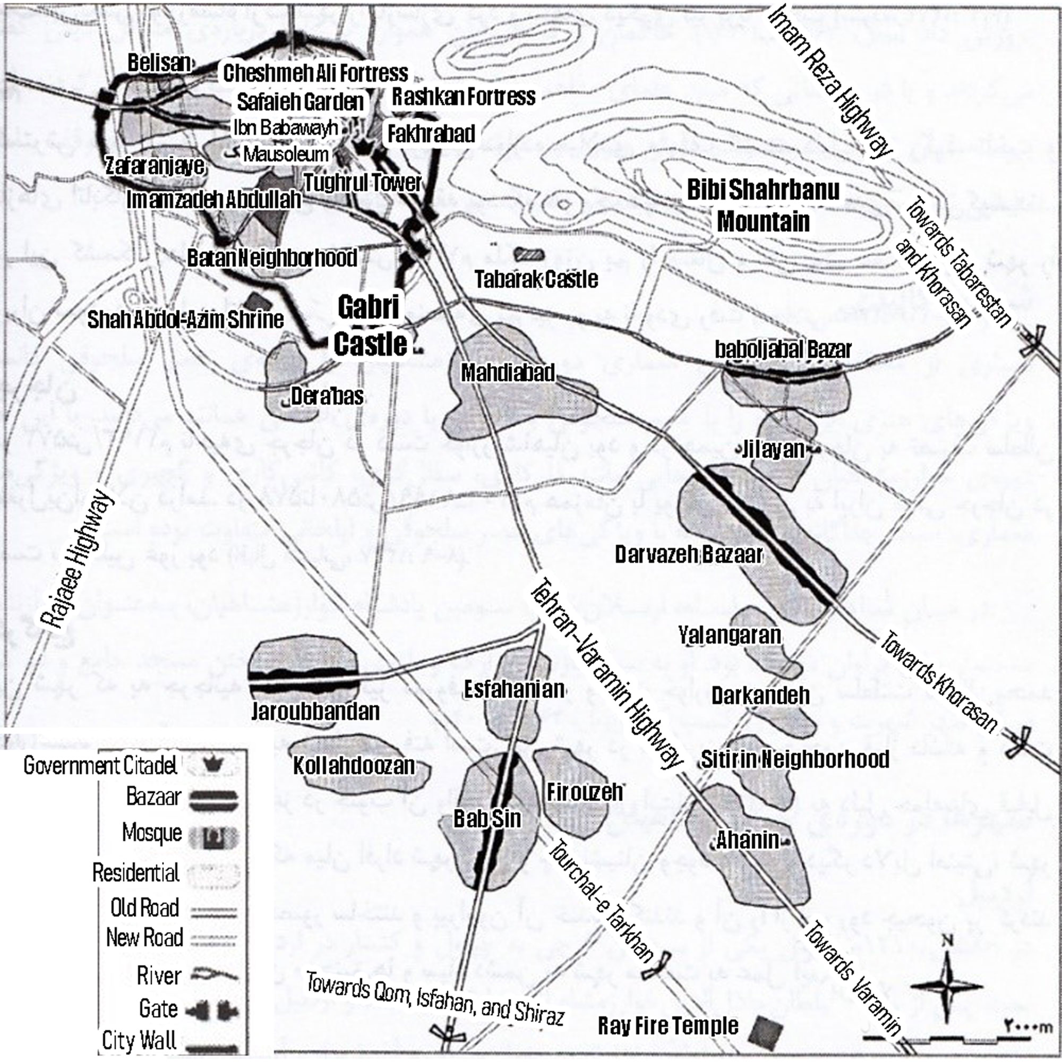
Figure 4. The City of Rey in the Khwarazmian Period (Obtained from the Faculty of Archaeology, University of Tehran)
Hamawi (AH 574) described Rey as follows: “Ray is renowned, and I have seen it. This city is extraordinary for its beautiful brick buildings, richly adorned and glazed with yellow enamel, resembling green enameled tiles”. However, this description sharply contrasts with the current appearance of Rey, filled with gray, half-built structures and widespread pollution. While these physical changes are evident, the city’s economic history is equally complex. Economically, the city was never merely an agricultural zone; rather, its commercial and strategic position fostered vibrant trade. Indeed, in the past, caravan routes not only created trading posts but also shaped the city’s identity through bazaars, trading houses, and caravanserais. As a crossroads of exchanges, Rey enabled farmers to market their produce widely. Moreover, beyond trade, historical sources also highlight other local industries, such as pottery and textile production, which incorporated innovative techniques for their time.
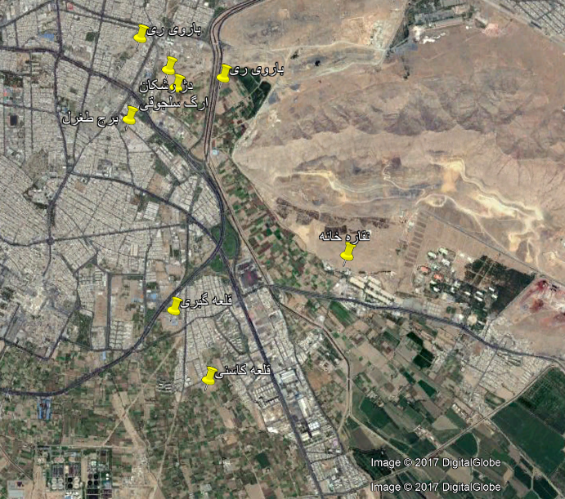
Figure 5. Satellite Image Obtained from the Iran Geographical Information Center
In recent decades, Rey, once a historically significant and relatively sustainable city, has become an industrialized and crisis-ridden area due to unbalanced development and misguided policies. Uncontrolled migration, unregulated expansion (Soleimani Moez, 2017), irresponsible density sales policies, population growth, pollution, crime (Taher Tolou Del, 2021), and unemployment are among its significant challenges. The inflow of Tehran’s wastewater into Rey has posed significant challenges for agriculture and endangered public health (Roozbeh, 2021). Moreover, the impacts of capitalism and central government decisions have weakened local agency and fostered anti-environmental practices to the extent that some sources have referred to Rey as the “graveyard of Tehran” (Hosseinzadeh, 2021). A comparison of Figures 4 and 5 reveals significant differences between Ray’s historical and contemporary conditions.
In addition to these challenges, industrial and household pollutants have led to soil salinization, farmland degradation, and the formation of salt flats. Waste fires have emitted severe air pollution (Ehteshami, 2007). Addressing these issues requires a focus on current realities and sustained interventions, ensuring that substantial results become apparent after implementation. Solutions must account for multiple factors: beyond quantitative metrics and spatial proportion, residents’ spiritual, cultural, and ethical needs must also be taken into account. By analyzing these issues, one can derive targeted indicators that support effective design (Fathi, 2021).
BIOCENTRISM IN DEVELOPING A BALANCED AND FLEXIBLE MODEL
In this study, biocentrism is presented not merely as an ethical counterpoint to anthropocentrism but as the foundational principle of analysis in both the Observer Model and Functional Model. Within this framework, biocentrism entails recognizing and prioritizing the intrinsic value of nature at every stage of design—from identifying needs and systems in the Observer Model to organizing spaces and shaping forms in the Functional Model. This perspective, echoing Paul W. Taylor’s (1981) teachings on the inherent worth of living beings, challenges human dominance over nature and underscores the necessity of sustainable coexistence (Taylor, 2017). The connection to Relativity lies in the recognition that, just as space and time are neither absolute nor fixed, the human position in urban design cannot be regarded as absolute or superior to other ecological components. Sustainable design must therefore be grounded in Relativity and interdependence, enabling nature, humans, and built structures to interact within a dynamic and flexible network. Such an approach fosters the emergence of urban patterns that are functionally effective, environmentally sound, and ethically sustainable.
a. Biocentrism in the Observer Model
In the Observer Model, which considers the basic systems and structures of the city, biocentrism has a strategic role in shaping how urban systems are analyzed. This involves identifying systems and subsystems, formulating key questions, and analyzing relationships within the city. These tasks must consider ecological networks, biological relations, and natural patterns. Here, “need” is defined not only by human comfort, but also by the requirements of ecological balance.
b. Biocentrism in the Functional Model
In the Functional Model, the focus is on the spatial arrangement and organization of activities. Biocentrism guides the selection of forms, materials, dimensions, and relationships between functions. Instead of focusing only on human-centered functions, this approach emphasizes the reciprocal interactions between human activities and natural processes. As a result, spatial orientation, building form, access to natural resources, use of daylight, and integration of flora and fauna are shaped by biocentric criteria.
From Indicators to Analytical Tools
The table of biocentric indicators is used to evaluate urban design. For instance, they can be applied in case studies from Rey to assess:
- The degree of alignment between forms and natural patterns (arches, biomorphic structures, local materials);
- The presence and functional integration of natural elements such as light, air, vegetation, and water;
- The evaluation of ecological sustainability through spatial connectivity, scaling, and ecological cycles.
These indicators can be analyzed using a mixed-methods approach, combining qualitative techniques—such as observation, image analysis, and interviews—with quantitative measures, including coding, biological density assessment, and calculating green and light-exposed surfaces.
Table 2. Elements of the Biocentric Model
Sensory Variability | Motifs | Place-Based Relationships
Information Richness  Age, Change, and Passage of Time  Growth and Flourishing  Central Focal Points  Patterned Wholes  Transitional Spaces  Connected Networks and Chains  Integration of Parts into a Whole  Evolutionary Contrasts  Dynamic Tension and Balance  Fractals  Hierarchy of Organized Proportions and Scales | Plant Motifs  Tree and Columnar Supports  Animal Motifs (Primarily Vertebrates)  Shells and Snails  Egg, Oval, and Cylindrical Forms  Arch, Vault, and Dome  Shapes Resisting Straight Lines and Right Angles  Simulation of Natural Features  Biomorphy  Geology  Biomimicry | Forms and Natural Shapes  Natural Patterns and Processes  Geographical Connection to Place  Historical Connection to Place  Biological Connection to Place  Cultural Connection to Place  Indigenous Materials  Landscape Orientation  Landscape Features Defining Building Form  Landscape Ecology  Integration of Culture and Ecosystem  Spirit of Place  Avoidance of Placelessness
Evolved human-nature relationships | Natural Features | Light and Space
Order and Complexity  Seduction and Curiosity  Change and Transformation  Safety and Shelter  Control and Domination  Influence and Belonging  Attraction and Beauty  Exploration and Discovery  Information and Perception  Fear and Awe  Reverence and Spirituality | Color  Water  Air  Sunlight  Plants  Animals  Natural Materials  Green Walls  Geology and Landscape  Ecosystems and Wildlife  Fire | Natural Features  Evolved Human-Nature Relationships  Natural Light  Soft and Diffuse Light  Light and Shadow  Reflected Light  Light Sources  Warm Light  Light as Form and Shape  Spatial Openings  Specific Variability  Space as Form and Shape  Specific Harmony  Outdoor-Indoor Spaces

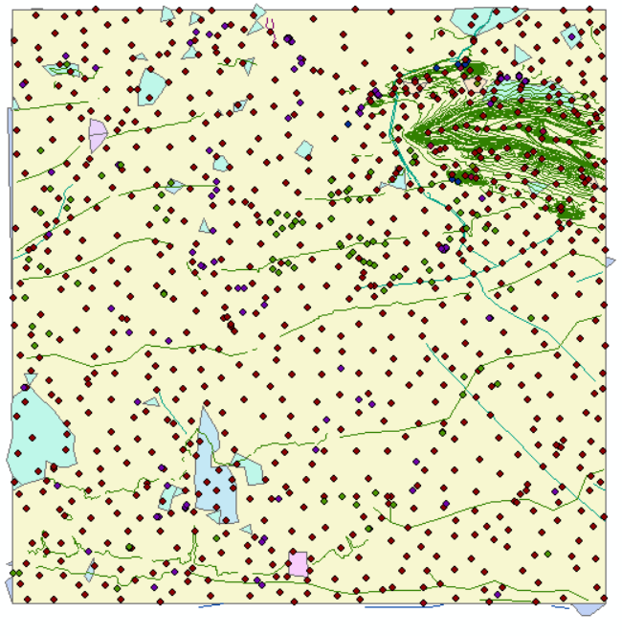
Figure 6. GIS Map of Selected Urban Functions in Rey City, Diagrammatic Representation
Figure 6 illustrates a diagrammatic representation of existing and alternative urban functions in Rey City, generated using ArcGIS software. This map was developed to analyze the spatial distribution of current functions and to examine possibilities for their modification or reconfiguration based on bio-centric principles. The analysis incorporates information layers, including land-use networks, dominant functions, areas with development potential, and natural zones (vegetation and wildlife). Existing functions that either conflict with the natural environment or fail to establish effective connections with the local ecosystem are identified and proposed as candidates for transformation or replacement. The purpose of this analysis is to provide a foundation for creating a balanced and sustainable spatial design, optimizing the relationship between urban functions and surrounding natural elements (land, water, flora, fauna). This map plays a crucial role in bridging the operational model with the physical realities of Rey City, serving as a basis for decision-making and policy formulation in urban regeneration.
ANALYSIS OF SPATIAL RELATIONSHIPS
From the processed data, a network structure emerges in which components are interconnected and overlapping (Alexander, 1965/2011). Interpreted through the lens of Relativity theory, this structure highlights that, just as space and its forms form a unified field shaped by mass and energy, urban spaces and their functional interactions are independent, reflecting the relational dynamics of the city.
Just as physical bodies are influenced by surrounding forces in Relativity, urban spaces are shaped by social, economic, and environmental forces. These functional forces, analogous to gravitational forces, determine the organization and interactions of spatial elements.
In this context, both the Observer Model and the Functional Model are directly linked to such analyses, but they approach the relationships between spaces in different ways. The observer Model focuses on analyzing the relationships between physical spaces and the “forces” that determine their arrangement, ensuring urban design achieves accurate interconnections. In contrast, the Functional Model interprets these forces as the ways different activities coexist and interact within a space. Both models thereby address spatial ratios and functional forces, but one emphasizes spatial arrangement, while the other centers on activity interactions—much like the interaction of space and time in Relativity—enabling urban design to manage complex and dynamic relationships.
Accordingly, if Relativity treats space and time as interdependent, urban design likewise must conceive of spatial elements as mutually interactive. These interactions may be assessed through relational matrices (similar to Table 1), where various forces are quantified.
When entities A and B are placed next to each other, several qualitative factors affect this choice. These factors act as attraction or repulsion forces between the entities—often referred to as a “functional relationship”. By analyzing these forces, people evaluate spatial relationships using solutions and distances. The distance between functions—whether far, close, or neutral—along with their material form, results from these positive and negative forces shaping their arrangement.
To construct a model, one must first address the fundamental question:
“On what basis are spaces positioned in relation to one another?”
In the next stage, spaces are placed along the rows and columns of a square matrix, where their possible relationships are experimented with. For instance: Does Solution 1 establish a relationship between A and B? Here, “0” denotes a negative relationship, “1” a positive one, and “–1” uncertainty or no Relativity, with reciprocal cases (e.g., B to A) noted in the same way.
At the conclusion, a table illustrates the intensity of relationships among urban spaces under the proposed solutions. In total, more than 45,000 spatial relations are evaluated, with each pair of objects tested 34 times. This result represents only a single example; in collaborative research with interdisciplinary teams, the analysis was expanded into multi-dimensional matrices (81×81×81×16).
At this stage, rigorous scientific methods are applied to synthesize the sixteen primary matrices, as shown in Figure 7.
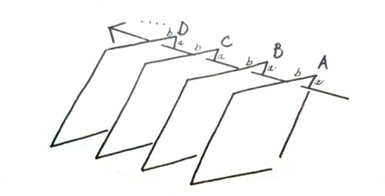
Figure 7. State of the Matrices
$$\frac{∑(a+b)}{N}$$
Equation 1. Summarization of Matrices
This study utilizes large-scale matrices (81×81×81×16) to analyze 81 selected urban functions, with the flexibility to incorporate additional functions. From these functions, 16 distinct valuation matrices are derived, each addressing specific issues such as urban morphology or minimum energy consumption. These matrices reveal the relationships among functions and generate procedure maps, which illustrate the relational context of each location. Ultimately, the designer determines the most suitable placement of functions within the city—for example, identifying the optimal distance of residential zones in Shahr-e Rey from natural areas or the best location for urban green spaces. A comparable approach is used by Wang & Ren (2025), who integrate machine learning-based scenario modeling with fuzzy multi-criteria decision-making in their decision support system. Their framework evaluates 15 parameters—including environmental impact, energy efficiency, social equity, and economic viability—using methods such as RF-RFE for feature elimination, LOPCOW for weight determination, and ERUNS for alternative ranking (Wang & Ren, 2025).
To analyze the relationship between (a) and (b), the net resultant of the forces—that is, the algebraic sum of the forces between (a) and (b) — is calculated and then divided by the total number of derived solutions. The resulting percentage expresses the probability of a relationship between (a) and (b).
The response matrix is a square matrix, which by itself does not provide outcomes. To derive a conclusive interpretation, it is converted into a triangular matrix, effectively representing the relationship percentages across all groups and facilitates the clustering.
Each matrix is assigned a name or subscript, which facilitates the analysis of relationships among its elements. One of the sixteen resulting matrices, for instance, estimates energy consumption to determine the most efficient option for the given condition. Each matrix element is encoded computationally, as illustrated in Tables 3 and 4.

Table 3. R1
land use | C011001
Relationship between functions | D221002
No disturbance | D022003
Maximum use of land facilities | C111004
Maximum natural features | C111005
No mess and confusion | C022006
security | C001007
Future expansion | B101008
Barren lands | C101009
Simple separation of lands | C111010
The ability to distinguish between private and public arenas | D222011
Internal expansion | C111012
Homogeneous distance between regions | 013
Homogeneous population distribution | D110014
traffic | C111015
Access between functions | C111016
Minimum intersection | D001017
Physical limitation of the land | B0D0018
Access to all points | A111019
comfort | C111020
Minimum shipping cost | B000021
Pedestrian Traffic | B101022
Vehicular Traffic | C111024
Communication network form | C111025
Minimum implementation fee | C111026

Table 4. R2
Vehicle Speed | B101038
Lack of Fatigue | B101039
Classification of Transportation Network | B000040
Easy Passage Through the Network | C111041
Scale of the Transportation Network | B000042
Scale of Adjacent Points | C111043
No Interference with the Natural Environment | C111044
Design Speed | A011045
Out-of-City Network | B100046
Out-of-City Connectivity without Intersections | C111047
Entrance and Exit Access | C111048
Access to Satellite Towns | C111049
City | C101050

HIERARCHICAL ANALYSIS OF URBAN FUNCTIONS
To conduct a hierarchical analysis of urban functions in Shahr-e Rey, all key variables were first entered into an SPSS worksheet, including the resident population of each neighborhood, the area of infrastructures related to each function (green spaces, markets, educational centers, etc.), the average distance from urban services, and the specific weight assigned to each function. In this worksheet, the columns denote functions (A, B, C, etc.), and rows indicate comparative samples such as Shahr-e Rey and other cities (City A, City B, etc.). The Hierarchical Cluster Analysis module in SPSS was then applied to generate a hierarchical matrix based on Euclidean distance or Ward’s method. In this process, SPSS calculates the similarity between each pair of cities based on a weighted combination of variables and generates a dendrogram that details the clustering of functions. The resulting outputs indicate how closely Shahr-e Rey aligns with the ideal urban model. Furthermore, these results reveal which functions, given their weight and optimal distance, should be prioritized and strengthened within the framework of the urban regeneration plan. This method demonstrates the analytical approach, although its accuracy depends on the use of actual empirical data.
DISCUSSION AND HYPOTHESIS TESTING
Soltani and Darabi, in their project, examined the quality of urban life in District 20 of Tehran (Soltani, 2013). The collected data indicate that Shahr-e Rey is experiencing a decline in quality of life, with most dimensions scoring between 2.1 and 3.0 out of 5—a level that reflects dissatisfaction and decreasing urban livability. Among the four assessed dimensions, indicators related to the physical environment and transportation are particularly critical, as they directly point to environmental degradation, including poor air quality, noise pollution, and inadequate waste, management as shown in Table 5.
This evidence demonstrates that the decline in quality of life is closely linked to the city’s natural environmental context. In other words, urban livability and ecological conditions are interdependent; when environmental indicators deteriorate, social well-being and economic satisfaction also decline. From the perspective of the theory of Relativity, the relationship between quality of life and the natural environment must be restored to achieve balance. Therefore, in designing analytical matrices and value-weighting systems, environmental criteria should be prioritized and assigned higher values, as they play a foundational role in sustaining both urban identity and long-term livability in Shahr-e Rey.
Table 5. Key Indicators of Quality of Life in Shahr-e Rey
Dimension | Key Indicators (examples) | Average Score (out of 5)
Physical Environment | Water quality, waste management, noise pollution | 2.1 – 2.6
Economic Environment | Employment, income satisfaction, cost of healthcare | 2.4 – 2.9
Social Environment | Security, social trust, sense of belonging, community relations | 2.5 – 3.0
Transport & Mobility | Public transport quality, traffic congestion, air pollution | 2.3 – 2.7

The considerations on urban planning present an analytical process that reconstructs the understanding of functions, spaces, and environmental pollution levels. This process connects to the ecological history of the area and views the urban system as a whole. The land consists of vegetative and animal domains, each comprising nodes that link with the matrix of urban functions to shape the city’s structure. These nodes appear as functional clusters in a bubble diagram.
This study integrates both theoretical and functional questions to envision a conceptual city. The theoretical model addresses fundamental questions. The functional model focuses on key urban performances. The knowledge map developed in this study visualizes the interrelations among these nodes. In this conceptual city, the vegetative domain is prioritized. The animal domain is allowed to reach optimal conditions. Conceived as a “new hidden city” within the vegetative domain, this city is designed to be environmentally sustainable. Accessibility and coherence in the city adhere to principles of sustainability and ecology. The configuration is grounded in communal structures and is free from capitalist constraints.
The proposed model examines the interrelations among urban nodes in Shahr-e Rey using sustainability indices, with biocentrism as the guiding framework. In the comparative matrix, a node receives a value of “1” if it outperforms another in environmental metrics, and “0” or “–1” otherwise. This approach emphasizes the regeneration and reinforcement of natural elements within the city. In practice, each node takes a composite score weighted across three sustainability categories: environmental (E), socio-cultural (S), and spatial-functional (F):
F.F^{W} + S.S^{W} + E.E^{W} = composite S
Equation 2. Formula for calculating the composite sustainability score
However, in the case of Shahr-e Rey, due to the reduction of green spaces and farmland alongside the increase in residential and administrative land use, the environmental index weight (E^{w}) is assigned significantly greater importance compared to the others. Based on the differences in composite scores between nodes, the relational matrix is generated. For each pair of nodes i and j, the following holds:
S composite (j) – S composite (i) = ij∆
Equation 3. Formula for calculating the difference in composite sustainability scores
Whenever a notable difference in favor of biocentric indices is observed between two nodes, this relationship is recorded as “1” in the relational matrix. This guide resource prioritizes and allocates resources in later stages of urban regeneration. Next, the vector of normalized indices (weighted or unweighted, depending on the test) is entered into SPSS. Hierarchical clustering or factor analysis is performed to determine the functional structure of the nodes. If special weighting for biocentrism is applied, the weighted vector serves as input. This ensures that the resulting clusters reflect biocentric priorities.
Evidence from Shahr-e Rey—such as declining vegetative cover and farmland, the uncontrolled expansion of residential and administrative buildings, and fragmentation of local production cycles—supports giving more weight to biocentrism. Restoring urban ecological structures enhances environmental resilience, fosters local self-sufficiency in food, water, and ecosystem, and revitalizes Shahr-e Rey’s historical identity. Therefore, assigning the top priority value “1” in the pairwise comparison matrix for biocentric regeneration is justified for both policy-making and sustainability.
CONCLUSION
This study sought to formulate a Relativity-based and biocentric analytical framework for sustainable urban planning in Shahr-e Rey, aiming to reconnect the city’s historical identity with its contemporary spatial and environmental realities. The findings indicate that Shahr-e Rey has undergone substantial land-use changes between 1988 and 2006, with over 213.8 hectares of agricultural land and 211.5 hectares of barren land converted into urban and built-up areas, while urban green spaces increased only marginally. Moreover, quality of life indicators, as documented in earlier studies, demonstrate low scores in the physical environment (2.1–2.6 out of 5) and transport-related dimensions (2.3–2.7 out of 5), revealing a marked decline in urban livability that is directly linked to environmental degradation. From the perspective of Relativity, these results emphasize that urban livability and environmental sustainability are not fixed attributes but relative and dynamic relationships that must remain in equilibrium. The imbalance observed in Shahr-e Rey—where rapid urban expansion has undermined ecological capacity—demonstrates the necessity of assigning greater weight to environmental criteria in analytical matrices and decision-making processes. In the hierarchical analysis, environmental factors consistently emerged as the most critical dimension (with the highest assigned weight), underscoring their foundational role in sustaining both urban resilience and historical continuity. In practical terms, this study highlights the urgent need for policy interventions that prioritize the restoration of ecological systems, the expansion of urban green infrastructure, and the reintegration of cultural–historical identity into planning frameworks. While the proposed model provides a theoretical and analytical foundation, its effectiveness will depend on future research that incorporates more extensive empirical datasets and applies the framework to comparative case studies. By adopting a relativity-based and biocentric approach, urban planning in Shahr-e Rey—and the other Iranian cities facing similar challenges—can move toward a more balanced, sustainable, and identity-centered trajectory. This article is excerpted from the treatise “Model Development of the Sustainability and Continuity of Urban ‎Settlement by Scrutiny of the Spatial Effects of Relativity and Domain (Dynamic Hypotheses and the Philosophy ‎of Return by Analytical Urban Design and Planning) case study: Shahr Rey”.

REFERENCES
Al Ani, M. Q. A. G. (2013). The Identity of Place... and Memory of Time... Define Space-Time of Human Architecture. Real Corp Planning Times, 927–943.
Alexander, C. (2011). Shahr yek derakht nist [A city is not a tree] (F. G. Farshad, Sh., Trans.). Armanshahr. (Original work published 1965)
Boyle, M. J. (2015). World order: reflections on the character of nations and the course of history. By Henry Kissinger. In: Oxford University Press.
Chakraborty, D., & Banerjee, D. (2020). Relativity Theory in Urban Space Design. International Journal of Science and Research (IJSR) 9(8). https://doi.org/10.21275/SR20814181506
Crampton, J. W., & Elden, S. (2006). Space, politics, calculation: An introduction. https://doi.org/https://doi.org/10.1080/14649360600971168
Ehteshami, M. S., Ali. (2007). Evaluation of the qualitative model of the Rey aquifer. Journal of Environmental Science and Technology (JEST), 4(8), 1–10.
Fathi, R., Shafaghi, S., & Beykmohammadi, H. (2021). Analysis of the physical structure of urban decay with a sustainable development approach (Case study: urban decay in Amol). Environmental Studies, 14(52), 83–100.
Foroutan, S., Shariat, M., Kheirkhah Zarkesh, M., & Sarvar, R. (2020). Assessment of the land-use change trend in Shahre Rey using remote sensing data. Environmental Research and Technology, 5(7), 55–66.
Hosseinzadeh, R., Safralizadeh, E., & Khabazi, H. . (2021). Assessment of the livability of urban neighborhoods in the context of sustainable development from the citizens' perspective (Case study: Shahr-e Kohneh and Seyed Morteza neighborhoods, Kashmar). . Geography and Environmental Studies, 10(40), 123–140.
Jabłońska, J., & Ceylan, S. (2021). Sustainable architecture in education. World Trans. on Engng. and Technol. Educ, 19(1), 96–101.
Kissinger, H. (2015). World order. Penguin Books.
Lefebvre, H. (2014). The production of space (1991). In The people, place, and space reader (pp. 289–293). Routledge.
Mehdizadeh, M. (2019). Examination of the relationship between smart cities and sustainable development, and the challenges of achieving a sustainable smart city. Shebak, 7(46), 119–128.
Mohedd, A., Shamaei, A., & Zanganeh, A. (2012). Recognition of physical identity in Islamic cities (Case study: Rey city). Regional Planning Quarterly, 2(5), 37–51.
Roozbeh, N. K. N., Shahrzad; Asemi Zavareh, Saeed Reza; Saeb, Keyvan. (2021). Investigation of the effect of irrigation with municipal wastewater on the accumulation of heavy metals in wheat (Case study: Farmlands of Rey city). Journal of Environmental Science and Technology (JEST).
Soleimani Moez, V. (2017). An overview of the economic position of Rey city and its transformations during the Islamic period Conference on Research in Islamic and Historical Architecture and Urbanism of Iran, https://sid.ir/paper/895464/fa
Soltani, L., & Darabi, M. . (2013). Evaluation of Environmental Quality in the Historical Urban Quarters of Iran (Case Study: The Quarter of Nafar-Abad, Rey). Human Geography Research, 4(48), 429–439. https://doi.org/10.22059/jhgr.2016.51980
Taher Tolou Del, M. S., Zare, M., & Ashraf Sadat, S. . (2021). Examination of social instability challenges in informal settlements based on urban sustainable development indicators. Geography and Environmental Studies, 10(38), 77–94.
Tahsildoost, M. (2012). Technology, architecture, and sustainability. Soffeh, 47–60.
Taylor, P. W. (2017). The ethics of respect for nature. In The Ethics of the Environment (pp. 249–270). Routledge.
Wang, Z., & Ren, F. (2025). Developing a decision support system for sustainable urban planning using machine learning-based scenario modeling. Scientific Reports, 15(1), 13210. https://doi.org/https://doi.org/10.1038/s41598-025-90057-5

