Ranking and Comparing Traditional and Contemporary Residential Spaces in Shiraz City Based on Green Architecture Indicators Using VIKOR Method

Ali Khaki ^{1*}, Ali Sadeghi habibabad ²

1*: Associate Professor of Architecture, Enghelab-e Eslami Technical College, National University of Skills, Tehran, Iran. E-mail address: akhaki@nus.ac.ir
https://orcid.org/0009-0006-9438-8625

2: Assistant Professor, Architectural Engineering Department, Faculty of Technical and Engineering, Yasouj University, Yasouj, Iran. E-mail address: alisadeghi@yu.ac.ir
https://orcid.org/0000-0001-9451-4907

Abstract
The article aimed to analyze and compare the various characteristics of different residential spaces in the Iranian city of Shiraz, especially the differences and similarities between traditional and Contemporary buildings based on green architectural standards and principles. To meet this, eight samples of traditional and Contemporary buildings of Shiraz City were randomly selected and were then evaluated and ranked using green architecture indicators using the VIKOR method. Therefore, the methodology of this study was descriptive-analytical via field surveys. Findings showed that in traditional buildings the architect used to apply the highest and the best types of green architecture indicators in his architectural model, while modern architecture requires applying local architecture to achieve green architecture indicators. Results also showed that architects of the past employed the best green architecture indicators in designing traditional housing while generating valuable patterns of use based on these indicators.

Keywords:
Shiraz Houses, Comparison and prioritization, Contemporary and Traditional Housing, Architectural Principles.

INTRODUCTION
Green architecture is a sustainable architecture approach aimed at reducing adverse impacts on the environment and increasing the quality of life of humans. According to this approach, environmental principles, renewable energies, energy efficiency, and local resources are utilized as waste is reduced, green spaces are generated, and an effective relationship with the environment is established. Green architecture not only helps to improve the quality of life of residents in buildings but also protects the environment and preserves natural resources. Among the concepts of this architectural approach are using solar energy systems, designing green spaces, energy efficiency, using environmentally friendly and recyclable material, generating living spaces, and effective irrigation.
This article investigated traditional and modern living spaces based on green architecture and analyzed these two environments based on key sustainability indicators. In this connection, this study analyzed the historical and contemporary approaches of green architecture and revealed the specific characteristics of traditional spaces and evolving modern sustainable design principles. By considering the strengths and weaknesses of both approaches, the study aimed to gain a more profound understanding of the principles of green architecture and its capacity to generate more sustainable and stronger living spaces. Also called sustainable architecture or environmentally friendly architecture, green architecture employs a set of principles and techniques to mitigate the adverse impacts of the environment on buildings. This approach seeks to reduce energy consumption, preserve natural resources, and improve quality of life in different stages of design and construction as well as in utilization and finally in building destruction stages. This architectural style endeavors to blend beauty and efficiency to incorporate human needs by protecting the environment (Ghaffari, 2017).
Green architecture is primarily aimed at prioritizing energy efficiency to focus on the effective use of renewable energy resources and the optimization of building designs to help reduce energy consumption (Y. Chen, Zhang, & Xu, 2010) (Yuan et al., 2017). This approach involves implementing advanced energy-saving technologies, which would not only contribute to storing energy but also mitigate environmental adverse impacts. Green architecture. Using these innovative technologies and designs, green architecture strives to provide a sustainable model in modern construction and to preserve the environment (Mohamed & Ali, 2014). According to green architecture, one of the primary principles is to generate interior spaces that are both healthy and convenient which is realized by employing advanced ventilation systems that allow for the flow of air. Also, environmentally compatible and less harmful materials could significantly contribute to the quality of the interior space; moreover, the maximum use of natural illumination could play a critical role and help the interior space to remain illuminated and pleasant. All of these elements work together to protect residents’ health and well-being (Piparsania & Kalita, 2022).
Environmental indicators, including energy consumption, water consumption, materials, and the volume of waste produced, are criteria used to evaluate the impacts buildings may have on the environment (Sadowski, 2021). Energy consumption per square meter: This indicator evaluates the building’s energy efficiency; Water consumption for each person: This indicator evaluates water utilization in the building, Hidden carbon footprint: This indicator shows carbon emission caused by the production and transfer of construction materials; Recycled materials content: This indicator examines the use of recycled materials in the building, and Social indicators (Qtaishat, Adeyeye, & Emmitt, 2020). Traditional architecture has been evolving for centuries, demonstrating its deep connection and specific harmony with the surrounding environment and the natural resources in each region. Utilizing local materials and construction techniques adapting to certain geographical regions, this type of architecture both maintains construction sustainability and significantly reduces destructive impacts on the environment. For this, traditional architecture represents an example of man’s intelligent interaction with nature and local resources (Zhu, 2023).
The study deals with a vital question of analyzing and comparing the traditional and contemporary residential buildings in the city of Shiraz in terms of green architecture indicators. Although modern architecture tends to focus more on new materials, technologies, and styles, it does not pay enough attention to the sustainable practices that were inherent in traditional architecture. This leaves a gap between the modern housing projects and the need to provide environmentally responsible, energy-efficient and culturally adaptive design solutions. The importance of the research is in the fact that it is a systematic study of the principles of green architecture that is implemented in both old and new houses, and how vernacular architecture of Shiraz already meets most of the requirements of sustainability. Using the VIKOR approach to multi-criteria decision-making, the study does not only indicate that traditional buildings are more economical in their energy consumption, climatic adaptation, and the use of local materials but also offers a scientific basis to advance the current housing trends.
This paper will be organized to first show the need and significance of green architecture and how it has helped in enhancing living standards and conserving the environment. It then gives a literature review on the past works that have been done comparing traditional and contemporary architecture. The eight main green architecture indicators (energy preservation, climate adaptability, reduced use of non-renewable energy, user respect, site respect, nature relationship/contact, use of local materials, and future focus) were assessed with the help of the VIKOR multi-criteria decision-making method. In the data analysis part, ranked and compared selected traditional and contemporary houses in Shiraz, it was found that traditional houses performed better according to most of the sustainability criteria. Lastly, the paper provides the suggestions on how to improve modern architecture by adopting the effective principles of vernacular architecture.

LITERATURE REVIEW & RESEARCH BACKGROUND
Jeumpa (Jeumpa & Harahap, 2024) concluded that based on green architecture indicators, traditional buildings produced higher benefits, whereas modern buildings exhibited lower benefits. This critical difference points to using sustainable methods to compare historical and modern residential spaces. Fengyan (Fengyan & Qi, 2024)investigated how modern green construction materials were integrated into traditional residential designs in Guangdong, China while employing the Building Information Management (BIM) system to analyze structures. This study investigated performance indicators such as cooling system efficiency and safety against earthquakes which indicate the improvement of livability and protection of the environment in residential areas.
Zhao (Zhao & Wei, 2024) investigated the environmental wisdom in designing traditional residential buildings, examining modern and advanced concepts of green buildings. This article showed the historical importance and hidden sustainable values of this specific architectural approach. The article primarily focused on how natural illumination and shading could be optimized for designing residences. This approach, the study found, specifically focuses on increasing residents’ quality of life and the harmony of these designs with locally peculiar characteristics of the environment. This approach to construction sought to incorporate all these measures to create a life that is in harmony with nature.
Berezovetska (Berezovetska, Oleksandr, Olena, Inna, & Vitalii, 2024) investigated contemporary architectural developments in green architecture and examined how sustainable materials and renewable energy resources can be used. This study evaluated the environmental impacts of these elements but did not compare or analyze traditional and modern residential spaces by using green architecture indicators.
Errante (Errante, 2022) investigated the transformation of public residential neighborhoods using ecologic and biophilic urban development principles, discussing green architecture indicators such as renewable energy production, green public spaces, and outdoor spaces, which were aimed to increase quality of life and social welfare.
Chen (L. Chen, 2020) investigated the role and significance of ecologic green architecture in designing residential buildings, explaining how this approach could help reduce natural resource consumption and environmental pollution. This study, however, did not comparatively analyze traditional and modern residential spaces based on green architecture indicators. This indicates that no direct relationship was seen between these two types of living spaces in line with green design architecture.
Mi (Mi, 2024) concentrated on the significance of modern residential spaces to investigate the role of green architecture indicators in mitigating environmental impacts. These indicators were found to not only reduce natural resource consumption and protect the environment but also increase energy efficiency, which provided residents with comfort and convenience compared to traditional designs. This study found that the intelligent use of green architecture approaches and modern technologies could promise long-term benefits and contribute to space sustainability over time. For this, using integrated and smart technological techniques in designing and constructing modern residences could pave the way for sustainability and more economic benefits.
Rudenko (Rudenko & Ladygina, 2022) investigated the role of green architecture in urban environments and considered its integration into post-industrial cities as a major milestone. Green architecture is characterized by some features such as green rooftops and symbols that would improve micro-climates and revitalize natural elements, whereas traditional residences lack these features.
Swanston (Gertosio Swanston, 2023) investigated modern residential spaces and discussed the major role of widespread green regions and their sustained vegetation in providing ecosystem services. Instead of analyzing or comparing traditional residential spaces based on green architecture indicators, this article was primarily focused on the peculiar features and environmental benefits of these modern spaces. The study found that widespread vegetation and expansive green areas not only increased the visual captivity of the living area but also had positive impacts on air quality, temperature, and even residents’ welfare, representing the significance of sustainably smart designs in modern construction.
Qtaishat (Qtaishat et al., 2020) investigated and compared local and contemporary architecture in Jordan where welfare and local cultural indicators were deemed by participants to be the major priorities. In this connection, the study developed an evaluating cultural-ecological tool to change major qualitative indicators into practically implementable guidelines under sustainable architecture principles. Thus, this would help establish a logical bond between traditional and modern construction styles and architectural space designs.
Chen (R. Chen, Yang, & Chang, 2012) developed a framework to evaluate green architecture in residential buildings and employed such criteria as using environmentally friendly materials, energy efficiency, and water consumption saving. In his analysis, Chen did not specifically compare and analyze traditional and modern residential spaces based on green indicators.
Balamurugan (Balamurugan, 2019) investigated and analyzed green buildings and explained the advantages and benefits of traditional structures, believing that the benefits could include a considerable reduction in natural resource consumption, an improvement in energy efficiency, and a reduction in destructive environmental impacts. The article also emphasized the significance of using sustainable design styles in modern residential spaces, explaining how these methods would play a major role in preserving the environment and urban development compared to conventional architecture. The article also discussed the critical role of green buildings in generating a more sustainable future while focusing on their positive impacts on modern societies’ quality of life.
Martinovic (Martinovic, 2016) investigated traditional and contemporary familial buildings and their impacts on energy efficiency, climate adaptability, and cultural identity, emphasizing the use of traditional architectural elements to help improve energy performance in new and existing buildings and harmony with green architecture principles.
Wisdianti (Syam, Wisdianti, Sajar, & Bahri, 2023) analyzed traditional and modern residential spaces using green architecture indicators. This study focused on sustainable architecture principles, seeking to mitigate environmental impacts by optimizing the use of materials, controlling energy consumption, and protecting the environment in designing buildings.

GREEN ARCHITECTURE
Training future designers and architects in the principles of green architecture will have a determining role in promoting modern and sustainable construction techniques (Cole, 2014). The training will be performed to help generate living spaces that would not only improve human health but also adapt to the environment. Making prospective architects and designers familiar with these principles helps develop approaches that will leave permanently positive impacts on nature and human societies (Ковальська & Гомон, 2024). In today’s world, modern green buildings are presumed to widely benefit from highly effective construction covering, which appears to help increase energy efficiency and generate thermal comfort. These coverings are made of advanced insulations and modern glazing, which can effectively prevent energy losses. Strategies used in this connection include using high-performance insulation capable of optimally maintaining heat. Besides, triple-pane windows are very much crucial in reducing thermal losses while preventing sound into the inside of buildings. Wind structure construction techniques, i.e., structures embedded to provide airflow inside buildings, are so designed to increase the effects of insulations and provide a more convenient and comfortable environment for residents. These modern design and construction approaches have demonstrated their effects on reducing energy consumption and preserving the environment, encouraging architects and engineers to move toward a more sustainable future (Du, 2024). Biophilic designs in modern green architecture refer to the widespread use of biophilic design principles, which will help integrate nature into the constructed environment to increase residents’ welfare and communication with the natural world. This is a crucial approach and involves the introduction of natural elements into constructed spaces, the use of natural materials, the generation of green spaces, and the realization of nature-based perspectives (Ignatieva & Ahrné, 2013).
In residential spaces, green architecture indicators promote sustainability and mitigate environmental impacts. For example, a green façade that represents a green space on the exterior frontage of buildings is a major element. Also, it is essential to use biological vegetation to decorate and provide ecological advantages, and to select environmentally adaptable materials to mitigate climatic adversity and increase carbon absorption. A green residential building is an evolving concept where energy systems are mixed with traditional strategies such as optimal building prioritization and renewable energy technology integration such as solar panels. Moreover, the focus of green architecture on social systems will give special importance to the interactions between performances, techniques, and the attraction of stakeholders in interior designs. Among the positive impacts of these indicators are increasing the quality of thermal insulation, improving urban ecological conditions, and promoting social welfare. These indicators will generally be involved in developing sustainable residential environments and are in conjunction with ecological principles, thereby laying the groundwork for a better life (ABOUBAKR, FATHI, & BAKR, 2022) (Bassas, Patterson, & Jones, 2020) (Ning, Li, Yang, & Ju, 2016)
Also, welfare and local culture indicators significantly contribute to the sustainable architecture of residential spaces (Qtaishat et al., 2020). In residential spaces, green architecture indicators include using illumination and low-consumption means, rainwater absorption systems, effective irrigation, inactive thermal control, and the building’s appropriate orientation to use daylight and ventilate optimally. These criteria will also help increase energy efficiency, manage water resources, reduce energy consumption, and preserve the environment while generating sustainable and healthy living spaces (R. Chen et al., 2012). In green architecture-based residential spaces, there are key indicators that leave considerable impacts on improving social welfare and life.
These indicators also include using renewable energy sources to produce the energy required by buildings, providing green public spaces serving as natural breathing in the urban environment and ensuring easy physical and social accessibility for the public. As stated, green architecture systems help create diverse entertainment and sports opportunities aimed at increasing social interaction and improving the physical status of residents. These elements help promote environmental quality and strengthen the sense of community in society (Errante, 2022). In residential spaces, green architecture indicators include using local materials, increasing energy efficiency, and water preservation and management, reducing greenhouse gas emissions, improving air quality, and providing designs adapting to the environment and tailoring to social needs (Khasseh, 2021).
In residential spaces, green architecture indicators include a set of criteria that play major roles in environmental sustainability and responsibility. One of these indicators is carbon dioxide neutrality, i.e., using construction materials and technologies to help offset greenhouse gas emissions. Energy self-sufficiency is another key criterion, including the use of renewable energy resources such as solar panels and effective thermal systems to minimize fossil fuel dependence. Meanwhile, it is critical to use non-polluting materials because they reduce adverse impacts on human health and the environment (Salfner & Lang, 2017).
In residential spaces, green architecture indicators include a wide range of techniques and technologies aimed at improving environmental livability and reducing environmental impacts. These indicators include the use of renewable energy resources such as solar panels to supply electricity and the use of thermal pumps for heating and cooling. Moreover, thermal renovation in buildings is yet another solution to reduce energy consumption and increase efficiency. Using natural solutions such as creating and installing green rooftops and walls helps create more favorable environmental conditions in residential spaces. These measures will not only help regulate the interior temperature of buildings but also absorb carbon dioxide and release oxygen to ventilate the air. In general, the indicators improve the living quality of residents and protect the environment (Vranayova, Tkachenko, Lis, Savchenko, & Vranay, 2023).
In residential spaces, green architecture indicators include a wide range of techniques and technologies aimed at improving environmental livability and reducing environmental impacts. As stated, one of these indicators is to use natural and local materials for construction which would reduce non-renewable resource consumption and reduce pollution caused by the transfer of materials to remote areas. Moreover, designs focused on reducing energy will have a determining role in saving energy resources and include effective cooling and heating systems. The passive use of solar energy to utilize illumination and natural heating is another effective technique to reduce the need for fossil fuels. Also, natural ventilation to improve the air quality of the inside of a building must be carefully designed and implemented to meet mechanical ventilation needs. All these solutions are aimed at preserving traditional architectural elements in various cultures. These solutions will also help environmental sustainability (Živadinović, 2024).

TRADITIONAL ARCHITECTURE
Traditional architecture is characterized by adaptive reuse, i.e., the re-utilization of existing structures and materials to reduce waste which indicates its respect for existing resources (Ghaffari, 2017). Traditional architecture is usually dependent on the materials supplied by local resources, thereby playing a major role in reducing transportation costs and minimizing environmental impacts caused by the displacement and use of non-local materials. This approach not only helps preserve the environment but also involves using naturally harmonious and climatically adaptive materials to create peculiar architectural styles (Domingo-Calabuig, Rivera-Linares, Lizondo-Sevilla, & Alapont-Ramón, 2024). Traditional architecture usually represents respect for place and integrates buildings with the surrounding perspectives while striving to reduce disruptions with natural habitats. This approach shows the significance of preserving biological diversity and establishing a relationship that is harmonious with the environment (Kusumawardhani & Wasilah, 2023). Traditional architecture largely makes use of local and climatic conditions and adaptation principles, as well as existing resources for construction. This type of architecture adapts to climatic conditions, uses local construction materials, and focuses on local culture and history to create buildings best harmonious and adaptive to the environment (Na & Sun, 2019). Table 1. Frequently reported components affecting green architecture in the literature.

Table 1: Common components affecting green architecture in the literature
 | Component | Description | Key Benefits
(Yuan et al., 2017) | Energy preservation | Measures to reduce energy use in buildings | Lowers operational expenses and environmental load
(Gholizade, Hafeze, & Rezaanvari, 2022) | Harmony with climate | Designing to suit the local climatic conditions | Increases comfort, lessens HVAC requirements
(Gholizade et al., 2022) | Site respect | Incorporation of natural features and landscape | Retains biodiversity, aesthetic value
(Xie, Clements-Croome, & Wang, 2017) | Visual and mental comfort | Designing environments that enhance psychological health | Enhances well-being and productivity
(Uddin, Wei, Chi, Ni, & Elumalai, 2021) | Using local materials | Using locally available materials | Less carbon footprint, local economy
(Gholizade et al., 2022) | User respect | Putting into consideration the needs of occupants in design | Improves satisfaction and usability
(Gholizade et al., 2022) | Reducing the use of new resources | Reducing the usage of new building materials | Encourages the circular economy and reduces cost
(Jahangir & Fathi, 2023) | Thermal comfort | Keeping the indoor temperature at the optimum level | Enhances energy performance and health
(Karimi, Adibhesami, Bazazzadeh, & Movafagh, 2023) | Focus on human dimensions & avoiding uselessness | Creating useful, purposeful spaces | Increases usability and occupant satisfaction
(Sagar, Arya, & Singhal, 2025) | Reducing the use of non-renewable energy resources | Focusing on point on renewable energy solutions | Reduces greenhouse gases
(Bagheri & Ravanshadnia, 2015) | Environmental perception | Promoting the knowledge of natural environment | Enhances the bond with nature, consciousness
(Logvinov, 2017) | Contact with nature | Tactile contact with the elements of nature | Improves the well-being, decreases stress
(Feizi, Mirkhosravi, & Hassanzadeh, 2019) | Human comfort | General physical and mental health | Increases satisfaction and productivity
(Ndiweni, 2020) | Future focus | With a view to long-term sustainability and adaptability | Provides resilience and long life
(Bernstein, Russo, & Jones, 2010) | Quality | Focus on durability, materials and finishing | Long life buildings with less maintenance

INTRODUCING SAMPLES UNDER STUDY
This section concerns studied examples. To this end, eight houses were randomly selected, including four traditional and four Contemporary houses. The random selection provided a kind of diversity in the investigation, as findings represented the general features of these houses in Shiraz City. The selected traditional houses represent the rich culture and architecture of Shiraz designed in historical eras. Conversely, Contemporary houses represent contemporary architectural and living developments that are designed and tailored to modern needs. These two categories help us better understand the cultural, social, and economic impacts on Shiraz’s architecture. Table 2 below summarily introduces these samples.

Table 2: A brief description of the samples under study
 | Name | Image | Brief description
Traditional buildings  Traditional buildings | Zyaian House  Qajar era | 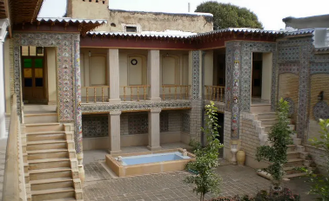  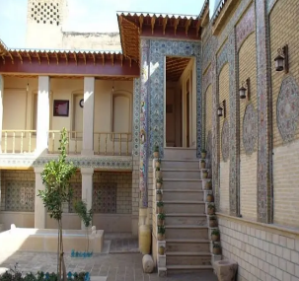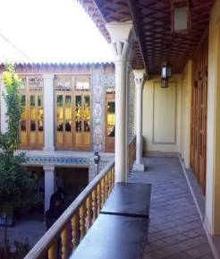 | The Zyaian Mansion, located in the historical Sang-e-Siah neighborhood, is an outstanding structure of Shiraz architecture that belonged to a famous person called Zyaie. This valuable mansion is distinguished from other mansions by its incorporation of a kind of simple beauty that has flourished due to its specific and captivating art of Haft Rang tiling, despite lacking the complicated and rich decorations of luxury houses of the old era. These tiles have blended colors artistically and created a kind of conspicuous and cozening colorful diversity. This diversity has given the mansion a specific manifestation of beauty when combined with simple and intimate architecture, thus making it one of the most historically representative attractions.
Traditional buildings  Traditional buildings | Zinat al-Molk House  Qajar era | 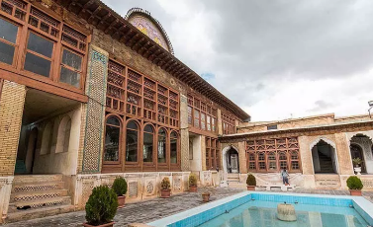  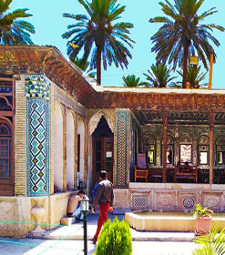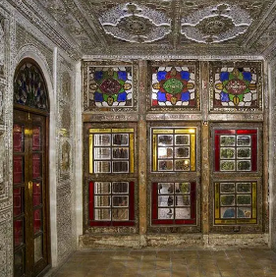 | A historical site in Shiraz, the Zinat al-Molk Mansion dates back to the Qajar era. This mansion features a specific architectural attraction, involving an underground connection to the Narenjestan Gaden. This underground route was formed because, in the past, the Zinat al-Molk mansion had been used in the Ghevam Garden as a place for interior residence. Constructed by an originally Iranian architectural style, this historical mansion features mirror work, plasterwork, tilework, and painting on wooden ceilings.
Traditional buildings  Traditional buildings | Sa’adat House  Qajar era | 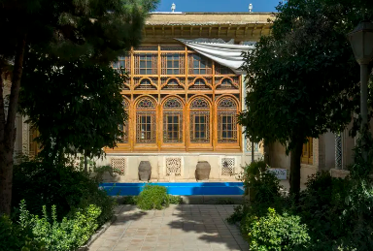  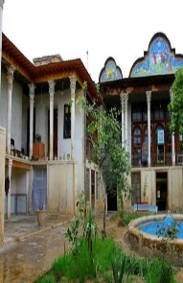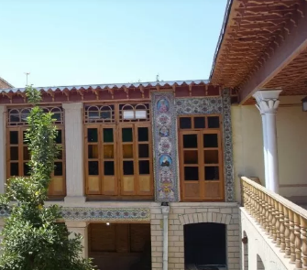 | A luxury historical mansion in Shiraz, the Sa’adat Mansion is located in the old texture of the city and the Sang-e-Sah neighborhood. This house features a beautiful and well-planned structure dating back to the Qajar era and is among the major historical attractions in Shiraz. Embellished by original Iranian architectural styles, this house offers the arts of tiling, plasterwork, brickwork, carving, and gereh-chini. This mansion is divided into various sections, including the two entrances on the eastern and southern angles, accompanied by a corridor, a courtyard, se-dari, and panj-dari rooms, as well as a basement.
Traditional buildings  Traditional buildings | Manteghi-Nejad House  Qajar era | 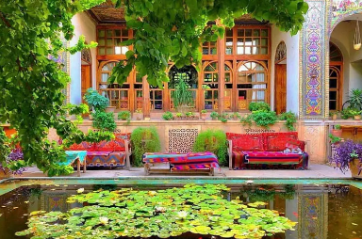  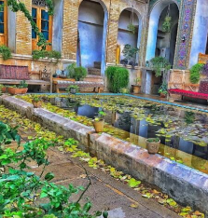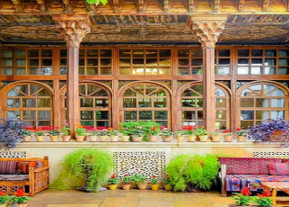 | The Manteghi-Nejad House also dates back to the Qajar era and is situated close to the Shah Cheragh. This mansion features an attractive green courtyard adorned by candlestick vases. Sitting wooden beds and rectangular water pools have also made this courtyard attractive.
Contemporary Buildings | House No. 07  Modern era | 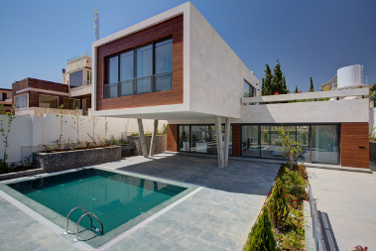  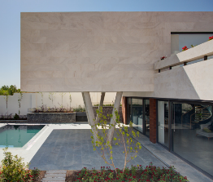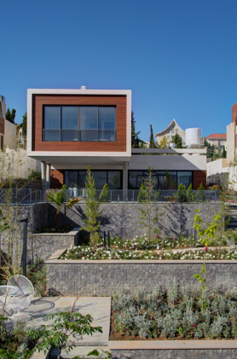 | Built over a steep slope, Villa No. 07 in Shiraz is seen as an ideal place for spending weekends and holidays. Fantastic vantage points on the upper floor and the need for a pool site have made the first floor be designed with a 90° rotation, thus adding two new spaces with different features to the villa.
Contemporary Buildings | Residential House No. 84  Modern era | 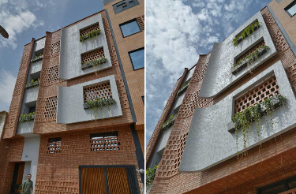  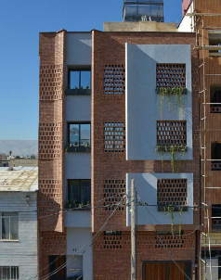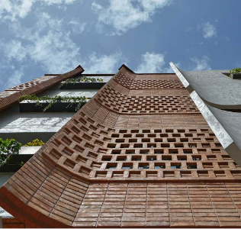 | Lying in the heart of the city of Shiraz, Residential Apartment No. 84 is in one of the most populated areas of the city. This apartment is designed to include four floors, each involving only a unit and featuring large windows to enjoy illumination and larger spaces. Embedded within larger windows are smaller windows for private rooms to control the entering light well. The apartment’s entrance has a lobby allowing residents to stop for a while there and leave behind daily stresses and experience tranquility.
Contemporary Buildings | Qazizadeh residential House  Modern era | 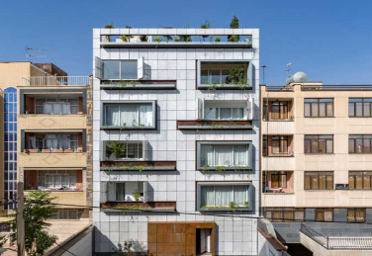  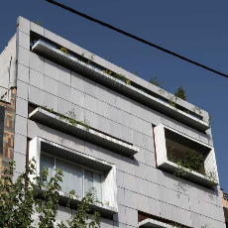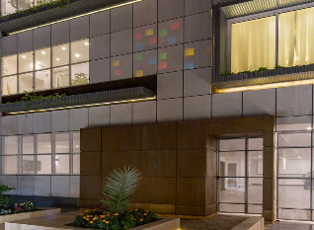 | To design the Qazizadeh building, designers attempted to create large outdoors to provide a good environment for residents, seeking to simultaneously maintain the priority of the interior privacy of the site over the outside view. The apartment was originally made flexible and adaptable to achieve favorable results by manipulating the spans, enabling the residents to enjoy better privacy.
Contemporary Buildings | Safari residential House  Modern era | 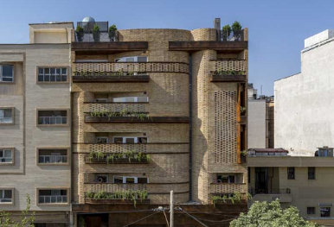  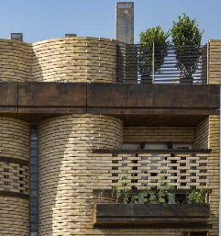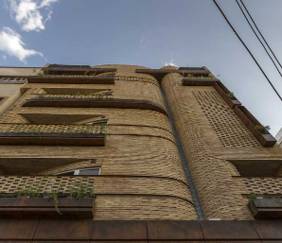 | Located in the southeastern part of Shiraz, the Safari residential house is in one of the oldest areas of the city. The complex was mainly designed to create an interactive and communicating space on all floors. This linking feature is embodied within the brick structure of the building’s façade where the two-dimensional shell turns into a three-dimensional volume. Part of the interior private space is allotted to the terrace by rotating and bending the walls to the main building’s axis, with the building’s façade serving as a liaison between urban space and interior space.

METHOD
Using a descriptive and analytical method, this study collected data from credible articles, books, field research, and Internet sources. This study examined and compared eight randomly selected traditional and contemporary buildings (four traditional and four contemporary buildings), in the city of Shiraz. According to the studies undertaken on green architecture indicators, eight major factors were identified- energy preservation, climate adaptability, the reduced use of renewable energy, user respect, site respect, nature relationship, local materials use, and future focus. These indicators were represented by “C”, and were weighted based on their respective importance using the SPSS software. Meanwhile, the VIKOR method was used to rank Shiraz’s buildings.
Selection of Sustainability Indicators: Eight indicators: (energy preservation, climate adaptability, reduced use of non-renewable energy, user respect, site respect, nature relationship/contact, use of local materials, and future focus) were selected through a thorough literature review and expert opinion. These indicators have been commonly used in past studies to evaluate the environmental and socio-cultural sustainability of residential architecture.
Analytical Technique (VIKOR Method): VIKOR multi-criteria decision-making method was used to rank and compare the performance of traditional and modern houses. This methodological rigor guarantees transparency and reproducibility, which is a solid foundation to incorporate traditional sustainable practices in modern housing development policies.

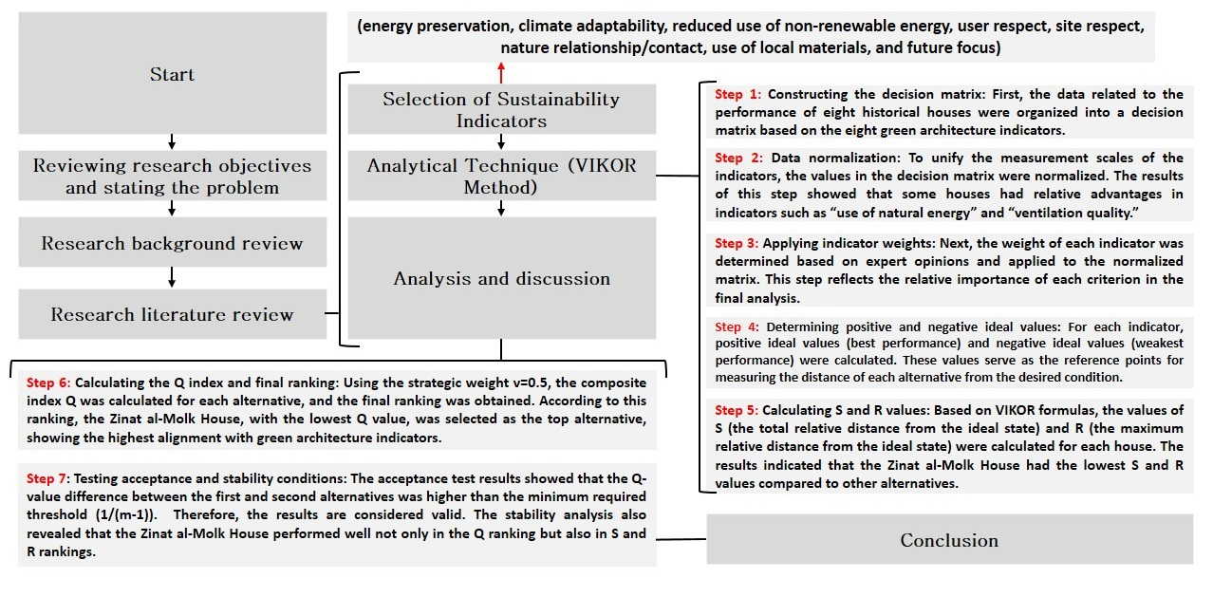
Fig. 1: The Stages Of Conducting Research

Research Innovation
- Localizing of Green Architecture Indicators: As compared to general work, the paper accommodates indicators of green architecture to the local context of Shiraz in terms of culture, climate and architecture.
- Comparative Analysis of Traditional vs. Contemporary Housing: The study shows that traditional houses in Shiraz possess the attributes of the sustainable design automatically and in this way it regularly dominates the modern house concerning some main criteria.
- Suggestion of a Model to Iranian Architecture in the Future: The research holds a premise that there is an opportunity, namely traditional Shirazi architecture, that could be emulated in the pursuit of enhancing the quality of modern architecture and the realization of sustainable developing urban buildings.

DISCUSSION
In this section; In the first step, fifteen indicators of green architecture were identified based on literature review and expert opinions. In order to reduce the number of indicators and avoid redundancy, Principal Component Analysis (PCA) was applied using SPSS. PCA is a statistical method that transforms a set of correlated variables into a smaller number of uncorrelated components, while preserving most of the variance in the dataset. The indicators with factor loadings higher than 0.70 were considered significant. As a result, eight key indicators were selected: energy preservation, climate adaptability, reduced use of non-renewable energy, user respect, site respect, nature relationship/contact, use of local materials, and future focus. The factor loadings obtained from PCA were then normalized to determine the relative weights of the indicators, which were subsequently used in the VIKOR method for multi-criteria decision-making. (Table 3 & 4)

Table 3: PCA Factor Loadings of 15 Indicators
Indicator | PCA
Energy Preservation | 0.842
Climate Adaptability | 0.816
Site Respect | 0.795
Visual and Mental Comfort | 0.512
Using Local Materials | 0.801
User Respect | 0.773
Reducing the Use of New Resources | 0.498
Thermal Comfort | 0.554
Focus on Human Dimensions & Avoiding Uselessness | 0.436
Reducing the Use of Non-Renewable Energy | 0.834
Environmental Perception | 0.471
Contact with Nature | 0.811
Human Comfort | 0.563
Future Focus | 0.827
Quality | 0.502

Table 4: Final Weights of Selected Indicators
Selected Indicator | How it is Applied in Architecture | Factor Loading | Normalized Weight
Energy Preservation | Designing buildings with insulation, passive heating/ cooling, efficient lighting and appliances to minimize energy demand. | 0.842 | 0.134
Climate Adaptability | Designing buildings to be naturally ventilated, shaded, and use sunlight based on the climate of the area. | 0.816 | 0.13
Reduced Use of Non-Renewable Energy | Focusing on renewable energy systems (solar, wind, geothermal) and reducing the use of fossil fuels. | 0.834 | 0.133
User Respect | Providing healthy indoor environments, thermal comfort, accessibility and user-friendly spaces. | 0.773 | 0.123
Site Respect | Retention of site topography, reduction of land disturbance and incorporation of design with natural environment. | 0.795 | 0.127
Nature Relationship/Contact | Including green space, vegetation indoors, water features, and views to nature. | 0.811 | 0.13
Use of Local Materials | Utilizing materials that are regionally available, natural and recyclable to minimize transportation energy and local economy. | 0.801 | 0.128
Future Focus | Creating adaptable, flexible and sustainable structures with sustainability objectives that are long-term. | 0.827 | 0.132

One of the multi-criteria decision-making methods is the VIKOR method that ranks alternatives in terms of several indicators. Eight indicators of green architecture were used to compare the traditional and modern houses in Shiraz. The VIKOR method is presented in detail in terms of step-by-step stages, tables of calculations, and analysis of results.
Step 1: Build decision matrix: In this step, data for eight historical houses regarding the performance of these houses were organized into a decision matrix using the eight green architecture indicators.
Step 2: Normalization: After normalization was applied to unify the measurement scales of the indicators (some relative advantages could be seen in "use of natural energy" and "ventilation quality"), the weights of each indicator based on expert opinions were determined, and then they were applied to the normalized matrix.
Step 3: Assign weights to indicators: Weights were assigned to each indicator based on expert judgment and applied to the normalized matrix, taking into consideration the relative significance of each criterion in the final assessment.
Step 4: Calculate positive ideal (best) and negative ideal (worst) values for each indicator: The best and worst performance levels across all indicators are determined and used as benchmarks against which other alternatives are measured.
Step 5: Calculation of S and R values: The values of S (the total relative distance from the ideal state) and R (the maximum relative distance from the ideal state) were calculated for each house based on VIKOR formulas, which indicated that Zinat al-Molk House had the smallest S and R values among other alternatives.
Step 6: Calculation of the Q index and final ranking: By using the strategic weight v=0.5, the composite index Q was calculated for each alternative and the final ranking was obtained; this ranking showed that Zinat al-Molk House with the lowest Q value was selected as the best alternative (i.e., most aligned to green architecture indicators).
Step 7: Acceptance and Stability Testing: Based on the acceptance test results, the difference of the Q-value between the first alternative (Zinat al-Molk House) and second alternative was more than the minimum required threshold (1/(m-1)). Therefore, it is a valid result. The stability analysis also showed that Zinat al-Molk House ranked well in all three rankings: Q, S, and R.
Table 5 shows the performance of the eight chosen houses on the eight green architecture indicators. As depicted, the traditional houses like Zinat al-Molk and Manteghi-Nejad had a better score in indicators like climate adaptation and use of local materials whereas the modern houses had a lower score in the same indicators. The following VIKOR calculations were based on this table.

Table 5: Decision Matrix, Houses scored based on 8 Green Architecture Indicators
Houses / Indicators | C1 | C2 | C3 | C4 | C5 | C6 | C7 | C8
Zinat al-Molk House | 9 | 8 | 9 | 8 | 9 | 8 | 9 | 9
Manteghi-Nejad House | 8 | 8 | 9 | 7 | 8 | 8 | 8 | 8
Sa’adat House | 8 | 7 | 8 | 7 | 8 | 7 | 8 | 8
Safari Residential House | 7 | 6 | 7 | 6 | 7 | 7 | 7 | 7
Qazizadeh Residential House | 5 | 4 | 5 | 4 | 5 | 4 | 5 | 4
House No. 7 | 4 | 4 | 5 | 4 | 4 | 4 | 4 | 4
Residential House No. 84 | 5 | 5 | 5 | 5 | 5 | 5 | 5 | 5
Zyaian House | 6 | 5 | 6 | 5 | 6 | 5 | 6 | 5

The Table 6 expresses the indicators in their normalized value to remove the impact of different measurement scales. The analysis shows that performance of houses towards specific indicators, including the use of natural energy and connection with the nature is more outstanding. Generally, even with normalization, there was still better performance on the traditional houses in most indicators.

Table 6: Normalized Data
Houses | C1 | C2 | C3 | C4 | C5 | C6 | C7 | C8
Zinat al-Molk House | 0.4 | 0.39 | 0.41 | 0.39 | 0.4 | 0.38 | 0.4 | 0.41
Manteghi-Nejad House | 0.36 | 0.39 | 0.41 | 0.34 | 0.36 | 0.38 | 0.36 | 0.36
Sa’adat House | 0.36 | 0.34 | 0.36 | 0.34 | 0.36 | 0.33 | 0.36 | 0.36
Safari Residential House | 0.31 | 0.29 | 0.32 | 0.29 | 0.31 | 0.33 | 0.31 | 0.32
Qazizadeh Residential House | 0.22 | 0.19 | 0.23 | 0.19 | 0.22 | 0.19 | 0.22 | 0.18
House No. 7 | 0.18 | 0.19 | 0.23 | 0.19 | 0.18 | 0.19 | 0.18 | 0.18
Residential House No. 84 | 0.22 | 0.24 | 0.23 | 0.24 | 0.22 | 0.24 | 0.22 | 0.23
Zyaian House | 0.27 | 0.24 | 0.27 | 0.24 | 0.27 | 0.24 | 0.27 | 0.23

The weighted normalized matrix indicates the real contribution of each indicator in the final evaluation; Table 7. E.g., had the indicator “climate adaptation” had a greater weight, the houses of Zinat al-Molk and Manteghi-Nejad, better fulfilling this point, would have obtained higher scores. On the other hand, modern houses with some benefits in other indicators scored lower in general.

Table 7: Weighted Normalized Matrix
Indicators | C1 | C2 | C3 | C4 | C5 | C6 | C7 | C8
Weights | 0.13 | 0.12 | 0.12 | 0.11 | 0.13 | 0.13 | 0.13 | 0.13

Table 8 shows the total relative distance (S) and maximum relative distance (R) of each house; Zinat al-Molk House had the lowest S and R values, which means it was closest to the ideal state for all factors compared with the other houses, while Qazizadeh and House No. 7 had the highest S and R values, meaning they are furthest from green architecture principles.

Table 8: S and R Values for Each House
Houses | R | S
Zinat al-Molk House | 0.08 | 0.15
Manteghi-Nejad House | 0.12 | 0.25
Sa’adat House | 0.15 | 0.32
Safari Residential House | 0.2 | 0.4
Qazizadeh Residential House | 0.35 | 0.65
House No. 7 | 0.4 | 0.72
Residential House No. 84 | 0.28 | 0.58
Zyaian House | 0.25 | 0.5

The final ranking of the houses is summarized in Table 9; Zinat al-Molk house had the lowest Q value and was followed by Manteghi-Nejad and Sa'adat houses in second and third place, respectively. The modern houses ranked lower than the others because they were far from green architecture criteria. These results show that traditional architecture in Shiraz inherently meets many of the concepts in green architecture and can be a model for improving contemporary architectural quality.

Table 9: Q Values and Final Ranking
Houses | Q | Rank
Zinat al-Molk House | 0.05 | 1
Manteghi-Nejad House | 0.15 | 2
Sa’adat House | 0.22 | 3
Safari Residential House | 0.3 | 4
Zyaian House | 0.45 | 5
Residential House No. 84 | 0.5 | 6
Qazizadeh Residential House | 0.7 | 7
House No. 7 | 0.78 | 8

The results indicated that the old houses (Zinat al-Molk, Manteghi-Nejad, Sa’adat) had better scores than modern ones (Qazizadeh and House No. 7), which means that the traditional Shirazi architecture is more in line with green architecture characteristics and can serve as a model for developing contemporary architecture.
Table 4 indicates that Q values and ranks for each residential house have been calculated. VIKOR value ranges from zero to one; the closer to zero, the more acceptable the house indicators are; the nearer it is to one, the more unacceptable the house indicators are, or the lower the rank has a higher priority. Figure 2 illustrates the ranking of traditional and new residential houses in Shiraz City.

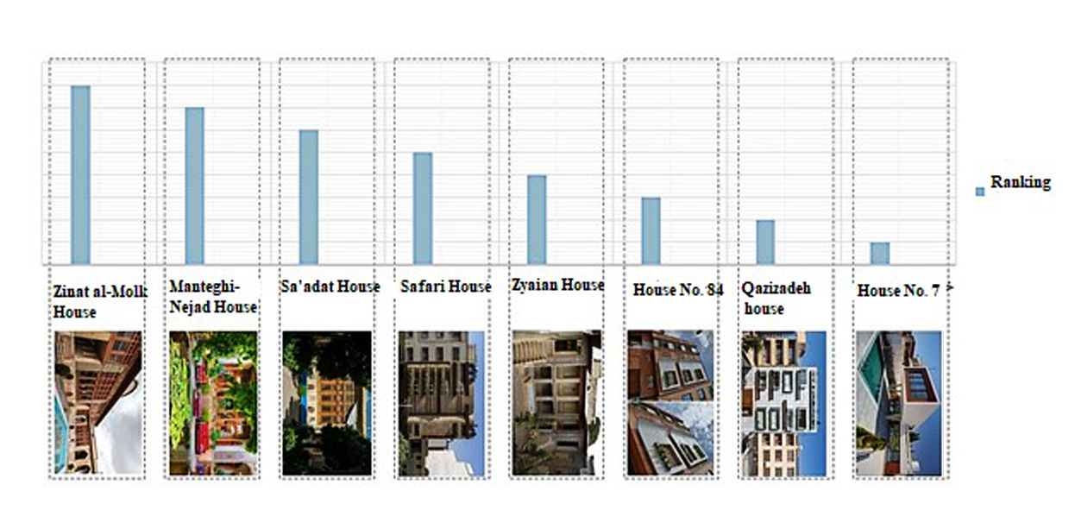
Fig. 2: Ranking Shiraz’s House by green architecture indicators

CONCLUSION
Results also showed that architects of the past employed the highest and the best green architecture indicators in designing traditional housing but modern architecture requires modeling local architecture to achieve green architecture indicators for modern housing. Green architecture, in the modern world, is regarded as a major theme in architecture and urban development areas. These features will help mitigate the need for artificial cooling and heating and provide more convenience and healthcare for residents. Second, green architecture is effective in preserving the environment. The principles of green architecture such as using renewable energies, environmentally friendly materials, reducing pollution, and energy consumption could help the environment and minimize destructive impacts on it. On the other hand, it is critical to intelligently use successful local architectural elements in modern designs. These local principles, inspired by various local and cultural experiences, are capable of adapting to the local environment. These principles, if applied to modern architecture, will not only protect cultural and architectural values but also establish a deeper and more spiritual link between residents and the natural environment. Therefore, a special focus on green architecture and integrating successful local models in modern designs will improve the quality of life, protect the environment, and maintain social, and cultural identity in each region. Findings showed that Shiraz’s traditional houses, compared to modern ones, enjoyed more acceptable green architecture indicators, suggesting that modern architecture requires to be inspired by traditional architecture to utilize green architecture indicators. These results could help develop sustainable and green architecture in contemporary housing.

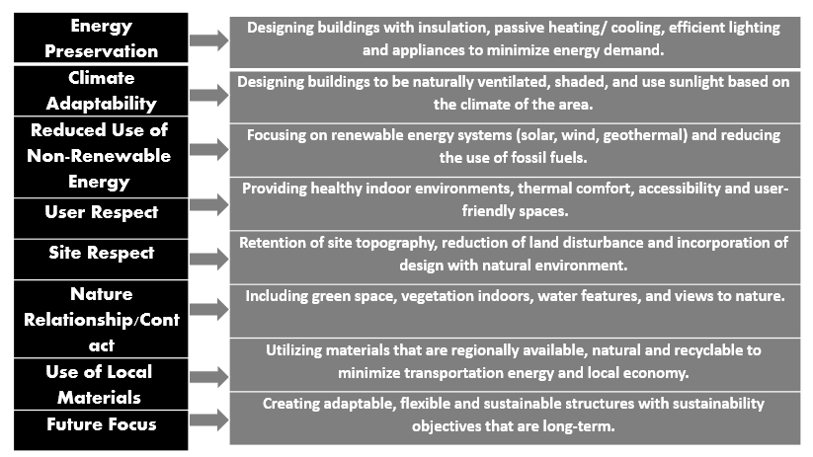
Fig. 3: Indicators Of Green Architecture

RECOMMENDATIONS
- Urban Policy-Making: These outcomes can be used by municipalities and urban revitalization units to develop construction policies and restoration plans of the historic homes in Shiraz, as well as nationally.
- Template to Modern Residential houses: The lessons learnt about traditional houses can act as a guide to the new schemes of residential premises particularly in having increased energy efficiency and enhanced a bond between them and nature.
- Educational and research applications: The paper may be used as a case study application in architectural, urban planning and environmental curriculums as a case study of an application in vernacular design since the green architecture concept was applied using vernacular solutions.
- Indicators Standardization: The eight indicators used in the current study could be used to become a localized model to evaluate the sustainability of buildings in Iran and other related applications.

APPENDIX:
1. PCA Validation: The Kaiser-Meyer-Olkin (KMO) measure and Bartlett's test of sphericity for assessing adequacy of sample and suitability of data for PCA were calculated to validate the Principal Component Analysis (PCA) on the 15 initial green architecture indicators. KMO Measure: Evaluates the sampling adequacy for each variable and the entire model, with values greater than 0.7 indicating acceptable adequacy. Bartlett's Test: Tests whether the correlation matrix is an identity matrix, and a significance level (Sig.) less than 0.05 confirms that PCA can be applied.

Table 10: PCA Validation
Indicators | KMO | Bartlett's Test (Chi-square) | df | Sig.
15 Initial Indicators | 0.78 | 245.63 | 105 | 0.000
- KMO > 0.7 implies that the sample is sufficient in relation to the PCA.
- Sig. < 0.05 affirms the fact that the correlation matrix is not an identity matrix.
- Consequently, PCA is appropriate in the reduction and selection of the key indicators.

2. Using a sensitivity analysis of VIKOR approach:We apply sensitivity analysis to VIKOR method to rank eight historical houses in Shiraz based on green architecture with eight identified indicators the Q index is calculated as follows:

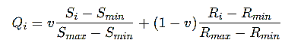
S_{i} is the total distance from positive ideal solution for alternative i. R_{i} is the maximum distance from positive ideal solution for alternative i. S_{min}, S_{max}, R_{min}, R_{max} are minimum and maximum S and R values over all alternatives.v is strategic weight, that represents the decision-maker preference to majority of criteria (commonly v = 0.5).

Table 11: Sensitivity Analysis of Q Index
House | Q (v=0.3) | Q (v=0.5) | Q (v=0.7) | Rank Stability
Zinat al-Molk House | 0.03 | 0.00 | 0.02 | Stable
Manteghi-Nejad House | 0.12 | 0.15 | 0.18 | Stable
Sa’adat House | 0.20 | 0.26 | 0.31 | Stable
Safari Residential House | 0.33 | 0.41 | 0.49 | Stable
Zyaian House | 0.49 | 0.57 | 0.64 | Stable
Residential House No. 84 | 0.61 | 0.69 | 0.76 | Stable
Qazizadeh Residential House | 0.79 | 0.86 | 0.92 | Stable
House No. 7 | 0.92 | 1.00 | 1.07 | Stable

Explanation: Ranking of houses is not sensitive to changes in v values which indicates the robustness of VIKOR results. PCA validation by KMO and Bartlett's Test shows that the sample size is adequate and data fit, and sensitivity analysis for the VIKOR Q index suggests that the ranking of historical houses is stable across different weights so the multi-criteria decision-making result is reliable.

3. Study Limitations: The study has the limitation of the not-large size sample (8 buildings), which can limit the generalizability of the findings.

REFERENCE
Aboubakr, s. H., fathi, a. A., & bakr, a. F. (2022). Composite indicators for assessing the carbon emission reduction on bio-eco-resilience of residential buildings. Wit transactions on ecology and the environment, 260, 289-298.
Bagheri, a., & ravanshadnia, s. (2015). Green architecture and its effects on human physical and mental health. Second international conference on research in science and technology.
Balamurugan, m. (2019). An analytical study on green buildings. Journal of emerging technologies and innovative research.
Bassas, e. C., patterson, j., & jones, p. (2020). A review of the evolution of green residential architecture. Renewable and sustainable energy reviews, 125, 109796.
Berezovetska, i., oleksandr, b., olena, z., inna, s., & vitalii, p. (2024). Analysis of environmentally sustainable projects in the field of green architecture: use of natural materials and renewable energy sources. Doi:10.33543/140139712
Bernstein, h. M., russo, m. A., & jones, s. A. (2010). Green bim: how building information modeling is contributing to green design and construction: mcgraw-hill construction.
Chen, l. (2020). Application analysis of green ecological building theory based on residential architectural design. Paper presented at the iop conference series: earth and environmental science.
Chen, r., yang, h. C., & chang, h. C. (2012). The application of green architecture to residential building development. Applied mechanics and materials, 193, 34-39.
Chen, y., zhang, s., & xu, s. (2010). Characterizing energy efficiency and deployment efficiency relations for green architecture design. Paper presented at the 2010 ieee international conference on communications workshops.
Cole, l. B. (2014). The teaching green school building: a framework for linking architecture and environmental education. Environmental education research, 20(6), 836-857.
Domingo-calabuig, d., rivera-linares, j., lizondo-sevilla, l., & alapont-ramón, j. L. (2024). Design strategies for circularity: km0 architecture in the spanish mediterranean. Open house international, 49(5), 927-942.
Du, b. (2024). Indoor environment design and energy saving analysis of sustainable development integrated with green building. Re&pqj, 29-38.
Errante, l. (2022). A green technological rehabilitation of the built environment. From public residential estates to eco-districts. Paper presented at the international conference on technological imagination in the green and digital transition.
Feizi, f., mirkhosravi, n., & hassanzadeh, m. (2019). Studying the effect of using green architecture in semi-open spaces on the quality of human psychological well-being. First international conference on civil engineering, architecture and urban regeneration , tehran.
Fengyan, l., & qi, l. (2024). Integration of traditional structures and modern green building materials of residential buildings in guangdong region. Appl. Math. Nonlinear sci, 9, 1-21.
Gertosio swanston, r. (2023). El paisaje habitacional moderno y el valor de su vegetación continua. Qru: quaderns de recerca en urbanisme(14), 194-217.
Ghaffari, m. R. (2017). Studying green architecture factors in order to achieving sustainable. International journal of scientific & engineering research, 8, 1246-1262.
Gholizade, m., hafeze, m., & rezaanvari, m. (2022). Green architecture: harmony and compatibility with the environment (case example: rasht city). Islamic art studies, 19(45), 539-559.
Ignatieva, m., & ahrné, k. (2013). Biodiverse green infrastructure for the 21st century: from “green desert” of lawns to biophilic cities. Journal of architecture and urbanism, 37(1), 1-9.
Jahangir, m. H., & fathi, a. (2023). Evaluation of thermal comfort of a building equipped with upgraded green roof with phase change materials.
Jeumpa, k., & harahap, r. (2024). Application of green building aspects in community residential houses. Emara: indonesian journal of architecture, 9(1), 30-37.
Karimi, h., adibhesami, m. A., bazazzadeh, h., & movafagh, s. (2023). Green buildings: human-centered and energy efficiency optimization strategies. Energies, 16(9), 3681.
Khasseh, s. (2021). Regional priorities in designing sustainable architecture based on clean and renewable energy in tehran. International journal of ecosystems & ecology sciences, 11(3).
Kusumawardhani, s., & wasilah, d. I. (2023). Application of green architecture principles in vernacular landscape. Paper presented at the iop conference series: earth and environmental science.
Logvinov, v. (2017). From “green building” to architecture integrated with nature: the principle of environmental interconnection. Проект байкал(51), 136-147.
Martinovic, o. I. (2016). Research on the potential of traditional and contemporary family houses with the aim to create a low-energy house. Facta universitatis, series: architecture and civil engineering, 91-110.
Mi, z. (2024). Sustainable architectural practices: integrating green design, smart technologies, and ultra-low energy concepts. Theoretical and natural science, 40(1), 8-13.
Mohamed, n. A. G., & ali, w. H. (2014). Traditional residential architecture in cairo from a green architecture perspective. Arts and design studies, 16(6).
Na, z., & sun, q. (2019). Research on the layout of low energy consumption ecological housing for farmers and herdsmen in cold regions based on climate adaptability. Paper presented at the iop conference series: earth and environmental science.
Ndiweni, s. (2020). Evaluating the adaptability of green buildings in the sustainability agenda in south africa.
Ning, y., li, y., yang, s., & ju, c. (2016). Exploring socio-technical features of green interior design of residential buildings: indicators, interdependence and embeddedness. Sustainability, 9(1), 33.
Piparsania, k., & kalita, p. C. (2022). Development of dash: design assessment framework for sustainable housing. Sustainability, 14(23), 15990.
Qtaishat, y., adeyeye, k., & emmitt, s. (2020). Eco-cultural design assessment framework and tool for sustainable housing schemes. Urban science, 4(4), 65.
Rudenko, a. O., & ladygina, i. V. (2022). Restoration of war-torn urban areas using smart technologies. Modern problems of architecture and urban planning, 64(295).
Sadowski, k. (2021). Implementation of the new european bauhaus principles as a context for teaching sustainable architecture. Sustainability, 13(19), 10715.
Sagar, s., arya, y., & singhal, p. (2025). Energy efficient green building design utlilising renewable energy and low-carbon development technologies. Science and technology for energy transition, 80, 25.
Salfner, s., & lang, w. (2017). Building with a positive ecological footprint: development and evaluation of a cradle to cradle®-inspired energy-plus house.
Syam, f. H., wisdianti, d., sajar, s., & bahri, s. (2023). Study of sustainable architecture concepts. International journal of research and review, 10(4), 419-424.
Uddin, m., wei, h., chi, h., ni, m., & elumalai, p. (2021). Building information modeling (bim) incorporated green building analysis: an application of local construction materials and sustainable practice in the built environment. Journal of building pathology and rehabilitation, 6(1), 13.
Vranayova, z., tkachenko, t., lis, a., savchenko, o., & vranay, f. (2023). Green buildings in pursuit of healthy and safe human living environment. System safety: human-technical facility-environment, 5(1), 204-211.
Xie, h., clements-croome, d., & wang, q. (2017). Move beyond green building: a focus on healthy, comfortable, sustainable and aesthetical architecture. Intelligent buildings international, 9(2), 88-96.
Yuan, y., yu, x., yang, x., xiao, y., xiang, b., & wang, y. (2017). Bionic building energy efficiency and bionic green architecture: a review. Renewable and sustainable energy reviews, 74, 771-787.
Zhao, y., & wei, s. (2024). New residential models in guanzhong region under the background of green buildings.
Zhu, y. (2023). Cultural identity of desert architecture: exploring strategies for integrating traditional and modern. Highlights in science, engineering and technology, 75, 51-60.
Živadinović, p. (2024). Transformative revitalization of auxiliary buildings of rural vernacular architecture into sustainable residential spaces. Zbornik radova sa nacionalne konferencije sa međunarodnim učešćem–zelena gradnja 2024(bioclimatic & biophilic arch), 93-98.
Ковальська, г., & гомон, о. (2024). Прийоми впровадження зеленої архітектури в освітньому процесі. Просторовий розвиток(7), 66-74.

literally translated as made of seven colors
Small wooden panels of geometric shapes are created individually, and combined to create an elaborate design

