Healing Cycles in Therapeutic Landscapes for Well-being:
A Causal Model of Urban Green Spaces for Promoting Physical, Mental, and Social Health

Elahe Mohajer*
Ph.D. of Architecture, Department of Architecture, Faculty of Art and Architecture, Shiraz Branch, Islamic Azad University, Shiraz, Iran.
Ellie.mohajer@gmail.com
0000-0002-3255-0504

Khosro Movahed
Associate Professor of Architecture, Department of Architecture and Urban Sustainability, University of the District of Columbia, Washington DC, USA.
Khosro.movahed@udc.edu
0000-0003-0609-1815

Abstract
Urban residents increasingly face high levels of stress and limited access to natural environments, raising concerns about the impact on physical, mental, and social well-being. While the benefits of urban green spaces (UGSs) are widely acknowledged, the specific design elements that contribute to these benefits and their causal relationships remain unclear. This study proposes a causal model of therapeutic landscape design components in UGSs, focusing on the synergistic interactions that enhance residents’ health. A mixed-methods approach was employed in three stages: a review of existing literature and expert interviews using the Delphi method to identify health-related design indicators; administration of a user survey assessing architectural qualities of UGSs; and factor analysis combined with covariance structural equation modeling (CSEM) to validate the proposed model. Six key design components were identified, Environmental Safety and Security, Spatial Vitality, Space Adaptability, Spatial Legibility, Spatial Sociality, and Space Diversity, that work together to support healing. Among these, Space Adaptability exhibited the strongest effect, explaining 93% of its variance, while Spatial Vitality accounted for 68% of its variance. Three primary synergy cycles emerged, illustrating how these components reinforce one another over time to create vibrant, inclusive, and health-promoting environments. The findings offer practical guidance for urban planners and landscape designers seeking to enhance the therapeutic potential of UGSs.

Keywords: Therapeutic landscapes, Urban green spaces, Health promotion, Wellbeing, Structural equation modeling

Introduction
Contemporary urban life is increasingly associated with psychological stress, sedentary behaviour, and weakened social ties. In this context, urban green spaces (UGSs) are recognised as critical urban infrastructures that support public health and well-being. A substantial body of research identifies three principal pathways through which UGSs influence health outcomes: promoting physical activity, supporting recovery from stress and attention fatigue, and enabling social interaction (Lee et al., 2015). In addition, UGSs provide essential ecological services, such as air purification, microclimate regulation, urban heat island mitigation, and biodiversity conservation, thereby contributing to environmental sustainability and urban resilience (Kuklina et al., 2021; Mukherjee & Takara, 2018; Yin et al., 2022).
Despite these benefits, rapid urbanisation, increasing land values, and densification pressures have resulted in the reduction and fragmentation of green spaces in cities worldwide. Evidence from diverse urban contexts links diminished access to green environments with higher prevalence of mental health disorders, chronic disease, and social isolation (Bratman et al., 2019; Sato & Zenou, 2015; Wang et al., 2020). As routine contact with nature declines, health inequalities become more pronounced, particularly among populations with limited access to high-quality public spaces.
In response, contemporary planning has shifted from a focus on the quantity of green spaces towards questions of quality, accessibility, and spatial configuration. Well-designed green environments are increasingly conceptualised as therapeutic landscapes that address physical, psychological, social, and cultural dimensions of well-being (Brown & Corry, 2011). However, much of the existing literature remains largely emphasising general associations between green space exposure and health outcomes. Empirical studies often examine isolated spatial features and rely primarily on correlational evidence, offering limited insight into how specific design components interact or how their combined effects contribute to healing processes across different urban and cultural contexts.
To address these limitations, the present study proposes a causal model of urban green space design and identifies synergistic cycles among spatial components, whose interactions collectively enhance the therapeutic potential of UGSs.
By clarifying these causal pathways, the study provides actionable insights for planners, designers, and policy-makers seeking to enhance the health performance of UGSs. More broadly, it contributes to bridging urban design and public health research by foregrounding design quality and spatial synergy as central determinants of healthier and more resilient urban environments.
Accordingly, the study is guided by the following research questions:
Q1. Which design components of UGSs contribute most significantly to their healing properties?
Q2. What synergistic cycles emerge among these components within the proposed causal model?
Through addressing these questions, the study offers a structured, evidence-based framework for designing urban environments that actively support physical, mental, and social well-being.
Background of the Research
The relationship between natural environments and human health has long attracted scholarly attention. Across historical periods and cultures, access to nature has been regarded as a fundamental human need rather than a discretionary amenity. Ancient writings suggest that landscapes were valued not only for their capacity to sustain life, but also for their influence on physical and psychological well-being (Thompson, 2011). In the 5th century BC, Hippocrates emphasized the influence of climate and environmental conditions on health outcomes, observing that variations in weather and surroundings could shape patterns of disease (Falagas et al., 2010). Building on this perspective, Vitruvius, writing in the 1st century BC, argued that urban planning must account for climate, topography, and settlement location to safeguard public health (Vitruvius, 2018).
These early observations were not isolated philosophical reflections but informed spatial practices across ancient civilizations. In China, Greece, and Rome, landscapes were deliberately shaped to harness the perceived healing properties of water, vegetation, and natural sounds, reflecting an intuitive understanding of environmental restoration (Velarde et al., 2007). During the Middle Ages, this understanding became institutionalised in the form of monastic healing gardens, where controlled natural settings were integrated into care environments to support recovery (Gerlach-Spriggs et al., 2004). Collectively, these precedents suggest that the health-promoting role of landscapes has deep historical roots.
Early professional perspectives reveal that environmental design, sanitation, and access to green spaces were understood as public health interventions as early as the American Civil War. The work of Frederick Law Olmsted, particularly his involvement in sanitary reform, exemplifies this approach (Eisenman, 2013), which has since been further articulated and supported within contemporary landscape and public health discourse (Bull et al., 2013).
Extensive research has shown that exposure to natural environments positively impacts both mental and physical health. Hartig et al. (2011) and Van den Berg et al. (2010) found that natural settings help mitigate stress and buffer against the negative effects of adverse life events. These benefits arise not only from active engagement but also from passive exposure to natural elements. Ulrich et al. (1991) reported that visual contact with vegetation and water can reduce stress, while Moztarzadeh and Mohajer (2020) showed that direct interaction enhances place attachment and emotional well-being. Mayen Huerta (2023) found that perceived quality, emotional attachment, and duration of use further amplify health outcomes. Taghipour et al. (2022) reported that exposure to green spaces positively affects health in residential environments, while Triguero-Mas et al. (2015) showed similar benefits at the neighborhood scale, supporting both general and mental health.
Recent scholarship has addressed the design aspects of UGSs. Stigsdotter (2015) conceptualized health-focused landscape design as support of health processes. Olszewska-Guizzo et al. (2022) identified specific urban landscape features associated with health benefits. At the urban scale, Russo (2024) highlighted the role of accessible, well-designed green spaces in addressing mental health, and Patwary et al. (2024) examined effects of green exposure in post-COVID-19 contexts.
Twohig-Bennett and Jone (2018) demonstrated that greenspace exposure is linked to multiple physical and mental health benefits. Gubbels et al. (2016) found that increases in greenery in deprived neighborhoods had limited effects on physical activity and mental health. Hunter et al. (2019) showed that UGS interventions effectively enhance health, well-being, social, and environmental outcomes.
Pastore et al. (2025) assessed both quantity and quality of green spaces to planning for environmental equity and support residents’ mental well-being. Xu et al. (2025) highlighted that vegetation diversity and water features support mental health. Callaghan et al. (2021) demonstrate how and to what extent urban green spaces are associated with improvements in mental health and wellbeing. Dietz et al. (2024) evaluate urban parks globally based on their capacity to support different health-related activities. At the neighbourhood scale, Veen et al. (2020) define context-specific urban green space design principles aimed at enhancing targeted health outcomes, such as physical health and social cohesion.
Enssle and Kabisch (2020) emphasized the role of social networks and self-perceived health in shaping older adults’ park use. Jabbar et al. (2022) confirmed UGS key role in supporting physical, psychological, social, and environmental dimensions of well-being.
Despite extensive evidence on the benefits of UGSs, while indicators and principles for therapeutic environments have been discussed, there is no urban-scale framework showing how design components interact to promote long-term health and well-being. This research addresses this gap by identifying key design components of UGSs and conceptualizing their causal and synergistic relationships through dynamic healing cycles. The proposed model provides a structured basis for understanding how spatial design decisions can systematically enhance public health and urban well-being.
Theoretical foundations
Healing is a broad process involving both the body and mind. (Marcus & Barnes, 1996) define healing as alleviation of physical symptoms, illness, and emotional trauma, which reduces nervous pressure and increases comfort. The healing process includes three aspects: 1) relief from physical symptoms, 2) reduction of tension and increased relaxation, and 3) improvement of comprehensive health and hope. The second aspect is considered a precursor to the third.
According to the World Health Organization (2025), health is a state of complete physical, mental, and social well-being, all of which are greatly enhanced by accessible green spaces (Russo, 2024), therefore, this holistic perspective should be explicitly integrated into the design of therapeutic landscapes.
UGSs, defined as publicly accessible urban and peri-urban open spaces partially or fully covered by substantial vegetation, include parks, playgrounds, forests, beaches, urban wetlands, and community gardens (Haq et al., 2021). Beyond aesthetics, UGSs form an essential component of green infrastructure, improving urban residents' quality of life (Crossley & Russo, 2022; Jabbar et al., 2022).
The term "therapeutic landscapes" describes the positive health effects of UGSs. These effects include lower risks of cardiovascular problems, better birth outcomes, reduced mortality rates (Browning et al., 2022), and mitigation of mental health burdens (Bratman et al., 2019). UGSs also foster social cohesion, which supports psychological health and promotes health-related behaviors (Jennings & Bamkole, 2019). According to Gesler (2003), people naturally respond positively to green spaces through a process called "soft absorption" (Kaplan & Kaplan, 2009). By focusing on specific environmental and spatial design factors, urban green spaces can be intentionally organized to enhance users’ psychological, social, and physical well-being, highlighting key components that contribute to their therapeutic effects."
Urban green spaces (UGSs) that support perceived psychological safety provide users with a sense of mental and physical security, reducing anxiety, stress, and vigilance, and thereby directly enhancing psychological well-being (Kawakami et al., 2011). By promoting spatial sociality, UGSs further strengthen mental and social health, as environments that facilitate social interaction encourage engagement, foster a sense of community, and enhance feelings of belonging, while spaces that support active lifestyles and opportunities for social exchange improve public health by promoting cohesion and reducing social isolation (Brown & Corry, 2011). Space diversity within UGSs contributes to well-being by offering varied spatial, social, and activity opportunities, encouraging physical activity, reducing sedentary behavior, and enhancing restorative experiences and sustained engagement through biodiversity (Russo, 2024). In addition, sensory and aesthetic stimulation plays a key role, as multisensory engagement through sight, smell, touch, and microclimatic variation reduces stress, supports psychological restoration, and enhances perceptual engagement and emotional comfort; visual qualities, including color use, influence mood, emotional responses, and perceived vitality, contributing to mental health outcomes (Grutter, 2022; Hill & Think, 2008; Jia et al., 2016; Oberlin, 2008; Shao & Liu, 2016). The legibility and comprehensibility of UGSs are also crucial, as clear and navigable environments increase feelings of safety and accessibility, while low legibility can cause confusion, stress, or fear; at the same time, a balanced level of complexity and a controlled sense of “mystery” stimulates cognitive engagement without inducing anxiety, enhancing comfort and well-being (Caniano, 2006). Finally, space adaptability, or the capacity of UGSs to accommodate changing uses and user participation, positively influences physical, mental, and social health, as flexible environments encourage engagement, social interaction, and physical activity, fostering a sense of control and mastery over surroundings; addressing user needs and promoting familiarity further strengthen comfort, belonging, and inclusivity, while participatory practices such as community-based activities demonstrate how flexible spaces can respond to diverse physical and psychological needs, supporting overall well-being (Caniano, 2006; Dul & Weerdmeester, 2018; Elsadek et al., 2020; Mishra et al., 2020; Nutsford et al., 2013; Zutter & Stoltz, 2023)
UGSs provide essential environmental and social functions in cities. Due to humans’ natural inclination toward nature, these spaces have long served as refuges from urban life, offering opportunities for tranquility, recreation, and restoration. Beyond providing rest, well-designed green spaces can positively influence physical, mental, and social well-being. Purposeful planning and organization are therefore essential to maximize their benefits and attract greater public engagement. Identifying architecture-based environmental factors that support the effective use of these spaces allows for a structured approach to their design. Building on these factors, a conceptual model can be developed to illustrate their interactions and the resulting environmental cycles, offering a practical framework for designing therapeutic and health-promoting landscapes. Table 1 presents key environmental factors and indicators, forming a framework for designing therapeutic landscapes that enhance urban well-being.
Table 1: Indicators affecting health in the environment, extracted from previous research studies
Name of researcher/researchers | Indicators | Factor
(Kawakami et al., 2011) | Psychological safety | Psychological and Safety Factors
(Wilson, 2006); (Malkin, 2003); (Marcus & Barnes, 1999) | Privacy in space | Psychological and Safety Factors
(Janssen & LeBlanc, 2010; WHO, 2017) | Support for physical activity | Psychological and Safety Factors
(Marcus & Barnes, 1999) | Free and unobstructed movement | Psychological and Safety Factors
(Bengtsson & Grahn, 2014; Caniano, 2006; Kaplan, 2017; Marcus, 2007) | Clear spatial organization | Psychological and Safety Factors
(Nesmith, 1995; Rapaport, 2005) | Appropriate user density | Psychological and Safety Factors
(Bentley et al., 2005) | Pleasantness of the space | Psychological and Safety Factors
(Nesmith, 1995; Van den Berg, 2005) | Thermal comfort | Psychological and Safety Factors
(Hill & Think, 2008; Oberlin, 2008; Ulrich et al., 2008) | Visual attractiveness | Aesthetic and Sensory Qualities
(Bengtsson & Grahn, 2014) | Engaging activities | Aesthetic and Sensory Qualities
(Bengtsson & Grahn, 2014; Caniano, 2006; Kaplan, 2017; Marcus, 2007) | Spatial complexity | Aesthetic and Sensory Qualities
(Chen & Lin, 2023; Grutter, 2022; Tabassum, 2025) | Sensory richness | Aesthetic and Sensory Qualities
(Malkin, 2003; Marcus & Barnes, 1999; Ulrich, 1999) | User agency | Adaptability, and Participation
(Caniano, 2006; Elsadek et al., 2020; Follman & Viehoff, 2015; Mishra et al., 2020; Nutsford et al., 2013; WHO, 2017; Zutter & Stoltz, 2023) | Flexible space | Adaptability, and Participation
 | Participation and environmental modification | Adaptability, and Participation
(Caniano, 2006) | Comprehensible spatial layout | Legibility and Comprehensibility
(Bengtsson & Grahn, 2014; Caniano, 2006; Kaplan, 2017; Marcus, 2007) | Ease of wayfinding | Legibility and Comprehensibility
 | Visual permeability | Legibility and Comprehensibility
(Marcus & Barnes, 1999) | Sociable spaces | Social Interaction
(Carp et al., 1976) | Social safety | Social Interaction
(Bengtsson & Grahn, 2014; Marcus, 2007) | Activity diversity | Space Diversity
(Caniano, 2006) | Availability of choice | Space Diversity
Methods
This study employs a mixed-methods approach, incorporating both quantitative and qualitative methods, and is conducted in three stages. In the first stage, existing literature was reviewed to extract therapeutic landscape indicators. To complement this, expert interviews were conducted using a two-round Delphi method with 12 experts in architecture and landscape design, selected through theoretical sampling. The health-related design factors identified through the literature review and Delphi process were then organized in a content-objective table, which guided the development of the user questionnaire.
In the second stage, a pilot survey was conducted prior to the main study to refine the questionnaire, ensure the clarity and relevance of the items, and assess its preliminary reliability and validity. Following this, a user survey was carried out using a questionnaire designed by the researchers in the first stage, measures the architectural qualities of the space on a 4-point Likert scale ranging from "completely agree" to "completely disagree." The content validity of this questionnaire has been confirmed through expert theoretical consensus.
The statistical population for this study consists of residents who regularly visit UGSs. The sample size was determined based on Kline’s (2023) recommendation, which suggests selecting a certain number of respondents per questionnaire item to ensure sufficient data for statistical analyses and reliable estimation in structural equation modeling. Based on the researcher’s questionnaire, which included 23 questions for users, and considering 5 respondents per question, the sample size was set at 138, then increased to 152 to include a 10% confidence margin. Participants for the user survey were purposefully selected, with questionnaires distributed to residents at Azadi and Jannat Parks in Shiraz, Iran, using a random cluster sampling method. It should be noted that while this method ensured targeted data collection, the use of only two parks and the sample size may limit the generalizability of the findings to other UGSs or regions.
Data analysis was conducted using SPSS-23 software, employing R factor analysis to identify the therapeutic design components in UGSs. In the third stage, AMOS software was used to perform covariance structural equation modeling (CSEM) through path analysis, assessing the validity of the therapeutic landscape design components model proposed in the study. Figure 1 illustrates the research process.

library and internet searches

Reviewing the sources related to the research topic

Extracting the therapeutic landscape components from sources
Compilation of Users’ researcher-made questionnaire

Interview with Experts
Forming a table of content goals
First phase:
Delphi Method and Document Mining
Qualitative

Exploring and introducing the therapeutic landscape design components of urban green spaces
Distributing questionnaires among the residents of urban green spaces
Conducting R-factor analysis
Entering information into Spss-23 software
Second phase:
User Surveying
Quantitative

Explaining the relationship patterns between the therapeutic landscape components
Examining the Fit Indices of the model
Presenting a compiled model of the therapeutic Landscape design components of urban green spaces and extracting the cycles in the presented model
Developing causal model using Amos
software
Third phase:
Correlation Method
Quantitative

Figure 1. The diagram of research process
Findings
In this study, the researchers developed and administered questionnaires to achieve the research objectives. The structural reliability of the research tool was assessed using Cronbach's alpha. Following a pilot study, the Cronbach's alpha coefficient for the questionnaire items was calculated as 0.84, indicating an acceptable level of reliability.
The questionnaires were subsequently distributed to 152 residents who frequently visit UGSs. To analyze the data, R-factor analysis was performed. As shown in Table 2, the sample size adequacy was confirmed through the KMO test, which yielded a value of 0.65, demonstrating that the sample size is sufficient. Additionally, Bartlett's test produced a significance level (SIG) of 0.000, confirming that the correlation matrix is appropriate for factor analysis.
Table 2. KMO and Bartlett's Test
Kaiser-Meyer-Olkin Measure of Sampling Adequacy |  | .653
Bartlett's Test of Sphericity | Approx. Chi-Square | 452.257
Bartlett's Test of Sphericity | df | 253
Bartlett's Test of Sphericity | Sig. | .000
The variance of the data after rotation indicates that seven factors have been identified based on the participants' responses. As shown in the variance table of the rotated data (Table 3), these factors explain a total of 70% of the variance related to the therapeutic design components in UGSs.
Table 3. Total Variance Explained
Component | Extraction Sums of Squared Loadings |  |  | Rotation Sums of Squared Loadings
Component | Total | % of Variance | Cumulative % | Total | % of Variance | Cumulative %
1 | 6.044 | 26.276 | 26.276 | 4.329 | 18.820 | 18.820
2 | 2.535 | 11.020 | 37.297 | 2.342 | 10.181 | 29.001
3 | 1.933 | 8.402 | 45.699 | 2.299 | 9.997 | 38.998
4 | 1.752 | 7.619 | 53.318 | 2.147 | 9.336 | 48.334
5 | 1.574 | 6.842 | 60.160 | 1.841 | 8.006 | 56.340
6 | 1.349 | 5.866 | 66.026 | 1.762 | 7.659 | 63.999
7 | 1.050 | 4.564 | 70.591 | 1.516 | 6.591 | 70.591
According to Table 4, the questions were divided into six factors, each named by the researchers based on the content of the relevant questions. These titles were approved by five experts. The factors include "environmental safety and security," "spatial vitality," "space adaptability," "spatial legibility," "spatial sociality," and "space diversity."
Table 4. The content of the questions for each of the design components of urban green space
Factor Load | Content of Questions | Question Number | Component
.853 | Perceived psychological safety | Q 14 | No. 1  Environmental Safety and Security
.826 | Perceived privacy within the space | Q 15 | No. 1  Environmental Safety and Security
.761 | Opportunities for physical activity | Q 2 | No. 1  Environmental Safety and Security
.674 | Ease of free and unobstructed movement | Q 9 | No. 1  Environmental Safety and Security
.605 | Clarity and coherence of spatial organization | Q 16 | No. 1  Environmental Safety and Security
.540 | Appropriate user density | Q 19 | No. 1  Environmental Safety and Security
.512 | Perceived pleasantness of the space | Q 8 | No. 1  Environmental Safety and Security
.506 | Thermal comfort | Q 20 | No. 1  Environmental Safety and Security
.787 | Visual attractiveness | Q 4 | No. 2  Spatial Vitality
.770 | Engaging and meaningful activities | Q 7 | No. 2  Spatial Vitality
.606 | Spatial complexity | Q 6 | No. 2  Spatial Vitality
.518 | Sensory richness | Q 12 | No. 2  Spatial Vitality
.811 | Perceived agency within the spatial environment | Q 13 | No. 3  Space Adaptability
.684 | Flexible spatial structure | Q 21 | No. 3  Space Adaptability
.659 | Opportunities for participation and environmental modification | Q 18 | No. 3  Space Adaptability
.854 | Comprehensibility of the spatial environment | Q 11 | No. 4  Spatial Legibility
.746 | Ease of wayfinding | Q 17 | No. 4  Spatial Legibility
.465 | Visual permeability of paths and spaces | Q 10 | No. 4  Spatial Legibility
.868 | Sociable spaces / opportunities for social interaction | Q 23 | No. 5  Spatial Sociality
.763 | Perceived social safety | Q 22 | No. 5  Spatial Sociality
.783 | Diversity of activities | Q 1 | No. 6  Space Diversity
.721 | Availability of choice | Q 3 | No. 6  Space Diversity
In the third stage of the study, the correlation method was used to model the causal relationships among the design components of UGSs design based on residents' health. After developing the theoretical model in the Amos software, the path analysis method was employed to measure the acceptability of the model, its appropriateness, and the significance of the relationships between the factors. The final and modified model is shown in Figure 2. In the presented model, the path coefficient of each variable is specified on the corresponding arrow.
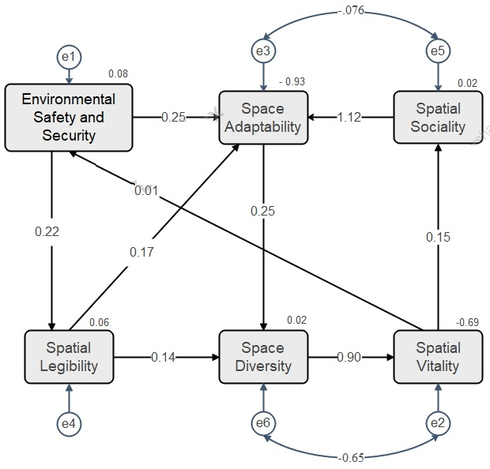
Figure 2. Final and modified model by Amos software

The fit indicators of the model are presented in Table 5.

Table 5. Fit Indices of the model
Reference | Comment | Current Model | Indices
(Kline, 2023) | Perfect fit | .996 | Goodness of Fit Index (GFI)
(Jöreskog & Sörbom, 2001) | Perfect fit | .977 | Adjusted Goodness of Fit Index (AGFI)
(Byrne, 2016) | Perfect fit | .804 | P
(Byrne, 2016) | Perfect fit | 1.624 | CMIN
- | Perfect fit | 4 | DF
(Kline, 2023) | Perfect fit | .406 | CMIN/DF
(Hu & Bentler, 1999) | Perfect fit | 1.237 | Tucker-Lewis Index (TLI)
(Tabachnick & Fidell, 2021) | Perfect fit | .969 | Bentler-Bonett Normed Fit Index (NFI)
(Tabachnick & Fidell, 2021) | Perfect fit | 1.000 | Comparative Fit Index (CFI)
(Hooper et al., 2008) | Perfect fit | .000 | Root Mean Square Error of Approximation (RMSEA)

According to Table 5, the goodness of fit index (GFI) and the adjusted goodness of fit index (AGFI) for the research model are 0.996 and 0.977, respectively, indicating an excellent fit. The p-value associated with the chi-square test is 0.804, which is greater than the 0.05 threshold, suggesting that the difference between the observed data and the proposed model is not statistically significant and the model fits the data well. The root-mean-square error of approximation (RMSEA) is 0.000, further confirming an excellent model fit. Overall, these fit indices demonstrate that the modified model is highly consistent with the observed data.
The coefficient of determination (R²) for each component indicates the proportion of variance explained by the model. Spatial Sociality and Space Diversity account for approximately 2% of their respective variances, Spatial Legibility explains about 6%, Environmental Safety and Security explains 7%, Spatial Vitality explains 68%, and Space Adaptability explains 93%. These results show that while the model strongly explains Space Adaptability and Spatial Vitality, other components are less strongly predicted, highlighting potential areas for refinement in future research. Table 6 presents the proportion of variance explained (R²) for each urban green space design component in the model.
Table 6. Squared Multiple Correlations
Component | R2 | R
Spatial sociality | .024 | 0.15
Space Diversity | .022 | 0.14
Spatial Legibility | .060 | 0.24
Space Adaptability | .933 | 0.96
Spatial Vitality | .685 | 0.82
Environmental Safety and Security | .077 | 0.27
According to Table 7, which presents the estimated measurement errors of the variables and their significance, the model can potentially be expanded at points e1, e4, e5, and e6, as the indirect relationships associated with these points suggest opportunities for refinement. In contrast, points e2 and e3, corresponding to the factors 'Spatial Vitality' and 'Space Adaptability,' indicate that these components are well-explained by the model and do not require modification.
Table 7. Variance of variables in the final model and estimation of operating errors
Factor | Operating Error | Estimate | S.E. | C.R. | P
Environmental Safety and Security | E1 | 32.250 | 4.083 | 7.898 | ***
Spatial Vitality | E2 | 15.861 | 13.027 | 1.218 | .223
Space Adaptability | E3 | 17.015 | 17.452 | .975 | .330
Spatial Legibility | E4 | 5.539 | .701 | 7.897 | ***
Space Diversity | E6 | 3.259 | .412 | 7.905 | ***
Spatial Sociality | E5 | 4.223 | .534 | 7.906 | ***
The research model also defines cycles known as synergy cycles, in which each design component evolves over time, reinforcing and enhancing the others. Three primary cycles can be identified within the current research model: the "Diverse and Lively Space" cycle, the "Adaptive and Social Space" cycle, and the "Security and Legibility of the Space" cycle. The cycles mentioned are further explained below:
"The Cycle of Adaptive and Social Space" (Figure 3) encompasses space diversity, Spatial Vitality, spatial sociality, and space adaptability. This cycle highlights how spatial adaptability in UGSs fosters diversity, ultimately enhancing vitality and Sociality. As a consequence, increased spatial sociality affects space adaptability, contributing to improved health outcomes for UGSs residents over time.
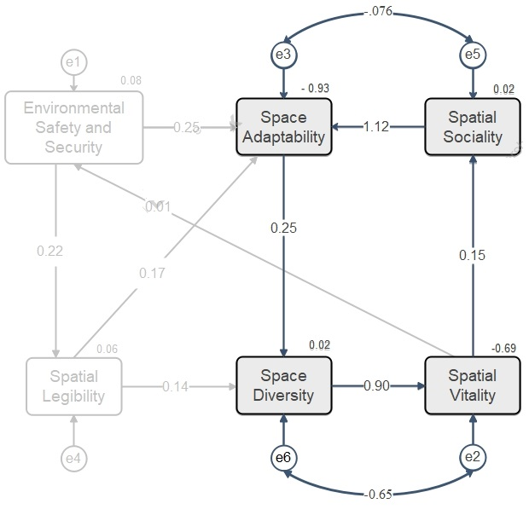
Figure 3. The cycle of adaptive and social space
"The Cycle of Security and Legibility of the Space" (Figure 4) includes components such as environmental safety and security, spatial legibility, space diversity, and spatial vitality. This cycle underscores how spatial diversity enlivens the space and, through spatial vitality, enhances environmental safety and security. Ultimately, improved spatial legibility positively impacts spatial diversity again. Over time, the interaction among these factors enhances the health of residents visiting UGSs.
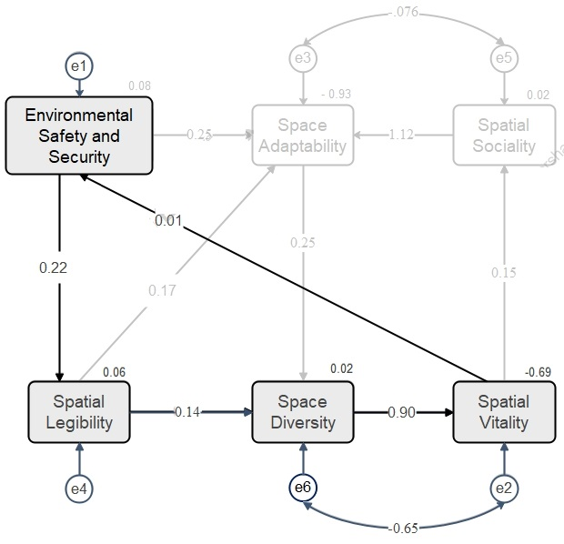
Figure 4. The cycle of security and Legibility of the space
"The Cycle of Diverse and Lively Space" (Figure 5) integrates space diversity, spatial vitality, environmental safety and security, and space adaptability. This cycle illustrates how spatial diversity promotes vitality, which in turn enhances environmental security and safety and facilitates spatial adaptability to user needs. This positive feedback loop ultimately enhances spatial diversity over time, culminating in improved health outcomes for UGSs residents.
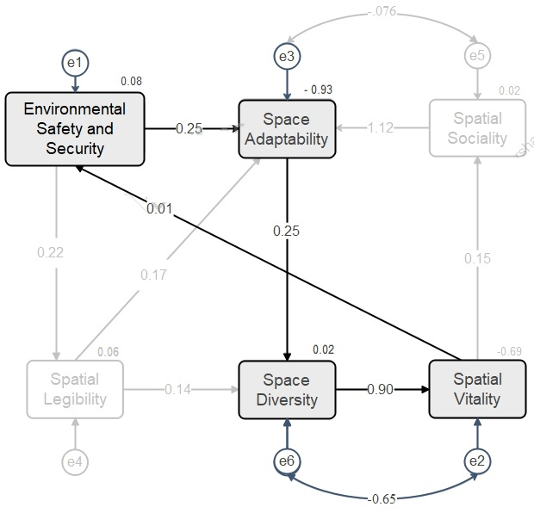
Figure 5. The cycle of diverse and lively space
Discussion
To address the first research question, an R-factor analysis was conducted on questionnaires completed by residents visiting UGSs. The analysis identified six key components of therapeutic landscape design in UGSs: Environmental Safety and Security, Spatial Vitality, Space Adaptability, Spatial Legibility, Spatial Sociality, and Space Diversity. Each of these components is discussed in detail below.
Environmental safety and security are closely related to satisfaction with the space, further promoting mental well-being and overall quality of life (Bentley et al., 2005). Spaces perceived as safe and calming, such as well-lit pathways, clear sightlines, and focal points, enhance both physical security and psychological comfort, supporting overall well-being.
Spatial sociality represents a key preference in UGSs, as socially supportive environments encourage interaction, shared activities, and informal encounters, all of which are associated with improved mental and social health. Research suggests that spaces enabling such interactions also promote more active lifestyles and repeated use, thereby amplifying their health benefits over time (Owens et al., 2024). In UGSs features that support sociality include layout arrangements that create clear visual connections between areas, centrally located gathering points, covered walkways and pavilions, tiered or stepped seating structures, and transparent or semi-transparent barriers that define spaces without obstructing sightlines.
Space diversity is linked to users’ preferences and perceived health benefits. Diverse spatial configurations, such as variations in scale, enclosure, and height; a mixture of open lawns, terraces, and intimate corners; and a range of visual stimuli including vegetation patterns, textures, and materials, can accommodate a wide spectrum of users and activities. These architectural features, alongside diverse circulation paths and spatial sequences, not only support movement and reduce sedentary behavior but also enhance psychological restoration and positive environmental appraisal (Russo, 2024).
Spatial vitality enhances engagement with the environment, ultimately contributing positively to users’ psychological well-being (Jia et al., 2016; Shao & Liu, 2016). Vital and sensory experiences understood as sensory richness and experiential stimulation, plays a significant role in enhancing health outcomes. In UGSs, vitality can be realized through dynamic features such as human movement and activity patterns, water elements, layered vegetation, the presence of birds or small domestic animals, and other sensory and kinetic stimuli.
Spatial legibility in UGSs influences users’ sense of comfort and safety within green environments. Research indicates that low legibility in dense or visually complex landscapes can trigger stress or fear responses (An et al., 2004). Therefore, clear spatial structure and ease of orientation support accessibility and reduce uncertainty, which is particularly important for vulnerable users.
Finally, space adaptability emerges as a critical preference associated with long-term health benefits. Flexible environments that support changing activities and user participation encourage physical activity, social interaction, and emotional engagement (Nutsford et al., 2013). In UGSs, adaptable environments that respond to users’ needs and support inclusive participation facilitate engagement with the environment for all community members, ultimately contributing to individuals’ psychological and social well-being.
These findings highlight the design elements that can influence health and well-being. Prioritizing adaptability and vitality, alongside safety, legibility, social interaction, and diversity, can help urban planners create therapeutic landscapes that are inclusive, resilient, and supportive of physical, mental, and social health.
To address the second research question, three interrelated cycles emerging from the research model illustrate how design elements in UGSs interact to promote health and well-being.
- Adaptive and Social Space Cycle: When UGSs are designed to accommodate multiple uses, they foster vibrant, diverse, and inclusive environments. Active, adaptable spaces encourage social interaction and community engagement across different ages, abilities, and social backgrounds. This interaction, in turn, reinforces adaptability, creating a positive loop that enhances visitor health, well-being, and inclusivity. Features such as walking paths, playgrounds, seating areas, and event spaces support this cycle by providing flexible opportunities for participation.
- Security and Legibility Cycle: The diversity and vitality of a space contribute to perceived safety and ease of navigation. Clear signage, well-maintained paths, and accessible routes enhance both legibility and security, encouraging more frequent use. Diverse vegetation and open spaces further support these aspects, making the environment more enjoyable and promoting physical and mental health.
- Diverse and Lively Space Cycle: Spatial diversity, including varied vegetation, activity zones, and architectural features, enhances vitality, safety, and adaptability. Flexible spaces accommodate multiple functions, from public events to informal gatherings, while diverse natural and built elements create engaging experiences for all users. Over time, these features strengthen social cohesion, promote health benefits, and support inclusive participation.
These cycles emphasize the dynamic and interconnected nature of UGS design, showing that vitality, safety, legibility, adaptability, sociality, and inclusivity work together to enhance physical, mental, and social well-being. Overall, integrating these synergistic strategies can guide policies and planning practices to create resilient, inclusive, and health-promoting urban landscapes.
The study has some limitations. The sample size imposes constraints, and the data were collected from only two urban parks, which may affect generalizability. Cultural and geographical contexts could influence perceptions of safety, vitality, and social interaction. Additionally, the cross-sectional design limits causal interpretations. Future research should employ larger, longitudinal, and multi-city studies to validate these cycles and refine design guidelines for diverse urban contexts.

Conclusion
This study was conducted to investigate the design components of UGSs that contribute to their therapeutic potential and to develop a framework elucidating the causal pathways through which these components influence physical, mental, and social well-being. It conceptualizes therapeutic UGSs through the dynamic healing cycles, offering a novel framework.
Using a three-stage mixed-methods approach, including document analysis, expert-informed questionnaire development, and a user survey combined with structural equation modeling, the research identifies six core spatial components for therapeutic landscapes: environmental safety and security, spatial vitality, space adaptability, spatial legibility, spatial sociality, and space diversity.
The findings highlight the foundational role of environmental safety and security in shaping perceptions of comfort and psychological ease, thereby supporting prolonged use, restorative experiences. Spatial vitality and space adaptability emerge as critical drivers of user participation and flexibility, enhancing mental stimulation and opportunities for diverse activities accessible to all users. Spatial sociality and space diversity facilitate social interaction and choice, promoting community well-being and inclusive participation, whereas spatial legibility ensures cognitive clarity and ease of navigation, mitigating stress and cognitive load for residents.
Building on these results, the study introduces three theoretical healing cycles, Adaptive and Social Space, Security and Legibility, and Diverse and Lively Space, which conceptualize how interrelated design components dynamically reinforce each other to promote long-term health benefits. This framework underscores the importance of a holistic, people-centered approach to UGS design, integrating multiple dimensions to maximize therapeutic impact.
While the proposed model offers a conceptual and exploratory contribution for urban planners and landscape designers, its empirical generalizability is limited by the cross-sectional design, sample size, and context. Future research should validate and refine the framework using larger, longitudinal, and cross-cultural datasets, and examine interactions between design features and residents’ health outcomes to determine which combinations most effectively promote well-being. Despite these limitations, the model provides actionable guidance for designing adaptive, safe, socially engaging, and health-promoting UGSs, supporting the creation of resilient, inclusive, and well-being-oriented urban environments.

Health’s Dimensions

Space Adaptability
Environmental physics
Space Diversity
Spatial vitality
Spatial Sociality
Spatial legibility
Environmental safety and security
Environmental perception
Environmental behaviors
Psychological Health
Physical Health
Social security
Safe pathways
Ease of movement
Physical security
Monitorability
Environment visibility
Permeability
Simplicity of spatial understanding
Spatial transparency
Variety of spatial forms, features, and sensory elements
Variety of environmental uses
Sensory engagement
Visual and focal interest
Presence of space
Opportunities for movement and activity
Opportunities for social activities, Opportunities for social interaction
Availability of usable space
Centralized spaces and focal points
Social Health
Environmental activities
Opportunities for inclusive participation
Ability to adapt and modify the environment according to users’ needs and preferences
Ease of use of the environment
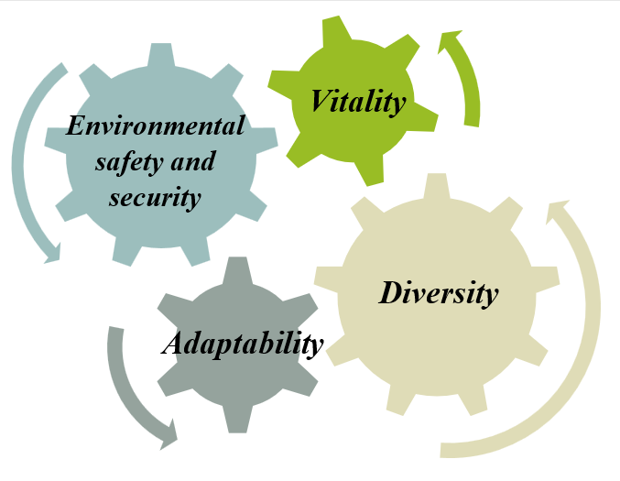
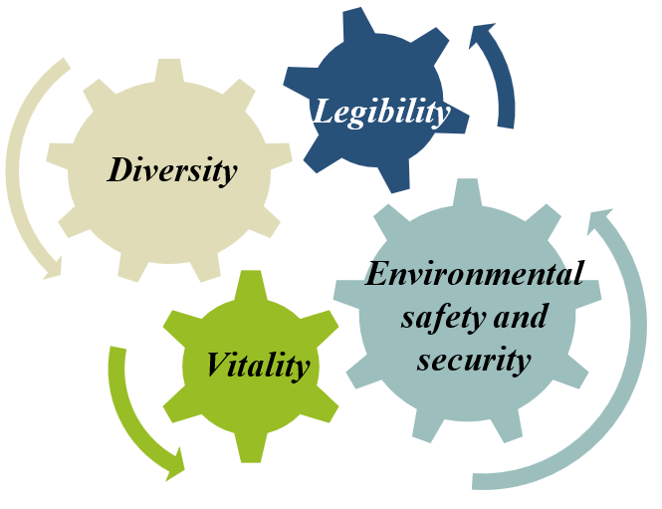
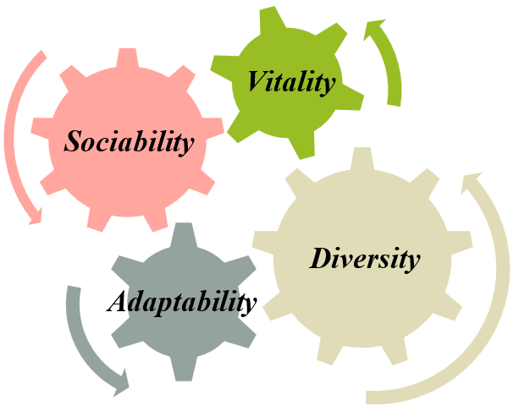
The cycle of diverse and lively environment
The cycle of security and Legibility of the environment
The cycle of adaptive and social environment

Figure 6. Promotion of various dimensions of health of residents visiting UGSs through therapeutic landscape design components
Declarations
Conflict of interest
All authors certify that they have no affiliations with or involvement in any organization or entity with any financial interest or non-financial interest in the subject matter or materials discussed in this manuscript.
Author Contributions
The authors contributed equally to the conceptualization and writing of the article. All of the authors approved the content of the manuscript and agreed on all aspects of the work, with no declaration of competing interests.
Funding
No funds, grants, or other support was received.
Data Availability Statement
The data supporting the findings of this study are available from the corresponding author upon reasonable request. Due to confidentiality agreements with study participants, some data may be restricted to protect privacy. The datasets generated and analyzed during the current study are not publicly available but can be shared with qualified researchers upon request and with permission from the institutional review board.
Acknowledgments
We are grateful to all the scientific consultants for this paper.
References
- An, K. W., Kim, E. I., Jeon, K. S., & Setsu, T. (2004). Effects of forest stand density on human’s physio psychological changes. J. Fac. Agric, 49, 283–291.
- Bengtsson, A., & Grahn, P. (2014). Outdoor environments in healthcare settings: A quality evaluation tool for use in designing healthcare gardens. Urban Forestry & Urban Greening, 13(4), 878–891. https://doi.org/10.1016/j.ufug.2014.09.007
- Bentley, A., Elkek, A., Morin, P., McGlynn, S., & Smith, G. (2005). Responsive environments. Elsevier Ltd.
- Bratman, G. N., Anderson, C. B., Berman, M. G., Cochran, B., de Vries, S., Flanders, J., Daily, G. C., Folke, C., Frumkin, H., Gross, J. J., Hartig, T., Kahn, P. H., Jr, K., M., Lawler, J. J., Levin, P. S., Lindahl, T., Meyer-Lindenberg, A., Mitchell, R., Ouyang, Z.,…Daily, G. C. (2019). Nature and mental health: An ecosystem service perspective. Science Advances, 5(7). https://doi.org/10.1126/sciadv.aax0903
- Brown, R. D., & Corry, R. C. (2011). Evidence-Based Landscape Architecture: The Maturing of a Profession. Landsc. Urban Plan., 100, 327–329. https://doi.org/10.1016/j.landurbplan.2011.01.017
- Bull, G., Evans, S., Knight, J., Shackell, A., Tisdall, R., & Westley, M. (2013). Public health and landscape: Creating healthy places. Landscape Institute. London, England: Retrieved.
- Byrne, B. M. (2016). Structural equation modeling with Amos. (3rd ed.). Routledge, Taylor Frances.
- Callaghan, A., McCombe, G., Harrold, A., McMeel, C., Mills, G., Moore-Cherry, N., & Cullen, W. (2021). The Impact of Green Spaces on Mental Health in Urban Settings: A Scoping Review. Journal of Mental Health, 30, 179–193. https://doi.org/10.1080/09638237.2020.1755027
- Caniano, G. M. (2006). An Integrative Approach to Therapeutic Outdoor Spaces in Dementia-Care Units Virginia Tech].
- Carp, F. M., Zawadski, R. T., & Shokrkon, H. (1976). Dimensions of urban environmental quality. Environment and behavior, 8(2), 239–264.
- Chen, M., & Lin, G. (2023). How perceived sensory dimensions of urban green spaces affect cultural ecosystem benefits: A study on Haizhu Wetland Park, China. Urban Forestry & Urban Greening, 86. https://doi.org/10.1016/j.ufug.2023.127983
- Crossley, A. J., & Russo, A. (2022). Has the Pandemic Altered Public Perception of How Local Green Spaces Affect Quality of Life in the United Kingdom? Sustainability, 14, 7946. https://doi.org/10.3390/su14137946
- Dietz, L. W., Šćepanović, S., Zhou, K., Zanella, A. F., & Quercia, D. (2024). Understanding the potential of urban parks to promote well-being. Nature Cities, 2, 1205–1216. https://doi.org/10.1038/s44284-025-00345-4
- Dul, J., & Weerdmeester, B. (2018). Ergonomics for beginners: a quick refernce quide (6th ed.). Markaz Nashr.
- Eisenman, T. S. (2013). Frederick Law Olmsted, Green Infrastructure, and the Evolving City. J. Plan. Hist. , 12, 287–311. https://doi.org/10.1177/1538513212474227
- Elsadek, M., Liu, B., & Xie, J. (2020). Window view and relaxation: Viewing green space from a high-rise estate improves urban dwellers’ wellbeing. Urban Forestry & Urban Greening, 55, 126846. https://doi.org/10.1016/j.ufug.2020.126846
- Enssle, F., & Kabisch, N. (2020). Urban green spaces for the social interaction, health and well-being of older people- An integrated view of urban ecosystem services and socio-environmental justice. Environmental Science & Policy, 109, 36–44. https://doi.org/10.1016/j.envsci.2020.04.008
- Falagas, M. E., Bliziotis, I. A., Kosmidis, J., & Daikos, G. K. (2010). Unusual climatic conditions and infectious diseases: observations made by Hippocrates. Enfermedades infecciosas y microbiologia clinica, 28(10), 716–718. https://doi.org/10.1016/j.eimc.2009.11.013
- Follman, A., & Viehoff, V. (2015). A green garden on red clay: creating a new urban common as a form of political gardening in Cologne, Germany. Local Environment. , 20 (10), 1148–1174. https://doi.org/10.1080/13549839.2014.894966
- Gerlach-Spriggs, N., Kaufman, R. E., & Warner, S. B. (2004). Restorative gardens: The healing landscape. Yale University Press.
- Gesler, W. M. (2003). Healing places. roman and Littlefield publishers.
- Grutter, J. K. (2022). Aesthetics in Architecture. Shahid Beheshti University Press.
- Gubbels, J. S., Kremers, S. P. J., Droomers, M., Hoefnagels, C., Stronks, K., Hosman, C., & de Vries, S. (2016). The impact of greenery on physical activity and mental health of adolescent and adult residents of deprived neighborhoods: A longitudinal study. Health & Place, 40(153-160). https://doi.org/10.1016/j.healthplace.2016.06.002
- Haq, S. M., Islam, M. N., Siddhanta, A., Ahmed, K. J., & Chowdhury, M. T. A. (2021). Public Perceptions of Urban Green Spaces: Convergences and Divergences. Front. Sustain. Cities, 3, 755313. https://doi.org/10.3389/frsc.2021.755313
- Hartig, T., van den Berg, A. E., Hagerhall, C. M., Tomalak, M., Bauer, N., Hansmann, R., Ojala, A., Syngollitou, E., Carrus, G., van Herzele, A., Bell, S., Podesta, M. T. C., & Waaseth, G. (2011). Health Benefits of Nature Experience: Psychological, Social and Cultural Processes. In K. Nilsson, M. Sangster, C. Gallis, T. Hartig, S. de Vries, K. Seeland, & J. Schipperijn (Eds.), Forests, Trees and Human Health (pp. 127–168). Springer Netherlands. https://doi.org/10.1007/978-90-481-9806-1_5
- Hill, T. R., & Think, L. (2008). Using Color to Create Healing Environments. DuPont.
- Hooper, D., Coughlan, J., & Mullen, M. (2008). Structural equation modelling: Guidelines for determining model fit. The Electronic Journal of Business Research Methods, 6(1).
- Hu, L., & Bentler, P. M. (1999). Cutoff criteria for fit indexes in covariance structure analysis: Conventional criteria versus new alternatives. Structural Equation Modeling. A Multidisciplinary Journal, 6(1-55). https://doi.org/10.1080/10705519909540118
- Hunter, R. F., Cleland, C., Cleary, A., Droomers, M., Wheeler, B. W., Sinnett, D., Nieuwenhuijsen, M. J., & Braubach, M. (2019). Environmental, health, wellbeing, social and equity effects of urban green space interventions: A meta-narrative evidence synthesis. Environment International, 130, 104923. https://doi.org/10.1016/j.envint.2019.104923
- Jabbar, M., Yusoff, M. M., & Shafie, A. (2022). Assessing the Role of Urban Green Spaces for Human Well-Being: A Systematic Review. GeoJournal, 87, 4405–4423. https://doi.org/10.1007/s10708-021-10474-7
- Janssen, I., & LeBlanc, A. G. (2010). Systematic review of the health benefits of physical activity and fitness in school-aged children and youth. Int. J. Behav. Nutr. Phys. Act. , 7(40). https://doi.org/10.1186/1479-5868-7-40
- Jennings, V., & Bamkole, O. (2019). The Relationship between Social Cohesion and Urban Green Space: An Avenue for Health Promotion. International Journal of Environmental Research and Public Health, 16(3), 452. https://doi.org/10.3390/ijerph16030452
- Jia, M., Jin, H. X., & Wang, S. F. (2016). On the Progress of Research of Landscape Plant Volatile Compounds and Their Influence on Human Health in Rehabilitation Landscape. Chin. Landsc. Archit., 13, 26–31.
- Jöreskog, K., & Sörbom, D. (2001). Lisrel 8: Users Reference Guide. Scientific Software International Inc.
- Kaplan, R. (2017). Psychological Testing: Principles, Applications, and Issues (9th ed.). Wadsworth Publishing.
- Kaplan, R., & Kaplan, S. (2009). The experience of nature: a psychological
- perspective. Cambridge University Press.
- Kawakami, N., Winkleby, M., Skog, L., Szulkin, R., & Sundquist, K. (2011). Differences in neighborhood accessibility to health-related resources: a nationwide comparison between deprived and affluent neighborhoods in Sweden. Health & Place, 17(1), 132–139. https://doi.org/10.1016/j.healthplace.2010.09.005
- Kline, R. B. (2023). Principles and Practice of Structural Equation Modeling: A Researchers Guide (5th ed.). Guilford.
- Kuklina, V., Sizov, O., & Fedorov, R. (2021). Green spaces as an indicator of urban sustainability in the Arctic cities: case of Nadym. Pol. Sci., 29, 100672. https://doi.org/10.1016/j.polar.2021.100672
- Lee, A. C. K., Jordan, H. C., & Horsley, J. (2015). Value of Urban Green Spaces in Promoting Healthy Living and Wellbeing: Prospects for Planning. Risk Manag. Healthc. Policy, 8, 131–137. https://doi.org/10.2147/RMHP.S61654
- Malkin, J. (2003). Healing environments as the Century mark: The quest for optimal patient experiences. The architecture of hospitals. NAi Publishers.
- Marcus, C. C. (2007). Healing gardens in hospitals. Interdisciplinary design and research e-Journal, 1(1), 1–27.
- Marcus, C. C., & Barnes, M. (1996). Gardens in Healthcare Facilities: Uses, Therapeutic Benefits, and Design Recommendations. Center for Health Design.
- Marcus, C. C., & Barnes, M. (1999). Healing Gardens: Therapeutic benefits and design recommendations (Vol. 4). John Wiley & Sons.
- Mayen Huerta, C. (2023). Understanding the pathways between the use of urban green spaces and self-rated health: A case study in Mexico City. PLoS One., 18(12), e0295013. https://doi.org/10.1371/journal.pone.0295013
- Mishra, H., Bell, S., Vassiljev, P., Kuhlmann, F., Niin, G., & Grellier, J. (2020). The development of a tool for assessing the environmental qualities of urban blue spaces. Urban For. Urban Green, 49, 1–11. https://doi.org/10.1016/j.ufug.2019.126575
- Moztarzadeh, H., & Mohajer, E. (2020). Effect of Green Space on Resident’s Place Attachment in Residential Spaces. IJAUD, 10(2), 13–24. https://doi.org/10.30495/IJAUD.2020.15846
- Mukherjee, M., & Takara, K. (2018). Urban green space as a countermeasure to increasing urban risk and the UGS-3CC resilience framework. Int. J. Dis. Risk Reduc. , 28, 854–861. https://doi.org/10.1016/j.ijdrr.2018.01.027
- Nesmith, E. L. (1995). Health Care Architecture: Designs for the Future. The American Institute of Architects Press.
- Nutsford, D., Pearson, A. L., & Kingham, S. (2013). An ecological study investigating the association between access to urban green space and mental health. Public Health, 127(11), 1005–1011.
- Oberlin, J. (2008). Evidence that pediatric settings can heal. Health Care Design.
- Olszewska-Guizzo, A., Sia, A., Fogel, A., & Ho, R. (2022). Features of Urban Green Spaces Associated with Positive Emotions, Mindfulness and Relaxation. Sci. Rep, 12, 20695. https://doi.org/10.1038/s41598-022-24637-0
- Owens, E. P., Koo, J., & Huang, Y. (2024). Outdoor Environments for People Considering Human Factors in Landscape Design. https://doi.org/10.4324/9781315100036
- Pastore, M. C., Parenti, C. I. M., & Patetta, C. (2025). Measuring Accessibility of Green Spaces for the Health and Wellbeing of Inhabitants of the Milan Metropolitan Area. Land, 14(1), 97. https://doi.org/10.3390/land14010097
- Patwary, M. M., Bardhan, M., İnan, H. E., Browning, M. H. E. M., Disha, A. S., Haque, M. Z., Helmy, M., Ashraf, S., Dzhambov, A. M., Shuvo, F. K., Alam, M. A., Billah, S. M., Kabir, M. P., Hossain, M. R., Azam, M. G., Rahman, M. M., Swed, S., Sah, R., Montenegro-Idrogo, J. J.,…Rodriguez-Morales, A. J. (2024). Exposure to urban green spaces and mental health during the COVID-19 pandemic: evidence from two low and lower-middle-income countries. Front. Public Health, 12, 1334425. https://doi.org/10.3389/fpubh.2024.1334425
- Rapaport, A. (2005). The meaning of the built environment. Publications of Urban Processing and Planning Company.
- Russo, A. (2024). Urban Green Spaces and Healthy Living: A Landscape Architecture Perspective. Urban Science, 8(4), 213. https://doi.org/10.3390/urbansci8040213
- Sato, Y., & Zenou, Y. (2015). How urbanization affect employment and social interactions. Eur Econ Rev., 75, 55–131. https://doi.org/10.1016/j.euroecorev.2015.01.011
- Shao, Y., & Liu, B. (2016). A Study on Microclimate Parameters of Urban Street Space and Its Influential Factors. Landsc. Archit., 10, 98–104.
- Stigsdotter, U. K. (2015). Nature, Health and Design. Alam Cipta., 8, 89–96.
- Tabachnick, B. G., & Fidell, L. S. (2021). Using multivariate statistics. Allyn & Bacon/Pearson Education.
- Tabassum, M. (2025). Understanding urban green spaces through lenses of sensory experience: a case study of neighborhood parks in Dhaka city. The Senses and Society, 20(1), 62–94. https://doi.org/10.1080/17458927.2024.2392960
- Taghipour, M., Azamati, S., & Mohajer, E. (2022). Investigating the Effective Components in the Design of Residential Complex Spaces Based on Enhancing Residents’ Public Health. Modern Architectural Research, 1(3). https://doi.org/10.5281/zenodo.18007070
- Thompson, C. W. (2011). Linking Landscape and Health: The Recurring Theme. Landsc. Urban Plan., 99, 187–195. https://doi.org/10.1016/j.landurbplan.2010.10.006
- Triguero-Mas, M., Dadvand, P., Cirach, M., Martínez, D., Medina, A., Mompart, A., & Nieuwenhuijsen, M. J. (2015). Natural outdoor environments and mental and physical health: Relationships and mechanisms. Environment International, 77, 35–41. https://doi.org/10.1016/j.envint.2015.01.012
- Twohig-Bennett, C., & Jone, A. (2018). The health benefits of the great outdoors: A systematic review and meta-analysis of greenspace exposure and health outcomes. Environmental Research, 166, 628–637. https://doi.org/10.1016/j.envres.2018.06.030
- Ulrich, R. S. (1999). Effects of gardens on health outcomes: Theory and research. In C. C. Marcus & M. Barnes. (Eds.), Healing Gardens: Therapeutic Benefits and Design Recommendations. Whiley.
- Ulrich, R. S., Simons, R. F., Losito, B. D., Fiorito, E., Miles, M. A., & Zelson, M. (1991). Stress recovery during exposure to natural and urban environments. Journal of Environmental Psychology, 11(3), 201–230. https://doi.org/10.1016/S0272-4944(05)80184-7
- Ulrich, R. S., Zimring, C., Zhu, X., DuBose, J., Seo, H. B., Choi, Y. S., X., Q., & Joseph, A. A. (2008). Review of the research literature on evidence-based healthcare design. HERD, 1(3), 61–125. https://doi.org/10.1177/193758670800100306
- Van den Berg, A. E. (2005). Health impacts of healing environments; a review of evidence for benefits of nature, daylight, fresh air, and quiet in healthcare settings. UMCG.
- Van den Berg, A. E., Maas, J., Verheij, R. A., & Groenewegen, P. P. (2010). Green space as a buffer between stressful life events and health. Social Science & Medicine, 70(8), 1203–1210.
- Veen, E. J., Ekkel, E. D., Hansma, M. R., & de Vrieze, A. G. M. (2020). Designing Urban Green Space (UGS) to Enhance Health: A Methodology. International Journal of Environmental Research and Public Health, 17(14), 5205. https://doi.org/10.3390/ijerph17145205
- Velarde, M., Fry, G., & Tveit, M. (2007). Health effects of viewing landscapes-Landscape types in environmental psychology. Journal of Urban Forestry & Urban greening, 6(4), 199–212. https://doi.org/10.1016/j.ufug.2007.07.001
- Vitruvius. (2018). The Ten Books on Architecture (Classic Reprint edition ed.). Forgotten Books.
- Wang, K., Li, Z., Zhang, J., Wu, X., Jia, M., & Wu, L. (2020). Built-up land expansion and its impacts on optimizing green infrastructure networks in a resource-dependent city. Sustainable Cities and Society, 55(102026). https://doi.org/10.1016/j.scs.2020.102026
- WHO. (2017). Urban Green Space Interventions and Health: A review of impacts and effectiveness. World Health Organization - Regional Office for Europe. https://www.who.int/europe/publications/urban-green-space-interventions-and-health--a-review-of-impacts-and-effectiveness.-full-report
- WHO. (2025). Health and Well-Being. World Health Organization. . World Health Organization. https://www.who.int/data/gho/data/major-themes/health-and-well-being#:~:text=The%20WHO%20constitution%20states%3A%20%22Health,of%20mental%20disorders%20or%20disabilities
- Wilson, K. C. (2006). The Ecology of Waiting within an Ambulatory Waiting Room, A Student Project for New York. Cornell University.
- Xu, Z., Marini, S., Mauro, M., Maietta Latessa, P., Grigoletto, A., & Toselli, S. (2025). Associations Between Urban Green Space Quality and Mental Wellbeing: Systematic Review. Land, 14(2), 381. https://doi.org/10.3390/land14020381
- Yin, J. D., Fu, P., Cheshmehzangi, A., Li, Z. C., & Dong, J. W. (2022). Investigating the changes in urban green-space patterns with urban land-use changes: a case study in Hangzhou, China. Remote Sens., 14(5410). https://doi.org/10.3390/rs14215410
- Zutter, C., & Stoltz, A. (2023). Community gardens and urban agriculture: Healthy environment/healthy citizens. International Journal Mental Health Nursing, 32, 1452–1461. https://doi.org/10.1111/inm.13149

* Corresponding Author: Email: Ellie.mohajer@gmail.com

