From Simplicity to Intricacy: Understanding Architectural Complexity in Modern Iran Using Box-Counting Method
Amirsam Saadati, Elham Parvizi*, Ghazal Taghilou, Shahnaz Dehghani, Aida Dehghani

Abstract
Residential building facades play a crucial role in defining the visual identity and character of urban spaces, significantly influencing individuals' perceptions. This study examines the visual complexity of residential facades in award-winning buildings from Iran's Memar architectural competition (2016–2024); The Memar Award, issued yearly by Memar Magazine, is considered one of the top architectural accolades in Iran. The research evaluates complexity, encompassing visual, structural, and functional dimensions, through the application of the box-counting method—a fractal analysis technique. By analysing two-dimensional line drawings, the study calculates fractal dimensions to quantify complexity, focusing solely on the impact of lines, excluding other factors such as texture or colour. The findings provide deeper insights into the visual and structural intricacies of facade design, highlighting the role of complexity in enhancing urban aesthetics and shaping residents' experiences. This research underscores the importance of facade complexity in architectural and urban discourse, offering valuable contributions to future design practices and urban planning strategies.

Keywords: Urban facades; Architectural complexity; Box-counting method; Memar Architectural Competition; Residential Buildings; Fractal Analysis

1.Introduction
Facades are essential elements of urban spaces that constitute the foremost impressions retained in the minds of citizens, playing a crucial role in presenting the character and enhancing the quality of urban spaces. Therefore, analysing and understanding the complexities of urban facades are of paramount importance. A significant portion of urban views is

formed by the facades of residential apartment buildings. The complexity of urban facades is closely linked to their visual appeal, affective feelings, and perceptual impact on individuals within the urban environment (Hollander & Anderson, 2020; Hussein, 2020). Recent studies emphasize that objective measurement of this complexity is critical for psychological well-being; as Anklesaria et al. (2025) show, spatial complexity directly associates with cognitive load, making its assessment vital for designing supportive urban environments. While this study does not directly assess psychological or health outcomes, these findings underscore the importance of objectively measuring façade complexity as a prerequisite for understanding its perceptual implications.
However, the visual and geometric complexity of these façades is not readily observable or easily quantifiable through conventional qualitative assessment. Therefore, using two-dimensional line drawings, this study seeks to measure the façade complexity of award-winning architectural projects in Iran, ranked first to third in the Memar Architectural Competition from 2016 to 2024.
Çoban and Okuyucu (2023) utilized the box-counting method to analyze historical public buildings in Afyonkarahisar, demonstrating how façade ordering aligns with the First National Architectural Period. Building on this application, recent research has refined the method's granularity; for instance, Ghouchani (2022) successfully used fractal analysis to decode the structural logic of 'Patkaneh' in Ardestan’s Jame’ Mosque, illustrating its capacity to capture intricate geometric details. This echoes earlier findings by Ediz and Ostwald (2012) on the Süleymaniye Mosque, which highlighted that structural form influences visual complexity more significantly than mere ornamentation. Furthermore, recent scholarship has expanded this scope to commercial typologies; Roodbari (2025) investigated the fractal geometry of Iranian Bazaars, bridging traditional spatial organizations with modern architectural contexts. Collectively, these studies confirm the adaptability of fractal analysis for quantifying the transition from historical simplicity to modern intricacy.
Nevertheless, the complexity of residential apartment buildings' facades, which significantly impact citizens' daily lives and are closely linked to contemporary societal living, has not been thoroughly analysed or investigated. Additionally, as modern facades gain popularity in Iranian architecture, an increase in facade complexity is expected.
While recent studies like Shen et al. (2024) identify a triad of complexity factors—structure, color, and surprise—this research specifically isolates the 'structural density' component. By focusing solely on line drawings, we aim to quantify the pure geometric intricacy of the façade form, independent of chromatic variations or material textures.
Despite extensive applications of fractal analysis in historical and iconic architecture, contemporary residential façades in Iran remain largely underexplored through quantitative methods. Furthermore, the relationship between measurable façade complexity and professional architectural evaluation is still unclear. This study addresses this gap by analyzing the visual complexity of award-winning residential façades from the Memar Architectural Competition using the box-counting method.

1.2. Complexity
A precise distinction must be drawn between 'complexity' and 'intricacy' in architectural analysis. While often used interchangeably, complexity in this context refers to the quantifiable structural organization and information density of a system—specifically, the hierarchical relationships between elements across scales (Salingaros, 2014). In contrast, intricacy describes the perceived visual richness, delicacy of detail, and interweaving of fine-grained patterns that contribute to, but are distinct from, the system's underlying structural order (Kolarevic, 2016). This study adopts a fractal-based approach to measure the former (structural complexity), acknowledging that higher fractal dimensions often correlate with the perceptual quality of the latter (intricacy). Kolarevic (2016) highlights the pervasive nature of complexity across various domains and disciplines, underscoring its contextual dependence for interpretation. Erdi, in his 2008 publication "Complexity Explained," asserted that discussions on complexity typically revolve around the structural intricacies of a system. However, Erdi is not alone in associating complexity with structure. Salingaros (2014) also delves into this connection in his paper, defining complexity as the intricacy of structure and the stored information regarding how a system operates and its composition. He emphasizes that this internal complexity remains unaffected by the system's outward appearance. Salingaros further suggests that a useful albeit constrained gauge of complexity is the Kolmogorov-Chaitin complexity, which measures the number of words required for a reasonably accurate description (Salingaros, 2013). In this context, the approach involves categorizing the elements of form that we wish to assess for complexity and attempting to describe them. The greater the number of words required for description, the higher the complexity. Similarly, Snodgrass & Vanderwart (1980) emphasize that complexity pertains to the quantity or intricacy of elements within a scene. Additionally, the concept of visual complexity has been explored. Visual complexity is contingent upon the number of design elements and the degree of similarity or dissimilarity between them (Berlyne, 1971, p. 149). Variation among visual elements can manifest on two levels: positional and chromatic. Therefore, this interpretation suggests that visual complexity is linked to three variables: the quantity of design elements, as well as the variation in their positioning and coloration (Hussein & Armstrong, 2016, p. 459; Rapoport, 1977, p. 169; Venturi, 1977, p. 20).
Defining complexity in architecture requires careful consideration of the intricate relationships and interactions among architectural elements within a system or product. Architectural complexity is characterized by the degree of intricacy and interconnectedness among components within a system, potentially affecting its design, development, and operational effectiveness (Gao et al., 2015; Jacobs & Swink, 2011). This complexity is shaped by various factors, including the system's structure, the interactions among its components, and the design decisions made throughout its development process.
Architectural complexity extends beyond the physical aspects of a system to include organizational structures and frameworks necessary for effective management and comprehension. It entails integrating subjective domain-specific knowledge to offer a flexible and rational measure of complexity within complex systems and Systems of Systems (SoS) (Gao et al., 2015). Furthermore, the definition of architectural complexity draws from diverse disciplines, including natural and social sciences to establish a comprehensive understanding of the concept (Jacobs & Swink, 2011).
As noted by Jesus Mosterin (2002), complexity, irrespective of its appearance in a pattern is inherently tied to the underlying reproducing algorithm, a series of instructions generating the visual pattern. Algorithms, including fractal dimensions and specifically box-counting, serve to assess complexity. Fractal dimensions are instrumental in measuring an essential aspect of a building's façade: visual complexity. Complexity holds significance as it serves as a predictor of preference, attractiveness, or beauty (Lee and Ostwald, 2021).

1.3. Fractal dimension in Architecture
In the 1970s, mathematician Benoit Mandelbrot introduced the term "Fractal" to distinguish self-repeating structures from smooth Euclidean ones (Figure 1). Since then, Fractals have been identified across various domains, including architecture (Wolfgang, 2009). The term "fractal" originates from Latin and means "divided" or "fragmented." Designers who aim to blend nature and order have recognized that nature possesses an irregular structure, leading them to utilize fractal geometry instead of Euclidean geometry to describe nature. The significant advancement of fractal geometry lies in its ability to unveil the order within chaos. Fractals are distinguished by their ability to provide increasingly intricate details, with each detail exhibiting "self-similarity" rather than repetition. Studies have revealed that even the smallest details in early Gothic cathedrals share the same characteristics as all other cathedrals (Lorenz, 2003:42).
Fractal fictions consist of structures that exhibit similar properties across all dimensions. The concept of self-similarity suggests a relationship between the smallest unit of a structural or formal fiction and the entirety of it (Bovill, 1996:194). This structural fiction is not required to possess identical characteristics in every dimension. While this allows for surprising and similar characteristics in each dimension, it also allows for continuity in the structural fiction (Ibrahim and Krawcyk, 2000:28). Therefore, in a building with the same structure, we can observe that the fiction in the whole is also present in the details when examining an object or a painting. These characteristics can be observed in the Julia Set, which was created by mathematician Gaston Julia (Ibrahim and Krawcyk, 2000:32).

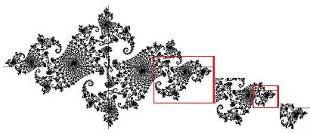
Figure 1. Julia Set (Bovill, 1996:194.)

In architecture, Fractal dimension denotes a mathematical concept gauging the intricacy and self-repetition within architectural shapes. It offers a method to dissect the detailed patterns within designs, unveiling insights into spatial arrangement and visual attributes of buildings. The utilization of fractal dimension in architecture allows for a deeper comprehension of the connection between constructed spaces and natural configurations, emphasizing the interplay among design, nature, and computational examination (Liang et al., 2022).
Research indicates that fractal geometry aptly describes the complexity of architectural formations, presenting a more holistic framework than conventional Euclidean geometry. Through fractal analysis, researchers can capture the nuanced features of architectural environments like self-resemblance, irregularity, and spatial arrangement (Nielsen et al., 1997). This methodology facilitates the evaluation of structural intricacy and architectural self-similarity, offering a means to measure the volume and distribution of intricacies within architectural components (Vaughan & Ostwald, 2017).
Moreover, fractal dimension analysis finds application in various architectural realms, including urban spatial configuration analysis and the examination of architectural distortions in mammograms. By scrutinizing the fractal attributes of urban landscapes and building layouts, researchers can discern relationships between architectural shapes and fractal dimensions, illuminating trends in urban development and spatial alterations (Fan et al., 2022). Furthermore, studies conducted on the forms and decorations used in traditional architecture and urban fabrics confirm the presence of fractal characteristics in them (Crompton, 2002; Salingaros, 2005; 2006; 2008; 2015). In medical imaging, fractal dimension serves to differentiate between normal and distorted architectural patterns, showcasing its adaptability across diverse disciplines (Tourassi et al., 2006).
Overall, integrating fractal dimension analysis into architecture furnishes a potent tool for evaluating the complexity, self-similarity, and spatial structuring of constructed environments. By quantifying the fractal traits of architectural forms, researchers can glean invaluable insights into the underlying patterns and design principles shaping our built surroundings.

1.4. Box-counting Method
The purpose of using Fractals dimension in architecture is to study and explain architectural quality and visual complexity. However, not all architectural forms and views are self-similar, instead, the box-counting method is utilized. This technique derived from fractal geometry and used to calculate the fractal dimension of complex structures (Robinson, 2010). it is a method used to determine the fractal dimension of complex structures, including architectural forms. The fractal dimension is a measure of the complexity and self-similarity of an object. In architecture, the box-counting method has been applied to analyze the complexity and self-similarity of building forms and facades (Ostwald, 2013; Ostwald & Vaughan, 2020; Chalup et al., 2009). Moreover, the box-counting method can also be applied to none-self-similar structures, which is crucial for developing a classification system where any elevation should be measurable (Wolfgang, 2009).
In this method, the calculation of the fractal size is based on the logic of calculating the number of boxes that contain data in a two-dimensional drawing (Figure 2). This is done by dividing the drawing into a grid system and determining the number of boxes that contain relevant information (Çoban & Okuyucu, 2023). Also, as the details increase, the fractal dimension also increases, and the details such as window records, doors, floor moldings (building floors), façade decorations on the façades cause the fractal dimension to be high (Gözübüyük, 2007).

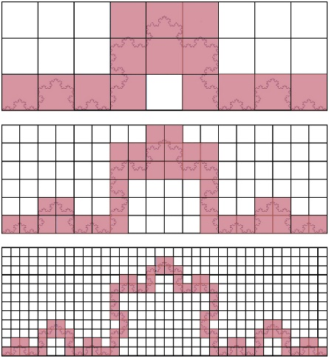
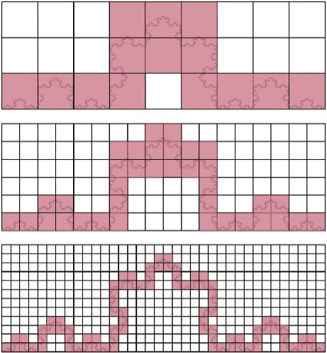
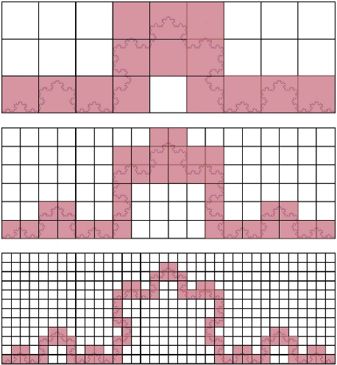
Figure 2. Applying the box-counting method to the Koch curve (Pilgrim & Taylor, 2018)
2. Methodology
The 1st, 2nd, and 3rd places of the Memar annual architectural competition award from 2016 to 2024 were chosen for complexity measurement using the "Box-Counting Method." This method allows us to quantify the complexity of architectural facades by analyzing their fractal dimensions.
To begin, we sourced the existing facade elevations of the award-winning buildings. The process started by standardizing the images, ensuring that both the length and width were equalized, resulting in a uniform aspect ratio of 1:1. This standardization was crucial to maintain consistency in the analysis. Next, we used AutoCAD software to grid the images.

Initially, each image was divided into a 4x4 grid. In this setup, we identified and counted the boxes that contained parts of the facade's lines. This initial grid provided a baseline for our analysis. We then proceeded to refine the
grid, increasing the resolution to capture more details of the facades. The subsequent grid systems used were 8x8, 16x16, 32x32, and finally, 64x64 (Figure 3). At each stage, the boxes containing parts of the facade were counted again. This step-by-step refinement allowed us to observe how the complexity of the facade became more apparent with higher grid resolutions (Figure 7, 8, 9, 10, and 11, respectively).
The data collected from the initial and final grids were then compared using a specific formula as outlined by Ostwald and Vaughan (2008: 27). This formula helped us calculate the fractal value for each cycle of grid refinement, providing a numerical representation of the facade's complexity. By systematically applying the Box-Counting Method across multiple grid scales, we were able to derive detailed fractal values that reflect the intricate designs of these award-winning facades. These values offer insight into the architectural complexity, contributing to a deeper understanding of urban aesthetics and facade design:
D = $\frac{log(x)-log(y)}{log(z)-log(q) }$
D: Fractal value
x: Number of filled boxes counted in the next cycle
y: Number of filled boxes counted in the previous cycle
z: Number of boxes in bottom row in the next cycle
q: Number of boxes in bottom row in the previous cycle (Bovil, 1996, p.194.).
The boxes in which there are lines of materials such as brick joints, wood patterns, stone lines, etc. are assumed as empty boxes, so the complexity caused by the material is not investigated in this article.

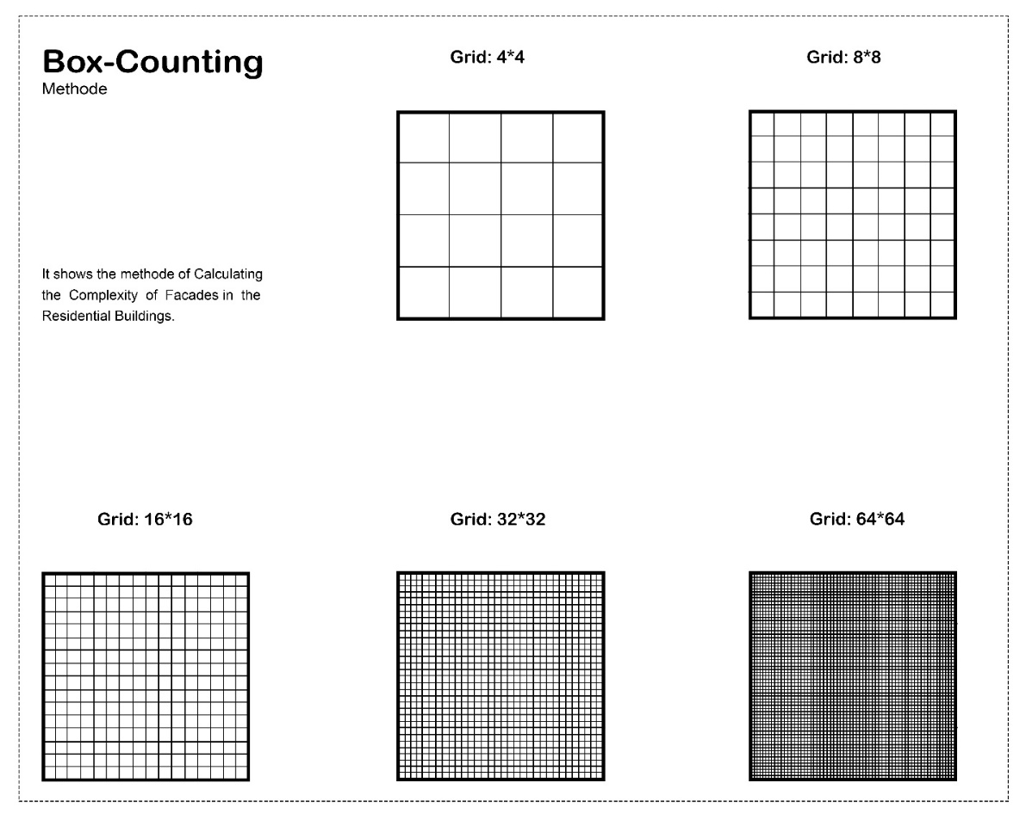
Figure 3. The method of grid framing of the elevations

In Figure 4, you can see the selected samples for analysis.

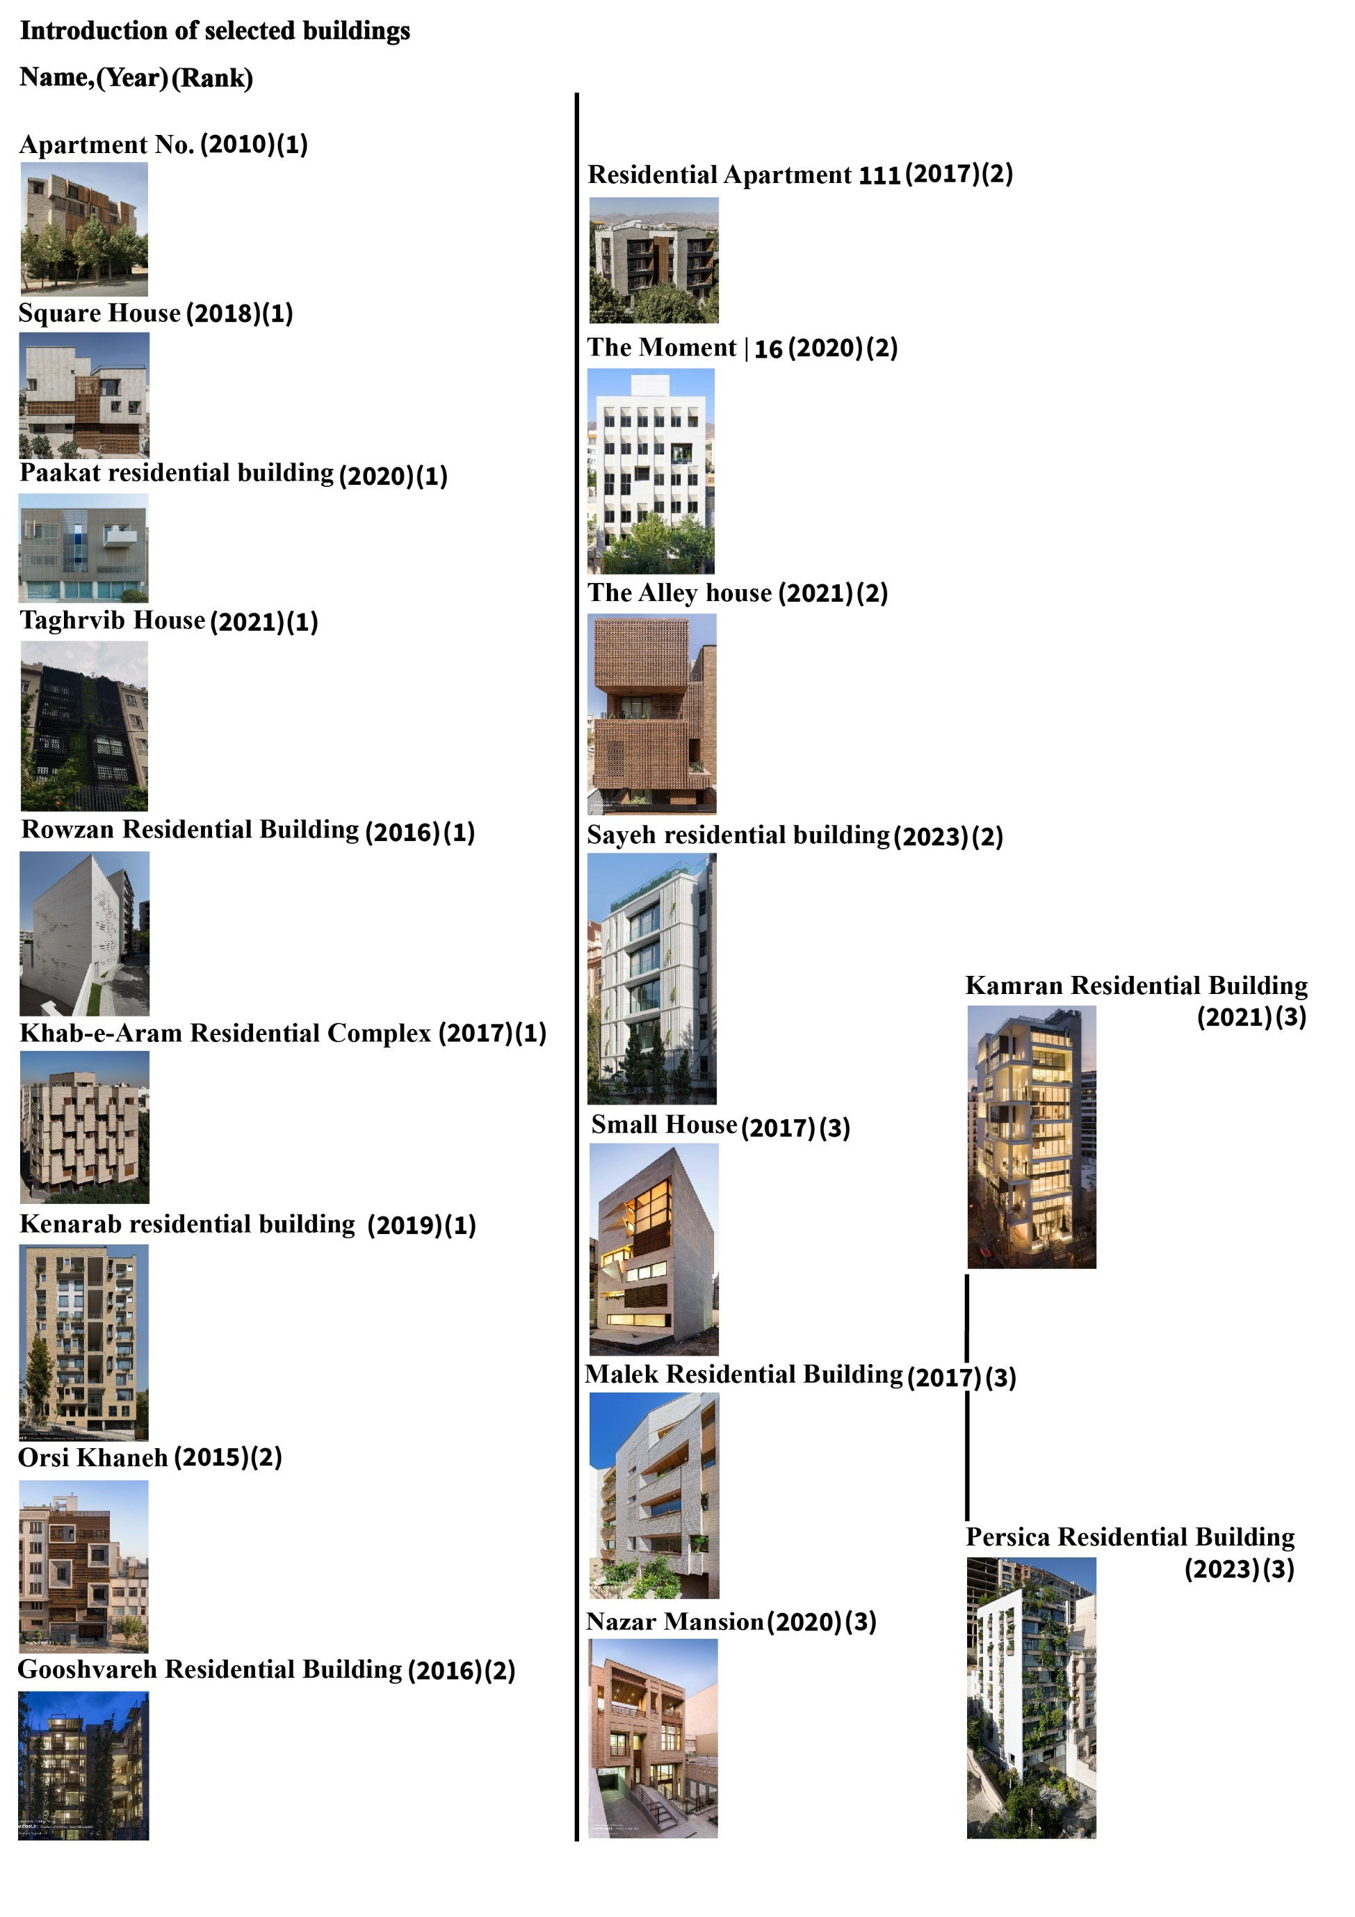
Figure 4. Introduction of selected buildings ranked 1 to 3

Here, we have illustrated the calculation method (Figure 5 to 9) for just one sample named "The Alley House."

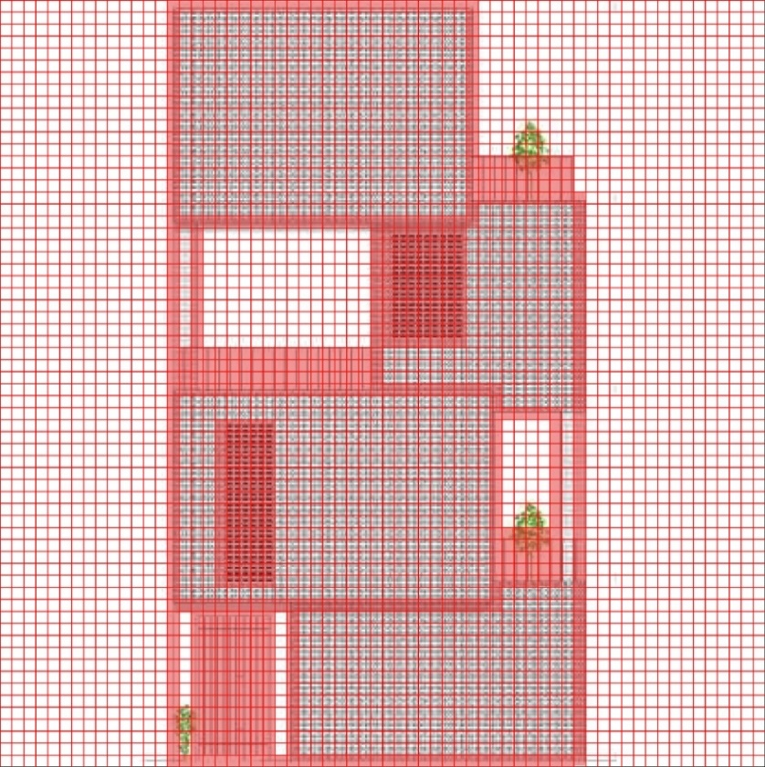
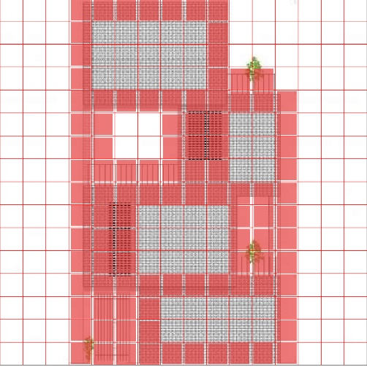
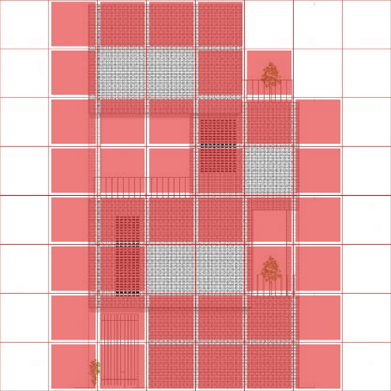
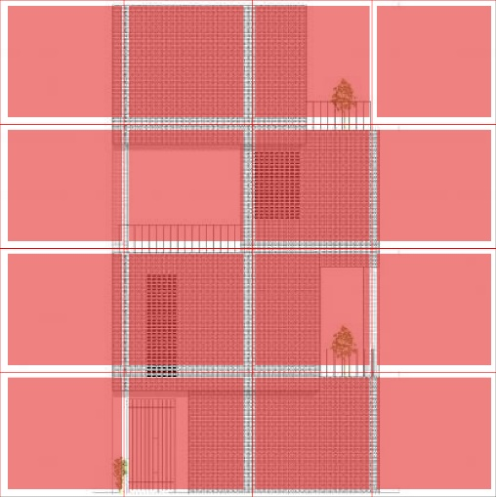
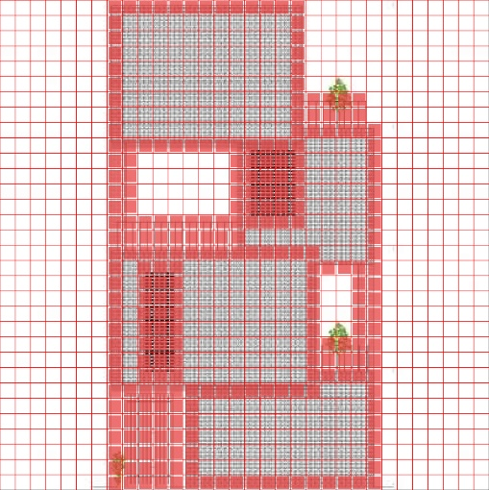

 | Full boxes | empty boxes
4×4 | 16 | 0
8×8 | 40 | 24
16×16 | 103 | 153
32×32 | 258 | 766
64×64 | 661 | 3435

Table 1. counting boxes $\frac{log\left(40\right)-log\left(16\right)}{log\left(8\right)-log\left(4\right)}=1.3$
Figure 5 to 9. The Alley house 4×4, 8×8, 16×16, 32×32, and 64×64 gridlines, repectively.

$\frac{log\left(258\right)-log\left(103\right)}{log\left(32\right)-log\left(16\right)}=1.29$
$\frac{log\left(103\right)-log\left(40\right)}{log\left(16\right)-log\left(8\right)}=1.36$
$\frac{log\left(661\right)-log\left(258\right)}{log\left(64\right)-log\left(32\right)}=1.41$ $D\left(avg\right)=1.34$

3. Findings and discussion
As described in the Methodology section, the complexity analysis in this study was carried out using the box-counting method in AutoCAD, where grids were applied to each façade and line-based information was systematically counted. To ensure reliability, the calculations were performed independently by three researchers, and all results were re-calculated and verified by the supervisor.
The literature shows that architectural complexity, especially its structural and geometric dimension, influences visual preference, perceptual comfort, and cognitive load (Berlyne, 1971; Snodgrass and Vanderwart, 1980; Salingaros, 2014; Hussein, 2020). Fractal analysis, and particularly the box-counting method, is widely recognized as a reliable tool for quantifying architectural complexity (Ostwald, 2013; Ostwald and Vaughan, 2020; Çoban and Okuyucu, 2023). Although fractal analysis has been applied to historical and iconic buildings (Bovill, 1996; Ediz and Ostwald, 2012; Ibrahim and Krawcyk, 2000; Ghouchani, 2025; Roodbari, 2025), contemporary Iranian residential façades have not been sufficiently studied. This research aims to fill that gap.
According to Spehar et al. (2002) and Taylor et al. (2005), fractal dimension values between 1.1 and 1.2 correspond to low aesthetic preference, values between 1.3 and

1.5 indicate high preference, and values between 1.6 and 1.9 return to lower preference. Bovill (1996:198) also states that values closer to 1 show simplicity, while values approaching 2 indicate high complexity.
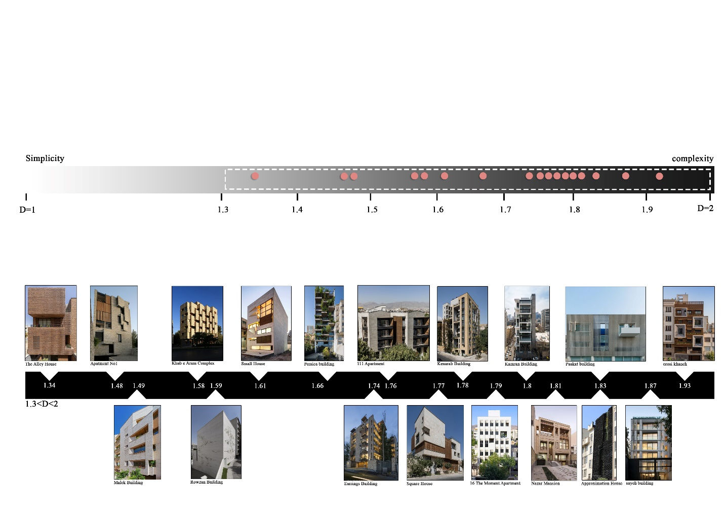
Within this framework, the façades analyzed in this study fall between D = 1 and D = 2. Alley House (D = 1.34) is the simplest example and lies within the high-preference range identified in the literature. In contrast, house of OROSI (D = 1.93) is the most complex façade. The distribution shows a strong concentration of façades between 1.7 and 1.9 (ten samples), demonstrating a notable trend toward highly complex compositions in contemporary Iranian residential design. Only one façade appears in the preferred 1.3 to 1.5 interval, and none in the 1 to 1.3 simplicity range (Figure 10). Although no precise definition of an optimal level of architectural complexity exists in the literatures, the concentration of competition-winning façades within the 1.7–1.9 fractal dimension range may suggest that higher levels of complexity are perceived as visually appealing within the context of contemporary Iranian residential architecture.

Figure 10. Graphical diagram of buildings based on the complexity of their facades

There is no direct relationship between façade complexity and ranking in the Memar Competition. Simple and highly complex façades appear across first-, second-, and third-place winners. Table (1) summarizes 18 accessible cases, reinforcing this observation.
Overall, the findings indicate that although architectural complexity is
measurable and influential, contemporary Iranian residential façades tend to exceed the complexity levels associated with optimal visual preference. This responds directly to the reviewer’s questions by clarifying both the conclusions drawn from the literature and the accepted complexity range, which lies between 1.3 and 1.5.

Table 1. The result of the competition winners
Name | Year | Rank | D (fractal value)
The Alley house | 2021 | 2 | 1.34 | 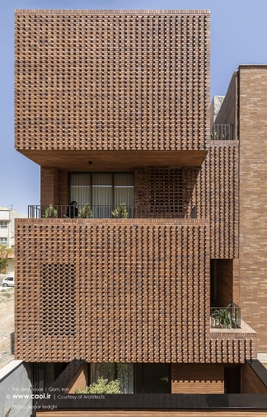
Apartment No.1 | 2010 | 1 | 1.48 | 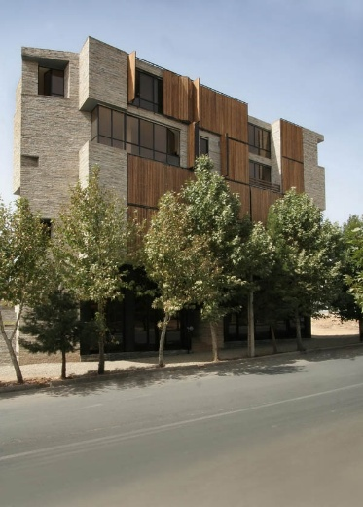
Malek Residential Building | 2017 | 3 | 1.49 | 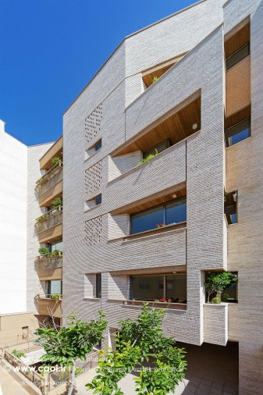
Khab-e-Aram Residential Complex | 2017 | 1 | 1.58 | 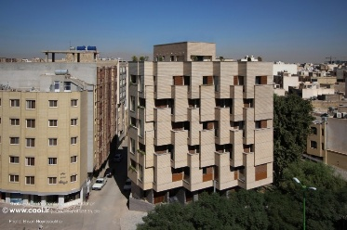
Rowzan Residential Building | 2016 | 1 | 1.59 | 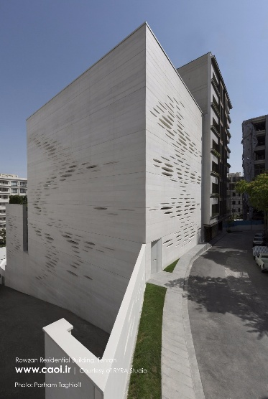
Small House | 2017 | 3 | 1.61 | 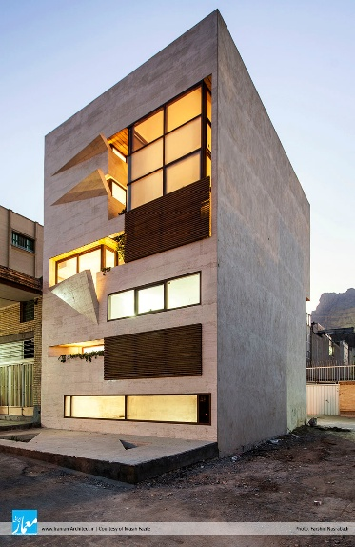
Persica Residential Building | 2023 | 3 | 1.655 | 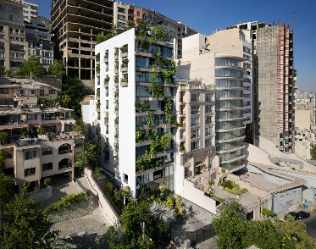
Nazar Mansion | 2020 | 3 | 1.7 | 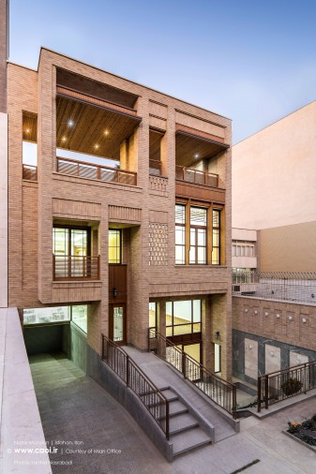
Gooshvareh Residential Building | 2016 | 2 | 1.74 | 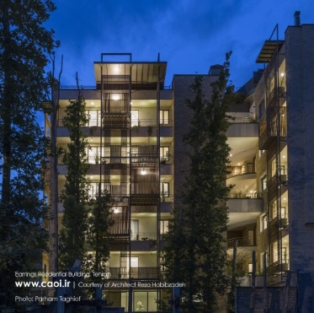
111 Residential Apartment | 2017 | 2 | 1.755 | 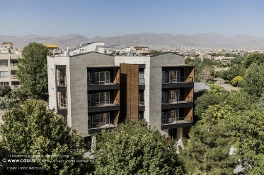
Square House | 2018 | 1 | 1.77 | 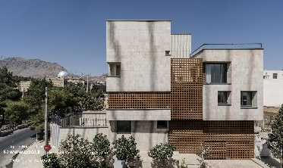
Kenarab residential building | 2019 | 1 | 1.78 | 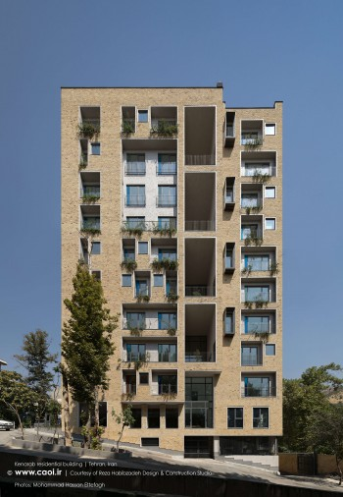
16 | The Moment | 2020 | 2 | 1.79 | 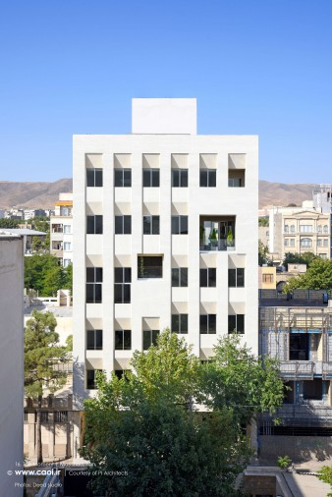
Kamran Residential Building | 2021 | 3 | 1.8 | 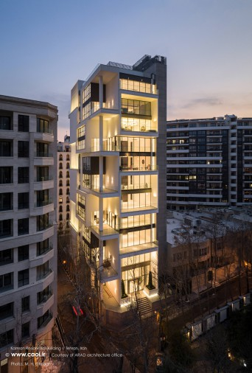
Paakat residential building | 2020 | 1 | 1.83 | 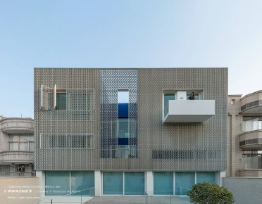
Taghrib House | 2021 | 1 | 1.83 | 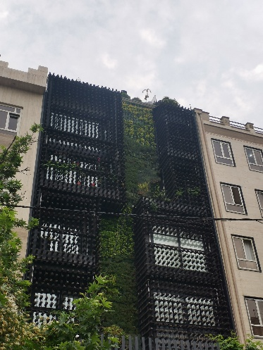
Sayeh residential building | 2023 | 2 | 1.87 | 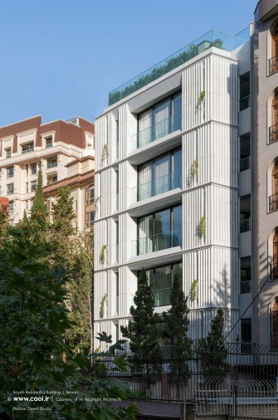
House of Orosi | 2015 | 2 | 1.93 | 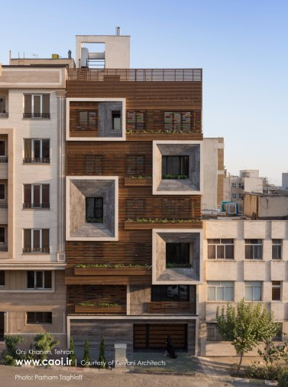

4. Conclusion
This study used the box-counting method to examine the visual complexity of award-winning residential facades from the Memar Architectural Competition (2016–2024). The results show a clear pattern in contemporary Iranian residential design: most facades fall within a relatively high complexity range, typically between 1.7 and 1.9, while genuinely simple compositions (below 1.4) are uncommon. Yet complexity alone does not seem to shape architectural success. Both one of the simplest facades (D

≈ 1.34) and one of the most complex ones (D ≈ 1.93) appeared among second-place winners, revealing that higher visual complexity does not necessarily align with higher professional evaluation.

Figure 11. Pictogram chart of analysed data

One of the main contributions of this research is its focus on contemporary Iranian residential facades—a topic that has been largely overlooked in previous fractal studies, which often concentrated on historical or iconic buildings. By analyzing only line-based drawings, the study isolates geometric form and uncovers a previously unreported finding: although complex facades are a prominent trend in current architectural practice, this complexity does not appear to influence competition rankings. This gap between design tendencies and evaluation criteria represents the novelty of the study.
The findings also offer practical value for architects and urban designers. Since complexity does not reliably predict architectural merit, designers may benefit from balancing layered, detailed forms with clarity, contextual sensitivity, and user experience. The prevalence of highly
complex facades also raises questions about long-term legibility, maintenance, and the overall coherence of dense residential environments. In essence, adding more visual layers does not automatically improve a design, and intentional moderation may lead to more effective and sustainable architectural outcomes.
This study shows that facade complexity is important but must be balanced with other design considerations to enhance both visual appeal and functionality in urban environments. Unlike previous research that focused on historical or iconic buildings, this article examines contemporary Iranian residential facades. Using winners of the Memar architectural competition, it applies the box-counting method to two-dimensional line drawings, focusing on form rather than material or color. The resulting fractal values are interpreted in relation to aesthetic preferences, offering insights into broader design trends rather than just numerical measurements.
Looking ahead, future research can build on these findings by incorporating materiality, color, texture, and facade depth, or by combining fractal analysis with user-centered approaches such as eye-tracking and preference studies. Integrating these qualitative and quantitative perspectives will help form a more complete understanding of how different levels of complexity may shape perception, comfort, and everyday urban experience.

Figure 12. The complexity chart

References:
Anklesaria, F., Mavros, P., Jamaluddin, S. A., & Trivic, Z. (2025). Cognitive Complexity in Architectural Layouts Integrating Spatial Analysis, Eye-Tracking, and Surveys. ResearchGate.

Berlyne, D. E. (1970). Novelty, cotnplexity, and hedonic value. Perception and Psychophysics, 8(5A), 279-286.
Branko Kolarevic (2016). Simplexity (and Complicity) in Architecture. University of Calgary.
C, Bovill (1996). Fractal Geometry in Architecture and Design, Birkhäuser, Boston, Mass, 194-198.
Chalup, S., Henderson, N., Ostwald, M., & Wiklendt, L. (2009). A computational approach to fractal analysis of a cityscape's skyline. Architectural Science Review, 52(2), 126-134.
Ediz, O and Ostwald, J (2012), The Süleymaniye Mosque: a computational fractal analysis of visual complexity and layering in Sinan’s masterwork
Érdi, P (2008), Complexity explained, Springer, Berlin Gombrich, EH 1979, The Sense of Order: A Study in the Psychology of Decorative Art, Cornell University Press, Ithaca, NY
Fan, Q., Mei, X., Zhang, C., & Wang, H. (2022). Urban spatial form analysis based on the architectural layout -- taking zhengzhou city as an example.
Gamze Çoban and Şerife Ebru Okuyucu (2023). Fractal Analysis of Façades of Historical Public Buildings with Box Count Method: The Case of Afyonkarahisar.
Gao, L., Warnier, M., Splunter, S., Chen, L., & Brazier, F. (2015). Architectural complexity analysis for large-scale emergency rescue management systems: a preliminary study.
Gözübüyük G (2007). Farklı Mimari Dillerde Fraktallere Dayalı Form Üretimi, [Yüksek Lisans Tezi]. İstanbul: İstanbul Teknik Üniversitesi
Ghouchani, M., & Mokaberian, M. (2022). Fractal Dimension of Islamic Architecture: The Structure of the “Patkaneh” in the dome of the Jame’ Mosque of Ardestan, Iran. Gazi University Journal of Science, 35(4),

Hollander, J. and Anderson, E. (2020). The impact of urban façade quality on affective feelings. International Journal of Architectural Research Archnet-Ijar, 14(2), 219-232.
Hussein, D., & Armstrong, P. (2016). Building an Arithmetic Model to Assess
Visual Consistency in Townscape. Civil, Environmental, Structural, Construction and Architectural Engineering, 10(4), 457-464.
Hussein, D. (2020). A user preference modelling method for the assessment of visual complexity in building façade. Smart and Sustainable Built Environment, 9(4), 483-501.
Ibrahim, M.M., Krawczyk, R.J., (2000), Generating fractals based on spatial organizations, Illinois Institute of Technology College of Architecture, Chicago, IL USA, pp.28-34
Jacobs, M. and Swink, M. (2011). Product portfolio architectural complexity and operational performance: incorporating the roles of learning and fixed assets. Journal of Operations Management, 29(7-8), 677-691.
Jesus Mosterin (2002) 'Kolmogorov Complexity', in Agazzi, Evandro and Montecucco, Luisa (eds.), Complexity and Emergence, Proceedings of the Annual Meeting of the International Academy of the Philosophy of Science, Bergamo, Italy
Kellert, J. H. heerewagen, & M. L. Mador (Eds). Biophilic design: The theory, science and practice of bringing buildings to life. Hoboken: Wiley, 59-83.
Lee, Ju Hyun, and Michael J. Ostwald. 2021. “Fractal Dimension Calculation and Visual Attention Simulation: Assessing the Visual Character of an Architectural Façade.” Buildings 11 (4): 163.
Lorenz Wolfgang (2009), Fractal Geometry of Architecture: Implementation of the Box-Counting Method in a CAD-Software
Liang, J., Xu, L., Li, J., & Ding, X. (2022). Fractal design of indoor and outdoor forms of architectural space based on a three-dimensional box dimension algorithm. Mathematical Problems in Engineering, 2022, 1-10.
Nielsen, K., Lynch, J., & Weiss, H. (1997). Fractal geometry of bean root systems: correlations between spatial and fractal dimension. American Journal of Botany, 84(1), 26-33.

Ostwald, M.J., Vaughan, J. (2008). A Data- Cluster Analysis of Facade Complexity in the Early House Design of Peter Eisenman. Computation: The New Realm of Architectural Design, 16-19 Eylül 2009, İstanbul Teknik Üniversitesi ve Yıldız Teknik Üniversitesi, İstanbul, pp.27
Ostwald, M. (2013). The fractal analysis of architecture: calibrating the box-counting method using scaling coefficient and grid disposition variables. Environment and Planning B Planning and Design, 40(4), 644-663.
Ostwald, MJ and Vaughan, J (2016). The Fractal Dimension of Architecture, Birkhäuser, Basel
Ostwald, M. and Vaughan, J. (2020). Fractal dimensions in architecture: measuring the characteristic complexity of buildings., 1-17.
Patuano, A and Francisca Lima, M (2021), The fractal dimension of Islamic and Persian four-folding gardens.
Pilgirim, I and Taylor, R (2018), Fractal Analysis of Time-Series Data Sets: Methods and Challenges.
Rapoport, A. (1977). Human Aspects of Urban Form: Towards a Man-Environment Approach to Urban Form and Design (Vol. 15). U.K.: Pergamon Press.
Robinson, J. (2010). Box-counting dimension., 31-40.
Roodbari, F., & Samaiee, K. (2025). Investigating fractal geometry in Iran’s Bazaars with an expansion approach and adjusting to the world’s modern architecture (Case study: Qom, Kashan, Tehran’s Timcheh). Architectural Dimensions and Beyond, 2(2), 126–144.

Salingaros, N. A. (2005). Principals of Urban Structure (Amsterdam, Holland: Techne Press).
Salingaros, N. A. (2006). A Theory of Architecture (Solingen, Germany: Umbau-Verlag).
Salingaros, N. A, & Masden, K. G. (2008). Neuroscience, the natural environment, and building design. In S. R.
Salingaros, N. A. (2013), “Kolmogorov-Chaitin Complexity,” Meandering Through Mathematics, September 2012. Reprinted as Chapter 9 of Unified Architectural Theory, Sustasis Press.
Salingaros, N. A. (2014). Complexity in architecture and design. University of Texas at San Antonio
Salingaros, N. A. (2015). Biophilia & Healing Environments: Healthy Principles for Designing the Built World (Alavi Zadeh. A. & Pordel. B. Trans). (First Edition) Jahade Daneshgahi Vahede Ardebil.
Snodgrass, J. G., & Vanderwart, M. (1980). A standardized set of 260 pictures: norms for name agreement, image agreement, familiarity, and visual complexity. Experimental Psychology: Human Learning and Memory, 6(2), 174-215.
Tourassi, G., DeLong, D., & Floyd, C. (2006). A study on the computerized fractal analysis of architectural distortion in screening mammograms. Physics in Medicine and Biology, 51(5), 1299-1312.
Vaughan, J. and Ostwald, M. (2017). The comparative numerical analysis of nature and architecture: a new framework. International Journal of Design & Nature and Ecodynamics, 12(2), 156-166.
Venturi, R. (1977). Complexity and Contradiction in Architecture (2nd ed.). New York: The Museum of Modern Art Papers on Architecture.

