From Simulation to Reality: Using Digital Twin Technology (DT) to Design Sustainable Smart Cities

Mahshid Ghorbanian
Assistant professor, Department of landscape Architecture, School of Architecture and
Environmental Design, Iran University of Science and Technology, Tehran, Iran.
Email: ghorbanian@iust.ac.ir

Abstract:
In recent times, DT technology has emerged to act as a potential facilitator in conceptualizing a sustainable smart city, thereby allowing virtual models to be integrated seamlessly into the physical environment. This paper tends to explore the contribution of DT in urban planning, management, and optimization processes in regards to contemporary trends on sustainability and enhancement of livability within smart city paradigms. DT technology replicates systems, processes, or infrastructures and allows simulation of minute details through extensive analysis and real-time monitoring. DT bridges the gap between virtual and physical spaces, offering data-informed insights to policymakers, urban planners, among other stakeholders, in optimizing urban systems, enhancing resource efficiency, and making better decisions within the paradigm of urban management. The study then enumerates several DT applications; among them are traffic management, environmental monitoring, and emergency response. These represent potential alleviation to urban problems and increasing the quality of life in citizens. On the other hand, DT deployment in urban environments faces challenges related to data privacy and interoperability aspects, which require high infrastructural costs and cooperative solutions. This is further entrenched through the use of case studies and literature reviews that substantiate the potential of DT in guiding cities toward a more sustainable and resilient future by dynamically fostering responsive smart cities that address environmental and social imperatives.
Keywords: Digital Twin Technology, Smart Cities, Urban Optimization, Cognitive City, Inclusive Cities, Real-Time Simulations.

1- Introduction
Urban development is evolving with the rise of smart cities, aiming for more efficient, sustainable, and livable environments. Digital twin technology (DT) is key in this transformation, acting as a virtual replica of physical systems to aid in the simulation, analysis, and optimization of urban infrastructure and services like transportation and energy (Government Technology, 2023; Botín-Sanabria et al., 2022). The paper explores DT's potential for creating sustainable smart cities. Much emphasis is placed on the role DT will play in urban design, management, and sustainability using real-world case studies that tried to highlight the benefits and challenges of this concept (Fuller et al., 2020).
The concept of a smart city makes use of technologies for an improved quality of citizens' lives and optimization in leveraging urban resources. In that sense, they apply different technologies such as IoT, AI, and big data in capturing data and analyzing for improvement in urban infrastructures and services (TechTarget, 2020; Joshi, 2021; Thales Group, 2023). The aim is toward resilient and livable cities that encourage economic growth and build better efficiency in all urban systems related to manufacturing and farming (McKinsey Global Institute, 2018; Utilities One, 2023).By following steps like data collection and analysis, smart cities can enhance key quality-of-life indicators by up to 30% (Thales Group, 2023; McKinsey Global Institute, 2018).
As shown in Figure 1 the concept secures several dimensions of smart city planning and design: smart living, education, citizen engagement, government services, infrastructure, utilities, mobility, environment, and business—which are discussed in the following:

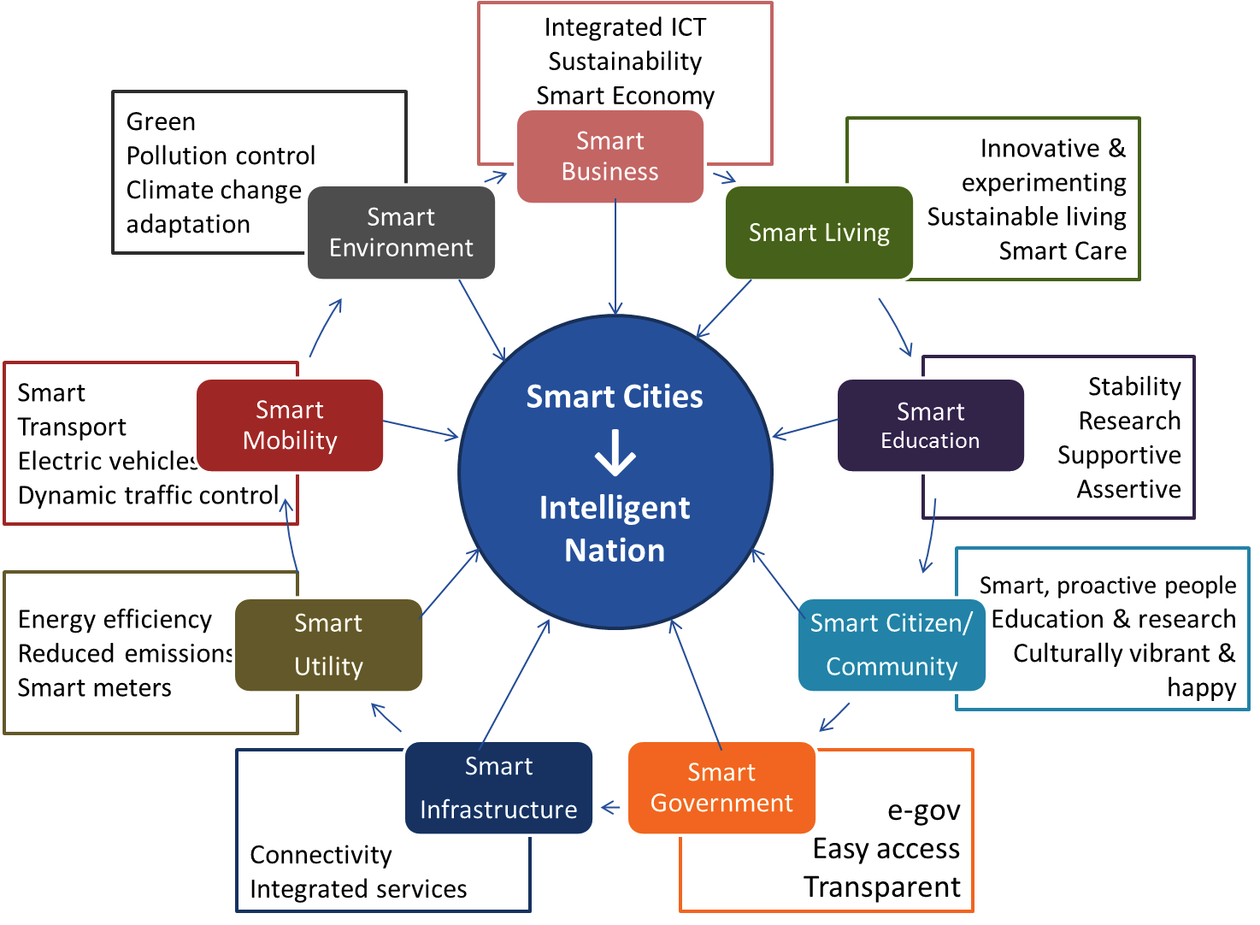

Figure 1. Dimensions of Smart City Planning and Design. Source: (Jeffin, 2016).
The success of smart cities depends on the collaboration between government, citizens, and private enterprise (Caragliu & Nijkamp, 2011). The benefits derived from smart city planning are improved sustainability, economic development, and enhanced quality of life for citizens (TechTarget, 2020; Albino et al., 2015). Smart transportation systems and improved energy consumption decrease the levels of emission, enhance air quality, and increase access, thereby making cities more livable (Joshi, 2021; Zhang, 2020). Additionally, these initiatives attract businesses, create jobs, and stimulate economic growth (De Falco et al., 2019).
2- From Smart to Cognitive: The Evolution of Urban Environments
The evolution toward future cities is centered on a vision of digital, interconnected, and cognitive urban environments (Saeed et al., 2022). Recurring themes include smartness, sustainability, and resilience, highlighting the transformative role of technology. Cognitive cities, an advanced version of smart cities, leverage human-machine collective intelligence to dynamically learn and adapt, supported by advanced ICTs (Cornwell, 2023; Psaltoglou, 2018). While offering improved services, cognitive cities raise privacy concerns due to active data sharing (Misra, 2018). Unlike traditional cities, cognitive cities connect and adapt in real-time, addressing complex urban challenges (Kansal, 2023).
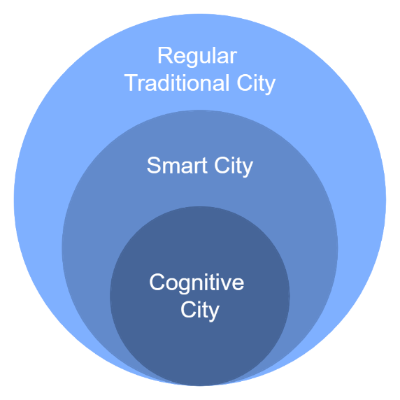
Regular Traditional City
- City elements are not digitally connected
- Urban fabric remains static
- No response to changes or interactions
Smart City
- City elements are digitally connected
- Limited interaction among city components
- Basic digital representation of the city
- Ability to learn and document physical conditions
- Limited user interaction, primarily sensing
Cognitive City
- Real-time digital connectivity among city elements
- City elements can learn, adapt, and respond dynamically
- Collective intelligence of the city
- Active response to continuous changes and interactions
- Continuous network of city elements within a digital system

Figure 2. The key characteristics of regular cities, smart cities, and cognitive cities
Adopted from: (Saeed et al., 2022; Cornwell, 2023; Psaltoglou, 2018; Misra, 2018; Kansal, 2023; BMS, 2022)
The shift from regular to smart to cognitive cities highlights the transformative role of advanced technologies and human-machine intelligence in urban development. Regular cities are static, while smart cities introduce digital connectivity. Cognitive cities, however, offer real-time interconnectedness and active adaptation, representing a significant urban evolution (Kansal, 2023). Cognitive cities go beyond smartness, creating significant value and further advancing urban progress (BMS, 2022). Some of the main features of cognitive cities have been mentioned in Figure 3.

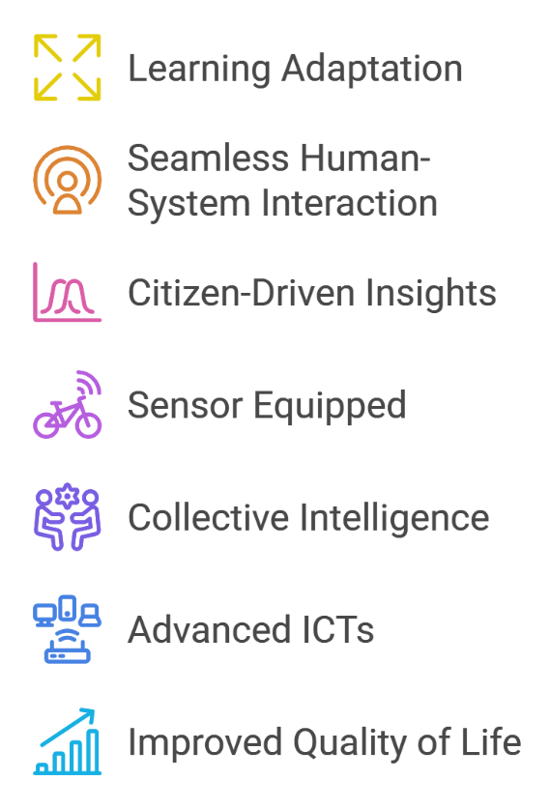
Cognitive cities continuously learn from user-generated metadata in the community's activities. They adapt their behavior based on past experiences and respond to changes in their environment.
The integration of human interactions with city systems is designed to be smooth and efficient, allowing for effective communication and collaboration.
The integration of human interactions with city systems is designed to be smooth and efficient, allowing for effective communication and collaboration.
The entire city is equipped with sensors that upload data to the cloud (cloud computing).
Cognitive cities use collective intelligence for better decision-making and community well-being. However, data sharing raises privacy concerns, and effective planning demands a deep understanding of local context and needs.
Cognitive cities utilize advanced ICTs to automate daily urban processes, enabling learning from past experiences and adaptation to environmental changes and new requirements.
Cognitive cities aim to enhance citizens' quality of life by offering better services, reducing traffic congestion, and enhancing public safety.

Figure 3. some of the main Features of Cognitive Cities
Adopted from: (Psaltoglou, 2018; Misra, 2018; Kansal, 2023; Argula et al., 2019, BMS, 2022)
3- Building a Digital Urban Realm: Bridging the Gap Between Physical and Digital Realities
The rise of digital cities and digitalization has transformed urban environments, introducing the concept of the "digital twin," a digital replica of the physical urban landscape (Saeed et al., 2022). Digitalization enables real-time data flow and monitoring, fostering interconnected urban infrastructures (Meijer & Bolívar, 2016). It also promotes the creation of a "city data capital" for better urban management and governance (Kumar & Dahiya, 2017), while supporting sustainable and climate-resilient urban development (De Jong et al., 2015). Overall, digital cities provide a framework for smart living, innovative
To realize the benefits of digital twinning in urban environments, digitalization of the physical realm is crucial. This process integrates advanced ICT to create an interactive, interconnected digital infrastructure that enhances the built environment's quality and performance (Saeed et al., 2022). The digitalization of urban realms is supported by three key principles: interconnected infrastructure for real-time data, the "urban brain" as a data hub, and responsive applications to manage urban events. Together, these elements transform cities into dynamic, responsive systems that address contemporary challenges (Saeed et al., 2022).
A digital connection in cities requires both a shared language, represented by urban big data, and a delivery method, facilitated by the Internet of Things (IoT). Urban big data encompasses the vast amount of static and dynamic data generated in cities, which is analyzed and integrated to enhance decision-making (Saeed et al., 2022). The IoT, powered by technologies like 5G, ensures real-time connections between urban elements and users through dynamic data streaming. This "Digital Urban Realm" bridges physical and digital worlds, driving urban innovation, development, and sustainability (Saeed et al., 2022).
4- Digital Twins: Essential Tools for Sustainable Smart City Design
4-1- Defining concept of urban digital twins: a multidisciplinary perspective
Digital twins, emerging in response to the need for smarter, sustainable environments, are virtual representations of physical entities, particularly in urban settings. These twins align spatial data with 3D models to create a dynamic real-time interaction between physical and digital elements (Saeed et al., 2022). In urban contexts, digital twins describe the position, condition, and performance of city components, requiring rapid communication between physical and digital realms to stay "live" (Saeed et al., 2022). Unlike traditional digital representations, they create a quantifiable system that reflects real-time interactions between city assets.
Information and communication technology (ICT) applications are crucial for digital twins, enabling them to learn, analyze, and respond to real-world city conditions, thereby improving urban environments (Saeed et al., 2022). In urban planning and construction, digital twins are gaining traction, offering significant value for stakeholders in smart city projects (Brilakis et al., 2019). Digital twins are commonly defined by three core elements: the physical component, the digital component, and the information link connecting them, making them an interconnected digital version of physical structures (Brilakis et al., 2019).
Researchers differentiate between "digital models," "digital shadows," and "digital twins." A digital model simulates without automatic data exchange, while a digital shadow has one-way data flow from physical to digital components. In contrast, a digital twin enables bi-directional data flow, integrating both realms (Brilakis et al., 2019). Saeed et al. (2022) describe digital twins as virtual representations of physical objects or systems that continuously update with real-time data throughout their lifecycle, involving the physical object, its environment, and its digital counterpart.
Digital twins, as described by Javaid and Haleem (2023), are virtual models replicating physical entities throughout their lifecycle, enabling simulations, monitoring, and maintenance across urban domains like transportation and energy. By 2025, over 500 cities are expected to adopt digital twins, enhancing process optimization, reducing waste, and improving citizens' quality of life (Government Technology, 2023; AWS, 2023). Their potential to bridge physical and digital realms offers promising advancements in smart cities, but ethical data governance will require collaboration among governments, industry, and citizens (IBM, 2020; Javaid & Haleem, 2023).
Table 1. Digital twin concepts: definitions and characteristics from different sources
Authors | Definitions | Key Characteristics
Saeed et al., 2022 | Digital twins are virtual representations of physical entities used to create smarter, more integrated, and sustainable built environments. They align spatial data with three-dimensional models and support real-time interaction between physical and digital elements. | - Dynamic interaction between real world and digital elements in real-time  - Enable smarter and more sustainable built environments.  - Align spatial data with three-dimensional models.  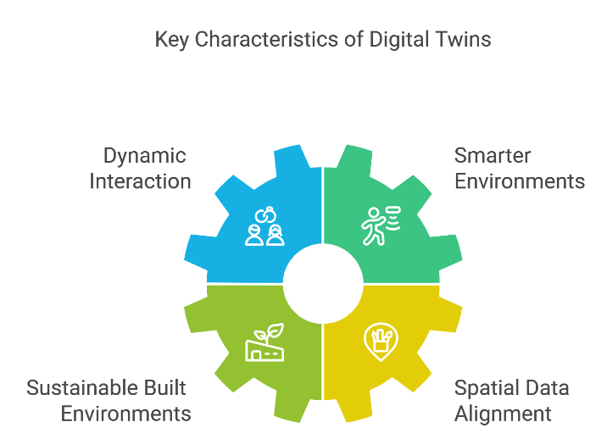  - Support real-time interaction between physical and digital elements.
Brilakis et al., 2019 | A digital twin is a digital rendition of a physical structure, wherein the digital and physical segments are inherently interconnected, with common threads centered around three essential elements: the physical component, the digital component, and the information linkages between them. | - Standardization with extensibility  - Bi-directional data exchange  - Cloud-friendly and scalable  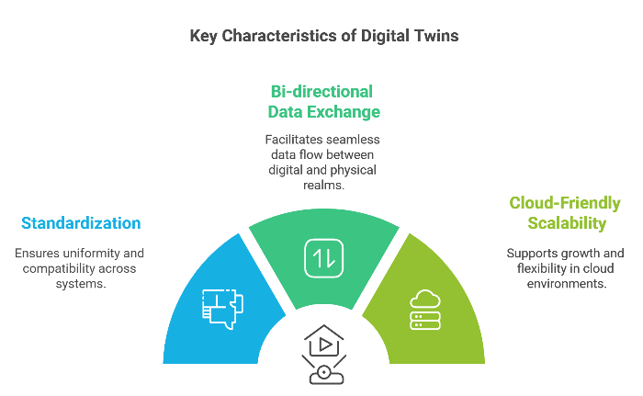
Javaid & Haleem, 2023 | Digital twins replicate the behavior of physical entities, enabling simulations, integrations, tests, monitoring, and maintenance in urban domains like transportation, energy, water management, and public safety. | - Replicate behavior of physical entities.  - Enable simulations, integrations, tests, monitoring, and maintenance in urban domains.  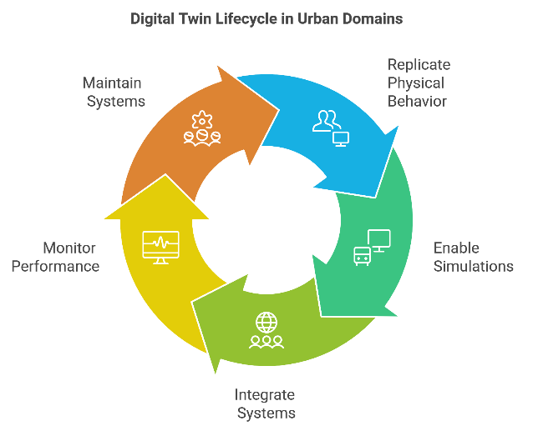
Government Technology, 2023; IBM, 2020 | Rapidly updated digital copies of physical structures in urban environments | 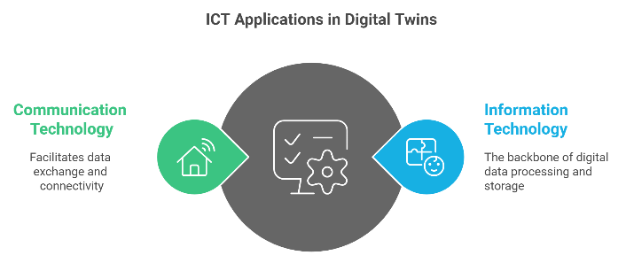  - Integration with information and communication technology (ICT) applications
IBM, 2020; Brilakis et al., 2019 | Innovative concept in urban planning and construction, with potential added value | - Bridging the physical and digital worlds.  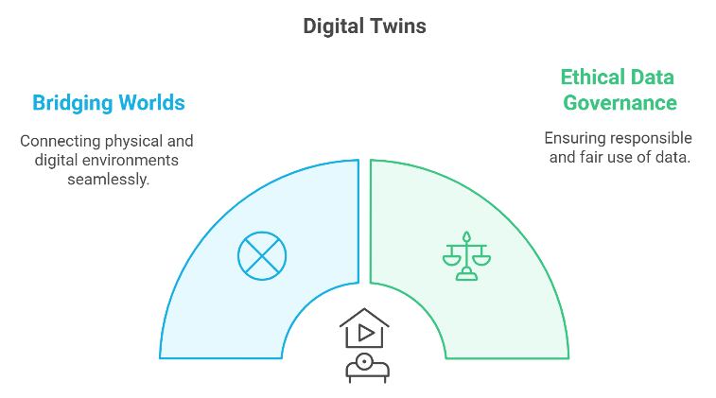  - Collaborative efforts for ethical data governance
Arup, 2019 | A digital twin, as a means to link digital models and simulations with real-world data, creates new possibilities for improved creativity, competitive advantage, and human-centered design. | - Enhances creativity, competitive advantage, and human-centered design possibilities.  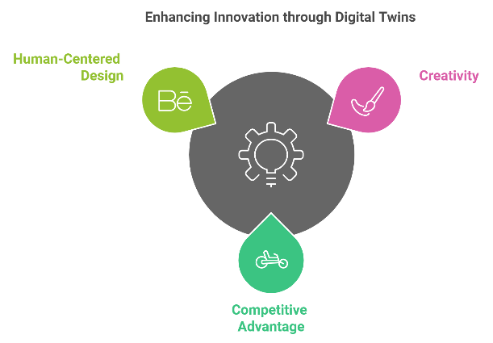
El Saddik, 2018 | A digital twin is a digital replica of a living or non-living physical entity. By bridging the physical and the virtual world, data is transmitted seamlessly allowing the virtual entity to exist simultaneously with the physical entity. | - Bridges the physical and virtual worlds.  - Enables seamless data transmission between physical and virtual entities.  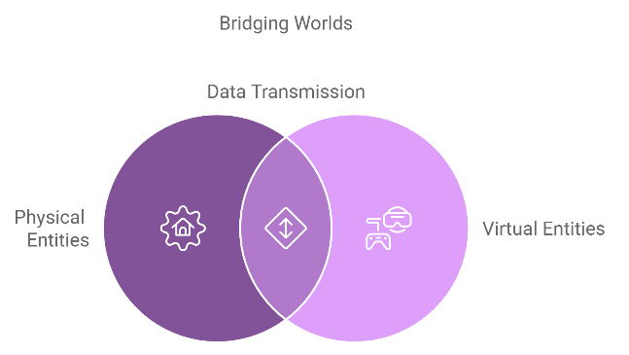
Tao et al., 2018 | A digital twin is a real mapping of all components in the product life cycle using physical data, virtual data, and interaction data between them. | - Maps components in the product life cycle.  - Incorporates physical, virtual, and interaction data.  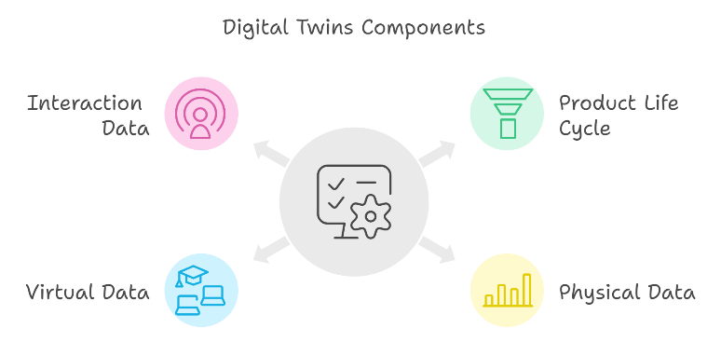
Grieves & Vickers, 2017 | A digital twin is a set of virtual information constructs that fully describes a potential or actual physical manufactured product from the micro atomic level to the macro geometrical level. At its optimum, any information that could be obtained from inspecting a physical manufactured product can be obtained from its digital twin. | - Fully describes physical manufactured products virtually.  - Provides all information obtainable from inspecting physical products.  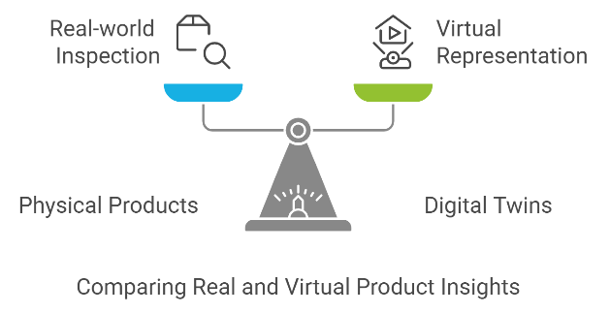
4-2- Benefits of using Digital Twin technology in urban planning and design
Utilizing Digital Twin technology in urban planning offers numerous benefits, such as integrating spatial data with 3D models to create comprehensive representations of urban environments (Schrotter & Hürzeler, 2020). This allows for visualization and scenario simulation before implementation (Brilakis et al., 2019). Digital Twins also enable real-time monitoring, optimizing resources and enhancing urban sustainability (Hexagon, 2022). Planners can simulate environmental factors and test scenarios, such as population density changes, to inform future developments with data-driven insights (PWC, 2023; Schrotter & Hürzeler, 2020).
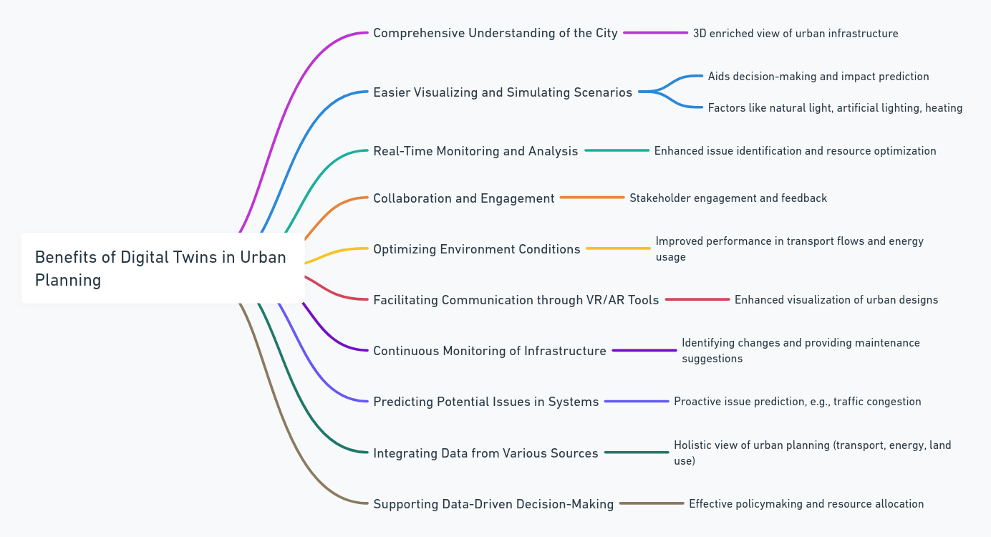

Figure 4. Benefits of Digital Twin Technology in Urban Planning and Design
Adopted from: (Schrotter & Hürzeler, 2020; Lin et al., 2022; Shahat et al., 2021; Brilakis et al., 2019; Saeed et al., 2022; ARUP, 2019)
One of the main benefits of Digital Twins is that they can merge data from transport, energy, and land use to provide an integrated Urban insight that enhances decision-making (ARUP, 2019; Government Technology, 2022). Digital Twins allow varied stakeholders to be more involved in interactive ways, enabling them to participate in urban planning processes as citizens, policymakers, and others. This fosters inclusive development (ARUP, 2019; Shahat et al., 2021). It provides additional sustainability, monitoring, and collaboration to build up a more efficient and inclusive future city.
5- How Digital Twin, BIM, and CIM Are Revolutionizing Design and Construction
Researchers at Siemens consider that buildings are becoming increasingly smarter and more networked. Buildings do not just consume, as well as store and distribute energy. Figure 5 shows how Siemens pursues smart buildings (Brilakis et al., 2019: 8).
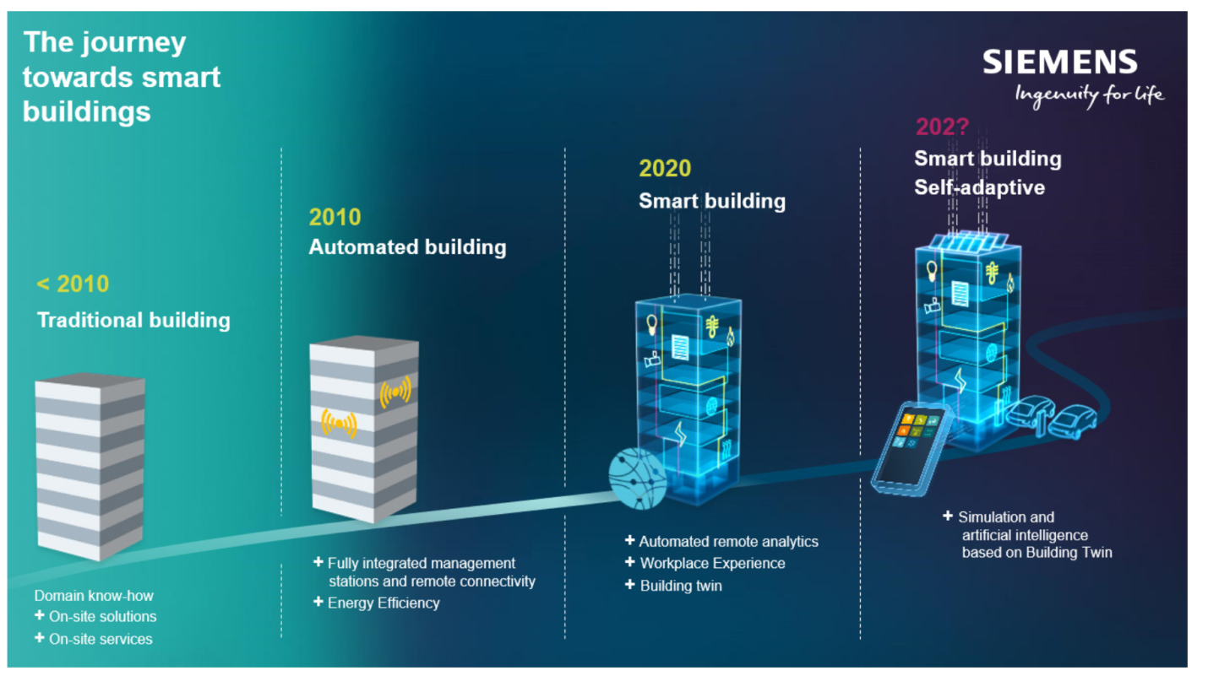
Figure 5. The journey towards smart buildings from Siemens. Source: (Brilakis et al., 2019: 8)

Digital Twin (DT), Building Information Modeling (BIM), and City Information Modeling (CIM) are transformative technologies reshaping design and construction. BIM, a foundational tool in construction, creates digital representations of physical assets and supports design, management, and maintenance (Saeed et al., 2022). However, BIM lacks real-time updates, relying on manual input. Digital Twins address this gap by enabling a dynamic, real-time connection between physical assets and their digital counterparts through bidirectional data flow via sensors. This allows for continuous monitoring, analysis, and optimized decision-making (Saeed et al., 2022).
City Information Modeling (CIM) extends BIM to the urban scale, incorporating geospatial and sensor data to capture urban elements and enhance city-level analysis using ICT applications. CIM is more complex than BIM but requires regular data monitoring to maintain dynamic city replication (Saeed et al., 2022). While BIM provides static representations for architects and engineers, Digital Twins offer dynamic, real-time data streams for ongoing management, focusing on performance rather than just physical characteristics (Deng et al., 2021). To integrate Digital Twins into construction, BIM models are enhanced with real-time IoT data, enabling continuous monitoring and optimization (Nguyen & Adhikari, 2023). The different types of digitalization in the built environment are illustrated in Figure 6.
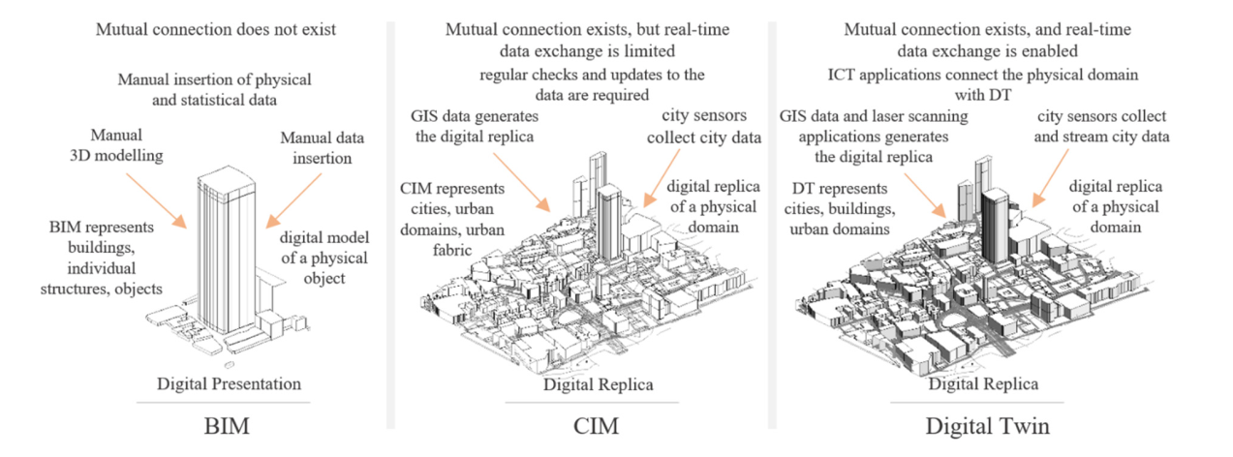
Figure 6. Different types of digitalization in the built environment: BIM, CIM and DT. Source: (Saeed et al., 2022).
In conclusion, the integration of BIM, CIM, and Digital Twins is transforming the design and construction sectors. BIM offers a foundational digital model for building projects, CIM expands this to encompass urban-scale applications, and Digital Twins bridge physical and digital spaces through real-time data. Together, these technologies promote innovation, efficiency, and sustainability in architecture, urban design, and planning. Figure 2 outlines the key differences between BIM, CIM, and Digital Twins, comparing their scope, purpose, capabilities, and applications in design and construction.
Table 2. Comparative Analysis of BIM, CIM, and Digital Twins (DT) in Design and Construction
Key Aspect | Building Information Modeling (BIM) | City Information Modeling (CIM) | Digital Twins (DT)
Focus and Scope | Physical aspects of a building (e.g., geometry, materials) | Comprehensive view of urban environments (e.g., traffic, energy) | Asset performance, predictive maintenance, real-time data utilization, simulations, and emphasizing the interconnectedness of digital and physical realms (buildings or the entire city).
Main Objective | Efficient design, construction, and cost management | Informed decision-making, infrastructure optimization | Real-time asset monitoring and optimization
Nature of Representation | Primarily static representation of a building's physical and functional characteristics | Dynamic representation of a city's physical and functional characteristics | Dynamic and real-time, representing individual assets with ongoing real-time data
Update Frequency | Typically created during design and construction phase | Typically created after construction and used for ongoing monitoring | Continuously updated in real-time with sensor data
Scale | design, construction, project management, and the ongoing management of individual assets | Supports citywide planning, infrastructure management, and public services | Smart buildings, smart cities, real-time optimization, post-construction operations, predictive maintenance, and performance optimization
Lifecycle Stages | Relevant in early and mid-stages of asset's lifecycle (design, construction) | Relevant across the entire lifecycle of urban assets, including planning, management, and development | Relevant throughout the entire lifecycle of individual assets, focusing on performance optimization
Data Sources | 3D models (geometric representation), design data (architectural plans), CAD (Computer-Aided Design) drawings and designs, user-generated data (collaboration and notes), Limited use of IoT devices and building management systems. | 3D models (urban infrastructure models), GIS data, sensor data from various systems, geospatial data, environmental sensors, geographical and urban data. Limited use of CAD and building management systems. | 3D models (building and urban 3D models), real-time sensor data, geospatial data, operational data, architectural and design data, user-generated data, real-time building data, extensive sensor networks, GIS and IoT devices etc.,

Adopted from: (Deng et al., 2021; Saeed et al., 2022; Nguyen & Adhikari, 2023; Brilakis et al., 2019).

6- How Digital Twin Can Help to Reach Smart Cities
6-1- Real-world applications of digital twin technology in smart city design
Real-world applications of digital twin technology in smart city design include condition monitoring, facilities management, design simulations, construction and real estate, emergency management, traffic management, public health, security, environmental sustainability, water resource management, energy optimization, and tourism and cultural heritage. These applications, integrated with geographic information systems, allow for dynamic monitoring and prediction by incorporating factors such as time and human behavior (Boulos & Zhang, 2021). The ability to test intervention scenarios virtually aids policymakers and planners in making informed decisions for smart city development and management.
- Condition Monitoring
Condition monitoring through digital twin technology is crucial for smart city infrastructure management. For instance, digital twins enable real-time monitoring of systems like gas distribution networks by integrating geometric and surface data, allowing engineers to visualize current infrastructure conditions and compare them with historical data to track changes over time. Similarly, sewer systems benefit from digital twins by monitoring parameters like flow rates, predicting blockages and disruptions, and enabling predictive maintenance. This data-driven approach supports more efficient urban infrastructure management and enhances the resilience of smart cities (Brilakis et al., 2019).
- Facilities management
Facilities management is a critical area in smart city design where digital twin technology plays a transformative role. By integrating sensors with digital twins, real-time data on how people interact with facilities is captured, enabling the optimization of environmental conditions and enhancing overall well-being (Brilakis et al., 2019). For example, digital twins can monitor air quality across a metropolis, giving city planners and managers the tools to improve living and working environments. This proactive approach promotes the well-being of inhabitants and supports the overarching goals of smart city design.
- Simulations In Design
Digital twin technology plays a crucial role in smart city design by enabling simulations during the design process. Designers and engineers use digital twins to model various scenarios, such as modifying existing structures or creating new ones, and simulate factors like natural light, artificial lighting, and heating (Fiq. 5). This allows for the prediction of changes without real-world implementation. Augmented and virtual reality (AR/VR) further enhance these simulations by enabling designers to visualize and communicate designs to clients effectively. This process improves collaboration and supports more informed design decisions (Brilakis et al., 2019; Natephra et al., 2017).
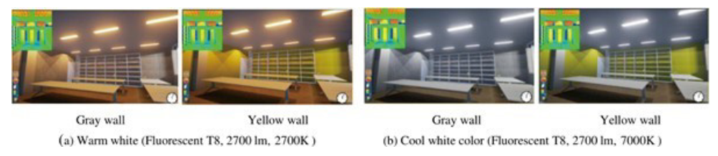

Figure 7. Visualization examples of lighting atmospheres
of different design options (Natephra et al. 2017)
- Leveraging Digital Twins in Construction and Real Estate
Digital twin technology, extensively used in construction and real estate, serves as a valuable tool throughout the lifecycle of built environments, from construction to ongoing maintenance. By utilizing 3D spatial data and digital models, digital twins mirror the behavior of physical structures and map construction and operational processes, whether for existing buildings or those under development. This technology revolutionizes design, assessment, and maintenance practices. The integration of Building Information Modeling (BIM) further enhances visualization, enabling designers to assess aesthetics and effectively communicate changes to clients (Schrotter & Hürzeler, 2020).
- Emergency Management
Application of digital twin technology in smart city design, therefore, forms the basis upon which increased efficiencies in responding and managing emergencies are unlocked. Digital twins, for instance, enable the creation of real-time road closure scenarios by emergency responders to gauge immediate effects and those across broader systems. That gives way to the dynamic capability of simulation that city planners and emergency personnel find quite useful; it provides them with insights that will afford them the capability to make quick decisions and, therefore, provide more effective responses and better prepare urban environments against unexpected events.
- Traffic Management
Digital twins provide real-time representations of a city's traffic infrastructure, offering valuable insights for city planners and traffic management. By monitoring and optimizing traffic flow, digital twins enable proactive responses to congestion and other challenges. For instance, they can simulate the effects of road closures or detours, aiding in rerouting efforts and minimizing disruptions. Digital twins also support the development of predictive algorithms to forecast traffic patterns and congestion hotspots. Additionally, they help evaluate transportation scenarios, such as infrastructure projects or the integration of autonomous vehicles, ultimately improving traffic management, reducing congestion, and fostering more efficient, sustainable urban environments.
- Public Health
Digital twin technology plays a crucial role in public health within smart city design by providing real-time, data-driven insights that empower urban planners and health authorities (Zhu & Wu, 2021). These digital replicas monitor public health infrastructure, simulate disease spread, and help manage potential outbreaks by aiding resource allocation. Digital twins also assess environmental factors like air quality and noise pollution, optimize healthcare services, and enhance emergency response planning. By leveraging this technology, smart cities can proactively tackle public health challenges, improving residents' quality of life and fostering healthier, sustainable urban environments.
- Security and Surveillance
Digital twin technology is revolutionizing security and surveillance in smart cities by creating real-time digital replicas of urban environments. These digital twins, integrated with a network of surveillance cameras and sensors, monitor public spaces, infrastructure, and potential security threats. The data collected helps identify unusual activities or security breaches, enabling swift responses from law enforcement. Digital twins also optimize surveillance camera placement, ensuring comprehensive coverage and assisting in forensic investigations with historical event records. Additionally, they enhance crowd management during large events or emergencies, ensuring public safety and efficient resource allocation. This integration marks a shift towards data-driven, proactive urban security planning.
- Environmental Sustainability
Digital twin technology is essential for promoting environmental sustainability in smart city design. By monitoring and managing key areas like energy consumption, waste management, and emissions control, digital twins provide actionable insights that help cities reduce their environmental footprint. They enable the collection and analysis of real-time data, allowing urban planners to make informed, eco-friendly decisions that enhance sustainability efforts. Through the use of digital twins, cities can proactively manage resources responsibly and drive sustainable urban development, ultimately benefiting both the environment and the well-being of their residents.
- Water Resource Management
Digital twin technology is crucial for optimizing water resource management in smart cities. It enables efficient water distribution and wastewater management by predicting water demand, detecting leaks, and ensuring a sustainable supply of clean water. The predictive capabilities of digital twins allow cities to plan for future water needs while minimizing waste, leading to more efficient resource use and promoting environmental sustainability. As a result, digital twins provide an innovative and essential tool for achieving responsible and sustainable water management in modern urban settings.
- Energy Optimization
Digital twin technology is essential for energy optimization in smart city design, enabling efficient management of complex energy grids. These digital replicas monitor and control power supply in real time, allowing for precise analysis of energy consumption patterns. This data-driven approach helps cities maintain a stable and reliable energy infrastructure. Additionally, digital twins facilitate the integration of renewable energy sources, reducing carbon emissions and promoting sustainability. By supporting energy efficiency and eco-friendly practices, digital twins play a crucial role in advancing sustainable and environmentally conscious urban development.
- Tourism and Cultural Heritage
Tourism and Cultural Heritage greatly benefit from digital twin technology in smart city design, allowing cities to enhance tourism and preserve historical sites. Digital twins create immersive experiences for tourists, offering virtual tours of cultural landmarks and providing a deeper connection with the city's heritage. These digital replicas also enable visitors to explore the evolution of sites over time, enriching the tourism experience while promoting the conservation of cultural assets. Moreover, digital twins play a crucial role in disaster management, safeguarding historical treasures from natural or man-made catastrophes. For instance, the destruction of the Bam Citadel in the 2003 earthquake underscored the need for digital replicas to protect cultural heritage. By leveraging digital twins, cities can secure the preservation of their cultural heritage for future generations, ensuring that priceless historical sites are not lost to unforeseen disasters.
6-2- Challenges associated with the implementation of DT in the design of a smart city
The integration of Digital Twin technology in smart cities faces numerous challenges that must be overcome for successful implementation. Key issues include:
- Data Security and Privacy: Ensuring secure handling and protection of the vast data collected by digital twins is crucial, especially with the potential for breaches in personal and sensitive information.
- Blockchain Adoption: Utilizing blockchain to secure data integrity and transactions within the digital twin ecosystem is still in its early stages.
- Precise Mapping and Standardization: Achieving accurate digital replicas and standardizing data across systems is complex, requiring uniform protocols.
- Data Complexity and Synchronization: Managing, processing, and keeping large and diverse data streams synchronized in real time presents technical difficulties.
- Latency and Network Connectivity: High-speed, reliable networks (such as 5G) are essential to minimize latency and ensure seamless operation, but widespread infrastructure is still developing.
- Cost Barriers: The significant financial investment required for digital twin setup, maintenance, and infrastructure is a challenge for many cities.
- Interoperability: Ensuring that different systems and technologies work together seamlessly is critical to leveraging the full potential of digital twins.
- Technical Expertise: Developing and maintaining digital twins requires specialized knowledge, which may be lacking in many regions.
- Regulation and Standards: Establishing global standards and regulatory frameworks is necessary to guide the ethical use and development of digital twins.
Addressing these challenges will be essential for the successful integration of digital twins in smart cities.
- Challenge 1: Data Security in Smart City Design
A critical challenge in implementing Digital Twin technology in smart city design is ensuring robust data security. With numerous stakeholders, including government, academia, and private sectors, the risk of data breaches increases significantly. It is essential to secure the storage, transmission, and handling of the extensive digital data involved in the Digital Twin framework (Brilakis et al., 2019).
One solution is the adoption of blockchain technology, which offers a decentralized network for recording immutable data, significantly enhancing data security (Zheng et al., 2017). Unlike traditional centralized systems, blockchain's decentralized structure reduces vulnerabilities, creating a more resilient environment for data storage. By incorporating blockchain, smart cities can strengthen their data security, a critical factor for the successful deployment of Digital Twin technology (Brilakis et al., 2019).
- Challenge 2: Ongoing Evolution and Adoption of Blockchain
While blockchain technology shows great promise for improving data security and reducing operational costs, its full potential in safeguarding digital data within the Digital Twin framework is not yet fully realized. Significant research, development, and integration efforts are required to ensure its effectiveness in enhancing data security in smart city design (Brilakis et al., 2019). These efforts must focus on optimizing blockchain's application to address the unique challenges of Digital Twin technology and to ensure robust and reliable data protection.
- Challenge 3: Precise Mapping and Interaction Between Virtual and Physical Urban Spaces
A key challenge in implementing Digital Twin technology for smart city design is achieving precise mapping and seamless interaction between virtual and physical urban spaces. This complex process requires advanced technologies to ensure accurate and dynamic mapping, as well as efficient synchronization between the Digital Twin and the real-world environment (Lin et al., 2022). The significance of this challenge lies in its direct impact on the effectiveness and practical application of Digital Twin solutions in smart cities. Without precise integration, the utility of Digital Twin technology in urban management and planning is compromised.
- Challenge 4: Lack of Standardization and Interoperability
A major challenge in implementing Digital Twins for intelligent building representations is the lack of standardization within the industry. This absence of uniform standards complicates the integration of data from diverse sources and hinders interoperability between various systems. As a result, data silos can form, preventing a comprehensive and holistic view of a building’s performance, which is essential for effective management and optimization (Deng et al., 2021).
- Challenge 5: Data Complexity and Real-time Processing
A related big challenge lies in the data of the Digital Twins. Big data emanates from sensors, building management systems, and various devices by most of the systems, so that their handling and processing in real time to come up with updated and correct information on the performance of the building can be challenging for most of them, especially the older generation buildings lacking infrastructural capacities (Deng et al., 2021).
- Challenge 6: Security Concerns
Security is one of the prime concerns when it comes to Digital Twins. Since Digital Twins are connected to real-time data streams, they become highly vulnerable to cyberattacks and other security threats. This becomes highly critical in cases where Digital Twins are implemented on critical infrastructure like hospitals or government buildings because a security breach could have very serious consequences (Deng et al., 2021).
- Challenge 7: Cost Barriers
The issue of cost presents another challenge in the adoption of Digital Twins for intelligent building representations. Implementing a Digital Twin system requires a significant investment in hardware, software, and other infrastructure. This financial barrier can be particularly daunting for smaller organizations or those with limited budgets. Nonetheless, despite these challenges, many organizations recognize the substantial benefits of Digital Twins and are investing in this technology to enhance the efficiency and effectiveness of their operations. With the ongoing evolution and maturation of the technology, it is likely that many of these challenges will be addressed, making Digital Twins an increasingly valuable tool for intelligent building representations (Deng et al., 2021).
- Challenge 8: Data Synchronization
Data synchronization stands out as a fundamental challenge when implementing Digital Twin technology in smart cities. Maintaining consistency and accuracy between the physical environment and its digital counterpart is critical for effective decision-making and urban planning within the Digital Twin framework (Sepasgozar, 2021).
- Challenge 9: Latency and Network Connectivity
Latency, which refers to the delay in data transmission, presents a specific challenge in the context of Digital Twin implementation in smart cities. High latency can hinder real-time decision-making and responsiveness, particularly in scenarios that require swift and precise actions. Additionally, the risk of network gaps and disconnection further compounds this challenge. In a smart city ecosystem, data flows from various sources, including sensors, IoT devices, and cameras, making uninterrupted connectivity crucial for the Digital Twin's effectiveness. Network gaps may arise due to technical issues, network congestion, or infrastructure limitations, posing potential hurdles for maintaining the real-time and synchronized nature of the Digital Twin (Sepasgozar, 2021). Addressing these combined challenges is essential for enhancing the reliability and functionality of Digital Twins in urban planning and decision-making processes.
- Challenge 10: Security and Privacy
The security and privacy of data are paramount concerns in the context of Digital Twins in smart cities. The extensive data collected from various sensors and devices may contain sensitive information that requires robust protection from unauthorized access and potential cyber-attacks. Ensuring the security and privacy of data is crucial for the successful adoption and trustworthiness of Digital Twins in urban environments.
- Challenge 11: Real-time Big Data Transfer and 5G Integration
The transfer of large volumes of data in real-time for immediate scenario optimization presents a significant challenge in the current landscape of smart city development. As Sepasgozar (2021) pointed out, leveraging the potential of 5G technology could address this issue in the future. 5G networks provide faster and more reliable data transfer capabilities, which are crucial for ensuring real-time control and optimization within the Digital Twin framework. Overcoming the challenge of data transfer will enable smart cities to utilize the full potential of Digital Twins for immediate and precise decision-making, especially in scenarios requiring swift responses.
- Challenge 12: Data Integration and Management
One of the main challenges associated with the implementation of Digital Twin in the design of a smart city is data integration and management. Digital Twin technology requires the integration of data from various sources, including sensors, cameras, and other IoT devices, to create a virtual replica of the physical city. However, integrating and managing this data can be complex and time-consuming (Wang & Wang, 2023).
Digital Twins generate a large amount of data, which requires effective data management strategies. The challenge lies in collecting, storing, processing, and analyzing this data in real-time to make informed decisions.
- Challenge 13: Data Privacy and Security
Another challenge is ensuring the privacy and security of the data used to create the digital twin. The data collected from various sources may contain sensitive information, and ensuring that this data is protected from unauthorized access is crucial (Wray, 2022).
- Challenge 14: Interoperability
Interoperability is another challenge associated with the implementation of digital twin in the design of a smart city. The digital twin must be able to communicate with various systems and devices within the city, including transportation systems, energy grids, and public safety systems. Ensuring that these systems can communicate with each other can be challenging (Wang et al., 2023).
- Challenge 15: Cost
The cost of implementing digital twin technology in the design of a smart city is another challenge. The technology requires significant investment in hardware, software, and infrastructure. Ensuring that the benefits of the technology outweigh the costs can be challenging (Wray, 2022).
- Challenge 16: Stakeholder Engagement
Stakeholder engagement is another challenge associated with the implementation of digital twin in the design of a smart city. The technology requires collaboration between various stakeholders, including city officials, planners, engineers, and citizens. Ensuring that all stakeholders are engaged and invested in the technology can be challenging.
- Challenge 17: Technical Expertise
Implementing digital twin technology in the design of a smart city requires technical expertise. Ensuring that there are enough skilled professionals to design, implement, and maintain the technology can be challenging (Wang et al., 2023).
- Challenge 18: Regulation and Standards
Finally, regulation and standards are another challenge associated with the implementation of digital twin in the design of a smart city. Ensuring that the technology complies with relevant regulations and standards can be challenging, particularly as the technology is still relatively new (Wray, 2022).
These challenges underscore the need for continuous research, technological advancements, and strategic planning to overcome the obstacles associated with Digital Twin implementation in smart cities. Addressing these challenges is essential for realizing the full potential of Digital Twin technology in the development of smart cities.
7- Conclusion
In retrospect, the exploration of Digital Twin technology (DT) within the context of designing sustainable smart cities has uncovered a transformative landscape in urban development. The shift towards smart cities, driven by a vision of enhanced efficiency, sustainability, and livability, reflects a fundamental change in how we approach urbanism. DT, as a powerful tool that enables the replication of physical systems for simulation and optimization, has proven to be a linchpin in this evolution.
Throughout our analysis, we delved into the core elements that define smart cities, emphasizing the integration of advanced technologies and data-driven decision-making. The adoption of IoT, AI, and big data analytics, among others, underscores the commitment to creating more efficient, resilient, and citizen-centric urban environments. The potential benefits are substantial, spanning from energy efficiency and job creation to reduced crime and improved overall well-being.
However, the journey towards smart cities is not without its challenges. Data privacy concerns, potential social inequalities, and financial burdens necessitate careful planning and collaboration among various stakeholders. It is evident that a comprehensive and collaborative approach is essential to aligning these innovations with community needs and ensuring equitable access.
The paper's focal point on the evolution of urban environments towards cognitive cities highlights the growing significance of artificial learning and human-machine collective intelligence. As we transition from conventional to smart and cognitive cities, the convergence of advanced technologies and their impact on urban challenges becomes even more pronounced. Privacy and security concerns, though, must be managed as we embrace these new paradigms.
The concept of digitalization and the emergence of digital twins as bridges between the physical and digital worlds represent a profound shift in how we interact with urban environments. The potential for innovative approaches, data-driven problem-solving, and enhanced quality of life is undeniable. Urban digital twins, in particular, promise comprehensive understanding and real-time monitoring, which are instrumental in improving resource utilization and sustainability.
Our analysis of the benefits of using DT in urban planning and design showcases the transformative potential of this technology. It integrates spatial data, supports real-time monitoring, and facilitates data-driven decision-making, offering a path towards more inclusive and effective urban development. However, the challenges associated with its implementation, ranging from data security to interoperability, cannot be ignored and must be addressed to unlock DT's full potential.
In conclusion, the integration of DT in the design of smart cities is a significant milestone in urban development. The past analysis underscores the profound changes underway, and the need for stakeholders, including government, industry, and citizens, to collaborate in overcoming challenges. This paper contributes to the broader discourse on the future of urbanism, providing insights into the transformative potential of DT. As we move forward, we collectively strive to create smarter, more sustainable cities that enhance the quality of life for all residents, while navigating the complex landscape of advanced urban technologies.al twin, can enable more efficient and sustainable operations for a variety of applications.

References
- Albino, V., Berardi, U., & Dangelico, R. M. (2015). Smart cities: Definitions, dimensions, performance, and initiatives. Journal of Urban Technology, 22(1), 3-21.
- ARUP. (2019). Digital twin: Towards a meaningful framework. Retrieved from https://www.arup.com/digitaltwinreport
- AWS. (2023). What is Digital Twin Technology? Retrieved from https://aws.amazon.com/what-is/digital-twin/
- El Saddik, A. (2018). Digital twins: The convergence of multimedia technologies. IEEE multimedia, 25(2), 87-92.
- Tao, F., Zhang, H., Liu, A., & Nee, A. Y. (2018). Digital twin in industry: State-of-the-art. IEEE Transactions on industrial informatics, 15(4), 2405-2415.
- Grieves, M., & Vickers, J. (2017). Digital twin: Mitigating unpredictable, undesirable emergent behavior in complex systems. Transdisciplinary perspectives on complex systems: New findings and approaches, 85-113.
- Botín-Sanabria, D. M., Mihaita, A. S., Peimbert-García, R. E., Ramírez-Moreno, M. A., Ramírez-Mendoza, R. A., & Lozoya-Santos, J. D. J. (2022). Digital twin technology challenges and applications: A comprehensive review. Remote Sensing, 14(6), 1335
- Boulos, M N K., & Zhang, P. (2021). Digital Twins: From Personalised Medicine to Precision Public Health. https://scite.ai/reports/10.3390/jpm11080745
- Brilakis, I., Fischer, H., Pan, Y., Borrmann, A., Mayer, H.-G., Rhein, F., Vos, C., Pettinato, E., & Wagner, S. (2019). Built Environment Digital Twinning: Report of the International Workshop on Built Environment Digital Twinning. Technical University of Munich, Germany.
- Caragliu, A., Del Bo, C., & Nijkamp, P. (2011). Smart cities in Europe. Journal of urban technology, 18(2), 65-82.
- Cornwell, S. (2023). Our Relationship with Cities is Changing, Urban Development and Planning Must Change With It. IIoT World. Retrieved June 19, 2023, from https://www.iiot-world.com/smart-cities-buildings-infrastructure/smart-cities/our-relationship-with-cities-is-changing-urban-development-and-planning-must-change-with-it/
- De Falco, P., Angelidou, M., & Addie, J. P. (2019). The smart city as a system of systems. Journal of Open Innovation: Technology, Market, and Complexity, 5(2), 46.
- De Jong, M., Joss, S., Schraven, D., Zhan, C., & Weijnen, M. (2015). Sustainable–smart–resilient–low carbon–eco–knowledge cities; making sense of a multitude of concepts promoting sustainable urbanization. Journal of Cleaner production, 109, 25-38.
- Deng, M., Menassa, C. C., & Kamat, V. (2021). From BIM to digital twins: A systematic review of the evolution of intelligent building representations in the AEC-FM industry. Journal of Information Technology in Construction, 26, 58-83.
- Fuller, A., Fan, Z., Day, C., & Barlow, C. (2020). Digital twin: Enabling technologies, challenges and open research. IEEE Access, 8, 108952-108971. https://doi.org/10.1109/ACCESS.2020.2998580
- Government Technology. (2022). Planning Urban Cities Smartly With Digital Twins. Retrieved from https://www.govtech.com/sponsored/planning-urban-cities-smartly-with-digital-twins
- Government Technology. (2023). Smart Cities Tech Giving Rise to the 'Digital Twin'. https://www.govtech.com/smart-cities/smart-cities-tech-giving-rise-to-the-digital-twin
- Hexagon. (2022). Why digital twins are essential for urban planning - Safety, Infrastructure & Geospatial. Retrieved from https://sigblog.hexagon.com/why-digital-twins-are-essential-for-urban-planning/
- IBM. (2020). Cheat sheet: What is Digital Twin? Retrieved from https://www.ibm.com/blog/iot-cheat-sheet-digital-twin/
- Javaid, M., & Haleem, A. (2023). Digital Twin applications toward Industry 4.0: A Review. Cognitive Robotics.
- Jeffin, J. (2016), Smart City, Structuring a Smarter India, https://www.cronj.com/blog/smart-citystructuring-a-smarter-india/amp/
- Joshi, A. (2021). Smart city planning and design. In A. Karimi, T. M. Vinod Kumar, & M. Tavana (Eds.), Handbook of research on smart cities and recent advances in ICT (pp. 1-15). IGI Global.
- Kansal, S. (2023). Transitioning from a Smart City to a Cognitive City - The Role of Artificial Intelligence and Advanced Technologies. SSRN. https://papers.ssrn.com/sol3/papers.cfm?abstract_id=4425959
- Kumar, T. V., & Dahiya, B. (2017). Smart economy in smart cities. Smart economy in smart cities, 3-76.
- Lin, H., Xu, B., Chen, Y., Li, W., You, L., & He, J. (2022). VGEs as a New Platform for Urban Modeling and Simulation. Sustainability, 14(13), 7980.
- McKinsey & Company. (2018). Smart cities: Digital solutions for a more livable future. Retrieved from https://www.mckinsey.com/capabilities/operations/our-insights/smart-cities-digital-solutions-for-a-more-livable-future
- Meijer, A., & Bolívar, M. P. R. (2016). Governing the smart city: a review of the literature on smart urban governance. International review of administrative sciences, 82(2), 392-408
- Misra, V. (2018). Framework & Challenges for Developing Better Digital Lives for Smart Cities. JETIR, 5(9). Retrieved from https://www.jetir.org/papers/JETIRB006073.pdf
- Natephra, Worawan; Motamedi, Ali; Fukuda, Tomohiro; Yabuki, Nobuyoshi (2017): Integrating building information modeling and virtual reality development engines for building indoor lighting
design. In Visualization in Engineering 5 (1), pp. 1–21.
- Nguyen, T. D., & Adhikari, S. (2023). The Role of BIM in Integrating Digital Twin in Building Construction: A Literature Review. Sustainability, 15(13), 10462.
- Psaltoglou, A. (2018). From Smart to Cognitive Cities: Intelligence and Urban Utopias. Archidoct, 6(1). Retrieved from http://archidoct.net/Issues/ArchiDoct_vol6_iss1.pdf#page=94
- PWC. (2023). How digital twins can make smart cities better. Retrieved from https://www.pwc.com/m1/en/publications/documents/how-digital-twins-can-make-smart-cities-better.pdf
- Saeed, Z. O., Mancini, F., Glusac, T., & Izadpanahi, P. (2022). Future City, Digital Twinning and the Urban Realm: A Systematic Literature Review. Buildings, 12(5), 685.
- Schrotter, G., & Hürzeler, C. (2020). The digital twin of the city of Zurich for urban planning. PFG–Journal of Photogrammetry, Remote Sensing and Geoinformation Science, 88(1), 99-112.
- Sepasgozar, S. M. E. (2021). Differentiating Digital Twin from Digital Shadow: Elucidating a Paradigm Shift to Expedite a Smart, Sustainable Built Environment. Buildings, 11(4), 151.
- Shahat, E., Hyun, C. T., & Yeom, C. (2021). City Digital Twin Potentials: A Review and Research Agenda. Sustainability, 13(6), 3386.
- TechTarget. (2020). What is a smart city? Definition, examples and technologies. TechTarget. Retrieved from https://internetofthingsagenda.techtarget.com/definition/smart-city
- Thales Group. (2023). Secure, sustainable smart cities and the IoT. https://www.thalesgroup.com/en/markets/digital-identity-and-security/iot/inspired/smart-cities
- Utilities One. (2023). Telecommunications and urban planning enabling smart cities. https://utilitiesone.com/telecommunications-and-urban-planning-enabling-smart-cities/
- Wang, X., Li, X., & Wang, Y. (2023). Digital twin-supported smart city: Status, challenges and future research directions. Journal of Cleaner Production, 330, 129865.
- Wray, S. (2022). Three cities on the benefits and challenges of digital twins. Cities Today. Retrieved from https://cities-today.com/three-cities-on-the-benefits-and-challenges-of-digital-twins/
- Zhang, X. (2020). Big data and the smart city. Big Data & Society, 7(1), 2053951720909067.
- Zheng, Zibin; Xie, Shaoan; Dai, Hongning; Chen, Xiangping; Wang, Huaimin (2017): An overview of
blockchain technology: Architecture, consensus, and future trends. In: 2017 IEEE international
congress on big data (BigData congress). IEEE, pp. 557–564.
- Zhu, J., & Wu, P. (2021, May 12). Towards Effective BIM/GIS Data Integration for Smart City by Integrating Computer Graphics Technique. https://scite.ai/reports/10.3390/rs13101889

