How built environment and studentification can explain crime occurrence in urban areas?
Reza Ghazi¹, Mohammad Ghazaie^{2*}
1- Master of Urban Planning, Department of Urban and Regional Planning. Faculty of Fine Art, Tehran University, Tehran, Iran. r.ghazi@alumni.ut.ac.ir
2*- Corresponding Author. Assistant Professor of City and Regional Planning, Department of City and Regional Planning. Faculty of Art and Architecture, Yazd University, Yazd, Iran. mohammad.ghazaie@yazd.ac.ir , +989158992440

How built environment and studentification can explain crime occurrence in urban areas?
Abstract
This paper aims to investigate crime, and especially, robbery occurrence in the second largest city in Iran – Mashhad – to see if urban facilities and students as representatives of the built environment and studentification, act as crime attractors and/or detractors, and introduce crime prevention strategies in urban settings, along with a focus on crime detractors. To this aim, a quantitative analysis as well as inferential and spatial statistics methods such as correlation, regression, Moran's I index, and Getis-Ord Gi are used to study the spatial distribution of different types of robbery and their relationships with urban facilities and students. Results suggest that robberies are usually clustered in impoverished and marginalized areas. Commercial, residential, educational, green spaces, farms and gardens, as well as warehousing, usually act as robbery attractors while cultural facilities, as well as students, as culturally expressive social groups, act as robbery detractors. Questioning the idea of rational offenders, it is believed that committing a crime has mainly to do with life necessities. Besides, when almost all facilities are attracting crime and cultural facilities as centers of improving social capital and students as guardians and those who influence others according to studentification theory, are playing the role of detractors, a culture-led crime prevention strategy could be introduced as the pathway for reducing crime rates.
Keywords: Crime prevention, Cultural facilities, Detractors, Robbery, Studentification, Urban facilities

Introduction
Living in highly urbanized cities could be considered a two-edged sword. Residents, for one thing, can benefit from possible opportunities provided by city life, and for another thing, they might be in danger of its harm, which together could impact their quality of life (in)directly. Urban crime and delinquency are among the most significant phenomena in cities that not only put residents in danger physically and economically but could affect individuals’ anxiety and fear of crime. They also make residents’ presence and contribution to city life rare (Yun, Kercher and Swindell 2010). Structuralists believe that urbanization predisposes urban environments to crime and increases crime rates (Fitzgerald 2011). The importance of urban crime and its consequences have made many scholars to explore its spatial distribution in urban settings and predicting it using sociological, environmental, economic, political and demographical factors (Fitzgerald 2011; Zhang, Suresh and Qiu 2012; Livingston, Kearns and Bannister 2014).
Urban crime studies’ focus, however, has been mainly on western contexts (Yun et al. 2010; Kim and Hipp 2021) and in terms of variables, ethnicities, races and immigration (Yun et al. 2010) as well as land-use and urban facilities have been more studied than other variables (Kim and Hipp 2021; Sukartini, Auwalin and Rumayya 2021; Alguera and Meave 2021). Despite the frequency of immigrants as a variable in crime studies, Ousey and Kubrin's (2018) systematic meta-analysis indicated that the presence of immigrants in a spatial unit does not lead to higher crime rates necessarily. Considering urban land uses as other common predictor variables, Wilcox and Eck (2011) also suggested that a vast majority of particular land uses are criminogenic. Despite these dominant studies dedicated to western contexts and studying the roles of ethnicities, immigrants and races in crime rate and introducing criminogenic urban facilities, the current paper tries to stand out by laying emphasis on three main distinctions, which shape the central aims of the paper as well.
It, firstly, tries to add information from an understudied context to the global experiences by providing evidence from a Middle-eastern context located in the north-east of Iran. Mashhad – the center of Razavi Khorasan province and the second-most-populous city in Iran – is the studied context. It has been known as a cultural and religious city throughout history. Owing to the importance of the city, it has experienced massive demographic and physical changes recently, which have turned it into a metropolitan area with almost 3 million residents and millions of tourists and pilgrims, who visit it annually (Shahivandi et al., 2017; Ghazaie et. al., 2017). Besides, rural-urban migrations, as well as immigration from neighboring countries such as Afghanistan, have made Mashhad one of the five most prone Iranian cities to attract (im)migrants (Ghazaie et al., 2021a), who have usually belonged to middle and lower-income households. Most of these (im)migrants have been pushed to Mashhad peripheries known as marginalised areas located in the northern parts of the city and constitute almost one-third of Mashhad’s population (Bazargan and Ajza Shokouhi 2020). These changes as well as the economic crisis have turned Mashhad into the second crime hotspot after Tehran, in Iran (Jelokhani-Niaraki, et al. 2020). Although crime is classified into different types, the current paper focuses on robbery and its most frequent types because of three main points.
Initially, statistics suggest that the number of robberies in Mashhad has been rising upwards along with the increasing of corresponding figures in Iran and Razavi Khorasan province. According to the Statistical Centre of Iran, they experienced an increase of 16 and 32 percent, respectively between 2018 and 2021. In 2021, there were 1063 cases of robbery for every hundred thousand people in Iran while it was 1924 cases for Razavi Khorasan which included almost 14 percent of all Iran’s robberies. Almost half of the criminal acts committed in Razavi Khorasan are ascribed to robbery and 62 percent of them are occurred in Mashhad. It is also following an upward trend because it has experienced a 60-percent rise between 2016 and 2019. Owing to this frequency and increasing trend, robbery has become one of the most serious problems of Mashhad - especially in its marginalized areas – and the police priority to prevent it from happening. Subsequently, among all 12 types of robbery in Mashhad, shoplifting, home burglary, street robbery, car theft and motorcycle theft constitute almost 40 percent of all robberies and have attracted more attention in crime prevention policy. Lastly, robbery offences influence a wider range of citizens because they are more likely to occur on streets and open spaces of urban environments, where people spend most of their time (Zhang et al. 2012).
Secondly, considering the environmental criminology perspective, the current paper tries to shed light on the spatial distribution of crimes in Mashhad and their relationships with their spatial locations, especially in terms of concentrated disadvantage in areas explained by poverty, which according to Cook (1986) seems to be associated with robbery. More importantly and based on the fact that ‘... the study of crime, criminality, and victimization as they relate first, to particular places, and secondly, to the way that individuals and organizations shape their activities by placed-based or spatial factors’ (Bottoms and Wiles 1997, p. 305; Siegel 2001); the paper aims to study the relationships between number of urban facilities as built environment representatives in each police district and number of robberies. The focus is on introducing those urban facilities not included in Wilcox and Eck's (2011) statement and can be introduced as non-criminogenic facilities, which can detract/prevent criminal offences.
Finally, by considering the behaviourism perspective and Bottoms and Wiles's (1997, p. 305) quotation and putting studentification as the core theory, the paper tends to shift the focus from immigrants and ethnicities and their impacts on urban environment to students to see if their presence causes higher crimes or leads to lower robbery rates. Smith (2002) traced the impacts of students on host communities and coined it studentification, which considers sociocultural, economic, and physical changes resulting from students’ presence in the city’s neighborhoods (Tallon 2010). Consequently, students, who are predominantly from middle-class backgrounds (Hubbard 2008), are deemed responsible for negative and/or positive impacts on their residential environments (Smith 2008). Hence, the social contexts of spatial units, which include offenders and victims simultaneously, can be influenced (in)directly by their multidimensional and co-constitutive relationships (Burke et al. 2009) with students, who are quite a lot in number and play a pivotal role in social relations owing to their daily commute to school and the impact they have on their families as discussed in social control theory (Zembroski 2011; Glaeser and Sacerdote 1999). Apart from these reasons, it is of paramount importance that students constitute almost one-fifth of Mashhad’s population and educational facilities are the fourth most common urban facility after housing, commercial and unclassifiable units, respectively.
In the following, we lay the theoretical foundation. Then the study area, data, dependent and independent variables and methods are discussed. At the end, findings and results are presented. Results suggest that cultural facilities as well as students are in indirect relationships with robberies, so they can be introduced as as main factors of culture-led crime prevention.

Literature review
Considering the fact that crime’s definitions are historically and spatially contingent, it can be stated that its definition can vary from time to time and from place to place. Regardless of these two, causes and harms are exactly what turn an act into a crime (Garside 2011). Accordingly, crime and its causalities are explained by various theories from different perspectives. Each considers specific aspects of crime and explains it through religious, biological, personal, social, cultural, economic, political, lawful, environmental, and behavioral perspectives (Loader and Sparks 2016; Fitzgerald 2011). Their focus has been on law, offenders, targets, and the place as four dimensions of crime (Brantingham and Brantingham 1981) and they explain why, when, and where crime might occur, who might commit it, and be considered potential targets. Although these perspectives seem to be interconnected and pivotal in explaining crime, the current study's focus is more on crime facilitators and inhibitors by emphasizing environmental and behavioral perspectives.
Crime pattern, rational choice, and routine activities theories are three primary approaches in environmental criminology (Sypion-Dutkowska and Leitner 2017). Firstly, these theories consider offenders as rational individuals, who decide to commit a crime based on their evaluation of possible opportunities and harms (Cornish and Clarke 2017). Routine activities theory suggests that a crime occurs only if a motivated offender, an interesting target and a lack of capable guardians co-exist in a spatial unit. Therefore, activities that lead to the reduction of potential offenders and interesting targets in the presence of capable guardians could cause lower rates of crime occurrence (Felson 2017). Crime pattern theory introduces action space as a place where offenders’ activities overlap with targets and potential victims, which could be different individuals and/or facilities. Thus, considering these theories, it can be declared that offenders known as rational individuals are highly likely to select the least dangerous and most beneficial potential targets, and then, commit the crime. Since these targets might be recognized by other criminals, their geographical locations known as action spaces are usually concentrated with more crime occurrences (Brantingham, Brantingham, and Andresen 2017).
Considering environmental perspective theories and the whole idea behind action space, it can be stated that the crime occurrence and its spatial distribution in urban environments can be explained by referring to three primary components—namely geographical locations of criminal acts (where in the city criminal acts are committed), the physical characteristics of these locations, and individuals concentrated there as potential victims and/or offenders. Although there might be several explanatory factors of geographical locations affecting the rate of crime in urban environments, Warner (1999) focuses on poverty and states that it should be taken into account while studying crime. Moreover, studies conducted in Mashhad’s context also introduced poverty as one of the most crucial influencing factors in crime. For instance, Fouladiyan and Rezaeebahrabad (2019), laying the foundation of their study on social anomie and relative deprivation theories, declare that people living in marginalized and poor parts of the city are more prone to commit a crime owing to their low rate of unemployment, illiteracy, life satisfaction and experiences of inequality. Alimoheseni and Zoghdarmoghadam (2018) also consider poverty a significant explanatory factor for criminal acts. Likewise, economic factors are also introduced as the primary and most important factors for committing a crime in Mashhad (Shahivandi, et al. 2017; Bazargan, et al. 2017).
Considering international contexts, such as Germany and the United Kingdom, it is also emphasized that poverty and inequality play a significant role in the crime rate (Lymperopoulou and Bannister 2022; Mehlum, Miguel and Torvik 2006) even though according to Song, Yan and Jiang (2020) the latter seems to be more important, especially in Chinese contexts. It is also recognized that welfare spending as a pro-poor policy in Argentina has also contributed to the reduction of total crime (Meloni, 2014). In his Swedish context, Larsson (2006) looks at this issue somehow differently and suggests that the risk of being exposed to property crime related to residence is greater for the poor compared to the non-poor because they are poor. Using data related to 875 cities, Neapolitan (1994) links the relationship between crime and poverty to the spatial units and suggests that poverty has no effect on property crime in small and less populated urban areas while in larger ones its effects are quite significant. Consequently, the impact of poverty on crime is twofold. For one thing, it makes individuals more prone to commit a criminal act, and for another thing, it turns the poor into potential victims. It is worth mentioning that the reason for both of these trends is being poor. The former individuals are poor so they commit crimes to compensate for it and the latter are poor so they are not capable of running a normal life and maintaining their goods and as a result, are more exposed to crime. Having said that, poverty is also likely to reduce the crime rate owing to the reduction of opportunities for offenders (Cook, 1986).
Considering the built environment and physical characteristics of action spaces as the second component of explaining crime and its distribution, urban facilities are taken into consideration and introduced to generate, attract or detract crime (Kinney, et al. 2008). Crime generators such as bars and clubs, which are highly context-dependent and may not exist or be allowed owing to cultural, religious and legal reasons, bring potential victims and offenders into the place while crime attractors are potential places that attract offenders. However, Crime detractors prevent crime from occurring or discourage it (Ratcliffe and Rengert 2008). Cozens (2011) suggests that public routes, recreational settings, public transport, retail stores, educational settings, offices, human support services, and industrial locations are considered the riskiest settings for crime occurrence. Sypion-Dutkowska and Leitner (2017) in a review of studies related to land-uses and nine types of prevalent crimes indicate that housing project blocks, residential blocks with taverns or cocktail lounges, subway stations, public housing, neighborhood parks (Kimpton, Corcoran and Wicke 2016), sports clubs, youth clubs, restaurants, multifamily apartment blocks, malls, schools, universities, retail properties, at-risk housing, pawnshops, and drug markets hosted higher rates of crime. They also in their study conducted in Poland (2017) suggest that alcohol outlets (Livingston et al. 2014), clubs and discos, cultural facilities, municipal housing, and commercial buildings increase crime. Meshkini et al. (2016) and Mohamadi, Hoseeinzadeh Dalir and Norozi Sani (2017) also indicate that residential and commercial facilities also attract offenders and criminal acts in Tehran and Tabriz, respectively.
Tillyer, Wilcox, and Water (2020) in their study in San Antonio indicate that banks and credit unions, gas stations, fast food, hotels, grocery and food stores, convenience stores, bars, liquor stores, and pharmacies are violent, property and drug crime generators. They also suggest that the direct relationships between facilities and crime are stronger in neighborhoods with higher levels of concentrated disadvantage and traffic congestion but are weaker in neighborhoods with stronger civic engagement. Although most businesses correlate directly with violent and property crime, local businesses, specifically small local businesses have significantly lower crime-enhancing influences (Kim and Hipp, 2021). Bernasco and Block (2011) state that blocks with bars and clubs, barbers, fast food restaurants, groceries, merchandise stores, liquor stores, gas stations, Laundromats, pawn shops, and check cashing services indicate higher rates of street robbery. Educational facilities also increase the crime rate (Zhang et al., 2021). However, Urban linear parks, ironmongers, doctor offices, college hostels, and tailor shops are associated with lower rates of crime. Grandstands cemeteries, green areas (Branas, et al. 2011), allotment gardens, and depots and transport bases also lessen crime (Sypion-Dutkowska and Leitner, 2017). Green spaces are also believed to have a mitigating impact on robbery (Sukartini et al. 2021; Shepley et al. 2019; Wolfe and Mennis 2012). Zamiri and Sharifi Noghabi (2021) in their studies in Bojnord also suggest that green spaces in cities’ neighborhoods increase individuals’ tendency to do social activities and consequently lessen the opportunities for criminal acts. Cultural facilities, which contribute to strengthening social ties and cohesion, are also introduced as crime detractors in Ahvaz (Sajadyan, Shojaeyan and Keshtkar 2015). Alguera and Meave (2021) also indicate that convenience stores are detractors of home robberies and burglaries. However, Lee, O, and Eck (2021) declare that although almost all facilities are property crime generators, it is their management and ownership which affect their influence on crime.
Apart from detractors’ and/or generators’ facilities, there are other detractors and/or generators that affect crime, which can be considered as the third mentioned explanatory component. Since dominant social groups’ behavior could affect crime occurrence (Fitzgerald 2011), researchers have put more emphasis on (im)migrants and ethnic/racial groups, which according to Ousey and Kubrin (2018) are detracting crime rather weakly, and less attention has been given to other social groups. Although there might be several social groups for consideration, students, who usually constitute a significant proportion of the cities’ population, are taken into account. Besides, Hubbard (2008) believes that students can be regarded as a significant cause for the increase and/or reduction of crime owing to their ambivalent position in socio-spatial hierarchies, being culturally expressive, belonging to middle socioeconomic groups, possessing extremely valued and professionally-accredited pieces of knowledge, being in debt, and excluded from mainstream social life.
Studentification has been the name that smith (2002) selected for navigating the impact of students on their place of living – their spatial results (Sage, Smith and Hubbard 2011) – which as studies indicated have had positive and negative influences on different contexts (Tallon 2010; Sage, Smith and Hubbard 2012). Besides, Paige, Andell, and Modzeleski (2002: 6-7) introduce student-led crime prevention which “is about youth-adult collaboration and trusting the capacities of young people to make a real difference in an area important to them—the safety and security of themselves, their friends, their school and their community.” It is expected that students living in urban settings affect the broader neighbourhoods’ attitudes and behaviours (Kenna 2011). Scholars found that families with children and individuals with education are significantly sensitive to crime occurrence (Cullen and Levitt 1999). Kim (2020) states that the higher the high school enrollment in 229 major cities of the US, the lower the violent crime rates they have. Barbaret et al. (2004), however, suggest that student-dominated areas tend to have higher rates of burglary. Allinson (2006) also declares that the presence of students in urban areas attracts burglars to these places (Smith, Sage, and Balsdon 2014). Consequently, explaining criminal acts cannot be limited to the built environment and also includes different social groups living in cities’ environments.
As a result, the focus of this study is two-fold. It, first, studies the spatial distribution of crime – especially robbery and its five mentioned types – and its relationship with poverty as a representative of geographical location. It, then, tries to introduce crime attractors, generators, and detractors using urban facilities and students as independent variables.

Methodology

Study area
As a northeastern city of Iran, Mashhad is located between the Kopeh-Dagh mountain range in the north and Binalud in the south. It extends over an area of 35147 hectares and is considered to be the second-most-populous city in Iran (Firoozi et al. 2019). Mashhad is also the second-largest holy city in the world owing to the presence of Imam Reza’s shrine—the eighth Shia Imam. It was also called the capital of Islamic culture in 2017 at the 7th ISESCO Summit in Algeria owing to its cultural resorts such as the Ferdowsi tomb. Consequently, religious and cultural considerations have always been the two main forces of governing relations in the city.
Mashhad is divided into 13 municipal regions, 41 districts, and 158 neighborhoods. Based on the last census conducted in 2016 by the Statistical Center of Iran, almost 3057679 million inhabitants live in Mashhad and its population density is around 87 individuals per hectare. The city proper is also under the surveillance of 31 police stations mainly concentrated in the city center where Imam Reza Holy shrine and many of the trans-regional functions exist. The city has an international airport, a train station, and three interurban terminals (Figure 1). Eghbali et al. (2016) indicated that Mashhad attracted the highest number of tourists in 2012. Almost 30 million pilgrims and tourists visit Mashhad annually, especially for religious purposes (Shahivandi et al., 2017). Hence, the city economy highly depends on religious tourism while big shopping and entertainment centers as well as impressive medical facilities have caused an increase in recreational and health tourism as well (Saberifar, 2018). As a result, the third factor which influences the city’s relations has to do with millions of pilgrims and/or tourists who visit Mashhad from other parts of the country and/or mostly Islamic Countries.
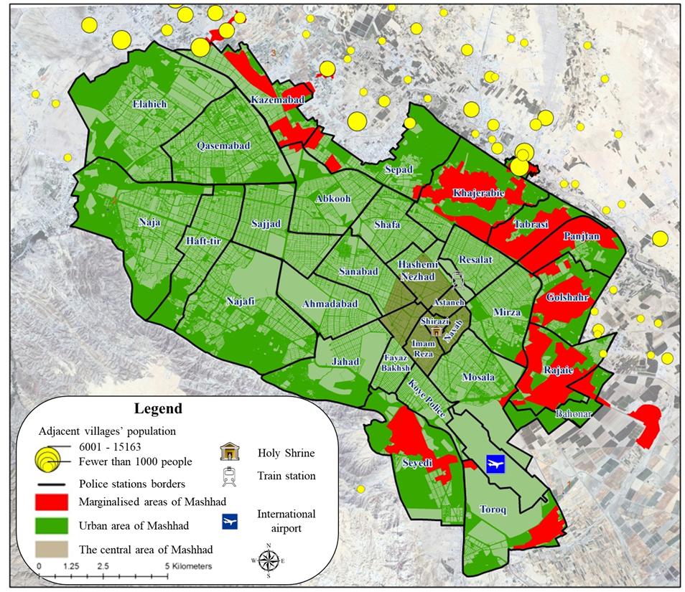
Figure 1. Mashhad city and its major elements
The fourth influential factor, which affects different aspects of the city and has several consequences, is related to the (im)migration phenomenon from neighboring countries and/or other urban and rural parts of Iran to Mashhad considered the first and foremost (im)migrants’ destination in the eastern part of the city. Consequently, Mashhad's population and area have respectively become 11.25 and 18.75 times larger from 1956 to 2011 (Firoozi et al., 2019). Almost one-sixth of Mashhad’s population is constituted by (im)migrants who almost 33 and 25 percent of them left their origins because of joblessness and low quality of life, respectively and, have come to Mashhad, where wealth and job opportunities are more frequent (Fouladiyan and Rezaeebahrabad 2019; Rafieian, Ghazaie and Ghazi 2018). According to Fouladiyan and Rezaeebahrabad (2019), migrants from other cities and villages constitute almost 40 and 17 percent of the population in marginalized areas, respectively. (Im)migrants have been mostly inhabited in these areas – mostly in Northern, Northeastern, and Northwestern parts of the city –, where almost one million individuals (one-third of Mashhad’s population and one-seventh of Iran’s marginalized population) are living in an area of 3695 hectares (almost 10% of Mashhad’s area and 6% of Iran’s total marginal areas). Besides, the population of adjacent villages mainly located in the northern part of the city (Figure 1) has increased nine times since forty years ago, which increases the danger of rising criminal acts if they are about to merge into the city.
Rafieian et al. (2018) also suggested that the lower the socioeconomic status of (im)migrants’ origins is, the more likely they are to live in marginalized areas. Compared to the rest of the city, these areas are mainly concentrated by poverty and criminal acts and lack social sustainability and security. It is also suggested that drug dealing and drug addicts associated with robbery and poverty are also mainly concentrated in the northern and northeastern parts of the city (Mafi and Abdoulahzadeh 2017; Azami and Rusta 2012). According to Farhadikhah et al. (2018), Farhadikhah, Hataminezhad and Shahi (2019), Hataminezhad, Mansouri Etminan and Farhadi (2022) as well as Soleimani Moghadam, Zandi and aKbari (2021) the spatial concentration of poverty in Mashhad, which is one of the crucial explanatory factors of crime in its context (Fouladiyan and Rezaeebahrabad 2019; Alimoheseni and Zoghdarmoghadam 2018; Shahivandi, et al. 2017; Bazargan, et al. 2017), follows a clustering pattern and is mainly more concentrated in Northern and Northeastern parts of the city, where marginalised areas are mostly located. It also suggests that there is a severe disequilibrium of economic status in Mashhad, which states that the closer the neighborhoods are to the North and Northeastern parts of the city, the more deprived they are (Figure 2). Overlapping poverty map, population and the distribution of five types of robbery suggest that almost 41% of Mashhad’s population is inhabited in places where poverty is very high and high. Also, 49% of home burglaries, 46% of motorcycle theft and 49% of shoplifting are committed in places where poverty is more concentrated. In contrast, less poor areas are places where car theft and street robberies are more frequent, at 41% and 42% respectively. Khajerabie, Panjtan, Rajaie, Tabarsi and Golshahr are police station districts that constitute almost 55% of most deprived individuals.
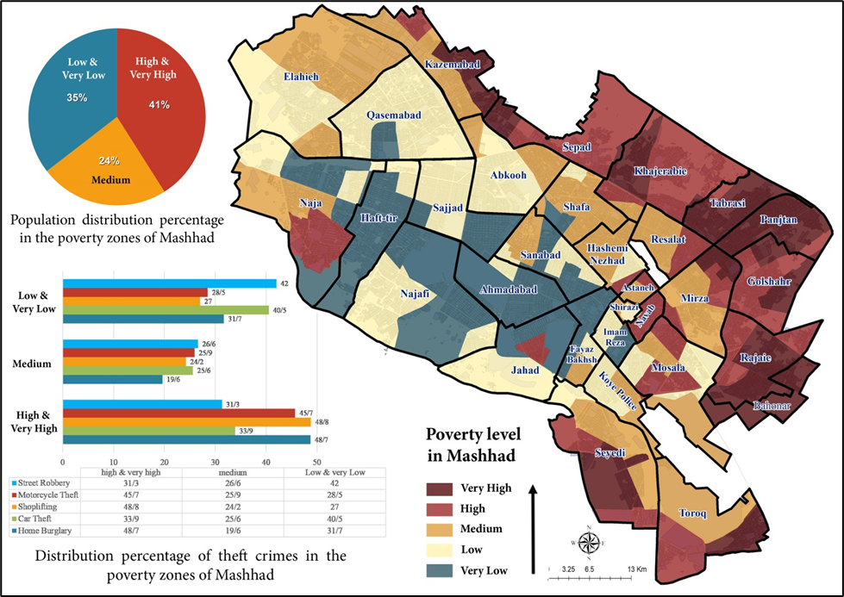
Figure 2. Spatial distribution of poverty and its overlap with population and robbery in Mashhad (Farhadikhah et al., 2018)
To sum up, it can be declared that Mashhad is a heterogeneous city with a mixture of pilgrims, tourists, national and international (im)migrants and local people and is mainly governed based on religious and cultural perspectives. Poverty, marginalisation, anonymity, increase in criminal acts, lack of sense of belonging and social unsustainability are some of the adverse consequences of the current situation.

Spatial unit of analysis
Scholars have usually used census tracts and neighborhoods as their spatial unit of analysis while the current study focus is on the police station districts in Mashhad. Since this study is conducted based on the police reports about the increase in robbery rates in Mashhad and their willingness to find ways to prevent crime, analyses are conducted based on the police station districts to make the result more perceptible for them. There are 31 police station districts in Mashhad and crime-related data is usually collected and analyzed based on them. Police station districts also include those areas which are in close relationship with the city but are not included in its proper necessarily. These districts officially introduced for monitoring crime are not adjusted to the municipal regions’ borders necessarily, and the central police station of Mashhad runs them.

Data and variables
Considering the limitation on access to data owing to confidentiality of crime related data and the fact that robbery has inclusive impacts on everyone, it and its types are considered the main focus of this paper. Robbery data was gathered in 2018 by the Central Police Station Department (CPSD) and is divided into 12 main categories, which among them home burglary, street robbery, shoplifting, car theft, and motorcycle theft are considered police priorities owing to their frequency. The aggregation of these crimes for each police station district is also called total crime. To analyze the probable relationships between robbery and its geographical location, the level of poverty is selected as a variable that represents socioeconomic as well as physical aspects of geographic locations simultaneously.
Farhadikhah et al. (2018), Farhadikhah et al. (2019), Soleimani moghadam et al. (2021) and Hataminezhad et al. (2022) all studied the status of poverty in Mashhad. They all considered social, economic and physical factors for analyzing the level of poverty in different parts of the city. Besides, their results also suggest a high level of consistency and according to them the highest level of poverty is concentrated on Mashhad’s periphery, especially in its North and Northeastern parts. Since these papers’ results do not indicate significant distinctions and are much alike in terms of variables, this study has focused on Farhadikhah et al.'s (2018) paper. Thus, poverty-required data is extracted from it and then results are adjusted to the spatial unit of this study (Figure 2). Farhadikhah et al. (2018) like other researchers who dedicated their studies to poverty in Mashhad emphasized socioeconomic and physical factors and used almost 30 different variables.
Children’s mortality rate, illiteracy rate, graduate education rate, access to computers, family size, elderly rate, the proportion of the disabled and fertility rate are variables used for examining social poverty rate. The dependency ratio, unemployment rate, women’s unemployment rate, tenant rate, car ownership rate and activity (economic partnership) rate are variables used in calculating economic poverty. Families’ income is a variable which seems to be absent from the list of variables for calculating economic poverty. However, since Iranian families are not willing to release their income and the required data for calculating poverty is extracted from census data, which usually does not have the required data for households’ income, not only Farhadikhah et al. (2018) but Farhadikhah et al. (2019), Soleimani Moghadam et al. (2021) and Hataminezhad et al. (2022) also did not consider families’ income as a potential variable. Family per house, person per room and housing unit, population density, houses without electricity/gas/drinking water ratio, housing area, quality of housing, etc. are also among the most significant variables used for analyzing physical poverty. Using these variables as well as considering their weights compared to other variables resulted in the level of total poverty in different parts of Mashhad (Figure 2) (Farhadikhah et al. 2018).
For identifying crime generators, attractors, and detractors, robbery and its types are the dependent variables and two sets of variables act as independent ones (Figure 3), their data belong to the last census conducted in 2016 by the Statistical Center of Iran. The first set which includes only one variable considers the total number of students and pupils living in each police station district. Choosing students as one of the independent variables is twofold. For one thing, it has to do with studentification and behaviorism perspectives, and for another thing, it is related to the frequency of them and urban facilities, i.e., educational facilities, that bring them to urban environments and/or action spaces. According to the census in 2016, there are almost 650000 students in Mashhad who constitute almost one-fifth of the total population. Furthermore, the proportion of different urban facilities in Mashhad, also suggests that educational facilities are the fourth most ubiquitous urban facility (0.41%) after housing (78.3%), commercial (9.49%) and unclassifiable (7.34%). The second set of independent variables includes the number of facilities that fall under one of these land-use categories: residential, commercial, educational, administrative, sanitary, sport, green space, cultural, religious, infrastructural, warehousing, farm and gardens, and unclassifiable.

Methods
To address the main aims of the current study, for one thing, the spatial distribution of robbery and its types as well as their possible relationships with the built environment should be analyzed. For another thing, exploratory variables – number of facilities and students – which define robbery and its types should be unearthed through inferential statistics (Figure 3).
The spatial distribution of crime is analyzed based on the GIS spatial analysis. At first, a Moran I index is used to see if the same types of robberies occur in the neighboring police station districts. It illustrates whether robbery and its types follow a clustered pattern of occurring or a dispersed one. Moran I index varies between -1 and 1, and the closer the value is to 1 the more similar robberies are occurring adjacently, and the closer the value is to -1 the more dispersed they are (Ghazaie et al. 2021b). Since the Moran I index does not provide a visual understanding of robberies and their levels of concentration, A Getis-Ord Gi* analysis is used for robberies that follow a clustered pattern. This analysis not only provides the geographies of similar robberies’ concentrations but ends with a unique value (Z-score) for each district. The higher the value is, the more similar types of robberies occur in the same district (Ord and Getis 1995). Finally, a Pearson Correlation between Z-scores and poverty levels extracted from Farhadikhah et al. (2018) could indicate if there is any possible relationship between robberies occurrence and their geographical locations in the city.
After exploring crime’s spatial distribution, the study tries to find out if there is a possible relationship between crime and the number of different facilities and students. The purpose is to identify crime generators, attractors, and detractors’ facilities and understand how the number of students in each district affects crime. To this aim, the total number of facilities for each category – extracted from Mashhad’s comprehensive plan –, the total number of students – extracted from Mashhad’s latest census in 2016 – as well as the total number of robberies and their types – extracted from CPSD’s records in 2018 – are taken into account. Regression analysis is used for studying probable relationships. In this regard, the total number of robberies and their types are cast as our dependent variables. Since the areas of spatial units, i.e., police station districts, are not uniform, robbery data is normalized based on the area (Figure 4). Independent variables are selected from the provided list after examining possible collinearity between variables. Consequently, variables whose Variance Inflation Factor (VIF) values are 10 or more are removed from the regression analysis. Independent variables’ VIF values suggest that 8 variables out of 13 could be considered (Figure 3).

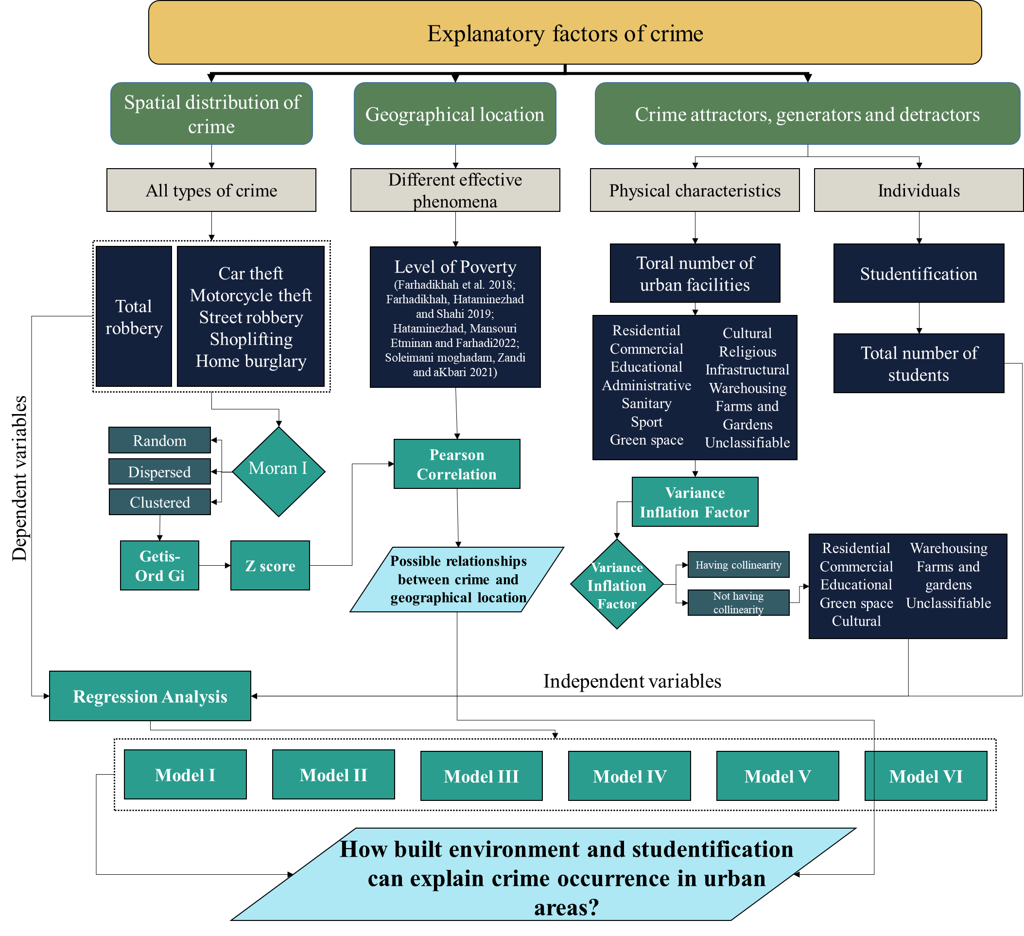
Figure 3. The procedural model of studying the influence of built environment and studentification on crime occurrence in urban areas

Results

Spatial distribution of robbery and its types in Mashhad
According to CPSD, 29332 robberies occurred in Mashhad in 2018 which Shirazi and Khajerabie districts had the lowest and highest numbers of robberies, respectively (Figure 4). Based on Figure 5 northern districts had the highest number of robberies and home burglary, car theft, and street robbery were also the most common types of robbery in 2018.
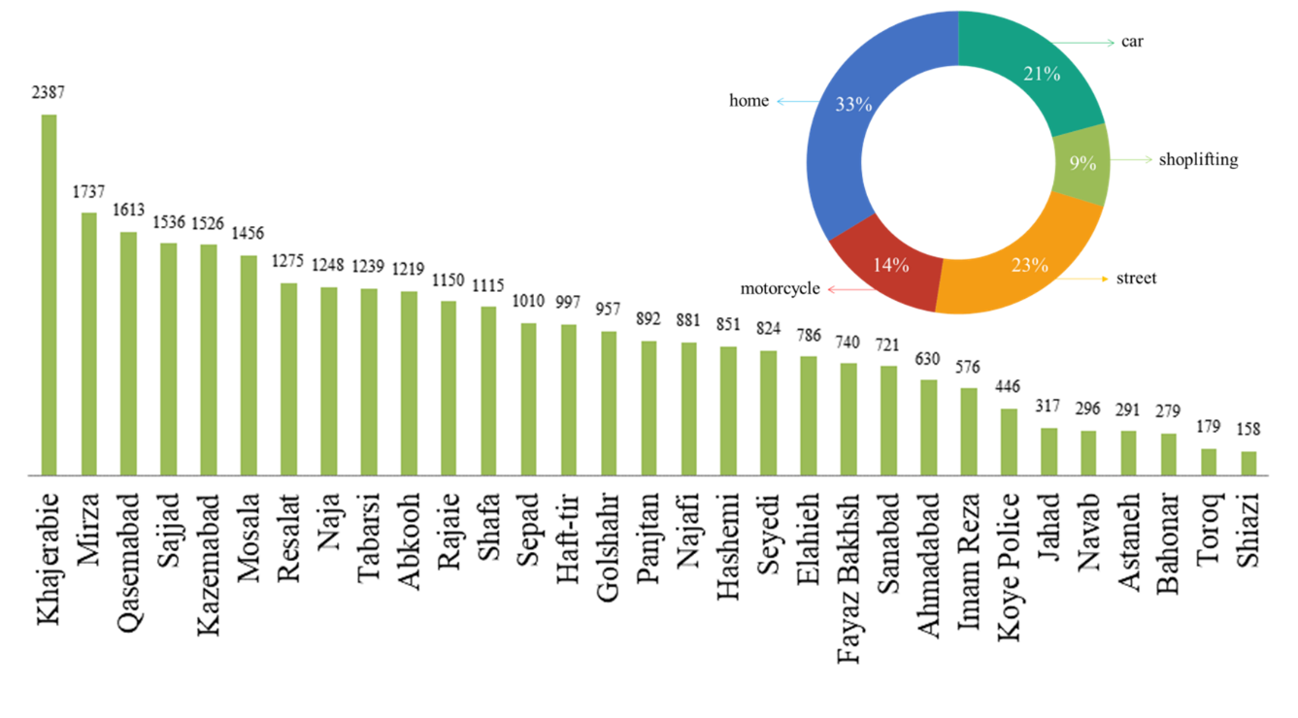
Figure 4. Total number of five selected types of robbery in police station districts
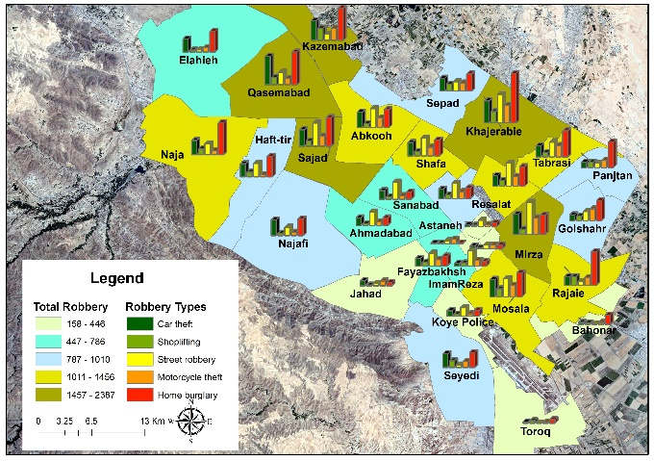 | 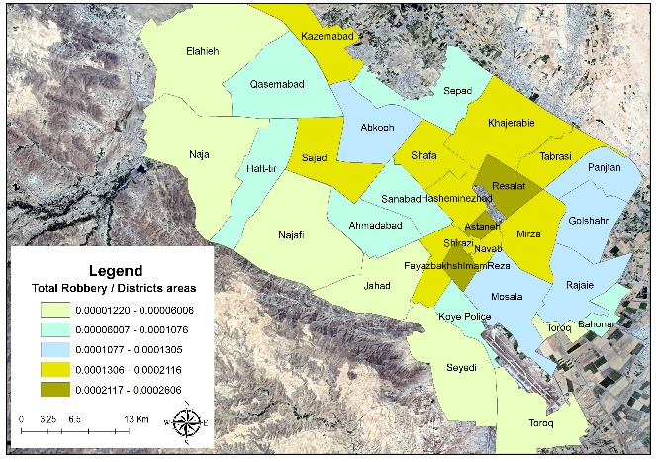
Figure 5. Number of robberies and their types in Mashhad Police Station Districts | Figure 6. Number of robberies to the areas of each district
As Figure 6 illustrates, considering district areas could affect the probability of districts attracting offenders. For instance, Resalat, Astaneh, and ImamReza districts are considered the most robbery-prone districts in Figure 6 although they do not have the highest number of robberies. That is why robbery data is normalized based on the area. Moran I indexes also suggest that offences usually occur in close geographical districts. Analyses indicate that the concentration of robberies in Mashhad could be classified into three main categories based on their Moran I statistics values. Robbery in its general understanding as well as shoplifting, car theft, and home burglary have the most clustered pattern in the city. The Moran I value for total robbery is 0.3014 (p-value=0.01) and its values for shoplifting, car theft and home burglary, which constitute 8.87%, 21.1%, and 33.88% of total robberies, are 0.2583, 0.3387, and 0.3904 (p-value=0.01), respectively. Since home burglary has the greatest Moran I value, it can be declared that districts which attract home burglars are highly located next to each other. The second category belongs to motorcycle theft which constitutes almost 13.57% of total robberies. Its Moran I value is 0.1847 (p-value=0.05). Hence, districts that attract motorcycle thieves are less clustered. The third category belongs to street robbery with 22.58% of total robberies, which follows a random spatial pattern with a Moran I value of 0.068 (p-value=0.28).
Consequently, all types of robbery except street robbery illustrate a tendency for clustering although motorcycle theft is less clustered than the rest. Hence, crime-prone districts are mainly located next to each other. The positive Z-scores also support the clustering patterns of robbery in Mashhad. In the next step, the Hotspot analysis is conducted whose results for clustered variables are provided in Figure 7.
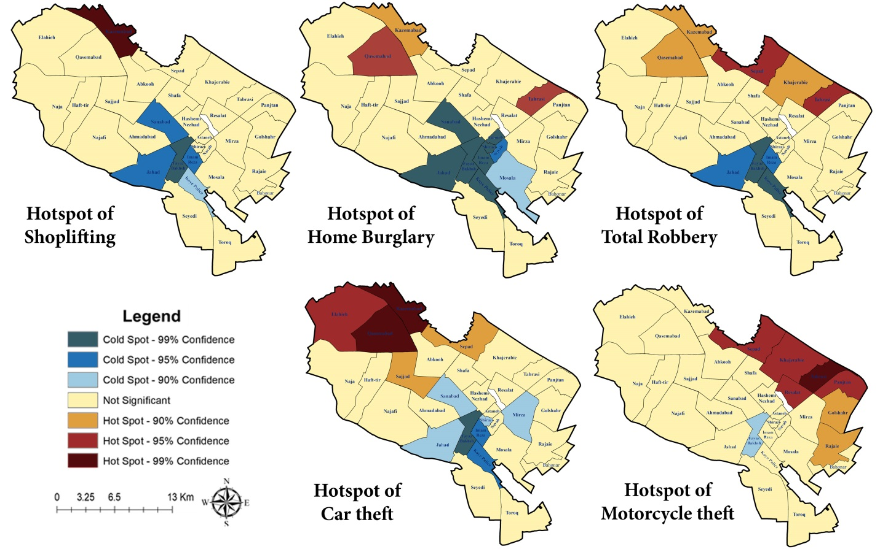
Figure 7. Robbery-prone districts in Mashhad city
As Figure 7 indicates, in general, northern districts are more prone to robbery and its types and southern ones have the least concentration of crime. Hotspot analysis also suggests that separated Hotspots or Coldspots could hardly ever be found. Considering hotspot maps, it is stated that Kazemabad, Qasemabad, Sepad, and Tabrasi are the most crime-prone police station districts in Mashhad. However, Fayazbakhsh, Koye police, Jahad, and ImamReza are the least crime-prone districts. Crime-prone districts are usually newly-built parts of the city, which can be divided into planned and unplanned developments. Northern districts, especially those located next to the Northern border of the city are mostly inhabited by (im)migrants and lower-income families. These are places where marginalization and spontaneous growth are common. In contrast, Qasemabad is one of the newly built and planned districts of Mashhad whose higher rate of crime could be explained by residents’ dependency on private cars, lower social cohesion as well as anonymity (Ghazaie et al. 2018; Lotfi and Ghazaie 2019). Car theft is the only type of robbery in which its occurrence is more concentrated in districts like Elahieh and Sajad usually inhabited by higher incomes.
Furthermore, the results of the Pearson Correlation indicate that there is a significant relationship between crime and geographical location. Analysis indicates a relatively positive correlation (R=0.356, Sig=0.05) between poverty and total crime, which means that poverty could predispose the urban environment to be prone to crime. A relatively positive correlation between home burglary (R=0.395, Sig=0.028); and strong positive correlations between motorcycle theft (R=0.543, Sig=0.002) and shoplifting (R=0.591, Sig=0) and poverty are also suggested. Hence, shoplifting and Motorcycle theft are consequently more common in more impoverished districts. Besides, since shoplifting, as a kind of petty robbery and/or pilfering usually committed by addicts, has the greatest correlation with poverty, which is more concentrated in northern parts of the city where drug addicts are also frequent, it can be claimed that shoplifting has more to do with meeting basic needs. On the other hand, there is not any significant correlation between poverty and car theft (R=0.075, Sig=0.687). Consequently, stealing cars is not necessarily related to geographical location and/or poverty and compared to shoplifting, which seems to be related to individuals’ needs, has more to do with rational offenders who consider merits and demerits before committing a crime and their action has less to do with being poor or not.

Robbery generators, attractors, and detractors
Here, it is tried to find crime attractors, generators, and detractors and see if studentification could affect crime occurrence. Based on the VIF’s values, administrative, sanitary, sports, infrastructural, and religious facilities were removed owing to their high collinearity with other facilities. Table 1 gives information about the descriptive statistics of either of the remaining facilities and Figure 8 illustrates their Kernal density as well as the number of students in each district.
Table 1. Descriptive statistics of Mashhad’s urban facilities in 2016
Urban facilities | Number | Percentage | Area (h) | Percentage
Residential | 451932 | 78.3 | 7508 | 33.6
Commercial | 54788 | 9.5 | 609 | 2.7
Educational | 2417 | 0.4 | 1277 | 5.7
Green space | 1011 | 0.2 | 1048 | 4.7
Cultural | 219 | 0.04 | 23 | 0.1
Warehousing | 2201 | 0.4 | 315 | 1.4
Farm and Gardens | 1284 | 0.2 | 4666 | 20.9
Unclassifiable | 42378 | 7.3 | 4790 | 21.5
Other facilities | 20763 | 3.6 | 2091 | 9.4
Total | 576993 | 100 | 22327 | 100

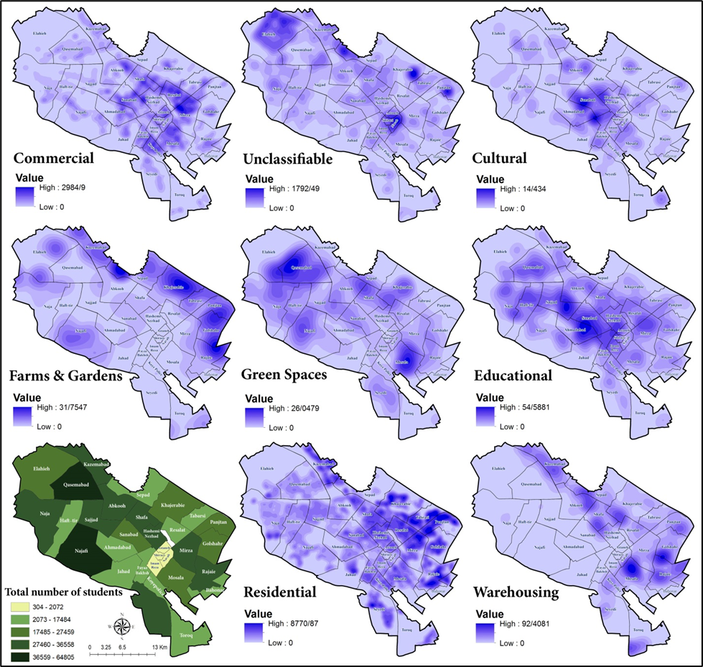
Figure 8. Urban facilities’ Kernal density, and the number of students in each district
As Figure 8 indicates commercial, educational, cultural and unclassifiable facilities are more located in the center of the city while farms and gardens and residential facilities are more located in the northeastern parts. Regression analysis is conducted to study the causal relationships and find how these variables cause robbery and its types (Table 2).
Table 2. Exploratory variables of robbery and its types
Model | Variable type | Variable name | Coefficient | Probability | R² | Adjusted R² | N
Model I | Dependent variable | Total Robbery |  | 0.00 | 0.906 | 0.866 | 31
Model I | Independent variables | Constant | 85.197 | 0.327 | 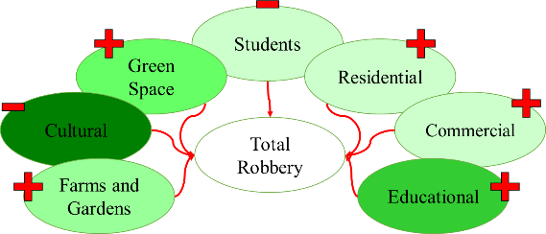
Model I | Independent variables | Residential* | 0.034 | 0.001
Model I | Independent variables | Commercial* | 0.093 | 0.011
Model I | Independent variables | Educational* | 4.228 | 0.00
Model I | Independent variables | Green space* | 3.354 | 0.006
Model I | Independent variables | Cultural* | -17.332 | 0.003
Model I | Independent variables | Warehousing | -0.479 | 0.485
Model I | Independent variables | Farms and gardens* | 2.625 | 0.013
Model I | Independent variables | Unclassifiable | 0.029 | 0.26
Model I | Independent variables | Students* | -0.011 | 0.031
Model II | Dependent variable | Car theft |  | 0.00 | 0.842 | 0.775 | 31
Model II | Independent variables | Constant | 8.663 | 0.748 | 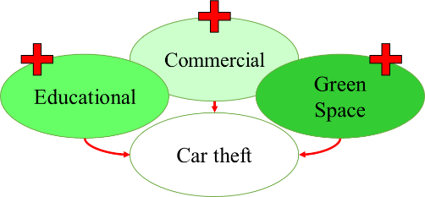
Model II | Independent variables | Residential | 0.002 | 0.454
Model II | Independent variables | Commercial* | 0.023 | 0.037
Model II | Independent variables | Educational* | 0.741 | 0.032
Model II | Independent variables | Green space* | 1.151 | 0.003
Model II | Independent variables | Cultural | -2.824 | 0.091
Model II | Independent variables | Warehousing | -0.078 | 0.717
Model II | Independent variables | Farms and gardens | 0.492 | 0.113
Model II | Independent variables | Unclassifiable | 0.009 | 0.262
Model II | Independent variables | Students | 0.001 | 0.60
Model III | Dependent variable | Shoplifting |  | 0.00 | 0.812 | 0.732 | 31
Model III | Independent variables | Constant | 19.958 | 0.124 | 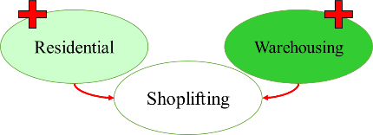
Model III | Independent variables | Residential* | 0.003 | 0.017
Model III | Independent variables | Commercial | -0.002 | 0.665
Model III | Independent variables | Educational | 0.216 | 0.167
Model III | Independent variables | Green space | 0.311 | 0.06
Model III | Independent variables | Cultural | -1.013 | 0.189
Model III | Independent variables | Warehousing* | 0.222 | 0.036
Model III | Independent variables | Farms and gardens | 0.152 | 0.286
Model III | Independent variables | Unclassifiable | -0.0003 | 0.917
Model III | Independent variables | Students | -0.001 | 0.151
Model IV | Dependent variable | Street Robbery |  | 0.00 | 0.797 | 0.71 | 31
Model IV | Independent variables | Constant | 24.07 | 0.517 | 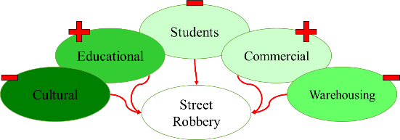
Model IV | Independent variables | Residential | 0.005 | 0.221
Model IV | Independent variables | Commercial* | 0.071 | 0.00
Model IV | Independent variables | Educational* | 1.651 | 0.001
Model IV | Independent variables | Green space | 0.326 | 0.495
Model IV | Independent variables | Cultural* | -4.836 | 0.038
Model IV | Independent variables | Warehousing* | -0.611 | 0.047
Model IV | Independent variables | Farms and gardens | 0.812 | 0.06
Model IV | Independent variables | Unclassifiable | -0.002 | 0.841
Model IV |  | Students* | -0.005 | 0.035
Model V | Dependent variable | Motorcycle theft |  | 0.00 | 0.761 | 0.659 | 31
Model V | Independent variables | Constant | 34.648 | 0.1 | 
Model V | Independent variables | Residential | 0.004 | 0.06
Model V | Independent variables | Commercial* | 0.024 | 0.006
Model V | Independent variables | Educational | 0.3 | 0.233
Model V | Independent variables | Green space | 0.173 | 0.512
Model V | Independent variables | Cultural | -2.341 | 0.06
Model V | Independent variables | Warehousing | -0.081 | 0.62
Model V | Independent variables | Farms and gardens* | 0.575 | 0.019
Model V | Independent variables | Unclassifiable | -0.001 | 0.917
Model V | Independent variables | Students | -0.002 | 0.137
Model VI | Dependent variable | Home burglary |  | 0.00 | 0.941 | 0.915 | 31
Model VI | Independent variables | Constant | -2.142 | 0.939 | 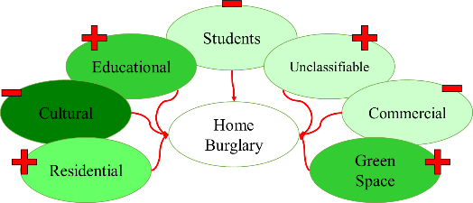
Model VI | Independent variables | Residential* | 0.2 | 0.00
Model VI | Independent variables | Commercial* | -0.024 | 0.043
Model VI | Independent variables | Educational* | 1.32 | 0.001
Model VI | Independent variables | Green space* | 1.393 | 0.001
Model VI | Independent variables | Cultural* | -6.318 | 0.001
Model VI | Independent variables | Warehousing | 0.069 | 0.758
Model VI | Independent variables | Farms and gardens | 0.529 | 0.104
Model VI | Independent variables | Unclassifiable* | 0.023 | 0.01
Model VI | Independent variables | Students* | -0.004 | 0.01
 | *Significant at the 0.05 level.

R-Squared values, in Table 2, suggest that a high percentage of the variances of dependent variables are explained by variances of independent variables. Hence, the provided models could explain crime occurrence in the city well. Based on the first model’s results, cultural facilities play an important role in reducing robbery occurrence in Mashhad police station districts. Besides, the frequency of students could lessen crime, as well. However, farms and gardens, green spaces, educational, residential and commercial units increase robberies. Car theft could be predicted by green spaces, educational and commercial facilities. Shoplifting is commoner in districts where residential and warehousing facilities are more. Street robbery which does not follow a clustered pattern in the city is lower in districts where cultural facilities, students, and warehousing units are greater. In contrast, it increases with a higher number of educational and commercial facilities. Motorcycle theft occurrence boosts in spatial units where farms and gardens as well as commercial units are more frequent. Home burglary is also lower in districts with a higher number of students and cultural and commercial facilities. On the contrary, Educational, residential and unclassifiable facilities, as well as green spaces, increase home burglary.

Discussion
This look at Mashhad robberies' occurrence and their spatial distributions provides useful insights for socio-physical planners, decision-makers, and police officers and let them know how they should prevent crime.
As Brantingham et al. (2017) suggested, action spaces for crimes are more overlapped with places where the poverty rate is higher (Tillyer et al. 2020; Fouladiyan and Rezaeebahrabad 2019; Alimoheseni and Zoghdarmoghadam 2018; Shahivandi, et al. 2017; Bazargan, et al. 2017). According to the twofold role of poverty in criminal acts level and results provided in the previous section, it can be declared that in contrast to what Cook (1986) mentioned, poverty has not reduced opportunities in Mashhad context. In fact, although beneficial opportunities may have diminished owing to the concentrated poverty, home burglary, motorcycle theft and shoplifting are increasing because of two primary reasons.
First, as Fouladiyan and Rezaeebahrabad (2019) suggest individuals in these areas are more prone to commit a crime to meet their basic needs owing to their unemployment, illiteracy and low level of life satisfaction. Moreover, these areas are also where most of the addicts, who are responsible for most of the pilfering, are located. Second, as Larsson (2006) declares these people are more exposed to robbery and more specifically property crime (home burglary and motorcycle theft) owing to their inability to run a normal life and safeguard their properties. The great correlation between shoplifting and poverty is associated with the fact that robbery in Mashhad is usually for meeting families’ basic needs and it has rarely to do with beneficial opportunities (Kimpton et al. 2016).
Therefore, according to routine activity theory (Felson, 2017) poor areas of the city are where motivated offenders such as addicts are frequent, interesting targets such as poor households, who cannot protect their goods, exist and there is a lack of guardian in the urban environment, which can be explained by low level of social sustainability in these areas (Mafi and Abdoulahzadeh 2017). Consequently, the idea of rational offenders (Cornish and Clarke 2017) as a general theme can be questioned in impoverished parts of Mashhad where robbery has more to do with life necessities than weighting opportunities and harms. However, Car theft and street robbery spatial patterns suggest that their occurrence is not necessarily because of poverty and car stealers and street robbers are more likely to be considered rationalists. For instance, the dispersed pattern of street robbery in Mashhad suggests that offenders try to find the most beneficial and the least risky targets in different parts of the city, so their space action can be as great as the city’s area.
Considering routine activities and crime pattern theory, results also suggest that physical characteristics, activities, and capable guardians could affect crime occurrence (Felson, 2017). Physical characteristics are usually defined based on urban facilities, which affect guardians and activities as well. Crime generators, detractors and attractors are what this part of the study wanted to focus on. However, distinguishing crime generators and attractors in the Mashhad context seems challenging because crime generators such as bars and alcohol outlets (Tillyer et al. 2020; Livingston et al. 2014) are mainly forbidden in Mashhad owing to religious and cultural considerations regarded as two main forces for governing city relations. Other urban facilities studied in this context are not mainly facilities which are in close connection with offenders, so they barely can be introduced as crime generators.
According to results and as Wilcox and Eck (2011) indicated, most of the facilities attract crime in Mashhad. Commercial facilities seem to be somehow the most significant robbery attractors for all types of robbery except home burglary (Bernasco and Block 2011; Meshkini et al. 2016; Mohamadi et al. 2017). Not only commercial facilities could act as interesting targets but they are also capable of attracting all walks of life. They usually seem to be located next to main streets (Figure 8) mobbed by passersby, shops, and cars, where motivated offenders, potential victims and lack of guardians exist (Mafi and Abdoulahzadeh 2017). In contrast, they can act as a crime detractor for home burglary because shoplifting seems to be less risky and more interesting than home burglary. Residential units also play the role of a crime attractor for robbery (Sypion-Dutkowska and Leitner 2017) and is a strong exploratory variable for predicting crime-prone areas (Meshkini et al. 2016; Mohamadi et al. 2017). Residential units are interesting targets for home burglars and that is why home burglary constitutes almost over one-third of the five studied types of robbery in Mashhad. Moreover, as Figure 8 suggests, there is an overlap between residential and commercial facilities. It means that they are located adjacently. This adjacency as well as the fact that robbery has to do with poverty elucidate why residential units play the role of a crime attractor for shoplifting.
Green spaces and educational facilities also can act as robbery attractors owing to the close and daily relationships of individuals with them (Zhang et al. 2021) although Branas et al. (2011) and Zamiri and Sharifi Noghabi (2021) respectively in their studies in American and Iranian contexts stated that green areas reduce crime rates (Shepley et al. 2019; Wolfe and Mennis 2012). Alizadeh and Anbari (2017) in their study in Mashhad indicated that parks as one of the main green spaces include defenseless spaces as well as social anomalies, which lessen security and boost criminal acts. Farms and gardens usually located in cities’ peripheries (Figure 8) also act as crime attractors because they play the role of second houses, and are not permanently inhabited by their owners. According to a study carried out by Izadi and Solhjoo (2018) in Mashhad, 35.6 and 31.6 percent of these second houses are mainly used 51 to 75 and 76 to 100 days per year, respectively. Consequently, the lack of guardians owing to the emptiness and homogeneity in terms of land-use (Taghvaee, Rafieian and Rezvan 2011) provides great opportunities for offenders. These facilities could also act as crime generators because they are located in places where less social sustainability and fewer guardians exist (Mafi and Abdoulahzadeh 2017). Warehousing also follows the same pattern of farms and gardens and that is why they act as crime attractors. However, they act as street robbery’s detractors since they are mainly located in cities’ peripheries and close to main roads and cities’ entrances (Figure 8). Therefore, there are fewer individuals on the streets and the rate of street robbery is also lower.
On the other hand, in contrast to Sypion-Dutkowska and Leitner (2017) and along with Sajadyan et al. (2015), regression analysis indicated that cultural facilities lessen the number of total robberies, street robberies and home burglaries. Since their coefficients are much greater than the corresponding numbers for other urban facilities, it can be declared that their role in detracting robberies and criminal acts is quite significant. Moarrab et al. (2018) also in their Iranian context suggest that cultural facilities and centers can improve social capital, so they are quite effective in improving social resiliency and lessening social vulnerability and ignoring them can cause more aggressive behavior, delinquency and crime (Ebadinezhad et al. 2009). Sajadyan et al. (2015) also explain that there should be a sensible relation between cultural facilities and population density, otherwise, criminal acts will increase. Reviewing Mashhad's developmental plans suggests that although addressing cultural facilities’ shortages has been taken into account, they have not been redistributed evenly (Figure 8) and policies that predispose these settings to make them places for social encounters have been neglected (Ghazaie et al., 2021a). The disequilibrium in the distribution of cultural facilities in Mashhad and the lack of them in Northern districts along with concentrated poverty have deteriorated the situation and consequently caused more criminal acts in these areas.
Moreover, in favor of Cullen and Levitt (1999) and Kim (2020), and in contrast with Barberet et al. (2004) and Allinson (2006)), students also act as crime detractors in Mashhad’s districts. An inquiry that might arise is why educational facilities attract robberies and students as those who use these facilities are crime detractors. In response, it should be said that the variable of educational facilities refers to the places where students study while the variable of the total number of students refers to their places of living. Besides, Mashhad’s educational facilities are usually located next to commercial facilities and greenspaces which also act as crime attractors. It means that the existence of students in urban environments, their daily commutes from home to schools and universities, and their cultural expressiveness could decrease the potentiality of crime occurrence in the city and affect residents’ attitudes and behaviors (Kenna 2011; Hubbard 2008; Fabua et al., 2017). According to what Andell et al. (2002) coined, it can be stated that students in Mashhad are taking part in student-led crime prevention unconsciously.
Consequently, culturally related facilities and studentification could detract offenders and decrease total robbery as well as street robbery and home burglary. Hence, it seems that a culture-led crime prevention strategy could be considered as a pathway for Mashhad and similar contexts to mitigate crime and robbery occurrence. It, for one thing, focuses on planning, location finding and redistributing cultural facilities all over the city, especially in districts with higher rates of crime and a greater number of crime attractors. Cultural facilities could generate secure action spaces that prevent crime from happening objectively and subjectively. For another thing, it can focus on the cultural expressiveness of students and pupils and count on their presence in urban settings which could reduce crime occurrence. Although, as it was suggested, the effect of students on crime seems to be spontaneous and does not happen because of a planned policy, providing required knowledge and skills and making students aware of the importance of their roles could improve their mitigation role on crime occurrence.

Conclusion
The current study through investigating the spatial distribution of different types of robbery and analyzing their probable relationships with urban facilities and one of the most dominant social groups of Mashhad – students – suggested how studentification and urban facilities could affect robberies. Results indicated that shoplifting, motorcycle theft, car theft, and home burglary follow a clustered pattern, and street robbery has a random spatial pattern. It suggests that robberies and offenders are usually concentrated in certain parts of the city where poverty and marginalization are also concentrated. Robbery is not found to be an organized crime necessarily and often occurs because of lives’ necessities. However, street robbery and car theft seem to follow rational offender theory owing to their spatial distribution in the city and their insignificant relationship with poverty. Residential, commercial, educational, green spaces, farms and gardens, and warehousing are crime attractors facilities, and cultural facilities, as well as students, are crime detractors in Mashhad districts. Cultural facilities and students’ roles in reducing crime rates in Mashhad suggest that a culture-led crime prevention strategy that follows environmental and behaviorism perspectives could be considered as a passway for crime prevention in cities. The following recommendations are given as takeaway policies for a culture-led crime prevention: revisioning urban developmental plans and considering cultural issues as one the main ideologies of these plans and focusing on social encounters as well as physical interventions for constructing cultural facilities in the city, government’s financial supports for creating and developing cultural facilities in the lower-income districts because investing on them seems unattractive in investors’ perspectives, even qualitative and quantitative redistribution of cultural facilities and services in the city, prioritizing the holding of cultural events and construction of libraries, cinemas, galleries, cultural centers and complexes, theaters, community halls in crime hotspots districts, enhancing cultural programs for educating and informing students as cultural ambassadors of the city and making them aware of their critical roles in crime prevention, conducting cultural comprehensive plans and prioritizing students’ roles as those who their presence and behavior could diminish crime rate.

Bibliography

Alguera, Gerardo Bonilla , and Raúl Gutiérrez Meave. 2021. "Zoning Out Robbery? An Empirical Study in Mexico City." Housing Policy Debate 1-20. doi:10.1080/10511482.2021.1915357.
Alimoheseni, reza, and Azar Zoghdarmoghadam. 2018. "Studying the relationship between urban space and crime: the case of Mashhad/s 11th urban region." Journal of Sociological Researches 11 (3.4): 151-171.
Alizadeh, Katayoon, and Seyyed Hussein Anbar. 2017. "The role of urban spaces defenseless in occurrence of crime with an emphasis on Parks District 9 Mashhad." Research and Urban Planning 8 (29): 141-160. doi:20.1001.1.22285229.1396.8.29.8.2.
Allinson, John. 2006. "Over-educated, over-exuberant and over here? The impact of students on cities." Planning, Practice & Research 21 (1): 79-94. doi:10.1080/02697450600901541.
Azami, Hadi, and Mojtaba Rusta. 2012. "Investigation and Analysis of the Effects of Inequalities on Societal, Economic and Political Security of Mashhad Metropolitan." Human Geography Research Quarterly 44 (3): 177-192. doi:10.22059/JHGR.2012.24987.
Barbaret, R, B S Fisher, and H Taylor. 2004. Student Safety in the East Midlands Home Office Online. Report 61/04, London: The Stationery Office.
Bazargan , Mehdi , and Mohammad Ajza Shokouhi. 2020. "Investigating spatial diffusion pattern of residential burglary in Mashhad in the 2011-2017 Period." Research Quarterly of Geographical Data (SEPEHR) 29 (113): 73-91. doi:10.22131/SEPEHR.2020.40472.
Bazargan, Mahdi, MohammadRahim Rahnama, Mohammad AjzaShokouhi, and SeyedHadi Zarghani. 2017. "Identification and Spatial Analysis of Crime Hotspots Robbery in Mashhad Metropolis." Research Political Geography Quarterly 2 (2): 21-46.
Bernasco, Wim, and Richard Block. 2010. "Robberies in Chicago: A Block-Level Analysis of the Influence of Crime Generators, Crime Attractors, and Offender Anchor Points." Journal of Research in Crime and Delinquency 48 (1): 33-57. doi:10.1177/0022427810384135.
Bottoms, A, and P Wiles. 1997. "Environmental criminology." In The Oxford handbook of criminology, by M Maguire, R Morgan and R Reiner, 305–359. Oxford: Clarendon Press.
Branas, Charles C., Rose A. Cheney, John M. MacDonald, Vicky W. Tam, Tara D. Jackson, and Thomas R. Ten Have. 2011. "A Difference-in-Differences Analysis of Health, Safety, and Greening Vacant Urban Space." American Journal of Epidemiology 174 (11): 1296–1306. doi:10.1093/aje/kwr273.
Brantingham, P. J., and P. L. Brantingham. 1981. Environmental criminology. Sage.
Brantingham, Paul J., Patricia L. Brantingham, and Martin A. Andresen. 2017. "The geometry of crime and crime pattern theory." In Environmental Criminology and Crime Analysis, by Richard Wortley and Michael Townsley, 98-115. New York: Routledge.
Burke, Nancy J. , Galen Joseph, Rena J. Pasick, and Judith C. Barker. 2009. "Theorizing Social Context: Rethinking Behavioral Theory." Health Education & Behavior 36 (1): 55S-70S. doi:10.1177/1090198109335338.
Cook, P. 1986. "The Demand and Supply of Criminal Opportunities. " In Crime and Justice: An Annual Review of Research, 7.
Cornish, Derek B., and Ronald V. Clarke. 2017. "The rational choice perspective." In Environmental Criminology and Crime Analysis, by Richard Wortley and Michael Townsley, 31-61. New York: Routledge.
Cozens, Paul Michael. 2011. "Urban Planning and Environmental Criminology: Towards a New Perspective for Safer Cities." Planning Practice and Research 26 (4): 481-508. doi:10.1080/02697459.2011.582357.
Cullen, Julie Berry, and Steven D. Levitt. 1999. "Crime, urban flight, and the consequences for cities." The Review of Economics and Statistics 81 (2): 159-169.
Ebadi Nezhad, Ali, Leyla Zoghi, Aziz Rafati, and Abbas Ghobadi. 2009. "The Relationship between Geographical Factors and Social order and security. Journal of Social Security." Journal of Social Order 1 (3): 127-140.
Eghbali, Sahar, Mozhgan Azimi Hashemi, and Hamed Bakhshi. 2016. "Typology of Cultural Tourism Action (Case Study: Mashhad Pilgrims and Tourists." Journal of Social Studies in Tourism 3 (6): 39-60.
Farhadikhah, Hossein , Hossein Hataminejad, Aref Shahi, and Masoud Zafari. 2018. "Spatial Analysis of Urban Poverty in Neighborhood Levels (case study: Mashhad city)." Urban Economics 2 (2): 17-36. doi:10.22108/ue.2018.108525.1049 .
Farhadikhah, Hossein , Hossein Hattaminejad, and Aref Shahi. 2019. "Investigating the Pattern of Residence of Immigrants and its Relationship with Slum area and urban poverty in metropolises Case Study: Mashhad Metropolis." Urban Economics 4 (1): 25-40. doi:10.22108/ue.2020.115485.1115 .
Felson, Marcus. 2017. "The routine activity approach." In Environmental Criminology and Crime Analysis, by Richard Wortley and Michael Townsley, 87-97. New York: Routledge.
Firoozi, MohammadAli, Jafar Javan, and Masoomeh Tavangar. 2019. "Genealogy of the Pilgrimage and Tourism Role of Mashhad." Journal of Geography and Regional Development 17 (1): 155-191.
Fitzgerald, Charity Samantha. 2011. "Historical Theories of Crime and Delinquency." Journal of Human Behavior in the Social Environment 21 (3): 297-311. doi:10.1080/10911359.2011.564954.
Fouladiyan, Majid, and Hasan Rezaeebahrabad. 2019. "A look toward social harms and crimes in Mashhad's marginalized areas and their facilitating factors." The sociology of Iran social issues 1-27.
Ghazaie, Mohammad., Abdolreza Pakshir, Sahand Lotfi, Ali Soltani, & Ali Goli. (2017). Studying the Urban Segregation of different groups In Mashhad with an emphasis on residential features. Geographic Space, 16(56), 33-51.
Ghazaie, Mohammad, Mojtaba Rafieian, and Hashem Dadashpoor. 2021a. "Celebrating diversity: A framework for urban discourses." Local Development & Society 1-20. doi:10.1080/26883597.2021.1883993.
Ghazaie, Mohammad, Iman Farahmandi, and Hadi Attarzadeh Tusi. 2018. "Bus Route Evaluation Using; A Triple Combination of DEA, Entropy & Topsis Models." ARMANSHAHR: Journal of Architecture, Urban Design & Urban Development 11 (23): 307-318.
Ghazaie, Mohammad, Mojtaba Rafieian, and Hashem Dadashpoor. 2021b. "Making the invisible segregation of diverse neighbourhoods visible." Journal of Housing and the Built Environment 1-25. doi:10.1007/s10901-021-09850-z.
Glaeser, Edward L. , and Bruce Sacerdote. 1999. "Why is There More Crime in Cities?" Journal of Political Economy 107 (S6): S225-S258.
Hataminejad, Hossien , Abolfazl Mansouri Etminan, and Ebrahim Farhadi. 2022. "Investigating the Role of Green Economy on Urban Poverty Reduction (Case Study: Mashhad)." Urban Social Geography 9 (2): 257-274.
Hubbard, Phil. 2008. "Regulating the social impacts of studentification: a Loughborough case study." Environment and Planning A 40: 323-341. doi:10.10 6 8 /a3 9 6.
Izadi, Hasan, and Mostafa Solhjoo. 2018. "Investigating the causes and consequences of the formation of second homes in suburbs of metropolises, case study: Mashhad." Journal of Regional Planning 8 (31): 129-152.
Jelokhani-Niaraki, Mohammadreza , Ramin Bastami Mofrad, Qiuomars Yazdanpanah Dero, Fakhreddin Hajiloo, and Abolghasem Sadeghi-Niaraki. 2020. "A volunteered geographic information system for monitoring and managing urban crimes: a case study of Tehran, Iran." Police Practice and Research 21 (6): 547-561. doi:10.1080/15614263.2019.1644175.
Kenna, Therese. 2011. "Studentification in Ireland? Analysing the impacts of students and student accommodation on Cork City." Irish Geography 44 (2-3): 191-213. doi:10.1080/00750778.2011.618073.
Kim, Dongwoo. 2020. "The relationship between violent crime and urban high school enrollment in the US." Applied Economic Letters 27 (12): 961-964. doi:10.1080/13504851.2019.1649357.
Kim, Young-An, and John R. Hipp. 2021. "Small Local versus Non-Local: Examining the Relationship between Locally Owned Small Businesses and Spatial Patterns of Crime." Justice Quarterly 1-26. doi:10.1080/07418825.2021.1879899.
Kimpton, Anthony, Jonathan Corcoran, and Rebecca Wicke. 2016. "Greenspace and Crime: An Analysis of Greenspace Types, Neighboring Composition, and the Temporal Dimensions of Crime." Journal of Research in Crime and Delinquency 54 (3): 303-337. doi:10.1177/0022427816666309.
Kinney, Bryan, Patricia Brantingham, Kathryn Wuschke, Michael Kirk, and Paul Brantingham. 2008. "Crime Attractors, Generators and Detractors: Land Use and Urban Crime Opportunities." Built Environment 34: 62–74.
Larsson, D. 2006. "Exposure to Property Crime as a Consequence of Poverty. " Journal of Scandinavian Studies in Criminology and Crime Prevention, 7(01), 45-60. doi:10.1080/14043850500342009.
Lee, YongJei, SooHyun O, and John E. Eck. 2021. "Why Your Bar Has Crime but Not Mine: Resolving the Land Use and Crime – Risky Facility Conflict." Justice Quarterly 1-27. doi:10.1080/07418825.2021.1903068.
Livingston, Mark, Ade Kearns, and Jon Bannister. 2014. "Neighbourhood Structures and Crime: The Influence of Tenure Mix and Other Structural Factors upon Local Crime Rates." Housing Studies 29 (1): 1-25. doi:10.1080/02673037.2014.848267.
Loader, Ian, and Richard Sparks. 2016. "Ideologies and crime: political ideas and the dynamics of crime control." Global Crime 17 (3-4): 314–330. doi:10.1080/17440572.2016.1169926.
Lotfi, Sahand, and Mohammad Ghazaie. 2019. "Studying the role of segregation in the emerging of deteriorated urban fabrics, Case study: ‘Qāssem-Ābād’ District (Mashhad, Iran)." Geography and Development Iranian Journal 17 (54): 15-36. doi:10.22111/GDIJ.2019.4349.
Lymperopoulou, Kitty , and Jon Bannister. 2022. "The spatial reordering of poverty and crime: A study of Glasgow and Birmingham (United Kingdom), 2001/2 to 2015/16." Cities 130: 1-12. doi:10.1016/j.cities.2022.103874.
Mafi, Ezzatolah , and Mahdi Abdoulahzadeh. 2017. "Assessment of Social sustainability in Mashhad Metropolis." Biannual Journal of Urban Ecology Research 8 (1): 65-78.
Mehlum, Halvor , Edward Miguel, and Ragnar Torvik. 2006. "Poverty and crime in 19th century Germany." Journal of Urban Economics 59: 370–388. doi:10.1016/j.jue.2005.09.007.
Meloni, Osvaldo. 2014. "Does poverty relief spending reduce crime? Evidence from Argentina?" International Review of Law and Economics 39: 28-38. doi:10.1016/j.irle.2014.05.002.
Meshkini, Abolfazl , Hafez Mahdnejad, Faryad Parhiz, and Akram Tafakori. 2016. "Evaluation of the Mutual Relationship between Land use Distribution and Frequency of Criminality in 12th District of Tehran." Armanshahr Architecture & Urban Development 8 (15): 357-367.
Mohamadi, Siamak, Karim Hoseeinzadeh Dalir, and Parviz Norozi Sani. 2017. "The analysis of land use type and density in forming of crime hotspots: the case study of theft in Tabriz City." Journal of Research and Urban Planning 8 (29): 43-60. doi:20.1001.1.22285229.1396.8.29.3.7.
Moarrab, Yasser , Esmaeil Salehi, Mohammad Javad Amiri, and Behruz Narouee. 2018. "Evaluation of Social and Cultural Resilience of Urban Land Use (Case Study: Region 1 Tehran)." Geography and Urban Space Development 5 (1): 113 - 130. doi:10.22067/gusd.v5i1.49505.
Neapolitan, J. 1994. "Poverty and property crime: The moderating effects of population size and concentration. " Sociological Spectrum: Mid-South Sociological Association, 14(2), 181-191. doi:10.1080/02732173.1994.9982060.
Ord, J. K., and Arthur Getis. 1995. "Local Spatial Autocorrelation Statistics: Distributional Issues and an Application." Geographical Analysis 27 (4). doi:10.1111/j.1538-4632.1995.tb00912.x.
Ousey, Graham C. , and Charis E. Kubrin. 2018. "Immigration and Crime: Assessing a Contentious Issue." Annual Review of Criminology 1: 63-84. doi:10.1146/annurev-criminol-032317-092026.
Paige, Rod, Judge Eric Andell, and William Modzeleski. 2002. Student-led Crime Prevention: A Real Resource With Powerful Promise. Washington, D.C.: U.S. Department of Education, Office of Safe and Drug-Free Schools.
Rafieian, Mojtaba, Mohammad Ghazaie, and Reza Ghazi. 2018. "Studying the Socio-Spatial Segregation of Migrants in Mashhad." Quarterly Journal of Social Studies and Research in Iran 7 (1): 151-178. doi:10.22059/JISR.2018.239125.547.
Ratcliffe, Jerry H, and George F Rengert. 2008. "Near-Repeat Patterns in Philadelphia Shootings." Security Journal 58-76. doi:10.1057/palgrave.sj.8350068.
Saberifar, Rostam. 2018. "Determining the appropriate areas for health tourism infrastructure in the outskirts of Metropolises (A Case Study of Mashhad Metropolis)." Urban Structure and Function Studies 5 (16): 27-46. doi:10.22080/SHAHR.2018.2011.
Sage, Joanna, Darren Smith, and Phil Hubbard. 2012. "The Diverse Geographies of Studentification: Living Alongside People Not Like Us." Housing Studies 27 (8): 1057-1078. doi:10.1080/02673037.2012.728570.
Sage, Joanna, Darren Smith, and Phil Hubbard. 2011. "the Rapidity of Studentification and Population Change: There Goes the (Student)hood." Population, Space and Place 1-18. doi:10.1002/psp.690.
Sajadyan, Nahid , Ali Shojaeyan, and Leila Keshtkar. 2015. "The effect of types and the extent of urban land use in forming the spatial patterns of delinquency, Case study: Camploo, Ahvaz city." Journal of Urban Ecology Researches 6 (11): 79-98. doi:20.1001.1.25383930.1394.6.11.5.4.
Shahivandi, Ahmad, Reza Raesivanani, Asghar Abdoli, and Masoud Mokhtari. 2017. "The spatial distribution of urban crimes' pattern and its main influential factors." Journal of Police Geography 5 (17): 1-26. doi:20.1001.1.23833580.1396.1396.17.1.0.
Shepley, Mardelle , Naomi Sachs, Hessam Sadatsafavi, Christine Fournier , and Kati Peditto. 2019. "The Impact of Green Space on Violent Crime in Urban Environments: An Evidence Synthesis." International Journal of Environmental Research and Public Health 16 (24): 1-19. doi:10.3390/ijerph16245119.
Siegel, Larry J. 2001. Criminology: Theories, patterns and typologies. Belmont: CA: Wadsworth.
Smith, Darren P. 2002. "Patterns and processes of studentification in Leeds." Regional Review 6-7.
Smith, Darren P. 2008. "The Politics of studentification and '(un)Balanced' Urban Population: Lessons for Gentrification and sustainable communities?" Urban Studies 45 (12): 2541– 2564.
Smith, Darren P., Joanna Sage, and Stacey Balsdon. 2014. "The geographies of studentification: ‘here, there and everywhere’?" Geography 99 (3): 116-127. doi:10.1080/00167487.2014.12094405.
Soleimani moghadam, Hadi, Rahman Zandi, and Ebrahim Akbari. 2021. "Spatial zoning and spatial analysis of urban poverty using spatial analysis (Case study: Mashhad city)." Journal of Applied researches in Geographical Sciences 21 (60): 239-258.
Song, Zhe , Taihua Yan, and Tangyang Jiang. 2020. "Poverty aversion or inequality aversion? The influencing factors of crime in China." Journal of Applied Economics 23 (1): 679-708. doi:10.1080/15140326.2020.1816130.
Sukartini, Ni Made , Ilmiawan Auwalin, and Rumayya Rumayya. 2021. "The impact of urban green spaces on the probability of urban crime in Indonesia." Development Studies Research 8 (1): 161-16. doi:10.1080/21665095.2021.1950019.
Sypion-Dutkowska, Natalia , and Michael Leitner. 2017. "Land Use Influencing the Spatial Distribution of Urban Crime: A Case Study of Szczecin, Poland." International Journal of Geo-Information 6 (74): 1-23. doi:10.3390/ijgi6030074.
Taghvaee, Ali Akbar, Mojtaba Rafieian, and Ali Rezvan. 2011. "Analysis of the relationship among the components of land use with the declining of urban crime and insecurity (case study: region 17th of the city of Tehran)." Human Geography Research Quarterly 43 (77): 19-38.
Tallon, Andrew. 2010. Urban Regeneration in the UK. New York: Routledge.
Tillyer, Marie Skubak, Pamela Wilcox, and Rebecca J. Walter. 2020. "Crime Generators in Context: Examining ‘Place in Neighborhood’ Propositions." Journal of Quantitative Criminology 1-30. doi:10.1007/s10940-019-09446-5.
Warner, Barbara D. . 1999. "Whither Poverty? Social Disorganization Theory in an Era of Urban Transformation." Sociological Focus 32 (1): 99-113. doi:10.1080/00380237.1999.10571126.
Wilcox, Pamela , and John E. Eck. 2011. "Criminology of the unpopular: Implications for policy aimed at payday lending facilities." Criminology & Public Policy 10 (2): 473-482. doi:10.1111/j.1745-9133.2011.00721.x.
Wolfe, Mary K., and Jeremy Mennis. 2012. "Does vegetation encourage or suppress urban crime? Evidence from Philadelphia, PA." Landscape and Urban Planning 108: 112–122. doi:10.1016/j.landurbplan.2012.08.006.
Yun, Ilhong, Glen Kercher, and Sam Swindell. 2010. "Fear of Crime Among Chinese Immigrants." Journal of Ethnicity in Criminal Justice 8: 71–90. doi:10.1080/15377931003760989.
Zamiri, Mahsa , and Azadeh Sharifi Noghabi. 2021. "Providing Solution for Increasing Security in Residential Areas through Environmental Design, case study: five neighborhoods of Bojnord." Human & Environment 19 (3): 129-141. doi:20.1001.1.15625532.1400.19.3.10.6.
Zembroski, David . 2011. "Sociological Theories of Crime and Delinquency." Sociological Theories of Crime and Delinquency 21 (3): 240-254. doi:10.1080/10911359.2011.564553.
Zhang, Fan, Zhuangyuan Fan, Yuhao Kang, Yujie Hu, and Carlo Ratti. 2021. "Perception bias”: Deciphering a mismatch between urban crime and perception of safety." Landscape and Urban Planning 207: 1-14. doi:10.1016/j.landurbplan.2020.104003 .
Zhang, Haifeng, Geetha Suresh, and Youliang Qiu. 2012. "Issues in the aggregation and spatial analysis of neighborhood crime." Annals of GIS 18 (3): 173-183. doi:10.1080/19475683.2012.691901.

