"The Evolution of Space in Houses from the Qajar Period to the Contemporary Period of Rasht City"

Amir Hossein Bagheri – Mojgan Khakpour• – Amena Agharabi

Abstract
The studies of Iranian architecture, especially in the contemporary era, have often been centered around monumental buildings in each period and their analysis. Residential buildings, as one of the most widespread urban elements, have received comparatively less attention, even though the importance of documenting them is evident, regardless of associated debates. This study examines the physical transformations, spatial connections, and functional uses of houses in the city of Rasht. To achieve this, the research employs the Space Syntax analysis method, analyzing 24 case studies of houses in Rasht from the Qajar period to the present and producing justified graphs. Using a qualitative approach and inductive reasoning, the study identifies patterns of layout changes across historical periods. The results outline the evolution of residential layouts in four stages: the Qajar era, the First Pahlavi period, the Second Pahlavi period, and the Islamic Republic. The findings show extensive transformations in Rasht’s houses across all aspects under study: minor changes began in the First Pahlavi period, paving the way for broader transformations in subsequent years; the Second Pahlavi period witnessed comprehensive shifts that redefined domestic space; and finally, during the Islamic Republic era, houses assumed the form in which they are designed and used today.

Keywords: Houses in Rasht – Residential layouts – Space syntax – Architectural evolution

Introduction
Houses have long been regarded as one of the most fundamental forms of architecture, and throughout different historical periods architects have shaped them in response to social needs and climatic requirements. Traditional houses in Iran largely preserved their core patterns across eras; however, beginning with the Qajar period, under the growing influence of Western architectural ideas, approaches, and trends, profound changes emerged in the form, spatial arrangements, and functional structures of traditional dwellings. Examining the trajectory of these transformations within a specific geographical context is essential for understanding the trends and approaches that shaped the architecture of a given region.
The historic houses of Rasht, which drew inspiration from the architecture of the surrounding villages, were formed through a remarkable interaction with the city’s climate and culture. With the broad cultural shifts taking place in society, architecture assumed a role as an instrument of change. Consequently, traditional houses, which had previously reflected climatic and cultural considerations not only in their overall form but in every component, began to be constructed with a new approach, particularly from the First Pahlavi period onwards. The focus of this study is therefore to trace the evolution of spatial connections and layouts in houses in Rasht. To this end, the study applies Space Syntax analysis to examine residential layouts from different historical periods.

Research Questions
- What has been the trajectory of residential layout evolution in houses in Rasht from the Qajar period to the present?
- What insights into the social, cultural, and lifestyle patterns of Rasht’s inhabitants can be gained through Space Syntax analysis of the city’s historic houses?

Research Method
This study employs a descriptive–analytical approach based on case studies, with inductive reasoning ultimately used to draw conclusions. In describing the steps and processes of the research, the following tools were applied: documentary research, observation, architectural measured survey (relevé), preparation of spatial justified graphs, and comparative analysis. After preparing justified graphs of the houses for each period, the graphs were analyzed and evaluated. A comparative assessment of the findings, combined with inductive reasoning, was then carried out to develop the discussion and derive the results.
For the purposes of this study, it was necessary to examine residential buildings in Rasht during the different periods following the Qajar dynasty. The Qajar period was chosen as the starting point because of the availability of sufficient architectural examples and the development of an urban lifestyle during this era. In total, the houses were examined across four periods: the Qajar period (1796-1925), the First Pahlavi period (1925-1941), the Second Pahlavi period (1941-1979), and the Islamic Republic (post-1979). Some sources, including Contemporary Iranian Architecture (Ghobadian, 2015), divide the architecture of the Islamic Republic period into two phases, before and after the eight-year war with Iraq. However, given the wartime conditions and the limited architectural changes in that period, especially in residential architecture, the present study does not treat the war-time and post-war phases as distinct.

Space Syntax in Architecture
All human experience and activity are fundamentally spatial, and every action unfolds within space, whose configuration shapes and constrains human movement and interaction (Pfeifer & Bongard, 2007). It is this inherent spatial structuring of human life that provides the foundation for the analytical framework of space syntax. Space syntax refers to the systematic analysis of spatial configurations and the relationships between different spaces within a building or settlement. Hillier and Hanson (1984;2003) pioneered this approach, conceptualizing architecture as a social art, in which spatial arrangements both shape and are shaped by patterns of human interaction. Hillier later emphasized that every building embodies “a system of spatial relations” (Hillier, 1996). From this perspective, analyzing the connections among spaces makes it possible to identify the social and cultural contexts that influenced their formation. Overall, space syntax frames the built environment through a social lens, situating spatial form within broader cultural and behavioral processes (Bafna, 2003; Hanson, 2003; Hillier, 1996; Hillier & Hanson, 1984). Local Iranian scholarship has introduced and expanded this approach in the context of Persian architecture (Memarian, 2002).
This process enables the development of secondary theories or practical explanations concerning the effects of spatial configuration on various social and cultural variables. In this context, research on spatial layout configuration also involves understanding configured space itself, especially the processes of spatial formation and the social realities it both reflects and produces (Bafna, 2003).
However, as (Griffiths, 2011) observes, the original “theory of spatial description” formulated by Hillier and Hanson is fundamentally synchronic, portraying spatial systems as fixed structures rather than as processes unfolding through time. While this framework remains invaluable for identifying social logics embedded in form, its static emphasis poses certain challenges for historically oriented analyses. This limitation becomes particularly evident in historical studies, where researchers encounter difficulties in incorporating temporality into spatial analysis. Treating time as external to configuration risks “spatializing history,” that is, reducing complex historical transformations to static spatial objects. In the context of this study, which examines the long-term evolution of residential architecture in Rasht, this critique is especially pertinent. Acknowledging the tension between spatial form and temporal process therefore becomes crucial for interpreting architectural change meaningfully across historical periods.
The philosophical foundation of this method rests on the principle that the spatial structure of any environment reflects the Social Logic of Space (Hillier & Hanson, 1984). In other words, spaces embody distinct “lifestyles” of their inhabitants. Thus, architectural space is not a neutral container but a kind of “non-discursive” element that unconsciously shapes behavior (Hillier, 1996), that is, it is not easy to be discussed using natural language and discursively. Space syntax, as defined by Griffiths and Sailer (2016), is a morphic language, which helps describe, analyze and represent space through the mathematics of graph theory and make the configurational qualities of individual places accessible to the design process (Griffiths & Sailer, 2016). The design of streets, sidewalks, and rooms can increase or decrease the likelihood of encounters, movement, and even crime. As Hillier argues, on the other hand, spatial configurations, whether organic or geometric, are universally organized by geometric intuition, to the extent that neither the forms of cities nor their functions can be understood without considering emergent, distinct, and pervasive geometric patterns (Hillier, 2012).
Griffiths (2011) extends space syntax theory by reintroducing the temporal dimension that early formulations had marginalized. He suggests that spatial description must be reconceived as “time–space description,” emphasizing that built environments themselves carry temporal information; cities, in a sense, remember (Griffiths, 2011). Through continuity, seams, and transformation, spatial configurations accumulate and express the passage of time. In this view, spatial form operates not only as a reflection of social relations but also as an archive of their historical unfolding. This relational and processual understanding of space opens a hermeneutic framework for space syntax, one that situates spatial analysis within historical and social temporality rather than outside it. Such a perspective is particularly relevant for this study which attempts to trace how the domestic spaces of Rasht have evolved across successive political and cultural periods.
One of the most important approaches that epitomize the distinct traits of society is the manner by which space is organized for human purposes; this approach achieves the appropriate and efficient functions of building layouts (Aspinall, 1993; van der Voordt et al., 1997). A product or process is considered functional when the product or process used is suitable for its purpose. For buildings, functionality may be defined as the degree to which activities are supported by the built environment. Functionality is related to the amount and form of space, the spatial relationship between spaces (functional zoning), and the routing through the building for the distribution of people (van der Voordt et al., 1997). When examined through the temporally sensitive lens proposed by Griffiths, functionality itself can be seen as a historical construct that evolves with social practices and the spatial grammars that support them (Griffiths, 2011).
Incorporating Griffiths’ (2011) argument that spatial description is always relative to the observer’s position in time and space further enriches this understanding. Abandoning the notion of a detached, external observer allows spatial syntax to engage interpretively with historical change, acknowledging that every spatial configuration is both a record and an agent of temporal transformation. This perspective helps with the objectives of the present study, which seeks not merely to classify spatial forms, but to interpret them as evolving expressions of social and cultural continuity and change.
Research Background
The theory of space syntax was developed in the 1970s and 1980s by Bill Hillier, Julienne Hanson, and their colleagues at University College London (UCL). Hillier and his team sought to uncover the mathematical rules and hidden patterns that shape spatial structures through the study of numerous building plans and urban maps. Their aim was to systematically transform the ‘intuition’ of designers into quantitative knowledge by developing new analytical methods. The most important early achievement of space syntax was the development of quantitative techniques for describing and analyzing spatial layouts. Central to these methods was the use of “justified graphs,” from which measures such as connectivity, depth, integration, and intelligibility were calculated. These allowed researchers to generate quantitative predictions about movement patterns and spatial use. Over time, space syntax gradually evolved from an academic theory into a powerful applied tool across multiple fields, and today it is a well-established interdisciplinary research domain.
The pioneers of introducing this approach in Iran were (Abbaszadegan, 2002) and (Memarian, 2002). Building on Abbaszadegan’s studies, subsequent research applied this perspective in urban contexts (Yazdanfar et al., 2008); (Rismanchian & Bell, 2010, 2011); (Molla Zadeh et al., 2012). Later, Memarian and colleagues expanded the application of this method to Iranian vernacular housing (Kamlipour et al., 2012), and further studies addressed the spatial syntax of Caravanserais (Soheili & Rasouli, 2016). Tabatabai and Sabernejad also employed space syntax in their article “Space Syntax as an Analytical Lens for Understanding the Spatial Configuration of Vernacular Dwellings in Qeshm,” which analyzed the houses of Laft village and presented their findings across three scales: micro, meso, and macro. Identifying patterns of residential development in different cities for the purpose of documenting and tracing their evolution has proven valuable across a wide range of studies (Tabatabae Malazi & Sabernejad, 2016). Rasht, however, despite its rich and distinctive architecture, has received comparatively little scholarly attention.
The architectural history of Rasht can be partly reconstructed from books that include general descriptions of the city’s architecture, often drawing on historical travelogues (Nikouyeh, 2008; Pandi, 2008). Both earlier and more recent studies have emphasized the influence of climatic factors on the city’s architecture (Soleymanpour et al., 2015; Zahedi, 1998). (Khakpour et al., 2010) were the first to systematically investigate and classify the houses of Rasht’s historical fabric. Subsequent efforts have included documentation and recording of these houses (Farshbaf, 2018; Sadeghi, 2015), classification of their design and construction elements (Afradi, 2018), as well as analysis of the role of their constituent spaces (Ziaee & Mahmoudi Zarandi, 2021). Notably, most of these studies have focused on specific periods of architecture. Among the few exceptions is the work of (Mortaz Hejri et al., 2022), whose article “Investigating the Interrelationships of Lifestyle and the Spatial Layout of Residences” examines Rasht houses across different periods, emphasizing the reciprocal influence between lifestyle patterns and the physical layouts of domestic spaces.
Building on this scholarly foundation, the present study applies the space syntax method to produce justified graphs of residential buildings in Rasht across different historical periods, and through analysis of these data, investigates the evolution of residential layouts in the city.
Justified Graphs
A justified graph is a tool that makes it possible to simulate different spatial patterns. With this tool, the internal relational features of complex layouts are translated into simplified diagrams. The data derived from these graphs allows researchers to identify connections among components and systematic activity patterns, and interpret the semantic dimension of spatial relations. Factors such as the form and size of spaces do not affect the graph; rather, its purpose is to clarify the degree of connection between spaces, as well as each space’s connection to the exterior (origin) (Memarian, 2002).
In a justified graph, Depth represents the number of edges that must be traversed from a chosen root space to reach any other space in the system (Hillier, 1996; Hillier & Hanson, 1984). A space directly connected to the root is at depth 1, while spaces requiring passage through multiple intermediaries are progressively deeper. The overall depth structure of a layout thus reveals its hierarchy of accessibility, indicating which spaces are more integrated or more segregated within the system.
Components of Justified Graphs
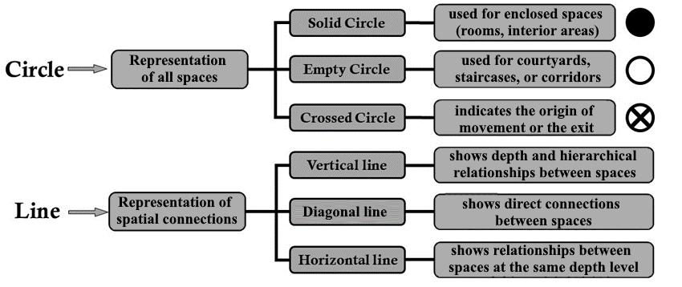
A justified graph illustrates the internal relational features of a plan. It is composed of nodes (represented as circles) and edges (represented as lines) in a very simple structure. When these graph components (Figure 1) are used to construct the justified graph of a building, they serve as a translation of the building’s spatial connections.
Figure 1: Components of a Justified Graph. Adapted from (Memarian, 2002).

Rasht City
Rasht is one of the major metropolises of Iran and the capital of Gilan Province. The city originally began as a settlement located between the two rivers Gohar Roud and Siah Roud, which accounts for its long history. The earliest mention of Rasht as an urban entity, however, is found in the works of Hamdallah Mustawfi in the 14th century CE (8th century AH). Historically, the city was known as Dar al-Marz or Dar al-Aman, and prior to these names, it was called Beyeh. In Persian dictionaries, Beyeh refers to a river or the confluence of two rivers, a name likely derived from Rasht’s location between two rivers, which served as a natural barrier and protective wall for the city (Rasht-Municipality, 2015).
The development of Rasht began during the Safavid period and continued through the Qajar era, supported by the expansion of international trade relations. During this time, Rasht came to be known as the “gateway to Europe.” The city’s growth reached a peak during the 1905 Constitutional Revolution of Iran, followed by the establishment of the municipality and the election of Rasht’s first mayor (Nikouyeh, 2008).
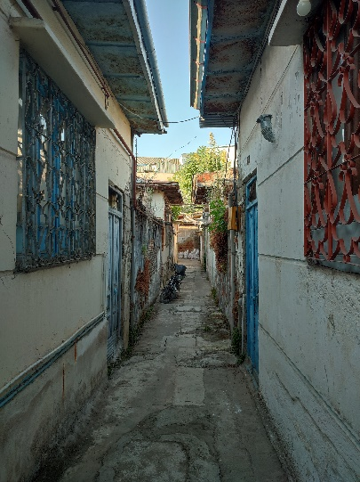
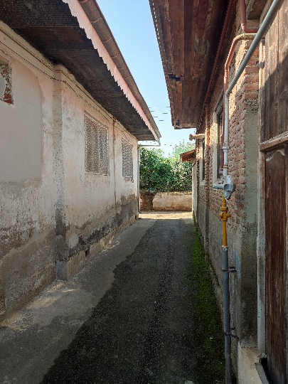
Historical accounts also describe the city’s neighborhoods: “The earliest record is attributed to Gmelin, who after visiting the city in 1772 CE, identified eight neighborhoods: Kiab, Khamiran, Chamarsara, Paskia, Ostadsara, Bazar, Seighalan, and Zahedan. [Later during 1949 city council elections] Rasht was divided into sixteen official neighborhoods, listed as follows: 1. Pirsara, 2. Sabzeh Meidan, 3. Cheleh Khaneh, 4. Cheheltan, 5. Chamarsara, 6. Saleh Abad, 7. Bijarkan, 8. Haji Abad, 9. Saghari Sazan, 10. Seighalan, 11. Masjid Safi, 12. Khamiran Zahedan, 13. Sorkh Bandeh, 14. Zir Koocheh, 15. Amin al-Zarb, 16. Sarcheshmeh” (Nikouyeh, 2008).
Figure 2: Old neighborhoods of Rasht. Left: Vojr Alley. Right: Sarab Alley. Saghari Sazan neighborhood, Rasht. Source: Authors.
After this period and both before and after the 1979 Revolution, new neighborhoods were added to the city. Nevertheless, this classification remains important as it highlights the historic fabric and older quarters of Rasht. The houses analyzed in this study, extending up to the end of the Pahlavi period, were, as expected, located in or near these older districts, which have to some extent retained their original fabric (Figure 2).
Case Studies
Figure 3 shows the location of the cases on the comprehensive map of Rasht and in Table 1, the layout plans corresponding to different historical periods are presented separately, together with their space syntax analysis and the physical characteristics of each period. It should be noted that the transformations identified in the following analysis occurred gradually. The period divisions indicate the general course of developments within each era, rather than the exact dates of their occurrence.
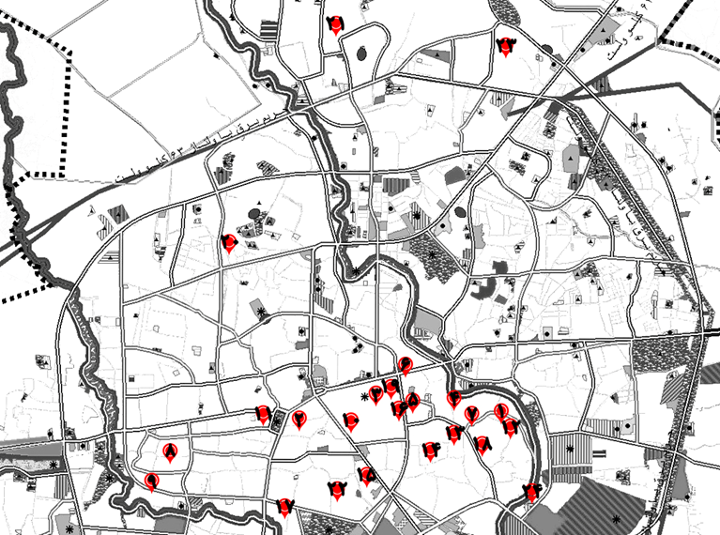
Figure 3: Location of the case studies. Source: Authors, based on the Comprehensive Plan of Rasht.
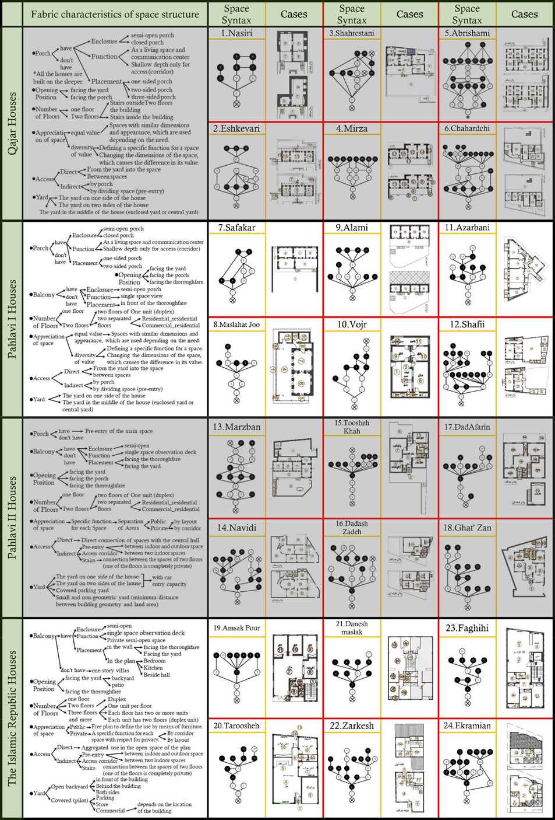
Table 1: Houses examined across different periods, with their space syntax analysis and physical characteristics of each period. Source: Authors.
Case Selection
The selection of buildings for each period posed its own challenges. Among them, a number of Qajar houses and a limited set of Pahlavi-period houses had already been registered due to their historical value (General-Administration-of-Cultural-Heritage-Tourism-and-Handicrafts-of-Gilan-Province; Khakpour, 2018; Khakpour et al., 2010). General Administration of Cultural Heritage, Handicrafts, and Tourism of Gilan Province). Most of the Qajar-era buildings belong to the city’s affluent classes, and only a few traces of ordinary dwellings remain largely because they were built using less durable construction materials (Khakpour et al., 2010). Given the limited availability of potential cases, the main criteria for case selection were accessibility and authenticity. Efforts were also made to include houses from different parts of the city so that, as far as possible, the cases would represent Rasht’s urban diversity and allow for a fuller understanding of its residential architecture. To ensure comparability, the number of houses from each period was set at six.
Cases studied from the Pahlavi era, despite extensive transformations in residential construction during that period, mostly involve administrative and public buildings. Accordingly, to complete the dataset, additional residential cases from the Pahlavi period along with a few others from other periods were documented through architectural measured survey (relevé) and analyzed accordingly. The post-revolution, Islamic Republic period, by contrast, offers the largest number of cases available for study. For this period, the focus has been on selecting houses from different decades that can reflect diversity of facade and include both landed and apartment-type dwellings.
Development of Spatial Arrangements
The trajectory of spatial arrangements in Rasht’s residences over the past centuries has been largely shaped by rural architectural patterns. In a typical rural dwelling, this structure consisted of two main elements, a porch and a living room, which, with slight modifications, were also adapted to urban architecture (Nikouyeh, 2008). Khakpour et al. have studied this spatial structure along with the patterns of sequencing and allocation of spaces in houses of the historic fabric of Rasht, and their study suggests that "the one unifying factor in [traditional] residential architecture is the arrangement of rooms and porches in such a way that the porch was considered as important as the living room, and it held a special position in the living traditions of the city’s inhabitants" (Khakpour et al., 2010).
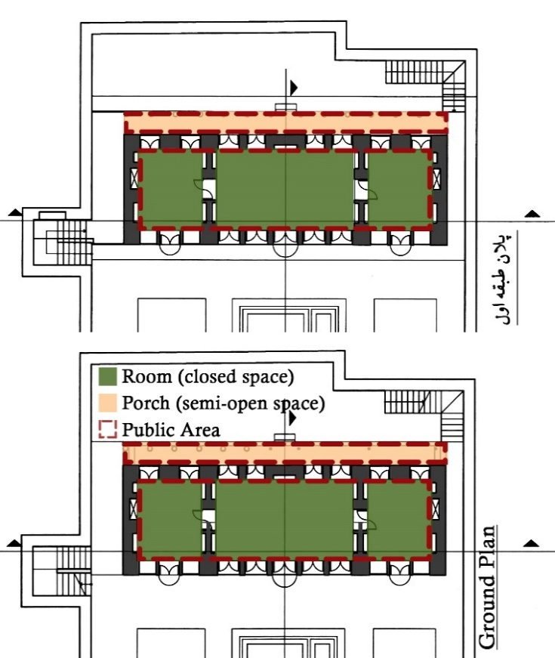
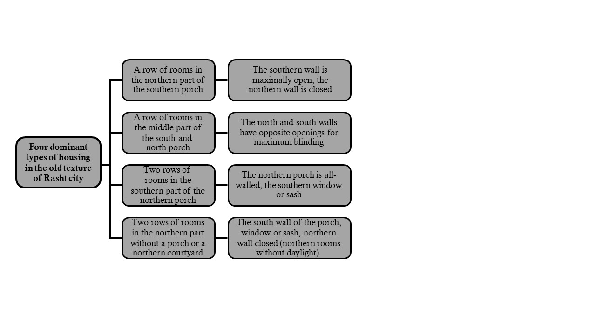
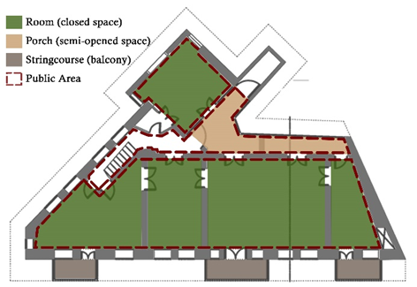
The patterns shown above (Figure 4) shaped the residential architecture of the Qajar period and much of the First Pahlavi period. During the First Pahlavi era, despite its short duration and the regime’s focus on the construction of administrative and public offices, residential architecture did not undergo extensive transformations. However, the minor adjustments introduced during this time paved the way for broader changes in the following period. In this era, as in previous ones, most house openings continued to be oriented toward the courtyard. A comparison of the plan of the Ashkouri house from the Qajar era (Figure 5) with the plan of the Azarbani house from the early Pahlavi era (Figure 6) clearly demonstrates these similarities.
Figure 5: Spatial layout of the Eshkevari House, Qajar period. Source: authors.
Figure 4: Typology of housing patterns in the historic fabric of Rasht. Adapted from Khakpour et al. (1389 [2010]).
Figure 6: Spatial layout of the Azarbani House, First Pahlavi period. Source: authors.
This began to change with the introduction of street construction in the city, as some houses were reoriented toward the street and incorporated retail and commercial components on the ground floor (Table 1, cases 11 and 12). There were even regulations introduced to govern the construction of such houses and the design of their street-facing façades (Ghobadian, 2015).
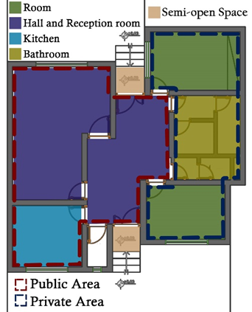
Despite this, older spatial patterns continued to be used in Rasht’s neighborhoods and alleys until their full transformation during the Second Pahlavi period. This era marked a major turning point in the city’s residential architecture. With the emergence of independent spaces assigned to specific functions, all spatial components came to be organized around a central core, and their dimensions were determined according to their intended use. Bathrooms, which until then had been located in the courtyard, were integrated into the interior of the house from this period onwards. As roles were increasingly defined for each functional space, residential architecture underwent a significant shift: Houses were now structured into three distinct domains of public, private, and service areas. As evident in the example of the Toushekhah house from this period (Figure 7), the spatial configuration of the houses of this era is such that aims to maximize separation of public and private domains. In most such cases surveyed in this study, public areas occupied one pole of the house, while private areas were concentrated at the opposite pole. In two-story (duplex) houses, this division was further accentuated through vertical separation between floors.
Figure 7: Spatial layout of the Tooshehkhah House, Second Pahlavi period. Source: authors.
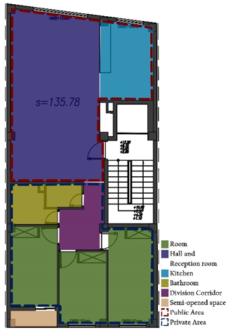
The residential patterns established during the Second Pahlavi period were later transformed in new ways after the 1979 revolution and under the Islamic Republic. During this period, spaces with clearly defined functions were configured in relation to one another to improve efficiency, producing an open-plan layout. The open plan comprises public, service, and circulation domains, whose logic is articulated through the arrangement of elements. In this scheme, the former central core is replaced by a corridor that provides access to the private domain. The spatial arrangement of the Faghihi house from this period (Figure 8) demonstrates the altered entry sequence and the clear separation between the private and guest realms.
Figure 8: Spatial layout of Faghihi House, Islamic Republic period. Source: Authors.
Transformations in the Islamic Republic period were closely tied to regulatory frameworks established by municipal and national authorities. Chief among these were comprehensive and detailed urban development plans, and Rasht was one of the first cities in Iran for which such a comprehensive plan was prepared. To date, three comprehensive plans have been produced for the city: the first was proposed in 1966, approved in 1971, and accompanied by a detailed plan issued in 1978. These plans outlined land-use patterns at the neighborhood level, specifying exact allocations for each function and influencing key parameters such as residential density and site coverage (Hodjati et al., 2018). Another regulatory milestone was the introduction of the national building codes. Preliminary studies began in 1973, and the first edition was issued in 1987. Their implementation subsequently became mandatory nationwide, with two principal aims: safeguarding state and public interests, and improving construction quality by enhancing safety, health, welfare, comfort, and economic efficiency (National-Building-Regulations-Office, 2013). Although many of these regulations were in fact introduced prior to the Islamic Republic, unstable national conditions meant that their implementation was slow, and their major impact on residential architecture became evident only during the Islamic Republic period.
Evolution of Spatial Relations and Organization
Another aspect to be examined in the transformation of residential layouts in Rasht is the sequencing of spaces, or the nature of their interconnections. Spatial sequencing (or sequencing of spaces) refers to the arrangement and ordering of spaces in relation to one another and the network of connections they form. This concept is central to space syntax theory (Bafna, 2003; Hillier & Hanson, 1984).
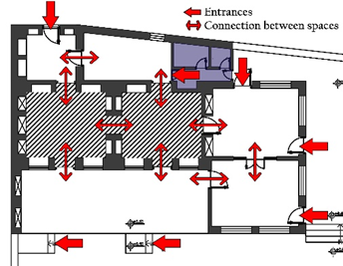
During the Qajar period, although most adjoining spaces within houses maintained direct connections, the porch (ivan) played a central role in mediating spatial relationships. Access from the courtyard into the building could be achieved either directly or indirectly through the porch. Despite the multiplicity of access points and the overall direct connectivity between spaces, some rooms were positioned deeper within the layout and thus functioned as more private areas. In single-story houses, this was manifested in the close and immediate connection of several rooms to the main courtyard entrance, while other rooms were oriented toward the backyard and accessed via the porch (Figure 9). In two-story houses (Table 1, cases 1, 2, 4, and 6), the depth of certain spaces increased through changes in floor level, and in all these examples, more than one staircase provided access to the upper story. The placement of each staircase reflected a hierarchy of privacy, depending on the areas it served.
Figure 9: Spatial relations in the Shahrastani House, Qajar period. Source: Authors.
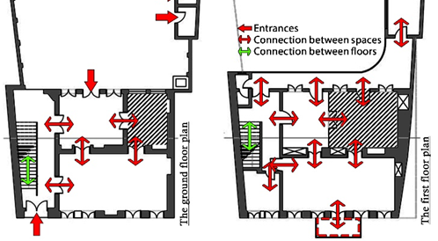
As noted earlier, the First Pahlavi period brought only minor changes to the interior spaces of houses, and likewise only modest shifts are evident in the connections among their spatial components. One such change was the increasing use of the porch (ivan) purely as an access zone. In addition, vestibules and other transitional spaces appeared more frequently than in earlier periods. Another innovation was the introduction of projecting street-facing consoles or herreh (proto-balconies), which acted as independent spaces accessed directly from individual rooms (Figure 10).
Figure 10: Spatial relations in the Shafiei House, First Pahlavi period. Source: Authors.
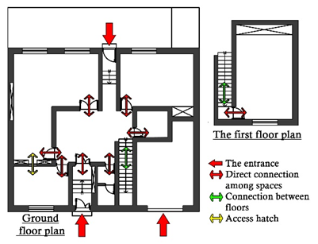
The new identity of spaces and the independent character assigned to each of them brought about a reconfiguration of residential layouts during the Second Pahlavi period. The living room, located at the center of the house, functioned as the primary distribution space, providing access to all other rooms. Typically, two entrances connected the central living room to the exterior: in most cases, one opened toward the street and was linked through a vestibule, while the other faced the backyard. In other houses, the arrangement differed, with one entrance leading to the front yard and the second to the backyard. The reception room, serving as the principal social space of the house, was accessible from two points in the living room. One of these connections was placed near the kitchen to facilitate service, and in most cases the reception room and kitchen were also linked by a door or serving hatch to allow for efficient transfer of food and provisions (Figure 11).
Figure 11: Spatial connections in Dadafarin House, Second Pahlavi period. Source: Authors.
Having acquired a new identity, bedrooms now formed the household’s private domain. In single-story houses they still opened onto the central living room, but their clustering at one pole of the house reinforced their separation from the reception room. In two-story houses, relocating the bedrooms to the upper floor further distinguished them from public areas.
From this period onward, bathroom facilities, which had previously been located in the courtyard, were integrated into the interior of the house. They were generally placed around the central living room, often preceded by small vestibules that buffered them from direct exposure. In some cases, all sanitary spaces were clustered along a corridor near the rear courtyard entrance, with the corridor itself functioning as a transitional zone. Porches and balconies (in two-story houses) continued to appear, but the porch now served primarily as a vestibule to the central living room, while balconies, stripped of their earlier connective role, were subsumed into the overall building volume.
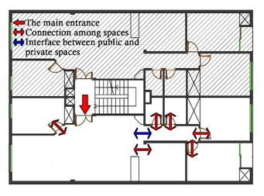
One of the most significant shifts in housing during the Islamic Republic period has been the concentration of multiple residential units within a single building, or apartment block construction. This new housing type has a considerable impact on spatial organization, particularly in the communal areas before reaching each apartment unit. Typically, the ground floor of apartment blocks is designed as a pilotis level, providing communal spaces for residents such as parking, storage, and utility rooms. Stairs and elevators are standard shared elements, providing vertical access to the individual units (Figure 12).
Figure 12: Spatial connections in Danesh-Maslak House, Islamic Republic period. Source: Authors.
Within the apartments themselves, the internal organization of spaces has undergone gradual changes. The reception room, which in earlier houses functioned as an independent space with two entrances from the living room, is now merged with the living room, reshaping the relationships among the public areas. The kitchen remains adjacent to these spaces but is now opened directly toward them. This new clustering of public functions produces a different kind of spatial organization, where the placement of loose furniture largely determines the divisions and connections between spaces, and may be reconfigured as needed. Private areas continue to be grouped on one pole of the dwelling, but their access has shifted from the living room to a semi-private corridor. This corridor acts as a transitional zone, mediating between domains and reinforcing privacy gradients. In duplex apartment units (Table 1, case 24 – Ekramian), as in the previous era, private spaces are located on the upper floor. Like in the previous period, balconies are typically attached to one of the bedrooms or placed adjacent to the kitchen. A secondary wet kitchen is sometimes added, directly accessible from the main kitchen, depending on the size of the apartment and the preferences of the owner. In some cases, the entrance hall is separated from the public areas by a corridor, and toilet facilities are positioned just beyond the entrance. In other cases, they are accessible from the semi-private corridor. Master bedrooms increasingly feature en-suite bathrooms and walk-in closets, introduced as optional elements according to household needs.
Evolution of the Function of Spaces
In architectural design, function is primarily understood as a sequence of human actions supported by tools to meet specific daily needs within a defined spatial unit (Reveron, 2009). According to Hillier, function is “the ability of a complex to accommodate functions in general and therefore potentially a range of different functions, rather than any specific function”{Hillier, 1996 #42}. Functional factors such as the relationships between spaces and activities, axes of circulation, flexibility, suitability, and safety are central aspects of spatial layout design (Al-Nijaidi, 1985; Karlen, 2009). In this sense, the function of spaces reflects the overall capacity of a building to adapt and accommodate multiple uses and a diversity of activities, rather than being confined to a single, fixed role.
During the Qajar period, domestic architecture was composed of only a few key elements, essentially “a porch for use in summer and a room for living in winter” (Nikouyeh, 2008). Yet this simple arrangement fully met the residents’ needs at the time. The porch (ivan) was one of the main spaces of the house in this climate, where family members spent much of the day and night. Cooking, eating, resting, and even hosting guests were all carried out here in friendly weather conditions. In adverse conditions, these activities shifted indoors. Two-story houses were more common in this period. The central room on the lower floor served as a warm place during cold winter nights, heated by stoves and the traditional korsi (a low, heated table covered with blankets). The corresponding room on the upper floor, by contrast, offered ventilation and became the preferred indoor space for summer nights (Mortaz Hejri et al., 2022). Overall, each space could change its function according to household needs, without being fixed to a single use. The courtyard also had a service role, accommodating daily chores, with sanitary spaces placed in one corner.
The modest physical changes to houses during the First Pahlavi period also reflected only slight shifts in how the residential spaces were used. One such change was the resizing of certain rooms, which were redefined as reception spaces for guests. The courtyard continued to serve primarily as a service zone, and in some houses, other elements such as the kitchen were also added to the courtyard area. The role of the porch (ivan) gradually diminished, functioning mainly as a transitional element providing access to other spaces. Street noise and the exposure of the projecting proto-balconies (herrehs) to passers-by further reduced the use of this semi-open element in houses located along arterial roads. As noted earlier, in some two-story houses adjoining the street, the ground floor began to accommodate commercial activities.
The transformation of layout designs in the Second Pahlavi period evolved in such a way that household functions came to revolve around the central living room. Beyond providing circulation, this space became the hub of most daily activities of family members, including leisure, dining, and shared routines. When guests were present, these activities shifted to the reception room, which otherwise remained less frequently used by the household. The kitchen served primarily for food preparation and, in some cases, also as a dining area sized to accommodate the family. Bedrooms, now defined more explicitly as private spaces, were used for rest, study, or work. A distinctive addition in this period was the Linen room (storage for extra bedding and guest mattresses), either directly accessed from the living room or located within a bedroom, functioning as a storage space for bedding.
Regarding semi-open spaces, the all-encompassing porches of earlier periods disappeared during the Second Pahlavi era. Porches were still present, but only in limited form, serving mainly as vestibules to the central living room. In two-story houses, the proto-balconies (herrehs) were replaced by balconies, which could face either the courtyard or the street, offering family members access to semi-open spaces for daily use.
A fundamental change during the Islamic Republic period was the transfer of circulation functions from the central living room to a corridor, around which the private spaces are organized. Other areas of the house have come to be arranged in a more open plan. The sitting room is placed in one corner as the hub of family activity, while another corner is allocated for hosting guests. The removal of kitchen walls has created a direct visual connection between the kitchen and both the sitting and reception areas, which in turn, has encouraged homeowners to incorporate a secondary wet kitchen behind the main kitchen. In some cases, a dedicated dining space has been introduced adjacent to the kitchen. Private rooms have largely retained their earlier functions, though in some cases one bedroom is distinguished by an en-suite bathroom, giving rise to the concept of the master bedroom, intended for the parents’ use.

Conclusion
The main objective of this study has been to examine the spatial evolution of residential plans in Rasht, from the Qajar period to the present. To this end, 24 houses were analyzed, focusing on their spatial syntax—namely, the connections, functions, and layouts of their different parts (Table 1). While variations exist within each historical period, the patterns discussed here represent the characteristic typologies of their time. Identifying these patterns constitutes the first step toward establishing appropriate design criteria for contemporary housing in Rasht. The subsequent stages of this research examined the forces of transformation and the factors that have influenced the development of each pattern.
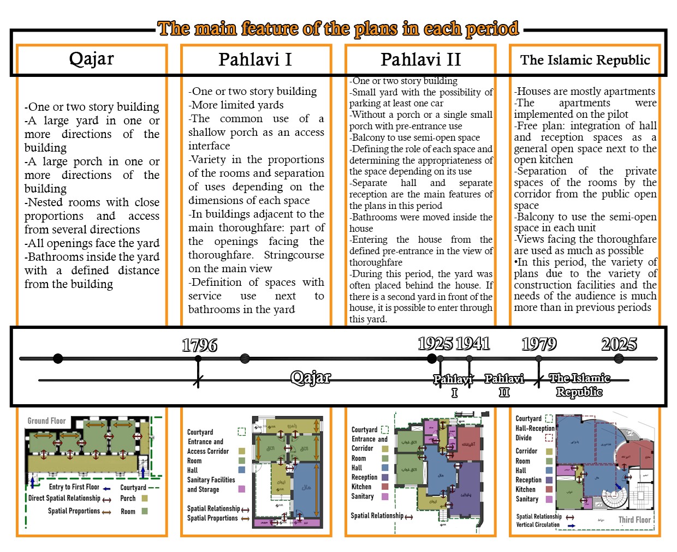
Two questions guided this study into tracing a roughly 200-year trajectory of change. In answer to the first research question, which asks about the evolution of residential plans in Rasht from the Qajar period to the present, the findings reveal that building layouts underwent sudden shifts within relatively short spans of time (see Figure 13 for the defining features of plans in each period). In general, the design patterns of residential layouts in Rasht during the Qajar era were derived from earlier architectural traditions and changed only minimally over time, especially when compared to subsequent periods. The changes introduced in the First Pahlavi era, albeit limited, proved consequential, as the Second Pahlavi period became the peak of this transformation. The introduction of clearly defined functional spaces in the Second Pahlavi period created entirely new spatial relationships in residential layouts. During the Islamic Republic era, residential plans have continued to evolve, though not as extensively as in the Second Pahlavi period.
Figure 13: Key features for identifying residential plans in each period and their corresponding chronological span. Source: Authors.
In response to the second research question, which asks how spatial syntax contributes to the interpretation of Rasht’s historic residential architecture and what insights this method provides, the study finds that spatial syntax translates the complex spatial relationships of house plans into simplified graphic representations, such as justified plan graphs. These allow the sequencing of spaces and the nature of their interconnections to be clearly identified. Such patterns are directly linked to the functional roles of different spaces and therefore support the analysis of domestic activities. Applying spatial syntax to the surveyed houses (Table 1) made it possible to identify the underlying spatial patterns of Rasht’s post-Qajar residences.
The results of this study also indicate that Rasht’s Qajar-era houses were composed of only simple elements, namely a room and a porch (ivan). The sole factor producing variation among layout patterns of this period was the way these spaces were placed in relation to one another. Minor modifications to the layout elements were offset by the multiple uses assigned to each space. A diverse set of circulation paths and the direct connection of adjoining spaces are characteristic features of houses from this era, and these continued into the First Pahlavi period as well (Figures 9 and 10). Despite the direct connectivity between spaces, a number of rooms were positioned at greater depth within the layout (i.e., accessed through several intervening spaces), which thereby created more private domains (Table 1, case 3).
In the First Pahlavi period, changes to residential layout plans were relatively modest and, moreover, did not occur in a uniform manner. Some houses located within inner neighborhoods continued to preserve Qajar-era patterns (Table 1, cases 7–9). By contrast, houses facing the newly established streets often allocated much of the ground floor to commercial functions, while the residential upper floor featured openings toward the street (Table 1, cases 11–12). The herreh, a newly introduced projecting element on street-facing façades, became a notable feature of this era, later evolving into the balcony. The porch (ivan) in these houses was reduced to a purely transitional element for circulation, typically oriented toward the backyard. The final change identified in this study for the First Pahlavi period was the resizing of certain rooms and their elevation into the principal reception spaces of the dwelling (Table 1, case 10).
In the Second Pahlavi period, layouts with direct spatial connections, which had remained customary up to the First Pahlavi, gave way to the central living room that now functioned as the heart of the house, with all circulation passing through it. The most significant transformation of this era was the emergence of distinct, independently defined spaces, each assigned to a specific function. In single-story houses of this period (Table 1, cases 15 and 18), spatial syntax analysis shows most spaces occupying the same depth level, yet a closer look at the layouts reveals the separation of domains through their arrangement. Other notable changes of this era include the relocation of service areas into the interior of the house and the introduction of balconies on the façades of two-story houses (Table 1, case 16).
An independent reception room, often with more than one access point and an L-shaped layout, was one of the defining features of Second Pahlavi houses. In the Islamic Republic period, however, this space was merged with the central living area. With the kitchen opening directly to both these spaces, an open-plan configuration emerged in the public domain. Other notable interior changes of this period include the addition of an access corridor separating private spaces and the incorporation of new elements, such as the wet kitched, master bedroom, and walk-in closet, depending on the size of the house and the preferences of the homeowner. Structurally, a fundamental shift also occurred: most detached and duplex houses gave way to multi-story apartment blocks, in which each floor, depending on its size, could accommodate one or several independent residential units.

References

Abbaszadegan, M. (2002). Space Syntax Method in Urban Design Process, with an Overview on Yazd City. Urban Management, 3(9), 64–75.
Afradi, K. (2018). Categoraizing the Design and Manufacturing Methods of Doors and Portals in Historical Structures of Rasht from Qajar Period Until Now. Archaeological Research of Iran, 7(15), 203–218. https://doi.org/10.22084/nbsh.2017.6202.1260
Al-Nijaidi, H. R. (1985). Flexibility in the design of buildings [PhD Thesis, Oxford Brookes University].
Aspinall, P. (1993). Aspects of spatial experience and structure. In B. Farmer & H. Louw (Eds.), Companion to Contemporary Architectural Thought (pp. 337). Routledge.
Bafna, S. (2003). Space Syntax:A Brief Introduction to Its Logic and Analytical Techniques. Environment and Behavior, 35(1), 17–29. https://doi.org/10.1177/0013916502238863
Farshbaf, F. (2018). Old Buildings of Rasht. Abrishami Publications.
General-Administration-of-Cultural-Heritage-Tourism-and-Handicrafts-of-Gilan-Province. Archive of the Cultural Heritage Documentation Center, Rasht.
Ghobadian, V. (2015). Theories and Styles in Contemporary Iranian Architecture. Elm-e Me'mar Royal.
Griffiths, S. (2011). Temporality in Hillier and Hanson's Theory of Spatial Description: Some Implications Of Historical Research For Space Syntax. Journal of Space Syntax, 2(1), 73–96.
Griffiths, S., & Sailer, K. (2016). From Non-Discursive Qualities of Space to Conscious Design. Conscious Cities Journal, 1(1), 1–6. https://doi.org/10.33797/ccj.01.06
Hanson, J. (2003). Decoding Homes and Houses. Cambridge University Press.
Hillier, B. (1996). Space Is the Machine: A Configurational Theory of Architecture. Cambridge University Press.
Hillier, B. (2012). Studying Cities to Learn about Minds: Some Possible Implications of Space Syntax for Spatial Cognition. Environment and Planning B: Planning and Design, 39(1), 12–32. https://doi.org/10.1068/b34047t
Hillier, B., & Hanson, J. (1984). The Social Logic of Space. Cambridge University Press. https://doi.org/10.1017/cbo9780511597237
Hodjati, H., Pourmohammadi, M. R., & Ghorbani, R. (2018). A Review of the Comprehensive Planning Process of Rasht City with a Comparative Approach (Triple Comprehensive City Plans). Urban Planning Knowledge, 2(1), 1–22. https://doi.org/10.22124/upk.2018.8792.1010
Kamlipour, H., Memarian, G. H., Faizi, M., & Mousavian, S. M. F. (2012). Formal Classification & Spatial Configuration in Vernacular Housing: A Comparative Study on the Zoning of the Reception Area in Traditional Houses of Kerman Province [Research]. Journal of Housing and Rural Environment, 31(138), 3–16.
Karlen, M. (2009). Space Planning Basics (3rd ed. ed.). John Wiley and Sons, Inc.
Khakpour, M. (2018). Architecture of Gilan Houses. Farhang-e Ilya.
Khakpour, M., Ansari, M., & Tahernian, A. (2010). The typology of houses in old urban tissues of Rasht. Journal of Fine Arts: Architecture & Urban Planning, 2(41), 29–42.
Memarian, G. H. (2002). Syntax of Architectural Space. Soffeh, 10(35), 75–83. https://doi.org/20.1001.1.1683870.1381.12.4.1.2
Molla Zadeh, A., Barani Pesian, V., & Khosro Zadeh, M. (2012). The application of the space syntax of the Valiasr St Basht city [Research]. Journal title, 10(29), 81–90.
Mortaz Hejri, M., Yazdanfar, S. A., & Hosseini, S. B. (2022). The Interrelationship of Lifestyle Patterns and Spatial Organization of Houses Case Study: Rasht Residential Buildings (from the Qajar Period to the Present). Journal of Iranian Architecture Studies, 10(19), 193–213.
National-Building-Regulations-Office. (2013). National Building Regulations (Part I), Preface. Nashr-e Tose'e-ye Iran.
Nikouyeh, M. (2008). Rasht, City of Rain. Farhang-e Ilya.
Pandi, K. (2008). Rasht in the mirror of history. Gil inscription.
Pfeifer, R., & Bongard, J. (2007). How the Body Shapes the Way We Think: a New View of Intelligence. MIT Press. https://doi.org/10.7551/mitpress/3585.001.0001
Rasht-Municipality. (2015). History of Rasht. https://invest.rasht.ir/page-invshow/fa/10/form/pId8365
Reveron, F. O. (2009). Developing Spatial Configuration Abilities Coupled with the Space Syntax Theory for First Year Architectural Studies. Proceedings of the 7th International Space Syntax Symposium, Stockholm, Sweden.
Rismanchian, O., & Bell, S. (2010). The application of space Syntax in studying the structure of the cities. Journal of Fine Arts: Architecture & Urban Planning, 2(43), 49–56.
Rismanchian, O., & Bell, S. (2011). A study over spatial segregation of deprived areas in spatial structure of Tehran by using space syntax technique. The Monthly Scientific Journal of Bagh-e Nazar, 8(17), 69–80.
Sadeghi, S. (2015). Architecture of Traditional Houses in Rasht. Gil and Daylam Publications.
Soheili, J., & Rasouli, N. (2016). A Comparative Study of the Architectural Space Syntax of Caravansaries Qajar era (Case Study: caravansaries Qazvin and Kashan). Hoviatshahr, 2, 47–60.
Soleymanpour, R., Parsaee, N., & Banaei, M. (2015). Climate Comfort Comparison of Vernacular and Contemporary Houses of Iran. Procedia - Social and Behavioral Sciences, 201, 49–61.
Tabatabae Malazi, F., & Sabernejad, J. (2016). The Space Syntax Analytical Approach in Understanding the Configuration of Qeshm Vernacular Housing (Case Sudy: Laft Village) [Research]. Journal of Housing and Rural Environment, 35(154), 75–88.
van der Voordt, T. J., Vrielink, D., & van Wegen, H. B. (1997). Comparative floorplan-analysis in programming and architectural design. Design Studies, 18(1), 67–88.
Yazdanfar, S. A., Mousavi, M., & Zargar Daghig, H. (2008). Analysis of the Spatial Structure of Tabriz City in the Bar Area Using Space Syntax Technique. Rah va Sakhteman Monthly(67), 58–69.
Zahedi, M. (1998). Effects of climate elements on the formation of Rasht architecture. Persian Language and Literature, 41(168), 69–90.
Ziaee, S., & Mahmoudi Zarandi, M. (2021). An analysis in half-opened spaces in residential vernacular architecture of Rasht to use natural ventilation. Journal of Studies of Human Settlements Planning, 16(3), 523–535.

M.A. student of Architecture, Faculty of Architecture and Art, University of Guilan, Rasht, Iran. Behavar77@gmail.com
• Corresponding author
Assistant Professor of Architecture Department, Faculty of Architecture and Art, University of Guilan, Rasht, Iran. Khakpour@guilan.ac.ir
Assistant Professor of Architecture Department, Faculty of Architecture and Art, University of Guilan, Rasht, Iran. a.agharabi@guilan.ac.ir
References to historical periods in this article follow the conventional chronology: Qajar period (1796–1925), First Pahlavi period (1925–1941), Second Pahlavi period (1941–1979), Post-Revolution or Islamic Republic period (1979- ).

