Assessing Expectations of Urban Park Services: Insights from Citizens and Experts

Davood Vafadari Komarolya
Department of Urban and Rural Planning, Faculty of Social Sciences, University of Mohaghegh Ardabili, Ardabil, Iran

Hossein Nazmfar
Department of Urban and Rural Planning, Faculty of Social Sciences, University of Mohaghegh Ardabili, Ardabil, Iran

Parya Nasiri
Department of Urban and Rural Planning, Faculty of Social Sciences, University of Mohaghegh Ardabili, Ardabil, Iran

Narjes Sadat Barakbaf
MSc of geography and urban planning, University of Ferdowsi Mashhad, Mashhad, Iran

Mohammad Vafadari Komarolya
Master student in geography and urban planning, University of Zanjan, Zanjan, Iran

Abstract
Urban parks play a critical role in enhancing the quality of urban life by offering a range of services. This study explores public expectations regarding services provided in urban parks, using a mixed-methods approach. Quantitative data were collected through a questionnaire completed by 481 participants, while qualitative insights were gathered via semi-structured interviews with 22 stakeholders. The analysis revealed that recreational and comfort-related services are the most valued features of urban parks. Participants emphasized the importance of soft landscapes, greenery, diverse and age-appropriate play equipment, walking paths, and spaces for popular group games. Additionally, there was strong support for incorporating intellectual and educational games to enrich the park experience and promote informal learning. Findings indicate that urban park planning should prioritize recreational and welfare functions, supported by thoughtful landscape design. Enhancing features such as green spaces, play diversity, and inclusive public areas can significantly improve user satisfaction and the overall functionality of urban parks. These insights can inform urban planners and designers in creating parks that better align with community needs and preferences.

Keywords: urban spaces, urban open spaces, urban landscape, urban green spaces, mixed research method

Introduction
Urbanization is a global phenomenon that is reshaping the relationship between humans and the natural environment. By 2030, over 66% of the world’s population is projected to reside in urban areas (Gai et al., 2022). This trend has prompted policymakers and urban planners to increasingly prioritize strategies that promote urban resilience, sustainability, and livability in response to the escalating challenges of climate change. Among these strategies, nature-based solutions have gained widespread recognition as integrated approaches to sustainable urban development (Bush & Doyon, 2019; Gai et al., 2022). These solutions effectively address both social and environmental issues, enhance biodiversity, and contribute to human well-being (Gai et al., 2022). In addition, they are instrumental in alleviating the physical and psychological stress that urban populations often face (Chen et al., 2019; Gai et al., 2022).
In densely populated cities, access to natural environments is frequently limited. As a result, urban green spaces—particularly urban parks—have become increasingly important as some of the few remaining areas where residents can interact with nature (Wolch et al., 2014; Sadeghian & Vardanyan, 2013). Urban parks serve as critical components of urban infrastructure, offering a wide array of services that enhance the quality of urban life. These services can be broadly categorized into four key areas: welfare services, which support physical and mental health; recreational services, which provide spaces for leisure and relaxation; sports services, which promote physical activity and organized exercise; and educational services, which facilitate environmental learning and civic engagement. Collectively, these functions contribute to public health, foster social cohesion, and support the long-term sustainability of urban communities (Larson et al., 2016; Komarolya et al., 2024; Komarolya et al., 2023; Vafadari Komarolya et al., 2024; Vafadari Komarolya et al., 2026; Komarolya et al., 2025; Myalkovsky et al., 2023; Vafadari Komarolya et al., 2024; Palliwoda & Priess, 2021).
Despite this recognized significance, existing research on urban parks tends to be fragmented. Many studies concentrate on isolated functions—such as microclimate regulation, biodiversity enhancement, or recreational use—without addressing the full spectrum of services that parks provide (Lin et al., 2023; Torabi et al., 2020 ; Nielsen et al., 2014; Li et al., 2024; Sarı & Bayraktar, 2023; Myalkovsky et al., 2023). Additionally, there is a frequent focus on individual parks rather than urban green space networks, and a bias toward expert or planner perspectives over those of regular park users (Torabi et al., 2020; Gai et al., 2022). While the welfare and recreational functions of parks are relatively well-documented, their roles in supporting sports and especially educational services remain understudied, with limited empirical evidence on how these services are perceived and valued by different stakeholder groups (Leonel da Silva et al., 2025).
This study seeks to address these gaps by systematically evaluating the expectations of both citizens and experts regarding the welfare, recreational, sports, and educational services provided by urban parks. Through a comparative analysis of these perspectives, the research aims to develop a more comprehensive understanding of park service provision and to uncover potential misalignments or synergies between public needs and expert planning. The study’s novelty lies in its integrative, multi-stakeholder approach and its balanced attention to all four service categories—offering valuable insights for the future design, management, and policy development of urban parks (Torabi et al., 2020; Gai et al., 2022; Leonel da Silva et al., 2025).
Therefore, this study aims to bridge the identified research gaps by systematically assessing both citizen and expert perspectives on the full range of urban park services. The results provide actionable insights for more user-centered and integrated park planning, management, and policymaking.

Literature Review
Understanding the differing expectations of urban park services between citizens and experts is essential for effective planning and management. Existing research highlights both gaps and overlaps in how these groups perceive and prioritize the benefits of urban parks

.

Differing Perceptions and Priorities
Studies consistently show that experts and citizens diverge in their evaluations of park functions. Experts often emphasize management-oriented and regulatory ecosystem services, such as air purification and temperature regulation. In contrast, citizens tend to value experiential and cultural aspects like recreation, aesthetics, and nature engagement (Riechers et al., 2017; Wei et al., 2024; Stępniewska, 2021). For instance, in Berlin, experts framed cultural services through a managerial lens, while residents focused on personal enjoyment (Riechers et al., 2017). Similar patterns emerged in Shanghai, where professionals prioritized regulatory services, and citizens highlighted visual and cultural qualities (Wei et al., 2024).

Role of Knowledge and Education
Public awareness significantly influences perceptions of ecosystem services. Individuals with greater environmental knowledge recognize less visible benefits, such as noise mitigation and air quality improvement, while those with limited knowledge focus on tangible features like biodiversity and microclimate effects (Ge et al., 2024; Stępniewska, 2021). Environmental education can therefore broaden understanding and help bridge perceptual gaps between experts and the public

Socio-Demographic Influences
Demographic factors also shape park expectations. Middle-income individuals and those engaged in community activities show greater awareness of ecosystem services (Ge et al., 2024). Age-related differences are notable: older adults often value parks for social interaction and relaxation, while younger users prioritize recreational facilities and dynamic environments (Zhang et al., 2022; Xiao et al., 2024)
.
Implications for Park Management
These divergent expectations underscore the importance of participatory planning and inclusive governance. Failing to align expert assessments with public preferences can lead to ineffective management and social dissatisfaction (Riechers et al., 2017; Jang-Hwan et al., 2020). Tools such as stakeholder surveys and importance–performance analysis can help identify service gaps and align planning with user needs (Xiao et al., 2024).

Bridging these differences requires continuous dialogue, targeted education, and collaborative decision-making. Acknowledging and integrating diverse perspectives is key to creating parks that are both ecologically functional and socially responsive.

Theoretical Framework
Urban Parks as Providers of Multifunctional Services
Urban parks are vital elements of urban infrastructure, offering a wide array of services that support the physical, social, and cognitive well-being of city residents. These services are often understood through the lens of Cultural Ecosystem Services (CES), which refer to the non-material benefits derived from nature—such as recreation, education, aesthetic experiences, and social interaction (Zhang et al., 2025; (Dushkova et al., 2025; Song et al., 2023).

Welfare Services
Parks contribute significantly to public welfare by promoting mental and physical health, enhancing social cohesion, and providing accessible green spaces for all demographics. They are particularly important for marginalized groups with limited access to private recreational opportunities (Baitalik et al., 2024; Mäntymaa et al., 2021). Equitable distribution and inclusive design are essential to realizing these welfare benefits and ensuring that parks serve as inclusive public spaces (Erkip, 1997; Joassart-Marcelli, 2010).

Recreational and Sports Services
Recreation remains a primary function of urban parks, offering opportunities for both informal and organized physical activities. The quality, diversity, and accessibility of facilities—such as walking paths, playgrounds, and sports fields—strongly influence the frequency and satisfaction of park use (Voigt et al., 2014; Yang et al., 2021; Li et al., 2020; Zhu et al., 2020; Guo et al., 2024). Spatial design and maintenance also play a critical role in supporting these uses (Sun et al., 2019; Li et al., 2024).
Educational Services
Though often secondary to recreation and welfare, the educational function of parks is increasingly recognized. Urban parks can foster environmental awareness, cultural learning, and nature-based experiences. However, these services remain underdeveloped in many contexts, pointing to a need for more intentional integration of educational programming in park planning (Dushkova et al., 2025; Zhang et al., 2025; Song et al., 2023).

Integrating Stakeholder Perspectives
Balancing the expectations of citizens and experts is key to effective park governance. While the public often emphasizes relaxation, aesthetics, and recreation, experts may prioritize ecosystem regulation, inclusivity, and long-term sustainability (Zhang et al., 2025; Dushkova et al., 2025). Bridging these perspectives through participatory planning can enhance responsiveness to community needs and improve the multifunctionality of urban parks (Tong et al., 2023; Song et al., 2023).

This framework positions urban parks as multifunctional spaces delivering welfare, recreational, sports, and educational services. These benefits are shaped by infrastructure, accessibility, and the extent to which diverse stakeholder perspectives are integrated. Addressing service gaps and fostering inclusive decision-making are essential for maximizing the social and ecological value of urban parks (Zhang et al., 2025; Yang et al., 2021; Baitalik et al., 2024; Voigt et al., 2014).

Materials and Methods
Research Design
This study employed an applied research approach in terms of purpose and a descriptive design in terms of methodology. A mixed-methods strategy was used to combine quantitative survey data with qualitative insights from expert interviews (Vafadari Komarolya et al., 2024b)

Statistical Population and Sampling
The statistical population consisted of two groups:
Citizens who visited urban parks across various regions of Iran.
Experts in urban planning, urban design, landscape architecture, and environmental planning.
A total of 481 citizens participated in the survey using simple random sampling, with the questionnaire distributed both online and in person to ensure geographic and demographic diversity. Simultaneously, 24 experts were selected using the snowball sampling method for semi-structured interviews, with theoretical saturation reached by the 22nd interview. Each expert interview lasted approximately 12 minutes (Komarolya, et al., 2024)

Data Collection Tools
Data were collected using a structured questionnaire and semi-structured interview protocol.
The questionnaire was based on four service categories:
Welfare facilities (e.g., greenery, furniture, rest areas)
Recreational facilities (e.g., play equipment, events)
Sports facilities (e.g., walking paths, team sports zones)
Educational facilities (e.g., learning games, signage)
It included 16 components drawn from literature, field observations, and expert input. The questionnaire’s reliability was confirmed with a Cronbach’s alpha of 0.83, and its content validity was reviewed by 10 domain experts.
The interviews followed a semi-structured format exploring the same four categories, allowing experts to elaborate on service priorities, perceived gaps, and user needs in urban park design.

Interview Themes
The semi-structured interviews explored several key themes, including:
⦁ Experts’ priorities among welfare, recreational, sports, and educational services
⦁ Perceived gaps and challenges in current park facilities
⦁ User engagement and accessibility issues
⦁ Recommendations for improving urban park design and management
This approach allowed experts to elaborate on specific needs, priorities, and opportunities for enhancing park services across diverse urban contexts.

Data Analysis
Quantitative data were analyzed using SPSS, applying both descriptive statistics (mean, standard deviation) and inferential tests (Kolmogorov–Smirnov, Friedman test, and Chi-square).
Qualitative data from interviews were coded and analyzed using structural analysis in Atlas.ti, following a line-by-line coding approach. Relationships among codes were mapped to extract dominant themes.
The final stage involved integrating the quantitative and qualitative findings using a convergent mixed-methods approach, allowing equal weight to both strands of data to ensure triangulation and consistency.

Results & Discuss
Normality Test Results
To assess the distribution of the main research variables, the Kolmogorov-Smirnov (K-S) test was employed. This non-parametric test evaluates whether a dataset significantly deviates from a specified distribution—in this case, the normal distribution—by comparing the empirical and theoretical cumulative distributions.
In interpreting the K-S test, if the p-value (significance level) is greater than 0.05, the null hypothesis (H₀) is accepted, indicating that the data follow a normal distribution. Conversely, if the p-value is less than 0.05, the null hypothesis is rejected, implying that the data deviate significantly from a normal distribution.
H₀: The data are normally distributed.
H₁: The data are not normally distributed.
The results of the normality test for the key research variables are presented in the following table.

Table 1- Kolmogorov-Smirnov test results (source: research findings, 2024)
Research variable | test status | mean | N | standard deviation | significance level
recreational facilities | 0.176 | 2.490 | 481 | 97263 | 000/0
welfare facilities | 0.151 | 2.497 | 481 | 1.034 | 000/0
sports facilities | 0.190 | 2.501 | 481 | 1.038 | 000/0
educational facilities | 0.113 | 2.497 | 481 | 1.009 | 000/0

As shown in the table, the significance levels from the Kolmogorov-Smirnov test for all research variables are below 0.05, indicating that the data distributions deviate significantly from normality. Therefore, the null hypothesis of normal distribution is rejected.
Given the non-normality of the data, non-parametric tests such as the Friedman test and the Chi-square test were employed to examine the significance of differences between the indicators.
To assess the participants’ prioritization of each index, the following hypotheses were tested:
H₀: The mean value of the variable is equal to 2, representing an average level of prioritization (i.e., no significant preference).
H₁: The mean value of the variable is significantly different from 2, indicating a prioritized (high or low) perception.
In this study, a 4-point Likert scale was used to rank priorities (1 = first priority, 4 = fourth priority), making the midpoint 2 the reference value representing a neutral or average priority.
If the null hypothesis is accepted, the index is interpreted as not significantly prioritized by the respondents.
If the null hypothesis is rejected and the median is greater than 2, the index is considered less important to respondents.
If the null hypothesis is rejected and the median is less than 2, the index is considered more important and aligned with participant preferences.
This approach ensures a reliable interpretation of ordinal data using appropriate non-parametric methods in line with the observed non-normal distributions.

Services Provided in Urban Parks
In this study, both the Friedman test and the Chi-square test were employed to analyze the importance of services provided in urban parks. The Chi-square test was used to assess whether the four main service categories—recreational facilities, comfort (welfare) facilities, sports facilities, and educational facilities—were considered equally important by respondents. Meanwhile, the Friedman test was applied to determine whether the differences in prioritization among these services were statistically significant.
According to the test results, the significance value (Asymp. Sig) is 0.000, which is below the 0.05 threshold. This indicates a statistically significant difference in how respondents prioritize the four service categories. Therefore, the null hypothesis, which assumes no difference in perceived importance, is rejected at the 95% confidence level.
The test output includes the number of observations (N), the Chi-square statistic, the degrees of freedom (df), and the significance level. Based on this analysis, it is evident that respondents do not consider all four categories to be equally important, and that prioritization of urban park services varies significantly among participants.
Table 2-Test Statisticsa
N | 481
Chi-Square | 1056.762
df | 3
Asymp. Sig. | .000
a. Friedman Test
According to the results of Friedman's test, two tables were produced for analysis. The first table presents the mean ranks of the four service indicators. Based on these results, recreational facilities received the highest average rank, indicating that respondents prioritized this indicator more than the others.
The second table reports the significance level of the Friedman test. With a p-value less than 0.05, the null hypothesis is rejected, confirming that there are statistically significant differences among the four indicators in terms of perceived importance. In other words, respondents do not consider all service categories equally important, and recreational facilities stand out as the top priority for users of urban parks (Tables 3 and 4).
Table 3-Ranks
Indicators | Mean Rank
recreational facilities | 2.56
welfare facilities | 2.42
sports facilities | 2.51
educational facilities | 2.51

Therefore, the output of the test results is organized by indicator and presented in four key rows: the first row shows the number of subjects (N), the second row presents the Chi-Square statistic value, the third row indicates the degrees of freedom (df), and the final row displays the Asymptotic Significance (Asymp. Sig), which serves as the decision criterion for statistical significance.

Table 4-Test Statisticsa
N | 481
Chi-Square | 4.124
df | 3
Asymp. Sig. | .248
a. Friedman Test
In the following section, the Chi-square test is used to identify which variables, indicators, and components are considered more important than others.

Prioritizing Urban Park Services
In this section, after identifying the main variables of the study, an analysis is conducted to determine which indicator is considered the most important by the research participants. To address this, the overall significance of the services provided in urban parks is first examined. The average importance of each service category is also presented in the table below. Based on Table 5, the significance level is 0.000, indicating a statistically significant difference in the perceived importance of the services. Among the various service categories, recreational facilities received the highest average score of 3.62, making them the top priority according to respondent opinions.
Table 5- Degree of significance and average impact of services provided in urban parks (source: research findings, 2024)
Asymp. Sig | df | standard deviation | mean | Number of data | fourth priority | third priority | second priority | first priority | Indicator | -
.000 | 3 | .872 | 3.62 | 481 | 30 | 66 | 198 | 187 | recreational facilities | Urban parks services
.000 | 3 | .969 | 1.87 | 481 | 51 | 88 | 179 | 163 | welfare facilities | Urban parks services
.000 | 3 | 1.10 | 2.69 | 481 | 149 | 134 | 102 | 96 | sports facilities | Urban parks services
.000 | 3 | .824 | 1.62 | 481 | 251 | 193 | 2 | 35 | educational facilities | Urban parks services

Key Priorities Across Urban Park Facilities
According to Table 6, the significance level for all components across the four main indicators—recreational facilities, comfort facilities, sports facilities, and educational facilities—is 0.000. This indicates that all components were considered statistically significant and important by the research participants. In the recreational facilities category, the component "having various play equipment" received the highest average score (2.729), while "holding various festivals" was rated the lowest (2.029). For comfort facilities, "a green environment" was identified as the most important component (3.02), whereas "suitable furniture" was rated the least important (1.873). Within the sports facilities indicator, "spaces for popular sports" was prioritized highest (2.866), while "walking paths" received the lowest average (2.384). Finally, in the educational facilities category, "educational and cognitive games" were deemed most important (2.808), while "civic education spaces" ranked lowest (2.185). These results highlight the nuanced preferences of urban park users, offering a clear direction for prioritizing specific features in future park planning and design.
Table 6-Degree of significance and average impact of all indicators and components(entertainment facilities, comfort facilities, sports facilities and educational facilities)
Asymp. Sig | Chi-Square | df | standard deviation | mean | fourth priority | third priority | second priority | first priority | Components | Indicator
.000 | 147.782 | 3 | 1.104 | 2.729 | 77 | 70 | 126 | 208 | Having a variety of play equipment | recreational facilities
.000 | 33.304 | 3 | 1.191 | 2.621 | 168 | 79 | 118 | 116 | Having various game booths | recreational facilities
.000 | 16.821 | 3 | 1.119 | 2.615 | 147 | 99 | 138 | 97 | Having seasonal markets | recreational facilities
.000 | 103.175 | 3 | .9046 | 2.029 | 89 | 233 | 99 | 60 | Holding various festivals | recreational facilities
.000 | 178.351 | 3 | 1.164 | 3.02 | 30 | 90 | 151 | 210 | Having a green environment | welfare facilities
.000 | 35.349 | 3 | 1.006 | 2.511 | 100 | 129 | 169 | 83 | Having a calm environment | welfare facilities
.000 | 77.827 | 3 | 1.021 | 2.561 | 104 | 185 | 86 | 106 | Having a picnic area | welfare facilities
.000 | 151.225 | 3 | .9256 | 1.873 | 247 | 77 | 75 | 82 | Having suitable furniture | welfare facilities
.000 | 73.304 | 3 | .989 | 2.384 | 87 | 102 | 201 | 91 | Create a bike path | sports facilities
.000 | 56.838 | 3 | 1.104 | 2.087 | 188 | 127 | 93 | 76 | Create a walking path | sports facilities
.000 | 14.809 | 3 | 1.067 | 2.652 | 135 | 128 | 134 | 84 | Consider a variety of sports equipment | sports facilities
.000 | 155.682 | 3 | 1.160 | 2.866 | 74 | 124 | 53 | 230 | Considering a place for popular sports
.000 | 129.586 | 3 | 1.154 | 2.808 | 90 | 89 | 122 | 180 | Having educational and intellectual games | educational facilities
.000 | 36.913 | 3 | 1.129 | 2.245 | 101 | 93 | 109 | 178 | Having a botanical department | educational facilities
.000 | 41.137 | 3 | 1.159 | 2.767 | 181 | 101 | 103 | 96 | Having a zoology department | educational facilities
.000 | 45.445 | 3 | 1.129 | 2.185 | 109 | 198 | 147 | 27 | Considering spaces for teaching the principles of citizens | educational facilities

Statistical Ranking of Urban Park Services
To test the research hypothesis, a one-sample chi-square test was conducted. According to Table 7, the results indicate statistically significant differences among the four service indicators. For recreational facilities, the chi-square value is 405.028 with 12 degrees of freedom and a significance level of 0.000, indicating a highly significant result. In the case of welfare (comfort) facilities, the chi-square value is 308.919, with 12 degrees of freedom and a significance level of 0.000. For sports facilities, the chi-square value is 171.316, also with 12 degrees of freedom and a significance level of 0.000. Lastly, the educational facilities index yielded a chi-square value of 171.316, with 11 degrees of freedom and a significance level of 0.000.
These results confirm that all four service categories are statistically significant. However, among them, recreational facilities exhibit the highest chi-square value, suggesting that they are perceived by participants as the most important component in urban park services.
table 7-Test Statistics
Indicator | recreational facilities | welfare facilities | sports facilities | educational facilities
Chi-Square | 405.0281 | 308.919 | 2061.243 | 171.316  11
df | 12 | 12 | 12 | 46
Asymp. Sig. | .000 | .000 | .000 | .000

Interview section
Urban Park Service Priorities
Structural analysis of interview data revealed that welfare facilities were identified 16 times as the top priority, making them the most valued service in urban parks. Recreational facilities followed with 10 first-priority mentions, ranking second in importance. Sports and educational facilities were selected 5 and 3 times, respectively, placing them third and fourth in priority.
These findings suggest a clear preference among visitors for comfort-oriented amenities, highlighting the unique importance of welfare services. However, all four categories—welfare, recreational, sports, and educational—hold value and serve diverse user needs. Therefore, urban park planning and design should address each service category thoughtfully and proportionally, ensuring a balanced and inclusive approach to meet the broad expectations of park users.

Welfare Priorities in Urban Parks
Structural analysis of the interview data reveals that among welfare-related amenities in urban parks, green environments emerged as the top priority, referenced by participants 14 times, followed by calm and quiet settings (12 mentions), picnic areas (6 mentions), and adequate seating and furniture (2 mentions). These findings underscore the heightened value placed on soft landscapes and tranquil atmospheres over other welfare-related features.
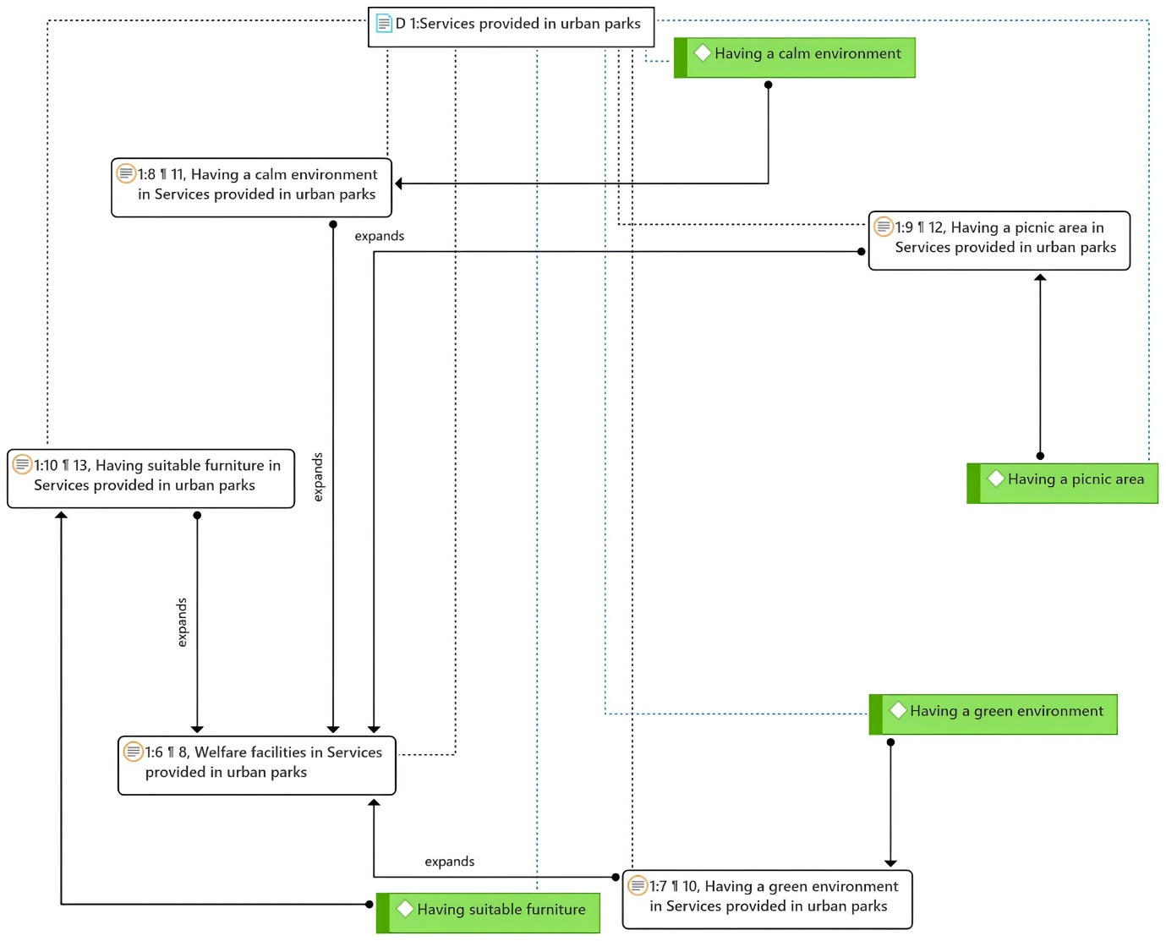
The resulting conceptual model indicates that these four amenities not only fulfill fundamental user needs but also represent strategic focal points for park planning and design. While all welfare facilities contribute to park functionality, prioritizing green, peaceful, and socially supportive environments is likely to have the most significant impact on user satisfaction and the overall effectiveness of urban parks.
Figure 1. The model extracted from the software for Welfare facilities

Recreation Priorities in Urban Parks
Structural analysis of the interview data indicates that among recreational amenities, a variety of play equipment was the highest priority, cited 14 times by participants. This was followed by diverse game booths (10 mentions), seasonal festivals (6 mentions), and bazaars or pop-up markets (4 mentions). These results reflect a strong user preference for interactive and diverse recreational opportunities, with playground variety emerging as a particularly critical feature.
The conceptual model suggests that these four amenities not only address core recreational needs but also serve as key planning touchpoints for enhancing park attractiveness and usability. Prioritizing the development and diversification of recreational infrastructure—especially playground equipment—can significantly improve user engagement and contribute to the broader social and recreational value of urban parks.
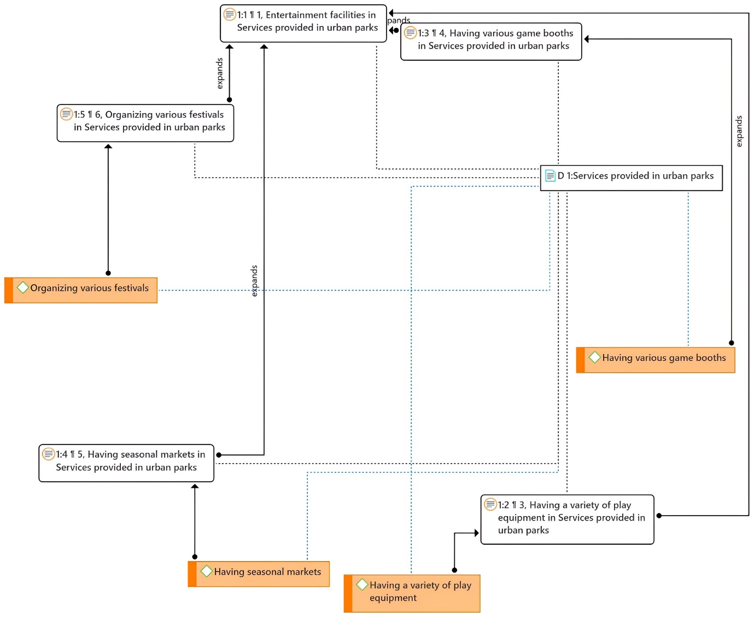
Figure 2. The model extracted from the software for recreational facilities

Sports Priorities in Urban Parks
Structural analysis of interview data reveals that among sports-related amenities, walking paths were identified as the top priority (14 mentions), followed by cycling paths (8 mentions), designated spaces for popular sports (6 mentions), and a variety of sports equipment (5 mentions). These findings highlight the central role of walking and active mobility in shaping the recreational value of urban parks.
The conceptual model emphasizes that walking paths, cycling infrastructure, and diverse sports facilities serve complementary functions in promoting physical activity and user satisfaction. Prioritizing these elements in urban park planning and design can enhance accessibility, support public health, and foster more inclusive and active green spaces.

Figure 3. Model extracted from software for sports facilities

Educational Priorities in Urban Parks
Structural analysis of interview data indicates that among educational amenities, educational and cognitive games emerged as the top priority (12 mentions), followed by botany sections (9 mentions), zoology sections (7 mentions), and spaces for civic education (6 mentions). These results underscore the importance of interactive learning tools and the growing demand for hands-on environmental and civic education in public green spaces.
The resulting conceptual model emphasizes that while each of these components can independently enrich the visitor's educational experience, their integration can produce a synergistic effect. A well-rounded educational program—combining playful cognitive engagement with exposure to natural sciences and civic learning—can significantly enhance environmental awareness, public knowledge, and social responsibility in urban park users.

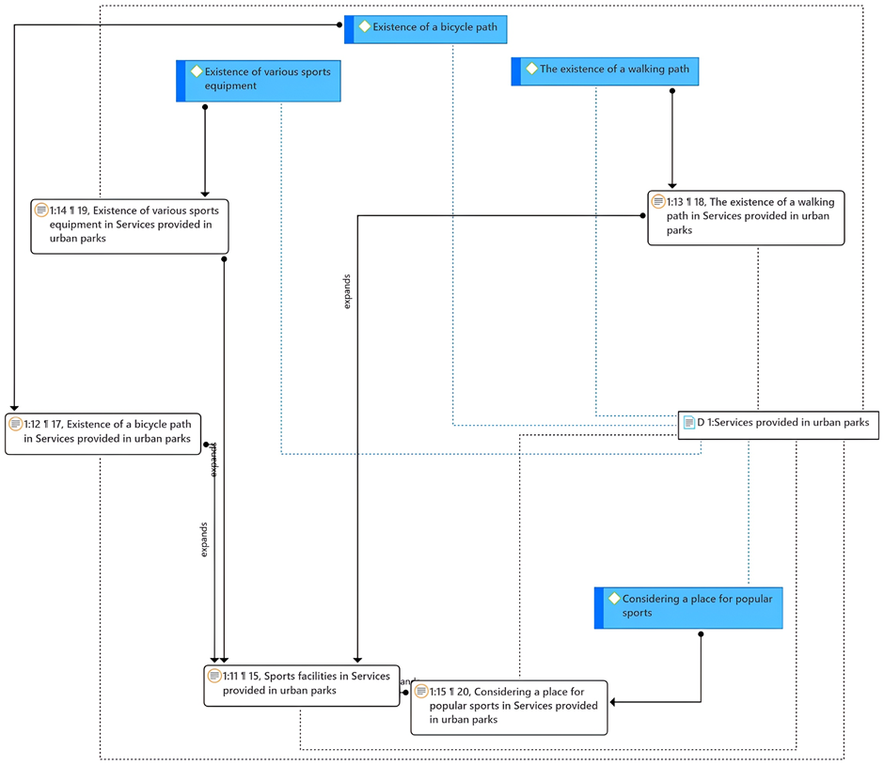
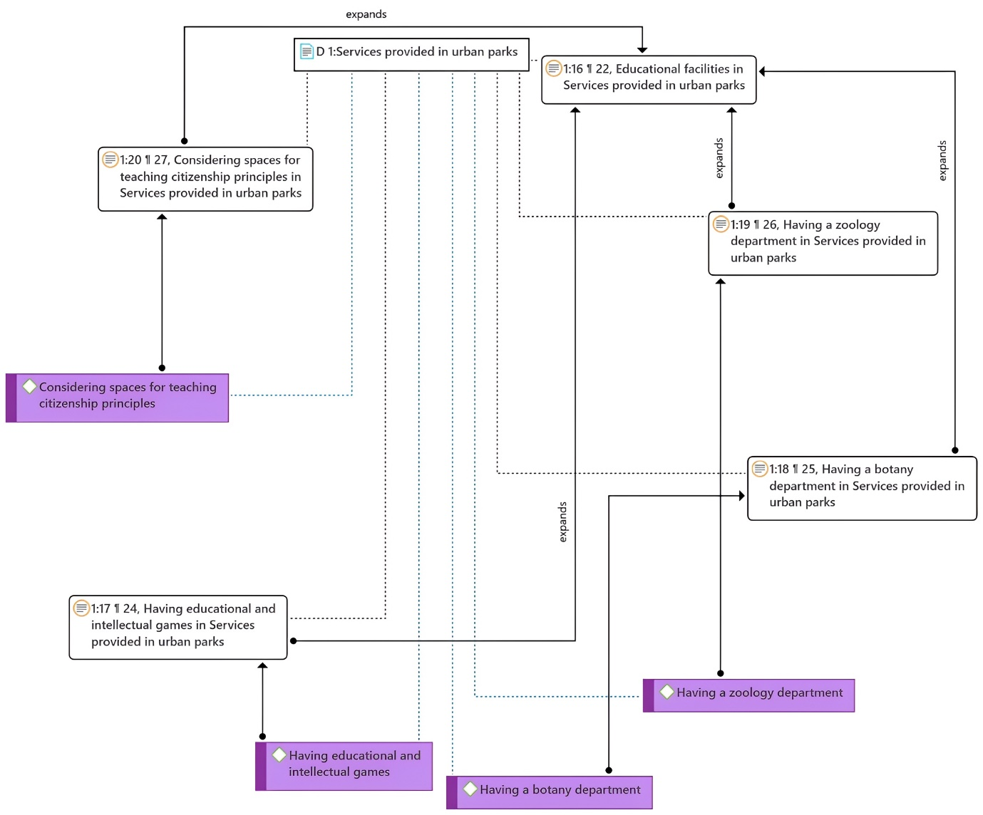
Figure 4. Model extracted from software for Educational facilities

Combined section
Urban Park Service Priorities
Based on the integrated results from both the questionnaire and interview data, comfort (welfare) facilities and recreational facilities emerged as the most important and consistently emphasized components among participants. These two categories showed the highest level of convergence in terms of perceived value and priority. Accordingly, prioritizing amenities related to comfort and recreation can significantly enhance the functionality and overall effectiveness of urban parks.
Sports and educational facilities ranked slightly lower in perceived importance but still received considerable attention from participants. To achieve well-rounded planning and effective urban park design, it is essential to consider and integrate all four service categories—comfort, recreational, sports, and educational—according to their relative importance.

Welfare Facilities
According to the findings from both the questionnaire and interviews, the presence of a green environment emerged as the most important component within the welfare facilities index across both quantitative and qualitative analyses. Conversely, the availability of appropriate furniture was consistently identified as the least important component in both datasets. This strong alignment between quantitative and qualitative results indicates a high level of convergence and reliability in the research findings regarding welfare facility preferences.

Recreational Facilities
Based on the results from both the questionnaire and interviews, the presence of diverse play equipment was identified as the most important component within the recreational facilities index in both the quantitative and qualitative phases. Meanwhile, the organization of diverse festivals was consistently ranked as one of the least important components. The consistency between the two research approaches reinforces the reliability and convergence of the findings in this category.

Sports Facilities
In the case of sports facilities, the findings reveal a partial divergence between the quantitative and qualitative data. In the quantitative results, designated spaces for popular sports (e.g., football) were rated highest, while in the qualitative interviews, walking paths emerged as the primary concern. This discrepancy may be explained by differing perspectives: experts emphasized walking as a fundamental, universally needed activity, stressing the importance of providing supportive infrastructure; meanwhile, citizens prioritized specific sports activities. Therefore, in planning for sports facilities, it is essential to consider both components to meet the diverse needs of stakeholders
.
Educational Facilities
For educational facilities, both the quantitative and qualitative data identified educational and cognitive games as the most important component. Conversely, spaces dedicated to civic education were considered the least important across both datasets. This consistency indicates a strong convergence between methods and reinforces the credibility of the research findings in this category.

Discussion
Urban parks and the services they provide play a critical role in enhancing the quality of urban life. The present study was undertaken to explore this issue in depth. In many previous studies, urban parks have often been examined through a one-dimensional, primarily environmental lens. For example, earlier research has emphasized the ecological functions of green spaces, noting their contributions to air quality improvement, visual appeal, and physical and mental well-being (Almeida et al., 2018; Xia et al., 2023). Other studies have focused more narrowly on specific park features, such as the density of amenities or the extent of vegetation, concluding that these elements can enhance the recreational value of urban parks (Wang et al., 2022). Consistent with these findings, the present study also identified greenery as a key factor influencing the appeal of urban parks.
However, a significant gap remains in the literature: few studies have comprehensively assessed the full range of services offered by urban parks. Prior research has either concentrated solely on ecosystem services or limited its scope to a single type of facility—often using only quantitative or qualitative methods in isolation. In contrast, the present study aimed to holistically examine four key categories of park services—recreational, comfort, sports, and educational facilities—and their role in attracting urban residents. The findings from both the quantitative and qualitative phases demonstrated a high degree of convergence, underscoring the validity and reliability of the results. This integrated approach provides a more nuanced understanding of the multifaceted functions urban parks serve in the urban environment.

Limitations and Suggestions for Future Research
Limitations
While this study provides valuable insights into the expectations of urban park services from both citizens and experts using a mixed-method approach, several limitations should be acknowledged. First, the absence of a specific case study limits the contextual depth of the findings. The generalizability of the results may be constrained, as urban park services can vary significantly across different geographic, cultural, and socio-economic contexts. The mixed-method design, although robust in capturing both quantitative and qualitative perspectives, may have been limited by sample size or selection biases in either the survey or interview components, potentially affecting the representativeness of the findings.
Additionally, the study relied on self-reported data from citizens and experts, which may introduce subjective biases or discrepancies in how expectations are articulated. The quantitative data may not fully capture nuanced preferences, while the qualitative data may be influenced by the framing of interview questions or the interpretation of responses. Furthermore, the study did not account for temporal changes in expectations, as urban park usage and needs may evolve due to seasonal, environmental, or societal shifts.

Suggestions for Future Research
Future research could address these limitations by incorporating case studies of specific urban parks to provide a more contextualized understanding of service expectations. Expanding the sample size and diversity in both quantitative surveys and qualitative interviews would enhance the robustness and generalizability of findings. Longitudinal studies could be employed to examine how expectations of urban park services change over time, particularly in response to urban development, climate change, or policy interventions.
Additionally, integrating advanced analytical methods, such as machine learning or spatial analysis, could help identify patterns in quantitative data, while more in-depth qualitative approaches, such as focus groups or participatory observation, could uncover deeper insights into user experiences. Exploring the perspectives of marginalized or underrepresented groups could also ensure a more inclusive understanding of urban park service expectations. Finally, comparative studies across different cities or countries could highlight how cultural and environmental factors shape citizen and expert expectations, contributing to more tailored urban park planning and management strategies.

Conclusion
Urban parks play a vital role in enhancing urban livability through the provision of welfare, recreational, sports, and educational services. This study found that comfort (welfare) and recreational facilities are prioritized most by both citizens and experts, followed by sports and educational facilities. Notably, elements such as green environments, varied play equipment, walking paths, and educational games were consistently ranked as essential components, while items like festivals and citizenship education spaces were seen as less critical.
These findings reveal both shared and divergent expectations across stakeholder groups. For instance, citizens emphasized spaces for group sports like football, whereas experts highlighted general accessibility and inclusivity, such as walking paths. The convergence between qualitative and quantitative results reinforces the reliability of these insights.
For future park planning, a greater focus should be placed on:
Enhancing natural and green landscapes
Providing diverse and age-appropriate recreational equipment
Incorporating inclusive sports and walking facilities
Adding interactive and educational play elements
Ensuring comfort and relaxation features, such as shaded seating and picnic zones
These recommendations support the creation of more user-centered, multifunctional, and inclusive urban parks that align with the needs of diverse populations. The outcomes of this study can inform urban planners, designers, and municipal decision-makers aiming to improve urban park services across Iran and beyond.

References
Almeida, C. M. V. B., Mariano, M. V, Agostinho, F., Liu, G. Y., Yang, Z. F., Coscieme, L., & Giannetti, B. F. (2018). Comparing costs and supply of supporting and regulating services provided by urban parks at different spatial scales. Ecosystem Services, 30, 236–247. https://doi.org/https://doi.org/10.1016/j.ecoser.2017.07.003
Baitalik, A., Chakraborty, A. K., & Bhattacharjee, T. (2024). Urban amusement parks of Midnapore (West Bengal, India): Utility, accessibility and structural diversity. International Journal of Geoheritage and Parks, 12(4), 558–579. https://doi.org/https://doi.org/10.1016/j.ijgeop.2024.11.001
Bush, J., & Doyon, A. (2019). Building urban resilience with nature-based solutions: How can urban planning contribute? Cities, 95, 102483.
Chen, X., de Vries, S., Assmuth, T., Dick, J., Hermans, T., Hertel, O., Jensen, A., Jones, L., Kabisch, S., & Lanki, T. (2019). Research challenges for cultural ecosystem services and public health in (peri-) urban environments. Science of the Total Environment, 651, 2118–2129.
Dushkova, D., Taherkhani, M., Konstantinova, A., Vasenev, V. I., & Dovletyarova, E. A. (2025). Understanding Factors Affecting the Use of Urban Parks Through the Lens of Ecosystem Services and Blue–Green Infrastructure: The Case of Gorky Park, Moscow, Russia. Land, 14(2), 237.
Erkip, F. B. (1997). The distribution of urban public services: the case of parks and recreational services in Ankara. Cities, 14(6), 353–361.
Gai, S., Fu, J., Rong, X., & Dai, L. (2022). Users’ views on cultural ecosystem services of urban parks: An importance-performance analysis of a case in Beijing, China. Anthropocene, 37, 100323.
Ge, Y., Chen, S., Ma, Y., Wang, Y., Guo, Y., & Gan, Q. (2024). Ecosystem services and public perception of green infrastructure from the perspective of urban parks: a case study of Luoyang City, China. Sustainability, 16(17), 7657.
Guo, R., Diehl, J. A., Zhang, R., & Wang, H. (2024). Spatial equity of urban parks from the perspective of recreational opportunities and recreational environment quality: A case study in Singapore. Landscape and Urban Planning, 247, 105065.
Jang-Hwan, J., So-Hee, P., JaChoon, K., Taewoo, R., Lim, E. M., & Yeo-Chang, Y. (2020). Preferences for ecosystem services provided by urban forests in South Korea. Forest Science and Technology, 16(2), 86–103.
Joassart-Marcelli, P. (2010). Leveling the playing field? Urban disparities in funding for local parks and recreation in the Los Angeles region. Environment and Planning A, 42(5), 1174–1192.
Komarolya, D. V., Kafi, M., & Khansefid, M. (2023). Investigating the preventive factors of people in the society from attending urban parks during the COVID-19 pandemic.
Komarolya, D. V., Kafi, M., Khansefid, M., & Diehl, J. A. (2024). Criteria for designing urban parks in a pandemic of infectious diseases: a survey based on experts’ opinions. International Journal of Architectural Engineering & Urban Planning, 34(1).
Komarolya, D. V., Nazmfar, H., Hami, A., & Yazdani, M. H. (2024). Analyzing and Identifying the indicators of planning and designing a happy urban landscape. Regional Development Studies (JSURDS), 5(4), 69–86.
Komarolya, D. V., Nazmfar, H., Hami, A., & Yazdani, M. H. (2025). Identifying indicators for planning and designing lively urban landscape. Landscape Architecture and Sustainability, 1, 100002.
Larson, L. R., Jennings, V., & Cloutier, S. A. (2016). Public parks and wellbeing in urban areas of the United States. PLoS One, 11(4), e0153211.
Leonel da Silva, A. R., Alves Carvalho, P., de Oliveira Ribeiro, V., & Ferreira Corrêa, N. (2025). URBAN PARKS IN PERMANENT PRESERVATION AREAS AS A TOOL FOR CONSERVATION AND ENVIRONMENTAL EDUCATION: A BIBLIOMETRIC STUDY. Environmental & Social Management Journal/Revista de Gestão Social e Ambiental, 19(2).
Li, F., Li, F., Li, S., & Long, Y. (2020). Deciphering the recreational use of urban parks: Experiments using multi-source big data for all Chinese cities. Science of the Total Environment, 701, 134896.
Li, J., Huang, Z., Zhu, Z., & Ding, G. (2024). Coexistence Perspectives: Exploring the impact of landscape features on aesthetic and recreational values in urban parks. Ecological Indicators, 162, 112043.
Lin, J., Deng, Y., Chen, S., Li, K., Ji, W., & Li, W. (2023). Research progress of urban park microclimate based on quantitative statistical software. Buildings, 13(9), 2335.
Mäntymaa, E., Jokinen, M., Juutinen, A., Lankia, T., & Louhi, P. (2021). Providing ecological, cultural and commercial services in an urban park: A travel cost–contingent behavior application in Finland. Landscape and Urban Planning, 209, 104042.
Myalkovsky, R., Plahtiy, D., Bezvikonnyi, P., Horodyska, O., & Nebaba, K. (2023). Urban parks as an important component of environmental infrastructure: Biodiversity conservation and recreational opportunities. Ukrainian Journal of Forest and Wood Science, 14(4), 57.
Nielsen, A. B., Van Den Bosch, M., Maruthaveeran, S., & van den Bosch, C. K. (2014). Species richness in urban parks and its drivers: A review of empirical evidence. Urban Ecosystems, 17(1), 305–327.
Palliwoda, J., & Priess, J. A. (2021). What do people value in urban green? Linking characteristics of urban green spaces to users’ perceptions of nature benefits, disturbances, and disservices. Ecology and Society, 26(1), 28.
Riechers, M., Noack, E. M., & Tscharntke, T. (2017). Experts’ versus laypersons’ perception of urban cultural ecosystem services. Urban Ecosystems, 20(3), 715–727.
Sadeghian, M. M., & Vardanyan, Z. (2013). The benefits of urban parks, a review of urban research. Journal of Novel Applied Sciences, 2(8), 231–237.
Sarı, E. N., & Bayraktar, S. (2023). The role of park size on ecosystem services in urban environment: a review. Environmental Monitoring and Assessment, 195(9), 1072.
Song, L., Wu, M., Wu, Y., Xu, X., & Xie, C. (2023). Research on the evaluation of cultural ecosystem services in zhengzhou urban parks based on public perceptions. Sustainability, 15(15), 11964.
Stępniewska, M. (2021). The capacity of urban parks for providing regulating and cultural ecosystem services versus their social perception. Land Use Policy, 111, 105778.
Sun, R., Li, F., & Chen, L. (2019). A demand index for recreational ecosystem services associated with urban parks in Beijing, China. Journal of Environmental Management, 251, 109612.
Tong, A., Qian, X., Xu, L., Wu, Y., Ma, Q., Shi, Y., Feng, M., & Lu, Z. (2023). Demand-led optimization of urban park services. Forests, 14(12), 2371.
Torabi, N., Lindsay, J., Smith, J., Khor, L.-A., & Sainsbury, O. (2020). Widening the lens: Understanding urban parks as a network. Cities, 98, 102527.
Vafadari Komarolya, D., Nazmfar, H., Hami, A., & Yazdani, M. (2024a). Analyzing and Recognition indicators of 24-hour urban landscape planning and design (Articles in Press). Geography and Human Relationships. https://doi.org/10.22034/gahr.2024.453164.2100
Vafadari Komarolya, D., Nazmfar, H., Hami, A., & Yazdani, M. H. (2024b). Identifying of the aesthetic indicators of the urban landscape. Geography, 22(82), 149–164.
Vafadari Komarolya, D., Pourbeirami hir, Y., & Vafadari Komarolya, M. (2024). Futuristic design of urban parks with the biophilic urban approach. Environment. Interdisciplinary Development, 9(86), 65–87. https://doi.org/10.22034/envj.2025.479139.1416
Vafadari Komarolya, D., Yousefpour Dokhaniyeh, A., Heidari, A., & Nazmfar, H. (2026). Future research of factors affecting the acceptability of urban parks with an emphasis on women’s parks. Geographical Engineering of Territory, 9(4).
Voigt, A., Kabisch, N., Wurster, D., Haase, D., & Breuste, J. (2014). Structural diversity: a multi-dimensional approach to assess recreational services in urban parks. Ambio, 43(4), 480–491.
Wang, Y., Shi, X., Cheng, K., Zhang, J., & Chang, Q. (2022). How do urban park features affect cultural ecosystem services: Quantified evidence for design practices. Urban Forestry & Urban Greening, 76, 127713.
Wei, W., Wang, Y., Yan, Q., Liu, G., & Dong, N. (2024). Assessing Buffer Gradient Synergies: Comparing Objective and Subjective Evaluations of Urban Park Ecosystem Services in Century Park, Shanghai. Land, 13(11), 1848.
Wolch, J. R., Byrne, J., & Newell, J. P. (2014). Urban green space, public health, and environmental justice: The challenge of making cities ‘just green enough.’ Landscape and Urban Planning, 125, 234–244.
Xia, Z., Yuan, C., Gao, Y., Shen, Z., Liu, K., Huang, Y., Wei, X., & Liu, L. (2023). Integrating perceptions of ecosystem services in adaptive management of country parks: A case study in peri-urban Shanghai, China. Ecosystem Services, 60, 101522.
Xiao, X., Ye, Q., & Dong, X. (2024). Using importance–performance analysis to reveal priorities for multifunctional landscape optimization in urban parks. Land, 13(5), 564.
Yang, Y., Wang, Z., & Lin, G. (2021). Performance assessment indicators for comparing recreational services of urban parks. International Journal of Environmental Research and Public Health, 18(7), 3337.
Zhang, K., Tang, X., Zhao, Y., Huang, B., Huang, L., Liu, M., Luo, E., Li, Y., Jiang, T., & Zhang, L. (2022). Differing perceptions of the youth and the elderly regarding cultural ecosystem services in urban parks: An exploration of the tour experience. Science of The Total Environment, 821, 153388.
Zhang, Y., Fu, B., Sun, J., & da Silva, R. F. B. (2025). Quantifying supply and demand of cultural ecosystem services from a dynamic perspective. Land Use Policy, 148, 107414.
Zhu, J., Lu, H., Zheng, T., Rong, Y., Wang, C., Zhang, W., Yan, Y., & Tang, L. (2020). Vitality of urban parks and its influencing factors from the perspective of recreational service supply, demand, and spatial links. International Journal of Environmental Research and Public Health, 17(5), 1615.

