Advanced informetrics framework based on the theoretical principles of architecture and urban planning along with achieving data-driven scientometrics functions based on: indicator, index, aspects, product and classification

Hadi Farhangdoust,Toktam Hanaee , Hero Farkisch

¹ Master of Islamic Architecture, Department of Islamic Art and Architecture, Faculty of Islamic Art and Architecture, Imam Reza International University, Mashhad, Iran (Corresponding Author)
² PhD, Faculty Member of Urban Planning Department, Faculty of Art and Architecture, Islamic Azad University, Mashhad Branch, Mashhad, Iran
3 PhD, Faculty Member of Architecture Department, Faculty of Art and Architecture, Islamic Azad University, Mashhad Branch, Mashhad, Iran

  - Abstract:
The field of Knowledge and Information Science in its scientometric branch examines scientific indicators for evaluating the content and method. Using the benchmarks of this discipline in architecture and urban planning, while improving its theoretical foundations, also organizes its processes. This study aims to provide a comprehensive framework to resolving this issue. The main questions of this research are formed based on the recognition of the types, evolution and impact of theoretical foundations on the objective framework of this field. The research method based on its reflexive grounded theory, with constructive interaction between several layers of interdisciplinary and transdisciplinary perspectives, has tried to measure the extent and method of impact of different scientometric layers as dependent variables on the scientific strategies of architecture and urban planning. The process of implementing the research method in MAXQDA software has been such that all sections have items as research layers. These items have been introduced to the software by providing a variety of descriptive, related keywords used in architecture and urban planning research along with theoretical saturation technique. The innovative part of this research is in examining the controlling variable that has comparative values of architecture and urban planning along with values of the content of information science and epistemology. The findings of this research lead to the recognition of the role, connection, and application of the layers of the theoretical foundations of these fields from a scientific point of view. It is also related to the improvement of theoretical quality and methods, indicators, applications and strategies based on theoretical foundations in architecture and urban planning. It increases the efficiency of scientific methods and theoretical support of the processes of these disciplines both in the production of written works and in building information modeling software.

  - Keywords: Theoretical principles, Scientific processes, Knowledge and information science, Policymaking, Interdisciplinary collaboration

Introduction
Scientometrics is the field dedicated to analyzing and measuring the impact of scientific publications (Vorobiov & Shylo, 2023). In the realm of architecture and urban planning, scientometrics is a valuable tool for analyzing the impact of theoretical principles (Rodríguez, Melgar, Cordero, & Márquez, 2021). On the other hand, the theoretical principles of architecture and urban planning encompass the foundational ideas, concepts, and frameworks that shape the design and growth of buildings, cities, and communities. (Vasilenko & Chernysh, 2023). These principles draw from a range of disciplines, including architecture, urban planning, sociology, psychology, economics, and environmental science (Encyclopedia of Urban Studies, 2010).
The integration of scientometric methods and indexes into architectural and urban planning frameworks has become increasingly essential in response to the growing complexity and interconnectedness of urban environments. Scientometrics, traditionally utilized in fields like information science and sociology, offers valuable insights into research trends, the impact of theoretical foundations, and interdisciplinary collaborations (Salama & Madhavi, 2024). By leveraging these tools, architecture and urban planning practitioners can better assess the influence of theoretical models on practice and identify innovative methods for urban development. For instance, using citation analysis to understand which theoretical frameworks are most frequently referenced enables architects and urban planners to align their strategies with widely accepted standards, thereby ensuring that their projects are grounded in well-validated knowledge (Liu, Zhang, Wang, Hua, & Xue, 2021).
Research indicates that the demand for information on structure and function significantly impacts the architectural design process. In the meantime, Scientometrics has emerged as an important method to analyze the evolution and trends theoretical principles in architecture and urban planning research.
Accordingly (Figure 1), the necessity for a universal theoretical language to enhance communication and optimize information resource services within this field (Bingcheng & Jinfeng, 2022). Meanwhile they demonstrated the significance of addressing the theoretical foundations as a key player in scientific and artistic processes in many actions such as designing and decision making. These foundations provide the basis for comprehension, understanding and the advancement of knowledge (Karwowski, 2019). Fundamentally, they guide the development of innovative approaches and methodologies, by ensuring correctness and novelty in many aspects of evolution systems such as in contraction economic (Steshenko & Steshenko, 2023).
Knowledge-thematic gaps formed from this point, that with a multidimensional view, the foundations serve as science policy interfaces, facilitating the exchange of scientific knowledge in complex every human base since decisions framework, such as political science (Gasanov, Gasanov, Zhironkin, & Krasota, 2023), architecture and urbanism (Farhangdoust, Farkisch, & Hanaee, 2022). In the context of knowledge-methodical gaps, theoretical foundations must help in shaping interdisciplinary discourse, fostering intellectual and creative development through a research-oriented paradigm (Barnett, Epstein, Greengard, & Magland, 2022, p. 37).
Moreover, theoretical foundations underpin discussions on corporate social responsibility, defining co-responsibility along global supply chains (Farhangdoust, 2022a, pp. 76–77) and addressing the evolving dynamics of the market (Oehmer & Jarren, 2019). Overall, the reason for this research is that the theoretical foundations are essential for establishing credibility, driving innovation, and enhancing the effectiveness of scientific endeavors in architecture and urban planning (Liua & Zhang, 2020). so, for studying about this reason, the main question could have three parts:

- How do theoretical principles in architectural and urban planning processes relate to knowledge and information science?
- Answered by distinguishing between: Index (Table 3), Aspects (Table 4), Product (Table 5), Classification (Table 6), Indicator (Table 7).
- What are the different scientometric functions in architecture and urban planning?
- Answered by presenting related keyword in the (Table 8)
- How does the integration of scientometric and theoretical frameworks specifically enhance the scientific processes within architecture and urban planning, and what are the resulting implications for practical applications in these fields?
- Answered by presenting related: Nature, Steps, Goals, Research Suitability and Knowledge Context Tree in the (Table 11)

To answer this question, the goal is the multidisciplinary research about the structure and function (Roles and Indicators) of theoretical principles in architecture and urbanism (Chart 1). The fundamental innovative ways of this research to answer these questions are in the potential applications of scientometrics in the context of theoretical principles in architecture and urban planning (Rusliana, Komaludin, & Firmansyah, 2022)include below items. This paradigm shift has allowed designer to move beyond conventional design processes, incorporating real-time data and user feedback into design workflows. As a result, buildings can be more adaptive to user needs and environmental conditions, leading to improved energy efficiency and occupant satisfaction.

- Policy-making: Scientometrics can inform policy-making in architecture and urban planning by identifying the most influential theoretical principles and researchers in the field (Hu, Dong, Hwang, Ren, & Chen, 2019). The use of scientometrics also enables policy-makers in urban planning to allocate funding more effectively by identifying high-impact research areas and emerging trends that warrant further exploration.
- Research funding: Scientometrics can be used to allocate research funding to projects that apply theoretical principles from other disciplines (Mosleh, Roshani, & Coccia, 2022)to architecture and urban planning (Elrahman & Asaad, 2021).
- Education and training: Scientometrics can using to develop curricula and training programs that emphasize the importance of theoretical principles in architecture and urban planning (Maruna, 2019).
- Interdisciplinary collaboration: Scientometrics can facilitate interdisciplinary collaboration of architecture and urban planning by identifying common theoretical principles and researchers across different disciplines (Brown, Werbeloff, & Raven, 2019).
- guide the adoption of innovative methodologies: by highlighting the most influential sources in architectural theory and practice. For example, by examining publication trends in high-impact journals, researchers can observe the shift from traditional formalism to more adaptive and participatory design models, particularly those incorporating computational design techniques and data-driven approaches (Xiong, Liu, Qin, & Chen, 2024)
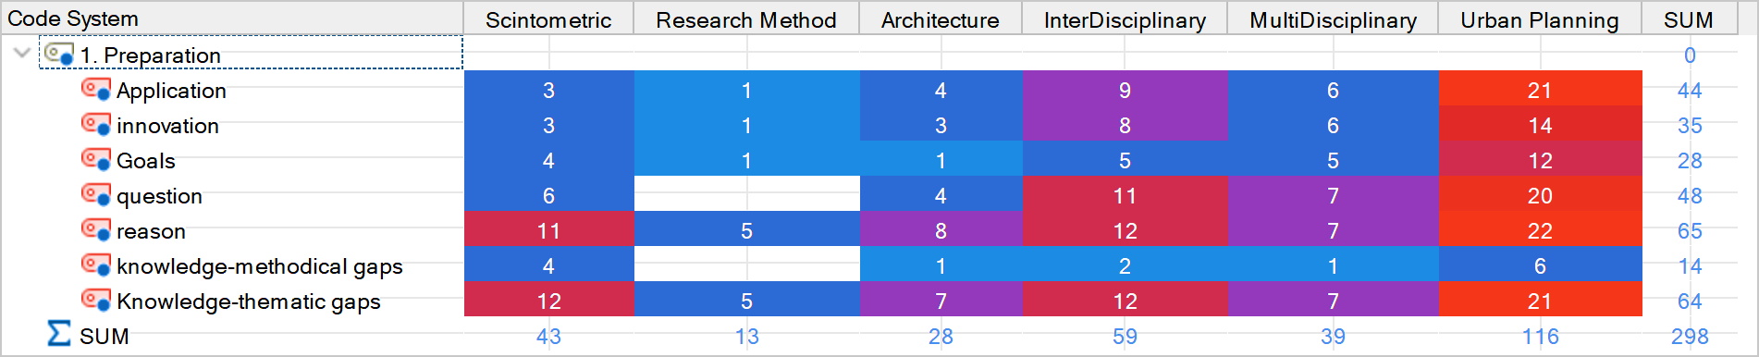
Chart 1: The relationship between the generalities of this research with each other by separating the sources used in the MaxQDA software (Source: MAXQDA software outputs)

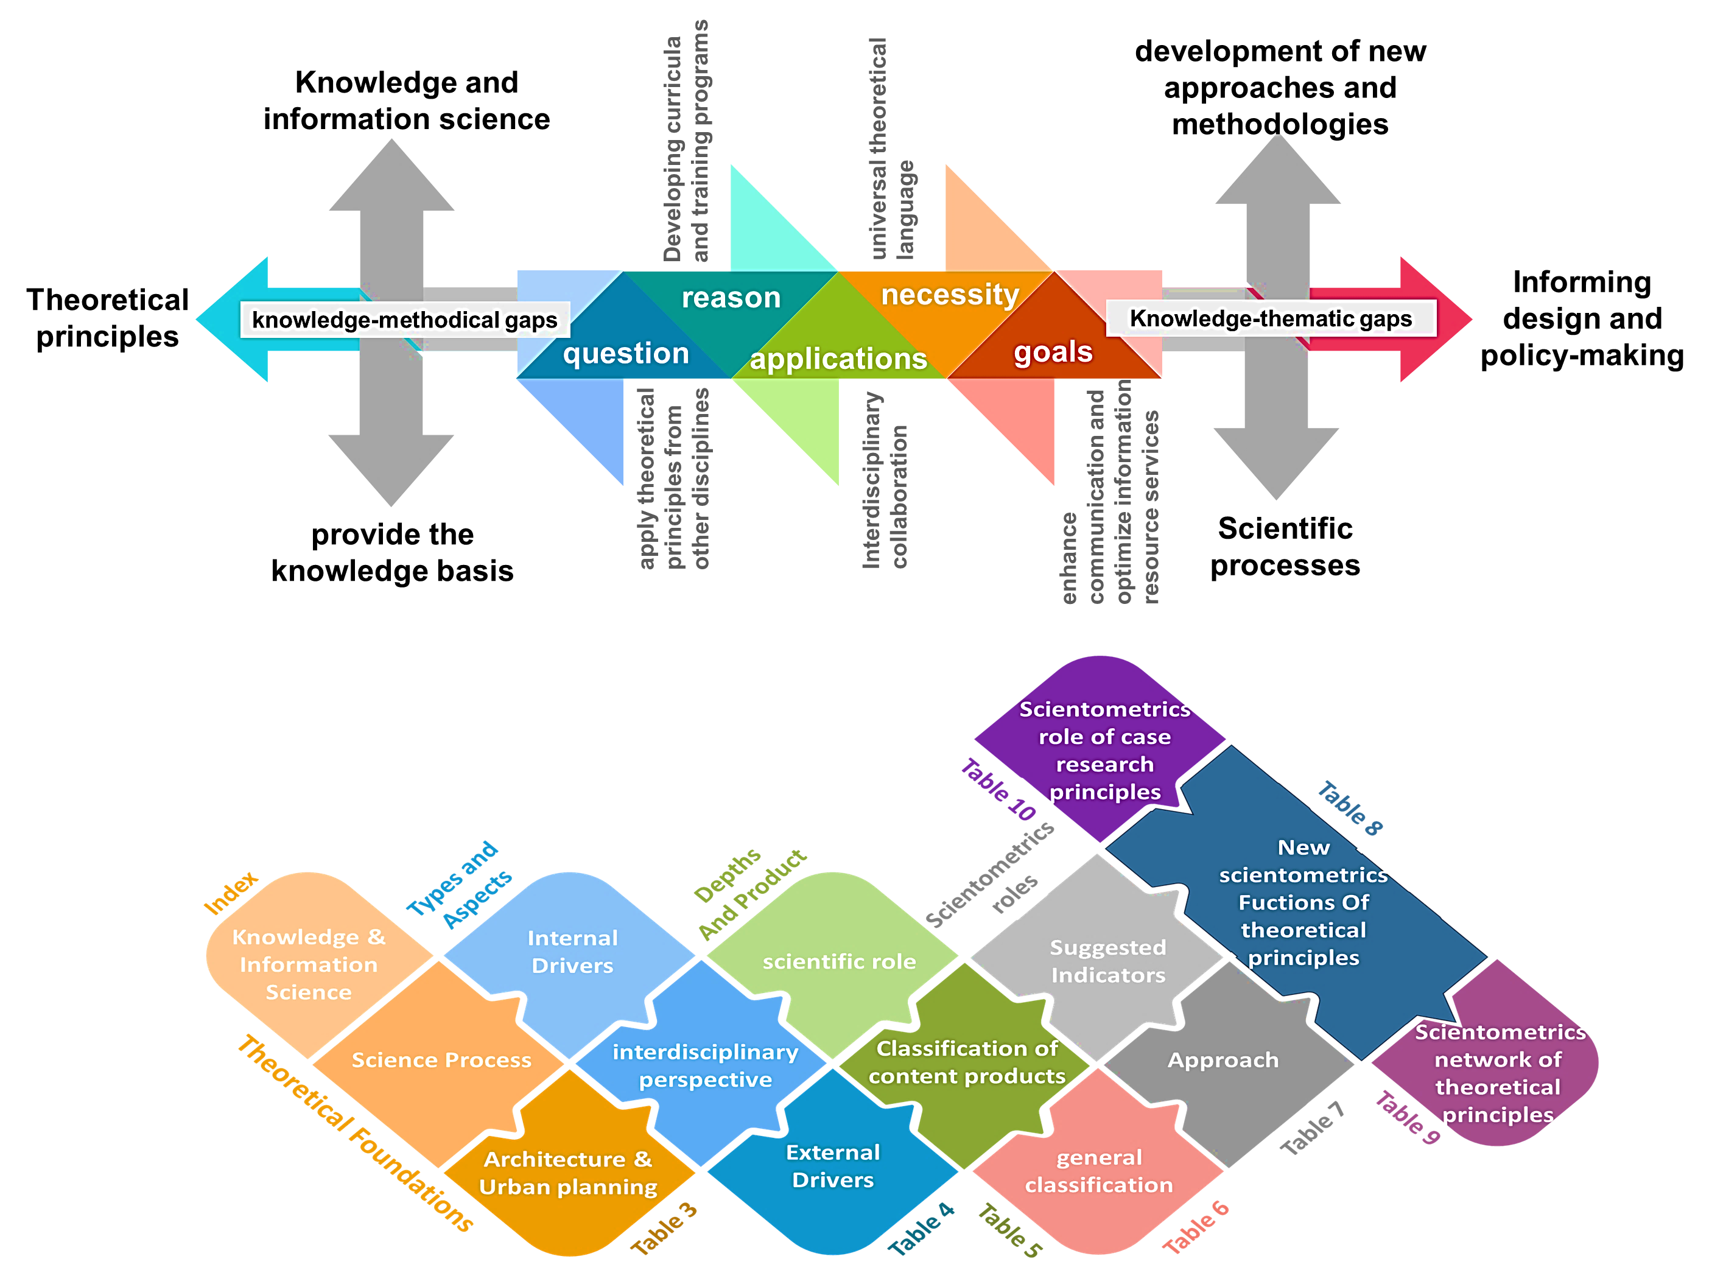
Figure 1: Problem statement in this research (up)and Content cycle (Down) (Source: the authors based on summarizing the text in this section)
As in it is mentioned in Chart 2, to guarantee the quality of data in the field of architecture and urbanism, some best practices for validating and verifying data include the use of a Validation and Verification (V&V) model with a hierarchical process (Serrano, 2022). This model provides data abstraction, value-added services, and authenticity based on Artificial Intelligence (AI) (Xu, Liu, & Yang, 2023). These practices help ensure the validity, reliability, and credibility of the managed information in architecture and urbanism research. Therefore, the data in this research have been reviewed, approved, and verified based on the following:
A: alignment the degree of consistency of content values with the macro-view of this study.
B: The origin and assets of the data formation and amount to the extent of the chosen data’s coverage with current research inquiries.
C: The alignment of data formation policies with current research questions.
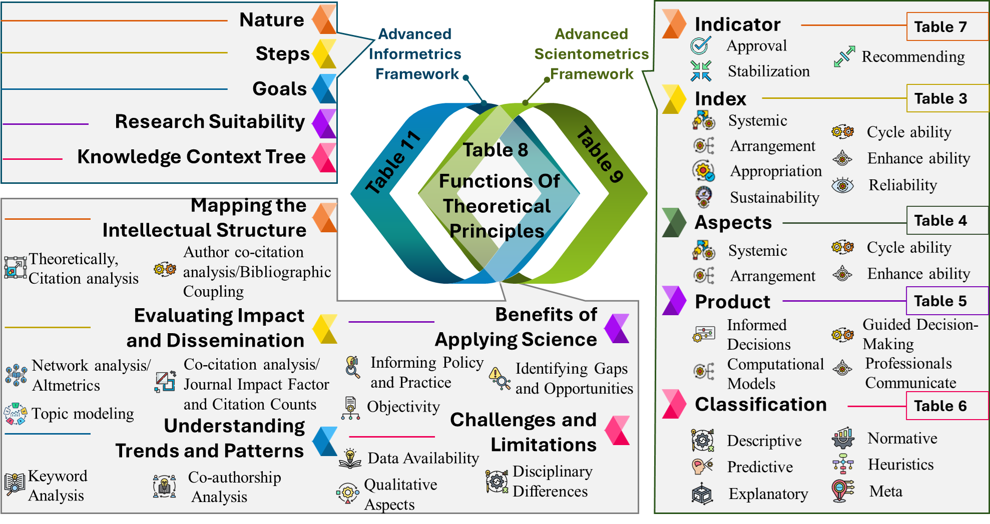
Chart 2: Conceptual Map Of parts of this research (Source: authors based on the research plan)

Background
In architecture, bibliometrics is used in the study of several types of scientific outputs such as articles, books, conference proceedings, and others. These analyses can help identify research trends, citation patterns, collaborations among researchers and research centers (Perera, Babatunde, & Ekundayo, 2022). Similarly, in urban planning, bibliometrics is used to examine topics related to urban plans, urban management, infrastructure, and more advances in knowledge and information science have significantly influenced the application of theoretical principles in architectural and urban planning processes (Bibri, 2017).
Meanwhile (as mentioned in Table 1), the integration of information technology (IT)tools in design practices has led to a paradigm shift, enhancing the quality of decision-making processes and design outcomes (Mattila, Olsson, Lappi, & Ojanen, 2022). Additionally, the evolution of architectural scholarly knowledge as a cultural phenomenon (Farhangdoust, 2022b, p. 115) highlights the importance of reevaluating historical theories using contemporary methodologies and tools, aiming to predict the future development of architectural science (Couclelis, 2021).
Furthermore, the emergence of data-oriented strategies in design and planning science emphasizes the need to adapt to the complexities of the digital age, replacing traditional methods with evidence-based actionable knowledge for designers, researchers and planners (Al-Douri, 2022). These advancements underscore the necessity for a balance between abstract and scientific knowledge in knowledge-based planning approaches (Farhangdoust, Farkisch, & Tabasi, 2022, pp. 118–119).
Recent also point with a professionally and interdisciplinary view corrected. Because most the library resource have said the Theoretical principles play a crucial role in architectural and urban planning processes by integrating knowledge and information science. They believe that Knowledge-based planning emphasizes the balance between abstract and scientific knowledge in urban development (Mattila, Olsson, Lappi, & Ojanen, 2022).
Table 1: Mapping Research Landscapes and Trends of the key milestones in the evolution of scientometrics (Source: authors based on available studies in this field)
Milestone |  |  | evolution of scientometrics in architecture and urban planning
quantitative studies early 20th century |  |  | 1. In 1927, the term “scientometrics” is coined to describe the quantitative study of science.  2. In the 1930s, scientometrics evolved into the “science of science.”  3. J. D. Bernal’s 1939 book “The Social Function of Science” was a key transition point for the field.
Early Beginnings (1960s-1970s) | 1. The term “Scientometrics” was coined in 1969 and adapted into English in 1978.  2. The rise of computers enabled effective data analysis for scientometrics.  3. Foundations of scientometrics were laid in the 1960s and 1970s with bibliometric methods.  4. Derek de Solla Price, the “Father of Scientometrics,” published seminal works: 1963(Little Science, Big Science), 1965 (Networks of Scientific Papers), 1970 (Citation Measures of Hard Science, Soft Science, Technology, and Nonscience)  5. The first citation index, the Science Citation Index (SCI®), was first promulgated in Science in 1955, was launched in 1964, and Journal Citation Reports (JCR) were officially launched in 1975  6. The first architecture-specific citation index was developed in 1975 as The Arts & Humanities Citation Index (AHCI)  7. along with the Institute for Scientific Information (ISI) was founded in Philadelphia in 1956, Eugene Garfield introduced the Science Citation Index (SCI) in 1963.  8. The journal Scientometrics was established in 1978 as a dedicated outlet for the field.
Expansion and Diversification (1980s-1990s) | 1. The first International Conference on Scientometrics and Informetrics was held in Belgium in 1987.  2. The Journal of Architectural and Planning Research was founded in 1985 as a leading outlet for scientometric research in architecture.  3. After Temporal coverage from 1975, In 1988, Science Citation Index Expanded (SCIE) to include architecture, design, and urban planning journals by Arts & Humanities Citation Index® (A&HCI®).  4. Researchers explored citation analysis, co-citation analysis, and co-word analysis to map the intellectual structure of architectural research.  5. The first the International Conference on Bibliometrics, Informetrics and Scientometrics held in Berlin in September 1993.  6. The International Society for Scientometrics and Informetrics (ISSI) was founded in 1994 in the Netherlands.  7. New visualization techniques, such as citation networks and bibliometric maps, helped understand trends in architectural research.
Technological Advancements (2000s-2010s) | 1. In 2000, increased use of bibliometric and network analysis techniques in architecture and urban planning due to big data and digital technologies.  2. The evaluation and ranking of scientists and institutions came into focus, with the first Academic Ranking of World Universities (ARWU), also known as the Shanghai Ranking Founded in 2003.  3. In 2005, the founding of the International Society for Scientometrics and Informetrics (ISSI) for researchers to share knowledge and best practices.  4. The widespread adoption of digital technologies and the Internet led to the availability of large-scale bibliographic data for more comprehensive scientometric analyses in architecture.  5. The development of software tools and databases, such as Scopus and Web of Science, made it easier to collect, analyze, and visualize architectural research data.  6. Researchers explored text mining, machine learning, and network analysis to uncover patterns and insights in the architectural research landscape.  7. In 2007, the launch of the Journal of Informetrics (JOI)  8. In the 2012, the emergence of altmetrics and social media-based indicators expanded the scope of scientometric analysis, launch of the journal Frontiers of Architectural Research and Journal of Scientometric Research with a focus on interdisciplinary research and scientometrics.
Interdisciplinary Perspectives (2010s-Now) |  | 1. In recent years, discussions on developing improved metrics to objectively evaluate scholarly results.  2. Growing recognition of integrating scientometric approaches with other disciplines like sociology, economics, and innovation studies.  3. Researchers explored the relationship between architectural research and broader societal, economic, and technological trends, as well as its role in innovation and knowledge transfer.  4. The emergence of new research areas, such as studying the impact of architectural and urban planning research on practice and policy, broadened the scope of scientometric investigations.  5. In 2020, the COVID-19 pandemic accelerated the use of scientometric (data-driven) methods to understand the impact and research trends in architecture, design, and urban planning.  6. In 2023, the first special issue on Scientometrics Applications in Building Engineering and Sustainable Development was published in the Buildings Journal, highlighting the growing importance of the field.
Methods for applying scientometric analysis to architectural and urban planning theories across contexts
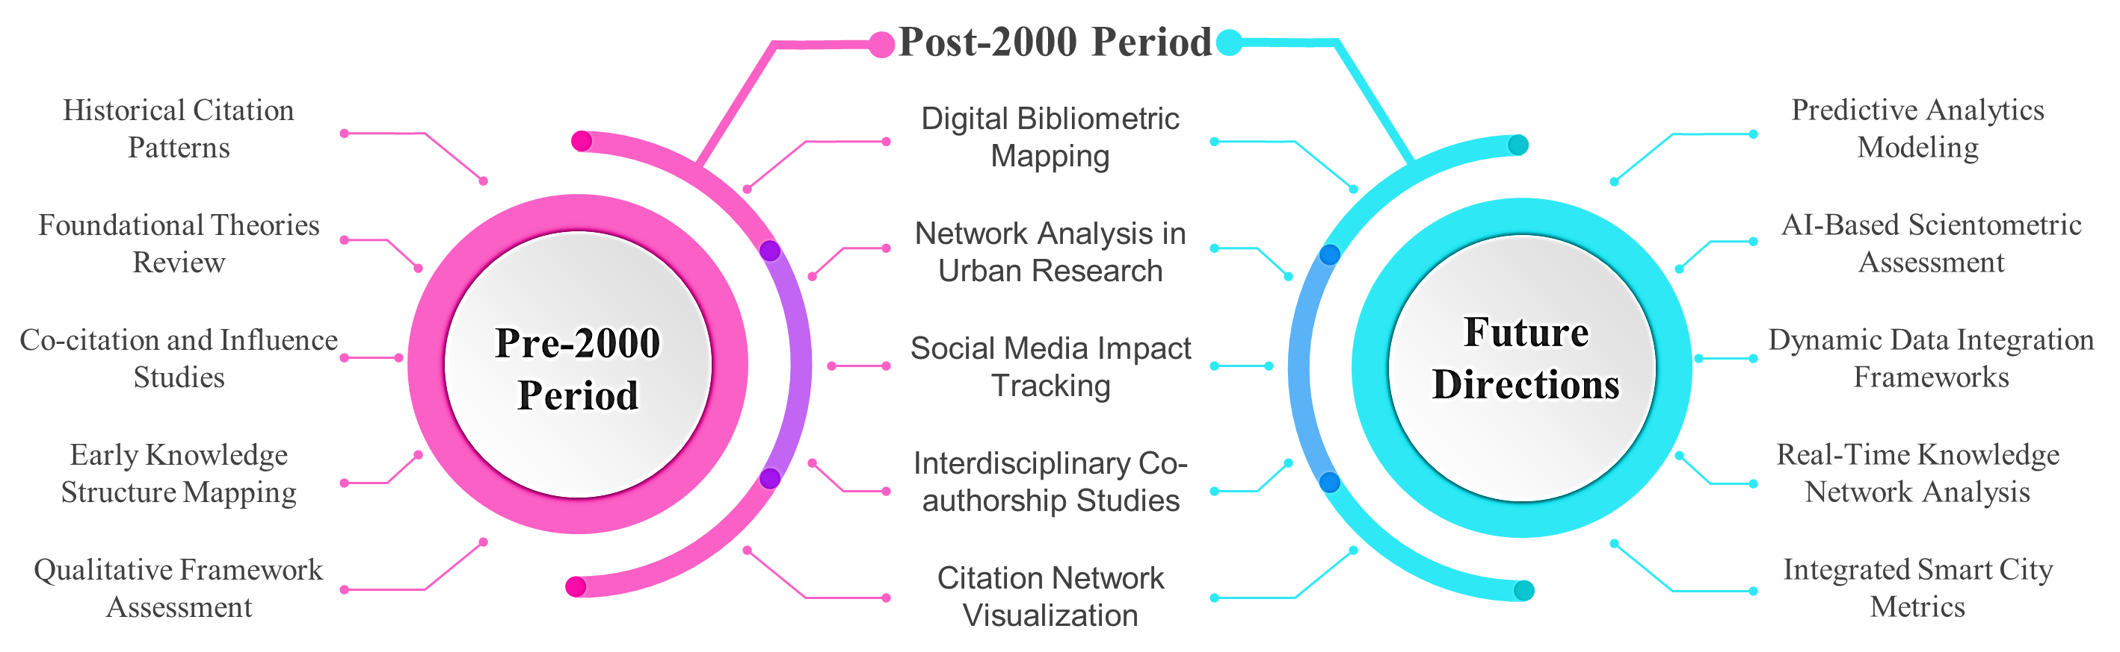

Another part of the source’s state that Understanding the theoretical architectural thought as a cultural phenomenon is essential for predicting the evolution of architectural science and solving major problems in the field (Tarasova, 2020). In fact, they believe that identifying theoretical standards from the perspective of architecture and urban planning Process is fundamental approach in defining the elements contributed to design and its relationship with planning processes (Elrahman & Asaad, 2019). In other words, this theoretical approach, viewing objects as combinations of informational flows that could help addressing practical issues by considering various environmental factors like economics, cultures, and historical aspects (Lidin, Meerovich, Bulgakova, Vershinin, & Papaskiri, 2018).
As it is mentioned in the Chart 3, theoretical principles in architectural and urban planning processes are closely intertwined with knowledge and information science (Peckham, 2009; Martinus, 2010). These fields emphasize on the gap study about leveraging knowledge-based approaches (Moretto, Gianluca, & Ghiani, 2021)to enhance design decisions and urban development (Mohammadi, Vimal, & Taylor, 2020). Other gag is about the criticisms and challenges associated with the use of scientometric indicators and overreliance on them. In fact, while scientometric analysis has proven useful in understanding trends and impacts in architecture and urban planning, it is crucial to consider its limitations, especially in fields where qualitative and contextual factors play a significant role. Over-reliance on quantitative indicators, such as citation counts and journal impact factors, may undermine the inherently artistic, interpretive, and context-sensitive nature of architectural theory and practice. Architecture and urban planning are disciplines deeply rooted in social, cultural, and environmental contexts, where success often hinges on subjective and situational insights that quantitative metrics cannot fully capture (Heidari & Olivieri, 2023).

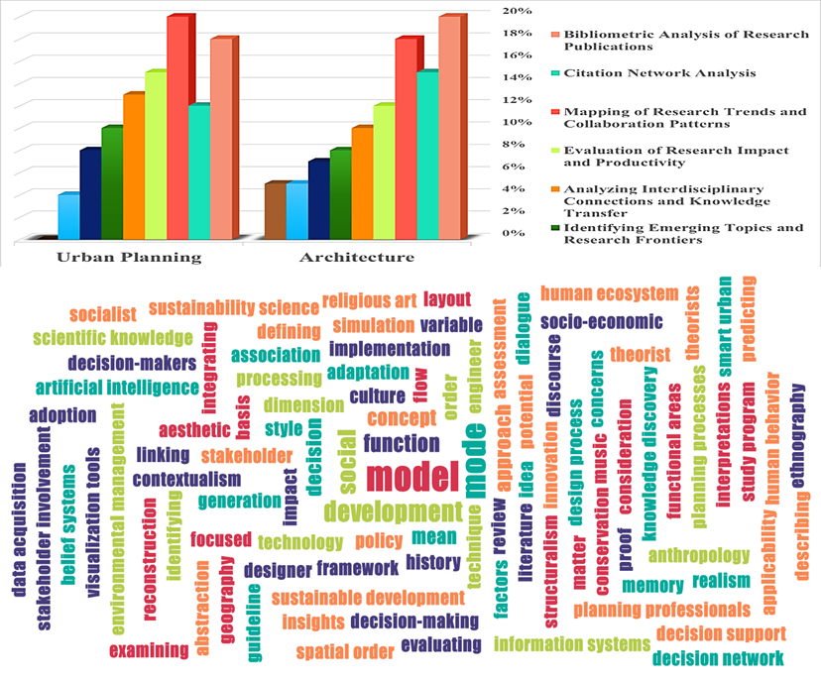
Chart 3: Common Scientometrics Research Topics (up)and most repetitive key words in this type of research on the Architecture and Urban Planning from 2000 to 2024 (Source: authors based on the studies available in the sources )
Critics argue that an excessive focus on scientometrics can create perverse incentives and lead to a publish-or-perish environment that may compromise the quality of research. The answer of this research to this study gap is to provide indicators that enable the evaluation of architecture and urban planning studies and theories for the integration of intellectual literacy, semantic web technologies, and the reinterpretation of modern modes of making and generation of knowledge play pivotal roles in advancing architectural and urban planning practices.
The integration of architecture and urban planning with information science through scientometric methods has increasingly facilitated a data-driven approach to addressing complex urban challenges. By employing scientometric indicators, researchers can analyze citation trends, interdisciplinary collaborations, and the influence of various theoretical foundations on practical outcomes in architecture and urban planning. One notable example is the use of scientometric mapping to study resilience frameworks in urban environments. This approach aids urban planners in identifying highly cited studies on green infrastructure and adaptive urban design, offering actionable insights for developing climate-resilient cities that incorporate green roofs, urban forests, and water-sensitive urban designs (Li, et al., 2024).
In practical terms, scientometric analysis helps urban planners and architects to synthesize key themes and trends that have influenced sustainable development. For instance, research has shown that studies incorporating resilience and sustainability in urban planning have been influential in advancing eco-friendly policies, especially within the context of the United Nations Sustainable Development Goals (SDGs). Scientometric tools like co-citation analysis and bibliometric mapping enable the tracking of significant themes such as urban resilience and social equity, thus facilitating the prioritization of sustainable urban development projects (Sheikhnejad & Yigitcanlar, 2020). Such approaches not only enhance academic understanding but also provide a foundation for practical policy decisions and environmental strategies in urban planning (Xu , Li, Tan , & Deng, 2021).

Materials and Methods
The reflexive grounded theory (RGT) as a Research Methodology is a framework that emphasizes the need for researchers to be aware of other same influence on the research process and the interpretation of data (Bonfim, 2020, pp. 502-503). The steps involved in a reflexive methodology can vary depending on the specific approach. This approach emphasizing on the Reflecting values, meanings, motivations, issues, behavior of researchers in the classification of concepts and categorization (Schmidt, Falk, Siegmund-Schultze, & Spangenberg, 2020, pp. 3-4). It involves a systematic and intentional process of critical thinking and awareness of biases, assumptions and values (Paula, 2021, p. 437).
This perspective acknowledges that research by embracing reflexivity, and open up new vistas for understanding complex phenomena more comprehensively (Woodward & Ball, 2023). In summary, reflexive methodology offers a transformative lens that enriches our understanding of the world by acknowledging and working with the inherent complexities and subjective dimensions of knowledge production. It pushes the boundaries of traditional research paradigms, fostering more inclusive, dynamic, and ethical research practices (Furman, 2022).
This method ensures a systematic and rigorous approach to deriving reliable, validated, and applicable information from scholarly sources for the theoretical foundations of architecture and urban planning. In the other hand, scientometrics is a quantitative approach used to examine and analyze scientific studies and outputs in various fields, including architecture and urban planning. As it is viewable in the Figure 3, this approach helps professionals in these fields to better understand the research trends, challenges, hot topics, strengths and weaknesses in these areas.
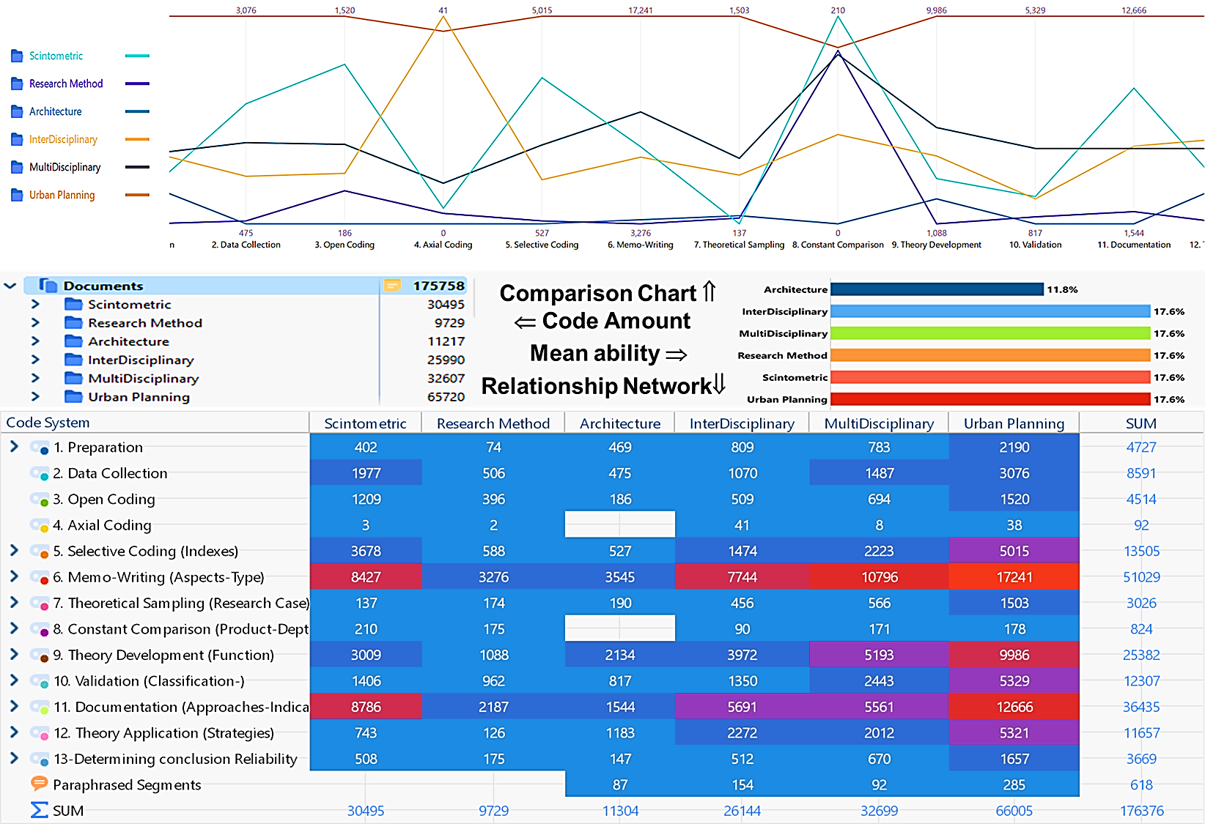
Figure 2: The general situation of the resources and the implementation network of this research (Source: MAXQDA software outputs)
The general approach of the work has been as follows. First, the research topic was converted into research questions and objectives. Then, the related library resources have been collected and categorized into architecture, urban planning, interdisciplinary, multidisciplinary, scientometric and research method groups. Then, several research maps were drawn based on them and were experimentally implemented and ranked. Then recoding was done and then the methods used in other existing research were also examined and selective coding was implemented. By examining the steps taken with the research plan selected from among the types of initial plans, it was assured that theoretical saturation was achieved.
To test the findings of the next steps, a part of the key theoretical foundations has been selected and analyzed by the lexical key as a research sample and introduced to the software. In the following, the views within the field about the theoretical foundations have been analyzed, layered and parallel coded. At the same time, multidisciplinary perspectives in this field have also been examined and a basis for creating a framework for the validity of research findings. Thus, the main core of the research findings was formed by the synergy of the previous sections and were implemented for the study sample for their validity and applicability. Finally, by deepening the findings, a network of scientific strategies for architecture and urban planning have been presented. Here, all these steps are presented in the form of a chart:
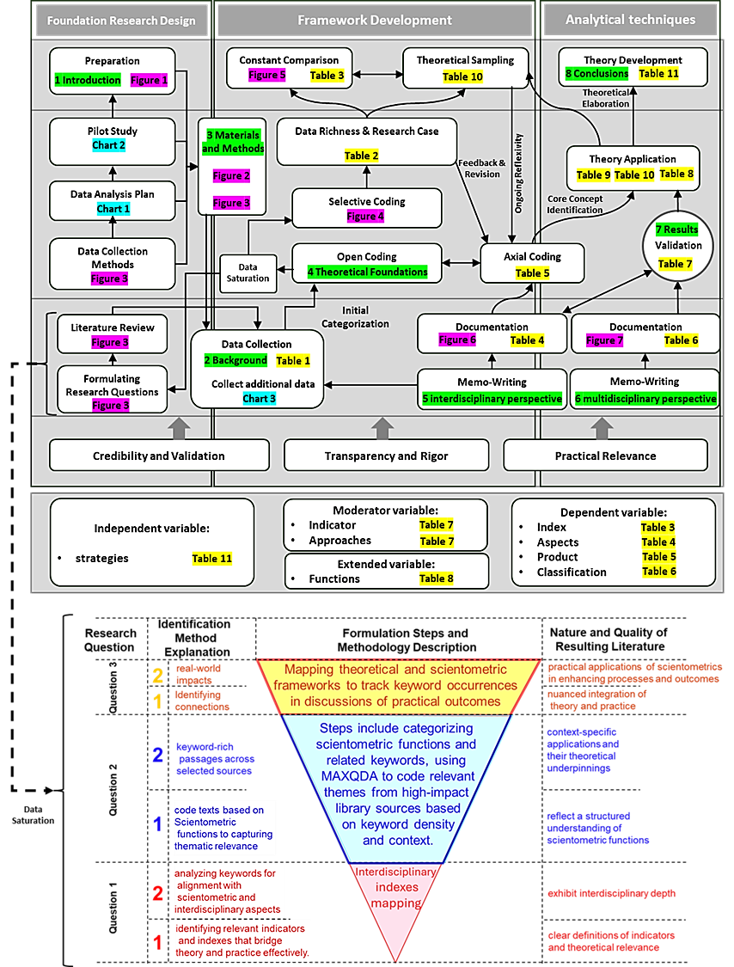
Figure 3: The process of implementing the reflective ground research method in this research (Source: authors based on the studies available in the sources)

The Evolution, Impact and Relationship of Theoretical Foundations
The theoretical foundations in architecture and urban planning are diverse and stem from various philosophical, sociological, and design-oriented perspectives. These theories not only influence the way that buildings and cities are designed but also reflect broader cultural and social dynamics. These theoretical foundations provide architects and urban planners with frameworks to guide their design decisions, reflecting both practical needs and cultural values. Each theory offers unique insights and tools, shaping the environments in which people live, work, and interact.
The evolution of the formation and use of theoretical foundations in architecture and urban planning is a complex and rich history that has been shaped by numerous factors over time (Bevz, 2021). Here is a brief overview of some key developments:
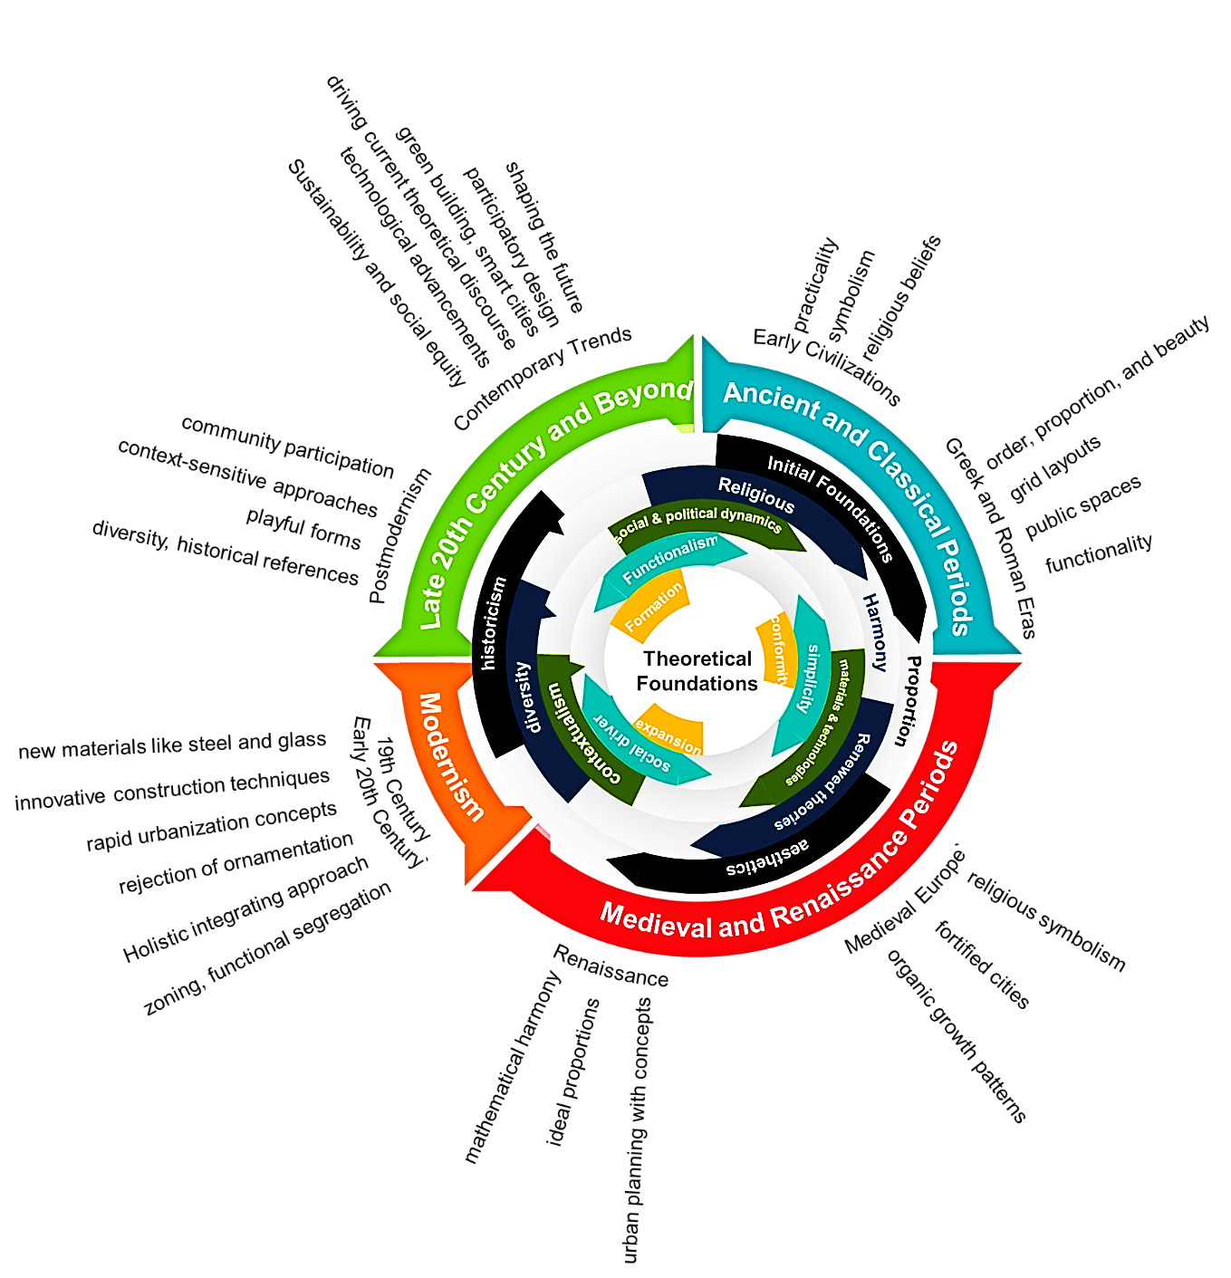
Figure 4: Context Evolutions of theoretical foundations of architecture and urban planning (Source: authors based on the studies available in the sources)
as it’s mentioned in the Figure 4, In ancient civilizations such as Mesopotamia, Egypt, Greece, and Rome, architectural and planning principles were often based on religious, social, and functional considerations (Bober, 2001, p. 596). The Greeks, for example, developed theories of proportion and harmony that influenced architectural design for centuries (Łaszkiewicz, Nowakowska, & Adamus, 2022). During the Renaissance and Enlightenment periods in Europe, there was a renewed interest in classical architecture and urban planning theories (Remizova & Novak, 2019). Architects and theorists such as Vitruvius and Leon Battista Alberti studied and wrote about the principles of architecture, proportion, and aesthetics (Kim, 2016).
The early 20th century saw the rise of modernism in architecture and urban planning, which emphasized functionalism, simplicity, and the use of new materials and technologies (Grigoryeva & Lidin, 2021). The Bauhaus school in Germany and architects like Le Corbusier and Frank Lloyd Wright were key figures in developing modernist theories. But, in the latter half of the 20th century and into the 21st century, postmodernism emerged as a reaction against the strict functionalism of modernism (Zhao, 2021). Postmodern architects and theorists questioned the idea of a single universal theory of architecture and urban planning, instead embracing diversity, contextualism, and historicism (Saadlounia, Yazdani, Zarei, & chianeh, 2021).
Throughout history, various theoretical frameworks have influenced architecture and urban planning (Belof & Kryczka, 2021). Also, the evolving challenges of climate change, rapid urbanization, and technological advancements will continue to shape theoretical discourse in architecture and urban planning (Sharifi, Khavarian-Garmsir, Allam, & Asadzadeh, 2023). By understanding the historical evolution and diverse theoretical frameworks, architects and urban planners can better address contemporary challenges and create a more equitable, sustainable, and inspiring built environment for the future (Parris, et al., 2018; Azzopardi-Muscat, Brambilla, Caracci, & Capolongo, 2020).
The theoretical foundations in architecture and urban planning have significantly evolved, moving through various paradigms such as functionalism, structuralism, and postmodernism, each providing unique lenses to interpret the built environment. However, as architecture and urbanism have progressed, there has been a shift towards structuralism and postmodernism, which offer more nuanced perspectives on space as interconnected systems or as reflections of cultural narratives.
Scientometrics provides a valuable framework to analyze the impact and development of these theoretical paradigms by offering quantitative insights into the citations, co-citation networks, and publication trends of architectural and urban studies. For example, using scientometric tools to analyze the prevalence of functionalist principles in architectural journals reveals how these concepts influence contemporary urban design, especially in sustainable and adaptive spaces. By assessing citation data, researchers can understand how theories such as functionalism maintain relevance, adapting to the modern emphasis on resilience and eco-efficiency.
Postmodernism, on the other hand, advocates for plurality and contextual specificity, critiquing the universal standards upheld by earlier paradigms. This approach in architecture emphasizes the symbolic and cultural dimensions of buildings, advocating for designs that reflect local identities and societal values (Raji & Aliyu, 2021). Scientometric methods, when applied to postmodernist studies, can track the interdisciplinary influences between architecture and fields like sociology and cultural studies. Such analysis demonstrates the extensive impact of postmodernism on participatory urban design and public engagement frameworks, highlighting how cultural relevance in architecture fosters community interaction and social inclusivity (Martinez & Kumar, 2021, p. 86).

so, the key areas of focus may include:
Table 2: Evolution of the theoretical foundations content in architecture and urban planning (Source: authors based on gathering and summarizing the content of the sources)
Key Theoretical Frameworks
Formalism (1)  Maxqda Codes▷ |  | Focuses on aesthetics, geometric principles, and the visual composition of buildings and spaces.
 |  | Modularity, Gestalt, Typology, Proportion, formalize, Plasticity, Tectonics, Contextualism, Fragmentation, Algorithmic Design, Abstraction, Biomimicry, Pastiche, Genius Loci, Place-making, Megastructure, Plug-in City, Dynamism, Transparency, Exposed Concrete.
Functionalism (2)  Maxqda Codes▷ |  | Emphasizes the purpose and utility of structures, prioritizing efficiency and practicality.
Embodied Experience, Holistic Approach, Form-Function Relationship, Practical Utility,
Functional Design, Contextual Responsiveness, Emergent Patterns, Ideological Critique,
Sensory Experience, Interpretive Understanding, Deconstructed Form, Gendered Spaces,
Non-Anthropocentric Design, Relational Urbanism, Biophilic Design, Hybrid Actants, Socio-Spatial Dialectic, Atmospheric Design, Nonhuman Agency, Contextual Tectonics
Structuralism (3)  Maxqda Codes▷ |  | Examines the underlying systems and structures that shape the built environment.
Signifier, Lived Experience, Binary Opposition, Deconstruction, Feedback Loop, Hierarchy, Emergence, Sociocultural Context, Genius Loci, Interpretation, Fragmentation, Ideology, Gender,
Hybridity, Socio-Material Assemblage, Embodied Experience, Pastiche, Critique of Modernism,
Self-Organization, Socio-Spatial Production.
Post-structuralism (4)  Maxqda Codes▷ |  | Challenges established norms and explores the social and cultural influences on architecture and urban spaces.
 |  | Deconstruction, Embodied Experience, Gender and Space, Pastiche, Narrative and Myth, Posthuman Condition, Power and Ideology, Signification, Sense of Place, Fragmentation, Body and Space, Subjectivity, Materiality, Disjunction, Hierarchies, Pluralism, Resistance, Representation, Lived Experience, Posthuman Agency
Critical Theory (5)  Maxqda Codes▷ |  | Analyzes power dynamics, social inequalities, and the impact of the built environment on different groups.
Deconstruction, Embodied Experience, Patriarchal Structures, Spatial Justice, Commodification,
Semiotics, Fragmentation, Functionalism, Socio-material Assemblages, Racialized Spatiality,
Atmospheres, Emergence, Territoriality, Dwelling, Gender Performance, Hybridity, Uneven Development, Typology, Sensory Experience, Decolonial Praxis.
The Future of Theoretical Foundations
Resilient & Sustainable Design (6)  Maxqda Codes▷ |  | Creating buildings and cities that can adapt to climate change and minimize environmental impact.
Resilience, Sustainability, Adaptive Capacity, Biophilic Design, Urban Metabolism, Circularity,
Ecosystem Services, Disruptive Innovation, Redundancy, Diversity, Modularity, Closed-loop Systems, Transformability, Stewardship, Green Infrastructure, Nature-Based Solutions, Multifunctionality, Efficiency, Participation, Social Justice
Social Equity and Inclusive Design (7)  Maxqda Codes▷ |  | Addressing issues of affordability, accessibility, and community participation in shaping the built environment.
Social Justice, Gender Equity, Diversity, Intersectional Design, Inclusive Placemaking, Community Engagement, Accessibility, Sensory Experience, Contextual Design, Walkable Neighborhoods, Environmental Equity, Functional Design, Spatial Justice, Racial Equity, Equity of Outcomes, Embodied Experience, Inclusive Representation, Women’s Safety, Power Dynamics
Pluralism
Technological Integration (8)  Maxqda Codes▷ |  | Exploring the potential of new technologies like artificial intelligence, virtual reality, and digital fabrication to improve design and construction processes.
 |  | Adaptive Architecture, Emergent Urban Form, Digital Twins, Experiential Architecture, Biophilic Design, Socio-Spatial Justice, Gender-Inclusive Design, Decolonial Urbanism, Interpretive Planning, Socio-Technical Assemblages, Adaptive Reuse, Sensory Experience, Urban Assemblages, Architectural Performance, Generative Design, Transhuman Architectures, Vibrant Matter, Design Governance, Spatial Practices, Sustainable Transitions
Some of Source | 1: (Acuto, Dinardi, & Marx, 2019, pp. 476-477) 2: (Wang, Ma, Sun, & Zhang, 2021) 3: (Albertus, 2022) 4: (Stojiljković & Trajković, 2017) 5: (Kassam, Marcellus, Clark, & O’Mahony, 2020) 6: (Porfiriev, Dmitriev, Vladimirova , & Tsygankova, 2017) 7: (Grabowski, McPhearson, & Pickett, 2023) 8: (Yangxuan & Zhaoqianjing, 2021)

As it’s mentioned in the Table 2, Today, theoretical foundations in architecture and urban planning continue to evolve, with an increasing focus on sustainability, resilience, social equity, and participatory design (Fitzgibbons & Mitchell, 2019, p. 650). Architects and planners draw on a wide range of theories and approaches to address the complex challenges of contemporary urban environments (Shetty & Luescher, 2010).
By tapping into vast knowledge resources, including architectural memories, linked open data, and historical experimental natural philosophy, professionals can enrich their decision-making processes and contribute to the evolution of urban spaces (Doan, Pham, & Doan, 2021). The relationship between theoretical principles in architecture and urban planning with knowledge and information science underscores the significance of interdisciplinary collaboration and the utilization of innovative technologies to shape sustainable and efficient built environments (Kent & Thompson, 2014, p. 250).
By examining the search results, we can gain insights into the impact of theoretical principles on these fields, as well as the roles, indicators, and functions associated with them. Theoretical principles have a significant impact on architectural and urban planning practices. The relationship between urban design and urban planning, the use of scientometric indicators, and the integration of AI in urban planning are all influenced by theoretical considerations (Rusliana, Komaludin, & Firmansyah, 2022). However, it is important to be aware of the limitations and potential challenges associated with the use of scientometric indicators (Csomós, 2019).
The relationship between urban design and urban planning has been a topic of critical analysis. Over the past 50 years, there have been critiques regarding the definitions, principles, stakeholders, and processes involved in urban design projects (Fallmann & Emeis, 2020). It is common for urban design projects to deviate from their intended outcomes during implementation (Mazarro, Kaliaden, Wende, & Egermann, 2023). The theoretical relationship between urban planning and urban design is often seen as vague, and there is a need to bridge this gap on a theoretical level (Elrahman & Asaad, 2021).
Scientometric indicators are used to measure the impact and influence of scientific publications (Figure 5), including those related to urban planning (Sheikhnejad & Yigitcanlar, 2020). These indicators provide quantitative measures that help evaluate the quality and significance of research (Shablysta, 2019) . But these indicators are not set based on the content within the discipline. Based on this, the present research first evaluated some of the most important keywords with the ability to become a scientific index, and then validated their ability through artificial intelligence as the Following Figure.
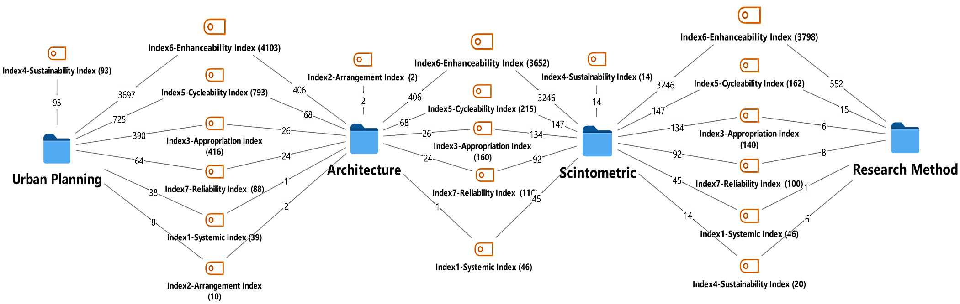
Figure 5: Evaluating the ability of keywords within the discipline to be used as a specialized scientific metric index. (the output of MAXQDA software based on the test of the cases announced to it by the authors)
In Figure 5, the keywords obtained from the coding of the sources, based on their content and semantic relationship with this part of the research, are selectively prepared and after presenting to the software, in terms of the degree of conformity of the result with the intended content. and compliance with the research method has been measured by the researchers. At the same time, the keywords selected and suggested by artificial intelligence for this section have also been analyzed by computing tools inside the software based on the number of codes. Finally, some of the codes selected by the researchers and suggested by artificial intelligence have been selected and reported based on the highest amount of coding plurality in the sources. Also, in Figure 5, the numbers in the middle of the connecting lines show the number of repetitions of the keywords that make up that index with the sources that have been entered into the software for different fields related to research. All of this process is repeated for Figure 6 and Figure 7 also.
One significant limitation of scientometrics in these fields is the potential to prioritize research that aligns with prevailing trends, potentially sidelining innovative or unconventional approaches that do not generate immediate citations. This phenomenon, often referred to as the "Matthew effect", reinforces the visibility of popular research while neglecting nascent, context-driven studies that may offer valuable insights into unique urban challenges or experimental architectural practices. Consequently, scientometrics may inadvertently discourage diversity in academic inquiry, leading to a narrower scope of architectural and urban research. So, Combining the most important selection codes with suggested codes neutralizes the Matthew effect.
As it is shown in the Figure 5, the proposed roles for interdisciplinary scientometric indicators in architecture and urban planning have the ability to communicate their content, as well as to create a cycle between basic content research method resources and scientometric resources. Now that the above hypothesis has been confirmed based on the help of artificial intelligence, it is necessary to discover and examine the content of the keywords with the above capability.
Moreover, the emphasis on metrics like journal impact factors can divert attention from the qualitative aspects essential to architectural and urban studies. Factors such as user experience, aesthetic value, and cultural relevance are central to the built environment but are not easily quantifiable. For example, the impact of an architectural design on community well-being or the cultural integration of an urban plan requires an evaluative index (Jones, 2009), that goes beyond citation counts and h-indexes. When metrics overshadow these nuanced aspects, there is a risk that administrating the environmental projects will prioritize scientific recognition over societal impact, potentially neglecting the values and needs of the communities they serve ( Lacerda & Dresch, 2020).
Based on the above content, it can be said the Scientometric evaluation involves the application of quantitative methods and indicators to assess the impact of scientific publications (Tang, Yang, & Zhang, 2021). It provides insights into the publication activity of individuals, teams, institutes, and countries. Scientometric evaluation is valuable for academics, academic managers, administrators, information scientists, and science policy-makers (Cohen, Sauermann, & Stephan, 2020). It helps in understanding the impact and visibility of research outputs and contributes to the advancement of science and technology.
Also, in recent years, there has been an increasing use of artificial intelligence (AI)in architecture and urban planning. Algorithmic urban planning utilizes AI to address economic, social, environmental, and governance challenges in cities. This approach leverages data-driven insights and computational models to support smart and sustainable development (Yigitcanlar , et al., 2020). Theoretical principles in architectural and urban planning intersect with knowledge and information science in several key areas, primarily through the shared focus on organization, accessibility, usability, and the management of design and planning produce as a complex system. Here’s a breakdown of how these fields relate and interact in the following table:
Table 3: Relationship indexes of Theoretical Foundations to each other and along with Knowledge and Information Science (Source: the authors based on extracting and expanding the studies available in the sources)
Architecture and Urban planning |  |  |  | Science Process | Knowledge and Information Science
This involves the planning of spaces to ensure they are functional, accessible, and meet the needs of their users in physical aspects. |  |  |  | there is a strong focus on how elements are structured and organized | organization pertains to the structuring of data and information in a way that makes it accessible and usable to its users
Systemic Index (1) |  |  | Principles such as hierarchy, categorization, and navigation are crucial in both fields and reflect a deep concern with user experience and interaction
 |  | Maxqda Codes▷ | Classification, Taxonomy, Hierarchical Structure, Networked Relationships, Interpretive Frameworks, Experiential Dimensions, Ideological Critique, Relational Patterns, Contingent Meanings, Gender-based Perspectives
Urban planning, like information systems design, involves the strategic arrangement of various components to serve large populations efficiently. |  |  |  | Ensure efficiency, scalability, and accessibility. | multiple layers of information which closely mirrors how information scientists design data systems
Arrangement Index (2) |  |  | Principles which related to making framework of data cycles; for example, data life-cycle in the Design and Planning System
 |  | Maxqda Codes▷ | Arrangement Index, Knowledge Hierarchy, Information Density, Spatial Configuration,  Interconnectivity, Perceived Functionality, Interpretive Frameworks, Spatial Experience,  Feedback Loops, Contextual Awareness
designing a building or space that accommodates all individual needs, including those with disabilities |  |  |  | Both science disciplines emphasize finding out the user’s needs for making data framework | In information science, it involves creating systems that are intuitive and meet the users’ information-seeking behaviors and needs.
Appropriation Index (3) |  |  | This approach ensures that systems (whether physical or digital) are Accessible and useful to all users
 |  | Maxqda Codes▷ | Representation, Datafication, Spatiality, Materiality, Abstraction, Algorithm, Governance,  Aesthetics, Embodiment, Visualization
This might involve considerations of environmental impact and long-term viability of city and buildings layouts. |  |  |  | Durability and flexibility in accepting planned and related roles | sustainability can refer to the long-term maintenance and preservation of digital resources, ensuring they remain accessible and usable over time.
Sustainability Index (4) |  |  | All principles might be related to the Sustainability and Long-Term Planning while meaningful the expansion and development with Minimal change in existential
 |  | Maxqda Codes▷ | Knowledge Integration, Data Analytics, Interdisciplinarity, Smart Infrastructure, Green Design, Resource Conservation, Community Engagement, Mixed-Use Development, Energy Efficiency, Affordable Housing
managing vast amounts of information, from technical specifications to user feedback |  |  |  | transform and continuously improve data into information | focus on the creation, storage, retrieval, and optimization of information with data management
Cycle ability Index (5) |  |  | Effective knowledge management supports decision-making processes in architecture and planning, as well as in business and technology environments
 |  | Maxqda Codes▷ | Sustainability, Integration, Interoperability, Resilience, Adaptability, Connectivity, Collaboration, Innovation, Efficiency, Accessibility
Enhance living conditions, streamline city operations, and improve overall efficiency in Smart buildings and city technologies, including IoT (Internet of Things) and AI systems |  |  |  | Integration data processing by multiple action, process, reaction in the same time, mostly in the background. | enhance data processing, storage capabilities, and providing advanced analytics
Enhance ability Index (6) |  |  | creating a suitable platform for broadening, deepening, and connecting the meaning or application with the reality of phenomena
 |  | Maxqda Codes▷ | Knowledge, Data, Learning, Context, Efficiency, Analysis, Algorithm, System, Framework,  Integration
involve issues related to surveillance, the use of public space, or equitable access to resources |  |  |  | Indirect and secretly Coding according to reference book | concerns revolve around data protection, user confidentiality, and the ethical use of information
Reliability Index (7) |  |  | Multilayer referencing the process of architecture and urban planning into principle
 |  | Maxqda Codes▷ | Accuracy, Consistency, Validity, Reliability, Predictability, Integrity, Objectivity, Transparency, Credibility, Robustness
Source | (Billger, Thuvander, & Wästberg, 2016); (Boeing, 2019); (Shrivastava & Mehrotra, 2023); (Pankiewicz, 2017); (Zwirowicz-Rutkowska & Michalik, 2016); (Murillo, 2019); (Shen, 2017); (Parveaz & Khan, 2022); (Ross S. , 2012); (Owan, Odigwe, & Bassey, 2020); (Babar & Arif, 2017);

as seem as in the Table 3, theoretical principles in architectural and urban planning and knowledge and information science are interconnected through their shared emphasis on structure, efficiency, user needs, sustainability, and ethical practice. Each field informs and enriches the other, offering insights that advance our ability to design both physical and informational environments that are effective, inclusive, and forward thinking.

Type of the Theoretical Foundations (interdisciplinary perspective)
Theoretical foundations in architecture and urban planning encompass various aspects. In architecture, the epistemological base is challenging to define, leading to interpretations from other disciplines (Barnett, Epstein, Greengard, & Magland, 2022). In the contemporary era, Postmodern architectural and urban planning thought heavily influences contemporary theoretical fields by emphasizing on the complex thinking and understanding architectural phenomena (Farhangdoust, Farkisch, & Hanaee, 2022) through creative, emotional, stylish and rational models (Lai & Huang, 2017).
On the other hand, BIM technology introduces a new concept of design Justice and Planning Impartiality as algorithmic expressive Framework foundations to rectify misdirection in planning and designing, by emphasizing equity and societal appeals of theoretical principles. Additionally, theoretical decision networks used in BIM technology offer a practical tool for addressing complex problems solving by enabling multiple and linked decisions for multiple stakeholders with multi-attribute preferences (Farhangdoust, 2022a, p. 95). These diverse theoretical foundations contribute to shaping the principles according to practices in architecture and urban planning as shown up in the following Table.
Table 4: Types and Aspects of theoretical foundations (Mohajer Milani & Einifar, 2022; Ghasemi & et.al, 2023, pp. 23-25)
Type▼/Aspects► |  | Epistemological |  |  | Phenomenological |  |  | Expressive |  | Practical | 
Internal Drivers | Objective | Concept  Structure  Basis |  |  | Type  Provisions  Status |  |  | Codes  Restriction  Literature |  | Standard  Legislation  Edict  Association  Opinion  Impact  Topic
Internal Drivers | Objective |  |  |  | Consideration | Cause |  | Policy  Potential  Capability
Internal Drivers | Advisory | Symbol | School  Doctrine |  | Hypothesis  Insight  Review  Approach  Theme  Confirmation | Perspective  Proposal  Suggestion
 |  |  |  |  |  | Rules  Law |  | Ordinance  Bylaw  Regulation Instruction  Algorithm  Variable  Attributes
 |  |  |  |  |  |  |  |  |  | Application
External Drivers | Subjective | Paradigm  Principle  Flow |  |  | Hypothesis  Insight  Review  Approach  Theme  Confirmation | Mean  Matter  Illustration  Explanation |  |  |  | Criterion  Directive  Manner  Dimension
Proof
Custom
Template
Guideline
Schema
 |  |  |  |  |  |  |  | Order  Mandate |  | Movement  Requirement  Technique
External Drivers | Compulsory | Framework  Common law  Theory  Discourse |  |  | Proof  Custom  Template  Guideline  Schema | Protocol  Routine  Norm  Style |  | Policies  Manuals  Model  Sample  Mold  Mind Plan  Layout  Agenda
Pattern
Mode
Idea
Factor

Similar to the previous step, it is necessary to evaluate the roles of the various theoretical foundations presented in this category. The criterion in this evaluation is the ability of these items to communicate content between architecture and urban planning. In the (Figure 6), this capability has been evaluated and finally the cases that have this capability are reported. All the subsets in the above table have been fully introduced to the software and have been reviewed.
The important point here is that some of the keywords introduced to the software, beyond the connection between architecture and urban planning, have been introduced by artificial intelligence as branches of transdisciplinary communication by urban planning. Based on this classification, the authors have added a new depth to the research at this stage and named it the product of theoretical foundations.
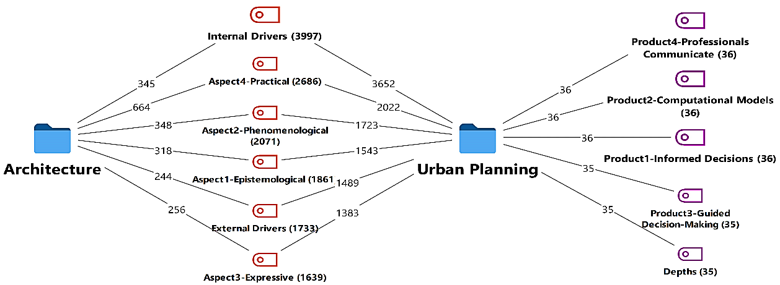
Figure 6: Context relationship between theoretical principles in Architecture and urban planning (the output of MAXQDA software based on the test of the cases announced to it by the authors)

Based on this, many sources of architecture and urban planning were analyzed. The keywords obtained from them are placed in four depths (Table 5). What is important is to mention that the key words are classified according to the stage of their emergence. That is, they may have the capacity to emerge in other stages (depth). Also, it should be kept in mind that this category about content products of theoretical foundations is available in studies and its general trend can be a platform for covering emerging applications of theoretical foundations. These newly emerging applications may be placed as sub-branches of this category or if they have a high impact and depth, they can be recognized as a new product category.
Table 5: Classification of content products based on the scientific role of theoretical foundations in architecture and urban planning (Source: authors based on gathering and summarizing the content of the sources)
Depths ►  Product ▼ |  |  | Phase 4 | Phase 3 | Phase 2 | Phase 1
 | Generate New Knowledge |  |  | Data Interpretation | Data Analysis | Data Collection
 | Model Development |  |  | Thematic Analysis | Statistical Analysis | Surveying
Informed Decisions (1) | Theory Building |  |  | Comparative Analysis | Spatial Analysis | Remote Sensing
Informed Decisions (1) | Knowledge Synthesis |  |  | SWOT Analysis | Pattern Recognition | GIS Mapping
Informed Decisions (1) | Innovative Design |  |  | Scenario Planning | Data Mining | Interviews
Informed Decisions (1) | Best Practices |  |  | Critical Analysis | Simulation Modeling | Observation
Informed Decisions (1) | Case Study Research |  |  | Content Analysis | Trend Analysis | Sensor Data
Informed Decisions (1) | Experimental Research |  |  | Narrative Analysis | Cluster Analysis | Crowdsourcing
Informed Decisions (1) | Benchmarking |  |  | Trend Interpretation | Regression Analysis | Archival Research
Informed Decisions (1) | Pilot Projects |  |  | Gap Analysis | Machine Learning | Questionnaires
 | Digital Potential Modeling by Building Information Modeling (BIM) |  |  | Implications Using Digital Twin Modeling (DTM) | Imaging and Simulations by 3d Modeling (3DM) | Virtualization by Volumetric Modeling (VM)
 | Life-cycle Management |  |  | Real-time Data | Rendering | Massing
Computational Models (2) | Parametric Design |  |  | Predictive Maintenance | Animation | Extrusion
Computational Models (2) | Clash Detection |  |  | Scenario Testing | Texturing | Vocalization
Computational Models (2) | Asset Management |  |  | Urban Analytics | Lighting Simulation | Geospatial Data
Computational Models (2) | Digital Twin Integration |  |  | Infrastructure Monitoring | Shading | Topology
Computational Models (2) | Energy Analysis |  |  | Environmental Impact Analysis | Photorealism | Morphology
Computational Models (2) | Structural Analysis |  |  | Remote Sensing | Kinematics | Spatial Analysis
Computational Models (2) | Construction Management |  |  | Smart City Applications | Virtual Reality | Density Study
Computational Models (2) | Cost Estimation |  |  | Systems Integration | Augmented Reality | Visualization Tools
Computational Models (2) | Facility Management |  |  | Asset Digitization | Motion Capture | 3D Plotting
 | Knowledge Management |  |  | Sustainability Framework | Information Behavior in Social Feedback | Theories of Cognition and Design
 | Data Sharing |  |  | Environmental Impact | Social Interaction | Spatial Cognition
Guided Decision-Making (3) | Information Systems |  |  | Renewable Resources | User Behavior | Embodied Cognition
Guided Decision-Making (3) | Knowledge Transfer |  |  | Green Architecture | Feedback Loops | Perception
Guided Decision-Making (3) | Collaboration Tools |  |  | Sustainable Materials | Social Dynamics | Place Identity
Guided Decision-Making (3) | Best Practices |  |  | Energy Efficiency | Community Engagement | Cognitive Mapping
Guided Decision-Making (3) | Organizational Learning |  |  | Climate Adaptation | Collective Intelligence | Wayfinding
Guided Decision-Making (3) | Knowledge Repositories |  |  | Ecosystem Services | Social Media Analytics | Design Thinking
Guided Decision-Making (3) | Data Management |  |  | Circular Economy | Information Exchange | Mental Models
Guided Decision-Making (3) | Intellectual Capital |  |  | Biodiversity | User Experience | Cognitive Load
Guided Decision-Making (3) | Knowledge Creation |  |  | Resilience Planning | Participatory Design | Neuroarchitecture
 | Mainstream roles |  |  | Means generation, correction and explanation | Presentations and Conferences | Reports and Publications
 | Regulatory compliance |  |  | Data analysis | Symposiums | Peer-reviewed journals
 | Professional standards |  |  | Model simulations | Workshops | Case studies
Professionals Communicate (4) | Policy advocacy |  |  | Stakeholder feedback | Keynote speeches | Government publications
Professionals Communicate (4) | Leadership development |  |  | Scenario planning | Panels and forums | Technical reports
Professionals Communicate (4) | Community engagement |  |  | Software tools | Networking events | White papers
Professionals Communicate (4) | Public awareness campaigns |  |  | Pilot projects | Webinars | Academic journals
Professionals Communicate (4) | Media relations |  |  | Prototype testing | Roundtable discussions | Industry reports
Professionals Communicate (4) | Training programs |  |  | Iterative design | Interactive sessions | Conference papers
Professionals Communicate (4) | Certification processes |  |  | Validation studies | Poster sessions | Statistical analysis
Professionals Communicate (4) | Institutional partnerships |  |  | Incremental updates | Q&A sessions | Research articles
Sources |  | 1: (Bellini, et al., 2021) 2: (Xia, Liu, Maria, Liu, & Lin, 2022; Wang, et al., 2022; Pan & Zhang, 2021) 3: (Constantino, Schlüter, Weber, & Wijermans, 2021, pp. 1655-1657; Birgani & Yazdandoost, 2018, pp. 2820-2823) 4: (Friend, et al., 2014; Zhang, Hooimeijer, Lin, & Geertman, 2020, pp. 1240-1242; Ripp & Rodwell, 2016, pp. 85-90)

As seem as in the Table 5, theoretical principles in architectural and urban planning processes are closely related to knowledge and information science in several ways, that is explained in the following:
First, both fields rely heavily on data collection, analysis, and interpretation. In architecture and urban planning, professionals need to gather information about the site, the environment, the community, and other relevant factors to make informed decisions. This data collection process is similar to the information-gathering process in knowledge and information science, where researchers collect and analyze data to generate new knowledge.
At the Second, both fields require the use of virtual models to conceptual understanding. In architecture and urban planning, professionals start this process by using computer-aided design (CAD)software and other tools to create virtual models of buildings and urban spaces that called volumetric model (VM). Then, by using a simulation model, it is trying to test and refine ideas that were created by 3D software and called 3D modeling (3DM).
Then with adding more details about construction and environmental impact, it’s converted to that knows as digital twin modeling (DTM). In a more important step, by using building information modeling (BIM)software, it could be making digital potential models (DPM)that help in visualizing the design and identifying potential issues before construction begins. Similarly, in knowledge and information science, researchers use computational models and simulations to test hypotheses and explore complex systems.
Third, both fields involve the use of theory and frameworks to guide decision-making. In architecture and urban planning, professionals use theories of design, sustainability, and social feedback to inform their work. Similarly, in knowledge and information science, researchers use theories of cognition, information behavior, and knowledge management to guide their research.
Finally, both fields are concerned with the dissemination of knowledge and information. In architecture and urban planning, professionals communicate their designs and plans to clients, stakeholders, and the public through presentations, reports, and other means. Similarly, in knowledge and information science, researchers communicate their findings through academic publications, conferences, and other channels.

Classification of theoretical foundations (multidisciplinary perspective)
For every human-base science such as the architecture and urban planning rely on well-defined theoretical frameworks to guide research and development (Araújo, 2006). For instance, the evolution of the logical design process has impacted environmental politics and the ability to address public space challenges effectively (Barnett, Epstein, Greengard, & Magland, 2022). Similarly, in economics and education aspects, the identification and organization of theoretical and methodological foundations are essential for advancing knowledge and training future professionals (Chopyk, 2013).
But, the limitations of scientometrics in this field, extend to evaluating interdisciplinary research in architecture and urban planning. As these fields increasingly integrate perspectives from sociology, ecology, and technology, scientometric indicators for classification may fail to capture the cross-disciplinary contributions of theoretical foundations, that do not fit neatly into established categories. For example, studies focusing on sustainable design principles may combine insights from environmental science, urban studies, and social justice, which scientometric tools may inadequately evaluate due to fragmented citation patterns across diverse disciplines ( Taylor, et al., 2021). This oversight can hinder the recognition of interdisciplinary research's value and may discourage collaborative approaches that are vital for addressing complex issues (D’Este & Robinson-García, 2023), in architecture and urban planning.
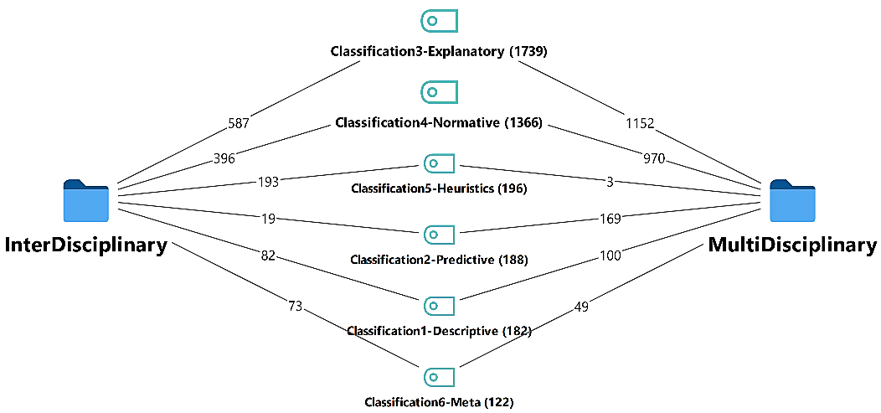
Figure 7: Context Relationship Between Interdisciplinary (Architecture and urban planning) and Multidisciplinary Theoretical Principles
At the same time as the depth of research about the scientific role of theoretical foundations in architecture and urban planning increases in this section, it seems necessary to consider their general classification in different sciences. At the same time, the closest and most important keywords describing these roles in the content of architecture and urban planning should also be extracted. According to the previous steps, dozens of keywords extracted from the sources were given to the software to check the approximate amount of the communication role between the internal and interdisciplinary relationship among the sources of this research (Figure 7).
In fact, by categorizing and understanding theoretical principles of architecture and urban planning, researchers can navigate complex issues, innovate, and contribute to the advancement of their respective fields, ultimately influencing the scientific progress. Here’s a classification of theoretical foundations from the perspective of their roles in scientific processes for adaptation processing into architecture and urban planning:
Table 6: general classification of theoretical principles in sciences (Source: the authors based on extracting and expanding the studies available in the sources)
Name | Role |  |  | Description
Descriptive | Provide a conceptual framework for understanding, organizing and describing empirical phenomena and observations (1) |  |  | These foundations aimed to describe and characterize natural phenomena or observed patterns. They help identify patterns, relationships, and mechanisms that govern the behavior of a system or phenomenon by Provide a conceptual framework for understanding and organizing empirical observations. Examples include theories in biology (e.g., cell theory), chemistry (e.g., atomic theory), and physics (e.g., Newton’s laws, Kinetic theory of gases). | 
Descriptive | Maxqda Codes▷ |  | Phenomenology, Social Interaction, Perception, Complexity, Spatial Analysis, Ecosystem Services, Land Use Patterns, Performance Evaluation, Health Impact Assessment, Urban Morphology, Social Production of Space, Social Practices, Resilience, Typology, Programmatic Needs, Activity Setting Theory, Cognitive Behavioral Science, Social Equity, Accessibility, Public Participation, Placemaking, Vernacular Architecture, Biomimicry, Life Cycle Assessment, Social Return on Investment, Scenario Planning, Vulnerability Assessment
Predictive | Make predictions and guide experimentation (2) |  |  | These foundations go beyond description and make specific predictions about future observations or experimental outcomes. They provide a basis for designing experiments and testing hypotheses. Examples include theories in physics (e.g., quantum mechanics, relativity), astronomy (e.g., gravitational waves), and climate science (e.g., global warming models). | 
Predictive | Maxqda Codes▷ |  | Simulation, Scenario Planning, Forecasting, Agent-based Modeling, System Dynamics, Spatial Analysis, Parametric Design, Optimization, Machine Learning, Cellular Automata, Network Analysis, Uncertainty Analysis, Sensitivity Analysis, Bayesian Networks, Fuzzy Logic, Multicriteria Decision Analysis, Spatial Optimization, Spatial Modeling, Spatial Interaction Models, Cellular Automata Modeling
Explanatory | Explain a deeper underlying mechanism and causes of certain phenomena of the natural world (3) |  |  | These foundations aim to explain why phenomena occur or why certain mechanisms operate. They provide a deeper understanding of the underlying causes and mechanisms that drive the behavior of a system, to finding out principles behind observed phenomena. Examples include theories in psychology (e.g., cognitive psychology), sociology (e.g., social learning theory), and economics (e.g., game theory), biology (Theory of natural selection), geology (plate tectonics). | 
Explanatory | Maxqda Codes▷ |  | Systems, Experience, Power, Meaning, Sustainability, Perception, Emergence, Patterns, Discourse, Process, Mechanism, Interpretation, Variation, Ideology, Abduction, Empowerment, Gender, Hybridity, Materiality, Assemblage
Normative | Guide decision-making and provide moral or ethical guidance (4) |  |  | These foundations provide a framework for evaluating and guiding decision-making processes. They offer a basis for making normative statements about what should be done or what is morally right or wrong. Examples include theories in ethics (e.g., moral relativism, utilitarianism), politics (e.g., democratic theory), and law (e.g., natural law theory). | 
Normative | Maxqda Codes▷ |  | Ethics, Politics, Law, Knowledge, Society, Experience, Pragmatism, Systems, Hermeneutics, Phenomenology, Cybernetics, Constructivism, Complexity, Evolution, Ecology, Discourse, Institutions, Cognition, Phenomenography
Heuristics | Provide practical guidelines or rules of thumb for solving problems (5) |  |  | These foundations offer practical guidelines or rules of thumb for solving problems or making decisions. They can be used to simplify complex situations and provide a starting point for further investigation. Examples include theories in cognitive science (e.g., heuristics and biases), decision theory (e.g., prospect theory), and philosophy of science (e.g., Popper’s falsifiability principle). | 
Heuristics | Maxqda Codes▷ |  | Heuristics, Satisficing, Representativeness, Framing Effect, Anchoring, Availability Heuristic, Affect Heuristic, Ease of Recall, Simulation Heuristic, Recognition Heuristic, Fluency Heuristic, Elimination by Aspects, Take the Best Heuristic, Lexicographic Heuristic, Tallying Heuristic, Satisficing Heuristic, Appropriate Ignorance, Fast and Frugal Heuristics, Heuristic of One Reason, Less is More Heuristic
Meta | Reflect on the nature of scientific inquiry and the limitations of scientific knowledge (6) |  |  | These foundations reflect on the nature of scientific inquiry itself, including the role of theory, observation, and experimentation. They provide a framework for understanding the scientific process and the limitations of scientific knowledge. Examples include theories in philosophy of science (e.g., realism, instrumentalism), sociology of science (e.g., constructivism), and epistemology (e.g., skepticism). | 
Meta | Maxqda Codes▷ | Constructivism, Realism, Instrumentalism, Skepticism, Falsificationism, Inductivism, Deductivism, Constructionism, Relativism, Objectivism, Positivism, Interpretivism, Pragmatism, Materialism, Idealism, Rationalism, Empiricism, Structuralism, Holism, Functionalism.
Source | 1: (Friesen, 2023) 2: (Wang, Rai, Pereira, Eetemadi, & Tagkopoulos, 2020; Brudvig & Catano, 2021) 3: (Dadashpoor & Ahani, 2021; Savva, Anagnostopoulos, Triantafillou, & Kolomvatsos, 2020) 4: (Kong, 2023; Andreoletti, Chiffi, & Taebi, 2022) 5: (Nalau, Torabi, Edwards, Howes, & Morgan, 2021; Kramer, Daly, Yilmaz, & Seifert, 2020) 6: (Harwood & Rudnitsky, 2020; Ariza, et al., 2021; Rizk & Elragal, 2020)

In summary, each type of foundation contributes to our understanding of the world and informs our approach to scientific investigation in architecture and urban planning. It’s important to note that these categories are not mutually exclusive, and a single theory may serve multiple roles. Additionally, the classification of a theory’s role may evolve as scientific understanding progress and new evidence emerges. Also, while scientometrics provides valuable insights into the influence and reach of architectural and urban research, it should be applied with caution and a critical awareness of its limitations. A balanced approach, incorporating qualitative evaluations and an appreciation for the contextual and artistic dimensions of architecture and urban planning, can ensure that the discipline remains inclusive, innovative, and aligned with societal values.

Results
This research has focused on the Scientometrics that could be used to analyze the impact of theoretical principles on the research output in architecture and urban planning. In the other word, by applying scientometrics to the study of theoretical principles in architecture and urban planning, researchers can gain a deeper understanding of the underlying ideas and frameworks that shape the field, and can identify opportunities for innovation and collaboration across disciplines.
The first step involved identifying key concepts and terms relevant to the theoretical foundations of architecture and urban planning to achieve the answers. This included understanding these concepts' verification, recommendation, and stabilization roles. The comprehensive literature review was conducted using academic journals, articles, and books from reliable library sources published between 2015 and the present. Each source was examined for relevant content based on the suggested roles and indicators in Table 7.
Specific information related to the keywords and their roles in the context of the theoretical foundations was extracted from the sources. This involved identifying passages, paragraphs, and sections that directly addressed the content, methods, and processes in architecture and urban planning. The extracted information was categorized into three suggested axes:
- Approval Indicator: Meaning of the Content and process of the method verification and correctness
- Recommending Indicator: Suggesting the appropriate method for content areas
- Stabilization Indicator: Validation of content and methods to respond to new conditions and needs
Each role was assessed for its Internal \External Drivers in terms of comprehensiveness and coverage to ensure it accurately represented the concepts defined by previous parts. This was quantified as a percentage to indicate confidence in the relevance and applicability of each keyword. The keywords were then organized into a multi-column table, with each row representing a unique keyword. Each keyword’s role was specified under the three axes with the reliability percentage indicated in parentheses.
Table 7: Scientometrics Approach and indicators with their corresponding roles percentages (Source: Authors from findings)
Approach | Type▼ Suggested Indicators► |  | Approval indicator |  | Recommending indicator |  | Stabilization indicator | 
Approach | Table 4
Approach | Internal Drivers | External Drivers
 | Theory | Framework | Validity (90) |  | Basis (85) |  | Adaptability (80)
 | Empiricism | Foundation | Evidence (88) |  | Practicality (83) |  | Realism (81)
 | Standards | Guideline | Consistency (92) |  | Benchmark (87) |  | Reliability (85)
 | Methodology | Procedure | Rigor (91) |  | Process (86) |  | Flexibility (84)
 | Framework | Blueprint | Structure (89) |  | Model (84) |  | Resilience (82)
 | Principles | Foundation | Accuracy (90) |  | Guidelines (85) |  | Sustainability (83)
 | Research | Investigation | Validation (88) |  | Insight (83) |  | Innovation (81)
Reliability | Simulation | Modeling | Testing (89) |  | Experimentation (84) |  | Adaptability (82)
Reliability | Best Practices | Standard | Quality (91) |  | Recommendations (86) |  | Consistency (84)
Reliability | Validation | Authentication | Verification (92) |  | Confirmation (87) |  | Endurance (85)
Reliability | Ethics | Norm | Integrity (89) |  | Morality (84) |  | Accountability (82)
Reliability | Sustainability | Durability | Longevity (90) |  | Responsibility (85) |  | Adaptation (83)
Reliability | Analytics | Evaluation | Data (88) |  | Insight (83) |  | Predictability (81)
Reliability | Integration | Unification | Coherence (89) |  | Harmonization (84) |  | Versatility (82)
Reliability | Metrics | Assessment | Measurement (92) |  | Evaluation (87) |  | Calibration (85)
Reliability | Adaptation | Modification | Flexibility (90) |  | Customization (85) |  | Responsiveness (83)
Reliability | Algorithms | Calculation | Precision (88) |  | Automation (83) |  | Scalability (81)
Reliability | Innovation | Advancement | Novelty (89) |  | Creativity (84) |  | Progression (82)
Reliability | Modeling | Prototyping | Simulation (91) |  | Design (86) |  | Adaptability (84)
Reliability | Collaboration | Partnership | Synergy (90) |  | Teamwork (85) |  | Robustness (83)
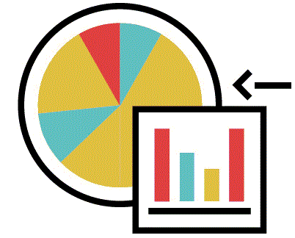 | Sustainability | Holistic Planning | Validation (80) |  | Appropriate Method (90) |  | Responding to Needs (85)
 | Resilience | Adaptability | Verification (85) |  | Suggesting Method (80) |  | Adapting to Change (90)
 | Ecosystem | Ecological Impact | Process Verification (75) |  | Appropriate Areas (85) |  | Conditions Response (80)
 | Urban Consonance | Integration | Content Accuracy (80) |  | Suitable Methods (75) |  | Future Adaptability (85)
 | Holistic | Comprehensive | Method Verification (85) |  | Comprehensive Approach (90) |  | Addressing New Needs (80)
 | Performance | Efficiency | Effectiveness (80) |  | Recommended Practices (85) |  | Meeting Emerging Needs (75)
 | Participatory | Inclusiveness | Accuracy (75) |  | Inclusive Methods (80) |  | Social Adaptability (85)
Relevancility | Green Spaces | Environmental | Process Validation (70) |  | Ecological Methods (85) |  | Environmental Adaptation (80)
Relevancility | Integration | Unification | Comprehensive Verification (85 |  | Appropriate Methods (80) |  | Future-Proofing (75)
Relevancility | Multi-Criteria | Precision | Method Accuracy (80) |  | Suggested Practices (75) |  | Adaptive Methods (80)
Relevancility | Urban Systems | Systems Approach | Validation (75) |  | Appropriate Approaches (85) |  | Adapting Methods (80)
Relevancility | Data-Driven | Informed emissions | Method Verification (85) |  | Databased Suggestions (90) |  | New Conditions Response (75)
Relevancility | Adaptability | Flexibility | Content Accuracy (80) |  | Flexible Methods (85) |  | Responding to Change (90)
Relevancility | Landscape | Ecological Planning | Verification (70) |  | Appropriate Methods (80) |  | Environmental Adaptability (85)
Relevancility | Innovation | Creativity | Process Validation (85) |  | Creative Methods (90) |  | New Needs Response (80)
Relevancility | Urban Form | Design Integrity | Method Accuracy (80) |  | Suitable Methods (85) |  | Adapting to Change (75)
Relevancility | Norms | Standardization | Content Validation (75) |  | Recommended Standards (80) |  | Stable Methods (85)
Relevancility | Zoning | Spatial Planning | Verification (80) |  | Suggested Zoning Method (85) |  | Adaptable Zoning (80)
Relevancility | Community | Social Cohesion | Process Accuracy (85) |  | Inclusive Practices (90) |  | Social Stability (85)
Relevancility | Flexibility | Versatility | Verification (80) |  | Adaptive Methods (85) |  | Conditions Response (90)
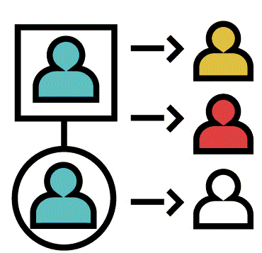 | Sustainability | Longevity | Validation (85) |  | Adaptation (90) |  | Resilience (95)
 | Integration | Unification | Holistic (80) |  | Harmonization (85) |  | Inclusivity (90)
 | Flexibility | Versatility | Adaptability (75) |  | Customization (80) |  | Scalability (85)
 | Efficiency | Productivity | Optimization (90) |  | Improvement (85) |  | Streamlining (80)
 | Innovation | Advancement | Novelty (80) |  | Creativity (85) |  | Progressiveness (90)
 | Collaboration | Teamwork | Partnership (85) |  | Synergy (90) |  | Community (95)
Seperatility | Resilience | Durability | Robustness (90) |  | Endurance (85) |  | Adaptation (80)
Seperatility | Contextuality | Localization | Relevance (85) |  | Appropriateness (80) |  | Suitability (90)
Seperatility | Functionality | Utility | Usability (90) |  | Practicality (85) |  | Efficiency (80)
Seperatility | Aesthetics | Beauty | Appeal (80) |  | Attractiveness (85) |  | Timelessness (90)
Seperatility | Accessibility | Inclusivity | Inclusiveness (90) |  | Reach ability (85) |  | Availability (80)
Seperatility | Safety | Protection | Security (85) |  | Protection (90) |  | Assurance (80)
Seperatility | Economy | Savings | Cost-effectiveness (80) |  | Affordability (85) |  | Sustainability (90)
Seperatility | Scalability | Expandability | Expandability (85) |  | Growth (90) |  | Flexibility (80)
Seperatility | Durability | Endurance | Longevity (90) |  | Resilience (85) |  | Stability (80)
Seperatility | Simplicity | Minimalism | Clarity (85) |  | Elegance (80) |  | Ease (90)
Seperatility | Innovation | Ingenuity | Originality (85) |  | Creativity (90) |  | Progressiveness (80)
Seperatility | Adaptability | Adjustability | Versatility (90) |  | Flexibility (85) |  | Resilience (80)
Seperatility | Equity | Fairness | Fairness (85) |  | Justice (90) |  | Inclusion (80)
Seperatility | Transparency | Visibility | Openness (80) |  | Accountability (85) |  | Clarity (90)
 | Formalization | Structuring | Validity (80) |  | Systematization (75) |  | Consistency (70)
 | Abstraction | Conceptualizing | Rigor (85) |  | Generalization (80) |  | Adaptability (75)
 | Deduction | Logicalizing | Reasoning (90) |  | Inference (85) |  | Transferability (80)
 | Axiomatics | Formalizing | Functionalism (92) |  | Guidance (88) |  | Robustness (85)
 | Theorization | Conceptualizing | Justification (95) |  | Recommendation (90) |  | Expandability (88)
 | Idealization | Conceptualizing | Correctness (85) |  | Typification (80) |  | Replicability (75)
 | Empiricism | Validating | Verification (90) |  | Experimentation (85) |  | Responsiveness (80)
Definitioanality | Falsifiability | Validating | Refutability (92) |  | Testability (88) |  | Responsiveness (85)
Definitioanality | Rationalism | Logicalizing | Reasoning (88) |  | Deduction (85) |  | Consistency (80)
Definitioanality | Induction | Validating | Generalization (90) |  | Observation (85) |  | Adaptability (80)
Definitioanality | Abduction | Logicalizing | Inference (88) |  | Hypothesis (85) |  | Transferability (82)
Definitioanality | Dialectics | Conceptualizing | Critique (92) |  | Dialogue (88) |  | Expandability (85)
Definitioanality | Hermeneutics | Validating | Interpretation (90) |  | Contextualization (85) |  | Responsiveness (82)
Definitioanality | Phenomenology | Conceptualizing | Description (88) |  | Experiential (85) |  | Adaptability (80)
Definitioanality | Structuralism | Formalizing | Systematics (92) |  | Typification (88) |  | Consistency (85)
Definitioanality | Functionalism | Validating | Performativity (90) |  | Optimization (85) |  | Responsiveness (82)
Definitioanality | Contextualism | Conceptualizing | Situatedness (88) |  | Responsiveness (85) |  | Adaptability (80)
Definitioanality | Postmodernism | Conceptualizing | Critique (92) |  | Pluralism (88) |  | Expandability (85)
Definitioanality | Constructivism | Conceptualizing | Subjectivism (90) |  | Perspective (85) |  | Transferability (82)
Definitioanality | Pragmatism | Validating | Applicability (88) |  | Instrumentalism (85) |  | Responsiveness (80)

Discussion
Scientometrics, the quantitative study of science and technology, can play a significant role in understanding and evaluating the theoretical principles of architecture and urban planning. While traditionally applied to scientific disciplines, its methods offer valuable insights into the development, impact, and effectiveness of architectural and urban planning theories.

Some potential research questions that can be addressed using scientometrics in the context of theoretical principles of architecture and urban planning include:
Table 8: Main functions of theoretical principles in architecture and urban planning along with their Extracted keywords as MaxQDA relative Codes (Source: the authors based on confirmation, modification and arrangement of MAXQDA software outputs)
Functions |  | It is the answer to this question |  | Description
Mapping the Intellectual Structure
Theoretically, Citation analysis  Most Keywords►   |  | How do theoretical principles from other disciplines influence the research output in architecture and urban planning? |  | This method can be used to study the citation patterns of research papers that apply theoretical principles, especially when they come from other disciplines to architecture and urban planning. By analyzing the citations, researchers can identify the most influential theories and principles in the field. Analyzing citations within architectural and urban planning literature helps identify influential theories, authors, and publications. This reveals the intellectual lineage of ideas and the relationships between different schools of thought. Tools like Scopus, Web of Science, and Google Scholar facilitate such analysis.
 |  | promoting styles, systematic thinking, referencing, culture, utilitarian, harmonic properties, heritage assessing, technological innovations, societal volatility, ideation tools, standardized rules, appropriations techniques, informational combination, knowledge management, city’s experience, addressing challenges, epistemological base, philosophical perspectives, urban culture, development planning, environmental information, belief systems, human behavior, political decisions, socio-economic, context adoption, Human Ecosystem, teaching process, underlying theories, Research opportunities, reopens questions, Design Process, develop balance, affecting mechanisms, dominant theme, accurate identification, visualization tools, Knowledge Discovery, promote participation, smart urban, challenges integration, pattern illustration, model providing, attachments framework, objective reflection, Typomorphology, shifting paradigms, conceptualizing relationship, multiattribute preferences, research defining,
Author co-citation analysis/Bibliographic Coupling  Most Keywords►   |  | Which disciplines have the most significant impact on the development of theoretical principles in architecture and urban planning? |  |  |  | This method can be used to identify the most influential authors in the field of architecture and urban planning and their contributions to the development of theoretical principles. Analyzing publications that cite the same references can reveal emerging research fronts and identify potential areas of convergence or divergence within theoretical frameworks.
 |  | aesthetic, social, Technology, culture, regional planning, history, Music, artificial intelligence, pedagogy, Future research, payload, Information science, digital reconstructions, Social communications, Sustainable Development, phenomenology, theories and school, anthropology, hazard management, environmental management, Religious studies, natural resource management, Science policy, economic developments, construction engineering, natural ecosystems, sustainable community, sustainability science, scientometric analyze, life programming, Civic Design, ethnography, Development processor, community planning, resource allocation, supporting dialogue, infrastructure management, third-party planning, Things Internet, sustainability discourses, visual communication, science, philosophy, Geography, social learning, sociocultural science, Urban ecology, health support, complex planning, urban economy
Evaluating Impact and Dissemination
Co-citation analysis/  Journal Impact Factor and Citation Counts  Most Keywords►   |  | What are the most influential theoretical principles in architecture and urban planning, and how do they relate to each other? |  | This method can be used to identify clusters of research papers that cite the same theoretical principles. This can help researchers identify the most influential theories and principles in the field and how they relate to each other. Examining how often two publications are cited together reveals clusters of related research and identifies core theoretical concepts within a field. This helps map the intellectual structure of the discipline and understand how different theories interact and influence each other. These metrics can assess the reach and influence of specific publications or authors within the field. This information is valuable for understanding the relative importance of different theoretical contributions.
 |  | Function, concept, decision, order, basis, discourse, stakeholder, review, matter, technique, approach, oriented solutions, interpretations, philosophical roots, structural interpretation, community effectivibility, environmental relationships, association forms, decision-making, foundations interfaces, conceptual foundations, keyword popularity, symbiotic relationships, integrated recommendation, practice theories, urban topics, thinking manner, theoretical standards, planning knowledge, environmental dimensions, design standards, geospatial attributes, development implementation, enhanced capabilities, institutional mechanisms, life regulation, engagement support, paradigm workflow, conceptual planning, integrated conservation, defining framework, providing explanation, ecological principles, environmental perspective, decision network, theorizing roles,
Topic modeling  Most Keywords►   |  | How do theoretical principles from architecture and urban planning influence other fields, such as urban sociology, environmental psychology, and sustainable development? |  |  |  |  |  |  |  | This method can be used to identify the underlying themes and topics in research papers that apply theoretical principles from other disciplines to architecture and urban planning.
 |  | Ideology, model, memory, style, development, spatial organization, heritage value, quality of experience(QoE), theoretical insight, design process, appropriate solutions, experimented techniques, action decisions, information modeling, collaborative work, comparing experiences, thinking reflection, contextualism, practicable theory, environmental impact, effective usage, origins and practices, sustainability policy, scientific systems, generating innovation, expert systems, urban ecosystems, study program, problems addressing, research themes, evidence planning, activities define, planning organizations, effective mechanisms, providing basics, promoting development, planning processes, data exploitation, Planning Practice, multifaceted environment, challenge addressing, context management, spatialities organizing, repositioning context, stakeholder involvement, importance overviewing, interdisciplinary language, focused issues, theoretical descriptions, acquired theorizing,
Network analysis/  Altmetrics  Most Keywords►   |  | Which research institutions and authors are most influential in the development of theoretical principles in architecture and urban planning? |  |  |  |  |  |  | This method can be used to study the relationships between researchers, research institutions, and theoretical principles in the field of architecture and urban planning. These alternative metrics track online engagement with research, such as social media mentions and downloads. Altmetrics can provide insights into the broader societal impact and public discourse surrounding architectural and urban planning theories.
 |  | Socialist, technologist, designer, minimalist, philologist, spatial planner, engineer, adaptation planner, engineering and construction fields(AEC), methodologists, environmental designer, interdisciplinary research, theorist, philosophizes, structuralists, resilience planner, policy-makers, theology, theorists, science mediators, city planners, Construction manager, city technologists, curricula planner, transdisciplinary strategy, government policies, Design technician, urban policies, decision-makers, environmental planners, urban Paradigmists, spatial analysts, digital visualizers, data interpreters, planning professionals, data analyst, city trendsetter, spatial technologist, restorers, heritage maintencers, normative scientists, city makuper, ecologists, health framers, decision planners, Urban theorists,
Understanding Trends and Patterns
Keyword Analysis  Most Keywords►   |  | What combinations of important terms have been effective in expanding the theoretical foundations of architecture and urban planning? |  |  |  |  |  |  | Analyzing the frequency and co-occurrence of keywords in publications can reveal emerging trends and shifts in theoretical focus within the field. This helps identify areas of growing interest and potential future directions for research.
 |  | form—function, behavior—objects, experience—decision, efficiency—form, theory—properties, value—policy, efficiency—innovation, social—culture, context—prototype, policy—decision, technique—application, information—context, information—modeling, context—design, framework—research, paradigm—methodology, theory—approach, culture—theory, being—impact, information—activities, origin—practice, nature—solution, policy—decision, planning—development, intelligence—management, concept—organization, goals—programs, theory—adoption, opportunity—potential, thinking—evidence, process—perspective, approach—planning, formation—expansion, emulation—adaptation, identification—optimizing, process—communication, components—decisions, rolls—practice, process—decision, approach—concept, information—morphology, model—context, scope capacity, object—reflect, role—aspect, prospect—benefits, literature—planning, attribute—decision, imply—approach,
Co-authorship Analysis  Most Keywords►   |  | What kinds of theoretical foundations roles have led to the formation of cooperative groups? |  |  |  |  |  | Examining collaboration patterns among researchers can reveal the formation of research groups and networks focused on specific theoretical approaches. This provides insights into the collaborative nature of knowledge production within the discipline.
 |  | formulating, describing, processing, categorizing, modifying, simulation, collectivization, defining, optimalition, Selecting, reconstruction, evaluating, topic diversity, complex thinking, roots perception, theoretical advocating, adaptation, methodological identification, traditional principals, recognition knowledge, policy making, knowledge productivity, data-driven manner, theoretical organization, guideline, science systematizing, themes emerging, thinking method, elements defining, literaturization, critical reviews, sustainability movement, precisely identification, visualization challenges, data potential, participation motivation, prospective expansion, improve benefitation, user-generated content, practical realization, complementary values, research designing, scope researching, environmental thinkings, potential impediments, decision formulating, dialogue promotion,
Benefits of Applying Science
Objectivity  Most Keywords►   |  |  | What are the most important topics and methods formed from theoretical foundations? |  |  |  | Scientometric methods offer a more objective and data-driven approach to evaluating theoretical contributions compared to traditional qualitative assessments.
 |  |  | Functionalism, Structuralism, adoption, progressing, relationalism, assessment, predicting, reinterpretation, synthesizing, applicability, perceiving, social awareness, enhancing understand, bridging capable, reflects credibility, ideas foundations, principle values, planning preconditions, information systems, evidence originality, decision support, fundamental suitability, production processes, keywords characteristics, structure morphology, curricula compatibility, foundational framework, potential topics, didactic design, theoretical perspective, argument foundation, patterns examination, changes seeking, allocating elements, implementation tools, data-driven approaches, mediation activities, insight direction, stakeholder participation, visual cultures, Intellectual overlap, reciprocally combination, conceptual framework, development bases, urban biodiversity, tensions identification, solution efficiently, diverse approaches,
Identifying Gaps and Opportunities  Most Keywords►   |  |  | What are the most important gaps related to theoretical foundations in architecture and urban planning? |  |  |  |  |  |  |  | By revealing trends and patterns in research, scientometrics can help identify gaps in current theoretical frameworks and highlight areas for further investigation.
 |  |  | F principles, systematic principles, building information, historical reference, harmonization, place-based policy, advancing opinions, co-existing circumstances, thinking promotion, validity and relevance, generation technique, information ranking, knowledge domains, interdisciplinary endeavor, combining research, methodological understanding, meaning perceived, environmental values, energy consuming, environmental conservation, religious art, sustainability problems, functions of foundations, knowledge efficient, artificial intelligence adoption, service ecosystem, learning objectives, development practices, impact contributions, practical techniques, literature background, knowledge potential, underlying causes, proven adaptability, functional areas, usability studies, isolated interpretations, citizens’ rights, urban setup, green management, science process, historical convergence, societal agendas, substantive objective, facts aspects, ecological threats, well-being principles, network addressing, theories contribution,
Informing Policy and Practice  Most Keywords►   |  |  | What are the most important strategies formed from theoretical foundations in architecture and urban planning? |  | Scientometric insights can inform evidence-based policy decisions and guide the implementation of urban planning and architectural strategies based on the meaning and dialogue of theoretical foundations.
 |  |  | Structuralism, integral systems, Linked Open Data(LOD), standardization, spatial dimensions, future development, university discourse, concept opportunities, decision processes, remote accessing, urban information, knowledge presentation, wider engagement, development research, examine opinion, explaining, context shaping, sustainable development, spatial data support, meaningfulness coverage, policy challenges, policy process, growth aspects, AI-based solutions, space architecture, methodological verification, discursive dimensions, future changes, city reforming, process relationship, theoretical values, affecting framework, continuity drawing, area situation, prototype studies, making datasets, professional norms, preferred improvements, space effectuation, computational data, scientific knowledge, mainstream activity, framework applicability, cultural phenomenon, direct influence, addressing principles, linked decisions, broad services,
Challenges and Limitations
Data Availability  Most Keywords►   |  |  | What are the best-known types of theoretical foundations among architects and urban planners? |  |  | Access to comprehensive bibliographic databases and citation data is crucial for conducting robust scientometric analysis.
 |  |  | creative basis, methodological concept, association, layout, proof, variable, technique, mode, idea, mean, flow, model, literature, policy, methodological model, mean ability condition, construction standards, impact, factories, potential, consideration, insights, concerns, environmental concept, dimension, framework, development theme, sample idea, theoretical means, theoretical illustration, comprehensiveness, development generalization, feasible method, model appearance, domain expertise, confirmation, capabilities schema, data application, spatial order, events analyzing, potential indicators, science mandate, theoretical synthesis, theoretical evolving, methodological expanding, algorithmic solutions, steps suggestion,
Qualitative Aspects  Most Keywords►   |  |  | What are the best methods of converting qualitative content to quantitative in theoretical foundations? |  | Scientometric indicators primarily focus on quantitative aspects and may not fully capture the nuances and qualitative dimensions of theoretical contributions.
 |  |  | Morphophonemics, data Behavior, linking, arranging, consulting, evaluating, categorization, location, integrating, abstraction, implementation process, multitask modeling, parameter modeling, recipients originating, highlighting overlaps, enabling conditions, leveling, elucidation, examining, strengthening, identifying, promulgation role, empirical analysis, reference analysis, prioritization, qualitative analysis, Balanced enrichment, epitomize, distillation, indexing, compelling, status investigation, transmutation, process converting, implementation, reference provocation, appropriate levels, overlooking, questioning maneuver, data acquisition, Revealing focus, information collaborative, conjunction process, connections relationship, upsetting assessment, semiology, theoretical explaining, critical discussion, numerical example, boundaries transcendation,
Disciplinary Differences  Most Keywords►   |  |  | What is the most important subject of literature in the theoretical foundations of architecture and urban planning that have the ability to become a scientific index? |  |  |  |  |  |  |  | The applicability of specific scientometric methods may vary depending on the specific characteristics of the architectural and urban planning literature.
 |  |  | Realism, systematist, experiential, innovation, beauties, conservation, generation, design tools, value-risk-based approaches, building life-cycle, value interpretation, conscious representations, interventions roots, relevant impact, application possibility, context Dependencelity, vernacular values, green certification, impact assessment, urination process, integration of knowledge, knowledge exchange, innovation and productivity, gap direction, constituent factors, content comparison, integration potential, focused, promulgation ability, process covering, knowledge bases, environmental consequence, concept dissemination, significance structure, data representation, result speculative, subordinate authenticity, computation normalization, enhance potential, fabric patterns, intertwined naturalness, assimilation, clarifying expectations, contributing, dialogue, Isolated focus, efficient representation, goal inclusivation.
Guide | Architecture Interdisciplinary Multidisciplinary Urban Planning

In conclusion, about the Scientometrics and its Role in Theoretical Principles of Architecture and Urban Planning, it can be said the scientometrics offers a valuable toolkit for understanding the development, impact, and interrelationships of theoretical principles within architecture and urban planning. By employing these methods, researchers and practitioners can gain valuable insights into the intellectual structure of the field, evaluate the effectiveness of theoretical approaches, and identify emerging trends and future directions for research and practice.
In summary, theoretical principles in architectural and urban planning processes are closely related to knowledge and information science in terms of data collection, modeling and simulation, theory and frameworks, and knowledge dissemination. Both fields share a common goal of creating better environments and systems that serve the needs of people and communities. There are numerous theoretical foundations in architecture and urban planning, each influencing the way designers, planners, and scholars approach the built environment. These theoretical foundations are not mutually exclusive, and many architects and urban planners draw from multiple traditions to inform their work. Here are some of the most significant ones:
Table 9: Advanced Scientometrics framework in Architecture and Urban Planning (Source: authors based on the compilation of results and findings)
Table 8 | Table 7 |  |  | Table 3 |  |  |  |  |  |  |  |  |  | Table 4 |  |  |  | Table 5 |  |  |  |  | Table 6
Functions▼ | ▼ Indicator |  |  | ▼ Index |  |  |  |  |  |  |  |  |  | ▼ Aspects |  |  |  | ▼ Product |  |  |  |  | ▼ Classification
Functions▼ |  |  |  |  |  |  |  |  |  |  |  |  |  |  |  |  |  |  |  |  |  |  |  |  |  |  |  | 
 | 6 | 6 | 5/5 | 1/8 | 0/3 |  | 5/3 | 2/4 |  | 5/4 | 5/9 |  | 3/9 | 6 | 6 | 6 | 6 | 2/3 | 2/2 |  | 2/2 | 2/2 | 5 | 3 | 5/9 | 6 | 0/6 | 4
 | 6 | 6 | 5/6 | 1/9 | 0/4 |  | 5/2 | 2/6 |  | 5/4 | 5/9 |  | 3/8 | 6 | 6 | 6 | 6 | 2/4 | 2/1 |  | 2/1 | 2/1 | 5 | 2/8 | 5/9 | 6 | 0/6 | 3/9
 | 6 | 6 | 5/5 | 1/9 | 0/4 |  | 5/3 | 2/5 |  | 5/4 | 5/9 |  | 3/9 | 6 | 6 | 6 | 6 | 2/4 | 2/2 |  | 2/2 | 2/2 | 4/9 | 2/9 | 5/9 | 6 | 0/6 | 4
 | 6 | 6 | 5/5 | 2 | 0/4 |  | 5/3 | 2/4 |  | 5/3 | 5/9 |  | 3/7 | 6 | 6 | 6 | 6 | 2/4 | 2/3 |  | 2/3 | 2/3 | 5 | 2/9 | 5/9 | 6 | 0/6 | 4
 | 6 | 6 | 5/5 | 1/9 | 0/3 |  | 5/2 | 2/7 |  | 5/4 | 5/9 |  | 3/7 | 6 | 6 | 6 | 6 | 2/3 | 2/2 |  | 2/2 | 2/2 | 5 | 3 | 5/9 | 6 | 0/6 | 4/1
 | 6 | 6 | 5/5 | 2 | 0/4 |  | 5/3 | 2/4 |  | 5/4 | 5/9 |  | 3/8 | 6 | 6 | 6 | 6 | 2/3 | 2/2 |  | 2/2 | 2/2 | 5 | 2/9 | 5/9 | 6 | 0/6 | 4
 | 6 | 6 | 5/5 | 2 | 0/4 |  | 5/3 | 2/4 |  | 5/3 | 5/9 |  | 3/8 | 6 | 6 | 6 | 6 | 2/4 | 2/2 |  | 2/2 | 2/2 | 5/1 | 2/8 | 5/8 | 6 | 0/6 | 4
 | 6 | 6 | 5/5 | 2 | 0/4 |  | 5/3 | 2/4 |  | 5/4 | 5/9 |  | 3/8 | 6 | 6 | 6 | 6 | 2/3 | 2/2 |  | 2/2 | 2/2 | 5 | 2/9 | 5/9 | 6 | 0/6 | 4
 | 6 | 6 | 5/5 | 2 | 0/4 |  | 5/3 | 2/4 |  | 5/4 | 5/9 |  | 3/8 | 6 | 6 | 6 | 6 | 2/3 | 2/2 |  | 2/2 | 2/2 | 5 | 2/9 | 5/9 | 6 | 0/6 | 4
 | 6 | 6 | 5/5 | 2 | 0/4 |  | 5/3 | 2/4 |  | 5/4 | 5/9 |  | 3/8 | 6 | 6 | 6 | 6 | 2/3 | 2/2 |  | 2/2 | 2/2 | 5 | 2/9 | 5/9 | 6 | 0/6 | 4
 | 6 | 6 | 5/3 | 2/2 | 0/5 |  | 5/4 | 2/4 |  | 5/1 | 5/9 |  | 3/8 | 6 | 6 | 6 | 6 | 2/4 | 2/3 |  | 2/3 | 2/3 | 5/1 | 2/8 | 5/9 | 6 | 0/5 | 3/9
 | 6 | 6 | 5/5 | 1/9 | 0/4 |  | 5/2 | 2/5 |  | 5/4 | 5/8 |  | 3/8 | 6 | 6 | 6 | 6 | 2/4 | 2/3 |  | 2/3 | 2/3 | 5 | 3 | 5/8 | 6 | 0/7 | 4/1
 | 6 | 6 | 5/5 | 1/9 | 0/4 |  | 5/3 | 2/5 |  | 5/4 | 5/9 |  | 3/8 | 6 | 6 | 6 | 6 | 2/4 | 2/3 |  | 2/3 | 2/3 | 5 | 3 | 5/9 | 6 | 0/6 | 3/9
Guide | All numbers are in percentage; therefore, The Sum Of each Row is Equal 100 Percentage
Guide | Lowest Value |  |  |  |  |  |  |  | Midpoint Value |  |  |  |  |  |  |  |  |  |  | Highest Value
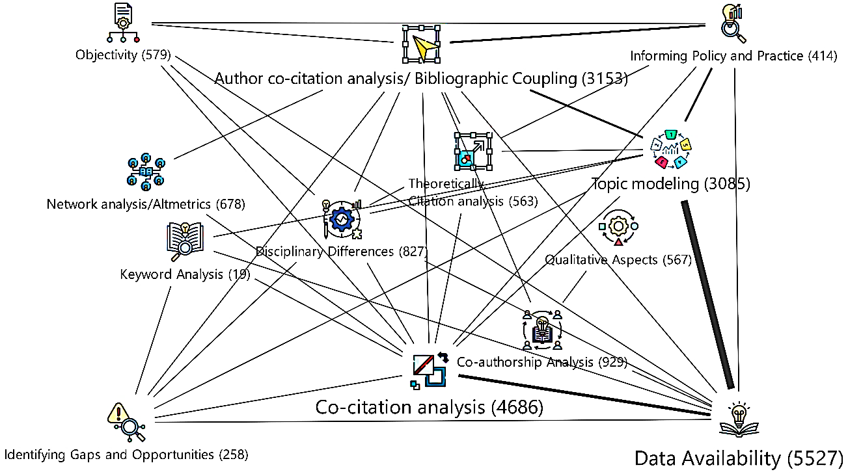

As it is seemed in the Table 9, Incorporating scientometrics into participatory urban design offers another practical application. By examining publication patterns in the context of community engagement and social equity, planners can identify effective participatory methods that align with community needs. For instance, data-driven insights derived from scientometric analyses have helped architects to adopt participatory frameworks that increase inclusivity in urban projects, ensuring that community voices are integral to the planning process. Such methods encourage collaboration between urban designers and local communities, leading to more socially responsive and sustainable urban spaces.
Additionally, scientometric methods have supported the adoption of digital twin technologies in smart cities, bridging the gap between theoretical principles and practical applications. By analyzing data on infrastructure performance and urban dynamics, planners can simulate and optimize city functions in real time. Studies indicate that digital twins improve urban management by allowing cities to monitor energy usage, transportation flows, and emergency responses, creating cities that are not only efficient but also adaptive to changing conditions. This integration exemplifies how the interdisciplinary application of information science tools in architecture can drive the development of technologically advanced urban spaces.
In summary, the integration of architecture and urban planning with information science through scientometrics provides robust methods for understanding and addressing real-world challenges. Scientometric tools support the design of sustainable, resilient, and inclusive urban spaces by enabling data-based insights into theoretical foundations, ultimately enhancing the practical impact of architectural and urban research.
At this stage, to test the findings, a part of the theoretical literature that was presented in the literature review stage was evaluated based on the nature of the scientific functions obtained in Table 9. The way of carrying out this process is that the Functions (in Table 9)obtained from the theoretical foundations are considered as scientific indicators and the degree of communication with the concerned theoretical frameworks (From Table 2)is reported as a percentage for all components in the Following Table.
Table 10: implementing Advanced Scientometrics framework (Table 9)of architecture and urban planning in case research principles (Table 2) (Source: the authors based on confirmation, modification and arrangement of MAXQDA software outputs)
Key Theoretical Frameworks and Future of Theoretical Foundations (Table 2)►  Function (Table 9)▼ | Formalism | Functionalism | Structuralism | Post-structuralism | Critical Theory | Resilient Sustainable Design | Social Equity& Inclusive Design Technological Integration | Technological Integration
Theoretically, Citation analysis | 13/9 | 2/9 | 17/3 | 15/4 | 13/5 | 19/2 | 15/9 | 1/9
Author co-citation analysis/Bibliographic Coupling | 14/1 | 3/1 | 17/2 | 15/4 | 12/8 | 19/4 | 16/3 | 1/8
Co-citation analysis/Journal Impact Factor and Citation Counts | 14/1 | 3/1 | 17/2 | 15/4 | 13/2 | 19/4 | 15/9 | 1/8
Topic modeling | 14/3 | 3/1 | 17/4 | 15/6 | 12/9 | 19/2 | 15/6 | 1/8
Network analysis/Altmetrics | 13/3 | 2/8 | 17/3 | 15/7 | 13/3 | 19/7 | 16/5 | 1/6
Keyword Analysis | 14/1 | 3/2 | 17/3 | 15/5 | 13/2 | 19/1 | 15/9 | 1/8
Co-authorship Analysis | 14 | 3/1 | 17/1 | 15/8 | 13/6 | 18/9 | 15/8 | 1/8
Objectivity | 14/1 | 3/2 | 17/3 | 15/5 | 13/2 | 19/1 | 15/9 | 1/8
Identifying Gaps and Opportunities | 14/1 | 3/2 | 17/3 | 15/5 | 13/2 | 19/1 | 15/9 | 1/8
Informing Policy and Practice | 14/1 | 3/2 | 17/3 | 15/5 | 13/2 | 19/1 | 15/9 | 1/8
Data Availability | 14/9 | 3/1 | 18 | 16/1 | 13 | 18/4 | 14/9 | 1/5
Qualitative Aspects | 14/1 | 3/5 | 17/2 | 15/4 | 13/2 | 18/9 | 15/9 | 1/8
Disciplinary Differences | 14/3 | 3/1 | 17 | 15/2 | 13 | 19/3 | 16/1 | 1/8

Conclusions
Urban planning and architecture are interconnected disciplines that address various issues related to the built environment. Urban planning involves determining the public interest, achieving change in accordance with goals, and shaping cities through communication and decision-making processes. Architecture contributes to urban planning by addressing technical, social, and political concerns. It is both a technical profession and an academic discipline, with a focus on the development and design of the built environment.
As the field evolves, scientometrics will play a critical role in helping professionals navigate the complex interactions between human, environmental, and technological systems that shape the built environment. This intersection of disciplines enables architects and urban planners to design spaces that are not only functional but also resilient, adaptable, and responsive to both current and future societal needs. Therefore, scientometric analysis has evolved as a valuable tool to make Advanced Informetrics framework (Table 11) research status, identify emerging trends, and forecast future directions in architecture and urban planning fields like urban resilience and sustainable urban planning.
Table 11: Advanced Informetrics framework in Architecture and Urban Planning process (Source: authors based on the compilation of results and findings)
Process | Nature: Explanations related to the nature of content and functionality
Process | Steps: Examining the necessary steps for its implementation among the functions listed in Table 8
Process | Goals: foreseeable practical purposes in case of use of the processing in question
Process | Research Suitability Keyword Cloud, and strangeness amount by %
Process | Layers of the Knowledge Context Tree for awareness of predictable results of implementing proposed process
Mapping (Tracking) Research Trends and Evolution Knowledge Domains | Nature | 1. Co-citation analysis: By analyzing the co-citation patterns of publications, scientometrics can map the intellectual structure of a field, revealing the most influential works, authors, and journals, as well as the evolution of research fronts over time. Scientometric analysis techniques have been used to systematically map the evolution of research in urban planning fields like urban resilience.  2. Cluster analysis: Scientometrics can group publications into clusters based on their citation patterns or textual similarities, allowing researchers to visualize the development of different research streams and their relationships. These methods help identify influential authors, countries, institutions, research categories, emerging topics, citation patterns, and research clusters over time.
 | Steps | 1 |  |  |  |  |  2 |  |  |  |  |  3 |  |  |  |  |  |  |  3 |  |  |  |  3 |  |  |  |  |  4 |  |  |  |  4
 | Steps | 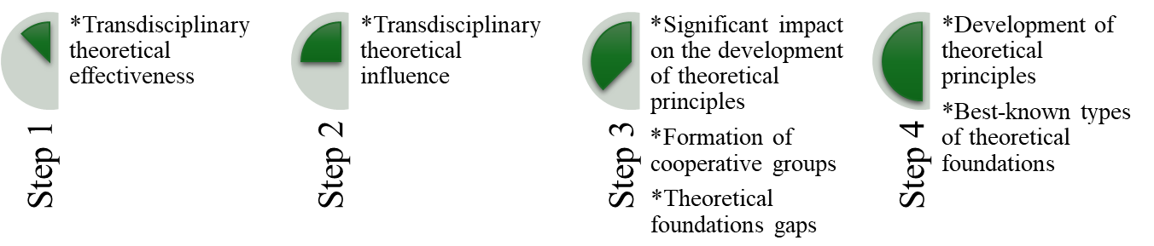
 | Goals | —Focusing on the quantitative analysis of scientific literature.  —Examining publication trends, citation patterns, and collaboration networks in architecture and urban planning.  —Map the intellectual structure and evolution of these fields. Such mapping of the intellectual landscape provides designer, urban planners and policy-makers with a comprehensive understanding of the state of knowledge, research frontiers, and potential future directions in specific domains like urban resilience planning.
 | Research Suitability | 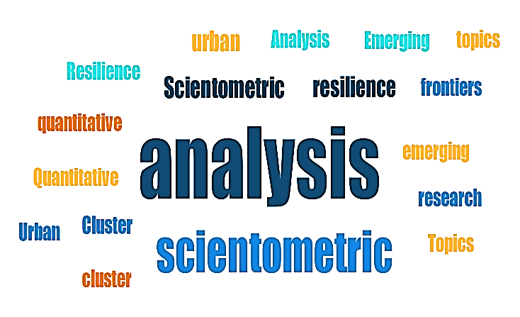 |  |  |  |  |  |  |  |  |  |  |  |  |  | 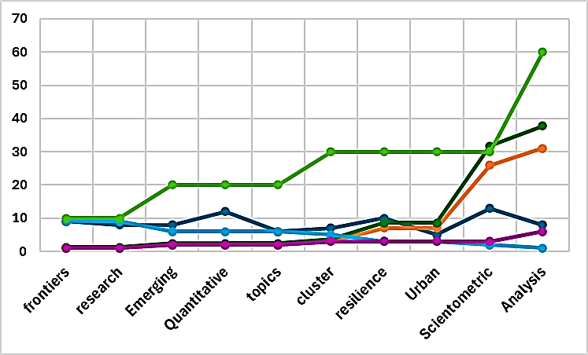
 | Knowledge Context Tree | 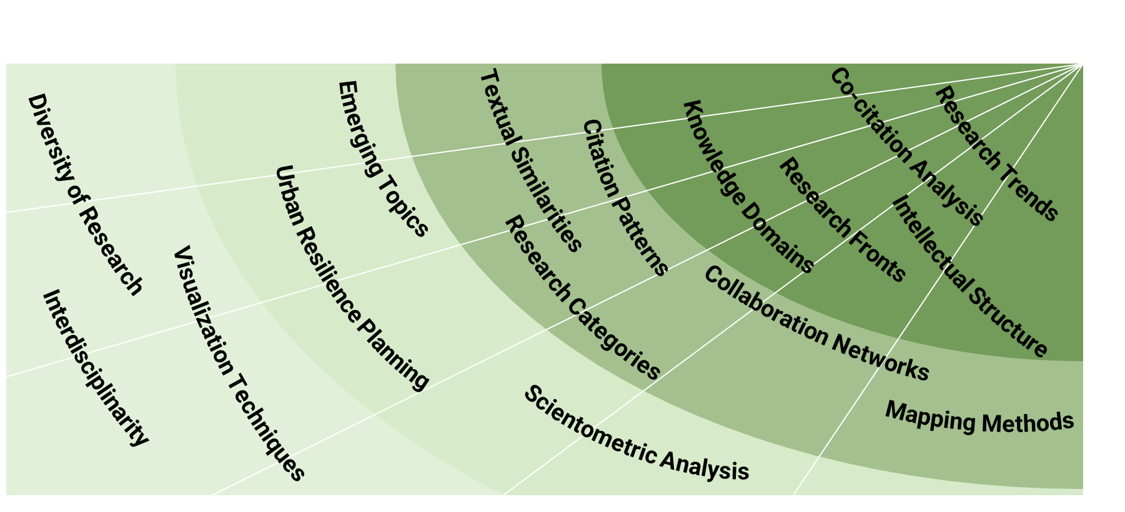
Identifying Knowledge Hotspots, Gap’s Priorities and Research Emerging Topics | Nature | 1. Co-word analysis: By analyzing the co-occurrence of keywords in publications, scientometrics can identify the most frequently discussed topics and their relationships, revealing research hotspots and emerging themes in urban planning.  2. Citation burst detection: Scientometrics can detect articles or topics experiencing a sudden surge in citations, indicating emerging or rapidly growing areas of interest.  3. visualizing research networks and citation patterns: scientometrics can pinpoint gaps, overlaps, and under-explored areas within urban planning disciplines. This systematic identification of research clusters and white spaces guides urban planners in setting relevant research agendas and priorities.  4. Scientometric Mapping: Gained prominence with the development of advanced visualization and network analysis tools.
 | Steps | 1 |  |  |  |  2 |  |  | 2 |  |  |  |  |  2 |  |  |  |  |  |  |  | 3 |  |  |  | 4 |  |  |  | 5 |  |  | 6
 | Steps | 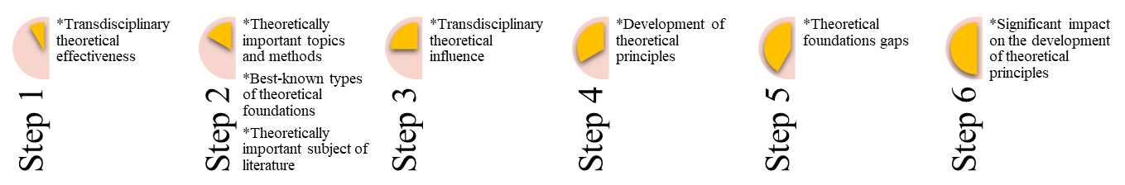
 | Goals |  | —Highlight existing research gaps that need to be addressed for effective integration into urban environments.  —Creating science maps and knowledge domain visualizations.
 | Research Suitability | 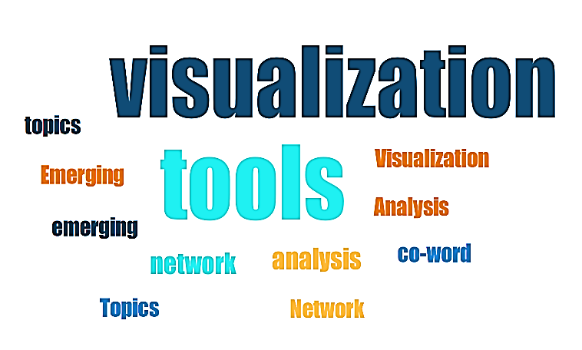 |  |  |  |  |  |  |  |  |  |  |  |  |  | 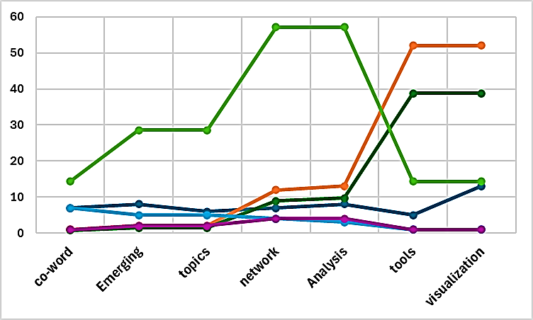
 | Knowledge Context Tree | 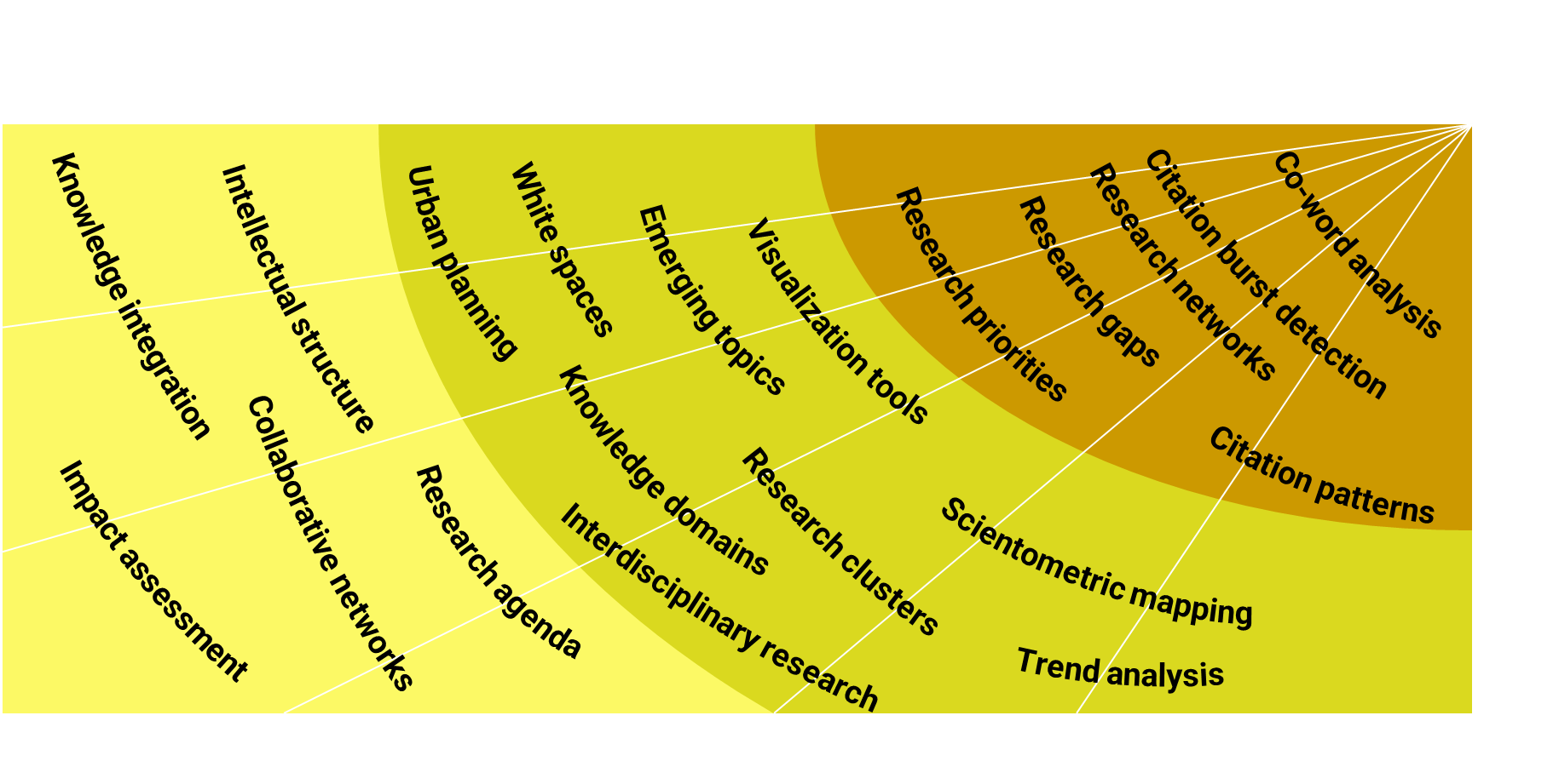
Monitoring Research Performance and Collaboration | Nature | 1. offering quantitative indicators: to assess research performance, productivity, and collaboration patterns of countries, institutions, and authors in urban planning fields. Metrics like publication counts, citation impact, and co-authorship networks help evaluate the influence and position of different urban planning research groups globally.  2. Interdisciplinary Collaboration: Observed a growing trend towards interdisciplinary collaboration, particularly with fields like computer science, geography, sociology, and environmental science.
Monitoring Research Performance and Collaboration | Steps | 1 |  |  |  |  |  |  |  | 2 |  |  |  |  |  |  |  |  |  |  | 3 3 |  |  |  |  |  |  |  |  4
Monitoring Research Performance and Collaboration | Steps | 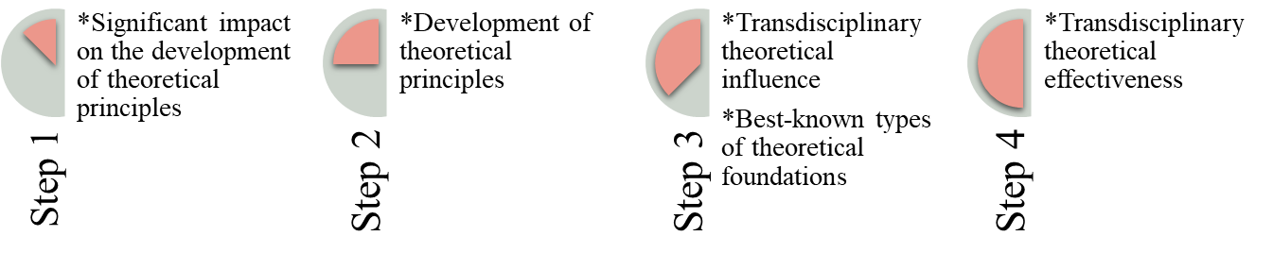
Monitoring Research Performance and Collaboration | Goals | —Identify strengths, weaknesses, and potential collaborators for interdisciplinary research efforts to tackle complex urban challenges more effectively.  —Examined the extent and nature of interdisciplinary interactions, as well as their impact on research productivity and innovation.  —Investigation topics such as cross-disciplinary knowledge transfer, the formation of interdisciplinary research teams, and the evolution of interdisciplinary research programs.
Monitoring Research Performance and Collaboration | Research Suitability | 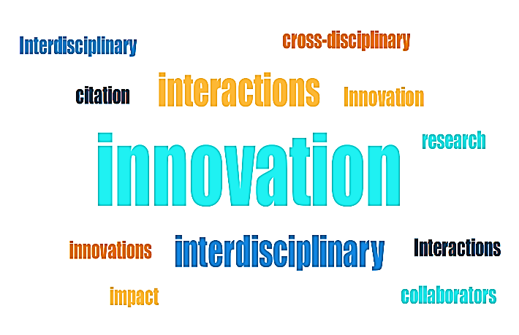 |  |  |  |  |  |  |  |  |  |  |  |  |  | 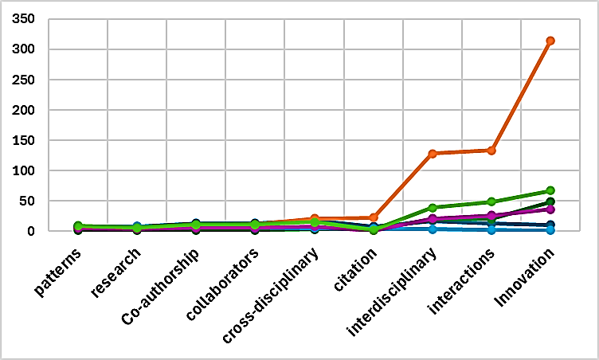
Monitoring Research Performance and Collaboration | Knowledge Context Tree | 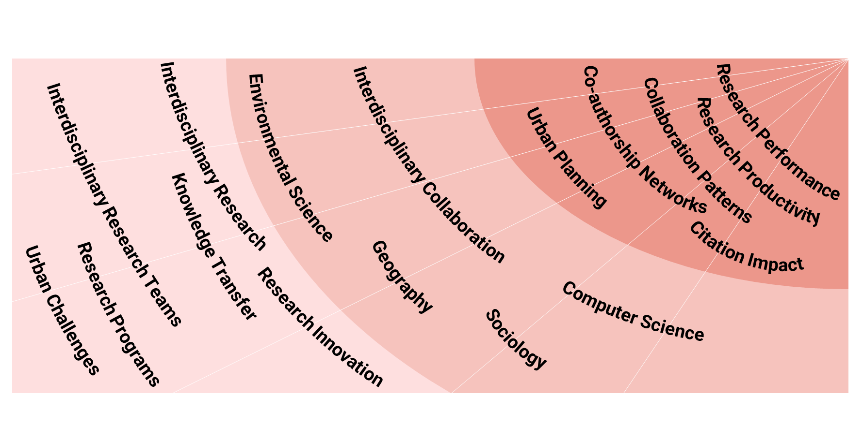
Forecasting Future Directions | Nature | 1. Machine learning algorithms: Scientometrics can leverage machine learning techniques, such as random forest algorithms, to predict the potential impact and citation patterns of publications based on various factors, including author influence, journal impact, keyword density, and research areas. This can help identify promising future research directions.
Forecasting Future Directions | Nature | 2. Visualization tools: Scientometrics employ visualization tools like CiteSpace to represent the evolution of research topics, collaborations, and citation networks over time, enabling researchers to identify emerging trends and potential future research avenues.
Forecasting Future Directions | Steps | 1 |  |  |  |  |  |  |  | 2 |  |  |  |  |  |  |  |  |  |  | 3 |  |  |  |  |  |  |  | 4
Forecasting Future Directions | Steps | 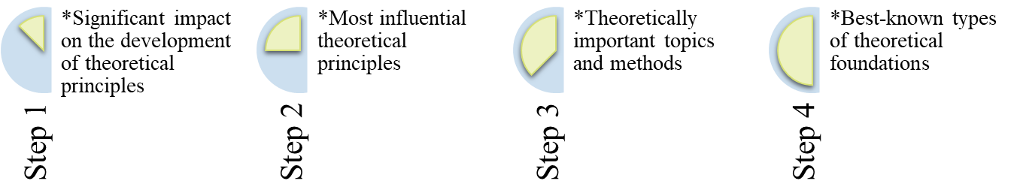
Forecasting Future Directions | Goals | -analyze and predict trends in summary  -provides a data-driven approach to understanding the current state researching  -identifying emerging topics and trends, and forecasting future research directions  -enabling researchers and practitioners to stay ahead of the curve and allocate resources effectively.
Forecasting Future Directions | Research Suitability | 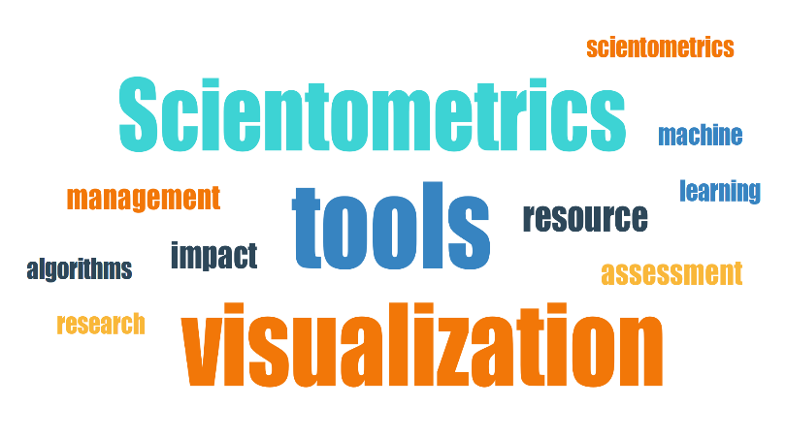 |  |  |  |  |  |  |  |  |  |  |  |  |  |  |  | 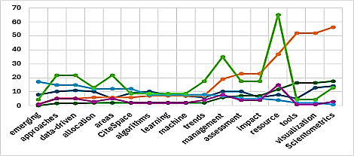
Forecasting Future Directions | Knowledge Context Tree | 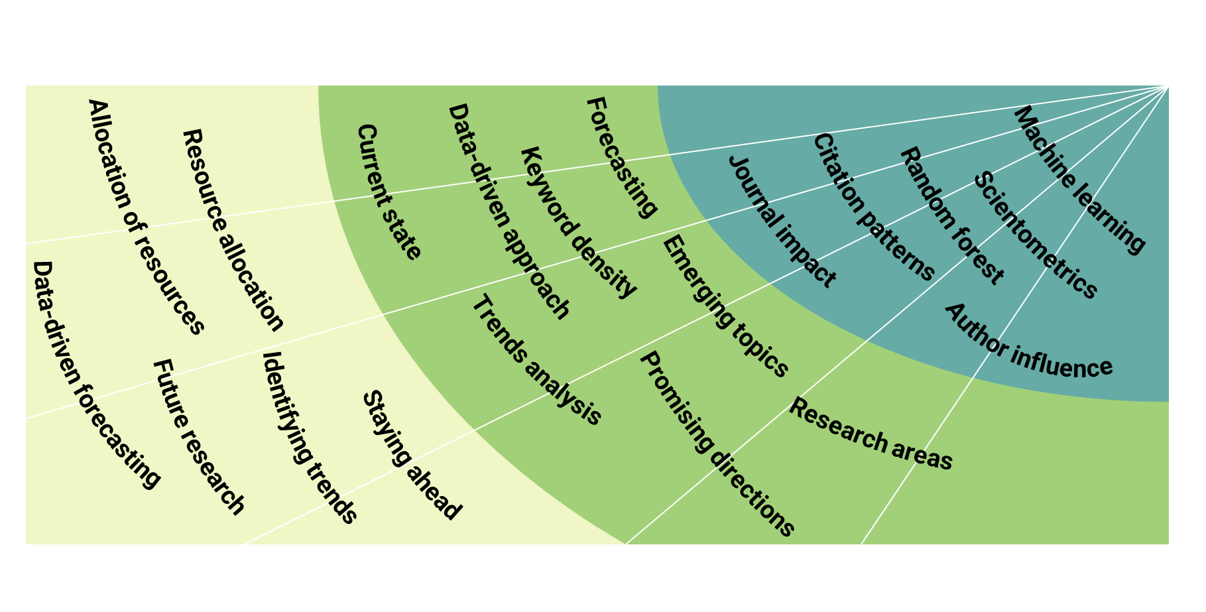
Emergence of Data-Driven Analysis | Nature | The use of scientometric analysis, which involves the quantitative analysis of scientific publications and citations, has gained prominence in architecture and urban planning. Data-driven analysis provides insights into research trends, publication outputs, active journals, and institutions, helping researchers identify key areas of focus and collaboration opportunities.
Emergence of Data-Driven Analysis | Steps | 1 |  |  |  |  |  |  |  |  |  |  |  |  |  |  | 2 |  |  |  |  |  |  |  |  |  |  2
Emergence of Data-Driven Analysis | Steps | 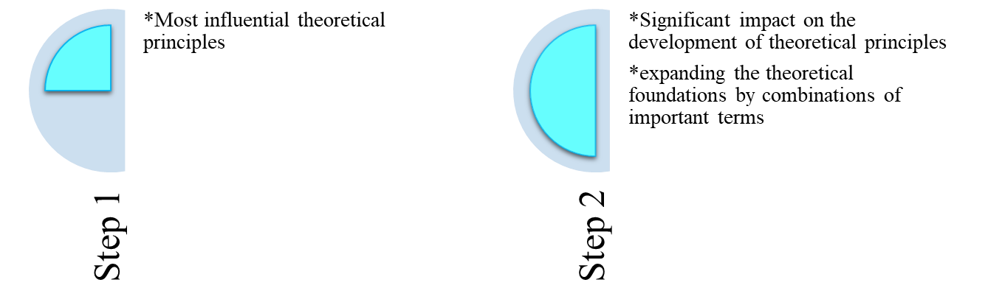
Emergence of Data-Driven Analysis | Goals | —Improved decision-making through the effective utilization of data-driven insights  —Enhanced predictive capabilities, enabling more accurate forecasting and planning  —Increased operational efficiency by identifying and addressing bottlenecks and inefficiencies within organizational processes  —Facilitated the development of personalized and targeted solutions for customers and stakeholders
Emergence of Data-Driven Analysis | Research Suitability | 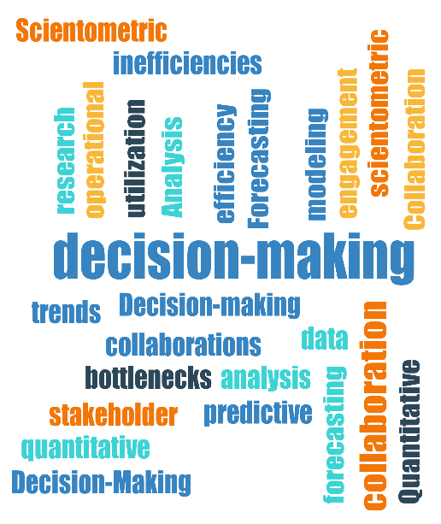 |  |  |  |  |  |  |  |  | 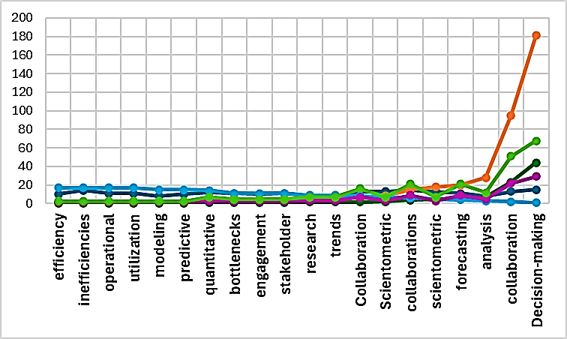
Emergence of Data-Driven Analysis | Knowledge Context Tree | 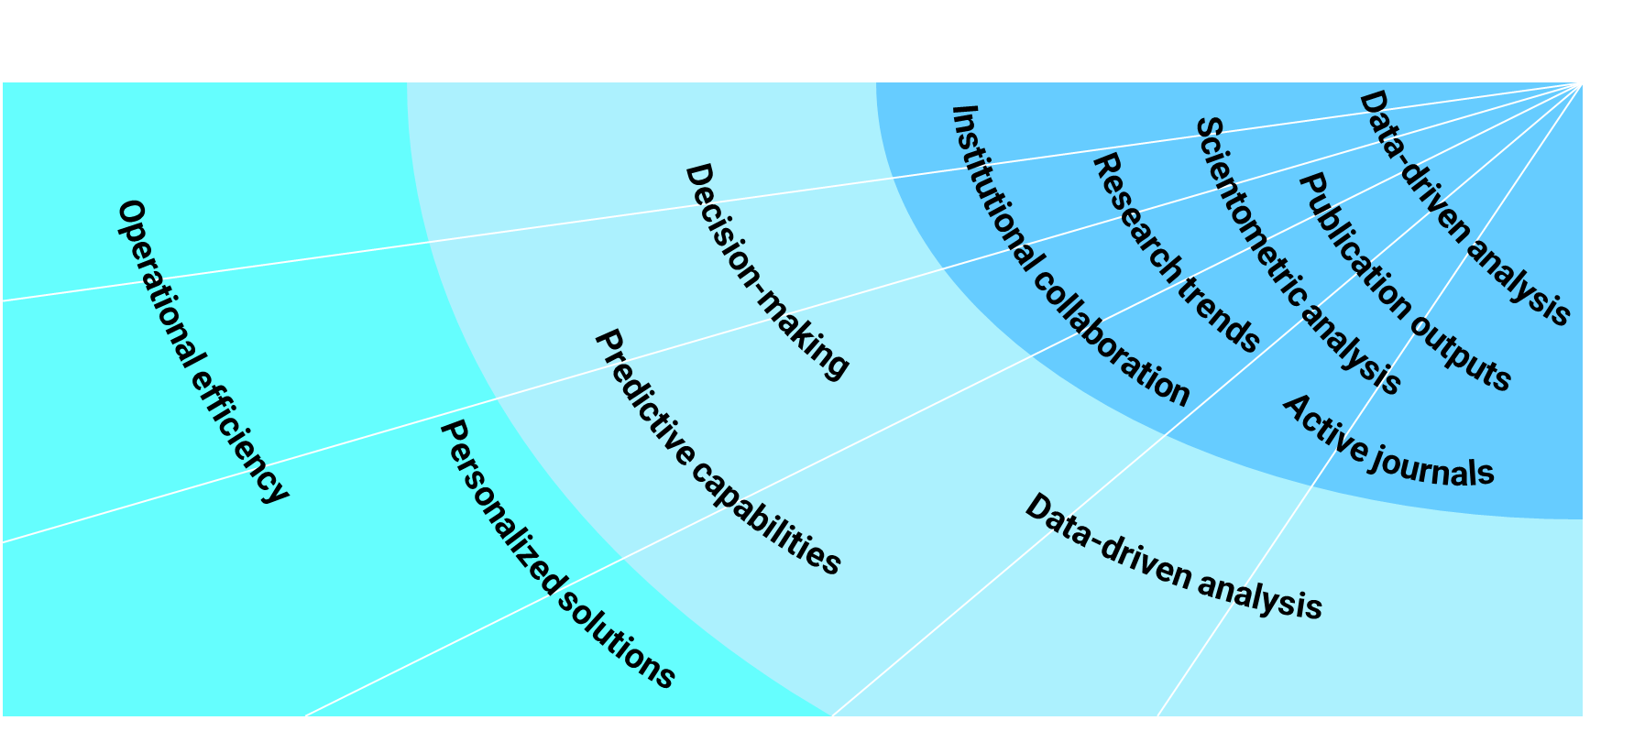
Focusing on the Building Life-cycle Stages | Nature | Scientometric analysis has been applied to different stages of the building life-cycle, including planning and design, construction, management, and maintenance. This approach allows for a comprehensive understanding of research trends and advancements specific to each stage.
Focusing on the Building Life-cycle Stages | Steps | 1 |  | 2 |  |  |  | 3 |  |  |  |  | 4 |  |  |  | 5 |  |  |  | 5 |  |  | 6 |  |  | 6 |  |  |  | 7 |  |  | 7
Focusing on the Building Life-cycle Stages | Steps | 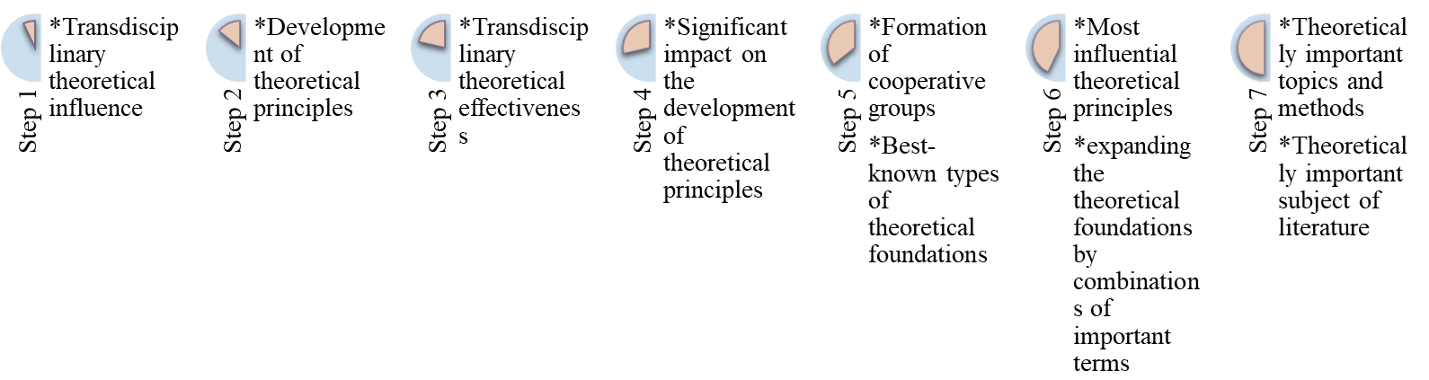
Focusing on the Building Life-cycle Stages | Goals | —Implementing a scientific strategy focusing on the Building Life-cycle stages has led to improved project cost estimates due to detailed analysis  —It has also enhanced project scheduling accuracy by incorporating timeframes specific to each stage  —The strategy has facilitated better resource allocation based on the unique requirements of each life-cycle phase  —Additionally, it has resulted in enhanced risk management through proactive mitigation strategies tailored to different stages
Focusing on the Building Life-cycle Stages | Research Suitability | 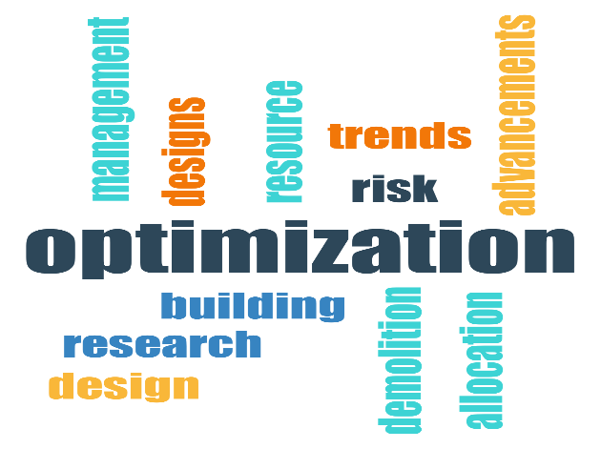 |  |  |  |  |  |  |  |  |  |  |  | 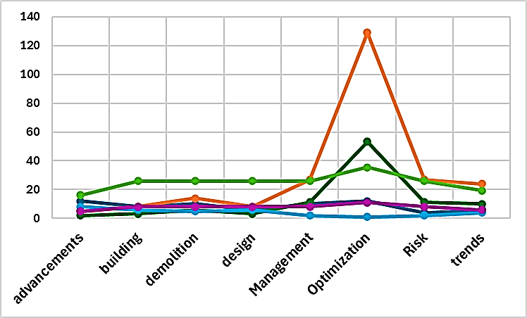
Focusing on the Building Life-cycle Stages | Knowledge Context Tree | 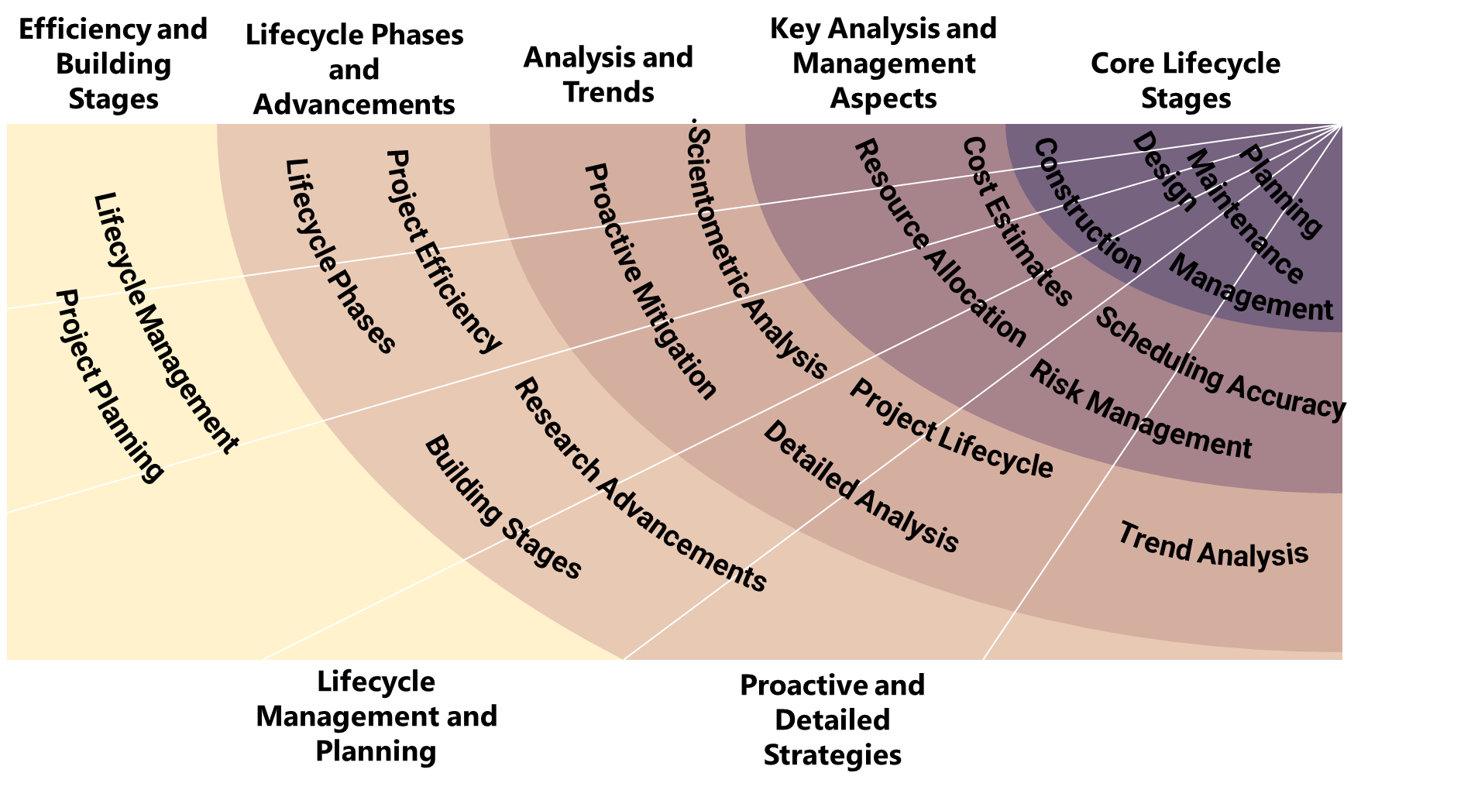
Adoption of Digital Technologies | Nature | The integration of digital technologies such as virtual reality, augmented reality, and digital twins into architecture and urban planning processes has significantly impacted scientometrics in these fields. These technologies have enhanced visualization, simulation, and analysis capabilities, leading to more informed decision-making.
Adoption of Digital Technologies | Steps | 1 |  |  | 2 |  |  |  |  | 3 |  |  |  |  | 4 |  |  |  |  | 5 |  |  |  |  | 5 |  |  |  | 6 |  |  |  | 6
Adoption of Digital Technologies | Steps | 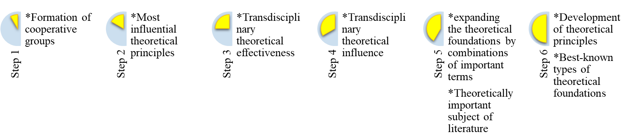
Adoption of Digital Technologies | Goals | —The adoption of digital technologies in businesses has been shown to increase productivity and efficiency by streamlining processes and enabling real-time data analytics  —Companies incorporating digital technologies have experienced improvements in customer engagement and satisfaction through personalized services and targeted marketing campaigns  —Adoption of digital technologies has facilitated remote work opportunities, allowing employees to work from anywhere, leading to better work-life balance and increased job satisfaction  —Implementing digital technologies has helped organizations gain a competitive edge in the market by offering innovative products and services to meet evolving customer demands
Adoption of Digital Technologies | Research Suitability | 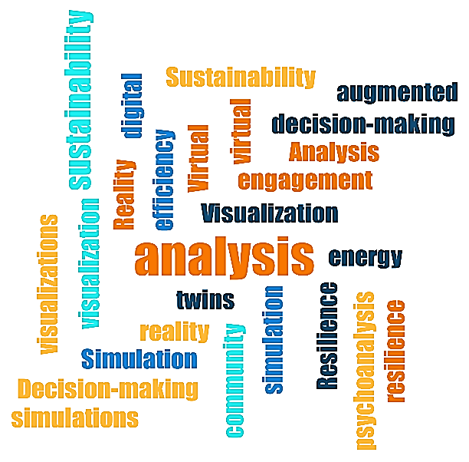 |  |  |  |  |  |  |  |  |  |  |  | 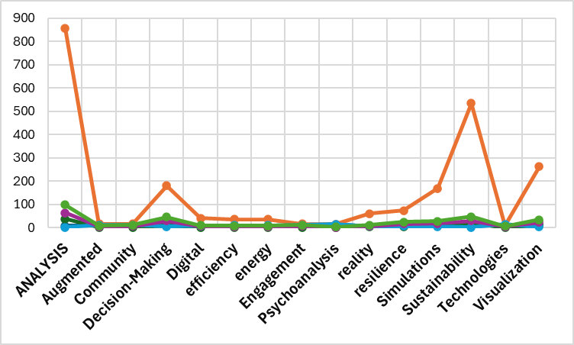
Adoption of Digital Technologies | Knowledge Context Tree | 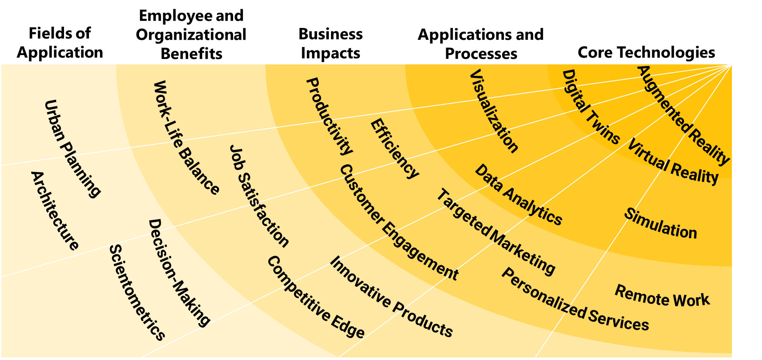

The application of scientometrics in architecture and urban planning opens significant avenues for advancing theoretical and practical approaches within these fields. Future research should consider using scientometric tools to assess the evolving priorities in urban policy, particularly how quantitative metrics can inform the development of sustainable and adaptive urban planning frameworks. Another important area is architectural education, where scientometric analyses can reveal trends and gaps in design pedagogy, encouraging the integration of interdisciplinary knowledge to prepare architects for complex, data-driven challenges. Further studies should also explore the potential of scientometric data in evaluating policy outcomes, offering evidence-based insights for refining planning processes and encouraging resilience-oriented practices in urban development. By expanding these avenues, future research can provide valuable guidance for integrating scientometrics into both theoretical and applied aspects of architecture and urban planning.
Table 12: Recommendations for future research
Research Topic | Method of Enhancing Theoretical Foundations | Future Direction for Theoretical Foundations | Impact on Design Processes | Impact on Policy and Planning Processes | Impact on Educational Processes
Examining the impact of scientometric indicators on sustainable architecture theory development | Systematic assessment of sustainability theories using scientometric tools | Developing comprehensive frameworks for sustainability in architecture grounded in scientometric data | Integrating sustainability metrics in design to enhance environmental resilience | Informing policies on sustainable urban development through scientometric insights | Promoting sustainability principles in architectural education through data-driven insights
Role of scientometrics in bridging architectural theory and social inclusivity in urban planning | Utilizing scientometric methods to evaluate social inclusivity principles | Directing urban theory towards inclusivity-focused frameworks through interdisciplinary scientometrics | Designing inclusive urban spaces with scientometrically validated social parameters | Encouraging inclusive policy development based on scientometrically analyzed inclusivity models | Integrating inclusivity principles into architectural curricula via scientometric analysis
Application of scientometric data in adaptive and resilient urban planning frameworks | Leveraging scientometric data to refine adaptive urban planning models | Fostering adaptive planning models with strong empirical and scientometric foundations | Enabling adaptive design approaches based on scientometric analysis of resilience studies | Shaping resilience-based policies informed by scientometric research on adaptive frameworks | Embedding resilience theory into educational modules through scientometric case studies
Assessing the influence of digital twin technology on future architectural research directions | Employing scientometrics to evaluate the influence of digital twin applications in architecture | Directing theoretical development in architecture toward digital integration | Enhancing digital design processes by integrating digital twin data with traditional design frameworks | Informing smart city policies through the analysis of digital twin applications in urban environments | Integrating digital twin concepts into architectural education to support modern technological trends
Integrating scientometric tools in evaluating the interdisciplinary nature of architectural knowledge | Utilizing co-citation analysis to highlight interdisciplinary trends in architectural research | Fostering interdisciplinary theoretical models grounded in scientometric indicators | Enhancing collaborative design frameworks through interdisciplinary scientometric insights | Formulating interdisciplinary policies informed by scientometricly validated architectural knowledge | Enhancing interdisciplinary curricula through data-driven analysis of co-citation patterns
Investigating scientometrics as a tool for evaluating cultural impacts on urban design principles | Analyzing scientometric data to highlight culturally significant urban planning theories | Establishing culturally sensitive urban theories grounded in scientometric evaluations | Designing culturally responsive urban environments based on scientometric cultural data | Supporting policies that emphasize cultural sensitivity in urban planning | Integrating cultural awareness principles in education using scientometric-based evidence
Exploring the impact of scientometric research on the integration of participatory design in urban planning | Applying scientometrics to map the development of participatory design models | Advancing urban theories that support participatory and community-driven planning | Promoting community engagement in design through scientometrically backed participatory frameworks | Developing policies that prioritize community engagement informed by scientometric insights | Emphasizing participatory design education through scientometrically supported models
Evaluating scientometric trends in sustainable material use within architectural design and urban planning | Mapping sustainable material research through scientometric tools | Strengthening material sustainability theory within architectural education | Supporting sustainable material selection processes in design based on scientometric findings | Establishing sustainability guidelines informed by scientometric research on materials | Including sustainable materials studies in architectural courses through scientometric data
Analyzing the role of scientometrics in advancing architectural education curricula | Assessing educational impact of architectural theories using scientometric metrics | Guiding curricula development with data-backed theoretical insights | Adapting design methodologies in education to emphasize current scientometric trends | Informing educational policy frameworks based on scientometric evaluations of architectural theories | Structuring architecture programs to reflect scientometrically evaluated theoretical trends
Using scientometric tools to measure environmental performance of architectural designs | Quantitatively assessing environmental performance trends in architecture via scientometric methods | Reinforcing environmental theory in architecture with empirical, scientometric evidence | Enhancing eco-friendly design approaches through scientometrically evaluated environmental frameworks | Developing environmental policies based on scientometric findings of architecture’s environmental impact | Strengthening environmental topics in architectural education using scientometric performance measures

Acknowledgments
The authors declare that in order to achieve desirable, generalizable and reliable results, they have tried to overcome the complexities of the current extensive and deep research by creating theoretical saturation and using artificial intelligence in a targeted manner. Also, regarding the main subjects and parts of this research, by using the repetition of the research with some applicable techniques in the form of the research method of this research and conducting parallel studies, ensure the correctness of the keywords extracted in all stages of this research. Targeted reporting of the vast amount of data used and numerous findings in its different parts has been one of the methods of revealing the current research process.
Table 13: The most important uses of artificial intelligence in MAXQDA software in Data Validation and Verification by this research
 |  | 
AI Coding | Chat with data | Generate term explanations
Automate coding process with AI Coding while maintaining complete control over analytical work: Analyze a single document and get coding recommendations for text segments matching coding criteria on the RGT methodology.  AI Assist provides comments for each coded segment, explaining the reasoning behind its suggestions. | Pose questions about already-coded text segments or entire documents. Responses reference specific text sections for easy review. it can harness the transformative potential of dialogue to:  - Consider different angles to enrich insights  - Reflect on decisions for a more self-aware approach  - Identify data gaps needing further exploration  - Maintain consistent coding and interpretations over time | Quickly clarify unfamiliar terms or phrases without leaving MAXQDA.  Highlight the text by asking AI Assist to explain it, and get an instant answer saved as an in-document memo for convenient reference.
 |  | 
Receive code label support | Summarize content | Reliability Analysis (Cronbach's Alpha)
Unlocked enhanced coding capabilities with AI Assist’s two code label recommendation features: by get new code recommendations based on a selected text passage with AI New Code Suggestions. Decide for which recommendation would like to apply according to the RGT methodology.  Alternatively, data-based subcategory division recommendations generated with AI Subcode Suggestions. | summaries Clearly marked as AI-generated, AI Assist summaries are flexible and transparent. Among others, get summaries of:  - Entire PDF and text documents  - Specific text segments  - Text segments coded with a particular code  - Selected coded segments in a document  - All paraphrases in a document | Creating Reliability scale can be a good way to properly measure the RGT methodology dimensions by Calculating Cronbach’s alpha to check reliability in MAXQDA. Then. By Saving scales as new variables and calculating the sum or mean of the item values, it was possible to calculate Reliability of finding while using standard mathematical operators.
An example of how to ensure the accuracy of the codes suggested by artificial intelligence is by checking the types of cases (Connection Method, Suitability %, Research Method, Arch. Sources %, Urban Planning Sources %, Time Period, Sources) for each suggested code. In this image, you can see the result of the proposed code by artificial intelligence for (Index3-Appropriation Index) ▼


An example of how to ensure the accuracy of combinations proposed by artificial intelligence to integrate architectural and urban planning topics with different scientometric topics by checking the types of cases (positive, negative, slightly negative, neutral, No sentiment) for each proposed code. In this image, you can see the result of the proposed code by artificial intelligence for (Index7-Reliability Index).▼



Disclosure statement
No potential conflict of interest was reported by the authors.

Funding
This research did not receive any specific grant from funding agencies in the public, commercial, or not-for-profit sectors.

References
Abusaada, H., & Elshater, A. (2018). Knowledge-Based Urban Design in the Architectural Academic Field. In A. A. Alraouf (Ed.), Knowledge-Based Urban Development in the Middle East (pp. 204-227). Hershey, PA, Pennsylvania: IGI Global. doi:10.4018/978-1-5225-3734-2.ch011
Acuto, M., Dinardi, C., & Marx, C. (2019). Transcending (in)Formal Urbanism. Urban Studies, 56(3), 475-487. doi:10.1177/0042098018810602
Albertus, S. M. (2022). THE ROLE OF STRUCTURALISM IN TOWN PLANNING RESEARCH IN THE DIGITAL ARCHITECTURE ERA. JoDA Journal of Digital Architecture, 2(1), 9-16. doi:10.24167/joda.v2i1.5543
Al-Douri, F. A. (2022). How Information and Communication Tools (ICT) affect the processes and decision-making in professional urban design practice? URBAN DESIGN International. doi:10.1057/s41289-022-00196-8
Allam, Z., Bibri, S. E., Chabaud, D., & Moreno, C. S. (2022). The Theoretical, Practical, and Technological Foundations of the 15-Minute City Model: Proximity and Its Environmental, Social and Economic Benefits for Sustainability. Energies, 15(16), 6042. doi:https://doi.org/10.3390/en15166042
Allen, M. (Ed.). (2017). The SAGE Encyclopedia of Communication Research Methods (Vol. FOUR VOLUME SET). Thousand Oaks, CA.
Andreoletti, M., Chiffi, D., & Taebi, B. (2022). Introduction: Severe Uncertainty in Science, Medicine, and Technology. Perspectives on Science, 30(2), 201–209. doi:10.1162/posc_e_00411
Araújo, C. A. (2006). Theoretical foundations of classification. Encontros Bibli: Revista eletrônica De Biblioteconomia E Ciência Da informação, 11(22), 117–140. doi:10.5007/1518-2924.2006v11n22p117
Ariza, M. R., Christodoulou, A., Harskamp, M. v., Knippels, M.-C. P., Kyza, E. A., Levinson, R., & Agesilaou, A. (2021). Socio-Scientific Inquiry-Based Learning as a Means toward Environmental Citizenship. Sustainability, 13(20), 11509. doi:10.3390/su132011509
Art and Architecture of the World’s Religions. (2010). Choice Reviews Online, 47(5), 47–2346. doi:10.5860/choice.47-2346
Azzopardi-Muscat, N., Brambilla, A., Caracci, F., & Capolongo, S. (2020). Synergies in Design and Health. The Role of Architects and Urban Health Planners in Tackling Key Contemporary Public Health Challenges. Acta Bio-Medica : Atenei Parmensis, 91, 9-20. doi:10.23750/abm.v91i3-s.9414
Babar, M., & Arif, F. (2017). Smart Urban Planning Using Big Data Analytics to Contend with the Interoperability in Internet of Things. Future Generation Computer Systems, 77, 65–76. doi:10.1016/j.future.2017.07.029
Barnett, A. H., Epstein, C. L., Greengard, L., & Magland, J. (2022). Part I - Theoretical Foundations. In Geometry of the Phase Retrieval Problem Graveyard of Algorithms (pp. 37–38). Cambridge: Cambridge University Press. doi:10.1017/9781009003919.004
Bellini, E., Bellini, P., Cenni, D., Nesi, P., Pantaleo, G., Paoli, I., & Paolucci, M. (2021). An IoE and Big Multimedia Data Approach for Urban Transport System Resilience Management in Smart Cities. Sensors, 21(2), 435: 1-34. doi:10.3390/s21020435
Belof, M., & Kryczka, P. (2021). Between Architecture and Planning: Urban Design Education in Poland against a Background of Contemporary World Trends. Journal of Planning Education and Research, 0739456X2110572. doi:10.1177/0739456x211057205
Bevz, M. (2021). PRESERVATION OF HISTORICAL FORTIFICATIONS AND VALUABLE URBAN STRUCTURE OF THE CITY (NOTES FOR SCIENTIFIC AND DESIGN DOCUMENTATION - HISTORICAL AND ARCHITECTURAL BASIC PLAN OF LVIV. Current Issues in Research, Conservation and Restoration of Historic Fortifications, 14, 2544-6517: 13-35. doi:10.23939/fortifications2020.14.013
Bibri, S. (2017). A Foundational Framework for Smart Sustainable City Development: Theoretical, Disciplinary, and Discursive Dimensions and Their Synergies. Sustainable Cities and Society, 38, 758–794. doi:10.1016/j.scs.2017.12.032
Billger, M., Thuvander, L., & Wästberg, B. S. (2016). In Search of Visualization Challenges: The Development and Implementation of Visualization Tools for Supporting Dialogue in Urban Planning Processes. Environment And Planning B: Urban Analytics And City Science, 44(6), 1012-1035. doi:10.1177/0265813516657341
Bingcheng, S., & Jinfeng, L. (2022). An information perspective based on architecture design. (pp. 523-525). Dalian, China: IEEE. doi:10.1109/IPEC54454.2022.9777467
Birgani, Y. T., & Yazdandoost, F. (2018). An Integrated Framework to Evaluate Resilient-Sustainable Urban Drainage Management Plans Using a Combined-Adaptive MCDM Technique. Water Resources Management, 32(8), 2817–2835. doi:10.1007/s11269-018-1960-2
Bober, P. P. (2001). Art, Culture, and Cuisine: Ancient and Medieval Gastronomy. The Sixteenth Century Journal, 32(2), 596-597. doi:10.2307/2671835
Boeing, G. (2019). Spatial Information and the Legibility of Urban Form: Big Data in Urban Morphology. International Journal of Information Management, 56, 102013: 1-9. doi:10.1016/j.ijinfomgt.2019.09.009
Bonfim, L. (2020). Spanning the Boundaries of Qualitative Grounded Theory Methods: Breaking New Grounds into the New Online Era. RAUSP Management Journal, 55(4), 491–509. doi:10.1108/rausp-04-2019-0061
Bornmann, L., & Mutz, R. (2015). Growth rates of modern science: A bibliometric analysis based on the number of publications and cited references. Journal of the Association for Information Science and Technology, 66(11), 2215-2222.
Brown, R. R., Werbeloff, L., & Raven, R. (2019). Interdisciplinary Research and Impact. Global Challenges, 3(4), 1900020: 1-4. doi:10.1002/gch2.201900020
Brudvig, L. A., & Catano, C. P. (2021). Prediction and Uncertainty in Restoration Science. Restoration Ecology, e13380. doi:10.1111/rec.13380
Chopyk, T. (2013). Classification of theoretical and methodological foundations of training future coaches. Pedagogics, psychology, medical-biological problems of physical training and sports, 17(6), 59-63. doi:10.6084/m9.figshare.714941
Chun Tie, Y., Birks, M., & Francis, K. (2019). Grounded theory research: A design framework for novice researchers. SAGE Open Medicine, 7. doi:10.1177/2050312118822927
Cohen, W. M., Sauermann, H., & Stephan, P. (2020). Not in the Job Description: The Commercial Activities of Academic Scientists and Engineers. MANAGEMENT SCIENCE, 66(9), 4108-4117. doi:10.1287/mnsc.2019.3535
Constantino, S., Schlüter, M., Weber, E. U., & Wijermans, N. (2021). Cognition and Behavior in Context: A Framework and Theories to Explain Natural Resource Use Decisions in Social-Ecological Systems. Sustainability Science, 16(5), 1651–1671. doi:10.1007/s11625-021-00989-w
Couclelis, H. (2021). Conceptualizing the City of the Information Age. In S. Wenzhong, M. F. Goodchild, B. Michael, M.-P. Kwan, & A. Zhang (Eds.), Urban Informatics (pp. 133–145). Singapore: Springer. doi:10.1007/978-981-15-8983-6_9
Csomós, G. (2019). On the challenges ahead of spatial scientometrics focusing on the city level. Aslib Journal of Information Management, 72(1), 67–87. doi:https://doi.org/10.1108/ajim-06-2019-0152
Dadashpoor, H., & Ahani, S. (2021). Explaining Objective Forces, Driving Forces, and Causal Mechanisms Affecting the Formation and Expansion of the Peri-Urban Areas: A Critical Realism Approach. Land Use Policy, 102, 105232: 1-18. doi:10.1016/j.landusepol.2020.105232
Delve, H. L., & Limpaecher, A. (2022, 2 8). How To Do Open, Axial, & Selective Coding in Grounded Theory. Practical Guide to Grounded Theory. Retrieved 6 20, 2024, from Delve: https://delvetool.com/blog/openaxialselective
Doan, K. M., Pham, V. H., & Doan, T. M. (2021). Sustainable Symbiotic Relationship in The Human Ecosystem in The Development of Public Spaces (Case of Hanoi Historical Inner-City Area). International Journal of Sustainable Construction Engineering and Technology, 12(3), 112-127. doi:10.30880/ijscet.2021.12.03.012
Elrahman, A. A., & Asaad, M. (2019). Defining the Urban Design Process: A theoretical perspective. Journal of Urban Research, 34(1), 112-133. doi:10.21608/JUR.2019.86335
Elrahman, A. S., & Asaad, M. (2021). Urban Design & Urban Planning: A Critical Analysis to the Theoretical Relationship Gap. Ain Shams Engineering Journal, 12(1), S2090447920301088:1163–1173. doi:10.1016/j.asej.2020.04.020
Encyclopedia of Urban Studies. (2010, July 1). Choice Reviews Online, 47(11). doi:10.5860/choice.47-6012
Erişen, S. (2020). The Architecture of Knowledge from the Knowledge of Architecture. Athens Journal of Architecture, 6(3), 293 -318. doi:10.30958/aja.6-3-5
Fallmann, J., & Emeis, S. (2020). How to bring urban and global climate studies together with urban planning and architecture? Developments in the Built Environment, 4, 100023. doi:10.1016/j.dibe.2020.100023
Farhangdoust, H. (2022a). Capacities of Building Information Modeling Technology (BIM) in utilizing the theoretical foundations of Construction with a focus on architecture. Journal of Future Cities Vision (JFCV), 2(4), 75-98. Retrieved from http://jvfc.ir/article-1-121-en.html
Farhangdoust, H. (2022b). The origin and nature of "conceptual architecture". Iranian Urbanism, 5(9), 108-126. Retrieved from https://dorl.net/dor/20.1001.1.27170918.1401.5.9.7.7
Farhangdoust, H., Farkisch, H., & Hanaee, T. (2022). Evolution of Theoretical Foundations of Contemporary Architecture and Urban Planning; Transition From the Discourse of Impressionability to Influence. Interdisciplinary Studies of Iranian Architecture, 1(2), 71-103. doi:10.22133/isia.2023.371008.1025
Farhangdoust, H., Farkisch, H., & Tabasi, M. (2022). The Origin and Nature of Productive Theory, Based on Design Theory, with a Focus on Design in the Field of Architecture. Raf Quarterly Scientific Journal of Architecture, Restoration and Urbanism, 1(2), 98-123. Retrieved from https://www.rafmagz.com/article_146906.html?lang=en
FARROW, R., INIESTO, F., WELLER, M., & PITT, R. (n.d.). In Research Methods Handbook (pp. 56-58). THE OPEN UNIVERSITY. Retrieved from https://open.library.okstate.edu/gognresearchmethods/chapter/grounded-theory/
Fitzgibbons, J., & Mitchell, C. L. (2019). Just Urban Futures? Exploring Equity in ‘100 Resilient Cities. World Development, 122, 648-659. doi:10.1016/j.worlddev.2019.06.021
Friend, R. H., Jarvie, J. K., Reed, S. E., Sutarto, R., Thinphanga, P., & Toan, V. D. (2014). Mainstreaming Urban Climate Resilience into Policy and Planning; Reflections from Asia. Urban Climate, 7, 6–19. doi:10.1016/j.uclim.2013.08.001
Friesen, J. (2023). Towards a Link between Quantitative and Qualitative Sciences to Understand Social Systems Using the Example of Informal Settlements. Entropy, 25(2), 262. doi:10.3390/e25020262
Furman, A. V. (2022). Architectonics of Activity Theory: Reflexive-Deed Scenario of Metamethodologization. Психологія і Суспільство, 1, 7–94. doi:10.35774/pis2022.01.007
García-Villar, C., & García-Santos, J. M. (2021). Bibliometric indicators to evaluate scientific activityIndicadores bibliométricos para evaluar la actividad científica. Radiología (English Edition), 63(3), 228-235. doi:10.1016/j.rxeng.2021.01.002
Gasanov, M. A., Gasanov, E., Zhironkin, S. A., & Krasota, T. G. (2023). Theoretical Foundation And Methodological Principles Of Economic Research. Vestnik of Khabarovsk State University of Economics and Law, 1(111), 16-20. doi:10.38161/2618-9526-2023-1-016-020
Ghasemi, H., & et.al. (2023). A Comprehensive Guide to Research (20 ed.). Tehran: andisheara.
Grabowski, Z. R., McPhearson, T., & Pickett, S. T. (2023). Transforming US Urban Green Infrastructure Planning to Address Equity. Landscape and Urban Planning, 229, 104591. doi:10.1016/j.landurbplan.2022.104591
Grigoryeva, E., & Lidin, K. (2021). A Modernist City. Project Baikal, 18(68), 81. doi:10.51461/projectbaikal.68.1807
Haghani, M., Sabri, S., Gruyter, C. D., Ardeshiri, A., Shahhoseini, Z., Sanchez, T. W., & Acuto, M. (2023). The landscape and evolution of urban planning science. Cities, 136, 104261. doi:10.1016/j.cities.2023.104261
Harwood, J. M., & Rudnitsky, A. (2020). Learning About Scientific Inquiry Through Engineering. doi:10.18260/1-2--14167
Hu, W., Dong, J., Hwang, B.-G., Ren, R., & Chen, Z.-L. (2019). A Scientometrics Review on City Logistics Literature: Research Trends, Advanced Theory and Practice. Sustainability, 11(10), 2724: 1-27. doi:10.3390/su11102724
Karczewska, A. (2020). From Bauhaus to Our House: Tom Wolfe Contra Modernist Architecture. Świat i Słowo, 34(1), 211-230. doi:10.5604/01.3001.0014.3069
Karwowski, E. (2019). Towards (de-)Financialisation: The Role of the State. Cambridge Journal of Economics, 43(4), 1001–10027. doi:10.1093/cje/bez023
Kassam, S., Marcellus, L., Clark, N., & O’Mahony, J. (2020). Applying Intersectionality With Constructive Grounded Theory as an Innovative Research Approach for Studying Complex Populations: Demonstrating Congruency. International Journal of Qualitative Methods, 19, 160940691989892: 1-11. doi:10.1177/1609406919898921
Kent, J. L., & Thompson, S. E. (2014). The Three Domains of Urban Planning for Health and Well-Being. Journal of Planning Literature, 29(3), 239–256. doi:10.1177/0885412214520712
Kim, Y. J. (2016). Discussing Architecture and the City as a Metaphor for the Human Body : From Marcus Vitruvius Pollio, Leon Battista Alberti, Andrea Palladio to Other Renaissance Architects. Architectural Research, 18(1), 1-12. doi:10.5659/aikar.2016.18.1.1
Kong, C. (2023). The Phenomenology and Ethics of P-Centricity in Mental Capacity Law. Law and Philosophy, 42(2), 145–175. doi:10.1007/s10982-022-09458-6
Kramer, J., Daly, S. R., Yilmaz, S., & Seifert, C. M. (2020). A Case-Study Analysis of Design Heuristics in an Upper-Level Cross-Disciplinary Design Course. 121st ASEE Annual Conference & Exposition, (pp. 8452: 1-7). Indianapolis, IN. doi:10.18260/1-2--19915
Lai, S.-k., & Huang, J.-y. (2017). Theoretical foundation of a decision network for urban development. Frontiers of Information Technology & Electronic Engineering, 18(8), 1033–1039. doi:10.1631/FITEE.1510000
Łaszkiewicz, E., Nowakowska, A., & Adamus, J. (2022). How Valuable Is Architectural Heritage? Evaluating a Monument’s Perceived Value With the Use of Spatial Order Concept. SAGE Open, 12(4), 215824402211427 : 1-13. doi:10.1177/21582440221142720
Lidin, K. L., Meerovich, M. G., Bulgakova, E. A., Vershinin, V. V., & Papaskiri, T. V. (2018). Applying the theory of informational flows in urbanism for a practical experiment in architecture and land use. Revista ESPACIOS, 39(1), 1-9.
Liu, W., Zhang, H., Wang, Q., Hua, T., & Xue, H. (2021). A Review and Scientometric Analysis of Global Research on Prefabricated Buildings,. Advances in Civil Engineering, 8869315. doi:10.1155/2021/8869315
Liua, S., & Zhang, Y. (2020). Cities without Slums? China’s Land Regime and Dual-Track Urbanization. Cities, 101, 102652: 1-13. doi:10.1016/j.cities.2020.102652
MacKie, E. W. (2012). A New Look at the Astronomy and Geometry of Stonehenge. (N. Campion, & R. Sinclair, Eds.) Culture and Cosmos, 16(1&2), 89-107. doi:10.46472/cc.01216.0217
Martinus, K. (2010). Planning for Production Efficiency in Knowledge‐based Development. Journal of Knowledge Management, 14(5), 726-743. doi:10.1108/13673271011074863
Maruna, M. (2019). Toward the Integration of SDGs in Higher Planning Education: Insights from Integrated Urbanism Study Program in Belgrade. Sustainability, 11(17), 4519: 1-17. doi:10.3390/su11174519
Mattila, H., Olsson, P., Lappi, T.-R., & Ojanen, K. (2022). Ethnographic Knowledge in Urban Planning–Bridging the Gap between the Theories of Knowledge-Based and Communicative Planning. Planning Theory & Practice, 23(1), 11-25. doi:10.1080/14649357.2021.1993316
Mazarro, A. D., Kaliaden, R. G., Wende, W., & Egermann, M. (2023). Beyond urban ecomodernism: How can degrowth-aligned spatial practices enhance urban sustainability transformations. 60(7), 1304–1315. doi:10.1177/00420980221148107
Miller, M. (2002). Garden Cities and Suburbs: At Home and Abroad. Journal of Planning History, 1(1), 6-28. doi:10.1177/153851320200100102
Mingers, J., & Leydesdorff, L. (2015). A review of theory and practice in scientometrics. European Journal of Operational Research, 246(1), 1-19.
Mohajer Milani, A., & Einifar, A. (2022). The Theoretical Relation of Patterns and Regulations in Architecture. Journal of Iranian Architecture, 13(2), 403-417. doi:10.30475/isau.2022.257504.1577
Mohammadi, N., Vimal, A., & Taylor, J. E. (2020). Knowledge Discovery in Smart City Digital Twins. Proceedings of the 53rd Hawaii International Conference on System Sciences (pp. 1656-1664). Hawaii: HICSS. doi:10.24251/hicss.2020.204
Moretto, V., Gianluca, E., & Ghiani, G. (2021). Leveraging Knowledge Discovery and Knowledge Visualization to Define the ‘Inner Areas’: An Application to an Italian Province. Journal of Knowledge Management, 26(10), 2743–2771. doi:10.1108/jkm-10-2021-0773
Mosleh, M., Roshani, S., & Coccia, M. (2022). Scientific Laws of Research Funding to Support Citations and Diffusion of Knowledge in Life Science. Scientometrics, 127(4), 1931–1951. doi:10.1007/s11192-022-04300-1
Moulis, A. (2012). An Exemplar for Modernism: Le Corbusier’s Adelaide Drawing, Urbanism and the Chandigarh Plan. The Journal of Architecture, 17(6), 871–887. doi:10.1080/13602365.2012.746043
Murillo, A. P. (2019). Data Matters: How Earth and Environmental Scientists Determine Data Relevance and Reusability. Collection and Curation, 41(3), 77–86. doi:10.1108/cc-11-2018-0023
Nalau, J., Torabi, E., Edwards, N., Howes, M. J., & Morgan, E. (2021). A Critical Exploration of Adaptation Heuristics. Climate Risk Management, 32, 100292 (1-12). doi:10.1016/j.crm.2021.100292
Nitoslawski , S. A., Galle, N. J., Bosch, C. V., & Steenberg, J. W. (2019). Smarter ecosystems for smarter cities? A review of trends, technologies, and turning points for smart urban forestry. Sustainable Cities and Society, 51, 101770: 1-32. doi:10.1016/j.scs.2019.101770
Oehmer, F., & Jarren, O. (2019). Foundations as organisational science policy interfaces? An analysis of the references to foundations made during parliamentary debates in the German federal parliament. Journal of Science Communication, 18(3), A06. doi:10.22323/2.18030206
Owan, V. J., Odigwe, F. N., & Bassey, B. A. (2020). Data Management Practices and Educational Research Effectiveness of University Lecturers in South-South Nigeria. Journal of Educational and Social Research, 10(3), 24-34. doi:10.36941/jesr-2020-0042
Pan, Y., & Zhang, L. (2021). Roles of Artificial Intelligence in Construction Engineering and Management: A Critical Review and Future Trends. Automation in Construction, 122, 103517. doi:10.1016/j.autcon.2020.103517
Pankiewicz, M. (2017). Causes and Effects - Methodologies Used in Digitalization of Architectural-Urban Heritage. eCAADe Proceedings. doi:10.52842/conf.ecaade.2017.2.025
Parris, K. M., Amati, M., Bekessy, S. A., Dagenais, D., Fryd, O., Hahs, A. K., . . . Williams, N. S. (2018). The Seven Lamps of Planning for Biodiversity in the City. Cities, 83, 44-53. doi:10.1016/j.cities.2018.06.007
Parveaz, S., & Khan, A. (2022). Understanding Information Seeking Behavior of Users in Academic Context (A Critical Review of Literature). ECS Transactions, 107(1), 9673-9694. doi:10.1149/10701.9673ecst
Paula, B. d. (2021). Reflexivity, methodology and contexts in participatory digital media research: making games with Latin American youth in London. Learning, Media and Technology, 46(4), 435-450. doi:10.1080/17439884.2021.1901114
Pauwels, P., Meyer, R. D., & Campenhout, J. V. (2011). Extending the design process into the knowledge of the world. Proceedings of the 14th International Conference on Computer Aided Architectural Design Futures (CAADFutures). Liège, Belgium.
Peckham, R. (2009). The City of Knowledge: Rethinking the History of Science and Urban Planning. Planning Perspectives, 24(4), 521–534. doi:10.1080/02665430903145762
Perera, S., Babatunde, S., & Ekundayo, D. (2022). Bibliometric analysis of peer-reviewed journal publications in construction management. Journal of Engineering, Design and Technology, 20(2), 438–453. doi:https://doi.org/10.1108/JEDT-01-2021-0024
Porfiriev, B. N., Dmitriev, A., Vladimirova , I., & Tsygankova, A. (2017). Sustainable Development Planning and Green Construction for Building Resilient Cities: Russian Experiences within the International Context. Environmental Hazards, 16(2), 165–179. doi:10.1080/17477891.2017.1280000
Ralph, N., Birks, M., & Chapman, Y. (2015). The Methodological Dynamism of Grounded Theory. International Journal of Qualitative Methods, 14(4). doi:10.1177/1609406915611576
Reitz-Joosse, B. (2016). The City and the Text in Vitruvius’s de Architectura. Arethusa, 49(2), 183–197. doi:10.1353/are.2016.0021
Remizova, O., & Novak, N. (2019). Dialogue of Epochs in Postmodern Urban Planning Concepts of the Late ХХth and Early ХХIst Centuries. Budownictwo i Architektura, 17(4), 067–075. doi:10.24358/bud-arch_18_174_07
Ripp, M., & Rodwell, D. (2016). The Governance of Urban Heritage. The Historic Environment, 7(1), 81–108. doi:10.1080/17567505.2016.1142699
Rizk, A., & Elragal, A. (2020). Data Science: Developing Theoretical Contributions in Information Systems via Text Analytics. Journal of Big Data, 7(1), 1-26. doi:10.1186/s40537-019-0280-6
Rodríguez, M. S., Melgar, S. J., Cordero, A. G., & Márquez, J. A. (2021). A Critical Review of Unmanned Aerial Vehicles (UAVs) Use in Architecture and Urbanism: Scientometric and Bibliometric Analysis. Applied sciences, 11(21), 9966. doi:10.3390/app11219966
Ross, L. D. (2009). Art and Architecture of the World's Religions (Vol. 1). ABC-CLIO.
Ross, S. (2012). Digital Preservation, Archival Science and Methodological Foundations for Digital Libraries. New Review of Information Networking, 17(1), 43–68. doi:10.1080/13614576.2012.679446
Rusliana, N., Komaludin, A., & Firmansyah, M. F. (2022). A Scientometric Analysis of Urban Economic Development: R Bibliometrix Biblioshiny Application. Jurnal Ekonomi Pembangunan, 11(2), 80–94. doi:10.23960/jep.v11i2.484
Saadlounia, H., Yazdani, M. H., Zarei, G., & chianeh, R. H. (2021). Philosophical and Epistemological Foundations of Contextualism in Postmodern Urban design and architecture. Interaction between Sciences and Philosophy, 15(36), 328-343. doi:10.22034/jpiut.2020.42156.2681
Salama, A. M., & Madhavi, P. P. (2024). Unpacking Transdisciplinary Research Scenarios in Architecture and Urbanism. Encyclopedia, 4(1), 352-378. doi:10.3390/encyclopedia4010025
Samwinga, V., Zulu, S., & Adeyemi, T. E. (2023). A Scientometric Analysis of Wellbeing Research in the Construction Industry. Sustainability, 15(24), 16662. doi:10.3390/su152416662
Savva, F., Anagnostopoulos, C., Triantafillou, P., & Kolomvatsos, K. (2020). Large-Scale Data Exploration Using Explanatory Regression Functions. ACM Transactions on Knowledge Discovery From Data, 14(6), 1-33. doi:10.1145/3410448
Schmidt, L. S., Falk, T., Siegmund-Schultze, M., & Spangenberg, J. H. (2020). The Objectives of Stakeholder Involvement in Transdisciplinary Research. A Conceptual Framework for a Reflective and Reflexive Practise. Ecological Economics, 176, 106751. doi:10.1016/j.ecolecon.2020.106751
Serrano, W. (2022). Verification and Validation for data marketplaces via a blockchain and smart contracts. Blockchain Research and Applications, 3(1), 100100. doi:10.1016/j.bcra.2022.100100
Shablysta, L. M. (2019). Quality Indicators of Research Results. Statistics of Ukraine, 87(4). doi:10.31767/su.4(87)2019.04.10
Sharifi, A., Khavarian-Garmsir, A., Allam, Z., & Asadzadeh, A. (2023). Progress and Prospects in Planning: A Bibliometric Review of Literature in Urban Studies and Regional and Urban Planning, 1956–2022. Progress in Planning, 173, 100740. doi:10.1016/j.progress.2023.100740
Sheikhnejad, Y., & Yigitcanlar, T. (2020). Scientific Landscape of Sustainable Urban and Rural Areas Research: A Systematic Scientometric Analysis. Sustainability, 12(4), 1293. doi:10.3390/su12041293
Shen, Y. (2017). Data Sharing Practices, Information Exchange Behaviors, and Knowledge Discovery Dynamics: A Study of Natural Resources and Environmental Scientists. Environmental Systems Research, 6(9), 1-14. doi:10.1186/s40068-017-0086-5
Shetty, S., & Luescher, A. (2010). Inter-Disciplinarity in Urban Design: Erasing Boundaries between Architects and Planners in Urban Design Studios. Open House International, 35(3), 87-97. doi:10.1108/OHI-03-2010-B0010
Shrivastava, A., & Mehrotra, S. (2023). Emerging Trends and Knowledge Domain of Research on Urban Green Open Spaces and Wellbeing: A Scientometric Review. Reviews on Environmental Health, 38(4), 663-679. doi:10.1515/reveh-2022-0091
Steshenko, N., & Steshenko, A. (2023). THEORETICAL FOUNDATIONS OF PREPARING STUDENTS FOR SCIENTIFIC RESEARCH ACTIVITIES. Transactions of Telavi State University,, 1(35). doi:10.52340/tuw.2022.01.35.27
Stojiljković, D., & Trajković, J. R. (2017). Semiotics and Urban Culture: Architectural Projections of Structuralism in a Socialist Context. Social Semiotics, 1-19. doi:10.1080/10350330.2017.1300084
Tang, L., Yang, L., & Zhang, L. (2021). Understanding Chinese science: New scientometric perspectives. Quantitative Science Studies, 2(1), 288–291. doi:10.1162/qss_e_00113
Tarasova, I. V. (2020). ON THE IMPORTANCE OF DEVELOPING A HISTORY OF THEORETICAL ARCHITECTURAL THOUGHT. Architecton: Proceedings of Higher Education, 4(72). doi:10.47055/1990-4126-2020-4(72)-3
Vasilenko, N. A., & Chernysh, N. D. (2023). DEFINITION AND SUBSTANTIATION OF ARCHITECTURAL OBJECTS' FUNCTIONAL STRUCTURE ON THE BASIS OF SYSTEM APPROACH. Bulletin of Belgorod State Technological University named after. V. G.Shukhov, 8(1), 74-88. doi:10.34031/2071-7318-2022-8-1-74-88
Vorobiov, V., & Shylo, О. (2023). NEW UNDERSTANDING OF THE ARCHITECTURAL AND URBAN PLANNING ENVIRONMENT FORMATION DURING OBJECTS’ CREATION ON EARTH AND OTHER PLANETS. Ukrainian Journal of Civil Engineering and Architecture, 1(13), 28–43. doi:10.30838/j.bpsacea.2312.280223.28.916
Waltman, L., & van Eck, N. J. (2012). A new methodology for constructing a publication-level classification system of science. Journal of the American Society for Information Science and Technology, 63(12), 2378-2392.
Wang, L., Xue, X., Zhang, Y., & Luo, X. (2018). Exploring the Emerging Evolution Trends of Urban Resilience Research by Scientometric Analysis. International journal of environmental research and public health, 15(10), 2181. doi:10.3390/ijerph15102181
Wang, W., Guo, H., Li, X., Tang, S., Niu, X., Xie, L., & Lv, Z. (2022). BIM Information Integration Based VR Modeling in Digital Twins in Industry 5.0. Journal of Industrial Information Integration, 28, 100351. doi:10.1016/j.jii.2022.100351
Wang, X., Rai, N., Pereira, B. M., Eetemadi, A., & Tagkopoulos, I. (2020). Accelerated Knowledge Discovery from Omics Data by Optimal Experimental Design. Nature Communications, 11(1), 5026. doi:10.1038/s41467-020-18785-y
Wang, Z., Ma, D., Sun, D., & Zhang, J. (2021). Identification and Analysis of Urban Functional Area in Hangzhou Based on OSM and POI Data. PLOS ONE, 16(5), e0251988. doi:10.1371/journal.pone.0251988
Woodward, E. N., & Ball, I. A. (2023). Perspectives on Learning to Practice Reflexivity While Engaging Communities in Implementation Science. Frontiers in Health Services, 2, 1-6. doi:10.3389/frhs.2022.1070444
Wrana, J. (2009). Cracovian Modernists - the 60 Ties, 90 Ties of the XX Century - the Returns. Budownictwo i Architektura, 4(1), 125–132. doi:10.35784/bud-arch.2339
Xia, H., Liu, Z., Maria, E., Liu, X., & Lin, C. (2022). Study on City Digital Twin Technologies for Sustainable Smart City Design: A Review and Bibliometric Analysis of Geographic Information System and Building Information Modeling Integration. Sustainable Cities and Society, 84, 104009. doi:10.1016/j.scs.2022.104009
Xu, Y., Liu, J., & Yang, Y. (2023). Data Quality Guarantee Mechanism Based on Sunk Cost Effect. IEEE 6th International Conference on Industrial Cyber-Physical Systems (ICPS) (pp. 1-6). Wuhan, China: IEEE. doi:10.1109/ICPS58381.2023.10127993
Yangxuan, & Zhaoqianjing. (2021). Influence of Virtual Reality and 3D Printing on Architectural Innovation Evaluation Based on Quality of Experience Evaluation Using Fuzzy Logic. Journal of Intelligent and Fuzzy Systems, 40(4), 8501–8509. doi:10.3233/jifs-189670
Yigitcanlar , T., Kankanamge, N., Regona, M., Maldonado, A. R., Rowan, B., Ryu, A., . . . Li, R. Y. (2020). Artificial Intelligence Technologies and Related Urban Planning and Development Concepts: How Are They Perceived and Utilized in Australia? Journal of Open Innovation: Technology, Market, and Complexity, 6(4), 187. doi:https://doi.org/10.3390/joitmc6040187
Your complete guide to grounded theory research. (2024, 6 20). Retrieved from qualtrics: https://www.qualtrics.com/en-gb/experience-management/research/grounded-theory-research/?rid=ip&prevsite=en&newsite=uk&geo=DE&geomatch=uk
Zara, V. (2011). From Quantitative to Qualitative Architecture in the Sixteenth and Seventeenth Centuries: A New Musical Perspective. Nexus Network Journal, 13(2), 411–430. doi:10.1007/s00004-011-0074-4
Zhang, L., Hooimeijer, P., Lin, Y., & Geertman, S. (2020). Roles and Motivations of Planning Professionals Who Promote Public Participation in Urban Planning Practice: Two Case Studies from Beijing, China. Urban Affairs Review, 1237–1262. doi:10.1177/1078087419895116
Zhao, Y. (2021). Transition from Modernism to Postmodernism in Urban Planning and Architecture. Architecture Engineering and Science, 2(4), 105-108. doi:10.32629/aes.v2i4.542
Zwirowicz-Rutkowska, A., & Michalik, A. (2016). The Use of Spatial Data Infrastructure in Environmental Management:An Example from the Spatial Planning Practice in Poland. Environmental Management, 58(4), 619–635. doi:10.1007/s00267-016-0732-0

h.farhangdoust@imamreza.ac.ir (09157058285)
t.hanaee@mshdiau.ac.ir (09151032873)
hero.farkisch@mshdiau.ac.ir (09192169877)
A practical example of scientometric application can be seen in studies that use co-citation analysis to map the intellectual structure of sustainable design (Samwinga, Zulu, & Adeyemi, 2023). This approach allows planners to identify key sustainability concepts and principles, such as biophilic design and resource efficiency, which have significant empirical backing. These insights facilitate the development of urban areas that are both environmentally resilient and socially inclusive, aligning with the principles of sustainable urbanization as highlighted in the UN's Sustainable Development Goals (Sheikhnejad & Yigitcanlar, 2020).
the relevancy and relationship of the data and information to the research topic
The findings are based on a comprehensive review of relevant literature from authoritative sources, such as: (Waltman & van Eck, 2012; Mingers & Leydesdorff, 2015; Bornmann & Mutz, 2015)
(Your complete guide to grounded theory research, 2024); (Allen, 2017); (Delve & Limpaecher, 2022); (FARROW, INIESTO, WELLER, & PITT); (Chun Tie, Birks, & Francis, 2019); (Ralph, Birks, & Chapman, 2015)
(MacKie, 2012; Reitz-Joosse, 2016; Ross L. D., 2009; Art and Architecture of the World’s Religions, 2010; Zara, 2011; Kim, 2016; Miller, 2002; Wrana, 2009; Moulis, 2012; Karczewska, 2020)
Functionalism, for instance, emphasizes utility and efficiency, focusing on the relationship between form and function. This approach, influential in the early 20th century, has impacted urban planning strategies by prioritizing spatial layouts that serve social and functional needs.
Some commonly and externally used scientometric indicators include impact factor, H-index, self-citation ratio, SCImago Journal Rank (SJR), and Source-Normalized Impact per Paper (SNIP). These indicators assist researchers in assessing the importance and influence of scientific journals and publications in the field of urban planning (García-Villar & García-Santos, 2021).
The keywords in this column represent significant concepts in architecture and urban planning.
The role in this column represents a unique function of the keyword based on scientific research.
Each keyword and its corresponding roles were referenced to specific pages in the identified sources. This ensured that the information was traceable and that the context of each keyword was accurately represented. Here is a Practical Example of the Method a. **Keyword Identification**: For example, “Theory” was identified as a key concept in understanding the foundational aspects of architecture. b. **Source Selection**: Relevant sources were reviewed. c. **Information Extraction**: Passages discussing the role of theory in validating methods, suggesting frameworks, and adapting to new conditions were highlighted. d. **Categorization and reliability**: The role of “Theory” was categorized under approval (validity), recommendation (basis), and stabilization (adaptability) with corresponding reliability percentages based on the confidence derived from the sources. e. **Table Entry**: The information was entered on the table under the respective columns with the associated reliability percentages and a one-word scientific role (“Framework”). f. **Referencing**: Detailed page numbers from the sources were cited, ensuring traceability.
The amounts of content in “steps” row calculated by One-Way Analysis of Variance (ANOVA). So, All Items of Function in Table 8 were as dependent variables and Every Strategy in this table was as factors.
For example, in urban resilience research, scientometrics revealed the shift in hot topics from exploratory analysis to disaster resilience, urban resilience practice, and social-ecological systems between 1993 and 2016. It highlighted influential works defining urban resilience concepts, adaptation models, analytical methods, and the focus on urban social-ecological systems as emerging trends (Wang, Xue, Zhang, & Luo, 2018)

