Analysis of structural details in the double space of conical domes
(Comparative study: Holy Tombs in Kashan)

Erfan, Bahador,
MA Architecture, National Skill University, Shahid Rajayi University, Kashan, Iran

Danaeinia, Ahmad
Restoration and Rehabilitation of Historic Buildings and fabrics Group, Faculty of Conservation and Restoration, Art University of Isfahan, Isfahan, Iran
a.danaeinia@aui.ac.ir (Corresponding Author)
Analysis of structural details in the double space of conical domes
(Comparative study: Holy Tombs in Kashan)

Abstract
Among the components of Double-Shell domes, the Stiffeners structure has a special place. The Stiffeners are responsible for transferring the load from outer shell to the bases, and therefore the form, location, how they are twisted, and how they behave in the architecture of the dome have special complexities and subtleties. This study aims to investigate the stability of the outer shell of the dome to find answers to the following two questions. What is the basis of the geometric structure and function of the Stiffeners for static and stress control in conical domes? And what is the role of clamping techniques, reducing the thickness of Khud, increasing the thickness of the Drum, Palanehsazi, A Short Cubic Brick, and connector belt in making conical domes? The result showed that Wooden Struts have a major role in the stability of Stiffeners and are divided into five types of vertical coils, chord, orbital, radial, and Sliced, and the architect according to its dimensions, opening and rising chooses one Act of them.

Keywords: Kashan, Conical domes, Static, Stiffeners, Wooden Struts.

1. Introduction
The dome is considered the most beautiful and complete arch-shaped element in Iranian architecture. Covering the domes with this form and using clay or brick in their construction technology has a rich history in architecture. Petralla (2013, p. 1030) considers the restriction of access to wood resources as a factor in the flourishing of the genius of Iranian architects in inventing and implementing special techniques. A way that over the years, they have been able to create evolution in the form, number, distances, and structural elements in the space between the two shells of Dome. The types of domes known as conical are generally one-shell, Double-Shell, and three-shell, with a circular, polygonal, turquoise, or ridged cross-section, generally made over the tombs of the Holy Tombs. In addition, the use of indigenous materials and techniques makes conical domes very diverse.
Due to the seismicity of large parts of the Iranian plateau, the use of methods and techniques that have matured over time, sometimes as the main elements and sometimes as reinforcing elements in the double-shell space of these domes have been used. Change the shape and cross-section of the dome, use the Stiffeners as supports attached to the structure, use a variety of coiling methods, reduce its thickness, increase the thickness of the grievance, use Wooden Struts, Increase the thickness of the drum,Change in the shape and cross section of the dome, use of poppies, coiling of the dome, reducing the thickness of the outer shell, increasing the thickness of the stem of the dome, is one of the techniques used in erecting this special type of domes.
Unfortunately, due to the renovation and reconstruction of the architecture of the holy shrines, the conical domes have been severely damaged and many of them have been replaced with new domes. In a way, this research can be considered as one of the first researches that have dealt with the technical aspects of the subject.
Their destruction and replacement and the lack of in-depth studies and research on this particular type of dome have led to the study in this study to integrate theoretical and practical foundations in the field of conical, organizing various techniques and structural details in such domes.

2. Background
Despite the importance and breadth of research related to Discontinuous Double-Shells one of the arch covering techniques in the architecture of historical buildings of Iran, the investigation and analysis of structural strengthening elements such as Stiffeners and Wooden Structures have been less discussed. According to Choisy, he attributed the historical roots of conical domes to the Armenian architecture of the 10th century AD, which the Seljuks adopted this style in the 11th century and spread it in the regions under their rule (1899, p. 101).
According to Choisy, she attributed the historical roots of conical domes to the Armenian architecture of the 10th century AD, which the Seljuks adopted this style in the 11th century and spread it in the regions under their rule (1899, p. 101). Abbaszadeh and Danesh's studies focused on the outer shell of the three-domed tower, which was probably rack-shaped and belonged to the Seljuk period (2023, p. 117).
Hayaty and Gomravi believe that the architecture of Bekaa Shushtar has changed over time and the type of its domes has also changed in the Seljuk and Ilkhanid periods from rack to Nari domes in the Safavid period (2020, p. 47). Korsavi and Aliabadi analyzed the descriptive and quantitative characteristics of conical domes to identify the principles of their geometry and proportion (2015, p. 1). Saidian et al. (2013) introduced the structure, covering and performance of a type of rack geometric domes called Urchin.
Building poppies, especially in the Avgoun part, greatly reduces the destruction of the dome during an earthquake and shows the architects' awareness of their structural role and function (Akbari, et al., 2023, p. 260). Pirnia and Bozorgmehri (1991), have described the function and method of Stiffeners to check the integrity of Discontinuous Double-Shell. Galdiri's studies (1996) regarding the recognition, strengthening, and restoration of dome structures from the 12th to the 17th century in Iran have pointed to the gravitational pressure caused by the small walls on the Ahyaneh.
Golombek and Wilber (1988, p. 112-114), divided the double-shell domes of the Timurid period into four categories: single-shell, two-shell, three-shell, and multifaceted or cone-shaped, and they spoke of small walls of Stiffeners as reinforcing elements of their cone-shaped shell and their combination with Golombek and Wilber divided the double-clad domes of the Timurid period into four categories: single-shell, two-shell, three-shell, and multifaceted or cone-shaped, and they spoke of poppy walls as reinforcing elements of their cone-shaped shell and their combination with vertical and horizontal Wooden Struts. The stiffener structural system is shown by Galdiri (1999, p. 76) in the mausoleum of Imamzade Mirseyed Afushte Natanz. Pope and Ackerman (2008, p. 1332) have spoken about the architectural innovation of Timurid double-shell domes, which in examples such as Amir's tomb or the Shah Mosque of Mashhad, wooden or Small Brick Column (Pillar) were mounted on the inner dome with a radial system to connect to the shell. Outside, be a support to strengthen it.
The research of Memarian and Safaeipour (2015) has addressed the effect of Stiffeners as a vertical and structural organ in increasing the dome's resistance. They have enumerated various features and functions of Stiffeners, such as creating balance in the outer shell of the dome, and stated the connection of wooden coils with it. Golabchi and Javani Dizaji (2013) while referring to the use of Stiffeners in modulating the thrust force of discrete two-shell domes, also describe the use of wooden battens in the stability of Stiffeners and how they are connected.
The research of Safaeipour, Haji Ebrahim Zargar, and Goudarzi (2012) in the field of Stiffeners typology in the most common discrete two-shell domes of Nar, is related to the introduction and analysis of the thickness, number, geometry, and cross-sectional area of ​​Stiffeners. Danaeinia and Korsavi (2017) have investigated the shell weight bearing of cone-shaped domes and their resistance to bending through the analysis of Stiffeners in the sample of Conical domes of Kashan City and have shown that the increase in the opening ratio depends on the weight load of the external shells and their bending.
Zomorshidi (2008) while referring to the structure of the Stiffeners, has discussed the method of coiling and linking the Stiffeners with them to restrain the dome. Also, Zomorshidi (2010) has provided explanations about the structure, function, and method of Stiffeners' connections to the shells of the dome and the piling structure on the porch. Yari et al. (2016, p. 3) have referred to the role of Stiffeners as elements of discrete two-shell domes, which, by connecting to the outer shell and shaping it, prevent the rotational force of such domes.
In a research, Akbari et al. discussed the transfer of the weight of Khashkhashi walls to the lower parts and foundations of the dome, the change in the number and proportions of Khashkhashi to prevent damage to the dome during an earthquake (Akbari, et al. 2023, p. 247). To numerically evaluate the seismic behavior of discrete two-shell domes, Feizolahbeigi, et al. (2021) have evaluated the effects of differences in geometrical features and structural techniques such as Stiffeners using finite element modeling and non-linear static analysis in discrete two-shell domes in four historical examples of Iran's Safavid era architecture.
In research, Feizollahbeig, Golabchi, and Rezazadeh (2021), studied the geometric design, proportions, and their relationship with the structural system such as the use of pre-seating of the dome foot and Stiffeners in five examples of discrete two-shell domes of Nar in Tafresh region of Iran. Also, the research of Feizollahbeigi, Golabchi, and Rezazadeh Ardebili (2020), while dealing with the geometric analysis of two-shell dome of Jāme' Mosque of Isfahān, found out the proportional system used in the design and construction of this dome and how to implement theoretical geometry into practical geometry in the form of a system. ValiBeig, Rahravi Poude, and Rahimi Ariaei (2016) have investigated the characteristics and details of poppies and wooden coils in the five distinct two-layer domes of Nar in the city of Isfahān through field analysis and using the theories of local master craftsmen. Hejazi and Pourabdin (2021, p. 1) have investigated the structural performance of Iranian two-shell domes made with building materials against earthquakes and studied the different shapes of their upper and lower shells.
They have investigated the stresses caused by seismic simulation of this dome by modeling the double dome of the Jāme' Mosque of Isfahān in reinforced cases with short, medium, and long Stiffeners. Pourabedin (2018) used Ansys software to analyze the structural behavior of the discrete two-layer Nar dome of Jāme' Mosque of Isfahānin different states, not reinforced with Stiffeners, reinforced with short and long Stiffeners, and reinforced with Stiffeners in the existing state, as well as several discrete two-layer brick domes of Nar with dimensions, and the hypothetical Masonry Ribs (Chafd, Arch) reinforced with Stiffeners, have paid against the earthquake. Bacigalupo, Cessari, and Fangi (1998) have created a mapping network in the two-layered space of the historical dome of the tomb of Amir of Samarkand, which includes Stiffeners, and have used the geometric data obtained in Autocad software to reconstruct and digitally simulate the two-layered space. Lorenzo (2018, p. 89) explains the geometry and morphology of the two-layered dome of Jāme' Mosque in Isfahān, and in the structure of this dome, radial reinforcing walls, joints and connecting wooden poles are used radially, circumferentially or diagonally.
The backgrounds explain that the issue of double domes have been examined by various researchers from the historical and technical aspects, but what makes it important to deal with the current research is the structural role and the techniques used in the poppies, which The structural stability of double-clad domes leads.

3. Research method
The first part of the research, which forms the theoretical framework, includes study and knowledge through library resources. The second part of the research is quantitative and relies on field analysis, by identifying different types of domes remaining over the tombs of Imamzadegan in Kashan city, finally six types of the oldest ones that were largely intact and had been slightly restored were selected. By being in the two-shelled space of the species, the original parts of the domes were photographed and the details of the plans and sections were taken by hand and laser meters. By extracting and adapting the quantitative data obtained from the field analysis, the required two-dimensional and three-dimensional drawings were drawn in Cad 2014 software, and then the architectural replica of the selected species was made with the necessary details. By determining the geometrical shape of the Stiffeners and Wooden Struts and determining their role in the stability of the double-clad space of the rack domes, their types were grouped and separated graphically in tables and charts in Excel software. Finally, in the form of charts, the frequency of each of them was analyzed and it was shown what components the architects of the past used in shaping the structure of this type of conical dome.
4. Geometric recognition of two-shell domes
In the past, Iranians considered the dome to be a symbol of the sky and upward movement to separate from the earth, and they used it in buildings such as mosques and tombs (Feizollahbeig, Golabchi, and Rezazadeh, 2021, p. 21). After sedentary man developed the wooden dome, masonry architecture of brick and stone began as an imitative act, reproducing the venerated forms that had formerly been constructed of less permanent materials. The formation of a domical architecture subsequently evolved as a symbolic expression through multiple structural systems. Ingenuity and proficiency developed in direct proportion to vault weight, indicating that the paramount criterion of beauty in domes was their apparent lightness, both materially and visually. What this suggests is that the "heavy" imitation may attain perfection only by reintegrating with the primordial lightness of the "cosmic tent" from which it sprang (Ardalan and Bakhtiar, 1973, p. 75).
The dome is one of the characteristic structures that Iranian architects make a lot of effort for its exist, It has special features that distinguish it from the arch, and their structure has the most important features of the height and width of the opening, which affects the geometry of the design. Its proportions are impressive and the variety and abundance of their bivalve types have caused many aspects of their form and construction technology to remain unknown (Faizollahbeigi, Gulabchi, and Rezazadeh Ardabili, 2020, p. 36). Researchers, according to the available documents date back the background of using domes, in Iran, to at least two thousand years Before Christ, whose most ancient document is a storehouse building that belonged to the Elamite era which has a dome-like roof« (Yari, et al., 2016, p. 1-2). Iranian architects have played a significant role in the evolution of the dome and while paying attention to static issues, they have also paid attention to their aesthetic aspects (Wahdattalab and Rezaiezadeh, 2016, p. 121). Structurally, traditional materials can generally withstand pressure. therefore, the form of traditional structures should be subject to patterns compatible with this type of load (Tehrani and Mashayekhi, 2013, p. 292) and forms with high compressive resistance should be used. The arch and dome are the simplest of these forms, which have led to various forms and solutions in Iran (Petralla, 2013, p. 1030). Thus, forms had to be adopted that, under uniform loading conditions, exploit masonry resistance to compression. Among these arches, vaults, and domes were the simplest and led to forms and solutions recognizable far beyond this original territory« (Petralla, 2013, p. 1030).
In the geometrical definition of the dome, it is created around a vertical axis, and in the architectural definition of the dome, the cover is erected on a round base (Pirnia and Bozorgmehri, 1991, p. 8) (Figure 1).
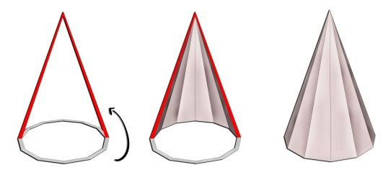
Figure 1: The steps of the formation of the outer shell of the conical dome through the Arch rotation around a polyhedral field (authors)
Later on, the idea of the double dome was introduced as it was recognized that there was a difference between the external appearance of the dome and the aesthetics of the interior of the domed space. The result was tall external domes with shallower interior domes (Petersen, 2002, p. 68).
The position and dimensions of stiffeners contribute to ensuring the monolithic behavior of the whole system. In the smaller domes, stiffeners control the crack pattern and evolution, but they are not very influential in the load capacity of the system. In larger domes, stiffeners were proven to be essential for the structural behavior under gravitational loads and for the seismic response of the system (Feizolahbeigi, et al., 2021, p. 1-2). Lightening, creating a hollow volume, creating a long cross-section, thermal insulation, and giving a human touch to the space are the advantages of using such domes (Esmaeili Sangari, 2015, p. 80). To increase the symbolic value of the building, the outer shell is always magnificent and placed on a long cylinder with a large diameter; While the inner shell had more human proportions (Bacigalupo, Cessari, and Fangi, 1998, p. 503). Discrete two-shell domes are a type of structure with different geometry and construction techniques in Iranian architecture (Feizolahbeigi, et al., 2021, p. 1).
5. Knowing the types and components of conical dome
Domes are classified into two groups: rec (conical) and nar (semi-hemispherical) (Tehrani and Mashayekhi, 2013, p. 292). These domes, with a different appearance from other domes, are known as discrete two-shells, which have separate two-shells; Its inner shell has a curved shape and its outer shell is usually a linear shape like a cone and a pyramid, which can be seen in many tombs and mills.Conical, polyhedral and pyramidal domes are among distinct features of Iranian domes which play an important role in the development of tomb towers and shrines (Korsavi and Aliabadi, 2015, p. 5). The climatic conditions of hot regions can be clearly seen on the architecture of its buildings, especially the formation of flat domes (Hayaty and Gomravi, 2020, p. 47).
The conical and pyramidal shape of the conical domes, placed on the base, provides more height and can be seen from a long distance (Memarian and Safaeipour, 2015, p. 508); however, its main and important role of neutralizing driving forces should not be neglected (Golabchi and Javani Dizaji, 2013, p. 160). The structural systems of Iranian domes have been diverse and thoughtful and several factors are involved in shaping the internal structure of the rack domes and their stability against the stresses resulting from various forces acting on them.
Poppy blades are the main factor in transferring the forces of the external cover of the dome. In order to better connect the elements of the dome and strengthen them against internal forces such as thrust, torsion and external forces such as wind and earthquake, Iranian architects have used poppies that rise to different heights depending on the type of dom (ValiBeig, Rahimi Ariaei, and Rahravi Poude, 2017, p. 201). The constituent elements of this dome include the following components (ValiBeig, Rahimi Ariaei, and Rahravi Poude, 2017, p. 201). The constituent elements of this dome include the following components.
1.5. Stiffeners Blades
Stiffener blades are the main factor in transferring the forces of the external cover of the dome. To better connect the elements of the dome and strengthen them against internal forces such as thrust, and rotation and external forces such as wind, and earthquake, Iranian architects have used Stiffeners that rise to different heights of the dome depending on the working conditions (ValiBeig, Rahimi Ariaei, and Rahravi Poude, 2017, p. 195) (Figure 4). The role of these walls in discrete two-shell domes is to mount and hold the Outer Shell or Khud on the Inner Shell or Ahianeh (Pirnia and Bozorgmehri, 1991, p. 79 & 86). These vertical interface blades, which are along the diameter of the two-layer base, cause a greater correlation of the space between the two layers. Each stiffener, as a joist, strengthens the walls of the tomb, makes it easier to bear the load of the dome, and facilitates the transfer of forces to the field (Mirlotfi and Ghazi Mirsaeid, 2005, p. 151). These vertical brick blocks, which are built together with the external shell and placed between the two shells, increase the dome's resistance by increasing the cross-sectional area of ​​the shell in several parts (Memarian and Safaeipour, 2015, p. 514). Since under the influence of compression and bending forces, the outer shell creates more stability for the Stiffeners; the architects built the poppy at the same time as the outer shell to create a greater connection between the two shells. Simple and natural examples of this pattern can be seen in nature and the poppy plant (Figures 3 A and B). Architectural patterns, similar to this natural pattern can be seen in the poppy structure in the rack domes (Figure 3C).
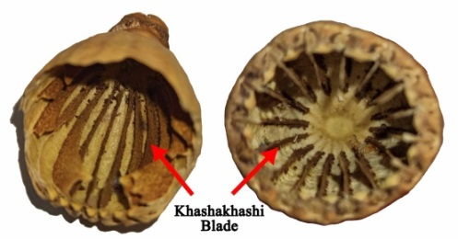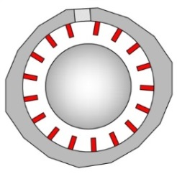
(a) (b) (c)
Figure 3: Slices of poppy fruit The fruit of the poppy plant (a,b), radial arrangement of Stiffeners blades inside the dome of Imamzadeh Mahmoud Ibn Mohammad Baqer (c)
Conical shells are mainly exposed to weight loads and bending, especially due to the high rise and small span (Danaeinia and Korsavi, 2017, p. 9). In some discontinuous double-shell domes, the construction of the two shells starts from the base, and meridian brick masonry walls or stiffeners are built in the space between the two shells (Fig. 1(d)). The upper and lower shells can have various shapes (Hejazi and Pourabedin, 2021, p. 3). These walls served as a stiffening membrane for the outer shell (Golombek and Wilber, 1988, p. 113). The outer shell is bigger at the points where the poppies are attached to it and prevents the outer movements of the shell and the Gareeve (Safaeipour, Haji Ebrahim Zargar, and Goudarzi, 2012, p. 5). From the design point of view, the geometry and proportions of the domes play an important role in their seismic behavior. The study of the geometry and proportions show that the ratio between the height and the diameter is an important parameter in the design of bulbous DDDs which determines the ability of the system to transfer loads and accommodate displacements and also affects the failure mechanism« (Feizolahbeigi, et al., 2021, p. 22).
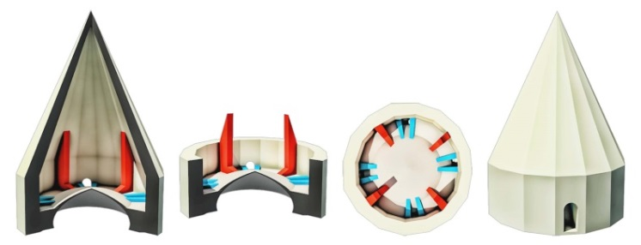
Figure 4: Graphical representation of the hierarchy of poppies and connecting belts in the two-layered space of the pyramid-shaped rack dome of Sultan Mirahmad's tomb.
With the increase in the height of the grave (dome stem), which plays an effective role in controlling the lateral thrust, the thrust force of the outer shell (self) increases; Therefore, poppies are used (Haji Ebrahim Zargar and Rooteh, 2018, p. 256). The design of Khashkhashi is aimed at raising and keeping the external shell balanced and has nothing to do with increasing the height of the dome. Poppies are used to control bending and carry heavy loads of the outer dome (Danaeinia and Korsavi, 2017, p. 11). In the structural behavior of discrete two-shell domes; Especially the control of tensile and compressive stresses, the fit between the geometric dimensions of the Stiffeners with the groove and the dome, especially in the height dimension, plays a decisive role (Feizollahbeig, Golabchi, and Rezazadeh, 2021, p. 41).
The stiffeners of the Conical dome of the tomb of Sultan Mirahmad in Kashan city, from point A to point B, were designed and executed based on the curvature of the external shell (Figure 5(a)) and the beginning of its bases in the form of a Racking Brick and a trapezoidal form the rear to the side of the top of the dome. The dome is elongated (Figure 5(b)). The rise of the dome and the dimensions of the Stiffeners are important and determining parameters between the geometric design and the structural system of the two-layered domes. In other words, the proportion between the dimensions of the Stiffeners, grave, and dome, especially in their height, plays a decisive role in the structural behavior of the system and the control of tensile and compressive stresses (Feizollahbeig, Golabchi, and Rezazadeh, 2021, p. 41). Thus, the stiffeners are effective in connecting the two shells and the drum, ensuring the monolithic behavior of the whole system (Feizolahbeigi, et al., 2021, p. 19).
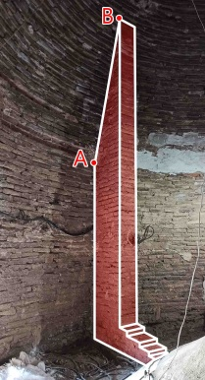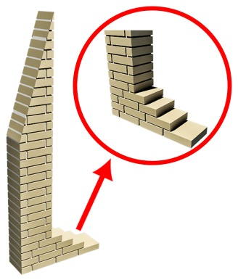
(a) (b)

Figure 5. stiffeners curve attached to the inner wall in the rack dome of Sultan Mirahmad's tombs (a) and details of Raking Back brickwork on its back (b)
If a force is applied to the building in different directions, its balance will be disturbed and cracks will be created in it; for this reason, the Buttress is used as a strong structure (Karimi, Abouei, and Heydari, 2016, p. 57). Khashkhashi also behaves similarly to Buttress Poppies transferring the weight of the outer shell to the stems. It is by using Khashkhashi that its resistance increases gradually (Esmaeili Sangari, 2015, p. 80).
From a technical point of view, the position and dimensions of stiffeners are effective in ensuring the monolithic behavior of the whole system. Results show that their incorporation into the structure has always had a beneficial effect on these structures, even when their influence on the seismic load capacity of the structure was not high (Feizolahbeigi, et al., 2021, p. 22). By using theoretical geometry along with practical geometry, the architect has been able to create discrete two-shell domes, and these two geometries are complementary to each other, which have a direct effect on the formation of the form and construction technology of these domes. Therefore, a deep understanding of their manufacturing technology helps to develop the necessary knowledge for their reconstruction or restoration based on technological knowledge (Feizollahbeigi, Golabchi, and Rezazadeh Ardebili, 2020, p. 46).
6. Samples
Among the historical cities of Iran, the city of Kashan has many values ​​in terms of the number and variety of dome architecture. Study examples include six important and well-known rack domes in Kashan City. (Figure 6). shows the location of the samples in the historical context of Kashan.
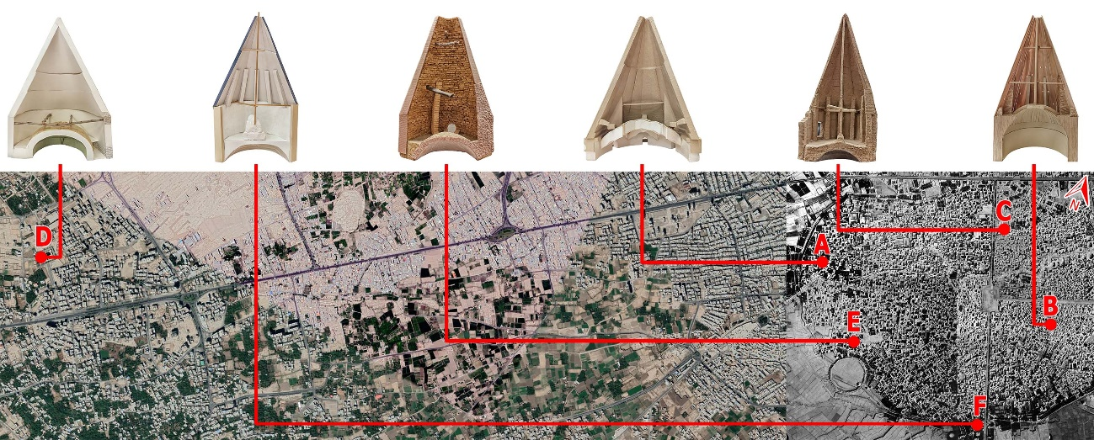
Figure 6: (A) Cheheltan Tomb, (B) Mirneshaneh Tomb, (C) Panja Shah Tomb, (D) Prince Ibrahim Tomb, (E) Sultan Mirahmad Tomb, (F) Sultan Atabakhsh Tomb.
1.6. Geometric Shape and Type of Poppies in Samples
The geometric shape of Khashkhashi is very diverse and none of them have the same shape. According to the base and height of the dome, the shape and height of Khashkhashi have varied.
The Chehltan mausoleum starts as an isosceles triangle from the end of the drum (gareeve) and the back and extends below its middle with a height of 3.15 meters. There are two types of short Khashkhashi in Mirneshaneh's tomb, both of which are executed from the level of the end of the drum and the back of the inner shell (Ahianeh). The long type is a combination of a vertical trapezoid and a diagonal obtuse triangle and is extended in its middle range with a height of 4.5 meters. In the short type, a simple form of a right-angled triangle with a total height of 65 cm is raised in the lower range of its middle. In the tomb of Panje Shah, the dimensions are a combination of a rectangle executed from the middle level of the drum and from the back and a right-angled triangle, which rises with a total height of 4.15 meters in its middle range of the outer shell (khud). In the mausoleum of Imamzadeh Sultan Mirahmad, there is a combination of the right and rectangular trapezium and a right-angled triangle, which extends from the middle of Khud with a total height of 3.4 meters. Here, according to the dimensions and height of the dome and to control the forces in the bases, the base of the poppies is connected to the roof in a raking back form (Figure 5 (b). In the tomb of Sultan Ata Bakhsh, which has the most complex volume composition among the types, using the technique of spreading and controlling the load through the increase of thickness in the bases, a rectangular volume is executed from the end of the Gareeve to the part of its thickness reduction, and then, three parallel-sided volumes in a linear form. It has been implemented with a total height of 4.05 meters in the range above the middle of outer shell . It is certain that to control the load from the Khashkhashi to the bases, the thickness of the Khashkhashi decreases from the base to the top. Table 1 shows the geometric form and general characteristics of Khashkhashi in the studied samples.
Table 1: Geometric form, general characteristics, and poppies Khashkhashi in the plan
Sultan atabakhsh (F) | Sultan amirahmad (E) | Shahzadeh Ibrahim(D) | Panjeshah (C) | Mirneshaneh (B) |  | Cheheltan (A) | Dome
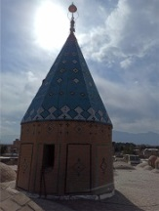 | 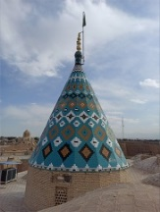 | 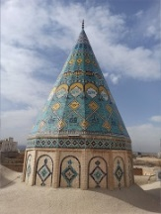 | 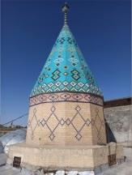 | 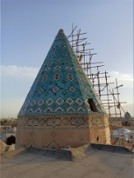 |  | 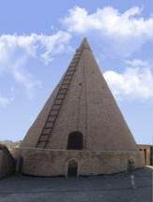 | View of the dome
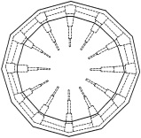 | 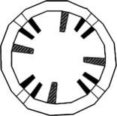 | 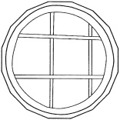 | 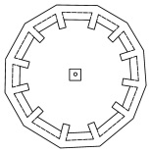 | 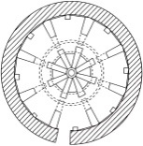 |  | 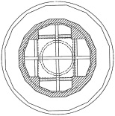 | Plan
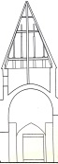 | 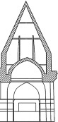 | 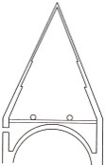 | 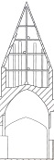 | 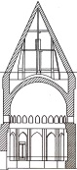 |  | 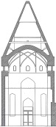 | Section
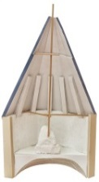 | 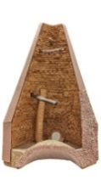 | 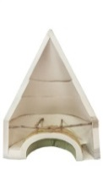 | 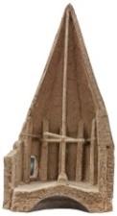 | 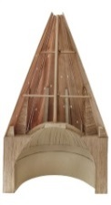 |  | 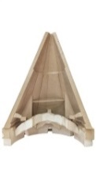 | Section Modeling
6.55 | 6.65 | 6.07 | 6.60 | 9.05 |  | 9.45 | Outer shell length | Dome
6.00 | 5.60 | 5.70 | 5.65 | 7.20 |  | 8.10 | Height | Dome
4.00 | 4.60 | 4.80 | 3.85 | 6.50 |  | 6.95 | Span | Dome
1.50 | 1.22 | 1.19 | 1.47 | 1.11 |  | 1.17 | Rise of Dome | Dome
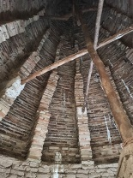 | 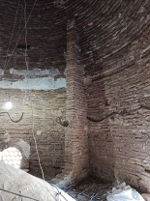 | 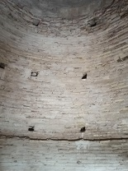 | 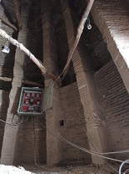 | 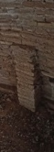 | 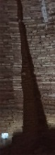 | 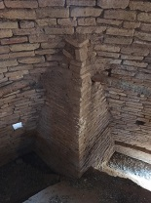 | Picture of khashkhashi
12 | 4 | No Stiffener | 12 | 8 | 8 | 4 | Numbers | khashkhashi
4.05 | 3.40 | No Stiffener | 4.15 | 0.65 | 4.50 | 3.15 | Height | khashkhashi
0.30 | 1.10 | No Stiffener | 0.50 | 0.17 | 1.00 | 0.90 | Width | khashkhashi
Upper | Lower | No Stiffener | Middle | Lower | Middle | Lower | Endpoint | khashkhashi
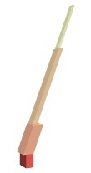 | 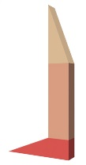 | No Stiffener | 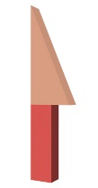 |  |  |  | Graphic shape | khashkhashi
Rectangle | Right Trapezoid | No Stiffener | Rectangle | Right Triangle | Right Trapezoid | Isosceles Triangle | Type of geometric compounds | khashkhashi
Parallelogram (Linear)
Parallelogram (Linear) | Rectangle | No Stiffener | Right Triangle | Right Triangle | Obtuse Triangle | Isosceles Triangle | Type of geometric compounds | khashkhashi
Parallelogram (Linear) | Right Triangle | No Stiffener | Right Triangle | Right Triangle | Parallelogram (Linear) | Isosceles Triangle | Type of geometric compounds | khashkhashi
4 Sections | 3 Sections | - | 2 Sections | 1 Section | 3 Sections | 1 Section | Type of geometric compounds | khashkhashi
Complex | Complex | - | Complex | Simple | Complex | Simple | Type of geometric compounds | khashkhashi

In determining the relationship between the geometrical plan and the structural system of discrete two-shell domes, the rise of the dome and the dimensions of the poppy are important parameters (Feizollahbeig, Golabchi, and Rezazadeh, 2021, p. 41).
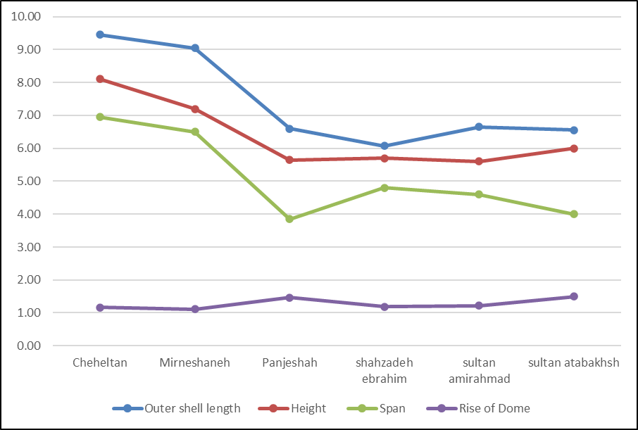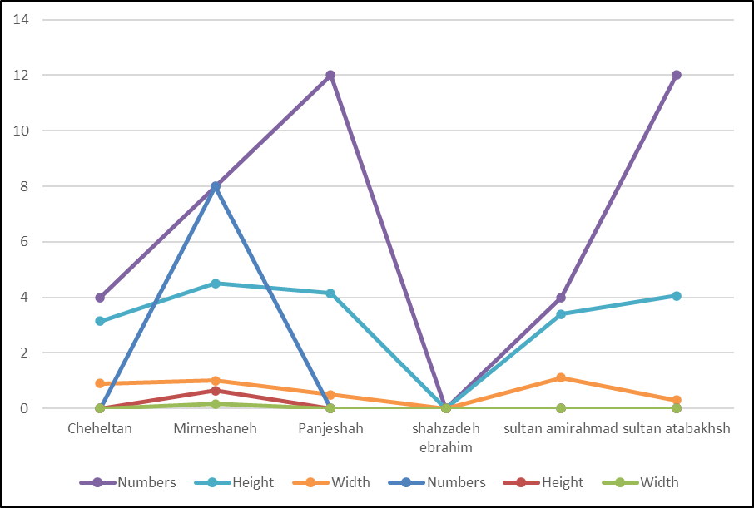
(a) (b)
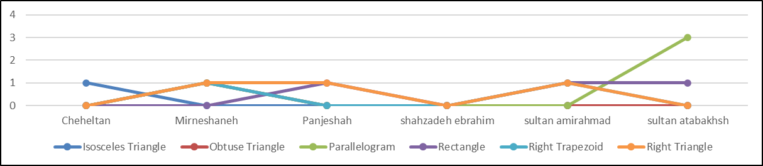
(c)
Figure 7. Characteristics of outer shell length, height, span, the rise of species (a) graph of the number, length, and width of poppies in species (b), frequency of volumes forming the form of Khashkhashi among species (c)
2.6. Curling Technique
Stitching and sewing the components of the Khashkhashi at different distances from the base to the top, or the coiling technique, is one of the most important measures that architects have used to stabilize the dome structure and connect it with the Khashkhashi.
Several thin, deep spur walls rested on the shoulders of the inner dome and appeared to have been bonded into the fabric of the exterior dome. Wood poles connected the adjacent spur walls and the central column (Golombek and Wilber, 1988, p. 114).
In Kalafkeshi, the main components of the building are twisted together by wood and have different functions based on the location and shape of the building. To create integrity in the structure of Kalafkeshi, they are connected with wooden coils (Figure 8 (a)). These horizontal coils, which are executed in different shapes (in diameter or the form of an intertwined network), are connected to the vertical rod (Shahang) that extends vertically from the roof to the top of the dome (Figure 8 (b)).
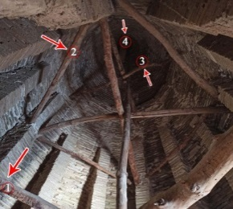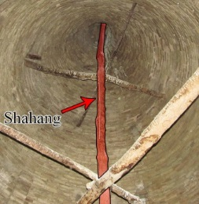

(a) (b)
Figure 8. Performance of four rows of coils in the dome of the tomb of Panjeshah (a) and the representation of Shahang in the dome of the tomb of Mirneshaneh (b).
The various techniques of coiling play an important role in the stability of rack domes. Connections between Khashkhashi, and inner and outer shells have a great effect in transferring forces to the dome (Valibeig, Rahravi Poudeh, and Rahimi Ariayi, 2016, p. 90). To maintain horizontal thrust, Khashkhashi walls are attached to the outer dome and embedded wooden elements connect them to the inner dome (Tavakoli Dinani, Sadeghi, and Lourenço, 2019, p. 90). These coils, in addition to helping the dome structure against forces such as soil settlement, earthquakes, wind, and the weight of the structure, are also used as scaffolding (Safaeipour, Haji Ebrahim Zargar, and Goudarzi, 2012, p. 6) (Figure 9 (a). In other words, during the construction of the dome, interlocking wooden coils may be used to balance horizontal thrusts or act as scaffolding on three levels of unsupported walls (Tavakoli Dinani, Sadeghi, and Lourenço, 2019, p. 90). The horizontal pieces of wood by repeating in three or four stages of the height of Shahang prevent the foundations from separating from each other. In some cases, due to the lack of support necessary for the coils to engage with the structure, a part of the two ends of the coils penetrates the heart of the outer shell and comes out of it, and this part will be visible from the outside (Figure 9 (b)).
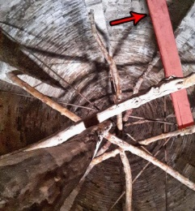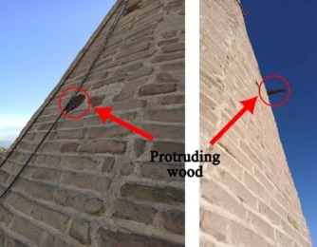
(a) (b)
Figure 9. The role of Khashkhashi as scaffolding in the tomb of Tahir and Mansour (a), the Kalaf protruding from its shell in the rack dome of Mirneshaneh(b).
In this way, Khashkhashi and the wooden coiling network system play an essential role in improving the connections of double-shell domes (Bacigalupo, Cessari, and Fangi, 1998, p. 94).
Table 2: The position of the coils in the space of the dome and how they are connected with the Khashkhashi in the study samples.
Sultan Atabakhsh | Sultan Amirahmad | Shahzadeh Ibrahim | Panjeshah | Mirneshaneh | Cheheltan | Shrine
 |  |  |  |  |  | Section
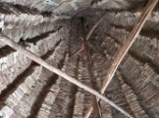 | 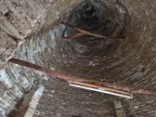 | 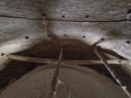 | 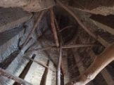 | 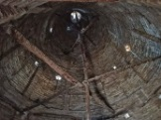 | 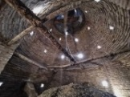 | Picture
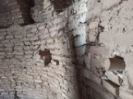 | 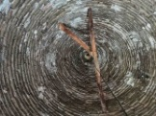 | 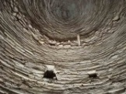 | 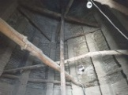 | 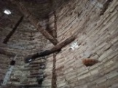 | 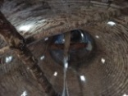
3 | 2 | 1 | 4 | 3 | 3 | Number of Wooden Struts
 | - | - |  |  | - | Vertical | Coiling Technique
 |  |  |  |  |  | Chord | Coiling Technique
- | - | - |  |  |  | Orbital | Coiling Technique
- |  | - | - |  | - | Radial | Coiling Technique
 | - |  |  |  | - | Sliced | Coiling Technique

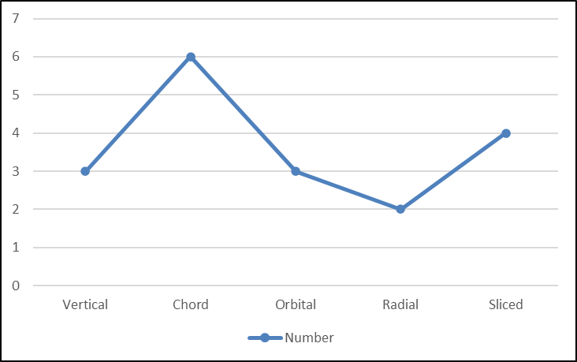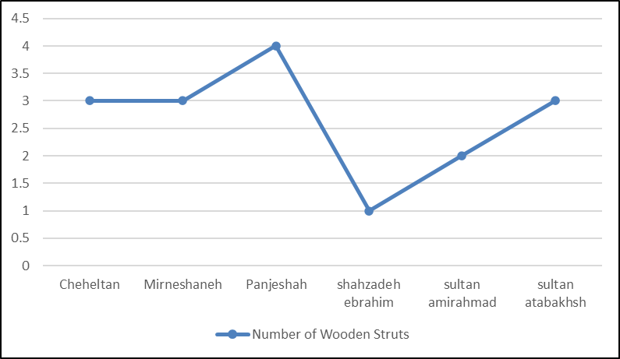
(a) (b)
Figure 10. The number of coiling rows in species (a), the frequency of coiling techniques in species (b).
In all the rack domes, the coiling system has been used as a fixed structural solution. According to the coiling techniques of poppies and rack domes in case examples (Table 2), five types of coils have been used to connect the poppy to the Outer Shell (Khud). These coils include the vertical coil: (the connecting factor of the inner and outer shell and the factor of neutralizing the dead load and compressive stress of the outer dome), the Orbital coil: (horizontally and around the upright domes and stabilizes the poppies as well as the entire structural system of the dome against shear stresses and breakage from lateral forces), Radial coil: (the connecting factor between the center and the outer shell of the dome), cross-sectional coil (cut): It is placed in the intervals of the vertical ridges of the dome and for better homogeneity and distribution of forces.
3.6. Reduce Thickness in the Outer Shell (Khud)
To reduce the weight load of the outer shell of conical domes, the thickness of the shell is reduced at different times; In such a way that the thickness of the shell is the thinnest at the top. This reduction in thickness is a function of the opening, height, and rise of the dome. At the junction of the outer shell and the Drum (Gareeve), this reduction in thickness is not a criterion. Generally, the restraining wooden coils, which are attached to the structure at the same time as the poppy and the outer shell, occur at the place where the thickness of the shell decreases, and their number and row changes depending on the height of the dome.
The restraining wooden coils, which are connected to the structure at the same time as the poppy and the outer shell, are created at the place where the thickness of the shell decreases, and their number and row varies depending on the height of the dome.
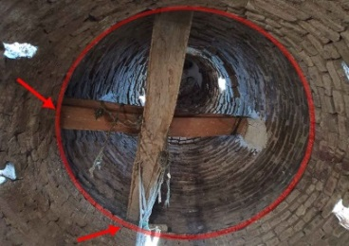
Figure 11. The reduction of thickness in the Cheheltan tomb.
Table 3: Examining structural details in case studies
Sultan atabakhsh | Sultan amirahmad |  | Shahzadeh Ibrahim | Panjeshah | Mirneshaneh | Cheheltan |  | Shrine
 |  |  |  |  |  |  |  | Plan
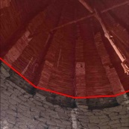 | - |  | 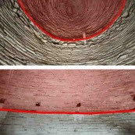 | 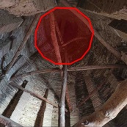 | 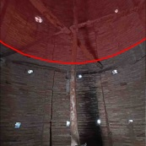 | 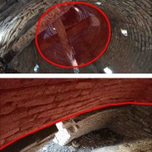 |  | Thickness Reduction Place of Outer Sell
Lower |  |  | Lower & Middle | Upper | Lower | Lower & Upper |  | Thickness Reduction Place of Outer Sell
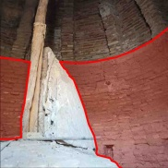 | - |  | - | 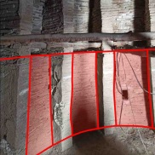 | - | - |  | Increase the Thickness of The Drum
- | - |  | - | - | 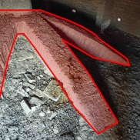 | - |  | Palanehsazi
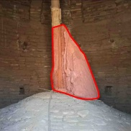 | - |  | - | 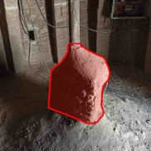 | 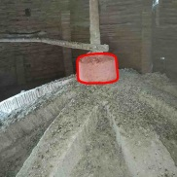 | - |  | Shangeh
- | 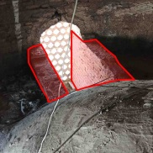 |  | - | - | - | 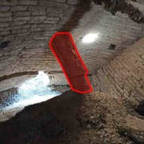 |  | Connector Belt
- | Wall | 8 Piece | - | - | - | Chafd | 4 Piece | Connector Belt

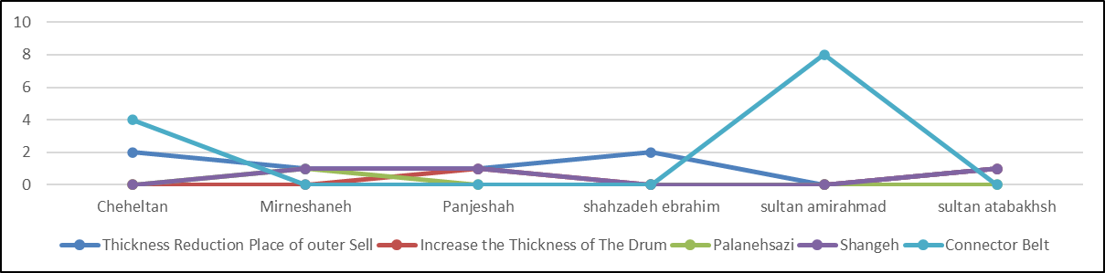
Figure 12. Representation of the frequency of self-thickness reduction, drum (Gareeve) thickness increase, Palanehsazi, shangeh, and connecting belt in case studies.
4.6. Increasing the Thickness of the Drum (Garive)
To make the Khashkhashi more stable and transfer the weight load from the outer shell to the bases better, the dome is thicker in the drum (Gareeve) area. This increase in thickness provided more support in the drum area and more stability of the base, creating a space so that the large primary wooden coils could be mounted on it (Figure 13). The diameter of the drum is directly related to the amount of load and changes accordingly (Feizollahbeig, Golabchi, and Rezazadeh, 2021, p. 41).
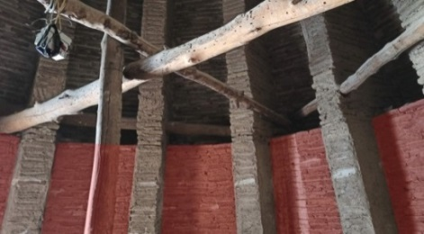
Figure 13. Increasing the thickness of Drum in Panje Shah tomb

5.6. The technique of raising (Palanehsazi) and using Shangeh (a short cubic brick)
In order to prevent the lateral pressure of the poppies on the inner shell, polygonal bearing arches are implemented on the inner shell to prevent the pressure of the poppies on it.
(Figure 14). This technique is called Palanehsazi (Rajabi and Mozafari, 2013, p. 144), which is one of the fixed structural components in conical domes (Fallahfar, 2009, p. 53). This Palanehsazi is implemented so that the load of Shahang is not placed directly on the inner shell and does not cause pressure and destruction.
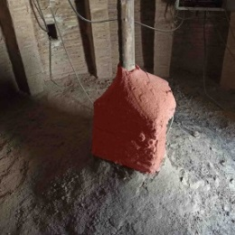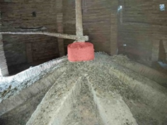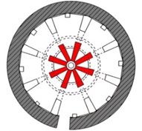
(a) (b) (c)
Figure 14. Shenge column placed on Panjeshah tomb conical dome (a), use of Palanehsazi technique on the Inner shell of Imamzade Mirneshaneh tomb conical dome (b), reverse plan of Palanehsazi technique in the conical dome of Imamzade Mirneshaneh (c).
6.6. Connecting Belt
These belts are strip-shaped brick blocks that are placed between the outer shell and Inner Shell and cause better control and distribution of forces. In addition, in the place of the bases, they create a better connection between the outer shell, Inner Shell, and the Khashkhashi (Figure 3((a,b)).
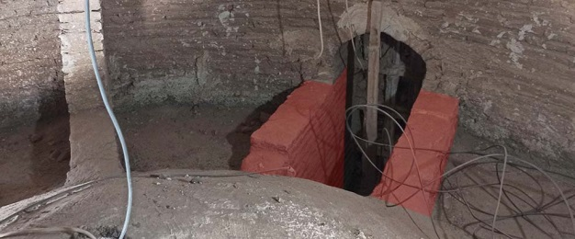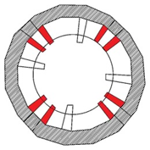
(a) (b)
Figure 15. The location of the connecting belt in the plan (a), and the position of the thick walls between the connecting belt in the conical dome of Imamzade Sultan Mirahmad's tomb (b).
7. Findings
Conical domes emerge from a certain arc cycle around a vertical axis (Figure 1). The cross-section of these domes shows the decreasing process of the thickness of the outer shell from the grave to the top of the dome (Figure 2). As the height increases and the opening decreases, the rise of the rack domes will increase.
2.7. The Main Factors in Shaping the Structure
According to the conical domes, major factors are involved in their structural structure as follows:
Khashkhashi blades act similarly to the protective fins of the outer shell of the poppy fruit and protect the internal parts. (Figure 3((a,b)). Based on Table 1, the Khashkhashi form is a function of the curvature of the slope of the outer shell. In some domes, such as Mirneshaneh, Panje Shah, Sultan Mirahmad, and Sultan Atabakhsh, Khashkhashi are placed in the form of regular radial blades around the axis of the dome; if there is no winged geometry in the dome of the Cheheltan tomb; Rather, it is thick brick blocks with a plan similar to a quarter circle. Depending on the shape and height of the dome, the beginning of the khashkhashi, the place where the khashkhashi rises and the bases of the khashkhashi in the examined domes are different. Based on Table 1 and Figure 7 (b), except for the flat dome of Shahzadeh Ibrahim's tomb, which does not have any khashkhashi, the number of khashkhashi in other species is even.
2.2.7. Wooden Struts
The number of Wooden Struts in the samples also has a high variety. Based on Table 2 and Figure 10 (a), the number of Wooden Struts in Shahzadeh Ibrahim's tomb is one row, which has the lowest value among the types; also, there are two rows in the dome of Sultan Mirahmad's tomb, and three rows in the tombs of Cheheltan, Mirneshaneh and Sultan Atabakhsh. Panje Shah's tomb has the largest number with four rows of Wooden Struts.

3.2.7. Reducing Outer Shell (Khud)-thickness, increasing Garive thickness, Palanehsazi, Shangeh (A Short Cubic Brick), and connecting belt
Based on Table 3 and Figure 12, it can be said that:
The place where thickness is reduced in the upright domes of the tombs of Mirneshaneh and Sultan Atabakhsh, below the middle of the dome, and in the tomb of Panje Shah, above the middle of the dome; also, this reduction in thickness has been implemented in the conical dome of Cheheltan tomb in the lower and upper middle of the dome and the conical dome of Shahzadeh Ibrahim tomb in the middle and below the middle range. The technique of reducing the thickness of the outer shell was not used in the dome of the tomb of Sultan Mirahmad, which has the lowest height among the types. In the conical dome of the Cheheltan tomb, by using the technique of reducing its thickness, a support has been created for placing the string struts.
Based on Tables 1, 2, and 3, small and large Khashkhashi, Wooden Struts, reducing its thickness, Palanehsazi and Shangeh (a Short cubic brick), increasing the thickness of ring Drum and connecting belt, are the techniques that have been used for the stability of the structure depending on the dimensions of the conical dome.
8. Result
Straight domes, which are created around a vertical axis from a specific arc, are considered double-shell domes. The thickness of the outer shell and the number of Khashkhashi vary according to the height and opening, and accordingly, the rise of the dome also varies. In other words, the rise has a direct relationship with the height of the dome. As the rise of the dome increases, the number of Khashkhashi increases, and since the stability of straight domes has a direct relationship with their rise, the role, and importance of structural techniques in them are revealed.
In response to the first question of the research, it should be said that the Khashkhashi are the main force transfer factor of the outer shell of the conical dome and are effective in stabilizing and controlling the tensions in the domes. Depending on the conditions and direction to deal with internal and external forces, architects use Khashkhashi of different heights. The basis of the formation of the shape of the Khashkhashi is a function of the curvature of the external shell of the dome, and based on the calculations of the architect, their shape and geometric type do not follow a fixed pattern. Not all domes are necessarily Khashkhashi racks and another technique may be used instead. Khashkhashi can be divided into small and large according to their geometric volume and height. Also, Khashkhashi is divided into two types, simple and combined, in terms of the geometrical composition of its constituent volumes. The simple type consists of only one type of geometric volume; In the case of the combined type, the complexity increases, and more than one type of geometric volume is used in their structure. The execution of the Khashkhashi mainly extends from the back to the tip of the dome and is rarely executed from the niche obtained from the thickness of the ring groove.
Wooden Struts are one of the other solutions of Iranian architects to deal with the tensions in conical domes. The coils at different intervals cause the sewing and dosage of different components of the domes and create different functions; In other words, they can play a functional role in dealing with different forces and play a structural role during construction or in necessary situations such as repairs of different sections between the two hulls. In general, five types of coils are used in conical domes. The first type is a vertical coil that connects the outer and inner shells. The second type is the sectional coils, which are in the form of cut sticks that are used in their thickness to better distribute the forces. The third type is a string coil that is used horizontally along the span. The string coil controls its tensile stress and restrains it. Connecting this coil to the vertical coil, while increasing its stability, causes maximum stability in the dome structure. In terms of frequency, this coil has the highest number of all of the samples. The fourth type is an orbital coil that, while rotating horizontally around the dome, creates an arrangement of a surrounding polygon that stabilizes the dome against lateral forces such as wind and earthquakes.
The fifth type of Wooden Strut called radial bracing, which connects the geometric center of the rack dome to the outer shell of the dome (Khud). These Struts may rely on the outer shell on one side and the string coil or vertical coil on the other side. Among the examined samples, this coil has been used in a limited way. In this way, it can be seen that the use of coiling is present in the structure of all the conical domes and the architect has never been satisfied with using one method.
At least two techniques are used in the method of Wooden Struts, and in some cases, the architect has used all five techniques in the Wooden Struts method, which indicates the diversity in the Wooden Struts method of such domes, and this makes the domes more stable. The number of Wooden Struts rows is also varied. The minimum is one row and the maximum is four rows.
In response to the second question of the research, in addition to the application of Wooden Struts techniques and types of Wooden Struts in strengthening the conical dome connections, other influential parameters also play a fundamental role in the construction process of such domes. One of the most important of them is the place of reducing its thickness, which helps to reduce the dead load and provide more stability in the dome. Due to this technique, as we approach the top of the dome, its thickness decreases to a certain ratio. In some cases, by increasing the thickness of the drum, while the load resulting from the weight of the outer shell is better transferred to the bases, it leads to a better connection of the Drum to each other and the outer shell. The stability of conical domes cannot be ensured only by increasing the thickness of the drum. To prevent the inner shell from breaking due to the pressure of the outer shell, the technique of Palanehsazi or using a brick column called Shangeh, (A Short Cubic Brick) is used; therefore, the necessity of using these two techniques is the existence of vertical Struts. The Small Brick Column (Pillar) of the Shangeh (a short cubic brick) is combined with the Shahang and by increasing the cross-section of the base of the vertical Struts, they prevent the collapse of the inner shell (Ahianeh).
9. Future research horizons
Other indicators are also effective in the stability of the dome structure, which can be investigated in future research. Indicators such as the thickness of the double layer, the basis for choosing the type of cover of the outer dome, the arrangement of materials, and the criteria for determining the springiness of the outer dome are very effective.

References
Abbaszadeh, M., & Danesh, L. (2023). Econstruction of the dome of seh-gonbad tombtower in urmia based on architectural documents. Journal of Iranian Architecture Studies, 12 (23), 117-133. doi: 10.22052/jias.2023.246597.1075.
Akbari, Z., Neyestani, J., Hejebri nobari, A., & Nasiri, M. R. (2023). The Process of Changes in the Appearance and Structural Elements of Bulbous Domes During the Timurid and Safavid Period in Central Asia and Iran. Parseh Journal of Archaeological Studies, 7 (23), 243-264. doi:10.30699/PJAS.7.23.243.
Akkach, S. (2005). Cosmology and architecture in premodern Islam: An architectural reading of mystical ideas. Albany, USA: State University of New York Press.
Ardalan, N., & Bakhtiar, L. (1973). The Sense of Unity: The Sufi tradition in Persian architecture. United States: University of Chicago Press.
Bacigalupo, C., Cessari, L., & Fangi, G. (1998). Geometric monitoring and integration of geodetic survey techniques to improve the knowledge of historic buildings. International Archives of Photogrammetry and Remote Sensing, 32 (5), 502-506.
Behrens-Abouseif, D. (1998). Islamic architecture in Cairo: An introduction. 3rd ed. Leiden, The Netherlands: E. J. Brill.
Choisy, A. (1899). Histoire de l'architecture (Vol. 2). Paris: Gauthier-Villars.
Danaeinia, A., & Korsavi, S. (2017). Techniques to carry weight loads and resist against bending in conical shells, studying case studies of Kashan. International Journal of Architectural Engineering & Urban Planning, 27 (1), 9-18. doi: 10.22068/ijaup.27.1.9.
Esmaeili Sangari, H. (2015). The Teachings of the restoration of historic buildings (3rd ed). Tabriz: Frouzesh Publications.
Fallahfar, S. (2009). Dictionary of traditional Iranian architecture (2nd ed). Tehran: Kavoshpardaz.
Feizolahbeigi, A., Lourenço, P. B., Golabchi, M., Ortega, J., & Rezazadeh, M. (2021). Discussion of the role of geometry, proportion, and construction techniques in the seismic behavior of 16th to 18th century bulbous discontinuous double shell domes in central Iran. Journal of Building Engineering, 33, 101575. doi 10.1016/j.jobe.2020.101575.
Feizollahbeig, A., Golabchi, M., & Rezazadeh, M. (2021). An investigation in geometry and proportion in relation with structural systems in buildings with discontinuous double shell domes in tafresh region. Soffeh, 31 (3), 21-42. doi: 10.52547/SOFEH.31.3.21.
Feizollahbeigi, A., Golabchi, M., & Rezazadeh ardebili, M. (2020). Analysis of theoretical and practical geometry of Abbasi jame mosque's discontinuous double shell dome. Honar-Ha-Ye-Ziba: Memary Va Shahrsazi, 24 (4), 35-48. doi: 10.22059/JFAUP.2020.279322.672253.
Galdieri, E. (1999). Restoration of a brick dome, an experience of Iran (Trans: Fakhari Tehrani, F). Soffeh, 9 (28), 72-77.
Godard, A., & Godard, Y. (2011). Vault and arch in the forms architecture of Iran. (1st ed, Trans: Gharagozloo and S. Saemi, H). Tehran: Modiran Emrooz.
Golabchi, M., & Javani Dizaji, A. (2013). Iranian architecture technology (1st ed). Tehran: University of Tehran Press.
Golombek, L., & Newton Wilber, D. (1988). The Timurid architecture of Iran and Turan (Vol. 1). Princeton, New Jersey: Princeton University Press.
Haji Ebrahim Zargar, A., & Mirhashemi Rooteh, S. E. (2018). An introduction to historic buildings restoration techniques (1st ed). Tehran: Shahid Beheshti University, Printing & Publishing Center.
Hayaty, H., & Gomravi, K. (2020). A Typology and Comparative Study of the Architecture of the Blessed Sacred Architecture of the Islamic Period (Case Study: Historical Monument of Shoushtar City). Journal of Architectural Thought, 5 (9), 40-54. doi: 10.30479/at.2020.12936.1472.
Hejazi, M., & Pourabedin, M. (2021). Performance of Persian brick masonry discontinuous double-shell domes against earthquakes. Engineering Failure Analysis, 119, 104994.
Hillenbrand, R. (2010). Islamic architecture: Form, function, and meaning (5th ed, Trans: Ayatollahzadeh Shirazi, B). Tehran: Rowzaneh Publication.
Korsavi, S., & Aliabadi, M. (2015). Geometry and Proportion of Conical Domes' Plans in Iran: Reviewing Case Studies. Journal of Architectural Engineering Technology, 4 (1). doi:10.4172/2168-9717.1000137.
Kashani, G. J. (1987). Rasaleh tagh va azaj. (Trans: Jazbi, S. A). Tehran: Soroush.
Karimi, N., Abouei, R., & Heydari, D. (2016). Typology and developments in buttresses from the beginning to the historical era in Iranian architecture. Bagh-e Nazar, 13 (40), 55-68.
Leacroft, H., & Leacroft, R. (1976). The Buildings of Early Islam (1st ed). London: Hodder & Stoughton.
Memarian, G. H., & Safaeipour, H. (2015). Iranian architecture: Its structure and construction (2nd ed, Vol. 2). Tehran: Now-Andish.
Mirlotfi, S. J., & Ghazi Mirsaeid, S. Z. (2005). Introduction to Iranian Architecture: Persian and Parthian style and arched structures (1st ed). Tehran: Ghazi Publications.
Petersen, A. (2002). Dictionary of Islamic architecture. United Kingdom: Taylor & Francis e-Library.
Petralla, S. (2013). Historical vaulted constructions of the Iranian heritage. 2nd International Balkans Conference on Challenges of Civil Engineering (BCCCE: 1036-1029). Tirana, Albania: Epoka University.
Pirnia, M. K., & Bozorgmehri, Z. (1991). Dome in Persian Architecture. Asar, 12 (20), 156.
Pope, A. U., & Ackerman, P. (2008). A survey of Persian art: From prehistoric times to the present (1st ed, Trans: Daryabandari, N., Vol. 3). Tehran: Elmifarhangi Publications.
Pourabedin, M. (2018). Structural behavior of Persian brick masonry discontinuous double-shell domes against earthquakes. Master's Thesis. Department of Civil Engineering.
Rafiei Sereshki, B., Rafizadeh, N., & Ranjbar Kermani, A. M. (2004). Descriptive dictionary of Persian architecture (1st ed, Vol. G-362). Tehran: Building and Housing Research Center.
Rajabi, M., & Mozafari, A. (2013). Theory and practice in historical monuments (1st ed). Tehran: Jamal-e Honar Publications.
Safaeipour, H., Haji Ebrahim Zargar, A., & Goudarzi, S. (2012). Typology of Khashkhashi (stiffeners) in discontinuous double-shell domes. Domes in the World, Florence, Italy, 1-19.
Tavakoli Dinani, A., Sadeghi, S., & Lourenço, P. B. (2019). A double dome through the ages: Building technology and performance of Isfahān Shah mosque’s dome. 11th International Conference on Structural Analysis of Historical Constructions, 87-95. Cham: Springer. doi: 10.1007/978-3-319-99441-3_8.
Tehrani, F., & Mashayekhi, M. (2013). Iterative ratios in the fractal geometry of urchīn domes. Journal for the History of Science, 11 (2), 291-310.
ValiBeig, N., Rahimi Ariaei, A., & Rahravi Poude, S. (2017). Persian architect's mastery over geometry to build discontinuous double-skin domes in Nain style. Pazhoheshha-ye Bastan Shenasi Iran, 7 (14), 191-206. doi: 10.22084/NBSH.2017.6824.1286.
Valibeig, N., Rahravi Poudeh, S., & Rahimi Ariayi, A. (2016). Disconnected double-shell domes: Geometry and construction. Soffeh, 26 (73), 85-104. doi: 20.1001.1.1683870.1395.26.2.5.0.
Wahdattalab, M., & Rezaiezadeh, E. (2016). Morphology of Domes; A study about aesthetic proportions and distribution of domes of mosques across the central Iranian plateau. CIAUJ, 2 (1), :109-122. doi: 10.29252/ciauj.2.1.109.
Yari, F., S. Silvayeh, Goodarzi, M., Amiri, A., & Hoorshenas, R. (2016). The Stability of Dome Structures in the Iranian Traditional Architecture, case study: Dome of taj-al-molk. Journal of Architectural Engineering Technology, 5 (2), 1-7. doi: 10.4172/2168-9717.1000164.

During the 14th and 15th centuries, the smooth conical form was replaced by a pyramidal form in which the conical form is made of flat plates that meet at the apex (Petersen, 2002, p. 123). e
. According to some architects, the reason for using this type of coil is like a rebar placed in concrete, which increases the tolerance of the tensile force in outer shell (Khud) ; (Vali Beig, Rahimi Ariaei, and Rahravi Poude, 2017, p. 201).
. The placement of wooden coils in Nar domes is a function of the tensile and compressive forces entering the dome and is usually placed at every 22.5 degrees of the dome angle and in line with the change of the axis of the tensile and compressive forces. According to the amount of load, the way of arrangement of clays, openings and risers, as well as their location depends on the type and conditions of implementation.

