Confrontation of Iranian Contemporary Architecture with Electronic era
Seyed Gholamreza Islami∗ and Somayeh Ebrahimi∗∗

Department of Art and Architecture,
Science and Research Branch, Islamic Azad University, Tehran, Iran

Confrontation of Iranian Contemporary Architecture with Electronic era

Abstract
Technology has many influences on the Iranian society in different eras. Today, information and telecommunication technology have revolutionized basic structures of society and new network society has been propagated inside traditional and semi modern context. In countries like Iran, which are in the way of modernization, a chaos deriving from the transition period is observed that leads to anomaly. In transition era the norms of traditional societies which offer discipline into these societies have been eliminated and new norms are not codified.
The transmission to new situation and following that confrontation with electronic world has instigated many disorders and anomalies in society's structure, with its physical expression portrayed in contemporary architecture. Today, architecture, according to social anomalies of transmission era, is affected by Kitsch art and a very visual architecture. Information viruses, by using visual attractive capsules and human's habitat of imitation, spread every where and change physical world dramatically, with propagation of networks making this process even faster.
This paper reviews confrontation of Iranian architecture with electronic world and the role of visual viruses in formation of physical body of Tehran. It seems that in the future, emphasis on the principles of design supported by collective intelligence [1] and individual creativity can decrease physical anomalies in built environment.

Key words: transmission era, social anomaly, visual viruses.

1-Introduction
By the end of the second millennium, a number of significant events deriving from science and technology advances have been occurred that revolutionized human life. It is said that industrial revolution transformed our environment and beholden to the production of automobiles, train, airplane and other instruments, spatial distances were conquered and places got closer to each other leading to an increase in relations. Contrary to the classic age, in which the world changes presumed to be linear, regular and predictable, new theories such as String Theory, Chaos, Quantum and Special Relativity depicted a non linear and dynamic picture of the world changing process in which widespread relations between the parts has made them closer to each other [2]. Moreover, concepts of space and time have been revolutionized in network societies and nowadays, human life is formed based on the flows of information. New world is a multidisciplinary and has made us confused; from this point of view we failed in finding our position in network society. According to Castells, “…we are not living in a global village, but in customized cottages globally produced and locally distributed” [3].
Globalization, crisis of identity, attempt for survival, sustainable development and other social concepts demonstrate the changes. Architecture can help new societies to establish effective ties with surrounding environment, transforming future world, past time, and tradition. In this situation, architecture, as the body and soul of a society, will express society progression and its anomalies. Iranian Contemporary Architecture, also, is such a mirror which can show all changes and anomalies in Iranian society during the transmission era by emphasis on confrontation with electronic world.

2-Transition to modern society
Iranian contemporary architecture affected by the modernity, industrialization and globalization movements. Transition to the modern society has been started one century ago and un appropriate management, sudden population growth (according to increase in public health level) and numerous immigration in to urban areas are among the parameters with negative impacts on Iranian architecture, thereby the quantitative growth and qualitative reduction resulted in construction low quality buildings as a secured investment. This speculative investment substitutes many productive operations and flourish the housing market leading to a false increase in prices.
Today, the governing soul of architecture is pluralism in which individualism and egotism are dominant features and collective intelligence and knowledgeable participation as requirements for establishing a coordinated system remained oblivious. Chaos and divergence is a main feature which architecture grappling with. According to Edward Hall, population explosion in cities has led to deteriorating behavior circles even more devastating than the hydrogen bombs.
Growth in quantitative needs culminates into widespread construction of residential accommodations mainly carried out by individual constructors (without efficient skills) construction companies and the government that perform mass production.

3-Anomalies in Iranian society and architecture during transition to modernity
Urbanization and industrialization have changed traditional life style and demolished many moral values and concepts. In this new condition, no new set of values and norms have been created. According to Durkheim (1897), anomaly is the feature of societies during transition period. The norms of traditional societies which offer discipline into these societies have been eliminated and new norms are not codified [4].
Contemporary architecture is the embodiment of our society and the chaos and anomaly is its main feature. Many ideas of modern architecture such as wide and direct streets, Intra and extra city highways, skyscrapers and high rising has been manipulated and used in our built environment. Emphasis on detaching from the past led to destruction and demolition of many of traditional valuable urban textures. Imitation from modern style and patterns not only failed to convert plurality to unity but also exacerbated the matter of regional and domestic identities in many societies (The identity is the distinguishing feature from one person to the other and from society to the other society), In this process many of the valuable concepts that posed by modern movement to remove discrimination have lost their real implications through misunderstanding and converted into the anti-values.
The modern movement has transformed our homes and towns structure and created superficial and sometimes deep alterations in Iranian lifestyle. In the following section the impacts of modern architecture expressed briefly.

3-1-Iranian modern architecture
Increase in number and dimension of towns and mega cities, growth in number of small towns (conversion of villages into towns), relative stability in medium size towns are basic changes which occurred during transition to modern society. Injudicious population growth and immigration to cities in recent decades brought physical growth to the towns. This process culminates to gradual formation of the new towns particularly around the mega cities.
In Tehran as a global city, these changes are more widespread and noticeable. In figures 1 and 2 a same district of north of Tehran in two different period of time is seen. The high risings with modern cubic, pyramid and other varied forms are seen, suggesting a special approach in design modern building.

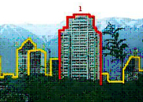
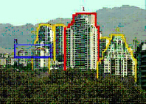
Figure1.urban texture, north of Tehran
www.worldisround.com

Figure2. urban texture, north of Tehran.
http://en.wikipedia.org

Today modern and mechanized life requires ever increasing development of transportation infrastructures. Development of highway networks in recent decades has changed the urban textures particularly historical towns and eliminated the integrity and beauty of traditional architecture. We need these transportation networks and must develop them continuously although the development process modality is very important.
It is obvious that many of these modern public spaces have been constructed without efficient respect the matter of quality. However, the role of economical, social and cultural factors shall not be ignored in this issue.
The Iranians are pacing forward to the modernity and require special and new spaces such as underground stations, technology parks, research centers and institutes, cultural centers, Disaster mitigations and management buildings, local parks, jungle parks and museums (water, aerospace and Cinema museums) that had not been demanded for human life in the past. Establishing and institutionalization these areas are underway in our built environment and quality some times ignore in growth process.

3-2-Architectural approaches during transition to modern society
During this era, along with undesirable constructions, valuable buildings have been erected too by consulting companies and architects, which include the various approaches from Iranian traditional architecture to hi-tech architecture. In figure number three to five many of valuable buildings have been depicted.
Architecture language in this era is plural, without focus on a special style or pattern and Iranian architects are trying to express themselves showing various reactions with the society governing soul. Some of them try to revive traditional architecture apparently and some of them try to put technology as their paradigm and imitating modern and hi-tech architecture. The others attempt to create their own styles. All over the world, architects are seeking an appropriate method for this transforming world facing with. This could be achieved by enacting appropriate rules and establishing proper paradigms.
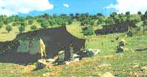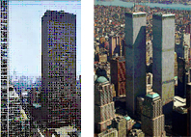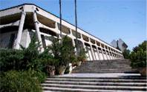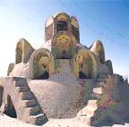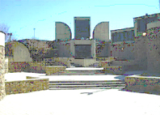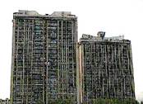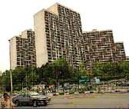
Figure4. Tehran Contemporary Art museum, inspiration of desert district's traditional houses
Figure3. Carpet museum, inspiration of tribe's Siaahchador
Figure5. High rise buildings in Tehran, imitation of modern architecture
4-Architecture and ongoing challenges during transition to network society
Apparently, technology plays a critical role in human life. Modern industries caused widespread alterations at global level; the changes were so great that were called industrial revolution. The industrial revolution not only transformed the human’s lifestyle, but also changed his worldview and following that, some basic concepts in art and architecture experienced a huge transformation.
Meanwhile, the information and telecommunication technology have created another revolution in history. They have been spread throughout the world in a short period of time and transformed all parts; the reason they are called information revolution is because the inherent nature of a revolution is to bring about a great alteration in a relatively short period of time. During the information revolution, technology affects, transfers, and processes information all over the world; As Castells said “these are technologies to act on information, not just information to act on technology” [3]. In the information age, logic of networking is predominant and flexibility and reversibility of the processes are considered as its main particulars.
Networks have transformed many basic concepts of human life and revolutionized form of relations in human societies. Since differences in various bonds among components act as a parameter distinguishing societies from each other, networks have established another form of societies which Castells (1999) calls them network societies; the societies underpinned by the logic of networking and with a network structure. Castells purpose is “to propose some elements of an exploratory, cross cultural theory of economy and society in the information age as it specifically refers to the emergence of a new societal structure” [3].
When interviewed by Harry Kreisler from the University of California Berkeley, Castells said "...the definition, if you wish, in concrete terms of a network society is a society where the key social structures and activities are organized around electronically processed information networks. So it's not just about networks or social networks, because social networks have been very old forms of social organization. It's about social networks which process and manage information and are using micro-electronic based technologies "[5].
The network societies by using micro-electronic based technologies have revolutionized the structure of traditional societies. Accordingly, the structures of all cities, homes, and even families, as the smallest component of each society, have been changed, too [6].
Information technology has transformed the smallest component of a society, i.e. family, and put traditional family at the eve of demolition. Houses, as the human accommodation structure, have faced a great revolution. Houses are filled with electronic and telecommunication tools pacing forward in the evolutionary path of creating an electronic cottage [7].
In a network society, concepts of time and space are transformed and consequently, architecture in these societies will be different from that in traditional and modern societies. Traditional and modern architecture, expressing governing soul of their age, can not meet the requirements of contemporary societies, which are experiencing a very dynamic development.

5- Towards Network Society
Iranian society is facing information and telecommunication technology advances, huge wave of globalization, formation of network society and space of flows in near future. Change on basic concepts in human life, such as space and time, will affect traditional societies and therefore, architecture will find its own required particularities in new societies. In table one the features of society, space, time and architecture with traditional, modern and network structure are depicted.
Today, during the transition to network society, Iranian architecture has experienced numerous tastes and different views. Some of architects employ elements from ancient architecture showing historical viewpoints trying to redefine the society’s identity against globalization movement, while others are inspired by technology and nature, natural forms and vernacular structures. Style free architecture and signs of pluralism during transition to network society are observable.
Furthermore, in countries like Iran, which are processing modernity, a chaos deriving from transition period is observable that leads to anomaly and Specifications of network and modern society have been formed in growth process as the extraneous factors. Although in more developed countries, endogenous development is observable [8]; Therefore, in these societies a kind of transformation is underway inside the heart of the society, while traditional and modern infrastructures are maintained intact.
Understanding the status Iranians are tackling with, can assist them in policy making, planning, and architecture design for a network society. Society's elites will support, guide, and supervise our city structures, in compliance with governing soul of the age, via studying future status and adopting appropriate planning. They will assist society in transition era to redefine its identity in space of flows, and if they do not act properly, a chaotic structure will be the main feature of Iranian cities in transition era.
How can architecture play its main role in network society? What are the challenges architecture confronts with in its transmission to electronic world? What is the role of architecture in a transforming world? These are questions that societies are trying to answer, but the answers are numerous and different as the created architectural styles will be.

5-1- Information Viruses as a Great Challenge facing Network Society
"It is necessary to ask then: what entities other than ourselves inhabit this informational universe? Sure enough, we share the physical universe with all biological life forms, but here is a non-biological realm. Which entities compete with our ideas, our knowledge, our thoughts, and our cultural products? The answer is as simple as it is disturbing: pieces of freely propagating clusters of information. These are called « memes ». They are informational entities that are greatly simplified versions of patterns, and which gradually replace patterns in organizing our interaction with the world " [9].
In the world of information, there are many junks and even detrimental information, in addition to useful, reproductive patterns that are multiplied due to their special properties and substitute the appropriate patterns in human memory. These junk or detrimental information pieces can be called “information viruses”; although, Richard Dawkins (1976) describes them as detrimental Memes. Dawkins uses this new term in his book” The Selfish Gene” exploiting from the similar pronunciation of Gene and Meme to induce this meaning that Memes, like Genes, contain information codes with extreme multiplication capabilities; their only difference is that sometimes they seem very useless or even detrimental items. According to Dawkins, Meme includes every idea or behavior bearing non material condition and can be transferred from one person to the other via learning or imitation [10]. He refers to some of its features as:
Immateriality, having extreme power of multiplication, sometimes useless and even detrimental, multiplication in cultural-social context (network society), including thoughts, ideas and theories; taking account of modes, moods and attitudes, dance, songs, and so on.
"...Memes are propagated in the collective mind of a society. A meme could be a catchy tune; an advertising jingle; a visual image; a religious or cult symbol; a political slogan; a chant; an idea or opinion (either sensible, or totally unfounded) about some topic; a message tied to an emotionally appealing issue, etc. Memes spread not because of any benefit or advantage to us, but because they have something attractive that makes them stick in one’s mind. Memes offer seductive features to people, who then propagate them " [9].
Memes can act like viruses in information world. we call these kind of memes Information viruses (Simple virus structure distinguish it from other living creatures and help it to enjoy a significant multiplication capability.). Information viruses achieve their reproduction power due to their extreme communication capabilities. The secret lies in their simplicity, assisting them to spread like contagious viruses in the information world and, sometimes even, replace the effective paradigms (For example, void ideas and modes substitute the proper paradigms). A detrimental information virus can be disguised by a beautiful cover or capsule showing a deceptive appearance and strands inside a person’s mind and transfers from one person to the other. Sometimes, the relation between an idea and its expression is astonishing. An idea can connect to totally unrelated things, helping them to spread and transfer. The information viruses tend to destruct useful files in human mind and replace them with other things. They spread impudently and detach human from its spiritual aspect, voiding him from spirituality and thinking. In large information networks, information can multiply all over the world rapidly and infect those minds suffering from an ineffective protection system. In this case, a host person or society helps the development of detrimental and wrong information and a detrimental circle starts whose consequences will be reflected in the physical world, society, and even personal relations [11].

5-2- Influences of information Viruses on built environment
Networks entail all kinds of information and transfer them without discrimination. Emphasis on the information value requires some criteria for judgment. In architecture field, this information includes schemes of a building or its plans, three dimensional images and descriptive texts created by computer. Some of the information offered is covered by an attractive sheath free from any significant value. Sometimes, an architectural virus lives in a physical and information world simultaneously. This information world includes human memory, mass media, computer data, and saving terminals [12].
"Architectural memes depend on people and human society for their existence. An informational virus is merely a handy description of actions that persons willingly take to reduce organized complexity in different media. Some individuals strongly believe in the propagation of a particular type of structure over the earth, and they devote their energies to this task. Most architectural movements in the twentieth century were driven by images tied to some questionable ideology "[9].
in the twentieth century architectural movements, computer aided design plays an important role and acts as a laboratory in which useful or detrimental pieces of information are produced before entering the physical world. Sometime, architects presume the computer produced pictures more complete than their real counterparts and commit fundamental mistakes for this reason. The virtual figures can attract a visitor positively, but they cannot transfer the real sense of place and physical property of the building and its space. "Generating alien forms on a computer thus becomes an innocent game because it is divorced from the physiological and psychological consequences those full-size built forms will have on human beings.... "[9].
Virtual space is a good opportunity for simulation of external realities, but it happens that the virtual space is so deceptive and misguides the user (such as computer games showing massacre and man slaughter which are the wrong actions in real world). If we go through the architecture books and magazines, we will find a world full of strange pictures, completely different from the real world we are living in. In this virtual world, every thing is degraded into two or three dimension pictures (reduction) and this kind of brevity helps information multiplication. It is worth mentioning that in modern movement, the ideas like simplicity and elimination of decorations in architecture have created these capabilities in the forms that are transferable all over the world specially when many of modernization problems, particularly in developing countries, are derived from their imitative nature [12]. Nowadays, besides the benefits of new technologies for Iranian architecture, the major flaw in artistic skills and understanding spatial realities are perceptible among new generation of architects.
"In the majority of architecture schools today, memes are realized as approved models; design examples offered as good ideas to copy; and computer-generated designs. Academic architects conform to those memes in the belief that they are being « original ». Those architects tend to live in an isolated world of images, not necessarily having anything to do with buildings. Their creative output can nowadays be judged strictly via a virtual portfolio. Architectural competitions and prizes are awarded on the basis of virtual designs, and so on.
....Alien buildings impact humankind because they conflict with — and replace — traditional architecture. They also make it impossible to build new, innovative buildings that comprise living architectural structure. Visible examples do far more damage to civilization than the obvious one inflicted upon the built environment, however. Alien images penetrate into our conscience, and thus profoundly influence our world view. The ideological memes of simplistic, broken forms have acquired physical vehicles (e.g. buildings; visual and electronic media) that make possible their transmission to the minds of the population at large. One could make the analogy with the HIV virus, which is suspected of originating in a small group of apes residing deep in the central African forest. By crossing over into the human population with its international travel routes, HIV has successfully spread over the entire globe. It found a vast new population of hosts and more efficient methods of transmission.
Alien buildings embody a physical randomness that is the antithesis of nature’s organized complexity. The danger is that such buildings are now registering subconsciously, to be used as mental templates for understanding and creating complex physical order. One’s worldview is stored in the brain’s permanent memory, which is being corrupted by alien images of a sleek, transparent, and broken architecture. It follows that these images will influence everything we design — undoing all our achievements in understanding complex systems and how our world works "[9].
Harmful influences of visual viruses on developing countries like Iran is more obvious, and can be depicted in some examples of Tehran buildings. Some of these images are imitation of styles (figures 8, 9, 10 and 11) and the others are imitation of traditional Iranian architecture (figures 6, 7). These are a few examples of many similar components which have made physical body of Tehran as the capital of Iran. These images portray how visualized architecture, separated from its origins, can act like an information virus.
Some obvious examples of visual architectural viruses in Tehran can be described as follows:
(1) Visual Imitation of western architecture (modern, post modern, organic and also ancient architecture);
(2) Visual Imitation of Iranian traditional architecture in different eras;
(3) The largest scale is dominant, with no respect to rules of urbanism in many of high rise buildings;
(4) Using of plate-glass walls, reflective metal sheets, and flat, prefabricated concrete panels on many of facades not properly;
(5) No proper boundaries, many of buildings in Tehran cut abruptly;
(6) Contradiction the forms of traditional architecture (which, however, is often very relaxed), with buildings around them:
(7) Un harmonic polyphony in many of urban spaces leads to visual disturbance.
Some contemporary buildings in Tehran are not understandable, they have not evolved adaptively to any purpose; they are results of a very visual architecture and influenced by informational viruses of electronic world, they create arbitrary and only mean to shock observer by their disconnectedness so as to create psychological and physiological anxiety in the observer.
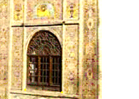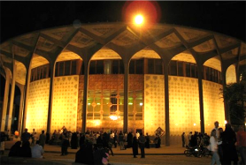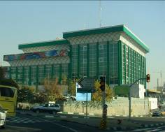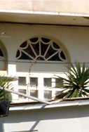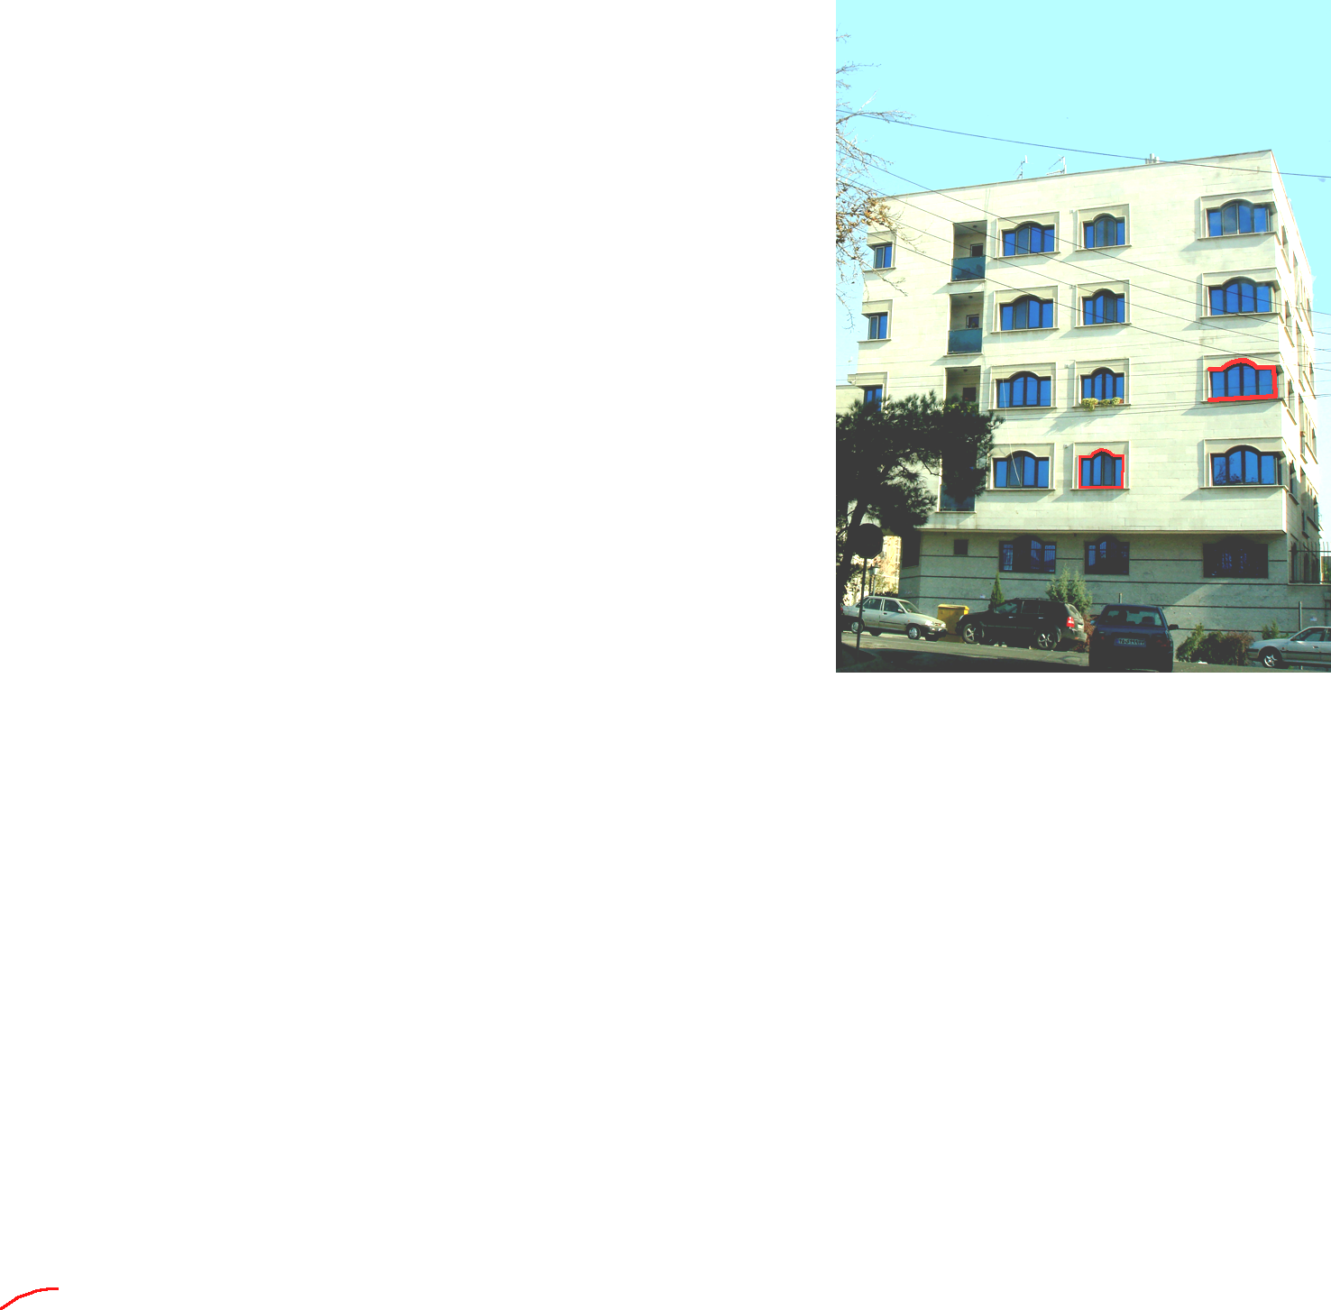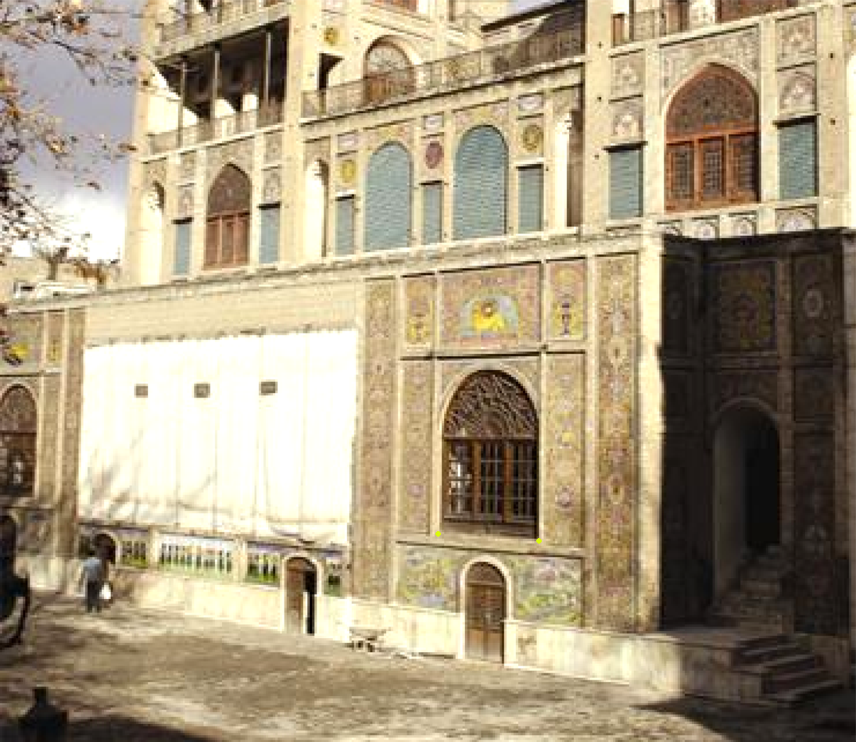
Figure6. Imitation of arch shapes only as graphic patterns
Figure7. Iranian post modern architecture and imitation of traditional architecture
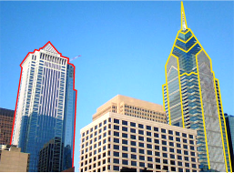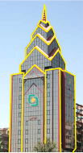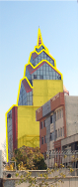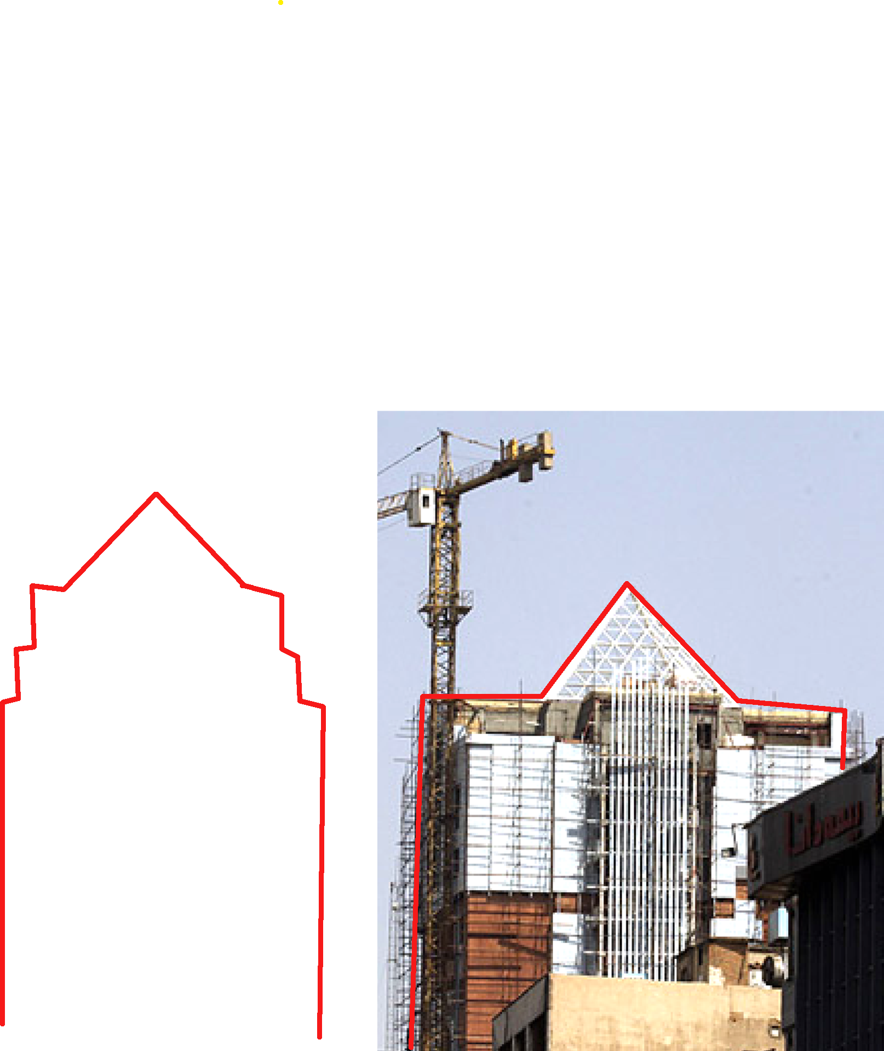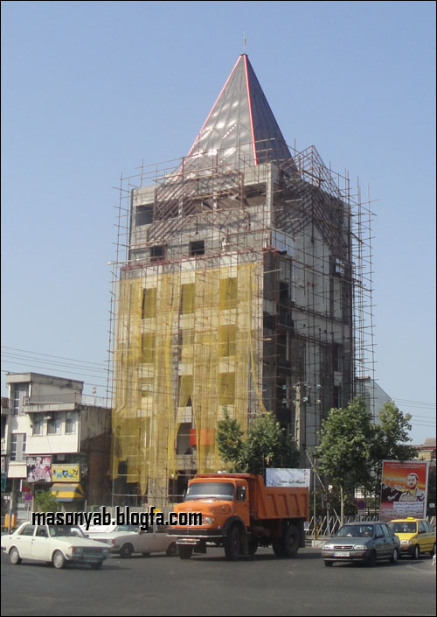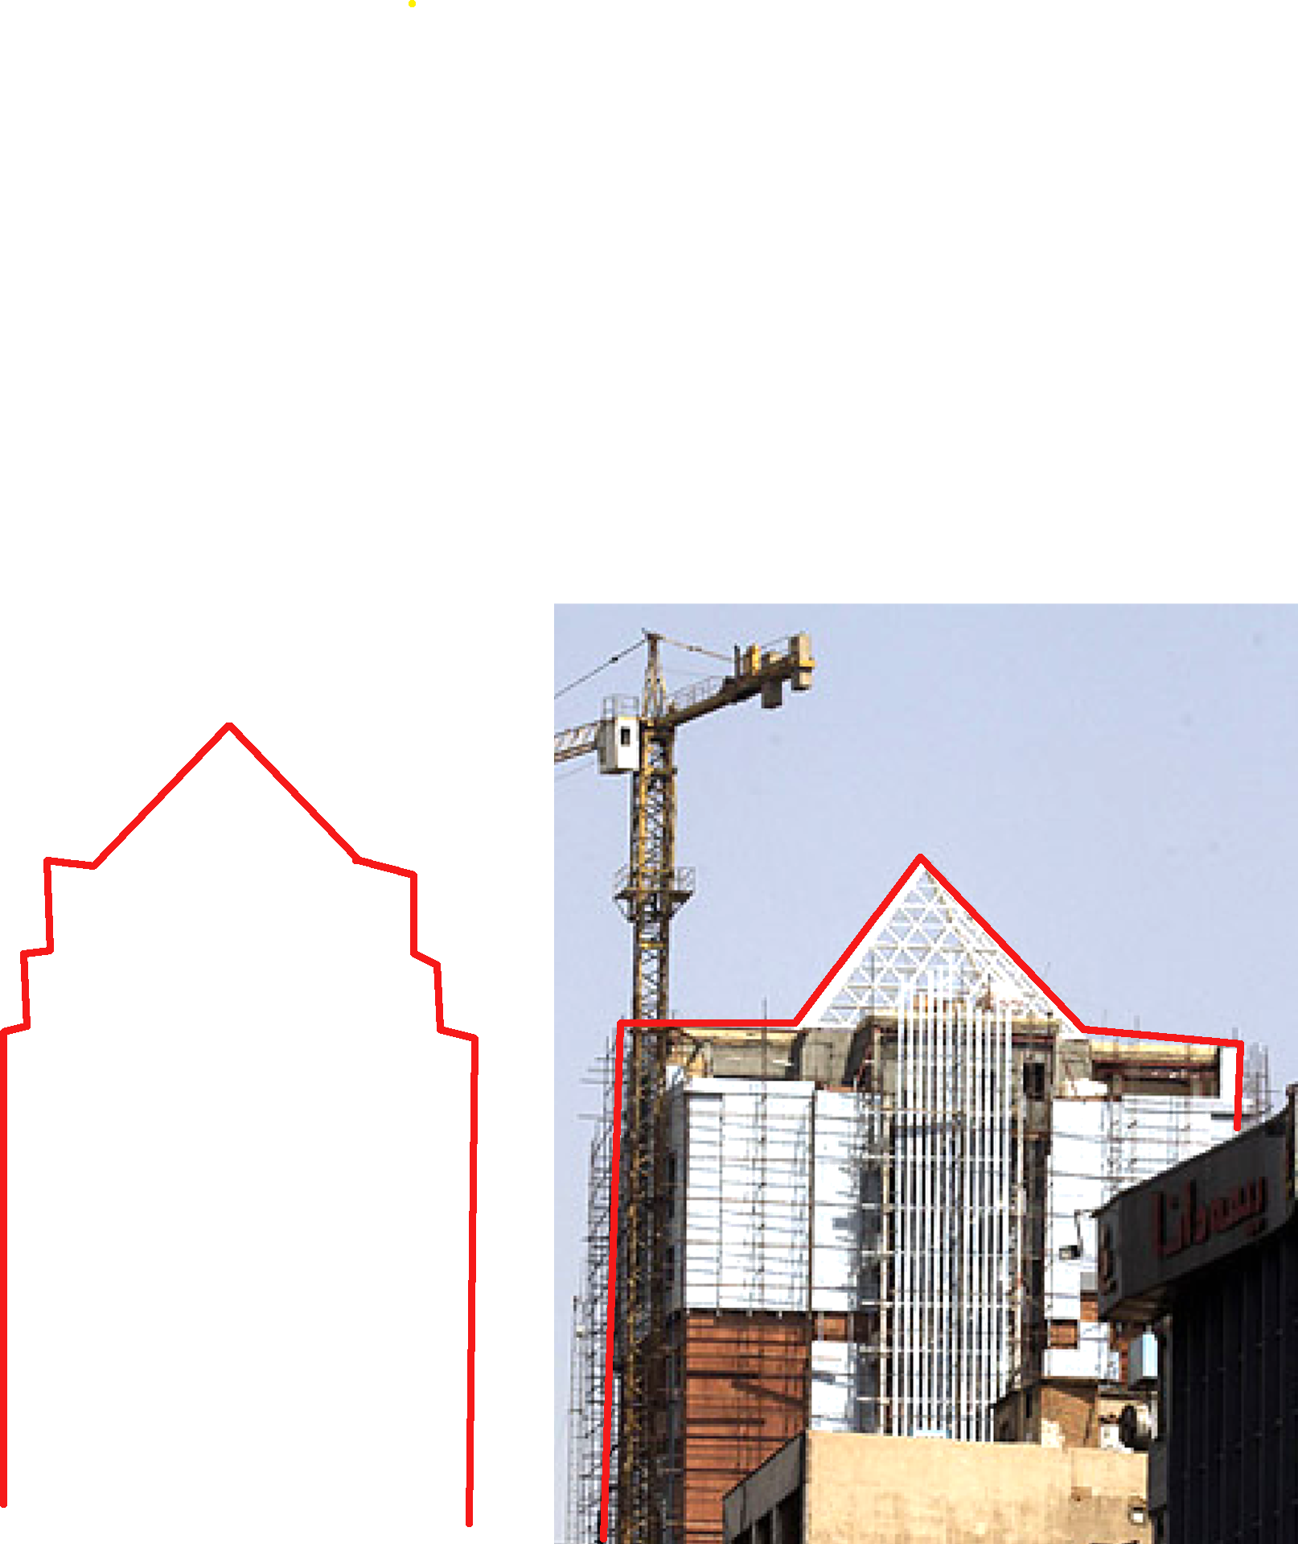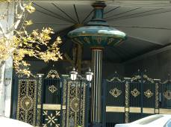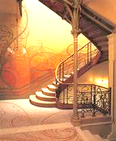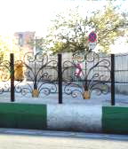
Figure8. Imitation of visual architecture and shapes of western architecture

West cement facade, building cuts abruptly.
Figure9. Imitation of organic patterns

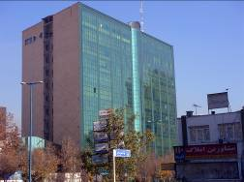
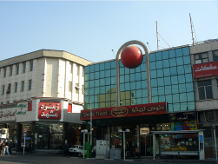
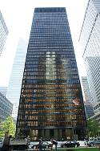
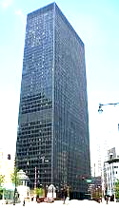
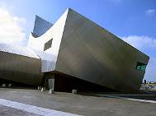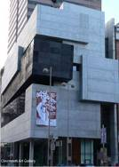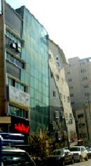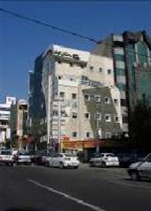
Figure10. Imitation of deconstruction style architecture
Figure11. Imitation of glass facade high rise buildings without sufficient theoretical and technical support
5-3- Immunity against Information Viruses
"Any virus -and a meme is no exception- uses packaging or surface configurations permitting the virus to attach to a host and inject its DNA. In the case of an architectural meme, this includes the appearance of aesthetic and social progress and the promise of prestige and career success for the transmitter. A virus has the ability to change its packaging so as to circumvent defenses. Because of a continuous mutation to avoid being eliminated by the natural immune system, viruses are not automatically recognized as damaging intruders. We have evolved our immune system to protect us. A virus cannot make headway unless it also develops sophisticated strategies to fool our immune system" [9].
As viruses employ a package or cover to transfer into the host and change their appearance to mislead the body immune system, information viruses also oppress our immune system through ideologies with beautiful capsules. For example, the initial attraction of modern movement was attributed to slogans such as ‘boring dominance of conventional architecture’ and ‘decoration: a kind of crime’ that captured all over the world. Consequently, modern architecture has led people to cheap, simple, and senseless apartments with low ceiling, distorted windows, and small kitchen eliminating many valuable traditional spaces [12]. In countries like Iran, improper imitation of modern architecture has led to construction of buildings with no harmony with local and domestic traditions and users’ needs. Today, confrontation with electronic world and great power of information-visual viruses is changing cities dramatically, therefore, Iranian society must have its own powerful defense system to accept or deny information in any possible fields. Architects are trying to prepare new definitions for architecture in future world using trial and error practice; thereby helping human to benefit from an appropriate relation between the physical world and information world, freeing us from wandering in the space of flows.
In order to decrease the effects of viruses on Iranian cities, Iranian architects must research more about the future as their paradigm by emphasis on the collective intelligence (individuals in society have advanced intelligent capacity, yet it is sometimes necessary to use a combination of minds to solve complex problems[13]) and establishing a thinking base that, not remain oblivious to the past, in this way they release themselves from stationary manner and act as effective and not simply as affecting member of the world community because many of the problems in current Iranian community derive from absence of future planning, creative Thinking and inappropriate imitation in all fields including architecture and urban development .

6-Conclusion
This paper was an attempt to discuss the confrontation of Iranian society with new situation, i.e., the emergence of Electronic world. This new world, despite its positive effects on human life, has brought about many challenges whose presentations are more discernible in developing countries like Iran. Iran, as a country which has not experienced the Endogenous development process, is facing a non harmonic development and transition on the surface with no influence from deeper layers of the society.
In contemporary era, Iranian society has experienced a transition to modernity; and subsequently, a transition to Electronic world and Network society. The transition has offered Iranian architecture a visual format, a format which is missing basic concepts and traditional values and is just trying to develop, spread, and answer the needs of the present time, without having any perspective of the future.
This rapid growth and over simplicity, resulting in the architecture’s loss of basic concepts and visual aspects, have provided a kind of architecture which acts as a mode in short run and virus in long run.
Furthermore, this event had led to a rapid change in Iranian cities structure and appearance, and while destroying many of traditional layers, has failed to offer an effective pattern. Therefore, some scholars believe that Iran contemporary architecture lacks identity. The characteristics of this architecture are plurality, fashionable, and short period functioning; an architecture which is imitated kind of information and physical world virus, forming the appearance of our cities.
Moreover, lack of an effective protective system in society has helped to the spread of information viruses. Supervision methods and appropriate and effective conventions can control the virus invasions to a great extent and lead Iran contemporary architecture to a proper path. Meanwhile, encouraging Iranian architects to think creatively instead of only imitating western and traditional patterns which seem better apparently can prevent the spread of kitsch architecture and visual viruses, and will assist Iranian contemporary architecture to be an effective one in global society.
This section draws on work by Francis Heylighen [12]. Heylighen defines intelligence as the ability to solve problems. Sometimes, as occurs in colonies of social insects such as termites and bees, intelligence is an emergent property, since each individual alone does not have the requisite neuronal capacity [7]. In the case of human beings, each individual does have advanced intelligent capacity, yet it is sometimes necessary to use a combination of minds in order to solve a complex problem [12]. A city works with complex mechanisms that together are too much for any individual human comprehension. A city built over time is the product of the collective intelligence of generations of people acting together, either in a spatial grouping or in a temporal perspective.

\

References
[1] Lévy P,: 1997, Collective intelligence: Mankind's emerging world in
cyberspace, Plenum Press, New York.
[2] Sharif S,: 2004, Nonlinear theory, Architecture & urban development magazine, No. 74-75.
[3] Castells M,: 1999, The Rise of the Network Society: The Information Age.
Economy, Society, and Culture, I, Wiley-Blackwell, Oxford.
[4] Durkheim M, Riley a,: 2006, on Suicide, Penguin Books, London.
[5] "Conversation with Manuel Castells, p. 4 of 6". Globetrotter.berkeley.edu. http://globetrotter.berkeley.edu/people/Castells/castells-con4.html. Retrieved 2008-10-06.
[6] Castells M,: 1999, The Power of Identity: The Information Age. Economy,
Society, and Culture, II, Wiley-Blackwell, Oxford.
[7] Castells M,: 1999, End of Millennium: The Information Age. Economy, Society, and Culture, III, Wiley-Blackwell, Oxford.
[8] Islami, S, G,: 1998, Endogenous Development: A Model for the Process of Man-environment Transaction, Unpublished PhD Thesis, Faculty of Environmental Studies, Herriot-Watt University, Edinburgh, U.K.
[9] Salingaros N. A,: 2006, Architectural memes in a universe of information, http://mondesfrancophones.com/espaces/cyberespaces/architectural-memes-in-a-universe-of-information.
[10] Dawkins R,: 2006, The selfish gene, Oxford University Press, Oxford.
[11] Dawkins R,: 2002, Viruses of the Mind, http://richarddawkins.net.
[12] Salingaros N. A, Terry M,: 2002, Darwinian process and memes in
architecture: A memetic theory of modernism, Journal of Memetics -- Evolutionary Models of Information Transmission 6 , Reprinted in DATUTOP Journal of Architectural Theory (2002) 23: 117-139.
[13] Salingaros N. A,: 2002, Design methods, emergence, and collective
intelligence, http://www.katarxis3.com/Salingaros-Collective_Intelligence.htm.

 Corresponding Author: gheslami@ut.ac.ir Associate Professor, School of Architecture, University College of Fine Arts, University of Tehran. Tel: 009821 66495341-2, 0098912 6959556

∗ Department of Art and Architecture, Science and Research Branch, Islamic Azad University, Tehran, Iran.

