Analyzing Façade Design in Vernacular Architecture of the City of Bushehr, Iran
Parastoo Eshrati
Assistant Professor, Department of Architecture, School of Architecture, College of Fine Arts, University of Tehran, Tehran, Iran. eshrati@ut.ac.ir
ORCID: 0000-0001-8319-8814
Roza Vakilinezhad
Assistant Professor, School of Art and Architecture, Shiraz University. arch.rv@shirazu.ac.ir
ORCID: 0000-0001-8597-1647
Arezoo Ghahramani
M.Sc. in Architecture, School of Architecture and Environmental Design, Iran University of Science and Technology, Tehran, Iran. Ar.ghahramani1992@gmail.com ORCID: 0000-0003-4140-9577
Dorna Eshrati
Assistant Professor, Department of Landscape Architecture, R.Wayne Estopinal College of Architecture and Planning, Ball State University, Muncie, IN, USA.deshrati@bsu.edu ORCID: 0000-0002-4890-176X
Mohammad Kazem Namazi
Master of Architecture, College of Architecture Planning and Design, Kansas State University, Kansas, USA. kazemnamazi@ksu.edu ORCID: 0000-0002-2105-7116

Analyzing Façade Design in Vernacular Architecture of the City of Bushehr, Iran
Abstract
Designing facades in vernacular architecture, various methods have been used for optimal energy consumption in different regions. In Iran, most of the vernacular buildings are still being used without major modifications even in challenging climates. In this article, the quantitative research method was applied to reveal principles of the facade design of the city of Bushehr vernacular architecture in mathematical language. Physical characteristics of eight houses, selected as the case studies have been extracted, including window-to-wall ratio, area of each façade as well as height and weight of different openings. Defining eighteen criteria, physical properties of the houses were extracted for either interior and exterior façades. Linear regression models were used for cases where a linear relationship between variables could be seen. All the statistical analyses were performed in IBM SPSS Statistics version 16.0. Results revealed the presence of 14 linear models (6 models for exterior, 5 models for interior, and 3 models for openings). The results showed that out of these 16 criteria, 11 criteria (6 criteria for exterior facades and 5 criteria for interior facades) in Bushehr vernacular buildings can be expressed as linear models. Although the linear models presented are completely specific to the vernacular architecture of Bushehr, the method presented in this study can be used by other researchers to recognize the principles used in vernacular facades of other parts of the world.
Keywords: Façade design; Vernacular Architecture; Hot-Humid Climate; Bushehr.

Abbreviations:
In: Interior
Ex: Exterior
S: Surface Area
N.: North
S.: South
E.: East
W.: West
WD: Width of Opening
H: Height of Opening
Arch: Arched Opening
Rec: Rectangular Opening

1- Introduction
Building façades present the relationship between inner and outer space (Askari and Dola 2009; Hayashi 2004). It is like an interface “between the pragmatic worlds of facts and the symbolic world of values” (Frampton, 2002, p. 151) which along with climatic and spatial features creates the identity in a context that can also be affected by culture (Sari et al. 2011). It is one of the most effective factors in the urban landscape and city image (H. Wang 2007; Utaberta et al. 2012). So, the building facades can be evaluated from various points of view (Namazi et al. 2016) (aesthetic, structural, social, cultural and climatic) and are determined by the composition, shape, texture, and color of their components (Baper and Hassan 2012).
In recent decades, the energy crisis, global warming, and reduction of fossil fuels, along with sustainable development, made a priority in energy efficiency. Building’s energy consumption is become a major concern as the building sector consumes about one-third of the total energy consumption worldwide (Nguyen et al. 2011). Building façade, including walls, roofs and openings, can control air temperature, shading and ventilation and assure thermal and daylight comfort (Thalfeldt et al. 2013). A proper design and accurate location of openings, coupled with sufficient window and door areas overall, are key factors in designing energy-efficient facades (Heiselberg, Bjørn, and Nielsen 2002) that can have significant impacts on the lighting, heating and cooling load and minimize the usage of air-conditioning (Okba 2005). As the result, appropriate facade design is decisive for the design of climatic buildings. Several studies have been analyzed the facade design influence on buildings’ energy consumption and thermal environment (Tzempelikos, Athanassios, Athienitis and Karava 2007; Boyano, Hernandez, and Wolf 2013; Poirazis, Blomsterberg, and Wall 2008; Motuzienė and Juodis 2010; Grynning et al. 2013; Susorova et al. 2013). Energy efficient facade properties include window-to-wall ratio, window sizes and properties, building orientation, wall insulation, external shading devices and some specific elements such as the shape of louvered windows and different forms of apertures (De Luca, Voll, and Thalfeldt 2016; L. Wang, Wong Nyuk, and Li 2007). Accordingly, most studies focus on the relationship between size, orientation and glazing properties of facade windows (Vanhoutteghem et al. 2015; Hachem and Elsayed 2016; Mangkuto, Rohmah, and Asri 2016; Thalfeldt, Kurnitski, and Voll 2015; Goia 2016; Ihara, Gustavsen, and Jelle 2015; Lee and Chang 2015; Konstantoglou and Tsangrassoulis 2016; Serralheiro, de Brito, and Silva 2017; Lau et al. 2016; Hoelscher et al. 2016). Some of these studies were done to give guidelines for designing building energy-efficient facade (Grynning et al. 2013; Thalfeldt et al. 2013). Pikas, et al. (2014) evaluated the most effective elements and techniques in façade design to be used in current buildings (Pikas, Thalfeldt, and Kurnitski 2014). Payback times and investment cost of façade design have also been thoroughly described by Thalfeldt et al. (2013).
Analysis of the vernacular settlements in Ushguli shows the overlapping between private and public spaces without any street or square. There is no dominating facade or hierarchical composition (Sousa et al. 2020). The façade of timber houses in Arakawa Village are designed along the wind direction, with a closed front façade to mitigate the effect of wind attacks (J. Wang and Ochiai 2021). Foged has investigated the thermal performances of Spanish Balcony as a vernacular envelope with operable elements. In Spanish balcony, the building envelope has consisted of vertical operable blinds, wooden foldable frames, and vertical rotational shutters. Based on the results, the facades’ operable elements significantly impact adaptive thermal comfort temperatures (Foged 2019)
Few Analyses have been conducted on traditional Turkish architecture including the façade design and some of the architectural features of a rural settlement. The facade characteristics of a traditional Turkish house are defined as no window facing the street in the ground-floor walls while double windows facing the street are used on the first floor (Acar Bilgin 2019). The features, plan and facade types of traditional Turkish houses have been determined in a study. The facades usually have rectangular, arched or trellised windows. The common features between facades are a cantilevered bay window, central overhangs, wooden buttresses and decorative elements and double-leaf doors partitioned in two or three parts are the characteristics of the entrances (Ayla and Eruzun 2021).
As so most of the previous studies investigated new building facades; however, façade properties of vernacular buildings have been rarely studied especially from the environmental point of view. On the other hand, vernacular architecture is recognized as a practical, effective solution for energy efficient design due to its adaptation to the climate and its context (Zhai and Previtali 2010; Bodach, Lang, and Hamhaber 2014; Philokyprou et al. 2017; Desogus, Felice Cannas, and Sanna 2016; Du, Bokel, and Dobbelsteen 2014; Anna-Maria 2009; Singh, Mahapatra, and Atreya 2010; Dili, Naseer, and Varghese 2010; Kubota and Toe 2015; Chandel, Sharma, and Marwah 2016; Motealleh, Zolfaghari, and Parsaee 2018). It is also indicated that reduced operating costs, better thermal comfort and indoor air quality in vernacular buildings as the advantages of the application of passive design strategies (Aflaki et al. 2015) in different and creative ways.
Iran has rich and diverse vernacular architectural design due to the different climatic conditions throughout the country (Brown et al., 2006: 23). Some of the elements of Iranian vernacular architecture, such as courtyards and wind-catchers, have been studied in previous literature (Santamouris 2007; Hamid Montazeri 2011; Saadatian et al. 2012; Memarian and Brown 2003; Motuzienė and Juodis 2010; H. Montazeri et al. 2010; Soflaei and Shokouhian 2005). However, vernacular façade design has not been much focused. A Comparative Study between vernacular architecture in Hot–Arid and Hot–Arid–Windy Regions of Iran, revealed that despite different appearances, either of these architectures follow the sustainable adaptation to context. According to the results, in Yazd, buildings are attached to neighbouring houses, so the external facades have no openings except the houses’ entrance doors. On the other hand, in Sistan, openings are designed in different levels in exterior facades. In Yazd, building facades are higher than Sistan resulting more shaded alleys (Sahebzadeh et al. 2017). In a recent study the Role of Orosi openings in the vernacular Building Façade considering daylight performance and visual comfort. The results confirmed a significant potential of orosi to address the requirements of visual comforts especially on the South façade (Hosseini, Hosseini, and Heiranipour 2020). The mentioned studies are among rare research which have been conducted considering façade design in Iranian vernacular architecture.
This paper aims to analyze the characteristics of vernacular façade design of the city of Bushehr. Although various strategies and physical elements of Bushehr vernacular buildings as microclimate modifiers have been studied in the previous studies (ranjbar, pourjafar and khaliji, 2010; Vakilinezhad, Mofidi and Mehdizadeh, 2013; Khajehzadeh, Vale and Yavari, 2016; Nikghadam, 2016; Montazeri et al., 2017; Hedayat and Eshrati, 2021), vernacular façade design principles have not been studied yet. Design principles conceived from this study could be recommended as the appropriate solutions for new building envelop design.
To reveal some façade design principles of vernacular houses in Bushehr, this paper was conducted in three steps: In the first step, previous studies about vernacular façade design were reviewed to find the research gap. In the second step, eight houses have been selected as the case studies. In the third step, data collected from the field study of the eight cases were classified and prepared to be analyzed using SPSS.

2- Materials and Methods

2-1- Case Study

2-1-1- City of Bushehr
The city of Bushehr is a peninsula in the south of Iran, on the north margin of the Persian Gulf. It has very hot and humid summers and temperate winters. Based on the Köppen’s climate classification, the climate of this port is hot and humid. Table 1 shows the climatic information of Bushehr. The average temperature is 26.2 degrees Celsius, reaching 45.6 C° on the hottest days, but rarely drops below 7 C°. Based on the meteorological data analysis of Bushehr synoptic stations by Terjang method in July, August, September, and October, it is extremely hot during the day and very hot at night. Its average humidity is 81% and can reach 98%. The prevailing annual wind is from the northwest with a maximum speed of 25 meters per second (90 kilometers per hour). Also, there are various local winds (Bushehr Meteorological Statistical Yearbook, 2021). Figure 1 illustrates the location of the historical texture of Bushehr at the tip of the peninsula.
Table 1. Monthly average of weather condition in Bushehr (Bushehr Meteorological Statistical Yearbook, 2021)
Bushehr | Jan | Feb | Mar | Apr | May | Jun | Jul | Aug | Sep | Oct | Nov | Dec
Average Dry Bulb Temperature (C) | 14.9 | 16.5 | 19.9 | 24.2 | 29.3 | 31 | 33.1 | 33.7 | 31.3 | 28.4 | 22 | 17.1
Average Relative Humidity (%) | 74 | 72 | 69 | 66 | 59 | 65 | 67 | 72 | 70 | 68 | 65 | 75

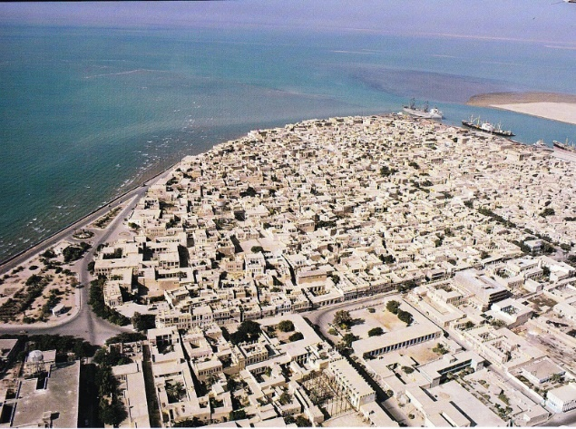
Figure 1. Location of Bushehr historical urban fabric in the peninsula; Source: (Document Centre of Bushehr)

2-1-2- Façade & Opening Characteristics
Bushehr vernacular buildings have an introverted-extroverted pattern. It means that facades open both towards the central courtyard and also the urban passageway (Karimi, 2012: 85; Eshrati et al., 2016: 45-47). This pattern helps to reduce humidity of interior spaces by making cross-ventilation possible (Brown et al., 2006; Vakilinezhad, Mofidi and Mehdizadeh, 2013: 6) (Figure 2).
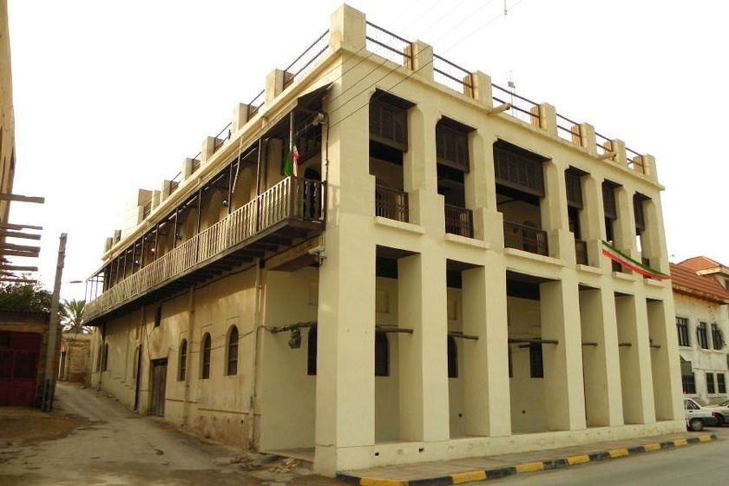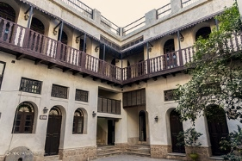
Figure 2. Vernacular architecture with introverted-extroverted pattern of Bushehr city: (left) Exterior views facing the urban passage; (Right) interior views facing the central courtyard; Source: (Document Centre of Bushehr)
Bushehr buildings have generally two floors (Khajehzadeh, Vale and Yavari, 2016: 473) There may be rooms in two, three, or four directions of the central courtyard. Facades have openings with different dimensions in both arched and rectangular shapes. Due to the diversity of sizes, in this article, openings were divided into three categories based on their sizes, including small, medium and large. Openings that occupy an area of less than 1 square meter are classified in the category of small openings, openings between 1 and 3 square meters are classified in the category of medium openings and openings that occupy more than 3 square meters of the facade are classified in the category of large openings. It should be noted that in this article, the term “opening” includes both windows and door-windows in the facade (Figure 3).
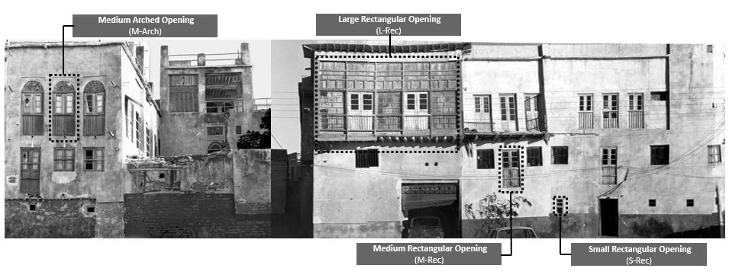
Figure 3. Classification of types of openings in vernacular buildings of Bushehr port based on shape and size; Source: (Authors based on Document Centre of Bushehr)

2-1-3- Selection of Cases
The following criteria were considered for selecting the case samples: 1) The main historical land use of the building should be residential; 2) Since the prevailing model of Bushehr historical buildings is two-floor, the building should be two-floor; 3) The building should be a registered by Iran’s Cultural Heritage Organization to show that it has special heritage values; 4) The plan pattern of the building should be one of the most frequent patterns based on the categories of Bushehr Cultural Heritage Organization; 6) the historical pattern of the building, whether in the plan or in the facade, should have been remained intact; 7) Available sufficient evidence of the building. 8) The possibility of visiting the building to update its documents if necessary. 9) Having various sizes and being located in different parts of the historic quarter of Bushehr except the coastal strip (because the buildings located in the coastal strip have a different pattern than other parts of the historical core).
Finally, eight houses have been selected as the case studies (Figures 4 to 6). Physical characteristics of each case have been extracted, including window-to-wall ratio, area of each façade as well as height and weight of different openings. Data have been collected for all facades; in this paper, facades faced to courtyards called ‘interior façade’ since they face the interior open spaces. And, facades faced to the alley called ‘exterior façade’ since they face the exterior open spaces. Table 2 shows the physical characteristics of these houses.
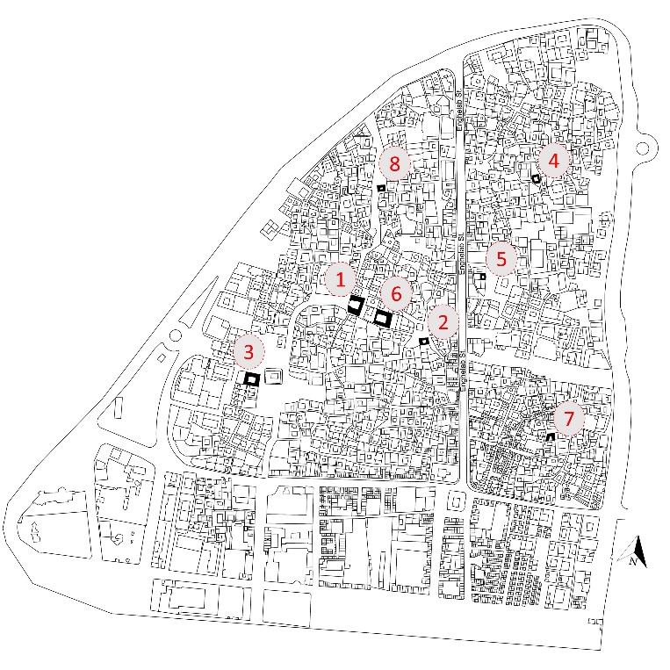
Figure 4. Location of case studies houses in the historic city of Bushehr; Source: (Authors based on Document Centre of Bushehr)

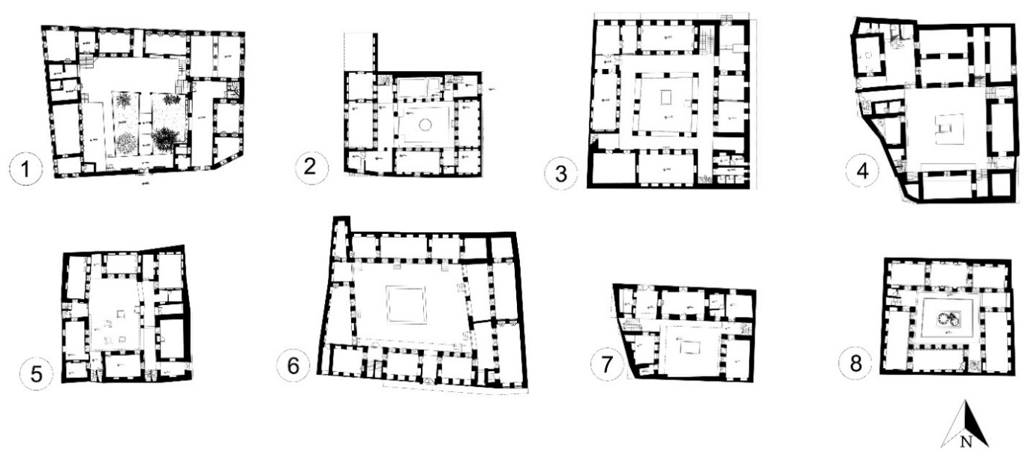
Figure 5. Eight vernacular building in city of Bushehr; Source: (Authors based on Document Centre of Bushehr)
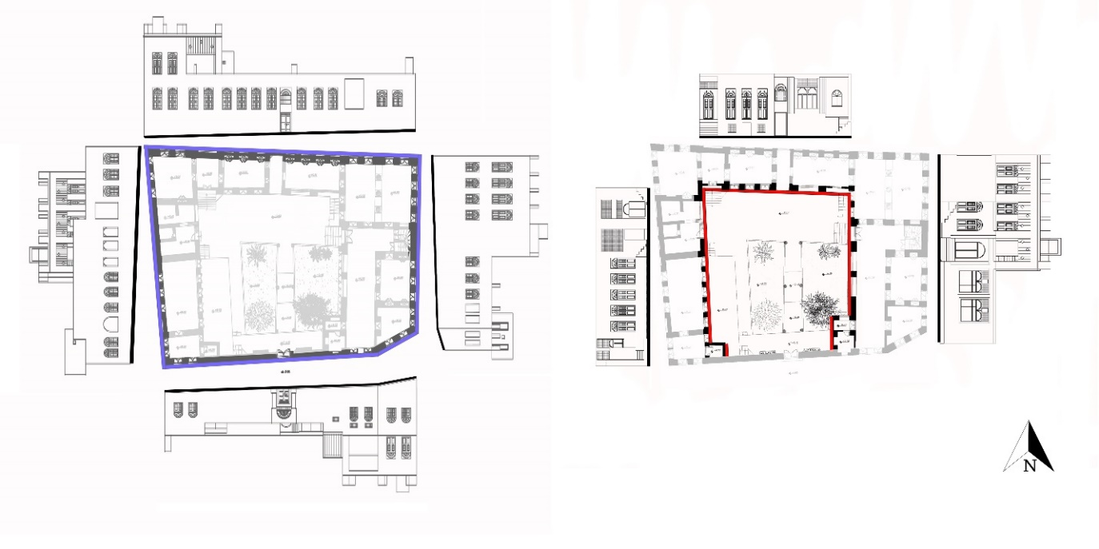
Figure 6. Facades of one case study houses, Asiaei house. (Left) Exterior Facades, (Right) Interior Facades; Source: (Authors based on Document Centre of Bushehr)

Table 2. Physical characteristics of eight selected vernacular houses of the city of Bushehr
No. | Building Orientation | Number of Floors | Number of Exterior Façade | Number of Interior Façade | Exterior Façade Surface Area (m²) | Interior Façade Surface Area (m²) | Exterior Opening Surface Area (m²) | Interior Opening Surface Area (m²)
1 | North-South | 2 | 4 | 3 | 678.68 | 271.65 | 139.63 | 55.75
2 | North-South | 2 | 3 | 4 | 597.67 | 135.86 | 67.24 | 70.01
3 | North-South | 2 | 2 | 4 | 410.97 | 493.10 | 87.21 | 108.62
4 | North-South | 2 | 4 | 4 | 395.55 | 386.77 | 96.53 | 114.79
5 | North-South | 2 | 1 | 4 | 105.80 | 165.89 | 12.30 | 55.50
6 | North-South | 2 | 1 | 4 | 138.38 | 430.80 | 64.33 | 120.39
7 | North-South | 2 | 2 | 3 | 246.69 | 201.82 | 36.08 | 43.56
8 | North-South | 2 | 4 | 4 | 629.03 | 312.64 | 117.34 | 112.75

2-2- Method
In the present study regarding to discovering strategies of vernacular façade design in city of Bushehr, a case analysis on the following criteria were investigated to reveal probable a) relationships between façade and opening areas and b) relationships between different opening shapes and sizes as follow:
A) The relationship between the façade area and the openings area includes the following sixteen criteria:
Exterior facade criteria
- Criteria 1 to 4: Relationship between the facade area and the ​​openings area in north, south, east, and west exterior facades
- Criterion 5: Ratio of ‘total area of ​​first floor exterior openings’ to ‘area of exterior first floor façade’
- Criterion 6: Ratio of ‘total area of ​​the second-floor exterior openings’ to ‘area of ​​the second-floor exterior façade’
Interior facade criteria
- Criteria 7 to 10: Relationship between facade area and openings area in north, south, east, and west interior facades
- Criterion 11: Ratio of ‘Total area of first floor openings of interior façade’ to ‘area of the first-floor interior façade’
- Criterion 12: Ratio of ‘total area of the second-floor openings of the interior façade’ to ‘area of the first-floor interior façade’
Parallel faces criteria
- Criteria 13 to 16: Ratio of ‘total area of north exterior openings to north exterior facade area’ to ‘ratio of total area of north interior façade openings to the area of north interior façade area’ and similar to south, east and west facades
B) Relationships of openings include the following two criteria:
- Criterion 17: The level of using all types of openings, including rectangular, arched, and also small, medium, and large openings and also the most frequent small, medium, large openings in exterior and interior facades
- Criterion 18: Relationship between height and width of openings (average height to width ratio in rectangular and arched openings, as well as small, medium and large openings)
To find an appropriate formula for obtaining the desired relationships, different statistical methods such as trying to find the distribution, finding the correlation between the desired variables, and drawing a scatter plot were used to visually observe the relationships. Finally, linear regression models were used for cases where a linear relationship between variables could be seen with a slight negligence. Also, for cases where there was no linear relationship between the variables (criteria 10, 13, 14, 15 and 16), attempts were made to use multiple regression models, but using the available data, the fit of the multiple regression model was not significant. Descriptive statistics were used to determine the use of different types of openings (criterion 17) based on available data and the percentages were reported. All the statistical analyzes performed in IBM SPSS Statistics version 16.0. Figure 7 shows the research Diagram.
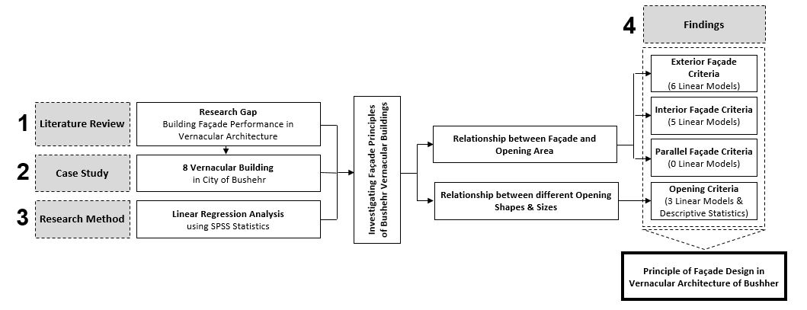
Figure 7. Research Process

3- Results and Discussion

3-1- Exterior Façades
- Criterion 1: North Exterior Façade
Among the 5 houses that have a north exterior facade, the ratio of the total area of the north exterior façade openings to the area of north exterior façade is a minimum of 9%, with an average of 20% and a maximum of 28%. The result of fitting a simple linear regression model is as follows:
S _{N.Ex Opening} = -34.65 + 0.42 S _{N.Ex Facade}
It means that, for example, for every 10 square meters of increase in the area of the north exterior facade, the area of openings of that facade increases by 4.2 square meters. The value of the coefficient of determination or R2 for this linear equation is 0.73, which is an acceptable value.
- Criterion 2: South Exterior Façade
The ratio of the area of the openings to the area of the south exterior facade in 6 houses with a south facade is a minimum of about 13%, with an average of 19% and a maximum of 27%. The result of fitting a simple linear regression model is as follows:
S _{S.Ex Opening} = 3.71 + 0.18 S _{S.Ex Façade}
It means that, for example, for every 10 square meters of increase in the area of the south exterior facade, the area of openings of that facade increases by 1.8 square meters. The value of the coefficient of determination or R2 for this linear equation is 0.82, which is an acceptable value.
- Criterion 3: East Exterior Façade
The ratio of the area of the openings to the area of the exterior east facade in 6 houses with an east facade is a minimum of 12%, with an average of about 19% and a maximum of about 27%. The result of fitting a simple linear regression model is as follows:
S _{E.Ex Opening} = 3.71 + 0.18 S _{E.Ex Façade}
It means that, for example, for every 10 square meters of increase in the area of the west exterior facade, the area of openings of that facade increases by 1.8 square meters. The value of the coefficient of determination or R2 for this linear equation is 0.81, which is an acceptable value.
- Criterion 4: West Exterior Façade
The ratio of the area of the openings to the area of the west exterior facade in 5 houses with a west facade is a minimum of about 5%, with an average of about 17% and a maximum of about 29%. The result of fitting a simple linear regression model is as follows:
S _{W.Ex Opening} = 9.11 + 0.13 S _{W.Ex Façade}
It means that, for example, for every 10 square meters of increase in the area of the west exterior facade, the area of openings of that facade increases by 1.3 square meters. The value of the coefficient of determination or R² for this linear equation is 0.71, which is an acceptable value.
- Criterion 5: First Floor of Exterior Façade
The ratio of "total area of first floor of exterior openings" to "area of first floor exterior facade" was examined. The results show that among the 8 houses that have a first-floor exterior facade, the ratio of the total area of the first-floor openings to the area of first floor exterior facade is a minimum of about 4%, with an average of about 11% and a maximum of about 20%. The result of fitting a simple linear regression model is as follows:
S _{First Floor Ex Opening} = -0.28 + 0.12 S _{First Floor Ex Façade}
It means that, for example, for every 10 square meters of increase in the area of the first-floor exterior facade, the total area of the openings of that facade increases by about 1.2 square meters. The value of the coefficient of determination or R2 for this linear equation is 0.69, which is an acceptable value (Figure 8).
- Criterion 6: Second Floor of Exterior Façade
The ratio of "total area of the second-floor exterior openings" to "area of the second-floor exterior facade" was examined. The results show that among the 8 houses that have a second-floor exterior, the ratio of the total area of the second-floor openings to the area of second floor exterior façade is a minimum of about 16%, with an average of about 27% and a maximum of about 49%. The result of fitting a simple linear regression model is as follows:
S _{Second Floor Ex Opening} = 7.56 + 0.23 S _{Second Floor Ex Façade}
It means that, for example, for every 10 square meters of increase in the area of the second-floor exterior facade, the total area of the openings of that facade increases by about 2.3 square meters. The value of the coefficient of determination or R2 for this linear equation is 0.61, which is an acceptable value (Figure 9).
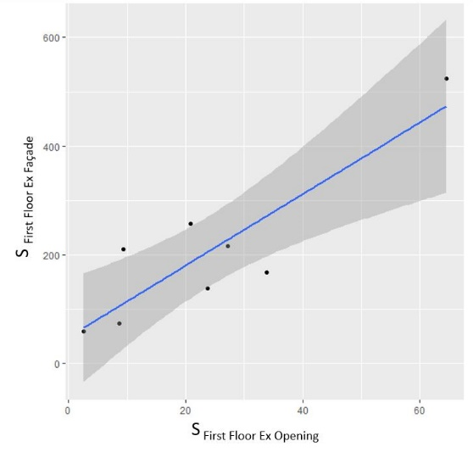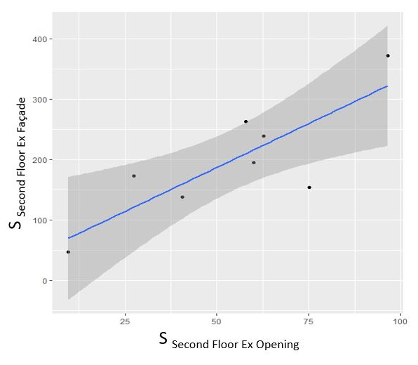
Figure 8 (left). The ratio of “total area of the first-floor openings of the exterior façade” to "area of the first-floor exterior façade”
Figure 9 (right). The ratio of "total area of openings the second-floor exterior façade” to "area of the second-floor exterior façade”
Despite the above results, no formula was obtained to show the variation of the openings area to the total exterior façade area ratio for each floor.

3-2- Interior Façades
- Criterion 7: North Interior Façade
The ratio of "total area of north interior openings" to "area of north interior facade" was examined. The study shows that among the 8 houses that have a north interior facade, the ratio of the total area of the north interior facade openings to the north interior facade area is a minimum of about 19%, with an average of about 26% and a maximum of 34%. Also, to examine the relationship between these two variables, the results of fitting a simple linear regression model can be used:
S _{N.In Opening} = 2.26 + 0.22 S _{N.In Facade}
It means that, for example, for every 10 square meters of increase in the area of the north interior facade, the total area of the openings of that facade increases by about 2.2 square meters. The value of the coefficient of determination or R2 for this linear equation is 0.7, which is an acceptable value.
- Criterion 8: South Interior Façade
The ratio of "total area of south interior openings" to "area of south interior facade" was examined. Among the 6 houses that have a south interior facade, the ratio of the total area of the south interior facade openings to the area of south interior facade is a minimum of 22%, with an average of 27% and a maximum of 35%. Also, to examine the relationship between these two variables, the results of fitting a simple linear regression model can be used:
S _{S.In Opening} = 4.04 + 0.23 S _{S.In Facade}
It means that, for example, for every 10 square meters of increase in the area of the south exterior facade, the total area of the openings of that facade increases by about 2.3 square meters. The value of the coefficient of determination or R2 for this linear equation is 0.66, which is an acceptable value.
- Criterion 9: East Interior Façade
The ratio of ‘total area of east interior openings’ to ‘area of east interior façade’ was examined. Among the 8 houses that have an east interior facade, the ratio of the total area of the east interior facade openings to the east interior facade area is a minimum of about 18%, with an average of about 27% and a maximum of about 41%. Also, to examine the relationship between these two variables, the results of fitting a simple linear regression model can be used:
S _{E.In Opening} = 0.96 + 0.25 S _{E.In Facade}
It means that, for example, for every 10 square meters of increase in the west interior façade, the total area of the openings in that façade increases by about 2.5. The value of the coefficient of determination or R2 for this linear equation is 0.61, which is an acceptable value.
- Criterion 10: West Interior Façade
The same examinations were performed to obtain the ratio of ‘total area of west interior facade openings’ to "area of west interior facade", but no specific pattern was obtained between the variables.
- Criterion 11: First Floor of Interior Façade
The ratio of ‘total area of the first-floor interior façade openings’ to ‘area of the first-floor interior façade’ was examined. The results show that among the 8 houses that have a first-floor interior facade, the ratio of the total area of the first-floor interior facade openings to the area of the first-floor interior facade is a minimum of about 19%, with an average of about 26% and at a maximum of about 41%. The result of fitting a simple linear regression model is as follows:
S _{First Floor In Opening} = 6.86 + 0.22 S _{First Floor In Façade}
It means that, for example, for every 10 square meters of increase in the area of the first-floor interior facade, the total area of the openings of that facade increases by about 2.2 square meters. The value of the coefficient of determination or R2 for this linear equation is 0.63 which is an acceptable value (Figure 10).
- Criterion 12: Second Floor of Interior Façade
The ratio of ‘total area of openings of the second-floor interior façade’ to ‘area of the second-floor interior façade’ was examined. The results show that among the 8 houses that have a second-floor interior facade, the ratio of the total area of the second-floor openings to the second-floor interior façade is a minimum of about 19%, with an average of about 29% and a maximum of about 49%. The result of fitting a simple linear regression model is as follows:
S _{Second Floor In Opening} = 13.93 + 0.17 S _{Second Floor In Façade}
It means that, for example, for every 10 square meters increase in the area of the first-floor interior facade, the total area of the openings of that facade increases by about 1.7 square meters. The value of the coefficient of determination or R2 for this linear equation is 0.64, which is an acceptable value (Figure 11).
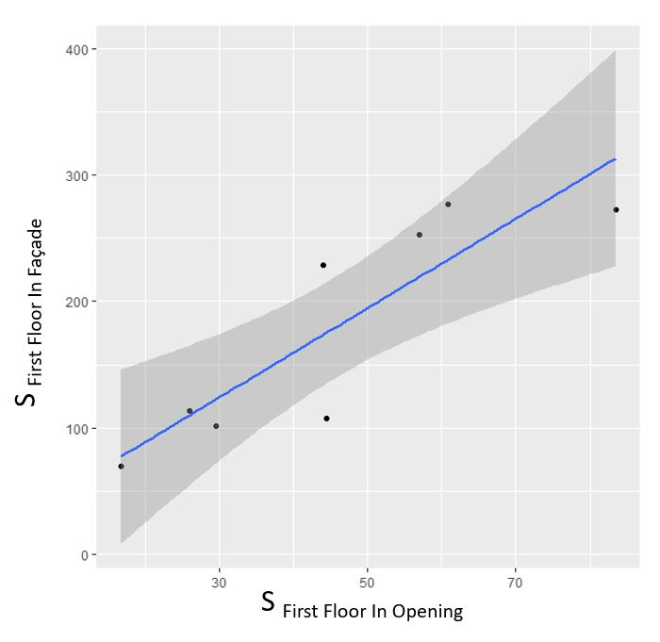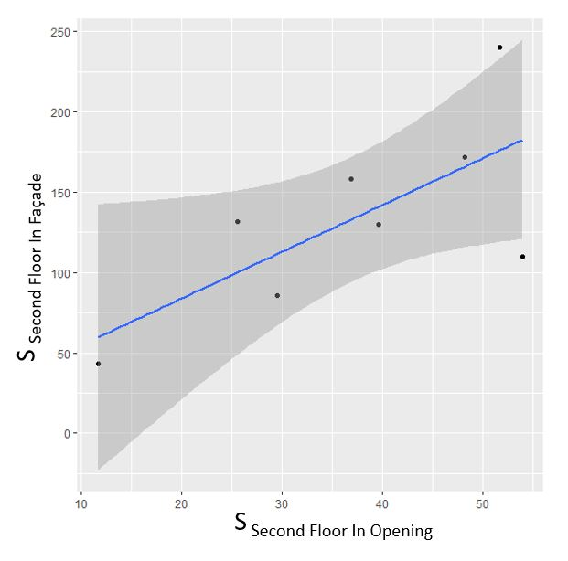
Figure 10 (left). The ratio of "total area of the first-floor openings of the interior facade" to "area of the first-floor interior facade"
Figure 11 (right). The ratio of "total area of the second-floor openings of the interior facade" to "area of the second-floor interior facade"
Despite the above results, no formula was obtained to show the variation of the openings area to the total interior façade area ratio for each floor.

3-3- Parallel Façades
The ratio of "total area of north exterior façade openings to the area of north exterior facade " to ratio of “total area of openings of north interior facade to area of north interior facade" was examined but no valid result was obtained. The same work was done for three other directions, but no special pattern was found for them. Therefore, criteria 13 to 16 in Bushehr vernacular architecture were not met.

3-4- Openings
- Criterion 17: Usage Rate of Different Shapes and Size of Openings
Descriptive statistics show that in total 55% of the openings are rectangular and 45% are arched. In terms of size, 65% of the openings used are medium, 30% are small and only 5% are large. Figure 12 shows to what extent each category of opening is arched or rectangular.
Figure 12. The use of arched and rectangular openings by opening size in vernacular residential architecture in Bushehr historic neighbourhoods except the coastal strip
Results of this study on different sizes of opening show that in the exterior facade, among 101 small openings, openings with length and height of 1.1 and 0.68, respectively, with 14 frequencies and openings with length and height of 1 and 0.7, respectively with 17 frequencies had the highest frequency. Among 220 medium openings, openings with length and height of 1 and 2.5, respectively, with 42 frequencies had the highest frequency. Among 18 large openings, openings with length and height of 2 and 3.5, respectively, with 3 frequencies had the highest frequency and openings with length and height of 2.6 and 3.2, respectively, with 3 frequencies had the highest frequency.
In the interior facade, among the 68 small openings, the openings with length and height of 0.83 and 0.48, respectively, with 19 repetitions, had the highest frequency, and the openings with length and height of 1 and 0.7, respectively with 17 frequencies had the highest frequency. Among 260 medium openings, openings with length and height of 1 and 2.6, respectively, with 75 frequencies had the highest frequency, and openings with length and height of 0.74 and 2.39, respectively, with 20 frequencies had the highest frequency. Among 30 openings, large openings with length and height of 1.5 and 2.6, respectively, with 21 frequencies had the highest frequency. Table 3 shows the most frequent small, medium, large openings in exterior and interior façade.
Table 3. The most frequently used types of small, medium, large openings in exterior and interior facades
Figure | Number of Repetition | H | WD | Opening Size | Façade
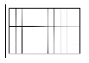 | 16 | 0.68 | 1.1 | Small | Exterior
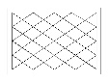 | 18 | 0.7 | 1 | Small | Exterior
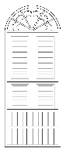 | 42 | 2.5 | 1 | Medium | Exterior
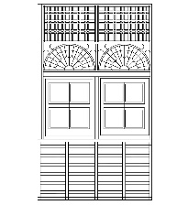 | 6 | 3.2 | 2.5 | Large | Exterior
 | 19 | 0.48 | 0.83 | Small | Interior
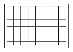 | 17 | 0.7 | 1 | Small | Interior
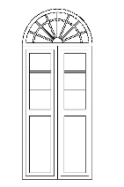 | 75 | 2.6 | 1 | Medium | Interior
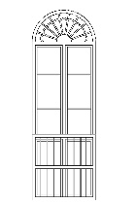 | 20 | 2.39 | 0.73 | Medium | Interior
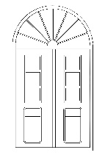 | 21 | 2.6 | 1.25 | Large | Interior
- Criterion 18: Relationship between height and width of openings
The results of fitting a simple linear regression model show that the height of rectangular openings is on average 83 cm lower than the height of arched openings. It means that more elongated openings are generally arched (R² = 0.80):
H _{Arch Opening}= 2.1 - 0.83 H _{Rec Opening}
According to the result of fitting a simple linear regression model in arched openings, the ratio of width to height in small, medium and large size openings follows the following equation (R² = 0.73):
WH _{Large Arch Opening} = 3.95 - 1.83 WH _{Medium Arch Opening} - 2.5 WH _{Small Arch Opening}
According to the result of fitting a simple linear regression model in rectangular openings, the ratio of width to height in small, medium and large size openings follows the following equation (R² = 0.73):
WH _{Large Rec Opening} = 2.73 - 0.83 WH _{Medium Rec Opening} - 2.02 WH _{Small Rec Opening}

4- Conclusion
Designing optimal-energy facades is necessary to achieve sustainable architecture. The knowledge that vernacular peoples have acquired about micro-ecosystems over the years has been reflected in vernacular architecture. Thus, vernacular architecture is a collection of solutions that can be used to achieve sustainable architecture. By examining the facades of vernacular houses in Bushehr, the present study sought to discover the solutions used in designing the facades of those houses and to express them in mathematical language that can be used by architects in designing contemporary facades. To achieve this goal, the physical properties of the facades of eight houses were extracted and 16 criteria (6 for exterior facades, 6 for interior facades and 4 for parallel facades) which are important in facade design were analyzed quantitatively with SPSS software. The results of linear regression analysis showed that out of these 16 criteria, 11 criteria (6 criteria for exterior facades and 5 criteria for interior facades) in Bushehr vernacular buildings can be expressed as linear models. Main conclusions of the results are as follow:
- Exterior Façades
The area of ​​the exterior facades on all the north, south, east, and west fronts with the area of ​​the openings of the same facade (criteria 1 to 4) follows the linear equations. In this regard, the obtained equation was the same for both the south and east fronts. Comparison of the ratio of openings area to facade area on four fronts in both south and east facades (19%), north facade that does not receive radiation (28%), and west facade that has a great effect on overheating of the building (29%) shows that radiation was not the only effective factor in the design of the openings of the north and west facades. In this case, to achieve more accurate results, it is recommended to future research to examine the samples separately in relation to the passageways and surrounding buildings.
Also, the ratio of the total area of the openings of the first-floor exterior facade to the area of the first-floor exterior facade (criterion 5) and the ratio of the total area of the openings of the second-floor exterior facade to the area of the second exterior facade (criterion 6) follow two linear equations. Comparison of these two equations shows that the area of the openings used on the second floor is more, which can be due to receiving favourable breeze and wind to create ventilation due to high air humidity.
- Interior Façades
The area of ​​interior facades in the three fronts of north, south, and east with the same area of ​​the interior facades on the same front (criteria 7 to 9) follows the specific linear equations. This variable does not have a specific formula only in the west facade. The climatic reason for it can be the change in the degree of desirability and priority of receiving radiation and wind from this front due to the difference in the environment around the building and the level of shading of adjacent buildings. Also, "the ratio of the total area of ​​the interior facade openings to the area of ​​the interior facade in both the first and second floors is at the lowest level (19%) and equal. The mean and maximum of these ratios, with a difference of 3 and 8%, respectively, are higher on the second floor, which, similar to the exterior facades, can be used to increase receiving breeze and creating ventilation.
- Parallel Façades
Regarding the parallel facades, the ratio of "total area of north exterior façade openings to north exterior façade area" to "ratio of total area of north interior facade openings to the area of north interior facade " and similar for south, east, and west facades does not follow any linear model.
- Openings
The results of the present study also determined the use of openings with different shapes and sizes (criterion 17). Most of the used openings are in medium and small sizes and large openings had been rarely used. More use of medium openings in this climate shows the importance of receiving breeze and ventilation along with reducing received radiation. The use of arched openings is 10% more than arched openings. Also, most medium openings are arched openings and most of small and large openings are rectangular. Accordingly, the most widely used type of opening in Bushehr is medium arched openings. These results allow designers to recognize the use of arched and arched openings as well as small, medium, and large windows, as well as the most widely used ones, and use them in their contemporary designs. Also, the results of this study presented the height-to-width ratio in small, medium, and large openings for both arched openings and arched openings as a linear equation (criterion 18).
One of the achievements of this study was recognizing the principles used in designing the interior and exterior facades of Bushehr vernacular architecture. Also, it presented the principles in simple mathematical language in the form of linear models. They allow architects to easily use these principles in designing contemporary facades. To achieve more accurate results, it is recommended to future research to examine this issue in related to the passageways and surrounding building. Although the linear models presented are completely specific to the vernacular architecture of Bushehr, the method presented in this study can be used by other researchers to recognize the principles used in the vernacular facades of other parts of the world.
Acknowledgements
Not applicable

References
Acar Bilgin, Elif. 2019. “Rural Architectural Characteristics and Conservation Issues of Alaaddinbey Village in Bursa, Turkey BT - Conservation of Architectural Heritage: A Culmination of Selected Research Papers from the Second International Conference on Conservation of Archite.” In , edited by Dean Hawkes, Hocine Bougdah, Federica Rosso, Nicola Cavalagli, Mahmoud Yousef M. Ghoneem, Chaham Alalouch, and Nabil Mohareb, 161–78. Cham: Springer International Publishing. https://doi.org/10.1007/978-3-030-10871-7_14.
Aflaki, Ardalan, Norhayati Mahyuddin, Zakaria Al-Cheikh Mahmoud, and Mohamad Rizal Baharum. 2015. “A Review on Natural Ventilation Applications through Building Façade Components and Ventilation Openings in Tropical Climates.” Energy and Buildings 101: 153–62. https://doi.org/https://doi.org/10.1016/j.enbuild.2015.04.033.
Anna-Maria, Vissilia. 2009. “Evaluation of a Sustainable Greek Vernacular Settlement and Its Landscape: Architectural Typology and Building Physics.” Building and Environment 44 (6): 1095–1106. https://doi.org/https://doi.org/10.1016/j.buildenv.2008.05.026.
Askari, Amir Hossein, and Kamariah Dola. 2009. “Influence of Building Façade Visual Elements on Its Historical Image: Case of Kuala Lumpur City, Malaysia.” Journal of Design and the Built Environment 5: 49–59.
Ayla, Zeyneb, and Kirenci Eruzun. 2021. “An Analysis of the Plan and Facade Typologies of Boyabat ’ s Traditional Turkish Houses.” Journal of Sustainable Architecture and Civil Engineering 1 (28): 40–55. https://doi.org/10.5755/j01.sace.28.1.27947.
Baper, Salahaddin Yasin, and Ahmad Sanusi Hassan. 2012. “Factors Affecting the Continuity of Architectural Identity.” In . Baper, S. Y., & Hassan, A. S. (2012). Factors affecting the continuity of architectural identity. American Transactions on Engineering & Applied Sciences.
Bodach, Susanne, Werner Lang, and Johannes Hamhaber. 2014. “Climate Responsive Building Design Strategies of Vernacular Architecture in Nepal.” Energy and Buildings 81: 227–42. https://doi.org/https://doi.org/10.1016/j.enbuild.2014.06.022.
Boyano, A, P Hernandez, and O Wolf. 2013. “Energy Demands and Potential Savings in European Office Buildings: Case Studies Based on EnergyPlus Simulations.” Energy and Buildings 65: 19–28. https://doi.org/https://doi.org/10.1016/j.enbuild.2013.05.039.
Brown, F, Gholam Hossein Memarian, Bryan Edwards, Magda Sibley, M Hakmi, and P Land. 2006. “The Shared Characteristics of Iranian and Arab Courtyard Houses.” In .
Chandel, S S, Vandna Sharma, and Bhanu M Marwah. 2016. “Review of Energy Efficient Features in Vernacular Architecture for Improving Indoor Thermal Comfort Conditions.” Renewable and Sustainable Energy Reviews 65 (C): 459–77. https://econpapers.repec.org/RePEc:eee:rensus:v:65:y:2016:i:c:p:459-477.
Desogus, Giuseppe, Leonardo Giuseppe Felice Cannas, and Antonello Sanna. 2016. “Bioclimatic Lessons from Mediterranean Vernacular Architecture: The Sardinian Case Study.” Energy and Buildings 129: 574–88. https://doi.org/https://doi.org/10.1016/j.enbuild.2016.07.051.
Dili, A. S., M. A. Naseer, and T. Zacharia Varghese. 2010. “Passive Environment Control System of Kerala Vernacular Residential Architecture for a Comfortable Indoor Environment: A Qualitative and Quantitative Analyses.” Energy and Buildings 42 (6): 917–27. https://doi.org/10.1016/j.enbuild.2010.01.002.
Du, Xiaoyu, Regina Bokel, and Andy Dobbelsteen. 2014. “Building Microclimate and Summer Thermal Comfort in Free-Running Buildings with Diverse Spaces: A Chinese Vernacular House Case.” Building and Environment 82 (December): 215–227. https://doi.org/10.1016/j.buildenv.2014.08.022.
Eshrati, Parastoo, Mohammad Kazem Namazi, Dorna Eshrati, and Somayeh Fadaei Nezhad Bahramjerdi. 2016. “Intimating Girls’ Schools With an Emphasis on Vernacular Architecture Bushehr City.” Jria 4 (2): 37–56. http://jria.iust.ac.ir/article-1-485-en.html.
Foged, Isak W. 2019. “Thermal Responsive Performances of a Spanish Balcony-Based Vernacular Envelope.” Buildings . https://doi.org/10.3390/buildings9040080.
Frampton, Kenneth. 2002. “Botticher, Semper and the Tectonic: Core Form and Art.” In What Is Architecture?, edited by Andrew Ballantyne, 1st Editio, 138–52. London and New York: Routledge Ltd. https://doi.org/https://doi.org/10.4324/9781315012933.
Goia, Francesco. 2016. “Search for the Optimal Window-to-Wall Ratio in Office Buildings in Different European Climates and the Implications on Total Energy Saving Potential.” Solar Energy 132: 467–92. https://doi.org/https://doi.org/10.1016/j.solener.2016.03.031.
Grynning, Steinar, Arild Gustavsen, Berit Time, and Bjørn Petter Jelle. 2013. “Windows in the Buildings of Tomorrow: Energy Losers or Energy Gainers?” Energy and Buildings 61: 185–92. https://doi.org/https://doi.org/10.1016/j.enbuild.2013.02.029.
Hachem, Caroline, and Mohanmed Elsayed. 2016. “Patterns of Façade System Design for Enhanced Energy Performance of Multistory Buildings.” Energy and Buildings 130: 366–77. https://doi.org/https://doi.org/10.1016/j.enbuild.2016.08.051.
Hayashi, Tomomi. 2004. “‘Lasnamäe Track and Field Centre:Façade, MAJA Estonian Architectural Review,’” May 2004. https://www.solness.ee/majaeng/index-gid=60&id=323.html.
HEDAYAT, AZAM, and PARASTOO ESHRATI. 2021. “Typology of Tarmeh in the Historic City of Bushehr.” HOUSING AND RURAL ENVIRONMENT 39 (172 #T001049): 106–19. https://www.sid.ir/en/Journal/ViewPaper.aspx?ID=815846.
Heiselberg, Per, Erik Bjørn, and Peter Nielsen. 2002. “Impact of Open Windows on Room Air Flow and Thermal Comfort.” International Journal of Ventilation 1 (October): 91–100. https://doi.org/10.1080/14733315.2002.11683625.
Hoelscher, Marie-Therese, Thomas Nehls, Britta Jänicke, and Gerd Wessolek. 2016. “Quantifying Cooling Effects of Facade Greening: Shading, Transpiration and Insulation.” Energy and Buildings 114: 283–90. https://doi.org/https://doi.org/10.1016/j.enbuild.2015.06.047.
Hosseini, Seyedeh, Morteza Hosseini, and Milad Heiranipour. 2020. “The Role of Orosi’s Islamic Geometric Patterns in the Building Façade Design for Improving Occupants’ Daylight Performance.” Journal of Daylighting 7 (November): 201–21.
Ihara, Takeshi, Arild Gustavsen, and Bjørn Petter Jelle. 2015. “Effect of Facade Components on Energy Efficiency in Office Buildings.” Applied Energy 158: 422–32. https://doi.org/https://doi.org/10.1016/j.apenergy.2015.08.074.
Karimi, Bagher. 2012. “Persian Gulf Architecture The Effect Of Bushehr Old Tissue On The Culture And Architecture Of The Persian Gulf Countries (Case Study: Al-Bastakiyeh Neighborhood In Dubai).” HOVIAT-E-SHAHR 6 (11): 85–96.
Khajehzadeh, Iman, Brenda Vale, and Fatemeh Yavari. 2016. “A Comparison of the Traditional Use of Court Houses in Two Cities.” International Journal of Sustainable Built Environment 5 (2): 470–83. https://doi.org/10.1016/j.ijsbe.2016.05.010.
Konstantoglou, Maria, and Aris Tsangrassoulis. 2016. “Dynamic Operation of Daylighting and Shading Systems: A Literature Review.” Renewable and Sustainable Energy Reviews 60: 268–83. https://doi.org/https://doi.org/10.1016/j.rser.2015.12.246.
Kubota, Tetsu, and Doris Hooi Chyee Toe. 2015. “Application of Passive Cooling Techniques in Vernacular Houses to Modern Urban Houses: A Case Study of Malaysia.” Procedia - Social and Behavioral Sciences 179: 29–39. https://doi.org/https://doi.org/10.1016/j.sbspro.2015.02.408.
Lau, Allen Khin Kiet, Elias Salleh, Chin Haw Lim, and Mohamad Yusof Sulaiman. 2016. “Potential of Shading Devices and Glazing Configurations on Cooling Energy Savings for High-Rise Office Buildings in Hot-Humid Climates: The Case of Malaysia.” International Journal of Sustainable Built Environment 5 (2): 387–99. https://doi.org/https://doi.org/10.1016/j.ijsbe.2016.04.004.
Lee, Jeehwan, and Jae D Chang. 2015. “Influence on Vertical Shading Device Orientation and Thickness on the Natural Ventilation and Acoustical Performance of a Double Skin Facade.” Procedia Engineering 118: 304–9. https://doi.org/https://doi.org/10.1016/j.proeng.2015.08.431.
Luca, Francesco De, Hendrik Voll, and Martin Thalfeldt. 2016. “Horizontal or Vertical? Windows’ Layout Selection for Shading Devices Optimization.” Management of Environmental Quality: An International Journal 27 (6): 623–33. https://doi.org/10.1108/MEQ-05-2015-0102.
Mangkuto, Rizki A, Mardliyahtur Rohmah, and Anindya Dian Asri. 2016. “Design Optimisation for Window Size, Orientation, and Wall Reflectance with Regard to Various Daylight Metrics and Lighting Energy Demand: A Case Study of Buildings in the Tropics.” Applied Energy 164: 211–19. https://doi.org/https://doi.org/10.1016/j.apenergy.2015.11.046.
Memarian, Gholamhossein, and Frank Edward Brown. 2003. “CLIMATE, CULTURE, AND RELIGION: ASPECTS OF THE TRADITIONAL COURTYARD HOUSE IN IRAN.” Journal of Architectural and Planning Research 20 (3): 181–98. http://www.jstor.org/stable/43030659.
Montazeri, H., F. Montazeri, R. Azizian, and S. Mostafavi. 2010. “Two-Sided Wind Catcher Performance Evaluation Using Experimental, Numerical and Analytical Modeling.” Renewable Energy 35 (7): 1424–35. https://doi.org/10.1016/j.renene.2009.12.003.
Montazeri, H., Y. Toparlar, B. Blocken, and J. L.M. Hensen. 2017. “Simulating the Cooling Effects of Water Spray Systems in Urban Landscapes: A Computational Fluid Dynamics Study in Rotterdam, The Netherlands.” Landscape and Urban Planning 159 (March): 85–100. https://doi.org/10.1016/J.LANDURBPLAN.2016.10.001.
Montazeri, Hamid. 2011. “Experimental and Numerical Study on Natural Ventilation Performance of Various Multi-Opening Wind Catchers.” Building and Environment 46 (2): 370–78. https://doi.org/https://doi.org/10.1016/j.buildenv.2010.07.031.
Motealleh, Parinaz, Maryam Zolfaghari, and Mojtaba Parsaee. 2018. “Investigating Climate Responsive Solutions in Vernacular Architecture of Bushehr City.” HBRC Journal 14 (2): 215–23. https://doi.org/10.1016/j.hbrcj.2016.08.001.
Motuzienė, Violeta, and Egidijus Juodis. 2010. “Simulation Based Complex Energy Assessment of Office Building Fenestration.” JOURNAL OF CIVIL ENGINEERING AND MANAGEMENT 16 (September): 345–51. https://doi.org/10.3846/jcem.2010.39.
Namazi, Mohammad, Parastoo Eshrati, Dorna Eshrati, and Somayeh Fadaei Nezhad Bahramjerdi. 2016. “The Study of Effective Components in Façade Engineering Towards Developing a Conceptual Framework.” Journal of Applied Environmental and Biological Sciences 6 (January): 61–68.
Nguyen, Anh Tuan, Tran Quoc Bao, Duc-Quang Tran, and Sigrid Reiter. 2011. “An Investigation on Climate Responsive Design Strategies of Vernacular Housing in Vietnam.” Building and Environment 46 (October): 2088–2106. https://doi.org/10.1016/j.buildenv.2011.04.019.
Nikghadam, Niloofar. 2016. “Airflow and Radiation Impact on Moderating Heat Conditions in the Bushehr Houses (Case Study: Golshan House).” Journal of Iranian Architecture & Urbanism(JIAU) 7 (2): 29–46. https://doi.org/10.30475/isau.2017.62028.
Okba, Ehab. 2005. “Building Envelope Design as a Passive Cooling Technique.” International Conference “Passive and Low Energy Cooling for the Built Environment.”
Philokyprou, Maria, Aimilios Michael, Eleni Malaktou, and Andreas Savvides. 2017. “Environmentally Responsive Design in Eastern Mediterranean. The Case of Vernacular Architecture in the Coastal, Lowland and Mountainous Regions of Cyprus.” Building and Environment 111: 91–109.
Pikas, Ergo, Martin Thalfeldt, and Jarek Kurnitski. 2014. “Cost Optimal and Nearly Zero Energy Building Solutions for Office Buildings.” Energy and Buildings 74 (May): 30–42. https://doi.org/10.1016/j.enbuild.2014.01.039.
Poirazis, Harris, Åke Blomsterberg, and Maria Wall. 2008. “Energy Simulations for Glazed Office Buildings in Sweden.” Energy and Buildings 40 (7): 1161–70. https://doi.org/https://doi.org/10.1016/j.enbuild.2007.10.011.
ranjbar, ehsan, mohammadreza pourjafar, and keynav khaliji. 2010. “Innovations In Climatic Designing Due to The Wind Flowing Through The Old Bushehr.” The Monthly Scientific Journal of Bagh-e Nazar 7 (13): 17–34. http://www.bagh-sj.com/article_23.html.
Saadatian, Omid, Chin Haw Lim, CH, Kamaruzzaman Sopian, Suleiman, and MY. 2012. “Review of Windcatcher Technologies.” Renewable & Sustainable Energy Reviews., April. https://doi.org/10.1016/j.rser.2011.11.037.
Sahebzadeh, Sadra, Abolfazl Heidari, Hamed Kamelnia, and Abolfazl Baghbani. 2017. “Sustainability Features of Iran’s Vernacular Architecture: A Comparative Study between the Architecture of Hot–Arid and Hot–Arid–Windy Regions.” Sustainability . https://doi.org/10.3390/su9050749.
Santamouris, M (Matheos). 2007. Advances in Passive Cooling . London: Earthscan.
Sari, Reyhan Midili, Derya Elmali Şen, Selda Al, Nimet Candaş Kahya, and Ayşe Sağsöz. 2011. “The Effects of Traditions, Customs and Beliefs on Architectural Design: The Example of Turkey.” In International Journal of Academic Research, 3:780–92.
Serralheiro, Maria Inês, Jorge de Brito, and Ana Silva. 2017. “Methodology for Service Life Prediction of Architectural Concrete Facades.” Construction and Building Materials 133 (C): 261–74. https://doi.org/10.1016/j.conbuildmat.2016.12.079.
Singh, Manoj Kumar, Sadhan Mahapatra, and Srinivas Atreya. 2010. “Thermal Performance Study and Evaluation of Comfort Temperatures in Vernacular Buildings of North-East India.” Building and Environment 45: 320–29.
Soflaei, Farzaneh, and Mehdi Shokouhian. 2005. “Natural Cooling Systems in Sustainable Traditional Architecture of Iran.” In 1st International Conference on Passive and Low Energy Cooling for the Built Environment (PALENCE2005).
Sousa, Goreti, Gilberto Carlos, Rui Florentino, and T Bermudez. 2020. “MULTIDISCIPLINARY ANALYSIS OF THE VERNACULAR SETTLEMENTS IN USHGULI (UPPER SVANETI, GEORGIA).” ISPRS - International Archives of the Photogrammetry, Remote Sensing and Spatial Information Sciences XLIV-M-1–2 (July): 189–93. https://doi.org/10.5194/isprs-archives-XLIV-M-1-2020-189-2020.
Susorova, Irina, Meysam Tabibzadeh, Anisur Rahman, Herek L Clack, and Mahjoub Elnimeiri. 2013. “The Effect of Geometry Factors on Fenestration Energy Performance and Energy Savings in Office Buildings.” Energy and Buildings 57: 6–13.
Thalfeldt, Martin, Jarek Kurnitski, and Hendrik Voll. 2015. “Comparison of Simplified and Detailed Window Models in Office Building Energy Simulations.” Energy Procedia 78: 2076–81. https://doi.org/https://doi.org/10.1016/j.egypro.2015.11.235.
Thalfeldt, Martin, Ergo Pikas, Jarek Kurnitski, and Hendrik Voll. 2013. “Facade Design Principles for Nearly Zero Energy Buildings in a Cold Climate.” Energy and Buildings 67: 309–21. https://doi.org/https://doi.org/10.1016/j.enbuild.2013.08.027.
Tzempelikos, Athanassios, Athienitis, Andreas K., and Panagiota Karava. 2007. “Simulation of Façade and Envelope Design Options for a New Institutional Building.” Solar Energy 81 (9): 1088–1103. https://doi.org/10.1016/j.solener.2007.02.006.
Utaberta, Nangkula, Afshin Jalali, Suhana Johar, Mastor Surat, and Adi Irfan Che-Ani. 2012. “Building Facade Study in Lahijan City, Iran: The Impact of Facade’s Visual Elements on Historical Image.” World Academy of Science, Engineering and Technology, International Journal of Social, Behavioral, Educational, Economic, Business and Industrial Engineering 6: 1839–44.
Vakilinezhad, Roza, S Mofidi, and Mehdizadeh. 2013. “‘Shanashil’: A Sustainable Element to Balance Light, View, and Thermal Comfort.” International Journal of Environmental Sustainability 8 (January): 101–10.
Vanhoutteghem, Lies, Gunnlaug Cecilie Jensen Skarning, Christian Anker Hviid, and Svend Svendsen. 2015. “Impact of Façade Window Design on Energy, Daylighting and Thermal Comfort in Nearly Zero-Energy Houses.” Energy and Buildings 102: 149–56. https://doi.org/https://doi.org/10.1016/j.enbuild.2015.05.018.
Wang, H. 2007. “Evaluation of the Facade of Buildings in ‘Type I Residential Area’ of the 7th Land Consideration District in Taichung City.” National Yunlin University of Science and Technology.
Wang, Jingying, and Chiho Ochiai. 2021. “Spatial Composition and Building Techniques of Farmhouses Prone to Windstorms:A Case Study in Arakawa Village, Shiga Prefecture, Japan.” Journal of Asian Architecture and Building Engineering, October, 1–15. https://doi.org/10.1080/13467581.2021.1972810.
Wang, Liping, Hien Wong Nyuk, and Shuo Li. 2007. “Facade Design Optimization for Naturally Ventilated Residential Buildings in Singapore.” Energy and Buildings 39 (8): 954–61. https://doi.org/https://doi.org/10.1016/j.enbuild.2006.10.011.
Zhai, Zhiqiang (John), and Jonathan M Previtali. 2010. “Ancient Vernacular Architecture: Characteristics Categorization and Energy Performance Evaluation.” Energy and Buildings 42 (3): 357–65. https://doi.org/https://doi.org/10.1016/j.enbuild.2009.10.002.

* Corresponding Author

