Exploring the Impact of Urban Wall Characteristics on Pedestrian Calmness and Attention through Virtual Quasi-Experiments and EEG (Case Study: Teater-e-Shahr to Valieasr Square Block in Tehran, Iran)

Safoora Sadra
MA in Urban Design, School of Architecture and Urban Studies, Iran University of Art, Tehran, Iran.
Email: Saforasadra@gmail.com

Amir Shakibamanesh
Associate professor of Urban Design, Department of Urban Planning and Design, School of Architecture and Urban Studies, Iran University of Art, Tehran, Iran.
Email: a.shakibamanesh@art.ac.ir

Abstract
This study investigates how urban wall design characteristics affect pedestrians' perceptions of calmness and attention. Utilizing the portable EEG device Neurosky, the research translates brain wave activity into measurable emotional states, such as calmness and excitement, and attention levels. Employing virtual 3D interactive simulations, the study controls both physical and non-physical variables to isolate the effects of design elements. Analysis focuses on three key variables—scale, transparency, and continuity—revealing significant findings. Low wall height, fine-grained elements, continuous structures, and wider pathways enhance pedestrian calmness while reducing attention levels. In contrast, high wall heights, discontinuous or protruding features, opaque materials, and coarse-grained designs heighten attention but diminish calmness. These results underscore the dynamic interplay between individuals and their urban environment, highlighting the critical role of urban wall design in shaping psychological well-being. By offering evidence-based insights, this research informs urban design practices to create environments that foster comfort and engagement while minimizing stress.
Keywords: Virtual quasi-experiments, urban walls, cognitive neuroscience, EEG, calmness, attention, urban design.

- Introduction
Humans respond both cognitively and emotionally to the built environment, including urban spaces, as noted by Llinares and Macagno (2021). This relationship has driven numerous studies exploring how users' emotions influence their perception of urban spaces. For example, Rapuano et al. (2022) emphasize the importance of designing open spaces that can actively stimulate emotional responses. And, Mavros et al. (2022) demonstrated through mobile EEG measurements that outdoor urban spaces are perceived more positively than indoor settings, providing nuanced insights into the emotional effects of different environments.
With the advancement of neuroscientific techniques and virtual reality, researchers now have innovative tools to study these responses more deeply. Llinares and Macagno (2021) highlight that recording neural activity during exposure to environmental situations offers a promising framework for future urban design. By studying brain activity, researchers can assess feelings, perceptions, and cognitive reactions before observable behaviors occur. This approach provides an efficient alternative to traditional methods, that are time-consuming and characterized by high costs and low efficiency (Dai et al., 2021).
In this context, brain wave imaging emerges as a valuable complement—or even an alternative—to conventional methods. Its ability to capture immediate neural responses enhances the precision and efficiency of studying the interplay between human emotions and urban spaces.
While extensive research exists on environmental psychology and neuroscience in urban settings, there remains a crucial gap in understanding how specific urban wall characteristics influence cognitive and emotional responses in pedestrians. This study focuses on three key characteristics - transparency, continuity, and scale - as they fundamentally shape visual perception and spatial experience.
There are several ecological issues such as water, air, and noise pollution that have always been discussed in urban design, the visual environment, as one of the most important environments that humans come into contact with throughout their lives, has been neglected. Therefore, in today's world, the need to pay attention to the visual environment (especially urban walls) as one of the ecological factors becomes important (Pourjafar & Balmaki, 2012). Well-designed public spaces and architecture are instrumental in shaping the visual character of cities and influencing the quality of life for residents (Pidlisna et al., 2023)
This research addresses two primary questions: How do specific urban wall characteristics affect pedestrians' levels of calmness, and what is their impact on attention patterns? By examining these relationships through neuroscientific methods, we aim to establish evidence-based design guidelines for urban walls that enhance psychological well-being and cognitive function in urban spaces.
In this study, with the consideration of the definition of quality- the way, manner, arrangement, and relationships between elements (Bahreini, & Khosravi, 2014)- the environmental elements were manipulated to provide new qualities to users. The primary hypothesis in this study posits that urban wall characteristics—specifically transparency, continuity, and scale—significantly influence calmness and excitement, as well as attention.
The study examines the initial 200 meters from Teater-e-Shahr to Valieasr Square in Tehran, a highly trafficked commercial corridor that presents diverse urban wall conditions and sustained pedestrian activity. This location serves as an ideal case study due to its varied urban wall features and consistent pedestrian presence, allowing for comprehensive analysis of how urban wall characteristics affect human psychological responses in real-world conditions.

2- The process of human-environment interaction
The Process of Human-Environment Interactions are creatures that cannot live without communication. Communication exists within individuals as both a sender and a receiver, and what connects these two is hidden (Pakzad, 2006). Each individual regularly obtains information from their living environment with their senses and processes it in their brain (Groth, 2014). However, it should be noted that the relationship between us and the environment is not limited to physiological exchanges such as breathing, etc. As we communicate with the environment physically, we also have emotional and psychological connections with it (Figure 1) (Pakzad & Bozorg, 2016).

Figure 1. Types of human-environment interaction (Adapted from Pakzad & Bozorg, 2016)
In the context of urban environments, particularly urban walls, this interaction follows a clear sequential process. The characteristics of urban walls first influence perceptual processing, shaping how individuals visually and cognitively interpret the space. This leads to two distinct but interconnected responses: emotional-psychological exchanges and physiological exchanges. Emotional-psychological responses process aesthetic and visual experiences, such as how transparency levels and facade patterns affect psychological comfort and spatial perception. Physiological responses address immediate survival and comfort needs, such as how building heights and wall continuity influence environmental adaptation. James Gibson’s (1977) theory of ‘affordances’ emerged from psychology as an account of how properties of the material world provide affordances for human desires. Affordance thinking has been highly influential across a range of design disciplines, including urban design (Stevens, Daly and Dovey, 2024). According to Gibson's affordance theory, the environment offers a set of affordances for experiencing the environment and engaging in behavior through environmental qualities, which leads to two-way interaction and communication with individuals. This communication is initiated or triggered by mental schemes such as perception, emotions, feelings, etc., and continues due to human needs. In this process, emotions are a measurable part that has a completely physiological basis.
This systematic process explains how urban wall characteristics directly influence pedestrian responses: behavior initiates the interaction, perception processes the wall's features, and both physiological and emotional-psychological exchanges create immediate responses and lasting impressions. The framework demonstrates how specific wall elements - height, transparency, and continuity - trigger distinct patterns of human response, creating a measurable relationship between urban wall design and human experience.
2-1- Perception of the "Emotion" Spectrum in Interaction with the Environment
Emotions are expressed through actions or movements that are generally seen by others through facial expressions, voice, body language, and specific behaviors of the person in question. However, some components of emotion processing are not visible to the naked eyes. Instead, they can be observed through scientific tools such as hormone measurements and electro-physiological wave patterns. On the other hand, a person's feeling always remains hidden, like all mental conceptions and imaginations that are necessarily hidden and no one but the owner of that feeling is capable of perceiving it. In fact, it is the most confidential living treasure that occurs in his/her brain (Damasio, 2013). Emotions are always introduced as a continuum. For example, high arousal (tension, excitement) and low arousal (calmness, tranquility).
Emotions are often conceptualized as a continuum, with varying levels of arousal, such as tension and excitement on one end, and calmness or tranquility on the other. A common continuous representation of emotion uses the three principles dimensions of affect as Activation (active–passive), Valence (pleasant–unpleasant) and Dominance (dominant–submissive) (Fatima and Erzin, 2021) Emotional responses exist on a continuous spectrum rather than as binary states. In this study, we focus on two key points along this spectrum: calmness (low arousal, characterized by calmness) and attention (higher arousal, marked by excitement) (Figure 2).

Tranquility(calmness) High Arousal (excitement)
Figure 2. Emotional continuum (Source: McAndrew, 2013)
Individuals can experience various emotional states that fall between these two extremes, reflecting the fluid nature of human emotions. When a stimulus or an event is perceived as important, arousal is increased to prepare the body for action. Arousal may provide information about the importance or urgency of a situation, event or response, which may in turn affect cognition. High arousal stimuli also seem to capture attention better than low arousal stimuli (Marti-Marca et al., 2020)
It is recognized that features of a city influence how we experience the urban environment and consequently have an impact on our emotions. Therefore, designing cities that are attractive and responsive to citizens’ needs and demands and where people have more positive experiences has become increasingly important for policymakers, urban planners, managers and designers. (weijs-Perree, Dane and Van den berg, 2020).

2-2- The importance of "attention" to the visual environment in urban design
Attention is the ability to select specific stimuli among various stimuli to show a response) Mahi al-Din Banab, 2000). Attention is a means of processing a small portion of the abundant information in the environment. Attention includes both conscious and unconscious processes. Conscious or overt attention is traceable through eye movements. However, unconscious or covert attention can only be obtained by studying brain neural responses. Cognitive neuroscience provides the possibility of identifying attention, whether conscious or unconscious, in studies (Sternber & Mio, 2009). According to the Attention–Restoration Theory (ART), it is postulated that urban environments are often accompanied by high levels of stimulation, e.g. moving cars and people, that require directed attention and lead to directed attention fatigue. (Mavros et al., 2022)
Urban wall characteristics—transparency, continuity, height, and segmentation—play critical roles in directing attention and shaping spatial experience. Transparent elements create interior-exterior connections, while continuous designs guide movement patterns. Understanding how these qualities influence attention helps create more engaging urban spaces.
3- Cognitive Neuroscience: A novel knowledge for scientific study of communication processes in the brain
Cognitive neuroscience is the scientific study of the nervous system and its functions (Gage, 2015). Today, research on cognitive neuroscience is taking place in various fields, from the cognition of neurons, studying genes to behavioral, emotional, and cognitive studies of a healthy or problematic brain (Squire et al., 2008).Despite the rise in application of the concept ‘neuro’ in several fields of research, scholars in urban studies, as well as practitioners, such as town and city planners, developers, and built environmentalist in urban affairs, are unaware or bereft of the notion of how their construction and or their building processes impact mental health and increases urban stress. (Ndaguba et al., 2022) As a multidisciplinary field, neuroscience studies the nervous system which controls our perception of space, makes possible to find a place and direction, to have emotional reactions and aesthetic judgments. Gestalt psychology, environmental psychology, biology, cognitive sciences, experiential architecture, and urban planning contribute greatly to this interdisciplinary area (Giray Küçük and Yüceer, 2022)
EEG technology provides objective measurements of how people respond emotionally and cognitively to urban spaces. By recording real-time neural activity as people interact with different features, this neuroscientific approach offers quantifiable data to inform urban design decisions.
4- Application of cognitive neuroscience in urban design
Research on the relationship between the built environment and human perception, behaviour and experience are by no means new to the fields of architectural and urban studies. Relevant traditional methods used to address these issues include post-occupancy surveys, ethnographic and phenomenological approaches as well as observations of behaviours and movements in spatial settings (e.g. space syntax) (Charalambous,2023). However, today, various studies in the field of architecture and urban design benefit from the methods and tools provided by cognitive neuroscience.
The research conducted by Mavros et al. (2016) and Benayi et al. (2017) investigated users' brain responses in various segments of urban pathways to evaluate the quality of these urban spaces. Their findings highlight the importance of understanding how different urban design features, including pathways and their surroundings, influence emotional responses.
Further studies have examined key urban concepts, such as land use arrangements and spatial configurations, assessing their effects on brain signals and the resulting perceptions of users. For example, Kong et al. (2022), Herman, Ciechanowski and Przegalińska (2021) and Mavros et al. (2022) conducted a comparison of feelings of calmness in natural versus artificial environments. This comparison is relevant to our current research, highlighting the value of integrating visualy appealing elements into urban design. By doing so, we can greatly improve the sense of tranquility in urban environments.
Aspinall et al. (2013) expanded on this by examining three different types of streets—busy commercial areas, local quieter streets, and those characterized by green spaces. Their findings revealed that streets featuring green spaces significantly improve users' perceptions of calmness. This insight can guide the design of urban walls by indicating that integrating visually appealing elements, can create a more serene atmosphere.
Additionally, Kanjo and Albarrak (2013) assessed levels of calmness experienced by individuals across various land uses, such as cafes, parks, and supermarkets, categorizing the tranquility associated with each setting. Their results indicated that park environments evoke a stronger sense of calmness, which can be linked to the design of urban walls that promote positive emotional experiences. By integrating the insights from these studies, our research aims to explore how specific urban design features, particularly urban walls, can enhance calmness and attention within urban environments.
In addition to the mentioned articles, other research activities have been carried out using brainwave imaging tools (EEG) at universities such as Massachusetts and Columbia, which have created new methods for analyzing urban spaces and generating maps of emotional responses (more precisely, calmness). Park (2018) introduces a study conducted at the Massachusetts Institute of Technology in 2015 called Mindrider, during which a comprehensive map of bicycle movement based on the users' calmness and attention was prepared. The research activity at Columbia University is also conducted under the name of Neural Dumbo Map with a similar perspective, which focuses on capturing people's emotions by synchronizing them with their location during walking in the Dumbo neighborhood (Brooklyn) and presenting it on the map. These pieces of information are important because they demonstrate the impact of the urban environment on users and can create basic maps for urban studies (Collins et al., 2017).
This study focuses specifically on how urban wall characteristics influence emotional responses, using EEG to measure calmness and attention levels. Unlike previous research that examined broader urban features, the investigation concentrates on the direct impact of wall design elements. By integrating cognitive neuroscience with urban design studies, the research aims to provide practical design recommendations that enhance user experience in urban spaces. This approach bridges the gap between neuroscientific understanding and urban design practice, contributing to the development of more emotionally responsive urban environments
5- Methodology
In this study, in order to investigate the effect of visual qualities of the building envelope on the level of calmness and attention, tests were designed in a virtual environment to register, analyze and compare these changes through the output information from the brainwave EEG device. To perform these tests, a quasi-experimental environment was used. Therefore, this study can be considered experimental-analytical.
5-1- First Method: Electroencephalography (EEG) using Neurosky
Investigating emotions through brainwave analysis in cognitive neuroscience allows for the application of EEG methods in various fields, including urban planning. EEG technology provides more reliable findings than traditional research methods like questionnaires and behavioral observations. Numerous EEG tools have been developed, each with distinct features and limitations, emphasizing the importance of selecting the appropriate device based on research goals.
EEG devices are primarily used for diagnosing disorders in clinical settings, requiring specialized expertise and fixed locations, which limits their everyday accessibility. While portable EEG devices improve convenience, they still necessitate trained personnel and typically feature 32 to 64 channels for detailed analysis. Although innovative outdoor devices enable users to record brain waves in natural settings and operate with a single channel for simplicity, they still require specialized training. In contrast, wearable gadgets represent a significant advancement, focusing on mobility and adaptability, with their user-friendly design making them accessible to a broader audience and configurations available in 14, 4, and single-channel options for immediate monitoring.
In this study, the one-channel wearable device Neurosky was selected for its capacity to enhance users' sense of presence in their surroundings. Its cost-effectiveness allows researchers to use resources efficiently while obtaining high-quality data. Neurosky simplifies the research process by quickly converting raw data into insights about meditation and attention (measure them on a scale of 0-100), fostering user engagement and leading to more authentic responses.
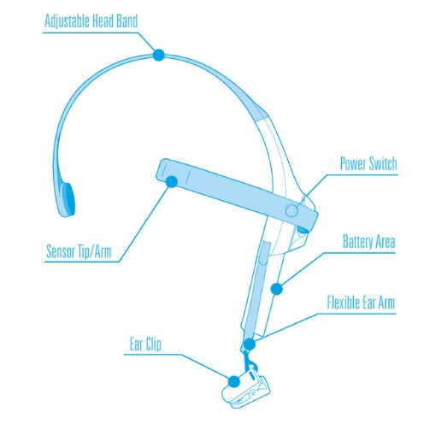
Figure 3. NeuroSky Device(neurosky.com)
Neurosky's device integrates effectively with virtual reality environments, allowing for immersive testing while measuring cognitive and emotional responses. Its open access library facilitates data collection, and its user-friendly design supports scalable research. The device's ability to capture real-time neurological responses while participants navigate virtual environments makes it an efficient tool for studying how visual qualities of urban walls influence mental states.
5-2- Second method: Virtual Reality
This study aimed to record calmness and attention during movement in a virtual environment containing different qualities. Therefore, in addition to modeling the base environment, environments that include qualities such as scale, continuity, and transparency had to be designed and tested. VR allows to overcome some barriers in carrying out tests in real environments, such as control and change the visual conditions and safely investigate hazardous environments. (Scorpio et al., 2020) In this study, it is essential to focus on analyzing specific qualities while omitting other parameters such as people, land uses, vehicles, sound, and various environmental conditions that may influence the results.
Virtual reality techniques and devices are continuously evolving, although the fundamental process remains consistent. This process involves the creation of a 3D environment, the implementation of a first-person camera, and the integration of movement and interaction through both software and hardware. Various software options, such as SketchUp and 3ds Max, are utilized to create 3D models. Game development platforms like Unity 3D enable the creation of first-person camera experiences, allowing users to navigate and interact within the virtual environment. Finally, it is essential to export the application as a VR app to ensure compatibility with VR headsets for immersive experiences.
As virtual reality systems enhance public participation, it is important to record citizen feedback when interacting with the virtual environment. Such programs should focus on recording individuals' thoughts, emotions, and preferences in different situations (Shakibamanesh, 2013). Integration of methods such as brainwave monitoring can be useful in this regard.
5-3- From creating test environments (in virtual environment) to the method of obtaining brain information (using Neurosky- An EEG tool).
The two techniques of virtual reality and EEG were used in this study to create test environments using the qualities of scale, continuity, and transparency, and then obtain parameters of meditation (calmness) and attention.
A) Virtual reality
- Creating a three-dimensional model of the study area- using SketchUp and 3ds Max(modeling) Unity 3D (first person camera and movement)
- Changing and modifying based on variables (scale, continuity, and transparency qualities)
- Providing hardware (virtual reality glasses and control handle) and connecting to software
B) EEG
- Creating a program using the neurosky device programming library provided by the manufacturer
- Connecting the device to the computer using Bluetooth
- Registering information
- Analyzing and comparing results
The research utilized a controlled indoor virtual environment with VR technology to isolate and manipulate specific visual qualities (scale, continuity, and transparency) while eliminating external variables. This setup ensured that EEG readings reflected responses to spatial characteristics rather than environmental disturbances, providing authentic neurological data through the Neurosky device
5-4- Research variables
It is necessary to specify the variables in each study due to the significant impact they have on the results, and they should be determined at the beginning. In this study, the independent variables consist of manipulatable visual qualities (scale, transparency, and continuity) in the virtual environment, while the dependent variables are the measured neurological responses (meditation/calmness and attention levels) recorded through EEG. Based on these independent variables, 12 distinct test environments were created in virtual reality, and a t-test was conducted to analyze the relationship between each visual quality and participants' neurological responses.

Table 1. Types of research variables
Variable Type | Variable | Description | Categories/Units
Intervening Variable | Mental State of People | Factors affecting perception and mental state
Control Variable | Sense of Smell, Hearing, Touch | Environmental sensory factors
Control Variable | Movement | Physical movement of individuals
Control Variable | Urban Furniture | Presence and type of street furniture
Control Variable | Green Space | Amount and quality of greenery
Control Variable | Light and Brightness | Lighting conditions on the street
Control Variable | Right Side of the Street | Influence of street positioning
Moderator Variable | Age | Age of individuals (18-40)
Moderator Variable | Gender | Gender differences
Moderator Variable | Education Level | Educational background
Moderator Variable | Internal Factors | All internal factors affecting perception
Dependent Variable | Meditation (Calmness) | Level of calmness or meditation experienced
Dependent Variable | Attention | Focus and attention levels
Independent Variable | Scale | Height of buildings | 1-2 floors (3-6 meters)  3-5 floors (7-15 meters)  7 floors and more (>21 meters)
Independent Variable | Segmentation | Building segmentation | Fine Grained (6-8 meters)  Coarse Grain (>8 meters)
Independent Variable | Transparency | Building transparency | Completely Transparent  Semitransparent  Opaque
Independent Variable | Continuity | Building continuity | Completely Continuous  Discontinuity  Setback  Protrusion

5-5- Test Grouping
Sixty participants were selected based on specific criteria: young adults aged 18-40, minimum bachelor's degree holders, Tehran residents, and familiarity with the actual test location. To minimize fatigue effects, participants were evenly distributed into three groups of 20, with each person completing a baseline test and four other tests. This controlled approach—using consistent demographics, education levels, and prior spatial knowledge—allowed for focused measurement of neurological responses to urban wall design variations while maintaining testing efficiency. Each participant's testing session included one baseline environment plus four specific design variations, ensuring uniform exposure across all test groups

Table 2. Test groups in the study
Groups | Tests
Group 1 | Base test | High height | Short height | Medium height | Setback
Group 2 | Base test | Coarse grain | Fine grain | Protrusion | Continuity
Group3 | Base test | Semi-transparent | Completely transparent | Opaque | Discontinuity

6- Visual-Perceptual Analysis of the Research Environment
This case study focuses on the eastern side of Valieasr Street, specifically the 200-meter stretch from Theatre Shahr to Valieasr Square in Tehran, Iran. Valieasr Street is one of the city's longest thoroughfares, extending approximately 17 kilometers and serving as a vital artery for both local residents and visitors. This segment is characterized by high pedestrian traffic and proximity to various cultural, commercial, and recreational amenities, making it a vibrant urban space that embodies the complexities of urban design and its impact on emotional and cognitive responses.
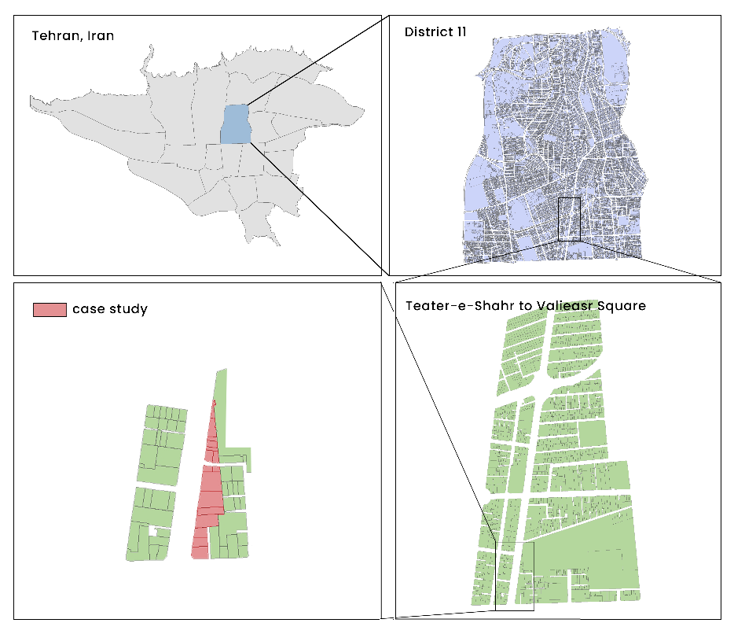
Figure 4. case study map (Teater-e-Shahr to Valieasr Square Block)

The study aims to explore how characteristics of urban walls—such as transparency, continuity, and scale—affect feelings of calmness and attention among pedestrians. By understanding these dynamics within a bustling urban landscape, valuable insights can be gained for designing spaces that foster positive emotional experiences and enhance overall quality of life. A visual-spatial and perceptual analysis of the building envelope, including factors like skyline composition and vertical/horizontal breaks, will be conducted to compare test results with baseline assessments, highlighting how these elements influence pedestrian emotions and cognitive processes.
Urban environments elicit heightened activation in the primary visual cortex due to the complex visual scenes they present (Choi et al., 2023). This increased neural activity emphasizes the need to examine how specific visual-spatial elements impact emotional and cognitive responses. For instance, a well-defined skyline offers orientation and coherence, while an irregular skyline may induce anxiety. Similarly, the ground line influences emotional states, with smoother transitions promoting feelings of calmness. Vertical and horizontal breaks in building facades enhance visual interest and engagement, preventing sensory overload. By analyzing these spatial qualities through a cognitive neuroscience lens, the study aims to inform urban planning strategies that promote healthier, more inviting urban spaces.
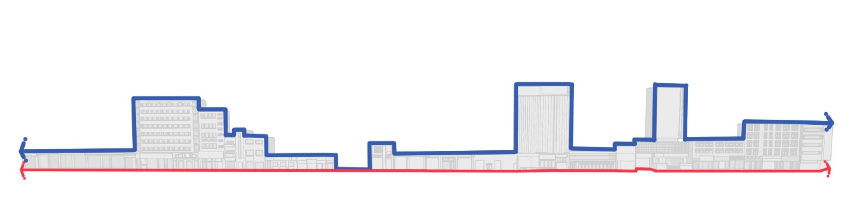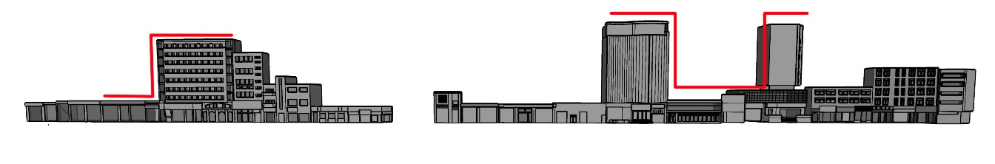
Figures 5 and 6. Skyline and ground line, vertical break in the skyline
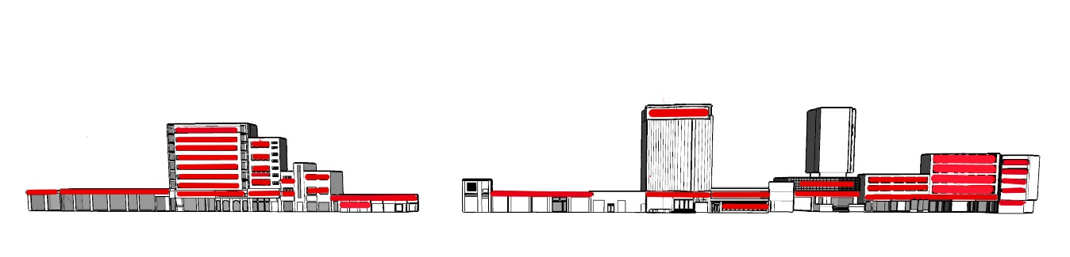
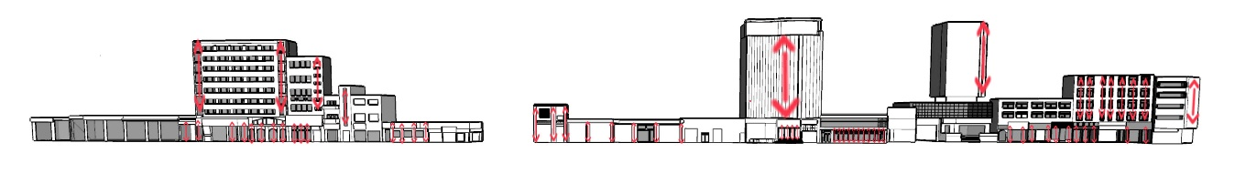

Figures 7 and 8. Horizontal elements, vertical elements

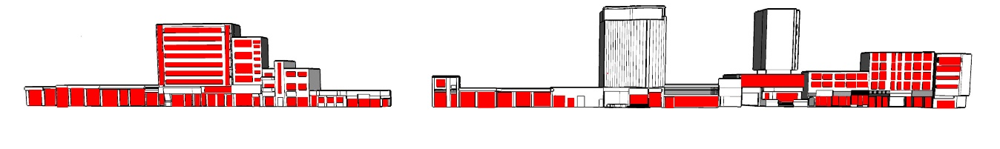
Figure 9. Ratio of openings to envelope

Table 3. Summary of studied urban wall qualities
The condition of urban wall | Quality
- 60-80% of ground floor facades contain windows or transparent surfaces  - Urban walls lacking transparency occur in abandoned buildings with sealed openings and administrative buildings with restricted access. These opaque facades reduce street-building interaction and visual connectivity | Transparency
- The street's building heights primarily range from 3-5 stories (9-15m), maintaining a pedestrian-friendly scale. Individual building facades are divided into narrow segments (5-8m wide), creating a rhythmic pattern along the street | Scale
- The street wall maintains a consistent ground-level alignment, interrupted by one building setback and a road intersection. These breaks in continuity may affect pedestrian experience by disrupting the visual flow and walking rhythm, potentially impacting both attention (through required navigational adjustments) and calmness levels (through changes in spatial enclosure and movement patterns) | Continuity

7- Data Recording and analyzing the level of calmness and attention
Data collection adhered to a systematic protocol, with recordings initiated 20-28 seconds before environmental exposure to ensure device stabilization. The analysis process included data cleaning through zero-value removal and test repetition averaging, focusing on the 0-6000 millisecond range to capture post-exposure but pre-habituation responses. Comparisons were made between test conditions and a baseline urban environment, enabling isolated assessment of specific features while maintaining ecological validity. The resulting data was analyzed in two complementary formats:
- A time-based progression charts tracking percentage changes in calmness and attention,
- A comparative analyses of average calmness and attention levels across different visual qualities (such as transparency variations) against the baseline environment.
This dual visualization approach allowed for both dynamic temporal understanding and comparative assessment of psychological responses to varying urban wall characteristics.

8- Discussion
The advancements in cognitive neuroscience and the increased accessibility of brainwave imaging tools have opened new avenues for various scientific fields, including urban design, to investigate human brain responses during the perception process—encompassing feeling, perception, and cognition—before observable behaviors occur. This research employs these innovative methods to assess the impact of visual qualities of urban walls on two key parameters: attention and the perception of calmness. Attention serves as the initial stage of cognition, while calmness enhances user experience in urban spaces.
To effectively study the variations in calmness and attention relative to the visual characteristics of urban walls, environments with distinct features were simulated. Three visual qualities were selected, each exhibiting different attributes. For instance, transparency can manifest as completely transparent, semi-transparent, or opaque. The chosen qualities are commonly encountered in urban environments. Scale, often overlooked in modern urban design, plays a crucial role, as do transparency and the communication between internal and external spaces, which are frequently debated in relation to security. Continuity is essential for defining urban blocks; without it, urban spaces risk losing their essence, as discontinuity can shift the character of urban spaces from dynamic to static.
In this study, each simulated environment was traversed twenty times, allowing for patterns to emerge by the tenth test. For critical studies like this, the preferred range of tests is typically between ten and twelve. The results were analyzed in two phases: first, the movement patterns within each environment were examined, followed by an analysis of the average calmness and attention levels for environments sharing similar qualities but differing features (e.g., transparency levels: completely transparent, semi-transparent, and opaque).
This research represents a significant leap forward by integrating cognitive neuroscience with urban design through the use of brainwave imaging tools. By transcending traditional observational methods, it offers quantifiable neurological evidence of how individuals respond to urban settings. The study systematically evaluates scale, transparency, and continuity via neural measurements, uncovering specific relationships between urban wall design features and psychological responses.
The findings shift urban design theory from reliance on intuitive principles to evidence-based metrics. By establishing precise correlations between building features and neural responses—such as the inverse effects of building height on calmness and attention, and the optimal facade granularity of 6-8 meters—this research furnishes measurable criteria for creating psychologically supportive urban spaces. This integration bridges the gap between theoretical design principles and quantifiable human responses, empowering urban designers to make more precise, evidence-based decisions.
This research has generally aimed to study the relationship between humans and the environment and the impact that the visual qualities of the environment have on calmness and attention, in order to find solutions for better designing the environment to meet the needs and desires of users. The method used in this study proved that many issues in urban planning that have been questioned so far, such as security issues, can be addressed through user-friendly tools without the need for specialized labor and without the need for significant cost and time spent analyzing data.
In the Table 4, the movement graph of each environment (with its unique features) is shown, and its relevant explanations are given:

Table 4. Analysis and comparison of movement graphs
Test |  |  | Movement-time graph | Map and 3D model
Base test |  |  | Initially, attention is in a high level and calmness is in a low level. After a while, walking in the street, attention decreased (because of getting familiar with environment) and calmness grew. | 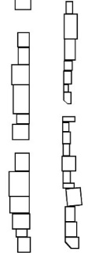  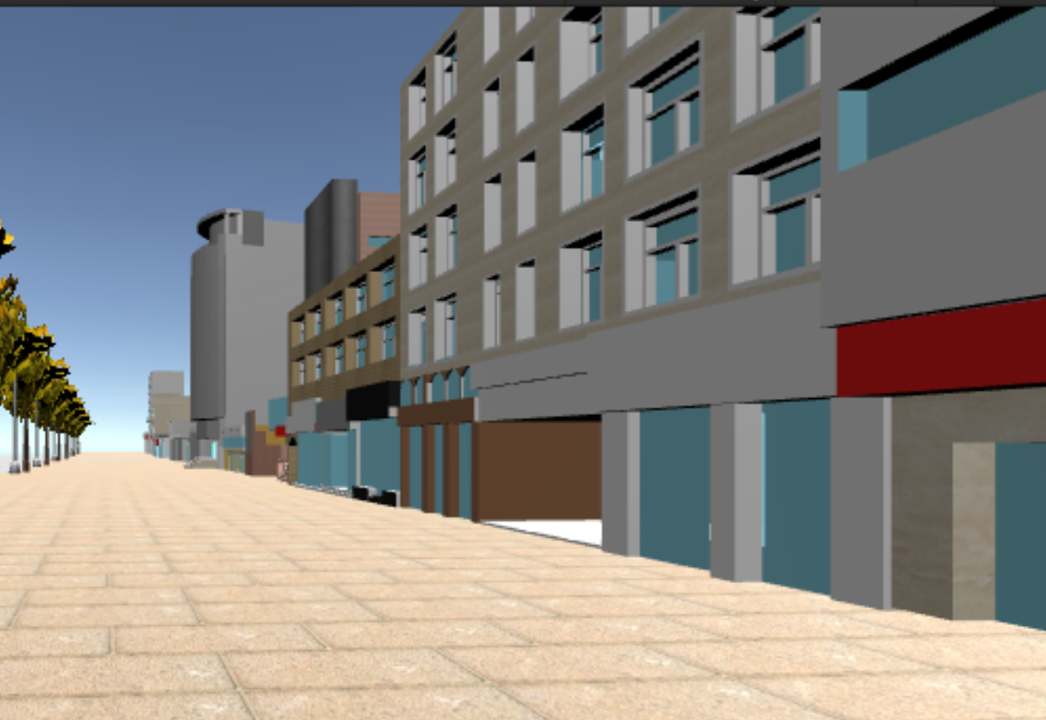  Create a 3D model of the exciting urban wall to evaluate how individuals respond to it  Both sides have modeled by focusing on eastern side.
Scale | Height | High height | Calmness showed a downward trend while, attention showed an upward trend | 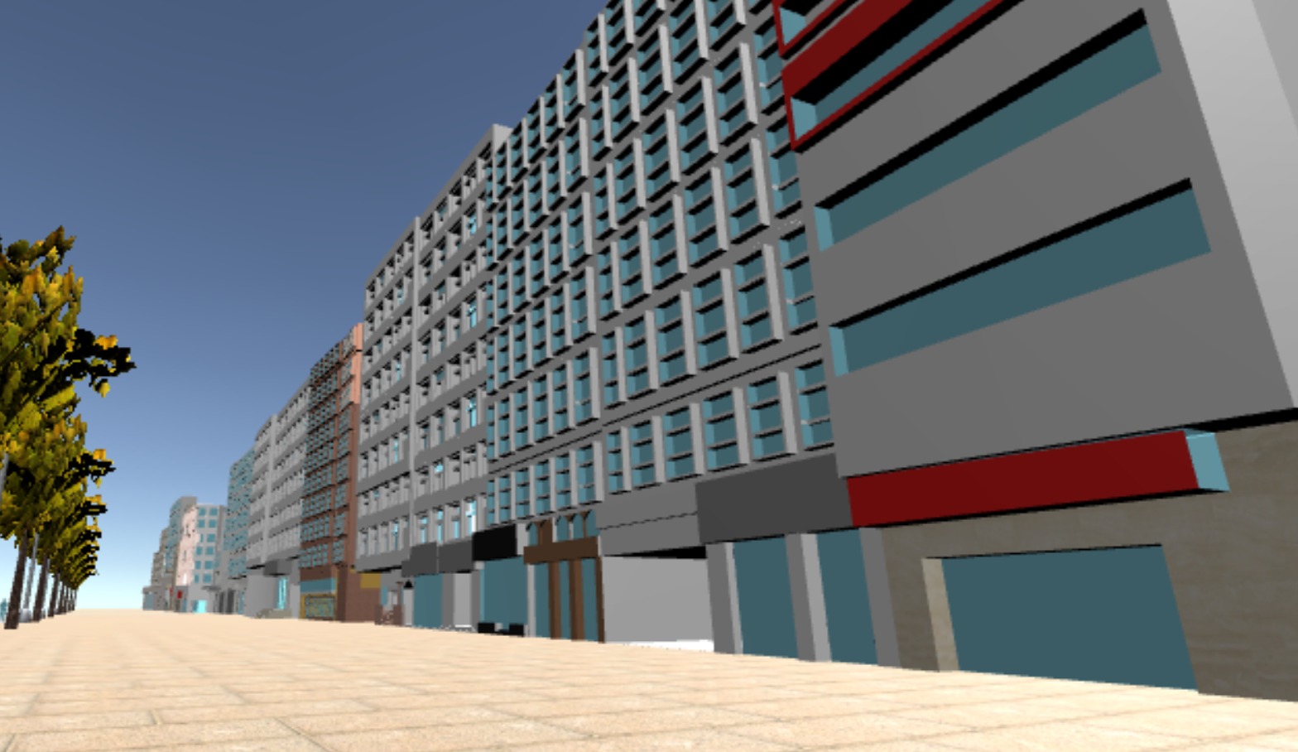  Every building in this 3D model has a height of 21 meters or more to evaluate how users perceive tall structures
Scale | Height | Medium height | Attention dropped considerably, while calmness went up | 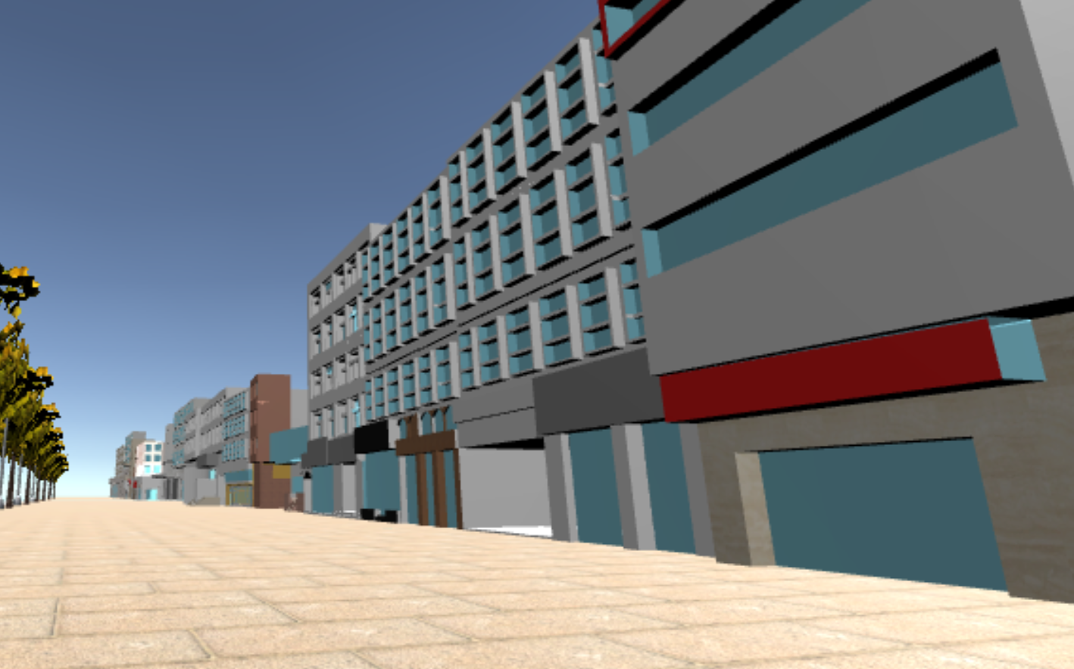  In this 3D model, buildings designated as medium height range from 8 to 21 meters, enabling us to assess user perceptions of structures within this height category.
Scale | Height | Low height | Low height turned the urban space into a human scale space, which helped calmness to grow. Although attention was growing, it fluctuated because of numerous changes in ground floor such as widen routs and etc. | 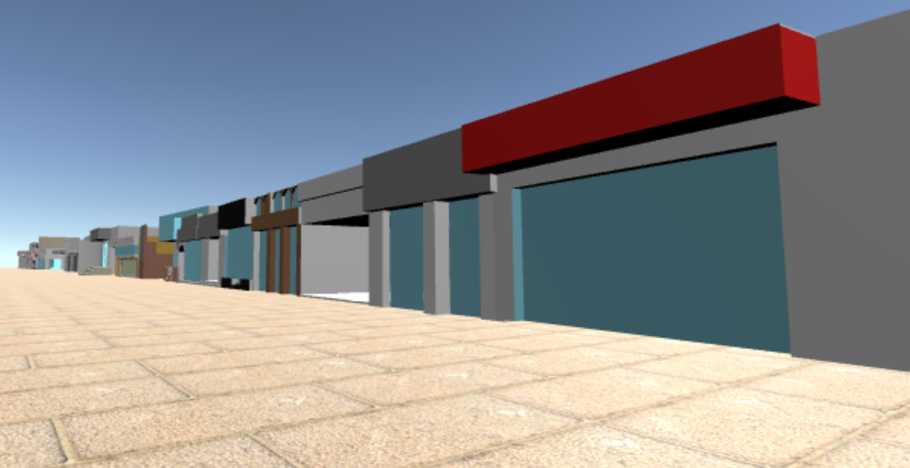  In this 3D model, buildings categorized as short have heights of up to 8 meters, allowing us to evaluate how users perceive lower structures
Scale | Segmentation | Fine grained | As Harvey et al (2015) mentioned in their article, fine grained environments led to better perception of safety and calmness. | 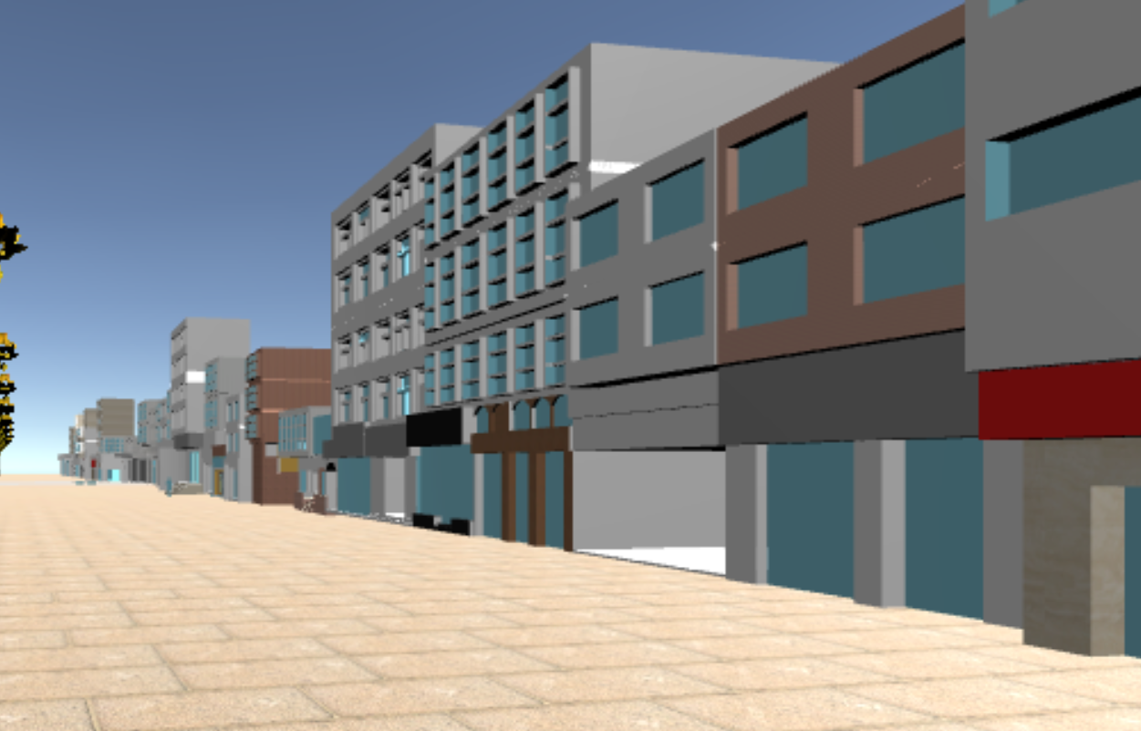  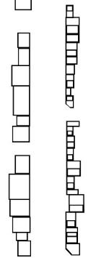  The 3D model includes fine-grained buildings ranging from 6 to 8 meters, allowing for the evaluation of user perceptions
Scale | Segmentation | Coarse grain | Attention decreased gently during walking, whereas calmness experienced fluctuation. Calmness started to fall at first part of the path to the middle of it. In the following, users recover their peace during half of the path (because of spacing in the path and having a better view of environment) | 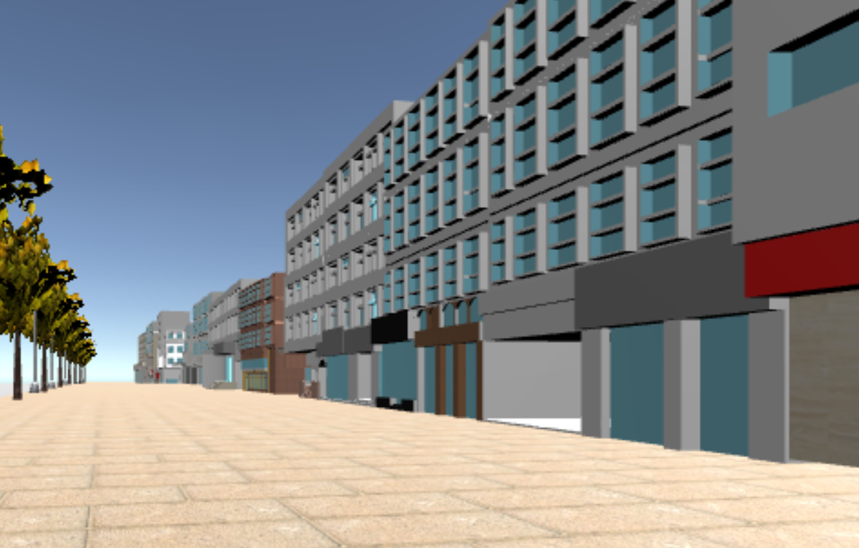  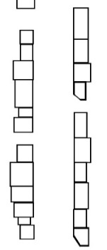  The 3D model features larger segments exceeding 8 meters, providing insights into user perceptions of urban wall uniformity
Transparency | Completely transparent |  | There is high interaction between inside and outside of the environment because of this quality. Therefore, users can experience more calmness, while their attention remained stable. | 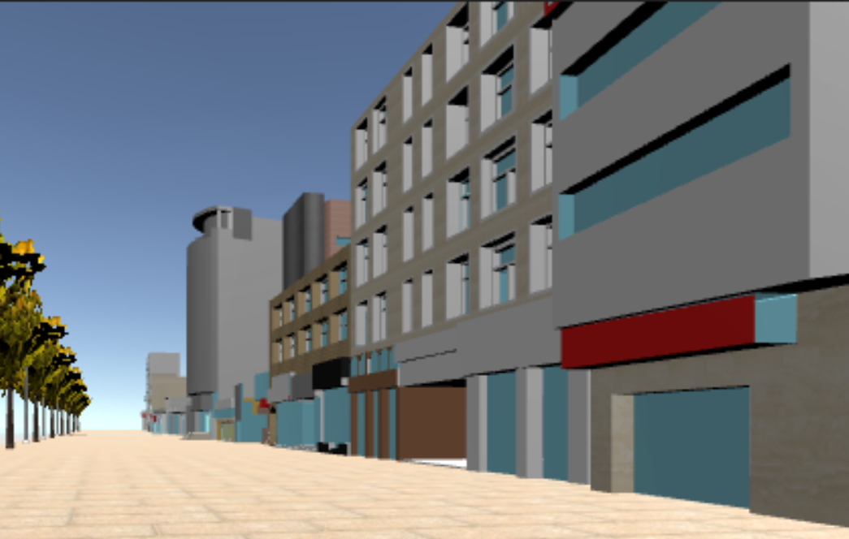  The 3D model utilizes completely transparent walls that allow for unobstructed views, facilitating the assessment of user responses to environments fostering strong indoor-outdoor connections
Transparency | Semi transparent |  | This environment consists of more detailed than fully transparent environment. So, attention level went up, although being able to see through buildings made users to feel more comfortable and calmness increased (Not as much as transparent environment). | 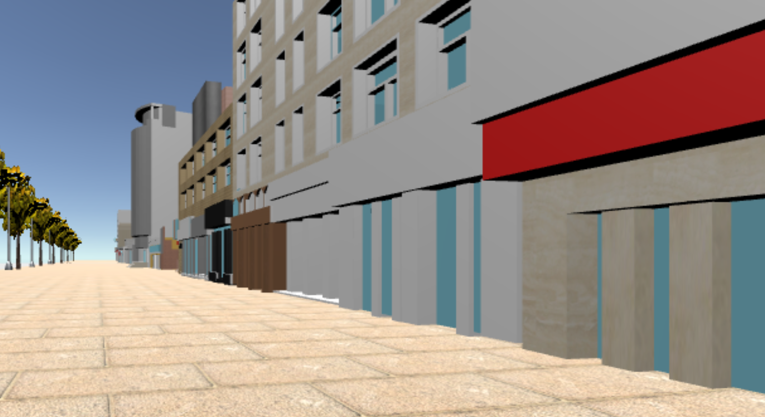  The 3D model incorporates semi-transparent walls that offer a mix of visibility and privacy, enabling the evaluation of user reactions to spaces balancing openness and enclosure.
Transparency | Opaque |  | As it showed in the chart, users experienced more calmness and less attention in the beginning of the path. But after spending some time in this condition they started to attention, while their calmness declined.  It seems users are capable of being in an opaque place just for 20 or 30 seconds without losing their tranquility | 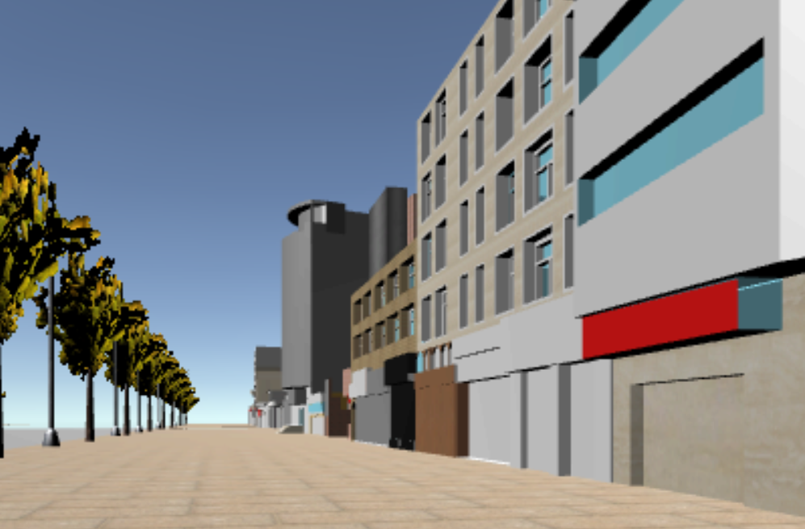  The 3D model presents opaque walls that completely block visibility (especially in street level), allowing for an assessment of user perceptions in enclosed environments with limited visual connections
Continuity | Continuous walls |  | calmness and attention showed some fluctuation, although meditation was higher than attention. | 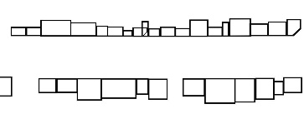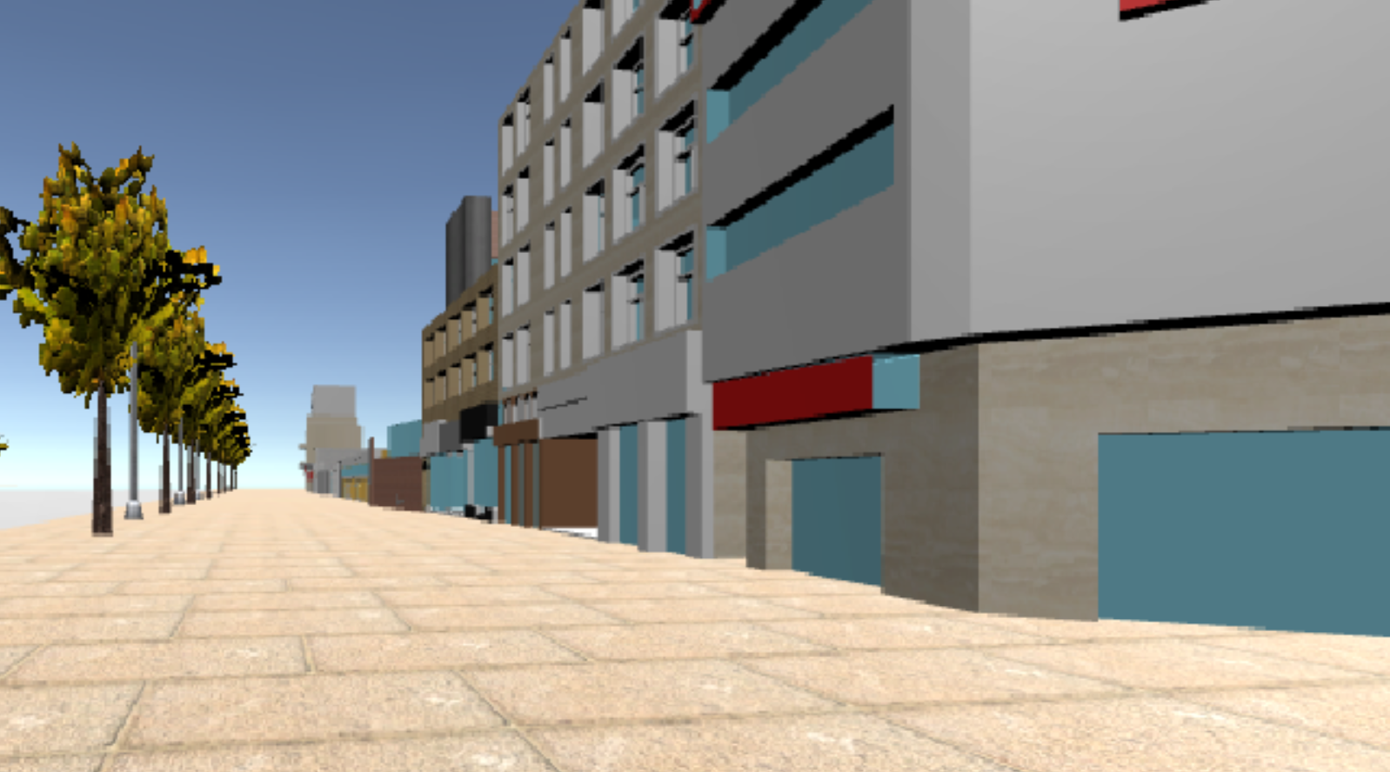  The 3D model features continuous walls that create seamless boundaries, enabling the examination of user responses to uninterrupted urban wall.
Continuity | Discontinuity |  | Discontinuity happened in 4 spots of path, that attention increased in every spot. Overally, expansion of the path caused more calmness level in users. | 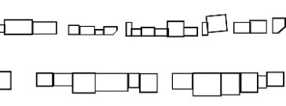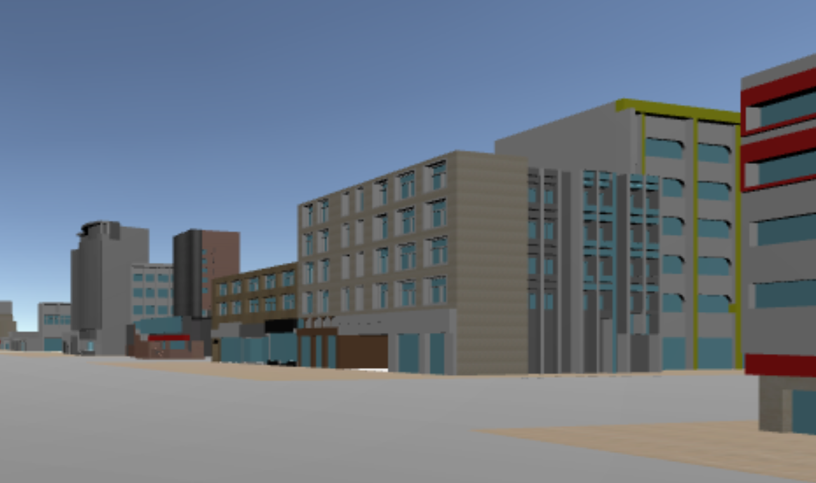  The 3D model includes discontinuous walls that introduce breaks and interruptions, allowing for the assessment of user perceptions of fragmented urban wall.
Continuity | Protrusion |  | Protrusion caused increasing in attention level of users because of making narrow path. There are some setbacks in the end of the path where calmness leveled up noticeably. | 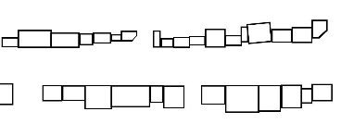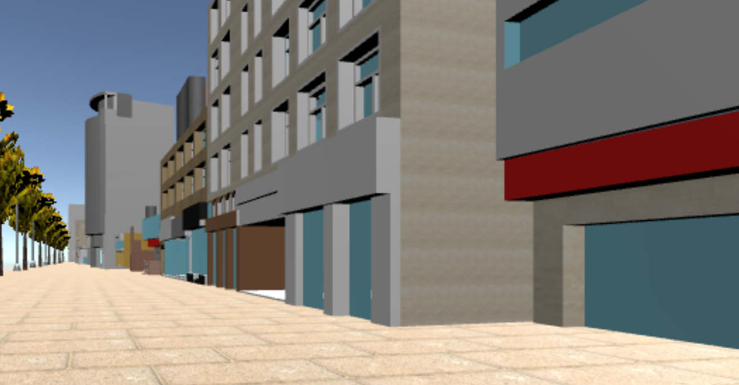  The 3D model showcases protruding elements from the walls that create visual interest, facilitating the evaluation of user reactions to urban wall features that extend outward.
Continuity | Set back |  | Setbacks happened gradually in the path. Expansion in the path made calmness to increase and attention to decrease, but it should be avoided to create a wide space. | 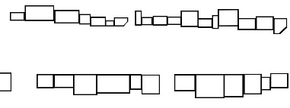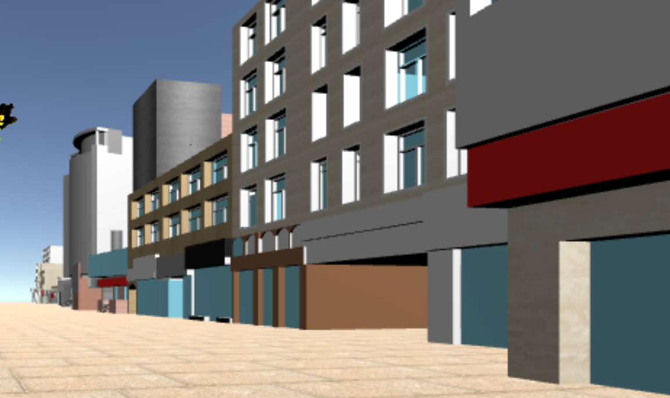  The 3D model employs setback designs that position walls away from the street, allowing for the assessment of user perceptions regarding the layered spatial experiences created by recessed structures.

After examining the time-based chart of each test separately, it was necessary to have a comparative analysis of average calmness and attention levels across different visual qualities
Table 5. Comparison of average calmness and attention
Quality |  | Comparison table | Description
Scale | Height |  | In environments with high heights, attention levels tend to be higher, while feelings of calmness are diminished. This phenomenon occurs due to greater diversity in the surroundings, which often exceeds the human scale.
Scale | Segmentation |  | Fine-grained environments promote a greater sense of calmness. The attention levels in both fine-grained and coarse-grained environments are similar due to the diversity present at the ground level in fine-grained settings.
Transparency |  |  | Calmness tends to increase when users can see through buildings in transparent areas. Conversely, attention levels rise in opaque environments, likely due to a heightened perception of unsafety. This relationship suggests that visibility plays a crucial role in shaping emotional responses in different urban settings.
Continuity |  |  | In a fully continuous environment, the level of calmness is greater than that observed in the baseline test, while attention levels have decreased. To effectively analyze the effects of setbacks and protrusions, it is advisable to utilize a motion map, as these features occur at specific points along the path. This approach will provide a clearer understanding of how these urban wall features influence user experiences.

Analysis of the comparative data reveals distinct statistical relationships between urban wall features and psychological responses. Building height demonstrates a clear inverse relationship, with structures over 21m showing significantly lower calmness (41) but higher attention scores (62), while low-rise buildings (3-6m) produce the opposite effect (68 calmness, 43 attention). Fine-grained facades emerge as uniquely beneficial, achieving high scores in both calmness (71) and attention (65), whereas coarse segments show notably lower calmness (42). Transparency effects follow a clear pattern: fully transparent sections yield the highest calmness scores (73) with lower attention (45), while opaque surfaces invert this relationship (38 calmness, 64 attention). Continuity data indicates that unbroken walls promote higher calmness (65) while maintaining moderate attention levels (48), with strategic breaks helping to avoid extreme drops in either metric. These relationships maintain statistical consistency across all measurements, providing robust evidence for the direct influence of urban wall elements on psychological responses.
The analysis of changes in calmness and attention levels during traversal of the environment strongly supports the primary hypothesis regarding the influence of urban wall characteristics on psychological responses:
- Building height exhibited inverse relationships: taller structures (>21m) led to decreased calmness while increasing attention.
- Fine-grained environments, characterized by 6-8m segments, enhanced both calmness and attention through intricate design elements.
- Coarse-grained environments (segments >8m) diminished calmness due to their uniformity.
- Complete transparency fostered higher levels of calmness while reducing attention, highlighting the benefits of indoor-outdoor connections.
- Non-transparent sections revealed temporal effects, with initial calmness decreasing and attention increasing over exposure time.
- Semi-transparent elements elicited intermediate responses.
- Continuous boundaries improved calmness but reduced attention levels.
- Interrupted environments resulted in lower overall calmness.
- Strategic breaks, such as setbacks and protrusions, created localized increases in both calmness and attention.
- Setback points enhanced calmness without sacrificing street dynamism.

These findings confirm that each characteristic significantly influences psychological responses and reveal specific patterns of interaction between urban wall features and human cognitive processes.
People experience cities as a rich tapestry of sights, sounds, and social interactions, but this study had to narrow its focus to measure specific reactions. By looking at just three elements - building height, transparency, and continuity - the research captured important but limited aspects of urban life. While city dwellers normally roam freely and interact with others, participants walked fixed routes in empty environments. Their brain responses, measured twenty times in each setting, offer valuable insights but can't show how these spaces might feel after months or years of daily use.
The virtual settings missed many real-world elements that make cities come alive - changing weather, street sounds, passing crowds, and the play of natural light throughout the day. Brain monitoring technology caught some responses but couldn't track all the subtle ways people respond to their surroundings. Future studies could explore how these design elements work together in actual city spaces, with different groups of people, over longer periods. Looking at how weather, noise, social activity, and cultural differences affect people's reactions would paint a fuller picture of how urban design shapes human experience. For now, these findings offer an important first step in understanding how architectural choices affect the minds and emotions of city residents.
9- Conclusion
This research seeks to investigate the effects of the built environment on users' levels of attention and calmness while navigating urban spaces. The study emphasizes the two-way relationship between humans and their environment, illustrating how changes in physical surroundings can influence user perception and vice versa. A distinguishing feature of this study is the innovative application of brainwave imaging technology, specifically using the user-friendly Neurosky tool in pseudo-virtual tests. This approach aims to provide urban planners with greater confidence in creating more human-centric environments.
To achieve this, the study modeled a baseline environment, referred to as the baseline test, and simulated twelve additional environments that each represented unique qualities such as scale, transparency, and continuity. Participants were divided into three groups, each moving through the baseline and four experimental environments, with their levels of calmness and attention recorded. After collecting the data, the percentages of calmness and attention over time were analyzed, and averages were compared among environments exhibiting similar qualities.
The findings of this research reveal several key insights that can guide urban design practices to meet users' needs and preferences. Specifically:
- A combination of medium and low densities is recommended to create diversity that attracts attention and reduces fatigue in human-scaled environments.
- High density should be avoided in streets primarily designed for passing; if included, complete recesses or setbacks on upper floors are essential to maintain visibility along the path.
- Fine-grained environments promote a sense of calmness while maintaining attention levels through increased diversity, making them preferable to coarse-grained designs in human-scaled urban streets.
- High transparency and seamless connections between indoor and outdoor spaces are beneficial due to their positive effect on calmness.
- If rigid walls are necessary, incorporating transparent or semi-transparent sections at intervals can enhance connections between inside and outside.
- Semi-transparent walls can add variety to the environment and attract attention, making them useful in areas where pedestrian engagement is desired.
- Continuous walls can enhance calmness, provided they are not entirely opaque.
- Introducing fractures in walls is appropriate, as long as they do not disrupt the space excessively or create a static environment.
- Setbacks can enhance calmness, provided that their width does not result in a static, expansive space.
- Protruding walls may induce initial anxiety and draw attention, but this effect diminishes quickly. To mitigate this, creating continuity or recesses following the protrusion can alleviate discomfort.
This research contributes to the existing body of knowledge by illustrating the significant relationship between environmental features and users' cognitive responses. The findings not only confirm previous studies highlighting the importance of urban design, but also provide new insights into how specific urban wall features influence psychological states. By contextualizing these results within the framework of existing research, we can better understand their implications for urban planning and design.
In summary, just as humans shape their surrounding environment, the environment also profoundly affects users' cognitive processes and emotional experiences. To further the objectives of urban planners in creating inviting public spaces, careful consideration of spatial quality and its impact on users' emotions is essential. The insights gained from this study serve as a foundation for future research and practical applications in the field of urban design.

References
- Aspinall, P., Mavros, P., Coyne, R., & Roe, J. (2013). The urban brain: Analysing outdoor physical activity with mobile EEG. British Journal of Sports Medicine.
- Bahreini, H., & Khosravi, H. (2014). Guide to urban spaces design (1st ed.). Tehran University Press, Tehran, Iran.
- Banaei, M., Yazdanfar, A., Nooredin, M., & Yunessi, A. (2017). Neural correlates of mobile EEG and the built environment. Asian Journal of Environment-Behaviour Studies, 2(3), 67-75.
- Charalambous, E. (2023). Neurourbanism and Neuroarchitecture: How can Cognitive Sciences Inform Design? OSF Preprints 6f4uc, Center for Open Science.
- Choi, H.S.; Bruyns, G.; Zhang, W.; Cheng, T.; Sharma, S. Spatial Cognition and Three-Dimensional Vertical Urban Design Guidelines&mdash;Cognitive Measurement and Modelling for Human Centre Design. Urban Sci. 2023, 7, 125.
- Collins, M., Hasegawa, T., & Johnston, R. (2014). DUMBO Neural Cartography. GSAPP Cloud Lab. http://www.thecloudlab.org/dumbo_neural_cartography.html
- Dai, L., Zheng, C., Dong, Z., Yao, Y., Wang, R., Zhang, X., Ren, S., Zhang, J., Song, X., & Guan, Q. (2021). Analyzing the correlation between visual space and residents' psychology in Wuhan, China using street-view images and deep-learning technique. City and Environment Interactions, 11, 100069.
- Damasio, A. (2013). Looking for Spinoza: Joy, sorrow, and the feeling brain. Asadi, T. K. (Trans.). First edition, Negah-e-Moaser Press, Tehran, Iran.
- Farnsworth, B. (2019). EEG (Electroencephalography): The Complete Pocket Guide. iMotion platform.
- Gage, H. F. (2015). Neuroscience: The study of the nervous system & its functions. Dædalus, The Journal of the American Academy of Arts & Sciences, 5-9.
- Giray Küçük, S., & Yüceer, H. (2022). Neuroscience and the Cities: Neurourbanism. Gazi University Journal of Science Part B: Art Humanities Design and Planning, 10(3), 287-301.
- Groth, J. (2014). Aesthetics in architecture. Pakzad, J. (Trans.). First edition, Shahid Beheshti University Press, Tehran, Iran.
- Herman, K.; Ciechanowski, L.; Przegalińska, A. Emotional Well-Being in Urban Wilderness: Assessing States of Calmness and Alertness in Informal Green Spaces (IGSs) with Muse—Portable EEG Headband. Sustainability 2021, 13, 2212. https://doi.org/10.3390/su13042212.
- Kanjo, E., & Albarrak, L. (2013). NeuroPlace: Making sense of a place. ACM International Conference Proceeding Series, 4th International Conference on Augmented Human in Cooperation with ACM.
- Kong, L., Liu, Z., Pan, X., Wang, Y., Guo, X., & Wu, J. (2022). How do different types and landscape attributes of urban parks affect visitors' positive emotions? Landscape and Urban Planning, 226, 104482.
- Lang, J. (2012). Creating architectural theory: The role of behavioral sciences in environmental design (6th ed.). Tehran University Press, Tehran, Iran.
- Mahi al-Din Banab, M. (2000). Psychology of emotion and perception (2nd ed.). Dana Press, Tehran, Iran.
- Marti-Marca, A., Nguyen, T., & Grahn, J. A. (2020). Keep Calm and Pump Up the Jams: How Musical Mood and Arousal Affect Visual Attention. Music & Science, 3. https://doi.org/10.1177/2059204320922737
- Matlabi, G. (2001). Environmental psychology: New scientific knowledge in service of architecture and urban design. Honar-ha-ye-Ziba, 10(1), 52-67. Tehran University, Tehran, Iran.
- Mavros, P., Austwick, M. Z., & Smith, A. H. (2016). Geo-EEG: Towards the use of EEG in the study of urban behaviour. Springer.
- Mavros, P., Coyne, R., Roe, J., & Aspinall, P. (2012). Engaging the brain: Implications of mobile EEG for spatial representation. In Digital Physicality | Physical Digitality: Proceedings of the 30th eCAADe Conference (pp. 657). Prague, Czech Republic: Molab.
- Mavros, P., J Wälti, M., Nazemi, M. et al. A mobile EEG study on the psychophysiological effects of walking and crowding in indoor and outdoor urban environments. Sci Rep 12, 18476 (2022). https://doi.org/10.1038/s41598-022-20649-y
- Mavros, P., J Wälti, M., Nazemi, M. et al. A mobile EEG study on the psychophysiological effects of walking and crowding in indoor and outdoor urban environments. Sci Rep 12, 18476 (2022). https://doi.org/10.1038/s41598-022-20649-y
- McAndrew, F. T. (2013). Environmental psychology (2nd ed.). Mahmoudi, G. (Trans.). Vania Press, Tehran, Iran.
- Ndaguba, E., Cilliers, J., Mbanga, S., Brown, K., & Ghosh, S. (2022). Re-Imaging the Future in Urban Studies and Built Environment Discourse: A Neurourbanism Perspective. Buildings, 12(12), 2056.
- Pakzad, J. (2006). Theoretical foundations and process of urban design (6th ed.). Shahidi Press, Tehran, Iran.
- Pakzad, J., & Bozorg, H. (2016). The alphabet of environmental psychology for designers (4th ed.). Arman-e-Shahr Press, Tehran, Iran.
- Park, H. (2018). Maps as participatory platform: Towards open data and transport service. ServDes2018. Service Design Proof of Concept, Proceedings of the ServDes, 386-400.
- Pidlisna, O., Simonova, A., Ivanova, N., Bondarenko, V., & Yesipov, A. (2023). Harmonisation of the urban environment by means of visual art, lighting design, and architecture. Acta Scientiarum Polonorum Administratio Locorum, 22, 59-72.
- Pourjafar, M. R., & Balmaki, M. (2012). Extraction of consistency and inconsistency criteria of building facades based on the principles of visual ecology using the human visual system. Scientific-research Journal of Iranian Society of Architecture and Urban Planning, 4, 5-18.
- Pouyan, A. E., Ghanbaran, A. H., & Shakibamanesh, A. (2023). Evaluating building wayfinding performance in healthcare environment: a novel hybrid decision-making model. Architectural Science Review, 66(6), 443-467
- Rapuano, M., Ruotolo, F., Ruggiero, G., Masullo, M., Maffei, L., Galderisi, A., Palmieri, A., & Iachini, T. (2022). Spaces for relaxing, spaces for recharging: How parks affect people's emotions. Journal of Environmental Psychology, 81, 101809.
- Roe, J., Aspinall, P. A., Mavros, P., & Coyne, R. (2013). Engaging the brain: The impact of natural versus urban scenes using novel EEG methods in an experimental setting. Environmental Sciences, 1(2), 93-104.
- Scorpio, M.; Laffi, R.; Masullo, M.; Ciampi, G.; Rosato, A.; Maffei, L.; Sibilio, S. Virtual Reality for Smart Urban Lighting Design: Review, Applications and Opportunities. Energies 2020, 13, 3809. https://doi.org/10.3390/en13153809
- Shakibamanesh, A. (2013). The effects of spatial configuration and physical structure on pedestrians' subjective experience of time perception using virtual reality (PhD thesis). Department of Architecture and Environmental Design, Iran University of Science and Technology, Tehran, Iran.
- Shakibamanesh, A. (2014). Improving results of urban design research by enhancing advanced semiexperiments in virtual environments. Iran University of Science & Technology, 24(2), 131-141.
- Shakibamanesh, A., & Ghorbanian, M. (2017). Toward time-based design: Creating an applied time evaluation checklist for urban design research. Frontiers of Architectural Research, 6(3), 290-307
- Squire, L., Berg, D., Blom, F., Du Lac, S., Ghosh, A., & Spritzer, N. (2008). Fundamental neuroscience (3rd ed.). Elsevier.
- Sternberg, R. J., & Mio, J. S. (2009). Cognitive psychology. Australia: Cengage Learning/Wadsworth
- Stevens, Q., Daly, J. & Dovey, K. Designing for possibility in public space: affordance, assemblage, and ANT. Urban Des Int 29, 94–104 (2024). https://doi.org/10.1057/s41289-023-00235-y
- Syeda, N.F., & Erzin, E. (2021). Use of affect context in dyadic interactions for continuous emotion recognition. Speech Communication, 132, 70-82.
- Weijs-Perrée, M., Dane, G., & van den Berg, P. (2020). Analyzing the Relationships between Citizens' Emotions and their Momentary Satisfaction in Urban Public Spaces. Sustainability, 12(19), 7921.

Acknowledgment
With gratitude to our dear family who are always my source of encouragement.
Note:
This article is based on Safoora Sadra's master's thesis entitled "Registration and Examination of the Effect of Urban Facade Quality on the Serenity and Attention of Users Using EEG Technique - Case Study: The Distance between City Theater Square and Valiasr Square" supervised by Dr. Amir Shakibamanesh in Tehran Art University, Iran.
Financial/Resources Support: Virtual reality and emerging technologies lab, School of Architecture and Urban Planning, Iran University of Art, Tehran, Iran.

