Popular Architecture and Urbanism of the City of Qom on the Edge of Tradition and Modernity

Masoud Nari Ghomi
Assistant Professor of Architecture, Department of Architecture and Urban Planning, Faculty of Civil Engineering and Architecture, Technical and Vocational University (TVU), Tehran, Iran
Phone: +98-251-37737636
Email: msnarighomi@ut.ac.ir
Mehdi Momtahen
Assistant Professor of Architecture, Department of Architecture and Art, University of Kashan, Kashan, Iran
Phone: +98-31-55913166
Email: Mehdi_momtahen@yahoo.com

Popular Architecture and Urbanism of the City of Qom on the Edge of Tradition and Modernity

Abstract
This research aims to explore the process of modernization of the city’s image—a topic that has not yet been critically examined. The study employs an interpretive-historical method, drawing on publications, photographs, and oral historiography related to both existing and lost buildings of the period. In the case of Qom, the obligatory modern changes—such as cutting streets through the traditional urban fabric—could not entirely erase traditional conceptions of the city image at the microscale. Revisiting the street façades of the early modern era in Qom reveals that the public perception of the new phenomenon of the street was derived from the spatial logic of inner courtyards as well as the bazaar. The baroque-style planning of the new city was exceptional within Reza Khan’s urban plans and had the greatest impact on turning the holy shrine into the new city center. However, about a decade after the onset of this modernization process, a popular trend emerged toward adopting certain modern spatial features. Thus, in this small city at the beginning of modernization—and later a large city at its peak—numerous popular adaptations between tradition and modernity can be observed, not only at the microscale and in façade design but also at the urban scale, where modern detached spaces were integrated through the adaptation of traditional spatial patterns.
Keywords: popular architecture, transition of modernity, façade changes, city of Qom, Pahlavi period.

- Introduction
The city of Qom is one of the three major Islamic cities that possess a dedicated historical record of their own. Located in central Iran and characterized by a hot and arid climate, Qom stands as a unique example of an urban environment from both social and spatial perspectives. This distinctiveness arises from its religious significance—as one of the two main centers of the Shiite world and the second most important pilgrimage destination in Iran—as well as its geographical position, which has allowed a large portion of the Iranian population to experience its urban environment.
It can be stated that the process of urbanization and urban organization in Iran began during the Pahlavi period; however, certain influences and patterns can also be traced back to the Qajar and even Safavid periods

(Ghasemi et al., 2019). The micro-level urban morphology of large cities in the Middle East, North Africa, and Southeastern Europe has not been thoroughly investigated, and its transformation over the past decades remains understudied (Masoumi et. al., 2019). Most research on the modernization and historical development of Iranian urbanism has focused on Tehran and other major cities such as Isfahan (Habibi, 2017; Masoumi et al., 2019), while only a few studies have explored smaller cities of the same period (Karimi & Boussauw, 2018). Another major challenge concerns the balance between the role of the people and local culture versus the influence of governmental power in shaping these developments. Therefore, this study seeks to examine the evolution of a small Iranian city at the beginning of the twentieth century, which, through modernization, transformed into a metropolis. The aim is to construct a more precise narrative of the modernization of Iran’s urban environment, emphasizing popular involvement in the process of transformation. In this regard, the city of Qom presents significant potential due to its close connection with Tehran and its distinct cultural character, making it a valuable case study. This goal is pursued through both macro- and micro-level analyses of urban and architectural morphology.

- Literature Review
This study addresses two major gaps in the literature on the built environment. The first concerns the limited body of research on popular involvement in the modernization of Iranian cities. Habibi and De Meulder (2015) identified the early years of the second Pahlavi period in the 1940s as the beginning of a localized modernization process in Iran and cited the Narmak neighborhood as an example of this phenomenon. In contrast, Mashhadi Moghaddam and Rafieian (2020) argued that urban development in Iran over the past century was characterized by top-down approaches with minimal public participation, thereby underestimating the role of ordinary people in shaping these programs. Similarly, Sintusingha and Mirgholami (2013) viewed the modernization of Tehran and Bangkok as a form of “self-colonization” driven by elite groups rather than by grassroots engagement (Sintusingha & Mirgholami, 2013).
At the architectural scale, recent research has primarily focused on the works and perspectives of elites. In addition to Architecture in the Experiences of Iran and the West (Falamaki, 1992), part of which is devoted to contemporary Iran—Exploring the Experiences of Urban Restoration (Falamaki, 1979) also provides an elitist interpretation of contemporary Iranian architecture and serves as a useful prototype for this approach. Mokhtari (2011), in The Heritage of Modern Iranian Architecture, adopts an ideology centered on reviving the cultural image promoted by Pahlavi-era architects and enters the paradigm of emancipatory research. However, his analysis remains largely confined to the intra-institutional sphere of architecture. His effort to explain the formation of Iran’s architectural institution through journals and professional discourse reflects his commitment to an “institutional” mode of inquiry. This institutional stance, combined with a selective Marxist framework, can also be traced in Bavar’s (2009) A Look at the Emergence of New Architecture in Iran (Bavar, 2009). Among the few comprehensive liberal research efforts that address external sociocultural factors—albeit still from an elitist standpoint—is Amir Bani Masoud’s (2009) Contemporary Iranian Architecture: In the Struggle between Tradition and Modernity, which offers a relatively complete historiography of modern Iranian architecture and engages with the rise of Iranian intellectual ideologies in recent decades. Nevertheless, despite the breadth of its chapters and reliance on secondary sources (mainly newspapers), this work still leaves the study of organized architectural practice and its social dimensions incomplete. As Ghayyoomi Bidhendi and Shams (2022) have noted, the lack of research on bottom-up influences in the history of the built environment represents a significant gap—one that the present study seeks to partially address(Qayyoomi Bidhendi & Shams, 2022).
The second area of study is the contemporary history of the city of Qom. Although some non-governmental organizations and individual researchers have made efforts in this field (Nari Ghomi et al., 2021), this area of study is still relatively novel and underexplored.
- Reaearch Methods
The research method used is interpretive-historical using publications, pictures and oral historiography of existing or lost buildings of the period. So firstly the first-hand documents related to the modernization period of Qom and the physical environment of the city, were studied. These include periodical bulletins of the municipality from 1939 to 1978, local newspaper of the city named Ostovar (since 1930 to 1978), old pictures derived from the archie of Qom branch of the Road and Urbanism ministery and some other reports from the period of Pahlavi. In addition, the facades of the era were discovered, pictured and somehoe drowed throughout the all areas of Pahlavi context of Qom by author and categorized for analyzing. For producing an integrated narration, the authors have obtained a general understanding of the mentioned data and qouted the publications of those periods as evidence for their impression (mainly in the form of background evidence. In terms of narrative validity, this method of interpretation relies on Collingwood's theory in historical narrative (Groat & Wang, 2005), which has given special credibility to the narrator's understanding. Since there were two previos study of new urbanism of Qom (Emco, 2002; Saeednia, 1987); In first part of the study a critical narration of the two was produced while the second part (architectural) is an originated narration.
- Qom at the edge of Modernization: Urban Macroscale
The developments that took place in Qom during the Pahlavi period were more influential than in many other Iranian cities. Almost all the phenomena associated with Reza Shah’s modernization can be observed in the urban fabric of Qom — including the construction of new streets, the demolition of cemeteries converted into parks, and the destruction of city gates and valuable Qajar-era monuments.
However, beyond Reza Shah’s official modernization program, several other social actors sought to introduce modernity into the cultural and physical context of Qom. Among them were the ulema (religious clerics), who supported the establishment of new public services such as hospitals and administrative offices, and intellectuals who promoted the construction of modern schools.
The discussion in this article focuses on the developments of this transformative period. For a clearer understanding, a brief overview of the city’s history before and after this era has also been included

The narration of Saeednia (1987) represents the first academic study of the growth of Qom up to the end of the Qajar period. The city’s structure at that time can be described as follows (Figure 1): ancient rural cores formed the primary urban centers, along which secondary sub-cores developed due to population growth, expanding along the old cores and their main axes as sub-parts of the same neighborhoods. Major urban cores in Qom, however, emerged largely as a result of government interventions. Notably, the Astana neighborhood—likely dating back to the period after Fath Ali Shah and associated with extensive pilgrimage to Qom (though the origin of the name remains uncertain)—and the Jame Mosque neighborhood, which developed after the construction of the Jame Mosque outside the urban context of that era, evolved over centuries. The Qom Bazaar functioned as a central axis connecting the two main parts of the city center, namely the “Arabestan” and “Labchal” neighborhoods.

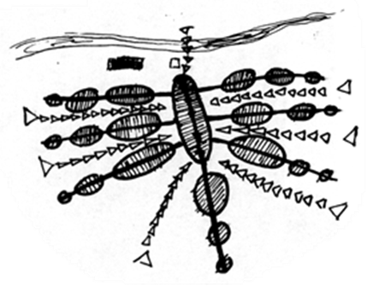
Figure 1. General Pattern of Qom Urban Texture before the Pahlavi Era (Source: Authors based on Saeednia, 1987, with Alteration)
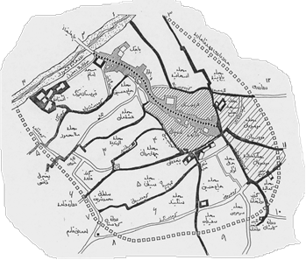
Figure2. Map of the Old Neighborhoods of Qom at the End of Qajar Period (Source: Emco, 2002)

  - Contemporary City
Over the centuries, Qom experienced multiple destructions due to Mongol, Afghan, and other governmental or religious attacks. However, the Qajar era, especially following Fath Ali Shah, marked a period of prosperity for the city. Since then, the city expanded in response to population growth, though this expansion was constrained by several physical and socio-cultural factors.

The first constraint was the religious sanctity of cemeteries, which limited the availability of developable land. As a result, the court of Fatemeh Masoumeh (PBUH) and the large northern cemetery—respected throughout the Shiite world—remained outside the urban core until the Pahlavi period. The second constraint was a social characteristic of Qom: both religious migrants and locals tended to integrate into existing neighborhoods, preventing the formation of entirely new settlements. Consequently, new inhabitants settled along preexisting neighborhoods and their main axes.

Another limitation was economic. Farmlands and, in particular, gardens—such as those in western Qomroud—were historically located outside the city limits and used as summer houses. Historical references suggest seasonal movement between the two sides of the river, and the northwestern part of the urban area, benefiting from the best irrigation, remained largely undeveloped until the present century.

Thus, the traditional structure of the city remained largely preserved for centuries. Fundamental changes began with the construction of the old Qom-Tehran road through the lands of Amin al-Sultan during the Qajar period. This development, driven by Fath Ali Shah’s attention to Qom and the reconstruction of the holy shrine of Fatemeh Masoumeh (PBUH), coincided with the revitalization of Qom’s religious schools. As a result, the city attracted extensive pilgrimage and scholarly visits, introducing a pilgrimage-tourism factor into its socio-economic structure.
The first urban developments beyond the old axes can be attributed to these economic and social changes, such as the creation of the Astana neighborhood. Immigrant settlements concentrated along the Qom-Tehran road, and for the first time, the Bazaar axis extended westward toward the river. The construction of the new bazaar (“Bazaar No”) and the emergence of the Bagh Panbeh (Cotton Garden) and Bajak neighborhoods can be understood in this context. Although these settlements retained a local structure, their resulting urban texture differed significantly from the axial pattern of ancient neighborhoods. Unlike older areas, they lacked coherent neighborhood centers and mixed-use nodes, representing the first major structural change in Qom’s urban fabric.

The first transformation of this type occurred along Imam Khomeini Street (formerly part of the Tehran-Qom road), which visually terminated at the shrine and acted as a “Baroque axis,” centered on the golden dome of the holy shrine. The natural growth of the city, driven by migration along this road, complemented this new urban axis.

After the construction of Amin al-Sultan Road in 1301 AH, and following Reza Khan’s visit in 1307 AH, significant changes ensued: the large cemetery was leveled and converted into a city park, the old bazaar was demolished, and Azar Street was constructed up to the shrine of Holy Hamzeh (PBUH). Two streets were built along the river—Behrooz (Bajak) and Eram—serving as the first major car routes in Qom. Public services gradually moved along these roads, turning Azar Street into a commercial axis, Eram Street into an administrative axis, and Bajak into a residential zone due to its distance from the main residential areas and the shrine.

Subsequent developments—the flood of 1313, the construction of the railway in 1316, the establishment of Qom railway station, and increased pilgrimage—further extended urban settlements westward across the river. New streets and squares, such as the “New Square,” “Tehran Street,” and “Station Street,” contributed to the integration of these areas into the city’s fabric. By 1328, the main road network in western Qom included Eram Street, Astana Street and its extension Behrooz Street (Bajak), Azar Street and its western continuation, Tehran Street, Arak Road, Station Street, the street in front of Fatemi Hospital, Museum Street, and the present-day Imamzadeh Ibrahim Street—previously rural roads—reflecting the city’s expansion beyond its traditional boundaries

.

It is noteworthy that the main streets constructed during the Reza Shah era were designed around new focal points of modern urbanism, with the exception of Tehran Street, which was built along the axis of the Holy Shrine. Nonetheless, all these streets followed the Baroque model of urban development exemplified in Rome under Pope Sixtus V and in Paris under Haussmann (Gidion, 1975), the first was a religious plan and the second a secular program that coincides with what happened to Qom.
Qom's commercial growth began during the Qajar period, following the special attention of Fath Ali Shah, and led to the construction of three Timchehs (traditional trading centers) and part of the New Bazaar, of which the Great Timcheh still remains. Alongside population growth and early industrialization, this development gradually transformed Qom from an “agricultural center” into a prominent regional service hub.

The expansion of the urban fabric between 1949 (Kariman map) and 1956 (aerial photograph by the Surveying Organization of Iran) is particularly significant. Most of this growth occurred along Azar Street and its connection to Kashan Road, extending southward toward Sar Houz Alley (near the present-day Sajjadieh crossroads). In the western part of the city, expansion was more pronounced: farmlands in Mubarak Abad (south of Khakfaraj) and along the route from Imamzadeh Ibrahim (PBUH) to the railway line were developed. New constructions in this area followed a checkered grid pattern.

An examination of the 1964 aerial photograph reveals that growth in the old city was limited, with new development primarily concentrated in the southeastern part—along Eram Street and the Joy Shoor and Safaieh neighborhoods—connected to the city and extending in a strip toward the railway line. Plots were organized to ensure access via main thoroughfares, with houses linked directly to these streets through relatively narrow alleys. Although physically disconnected from the old neighborhoods, this new area developed gradually and maintained a neighborhood social structure, fostering community relationships.

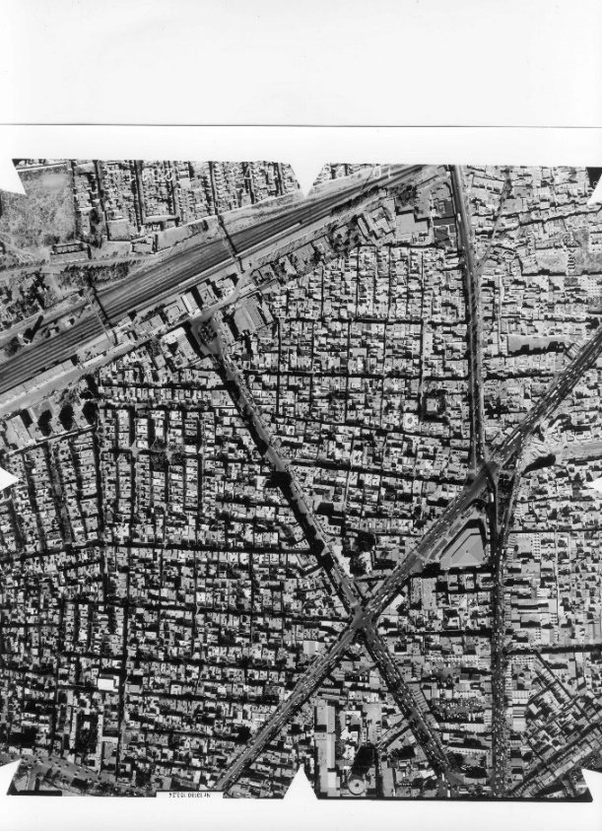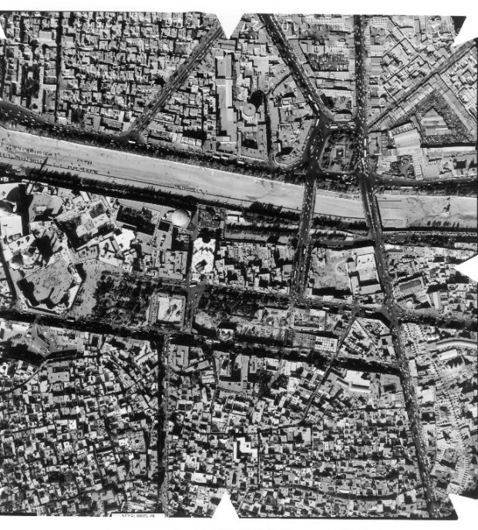
Azar street
Bajak street
Holly Shrine
Meydan No
Railway station
Figure3. The new street construction that took place in the early part of the first Pahlavi period in the part called "Section Two" (northwestern part of the river), occurred in the form of a Baroque network based on three main points: the golden dome of the shrine Holy Masume (PBUH), New Square and Qom railway station building (Aerial photo belongs to 1999. Source: General Directorate of Cultural Heritage of Qom Province).

Most of Qom’s development occurred in the northwestern part of the city, along Tehran Street, Imamzadeh Ebrahim (PBUH) Street, and the river, extending up to the New Cemetery (“No” cemetery). The structure of these developments was shaped by the division of arable lands and gardens, the alignment of existing main streets, and the checkerboard pattern of subdivided plots. Three uncoordinated factors—the main axis of Tehran Street, the river (which influenced the orientation of the grid), and organic elements such as farms—produced a structurally irregular set of streets and alleys in this area.
In 1965, Qom’s first comprehensive urban plan was prepared. The partial implementation of this plan resulted in segments of the city ring road (from 72 Tan Square to the end of Salafchegan Road), as well as the 45-meter-wide sections of Ammar Yaser and Honarestan Streets. The plan proposed further expansion towards second- and third-degree agricultural lands in the west and north; however, these directions ultimately played a minor role in the city’s growth compared to the more substantial expansion toward the southwest, south, and east.
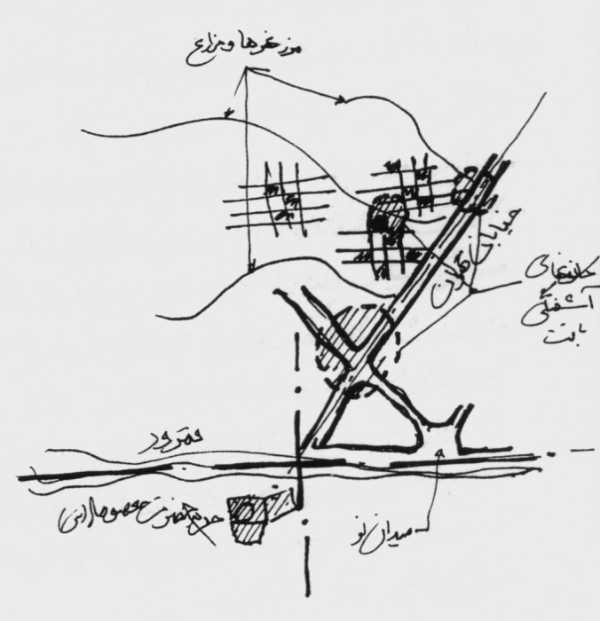
Boundary of farms
Tehran street
Qomrud river
The Shrine of Holy Masumeh (PBH)

“Meidan No” Square

Figure 4. Canons of Turbulent in North-west Developments of the Urban Context within 1950s and 1960 (Source: Authors)

The comprehensive plan of Qom in 1976 (prepared by the consulting engineers of Bor Bor), along with earlier plans, both emphasized the creation of bypass roads to separate inter-city traffic from urban traffic, reflecting Qom’s role as a key transportation hub in the country. This has been the most significant effect of these plans. However, within the city—particularly in the central areas targeted by both projects—no major changes occurred, and the urban texture and street layout remained largely unchanged from the time of Reza Khan until the 2000s.

Until approximately 45 years ago, the railway built during the first Pahlavi period marked the southern limit of the city’s growth. Subsequent urban expansion toward the railway, following the transfer of endowed lands for other uses, occurred through the gradual formation of neighborhood nodes. The neighborhoods of Joy Shoor and Safaieh are examples of this pattern of development.

Qom’s proximity to Tehran, combined with the overflow of immigrants to the capital and the growth of industries alongside the influx of rural populations—a trend seen across Iran—transformed Qom from an agricultural center into an industrial, service, and tourist hub, a status it retains today. After the 1940s, the urban fabric expanded rapidly due to these socio-economic changes, shifting from a semi-organic form to a lattice and radial street grid. As popular beliefs weakened, traditional elements such as cemeteries—once located outside the city due to central land scarcity—were incorporated into the urban fabric (Figure 5).

Extention of urban texture until 1960s
Structure of the old neighborhoods
The railway, gardens and farms.
Trading + tourists’ economy + agricultural economy
Sanctity of building on endowed lands

Limits of the premodern urban texture
Structure of the old neighborhoods
The cemeteries and religious manuments
agricultural economy
Sanctity of building on endowed lands

Figures 5. The sanctity of building on endowed lands has lost its importance in the public opinion urbanists only for about four decades; But we can boldly say: before the illegal encroachments and changes of use of the Astana endowment gardens and the main part of the large cemetery near the shrine of Holy Masumeh (PBUH) (which was done almost at the same time by the Pahlavi government, the patron saint of Astana and urban land grabbers, by governmental force or religious justifications), this public view to the sanctity was the main reason for the lack of development in the southern part of the "Qomrud" (an area that today is the main point of the urban context development and previously a large part of it, was the endowment gardens of the shrine of Holy Masoumeh (PBUH)).

Table1. Stages of Urban Development

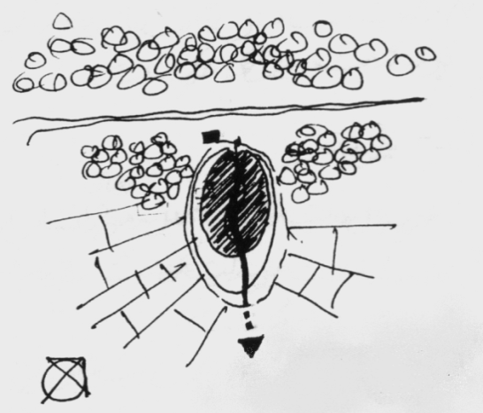 | 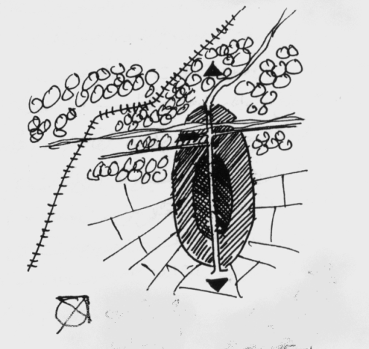
the primary Islamic city (source: Authors) | Qajar and Pahlavi I city (source: Authors)
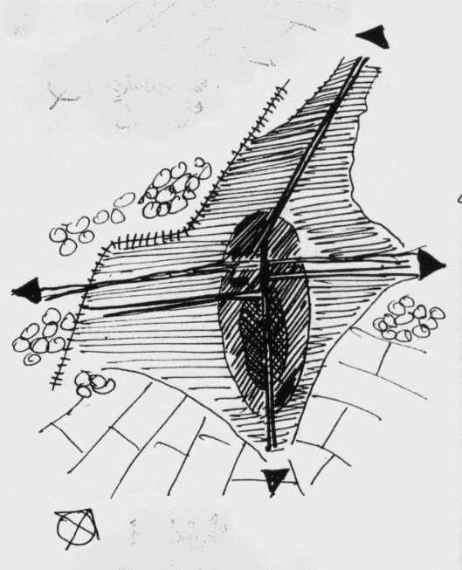  Endowed lands  Eram- Amin street along with road of Isfahan  railway  Tehran new Road  Tehran new Road  Tehran new Road | 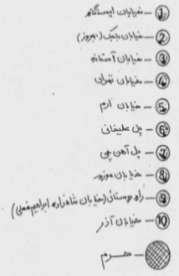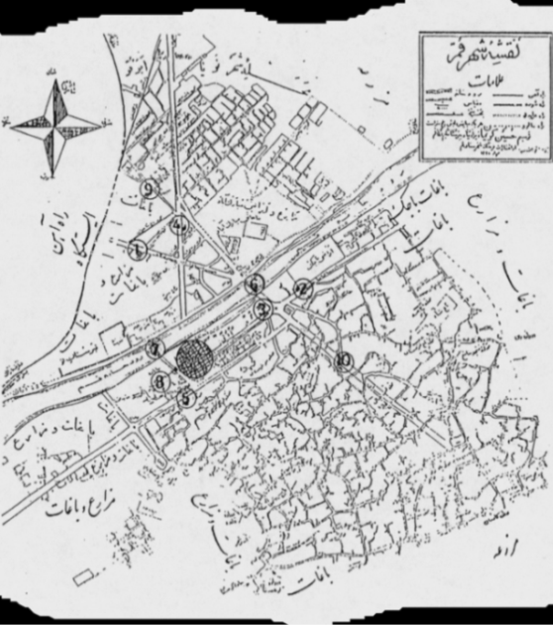
The City at the Beginning of the Industrial Period (1340s) (Source: Authors) | Map of Qom City in 1328 AH, drawn by Hossein Kariman (Source: Emco, 2002)

- Qom at the Edge of Modernization: Urban Microscale
In the case of Tehran, architectural modernization is usually understood as a phenomenon associated with the creation of new urban textures, even during the Qajar period. New facades and modern functional buildings emerged around new streets, squares, or within parks such as Bab Homayoon and Naser Khosro. This phenomenon became even more pronounced during the Reza Khan period. However, the micro-scale analysis of Qom’s urbanism reveals different phenomena that may require a revision of the conventional Tehran-centered narrative. In Qom, the evolution of spatial patterns during this period, as in Tehran, was largely influenced by the introduction of new architectural functions and their layouts. Buildings such as Fatemi Hospital, the former municipal building, the railway station complex, Dar al-Tabligh, and the tax office—both public and non-governmental—typically followed a linear arrangement in architectural plans. The frequent absence of a prominent central courtyard in these structures indicates a significant transformation in the city’s spatial patterns.
The destruction of the Bazaar and its replacement with Azar Street resulted in a somewhat integrated and extroverted urban form along the new street, with spatial patterns directly derived from the old bazaar. Typically, the internal bazaar featured one-story structures with brick-and-gypsum facades and arched roofs, in contrast to Tehran, where new eclectic facades were introduced
(Kiyani, 2004). However, for other new streets, the introduction of Baroque urban style—with its emphasis on focal points—reduced the visual significance of street facades. In streets such as Bajak and Istgah, many residential lots were aligned along the street with diverse façade styles. This pattern persisted in many later streets of Qom. By contrast, streets surrounding the Holy Shrine, as well as its alleys, displayed a greater degree of harmony in façade design, which will be discussed in detail later.
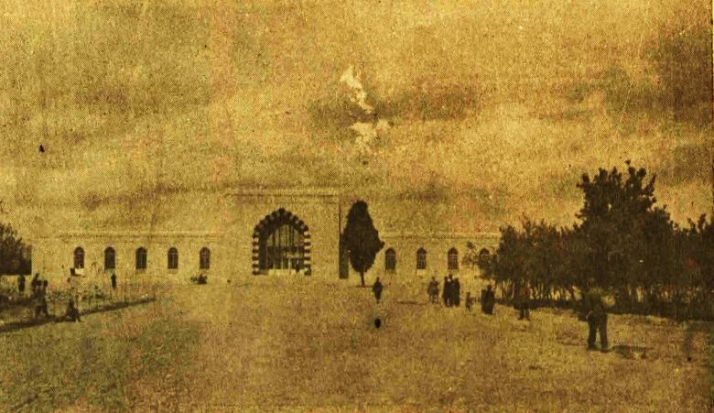
Figure 6. Front View of Qom Railway Station) (Source: Guide to Qom, 1938)

In the buildings of the Reza Shah era, the approach of combining Islamic-style elevations with modernist floor plans was quite dominant. For example, the traditional patterns of the newly constructed building at Qom railway station during the Reza Shah period, documented in several issues of Ostovar newspaper (e.g., Ostovar, March 8, 1969—most of these buildings no longer exist), resemble those of Dar al-Fonun (designed by Markov) or the doorway of the Royal Bank, designed and built by Lor-Zadeh. In contrast, the example of Fatemi Hospital, built on the advice of Ayatollah Haeri and funded by Dr. Fatemi, follows traditional Qajar plan patterns more closely.

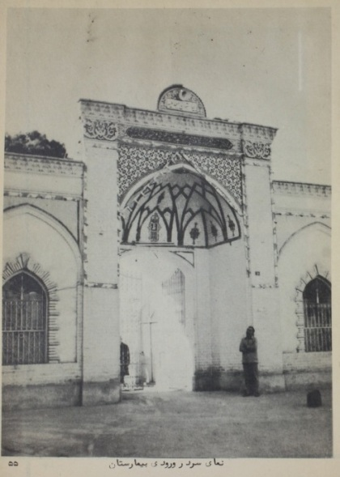
Figures 7 and 8. Qom Fatemi Hospital was built with private investment, initially in the Reza Shah period with a traditional model; Lack of attention to the well-known architectural patterns of the first Pahlavi period (archeology-oriented motifs and early modernist plans and elevations), despite the completely modern operation of the hospital, shows an example of public attitude towards the architecture of this period (Source: Opening of the hospital, 1935).

However, in ordinary buildings—both residential and public—a central courtyard often remained a key element of the plan. Even major functional uses retained their traditional forms: in Qom’s commercial buildings, whether as larger commercial complexes or rows of shops belonging to a single property, a large backyard or main caravanserai continued to be a common pattern well into the 1960s.

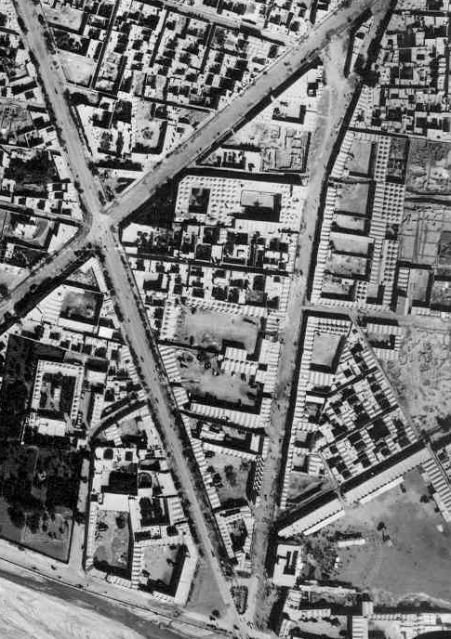
Figure 9. Aerial photo of 1956 shows newly built buildings around streets of Reza Shah Era across the river - the central courtyard behind the commercial rows is still a common pattern (Source: General Directorate of Cultural Heritage of Qom Province).
Figure 10. Pishva Yazdi Sketch of the Position of the Functions around Haj Zeinal Neighborhood of Qom during the Reza Shah Period (Pishwa Yazdi, 2011)

Haj Zainal had a place for his animals in the caravanserai, which also formed his dock. Next to these three, there was an alley of eight meters wide. He had made a home on the other side of the alley for himself, all of his staff and the swordmen. I mean the warriors who, in times of danger and attack and looting by thieves on the way, protected a large caravan of goods and people. In addition to the large house he had built for his family, he had about twenty other houses. In the first row of the castle, a few alleys away, there are several other caravanserais. A man named Haji Abdullah had built a large caravanserai and two houses on the other side of the street. Now, that building of Haji Abdullah is an insured office and used by the public (Pishvaizadi, 2011, 45-47)
This is also true about the combination of uses; for example, Nasser al-Sharia (2004, p. 411), says about the Kashan Gate Mosque, which was built in 1951:
This mosque is located in Darvazeh Kashan neighborhood located in the lower part of Qom city. Its founder is the late Haj Mirza Abdullah Kayhani, an architect from Tehran, who founded it in 1951. The location of this mosque was a flat land. As it is usual for most mosques in Qom, at first a large and unique underground water reservoir (Ab Anbar) was built, which is a very effective aid to the drinking water of the residents of that neighborhood, and then built a mosque on it. All the accessories of the mosque such as carpets, fans and other objects, all of which are provided by its founder, and endowments have been provided for its preservation and management. In addition to the mosque and the water reservoir, a small building has been built for the school and a house for the Imam of the mosque. The endowments of the mosque are several shops located on Amirieh Street in Tehran (Nasser al-Sharia, 2004).
Sometimes, transformations in land use—particularly following the relaxation of religious restrictions at the end of Reza Shah’s reign—exhibited a reversal toward more traditional patterns. A clear example of this is the conversion of Kamran Mirza Park, located at the intersection of Eram and Qom streets, into the Hojjatieh Islamic School.

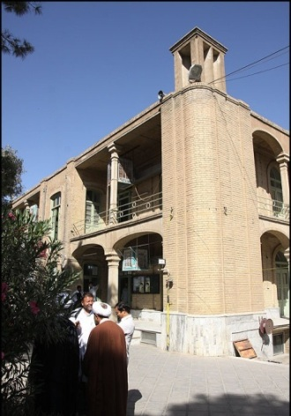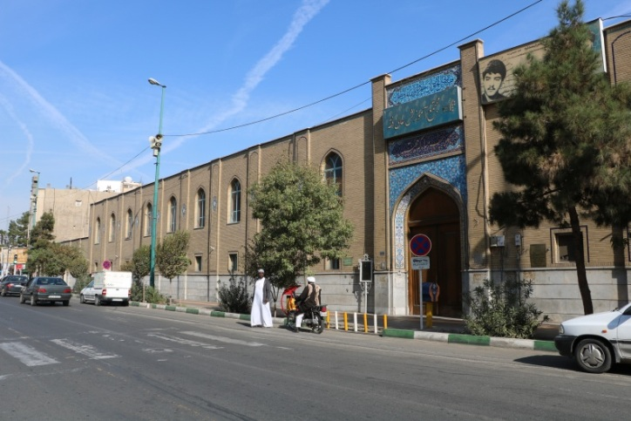
Figures 11 and 12. Inside and Outside Views of Hojjatieh School in the Current Era (Source: Authors)

Its description in the text of Nasser al-Sharia (ibid. p. 412) indicates a completely traditional view of construction:
This school, which later became known as the "Hojjatieh School", is built in six separate two-storey buildings and has a total of 126 bright and sunny rooms, so that all its rooms, especially the upper floors, have enough open air and light, and its students have been hygienic in every way. The four parts of the school building are located opposite each other on the north and south sides of the school yard, the two northern parts are lacated inside the school courtyard and the two southern parts are located next to a street that branches off from Safaieh Square and connects to the river. The other part is located on the west side. In front of it, on the east side, is the beautiful mosque of the school and its small courtyard, which was built by investment of the late Haj Ahmad Etefaq, an Azerbaijani businessman living in Tehran. The shrine of the late Ayatollah Hojjat is next to the mosque. Above the shrine and next to the mosque are the school rooms of the students, and thus the public building of the school is made in a rectangular shape and in a pleasant manner, especially the flower gardens and the lush trees that surround the large school pond, have given a special splendor and prosperity to that scientific and religious center. The big and pleasant crypt of the school is also in the northwestern part. In the hot summer season of Qom, it is an effective factor for the welfare and comfort of the school students. On the west side of this part is the huge water reservoir of the school, which was built by one third of the heritage of the late "Calcutta Chi" of Tabriz.
The persistence of this traditional orientation in spatial design is evident in Sheikhan Bazaar, constructed shortly after the aforementioned period in the early 1960s. Here, the interior space, organized around a four-part arch, creates a distinctly traditional atmosphere.

Figures 13 and 14. Internal and External Views of the Bazaar around Sheikhan (Original Condition) (Municipality-of-Qom, 1966)

Despite the pre-Pahlavi tradition of introverted buildings with minimal street-facing windows, outward-looking facades began to emerge during this period, displaying a relatively wide variety. Some surviving Qajar-style facades, such as those of the old National Bank or the hospital opposite the shrine, featuring gypsum decorations, were retained and remain particularly prominent at the entrances.
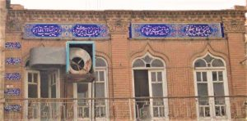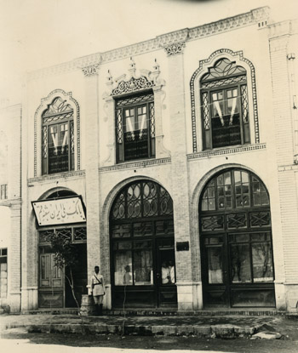
Figure 15. Shafakhane (a Doctor's Office) in front of the shrine of Holy Masume (PBUH) (Source: An Old Image of the doctor Shafa’ Addoleh Office and its Memorable Friezes, 2021)
Figure 16. National Bank, Branch of Qom (Facade does not exist now (Aghajani, 2016).

The use of circular forms at building corners was a common feature during the first and early second Pahlavi periods. In buildings likely belonging to the first Pahlavi period, this was achieved using semicircular or quarter-circular bricks to create a circular or semicircular column at the corner (Figure 17). In the second Pahlavi examples, larger-scale semicircular steel elements were employed. For instance, according to oral accounts, Amjadi Passage, dating to the late Pahlavi period, features a balcony with such characteristics at the corner of a three-way bazaar intersection. The technical aspects of using these steel profiles, including their fabrication, will be discussed further in this study.

In the early second Pahlavi building of Dar al-Tabligh (Fig. 17) and Sarai No (Figs. 17–18), the use of a corrugated façade—a feature of European Baroque style—demonstrates the influence of nineteenth-century urban architecture. This reflects the impact of actual “Western city” experiences rather than the modernist architectural principles introduced to Tehran by Western-educated architects. In a city like Qom, the preferences of non-architect clients often outweighed the formal modernist training of architects.
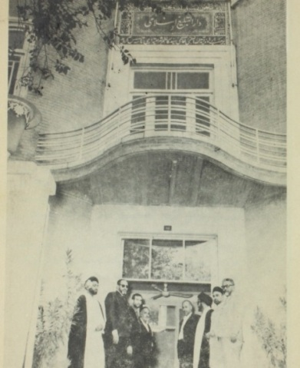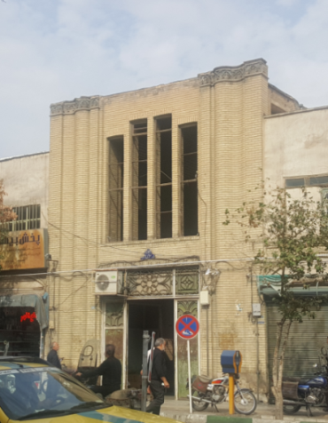
Figure 17 (Right). Entrance Of Dar Al-Tabligh Eslami Building, The Initial Situation in the 1960s (Dar-al-Tabligh-al-Islami., 1949)
Figure 18 (Left). Sarai No, Contemporary Situation (Source: Authors)
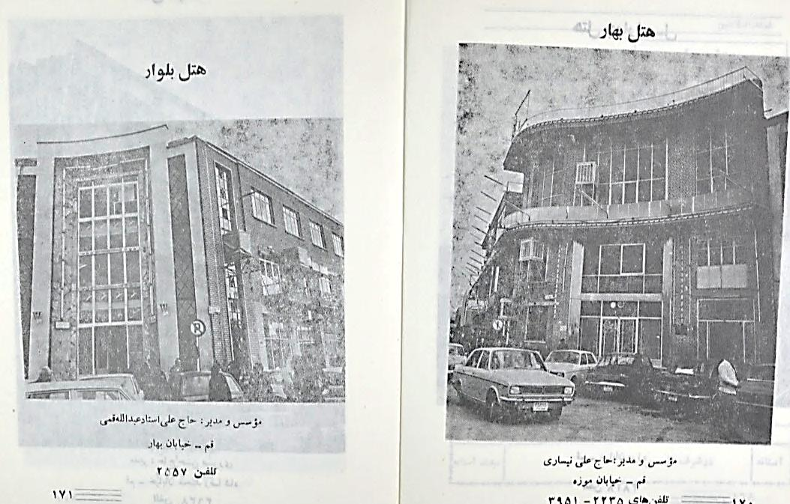
Figure 19. Tendency to curved walls, especially in the entrances of modern buildings; The influences of Art Nouveau or the Austro-French Art Deco can be seen in these examples (the Bahar Hotel in front of the A’zam Mosque and the Boulevard Hotel) (Source: Qom, the Sacred Land); However, inspiration from the public space of the European Baroque city can also be considered. Both examples do not exist now (Qom the sacred land, 171-2)

The phenomenon of the balcony, which became a common architectural element during the Reza Shah period (Kiyani, 2004), is evident in Qom in three forms: recessed (covered or uncovered), cantilevered (consoled and projected), and columned (Figures 16, 18, 31, and 33). At the same time, more traditional façades continued to be constructed, featuring arched windows or openings—commonly referred to in popular works as "Lento" or semicircular arches, a style dating back to the Qajar period (Figures 32–34).
In both residential and commercial buildings, the Qomi-push roof technique, an innovation from the Qajar era, significantly influenced the shaping of façades, and its use persisted until the end of the second Pahlavi period. For a more analytical perspective, it is important to distinguish between two groups of street-adjacent buildings: residential and commercial (including public buildings such as offices and hospitals). Due to the street planning patterns of the two Pahlavi periods, housing near main streets often remained the dominant use. Detailed analyses of these forcibly extroverted residential buildings reveal how they differ from inherently extroverted commercial and public structures along the street.

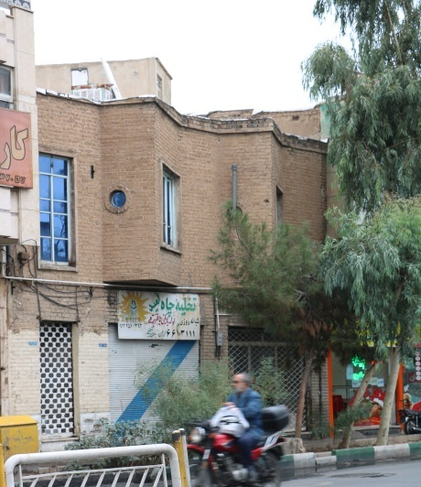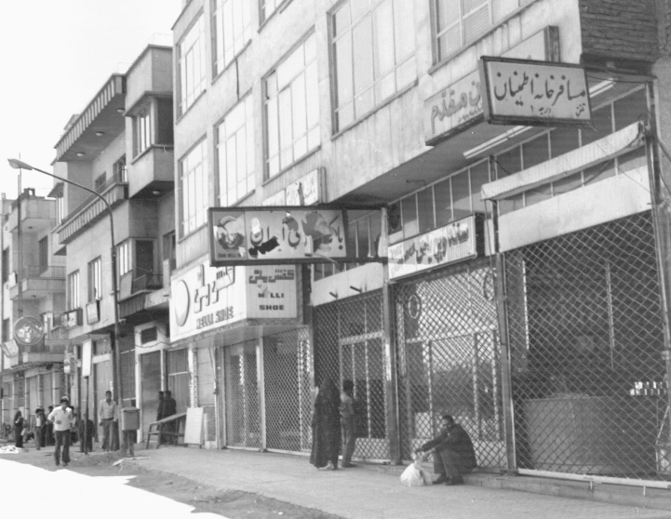
. Figures 20 and 21. Regular balconies with a console of about one meter appear in Qom in the 1960s and the development of the technique of working with fabricated steel profiles; But in earlier examples, the serrated edges on the façade (described in the text) were a dominant pattern (right source: Authors; left-archive of road and urbanism ministry branch of Qom)

5.1. Community Made Patterns and Components of the Facades: None-residential Buildings
Facing the street, as a new condition for commercial buildings—at least in its early stages—did not automatically lead to a modern choice of façades by the people. Instead, new façade typologies emerged that retained clear connections to the internal design of traditional bazaars. These façades, notable for their architectural detailing, exhibit a more coherent visual system compared with modern ones. A common principle in these designs is the concept of “two independent but cohesive cubes stacked on top of each other”. Within this framework, certain points of the façade—such as the transition between floors, the skyline, and the intersections of structural elements with the façade—hold special significance. Key characteristics of these elements include a solid body composed of two parts: brick strips, typically used for walls and load-bearing elements, and a lighter white surface surrounding openings covered with gypsum or plaster. Additionally, when an arch is employed for ground-floor openings, the resulting triangular transitional area is usually detailed in brickwork.

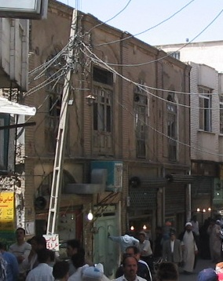
Figures 22, 23, 24. The harmonized facade pattern used at the beginning of the new street construction in Qom (brick half-columns with middle gypsum parts) was a Qajar pattern in Qom popularly used in the new street facades. Later this coordination was lost (right image: Gozarkhan; middle of Eram Street in the 1960s or 1970s (Aghaii Sarbarzeh, 2011); left: general pattern of facades of street-facing shops (source: Authors)

On the upper floor, the window usually occupies a small area; however, unlike the ground floor, there is considerable variety in its shapes, including rectangular, triangular, truncated, recumbent, and semicircular forms. In almost all cases, only one window is positioned between two brick strips. On the lower floor, the entire space between two brick strips is generally left open, with only the upper part of an arch—most commonly a segment of a circle—indicating the upper limit of the opening. Non-arched openings also exist, but wooden rectangular windows without horizontal divisions were the most common type in Qom during this period (Figure 24).

Wide windows, introduced from the Bauhaus as a symbol of architectural freedom from structural constraints, appeared in the popular architecture of Qom during the second Pahlavi period (Figures 20–21). This development may also be related to the use of steel frames and large flat glass panels; however, it cannot be attributed solely to technical considerations. The issue of privacy in Qom was so significant that outward-facing windows in public areas—at least within the alleys of old neighborhoods—were socially discouraged. Therefore, modern narrow and wide windows provided natural lighting without compromising privacy, which likely contributed to their widespread adoption. The construction of façade shutters with pointed arches, common in Markov’s works in Tehran (the Russian architect employed by the Pahlavi government), can also be observed in Qom in two government buildings designed by Maxim Siro (a French architect also working for the government): Hakim Nezami High School (Figures 25–27) and the railway station building (Figure 6). Additionally, a report in the Ostovar newspaper from Qom in 1937 indicates that other Qom railway buildings (which no longer exist) followed the same pattern (Source: Tehran to Qom, 1937).
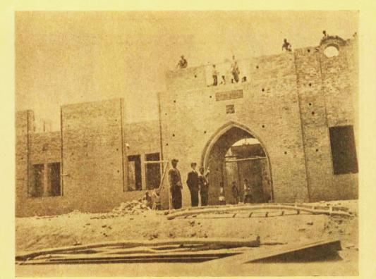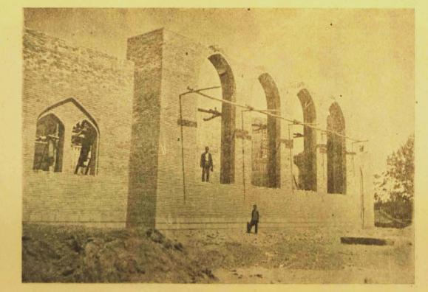

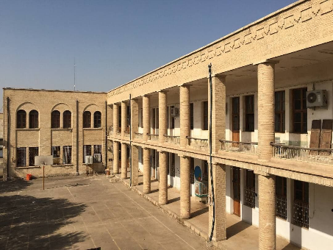
Figures 25 to 27. Hakim Nezami High School in Qom (of course, in the guide of Qom, 1938, it is called Hekmat). The above pictures in the guide of Qom (1938) were taken during the construction of this building, and the scaffolding and materials show the use of old execution techniques in this building with a jack-arched roof. The arches used in this building are not only decorative but also fully load-bearing. The image below shows the contemporary condition of this building. (Qompajoohi, 2021) ("Guide to Qom," 1938)

In both cases, a relatively similar structural approach is employed: horizontal lines stacked atop one another, each potentially differing in material or shape. In more complex examples, a row may consist of muqarnas (honeycombed) brick, semicircular brick, glazed azure semicircular brick, plain semicircular brick, and flat brick. Occasionally, these strips deform at the locations corresponding to the brick strips in the solid body, or they may project outward or increase in thickness. Some examples also incorporate gypsum carving and painted decoration along this portion of the skyline.

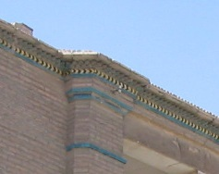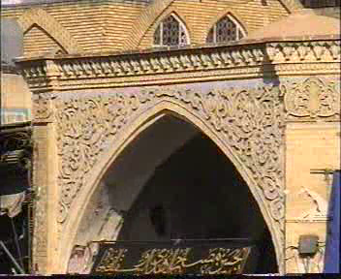
Figures 28 and 29. Two examples of Pahlavi cornice in Qom. Right: It shows the balcony facing the outside of Shakeri's house and the left side of the entrance of the new bazaar at the crossroads of the bazaar after contemporary repairs.

Figure 30. All-brick plinths are seen in older images of street shops near the street. The floor of the shops is one step above the street (Aghaii Sarbarzeh, 2011).

Columnar balconies, whether recessed into the building mass or projecting outward, exhibit a volumetric concept that, unlike the brick buildings with balconies described in Part A, still adheres to the “two separate cubes” pattern characteristic of this category. This effect is largely achieved through the use of balcony pillars. In particular, round columns with capitals are a defining feature of these buildings, consistently applied both inside and outside houses of this period, and are generally crafted from a single stone piece or a few large stone segments. In less articulated examples, rectangular columns or simple, capital-less columns are employed.

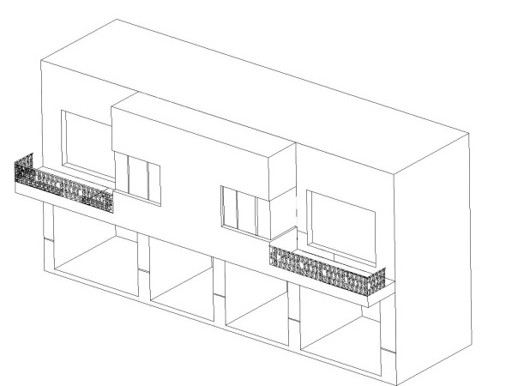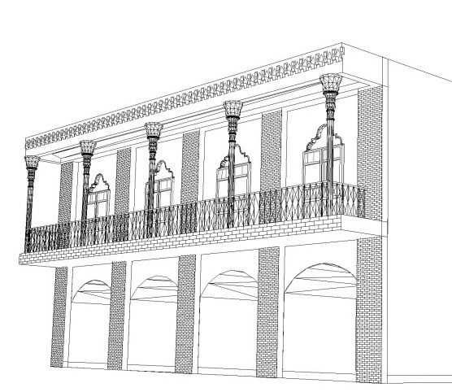
Figures 31 and 32. Two balcony types in the early modernism period: The left type with Qajar motifs is seen in early Pahlavi buildings and the right pattern is more prominent in the second half of the first Pahlavi to the end of the period studied in this research (1950s).
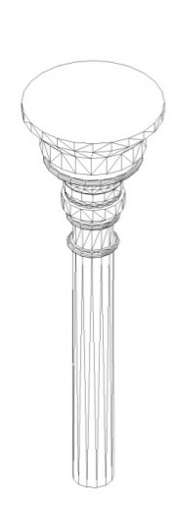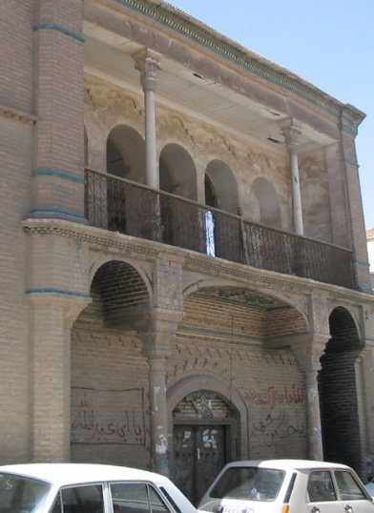

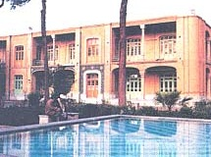
Figures 33 and 34. Carved in balconies without consoles with Qajar style columns can be seen in more popular works. Above: Shakeri House and below Hojjatieh Islamic School
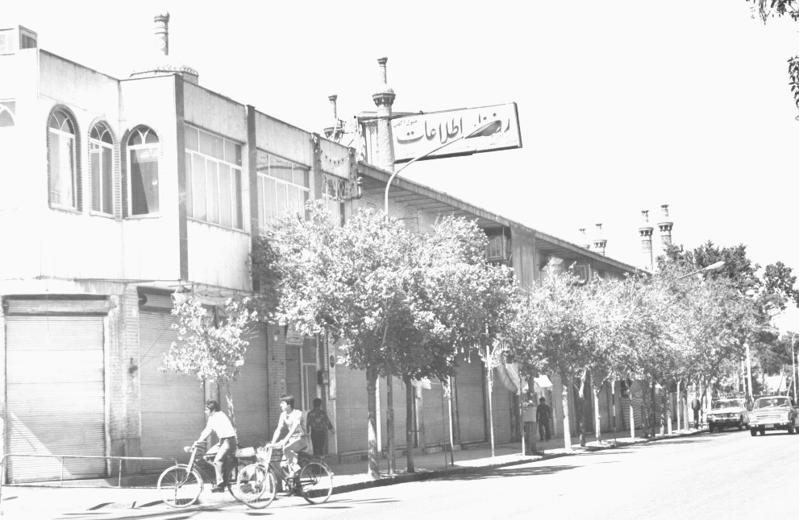
Figure 35. The commercial row behind the shrine of Holy Masumeh (PBUH), which was connected to the structure of the shrine wall as a console at the beginning of the second Pahlavi period. This example is without columns (old image of the 1960s or 1970s - Source: Archive of Road and Urbanism Ministry Branch of Qom)
5.2. Community Made Patterns and Components of the Facades: Residential Buildings
In residential buildings, the extroverted design characteristic of the Reza Shah era and the subsequent period primarily affects the exterior appearance rather than the interior layout. A notable distinction exists between one- and two-story houses. In two-story houses, which largely reflect the typical pattern of this period, the building façades generally follow the same design principles outlined above for commercial buildings, with differences mainly in the height of the floor openings. In one-story houses, while some of the previously mentioned façade techniques—such as brick strips and plasterwork—are used, significant variations appear in the type of plinths and openings, as well as the stepped azure skylines. Features such as emphasized window edges with brick rows, brick plinths along walls, and the absence of windows between certain strips accentuate wall height, giving the buildings a more massive, substantial appearance.

However, the patterns of housing design do not exhibit the uniformity observed in commercial buildings, and considerable variety exists. Several points are noteworthy in this regard:
- Establishing housing along open passages, unlike commercial buildings, was not a novel concept; thus, it did not necessitate a new design pattern, although it could be influenced by the street’s emerging architectural trends.
- Except for areas around Bajak Street and the Bagh-e-Panbeh neighborhood—which emerged roughly contemporaneously with or slightly earlier than the Bajak streets—most new houses were constructed by renovating or attaching to the existing urban fabric, resulting in strong continuity with older patterns. In these cases, reliance on the alley as an open space for functions such as light and ventilation, as seen in commercial buildings, is generally absent. Small windows (20–50 cm) are placed within the openings, and larger windows (about one meter) are set higher—over two meters inside and approximately three meters outside—for ventilation and indirect lighting in back spaces. This configuration is particularly associated with brick-pier structures that leave considerable empty space between piers.
- Concerns for privacy and intimacy, in addition to their previous impact, influenced the construction of relatively high parapet walls as a façade element in some buildings. Another manifestation is seen in extended street-facing windows, including two notable examples: (1) wooden doors with very small glass panels to partially close the windows, and (2) glazed terracotta lattice screens with circular perforations, which continue to be used in some cases today.

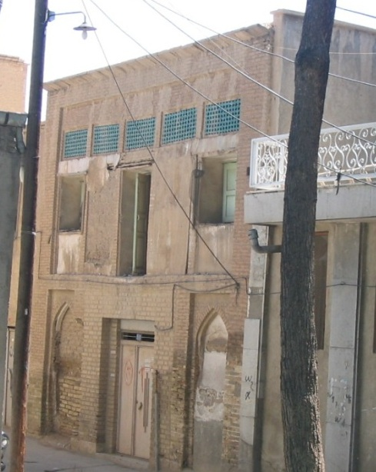

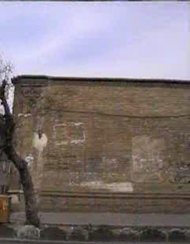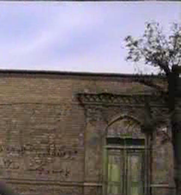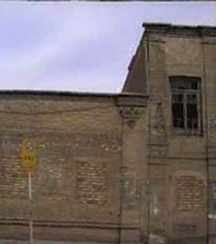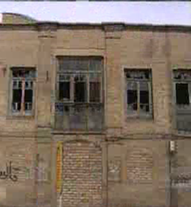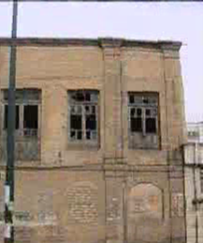

Figures 36 to 37. Examples of extroverted residential buildings: The climatic role of the upper openings and the influences of all of the openings from the atmosphere of the street, are evident. Modulation and symmetry are the factors of visual regulation while two factors of internal function and external privacy, in addition to the climate, is obvious in the above picture (Azar Shahzadeh Hamzeh (pbuh) quarter) is quite clear, but in the picture below (a house on Bajak Street at the edge of the main street demolished few years ago), the issue of privacy regarding windows is apparently not very much observed; in fact, the windows should have been covered with curtains. However, the details of this window have another kind of compatibility with the matter of privacy, which unfortunately, due to the destruction of both buildings, the possibility of accurate analysis has been lost.

•
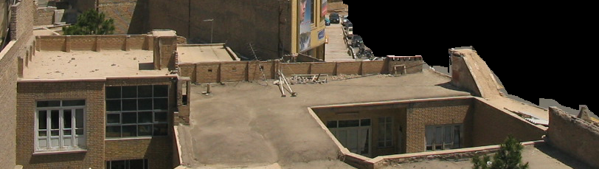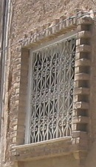
Figures 38 and 39. Procedures for creating privacy in the extroverting housing of the Pahlavi period: Wrought iron instead of brick lattice and roof walls, took the new task of preventing visibility of inside the home due to floor level differences (in addition to their old functions that was roof privacy for overnight stay).

• The combination of all the aforementioned features and techniques is rarely observed in a single façade. Economic factors and the income level of the owners clearly influenced their implementation. Houses of the prominent aristocracy were executed with greater detail, employing brick—a relatively expensive material—on a larger scale and creating more varied forms. Zand House, now converted into the Qom Cultural Heritage and Ethnology Museum, is a notable example. In contrast, the use of thatch instead of white coating on its façade appears to be a misapplied restoration model, borrowed from Yazd, which does not conform to Qom’s traditional architectural patterns.

In housing, the treatment of entrances deserves special attention. In traditional adobe, introverted houses of the early modern period, the entrance was a highly regarded and elaborated element, regardless of the overall articulation of the façade. Bricks—particularly shaped bricks—were commonly used even when other portions of the façade were built from adobe. Two entrance patterns are noteworthy:
- First pattern: Recessed entrances, typically accompanied by two side platforms. In such cases, façade detailing with brickwork is less pronounced, though richer examples exist. A characteristic feature is a step down into the recessed space before reaching the door. The floor of this space is usually paved with Kazakh bricks, while the walls may be thatch or plaster. This pattern is often seen in older homes and larger houses.
- Second pattern: Entrances without recessed or backward spaces. Here, emphasis is placed on the entrance through two half-protruding brick columns, creating a projecting entrance. The volume is usually decorated with brick (clay) moqarnas at its top edge, and the plinth is highlighted up to approximately one meter with a row of rounded bricks, sometimes featuring additional protrusions.

Notably, these entrance patterns are shared across housing and certain urban spaces, including shrines. For instance, the entrances of the Imamzadeh Hamzeh (PBUH) shrine follow the first pattern, while the Seyyed Sarbakhsh (PBUH) shrine adheres to the second. The recessed entrance pattern, observed in Atiq Mosque, Faizieh Islamic School, the courtyard of the Holy Masumeh (PBUH) shrine (glass-worked Iwan), Timcheh Bozorg, and Jahangir Khan School, is particularly inviting and better suited to public functions.

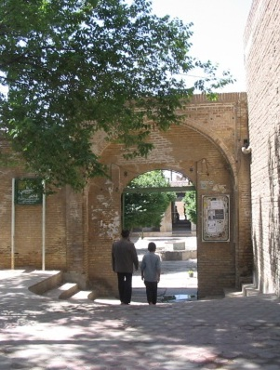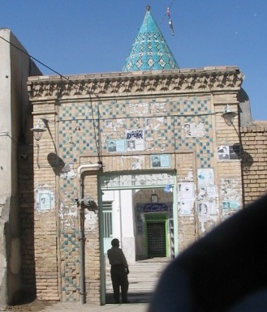
Figures 40 and 41. The first type of doorway in the entrance of the Pahlavi period of Imamzadeh Hamza (PBUH) and the second type of doorway in the entrance of Seyyed Sarbakhsh (PBUH)
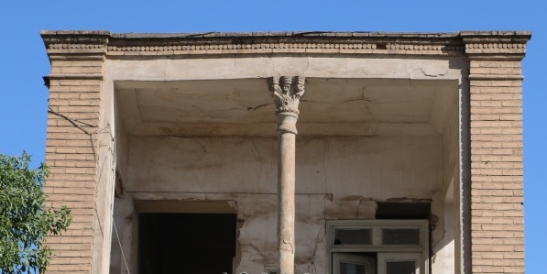

Figures 42 and 43. Balcony facing the street belongs to a first Pahlavi period house next to Eram Street with Qajar-style columns. In this example, the ground floor is completely introverted (compare with Figure 37 on Bajak Street). This example of a balcony or attic can also be seen in the lordly houses of the villages of Qom. Apparently, a kind of suburban perception of this Street, which is along the old road of Isfahan, has encouraged this special approach in housing.

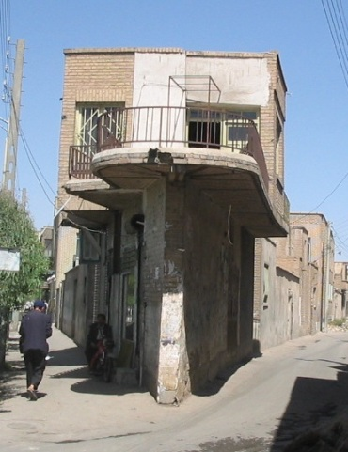
Figure 50. An interesting example of solving the problem of cutting limitation and beam size in a narrow plot of land most of which has been destroyed in Azar Street of Rezashah period

Buildings featuring very long horizontal windows, accompanied by horizontal cement strips above and below the openings—such as those along Imam and Safaieh streets—can arguably be considered the first truly modern structures in Qom in terms of architectural style. In these examples, the second floor often fully projects over the sidewalk, significantly altering the spatial quality of the pedestrian path. Additionally, the top of the staircase emerges as a prominent spatial and volumetric element, in contrast to the modest staircases of traditional buildings. The façade composition is typically arranged to maintain a harmonious balance between horizontal and vertical elements, reinforcing a clear gestaltic order.

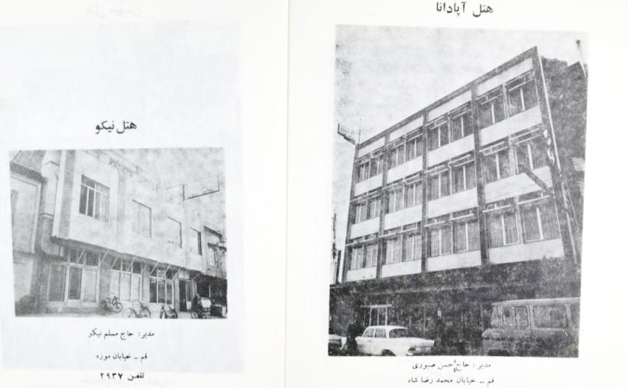
Figures 51 and 52. The high-modern style buildings can be seen in their populist form in the constructions of the 1960s, especially in the newly constructed streets of that time by cutting the context of the city (right picture, Chaharmardan - built in 1965) and the Hazrati street ( Left image). It can be seen that in the recent street, continuous body changes following fashion changes are quite evident in the surviving photos of that period. Metal and glass facades with travertine plaques in large sections and sometimes cement facades, are the main manifestations of the 1960s of these two areas (Source: Qom the Sacred Land, pp. 173-174).

In the interior, a prominent feature is the continuation of a traditional roof structure known as Qomi-Push, developed during the Qajar period. This system employs thin brick layering (only 3–4 cm thick) to span approximately 4 meters. Its persistence is likely due to the low cost and availability of materials, combined with aesthetic preferences rooted in traditional architecture. Another common interior type is a combination of brick walls with a jack-arch ceiling, often featuring exposed brickwork and steel beams beneath.

The widespread use of the four-arched roof system in early and mid-Pahlavi buildings in Qom, along with the display of intersecting steel arches under the roof, signals a notable shift in popular aesthetic taste. This contrasts with earlier periods, including the traditional Isfahani style of Iranian architecture up to the end of the Qajar era, where roof systems on square plans typically featured non-crossing structural elements, such as the Char-Tark or Kolambu roofing systems, as the main expression of non-domed interior spaces.

- Conclusion
The modernization process in smaller Iranian cities provides a valuable case for study, and Qom’s urban experience serves as an appropriate example for revisiting this narrative. In the case of Qom, mandatory modern interventions, such as cutting streets through the urban fabric, did not erase traditional perceptions of the city at the microscale. A review of street facades from Qom’s early modern era shows that public perceptions of the new street phenomenon were largely influenced by inner courtyards and the bazaar; in other words, streets functioned conceptually as external courtyards or unroofed bazaars. Even at the macroscale, the disruptive modernization of the Reza Khan period manifested differently in Qom compared with Tehran.

The Baroque-style planning of the new city was a distinctive feature of Reza Khan’s projects, particularly in establishing the holy shrine as the city’s new focal point, despite his secular agenda. Some microscale Baroque elements also appeared in new Qom buildings, such as wavy facades and Art Nouveau details. Because the shrine of Fatemeh Masoumeh (PBUH) was located on the city outskirts, with its endowments surrounding it, Reza Shah-era streets, unlike in other Iranian cities, did not heavily disrupt neighborhood centers. Instead, renovations and modernizations concentrated on the urban edges, resulting in a gradual modernization process within the existing urban context, shaped by local interpretations of modernity.

About a decade after the onset of this modernization, a popular tendency toward certain modern spatial features emerged. A soft transition from the enclosed bazaar space to the street became apparent, which intensified during the Second Pahlavi period, particularly after the developments of the 1950s following the coup d’état of 19 August 1953. During this period, Qom’s urban fabric experienced significant destruction in neighborhood centers due to street construction and the proliferation of completely modern buildings, often ignoring traditional patterns. Housing along the streets undermined previous social hierarchies and privacy, while stone, metal, and glass facades became commonplace along street edges.

Thus, in a city that transitioned from a small town at the beginning of modernization to a larger urban center at its peak, many local adaptations occurred between tradition and modernity—not only at the microscale and in façade design but also at the city scale, through the integration of modern detached spaces with pre-existing spatial patterns. This community-driven adaptation was partly enabled by the government’s decision to accelerate the modernization process, leaving limited time and budget for detailed urban planning in smaller towns. However, this adaptive advantage gradually diminished as official intervention increased, municipal authority expanded, and the modern lifestyle became more widespread.

References

Aghaii Sarbarzeh, M. (2011). Qom: In the sanctuary. Jahad-e Daneshgahi & Shahrdary Qom.

Aghajani. (2016). The first branch of Bank-e Melli in Pahlavi the first era in Eram street. Retrieved Sep. 2025, from http://qompajoohi.ir/%d8%a7%d9%88%d9%84%db%8c%d9%86-%d8%b4%d8%b9%d8%a8%d9%87-%d8%a8%d8%a7%d9%86%da%a9-%d9%85%d9%84%db%8c-%d9%82%d9%85-%d8%af%d8%b1-%d8%b2%d9%85%d8%a7%d9%86-%d9%be%d9%87%d9%84%d9%88%db%8c-%d8%a7%d9%88%d9%84/

Bani Masoud, A. (2009). Contemporary architecture of Iran (a struggle between the tradition and modernity). Me’mari-e Gharn pub.

Bavar, S. (2009). A Look at the Emergence of New Architecture in Iran. . Faza pub.

Dar-al-Tabligh-al-Islami. (1949). Familiarity with the activities of the Dar al-Tabligh al-Islami on the occasion of the tenth anniversary of its establishment. Islamic Propaganda Center.

[Record #7 is using a reference type undefined in this output style.]

Falamaki, M. M. (1979). An exploration of experiences of the urban restoration: from Veniz to Shiraz. the Ministry of Housing an Urbanism.

Falamaki, M. M. (1992). Formation of the architecture within the experiences of Iran and the West. Faza pub.

Ghasemi, K., Hamzenejad, M., & Meshkini, A. (2019). The livability of Iranian and Islamic cities considering the nature of traditional land uses in the city and the rules of their settlement. Habitat International, 90, 102-106. https://doi.org/10.1016/j.habitatint.2019.102006

Gidion, S. (1975). Space, Time and Architecture: growth of a new tradition (M. Mozaiieni, Trans.). Bongah-e Nashr-e Ketab.

Groat, L., & Wang, D. (2005). Research methods in architecture (A. Einifar, Trans.). University of Tehran pub.

Habibi, R. (2017). The institutionalization of modern middle class neighborhoods in 1940s Tehran – Case of Chaharsad Dastgah. Cities 60(A), 37-49. https://doi.org/10.1016/j.cities.2016.07.006

Habibi, R., & De Meulder, B. (2015). Architects and ‘Architecture without Architects’: Modernization of Iranian housing and the birth of a new urban form Narmak (Tehran, 1952). Cities, 45, 29-40. https://doi.org/10.1016/j.cities.2015.03.005

Karimi, N., & Boussauw, K. (2018). Sanandaj, Iran. Cities 72(B), 261-273. https://doi.org/10.1016/j.cities.2017.09.004

Kiyani, M. (2004). Architecture of the First Pahlavi Period, Transformation of Thoughts: The Origin and Formation of Architecture in the Contemporary Twenty-Year Period of Iran. Institute for Iranian Contemporary Historical Studies.

Mashhadi Moghaddam, S. N., & Rafieian, M. (2020). From the kingdom lash to participation: The tale of urban planning in Iran. Social Sciences & Humanities Open, 2(1), 100022. https://doi.org/10.1016/j.ssaho.2020.100022

Masoumi, H. E., Terzi, F., & Serag, Y. M. (2019). Neighborhood-scale urban form typologies of large metropolitan areas: Observations on Istanbul, Cairo, and Tehran. Cities 85, 170-186. https://doi.org/10.1016/j.cities.2018.09.005

Mokhtari, E. (2011). The heritage of the modern architecture of Iran. Daftar-e Pazhoohesh-Ha-ye Farhangi.

Municipality-of-Qom. (1966). Guide to Qom (Journal No. 3 of Qom Municipality to guide travelers and pilgrims). Novin-e Qom printing house.

Nari Ghomi, M., Mommtahen, M., & Omrani Pour, A. (2021). Factors and backgrounds of the emergence of new commercial complex at Modernization beginning of the first Pahlavi period (Case study: Qom). Iranian Islamic city studies, 43(12), 81-100. https://dorl.net/dor/20.1001.1.2228639.1399.10.40.6.0

Nasser al-Sharia, M. H. ( 2004). History of Qom or the holy sanctuary of the noble lady of the house of infallibility and purity of Hazrat Fatemeh Masoumeh. Rahnemoon.

An old image of the doctor Shafa’ addoleh office an its memorable friezes. . (2021). Retrieved Sep. 2025., from http://qompajoohi.ir/?p=2949

Opening of the hospital. (1935). Ostvar newspaper, 17(25), 1.

Pishwa Yazdi, M. (2011). The Narrative of Construction to Mastery: Memoirs of Master Architect, Mohammad Pishva yazdi (E. Androudi, Ed.). Elm-e Memar-e Royal.

Qayyoomi Bidhendi, M., & Shams, O. (2022). History of Mentalities in Iranian Architecture: an Introduction. Journal of Iranian Architecture Studies, 1(2), 5-25.

Qom, the Sacred Land.

Saeednia, A. (1987). Qom the origin of the city. In Iranian Cities (Vol. 2). Jahad-e Daneshgahi.

Sintusingha, S., & Mirgholami, M. (2013). Parallel modernization and self-colonization: Urban evolution and practices in Bangkok and Tehran. Cities (30), 122-132. https://doi.org/10.1016/j.cities.2012.02.001

Tehran to Qom. (1937, 17 March 1937). Ostvar newspaper, 2(86), 1.

"Structural-strategic plan of Qom city" does not consider this growth gradual.

