A Review

Ergonomics on the context of Sustainability:
A new approach towards the quality of life

Hassan Sadeghi Naeini
School of Architecture and Urban Studies, Industrial Design Dept., Iran University of Science and Technology (IUST), Tehran , Iran

Abstract

Ergonomics as a multidisciplinary science is known as a human centered science that is concerned with human beings and their quality of life. In this regard, the integration between ergonomics and the concept of sustainability might culminate in higher levels of quality of life. In this review article, we assessed some of the recent and related articles in which both ergonomics and sustainability were considered. This review aims to develop an integrated state-of-the-art approach including the benefits of both fields. PubMed and EBSCO were the databases consulted and the keywords of “ergonomics”, “sustainability”, and “product design” were selected to gather the relevant papers. Papers in English, which were published during last decade and that includes the keywords, were our inclusion criteria. Exclusion criteria were: microeconomics and cost-benefit studies, aspects of law in environmental issues, and technical issues in environmental protection (such as waste-water treatment, air pollution, etc.). We initially identified 255 papers. This was narrowed down to 33 articles that addressed issues. In a critical review of the abstracts and full papers, 9 papers remained for the final assessment. Of these papers, 64% were from a management approach. Three articles had product design approach. Most of the assessed issues were about ergoecology, business management, s system-based approach, global supply chains, design for sustainability, and a cost-effective approach. Based on the mentioned articles, it seems that introducing a new term that includes all the positive aspects of ergonomics and the sustainability scope, is unavoidable. Therefore, we propose a new approach that includes the majority aspects of ergonomics, sustainability, and design. This new paradigm helps the related experts to manage a better future life for all.

Keywords: Ergonomics, Sustainability, Quality of life, human being, health promotion

Introduction
Quality of life (QoL) is one of the main concerns of governments, economists, hygienists, municipalities, and social policymakers and authorities (Gan et.al. 2017; Leach et.al. 2017; Kaklauskas et.al.2018, Vlec, Skolnic, and Gatersleben 1998). Besides, QoL is known as one of the main indicators of sustainability (Dyllick, and Rost, 2017; Caiado, 2017; Moser, 2009). QoL is also one of the prominent approaches of the 17 targets of new approach on sustainable development goals (www.undp.org). Brundtland commission entitled “Our Common Future” (WCED, 1987) opened the gate towards quality of life throughout sustainable development (Moser, 2009). The significance of environmental protection, green economics, and quality of life is considered by social authorities, urban planners, health organizations and also economics associations (Campbell, 2013; Lindholm and Blinge,2014; Lee et.al.,2015; Pandit, et.al,,2017). Promotion in QoL and sustainability is important not only for general life style but also for industrial sectors and organization (Dyllick, and Rost,2017). Sustainability is growing day to day, and according to Gaziulusoy and Ryan (2017) sustainability evolution needs some systemic changes and also some structural improvement, also Kim and Moon (2017) mentioned the product design and development related studies have some ignorance three main pillars of sustainability. Besides, ergonomics scope and discipline also require some evolutions, in this regards making a synergy between two mentioned firms will be ended to a more appropriate and effective way to achieve quality of life for all and this is the main objective of this review in which the authors conducted to figure out the new approach towards the quality of life, based on both scope of sustainability and ergonomics. To achieve higher levels of quality of life whether in developing or developed countries, making and implementation appropriated process and systems are expected. In this regards, effective utilization of new multidisciplinary scientific paradigm might be considered to improve the quality of life. Moreover, majority of our life style is related to use products; in this regards ergonomics and sustainable products play a critical role in our life.
Undoubtedly ergonomics as a multidisciplinary science, product design as daily needs of human, and sustainability as a context, concerned with the human being, healthy life and environmental protection. Furthermore, in spite of some current approaches on ergonomics and sustainability, such as Ergoecology (Garcia-Acosta et al., 2012; García-Acosta, et al., 2012), HFE and Sustainability (Zink and Fischer, 2013; Zink 2013), and green ergonomics (Thatcher, 2013); more study and research about the role of ergonomics in sustainability needs to fill the some probably knowledge gaps. Additionally, relation between aspects of product design and ergonomics and sustainability is not also so clear, therefore, the authors decided to figure out some related issues throughout a review article.
In this work, according to the review of several sorts of reports and papers, we developed a new integrated approach consistent with all benefits of ergonomics and sustainability especially in the field of product design. Furthermore, to develop a better view of this new approach ergonomics and sustainability in both aspects of production and product design were focused. In fact the pros and cons of current published papers and studies in terms of interconnection of ergonomics and sustainability were considered. Also, it should be mentioned that the terms of ‘sustainability’ and ‘sustainable development (SD)’ which are often used interchangeably, are not the same and in this work we emphasized on ‘sustainability’ more than ‘sustainable development’.

Sustainability Concepts

Sustainability which is known as a global pledge is not a new term. Carlowitz (1713) used the word of sustainability to explain the significance of the natural resources (Thatcher, 2014).
Sustainability concepts and sustainable development are so important terms for academic researchers (Caiado 2017, Turcu 2012), business managers and product development authorities (Lacasa, Santolaya and Biedermann, 2016; Kim and Moon, 2017; Genc, 2017), community safety experts (Tyler, 2017) and so on.

United Nations as an intergovernmental organization and also another related organization such as the South Pacific Applied Geosciences Commission emphasize on the sustainability goals and developing the related indicators. Developing related indicators for sustainability measurement is considering during the past two decades (Dahl.A.L.,2012).

The concept of sustainability covers three main aspects of social, economic and ecological in which to make a balance between the mentioned scopes are considered (Lecasa et.eal., 2016; Rodríguez-Serrano et.al.,2017; Dawodu et.al., 2017; Partidario. P.J.,Vergragt. Ph.J.2002). Undoubtedly, pillars of sustainability have covers some different and vast scope per se. The firm of production and product design has an associate with the sustainability (Schoggl et.al. 2017; Samyeon and Moon, 2017; Lacasa, Santolaya and Biedermann, 2016). Sustainable development is known as an appropriated context towards the quality of life (Dyllick, and Rost, 2017; Caiado, 2017; Moser,2009). Furthermore, daily products have an important role in our life, and product design process is also associated with all three aspects of sustainability (Fig. 1)

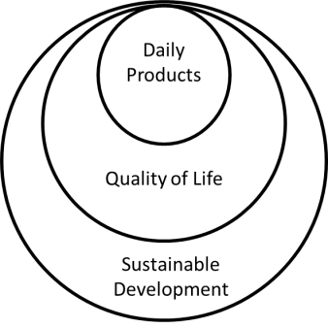
Figure 1: The scope of sustainability-related products

The role of products in our life style is related to materials, meeting the human requirements, environmental considerations and so on. Also considering with the importance of production and life, there are a lot of recent research about life cycle assessment of products (Laso et.al., 2017, Siebert et.al.,2017), therefore there is a firm association between products characteristics and sustainability concepts.

Ergonomics
One of the multidisciplinary sciences which may help to urban planners, managers, social authorities, health organizations and designers in terms of quality of life and sustainable development is Ergonomics. However this field of science in comparison with other knowledge seems a bit new, but during some decades, development of ergonomics scope has been substantial. This multidisciplinary science has a wide scope in which human being and design for human needs and requirements are known as the main aims (Turisova and sinay 2017, Haight.G.M.2013; Inkeles. G., and Schencke.I.1994; Bridger.R.2009).

Ergonomics is a multidisciplinary science which concerns about fitting the job to the operators and fitting products to users’ demand to make them more efficient, productive, safer and satisfied (Sadeghi Naeini.et.al.,2014; Karwowski W.2006).
Ergonomics has dual goals of health promotion and productivity and considers human health and human performance, simultaneously (Sadeghi Naeini. H, Mosaddad.S.H. 2013). Ergonomics has a vast field in which there are five sub-branches of micro-ergonomics, macro-ergonomics, cognitive, environmental and social ergonomics (Fig.2).

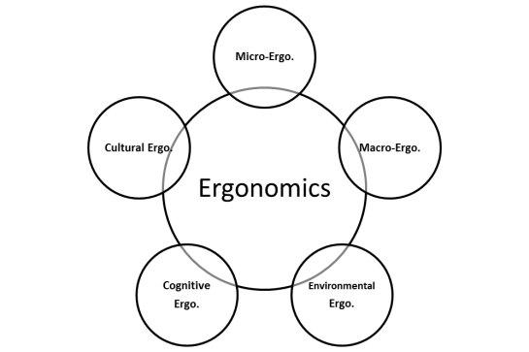
Figure 2: The scope of Ergonomics

Environmental and social ergonomics aspects are associated with sustainable development concept. Additionally, some new approaches in ergonomics scope have been introducing such as Ergoecology which is based on the sustainability, anthropocentric approach, and the systemic focus (Martha, H.2016). According to the wide scope of ergonomics, there are altered domains which might be related to ergonomics from health science to product design, and from physical activities and somatic disorders to mentality ( Kawowski 2005). In this regards, engineering fields, social science, psychology, design and art are related to ergonomics, as well.
As ergonomics is a human center science and considering the significance of environmental health for the human being, it is supposed to the ergonomics concerns sustainability, as well.

User center design as one of the ergonomics approaches contributes to lifestyle improvement through design for human activities and behavior. Moreover, Ergonomics has a prominent role in design culture and also design for culture. The themes which are involved in cultural-social ergonomics show the significance ergonomics place in social aspects of sustainability. Ergonomic design processes emphasize to meet human needs in both levels of individuals and the community, in this regards the ergonomic considerations should be emphasized on product design process.

Product Design
One of the main approach and expertise of industrial designers is product design. Industrial design students have some courses which are related to this review scope such as ergonomics and also introduction of materials. In the ergonomics courses, some parts of ergonomics such as micro-ergonomics, environmental and cognitive ergonomics would be covered, and in the course of materials, they learn about the materials and their applied in product During last decades, the knowledge of people about usability of product and inclusive design are evaluated, in this regards different aspects of product design and process of manufacturing might be consider by end users (Dias A., et.al.,2015). Furthermore, our resources are limit and there are some sorts of critical environmental impacts (Ljungberg, 2007), in which the role of materials is highlighted, in this regards the place of designers are also prominent. However, the linkage between materials and ergonomics and also sustainability aspects of design is a bit intangible. In this regards, in this review the authors conducted to point on product design as a keyword and also ergonomics and sustainability and figure out the relationship between these areas.
.

Method
This review article focused on the relationship between ergonomics and sustainability and aimed to develop an integrated state-of-art approach including all benefits of both mentioned fields. This new approach is supposed to play a critical role in the quality of life. In this research, we reviewed the literature on sustainable development and ergonomics by using PubMed and EBSCO. For gathering the related articles and information through the mentioned search engines, the keywords “ergonomics”, “sustainability”, and “product design” were preferred.

We initially identified 255 papers in English which were published in last 10 years. To have appropriated papers selection, the inclusion criteria were: ergonomics, sustainable development, and product design.
Exclusion criteria were: microeconomics and cost-benefit studies, aspects of law in environmental issues, technical issues in environmental protection such as waste water treatment, air pollution and so on. Likewise, the aspect of human-computer interaction which is related to human factors engineering was excluded.

By the mentioned criteria, 33 papers were chosen based on their titles (30 in EBSCO, and 4 in PubMed), in which one of the PubMed paper was removed as it was a review. After the abstracts reading, 18 papers in EBSCO, and two in PubMed were selected to full-texts assessing. Then, according to a critical review of the papers’ full texts and excluding the unrelated papers, 9 papers remained to final assessment. Figure 3 shows the papers’ screening process.
All of the articles were also searched during May 2017.

PubMed & EBSCO search
Keywords: ergonomics, sustainability, product design
Preliminary relevant articles
EBSCO:252
PubMed:4
Remove the non-related Titles= 222
30 articles for
abstract reading
Remove the non-related Titles=1
3 articles for
abstract reading
12 articles were removed
Screening by full text reading
No:18
Screening by full text reading
No:3
Remove the non-related full text= 9
Remove the non-related full text= 2
Articles included in the review= 9
(2 PubMed papers were similar to EBSCO)

Figure 3.The papers’ screening hierarchy

Results:
In this review, nine articles were assessed in terms of their objectives, theme, results and followed approach. We categorized these papers into two approaches of “management” and “product design” based on their contexts. 7 out of 9 papers consisted of management approach, and 3 ones have product design approach, of course, one out of 9 articles includes both the mentioned approaches. 64% of these studies typically were in management approach and 2 out of 3 papers with design approach which were studied in the USA. All of the selected papers were published during 2012 till 2016 in the USA, Brazil and some European countries i.e., Italy, Germany, Denmark and Serbia (Table 1).

More information about the articles is as follows:

Mario Cesar Vidal et.al (2012) (paper No.8, Table 1) concern with the relationship between ergonomics and business world, and operational engineering. They believe that ergonomics should be more involved in business management scope. In this regards, they mentioned that by Ergonomic Maturity Model (EMM) association of ergonomics and sustainability scope might be done. They also emphasized on the necessity of ergonomics involvement in managing the process, project and permanence (Mario Cesar Vidal et.al.2012).

Gabriel García-Acosta Et.Al (2016), (paper No.3, Table 1) emphasized on ergoecology. They believe that man-machine approach is related to the built environment in which the human being has a key role. In this paper PESTE factors introduced which including the five factors related to human and system’s surroundings. PESTE stands for a systems surroundings consists of political-legal (P-L), economic-financial (E-F), social-cultural (S-C), technological-scientific (T-C), and ecological-geographical (E-G) (Gabriel García-Acosta.et.al.2014).

Hasle et.al.(2012) in their paper (paper No.6, Table 1) mentioned about the relationship between global supply chain and sustainability, then pointed to the role of ergonomics in this relationship, as well.
They believe that strategies in human factors engineering and ergonomics help to production units involved in supply chains. This shows that there are some challenges on the role of sustainable ergonomics in the supply chain, in this regards, the integrated effects of micro and macro ergonomics was considered (Haslea.P.,Per Langaa.J.2012).

Sonja Pavlovic-Veselinovic (2014) in her paper (paper No.9, Table 1) emphasized on the role of ergonomics in sustainability. In this paper, ergonomics as a systemic, interdisciplinary, multidisciplinary and applied science was underlined. Ergonomics is related to the overall environment to humans’ characteristics i.e., psychophysiological capabilities and limitations, and also anatomy and psychology. Ergonomics is focusing on safety, health and quality of life. This multidisciplinary science concerns with work efficiency and productivity, as well. Based on the mentioned scope, ergonomic design has an association with the whole environment.

Francesca Tosi (2012) in his paper (paper No.2, Table 1) studied about the key role of ergonomic design is the context of sustainability(Tosi. F.,2012). He mentioned the effectiveness of ergonomics strategy in the process of design for sustainability and pointed on some industrial design projects which show the role ergonomics in sustainability, such as an Ergonomics and Ecology in the kitchen design and also a comfort bike design. These sorts of samples also show the role of ergonomics strategies in product development. Besides, he shows that the role of ergonomics in the field cultural based design.

Klaus J. Zink & Klaus Fischer (2013) in their paper (paper No.7, Table 1) was introduced the concept of sustainability as a new approach in human factors and ergonomics (Klaus J. Z., Fischer.K.2013). They mentioned that both of ergonomics and sustainability are the wide system including some similar scope. The interaction between ergonomics and sustainability paradigm, and necessity of sustainability in ergonomics as a new approach focused in their paper.

The six above mentioned papers, mostly have a point of view on management approach about ergonomics and sustainability relationship. However, the three papers as follows have the theme of the design approach.

Giuseppe A., et.al.(2012) studied about elderly in an environmental sustainable(paper No.4, Table 1), and in this case, they showed that the effectiveness of ergonomic design towards sustainability (Giuseppe A., et.al. ,2012). In this paper, the role of Information and communication information (ICT) on life easier and safer for vulnerable groups was emphasized, as well.

Nadadur. G. and Parkinson (2013) showed that anthropometric design could help to make a sustainable workplace (paper No.5, Table 1). This paper explains that ergonomic design throughout anthropometry is related to all aspects of sustainability, in which reducing the raw material also achieved (Nadadur. G. and Parkinson ,2013).

Pilczuk, D., and Barefield.K. (2014) showed (paper No.1, Table 1) that employees’ engagement increase in both programs of sustainability and ergonomics by ergonomics interventions. In this case study, the green ergonomics was introduced as a key factor towards sustainable development, too. The studied case also was a footrest design for office workers, in which the cost-effective ergonomic solutions were emphasized.

Based on the reviewed articles and considering with the main context and themes of the articles, we extracted the Table (2) in which 9 scopes are highlighted.

Table 1: The articles’ characteristics
No | Author(s) | Location | Title | Methods | Results | Conclusion
1 | Davana Pilczuk, and Kevin Barefield  2014 | USA | Green ergonomics: Combining sustainability  and ergonomics | In this case study, combination of ergonomics and sustainability was followed throughout assessment of foot rest among employees at Gulfstream Aerospace Corporation (GAC) | Results show that the effectiveness of ergonomic intervention throughout the footrest design was ended to cost-benefit aspects and saving money, as well. | Green ergonomics projects, as a new approach on ergonomics and sustainability helps manufacturing companies to reduce work-related disorders, and also getting better in terms of cost-benefit approaches.
2 | Francesca Tosi-2012 | Italy | Ergonomics and sustainability  in the design of everyday use products | In this case study, two different product design were analyzed in which the products’ comfortability was focused. | In this paper shows that ergonomics plays a critical role in innovative design approaches considering with a wide scope of ergonomics. | -In this paper the author emphasizes on applications of ergonomics theory and issues in the companies.  - The lack of Ergonomics structures produces a break in the  program sequences of systems so make a negative impact on management process, as well.I t means that Ergonomics should be involved with process, project and permanence.
3 | Gabriel García-Acosta.  Et.al  2014 | Colombia | Ergoecology: fundamentals of a new multidisciplinary field | In this paper ergoecology as a new multidisciplinary area was considered and human ecology also was focused. | In this paper a PESTE model was developed and ergoecology concepts were comprised of other related reports.  Relationship between different aspects of ergonomics and ergoecology was also considered. | Environmental preservation and sustainability might be achieved by ergonomics interventions.
4 | Giuseppe Andreonia.et  al.2012 | Italy | Ergonomics and design for sustainability in  healthcare: ambient assisted living and the  social-environmental impact of patients  lifestyle | The sample research project in this paper was Babylandia (a project for the  promotion of  Lombardy) in which the kids’ products were assessed. This assessment and prototyping focused on ergonomic design, too.  Samples in this research consisted of pupils of kindergarten | The results showed that usability and pleasure among pupils in the  interaction with the objects considered. | This research shows that Ergonomics  and Design in the healthcare field make a useful condition to achieve sustainability. Association between ergonomic design and ICT also create efficient circumstances.
5 | Gopal Nadadur & Matthew B. Parkinson  2013 | USA | The role of anthropometry in designing for  sustainability | In this paper anthropometric design is introduced as a way to achieve sustainability and following these three goals based on design for sustainability (DFS):reducing raw material consumption, increasing usage  Lifetimes and ethical human resource considerations.  The design specifications and relevant anthropometry that play a role in this case study. Besides, the application of anthropometry  synthesis, virtual fitting, and sizing and adjustability allocation methods in the design of an industrial workstation were considered. | This study showed that by seat design based on anthropometric data and related percentiles calculation, changing the seat pan depth and width size to less than current situation (case studies) raw material might be decreased, too. | This case study shows that there are some associations between ergonomics design and design for sustainability. Also the case studies in this reports show that anthropometric design based on the valid body size data help to designers to prepare appropriated designs. Besides according to these sorts of data, designers recognize the importance of human variability.
6 | Haslea, Peter and Jensen, Per Langa  2012 | Denmark | Ergonomics and sustainability – challenges  from global supply chains | In this study the relationship between ergonomics and global supply chains which are related to sustainability, was considered. | In this study five challenges of global supply chains which are associated with sustainability were introduced including:: (1) social aspect of sustainability, (2) the key performance indicators and its role in the supply chains management (3) the constant  changes in supply chains, (4) the challenge in establishing participation, and (5) the development of agency and regulatory  mechanisms. | Based on the findings and five challenges which are related to both ergonomics and sustainability aspects, it seems that the role of macro-ergonomics is critical, however, micro-ergonomics is also important. Ergonomics may have positive effects on marketing as well.
7 | Klaus J. Zink & Klaus Fischer  2013 | Germany | Do we need sustainability as a new approach in  human factors and ergonomics? | The interaction between ergonomics and sustainability paradigm, and necessity of sustainability in ergonomics as a new approach focused in this paper.  In this descriptive study some of the main definitions of Ergonomics from German Human Factors and Ergonomics Society (Gesellschaft fu¨ r Arbeitswissenschaft, GfA 1999) , IEA and so on considered. Furthermore the sustainability definition and scope also focused. | According to assess the scope of ergonomics and sustainability, there are several common issues and goals in these two disciplines. | Based on the assessment of ergonomics and sustainability issues it seems that the concept of sustainability as a totally new approach in human factors and ergonomics is not necessarily needed ,it means that these two disciplines have a common goals with a bit different methods.
8 | Mario Cesar Vidala et.al.,  ,2012 | Brazil | Ergonomic sustainability based on the  ergonomic maturity level measurement1 | The chosen method was based on Ergonomics Maturity Matrix (EMM) which includes four the following sections:  1-choice of representative  cases;  2-pre evaluation of maturity level  using the primary scale  3-building a secondary  scale (taxonomy of experienced troubles)  4-validate the new scale by specialists;  5-application  In this research a conceptual list was developed by some researchers, the participants assessed the mentioned list based on a Likert Scale.  The Crosby Quality Management Maturity Grid was also used in this study. | According to the questionnaires in which the importance of ergonomics was followed, in some cases especially for contractors, the ergonomics might be ignored. | -In this paper the authors emphasize on applications of ergonomics theory and issues in the companies.  - The lack of Ergonomics structures produces a break in the  program sequences of systems and makes a negative impact on management process, as well. I t means that Ergonomics should be involved with process, project and permanence.  -a table guide developed for industrial sectors how to improve the ergonomics conditions.
9 | Sonja Pavlovic-Veselinovic-2014 | Serbis | Ergonomics as a missing part of sustainability | The relationship between three aspects of sustainability and ergonomics was focused in this paper. | This paper shows that all three aspects of sustainability are related to ergonomics scope. Environmental sustainability is related to physical ergonomics concepts.  Also, human reliability and human error which are considered in ergonomics, are related to sustainability concepts. | According to the history of ergonomics and its scope, there is a clear association between ergonomics and sustainability.  Also, ergonomics covers several aspects of human life, working environments, human activities, products and users, and so on are included in ergonomics issues.

Table 2: The main articles theme based on the results and conclusion of reviewed articles (Authors)

Authers | Articles' main Theme
Authers | A | B | C | D | E | F | G | H | I
Pilczuk & Barefield-2014
Francesca Tosi-2012
Gabriel García-Acosta et.al.2014
Giuseppe Andreonia.et.al.2012
Gopal Nadadur & Matthew B. Parkinson.2013
Haslea & Jensen 2012
Klaus J. Zink & Klaus Fischer.2013
Mario Cesar Vidala et.al.2012
Sonja Pavlovic-Veselinovic-2014
A-ecology(17.24%), B- marketing & management(24.14%), C-environmental ergonomics(6.9%), D-sociotechnical aspects(3.45%), E-cultural ergonomics(3.45%),F-microergonomisc(17.24%), G-green design(10.34%), H-cognitive ergonomics(6.9%), I-social aspects(10.34%)

Discussion

According to ergonomics scope, to make the human well-being and optimize human- machine performance, all levels of the physical, perceptual, cognitive, emotional, social, organizational, environmental aspects should be considered. In this respect the concept of human machine system has been changed to artifact system-to-human system compatibility. Artifact-human system compatibility has a vast scope and including several sorts of factor and even biological system (Karwowski .W., Symvatology ,2000). There are some other references which emphasized on the broad field of ergonomics scope by introducing by some new terms, i.e. Eco-Ergonomics (Brown, 2007); green ergonomics (Thatcher, 2013); HFE and Sustainability (Zink and Fischer, 2013; Zink 2013); and Ergoecology (Garcia-Acosta et al., 2012; García-Acosta et al., 2012; Martha, H.2016).

Ergonomics provides the practical methodological approach towards user oriented design not only for products but also for environment. The product designers also play a critical role to create a better life style.

There are two main fields of ecoefficiency’ and ‘ecoproductivity’ in the context of ergoecology. Furthermore, the authors have mentioned that ergoecology consists of three approaches to anthropocentric, sustainability and also systematic (Martha, H.2016). Based on these kinds of reports, it seems that vision of Ergonomics should be expanding to include some aspects of environmental considerations (Nickerson.M. 1992).

Beyond the above mentioned themes, decision making for product design is known prominent aspects of development. Ergonomics also has an effective role in the mentioned area. Design for and Sustainability throughout ergonomics consideration is shown the role of ergonomics in the process of productivity and also innovation in product development (Nadadur. G. and Parkinson,2013; Tosi.F 2012). Ergonomics may make a comprehensive linkage between human being concepts of design and also other aspects of product design such as sustainability, because of a sustainable product should be a user friendly design (Ljungberg, 2007).

The main concept of sustainability is related to evaluate the quality of human life considering with the carrying capacity of eco-systems. Likewise, the aspects of product design in terms of material recycling and making an appropriated balance between economics aspects of production with other aspects of sustainability are considered by related issues (Nadadur. G. and Parkinson,2013; Sartori.S., 2014).

Based on MDGs and 2030 agenda about sustainability all civil societies, governments, and also private sectors should be involved to achieve the sustainability (www.un.org). However, sustainable development alone won’t be ended to sustainability targets. Indeed, it may in fact support the longevity of the unsustainable path. In this regards to complete the related actions and improve the quality of life, making integration between ergonomics and sustainability might be ended to better results for the human being and our ecosystem (Dahl.A.L.2012).

Conclusion
The future is not predictable, but achieving a better life for people is known as a main driving force and encourages us to focus on sustainability and ecological improvement. Undoubtedly this long terms action needs some effective tools and procedures, in this regards the side of green ergonomics plays a critical role.

According to above mentioned and assessed papers, and considering to the Table (1 & 2) which summarize the scope of ergonomics, product design and sustainability, it seems if we make a synergy between ergonomics and sustainability and introducing a new term which includes all positive aspects of ergonomics whether workstation design or ergonomic product design and also sustainability scope, better framework to implement ergonomics related sustainability will make. In this regards our work introduce an idea about the necessity of development a new multidisciplinary approach. In fact the reviewed papers emphasized on the significance of ergonomics and sustainability; however they didn’t mentioned how these two terms integrate together. Our following recommended framework about making a new theme based on integration between ergonomics and sustainability seems new, but this is only a qualitative approach and need more future study to change it to quantitative one, as well.

Recommendation
To make a practical and planned road map for having an integrated approach based on ergonomics benefits and sustainability scope, we recommend a new multidisciplinary approach entitled “ErgoSustaiNomics”. which has more integrated approach than ergoecology and green ergonomics .

ErgoSustaiNomics is known as a term in which all aspects of ergonomics, sustainability and also ergonomic design are considered. This new term helps us to manage the better future life for all. Besides, if the product designers follow the related consideration, their design will be ended to user and environmental friendly products, in terms of product development. It also helps to managers for introducing human center plans in both of industrial based performances or service design.

Figure (4) illustrates the scope of ErgoSustaiNomics as a new multidisciplinary approach .The authors believe that this presented field of science help all of the authorities and experts, managers, and designers to prepare and develop their plans and programs to achieve the better future for all of the societies in terms of quality of life.

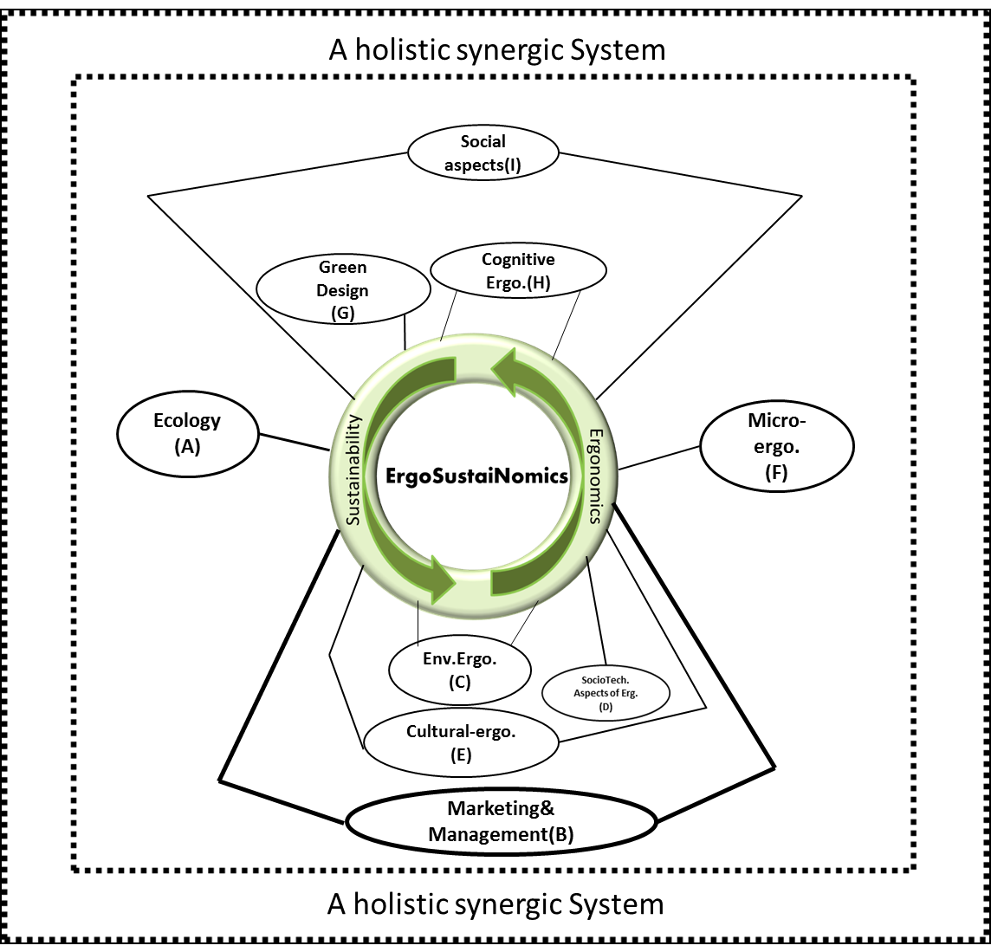

Figure 4. The scope of ErgoSustaiNomics (Authors)
(A): Tosi(2012), Andreonia(2012), Pavlovic-Veselinovic(2014), Parkinson(2013), García-Acosta(2014); (B):Tosi(2012), Pavlovic-Veselinovic(2014), Parkinson(2013), García-Acosta(2014), Zink & Fischer(2013), Haslea & Jensen (2012), Vidala et.al.(2012);(C) Andreonia(2012), Acosta(2014);(D): Zink & Fischer(2013); (E):Tosi(2012); (F): Tosi(2012), Pilczuk & Barefield(2014), Parkinson(2013), Haslea & Jensen (2012), Zink & Fischer(2013); (G): Tosi(2012), Hasle & Jensen (2012), Pavlovic-Veselinovic(2014); (H): Andreonia(2012), Pavlovic-Veselinovic(2014); (I): Andreonia(2012), Pavlovic-Veselinovic(2014), Acosta(2014)

Acknowledgments
Some parts of data gathering of this study was done at Ergonomics Department of KTH university in Stockholm-Sweden, so I thank the colleagues of Ergonomics Department especially Professor Jorgen Eklund for their expertise and assistance throughout all parts of my research. Also a special thanks to Professor Andrew Thatcher for his effective and great comments on my manuscript.

References

Bridger.R., Introduction to Ergonomics, 3rd Edition, CRC Press 2009.

Caiado R et al.,Towards sustainable development through the perspective of eco-efficiency - A systematic literature review, Journal of Cleaner Production,Volume 165, 1 November 2017, Pages 890-904.

Dahl.A.L., Achievements and gaps in indicators for sustainability, Ecological indicators,2012, 17, 14-19.

Dawodu A., Akinwolemiwa B., Cheshmehzangi A., A conceptual re-visualization of the adoption and utilization of the Pillars of Sustainability in the development of Neighbourhood Sustainability Assessment Tools, Sustainable Cities and Society 2017, 28, 398-410.

Dias. Ana Cristina, Almendra Rita., Silva F.,The application of ergonomic knowledge by undergraduate product design students: FAULisbon as a case study, Procedia Manufacturing 2015,3, 5851 – 5858.

Dyllick Thomas, Rost Zoe, Towards true product sustainability, Journal of Cleaner Production 2017, 162, 346-360.

*Gabriel García-Acosta.et.al., Ergoecology: fundamentals of a new multidisciplinary field, Theoretical Issues in Ergonomics Science, 2014,15 (2),111-113.

Genç Ruhet., The Importance of Communication in Sustainability & Sustainable
Strategies, Procedia Manufacturing 8 ( 2017 ) 511 – 516.

*Giuseppe A., et.al. Ergonomics and design for sustainability in healthcare: ambient assisted living and the social-environmental impact of patients lifestyle, Work, 2012,41, 3883-3887.

Haight.G.M.,Human Factors Engineering , 2nd Ed., ASSE Pub 2013.

*Haslea.P., Jensen P.,Ergonomics and sustainability – challenges from global supply chains, Work 2012,41,3906-3913.

Inkeles. G., Schencke.I., Ergonomic Living : How to Create a User-Friendly Home & Office, Fireside Pub 1994.

Jean-Claude Sagot, Vale´rie Gouin, Samuel Gomes (2003), Ergonomics in product design: safety factor, Safety Science 2003,41, 137–154.

Kaklauskas A, et.al., Quality of city life multiple criteria analysis, Cities 2018,72, 82–93, https://doi.org/10.1016/j.cities.2017.08.002

Karwowski W.2005 ”Ergonomics and human factors: the paradigms for
science, engineering, design, technology and management of human-compatible systems.”
Ergonomics 48 (5): 436-463.

Karwowski Waldemar., International Encyclopedia of Ergonomics and Human Factors,2006, 2nd Ed.

Karwowski .W., Symvatology: The science of an artifact-human compatibility, Theoretical Issues in Ergonomics Science, 2000, 1(1), 76-91.

*Klaus J. Z., Fischer.K., Do we need sustainability as a new approach in human factors and ergonomics?, Ergonomics, 2013, 56 (3), 348-356.

Laso. J.et.al.,Introducing life cycle thinking to define best available techniques for products: Application to the anchovy canning industry, Journal of Cleaner Production 2017, 155, 139-150.

Leach Joanne M., Lee Susan E., Hunt D., Rogers C., Improving city-scale measures of livable sustainability: A study of urban measurement and assessment through application to the city of Birmingham- UK, Cities 2017, 71, 80-87,https://doi.org/10.1016/j.cities.2017.06.016.

Lee ACK, Jordan H, and Horsley J. Value of urban green spaces in promoting healthy living and wellbeing: prospects for planning, Risk Manag Healthc Policy. 2015; 8: 131–137.

Lindholm ME, Blinge M., Assessing knowledge and awareness of the sustainable urban freight transport among Swedish local authority policy plannerse, Transport Policy 2014, 32, 124-131
Ljungberg Lennart ,Materials selection and design for development of sustainable products , Materials and Design 2007, 28, 466–479.

*Mario Cesar Vidal et.al., Ergonomic sustainability based on the ergonomic maturity level measurement, Work ,2012,41, 2721-2729.

Martha H. Saravia. M.H.,Pinilla.S., Daza-Beltr.C., Acosta.G., A comprehensive approach to environmental and human factors into product/service design and development. A review from an ergoecological perspective, Applied ergonomic,2016, 57, 62-71.

Moser Gabriel, Quality of life and sustainability: Toward person–environment congruity,Journal of Environmental Psychology 2009, 29, 351–357.

*Nadadur. G. and Parkinson.,The role of anthropometry in designing for Sustainability, Ergonomics, 2013, 56 (3), 422-439.

Nickerson.M. Seeing ourselves in the global picture: Guidepost in the sustainable future, Convergense, 1992, 24/25, 2, 63-69.

Pandit Arka, et al. Infrastructure ecology: an evolving paradigm for sustainable urban development,
Journal of Cleaner Production 2017, 63, Supplement Pages S19-S27.

Partidario. P.J.,Vergragt. Ph.J., Planning of strategic innovation aimed at environmental sustainability: actor-networks, scenario acceptance and backcasting analysis within a polymeric coating chain, Future, 2002, 34, 841–861.

*Pavlovic-Veselinovic, S., Ergonomics as a missing part of sustainability, Journal: Work, 2014, 49(3), 395-399.

*Pilczuk, D., and Barefield.K. Green ergonomics: Combining sustainability and ergonomics, Work. 2014;49(3):357-61. doi: 10.3233/WOR-141869.

Rodríguez-Serrano, Irene et.al., Assessing the three sustainability pillars through the Framework for Integrated Sustainability Assessment (FISA): Case study of a Solar Thermal Electricity project in Mexico, Journal of Cleaner Production 2017, 149, 1127-1143.

Sadeghi Naeini. H., Karuppiah.K., Tamrin.S., Dalal.K., Ergonomics in agriculture: An Approach in Prevention of Work-related Musculoskeletal Disorders (WMSDs), J. of Agriculture and Environmental Sciences, 2014, 3 (2), 33-51.

Sadeghi Naeini. H, Mosaddad.S.H., The Role of Ergonomics Issues in Engineering Education, Procedia - Social and Behavioral Sciences, 2013, 102, 587-590.

Sartori.S., Latrônico da Silva.F., Campos.L., Sustainability and sustainable development: a taxonomy in the field of literature, Ambient. Soc. 2014. 17(1),1-20.

Scott D. Campbell, Sustainable Development and Social Justice: Conflicting Urgencies and the Search for Common Ground in Urban and Regional Planning, Michigan Journal of Sustainability 2013, 1,75-91. DOI: http://dx.doi.org/10.3998/mjs.12333712.0001.007.

Siebert A. et.al., Social life cycle assessment indices and indicators to monitor the social implications of wood-based products, Journal of Cleaner Production 2017, in press ,Available online 9 March 2017.

Thatcher Andrew,Theoretical definition and models of sustainable development that apply to human factors and ergonomics, 11th International Symposium on Human Factors in Organisational Design and Management (ODAM 2014) conference proceedings, Copenhagen, Denmark.

Thatcher, A. , Yeow.P.,Human factors for a sustainable future, Applied Ergonomics 57 (2016),1-7
*Tosi.F., Ergonomics and sustainability in the design of everyday use products, Work,2012,41, 3878-3882.

Turisova, R., J. Sinay 2017 “Ergonomics versus product attractiveness.” Theoretical Issues in Ergonomics Science 18 (1): 1-13.

Turcu, C. 2013 “Re-thinking sustainability indicators: local perspectives of urban sustainability.” Theoretical Issues in Ergonomics Science 56 (5): 695-719.

Tyler N., Safety accessibility and sustainability: The importance of micro-scale outcomes to an equitable design of transport systems, IATSS Research 2017,41, 57-65.

Vlek C, Skolnik M, Gatersleben B., Sustainable development and quality of life: expected effects of prospective changes in economic and environmental conditions, Z Exp Psychol. 1998;45(4):319-33.

World Commission on Environment and Development 1987- Our common future, Oxford Press 1987
Xiaoyu Gan et al., When to use what: Methods for weighting and aggregating sustainability indicators, Ecological Indicators 2017,V.81, 491-502.

www.un.org, Sustainable development goals

