Emotional evaluation of homelike residence halls using self-assessment manikins
Fatemeh Khozaei* (Corresponding author)
Assistant Professor, Department of Architecture, Kerman Branch, Islamic Azad University, Kerman, Iran
Fkhozaei@iauk.ac.ir
Maryam Lesan
Assistant professor, Department of Architecture, Babol Noshirvani University of Technology,
Babol, Iran
Nadia Ayub
Professor, Dept of Business Psychology, College of Economics and social development, Institute of Business Management, Karachi, Pakistan
Qamar Ul Islam
Department of Electrical Engineering, College of Engineering & Technology, School of Engineering & Technology, Baba Ghulam Shah Badshah University - Rajouri (J&K) India. Email ID: qamarulislam@bgsbu.ac.in

Abstract
Students’ residence halls have been studied repeatedly during the last decades from various perspectives (eg satisfaction). However, our knowledge is very limited in terms of students’ emotions towards various residence hall interior and exterior spaces. Besides, very little study exists on the impact of home-like furniture on student’s emotions. The question driving this research is whether the replacement of institutional furniture with home like furniture affects students’ emotional states towards their residence hall? The research follows a mixed, multi-staged methodology. Stage one used structured interviews of students about that might make a residence hall similar to home environments. This second stage evaluates students’ emotions toward their current residence halls (with institutional furniture) and modified images of the same place with homelike furniture. We used SAM to evaluate students’ emotional reactions in terms of valence, arousal, and dominance. The findings of the study suggests that home like residence halls significantly affect students’ positive emotions. The most positive emotions (valence, arousal, and dominance) were reported on kitchenette, corridor, and yard spaces and no significant differences were found on in-room décor.
Keywords: residence hall design, self-assessment manikins, emotions
- Introduction
Meeting the rising standards of the students regarding their personal space is becoming the main concern of university administrators [1]. The increased expectations of residence hall students from their living environments have raised considerations on the similarities between residence halls and houses. As a place that meets physical, social, and psychological needs, home is central to our lives, therefore, it is required that residence halls share at least a number of similarities with the home environment as a place where students spend a huge part of their time. Understanding the importance of this issue even “University dining facilities have begun to emphasize décor, music, and lighting as a selling point to customers” [2]. The residence hall that gives a similar feeling of a home might contain proper facilities, is comfortable, secure, and private. It is also warm and friendly [3]. The concepts of the institutional or home-like environments are taken opposite in the literature, and students prefer the home-like residence halls. Shedding light on the differences between these two according to Robinson, homelike living rooms can accommodate five or fewer people, have various style furniture, look warm and friendly [4]. When these attributes are applied to residence hall spaces, they might create similar feelings. The possibility of personalization of private rooms and providing sufficient privacy, proper coloring, as well as usability of common facilities, is also believed to increase the feeling of home among residence hall students [5]. While previous studies have canonized the similarity of the residence hall and home, it is very little known about how these environments affect the students’ emotions.
Scientific evidence suggests that measuring a person’s emotional state is one of the most vexing problems in affective science [6]. Emotions can be mainly categorized from two viewpoints: discrete and dimensional. The two viewpoints differ in how emotional states are conceptualized and described [6]. According to the perspective of the discrete emotions, each emotion (e.g., anger, sadness, contempt) corresponds to a unique profile in experience, physiology, and behavior [7-8]. In contrast, from the dimensional perspective, there are only a few fundamental dimensions that organize emotional responses[6]. The most commonly assumed dimensions are valence, arousal (sometimes referred to as activation), and approach-avoidance[9-10-11]. The valence dimension is a continuum of states of pleasure (e.g., happy) with states of displeasure (e.g., sad), whereas the arousal dimension is a continuum of states from low arousal (e.g., quiet) to high arousal (e.g., surprised). Approach motivation is characterized by tendencies to approach stimuli (e.g., as would likely be facilitated by excitement), whereas avoidance motivation is characterized by tendencies to avoid stimuli (e.g., as would likely be facilitated by anxiety[6-12]. It is possible to reconcile both perspectives to some extent by proposing that each discrete emotion represents a combination of several dimensions[13-14]. For example, anger could be characterized by negative valence, high arousal, and approach motivation, whereas fear, could be characterized by negative valence, high arousal, and avoidance motivation [6]. The current study aims to examine the residence hall student’s emotions towards the current and modified images of their interior and exterior spaces with the home like furniture. The hypothesis of this research is that the replacement of institutional furniture with home-like furniture can affect students’ emotional status.
- User-oriented spaces
Understanding the effects of space on habitats has been central for creating user-oriented spaces. Bearing in mind the effect of space on people’s emotions, it is proved that people are emotionally engaged with their surroundings [15-16-17], and more specifically with the interior spaces [18]. Besides, People's behavior in different stimuli is influenced by their emotions, and they tend to approach pleasant settings more [19]. User-oriented space design is understood to consider users' emotions as well as the functions of space, producing a multi-sensory space [20].
While there have been several studies concentrating on user-oriented spaces, residence halls have been generally overlooked among various architecture spaces. On the other hand, most studies conducted on residence halls have focused on the post-occupancy evaluation of various architectural spaces, where the students’ emotions and experiences have not been the focus. Emotion has become a crucial influence in the design domain from the 20th century onwards [20]. Accordingly, measuring residence hall students' emotions can be verified and elaborated through empirical studies. One of the cost-effective, simple tools which evaluate emotion is Self-Assessment Manikins (SAM)[21]. SAM is a non-verbal emotion assessment that uses pictures to evaluate three emotional reactions related to an event. The reactions include pleasure, arousal, and dominance. As mentioned previously, this research deals with the measurement of students’ emotions in a students’ residence hall using a Self-Assessment Manikin method.
- Emotion Measurement in Architectural Spaces
Historically, architectural studies have been based on philosophical constructs or the analysis of behavioral patterns to relate human responses to the design under investigation [22]. While such approaches provide descriptive shreds of evidence, they cannot specify the reasons for different behaviors in built environments [18]. The field of neuroarchitecture studies the application of neuroscience in built spaces, aiming to better understand the impact of architecture on the brain and human behavior [23-24]. In recent years, advancements in neuroscientific methods have made it possible to fill the gap between architecture and psychology by explaining the influence of different architectural styles and features on human perception and affective states [25]. Numerous micro-architectural studies have investigated different architectural styles [26], embodiment [27], contours [25], height and enclosure[28], built versus natural environments [29-30], lighting [31], color[32-33-34], architectural forms and their impact on human emotions [18-35], and the impact of the built environment on human memory [36]. However, no approach has systematically described different furniture and how they relate to emotional statuses. There are various ways to measure people’s emotions to different stimuli and situations. Three main components of emotional response are categorized as an experimental response, physiological response, and behavior response[20].
- The Self-Assessment Manikin (SAM)

One of the cost-effective, simple tools which evaluate emotion is Self-Assessment Manikins (SAM) )[21]. The Self-Assessment Manikin (SAM) is a non-verbal visual assessment technique that directly measures the pleasure, arousal, and dominance associated with a person's emotional reaction to a wide variety of stimuli. SAM is an inexpensive, easy method for quickly assessing reports of affective response in many contexts[37]. This tool was developed by Lang [38] based on the Semantic Differential model (Henthfore SDM) which was proposed by Mehrabian and Russell in 1974. The evaluation is intuitive and culture-free [21-37-39]. The pictographic format of SAM makes it accessible for those with low literacy skills, therefore even children could provide ratings using the same instrument as adults. Similarly, ratings from different cultures could be easily compared as knowledge of the English language is not a requirement. SAM was originally a computerized test but later was presented in a paper-and-pencil version. Lang and his associates and Bradley and Lang [37]used the International Affective Picture System (IAPS) and International Affective Digitized Sounds (IADS) as a stimulus to induce emotion. A series of graphical figures are used to elicit a single rating for each of the three dimensions (valence, arousal, and dominance). The valence dimension is a continuum of states from positive to negative, whereas the arousal dimension is a continuum of states from calm to excited. The dominance dimension includes a range of ratings from being controlled (submissiveness) to being in control.

SAMs system has been widely used to investigate human emotional responses to stimuli in different disciplines. To recognize human emotions in natural speech, for example, Grimm and Kroschel [40] assessed the efficiency of self-assessment manikins. The study found that this simple and efficient method is capable of eliciting emotional responses at an utterance-based segmentation level. In another study, Suk and Irtel [41] examined the relationship between color attributes and three dimensions of emotional response: valence, arousal, and dominance. In their study, the participants were asked to show the emotional responses to each color stimulus on the SAM scale. In 2009, Morris and his colleagues [39] examined how three-dimensions of emotional responses (pleasure, arousal, and dominance) induced by television commercial stimuli can cause changes in different regions of the human brain. To measure emotional reactions and predict its related patterns of brain activation, they used Advertisement Self-Assessment Manikins (AdSAM1) and functional magnetic resonance imaging (fMRI). In searching for an effective and feasible method to label emotional changes in speech, Siegert and his colleagues[42] used emotion labels driven from three different methods (Basic Emotions, Geneva Emotion Wheel and Self Assessment Manikins). The findings of their study showed that the first two methods have better coverage of emotional reactions and are usable in serving their purpose. In another study, to understand expressive human communication, Busso and his associates [43] gathered the data on emotional expression and head movements from ten actors in dyadic meetings. Markers were placed on the face, head, and hands of the participants to elicit emotions during scripted and impulsive spoken communication scenarios. Two human evaluators were employed to evaluate the emotional reactions using SAM. Tsonos et al. [44] experimented to investigate the readers’ emotional reactions to font and typesetting features of documents. The data were collected through SAMsystem. The results showed text, background color, and font size can predict readers’ emotional reactions, no matter in what language the text is written. Fernandez and his colleagues [21] investigated the effect of emotion eliciting ﬁlm clips can on physiological responses. The study also used SAM to measure emotional reactions subjectively. The participants recruited for the study watched the ﬁlm clips. The results showed a convergence between subjective and objective measures. Geethanjali and his associates [45] investigated the emotional reactions of Indian nondancers and the classical dancers to see whether they have the same perceptions of emotions. For measuring the perceived emotions, they used the Self-Assessment Manikin Scale (SAM). The study found no variations among the groups in perceiving the pictures in valence space. The variations were mainly reported in arousal and dominance space. Classical dancers perceived emotions in three-dimensional spaces better than non-dancer participants. Stevens et al. [46] investigated the relationship between soundscape categorization (natural, human, and mechanical) and subjective evaluation using the Self-Assessment Manikin (SAM). Recently, SAM has been implemented in several studies in architecture; Banaei et al [18] investigated the effects of different interior architectural forms on emotional states by considering personality traits. To control the number of variables in the experiment, factors, such as color, material, and furniture, which could also be important in designing interior spaces, were not considered in their study.

- Research methodology

5.1. Case study Research
The studied university has 4 number of single-sex residence halls for female students. The layout of each building is different and the size of the room differs from approximately 13 to 24-meter square. All of the rooms are occupied with at least two students and the larger rooms occupy up to 6 students. Public bathrooms and toilets are located on each floor. Figure (1) shows the typical plan of a residence hall room contacting double story bed for better usage of space. Each room has a closet and a hanger and students use the space under the bed as storage for less used items.
  - Participants
The current study applied the mixed-method approach using both qualitative and quantitative methods sequentially. In the qualitative part of the study, 20 students volunteered to participate. The students were asked to discuss the aspects that might make a residence hall similar to the home environment. A series of semi-structured interviews more specifically concentrated on the furniture type and placement in the current residence hall and the more ideal and home-like environment. The selected furniture was located at places such as the Kitchen, Bedroom, TV room, corridor, and the surrounding landscape. These items were further used for examining the students’ emotions using the Self Assessment manikins scale. In the survey and quantitative research part of the study, a total number of 256 students with the mean age of 22.3 years were selected to participate in the study. All of the participants were female students residing in a university dormitory. The university only accommodates female students. The participants were healthy and did not suffer from mental disorders, and had no history of psychotropic treatment or drug use.
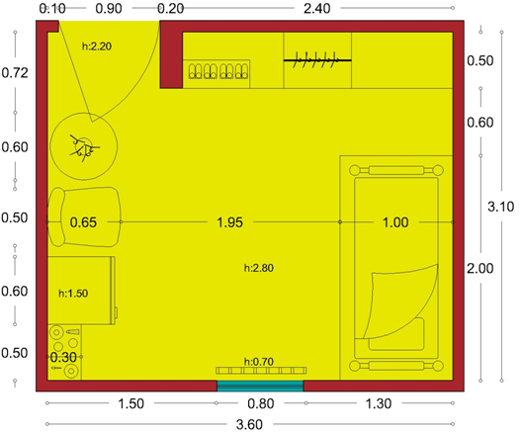 | 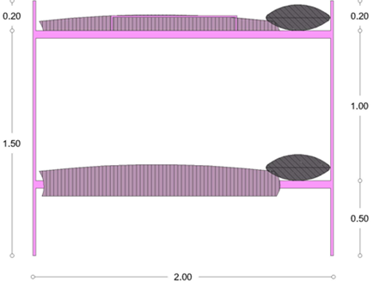
Figure 1: A typical plan of a residence hall room

  - Instrument Subjective measures (SAM Scale)
We used SAMs to evaluate emotional reactions on a five-point scale in terms of valence, arousal, and dominance [10]. There are ﬁve ﬁgures for measuring each dimension. The participants were asked to select the manikin that better describes the stimulus. This instrument has been used to evaluate emotion and showed a high inter-evaluator agreement and good reliability [40] and provided consistent results [39]. Based on SAM ratings of participants, we calculated Cronbach’s to see if our instrument shows a satisfactory level of the internal constituency.

  - Materials
We selected pictures from the International Affective Picture System. A total of ten pictures of five spaces of the kitchenette, study room, corridor, landscape, and bedroom were used in this study, 5 from the current situation of a residence hall with the institutional furniture and five modified pictures with the replacement of homelike furniture (Figures 2 to 11).

  - Data Procedure
Participants were asked to sit at a table. We projected each picture onto a clean white surface by using a slide projector. We instructed our participants about the test and showed them how to report their reactions to each picture in the given booklet. A pre-recorded voice was used for the participants for instruction. We allocated six seconds for presenting each image for the blank screen and 15 seconds for rating.

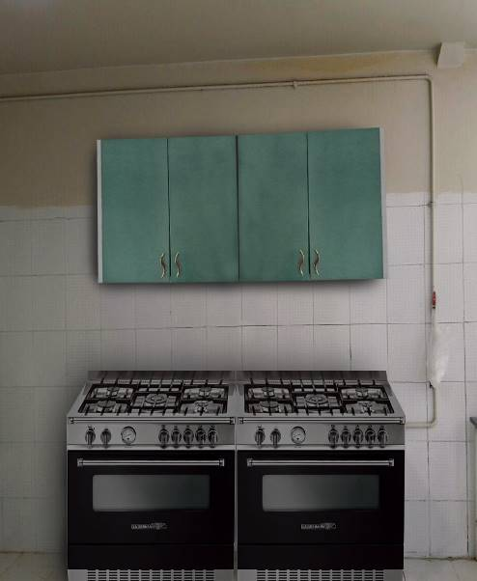
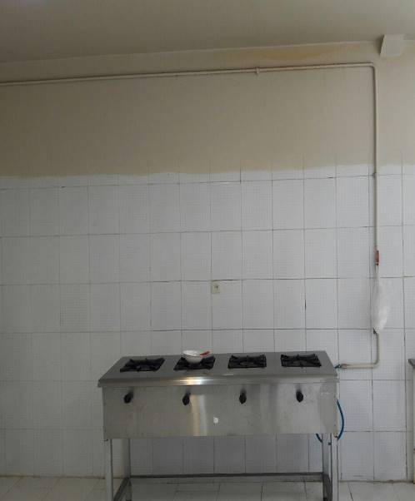
Figure 2: the residence hall current Kitchenet (Left)
Figure3: Homelike gas and stove with cabinet (Right)

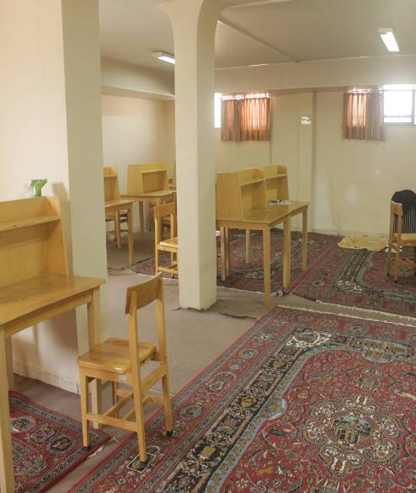
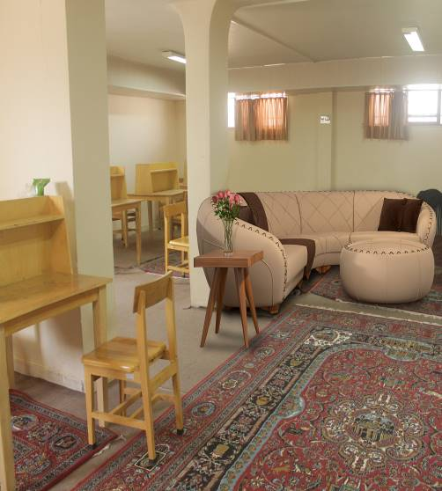
Figure 4: The residence hall current study room (Left)
Figure 5: Study room with home like furniture (Right)

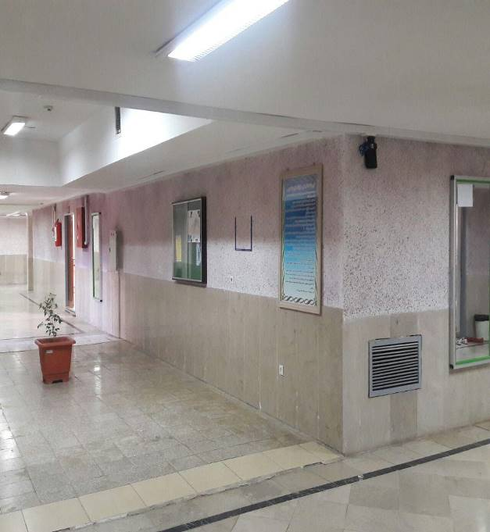
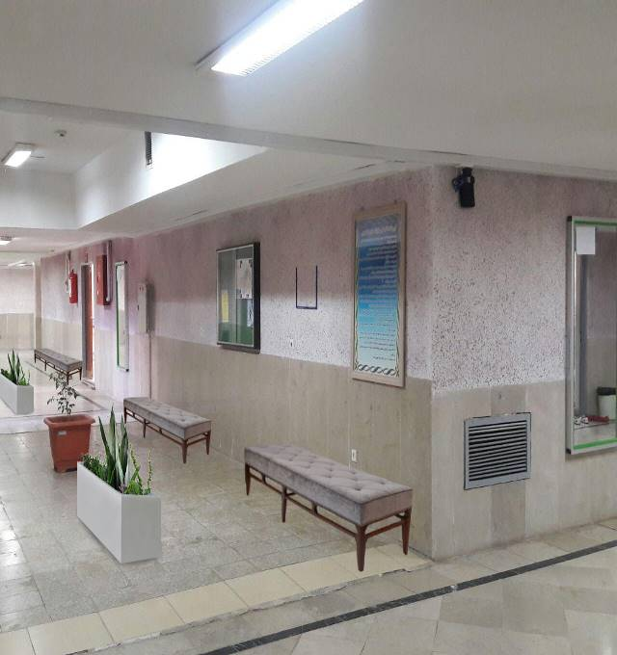
Figure 6: Current residence hall corridors (Left)
Figure 7: Corridor with homelike furniture (Right)

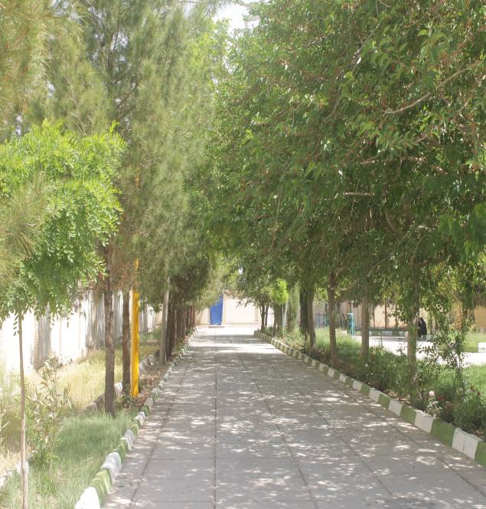

Figure 8: Current surrounding Landscape (Left)
Figure 9: Landscape with home like furniture (Right)

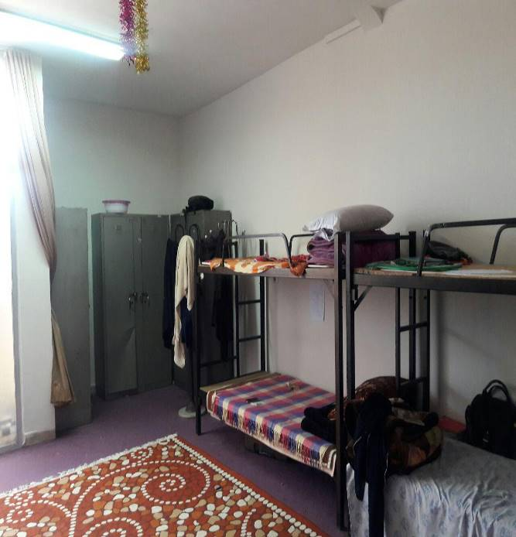
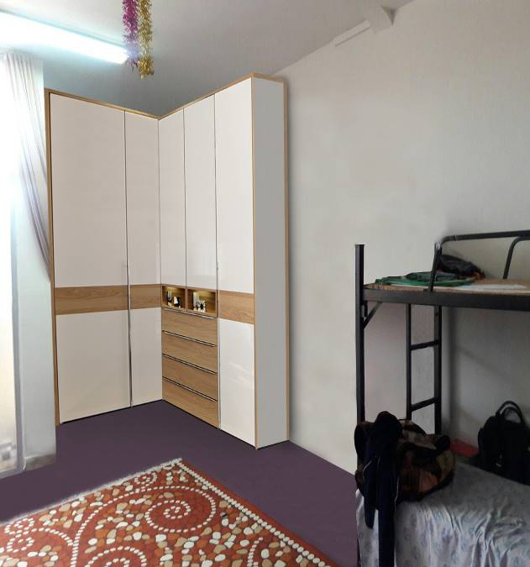
Figure 10: The residence hall room current closet (Left)
Figure 11: The residence hall room with home like closet (Right)

- Results
The first phase of the study involved understanding students’ perception of the home-like environment. Before this, the students were asked how do they use their current living space. It was found that in the room the students mostly spend their time on their bed as their territory. Hence the bed in the residence hall has a concept higher than a place for sleeping. Students used the floor for eating together or group communications. Hence the bed for students could be compared with the student’s private room in the house and the floor and other spaces of the room as a family room. Each student had a specific coping strategy to adjust herself to the residence hall space. The students were asked to describe home with 5 words. The permission was taken that students’ voices to be recorded. The transcripted interviews were codded and later categorized to capture the meaning of home in the students’ perspective. The students described their home Physical and social attributes. As it has shown in table 1 the physical attributes of the house were defined by items such as Size and dimensions, yard, decoration and style, cleanness as well as amenities and facilities.
Table 1 Students’ description of home environments
Physical attributes | Size and dimenstion | Spacious, big rooms, big yard,
Physical attributes | Yard | Gardening in the yard,
Physical attributes | Decoration and style | Presentation of self with decoration, watching TV on the sofa, modern furniture,
Physical attributes | Cleanness | Clean bath room, pleasurable living room,
Physical attributes | Amenity and facilities | Wifi, private bathroom, private laundry, ability to cook, Friedge, cold drinks, loud music
Physical attributes | Personal room | My personal room, the most secure part of the world, the ability to decorate your own room,
Social attributes | security | the most secure part of the world
Social attributes | Freedom | No limitation for the time of sleep, Baking cake, no responsibility for paying bills, the ability to change wall paper, freedom for managing your daily time, control over meeting and contacting people
Social attributes | Family members and support | Mother, warm food, smell of food, eating together,
Social attributes | Memories | Childhood memories
As mentioned earlier the current study attempts to investigate the students’ emotional differences with their current (Stimulus 1) and home-like (Stimulus 2) furniture images in the kitchenette, study room, corridor, landscape as well as the bedroom. For each photo, the valence, arousal, and dominance were examined. A series of Multivariate Analysis of Variance (MANOVA) was conducted to compare the students’ state of emotion between the current and modified images of the residence hall. A MANOVA identifies significant differences between groups of means rather than individual means. Conducting a MANOVA also reduced the chance of a Type I error. Table 2 shows the difference between the emotional states of respondents for the kitchenette. It was found that the students’ valence, arousal, and dominance were significantly higher for a home-like kitchenette in comparison to an institutional one. Homelike study room furniture increased the students’ arousal but no significant differences were found in terms of students’ valence or dominance (See table 3). Significant differences were found in the valence and arousal of home-like corridors but no significant differences were found in the dominance level of institutional versus homelike corridors (Table 4). Similarly, a significant difference was found between home like yard and institutional in term of valence and arousal but not in dominance (Table 5). No significant differences were found between the students’ home-like and institutional room closet.

Table 2
Univariate effect for Kitchen (Valence, Arousal, & Dominance)
Dependent Variable | Stimulus | Means | 99.9% Confidence Interval |  | df | F | Sig.
Dependent Variable | Stimulus | Means | Lower Bound | Upper Bound | df | F | Sig.
kitchenette Valence | Stimulus 1 | 1.824 | 1.676 | 1.973 | 1, 294 | 20.925 | .000
kitchenette Valence | Stimulus 2 | 3.932 | 3.784 | 4.081 | 1, 294 | 20.925 | .000
Kitchenette  Arousal | Stimulus 1 | 2.358 | 2.196 | 2.521 | 1, 294 | 8.611 | .004
Kitchenette  Arousal | Stimulus 2 | 2.622 | 2.459 | 2.784 | 1, 294 | 8.611 | .004
kitchenette Dominance | Stimulus 1 | 2.412 | 2.261 | 2.563 | 1, 294 | 37.543 | .000
kitchenette Dominance | Stimulus 2 | 2.655 | 2.505 | 2.806 | 1, 294 | 37.543 | .000

Table 3
Univariate effect for Institutional Study Room (Valence, Arousal, & Dominance)
Dependent Variable | Stimulus | Means | 99.9% Confidence Interval |  | df | F | Sig.
Dependent Variable | Stimulus | Means | Lower Bound | Upper Bound | df | F | Sig.
Study Room  Valence | Stimulus 1 | 1.959 | 1.812 | 2.107 | 1, 294 | .767 | .382
Study Room  Valence | Stimulus 2 | 2.176 | 2.028 | 2.323 | 1, 294 | .767 | .382
Study Room Arousal | Stimulus 1 | 2.831 | 2.660 | 3.003 | 1, 294 | 16.662 | .000
Study Room Arousal | Stimulus 2 | 2.655 | 2.484 | 2.827 | 1, 294 | 16.662 | .000
Study Room Dominance | Stimulus 1 | 2.108 | 1.939 | 2.277 | 1, 294 | .399 | .528
Study Room Dominance | Stimulus 2 | 2.405 | 2.237 | 2.574 | 1, 294 | .399 | .528

Table 4
Univariate effect for Corridor (Valence, Arousal, & Dominance)
Dependent Variable | Stimulus | Means | 99.9% Confidence Interval |  | df | F | Sig.
Dependent Variable | Stimulus | Means | Lower Bound | Upper Bound | df | F | Sig.
Corridor  Valence | Stimulus 1 | 1.777 | 1.631 | 1.923 | 1, 294 | 18.614 | .000
Corridor  Valence | Stimulus 2 | 3.784 | 3.638 | 3.930 | 1, 294 | 18.614 | .000
Corridor  Arousal | Stimulus 1 | 1.912 | 1.772 | 2.053 | 1, 294 | 9.734 | .002
Corridor  Arousal | Stimulus 2 | 3.858 | 3.718 | 3.999 | 1, 294 | 9.734 | .002
Corridor  Dominance | Stimulus 1 | 1.939 | 1.811 | 2.067 | 1, 294 | .134 | .715

Table 5
Univariate effect for Yard (Valence, Arousal, & Dominance)
Dependent Variable | Stimulus | Means | 99.9% Confidence Interval |  | df | F | Sig.
Dependent Variable | Stimulus | Means | Lower Bound | Upper Bound | df | F | Sig.
Landscape  Valence | Stimulus 1 | 1.777 | 1.631 | 1.923 | 1, 294 | 18.614 | .000
Landscape  Valence | Stimulus 2 | 3.784 | 3.638 | 3.930 | 1, 294 | 18.614 | .000
Landscape  Arousal | Stimulus 1 | 1.912 | 1.772 | 2.053 | 1, 294 | 9.734 | .002
Landscape  Arousal | Stimulus 2 | 3.858 | 3.718 | 3.999 | 1, 294 | 9.734 | .002
Landscape  Dominance | Stimulus 1 | 1.939 | 1.811 | 2.067 | 1, 294 | .134 | .715
Landscape  Dominance | Stimulus 2 | 4.223 | 4.095 | 4.351 | 1, 294 | .134 | .715

Table 6
Univariate effect for Room (Valence, Arousal, & Dominance)
Dependent Variable | Stimulus | Means | 99.9% Confidence Interval |  | df | F | Sig.
Dependent Variable | Stimulus | Means | Lower Bound | Upper Bound | df | F | Sig.
Room  Valence | Stimulus 1 | 2.054 | 1.906 | 2.202 | 1, 294 | .004 | .948
Room  Valence | Stimulus 2 | 3.831 | 3.683 | 3.979 | 1, 294 | .004 | .948
Room  Arousal | Stimulus 1 | 1.865 | 1.733 | 1.996 | 1, 294 | .367 | .545
Room  Arousal | Stimulus 2 | 4.081 | 3.950 | 4.213 | 1, 294 | .367 | .545
Room Dominance | Stimulus 1 | 1.939 | 1.801 | 2.077 | 1, 294 | .064 | .801
Room Dominance | Stimulus 2 | 3.966 | 3.828 | 4.104 | 1, 294 | .064 | .801

- Discussion
The current study aimed to examine the residence hall student’s emotions towards the current and modified images of their interior and exterior spaces with the home-like furniture. The hypothesis of this research was that the replacement of institutional furniture with home-like furniture can affect students’ emotional status. The students’ emotional state towards their current residence hall furniture and more home-like furniture in their bedroom, kitchenette, study room, corridor as well as surrounding landscape were examined. Adding a dish cabinet and replacing the gas with a more home-like one significantly increased the students’ arousal, valence, and dominance. It might be due to the fact that residence hall students spend significant time in the kitchenette where they meet their friends as well. The result of this study also revealed that Home-like study room furniture increased the students’ arousal but no significant differences were found in terms of students’ valence or dominance. It might be due to the fact that home-like furniture in the study room was considered exciting for students but it didn’t affect their positive emotion. Again as studying in a private room or cabin might be more appealing for the students than public study rooms the students’ dominance didn’t increase. Significant differences were found in the valence and arousal of home-like corridors but no significant differences were found in the students’ dominance level. Similarly, a significant difference was found between home like yard and institutional in terms of valence and arousal but not in term of dominance. It might be due to the fact that minor changes in term of room interior design and applying home like furniture is not enough to increase the students’ valence and dominance. The students’ expectations of a home-like bedroom might be beyond furniture and could be sought in achieving privacy and personal space. The result of this study confirms previous research that even small changes in the context of residence hall can have a great effect on the students [47]. Despite students' differences and preferences [48], the residence hall students share a lot in common. Accordingly, the response of the majority of students’ to the homelike environments was positive. In addition, the result of the study is in line with studies that confirm the effect of the physical setting of the residence hall in the psychological state of students [49]. The study sheds light on the fact that even changing the institutional furniture and not a vast renovation can have a huge impact on the students’ arousal, valence, and dominance.
- Conclusion
The current study examined the impact of a homelike residence hall on students’ emotions. The result of this study sheds light on the fact that homelike features of residence hall affect students’ emotions positively. The concept of the house is a multi-facet issue that is not limited to physical decorations and attributes, rather, it involves other social aspects. This might make the concept of a homelike environment difficult to perceive. The study attempts to cluster the physical attributes in order to capture a tangible meaning of the home environment. The result of unstructured interviews of the study also identifies that the concept of the home might have various meanings for different people. For making the evaluation accurate and valid the current study has concentrated on the home like furniture that is opposite to institutional residence halls. The result of the study is interesting and important in this case that even small changes can have big effects. The research has some limitations that further studies might address. The examination of the impact of architecture features on emotion is complicated using two-dimensional images in which the participants can not perceive in the real world. Accordingly, in comparison to using VR (virtual reality) or AR (augmented reality), the result of studies that concentrate on two-dimensional images might be less accurate but it has been widely used as a reliable method worldwide.
- References
[1] Devlin, A. S., Donovan, S., Nicolov, A., Nold, O., & Zandan, G. (2008). Residence Hall Architecture and Sense of Community Everything Old Is New Again. Environment and Behavior, 40(4), 487-521.
[2] Ng, Y. N. (2005). A study of customer satisfaction, return intention and word-of-mouth endorsement in university dining facilities Oklahoma State University.
[3] Khozaei, F., Amole, D., Hassan, A. S., & Khozaei, Z. (2010). Female Graduate Students’ Perception of the Relationships between the Residence Hall and the Home. Asian Social Science, 6(10), 68-76.
[4] Robinson, J. W. (2004). The architecture of Institution & Home: Architecture as Cultural Medium. The unpublished doctoral thesis Delft University of Technology.
[5] Thomsen, J. (2007). Home Experiences in Student Housing: About Temporary Homes and Institutional Character. Journal of Youth Studies, 10(5), 577-596.
[6] Mauss, I. B., & Robinson, M. D. (2009). Measures of emotion: A review. Cognition and Emotion, 23(2), 209-237. doi:10.1080/02699930802204677
[7] Ekman, P. (1999). Basic emotions. In T. Dalgleish & M. Power (Eds.), Handbook of cognition and emotion. New York: Wiley.
[8] Panksepp, J. (2007). Neurologizing the psychology of affects: How appraisal-based constructivism and basic emotion theory can coexist. Perspectives on Psychological Science, 2(3), 281-295.
[9] Davidson, R. (1999). Neuropsychological perspectives on affective styles and their cognitive consequences. In T. Dalgleish & M. Power (Eds.), Handbook of cognition and emotion. New York: Wiley.
[10] Lang PJ, Bradley MM, Cuthbert BN. (1999) International affective picture system (IAPS): Instruction manual and affective ratings. The center for research in psychophysiology, University of Florida.
[11] Russell, J., & Barrett, L. (1999). Core affect, prototypical emotional episodes, and other things called emotion: Dissecting the elephant. Journal of Personality and Social Psychology, 76(5), 805-819.
[12] Wong, M. (2006). Emotion Assessment in Evaluation of Affective Interfaces. (Masters). University of Waterloo, Ontario, Canada.
[13] Haidt, J., & Keltner, D. (1999). Culture and facial expression: Open-ended methods find more expressions and a gradient of recognition. Cognition and Emotion, 13(3), 225-266.
[14] Smith, C., & Ellsworth, P. (1985). Patterns of cognitive appraisal in emotion. Journal of Personality and Social Psychology, 48(4), 813-838.
[15] Gifford, R. (2007). Environmental Psychology: Principles and Practice (third ed.). WA: Optimal books Colville.
[16] Manzo, L. C. (2003). Beyond house and haven: toward a revisioning of emotional relationships with places. Journal of Environmental Psychology, 23, 47-61.
[17] Reddy, S. M., Chakrabarti, D., & Karmakar, S. (2012). Emotion and interior space design: an ergonomic perspective. Work, 41, 1072-1078.
[18] Banaei, M., Ahmadi, A., Gramann, K., & Hatami, J. (2019). Emotional evaluation of architectural interior forms based on personality differences using virtual reality. Frontiers of Architectural Research, 9(1), 138-147. doi:10.1016/j.foar.2019.07.005
[19] Russell, J. A., & Mehrabian, A. (1978). Approach-Avoidance and Affiliation as Functions of the Emotion-Eliciting Quality of an Environment. Environment and Behavior, 10(3), 355–387.
[20] Cho, M. E., & Kim, M. J. (2017). Measurement of User Emotion and Experience in Interaction with Space. Journal of Asian Architecture and Building Engineering, 16(1).
[21] Fernandez, C., Pascual, J. C., Soler, J., Elices, M., Portella, M. J., & Fernandez-Abascal, E. (2012). Physiological responses induced by emotion-eliciting films. Applied Psychophysiology Biofeedback, 37, 2, 73-79.
[22] Edelstein, E. A., & Macagno, E. (2012). Form follows function: bridging neuroscience and architecture. In S. T. Rassia & P. M. Pardalos (Eds.), Sustainable Environmental Design in Architecture: Impacts on Health (pp. 27-42). New York: Springer.
[23] Edelstein, E. A. (2008). Building health. HERD, 1, 54-59. doi: 10.1177/193758670800100208
[24] Nanda, U., Pati, D., Ghamari, H., & Bajema, R. (2013). Lessons from neuroscience: form follows function, emotions follow form. Intelligent Buildings International, 5, 61–78. doi: 10.1080/17508975.2013.807767
[25] Vartanian, O., Navarrete, G., Chatterjee, A., Fich, L. B., Leder, H., Modroño, C., . . . Skov, M. (2013). Impact of contour on aesthetic judgments and approach-avoidance decisions in architecture. Proceedings of the National Academy of Sciences, 10446–10453. doi:10.1073/pnas.1301227110
[26] Choo, H., Nasar, J. L., Nikrahei, B., & Walther, D. B. (2017). Neural codes of seeing architectural styles. Scientific Reports, 7(40201). doi:10.1038/srep40201
[27] Vecchiato, G., Tieri, G., De Matteis, F., Maglione, A. G., & Babiloni, F. (2015). Electroencephalographic correlates of sensorimotor integration and embodiment during the appreciation of the virtual architectural environment. Frontiers in Psychology, 6. doi:10.3389/fpsyg.2015.01944
[28] Vartanian, O., Navarrete, G., Chatterjee, A., Borson Fich, L., Gonzalez-Mora, L., Leder, H., . . . Skov, M. (2015). Architectural design and the brain: Effects of ceiling height and perceived enclosure on beauty judgments and approach-avoidance decisions. Journal of Environmental Psychology, 41, 10-18. doi:10.1016/j.jenvp.2014.11.006
[29] Roe, J. J., Aspinall, P. A., Mavros, P., & Coyne, R. (2013). Engaging the brain: the impact of natural versus urban scenes using novel EEG methods in an experimental setting. Journal OF Environmental Science, 1, 93-104. doi:10.12988/es.2013.3109
[30] Banaei, M., Yazdanfar, A., Nooreddin, M., & Yoonessi, A. (2015). Enhancing urban trails design quality by using electroencephalography Device. Procedia, Social Behavior Science, 201, 386-396. doi: 10.1016/j.sbspro.2015.08.191
[31] Shin, Y., Woo, S. H., Kim, D. H., Kim, J., Kim, J. J., & Park, J. Y. (2015). The effect on emotions and brain activity by the direct/indirect lighting in the residential environment. Neuroscience Letters, 584, 28-32. doi:https://doi.org/10.1016/j.neulet.2014.09.046
[32] Kuller, R., Mikellides, B., & Janssens, J. (2009). Color, arousal, and performance—A comparison of three experiments. Color Research and Application, 34, 141-152. doi: 10.1002/col.20476
[33] Valdez, P., & Mehrabian, A. (1994). Effects of color on emotions. Journal of experimental psychology: General, 123(4).
[34] Wilms, L., & Oberfeld, D. (2017). Color and emotion: the effects of hue, saturation, and brightness. Psychological Research, 82(2). doi:10.1007/s00426-017-0880-8
[35] Dazkir, S. S., & Read, M. A. (2011). Furniture Forms and Their Influence on Our Emotional Responses Toward Interior Environments Environment and Behavior, 44(5), 722-734. doi:10.1177/0013916511402063
[36] Sternberg, E. M. (2010). Healing Spaces: The Science of Place and Well-being. Cambridge, MA: Harvard University Press.
[37] Bradley MM, Lang PJ. (1994). Measuring emotion: the self assessment manikin and the semantic differential. J Behavior Therapy Exp Psychiatry 1994; 25: 49-59. 5.
[38] Hodes, R.L., Cook, E.W., III and Lang, P.J. (1985), Individual Differences in Autonomic Response: Conditioned Association or Conditioned Fear?. Psychophysiology, 22: 545-560. doi:10.1111/j.1469-8986.1985.tb01649.x
[39] Moris, J. D., Klahr, N. J., Shen, F., Villegas, J., Wright, P., He, G., & Liu, Y. (2009). Mapping a multidimensional emotion in response to television commercials. Human Brain Mapping, 30, 3, 789-796.
[40] Grimm, M. & Kroschel, K. (2005) “Evaluation of natural emotions using self-assessment manikins,” in IEEE Automatic Speech Recognition and Understanding Workshop (ASRU05), San Juan, Puerto Rico, pp. 381–385
[41] Suk, H.‐J. and Irtel, H. (2010), Emotional response to color across media. Color Res. Appl., 35: 64-77. doi:10.1002/col.20554
[42] Siegert, I., Bock, R., Vlasenko, B., Philippou-Hubner, D., Wendemuth, A., & 2011 12th IEEE International Conference on Multimedia and Expo, ICME 2011. (November 07, 2011). Appropriate emotional labeling of non-acted speech using basic emotions, geneva emotion wheel, and self-assessment manikins. Proceedings - Ieee International Conference on Multimedia and Expo.
[43] Busso, C., Bulut, M., Lee, C.-C., Kazemzadeh, A., Mover Provost, E., Kim, S. k., . . . Narayanan, S. (2008). IEMOCAP: Interactive emotional dyadic motion capture database. Language Resources and Evaluation, 42(4), 335-359.
[44] Tsonos, D., Ikospentaki, K. and Kouroupetrolgou, G. (2008). “Towards modeling of readers' emotional state response for the automated annotation of documents,” in Proceedings of the IEEE World Congress on Computational Intelligence (WCCI '08), pp. 3253–3260, Hong Kong.
[45] Geethanjali, B., Adalarasu, K., Hemapraba, A., Pravin Kumar, S., & Rajasekeran, R. (2017). Emotion analysis using SAM (Self-Assessment Manikin) scale. Biomedical Research, 18-24.

[46] Stevens, F., Murphy, D. , Smith S.L. (2017). Soundscape categorisation and the self-assessment manikin. Proceedings of the 20th International Conference on Digital Audio Effects

[47] Zabihi, A. and F. Khozaei (2017). "Little changes make big differences: the effect of greenery on dormitory students’ satisfaction." Building and Management 1(3): 49-55.

[48] Khozaei, F., et al. (2014). "Examination of student housing preferences, their similarities and differences." Facilities 32(11/12): 709-722.

[49] Khozaei, F., et al. (2012). "Sense of attachment to place and fulfilled preferences, the mediating role of housing satisfaction." Property Management 30(3): 292-310.

