Explanation of Everyday Life in Resolving Current Architectural, Urban Complexities and Urban Transformation; The Transformation of Valiasr Intersection, Tehran, Iran

∗P.Hashempour , M. Kaynejad , M. Mirgholami , S. Khani

Abstract
Nowadays, urbanization is growing increasingly and cities are going to be more complicated than ever including local-global duality. On one hand, Cities are not limited to their geographical boundaries. Neoliberal globalization, which has been rapidly expanding since the late 1980s in the economic circle, places the world into a money game and cities into competition with each other. On the other hand, there are some influential forces on a local scale that determine the urban evolutions. Regarding these two global-local factors, non-powerful groups are neglected increasingly from urban transformation and main projects. This article reviews the “everyday life” concept in spaces through Lefebvre’s writings and draws its dimensions and criteria through descriptive- analytical study. How could everyday life be explained in the current architectural and urban transformation? Surely, Urban evolutions could affect everyday life. After that, it reviews the transformation of Valiasr intersection through historical- interpretation study. Valiasr intersection is the most important intersection in Tehran. It is considered as the spatial gap of Tehran, separating the “high status” and the “low status. Recently, an underpass project for pedestrians was built in this intersection. The results show that this urban transformation is mainly defined by administrational- status forces in the absence of social ones which mainly consider the economic- ideological aspects. It reduces social inclusion and social participation. Following that, this important project could not improve the everyday life of Tehran.

Keywords: Everyday life, urban complexities, Valiasr intersection, urban transformation.
Methodology

Regarding the transformation of this urban space, this article investigates the influence of this project on the everyday life of Tehran. In this line, it reviews the driving forces on urban evolutions through content analysis. It also investigates the influential forces through library study affecting Valiasr intersection during its transformation. In this regard, it studies historical maps. Urban projects nowadays neglect the rights of the citizens. This article introduces everyday life as the criteria for evaluating urban projects among urban globalization and localization.

Introduction

Cities are considered to be complex beings and, no matter what the reasons for their formation are, they do not maintain their initial form due to being dynamic in nature. City changes are influenced by a variety of forces that originate from the nature of cities. The important event which happened during the past few decades is that cities have entered global equations and are no longer confined within geographical boundaries. Nowadays, the economic crisis in New York can cause city riots in the Middle East and city development in china helps keep up the workforce in Brazil. Cities, as economical bases, are making efforts to attract investments from all over the world. This competition has moved cities toward tourism in order to help attract more investments. This trend has made city development an exogenous issue and has caused them to be unaware of dependence upon local social production. Moreover, local forces are trying to claim local development and turn cities into storage space for their investments using their influence and wealth. In both cases, the result is a city that reflects the interests of only a small group of people. Social segregation, social gap, the increase in the center-periphery distance, general discontent, and even city revolutions are the results of these two dominant city development trends.

Research Methodology

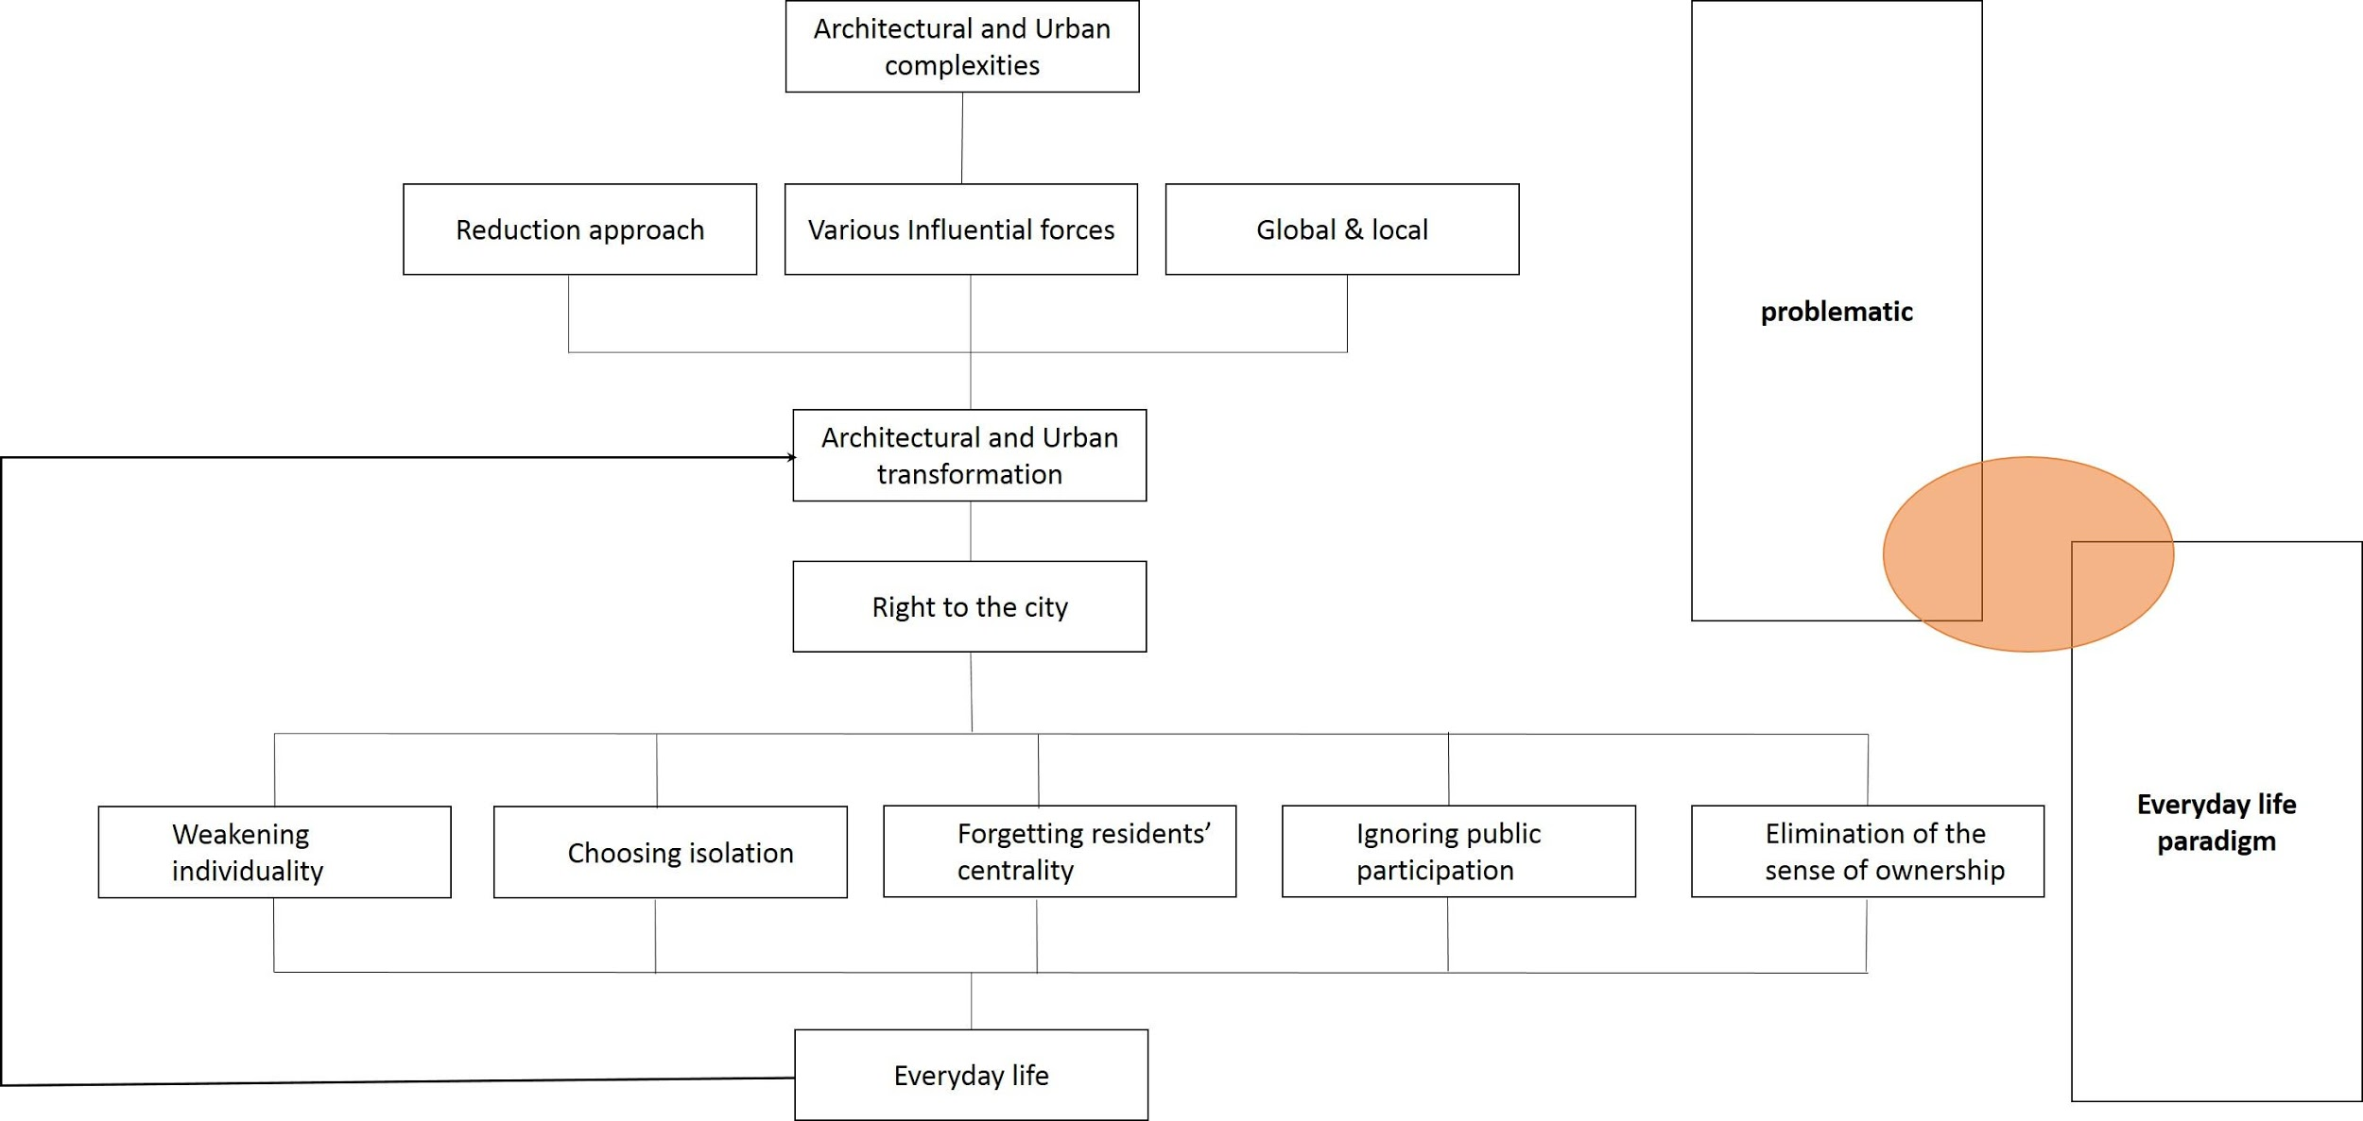
This article reviews the complexity of nowadays cities through descriptive-analytical study. Urbanization is a fast and widespread movement. In this line, many paradigms are going to shift and urban boundaries are not limited to its geographic specifics anymore. Cities even play an international role in the global period. In this regard, this article reviews the nowadays paradoxes of cities through library studies. Many researchers talk about global-local duality and some others try to connect these two and talk about global. The hypothesis of this article is that urban evolutions finally affect the everyday life of citizens. Then, urban projects should be evaluated by their influence on everyday life. Through descriptive-analytical study, Lefebvre’s notions about everyday life would be investigated. The parameters of everyday life will be introduced (figure 1). After that, this article tries to review the transformations of the Valiasr intersection through historical study and by reviewing historical maps and data. It also reviews the underpass project of this intersection that has been built recently. Finally, the influence of this project on everyday life will be discussed.

Fig 1. methodology and conceptual model of research; (Source: authors)

The complexity of nowadays cities

Localism
Urban fabric has always been influenced by various forces and components. Cities have been shaped differently according to their citizens’ needs. Madanipour emphasizes the human reason in shaping cities. “Reason is the human faculty that, through intuition and calculation, makes judgments about, and provides accounts for, what to believe and how to act” [27]. There are various theories considering factors that shape cities [4- 9 -7- 19- 21-26- 31- 32- 22]. Schmid and his colleagues count three main forces that create specificity for each city: territory, power, and difference. Territory refers to the geographical characters while power considers the urban plans and decision-maker and authority decisions. The difference also refers to the specific character each urban space has [3]. Someone believes in conflicts and challenges among different types of local state actors, officials, or non-profit organizations at different scales [34].
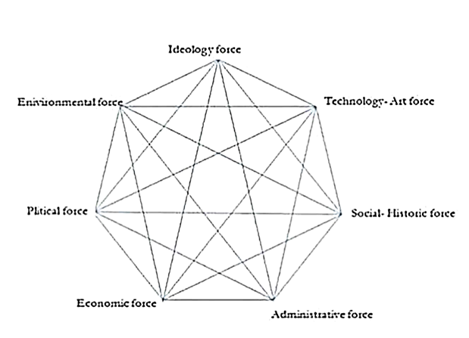
Soltani and Namdarian introduce various forces affecting the evolutions of a city. Forces such as natural forces like water, land topography and wind, construction technology or economical forces and capital flows, political forces and power flows, and social forces or civic institutions (as shown in figure 2)[35]. Kostof considers a lack of equilibrium between these forces in the city as the origin of a great number of urban problems and, therefore, the reason why urban space is influenced by them[21].
Fig 2. The forces influencing urban changes; (Source: [35])
Table 1. Forces and their impact on cities; (Source: [35])
Influential forces on urban evolutions | description | How the forces affect cities
Zeitgeist | The product of inhabitant’s experiences, regarding climate situation and social values | Emergence of organic zone  Harmony of texture and values and natural characters
Administrational force | Having plans and design, imposed from top to bottom | Master and detailed plans, grid network, building certificate from municipality or the other administrational organs,
Economic Force | Attention to relative advantages of places, irreverence to master plan propositions | Inharmonic and chaos in built environment, skyline disorder, disparate townscape, sprawl of main elements and the effect of capital on urban development
Political force | Based on power of central government, symbol of glory of government | Emergence of dual texture
Social Force | Attention to social values and long-term expedients of society | Organizing social society and creating social formation, improving social associations, creating sense of belonging.

What has happened in the cities of these days and age is that the evolution of development is dominated by the state-capital. This hidden settlement has driven other forces out of the stage of urban spaces. In other words, when the word ‘local’ is discussed, it is practically diminished down to the state-capital settlement. “In modern industrial societies, every day is clearly molded in fundamental ways by economic-technological imperatives that colonize space and time”.

city globalism
An important change has been happening since 1970. A change which, according to [6] and [14], has been a change towards deindustrialization and de-development and has caused industrial production to move beyond borders. Due to this, production has shifted towards financial intervention. Naturally, cities have been the base for all these changes, and what Chomsky calls ‘vicious cycle’ has corrupted urban cores.
In the process of commodification, cities have been degraded down to brands and, in other words, ‘exchange value’ has replaced ‘use-value’. In order to attract tourists and investors, cities have become delusive phenomena. Knox believes that, in this period, globalization has caused cities to be dependent on each other more than ever [20]. The levels of globalization have increased among urban populations…along with structural economic changes, globalization has also increased the competition among cities for the purpose of fundraising. As a result, the design has turned out to be an important element in the competition between cities in the post-industrial economy era. Gospodini also believes that nowadays urban space quality has turned out to be a pre-requisite of the economic development of cities and urban design has accepted a new role as a tool for economic development while, for several centuries, urban environment quality was a result of the economic development of cities [8].
Therefore, the economy keeps intertwining cities with global issues day by day and, in this respect, a competition for fundraising among cities has come about which can threaten the ‘local dimension’ and identity of cities. Multinational corporations, insurance companies, large-scale offices, etc. are land uses that function on a level far beyond their city and sphere of influence. These structures, due to their nature, possess a style that influences audiences and attracts investors and tourists. Schmid criticizes the notions regarding globalization as a homogenization process. In his point of view “The process of globalization is marked by contradictory processes of homogenization and differentiation leads to specifically individual urban situation and configuration” [33]. Another feature of this kind of architecture is that it is built using pioneering technology and is often in contrast and even clashe with its background in order to attract more attention. Such structures deteriorate the skyline and change the urban sky together and the urban land into the goods of their trade. Additionally, such land is used to try to control spaces and make them exclusive [29-30-5-9). In fact, urban globalization affects and even scares all aspects of our life. Recent delocalization of life has unfortunately implied a sort of indolence to renew territorial theories. Indolence is well represented by the fact that what has animated the city of the last twenty years can be summed up in the FIRE acronym, which is, Finance, Insurance, Real ‘State and Enterprise” [1]. As a result, a ‘mirage city’ is formed. ‘Mirage city’ stands for the dominance of a powerful minority over urban spaces and marginalizing the majority which lacks the influence and wealth to affect urban changes.

Everyday life

In his book, Urban Revolution, Lefebvre argues that one of the most important reasons for city life disturbance is the astonishing inaction by people and lack of intervention by those who are influenced by urban projects [25]. He asks questions like “why this silence?” and “what is it that lies behind this wrong strategy?[25]. Lefebvre believes that ‘cities have been attacked by industrialization” [24] which has led to people being uprooted, diminished residential areas, the existence of ghettos for those deprived of economic and social advantages, unsystematized people, torn apart societies, space fragility, and trafficking, and exploitation of finances.

This ambiguity generates conflicts that configure everyday life as a contradictory relationship between productive activity and passive consumption, between everydayness and creativity. For Lefebvre, therefore, the analysis of the extant must always take into consideration insurgent forces and the question of liberation. Insofar as the critique of everyday life shows how people live, it articulates at the same time an indictment against the strategies from which the everyday emerges and reveals the arbitrariness of the dominant order Lajevardi investigates Lefebvre’s ideas and points that he considers the features of everyday life in the modern age to be consumerism and alienation [23]. He considers this society in its entirety a terrorist society because it uses a variety of advertising tools and penetrates every aspect of everyday life suppressing all human potentiality from within. Lefebvre assumes a utopian view and believes that only after recognizing their potentials through everyday life and realizing the promotional terror in a consumerism culture can one actively embark upon liberating actions and de-alienate an alienated society. Lefebvre considers everyday life as the main domain for meaning production and, at the same time, as a place within which lies the potential to change the world.

Lefebvre believes that 'alienation' is not limited to the economic sphere as some might understand from Marx's writings. 'Alienation' - I know it is there in the love song I sing or the poem I recite, in the banknote I handle or the shop I enter, in the poster I glance at, or in the lines of this journal. At the very moment, the human is defined as 'having possessions' I know it is there, dispossessing the human. The capitalist mode of production established itself in industry, and integrated industry. Then, 'its integrated agriculture, it integrated the historical city, it integrated space, and it produced what I call la vie quotidienne [23].

Everyday life refers to the issues treated trivial as Lefebvre [24] points out that an initial definition would be to suggest that everyday life is everything left once work is removed: everyday life is sustenance, clothing, furnishing, homes, lodging, neighborhoods, and environment. Lefebvre [24] also demonstrate everyday life and concerns three definition to it

1)the gap between this level and levels above it (those of the State, technology, high culture);2)The intersection between the non-dominated sector of reality and the dominated sector; 3)transformation of objects into appropriated goods.

Ronneberger believes that according to Lefebvre, the reproduction of modern everydayness occurs through a threefold movement. First, socialization is accomplished through a “totalization of society.” Second, this process is accompanied by an “extreme individualization” which eventually leads to a “particularization.” Third, capitalist societies atomize people into isolated consumers. The “bureaucratic society of controlled consumption” is grounded upon the parcelization of social praxis and the shredding of social contexts. Lefebvre also asked about the shared features of three realms that have been separated from each other; work, private life, and leisure. He finally concluded that « everywhere one finds passivity, non-participation» [33].

In this line, everyday life makes a relationship with the “right to the city” issue which is also coined by Lefebvre and debated by many scholars (14- 15- 1- 17). Actually, everyday life in its ideal condition guarantees the right to the city which could be classified to some concrete rights as Jabareen identifies these rights: The right of appropriation, The right of participation, The right to centrality. The right to inhabit: or the right to urban citizenship, The right to habitat, The right to individualization in socialization.

Discussion

Historical transformation

This article reviews the Tehran transformations with regard to historical maps and indicates the Valiasr intersection in them. The maps will be mentioned below. After that, and in the Qajar period (1770-1920), Tehran was selected as Iran's capital which changed its destiny (figure 3). It is in these years that Tehran was extended and the northern settlements and gardens were taken into consideration due to the nice weather. In these ages, Valiasr site was placed on the city wall being built in the 1860s, although it is not shaped completely. After the 1880s was the time when Tehran went under rapid change and populated day after day, Valiasr intersection became involved in the life of the city.
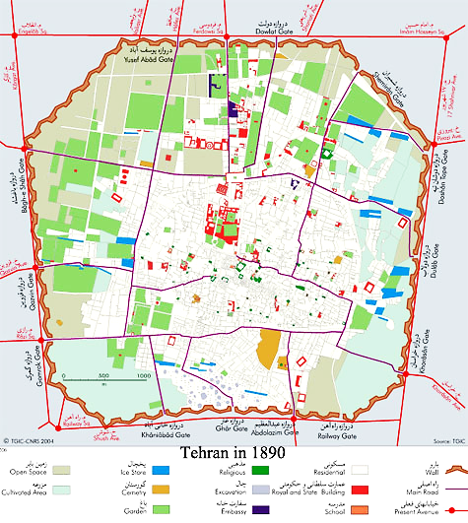
.



Fig. 3. The range of Tehran in Qajar period (1770-1920s); (Source: Madanipour (2011))

Madanipour notes that in the 1930s, Tehran underwent a radical transformation to symbolize the change of the new government’s ideal. New royal palaces were built and the old royal compound was replaced by a new government quarter. The city walls and gates were pulled down and a network of wide streets cut through the urban fabric, creating an open matrix for the easy movement of goods and vehicles across a unified urban space. This created a new basis for the growth of the city in all directions and defined a new character for the city [30] (figure 4, 5).

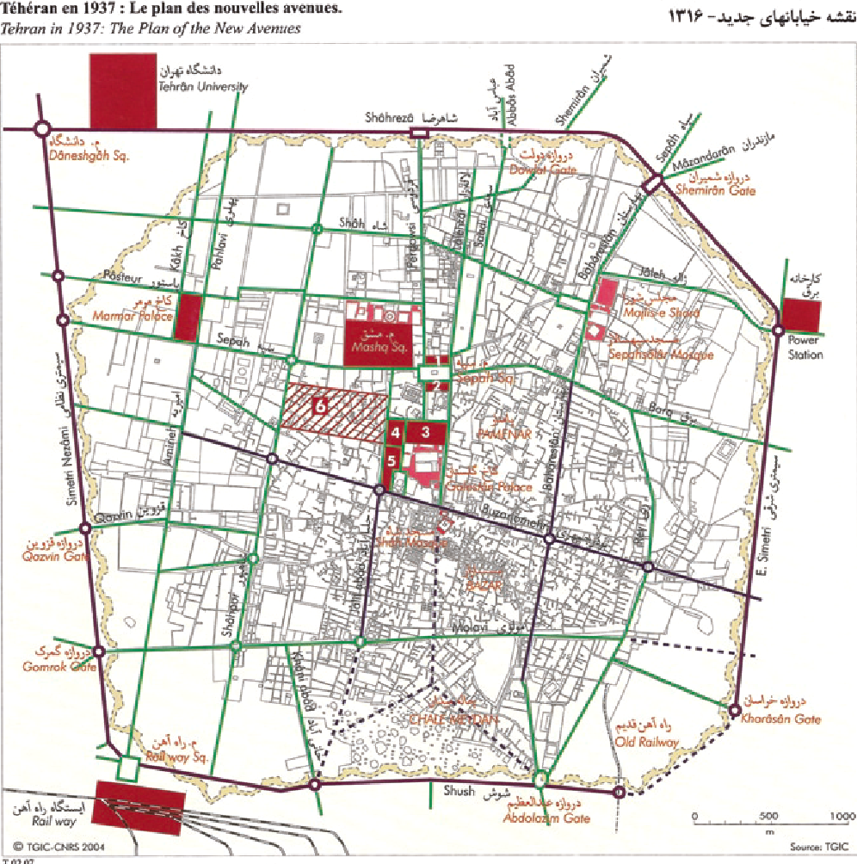
Fig 4. Tehran in 1937: The plan of the new avenues; (Source: Madanipour (2011))

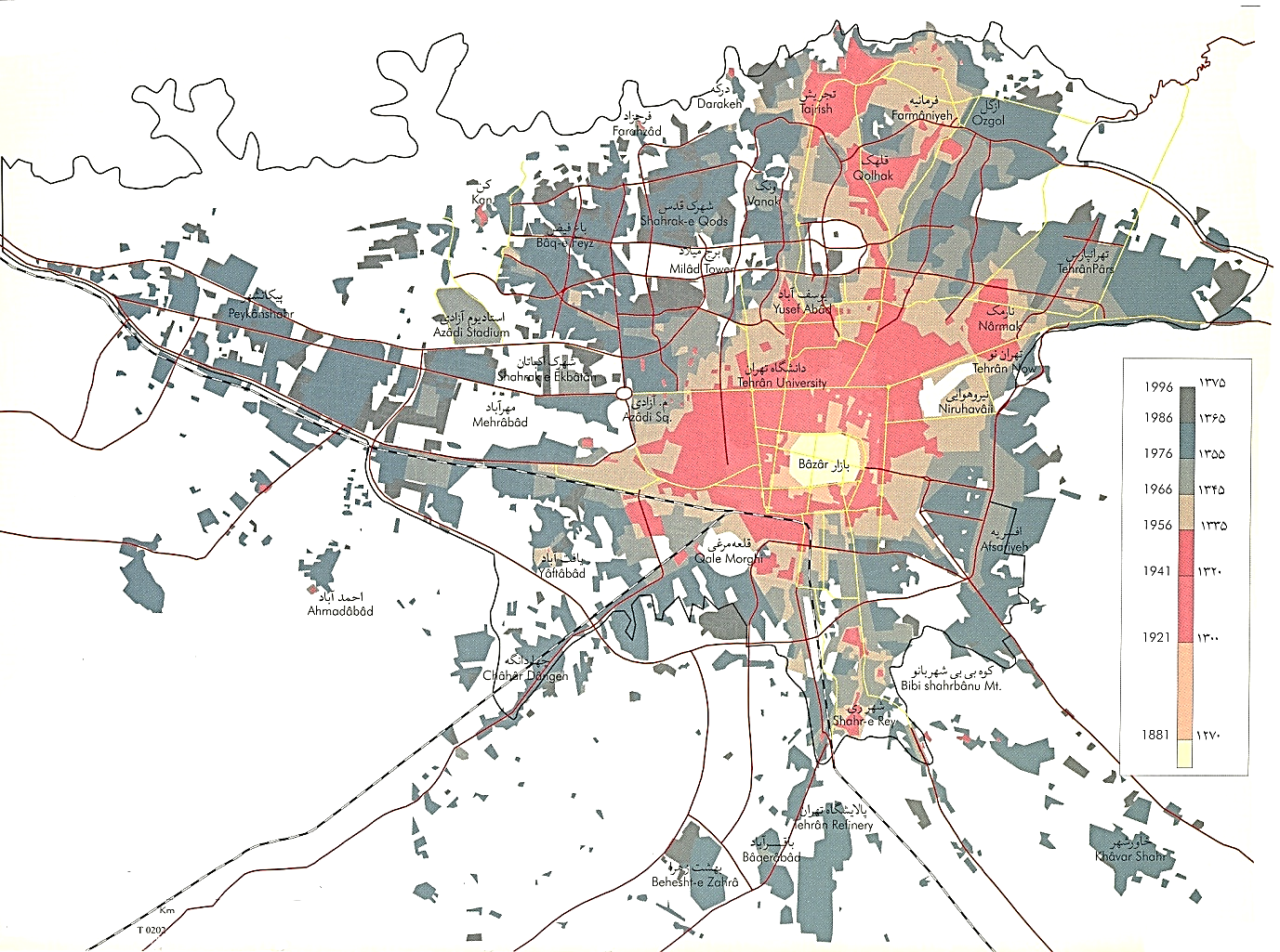

Fig 5. Growth of Tehran 1841-1996; (Source: [9])
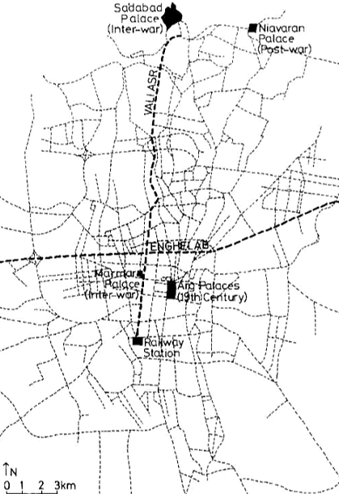
Valiasr intersection is the most important social-cultural node in Tehran and is the intersection of two important pivoting [29] (figure 6). He believes that these two axes are the result of three factors: the first is the incorporation of north-south and center-periphery relations the social-economic benefits of the north leading to the adjustment of center; the second is the power incorporation between people and governments that is the result of a thousand years dictatorship heritage in Iran and third is the background of this pattern in the history of Iran dating back to 2500 years.
Fig 6. Two main axes in spatial structure of Tehran; (Source: [29])
Tabe 2 reviews the transformations of this plaza and valiasr street.
Table 2. The transformation of Valiasr plaza ant the forces that influence the changes; (Source: Authors)
Changes | Year | Influential force
The formation between two governmental structures | 1920 | Governmental – natural
The street was paved | 1930 | Official
The street entered the everyday equations of the people | 1944 – the attack by the allies | Social–official
The street turned into a place for the cafes and societies for writers and intellectuals | 1944-1967 | Social-artistic-political
Construction of City Theater in Valiasr intersection | 1967 | Governmental-official-social
Valiasr intersection as the symbol of everyday life and ideological conflict | 1967-1979 | Social-artistic-economical
A change of name and the ruling ideology | 1979-1990 | Ideological-social-political
Globalization of Valiasr intersection- the role of spatial-class gap- a more important trade role for the street- a weaker social role for the intersection- financial institutions and governmental ministries | 1990-1998 | Ideological-political-economical
A more important social role for the intersection- the global role of the intersection continued- more important role for the City Theater- construction of subway station | 1998-2006 | Social-economical-artistic
Construction of a BRT line- the order for constructing a mosque next to City Theater | 2006-2010 | Official-ideological-economical-governmental
Ideological conflict- the operation of the BRT line and the dominance of transit traffic in Valiasr intersection- the initial design for the mosque was rejected and the construction of an unconventional mosque in order to match the City Theater design began- the construction of a pedestrian underpass in order to eliminate pedestrian traffic from the street- a security approach to space | 2010-2014 | Social-official-political-economical-ideological

Underpass project of Valiasr
The north-south pivot is Valiasr Street which is of the most well-known in The Middle East and the east-west pivot is the well-known Enghelab Street. City Theater and Daneshjoo Park are located in the southeast of this intersection. The west side of the intersection leads to the two important universities of Tehran and Amirkabir and also to Enghelab square. The north side leads to a computer activity center and Valiasr Street (figure 7, 8). The immediate vicinity of Valiasr intersection is considered as the heart of civic and cultural centers in Tehran. About 192 bookshops, 38 translation offices, and 1660 publishing centers are located in this vicinity. City Theater hosts about 2500 performances annually. Vahdat Hall hosts about 150 events each year. There are 12000 students in Amirkabir University and 35000 students at Tehran University. The population density of this vicinity is very young and is considered as the gravity center of the population in Tehran. “The university civic society is being formed here and “this vicinity has a good condition in the Comprehensive Plan of Tehran and is considered as one of the main seven centers of the city as the cultural and academic center of the city”.
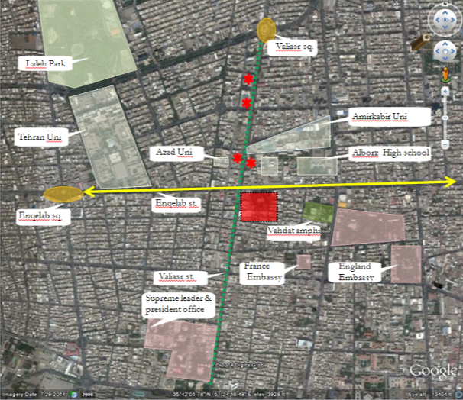 | 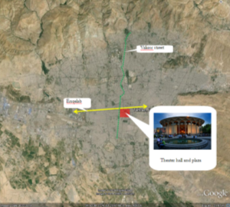
Fig7. Valiasr intersection and various uses around it ; (Source: Authors) | Fig 8. The situation of valiasr intersection; (Source: Authors)
The parts to the north of this vicinity are considered as modern Tehran and the parts to its south as traditional Tehran. In the Master Plan, due to the social and political roles of Enghelab Street which has been the ground for a great number of demonstrations, limitation of vehicle presence, and encouraging pedestrian traffic has been emphasized in order for the population to preserve its livability. Detailed plans for districts 6 and 11 and the Master Plan have also had this emphasis.
In 1970, Iran's government decided to build a new center for Tehran aiming to be international, political, and administrational [11]. This project which called Shahestan Pahlavi was the fulfillment of the biggest urban planning project in the world (ibid) and it was not just a new center but also new capital for all of Iran (ibid, 23) and the city that would be worthy for 21st-century civilization (ibid, 105). Besides the historical importance, there is another side to this intersection. More than 6 thousand cars, 260 buses, and a population of about 500 thousand people pass through this intersection and this has caused this intersection to turn into a constant traffic jam. In February 2013, the underpass was built in contrast to the studies of master and detailed plans. According to this new project, pedestrians go down and the intersection has been dominated by cars. Moreover, some barriers have been installed to prevent the pedestrian cross the intersection (Figure 9, 10). Actually, the pedestrians are forced to use this underpass.
Fig 9. The Valiasr pedestrian underpass project and  connection to the surrounding streets; (Source: Authors) | Fig10. Barriers for preventing crossing the intersection ; (Source: Authors)
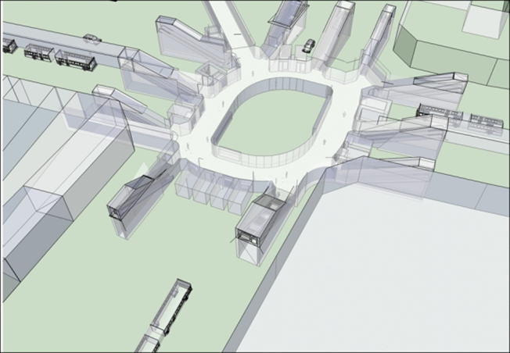 | 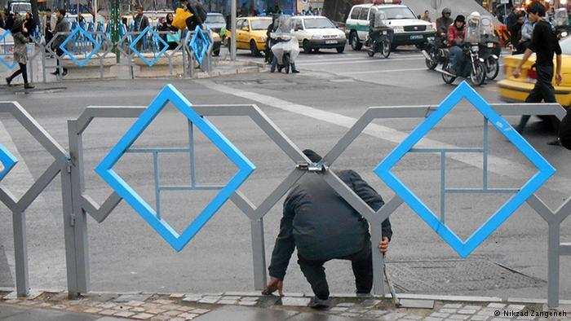

Finding
Contrary to district 11- which is located in the south of Valiasr intersection- district 6- which is located in the north of Enghelab-Azadi line and Valiasr intersection- has been the ground for physical, spatial, and political changes which are influential nationally and even internationally. “The practical and physical instances of these changes are the establishment of ten ministries, 142 affiliated organizations (50 percent of those in Tehran) 49 universities and academic institutions (50 percent of those in Tehran), 66 hospitals and medical centers (30 percent of those in Tehran), 26 embassies and offices of international organizations (30 percent of those in Tehran), and hundreds of official, financial, economic, cultural, and media centers” (District 6 Detailed Plan). Additionally, the number of those employed in district 6 is 1.23 percent more than those living in the district. Furthermore, this district contains 21 percent of the top jobs in Tehran and is, therefore, a focal point for the above-medium and decision-making social classes in terms of residence, employment, and leisure time (same source). These features further clarify the spatial importance of Valiasr intersection as the spatial gap joint of north and south. In addition, the above-mentioned features have caused the northern part of this intersection to be the focus of international attention and the target for global fundraising.
The transformation process of Valiasr intersection and its urban space, due to the reasons below have caused the everyday life in this intersection to lose its value and credit and prepare for the increasing “alienation” of the space users.

Elimination of the sense of ownership
Of the prominent features of Valiasr intersection is its socio-cultural dimension. Ownership not only refers to the right to occupy urban space, but it also refers to the right to create urban space which accounts for the needs of residents. Additionally, ownership gives residents the right to “make the most of” urban space in their everyday life. The Valiasr pedestrian underpass project has deprived citizens of making the most of the space. This pedestrian underpass is intended only to eliminate pedestrian traffic from the intersection in order to facilitate vehicle traffic.

Ignoring public participation
Citizens in Tehran are not able to intervene and participate, in the true sense, in their city for two reasons. The first reason is the focused structure of power, which has rarely allowed for intervention; and the second is a security approach to the area of citizen participation. Although in the political area one can witness democracy and people elect their representatives in macrostructures of power, “we are facing formal equality in the political area in many ways”. In the economic and social areas, people are facing real inequality. The truth is that the economical equations in urban projects are not quite clear and the municipality is practically selling Tehran in order to earn money. The people are not allowed to supervise their tax money in a democratic process.
Public participation is needed in all project levels, from feasibility planning to physical design, because a city, as a creative work, calls for the participation of all. Creative work means that, with creative action, people’s everyday life upgrades from an everyday dimension to a historical dimension. This creative action includes implementing environmental arts and presence and intervention in the designing process which leads to the production of space.

Forgetting residents’ centrality
The existence of the City Council and its election processes have provided the people with the possibility to attend local power relations. Currently, Tehran City Council has 31 members and is in its 4th term. However, there are two important arguments about the lack of centrality. The first one is the level of efficiency for this presence in space production trends. In its four terms, the City Council, though it has been influential in the urban development trend has failed to institutionalize citizen centrality in urban development and it has, in some ways, turned into a part of the far extended urban bureaucratic system and its supervising roles have diminished down to superficial everyday affairs. Where it has to, as Lefebvre puts it, intertwine everyday affairs with the historical dimension, it has failed to do so and the two powerful and influential factors in urban changes, namely state and capital, have assimilated the City Council.
Kheyroddin investigated the City Council actions in three consecutive terms when different political trends have been dominant in the council and have concluded that despite the differences in urban management through these years, the financing methods by the municipality have continued to be based on aggregation sale and has worsened the spatial gap [19].

Choosing isolation
The Valiasr pedestrian underpass project, intended originally to facilitate motorist traffic, has separated those who approach this intersection based on their travel behavior. The nature of this project has not been gathering different interests and passers-by have been separated to take different tunnels. These tunnels have only facilitated access to the BRT stop. Moreover, this project has not considered access to some special groups and has deprived some citizens of access to the intersection.
This project has such a strong separating nature that some experts have considered it as securing urban space and some have even regarded it as killing the heart of Tehran (figure 11, 12).
Even according to the Tehran municipality action plan until 2018 this project is the next priority but it is now being implemented as the first pedestrian underpass. The spatial nature of Valiasr intersection (as discussed so far) reinforces suspect militarization (security) of urban spaces and the Haussmannization of spaces. Therefore, in order to reinforce everyday life, the security approach must be omitted from urban spaces firsthand and the presence of people must be considered as an opportunity. Here, again, state and capital come in conflict with everyday life.
Fig 12. The separating nature of Valiasr underpass and the fencings around it; (Source: Authors) | Fig 11. Tunnels which do not bring different interests together; (Source: Authors)
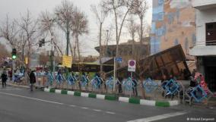 | 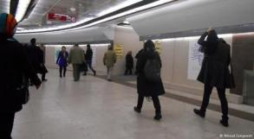

Weakening individuality
To classify people based on their travel patterns is to ignore their individuality and differences. Considering the role of Valiasr intersection and the land uses in its vicinity, one can safely say that different people with different views and incentives approach it. Different cultural centers, universities, Daneshjoo Park, and the existence of popular trade centers have made the purposes for approaching this intersection very diverse. Some even go there just to spend time and walk around or, as Bodler puts it, ‘wander’.

Conclusion
Nowadays, architecture and urban spaces have experienced many complexities including global-local ones. There are many influential forces that direct the evolution of cities. However, there are few groups that profit from architectural transformation, and many unpowered ones are deprived of development waves. This dominant movement in contemporary cities leads to many social-spatial problems. Following this dominant movement, architecture is changed to a subjective practice that is done by professional architects. They usually design what the powerful group asks them. Therefore, unpowered ones are neglected in this up-bottom process. The main purpose of architectural and urban projects is the economic accumulation or dictating special order which is drawn by government or ideology. Then, architecture could influence social life and social equity. In both the globalization trend and the native approach, which are currently leading city transformations, the one thing that is forgotten is the ‘everyday life’ of those people who form the majority of the society and lack the power to impact change. These are the same 99 percent mentioned by Chomsky [6]. The main decision-makers in cities carry this out through the submission of everyday life. In both cases, citizens become ‘alienated’ in space. Therefore, it is suggested that what must be considered in city planning and development as the working criterion is the everyday life of the residents which depicts urban space transformation as it is in a proper way; the everyday life which accounts for the factors of sense of ownership, public participation in all stages of decision making and construction, supporting residents’ centrality (figure 13).
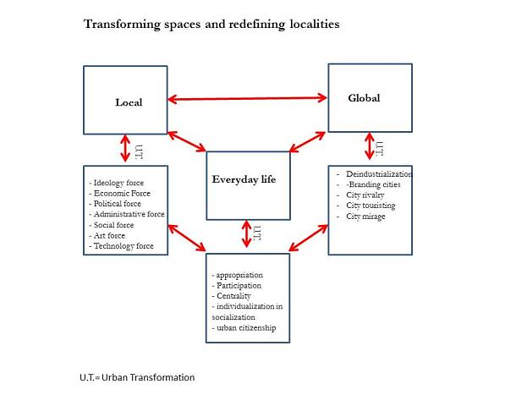

Fig 13. Everyday Life as an intermediary between local and global; (Source: authors 2014)

REFERENCES
[1] Acebillo, J., Le, J., Schmid, C., Globalization of Urbanity, Actar Publishers, 2012.
[2] Attoh, A. K., What kind of right is the right to the city? Human Geography, 35(5): 669-685, 2011.
[3] Basel, E.S., Diner, R., Herzog, J., Meili, M., De Meuron, P., Herz, M., & Topalovic, M. The inevitable specificity of cities, Lars Müller, 2015.
[4] Bentley, I., Urban transformations: Power, people and urban design, Routledge, 2004.
[5] Carmona, M., Claudio de Magalhaes., Hammond, L., Public space: the management dimension. Routledge. 2008.
[6] Chomsky, N., Occupy.Vol. 1. Zuccotti Park Press, 2012.
[7] Cuthbert, A.R., The form of cities: Political economy and urban design. John Wiley & Sons, 2008.
[8] Gospodini, A., European cities in competition and the new'uses' of urban design, Urban Design, 7(1):59-73, 2002.
[9] Habibi, S.M., Hourcade, B, Atlas of Tehran metropolis, Tehran Geographic Information Centre, Tehran, 2005.
[10] Hamidi, et al. The framework of Tehran, The technical and engineering of Tehran, 1998
[11] Hourcade, B, Tehran- Alborz, Tehran: Taraneh publication, 2009.
[12] Kheyroddin. R, Investigating justice in Tehran, Islamic architecture research, 2013.
[13] __________, Land-based analysis of urban managers between 1993-2003, Honarhaye ziba, 2010.
[14] Harvey, D, The right to the city, International Journal of Urban and Regional Research, 27(4): 939-941, 2003.
[15] Harvey, D., Potter, C, The right to the just city. In P. Marcuse, J. Connolly, J. Novy, I. Olivo, C. Potter, & J. Steil (Eds.), Searching for the just city: Debate in urban theory and practice (pp. 40-51), NY: Routledge, 2009.
[16] Harvey, D. The enigma of capital: and the crises of capitalism, Profile Books, 2011.
[17] Jabareen, Y, ‘The right to the city’ revisited: Assessing urban rights the case of Arab Cities in Israel, Habitate international, 41: 135-141, 2014.
[18] Jacobs, J, The economy of cities, Vintage Books, 1969.
[19] Kheyroddin, R.,The GIS analysis of Tehran’s management actions during 1993-2007,volum 42, p:71-82 , 2010.
[20] Knox P. L, Cities and design, Routledge, 2010.
[21] Kostof, S, The City Shaped Urban Patterns and Meaning Throughout History, Bulfinch, Boston, 1991.
[22] ________, The city assembled, The City Shaped, 1992.
[23] Lajvardi, H, Theories of everyday life, social science magazine, Tehran, 2005
[24] Lefebvre, H, The production of space, (Vol. 142): Oxford Blackwell, 1991.
[25] Lefebvre, H, The urban revolution: U of Minnesota Press, 2003.
[26] Lynch, K, Good city form, MIT press, 1984.
[27] Madanipour, A, Designing the city of reason: foundations and frameworks, Routledge, 2007
[28] Madanipour, A. ed, Whose public space? International case studies in urban design and development, Routledge, 2013.
[29] Madanipour, A, Tehran: the making of a metropolis, Academy Press, 1998.
[30] ____________, Sustainable Development, Urban Form, and Megacity Governance and Planning in Tehran, in Megacities Urban Form, Governance, and Sustainability, Springer, Tokyo, Dordrecht, Heidelberg, London &New York, 2011.
[31] Morris, A. E. J, History of urban form before the industrial revolution, Routledge, 2013.
[32] Mumford, L, The city in history: Its origins, its transformations, and its prospects, (Vol. 67), Houghton Mifflin Harcourt, 1961.
[33] Schmid, C, Henri Lefebvre’s Theory of the Production of Space; Towards a three-dimensional dialectic, trans, In Goonewardena, Kanishka, et al., eds., Space, Difference, Everyday Life, Reading Henri Lefebvre, Routledge, London and New York, 2008
[34] Shieh, E., Martouzet, D., piroozi, R., Main Intergovernmental Conflicts among Urban Management Actors of Small Cities Case Study: City of Natanz, Iran, International Journal of Architectural Engineering & Urban Planning, volum 30, issue 1.2020
[35] Soltani, A., Namdarian, A. The investigation of Influencing forces on urban spaces, Hoviat Shahr magazine, 7: p. 123-130, 2010.

This article is based on Ph. D thesis of Somayeh Khani at Tabriz Islamic Art University entitled: “Explaining the Action of Architecture on Everyday life In Contemporary Society of Iran”, which is written under the supervision of. Dr. Parisa Hashempour and Dr.Mohammadali Kaynejad and consulting Dr.Morteza Mirgholami. * The corresponding author of this article is Dr.Parisa Hashempour
Associated professor of architecture and urbanism, TIAU (Tabriz Islamic Art University), Tabriz, Iran. Email: p.hashempour@tabriziau.ac.ir
professor of environmental engineering, Tabriz Islamic Art University, Tabriz, Iran. Email: ma_kaynejad@tabriziau.ac.ir
Associated professor of TIAU (Tabriz Islamic Art University), Tabriz, Iran. Email: m.mirgholami@tabriziau.ac.ir
Ph.D. candidate in Islamic architecture, Faculty architecture and urban planning, Tabriz Islamic Art University, Tabriz, Iran. Email: Somaye.khani@ymail.com

