How exposure to blue elements (water and sky) can affect psychological restoration of university students?
Fatemeh Amirbeiki¹, Azadeh Khaki Ghasr^{∗ , 2}

1 Faculty of Art and Architecture, Yazd University, Iran
2 Faculty of Architecture and Urban Planning, Shahid Beheshti University, Tehran, Iran
Abstract
Even though the positive influences of nature on human health have been known for many decades, few studies have been carried out exclusively about the psychological benefits of exposure to water and sky as natural blue elements in built environments. Therefore, via close-ended questionnaire and structured interviews (with open-ended questions), this paper tries to estimate how exposure to natural blue elements (compared to green ones) can affect psychological restoration of university students, as a group who experience many psychological disorders. 67 students are considered as the participants and main central courtyards of two traditional dwellings, which currently are used as educational environments, are selected as the case studies in the hot-dry climate of Yazd, Iran.
The results of close-ended questionnaire show that among natural elements, water has the most significant influence on fascination and being away (two components contributing to restoration). In addition, although in comparison to water, sky has less effective influence on fascination and being away in the studied environments, it is as important as green elements in fostering fascination and being away. The results of structured interviews reveal that not only is water the most preferred and important natural element of both courtyards but also students’ pleasantness, refreshment and their relaxation from stress are mainly due to water exposure. This study tries to highlight that in addition to green elements, it is essential to consider blue elements and design strategies based on their exposure in educational environments in order to foster psychological restoration of university students.
Keyword: Natural blue elements, Natural green elements, Central courtyards of educational environments, Psychological restoration, Yazd

- Introduction
Although university students are known as privileged population, the number and severity of psychological disorders are increasing among them. It is reported that students’ sufferings and disabilities associated with psychological illnesses may cause negative effects on their academic success, productivity and social relationships [1]. However, characteristics and physical features of educational environments can bring positive impacts on psychological health of their occupants. Indeed, it is proved that nature exposure is one of the effective features which can intensively support restoration, which involve the renewal of depleted psychological resources, in built environments [2-4].
Many researchers have focused on the positive influences of green elements on physical, social and psychological health, especially in urban areas [5-9] and some specific types of buildings such as health care spaces [10-13], work places [14-16], which their occupants are under a lot of pressure and stress, and residential buildings [17, 18], which people spend the majority of their lives there. Considering the specific psychological restoration, some studies showed that perceived stress would be decreased significantly by more visits and more time spent per week in green spaces [19, 20]. Ulrich, who is one of the pioneer in debates of healing environments, revealed that after watching a stressor video, watching a 10 minutes video of nature view can recover participants from stress significantly within 4-7 minutes [21]. Another study showed that the presence of indoor plants in underground buildings, which people have mainly negative feelings towards them, can increase the positive perceptions [22]. Considering educational environments, a study conducted in sunken courtyards, as a type of underground buildings, confirmed that the strong link between nature and these environments can bring positive impacts on psychological perceptions of occupants [23]. Furthermore, it is reported that existence of green spaces with specific features in the university campuses can bring health benefits for both staff and students [24] and positively affect students’ learning process [25].
In addition to natural green elements, the introduction of the term “blue” (as a new color, literally and metaphorically, to the debates about environmental health and therapeutic spaces [26]) revealed that water and sky are the two major natural blue elements with significant influences on human health. Although some research contained water as an element of green spaces, these days, few experts have focused exclusively on the relation between water and health [27-32]. There are some evidences that people who live near canals of water experienced aesthetic value, engaged more in social activities and possessed emotional bonding to the water [33]. Furthermore, it is reported that both natural and built environments providing views to water were associated with higher preferences, greater positive effects and higher perceived restorativeness than those without water [34].
Sky is the most neglected natural element in debates related to human health. One study showed that in low-rise apartments, occupants who frequently watched sky from their windows, reported more effective functioning [35]. Another exception is the research done by Masoudinejad and Hartig [36, 37] who stated that view through windows to sky brings about significant restorative influences for occupants in a populated city.
The main objective of this study is to investigate the effects of natural blue elements (compared to green ones) on psychological restoration of university students, as a group who experience many psychological disorders, in educational environments. Noticing the aforementioned studies, although there are some studies that assessed psychological health of people associated with their perception of the totality of blue and green spaces, the psychological benefits of particular blue elements are not considered precisely. Hence, the main central courtyards of two traditional dwellings, which currently are used as educational environments and provide exposure to blue and green elements, are considered as case studies in the hot-arid climate of Yazd, Iran.
The paper will continue by presenting the features of the studied courtyards in Section 2. In Section 3, the methodology, which is applied to analyze the case studies, is explained. The results and conclusion are presented in Section 4 and 5 respectively. Section 6 describes the limitations of present study and suggests some opinions for future research.
- Field investigation
Based on the Köppen climate classification, there exists four climatic zones in Iran: hot–humid, hot–arid, mild humid and cold [38]. In this paper, main central courtyards of two traditional dwellings named Rasoolian and Mortaz, which are located in hot-arid climate of Yazd with high temperature and intense solar radiation, were selected. These courtyards have been used as open spaces of the art and architectural faculty of Yazd University for more than 25 years. The Rasoolian courtyard possesses older plants and trees such as four cedar trees (each one located in a corner of courtyard), a tall pomegranate tree and few flowers. However, the Mortaz courtyard provides more spaciousness because of less number of plants and trees (with lower height). It contains a fig tree, a tall palm tree, a ten-year-old orange tree as well as few rose bushes.
Both courtyards’ water pools were colored by Persian blue while Rasoolian’s water pool has higher width and depth than Mortaz’s water pool. These water pools are located in the center of courtyards.
Figure 1 and 2 show the studied courtyards and their plans. Figure 3 presents perspectives of the main central courtyards. In addition, some information regarding the dimensions of courtyards are presented in order to have more detailed analysis (see table 1).
- Methodology
In this study, two types of questionnaires (close and open-ended) have been used to analyze the psychological health of occupants in the studied courtyards. Close-ended questionnaire was distributed among 67 participants including students of architecture and urban design’s majors (spending at least three years in the case studies) in the April of 2019 while via structured interviews, the open-ended questions were asked by the researchers from the same participants in the May of 2019. It should be noted that the Mortaz courtyard is used mainly by students studying urban design while architecture students use frequently the Rasoolian courtyard. Demographic information was assessed by questions concerning age, sex, year of study, length of visiting courtyards. The number of female and male participants in this study was 64.18% and 35.82% respectively and their age ranged from 20 to 43 years old. The percentage of participants who visited the courtyards less than 1 hour, was 31.4%. 41.8% of them spent between 2 to 3 hours and the rest of them, about 26.8% of students, were more than 3 hours in the studied environments.
For close-ended questionnaire, the psychological variables were identified according to “attention restoration theory” which refers to restoration as a situation that attention goes without effort to interesting, pleasant aspects of environment [39]. Fascination (effortless engagement by objects in the environment), being away (gaining psychological distance from day-to-day routine mental contents and demands on directed attention), extent (scope and coherence of the environment engaged with) and compatibility (match between what a person can do, wants to do and must do in the environment) are four components contributing to this theory [40, 41] while in this step, there is a focus on fascination and being away. Hence, the close-ended questionnaire consists six questions which tries to estimate that how exposure to natural blue elements (compared to green ones) can foster fascination and being away.
First, more explanation about questions were given to the students and then all the respondents were asked to rate each question on a Likert scale from 1 (completely disagree) to 7 (completely agree). The questions are presented in table 2. Repeated measure ANOVA was conducted so as to analyze the responses and to compare the effects of natural elements on fascination and being away. The null hypothesis (H₀) is that there is no significant difference between the mean scores of the factors. The alternative hypothesis (H₁) assumes that there is a significant difference between at least two factors.
The second questionnaire consists open-ended questions which most of them were derived from validated and existing questionnaires [31, 41, 42]. These questions were asked via structured interviews which were fully controlled by the researcher and gave the participants less room to be flexible and casual [43]. According to a time schedule, each participant was asked to come to the courtyards and answer the questions with the same order. Indeed, these interviews were formulated to cover the gaps and help to deeply understand the association between psychological restoration and exposure to natural elements. It should be noted that all the interviews were recorded. The questions of this part are presented in Table 3.
In order to analyze the responses of structured interviews, first, the recorded responses were entered into MS Excel spread sheet, giving every participant a specific code (first capital letter of the case studied courtyard, then a number, e.g. R7=Rasoolian, participant no.7). For the next step, the core statements of responses were determined and the related core statements were categorized in the key themes. The results were categorized in the themes as perception, preference, promoting positive emotions and relieving negative feelings. Noted that the key themes are identified after repeatedly reading the responses and reducing them to the core statements [44]. Specifying the frequency of each theme (see table 4 and 5) made it possible to investigate the differences between the influences of blue and green elements on psychological restoration.
- Results and discussion
First, the validity and the reliability of the close-ended questionnaire were tested. The content validity indicates the extent that the questions are relevant and representative to measure the psychological restoration of the students. In this study, the content validity of the questionnaire was confirmed by the experts in this field. The reliability of the questionnaire indicates the internal consistency of the questions. In this study, the Cronbach’s alpha was 0.751, which indicated a high level of internal consistency of the scales.
To have detailed information about the effects of natural green and blue elements on occupants’ psychological restoration in terms of fascination and being away, repeated measure ANOVA with Greenhouse-Geisser correction were conducted. The results of this step are presented as error bar charts in figure 4. In this figure, the responses are ranked from higher to lower influences of natural elements. The overlap between the standard deviation bars can be used to determine whether or not a difference is significant. Note that the standard deviation is a measure of variability rather than being a statistical test. Hence, to have a valid conclusion, the results of the statistical test should be considered.
The results show that the mean psychological restoration level differs statistically significantly between various elements’ exposure in central courtyards (F (2.757, 181.961) =22.596, p=0.00). Post hoc using Bonferroni correction indicates that the mean score for the question related to the influence of water exposure on fascination (M=6.55, SD=0.53, P=0.00) is significantly higher than four questions’ mean score. However, water influence on being away (M=6.35, SD=0.73, P=0.27) is the factor which its mean score does not significantly differ from this factor. In general, these results suggest that water exposure has the most significant influence on fostering fascination and being away in the studied courtyards. Another finding of this step is that although in comparison to water, sky has less effective influence on fascination and being away, there is no significant difference between sky and green elements’ influences. It reveals that as the most neglected natural element in debates related to human health, sky is as important as green elements in fostering psychological restoration in terms of fascination and being away.
The results of structured interviews, presented in table 4 and 5, reveals more detailed information about the influence of natural elements on psychological restoration of university students. Although any assigned code and the percentage of responses are indicated, the most striking points contributing to a better understand are presented as follows. It should be noted that in addition to the natural elements, few responses were related to the totality of environment.
Findings of structured interviews showed that among positive emotions, pleasantness and refreshment of occupants are strongly associated with visiting water in the studied courtyards. Many students mentioned that although visiting sky and green elements in the courtyards can positively affect their emotions, the presence of water has the most significant effects on their psychological restoration in terms of promoting pleasant mood and refreshment. “Watching the waves and the ever changing appearance of water” and “visiting the reflection of built environment, sky and trees in water” were mentioned several times by respondents as the reasons beyond their pleasant mood. “Everything reflection, especially traditional doors, in water creates an imaginary and extraordinary scene” (R36) and “I enjoy watching waves and sun glitter in this mirror which only shows beauty” (M12). Indeed, moving and flickering profiles are capable to stimulate viewers’ eyes [45] as well as bringing about faster and more emotional reactions [46]. Hence, as water was mostly illuminated by sun during this study, its’ appearance changed constantly and quickly [47] by light reflections and waves which could more easily attract attention of occupants and foster their pleasantness more strongly compared to sky and green elements. It is interesting that some students appreciated the pleasantness of trees and especially sky through their reflection in the water pool: “water pool is a small sky on the ground” (R3) and “it keeps the vast beauty of sky” (R18) and “the trees vitality in a small area” (R19). Although sky and trees provide diversity in terms of perception, for example, sky during different hours of day with ever-changing colors and passing clouds and green elements during different seasons with various flora and fauna, compared to water, they were perceived less effective on the pleasantness of students.
“Hearing the sound of water”, “feeling the coolness and pleasant weather created by it” and “smelling its’ fragrance” were mentioned repeatedly by students which help them to get refreshed. Water plays a significant role in creating refreshment and thermal comfort of the occupants especially in hot-arid zones [48-50]. Hence, while the case studies are located in harsh climate of Yazd, the occupants’ perception of water influence on refreshment was intensified: “Breathing the cool weather associated with water helps me to get refreshed” (R9); “I like sitting near the water pool and enjoy the fresh weather and smell of water, especially during hot days” (R37). In addition to water, few students considered an important role for the “birds’ flight in the sky” and “their sound through the trees” in creating refreshment. “Sitting in this courtyard and listening to the songs of birds hidden among trees” (M1) and “watching their dance in the blue scene create joyful and refreshing moments” (M4).
Like the positive emotions, it is water which significantly relieve negative feelings of students. It was reported repeatedly that relaxation from stress is strongly dependent on the rich variety and the long lasting attraction of water in the studied environments: “spending few minutes near the water pool helps me to get relaxed and calm” (R30); “This water pool is pure calmness […] it invites me to live at the moment and forget all my worries” (M10). The responses showed that sky is the second natural element which has strong association with relaxation from stress. In contrary to other categories, which there is no big difference between the influence of sky and green elements, for relaxation from stress, sky plays more significant role than green elements. “Sky as the mother of the courtyard seems very close to earth” (M11) and “the vast expanse of it creates feelings of openness, freedom and great calmness” (M22). It is proved by other researchers that the vastness and amount of sky scenes can provide opportunities for restoration likelihood and make strong link to a specific place [31, 37, 51, 52].
Not only is water perceived the most important and reminder element of the studied environments, but also among the natural elements, it is the most preferred one. Many responses revealed when students try to remember the environment, water is the first natural element which comes to their minds and they considered a great role for it as they stated “water defines the center and the meaning of this environment” (R19) and “I could not imagine to remove water from this courtyard […] this place would be absurd without water.” (M3). Also occupants placed a premium on sky and green elements, but water remains as the basic and essential natural element of studied courtyards.
The results of this step completely support the data collected by close-ended questionnaire. In general, water plays the most significant role in fostering psychological restoration of university students in the studied environments. Also as the same as green elements, sky, which is the most neglected natural element in debates related to human health, is capable to restore psychological problems. Hence, in addition to green elements, it is essential to consider blue elements and design strategies based on their exposure in educational environments in order to foster psychological health of university students.

- Conclusion
This article conducted the close- ended questionnaires and structured interviews (with open-ended questions) to investigate the effects of natural blue elements on boosting psychological restoration of university students as a group who experience many psychological disorders. The case studies were main central courtyards of two traditional dwellings, which currently are used as educational environments of art and architectural faculty of Yazd University. Although many research were carried out to assess psychological health associated with perception of the totality of green and blue spaces, in this study it was tried to investigate psychological restoration related to the perception of particular natural blue elements (compared to green ones).
According to the results of close-ended questionnaire, although there is no big difference between the effects of sky and green elements, it is water which has the most significant influence on promoting fascination and being away. These findings were completely supported by the results of structured interviews. Not only are students’ pleasantness, refreshment and their relaxation from stress mainly due to water exposure but also this blue element is perceived as the most important and preferred natural feature of the studied environments. Also it was revealed that like green elements, sky, which is the most neglected element in debates related to human health, is capable to foster psychological restoration of university students in educational environments. This study tried to highlight that in addition to green elements, it is essential to consider blue elements and design strategies based on their exposure in educational environments in order to foster psychological restoration of university students.
- Limitations and future research
While the findings of this study showed important results, it is recognized that it has some limitations. First, this research were conducted during spring while trees and plants were green and there were few clouds in the blue sky with sunny weather. How different appearances of green and blue elements during other seasons would affect the ratings and students’ perceptions is an open question. Second, the case studies are located in specific geographical conditions (hot-arid climate of Yazd) and how other climatic conditions would affect the ratings and students’ perceptions is an open question. Third, although there exists some design strategies which present different views to natural elements, their influences are not considered. For example, in this study, the views to sky, water and green elements were perceived through the central courtyards, while various views through other design strategies would bring different effects. Hence, how different design strategies presenting various views to natural elements would affect the ratings and students’ perceptions is the other open question.
For future research, it is essential to consider case studies located in different climatic conditions of Iran. Also future works can address some limitations of present study with more attention to different appearances of natural elements during different seasons, more focus on weather, daylight variations and different design strategies. In addition, it would be interesting to do a comparison between the influences of natural green and blue elements in open spaces of traditional and modern buildings.
- References
1. Hunt, J. and D. Eisenberg, Mental health problems and help-seeking behavior among college students. Journal of adolescent health, 2010. 46(1): p. 3-10.
2. Staats, H., et al., Urban options for psychological restoration: common strategies in everyday situations. PLoS One, 2016. 11(1): p. e0146213.
3. Hartig, T., F.G. Kaiser, and P.A. Bowler, Psychological restoration in nature as a positive motivation for ecological behavior. Environment and behavior, 2001. 33(4): p. 590-607.
4. Hartig, T. and H. Staats, Restorative environments. Encyclopedia of applied psychology, 2004. 3: p. 273-279.
5. Lennon, M., O. Douglas, and M. Scott, Urban green space for health and well-being: developing an ‘affordances’ framework for planning and design. Journal of Urban Design, 2017. 1.
6. Evered, E., The role of the urban landscape in restoring mental health in Sheffield, UK: service user perspectives. Landscape Research, 2016. 41(6): p. 678-694.
7. Parry‐Jones, W.L., Natural landscape, psychological well‐being and mental health. Landscape research, 1990. 15(2): p. 7-11.
8. Burke, E., Expanding the social performance of food production landscapes: measuring health and well-being benefits. Landscape research, 2018. 43(5): p. 587-599.
9. De Vries, S., et al., Natural environments—healthy environments? An exploratory analysis of the relationship between greenspace and health. Environment and planning A, 2003. 35(10): p. 1717-1731.
10. Cutler, L.J. and R.A. Kane, Post-occupancy evaluation of a transformed nursing home: the first four Green House® settings. Journal of Housing for the Elderly, 2009. 23(4): p. 304-334.
11. Kane, R.A., et al., Resident Outcomes in Small‐House Nursing Homes: A Longitudinal Evaluation of the Initial Green House Program. Journal of the American Geriatrics Society, 2007. 55(6): p. 832-839.
12. Huisman, E.R., et al., Healing environment: A review of the impact of physical environmental factors on users. Building and environment, 2012. 58: p. 70-80.
13. Butterfield, A. and D. Martin, Affective sanctuaries: understanding Maggie’s as therapeutic landscapes. Landscape Research, 2016. 41(6): p. 695-706.
14. Korpela, K., et al., Nature at home and at work: Naturally good? Links between window views, indoor plants, outdoor activities and employee well-being over one year. Landscape and Urban Planning, 2017. 160: p. 38-47.
15. Kaplan, R., The role of nature in the context of the workplace. Landscape and urban planning, 1993. 26(1-4): p. 193-201.
16. Fjeld, T., et al., The effect of indoor foliage plants on health and discomfort symptoms among office workers. Indoor and Built Environment, 1998. 7(4): p. 204-209.
17. Chan, I.Y. and A.M. Liu, Effects of neighborhood building density, height, greenspace, and cleanliness on indoor environment and health of building occupants. Building and Environment, 2018. 145: p. 213-222.
18. Hadavi, S., Direct and indirect effects of the physical aspects of the environment on mental well-being. Environment and Behavior, 2017. 49(10): p. 1071-1104.
19. Grahn, P. and U.A. Stigsdotter, Landscape planning and stress. Urban forestry & urban greening, 2003. 2(1): p. 1-18.
20. Grahn, P. and U.K. Stigsdotter, The relation between perceived sensory dimensions of urban green space and stress restoration. Landscape and urban planning, 2010. 94(3): p. 264-275.
21. Ulrich, R.S., et al., Stress recovery during exposure to natural and urban environments. Journal of environmental psychology, 1991. 11(3): p. 201-230.
22. Kim, J., et al., The effects of indoor plants and artificial windows in an underground environment. Building and Environment, 2018. 138: p. 53-62.
23. Tafti, F.A., M. Rezaeian, and S.E. Razavi, Sunken courtyards as educational environments: Occupant's perception and environmental satisfaction. Tunnelling and Underground Space Technology, 2018. 78: p. 124-134.
24. Lau, S.S. and F. Yang, Introducing healing gardens into a compact university campus: design natural space to create healthy and sustainable campuses. Landscape Research, 2009. 34(1): p. 55-81.
25. Peker, E. and A. Ataöv, Exploring the ways in which campus open space design influences students’ learning experiences. Landscape Research, 2019: p. 1-17.
26. Völker, S. and T. Kistemann, The impact of blue space on human health and well-being–Salutogenetic health effects of inland surface waters: A review. International journal of hygiene and environmental health, 2011. 214(6): p. 449-460.
27. Finlay, J., et al., Therapeutic landscapes and wellbeing in later life: Impacts of blue and green spaces for older adults. Health & place, 2015. 34: p. 97-106.
28. White, M.P., et al., Feelings of restoration from recent nature visits. Journal of Environmental Psychology, 2013. 35: p. 40-51.
29. Roe, J.J. and P.A. Aspinall, Adolescents’ daily activities and the restorative niches that support them. International journal of environmental research and public health, 2012. 9(9): p. 3227-3244.
30. Wheeler, B.W., et al., Does living by the coast improve health and wellbeing? Health & place, 2012. 18(5): p. 1198-1201.
31. Völker, S. and T. Kistemann, “I'm always entirely happy when I'm here!” Urban blue enhancing human health and well-being in Cologne and Düsseldorf, Germany. Social Science & Medicine, 2013. 78: p. 113-124.
32. Karmanov, D. and R. Hamel, Assessing the restorative potential of contemporary urban environment (s): Beyond the nature versus urban dichotomy. Landscape and Urban Planning, 2008. 86(2): p. 115-125.
33. Yabes, R., K. Shetter, and J. Schneeman, Urban waterways: changing historical uses and users in a southwestern desert city. Landscape and urban planning, 1997. 39(2): p. 167-185.
34. White, M., et al., Blue space: The importance of water for preference, affect, and restorativeness ratings of natural and built scenes. Journal of Environmental Psychology, 2010. 30(4): p. 482-493.
35. Kaplan, R., The nature of the view from home: Psychological benefits. Environment and behavior, 2001. 33(4): p. 507-542.
36. Masoudinejad, S. and T. Hartig. Window view to the sky as a restorative resource for residents of a densely populated city. in 10th Biennial Meeting, Division of Environmental Psychology, German Psychological Association, Otto-von-Guericke University, Magdeburg, Germany. 2013.
37. Masoudinejad, S. and T. Hartig, Window View to the Sky as a Restorative Resource for Residents in Densely Populated Cities. Environment and Behavior, 2018: p. 0013916518807274.
38. Kasmai, M., Climate and Architecture (inPersian), ed. 2nd. 2005, Tehran: Khak Publication. 117–127.
39. Kaplan, S., The restorative benefits of nature: Toward an integrative framework. Journal of environmental psychology, 1995. 15(3): p. 169-182.
40. Kaplan, R. and S. Kaplan, The experience of nature: A psychological perspective. 1989: CUP Archive.
41. Hartig, T., et al., A measure of restorative quality in environments. Scandinavian housing and planning research, 1997. 14(4): p. 175-194.
42. Völker, S. and T. Kistemann, Developing the urban blue: comparative health responses to blue and green urban open spaces in Germany. Health & place, 2015. 35: p. 196-205.
43. Stuckey, H.L., Three types of interviews: Qualitative research methods in social health. Journal of Social Health and Diabetes, 2013. 1(02): p. 056-059.
44. Straus, A. and J. Corbin, Basics of qualitative research: Techniques and procedures for developing grounded theory. 1998, Thousand Oaks, CA: Sage.
45. Schiffman, H.R., Sensation and perception: An integrated approach. 1990: John Wiley & Sons.
46. Gell, A., The technology of enchantment and the enchantment of technology. Anthropology, art and aesthetics, 1992: p. 40-63.
47. Strang, V., The Meaning of Water. 2004: Bloomsbury Academic.
48. Navaie, K. and K. Haji Ghasemi, Khesht-o Khial; an Interpretation of Iranian Islamic Architecture. Tehran-Iran: soroush, 2011.
49. Shahcheraghi, A., Paradigms of paradise. 2013, Tehran: Jahad daneshgahi.
50. Ghobadian, V., Climatic analysis of the traditional Iranian buildings. Tehran, Iran, 1998.
51. Herzog, T.R., et al., Cultural and developmental comparisons of landscape perceptions and preferences. Environment and Behavior, 2000. 32(3): p. 323-346.
52. Ryan, R.L., Local perceptions and values for a midwestern river corridor. Landscape and urban planning, 1998. 42(2-4): p. 225-237.
53. Hajighasemi, K., Ganjnameh. Dictionary of Iranian Islamic Architecture,(Yazd Houses), Tehran, Shahid Beheshti University, Civil and Architecture Faculty, research and Documentation Center, pore, 2004.

Table 1. Features of studied courtyards
courtyard | Dimension of courtyard (m²) | Dimension of each garden (green elements)  (m²) | Dimension of water pool  (blue element)  (m²) | Dimension of the frame to the sky  (blue element)  (m²) | Ratio of gardens to the courtyard | Ratio of water pool to the courtyard | Height | Ratio of height to the width of courtyard
Rasoolian | 20.30*15.80=320.8 | 5.20*2.40=12.48  4 Gardens =4*12.48=49.9 | 12.00*4.60=55.2 | 20.30*15.80=  320.8 | 15.5% | 17.2% | 6.00m | 0.37
Mortaz | 25.60*17.20=440.3 | 6.80*2.80=19.04  4 Gardens= 4*19.04=76.2 | 14.80*4.40=65.1 | 25.60*17.20=  440.3 | 17.3% | 14.7% | 7.30m | 0.42

Table 2. Close-ended questionnaire
- To what extent sky in this courtyard, foster your fascination and your attention is drawn to it (Fascination)?
- To what extent water in this courtyard, foster your fascination and your attention is drawn to it (Fascination)?
- To what extent green elements in this courtyard, foster your fascination and your attention is drawn to them (Fascination)?
- To what extent visiting sky in this courtyard, distract you from day-to-day routine (Being away)?
- To what extent visiting water in this courtyard, distract you from day-to-day routine (Being away)?
- To what extent visiting trees and plants in this courtyard, distract you from day-to-day routine (Being away)?

Table 3. Open-ended questions
- Are you keen on spending your leisure time in this central courtyard?
- What natural element reminds you this central courtyard?
- What is the most important natural element of this environment?
- What is the most preferred natural element in this courtyard?
- Please describe every natural green and blue elements of this courtyard.
- What are your feelings associated with visiting each natural element?
- What makes this environment different from other places?
- How many hours are you in this place during a day? Less than 1hour Between 2 to 3 hours More than 3hours

Table 4. Results of structured interviews |  |  | Studied environments
 |  |  | n | %
 |  |  | 67 | 100
Promoting positive emotions | Pleasantness | Totality of environment | 6 | 8.9
Promoting positive emotions | Pleasantness | Sky | 7 | 10.4
Promoting positive emotions | Pleasantness | Water | 28 | 41.7
Promoting positive emotions | Pleasantness | Green elements | 15 | 22.3
Promoting positive emotions | Refreshment | Totality of environment | 6 | 8.9
Promoting positive emotions | Refreshment | Sky | 6 | 8.9
Promoting positive emotions | Refreshment | Water | 30 | 44.7
Promoting positive emotions | Refreshment | Green elements | 16 | 23.8
Promoting positive emotions | Excitement | Totality of environment | - | -
Promoting positive emotions | Excitement | Sky | 4 | 5.9
Promoting positive emotions | Excitement | Water | 8 | 11.9
Promoting positive emotions | Excitement | Green elements | 2 | 2.9
Relieving negative feelings | Stress | Totality of environment | 2 | 2.9
Relieving negative feelings | Stress | Sky | 25 | 37.3
Relieving negative feelings | Stress | Water | 43 | 64.1
Relieving negative feelings | Stress | Green elements | 11 | 16.4
Relieving negative feelings | Fatigue | Totality of environment | 3 | 4.4
Relieving negative feelings | Fatigue | Sky | 8 | 11.9
Relieving negative feelings | Fatigue | Water | 15 | 22.3
Relieving negative feelings | Fatigue | Green elements | 5 | 7.4

Table 5. Results of structured interviews |  |  | Studied environments
 |  |  | n | %
 |  |  | 67 | 100
Perception | Reminder element | Sky | 11 | 16.4
Perception | Reminder element | Water | 50 | 74.6
Perception | Reminder element | Green elements | 6 | 8.9
Perception | Important element | Sky | 16 | 23.8
Perception | Important element | Water | 50 | 74.6
Perception | Important element | Green elements | 15 | 22.3
Preference | Preferred element | Sky | 26 | 38.8
Preference | Preferred element | Water | 46 | 68.6
Preference | Preferred element | Green elements | 28 | 41.7

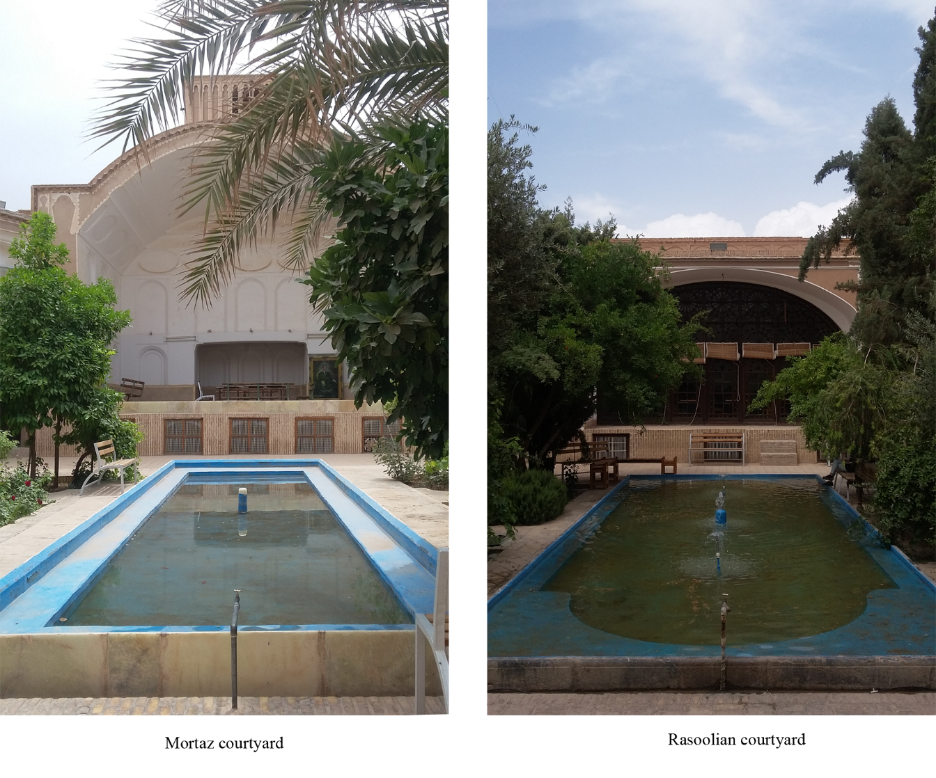

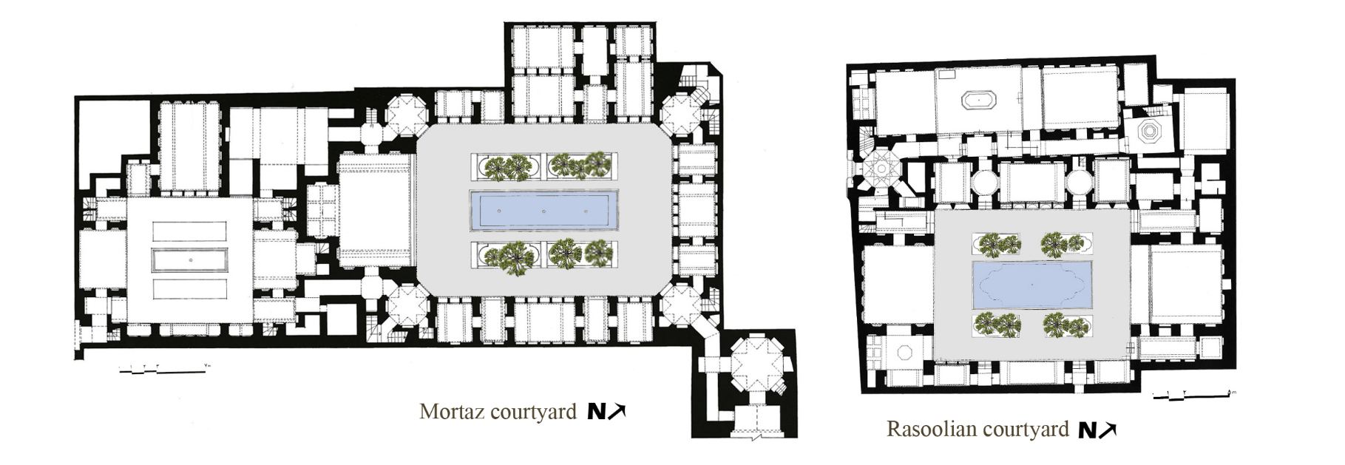

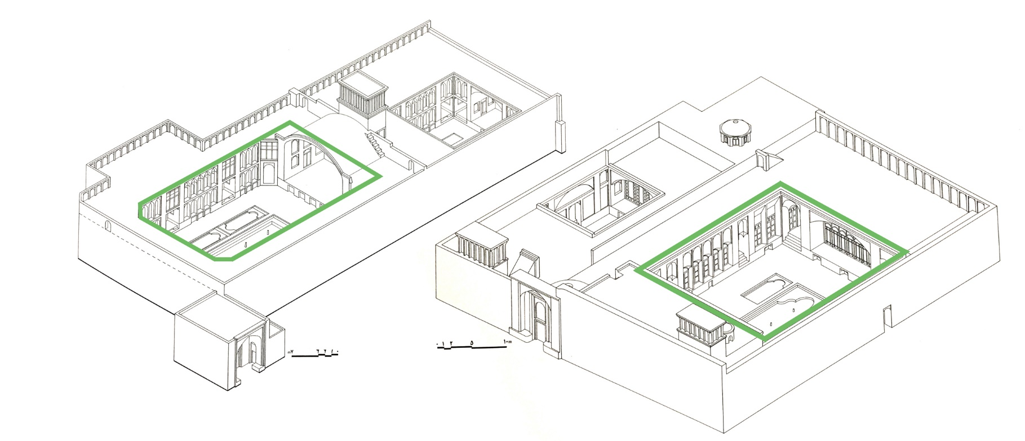

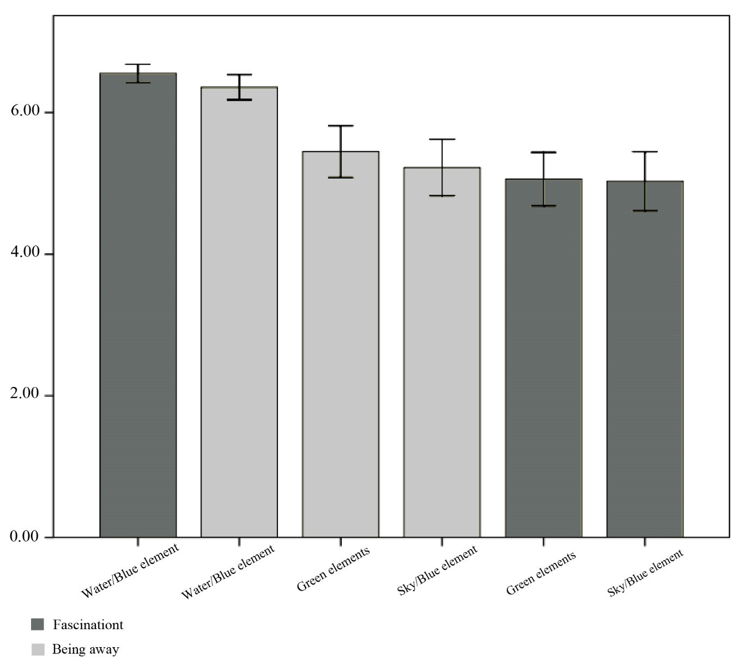

Captions
Fig 1. Studied courtyards: Mortaz courtyard (left), Rasoolian courtyard (right) (by authors)
Fig 2. Plans of studied courtyards [53]
Fig 3. Perspectives of courtyards: Mortaz courtyard (left), Rasoolian courtyard (right) [53]
Fig 4. The results of repeated measure ANOVA test

 Corresponding author: Azadeh Khaki Ghasr, Faculty of Architecture and Urban Planning, Shahid Beheshti University, P.O. box 1983969411, Tehran, Iran. E-mail address: A_Khakighasr@sbu.ac.ir

