Author: Nasser Koleini Mamaghani
Associate Professor
Industrial Design Department,
School of Architecture and Environmental Design,
Iran University of Science and Technology (IUST)

Co-Author: Elham Barzin
Ms Graduated in Industrial Design

Corresponding Author: Nasser Koleini Mamaghani
Tel: +98 21 77240467
Mobile: +98 9124478430

Application of quality function deployment (QFD) to improve product design: The school furniture case
Abstract: Today Quality Function Deployment (QFD) is a powerful development method whit a wide range of applications to translate customers’ needs into technical requirements for achieving customer satisfaction. The current study demonstrated a QFD analysis to improve school furniture design in Tehran as the baseline of Iran. Accordingly, we extended the widely used QFD method into a complex set of customer demands about the school furniture and showed the step-by-step application of QFD that focused on the firs matrix known as House of Quality matrix. The study started by identifying the problem statement, specifying the objectives and designing the scopes of school furniture. 160 students recruited from three high schools located in different areas of Tehran participated in our study. Student’s requirements were collected and translated into the technical requirements using QFD method. Data gathering was carried out through survey, questionnaire distribution and structured interview. Subsequently, the collected data was analysed to find the best solutions for the problems. Obtained results from House of Quality matrix evaluation, were used to provide suggestions and solutions to reduce the problems. The present case study shows that QFD method can help demonstrators to ascertain inter relationship between operation requirements and measures of performance.
Keywords: Quality function deployment; School furniture; Voice of customer; Customer satisfying; Methodology

1: Introduction
The issue of education in developing countries has always been a critical factor for achieving progress in economic, political, social and cultural background. In this regard, providing the necessary background to help education seems essential (Cotterell 1988; Gonzalez et al. 2003). In educational environment like schools, one of the most important and regularly used equipment by students is furniture. No doubt good furniture away from any issues will be effective to ease the process of learning (Mortazavi 1988). Previous studies in Iran showed that certain school furniture causes some medical problems such as short-term or chronic injuries in neck, backs and legs (Esmaeili et al. 2008). Moreover other issues like rough writing surface, inappropriate dimension, low quality and something like this, negatively affect education quality (Khorram et al. 2004). Additional description about school furniture problems in Iran will be described in this paper. The purpose of the present study is identifying student requirements regarding functionality, material, structure, ergonomics and aesthetics. Eventually, some suggestions will be provided to design strong, ergonomic, durable and charming furniture that efficiently improves student learning process. The organization of the study is as follows: First we explain the most important problems of school furniture in Iran. Then, we describe the methodology of the present study that is based on Quality Function Deployment (QFD) and literature review. It should be noted that, the main purpose of the present case study was to apply QFD to develop a method of customer-oriented design. It is also important to emphasize that this study have focused on House of Quality, described as the first step of QFD according to the research issue. Finally results of House of Quality evaluation will be presented in conclusion.

2: Problem statement
According to field studies in Iran, students almost spend one-third of their daily time in the school, near to 30 hours in a week. Therefore, comfortable furniture is necessary for their health and for improving the quality of education (Mirzaei 1997; Zamani 2004). In order to gather data from furniture in use, this study has been planned to visit different schools. Basic step in QFD method has been considered very well for help to experience the product, specific environmental parameters that product used in it, condition of usage and study about customer needs and problems (Gonzalez 2001). Based on information that found with this method, some reasons have been identified which cause student exhaustion. Also, the results of previous studied indicated that the most problems are mismatches between student anthropometrics and dimension of table or chair leading to pain and discomfort (Esmaeili et al. 2008). Range of participant student’s age in the current study was 14 to 16 years old. The reason of choosing this range is remarkable variation in student anthropometrics in these ages. However, furniture with the same dimension are used in schools for all the students with different anthropometric. 160 students from three high schools were studied. Students answered a questionnaire which asked about discomforts and dissatisfactions about furniture. Most important dissatisfactions were inappropriate material, dimension and form. Also several students complained about absence of dedicated place for their tools and bag. Also inferior materials that fall apart quickly, injure body and damage student’s clothes. Regarding ergonomics problems the most important mismatches are between both chair and table height with student’s body size. Generally these problems can be grounded in three different areas. First group is physical problems like arising due to lack of proportion of furniture and physical characteristics of the students. Second group is problems about student’s dissatisfaction that expressed in interviews such as low quality of material or non-attractive form and colour, inadequate surface for writing and so on. Lack of student interest in the environment and education facilities may indirectly cause negative impact on the education process. The third group is cost-related issues like poor quality of material and construction leading to a loss of funding that would be allocated for renewal of the furniture.

3: Literature review
Designing is a complex problem-oriented process, which must fulfil all the demands and expectation concerning the product (Gondor and Pataki 2008). The first step in product design is to analyse and translate the need or deficiency into specific qualitative and quantitative customer and design requirements (Verma and Knezevic 1996). In order to regard all demands concerning the design process, a complex methodology is needed. Quality can be defined as meeting customer needs by providing superior value. It focuses on satisfying the customer's on products or services. Quality often is hard to explore and sometime measurement of quality is difficult (Gento et al. 2001). There are many tools that help researcher to define and measure the quality. One of these methods is QFD. If we consider a line between art and engineering, QFD move on this line and help to combine these to create a successful product (Brotchner and Mazur 1999). Field of QFD application is very broad. This method introduce in Japan as quality system focused on delivering products and services that satisfy customers. Scope and depth of usage QFD was introduced in 1960 by Professor Yuji Akao and subsequently published in 1972 and in 1980 this method was used in Japan industry. According to Perry and Debra (1997) the term QFD is a loose translation from Japanese name for this methodology, "him shitsu" (quality), "kinkou" (function), "ten kai" (deployment). Traditional QFD has included 16 matrixes that pre computer age was done by hand. In most of USA companies QFD was known equal with 4 matrixes that we will show that in this paper. House of Quality is the name of first matrix that used in QFD method, a process framework to prioritizing consumer’s requirement. QFD is a detailed system requirement for implementing the wishes and desires of costumers in the design, manufacturing or service jobs (Moubachir and Bouami 2015; Terninko 1997). Generally QFD is a tool for assuring about both quality of product and quality of process (Delgado-Hernandez et al. 2007). To efficiency deliver value to customers, it is necessary to listen to the Voice of Customer throughout the product or service development process (Hwarng and Teo 2013; Mazur 1996). The QFD with the creation of a comprehensive process in design background, improve product quality and do this by creating sensitively to the demands of the customers or users (Zadry et al. 2015; Terninko 1997). In this method the role of experts as translators, is translate the users demand into the technical variables including product specifications, design attributes, and ultimately to the manufacturing process parameters (Rezaie et al. 2001; Mizuno and Akao 1994).
QFD is a product development process that stresses cross-functional integration (Ionica and Leba 2015; Gonzalez 2001). Indeed QFD has been used to translate customers’ requirements and needs into technical requirements for achieve customer satisfaction (Sadeghi et al. 2013; Akao 1990). According to Kim et al. (1998) advantages of using QFD are: decreasing the number of design changes, reduced product development cycle time, fewer problem in the start up the project and user satisfaction. QFD has been widely adopted in the development of various products (Cerit et al. 2014; Chan and Wu 2002). Based on records of activities that done by various organizations, in some cases it was observed that some companies continued in this way for years and then have been achieved remarkable results. Also during this time, reduction in the number of engineering changes cause that product development cycle was reduced by one third. Evaluation of true information could help to designers to make appropriate decisions to better and more efficient design (Sullivan 1986). In other activities the Puritan-Bennett company, designed and manufacturer of respiratory measurement devices, could with using this method introduced a new model of their product to the market that besides having more and better features and prices than their competitors. With this method could take the huge part of product market. This company used 16 types of QFD matrixes in following background: new product design, new manufacturing process, using new technology, manufacture product in new integrated manufacturing, manufacture product with new equipment and working with new staff (Terninko 1997). Several researchers have been working on approaches for QFD and developed a number of interesting models and applications using QFD as solution tool (Moldovan 2014; Gonzalez et al. 2003). In another study QFD used to evaluate the effectiveness of training sources in Hong Kong City University. They were used QFD and the analytic hierarchy process (AHP) to estimate training courses. They estimated the courses according to students, in spite of times that evaluations have been done by teachers (Syedjavadein and Shahhoseini 2006). It should be noted that engineering manager were also asked to prioritize their needs using the AHP (Rajesha and Malliga 2013). The AHP uses pairwise comparisons that allow for an accurate measure of importance, including a ratio scale distance between values, unlike the more traditional rating scale used in QFD (Pakizehkar et al. 2016; Mazur 1996a). Another study show that QFD was used for improving social services to disable people and shows that interviewing variables in providing quality services must be identified and managed (Mazur 1996b). Bolt and Mazur (1999) shows another background of QFD usage in tangible product design of animatronic dinosaur to be used in a service operation. Mazur (2008) shows that how the sales and customer satisfactions increase with using QFD in food industry. In furniture issue, Knight and Noyes (1999) shows that how student’s behaviour are affected from non-standard furniture, and with new design furniture were given more sitting position choice to the student to correction theirs false position of seating. Today, QFD continues to inspire strong interest around the world, generating ever new applications, practitioners and researchers each years.

4: Research methodology
Much literature has demonstrated both successes and issues with the QFD methodology (Chan and Wu 2002). According to Jackson and Frigon (1994) QFD uses the following seven management tools: affinity diagram, interrelationship diagram, tree diagram, matrix diagram, process decision program chart, arrow diagram, and matrix data analysis chart. Methodology of the present study based on QFD method is shown in Figure 1. The purpose of using QFD in the current study is summarized in three points. The first one is translation of student’s requirements from furniture into the technical requirements in design stage. Finding solutions to reduce furniture problems and defining the most important variable for the final product that increase student’s satisfaction are the following points. The data come from many sources, including focus groups, questionnaire surveys, experimental tests of computer's products, and published materials.
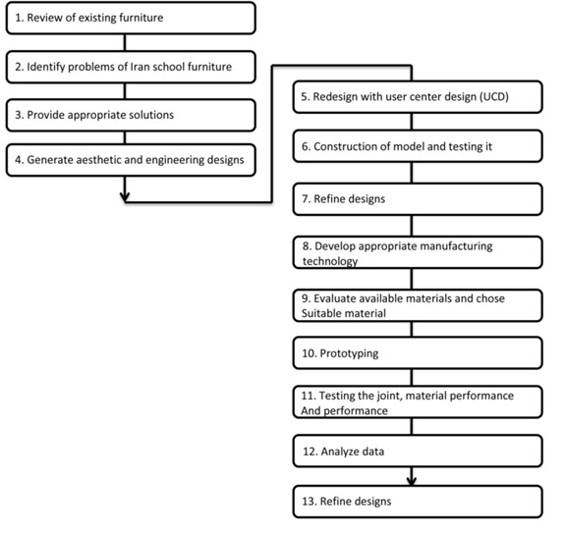
Figure 1. Methodology of our study.

Required information was collected by studying on 160 students from three independent high schools located in three areas of Tehran. As shown in Figure 2, QFD often employs four matrixes (Quesada 1997; Gonzalez 2001). The first phase of QFD is product planning matrix which is normally known as the House of Quality. On the other hand, the primary feature of the QFD process is the House of Quality, which provides inter-functional product planning mapping to link engineering attributes to customer desires, which are ranked in importance (Clausing and Hauser 1988; Hoyle and Chen 2007). It looks like a real house. The present study focused on the first matrix, House of Quality.
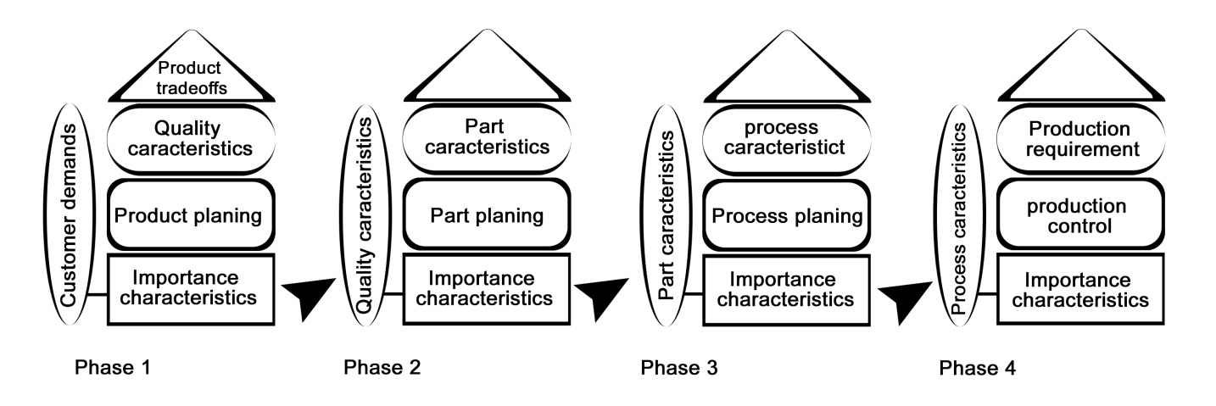
Figure 2. The four phase of Quality Function Deployment (QFD) (Marcum et al. 1995; Gonzalez 2001).
Collecting the information was started with going to the Gemba where the customer interfaces with the service to observe, listen, and record the problems customers experience and the opportunities they wish to seize. Gemba is a Japanese word using to describe the information that is achieved from true resources (Mazur 1996b). User’s comments and requirements were collected with a questionnaire by opened questions. Then To achieve new requirement from study of environment requirements classification has done with Voice of Customer method. In order to obtain and summarize the most important requirement, factor analysis has been used to decrease the number of House of Quality variables. Next step is the transferring the students requirement to the House of Quality matrix. The framework of a typical House of Quality, mainly includes seven parts, is shown in Figure 3. Step by step of completing the House of Quality matrix, has been described in Figure 3. This particular types of House of Quality emphasizes on the correlation matrix between customer requirements and technical parameters. In QFD application, it is essential to define the "What's" and "How's" according the nature of the issue. Also it is very frequent that each "What" needs a specific "How". The key question to be asked is "What" the students' expectations would be from the school furniture. Interviews, surveys, organizing groups, Gemba visit and content analysis are generally used in order to define the customer needs (Gonzalez et al. 2003). To develop the technical requirements as the "How's" part of House of Quality, a brainstorming was held with the members of the design team which consider the movement of target value for improvement of the layout and feature design. Using the correlation between the customer needs (What's) and the technical requirements (How's), it is possible to determine strength of relationship and impact on the need (Figure 3).
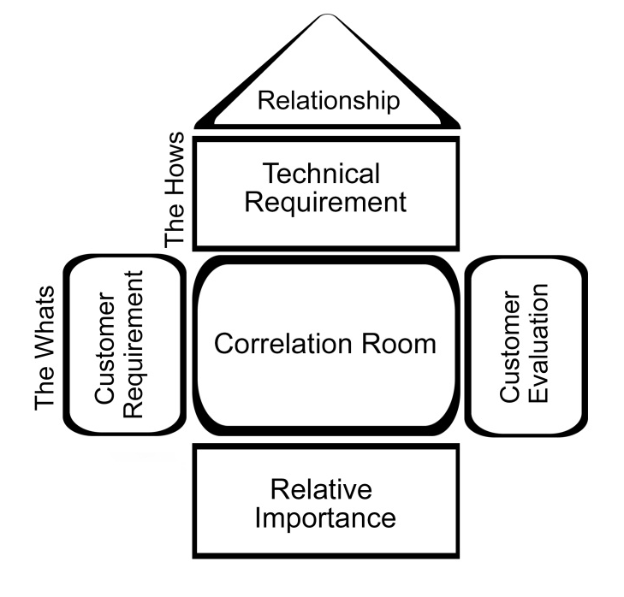
Figure 3. The framework of a typical House of Quality matrix (Gento et al. 2001).

5: QFD application on product development process
One of the most important purposes of QFD is to search all possible demands from consumers. In this study, student’s demands or problems were collected by going to the Gemba. Gemba include activities such as going to product usage environment, identifying product users and determining the methods to hear the Voice of Customer (Mazur 1996a), particularly in the context of product usage or service. Context is easily described by the 5W1H (who is using, what is it used for, when is it used, why is it used, and how is it used). Information was collected directly from students without any intermediate. The interviewees were given a questionnaire to fill up with contact information. Students were also asked to describe the school furniture and whether they are satisfied with the current ones. They were also inquired to indicate, if any, the improvements of the current school furniture that could be done. From the personal interviews and questionnaire information, 180 requirements (step 1 of Figure 4) have been identified. Subsequently, these 180 requirements were increased to 200 with classification and quantification of the Voice of Customer (step 2 in Figure 4).
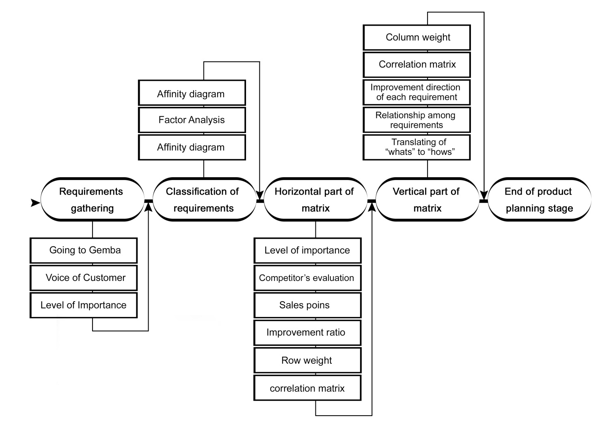
Figure 4. The House of Quality methodology in our study.
Next step was creating the harmony between obtained data. Data in this stage should be presented in desirable qualities form. Typically there are many customer’s requirements, but using a technique known as affinity diagramming, the team distils theses many requirements into 20 or 30 most important needs. Affinity diagrams are used to organize and gain insight into a set of qualitative information, such as Voice of Customer requirements. We also employed affinity diagram to identify the student requirements that were not expressed by them. Usually affinity diagrams are created in four steps: 1) recording each customer statement onto separate cards, 2) sorting cards into groups, 3) selecting or creating a title card, which summarizes the data within each group, and 4) title cards can be sorted into higher-level group. Transferring the 200 requirements to the “What's” part of House of Quality matrix is very difficult and time-consuming job. Therefore, we decreased the number of these requirements to the 28 requires using factor analysis (step 2 in Figure 4). In Table 1 shows how the 28 requirements were put into 28 variables. 28 requirements is still difficult to evaluate in House of Quality matrix, so the QFD team with help of manufacturer and the people involved in education system, decreased the number of requirements to 13 variables in two groups involved table and chair (Figure 4).
Table 1. 28 Original requirements of students.
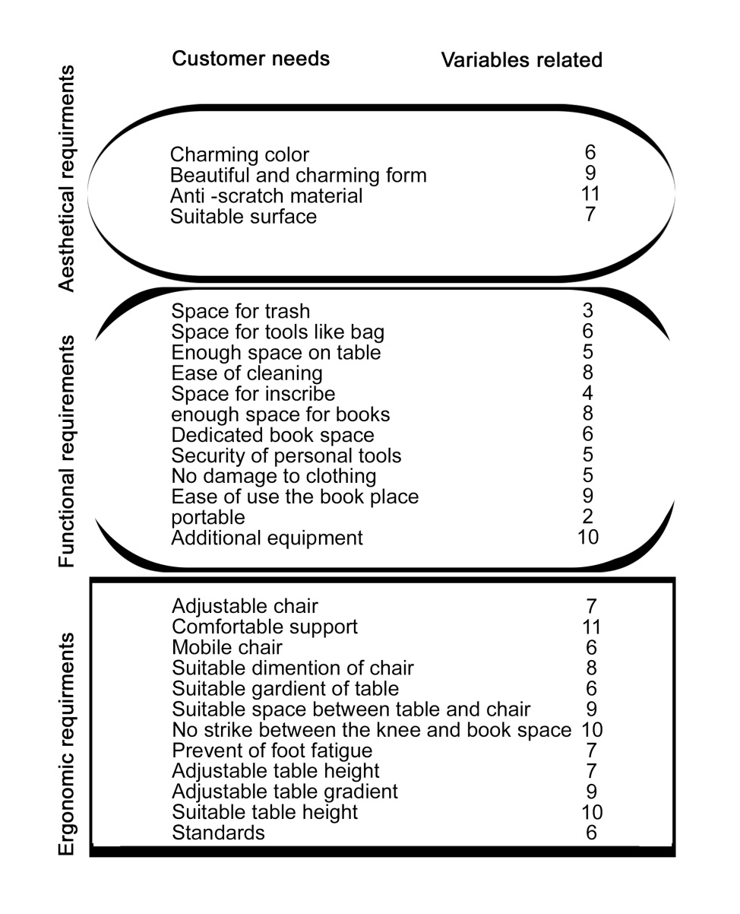
No doubt, the importance of all requirements is not equal from student’s or producer’s point of views. So, for determination the level of importance for all requirements, we used a rating system (from 1 to 5) with five selections points. Number 1 used to requirements that are not very effective on students satisfying and number 5 for requirements with most importance in their view point (step 3 in Figure 4). Obtained information was transferred into the House of Quality matrix. According to the stage three of Figure 4, the number of complains, evaluation of competitors, were considered. This matrix shows comparison of product capabilities in satisfying the customer with other competitor company capabilities. Other information were summarized in the House of Quality weight, a computed value relating the importance to customer, row weight and improvement ratio. This information will help us for identifying which customer requirement is most important to correction and spending time and money. In stage 4, we translated the student’s requirements, that called the “What's” in this matrix,, into the technical requirements that called the “How's”. In this regards, we asked manufacturers to how measure these requirements. The positive degree of correlation between student’s requirements and technical requirements is denoted with the following sing-scale: strong (9), medium (3), weak (1) and empty box (0). Then matrix like: targets, improvement ratio (relate target with the current performance measure in a specific requirement), sales point (the requirement in which the company has the ability to sell the product) and row weight were completed. Technical requirements were placed at the top of the House of Quality, and operational target values associate with these measures (Figure 5). In this study we focused on the first matrix for identifying the most important area about product that need to be improved. For building other matrix, inputs come from “How's” part of previous matrix that placed on “What's” in new matrix and this cycle continues until other matrix.
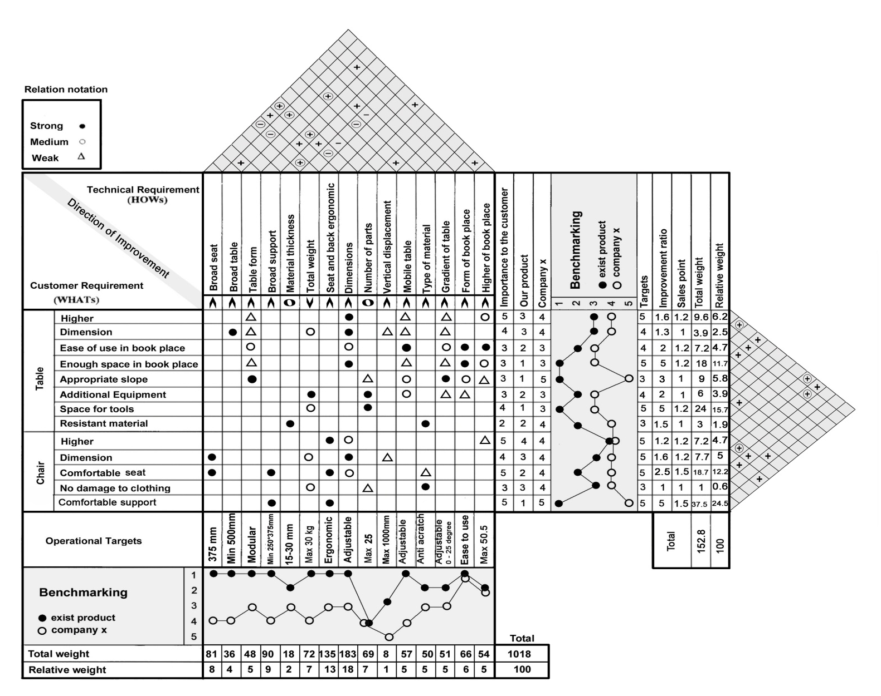
Figure 5. House of Quality matrix.

6: Discussion
Since traditional QFD may not cover all the urgent deployments, modern QFD (matrix-free) was used to response to the changing the needs of customers (QFD Institute 2008). In the present study, QFD matrix (House of Quality) helped us to identify student’s demands and problems about furniture during school time at three different high schools in Tehran. Using QFD method, the cycle of product design, the risk of product development and the costs can be generally decreased while the quality of the product is increased and the competition of enterprise is enhanced (Qu 2000; Liu and Zhang 2000). QFD is a valuable and flexible tool for designing. It has provided the tools, methods and structures to perform those activities, particularly at the critical to satisfaction phase (Falk and Schmitt 2014). The sequence of parts and steps during the QFD process can be changed according to the strategy adopted by the design team. The correlation matrix is the heart of the QFD process and stores precious information needed for design improvements (Gargione 1999). The presented study is one of the first report using QFD method undertaken in Iran about school furniture in students requires contents. In the previous studies design of school furniture such as chair and table was not impressible of student required in Tehran's schools. Using QFD, helped us to reach important and accurate information about student's needs and demands. Some of the student's requests seem not necessary at first, but this study showed that some requests such as "tools place" are important from viewpoint of students. These requests usually are ignored or unseen from designers. QFD discovered students hidden needs about chair and table that can lead to student's satisfaction and fulfil their demands such as "no damage to clothes", "resistance material" or "space for tools". According to Figure 5 in "importance to the customer" part, our findings showed that "comfortable seat", "height of the table and chair" and "comfortable support", come up with most importance for students. As well "dimension of table and chair" and "space for tools" are placed in the next stage. As student’s bag and clothes will be muddy without special space dedicated space for tools, is one of the requests that student emphasis on it repeatedly. Eventually, other customer need such as "ease of use and enough space in book place", "appropriate slope", "additional equipment" and "no damage to clothes" are in the next level of importance. "Resistance material" avoiding damage during the school time has found as the lowest importance factor.
Quality of furniture that are used in some school in Tehran is low and students have initial needs and request from designer to solve. Our finding indicated that student requests such as ergonomic and dimensional problems are simple and affordable. According to the Figure 5 the “comfortable support” requirement, with 24.5 weights, shows the most important requirements that need to superior attention. This comfort will be provided with “broad support” of chair and “seat and back ergonomic” as technical requirements. Comparing furniture in the present study with other companies’ products for this requirement indicated poor quality of our furniture. Weight of this requirements show the importance range of any require to improve. Second requirement representing highest weight is “space for tools” with total 15.7 weight. Student’s need about space for their tools such as bag, umbrella and etc. is more crucial in their view sight than our expects. Moreover, requirements such as “comfortable seat” and “enough space in book place” are important for consideration with 12.2 and 11.7 weights respectively. Another requirements such as “higher of table”, “chair dimensions”, “ease of use”, “book place” and “higher of chair” are placed on the next rank. Least weighs for “no damage to clothing” shows that this requirement is not very necessary to deal with. The comparison between our product and other products, shows that almost in used products is in low quality regarding the student’s requirements. This matter shows that existing table and chair need to be improved immediately because low quality of these furniture may cause many serious physical or mental problems for students. So it seems that designer must pay essential attention on school’s furniture. Weight of this requirements shows the priorities of them to improve.

7: Conclusion
The QFD method is a very helpful to analyse the customer's desires with solutions along a new design to generate high quality and competitive products and processes. Today the validity of the QFD method for linking customer expectations is increasingly recognized and this methodological tool is capable of providing a solution to the problems of integrating all aspects in to product design from degree program design, to curriculum, and to specific activity (Haapalainen et al. 2000). Artefacts produced in the course of QFD studies contain much data which correspond closely to the data required as input to various popular object oriented methodologies. The QFD enables to know which user’s requirements are the most important and which need to be included in the final new product. Understanding the true needs of customers requires work on the part of designers and planners. In this study, the quality based requirements are considered first, then the issues of scheduling are evaluated.
Our finding revealed that how furniture defects can negatively impact on student satisfying and exhausting during education process. According to obtained data, "seat comfortable" is the most important issue from view point of students that cause back, neck and leg pain. Design of table and chair according to the House of Quality matrix may solve furniture problems and satisfy student, but augment of this issue needs more research and study after using the product in long time. However, many other important problems of school furniture were also identified including teacher’s desk and table and classroom board that need special attention to improve. It should be noted that as QFD just provides a framework deploying the customer requirements into product design, other approaches must be applied and recommend with QFD in order to make the method stronger and more effective in the conceptual design of school furniture. Giving a theoretical foundation, the analysis of our study has verified that the new design based on finding is relevant and effective. Using QFD method, it is possible to determine the most important point in existing furniture that should be corrected and provide technical solution as technical targets in product planning stage for achieving the students comfort and satisfying. In conclusion, QFD has been proven to be an effective means of process development and product deployment, and it is a good suggestion to solve problem of this furniture in the future. This study present basic information about student and their requirements in classroom and future study could employ this information to solve student's problem completely. In the future research, we will consider the conflict and optimization between qualities and schedule, as well as resource limitations to establish a more complete expert system.

References

Akao, Y. 1990. Quality Function Deployment: Integrating Customer Requirements into Product Design. Productivity Press. Translated by Glenn Mazur Cambridge, MA.

Akao, Y.1994. "Recent approach of quality function deployment." In QFD: The customer-driven approach to quality planning and development. Edited by Mizuno, S., and Akao, Y. Asian Productivity Organization. Tokyo.

Bolt, A., and Mazur, G. 1999. "Jurassic QFD: Integrating Service and Product Quality Function Deployment." Paper presented at The Eleventh Symposium on Quality Function Deployment, Novi, Michigan, June 14-15.

Brotchner, J., and Mazur, G.1999. Brand engineering using Kansei Engineering and QFD. QFD Institute.

Cerit, B., Küçükyazıcı, G., and Kalem, G., 2014. "Quality Function Deployment and Its Application on a Smartphone Design", Balkan Journal of Electrical & Computer Engineering, Vol.2, No.2, pp. 86-91.

Chan, L.K., and Wu M.L. 2002. "Quality Function Deployment: A literature review." European Journal of Operational Research 143 (3): 463-497.

Clausing, D., and Hauser, J. 1988. "The House of Quality." Harvard Business Review 66 (3): 63-73.

Cotterell, j. L. 1988. "Effects of school architectural design on student and teacher anxiety." Environment and Behaviour 16: 455-479.
Delgado-Hernandez D.J., Bampton, K.E., and Aspinwall, E. 2007. "Quality function deployment in construction." Construction Management and Economics 25: 597-609.

Esmaeili, S.A., Atri, A.E., and Javaheri, A.A.H., 2008. "Evaluation and Investigation of Ergonomics of School Chair and Table with Students' Anthropometric Data." Paper presented at Six International Conference on Education and Sport Science, Kish Island, Iran.

Falk, B., and Schmitt, R., 2014. "Sensory QFD: Matching Sensation with Measurement, Variety Management in Manufacturing. Proceedings of the 47th CIRP Conference on Manufacturing Systems, Procedia CIRP, 17, pp. 248 – 253.

Gargione, L.A. 1999. "Using quality function deployment (QFD) in the design phase of an apartment construction project." Paper presented at IGLC-7, 26-28 July 1999, University of California, Berkeley, CA, USA.

Gento, A. M., Minambres, M.D., Redondo, A. and Perez, M.E. 2001. "QFD Application in a Service Environment: A New Approach in Risk Management in a University." Operational Research, An International Journal 1 (2): 115-132.

Gondor, V., and Pataki, M. 2008. "Designing textile products for the full life cycle with a special focus on maintenance during usage." Acta Polytechnica Hungarica 5(3): 19-28.

Gonzalez, M. 2001. QFD: A Road to Listening to Customer Needs. 1st ed., Mexico: McGraw-Hill.

Gonzalez, M., Quesada, G., and Bahill, T. 2003. "Improving Product Design Using Quality Function Deployment: The School Furniture Case in Developing Countries." Quality Engineering 16(1): 47–58.

Haapalainen, M., Kivisto-Rahnasto, J., and Mattila, M. 2000. "Ergonomic design of non-powered hand tools: An application of quality function deployment (QFD)." Occupational Ergonomics 2 (3): 179-190.

Hoyle, C., and Chen, W. 2007. "Next generation QFD: Decision-based product attribute function deployment." Paper presented at International Conference on Engineering Design, ICED'07, 28-31, August, Paris, France.

Hwarng, H. B., and Teo, C., 2013. "Translating customers' voices into operations requirements: a QFD application in higher education", International Journal of Quality and Reliability Management, 18, pp.195–225.

Ionica, A. C., and Leba, M., 2015. "QFD Integrated in New Product Development - Biometric Identification System Case Study", Procedia Economics and Finance, 23, pp. 986 – 991.

Jackson Jr., H.K., and Frigon Sr., N.L. 1994. "The practical Guide to World Class Competition" In Management 2000, edited by Van Nostrand Reinhold, N.Y. Chapter 9: 342-367.

Khorram, M., et. al. 2004. Evaluation of School Equipment Standardization. Published by: State Organization of School Renovation, development and mobilization- Iran (in Persian).

Kim, J.K., Han, C.H., Choi, S. H., and Kim, S. H. 1998. "A knowledge-based approach the quality function deployment." Computers and Industrial Engineering 35(3-4): 233–236.

Knight, G., and Noyes, J. 1999. "Children’s Behaviour and the Design of School Furniture." Ergonomics 42(5): 747-760.

Liu, E. and Zhang, L.(2000) Quality Function Deployment Theories and Methods-Review on research progress, System Engineering, Vol.18, Feb.2000, pp.1-5.

Marcum, J.W., Hatcher, J.M. Green, R., and Hodges, B.A.1995. Book Review- QFD: The Customer-Driven Approach to Quality Planning and Development, edited by S. Mizuno and Y. Akao. National Productivity Review 14(2): 128-129.

Mazur, G. 2008. QFD in the food processing Industry. 2008 QFD Institute.

Mazur, G.1996b. "The Application Quality Function Deployment (QFD) to Design a Curse in Total Quality Management (TQM) at the University of Michigan College of Engineering." Paper presented at International Conference on Quality, ICQ '96- Yokohama, Japan, JUSE, October15-18, 1996.

Mazur, G.1996a. "Voice of Customer Analysis: A Modern System of Front-End QFD Tools, with Case Studies." Paper presented at Proceeding of AQC 1997, Orlando, May 5-7, 1997, ASQC.

Mirzaei, R. 1997. "Discussion of School equipment Standardization." Quarterly Journal of New School 7: 6-11 (in Persian).

Mizuno, S., and Akao, Y. 1994. QFD: The customer-driven approach to quality planning and deployment. Asian Productivity Organization. Tokyo.

Moldovan, L., 2014. "QFD employment for a new product design in a mineral water company", Procedia Technology, 12, pp. 462-468.

Mortazavi, S.1988. Environmental Psychology of Educational Spaces. Published by: State Organization of School Renovation, development and mobilization- Iran (in Persian).

Moubachir, Y., and Bouami, D. 2015. "A new approach for the transition between QFD phases", Procedia CIRP, 26, pp. 82 – 86.

Pakizehkar, H., Sadrabadi, M. M., , Mehrjardi, R. Z., and Eshaghieh, A. E., 2016, "The application of integration of Kano's model, AHP technique and QFD matrix in prioritizing the bank's subtractions", Procedia - Social and Behavioral Sciences , 230, pp. 159 – 166.

Perry, J.L., and Debra J.M.1997 "Strategic human resource management, Public Personnel Management: Current Concerns." In Future Challenges. Edit by Carolyn Ban and Normal M. Second Edition. Riccucci. New York: Longman.

QFD Institute. 2008. QFD: Transactions from the Twentieth Symposium on Quality Function Deployment. Santa Fe, NM, October 24, 2008.

Qu, L. 2000. "Review on Quality Function Deployment Technology and Application." Journal of Industrial Engineering 14: 52-60.

Quesada, G.1997. Design of Quality Strategies Focused on Customer Service (ECSEC). Unpublished dissertation. Cartago. Costa Rica Institute of Technology of Costa Rica: 50–57.

Rajesha, G., and Malliga, P., 2013. "Supplier Selection Based on AHP QFD Methodology", Procedia Engineering, 64, pp. 1283 – 1292.

Rezaie, K., Ashtiyanie, H. and Houshyar, M.2001. QFD: An approach to customer oriented in Planning and Quality Function Development of Product. Published by RWTUV & Atena Press, (in Persian).

Sadeghi, M. Tabatabai, D., and Alizadeh, D., 2013. "Training of customer satisfaction modeling with the approach of KANO". (First publication), Koohsar publications.

Sullivan, L.P. 1986. "Quality function deployment." Quality Progress 19 (6): 39–50.

Syedjavadein, S.R., and Shahhoseini, M.A., 2006. "Organizational Training Needs Design by QFD: Productivity Improvement Approach." Iranian Accounting & Auditing Review 46: 28-43.

Terninko, J.1997. Step-by-Step QFD: Customer- Driven Product Design. St. Lucie press, Nottingham.

Verma, D., and Knezevic, J. 1996. "A Fuzzy weighted wedge mechanism for feasibility assessment of system reliability during conceptual design." Fuzzy Sets and Systems 83 (2): 179-187.

Zadry, H. R., Rahmayanti, D., Susanti, L., and Fatrias, D., 2015. "Identification of design requirements for ergonomic long spinal board using quality function deployment (QFD)", Procedia Manufacturing, 3, pp.4673 – 4680.

Zamani, B.E. 2004. "Preparing student for life: Education for Information ages." Journal of Technology of Education, 7: 22-25 (in Persian).

