A method to Use Metaphors in Creative Architectural Design

Mehdi Khakzand
Assistant professor in landscape architecture,
Iran university of science and technology, Tehran, Iran
Email: mkhazand@iust.ac.ir
Tell: +98(21)77240467 Fax: +98(21)77240468

Maryam Azimi
PhD in Architecture
Email: m_azimi@iust.ac.ir

A method to Use Metaphors in Creative Architectural Design

Abstract
In the developing world, skills in innovation and creative design have emerged as key attributes for graduating designers. Creativity is essential if we want to generate new solutions to the considerable and complex problems in architecture. Metaphor is frequently expressed as a key tool for enhancing creative design yet little empirical research has been performed on how novice designers can use it within their design.
The goal of this study was to research empirically the use of metaphor in the design studio, with a focus on its affects on design creativity and quality. A three stage method for novice designers to use meanings and metaphors in the early stages of the design and idea generation is presented. This method was tested in architectural studio in two groups as experiment and control group and a qualitative research method was used to evaluate it. A questionnaire was prepared in which the students were requested to assess the use of this method in their design process. Also expert designers evaluated the design products in both control and experiment groups. The results emphasize that metaphor is a helpful and valuable source for young designers to stimulate design creativity and has affect on different design quality factors. Findings have implication for novice architecture designers and help them to enhance creativity and increase design quality.

Key words: Metaphor, Creativity, Design, Design process and product.

1- Introduction
Almost all design proceeds by transforming, combining and adapting elements and objects. Everything can be a source of inspiration to designers. They use a variety of references: comparable designs; other types of design; images and works of art; and objects and phenomena from nature and everyday life [1].
Considering this reality is important that architecture forms require creativity. To enhance this aim, designers use different kinds of principles, tools, and heuristics, such as metaphors.
Metaphorical thinking is defined as ‘‘a description of an object or event, real or imagined, using concepts that cannot be applied to the object or event in a conventional way’’ [2]. Metaphors are commonly used as linguistic devices in everyday communication [3], but can be also found in a variety of domains such as science, engineering, art, design, and education.
Stories and anecdotal examples about the use of metaphors can be found in the design literature [4], but empirical evidence of its utility and effectiveness during the design task is rather scarce. Apart from the use of metaphors in design, their contribution to design thinking is not completely understood. In one of the few empirical studies, Casakin [5] found that metaphors facilitate the identification of design goals and the retrieval of design concepts. Metaphors also facilitate the generation of innovative solutions, mainly in earlier stages of the design process [6].
Metaphorical reasoning can help to use artistic and technological knowledge and increases the exploration of various design solutions and develops lateral thought processes [7], and improve students’ performance in the design studio by encouraging reflection on design problems anew [8].
From a cognitive point of view, metaphors are considered as a valuable problem solving strategy [3, 9]. A major feature is that they enable the structuring of a problem situation from a novel perspective that is mostly important for creative activities like design [10].
Believing that creativity is a skill that can be learned and taught, the question of how creativity can be enhanced or how one can be creative in design problem-solving has been a challenge of design education [6, 11, 12 and 13].
Additional empirical research is needed in order to gain a better insight about the use of metaphors in design problem solving, and in the architecture domain in particular. The questions of how metaphor can affect creativity of design product and how it should be employed by the novice designers constitutes the main framework of this study, which is assumed to have considerable implications for teaching creativity in design in particular.
The study aims to explore empirically how novice students recognize and put into practice metaphors during a three-stage process (designed by authors), in order to deal with architectural design problems.
In the first part of this research, the significance of creativity in evaluating the design product is explained. Then, the importance of metaphor and its relevance to design is discussed. In the second part, author’s experience and empirical study conducted in design studio is described. Next, the results from a survey completed by students about the influence of the method on their design product and a survey completed by architecture experts about the assessment of creativity in designs, and conclusions about the use of metaphors during the important stages of the design process are described.
2- Materials and Methods
2-1- Creativity and design
Creativity is a complex human phenomenon that is widely believed to be inaccessible to analysis and even less so to measurement. Nevertheless, in recent times there have been advances in our understanding of the nature of creativity and a growing consensus that common features can be identified across different domains [14].
There are many definitions of creativity. In a recent complete survey, Sarkar and Chakrabarti [15] analyzed over 160 definitions. From these, with two different methods – majority analysis and relationship analysis – they proposed a “common” definition of creativity, as follows: Creativity occurs through a process by which an agent uses its ability to generate ideas, solutions or products that are novel and valuable. Value, in the context of technical or engineered products (hence forth referred to as products), take on the meaning of utility, or usefulness.
The purpose of architectural design activity is to develop an initial idea or concept and transform it into a complete design for a building [16]. Creativity is a fundamental aspect in design problem-solving since the development of new design solutions demands to put into practice creative skills [12]. In fact design is understood as a problem- solving involving productive thinking [17] and the generation of innovative solutions [18, 19].
The question is how the creativity of design students and their products can be evaluated. Guilford [20] defined four main factors to assess creativity when is put into practice. These included: originality or innovation (the statistical rarity of the responses), elaboration (amount of detail in the responses), fluency (the total number of relevant responses), and flexibility (different categories of relevant responses).
The suggested factors are necessary and important in assessments of individual creativity in a variety of fields. But these factors are insufficient to assess creativity in architectural design. The reason is the complexity of design problems, which involves a large number of aspects.
Casakin and Kreitler [21] used additional group of variables for design evaluation. These factors involve the following: (i) consideration of problem constraints; (ii) usefulness of the design product; (iii) aesthetics of the design product; (iv) practicality of the design product; (v) relation of the design to the physical context; and (vi) value of the design product.
In this paper, in addition to sited factors, authors used some other indicators about creativity and design quality. These factors are being satisfied from the design product, using new and none repeated forms, considering consequence of initial beliefs, novel design and innovation instead of routine design.
2-2- Metaphor
Current theories have defined metaphors as a structuring of our cognitive system [3]. Metaphors structure human thinking in every form of knowledge [22]. They are critical forms of understanding by which we figuratively understand our experiences in the world. The metaphors that inform our thought and structure our knowledge range from those which might be regarded as functioning on a surface level in language to those which seem to work on a more deeply embedded cognitive level [23].
Metaphors facilitate the understanding of an unfamiliar situation in terms of a known situation [24]. By means of metaphors, it is possible to make reference to what is clearly understood in order to elucidate the unknown. Basically, metaphors constitute an uncommon juxtaposition of the familiar and the unusual [9]. Metaphors are viewed by cognitive psychologists [24, 25] as efficient heuristics aiding problem solving, particularly in a variety of domains such as engineering [26], education [27] art and architecture [28, 29] where the production of creative solutions is necessary.
The theory of metaphor presented by Lakoff and Johnson [3] and by Lakoff [9] views metaphor as a tool that enables to categorize experiences according to a conceptual system. A main characteristic is that it influences how people think, perceive, understand, and classify experiences in their minds. The ambiguous character of these cognitive instruments allows exploring unfamiliar concepts and establishing novel correspondences with remote domains that are not connected to the problem at hand. Metaphorical reasoning permits the identification of previously unnoticed similarities regardless of the existence of vast difference. In the interplay between similarity and difference, conceptual meaning emerges and new knowledge categories such as technology are created [30]
According to these theories, metaphors are really helpful and valuable in problem-solving tasks and can help designers to enhance creativity.
2-3- Metaphor and Design Creativity
The process of design begins with a problem [31]. Designers solve the problem by the output designed through the design process [32]. In design, metaphors are viewed as heuristics that help organize design thinking and deal with ill-defined design problems [4, 28]. Metaphorical reasoning is an iterative process through which designers gradually increase their knowledge of a design situation. Basically, the use of metaphors aids in structuring design problems, which by definition are non-routine [33]. Thus, when solving non-routine design problems, it is difficult to predict what a solution will look like. It is in the early stages of the design process, when fuzzy metaphors aid reflection about the essence of a situation. Not only can metaphors assist in problem reflection but also help to break away from the limitations imposed by initial problem constraints [34], explore unfamiliar design alternatives, and establish novel associations with the design problem [35]. These are in themselves important reasons for which metaphors are believed to stimulate design creativity.
Antoniades [28] makes a distinction between the use of tangible and intangible metaphors in architecture. Whereas intangible metaphors are characterized by ideas, concepts, and qualities, tangible metaphors are related to visual aspects. It’s remarkable here that both of these categories can be inspiration sources for designers.
There are numerous examples and buildings designed by architects using visual metaphors, in the design literature, that have characterized some leading architectural design movements. According to Rowe [4] metaphors stressed by several of these movements have provided the force to highlight certain design aspects over others. The result has been a clear influence over architects' actions in the direction of what is thought to be the appropriate way of designing. An illustrative example is the metaphor `form follows function' proposed by the modern movement. The physical outcome is the result of a system of relationships among structural and environmental systems and internal functions. This was evidenced in the expression of the organizational systems, construction methods, and standardized elements of the architectural design artifact. The metaphor strongly structured the design thinking of an entire generation of architects during the modern period.
Although the large number of examples demonstrating the aid provided by metaphors in design, and in architectural design in particular, more research is needed to gain a deeper understanding in the use of metaphors during the design process.
2-4- Metaphor in architecture design studio
Design products of the physical kind such as objects or buildings are said to be designed on the basis of a ‘design concept’, which is an idea that drives many of the major preliminary design decisions. Such a concept may be arrived at by using a clear set of constraints and objectives as a starting point. The authors believe in ideas as an origin for the start point in design. But the issue is that “How could we approach to this stage as a critical position in design process? How could we present and blurt these ideas in a design process? And how could we direct them to the forms?”
Metaphors are acknowledged as being integral to architecture and product design [8]. They are used by designers to structure their approach to a given problem, allowing them to set boundaries and identify the potential relationships to be made [29]. Therefore, metaphors can be a helpful starting point for the students.
Casakin and Miller [36] explained that the basic processes of metaphorical reasoning can be organized into three major phases comprised of: identification and retrieval, mapping and transference, and application.
So the authors used a three-stage process in the design studio to help the students to use meanings and metaphors in their design. These 3 main stages are named: Idea, Concept and Form. These stages are as followed:
2-5- Empirical Research
2-5-1- A Unique Experience in Architectural Studio
The design studio, the setting of most architectural design education today, is a complex and challenging experience. Not only are the students expected to grasp many new concepts and ideas but they are also asked to perform at least two tasks simultaneously: to design and to learn to design.
In studio, designers express and explore ideas, generate and evaluate alternatives, and ultimately make decisions and take action. They make external representations (drawings and three-dimensional models) and reason with these representations to inquire, analyze, and test hypotheses about the designs they represent.
The design studio is a very important educational environment where students are exposed to a variety of views from their instructors. There are different methods for teaching design and practicing in design institutions around the world. A novel and remarkable experience in teaching and learning design in an architectural studio is presented here that has 3 stages: idea, concept and form.
- Idea:
Principally, the designers should find this stage in the world of values. So, the authors in their educational experiences used metaphors as origins and value creators in their design studio. Not only the metaphors could be appropriate start point and source for young designers, but also could improve the design activity.
There are two main points; the students should attention to, especially in this stage:
- The relationship between the selected metaphors and the subject of design
- Containing the human values in the selected metaphors.
The students endeavor to represent the metaphor in a free-scale and free-material maquette according to the stated limitations in the studio. This freedom in composition activity will cause creativity in the studio works. Authors called this stage as “idea development” and while theorists mentioned that as “big ideas” the student could select their ideas from worldwide metaphors and try to represent them as physical compositions.
The students should immerse in all text and data related or non-related to the subject of design. They have found many explanations from Iranian familiar poets, writers and even scientists.
Indeed the young designers should try to translate the words and senses within them, to shapes and physics. But a good translation is not a word by word one. They should understand weather in translation process, the results (in scale, quantity of shapes, etc.) aren’t look like or in close relation. Better perception of their selected metaphor can help them in completing better the job.
As can be seen in some examples the variety of products in the stage of representing metaphors in compositions is very high rated. So, the students according to the given criteria should start selecting the good ones.
- Concept:
Actually, in this step the designer endeavors to be closer to the final form (composition). In other words, with some new criteria the students try to represent their idea products in a series of compositions. These new criteria are: using specific and appropriate geometry, being committed to the composition rules, high rate of flexibility, good relation to the metaphor and idea presentation, existence of logical distance to final form -or mass composition-.
As, flexibility, plays an important role in this stage of composition, the students should learn and perform creating flexible compositions which each one can conclude to some final form compositions. As can be seen, creating compositions with some physical elements like planes, lines, etc to represent the flexibility is one of the activities the students apply in the studio.
In the concept formation stage, environmental and contextual concerns beside site general directions and positions are effective factors, but as mentioned before they shouldn’t be fixed during this period due to flexibility criterion.
The authors believe that the concept composition is the content and basis for final form composition and young designers in order to gain an appropriate answer should try this step on several alternatives. They should observe the given rules and criteria.
According to the presented criteria, some alternatives are closer and some are far from the “form” stage. Finally, the authors should state that “the concept to form stage distance” is less than “the idea to concept stage distance”.
- Form:
We could call this step as the conclusion of the design activity. The result of designers’ efforts can evaluate positive, if this step owns conceptual and meaningful values based on the good metaphors and concepts.
Table 1: some design products of the experiment group
Idea | concept | form
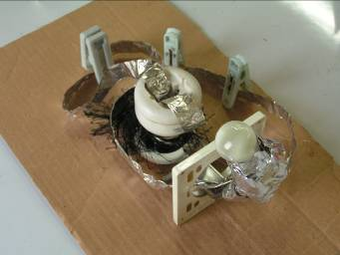 | 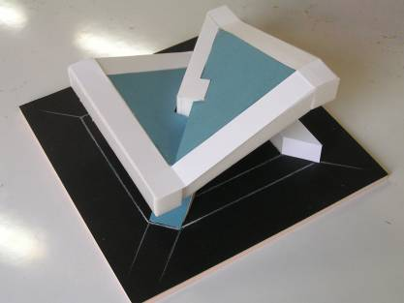 | 
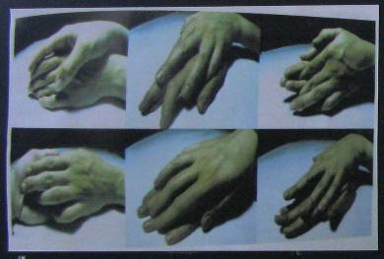 | 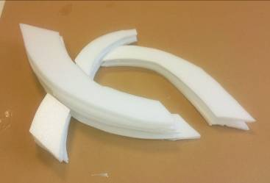 | 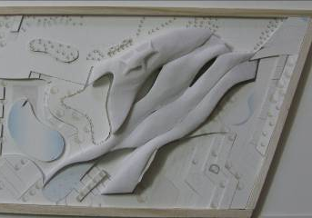
 | 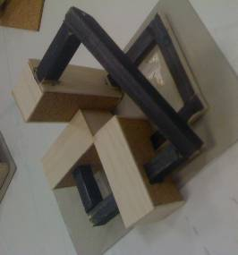 | 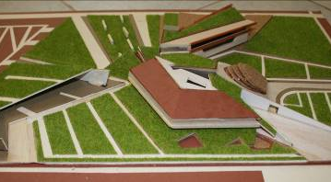

2-5-2- Research Goals
In design education, the development of the design process is difficult and not always understood. The application of knowledge transmitted by design teachers to solve a design problem demands some level of expertise and skills that novice students do not always have. Sometimes, a hidden curriculum of architectural design education is used to control the quality of designs and to impose a status quo architectural theory [37].
The first goal of this investigation is to explore and introduce a method that novice architecture designers can utilize metaphors in their design. This method is considered as a major aid for helping novice students foster their own concepts and ideas in developing design solutions and for overcoming their lack of knowledge and experience. The second goal is to examine how students of architecture assess the creativity of their own design processes and outcomes and to gain insight in how they behave with the use of metaphors as a new tool for design problem solving. The third goal is to determine the role of using metaphors in enhancing creativity and increasing design quality.
2-5-3- Participants
40 participants who were senior B.S students of architectural design in Iran University of Science and Technology took part in this research. They were passing their last design studio. All of them were unpaid volunteers, who received no additional course credits for their participation. They were divided in two groups: experiment group and control group.
2-5-4- Design Task
The students were asked to design a cultural center. They could choose metaphors from culture. They were requested to produce a brief that states the design goals, design requirements, and present sketches, conceptual models, final drawings, concrete models and final design outcomes.
Questionnaire
Upon completion of the design task, a survey on the use of metaphors and design creativity was conducted. Students were requested to assess the factors of creativity and design quality of their projects and the aid of metaphors in the design process. In order to make this assessment an ordinal scale as Likert Scale from 1 to 5 was used to assess the quality of the solutions to the design problems. A low score of 1 or 2 was assigned when the design solution did not satisfy the requirements. A high score of 4 or 5 was given when the solution was perceived as satisfying the design requirements.
In another part, 11 experts in architecture design who were teaching design studio evaluated the design products. Experts assessed the chosen factors in the design products in both experiment and control group. In this evaluation they were requested to use an ordinal scale from 1 point to 100 percent. They scored the subjects' designs on the basis of the students’ and models. The judges worked independently; they volunteered their time and received no compensation.
3- Results
In this section, quantitative results obtained from the use of metaphors during the design process are presented.
This section is divided into two parts. In the first part, the results of the use of metaphors in the design process by students are described. In the second part a comparison of creativity factors between the design products of the experiment and control group is presented.
A chi-square test was used for the questionnaires and Observed and expected frequencies were estimated. The questionnaires was concluded 14 factors, related to creativity and design quality to assess the use of three-stage method in design process. The results showed that student assess the method effective in all 14 factors (Table 2).
Table2: The evaluation of the participants (students of experiment group)
Factor | Items | x2 | Degree of Freedom | Level of Significance
S1 | Novelty and originality of the design product | 12.800 | 3 | 0.005 | Moderate- High
S2 | Value of design product | 7.900 | 2 | 0.019 | High
S3 | Flexible and fluent process | 1.900 | 2 | 0.387 | Moderate- High
S4 | productivity and functional design product | 9.200 | 3 | 0.027 | Moderate- High
S5 | Responsibility to limits | 16.900 | 2 | 0.000 | Moderate
S6 | Aesthetic aspects of the design product | 7.900 | 2 | 0.019 | Moderate- High
S7 | Consideration of details | 7.600 | 2 | 0.022 | Moderate- High
S8 | relation with context and environment | 20.500 | 4 | 0.000 | Moderate
S9 | Flexible design product | 7.600 | 3 | 0.050 | Moderate- High
S10 | Useful design product | 8.800 | 3 | 0.032 | Moderate- High
S11 | Satisfied from the design product | 5.200 | 3 | 0.158 | Moderate- Very High
S12 | New and Non repeated Forms | 6.800 | 3 | 0.079 | Moderate- Very High
S13 | Consequence of initial beliefs | 7.300 | 2 | 0.026 | Moderate- High
S14 | Novel design and innovation instead of routine design | 1.000 | 2 | 0.951 | Moderate- Very High

The results indicate that the method helps students to enhance novel design and creativity instead of a routine design process (s14) with the mean of 4.00, Flexible and fluent process (s3) with the mean of 3.75, Consequence of initial beliefs (s13), New and Non repeated Forms (s12), Satisfied from the design product (s11), Useful design product (s10) with the mean of 3.60, more than other factors. Also the Responsibility to limits (s5) has less mean than other factors (Table 3).
Table 3: Descriptive statistics of experiment group participants’ evaluation
Factor | Mean | SD | N
S1 | 3.5000 | 0.68825 | 20
S2 | 3.6500 | 0.58714 | 20
S3 | 3.7500 | 0.78640 | 20
S4 | 3.5500 | 0.82558 | 20
S5 | 2.8500 | 0.48936 | 20
S6 | 3.5000 | 0.60698 | 20
S7 | 3.2000 | 0.61559 | 20
S8 | 3.1500 | 0.93330 | 20
S9 | 3.5500 | 0.82558 | 20
S10 | 3.6000 | 0.82078 | 20
S11 | 3.6000 | 0.88258 | 20
S12 | 3.6000 | 0.99472 | 20
S13 | 3.6000 | 0.59824 | 20
S14 | 4.0000 | 0.85840 | 20

Further Pearson Correlation were performed to check the correlation of different factors of metaphor use along the three stages of the. The results show that s1- s2, s2- s10, s3-s14, s5- s12, s6-s9, s6- s11, s8- s10, s10- s14 have positive correlation and s3- s4, s4-s9, s5- s6 have negative correlation (Table 4).

Table 4: Pearson Correlation between 14 factors
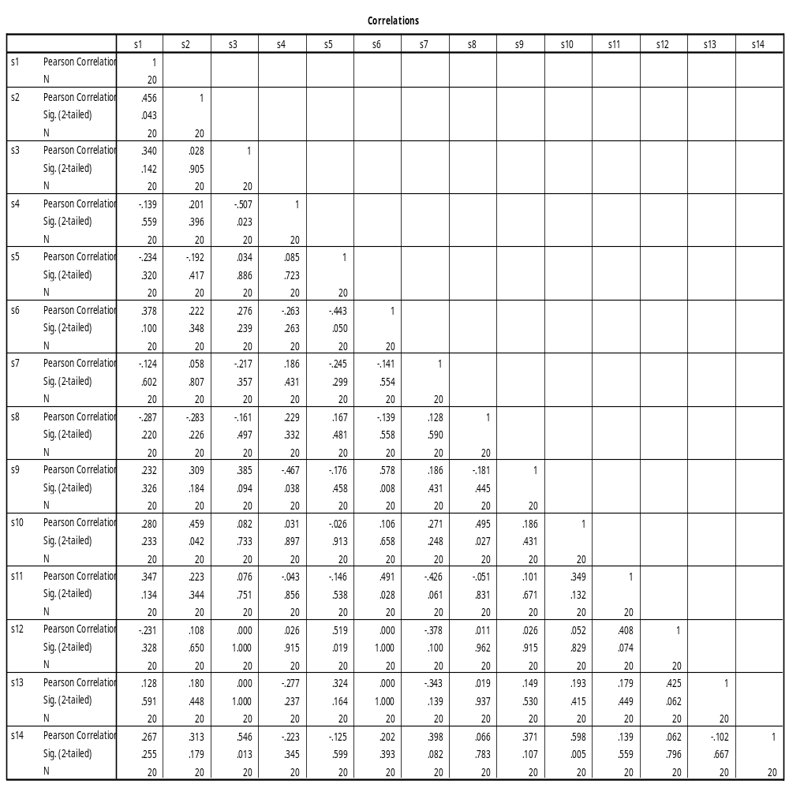

Variance explained by each factor and the percentage of equity variable table shows that 24.21 percent of the variances are explained by the first factor (s1), 16.79 percent of the variances are explained by the second factor (s2), 14.23 percent of the variances are explained by the third factor (s3) and 11.55 percent of the variances are explained by the fourth factor (s4). So in total the results show that 66.77 percent of the variances are explained by 4 factors and 23.33 percent of the variances are explained by other 10 factors.
In conclusion we can consider four factors: Novelty and originality of the design product, Value of design product, Flexibility and fluency and productivity and functionality to analyze (Table 5 and Figure 1).
Table 5: Total Variance Explained
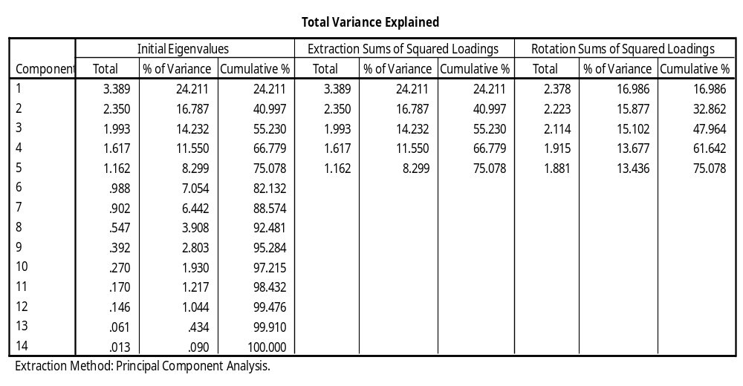

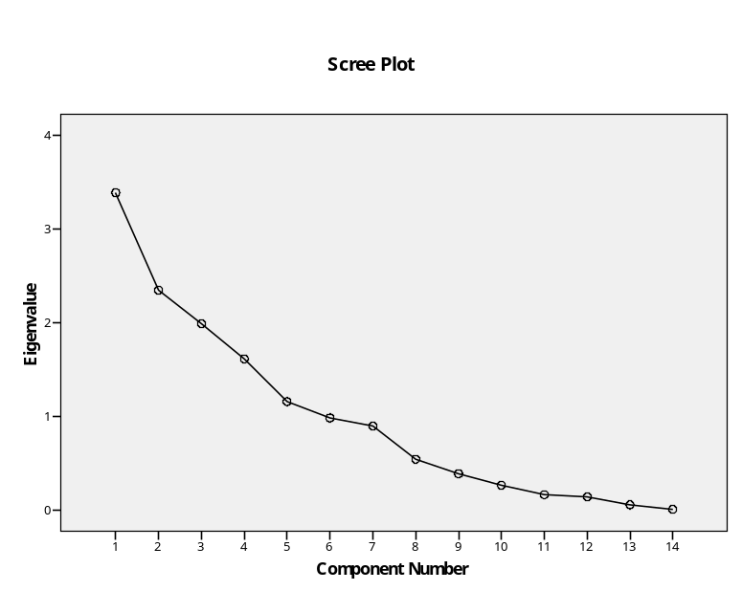
Figure 1: Total Variance Explained

The results of the evaluation by experts that show the comparison of design product between experiment and control group are as followed. The results indicate a distinctive difference between the scores. The architecture design experts evaluate all factors in experiment group in a higher score than the control group (Table 6).
Table 6: Expert evaluation (Design Products)
Item | Experiment group | Control Group
novelty | 55.27 | 34.91
value | 53.36 | 39.82
flexibility | 56.36 | 42.18
usefulness | 53.00 | 51.73
more details | 48.00 | 35.09
creativity | 58.73 | 33.73

4- Discussion
Analyzing the results show that presented method can be effective on design process and product in several aspects. First, the findings explain that it can improve all the assessment factors in design.
As stated before metaphors reveal values, so it would be possible to extract the value factors visually from the final composition and products. So, it’s not amazing that the value factor achieves “high degree” in experiment group evaluation. Moreover, results show a significant relationship between product values and their usefulness and rationally with the product novelty and originality.
According to what mentioned above, it can be argued that flexibility in the design process could cause various and different outcomes which could access a novel result. So, results show a relationship between the flexibility in the process and novelty in the outputs.
The presented method answers many design problems and limitations beside its specific metaphoric and flexible approach. This process guides the students toward a unique and none repeated outcomes.
It can be seen that the students could select the best choice from various answers considering the aesthetical approaches, flexibly. This final product will satisfy the designer visually and rationally, because its one in many. Further this method can lead the students to consider the relation of the design product with its context and environment and because of that design more useful product.
In this method, novel design products can be positive and helpful. So the results indicate when designer can produce more useful product, can have a novel and non routine one.
It can be argued from the concept step that two items are fundamental ones of this step, geometry and context. Using unique geometry according to the site potentials, project topic and the picked metaphors could guide the designers to a novel and original answers. Also, considering the context in the design process could lead the students to an actual and useful project.
As can be seen the main factors sound in the results refer to the novelty and originality of the products and outcomes, values of results, flexibility of the process and finally productivity and functionality of design answers.
Experts evaluated a high distinction in two control and experiment group. novelty and creativity are the factors that got more difference in their assessment. It’s considerable that there is a significant difference between experts and students view points. Experts’ answers are similar to the students but rather more in each case. It seems that their experiences could cause this dissimilarity.
5- Conclusions
The focus of this study was to shed light on the use of metaphors in the early stages of design problem-solving by novice students and to inspire creativity in design studio. In particular, this study aims to introduce a new and unique three- stage method that is designed by authors, to use metaphors in design studio and explore empirically how architectural students perform this cognitive strategy during the process.
With an understanding of first principles, experience and intuition, most designers reach heuristically their design solutions. Methods to increase creativity are rarely mentioned when the experienced designer’s process is discussed and the question of creativity is often considered an implicit factor. Therefore, authors designed a method to use metaphors as an aid to increase creativity and design quality in design studio that can help young designers to enhance rich performance and outcomes. Three main steps of this process includes: Idea, Concept and Form.
Idea stage refers to the meanings and values and the designer tries to translate the words and senses to physical shapes. In the next stage the designer endeavors to be closer to the architectural form. In the final stage designer presents the final form.
The presented method in this paper identifies the route to create creative output and distinguishes between the creative design process and a routine one. It provides guidelines for teachers to facilitate students along the creative thinking process. Also, it helps to foster creativity in the next generation, optimize the quality of the solutions to the unknown problems which cannot be solved by the existing solutions.
The assessment of the use of the designed method in architectural design studio was analyzed through main factors. In sum, the offered method is effective for novice designers to enhance novel and original, valuable, productive, flexible, responsible to limits, useful and non routine design product.
It is believed that, this method of using metaphor in architectural design will produce a better understanding of the design process, will lead to more creativity, and will improve critical design abilities. This method will provide novice students with a framework to develop their own ideas and personal skills in design problem-solving.

References
[1] Eckert, C.M. and. Stacey, M.K,: 2000, Sources of Inspiration: A Language of Design, Design Studies, volume 21 number 5, 523-538.
[2] Indurkhya, B.: 1992, Metaphor and cognition, Dordrecht: Kluwer Academic Publishers.
[3] Lakoff, G., & Johnson, M.: 1980, Metaphors we live by. Chicago: University of Chicago Press.
[4] Rowe, P.: 1987, Design thinking. Cambridge, Massachusetts: MIT Press.
[5] Casakin, H.: 2004, Metaphors in the design studio: Implications for education. In Proceedings of the changing face of design education: 2nd international engineering and product design education conference, pp. 265–273, Delft.
[6] Casakin, H.: 2007, Metaphors in design problem solving problem solving: Implications for creativity. The International Journal of Design, 1(2), 23–35.
[7] Kowaltowski, D. C. C. K., Bianchi, G. & de Paiva, V. T.: 2009, Methods that may stimulate creativity and their use in architectural design education, International Journal of Design Education.
[8] Schon, D. A.: 1984, The architectural studio as an exemplar of education for reflection-in-action. Journal of Architectural Education, 38(1), 2–9.
[9] Lakoff, G.: 1993, The contemporary theory of metaphor. In A. Ortony (Ed.), Metaphor and thought, pp. 202–251, New York: Cambridge University Press.
[10] Casakin, H.: 2011, Metaphorical reasoning and design expertise: A perspective for design education, Journal Of Learning Design, Vol 4, No 2, 29-38.
[11] Casakin, H., & Goldschmidt, G.: 1999, Expertise and the use of visual analogy: Implications for design education. Design Studies, 20(2), 153-175.
[12] Cross, N.: 1997, Descriptive models of creative design: Application to an example. Design Studies, 18(4), 427–455.
[13] Hasirci, D., Demirkan H.: 2007, Understanding the Effects of Cognition in Creative Decision-Making: A Creativity Model for Enhancing the Design Studio Process, Creativity Research Journal, vol. 19, nos. 2-3, pp. 259-271.
[14] Sternberg, R.J. (ed.): 1999, Handbook of Creativity, Cambridge University Press, Cambridge, UK.
[15] Sarkar, P. and Chakrabarti, A.: 2008. Studying engineering design creativity- developing a common definition and associated measures. In, John Gero (Ed.) Studying Design Creativity, Springer Verlag.
[16] MacKinnon, Donald W. 1978. In Search of Human Effectiveness. Buffalo, New York: Creative Education Foundation.
[17] Dominowski R.: 1995, Productive Problem Solving, in R. Finke, T. Ward, and S. Smith (Eds.), The creative cognition approach, 73-95, MIT Press, Cambridge, MA.
[18] Goldschmidt G. & Smolkov M.: 2006, Variances in the impact of visual stimuli on design problem solving performance, Design Studies, 27, 5, 549-569.
[19] Harfield S.: 2007, On design ‘problematization’: Theorising differences in designed outcomes Design Studies, 28, 2, 159-173.
[20] Guilford J. P.: 1981, Potentiality for creativity, in J. C. Gowan, J. Khatena, & E. P. Torance (Eds.), Creativity: its educational implications (2nd ed.), 1-5, Kendall Hunt, Dubuque, IA.
[21] Casakin, H. P., & Kreitler, S.: 2005, The nature of creativity in design: Factors for assessing individual creativity. In J. S. Gero, & N. Bonnardel (Eds.), Proceedings of International Workshop on Studying Designers, pp. 87-100, Sydney: University of Sydney, Key Centre of Design Computing and Cognition.
[22] Schon, D.: 1979, Generative metaphor: A perspective on problem-setting in social policy. In A. Ortony (Ed.), Metaphor and thought, pp. 254-283, Cambridge: Cambridge University Press.
[23] Johnson, N,: 1992, Metaphor and Design, Studies in Art Education, Vol. 33, No. 3 (Spring, 1992), pp. 144-153.
[24] Ortony, A.: 1991, Metaphor and thought. New York: Cambridge University Press.
[25] Gentner, D., Bowdle, B., Wolff, P., & Boronat, C.: 2001, Metaphor is like analogy. In D. Gentner, K. J. Holyoak, & B. N. Kokinov (Eds.), The analogical mind: Perspectives from cognitive science (pp. 199-253). Cambridge, MA: MIT Press.
[26] Hey, H. G., Linsey, J., Agogino, A. M., & Wood, K. L.: 2008, Analogies and metaphors in creative design. International Journal of Engineering Education, 24(2), 283–294.
[27] Mayer, R.: 1993, The instructive metaphor: Metaphoric aids to students’ understanding of science. In A. Ortony (Ed.), Metaphor and thought, pp. 561–578, New York: Cambridge University Press.
[28] Antoniades, A.: 1992, Poetics of architecture: Theory of design. New York: Van Nostrand Reinhold.
[29] Coyne, R., & Snodgrass, A.: 1995, Problem setting within prevalent metaphors of design. Design Issues, 11(2), 31–61.
[30] Coyne, R.: 1995, Designing information technology in the postmodern age: From method to metaphor. Cambridge, MA: MIT Press.
[31] Chand, I., & Runco, M.: 1992, Problem finding skills as components in the creative process. Personality and Individual Differences, 14, 155–162.
[32] Aspelund, K.: 2006, The design process. New York, NY: Fairchild.
[33] Gero, J. S.: 2000, Computational models of innovative and creative design processes. Technological Forecasting and Social Change, 64(2-3), 183-196.
[34] Snodgrass, A., & Coyne, R.: 1992, Models, metaphors and the hermeneutics of designing. Design Issues, 9(1), 56 -74.
[35] Casakin, H.: 2006, Assessing the use of metaphors in the design process. Environment and Planning B: Planning and Design, 33(2), 253–268.
[36] Casakin, H and Miller, K.: 2008, Individual learning styles and design performance in the metaphorical reasoning process, J. of Design Research 2008 - Vol. 7, No.3 pp. 275 - 293.
[37] Ward, A.: (1990). Ideology, culture and the design studio. Design Studies, 11(1), 10-16.

