Does Vegetation Complexity Affect Park Usability? Vegetation Spatial Arrangement for Content Usage

Hami, Ahmad
Department of Landscape Engineering, Faculty of Agriculture, University of Tabriz, Boulevard of 29 Bahman, Tabriz, Iran. Email: hamiahmad@yahoo.com

Suhardi, Bin Maulan
Department of Landscape Architecture, Faculty of Design and Architecture, Universiti Putra Malaysia, 43400 UPM Serdang, Selangor, Malaysia

Manohar, Mariapan
Department of Recreation and Ecotourism, Faculty of Forestry, Universiti Putra Malaysia, 43400 UPM Serdang, Selangor, Malaysia

Malekizadeh, Muhammad,
Department of Architecture, Faculty of Engineering and Built Environment, Universiti Kebangsaan Malaysia (UKM), 43600 UKM Bangi, Selangor, Malaysia

Abstract

The relationship between vegetation spatial complexity and park usability is taken interest of this study. A photo - questionnaire was conducted among public users in two urban parks (El Gholi Park and Big Park) in Tabriz, Iran to gauge the relation of aprk usability and complexity (high, moderate, and low) levels of vegetation. The survey was held on among 296 of the participants in November 2012. The result suggested three dimensions for park usability such as social activities, passive nature activities, and nature appreciation, meanwhile passive nature activities received the highest preference. Vegetation scenes with wider visual view and physical access contributed in park usability than the scenes with crowded plants and blocked views. The findings allege that plants aroused people’s enthusiasm to do activity in urban parks whilst the scenes without lawn and water features were perceived improper place for activity. Similarly, landscape scenes with fewer plant species were better place to involve activities than the scenes with more plant species. This study proved that a landscape designed with ground cover such as lawn implies increment of park usability. Moreover, landscape designers should avoid suggesting crowded planting areas, which obstruct visibility in urban park and probably reduce perceived safety. It seems that water features show positive effect on people activity in urban park. However, spatial arrangement of vegetation might affect park usability through safety feeling in urban park which is needed to be studied in the future research.

Keywords: urban parks, landscape preference, vegetation complexity, park usability

Introduction

Urban parks as important public open spaces and multifunctional places can be used for wide ranges of activities. Gehl (1987) discusses elements of spatial deﬁnitions as well. Similarly, Whyte (1980) explains that the usage–spatial relationship is referred to the forms and ooccupancies, e.g. sitting. Goličnik and Ward Thompso also argued that usage levels depend on the spatial characteristics of the places.

Landscape Preference

Hammit (1978) defines preferences as a presentation model of the human brain where it is resulted through visual perceptions meanwhile, other types of information (motivation, emotion, and impression) are transferred into it . Preference, the result of perception, contains an accumulation of information regarding the way people experience their environment . Preference has been a popular approach to assess peoples' perceptions of a certain setting . The previous researches argued that preference approach is a valid and reliable measurement for obtaining data about what kind of landscapes are acceptable and preferable for people .

Preference is a approach to achieve a human response to provide valuable information regarding public’s attitude towards a particular environment, including the individual's reactions to the content and spatial configuration (Kaplan & Kaplan, 1989). It has been argued that preference studies are practical, valid, reliable and systematic approach which can be used to measure people’s preferences for gathering data in order to categorize landscape measurements such as; level of human effects, as well as the elements and features in landscaping as preferred or disliked by people as mentioned by Moula (2009). In general, the concept of preference is known as a simple perceptual response regarding to the particular setting to expose that they prefer more than others do.

Aside, vegetation visual preferences have received attention from different scientists such as landscape architecture, forestry, outdoor recreation, and psychology . Vegetation visual preferences are aesthetic response as a fundamental concept of human evaluation of landscape (Kaplan & Kaplan, 1989; Zube at al., 1982). Daniel (2002) defined “vegetation visual preference” as an individual’s degree of like or dislike for the visual appearance of a place as compared to another . Since the study concentrates on visual aspect, thus “vegetation visual preference” term is used to distinguish from other senses such as sound, smell, and touch.

One study suggested three main factors for landscape visual preferences namely physical features, region’s biology (vegetation and other biological components of the environment), and human interest (how the vegetation impresses people) . This means that the human’s interest is connected with the environment where certain phenomena occurs . Thus, vegetation visual preference is result of the interaction of certain features of the landscape with psychological (perceptual, cognitive, and emotional) processes in the observer .

Nasar and Jones also illustrate the components of an individual’s response to his/her environment as physiological response, an effective appraisal/emotional reaction, a behavior change, and the aesthetic response occurs at the intersection of the three . Majority of landscape perception studies focused on the effective appraisal reaction section . Nasar explained the effective appraisal is the individuals’ judgments of like or dislike of a certain environment. This study attempts to understand public preferences for like or dislike of vegetation scenes compare to others. Thus, a preference study is established to obtain public opinion on vegetation complexity quality to examine its relationship with preferred activity of urban parks.

Several theories interpret vegetation preference studies and the information- processing theory is ons of the more comprehensive concept. Preference for an environment mainly is explained by the information that emits from the setting. Kaplan and Kaplan’s (1989) information- processing theory elucidated the indicators that cover preferences for an environment. Kaplans’ theory supports both the ecological and psychological explanations.The exploration part of the theory is similar to Appleton’s prospect-refuge theory at the same time, the understanding part of the theory is in coincidence with the arousal theory thus it is being known as the most important theory in vegetation visual preference research . This theory integrates the psychological needs for stimulus thus it provides a comprehensive description for vegetation visual preference. Vegetation visual preference theories can be grouped into ecological and psychological explanations where the ecological focuses on the environment and its supports for life, meanwhile the psychological explanation concentrates on the process of landscape preference within the individuals’ mind . It was uncovered that people interpret environment not only because of basic needs such as food and drink but also because of its contribution on recreational activities and intertainments.

Vegetation Complexity Levels

The early research emphasized the role of plants in environment complexity (Robert & Atwood, 1978). The industrial park, urban park, and residential landscape were rated having the lowest complexity whilst highway landscape had the highest complexity (Robert & Atwood, 1978). Their study did support the idea that plants increase complexity and provide more pleasure for the visitors. This study reveals that vegetation complexity would be classified into three categories and they are; ‘high complexity’, ‘moderate complexity’, and ‘low complexity’ (Table 1).

Table 1 Complexity Levels of Vegetation in Urban Park
Number |  | Complexity Levels |  | Parameter
1 | High Complexity |  | Number of plants’ varieties and repetitions are high
2 | Moderate complexity |  | High number of plants’ varieties with low repetition and vice versa
3 | Low Complexity |  | Low number of plants’ varieties with low number of repetitions

Another study examines various items through theoretical concepts for aesthetic preference and cognitive ratings . They determined that cognitive attributes are reliable predictors for aesthetic landscape preference. Altogether, 11 stimuli photos were used in the survey. The results showed that all four cognitive items ‘attractive vegetation’, ‘inviting to visit’, and ‘valuable for conservation’ correlate with aesthetic preference for ten landscape vistas. Four cognitive factors emerged from factor analysis results namely ‘coherence’, ‘undisturbed’, ‘historicity’, and ‘complexity’ and all these 4 factors cannot be found in the subjects, however, some items seem to have association in most of the cases. Except ‘complexity’, the three other predictors belong to a different factor. These findings demonstrate that it is very difficult to have clear theoretical concepts, which can determine landscape perception. However, complexity is the only cognitive item that can be used in many subjects to assess landscape perception and evaluation.

Kaplan et al. (1972) examined the relationship between human senses particularly pleasing with spatial quality (complexity) of the vegetation scenes. Their experimental research revealed that complexity has straight- line (direct) relationship between complexity and pleasure. This study was one of the earliest research to understand and explore the communication of human senses with landscape spatial quality especially complexity. However, the relationship between other aspects such as activity with preferences for complexity concept remained. In addition, human feelings might differ in different vegetation areas with different visual complexity. Therefore, complexity is categorized into three levels namely low, moderate, and high. Hence, the effect of park usability as the central issue is examined based on preferences for vegetation visual complexity in urban parks.

The density of the surrounding area may vary and are likely inﬂuence the activities.The questionnaire provides a useful information for designers regarding park design and usability of urban park .

Park Usability

Gehl has categorized people’s outdoor activities based on how ‘compulsory’ or ‘voluntary’ they are. His contribution lies beyond merely recording different types of activity (e.g. walking, cycling) and shows how to interpret and evaluate observation behaviour. He found that voluntary and lasting activities were most affected by the environmental quality and these show significant role in the social cohesion of a neighbourhood. His finally argument was It is possible to inﬂuence some aspects of outdoor activities which activity types can develop through the design and spatial arrangement of urban settings . The main concern of this research is the spatial relationship between uses and places.

Affordance Theory

According to affordance theory, Gibson (1979) asses peoples' preference for the environment for its ability in providing activity for human. The theory discloses that human perceive environment for the actions, what they can do with it. For instance, peoples' preferences are affected by its ability to offer human activities such as walking, when they see a surface . Public preference might correlate with spatial quality of park vegetation as well. Urban park vegetation has potential to offer different types of recreation for users and this part discusses activities related to park planting area.
Several studies have investigated people’s preference for nature-related activities in urban park . Based on the literature, the potential activities in park vegetation areas can be classified into three different groups such as physical activity, passive activity, social activities, and nature appreciation . Passive activities are referred to less active activities such as watching water, sitting around water pool, lying down on the grass, and studying books, news, or magazine. Active activities are called the actions which are more active than passive recreations such as walking around water, snap photos of water and flowers, watering plants, and boating. Social activities provide opportunities like gathering andfamily, play with children, and having dinner on the grass and finally the nature appreciation includes nature involvements such as being with nature, viewing landscape scenes, and drawing nature figures.

The main reason of participants for activity in urban park is to have health and well-being. A large number of experimental studies have proved that nature involvement has possitive effect on recovery from stress and attention fatigue . On the other hand, it has been long known that physical activity improve human health conditions. It was argued that people prefer to involve with physical activity in green areas more than built environment because they might encourage people to engage with activities such as walking. Another research showed the amount green and recreational areas contribute on physical activities .

Parsons and Daniel claimed strong positive association between passive activity and green spaces. It shows that people have courage to involve with passive activities in the setting with more green spaces than the environment with less green space. Passive activities include socialization, observation, relaxation, and viewing landscape scenes . However, there is lack or very less information on the correlation between vegetation complexity quality and activities. It is necessary to know the association between vegetation complexity levels and activities since with high rapid of urbanization the needs for both of them are highly demanded in Tabriz urban parks . Therefore, assessment of relationship between vegetation complexity levels and activities provides helpful information for proper planting design and renovation.

Green spaces in an urban park are destination for majority of visitors for entertainment and involvement with various activities. Quality of green spaces has direct effect on the activities that people perform in it. It is important to find out how the preferred activity items correlate with the vegetation complexity levels. Understanding this relation causes authorities take vegetation complexity in urban park into the consideration to provide fruitful setting for people engagement. Thus, proper landscape structure leads to reduce re-planting and keep changing park vegetation. The review of the literature showed that activity items can be measured by using the Likert scale technique.In the current study, the activity alternatives are measured by applying 5 point Likert scale (1= strongly disagree, 2= disagree, 3= neither agree nor disagree, 4= agree, 5= strongly agree).

Methodology

A survey was used to gather data in this study because it allows to participate large number of population and also accurate and exact answer can be achieved via photo-questionnaire. Photo questionnaire has been acknowledged as a valid and reliable method to represent real and actual environment . The questionnaire contained a set of questions regarding park usability ( independent variable) and vegetation complexity levels (dependent variable) measured by a Likert scale (1= strongly disagree to 5= strongly agree), and demographic questions (measured by categorical tecnique). In order to prepare a photo - questionnaire of the survey, there should be a systematic process to prepare scenes, which is described in the following subsection.

Scene Classification Procedure

The scenes are prepared according to complexity level of vegetation in urban parks in Tabriz therefore the nature of work is confirmatory. Vegetation complexity levels of urban park was classified into three categories (Table 1);

Table 2 Identified Vegetation Complexity Levels in Urban Park in Tabriz
Number |  | Vegetation Complexity
1 | High Complexity
2 | Moderate Complexity
3 | Low Complexity

Summer season was selected to take photos because vegetations of the parks have the maximum grow meanwhile they are still green. The scenes were collected from El Gholi Park and Bagmishe Park as predominant urban parks in Tabriz. These parks include large vegetation areas and, most famous and more used urban parks in Tabriz city meanwhile the problem of less-use and non-use is still exist, which deter visotors to come to vegetation areas.The photos were taken from the –vegetation areas in parks and hard-landscape of the parks such as buildings, walkways, and other constructions were excluded. In addition, the scenes with slight construction were also excluded because the researcher believes that the scenes with construction might influence people preference for vegetation. The photos were not captured if there is any user, therefore the researcher waited until the place become empty of people to prevent affecting of peoples' judgment. All the photos were taken at the eye levels. Therefore, the scenes did not include any noise such as hard-landscape and presence of peopls. In the first stage, the scenes were grouped into the 3 complexity levels by landscape architectures. In the next stage, the scenes were printed out on A3 size paper with 4 scenes located in each paper. Each group of complexity level included 15 scenes numbered from 1 to 15 and a group of public (10 male and 10 female) ranked the scenes according to three complexity levels. The participants were trained to indicate the smallest number for the more relevant scene. At the end of this part, 27 scenes (9 scenes for each vegetation complexity level), with highest agreement were selected by the participants. The results of public scene selection procedure were emailed to the experts in UPM and they were asked to rank the five top related photos at each group from 1 to 5. From the result of email survey, three scenes were picked up for each complexity level therefore 9 scenes were selected for final survey presentation. The research was held among 296 participants of two urban parks (El Gholi Park and Big Park) users and the respondents were taken via a systematic sampling method and the data were analyzed by using SPPS and SEM softwares.

Results

Demographic profile of the participants

Participants’ in the survey are classified according to gender, marital status, age group, education level, income level, and occupation statues. Although, 296 questionnaires were collected in this study and Males are n= 163 (55.1%) and females are n= 130 (43.9%) of the participants (See table 2). The data reflect the study by Nohorly (1999) and Hami (2009) where they show that males are the main users of parks in Tabriz. Regarding to marital status, the majority of participants (n= 173, 58.4 %) are married and n= 121 (40.9 %) are single. In terms of age groups, 47.3 % (n= 140) have age between 18 – 29 years, 24.9 % (n= 87) are between 30-39 years, 12.2 % (n= 36) are 40-49 years, and 10.1 % (n= 30), of the participants have age above 50 years.

Table 3 Participants’ Backgrounds
Participants |  | Number | Percent
Total public participation |  | 296 | 100.0
Factors Sub-category
Gender | Male | 163 | 55.1
 | Female | 130 | 43.9
Marital status | Single | 121 | 40.9
 | Married | 173 | 58.4
Age(years old) | 19-29 | 140 | 47.3
 | 30-39 | 87 | 29.4
 | 40-49 | 36 | 12.2
 | Above 50 | 30 | 10.1
Education | Secondary and below | 25 | 8.4
 | Under diploma | 26 | 8.8
 | Diploma | 88 | 29.7
 | University | 152 | 51.4
Income(Toman) | Between 350,000 and 900,000 | 126 | 42.6
 | Under 350,000 | 86 | 29.1
 | Between 900,000 and 1,500,000 | 24 | 8.1
 | Above 1,500,000 | 11 | 3.7
Occupation | Governmental employee | 45 | 15.2
 | Private sector | 30 | 10.1
 | Student | 56 | 18.9
 | Household | 31 | 10.5
 | Business | 30 | 10.1
 | Others | 70 | 23.6

For educational level, the majority of the participants have university education (n= 152, 51.4%) and income between 350 and 900 thousands Tomans. Some studies have shown that greater education and high income are associated with participation of leisure activities. The data show the participants are varied when it comes to age groups, job classes, and education levels.

Preferences for Park Usability

The purpose of this analysis is to explain the participants’ opinion for preferred activities in the parks. The participants voted thirteen items related to park usability using five Likert scale (1= strongly disagree to 5= strongly agree) and the items are; watch water flow, walking and sitting around water, photograph from water features and flower scenes, lie down on the grass, touch flowers, sit under tree shade, socializing with friends and family, and finally playing with children. The result from table 4 shows that the highest mean value is for watching water flow in the park (mean= 4.72, sd= 0.55), followed by sitting around water pool (mean= 4.59, sd= 0.64), walking around water (mean= 4.53, sd= 0.66), and the lowest mean score is for playing with children in the park (mean= 3.70, sd= 1.20).
Table 4 Preferences for Park Usability
 |  | Activities dimensions | Mean |  | Sd.
a) | I like to watch water flow in park |  |  | 4.72 | 0.55
b) | I like very much to walk around water |  |  | 4.53 | 0.66
c) | I want to sit around water pool |  |  | 4.59 | 0.64
d) | I like very much viewing landscape scenes |  |  | 4.46 | 0.87
e) | I like to sit under trees' shade |  |  | 4.37 | 0.78
f) | I like very much to socialize with friend |  |  | 4.33 | 0.83
g) | I like very much to eat dinner on grass area |  |  | 4.33 | 0.88
h) | I like to have picnic with family in green areas |  |  | 4.27 | 0.93
i) | I like to touch flowers in park |  |  | 4.12 | 1.03
j) | I like very much to photograph flower scenes |  |  | 4.08 | 0.88
k) | I like to lie down on the grasses |  |  | 3.96 | 1.15
l) | I like very much to photograph water features in park |  |  | 3.93 | 0.90
m) | I like very much to play with children in the parks |  |  | 3.70 | 1.20

The result reveals that the participants prefer to get involved in passive activities related to water features such as sitting around water features and watching water. The result is compatible with the most and least preferred scenes’ result where the scenes with water features are highly appreciated. It also supports the conclusion of the previous studies, which argue passive activities are the most preferred activities in urban parks (Gobster, 2001& Hami, 2009). Moreover, engagement with nature is another top priority of the participants to be involved in urban parks. It can be said that people seek water features’ entertainment and nature involvement in urban parks in Tabriz.

Table 5 Rotated Component Matrix for Activity Scales
Activity Scales | Factors¹ |  | Alpha² |  | Mean | Sd. dv.
1. Passive Nature Activities |  | - |  | 0.64 | 4.44 | 0.67
1. I like to watch water flow in park |  | .734 |  | .584
2. I like very much to walk around water |  | .698 |  | .637
3. I want to sit around water pool |  | .667 |  | .590
2. Social Activities |  | - |  | 0.663 | 4.19 | 0.69
7. I like to spend time with family for picnic in green areas |  | .746 |  | .519
8. I like very much to play with children in the parks |  | .633 |  | .524
9. I like very much viewing landscape scenes |  | .631 |  | .583
10. I like very much to eat dinner on grass area |  | .597 |  | .519
3. Nature Appreciation |  | - |  | 0.68 | 4.04 0.93
4. I like very much to photograph water features in the park |  | .892 |  | .460
5. I like very much to photograph flower scenes |  | .852 |  | .317
6. I like touch flowers in park |  | .656 |  | .802

Activities such as nature related activities might attract more people to visit the parks. It is interesting to know the relation between plants’ contribution to do activity in urban park. A factor analysis for activity scales revealed three factors containing twelve items and they are namely Passive Nature Activities (mean= 4.44, sd= 0.67), Social Activities (mean= 4.19, sd= 0.69), and Nature Appreciation (mean= 4.04, sd= 0.93) received the highest rate respectively (Table 5).

Preferences for Vegetation Complexity Levels

Vegetation scenes with high complexity level had higher mean preferences (mean= 3.50, sd= 1.10) and it followed by low complexity level (mean= 3.23, sd= 0.1.12) and moderate complexity level (mean= 3.14, sd= 1.11) (Table 6). It supports the findings of the study in which showed that dense trees increase peoples' preferences .

Table 6 Preferences for Vegetation Visual Complexity Levels
Preference for complexity |  | Mean | Sd. Dv. | Cronbach Alpha
1. | High complexity | 3.50 | 1.10 | 0.86
2. | Low complexity | 3.23 | 1.12 | 0.83
3. | Moderate complexity | 3.14 | 1.11 | 0.83

In addition, another study declared that people like city parks with trees and plants more than parks without plants . They claimed that plants have an additive effect on complexity. This result can be interpretated via definition of complexity by Rapoport and Hawkes (1970) where they explained that “urban complexity is a function of the violation of certain visual expectations that an environment may establish”. Based on this definition, high complexity is perceived when there is an expectation in any other types of changes in any plants as urban stimulus.

Regarding to vegetation with high complexity, it was found that scene 12 with colorful vegetations and short crowns is perceived appropriate for activities (mean= 4.02, sd= 0.96) among the scenes without lawn and flowers. In overall, the mean scores for vegetation with high complexity lie between 2.90 to 4.02 out of 5 point Likert scale (Figure 1). According to the figure 2, none of the activity latents had not significant effect on visual vegetation with high complexity levels in 5 % of significant level. In other words, vegetation with high complexity didn’t contribute significantly in people willing to involve with nature appreciation, passive, and social activities in urban park (Table 7). Since the regression value (R² = 0.02) of the model is extremely low, it can be argued that this model is weak and the correlation between the latents and are not enough strong (Figure 2).

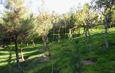
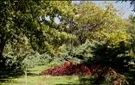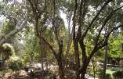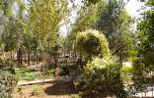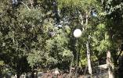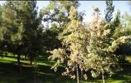
Scene 12 Mean = 4.02
St. Dev. = 0.96

Scene 11 Mean = 3.49
St. Dev. = 1.13

Scene 9 Mean = 3.63
St. Dev. = 1.13

Scene 8 Mean = 3.65
St. Dev. = 1.05

Scene 13 Mean = 3.33
St. Dev. = 1.21

Scene 10 Mean = 2.90
St. Dev. = 1.23

Figure 1 Rating of Appropriateness of Scenes for Activities among Urban Park Users in Tabriz, Iran, Six Scenes Varying in Vegetation Content with High Complexity Level. Scale from 1 (strongly disagree) to +5 (strongly agree).

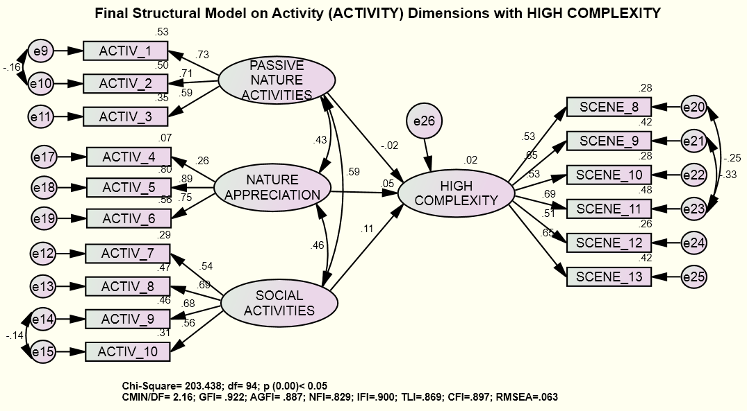
Figure 2. CFA Model on HIGH COMPLEXITY Items

Table 7 Estimates of Regression Weights or Significant Estimates for HIGH COMPLEXITY
Items – Constructs¹ |  |  | Estimate | S.E. | C.R. | P²
HIGH_COMPLEXITY | <--- | SOCIAL_ACTIVITIES | .138 | .134 | 1.032 | .302
HIGH_COMPLEXITY | <--- | NATURE_APPRECIATION | .135 | .245 | .551 | .582
HIGH_COMPLEXITY | <--- | PASSIVE_NATURE_ACTIVITIES | -.028 | .181 | -.153 | .879
¹ Constructs are represented by: HIGH COMPLEXITY = activity, ACTIVITY= social activity, passive nature activities, and nature appreciation, ² These based from the standardized estimate values; *** p<.005

The results of figure 3 revealed that the ranges of mean for suitability for activity in vegetation with moderate complexity locate benween 4.02 to 2.73 out of 5 point Likert scale. however, only scene 18 received high mean value (mean = 4.02, sd = 1.07) where the ground is covered by appropriate and well maintained lawn which might increase aesthetic value of the scene. In addition, this scene provides proper visibility and long distance view compared to the other scenes. Moreover, the result of SEM model in figure 4 and table 8 showed that social activity has positive significant effect on moderate complexity (r = .33, R² = 0.10, p = .01<0.05). It proves that moderate complexity level of vegetations likely offer friendly environment for social meetings such as family gathering. However, there is no enough evidence to prove that it is appropriate environment for passive activities and nature appreciation where they are more individual activities. It can be argued that being with group probably brings enthusiasm and encourage them to engage with activity in park environment.

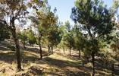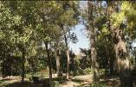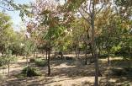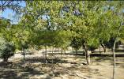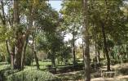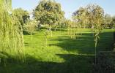
Scene 19 Mean = 2.97
St. Dev. = 1.17

Scene 15 Mean = 2.73
St. Dev. = 1.14

Scene 18 Mean = 4.02
St. Dev. = 1.07

Scene 17 Mean = 3.36
St. Dev. = 1.09

Scene 14 Mean = 2.79
St. Dev. = 1.10

Scene 16 Mean = 3.05
St. Dev. = 1.09

Figure 3 Rating of Appropriateness of Scenes for Activitties among Urban Park Users in Tabriz, Iran, Six Scenes Varying in Vegetation Content with Moderate Complexity Level. Scale from 1 (strongly disagree) to +5 (strongly agree).

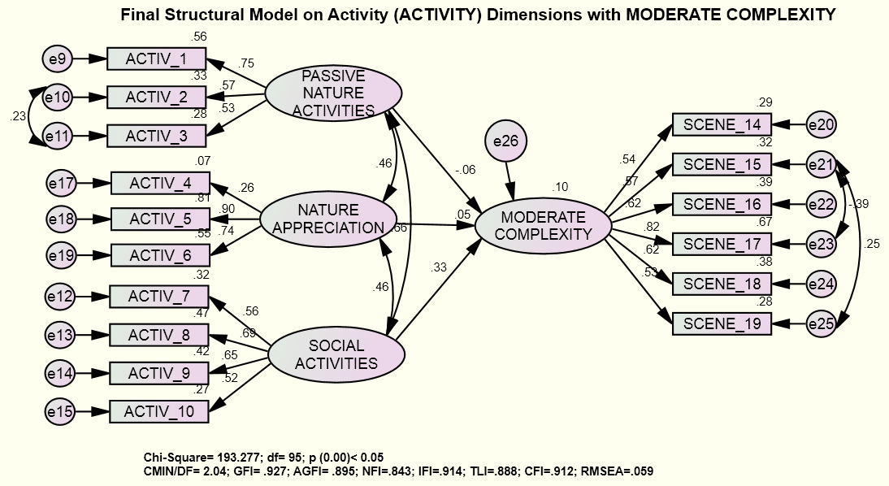
Figure 4 CFA Model on MODERATE COMPLEXITY Items
Table 8 Estimates of Regression Weights or Significant Estimates for MODERATE COMPLEXITY
Items – Constructs¹ |  |  |  |  | Estimate | S.E. | C.R. | P²
MODERATE_COMPLEXITY | <--- |  | SOCIAL_ACTIVITIES |  | .356 | .138 | 2.576 | .010
MODERATE_COMPLEXITY | <--- |  | NATURE_APPRECIATION |  | .127 | .217 | .585 | .558
MODERATE_COMPLEXITY | <--- |  | PASSIVE_NATURE_ACTIVITIES |  | -.113 | .241 | -.470 | .639
¹ Constructs are represented by: MODERATE COMPLEXITY = activity ACTIVITY= social activity, passive nature activities, and nature appreciation, ² These based from the standardized estimate values; *** p<.005

People’s preferences for doing activities in vegetations with low complexity lie between 3.91 to 2.54 which is slightly smaller than mean ranges for high and moderate complexity. Moreever, scenes 24 (mean = 3.91, sd = 1.04) and 23 (mean = 3.80, sd = 0.97) received highest mean values where grass and lawn are compose main body of them. It is obvious that these scenes provide great visibility and open areas for visitors compared to the scenes with moderate and high complexity.

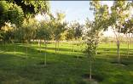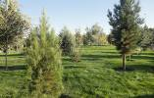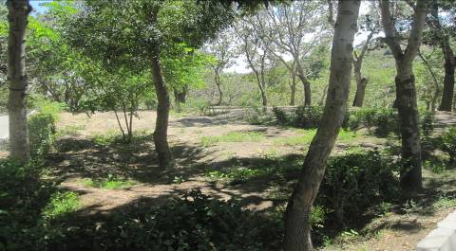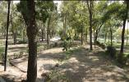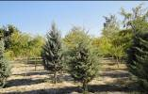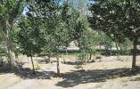
Scene 24 Mean = 3.91
St. Dev. = 1.04

Scene 23 Mean = 3.80
St. Dev. = 0.97

Scene 25 Mean = 3.12
St. Dev. = 1.18

Scene 21 Mean = 2.93
St. Dev. = 1.19

Scene 20 Mean = 2.54
St. Dev. = 1.15

Scene 22 Mean = 3.07
St. Dev. = 1.18

Figure 5 Rating of Appropriateness of Scenes for activities among Urban Park Users in Tabriz, Iran, Six Scenes Varying in Vegetation Content with Low Complexity Level. Scale from 1 (strongly disagree) to +5 (strongly agree).
From the SEM model in figure 6 and table 9, it was found that vegetations with low complexity significantly contribute on people involving with social activities ( r = 0.25 , R² = 0.07, p = 0.024) whilst they had opposite effect of passive native activities (r = -.24, R² = 0.07, p = 0.024). Perhaps people need more privacy and lonely place to enjoy of resting on green environment or watching water features where environment with less vegetation doesn’t provide such setting. In addition, it can be said that passive activities in park are lickly exploratives matters and visitors lose concentration on them in more open environment which is subjectively unsafe. The SEM result also did not show enough evidence to justify that people appreciate nature environments of vegetation areas with low complexity.

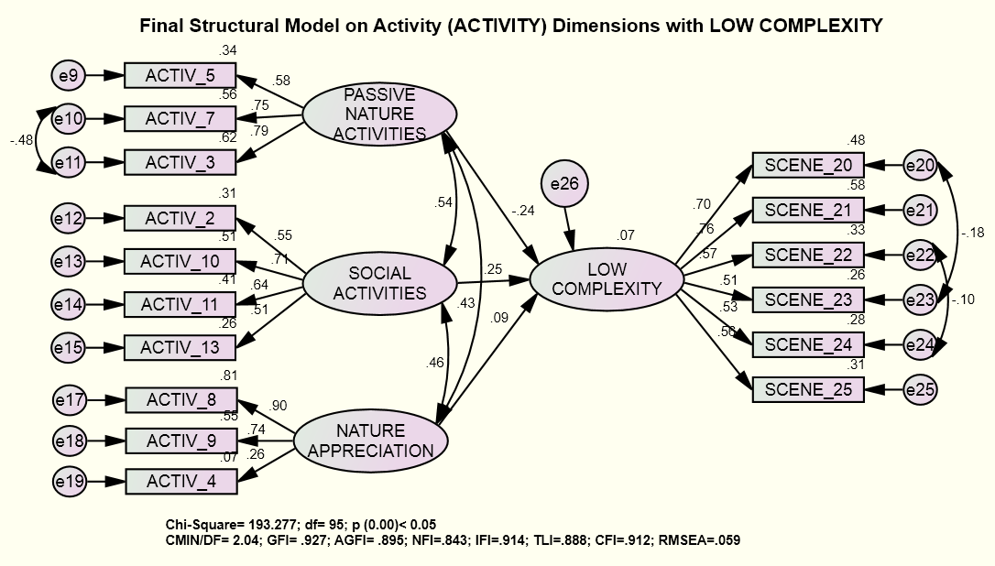
Figure 6 CFA Model on LOW COMPLEXITY Items
Table 9 Estimates of Regression Weights or Significant Estimates for LOW COMPLEXITY
Items – Constructs¹ |  |  | Estimate | S.E. | C.R. | P²
LOW_COMPLEXITY | <--- | SOCIAL_ACTIVITIES | .185 | .082 | 2.251 | .024
LOW_COMPLEXITY | <--- | NATURE_APPRECIATION | .056 | .054 | 1.048 | .295
LOW_COMPLEXITY | <--- | PASSIVE_NATURE_ACTIVITIES | -.242 | .107 | -2.261 | .024
¹ Constructs are represented by: LOW COMPLEXITY = activity, ACTIVITY= social activity, passive nature activities, and nature appreciation, ² These based from the standardized estimate values; *** p<.005

Findings and Conclusion

The majority of the participants is male, married with university level of education. In addition, more than 40 % of them are 19-29 years old age group with moderate income level. The result reveals that the participants prefer to get involved in passive activities related to water features such as sitting around water features and watching them. It supports the conclusion of the previous studies, which argue passive activities are the most preferred activities in urban parks (Gobster, 2001& Hami, 2009). People were interested to involve directly with natural elements such as water. It seems that vegetated areas and water features provide users to feel peacefulness and calmness in parks. The result exposed that walking, sitting, and watching vegetation scenes were activities that were done mostly in urban parks. Moreover, engagement with nature is another top priority of the participants to be involved in urban parks. It can be said that people seek water features’ entertainment and nature involvement in urban parks those might attract more people to visit parks.

The study also showed correlation between people’s opinion for usability and preference for vegetation visual complexity. The SEM model also revealed positive effect of activities on moderate visual complexity and negative effect of activity on vegetation with low complexity. Park usability is important because a decline in the park usage can reduce informal controlling of park activities which lead to increase the risk of facing with undesirable behaviors such as drug use.
It was argued that facilities of parks for both structured such as sport fields and unstructured physical activity such as paths played important role to encourage park visitors . Another study suggested that people visited park with walking paths and trails more often than the parks including sport facilities . Activities related to water features encourage people to visit park but water amenities may permit parks to be used for longer period . Moreover, the presence of drug addicts, muggers, offenders, and darkness of green areas are considered significant obstacles to come to the parks in Tabriz. A research also suggested that disclosure of even non-criminal but anti-social behaviors such as vandalism, verbal rudeness, and other inconsistent behavior with the visitor’s culture is related to crime risk .

The study proved that spatial configuration of vegetations correlates with urban park usability in Tabriz. Spatial quality of vegetation contributed in improvement of public’s social skills however, high vegetation complexity detracted social activities in park environment. Therefore, proper vegetation design can increase societal sustainability. The study emphasized the importance of vegetation arrangement and configuration with regard to improvement people social life. Morever, people activities in urban parks should be designed and anticipated in relationship with vegetation spatial configuration.

References

