Compartion sense of place and place attachment concepts in the student dormitory
Yazdanfar . Seyed Abbas, Heidari. Ali Akbar, Nekooeimehr.Fatemeh

1. Assistant Professor of Architecture, Iran University of Science
& Technology, Tehran, IRAN
2. PhD Candidate in Architectural Departement, Iran University of Science
& Technology, Tehran, IRAN
3. Master of Architecture, Asalooieh International Payamnooruniversity, Asalooieh, Iran

Abstract

Today, there are many concepts such as a sense of place and attachment to place presented in architecture and urban literature in the field of environmental studies. Meanwhile, relationship between the two is not much explained. This study defines the concept of sense of place and attachment to place and the factors influencing them followed by providing five-dimensional model derived from social factors influencing the two concepts as the study theoretical model. This five-dimensional model was tested in case studies of Eram and Ghods dormitories of Shiraz University. In this study, depth interviews and questionnaires were used to collect data for process of testing. Spss software was used to analyze and interpret the survey results.
Obtained results show that there is a strong relationship between sense of place and attachment to place. The findings also suggest that physical factors of the environment are important to create a sense of place and time as well as attachment to place. Moreover, time factor has lowest degree of importance in creating a sense of place compared with the creation of sense of attachment to the place. This factor is the most important after physical factors.

Keywords: Place, sense of place, attachment to place, physical factors, time, student dormitory.

1. Introduction
Student dormitories are among the areas that many people, especially during the period of their study, live there which are in cities other than their dwelling place. Dormitory is a place where people live for limited period of time (at least several years) and then are forced to leave there after completing their course of study. These people in dormitories experience a new life that have not had such an experience in their home environment before. Usually, the physical structure and functional accommodation of dormitory for these people is different with that of home. Accordingly, the dormitory environment seemed a good place where people show their different feelings ranging in different time of arrival, length of stay and the time of graduation. These centers require facilities for providing services to students. According to acceptance of non-traditional students in the majority of higher education institutions, proper facilities including a perfect accommodation for these students are essential. This space is not only a shelter for the students but also should provide required space for their scientific, intellectual and characteristic development. It seems that designers comprehensive understanding of concepts such as a sense of place and attachment may influence human understanding and his interact with the environment and thereby creates a more appropriate place for development of his different aspects of human existence.
This study is an attempt to find the relationship between the two concepts of sense of place and attachment to place. For this purpose, various definitions and factors affecting them are defined and a research model is obtained to investigate and confirm the relationship between the two concepts. This study conducted to test two case studies of Eram dormitory and Ghods dormitory accommodation for female students of Shiraz University.

2. Literature review
This section examines the overall definitions of place, sense of place and attachment to place and their influencing factors. Results of this section helps to obtain a theoretical model.
2.1. Semantic dimensions of place
Place is where concrete manifestation of life-world can be observed which forms spatial and temporal stability of the environment life (Schulz,2002: 31). Place is a space witch have meaninng, so place is defined as space where social relations are characterized. Rappaport defines place as the one of four elements defining a space which in combination with meaning, time and communications forms the human environment (Rappaport,2005).
In many related literatures often the place concept emphasis on the sense of belonging or emotional attachment which defined with terms such as rootedness, attachment, identity and so on. Lynch defines place identity simply as its uniqueness compared with other places (Lynch,1993). Relph defines place identity as separate address for each place. He states: physical characteristics, meanings and functions are considered as three main basis of place identity. It should be mentioned that human interaction with these three elements forms the sense of place (Relph,1976).
Belonging to a place is the most important concept in the sense of place. This concept is meaningful along with a positive sense of place or love of place which leades to positive memory of a place (Seaman, 2008). Steele defines belonging to a place beyond emotional experiences and it is includ cultural beliefs and activities that makes a contact between human and environment (Cross, 2001). Tuan believed that sense of belonging to a place is more than just experiencing it cognitively and emotionally, rather includes related cultural beliefs of the people living in a place. He also believed that such relation occurs throughout life and long-term experience of place.
Tuan defines respect to a place as a strong chain between an individual and place while place attachment is commitment to the aesthetic, tactile and emotional environment. (Tuan, 1980). Sense of respect to a place is one of the characteristics of a place that distinguishes it from other places which is called intelligence or spirit of the place.
2.2. Sense of place

In phenomenological approach, sense of place is the place truth which is used more in the non-material features and characteristics with a meaning close to the spirit of the place. It means that some places are so attractive that give individuals a indescribable feeling which makes them lively, vibrant and eager to return to them. Tuan used the term Topophilia instead of sense of place and considered it as a lovely and effective relationship between people and place in the form of aesthetic, sensory, emotional feelings (Tuan, 1980).
The term sense of place has vast and varied implications in the scientific, sociological, cultural and psychological areas. Falahat believes that sense of place means individuals perception and more or less conscious feelings of the environment that puts the person in internal relation to the environment so that the understanding and feelings are bound with the meaningful context (Falahat, 2006). Recent researches indicate that environment in addition to the physical elements consists messages, meaning and codes which are decoded by people based on their expectations, motivation and other factors and according to this make judgments abaut them. This general sense obtained after perception and judgment in relation to the specific environment in individuals is named sense of place. This sense makes coordination and better utilization of the individual and the environment, consumer satisfaction, place attachment and ultimatly their continual presence in the place (Relph, 1976).
The concept of sense of place on one hand rooted in the subjective experience (eg, memories, traditions, history, culture and community) and the other hand is affected by objective and external area conditions (such as landscape, smell, sound, etc.) which causes different reminiscent of a place (Falahat, 2006). Therefore, sense of place is a complex concept of human attachment to environment which is created whit human adaptation and application of the place. It means that sense of place is not something predetermined but is created by human daily interaction with places.
2.2.1. Factors affecting sense of place
According to the different perspectives in sense of place which mentioned above, sense of place has both descriptive and emotional aspects of the experience of the environment. This means that the concept of sense of place is both psychological and physical. According to Steele, sense of place is the particular experience of a person in a particular setting. Factors that lead to a sense of place would be divided into two general categories: cognitive - perceptual and physical factors (Steele, 1981:35). In this regard, cognitive-perceptual factors include concepts which are decoded by the person after his perception. Therefore, a sense of place can not only be called as an emotional sense to a place rather it is a cognitive structure that bind a person to the concepts. Therefore, it can be concluded that there are different senses among different people based on their experiences, motivations, past mentality background and physical characteristics of environment. These factors influence their sense of place.
In another study by Jorgensen (2001), based on the theory of "attitude", three dimensions are considered for place. Individual feelings associated with places represents emotional aspect, his understanding of the place physics represents cognitive aspects and his behavior in one place represents behavioral aspect (Jorgensen, 2001). These dimensions are somehow corresponding to Canter three-dimensional sense of place, so the cognitive aspects is corresponded to form, behavioral aspect is corresponded to function emotional aspects is associated with individual perceptions (Hashemnezhad, et al, 2013). Based on Canter view, place is a part of the natural or built environment with specified conceptual or material ranges which is extracted from relationship between the three concepts of human behavior, physical characteristics and concepts ( Canter, 1977).
This literature review shows that physical properties not only cause distinction of different environments but also affects the meanings that people perceive from their environment. Steele believed that the most important physical factors affecting place perception are factors such as location, size, scale, components, texture, decoration, color, odor, noise, temperature variation and visual variety. He also considers features such as identity, history, fiction, mystery, memories, fun, secrets, goodness, security and vitality as factors influencing the concentrated relationship with place (Steele, 1981).
By comparison of the two models of Steele (1981) and Canter (1977), it can be concluded that the form and function factors in the Canter model are correspondent with steele physical factors while meaning in the Canter model is correspondent with Steele cognitive- perceptual factors which in turn includes parameters such as culture, identity, history, fun, pleasant, security, vitality, and memories.
3 . Place attachment
Attachment to place is a symbolic relationship that is created by individuals towards a place which gives a common emotional and cultural meaning to a particular area and it is considered as a basis for development of individual and group understanding of environment (Low & Altman, 1992: 5). Place attachment is an aspect of overall sense of place that develops between people and places (Stedman, 2003). This aspect is the result of positive feelings and beliefs that give meaning to place (Rubinstein & Par melee, 1992). During this process, an individual develops his relationship with others and place. There is a direct relationship between individual and his attachment to special place. This relationship is based on individual- place and his activities interactions in a specific place. (Ralph, 1976; Low & Altman, 1992). Attachment to a place is created by interest, knowledge and individual experience in relation to place and based on cultural characteristics and social ties between people (Low & Altman, 1992). In fact, it is based on cognitive, emotional and behavioral interaction between individuals, groups and physical- social place formed consciously and unconsciously over time. It is created in emotional connection between people and place based on judgment methods, preferences and understanding of places (Riley, 1992).
3.1. Factors affecting place attachment
According to literature review in place attachment, effective factors in development of place attachment can be classified in terms of the following topics:
1. Physical Factors
There is many studies that emphasized on physicl factor in place attachment. Stedman studies on the role of the physical component in the attachment to place indicate its direct role in the place satisfaction (Stedman, 2003). Context of place, available services, facilities, its location in urban areas, its relation to surrounding and many other properties, are among factors mentioned in the studies (Bonaiuto et al, 1999).
2. Social factors
Basically, environment psychology is not only related to the physical aspect of environment but also its social aspect is considered too (Bonnes & Secchiaroli, 1995). Positive relationship between individual and physical place and his emotional satisfaction are related to available social relationships in the place, so that social interactions in the place make it possible to create a meaning of place. Some researchers considered the attachment to a place based on public participation in place, amount of employment in social networks and cultural exchanges (Marcus, 1995) .
3. Cultural Factors
All members of society with their special culture share the same attachment to a particular place (Low, 1992 & Hummon, 1992). Attachment to place is related to activities performed by individuals in the form of their cultural requirements (Low & Altman, 1992).
4. Individual Factors
Attachment to place varies from person to person (Tuan, 1979). People chose places based on their conscious preferences obtained by their individual characteristics attached to them. Individuality is also important in the development of social relationships. This is called mental characteristics of primary trends (Riley, 1992).
5. memories and experiences
Attachment to place usually happens after a strong or long term attachment to the place experience in which place obtains a broad sense for individual (Tuan, 1974; Kaplan, 1995). In this regard, Tuan emphasized a factor as rootedness in place which means unity of individual with place (Tuan, 1980). Riley in his study on attachment to places found that attachment to place is the result of memories of growth period and relationship that takes place in one place. He believed that we remember an ideal location where remember real favorable experience events and place is a part of our experience that can be a symbol of that experience (Riley, 1992: 19).
6. Satisfaction of the place
Emotional relationship between individual and place depends on his satisfaction of place and his method of evaluation (Bonnes & Secchiaroli, 1995). The amount of this relation depends on the the individual's perception of place and extent of his satisfaction, place quality and its security (including economic, social, and physical security). It occur when the human requirements and expectations are met in the place. Therefore, one of the most important aspects that should be considered in this regard is the amount of individuals satisfaction of those places. whatever individuals needs and expectations of the place increased, the likelihood of a more favorable emotional develops (Fisher et al, 19 85). satisfaction factor also is dependent on factors such as: facilities, location and function proportionality, consistency, visual characteristics, management, place economic value, social context of place, social communication and background characteristics (Bonaito et al, 1999).
7. Activity agents
One of the most impressive features of place which is involved in promoting attachment to places is individual-place activities and interactions (Rubistain & Parmelee, 1992; Relph, 1976; Low & Altman, 1992). In fact, it is rooted in how people interact with physical and social space in the form of cognitive, behavioral, and emotional interactions which leads to attachment to the place. It means that the kinds of activities in a place lead to obtaining the place meaning which in turn is the basis of attachment to place (Relph, 1976; Freid, 1963; Brown, 19 92; Low & Altman, 1992) . Studies show that attachment to places will increase by continuing events or activities in the place (Low & Altman, 1992).
8. Time factor
Time factor, or length of residence, plays an important role in creating attachment to place. This issue is confirmed by many researchers (Bonaiuto et al, 1999). The time factor in adults and children is considered as a determining factor in the degree of attachment to place and it can be studied both in the process and the level of attachment to a place (Low & Alt man, 1992).
4. Theoretical framework
What examined so far was different models of sense of place, place attachment and various factors influencing these concepts. In order to obtain the research theoretical model, triple factors of a sense of place and eight factors of place attachment collected and finally five factors were obtained. Therefore, the form factor of a sense of place characterized by physical factors of place attachment classified as "physical factors", the performance factor of the sense of place attachment with the term of function in sense of place classified as "functional elements", the factor of meaning of the sense of place and cultural, individual, memories and the exchange of experiences in place attachment considered as "perceptual – cognitive factors". "Social factors" and "time factor" of attachment, without any corresponding factors of sense of place, were considered separately in the research theoretical model. Therefore, among all factor influencing the sense of place and place attachment, five physical factors, functional factors, cognitive - perceptual factors, social factors and time factor considered as five factors obtained from theoretical models. (Table 1).

Table 1. Obtaining five basic framework of effective factors on sense of place and attachment to place
 | All factors | Sense of place | Place attachment | Conceptual framework
1 | Form | * |  | Physical factors
2 | Physical properties |  | * | Physical factors
3 | Function | * |  | Functional factors
4 | Activity |  | * | Functional factors
5 | Meaning | * |  | Perceptual – cognitive factors
6 | Cultural |  | * | Perceptual – cognitive factors
7 | Individual |  | * | Perceptual – cognitive factors
8 | Memories and experiences |  | * | Perceptual – cognitive factors
9 | Satisfaction |  | * | Perceptual – cognitive factors
10 | Social |  | * | Social
11 | Time |  | * | Time

5. Methodology

Before explaining the research method, it is necessary to discuss about the case studies. Pardis Eram Complex, famous as Eram dormitory, is located on a hill near the campus of the University of Shiraz on a very large area of high ground above the town overlooking Is located. Minoru Yamasaki, designer of this collection, is designer and architects of New York Trade Center too.

 | 
Figure. 1 & 2. Shiraz Eram Dormitory
Ghods dormitory is also another dormitory belong to Eram Shiraz University located at the end of Eram Blvd near the Daneshjoo square in the urban context of the city. This 11- story dormitory was built in which the sixth and ninth floors assigned to accommodation of graduate and undergraduate students.


Figure 3. Ghods dormitory in Shiraz

In this study, questionnaires were distributed among students in both dormitories. After completing the questionnaires, SPSS WIN17 software was used for data processing by appropriate descriptive and deductive statistical methods. At descriptive level, absolute, relative, and cumulative frequency distribution methods were used. At deductive level, correlation coefficient, regression and mean comparison testing were used regarding the nature of variables.
One of the major issues in social research is how to determine number of participant. To determine, first accuracy and confidence level of sample generalization must be specified. 5% confidence level is usually considered in the social sciences. In this study, the "Cochrane" participant calculation formula is used as follows:
N= Population
T = 95% confidence level equal to 1/96
d = potential efficiency half of the confidence distance
Confidence interval (p) in this study was 10%. Therefore, the potential efficiency of 5%
calculated.
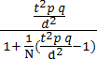
6. Participant Frequency
According to Cochran formula, 154 questionnaires were distributed randomly among students of each dormitory of which 77 were in the Eram dormitory and 77 were in Ghods dormitory. Education level of the study population included 3 student at degree level, 128 student at undergraduate level and 23 student at postgraduate level. Collected data indicates frequency range of the studied students is at undergraduate level. Frequency distribution of the study population included 53 student in first academic year, 35 students in the second year, 28 in third year and 38 in the fourth year. So, most students are in first year of their study at university.

Table 2. Frequency table of Participant Frequency
Frequency | Levels |  |  | Academic year |  |  |  | Total
Frequency | Associate degree | Undergraduate | Postgraduate | 1 | 2 | 3 | 4
Eram | 0 | 64 | 13 | 21 | 20 | 16 | 20 | 77
Ghods | 3 | 64 | 10 | 32 | 15 | 12 | 18 | 77

7. Discussion
Research hypotheses analysis
The main hypothesis of this study is to find the relationship between sense of place and place attachment which is presented as hypotheses No.1 in the table (3). According to the early investigations in litretare review, two factors of time and physical factors considered more important of other five factors. Therefore, their effects on sense of place and place attachment are more specifically examined in the form of hypotheses 2 to 5 (Table 3). Accordingly, the Pearson correlation coefficient and significance coefficient were analyzed separately for each five factors and due to lack of time, more assumptions about other factors of conceptual framework are not analyzed because.

Table 3. Pearson Test of significance level in the study hypothesis
Hypotheses | Pearson test | Significance level
1 - There is a significant relationship between sense of place and place attachment. | 958/0 | 000/0
2 - There is a significant relationship between the physical factors and place attachment. | 89/0 | 000/0
3 - There is a significant relationship between the factors of time and sense of place. | 197/0 | 0/040
4 - There is a significant relationship between, physical factors and sense of place. | 936/0 | 0/000
5 - There is a significant relationship between time factor and place attachment. | 716/0 | 0/040

Hypothesis (1): This hypothesis attempts to find a relationship between the two main variables of a sense of place and place attachment. For temporarily reject or confirm of the hypothesis and by considering the measurement level, Pearson correlation coefficient are used as statistical test. In the Pearson test, -1≤ r ≤+1 can be observed. Whatever (r) or obtained coefficient correlation of the test is closer to +1, a stronger relationship will be indicated and weaker correlation can be observed in the opposite direction. Pearson test indicates strength and weakness of this relation. According to high correlation coefficient of 0.958 in this hypothesis close to 1, a strong relationship prevails between the concepts. Level of significance or (sig) in this respect should be less than or equal to 0.05, otherwise the relationship is not significant. this hypothesis with a significance level of 0.000 is confirmed. Since the significance level is less than 0.05, the related hypothesis is confirmed. Thus it can be stated that there is a very strong relationship between sense of place and place attachment.
Hypothesis (2): This hypothesis seeks to explain the relationship between physical factors and place attachment. According to high correlation coefficient of 0.89 in this hypothesis close to +1, a strong relationship prevails between the concepts. This hypothesis with a significance level of 0.000 is confirmed. Since the significance level is less than 0.05, the related hypothesis is confirmed. Thus it can be stated that there is a very strong relationship between physical factors and attachment to place
Hypothesis (3): This hypothesis is aimed at finding time factor in the sense of place. The correlation coefficient between the two variables is 0.197, which is very low level. However, the significance level of 0.040 has been approved. Since the significance level is less than 0.05, the related hypothesis is confirmed. Thus it can be stated that there is a very strong relationship between time factor and sense of place.
Hypothesis (4): This hypothesis seeks to explain the relationship between physical factors and the sense of place. According to high correlation coefficient of 0.936 in this hypothesis, significance level of 0.000 is confirmed. Therefore, the related hypothesis is confirmed. Thus it can be stated that there is a very strong relationship between physical factors and sense of place.
Hypothesis (5): This hypothesis seeks to explain the relationship between time factor and place attachment. High correlation coefficient of 0.8716 in this hypothesis and significance level of 0.040 is confirmed. Since the significance level is less than 0.05, the related hypothesis is confirmed. Thus it can be stated that there is a very strong relationship between time factor and place attachment.
Above analysis and interpretation of the hypotheses indicate that there is a strong relationship between two main variables of sense of place and place attachment. According to literature review, sense of place is a kind of individual's sense to a place created by individual interaction with that place. It must be mentioned physical factors, activities, and meanings associated with this place are factors that are influential in shaping a sense of place. These factors are put together in the process of individual- place interaction. On the other hand, literature review of place attachment also explains the fact that attachment to place is a positive emotional connection with the place. This is based on previous experiences of life, behavioral, cognitive, social, emotional and individual structures. So people create their behavioral, cognitive, emotional and social model based on this relationship and classify their new experiences accordingly to guide the motivation for the behavior and activities of a person in relation to their "self" design. When "self" is creating, the individual needs and expectations are also established. When expectations are met by the object or subject, a sense of peace and security can be obtained and he will continue to meet his needs objectively and subjectively. The result of this process is interests and passion for life with others. The obtained results show that place attachment is one of the subsets of sense of a place. Thus, the person's sense of place can be considered an overall feeling of the place and attachment to place is a positive feeling that a person will get from the place.
In the next step, the relations of the five parameters in model of the research on place attachment and sense of place are examined separately. As mentioned above, there is a strong significant relationship between physical factors and attachment to place (what is seen in hypothesis 2). It is due to a person lives in direct contact with the physical and physiological factors such as his residence (form, color, light, texture, perspective ...) and pays so much attention to these factors to enhance the quality of life.
There is a significant relationship between time factor and sense of place While the correlation of these two variables on each other intensity is weak. (What is seen in hypothesis 3). whether the intensity of the relationship between the factors of time and place attachment is at higher level (hypothesis 5). This is because if a person's sense of place considered as his overall sense to the place, place attachment is a positive feeling which grows over time and individual becomes interested in the place. That is why people who live in a place become accustomed to their dwelling over time and all the factors that will affect their lives becomes important to them. This causes their interest to the place.

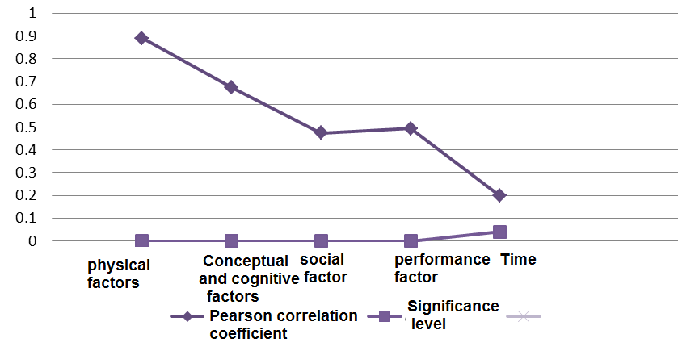

X Axis: influencing parameters
Y Axis: Correlation coefficient and significance level
Figure 4. Evaluation of correlation coefficient and significance level of the parameters affecting the sense of place

What can be observed in the figure (4) is the effect of five factors of the theoretical framework on the sense of place. This diagram represents the five factors of the theoretical framework along the (x) axis ,Pearson correlation coefficient (correlation coefficient) and the significance level of these parameters in (y) axis. According to this diagram, it can be concluded that physical factors are the most influential parameters on the sense of place that students in dormitory considered them as most important factors. Time factor contains the lowest correlation coefficient and significance level which indicates that the time factor has the minimal impact on the sense of place.

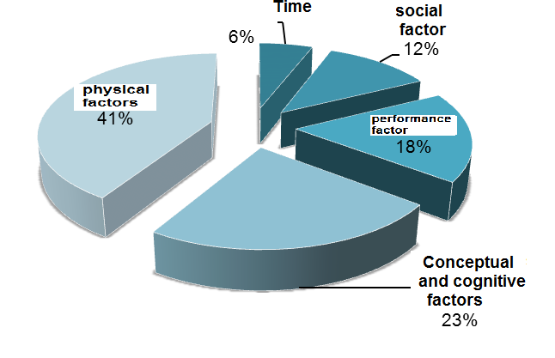
Figure 5. The effect of the five factors of the theoretical framework on the sense of place

What can be observed in the figure (6) is the effect of five factors mentioned in the conceptual framework on place attachment. Five factors of conceptual framework is represented along the (x) axis and the significance level of these parameters in (y) axis. Purpose of researcher is to evaluate the relationship between the internal variables and their amount. It can be inferred from this diagram that physical parameters are the most influential factors affecting place attachment after which time factor has the greatest impact on it.
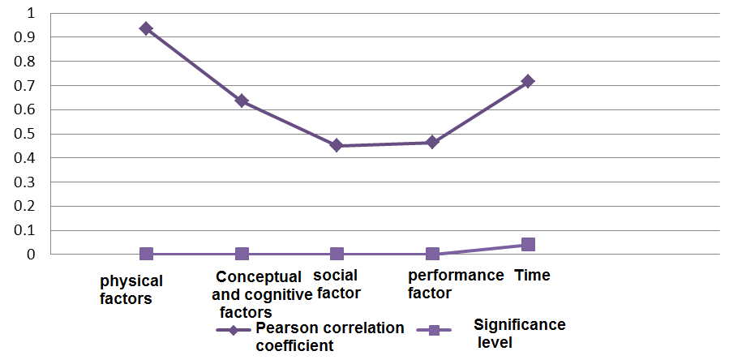
X Axis: influencing parameters
Y Axis: Correlation coefficient and significance level

Figure 6. Evaluation of correlation coefficient and significance level of the parameters affecting attachment to place

Figure 7. The effect of the five factors of the theoretical framework on attachment to place

8. Conclusion
According to literature review, a sense of place is generally regarded as a holistic concept in the form of which individuals percept the place and attend meaning to it. Understanding of various aspects of forming a sense of place and understanding how people show tendency to it is useful to assess general attachment of individual to a place. Place attachment is related to emotional and functional relationship between individual and place investigated in environmental psychology.
According to what mentioned above, the purpose of this study is to explain the definition of a sense of place attachment and the factors affecting them, and compare the relationship between the two concepts. During this study, the opinions of the two samples students living in dormitories (Shiraz University Dormitories: Eram and Ghods) through in-depth interviews and a questionnaire are used to analyze and interpret the results.
The results indicate that there is a significant relationship between the sense of place and Place attachment. According to the interviews, a sense of place is the overall and primary feeling of an individual to a place that may change to Place attachment over time if to be positive. But in the case of negative sense of place, it becomes a feeling of disgust to places. Therefore, place attachment is followed by the sense of place and is considered as its subset.
The other part of this study investigated factors affecting the sense of place and place attachment. The results indicate that among the five factors presented in the theoretical framework, the physical factors have had the greatest impact on both the sense of place and place attachment. This indicates the important role of physical environment on the formation of initial feeling and positive impression of place on the people. Another obtained result in this study is investigation of the time factor related to sense of place and place attachment. This study demonstrated that time factor, compared with the sense of place, has the lowest correlation while in relation to place attachment, after the physical factor, is the most important one. Obviously, in the initial encounter with the places, the time factor is not very important and individual receives greater perception from the physical environment based of which a mental image of the place will be created. However, the more time a person associated with that place, more feel compouned to that place and therefor more attachment to place may be shaped.

References
- Bonaiuto, M., Aiello, A., Perugino, M., Bones, M., & Ercolani, A. P. (1999). Multidimensional perception of residential environment quality and neighborhood attachment in the urban environment. Journal of Environmental Psychology, 19, 332–352.
- Bonnes M. Secchiaroli G. (1995), Environmental Psychology, a psycho-social introduction. London: Sage Publication.
- Brown, B. B., & Perkins, D. D. (1992). Disruptions in place attachment. In I. Altman, & S. M. Low (Eds.), Human behavior and environments: Advances in theory and research. Place attachment, Vol. 12 (pp. 279–304). New York: Plenum Press.
- Canter, David. (1977b). The Psychology of Place. London: Architectural Press.
- Cross, J. E. (2001). What is Sense of Place, Reasearch on Place & Space Website Retrieved 12 Mar.2003, 20 Feb. 2003.
-Falahat, Mohammad Sadiq, (2006), "The Concept of Sense of Place and its Constituent Elements," Journal of Fine Arts, Tehran, No. 26, 57-66.
- Fisher, S.,Murray, K.,& Frazer, A.(1985).Homesickness,healthand efficiency in first year students. Journal of Environmental Psychology, 5(2), 181–195
- Hashemnezhad, Hashem, Heidari, Ali Akbar, & Mohamadhosseini, Parisa. (2013). “Sense of Place” and “Place Attachment” (A Comparative Study ). International Journal of Architecture and Urban Development, 3(1), 5-12.
- Hummon, D. M, (1992), “Community Attachment: Local Sentiment and Sense of place”, Plenum, New York.
- Jorgensen, B., & Stedman, R. (2001). Sense of place as an attachment: Lakeshore owners attitudes toward their properties. Journal of Environmental Psychology, 21, 233–248
- Kaplan, S. (1995). The restorative benefits of nature: Toward an integrated framework. Journal of Environmental Psychology, 15, 169–182.
- Low, S. M. (1992). Symbolic ties that bind. In I. Altman, & S. M. Low (Eds.), Place attachment (pp. 165–185). New York: Plenum Press.
- Low, S. M., & Altman, I. (1992). Place attachment: a conceptual inquiry. In I. Altman, & S. M. Low (Eds.), Place attachment (pp. 1–12). New York: Plenum Press.
- Lynch, Kevin (1993), The Image of City, translated by Mozayeni.,M, Tehran Universitypublications: Tehran.
- Marcus, C. C. (1995). House as a mirror of self: exploring the deeper meaning of home. Berkeley, CA: Conari Press.
- Norberg-Schulz, Christian (2002), Architecture: Presence, Language, Place, translated by Ahmadian, Seyed Alireza, Institute of Architecture Publications: Tehran.
- Rappaport, Amos (2005), The Meaning of the Built Environment: A Nonverbal Communication Approach, translated by Habib. Farah, Urban Processing and Planning publications: Tehran
- Rubinstein, R. L, & Parmelee, P. A. (1992). Attachment to place and representation of life course by the elderly (Vol. 12). New York: Plenum Press.
- Relph, E. (1976). Place and Placelessness. London: Pion.
- Riley, R, (1992), “Attachment to the ordinary landscape”. In I. Altman and S. Low (Eds.), Place attachment (pp. 13-36), Plenum Press, New York.
- Seamon, (2008), Place, Place Identity ,and Phenomenology : A Triadic Interpretation Based on J. G. Bennett’s Systematics, David, Seaman.
- Steele, F., (1981), the sense of place. Boston: CBI Publishing Company.
- Stedman,( 2003),Redden,(1993), sense of place and place- Based Introductory.
- Tuan, Y.F.(1974). Topohilia: Astudy of environmental perception, attitudes andvalues. New York :Columbia University Press
- Tuan, Y. F. (1979) Space and place: humanistic perspective, In: Philosophy in Geography, pp. 387-427, S. Gale and G. Olson (Eds). D. Reidel, Dordrecht.
- Tuan, Y.F.(1980).Rootedness versus sense of place. Landscape, 24, 3–8.

