Double skin glass façade and its effect on saving energy

Zohreh Nayebi¹, Mohammad Farrokhzad²
¹ Graduate student of architecture, Noor Islamic Azad University, Iran, architect13652005@yahoo.com
² Golestan University, Gorgan, Iran, m.farrokhzad@gu.ac.ir

Abstract
One of the most important methods of saving energy and providing indoor comfort conditions of buildings is carefully designing of the façades. A “double skin glass façade” is optimally one of the best options which manage the heat interaction between indoor and outdoor spaces. The total solar energy transmittance into the interior space is one of the key significance for the cooling load of the building and its occupants’ thermal comfort. It's also provides flexibility in architectural design. Recently, it has been more attention to double skin glass façades opposed to the most typically curtain walls .This is because of its ability to efficiently reduce energy consumption and therefore saving cost. The amount of energy saved depends on the climate condition and the design method chosen. The design of the double skin glass façade involves decisions of geometric parameters, glass selection, ventilation strategy, shading, daylighting, wind loads, and maintenance and cleaning cost expectations. Double skin glass façade has important influence on several aspects of the design phase of a building.
In this article the authors are going to pay to investigate features of double skin glass facade in reducing air pollution, air conditioning, smoke and also in the optimal use of sunlight within the building.
In another part, will pay effect of wind, shading, type of glass and ventilation in the space between skins on the performance of double skin glass façade and their effect on energy saving.
Finally, we analyzed the rate of energy transfer from the double skin glass facade and provide the case study. Also, this paper shall review previous studies done on double skin glass façade systems in building for saving energy.

Keywords: Double skin glass façade, saving energy, Air conditioning, indoor, comfort conditions

. Introduction
Conventional building skin facades are known to have numerous problems such as thermal comfort, natural ventilation and glare especially in buildings with high glazing skin, which are located in hot temperature regions. These problems encourage the engineers to sought ways of and improving the problems faced by the utilization of new techniques and devices such as shading devices, colour glass and tint glass. The adoption of these techniques have shown a reduction in natural lighting, and the increase in the use of artiﬁcial light; which inevitably led to the increase in the interior heat gain besides the utilization of other electric devices and office equipments that were used to counter the lack of penetration of external illumination. This interior heat gained is coupled with the external heat gained coming from solar radiation that is usually caused in some cases by poorly shaded buildings. To combat this situation, air-conditioning is used to cool down the heat effect. This results in the increase of energy consumption which leads to the increase the cost [1,2].
In 1990s, the concern pertaining to global warming and of the increasing demand for high-quality ofﬁce building encourages the engineers and developers (who are interested in natural cooling strategies) to look for new techniques as solutions, together with clear and environmental friendly energy to be used as an alternative source of energy for artiﬁcial lighting for buildings, ventilation and Air-conditions [3].
Double skin facade—DFS are used to better the thermal energy performance of facades of buildings with high glazing fractions. It is made of an external glazing offset from an internal glazing integrated into a curtain wall. It commonly features a controllable shading system located in the cavity between the two glazing systems [3,4]. It has gained much popularity in prevalent time for its ability to reduce solar heat gain or losses in buildings [5–7]. In fact, it has become highly signiﬁcant worldwide modern building practice especially in cool climate regions. The main architectural reason for using DSF is in its transparency properties because it allows close contact with the surroundings of the building, and of the fact that it admits a large amount of daylight to enter the building without glare. Finally it has attractive aesthetic value which is much desired by architects, developers and owners [8,9]. On the other hand, there are several disadvantages of using DFS; one of them is the investment cost that is considerably much higher than a traditional single-facade. Furthermore, the risk of overheating on warm sunny days is evident and may lead to a higher cooling demand [10,11].
The design of the DSF involves decisions on geometric parameters glass selection, ventilation strategy, shading, daylighting, aesthetics, wind loads, and maintenance and cleaning cost expectations [12].
Unfortunately, to date, there are still relatively few buildings which actually use DSF. Furthermore, there is too little information on their operational behavior. Thus it is said that it is quite difficult to ﬁnd any objective data on the actual performance of buildings with DSF (1, 10 and 11). In this paper we will discuss
some of the conﬁgurations issues in designing a DSF,where the aims of this study is to give a broad overview of double skin facade for different climate and regions.

.Reciprocal interaction of double skin glass facade and its elements on saving energy

DSFg ventilation
Ventilation is used for different purposes. Its principal purpose is to exchange contaminated air with clean air. It is also important to create a room climate without draught problems and only slight temperature changes in the occupied zone [6]. DSFg is categorized according to its function (i.e. ventilation type of the cavity). They are the natural, the mechanical and the hybrid ventilation. In order to provide fresh air before and during the working hours, different types of DSFg ventilation can be applied in different climates, orientations, locations and building types to minimize the energy consumption and improve the comfort of the occupants [7]. Furthermore, Ding et al. 2005 [8] suggested adding a thermal storage space called a solar chimney above the double-skin space to improve the stack effect in the double skin. Reduced-scale-model experiments and computational ﬂuid-dynamic analyses were carried out to evaluate the performance of the natural ventilation in prototype building. Suffice to say, the system improved the chimney effect of the double skin despite necessitating a chimney reaching at least 11 meters above the building. However, this is no doubt a signiﬁcant aesthetic constraint.
Further researches and studies on DSFg were also done by Gartia and Herde 2007c [8] who examined how natural ventilation can be achieved during a sunny summer day in an office building with a double-skin glass facade. They concentrated on the possibility of natural ventilation during the daytime in relation to the orientation of the double skin and the speed and orientation of the wind. It determined the way in which the DSFg should be opened, and the size of the openings necessary, to achieve a ventilation rate of 4 ach in each office under various wind conditions. However, these results cannot be generalized to other conﬁgurations of DSFg, and are insufficient for the technical design of a double skin glass facade as it is only the initial step towards a better understanding efficient DSFg design. Ensuing with the endings by Gartia and Herde 2007c, the researchers of this study brings to attention the study done by Kim and Song 2007 [11] who examined the contribution of a Double Skin Envelope (DSE) to the heating energy savings brought by natural ventilation in office buildings. ADSE was applied to the east and west facing walls on an actual three-ﬂoor building. Field measurements and computer simulations were performed in winter. The results implied that the DSE on the west-facing wall contributed to energy savings when natural ventilation was supplied from the cavity to the indoor space. The DSE facing east was not recommended for energy savings by natural ventilation because of its smaller exposure to solar irradiance.
Other related studies include a study done by Manz et al. 2004 [12] who implemented numerical simulations on the natural and Mechanical ventilation for glass double facades. It was found that air-ﬂow patterns depend on boundary conditions and it is much more complex than postulated by the piston-ﬂow assumption in simple analytical models ﬁnally, it demonstrated that a change in the orientation of the facade ﬂow can inﬂuence the total solar energy gain.
In addition, Xu and Yang 2008 [13] made a detailed analysis of the thermal process in glass double facade with Venetian blind. Governing equations were solved by using CFD, optical and heat balance model for multi-layered transparent system. It was found that the more complex natural ventilation exists in the two air gaps divided by the Venetian blind, which cannot be reﬂected with the simpliﬁed model. It can be used as a reliable tool to analyze the ventilation in the double skin facade with Ventilation blind. The results show that there is good agreement achieved between the simulation and experimental results for the maximal and minimal errors, which are 12% and 2.5% respectively. The reliability of the Simulation model is thus veriﬁed. Double-skin glass facades (DSFg) are a technique developed for colder climates, so few people think about whether or not it can also be used for hot-summer. Zhou et al. 2009 [14] studied it for hot summer and cold-winter zone in china. It was found that the ventilated DSFg with controlled shading devices can be used even in hot summer in China.

Shading device and DSFg
The main goal in designing a building from an engineer’s point of view to compute the total heat transfer through the cavity. This requires an adequate knowledge of correctly sided inlet and outlet openings, well-positioned shading device, as well as an optimized space between the facade and proper working conditions of fans located in the facade itself [16].
In one experiment, blinds and shading devices were placed inside a cavity between the two skins to provide protection against intrusion, glare and direct sunlight. It is to be noted that external or mid-pane types provide reductions in solar heat gains. In addition, the use of blinds can lead to considerable energy savings if controlled and adjusted correctly [17].
With regards to shading device and DSFg, Baldineli 2009 [18] presented the glass double skin glass facade equipped with integrated movable shading device. Energy performance was determined by measuring the optical properties of materials and by implementing a computational ﬂuid dynamics analysis. Validation was made by comparing with data of similar experimental apparatus. The façade performance was then compared with traditional enclosures such as glazed and opaque walls. The result showed that the facade signiﬁcantly improves the building energy behavior, especially when the conﬁgurations with winter farced convection is considered. A comparison with opaque walls showed an energy saving of up to 60 kwh per year per facade square meter.
Furthermore, it was found that correct position of the blinds makes it possible to reduce heat consumption of the building. And it was found that light coloured blind tends to invite more light into the office buildings.
Gratia and Herde 2007d [19] illustrated how the position and the colour of blinds affect the cooling consumption in a building with a double-skin glass facade wall. They also highlighted the importance of the opening of the double-skin glass facade. Other interesting factor to note is the impact of the blinds characteristics on human comfort and ergonomics. The result showed that the position and the colour of the blinds have an inﬂuence on the temperature of the inner skin windows. Logically and practically, the rights setting of blinds can ﬁlter the hot radiation coming from the windows to the occupants.
All of this design options are for conventionally located shading devices such as roller shades, louvered blinds, ﬁxed versus manually or automatically controlled, horizontal versus vertical ﬁns, etc. The designer should consider how the device will affect air-ﬂow within the cavity, and how solar gains absorbed by the shade will be radiated relative to the interior facade [20]. Furthermore, the types, sizes and positioning of any shading devices depend on the climate and function of buildings. Furthermore, the source of the light may be excluded; whether at a high or a low angle of direct sunlight, diffuse sky light, or perhaps reﬂected light from the exterior pavement on the street outside [21].

Smoke and DSFg
Extensive use of glass sheets in glazing might cause ﬁre problems. There is a public concern on the safety of buildings that have high window to wall ratio with large glass panels. Experiments with physical scale models were carried out to investigate the ﬁre hazard of DSFg. Many new construction projects with DSFg failed to comply with the ﬁre safety codes. The temperature gradient inside the glazing could be observed by increasing the risk of thermal that breaks the glaze.
In relation to this, Chow and Hung 2006 [22], Chow et al. 2007 [31], studied the spreading of smoke and ﬂame into the cavity of DSFg. The main ﬁre safety concern for DSFg is that smoke might spread to other levels through air cavity when a glass panel of DSFg is destroyed by ﬁre.
Depth of the cavity was identiﬁed as the main agent in ﬁre eruptions in building with DSFg. When ﬁre erupts, smoke would move at the centre of the cavity rather than along the wall. Hot smoke will then be forced towards the outer panel at the beginning and bounced back to the inner panel. The upper glass panel would be affected if the hot gas moves upward to the upper inner skin by the induced air ﬂow. Thus, it is suggested that using different types of glass for inner and outer skins might provide more desirable ﬁre safety.
In addition, Ding and Hasemi 2006 [10] examined the possibility of using natural ventilation system of a double-skin glass facade for smoke control. They conducted reduced-scale model experiments and CFD analysis. It was found that smoke from a ﬁre room escaping through the inner facade into the intermediate space between the two skins may accumulate and spread horizontally or vertically to other rooms that have openings connected to the intermediate space. The result showed that smoke spread can be prevented with suitable arrangement of openings.

Cavity depth of DSFg
When considering double skin glass facades (DSFs), consideration of the cavity that lies sandwiched between the two walls (internal and external wall) is inevitable. According to Sinclair et al. 2009 [23], the depth of the cavity is determined by a number of parameters including the aesthetics, types of shading devices/blinds, access to the cavity for cleaning, and the ventilation strategy that include arrangement and ﬂow rates.
Chen et al. 2009 [24] carried out experiments using a solar chimney model with uniform heat ﬂux on a low wall. The inducing air-ﬂow rates were obtained by changing the gap-to-height ratio between 1:15 and 2:5 at different heat ﬂuxes and inclination angles. The optimal gap width or optimal gap-to-height ratio is the gap size or ratio when a maximum ventilation ﬂow rate was achieved. Regardless of the results, the obtained optimal spacing from these studies lack consistency. From heat transfer point of view, the optimal spacing should be the gap size when the vented heat is high, or when the heat is blocked by roof structure.

Wind pressure and DSFg
Wind pressure in the one of the most important thing affecting the glass. For DSFg it is very important to check for that because DSFg have three surfaces subjected to wind pressure due to the air-ﬂow between the double facades; those are the outside and inside surfaces of the external skin facade and the outside surfaces of the internal skin facade [25].
According to Grabe 2002 [26], the wind creates differences of pressure that stimulates the air-ﬂow in the building. He suggested that values of pressure differences on the facade of the building depend on the direction of the wind, shape and height of the building. In particular, value of the wind pressure coefficient depend ﬁrst on the direction of wind and for different building construction different formulas are given.
In addition, Luo et al. 2005 [25] studied the wind pressure distribution on each surface of the double-skin glass facades using wind tunnel tests. Furthermore, the characteristic of the wind pressure distribution on the long-span canopy was also obtained from the tests. Result shown that the effect of wind load is appear when it blowing in front of the canopy and it is almost the same when the wind load acting on the upper and lower surfaces of it.
Other related studies include a study by Zhang et al. 2008[27] analyzed the wind pressure and gust factor distribution on DSFg and comparison of wind load between internal and external facade in different air-ﬂow zone by using model tests in wind tunnel and synchronous manometric method on internal and external facades,. Result shown that aroused by vortex shading mostly acts on external facade, while compression force aroused by air-ﬂow adhesion and collision mostly acts on internal facades. And DSFg gust factor changes largely as variation of facade’s region or wind direction.
Moreover Luo et al. 2009 [28] studied mean wind pressure distribution on DSFg used wind tunnel tests. Result shown that mean wind pressure mostly acts on external facade is larger than that on the internal faced.
On the other hand, to determine the wind load on DSFg and predict the load difference between single skin glass facade and double skin glass facade Luo et al. 2008 [28] used wind tunnel tests to study the tall building with arc-shape and L-shape double-skin glass facade. This study indicated that pressure in the draught corridor that acts on the external and internal facade at any point is same. The wind load carried by internal facade can be also decided the same as that of single-skin glass facade. However the wind load carried by external facade can make a discount when the facade locates at the middle of the arc-shape or the long side of the L-shape corridor, and should be ampliﬁed when the facade locates at the end of the arc-shape or the short side and the turning point of L-shape corridor.
Furthermore, in another study done by Luo and Zhang 2009 [29] study the characteristics of the wind loads on the arc DSFg with different central angles using wind tunnel tests. Result shown that the wind load of the internal skin facade are even and increase with the central angle decreasing .The wind loads acted in the end of the external skin facade are larger than that on the centre of the external facade and much larger than the single skin glass facade.

.investigate case study
- Case Study 1
The facade of the office levels has mechanically ventilated windows. The warm air in the room is extracted above the lighting units, so that the air also takes up their additional heat. Then this air is fed via specially shaped ducts at the level of the topmost transoms into the narrow cavity of the story-height ventilated windows. Here the air is warmed further by taking up heat from radiation of the glass; it is then taken out at the bottom of the window and drawn forward to the air conditioning system of the building. The aim in extracting the air via the lighting and then down from the top to the bottom of the cavity, is to utilize the internal heating loads as much as possible in achieving higher temperatures on the surface of the window during colder periods; this improves the thermal comfort in the office space near the windows.(Fig.1)
The integration with the AC system achieves preferred temperatures on the surface of the window. In the proposed addition to Cowgill Hall, heat absorbing glass is proposed to achieve high temperature in the cavity without blocking views
Figure .1: Headquarters of the Lloyd’s Insurance Company, London by the Richard Rogers Partnership
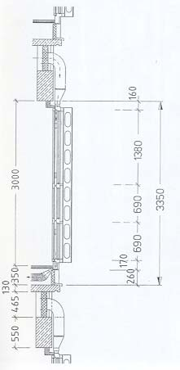
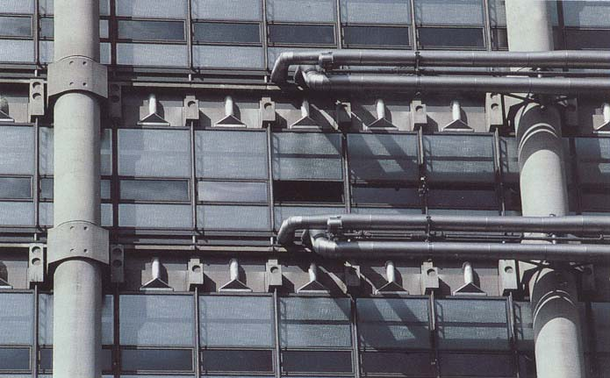

- Case Study 2
In this project, the street facade is composed of load bearing sandstone piers and glazed bay windows. As these windows are not intended to be opened, for reasons of safety and acoustic insulation, a ventilated cavity façade was proposed. The window construction is composed of an external insulating unit ( an external clear laminated glass, an argon gas filling in the cavity, and an internal float glass with a low-E coating), and internally an opening sheet of toughened glass. Solar shading is taken care of by adjustable Louvre blinds integrated in the 75 mm wide cavity between the outer and inner skins, and by light shelves positioned above the bays; these shelves shade the area immediately next to the window, and they are designed to reflect daylight into the back of the room.(Fig.2)
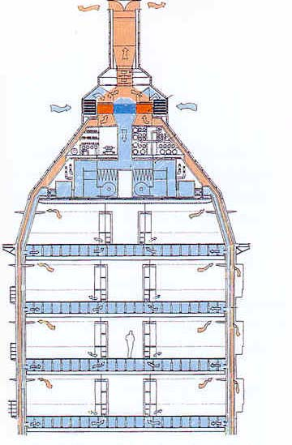
It is important to integrate lighting devices with the double glass facade to maximize the benefit of the double glass facade in buildings which do not have an all-glass surface. In case of the proposed addition to Cowgill Hall, the all glass facade is sufficient for natural lighting.
Figure.2:New Parliamentary Building, Westminster, London by Michael Hopkins and Partners
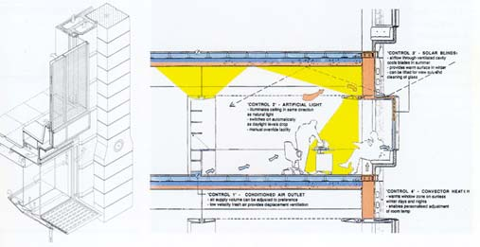

- Case Study 3
The glass skin gives an overall unity to the existing building with its stone facade and its new extension. At each storey level the mullion and transom frame has triple horizontal banding with top-hung windows. The glazing band at window level is of clear insulating glass; these sections can be opened manually for ventilation by the rooms’ occupants. The upper band consists of insulating glass with integrated prismatic panels. These glazings are computer- controlled to track the sun across the sky and thus protect the interior of the offices from direct sunlight. The top-hung windows in the lower band at each floor level, however, fulfill a different function in the energy system of the building. In winter they remain generally closed and create a buffer air zone in front of the parapet. In summer they are open, to prevent the stone façade of the old part of the building from overheating and to ensure night-cooling of this facade. This possibility of adjusting the glass panels permits a differentiated approach to respond to changing the weather and climatic conditions and shows how other aspects such as natural ventilation, light deflection, etc., are becoming increasingly important components of façade planning. The increasing complexity in facade requirements high lights the need for new working methods to guarantee optimum interaction of façade and building services.(Fig.3)
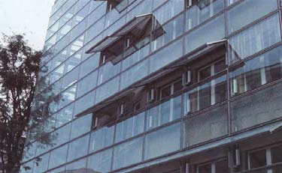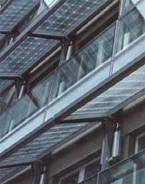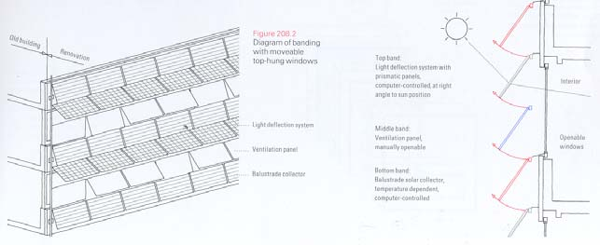
Figure.3:Headquarters of the Swiss -Insurance Company, Basel by Herzog and de Meuron

.A closer look at double skin glass facades, physical characteristics
Assuming that fresh air enters a building through the cavity between a double-leaf façade, it’s very important, especially during transition periods and when individual occupants want natural ventilation that no extreme temperature increase occurs in the cavity between the window panes, because the heated outside air would then overload the room temperature. The Figure series compares the temperature in this transition space for different types of shading (reflection quotient). In this example, fresh air enters into the window-pane configuration at a temperature of 25 centigrade and is already heated in the boundary layer region in the outer pane. On this path through the cavity between panes, the temperature rises further. The rise in temperature in this space due to reflection and especially due to light absorption may vary greatly and reach maximum temperature of 70 centigrade.
Temperatures in different cavities vary considerably. The question of how to remove the heat from the cavity is important. Very little inlet and outlet design has been done. The idea of accelerating ventilation by designing the inlet and outlet seems promising.
The chart presents a calculation of the change in total solar energy transmission per changing reflection quotient. When the reflection quotient diminishes (pollution), the total solar energy transmission does too, because there is less radiation transmission, which is usually positive in terms of heat for the adjoining rooms. On the other hand, the light quality may suffer. The quality of the Louvre, for e.g., reflection quotient, is worth studying.
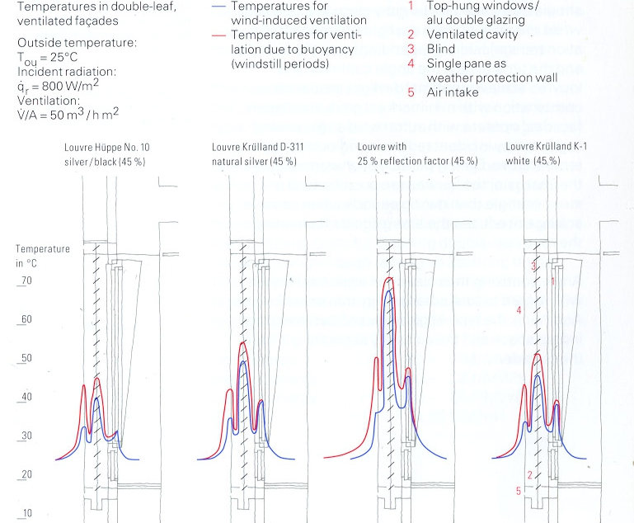
Chart 1: of Temperature in transition space for different types of louvre

While the surface of the Louvre is most important, the angle at which it is placed has an influence as well and changes the total solar energy transmission. The chart shows an example of two different louvers and how the total solar energy transmission changes, depending on the angle. Hence, the correct form of angle control (computer-aided) is key to the optimization of a facade, since direct radiation of office areas should be avoided for lengthy periods of the year while maintaining high daylight utilization (radiation transmission). Depending upon the season and the time of day, the angle control of louvers achieves optimal daylight incidence in combination with minimal heat gain. ‘Intelligent facades’ operate with automated angle control regulated by incident radiation and outside air temperature. During periods of unwanted thermal gain, the louvers are positioned at a steeper angle than during periods when passive solar gain reduces the energy costs for heating the room. Angle control is thus clearly an important factor with regard to total solar energy transmission. Another is the type of glazing used between the indoor space and the air cavity.
Since direct radiation of office areas should be avoided for lengthy periods of the year while maintaining high daylight utilization, the question is, “how much energy can computer-aided control save and is it a sufficient method to achieve cost efficiency?”

Conclusion
The main deductions which can be concluded from the results of the present studies are summarized as follows:
1) The idea of DSFg has been a source of numerous studies conducted on different areas since the 1990s.
2) Ventilation is the most important part studied by most of the researchers while the researchers highlights the inadequate past researches done on daylighting.
3) It was found from past researches that shading devices can reduce the external hot gain if it is placed correctly in the DSFg cavity.
4) However, it was discovered that DSFg pose a high ﬁre hazard risk.
5) The researches done on DSFg need further exploration.
6) Users of the DSFg (especially in hot and humid climate) are still in the early stages of development. Therefore, urgent theoretical and experimental research works is needed in order to clearly understand the challenges, effects and implications of DSFg.
In conclusion, double skin glass facade (DSFg) has been proven to be highly useful and signiﬁcant in current building developments. The only downside of double skin glass facade is that it is said to be more expensive than the traditional single glass facade. However, it is widely agreed by many experts that double skin glass facade (DSFg) is more cost-effective in the long run. This is because it is long lasting and more durable as compared to the single glass facade. In Addition, it provides other beneﬁts that cannot be found in single glass facade. One of it is that double skin facade helps create a more comfortable and eco-friendly office environment which in turn, further reduces maintenance costs as it saves the building’s energy resources.
Finally, DSFg systems have great potential for decrease energy consumption in wide ranges of research areas. The systems based on the ideal can ﬁnd signiﬁcant opportunities to be used in some innovative and prospective studies with multi disciplinary research structure.
Thus, the researchers of this study propose future works and more studies to be done on DSFg designs, on the problems in DSFg designs and its impact on the environment, building ergonomics and human psychology, and comfort. Innovations in DSFg designs should be further pursued and DSFg applications in buildings should seriously be considered as an element in addressing climatic changes and environmental hazards as it is cost and energy efficient.

References
[1]. Baker, N. & Steemers , K., Energy and Environment in Architecture; a Technical Design Guide, Routledge , New York 2000
[2].Boake et al., (n.d.), The Tectonics of the Double Skin: What are double facades and how do they work? [pdf] Publisher: University of Waterloo.
[3]. Boyce P. et al., 2003, the Benefits of Daylight through Windows. [pdf] Publisher: Lightning Research Center Rensselaer Polytechnic Institute
[4]. Heiselberg P. et al., 2008, Modeling a Naturally Ventilated Double Skin Façade with a Building Thermal Simulation Program
[5]. Loncour et al., 2004, Ventilated double Facades. Classification and Illustration of Façade Concepts
[6]. Harris Poirazis, Introductory Report for the Glazed Office Buildings Project ,Internal Report (2005) Report EBD-R–5/10, Division of Energy and Building Design, Department of Construction and Architecture, Lund Institute of Technology, Lund University
[7]. Till Pasquay. Natural ventilation in high-rise buildings with double facades, saving or waste of energy. Energy and Buildings 2004.
[8]. Wenting Ding, Yuji Hasemi, Tokiyoshi Yamada. Natural ventilation performance of a double-skin facade with a solar chimney. Energy and Buildings 2005; 411–418
[9].Giuseppe Ballestini, Michele De Carli, Nicola Masiero, Giovanni Tombola .Possibilities and limitations of natural ventilation in restored industrial archaeology buildings with a double-skin facade in Mediterranean climates. Building and Environment 2005;40–95
[10]. Wenting Ding, Yuji Hasemi. Smoke control through a double-skin facade used for natural ventilation 2006. ASHRAE Journal 2006;112(Part 1) 181.
[11]. Kim SY, Song KD. Determining photo sensor conditions of a daylight dimming control system using different double-skin envelope conﬁgurations .Indoor and Built Environment 2007.
[12]. Manz H, Schaelin A, Simmler H. Air ﬂow patterns and thermal behavior of mechanically ventilated glass double facades. Building and Environment 2004:1023–33.
[13]. Lei Xu, Toshio Ojima. Field experiments on natural energy utilization in a res- idential house with a double skin facade system. Building and Environment 2007; 14–23.
[14]. Zhou J, Chen Y-M, Fang S-S. ventilated double skin facades in hot summer and cold-winter zones in China. Journal of Hunan University Natural Sciences 2009 (Part SUPPL):160–2
[15]. Wolfgang Streicher, BESTFAC ¸ ADE, Best Practice for Double Skin Fac ¸ ades,WP 1 Report “State of the Art”, (WP1Leader) EIE/04/135/S07.38652. Institute of Thermal Engineering, Graz University of Technology; 2005
[16]. Carla Balocco, Massimo Colombari. Thermal behavior of interactive mechanically ventilated double glazed facade: non-dimensional analysis. Energy and Buildings 2006; 1–7
[17]. Matthias Haase. Double-skin facades for Hong Kong, PhD Thesis University of Hong Kong; July 2008
[18]. Baldinelli G. Double skin facades for warm climate regions: analysis of a solution with an integrated movable shading system. Building and Environment 2009;–18
[19]. ElisabethGratia, AndreDeHerde. Themost efﬁcient position of shading devicesin a double-skin façade . Energy and Buildings 2007;39:364–73.
[20]. Remi Charron, Athienitis Andreas K. Optimization of the performance of double-facades with integrated photovoltaic panels and motorized blinds. Solar Energy 2006; 80–91
[21]. Daylighting in building, THERMIE program me , (UCD-OPET) European Commission, Directorate-General of Energy (DGXV11) Thermie Daylighting Workshop, Dublin, 3–4 February 1994 Energy Research Group, School of Architecture, University College Dublin, Rich view, Clonskeagh, Dublin 14, Ireland
[22]. Chow WK, Hung WY, Gao Y, Zou G, Dong H. Experimental study on smoke movement leading to glass damages in double-skinned facade. Construction and Building Materials 2007;21:556–66
[23]. Sinclair, Duncan Phillips, Associate, Vadim Mezhibovski, ventilation facades, ASHRAE Journal; April 2009.
[24]. Chan ALS, Chow TT, Fong KF, Lin Z. Investigation on energy performance of double skin facade in Hong Kong. Energy and Buildings 2009;41–42.
[25]. Lou W, Jin H, Chen Y, Cao L, Yao J. Wind tunnel test study on wind load characteristics for double-skin facade building with rectangular shape. Journal of Building Structures 2005;26(Part 1):65–70
[26]. Jorn von Grabe. A prediction tool for the temperature ﬁeld of double facades . Energy and Buildings 2002;34:891–9.
[27]. ZhngM, LouW-J, Chen Y.Wind pressure distribution and gust factor on double skin facades of high-rise building with rectangular shape. Journal of Zheliang University (Engineering Science) 2008;42(Part 1):54–9
[28]. Lou W, Zhang M, Shen G. Wind tunnel test study on mean wind pressure distribution for double-skin facade. Journal of building Structures 2009;30(Part1):120–5.
[29]. Lou W, Zhang M. Test of wind load characteristics of cylindrical building with double-skin facade. Journal of Huazhong University of Science and Technology 2009; (Part 5).

