Optimal Atrium Configuration in Office for Thermal Comfort Enhancement (Case Study: Yazd and Tabriz Cities)

Abstract

Climate change and rising temperatures have made thermal comfort and energy management in buildings a fundamental challenge. Optimizing environmental conditions requires intelligent design and accurate simulation tools. This study aims to determine the optimal placement of atriums in office buildings located in two different Iranian climates: the hot-dry climate of Yazd and the cold-dry climate of Tabriz. Thermal comfort was evaluated using Predicted Mean Vote (PMV) and Predicted Percentage of Dissatisfied (PPD) indicators, combined with solar radiation and climate data. Simulations were conducted using the Honeybee and Ladybug plugins for Grasshopper, enabling parametric analysis of thermal comfort. In Yazd, Summer PMV values (2.34–2.50) indicate reduced comfort, with Types 5 and 8 showing the lowest discomfort (PMV = 2.34). Winter PMV values (-3.48 to -3.63) indicate cold conditions, where Type 5 performs relatively better. During spring and autumn, PMV values for Types 5, 8, and 3 approach near-zero. Southern-oriented atrium (Type 8) maximizes solar gain in winter. In Tabriz (cold-dry), Most PMV values fall outside the comfort range (-0.5 to +0.5). Only Atrium Type 3 achieves comfort during autumn. Type 3 receives maximum solar radiation in winter, enhancing natural heating. Strategic atrium placement based on solar exposure significantly improves seasonal thermal comfort. Type 8 (southern orientation) is optimal for Yazd, while Type 3 (northeast orientation) is optimal for Tabriz. These findings provide actionable insights for climate-responsive office building design in arid and semi-arid regions. Based on hypothesis Solar-based atrium placement significantly improves seasonal thermal comfort in both climates. Further research should examine other building typologies, alternative atrium geometries and other climatic zones in Iran.

Keywords: Optimal Atrium Configuration, Thermal Comfort, Yazd, Tabriz, PMV, PPD.

1-Introduction
Atriums are popular architectural elements used in residential, commercial, office, and educational buildings. For daylight to pass through an atrium, at least one facade must be transparent (Xu et al., 2025).A glass atrium can provide natural light in places where direct daylighting is not possible(S. Xu et al., 2024). The use of daylighting through atriums not only reduces artificial lighting (Shayanian & Qhadikolaei, 2024), but also provides significant psychological and ergonomic benefits to the population (Heydari, Ghanbaran, & ... 2024; Ye, Zhang, Li, & Braham, 2025). In atriums, ignoring climatic design factors can lead to poor lighting and thermal performance (CheshmehNoor, Mehdizadeh Saradj, & YazdanFar, 2020). Atriums receive heat based on their location, dimensions, height, and the distance between the measurement point and the transparent facade. A multi-story building with a deep atrium (atriums with a low width or length to depth ratio) may experience excessive heat on the upper floors, resulting in discomfort, while the lower floors may require artificial lighting (Gorji Mahlabani, Azizzadeh Araee, Motevali Alamuti, & Mofrad Boushehri, 2019). In addition, architects and designers face a more difficult challenge in quantifying and accurately measuring energy consumption, which requires specific awareness and knowledge of relevant energy efficiency issues (Aldawoud, 2013).
Certain regions of China have a wide range of climates, from cold in winter to warm and humid in summer. The air-conditioning of atria in these regions consumes an enormous amount of energy. It is therefore extremely challenging to manage their respective energy consumption without compromising the indoor thermal comfort. The geometric configuration of the atrium has preliminary and significant effects on the indoor environment and energy consumption (L. Wang, Huang, Zhang, Xu, & Yuen, 2017). However, the results show that improper atrium design may increase energy consumption or create discomfort for users. (Omrany, Ghaffarianhoseini, Berardi, Ghaffarianhoseini, & Li, 2020)
It impacts not only the shape and usage experience of employees, but it can also increase overall energy consumption costs for the entire building if misused. Global carbon dioxide emissions are accounted for by the building sector, and green and sustainable building concepts have become central to architectural design (Khoroshiltseva, Slanzi, & Poli, 2016), (L. Wang et al., 2017). An atrium provides an area for gathering and communication in public office buildings. It brings natural light and solar radiation into the building. (L. Wang et al., 2017) Energy consumption can be high if misused. Considering the atrium's large size, external conditions may easily affect it. In hot and dry climates, this can result in reduced thermal comfort, increased temperatures, or cooling of the space. The design of large atriums in many new office buildings has been illogical in recent years, resulting in massive energy waste. A skylight is one of the most important components of an atrium (Marzouk, ElSharkawy, & Mahmoud, 2022; Yu & Leng, 2021). Transparent materials provide natural light and solar radiation (Fang, Cho, Wang, & He, 2023). An atrium with a poor skylight heat transfer performance, a large volume, and significant amounts of light entering the atrium can result in high energy consumption, glare, and excessive heat in the summer. (Dolnikova, Katunsky, & Darula, 2020). This research addresses the growing need to optimize atrium design in office buildings, aiming to enhance indoor thermal comfort and energy efficiency. The study investigates the optimal placement of atria in office buildings, emphasizing the integration of atrium design with spatial requirements in Yazd and Tabriz, two cities characterized by contrasting climatic conditions: hot summers and cold winters. Yazd and Tabriz in Iran exhibit distinct climatic conditions that influence atrium design and performance. Yazd experiences a hot desert climate, while Tabriz has a cold semi-arid climate. Both cities require strategic atrium placement to optimize thermal comfort and minimize energy consumption. Improperly designed atriums can result in energy inefficiency, increased cooling and heating demands, and occupant discomfort. Efficient atrium placement and geometric configuration are critical factors affecting office worker comfort and building energy performance. Improper atrium placement in these climates can lead to excessive heat gain in the summer or heat loss in the winter, resulting in increased energy consumption. This research will examine how various atrium designs in office buildings can be adapted to improve daylight penetration and natural ventilation while maintaining thermal comfort. The study will assess the impact of design parameters, including atrium orientation, skylight dimensions, and façade materials, all of which are essential for controlling heat transfer. This study will also analyze how atrium positioning and geometry influence the energy efficiency of office buildings in Yazd and Tabriz. The research will evaluate how these design elements can reduce energy costs while ensuring a comfortable and productive environment for occupants. By determining optimal atrium configurations for these cities, the study aims to offer practical guidelines for architects and engineers to design office buildings that meet thermal comfort standards in both hot and cold climates. The primary objective of this study is to determine the optimal atrium type for improving seasonal thermal comfort in office buildings located in two different Iranian climates: Yazd (hot-dry) and Tabriz (cold-dry).
Research questions:
- Which atrium placement type provides better seasonal thermal comfort in the hot-dry climate of Yazd and the cold-dry climate of Tabriz?
- How does the optimal placement of an atrium, based on solar exposure, influence seasonal thermal comfort in office buildings in Yazd and Tabriz?
Theoretical framework and background
In recent years, atriums have become increasingly popular in public buildings due to their attractive appearance and wide view(Javid, Nikghadam, Karimpour, & Sabernezhad, 2025; Lu, Xiang, Chen, Liu, & Wang, 2020). Furthermore, they can increase indoor natural daylighting and reduce the energy consumption of lighting to a certain extent(Acosta, Varela, Molina, Navarro, & Sendra, 2018). In hot summer months, however, atriums require a tremendous amount of energy to maintain a comfortable indoor temperature(Sher, Kawai, Güleç, & Sadiq, 2019). An atrium's optical and thermal properties are contradictory during the summer. In contrast, indoor thermal environment is almost inversely proportional to the glass roof area (Ghasemi, Noroozi, Kazemzadeh, & Roshan, 2015)Lighting performance is almost proportional to the glass roof area. Consequently, balancing their relationship is crucial to optimizing the atrium environment. Several studies found that atrium optical performance is primarily determined by its geometric characteristics(N. Nikghadam, Javid, Parisa , Karimpour, Alireza , Sabernejad, Jaleh, 2026; van Dijk, 1995). Several factors are essential in the daylighting design of atrium buildings, including the shape(Fan, Yang, & Yang, 2021), size(Calcagni & Paroncini, 2004), and the ratio of atriums (Samant, 2011) And glasses. Atrium height and monitor roof glazing height, as well as atrium position, have been evaluated by some researchers (Huang, Borong, Yao, & Yingxin, 2015). The importance of several dimensionless factors has also been established. An area ratio (AR) represents how much heat an atrium receives from the sun, defined as the ratio of the area of the glass to the area of the roof. The optimal combination of daylighting and thermal comfort based on energy consumption simulations by Design Builder is AR = 1/4, according to Nasrollahi (Nasrollahi, Abdolahzadeh, & Litkohi, 2015).
Section aspect ratio (SAR) is the vertical geometric feature of atriums and is defined as the ratio of atrium height to skylight width(L. Wang et al., 2017). At different heights, widths, and ratios of atriums in Tehran, Rastegari (Rastegari, Pournaseri, & Sanaieian, 2021) sought to obtain the optimal illuminance. For providing sufficient daylight in the spaces adjacent to a vertical top-lit atrium, Ghasemi (Ghasemi, Kandar, & Noroozi, 2016) proposed a model of an atrium with an aspect ratio of 1/3, a section aspect ratio of 1, and a clerestory height to atrium height ratio of 3/8. During winters in China's hot regions, atrium thermal environments are relatively comfortable (Yang et al., 2019), while in summer they are extremely harsh, particularly at the bottom of the building. Glass roofs have high heat transfer and transmission coefficients. Additionally, atriums are dynamically coupled by radiation and convection(Abdullah, Meng, Zhao, & Wang, 2009). The result is a high surface temperature on the glass roof and a large temperature gradient in both the vertical and horizontal spaces of the atrium (Abdelaziz Laouadi & Atif, 1998) . Furthermore, atriums reduce indoor thermal comfort and air conditioning energy consumption during the summer(Vujosevic & Krstic-Furundzic, 2018; Vujošević & Krstić-Furundžić, 2017). The majority of today's energy optimization strategies are active, such as airflow organization (Chu, Liu, Gao, Guo, & Shen, 2017; Hussain & Oosthuizen, 2012) and stratified air conditioning(H. Wang et al., 2019),(Chu, Sun, Jing, Sun, & Sun, 2017). The use of active strategies can improve thermal comfort and energy efficiency(Moosavi, Mahyuddin, & Ghafar, 2015). To solve energy consumption problems, indoor heat load must be reduced (Faraji, Rashidi, Rezaei, & Sorooshnia, 2022). By implementing passive strategies and architectural energy conservation, atrium climatic conditions can be improved without having to compensate for potentially poor energy performance in practice (Watson, 1985). The amount of air changed per minute can be increased by 40% through stack ventilation(Cuce et al., 2019). The cooling load was reduced by 24%-32% by nighttime ventilation(Albuquerque, Mateus, Avantaggiato, & Carrilho da Graça, 2020). The optimization of the atrium's geometric size and design configuration has attracted more attention due to the direct reduction of heat load(A. Laouadi, Atif, & Galasiu, 2002). According to Assadi(Assadi, Dalir, & Hamidi, 2011), an atrium can reduce the heating load for an institutional building by 25%. Atriums have a relationship between passive heating and ventilation, as well as their dimensions. Using computational fluid dynamics (CFD) as well as scale model tests, Liu (Liu, Lin, & Chou, 2009) develops a methodology for predicting buoyancy-driven ventilation in atrium buildings during the design stage. In a building atrium study by Aldawoud (Aldawoud, 2013), different shapes and geometries were examined. As a result, he identified the most energy-efficient atrium design based on an assessment of the impact of the atrium shape on the total energy consumption of the building. Wang (L. Wang et al., 2017) investigated how to minimize the annual energy consumption of atriums with different SARs by analyzing temperature distribution profiles and energy performance. Atrium geometric parameters have been optimized primarily by optimizing the indoor light environment or building energy consumption(Kim & Kim, 2010; Naeemaee & Sü Gül, 2024), but little has been done to study the internal thermal environment during the day. A simultaneous study of the indoor climate and energy consumption was not conducted. Table 1 provides a comprehensive literature review on the optimization of atrium designs in various climates.

Table 1-Literature Review
Reference | Design  parameter | Impact | Method | Case study | Results
(Li, Guo, Hong, & Yao, 2025) | Section aspect ratio (SAR) | Zero Energy Building | Simulation analysis | T&A House (zero energy house, severe cold plateau region of China) | Transforming the atrium into a central courtyard led to an increase in both annual cooling demand (ACC) by 431.31 kWh (a 44.64% increase) and yearly heating demand (AHC) by 1480.1 kWh (a 21.91% increase).
(Xu et al., 2025) | Height-to-width ratio, skylight solar heat gain coefficient, sidewall window-to-wall ratio | building energy consumption, indoor thermal comfort, and daylighting performance. | Multi-objective fast optimization | University library atrium (Wuhan, China) | Machine learning models predicted performance 400 times faster than traditional simulations. The maximum optimization rates for building energy consumption, indoor thermal comfort, and daylighting performance were 29.46%, 10.46%, and 65.56%, respectively.
(Su et al., 2025) | Shading, air conditioning, and their combination | cooling | Computational fluid dynamics simulations | High-rise office building in Xi'an, China | Combining shading and air conditioning in summer resulted in the best cooling effect (7.87°C). Shading reduced vertical temperature gradients, and ambient temperature was the most significant factor influencing atrium temperature.
(D. Xu et al., 2024) | External climate (temperature, wind velocity), smoke | Impact of varied climates on smoke movement and ventilation efficiency | Numerical simulations, NSGA-II multi-objective optimization method | Atrium-type metro stations | Improved ventilation strategies, such as platform make-up air systems and roof mechanical extraction, significantly enhanced smoke control and evacuation safety. Optimal values of Vp, vr, and Vc were proposed based on different climate conditions.
(Lei et al., 2024) | flow rate distribution | smoke control effectiveness and safety | numerical simulations | Building with an atrium | The makeup air flow rate was redistributed based on CO concentration, with optimal flow rate proportions (15%, 27%, 28%, and 30% for the 1st to 4th floors) significantly improving smoke control and evacuation safety.
(Pang et al., 2023) | Atrium height, platform position, atrium shape, | (CFD) | Simulation analysis | Hotels in the cold climate zone, China | The optimal platform position was at the top of the second floor. With the same atrium height, smaller STH (sunlight exposure) results in less energy consumption. With the same atrium width, a higher height results in lower energy consumption.
(Xiao, Zhong, Wu, & Zhang, 2023) | south facade inclination, roof inclination | Optimized combination for balanced daylighting, energy consumption, and thermal comfort | Multiobjective optimization (MOO), metrics for UDI, EUI, TDP | Building in the HSCW zone, China | The optimal combination of design parameters (south-by-west orientation, positive south facade inclination, negative roof inclination, large SARs/SARn, SARe/SARw, small TFAR) improved energy use intensity (EUI) by 18.67%.
(Rastegari, Pournaseri, & Sanaieian, 2023) | Reflectance distribution, daylight autonomy (DLA), daylight factor (DF) | Optimized daylight illuminance and DLA | Simulation | Kaveh Building, Tehran | Horizontal reflectance distribution with black at the top (0.02 reflectance) and white at the bottom (0.85 reflectance) optimized the illuminance and DLA.
(Jalil Shaeri, Mahdavinejad, Vakilinejad, Bazazzadeh, & Monfared, 2023) | Atrium ceiling shapes | Improved natural ventilation and thermal comfort | CFD simulation, wind tunnel experimental validation | Bushehr, Iran (BWh climate) | Specimen #12 (cube-shaped roof with blade for air pressure difference) had the highest airflow (2 m³/s) and the best thermal comfort (PMV = 2.6), with PMV correlated with environmental parameters like air velocity, temperature, and air pressure.
A notable gap in atrium design research is the lack of comprehensive studies that simultaneously assess thermal comfort and energy efficiency of atrium geometry, particularly in regions with extreme climates such as Yazd and Tabriz, Iran. While previous studies have examined the optical performance of atriums and their effects on natural lighting, few have investigated how geometric features influence thermal comfort throughout the day in cities with hot summers and cold winters. Further research is needed to explore the interplay between daylighting and thermal comfort in these climates, advancing sustainable and energy-efficient building design. This study aims to develop a framework for optimizing atrium configurations in office buildings to enhance thermal comfort and reduce energy consumption in the specific climate contexts of Yazd and Tabriz.
Predicted Mean Vote (PMV)
There are two main approaches for evaluating thermal comfort. First, the thermal balance approach, which is based on the results of Fanger's research under laboratory conditions, and second, the adaptive approach. The theoretical basis of the thermal balance approach is the close relationship between thermal sensations and the body’s temperature regulation system(Habibi, Tafvizi, Nikkar, & Sharifi, 2024). In this study, the PMV and PPD indices have been used. (Fanger, 1970). The Fanger model is based on the ISO 7730 standard for thermal comfort. (J Shaeri & Mahdavinejad, 2022). The thermal comfort of an individual can be determined using the Predicted Mean Vote (PMV) index(Khorasani, Moazen, & Ghane, 2025). The PMV index uses seven scales to measure the level of thermal comfort, as shown in Table 2. The PMV index depends on six factors: metabolic rate, clothing insulation, air temperature, relative humidity, air velocity, and mean radiant temperature. This index can be formulated using Equation (1).
Table 2. PMV index scales with thermal perception
Thermal perception | Scales
Hot | 3
Warm | 2
Slightly warm | 1
Neutral | 0
Slightly cool | -1
Cool | -2
Cold | -3

(1)
$$PMV=0.303 e^{-0.036}M+0.028x\left[\left(M-W\right)-3.05x{10}^{-3}\left[5733-6.99\left(M-W\right)-Pa\right]-0.42\left\{\left(M-V\right)-5815-1.7x{10}^{-5}M\left(5867-Pa\right)-0.0014M\left(34-ta\right)-3.96x{10}^{-8}fcl\left\{tcl+272)^{4}-(tr+273)^{4}\right\}-fcl×hc(tcl-ta)\right\}\right]$$
Here, M and W represent the metabolic rate and external work, respectively, both measured in units of $W/{m^{2}}$. Pa is the partial pressure of water vapor, measured in Pascals, and ta and tr are the air temperature and mean radiant temperature, respectively, in degrees Celsius. The clothing surface temperature, tcl, and the convective heat transfer coefficient, hc, can be calculated using Equations (2) and (3) (Dyvia & Arif, 2021).
(3)
(2)
$$tcl=35.7-0.028\left(M-W\right)-Icl\left[3.96x{10}^{-8}-fclx\left[(tcl+273)^{4}-(tr+274)^{4}\right]+fcl.hc(tcl-t)\right]$$
$$hc=\left\{2.38(tcl-ta)^{\frac{1}{4}},hc>12.1√Va\right\}$$
$$hc=\left\{12.1\sqrt{Va},hc<12.1√Va\right\}$$
Va is the air velocity, measured in meters per second ($m/s$, And Icl is the thermal resistance of the clothing, measured in square meters per degree Celsius per watt ($m^{2}.{°C}/W$). These two equations are solved iteratively until a specified degree of convergence is reached or the maximum number of iterations is reached. Meanwhile, fcl is the ratio of the surface area of the body covered by clothing to the surface area of the bare body, which is defined by Equation (4) and (5).
$$fcl=\left\{1.00+1.290Icl, Icl≤0.078\right\}$$
$$fcl=\left\{1.05+0.645 Icl, Icl≤0.078\right\}$$
Pa is the water vapor pressure, measured in Pascals, which is related to the thermal comfort parameter through the relative humidity of the air. Additionally, ha, which can be calculated using the equation, is related.
(6)
(5)
(4)
$$Pa=10 ha e^{((16.6536-4030.183)/(Ta+235))}$$
Analysis of Thermal Comfort Parameters
The analysis of the thermal comfort parameter was carried out using linear regression statistical methods. The study of the relationship between environmental parameters was conducted to examine the intensity and direction of the relationship between the PMV index and environmental parameters by finding the coefficient of determination (R²) and the linear regression equation using Microsoft Excel. The calculation of the coefficient of determination can be seen in Equation (6). Linear regression explains the causal relationship of the variables using the model equation, as seen in Equation (7).
(7)
$$R^{2}=1-\frac{\left[\sum_{i=1}^{N}{(Y\left(i\right)-Ot(i))^{2}}\right]}{\left[\sum_{i=1}^{N}{(Y\left(i\right)-Ot)^{2}})\right]}$$
Y(i) is the value predicted by the model, Ot(i) is the calculated value, 𝑂𝑡̅̅̅ is the mean of the calculated values, and N is the number of data points.
(8)
$$Y=a+bx$$
Y is a dependent variable that represents the PMV index value, X is an independent variable that inversely reflects the environmental parameters, a is a constant, and b is the slope coefficient of the regression line, as seen in Equation (8).
2.Materials and Methods
The modeling of this case study in this research was conducted in the Grasshopper plugin environment, which is installed on Rhino software. Simulations for lighting, thermal comfort, energy, and climate analysis were carried out in the Honeybee and Ladybug environments. Their plugins were added to the Grasshopper environment, enabling it to perform energy and daylighting analyses. (Sadeghipour Roudsari & Pak, 2013). In the Grasshopper plugin environment, the Honeybee and Ladybug plugins can parametricize the building physics simulation algorithm. In other words, all variables in a simulation can be instantly adjusted, allowing for highly flexible simulations. The Honeybee and Ladybug plugins serve as a wrapper for energy and thermal comfort simulation software, connecting energy-related simulations to OpenStudio and EnergyPlus, and analyzing thermal comfort issues through these connections. (Pilechiha, Norouziasas, & ... 2022). A study conducted by(Ashdown et al., 2006) Based on a comparative study between the simulation model and experimental analysis, it is proven that Radiance analyses perform with high accuracy. Additionally, Reinhart and colleagues show that the accuracy for simulating PMV is similar to the experimental model, indicating the reliability of the data. (Zhou et al., 2023). In Figure 1, the research tools used in this study are specified. Thermal comfort simulations can be performed using the Legacy version of the Honeybee plugin. To calculate annual thermal comfort indices during specific periods, the use of the Honeybee Plus version is essential. The added capabilities in this version allow for conducting cross-sectional studies for thermal comfort simulations and can even calculate thermal comfort indices for short periods, such as one day.

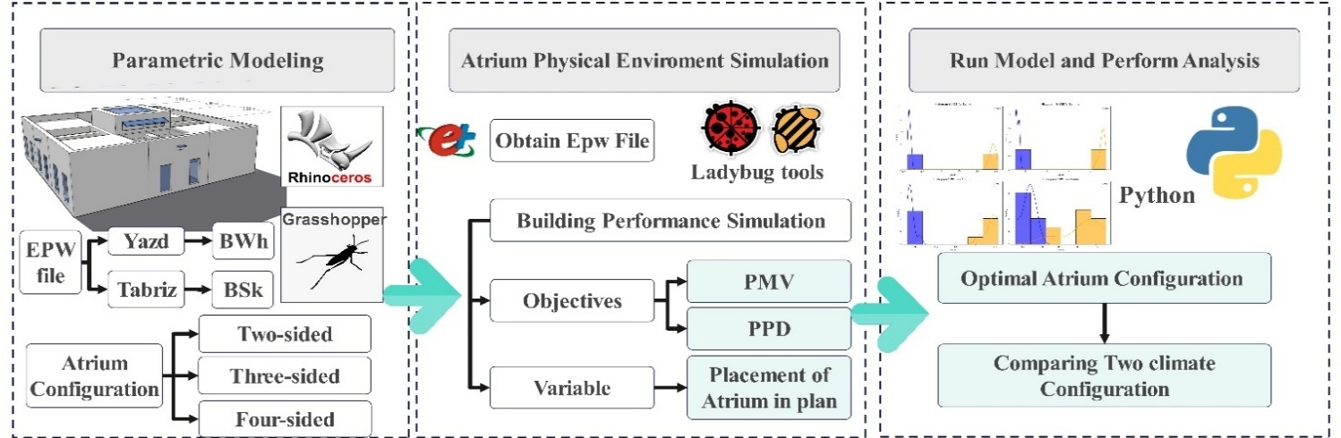

Fig. 1. Research process
Figure 1 illustrates the research process, outlining the steps involved in analyzing atrium configurations and their impact on thermal comfort in different climates. In this study, a five-story office building is considered, with the top floor being modeled and simulated. By default, the geometry of this office building is a square with dimensions of 15 meters by 15 meters, divided into nine equal sections. Each office room, by default, is 5 meters by 5 meters, and the atrium is assumed to have a fixed square geometry. What varies in this study is the placement of the atrium on different facades of the building plan. The plan is divided into a 9-grid layout, and these nine sections are rearranged to simulate various configurations. The objective of this research is to determine the optimal placement of the atrium in two different climates: the cold and dry climate of Tabriz and the hot and dry climate of Yazd. In these various placements, the atrium is indirectly connected to the office spaces through a ceiling-mounted channel. This model is explained in Table 3 by default. Additionally, three types of atrium connections to the office spaces are considered: an atrium connecting to two adjacent rooms, an atrium connecting to three adjacent rooms, and an atrium connecting to four adjacent rooms.
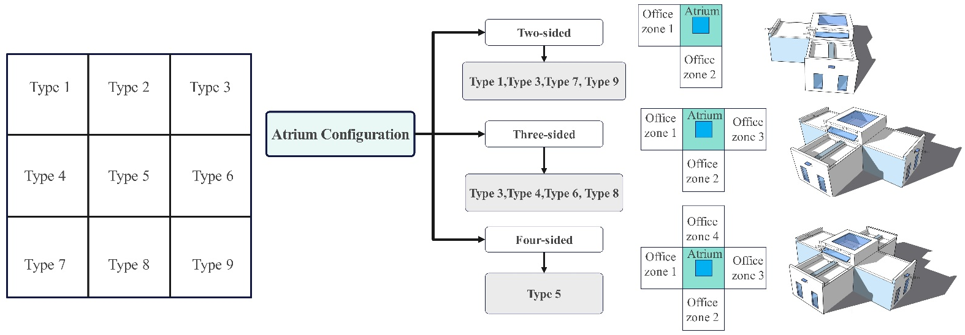

Fig. 2. The base atrium model

A five-story office building was modeled, with only the top floor simulated to reduce computational complexity while maintaining relevance for atrium performance analysis. The building geometry is a 15 m × 15 m square, divided into nine equal sections (5 m × 5 m each) . Each office room is 5 m × 5 m by default, and the atrium maintains a fixed square geometry. The primary variable in this study is the placement of the atrium within the 9-grid layout of the building plan. The nine sections were rearranged to simulate various spatial configurations. The research objective is to determine the optimal atrium placement in two distinct climates, cold-dry (Tabriz) and hot-dry (Yazd) (N. Nikghadam, , , , , Sabernejad, Jaleh). This configuration is graphically shown in Figure 2, and the base atrium model with indirect connection via a channel. Seasonal divisions were defined according to the climatic characteristics of each city:
Yazd (hot-dry climate):
  - Spring (moderately hot): March, April, May
  - Autumn (moderately cold): September, October, November
  - Hot season: June, July, August
  - Cold season: December, January, February
Tabriz (cold-dry climate):
  - Hot season: July, August
  - Cold season: January, February, March
  - Moderately hot season: May, June
  - Moderately cold season: September
Atrium Connection Types
In all configurations, the atrium is indirectly connected to office spaces through a ceiling-mounted channel (see Table 2 for the default model). Three types of atrium connections were considered based on the number of adjacent office rooms:
- Two adjacent rooms – when the atrium is in grid sections 1, 3, 7, or 9
- Three adjacent rooms – when the atrium is in grid sections 2, 4, 6, or 8
- Four adjacent rooms – when the atrium is in the central grid section (number 5)

Parameter | Value
Location / Climate zone | Yazd, Iran/BWh, Tabriz, Iran/BSk
Floor area | 225.00 $m^{2}$m2 (15.00 m× 15.00 m)
Channel length | 5 $m^{2}$m
Zones height | 3.50 m
Room Window | 0.9×1.92 m2$m^{2}$
Atrium height | 5.00 m
Schedule | Saturday to Wednesday (9:00 to 17:00)
HVAC settings | Always off
Infiltration rate per area | 0.0003 m3/S.m2
Number of people per unit of area | 0.10 People/m2
Output intervals | Annual
Table 3. Values during the simulation (N. Nikghadam, Javid, Parisa , Karimpour, Alireza, Sabernejad, Jaleh, 2025)
In the summer, atriums can become warmer if the windows are closed, which reduces the need for air conditioning. Regardless of whether HVAC systems are on or off, atrium windows allow natural ventilation to exit through the atrium by default. As a result of the ventilation channel width, natural ventilation is adequate in regulating the atrium's temperature (Javid, Nikghadam, Karimpour, & Sabernejad, 2025a). Table 3 shows the simulation for fixed values, and Table 4 shows the materials used.
Table 4. Materials used in the model (Javid, Nikghadam, Karimpour, & Sabernejad, 2025b)
` | Structure (m) | Thickness | Thermal Conductivity (W/m.K) | Specific Heat (J/kg.K) | Density (kg/m³)
External Wall | Plaster | 0.025 | 0.7 | 1000 | 1400
 | Brick | 0.2 | 0.39 | 840 | 866.67
 | Uninsulated Lecca Block | 0.05 | 0.0229 | 923 | 520
 | Plaster | 0.025 | 0.7 | 1000 | 1400
Internal Wall | Brick | 0.03 | 0.39 | 840 | 866.67
 | Plaster | 0.025 | 0.7 | 1000 | 1400
 | EPS Insulation | 0.07 | 0.0385 | 1200 | 30
 | Plaster | 0.025 | 0.7 | 1000 | 1400
Floor | Heavy Concrete | 0.15 | 1.06 | 1000 | 2000
 | Ceramic Tiles | 0.01 | 1.3 | 840 | 2300
 | EPS Insulation | 0.1 | 0.0385 | 1200 | 30
 | Plaster | 0.025 | 0.7 | 1000 | 1400
Roof | EPS Insulation | 0.03 | 0.0385 | 1200 | 30
 | Asphalt | 0.05 | 0.7 | 1000 | 1200
 | Plaster | 0.2 | 0.0385 | 1000 | 1400
 | Heavy Concrete | 0.02 | 1.06 | 1000 | 2000
Window | U 0.5 SHGC 0.34 Simple | 0.01 | 520 | 2297 | 923
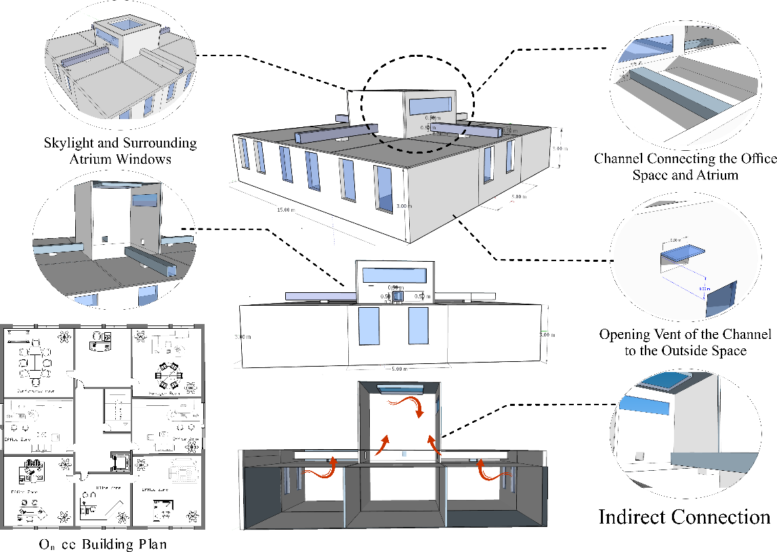
As shown in Fig. 3, a channel provides an indirect connection between the atrium and office zones. This design allows air and heat energy to freely flow between the two rooms without interacting directly. Besides promoting natural ventilation, the channel also regulates temperature. There is a difference in air pressure and temperature between the atrium and the office zone. An indirect connection enhances building energy efficiency by improving thermal comfort and airflow. By reducing mechanical HVAC systems, it is possible to maintain an optimal indoor climate. The purpose of this study is to examine how channel configuration size affects thermal comfort in central atriums of office buildings in BWH and BSK climates.

\

Fig 3. Indirect Connection Atrium and Office Zones by Channel

Software Validation
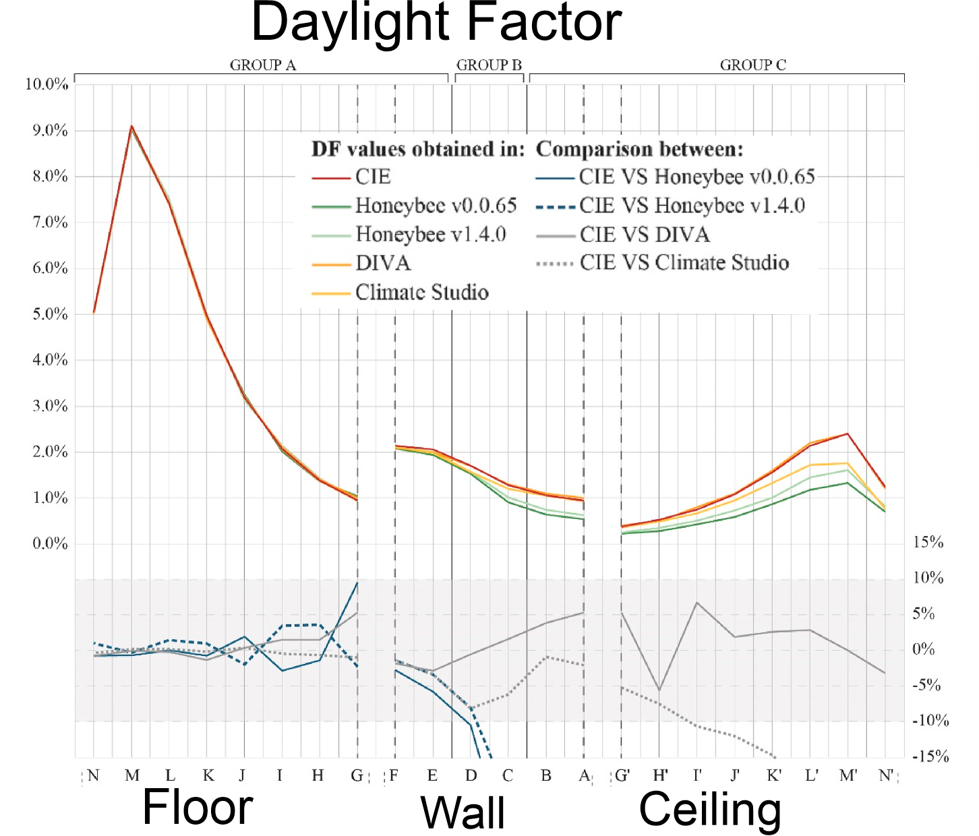
Validation of Honeybee and Ladybug plugins, which are widely used in daylighting simulations, was conducted in this study. A standard lighting analysis tool is operated by these plugins, integrated within the Grasshopper environment (Campano Laborda, Acosta, Leon-Rodriguez, & Calama-González, 2018; Méndez, Muñoz, Alfaro-Ponce, Giorgi, & Peffer, 2025) Numerous studies have demonstrated the reliability of these tools in different research contexts (Fig. 4).

Fig. 4. illustrates the assessment of the DF using various tools in the CIE Test Case for a 4-meter by 3-meter unglazed opening. (Aguilar-Carrasco, Díaz-Borrego, Acosta, Campano, & Domínguez-Amarillo, 2023).

By comparing Honeybee's results with a recognized benchmark, specifically the CIE 171:2006 Test Cases, this research validated the latest version of Honeybee from Ladybug Tools (1.8.0). Based on this comparison, the simulation results demonstrated high accuracy and alignment with set standards, which have significant implications for daylighting simulations (Aguilar-Carrasco et al., 2023). Additionally, the validation demonstrated the reliability of the parametric workflows used in the study, with minimal errors, indicating the effectiveness of the plugins for daylighting simulations (Institute, 2020; Mardaljevic, 1999). This study thoroughly and comprehensively compared the two methods. The simulation results from various programs and workflows were compared to the reference values of the CIE Test Cases. In addition to comparing the results obtained from each lighting program with the CIE Test Cases, these results were also compared with one another. In addition to evaluating the accuracy of the tools through this comparison process, we also analyzed the input and use of boundary parameters through updates of each tool, including Honeybee, which has been updated to version 1.4.0 from version 0.0.65, and Solemma, which has been upgraded to Climate Studio from DIVA (Méndez et al., 2025)
Climate Analysis of Yazd: Yazd is situated in the center of Iran and experiences a variety of climatic conditions throughout the year. As a result of its location in the global dry belt, its climate is characterized by cold, dry winters and hot, dry, and long summers. As in many desert regions, temperatures in Yazd fluctuate significantly from season to season and even day to day. Yazd, for example, has an absolute minimum temperature of -3.2 °C and a maximum temperature of 41.28 °C. Based on temperature maximums, minimums, and averages, Table 5 shows Yazd's climate parameters. Figures 4 and 5 depict accurately the climatic analyses of this region, and Figure 6 shows the UTCI chart for Yazd.
Table 5 - Climatic Parameters of Yazd
Max | Min | Average | Unit | Climatic Parameter
41.28 | -3.2 | 20.89 | $$℃$$ | Dry Temperature
78.76 | 10 | 44.38 | $$\%$$ | Relative Humidity
8.14 | 0 | 4.07 | $$m/s$$ | Wind Speed
26543 | 0 | 13271.5 | $${Wh}/{m^{2}}$$ | Direct Normal Radiation
390 | 209.8 | 299.9 | $${Wh}/{m^{2}}$$ | Diffuse Horizontal Radiation
36974.8 | 0 | 18487.4 | $${Wh}/{m^{2}}$$ | Horizontal Radiation
9 | 0 | 4.5 |  | Sky Cover

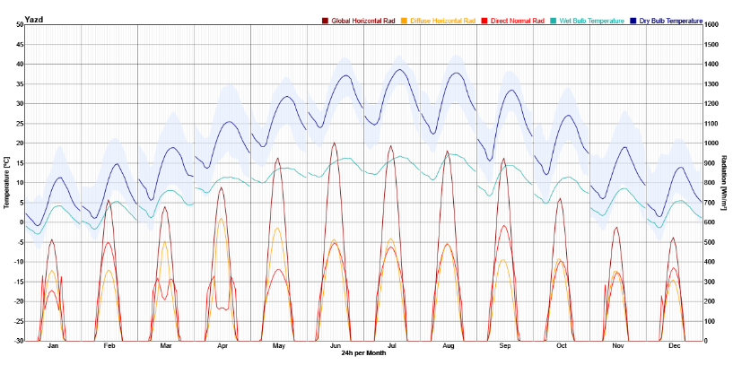

Figure 4 - Solar Radiation in Yazd

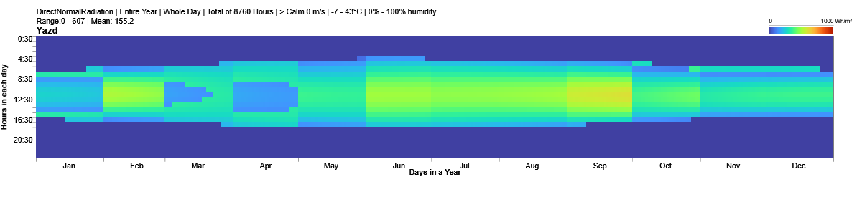

Figure 5 – Direct Normal Radiation Yazd
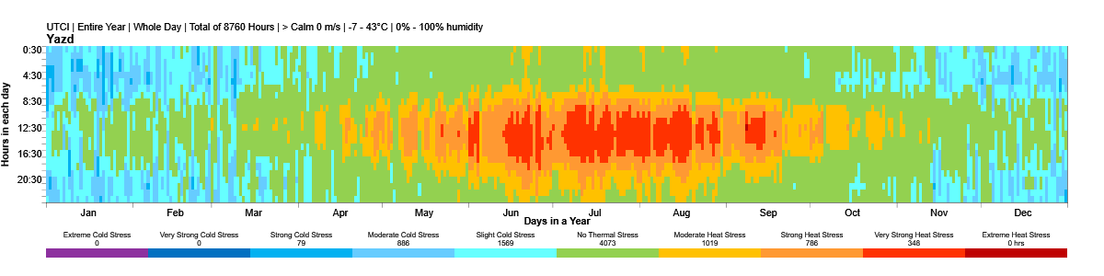

Figure 6 - UTCI Chart of Yazd
Climate analysis of Tabriz:
The climate in Tabriz is influenced by several climatic systems that are located in the northwestern region of the country. As a result of its proximity to the Zagros Mountain range, it experiences cold, snowy winters and mild, warm summers. In Tabriz, winter brings snowfall and temperature drops, especially in December and January. There are also clear seasonal temperature fluctuations in the city. During summer, the nights are usually cooler, and the heat is not as intense. Extreme temperature changes can occur suddenly, especially at night. A minimum temperature of -9°C and a maximum temperature of 40°C are recorded at Tabriz Station. Below is a table showing maximum, minimum, and average temperatures. Tabriz's charts, Figs 7 and 8, and Fig 9, contain climatic analyses for this region (Table 6).
Table 6 - Climatic Parameters of Tabriz
Max | Min | Average | Unite | Climatic Parameter
38.9 | -15.6 | 11.65 | $$℃$$ | Dry Temperature
82 | 10 | 46 | $$\%$$ | Relative Humidity
19 | 0 | 9.5 | $$m/s$$ | Wind Speed
985 | 98.5 | 541.75 | $${Wh}/{m^{2}}$$ | Direct Normal Radiation
535 | 53.5 | 294.25 | $${Wh}/{m^{2}}$$ | Diffuse Horizontal Radiation
1007 | 100.7 | 553.85 | $${Wh}/{m^{2}}$$ | Horizontal Radiation
10 | 0 | 5 |  | Sky Cover
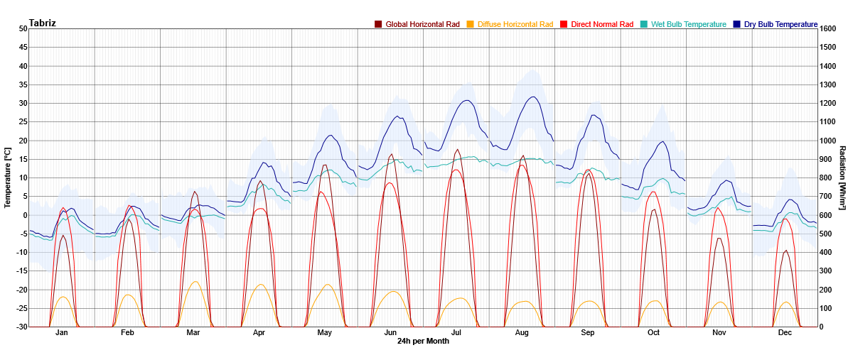

Figure 7 - Solar Radiation in Tabriz

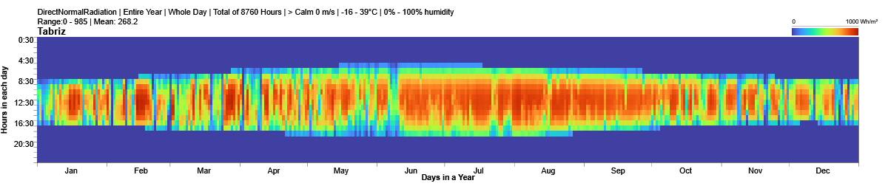

Figure 8 – Direct Normal Radiation Tabriz
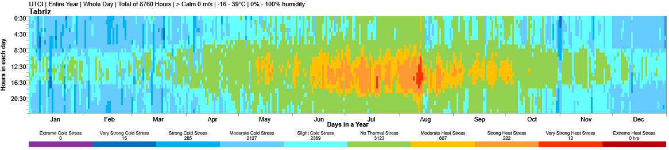

Figure 9 - UTCI Chart of Tabriz
3. Results and Discussion
Thermal Comfort Analysis Based on PMV
Yazd: This analysis evaluates Predicted Mean Vote (PMV) outputs for summer, winter, and moderate seasons (spring and autumn) in Yazd city. PMV quantifies thermal comfort, with negative values reflecting higher comfort. During summer, PMV values range from 2.34 to 2.50, where higher values correspond to reduced comfort. Type 7 exhibits the highest PMV (2.50), indicating the lowest comfort, while Types 5 and 8 show the lowest PMV (2.34), indicating improved comfort. In winter, PMV values range from -3.48 to -3.63; more negative values denote better comfort. Type 1 achieves the lowest PMV (-3.63), representing optimal comfort, whereas Type 9 records a slightly higher PMV (-3.48). For moderate seasons, PMV values span from 0.014 to -0.11, with more negative values again indicating better comfort. Type 3, with a PMV of 0.014, demonstrates the highest comfort, followed by Types 4 and 5 (PMV = -0.07). Table 7 presents the thermal comfort results for Yazd city when the HVAC system is deactivated.
Atrium Placement | Spring (Apr-May) | Summer (Jun-July-Aug) | Autumn (Sep-Oct-Nov) | Winter (Dec-Jan-Feb-March)
Type 1 | -0.02 | 2.48 | -0.75 | -3.63
Type 2 | -0.066 | 2.40 | -0.73 | -3.58
Type 3 | 0.014 | 2.46 | -0.75 | -3.62
Type 4 | -0.07 | 2.38 | -0.73 | -3.59
Type 5 | -0.11 | 2.34 | -0.76 | -3.62
Type 6 | -0.077 | 2.39 | -0.72 | -3.59
Type 7 | 0.023 | 2.50 | -0.60 | -3.49
Type 8 | -0.11 | 2.34 | -0.75 | -3.60
Type 9 | 0.033 | 2.49 | -0.61 | -3.48
Table 7. Atrium Placement based on PMV in Yazd
In Yazd city, under extreme heat conditions during the summer, Type 8, with a PMV of 2.34, performs better due to its lower PMV value. This provides superior thermal comfort. When comparing Types 5 and 8, their results are generally similar, though slight differences exist that may depend on specific environmental conditions or individual needs. For Type 5, the thermal comfort is as follows: during summer, the PMV value is 2.34, indicating relatively high thermal comfort for this season. In winter, a PMV of -3.62 provides favorable thermal comfort conditions, while in the moderate seasons (spring and autumn), a PMV of -0.07 also creates comfortable conditions. For Type 8, the PMV in summer is also 2.34, matching Type 5 and indicating comparable thermal comfort. In winter, a PMV of -3.48 is slightly less harmful than for Type 5, suggesting marginally reduced comfort. During spring and autumn, both types maintained a PMV of -0.07, demonstrating equivalent comfort levels. Both Types 5 and 8 provide similar performance during the summer, with a PMV of 2.34, indicating adequate thermal comfort in the hot months. However, in winter, Type 5 leans slightly towards providing more optimal thermal comfort, as its PMV value of -3.62 is more negative than Type 8’s PMV of -3.48. In the moderate seasons, there is no notable difference between the two types, as both exhibit a PMV of -0.07, indicating similar levels of comfort.

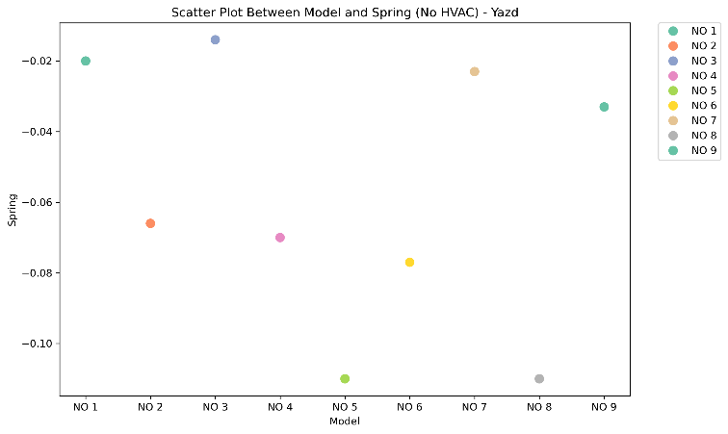
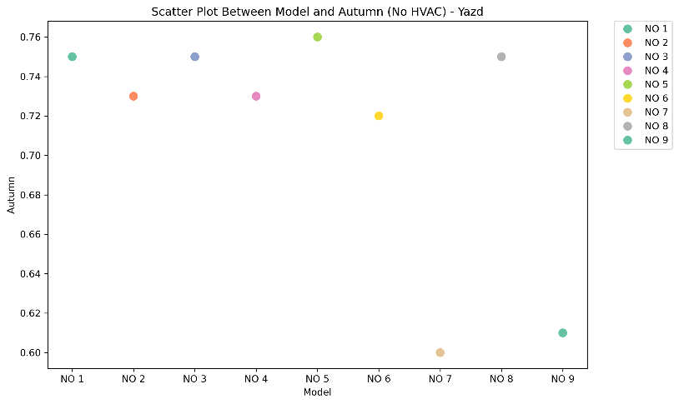
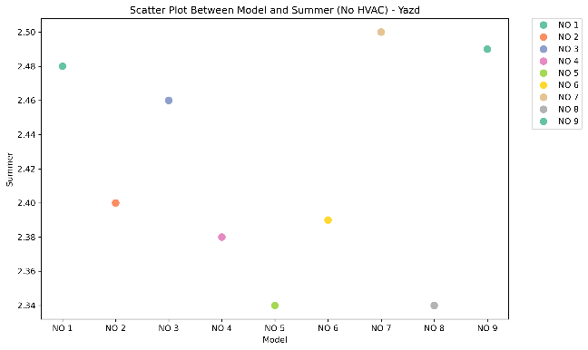
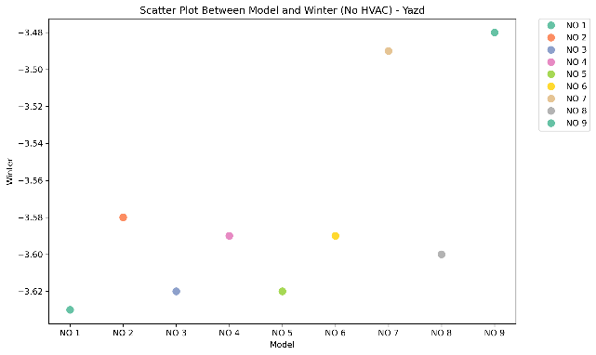
Scatter plot for the spring season in Yazd
Scatter plot for the summer season in Yazd

Scatter plot for the autumn season in Yazd
Scatter plot for the winter season in Yazd

Figure 10. Scatter plot for Yazd city

Type 8 demonstrates marginally improved performance in winter, as indicated by its lower Predicted Mean Vote (PMV) value. During summer and moderate seasons, performance differences between Type 8 and Type 5 are negligible. When the objective is to minimize energy consumption or enhance thermal comfort in summer, both types are effective. For colder climates, Type 8 is preferable due to its superior winter performance. During summer, both Type 8 and Type 5, each with a PMV of 2.34, outperform Type A, which has a PMV of 4.257. As a result, Type 8 offers greater thermal comfort and operational efficiency in Yazd’s hot climate. This improvement reduces reliance on cooling systems and subsequently decreases energy consumption (Figure 10).

Tabriz: A Predicted Mean Vote (PMV) analysis was conducted in Tabriz city for the three seasons of summer, winter, and moderate (spring and autumn). PMV quantifies thermal comfort, with negative values reflecting greater comfort. During summer, PMV values range from 0.60 to 0.82, where higher values correspond to reduced comfort. Type 9 exhibits the highest PMV (0.82), showing the lowest comfort, while Types 2, 3, and 7 show the smallest PMV values (0.60–0.78), indicating improved comfort. In winter, PMV values range from -5.58 to -5.02; more negative values indicate better comfort. Type 3 achieves the lowest PMV (-5.58), representing optimal comfort, whereas Type 9 records a slightly higher PMV (-5.032). For the moderate seasons, PMV values span from 0.014 to -1.29, with more negative PMV values indicating better comfort. Type 3, with a PMV of 0.014, demonstrated the highest comfort, followed by Type 2 (PMV = -1.29). Table 8 presents the thermal comfort results for Tabriz city when the HVAC system is deactivated.
Atrium Placement | Spring (Apr-May) | Summer (Jun-July-Aug) | Autumn (Sep-Oct-Nov) | Winter (Dec-Jan-Feb-March)
Type 1 | -0.70 | 0.72 | -1.14 | -5.15
Type 2 | -0.80 | 0.60 | -1.29 | -5.14
Type 3 | -0.68 | 0.78 | 0.014 | -5.58
Type 4 | -0.70 | 0.67 | -1.21 | -5.12
Type 5 | -0.75 | 0.62 | -1.26 | -5.02
Type 6 | -0.73 | 0.62 | -1.24 | -5.13
Type 7 | -0.59 | 0.76 | -1.12 | -5.04
Type 8 | -0.71 | 0.66 | -1.22 | -5.13
Type 9 | -0.55 | 0.82 | -1.08 | -5.032
Table 8. Atrium Placement based on PMV in Tabriz
In Tabriz city, under extreme heat conditions during the summer, Type 3, with a PMV of 0.014, performs better due to its low PMV value. This provides superior thermal comfort. When comparing Types 2 and 3, their results are generally similar, though slight differences exist that may depend on specific environmental conditions or individual needs. For Type 2, the thermal comfort is as follows: during summer, the PMV value is 0.60, indicating relatively high thermal comfort for this season. In winter, a PMV of -5.14 provides favorable thermal comfort conditions, while in the moderate seasons (spring and autumn), a PMV of -0.80 creates comfortable conditions. For Type 3, the PMV in summer is 0.78, slightly higher than Type 2, indicating less thermal comfort. In winter, a PMV of -5.58 offers optimal comfort, the lowest PMV in this dataset. During spring and autumn, a PMV of 0.014 provides the highest comfort, followed by Type 2 with a PMV of -1.29 (Fig 11).

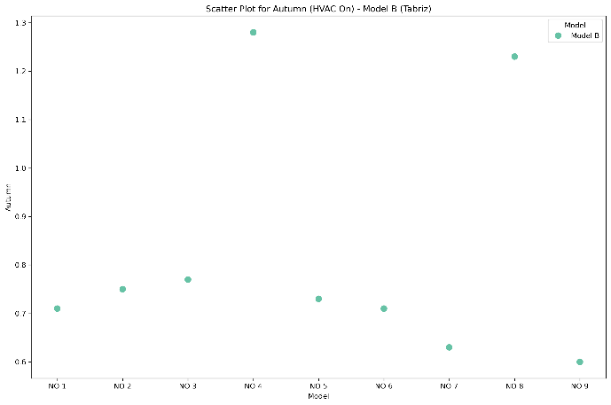
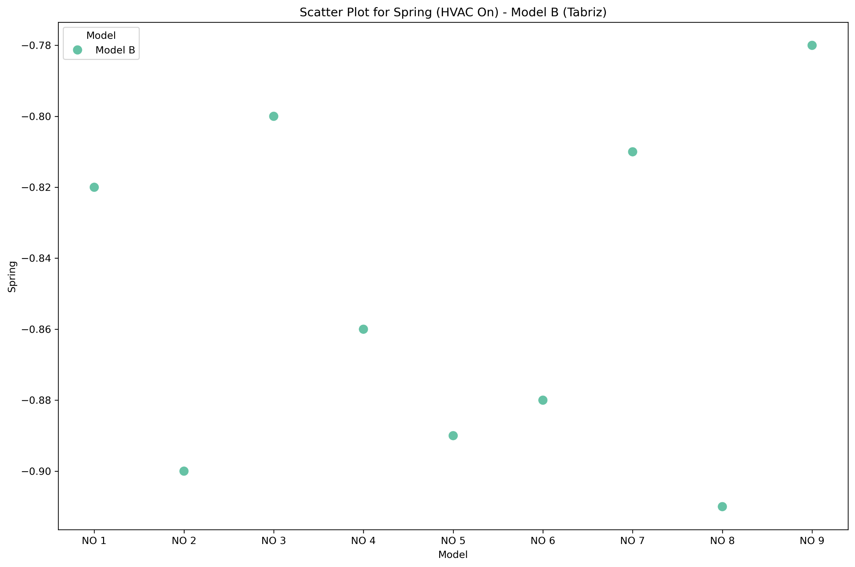
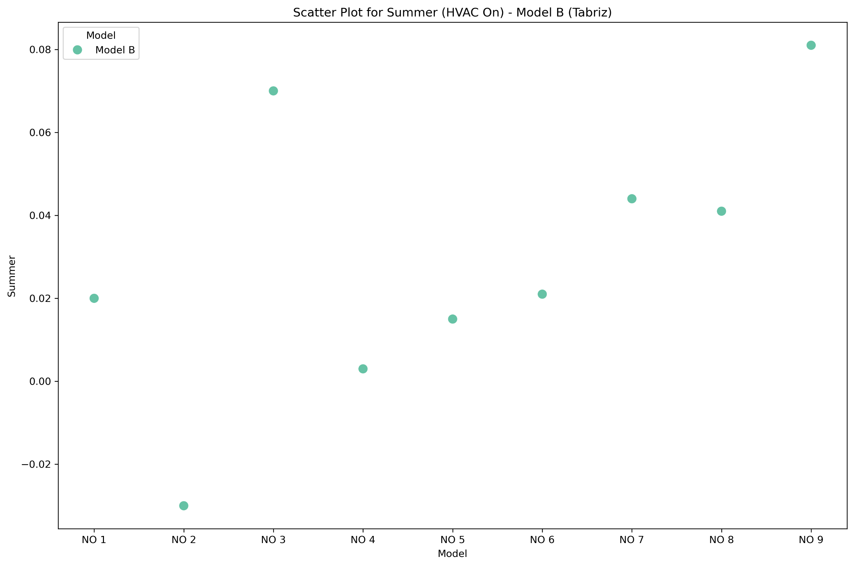
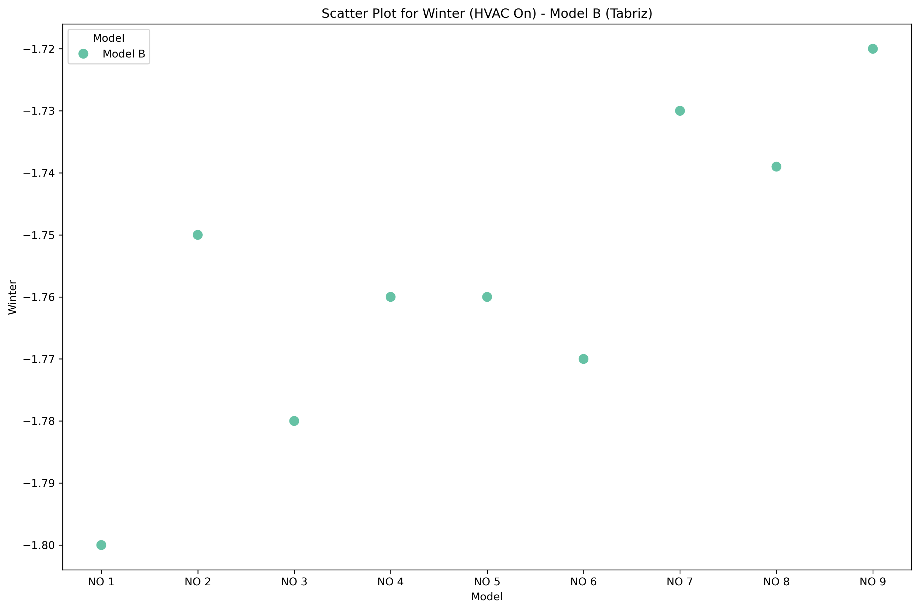

Scatter plot for the Spring season in Tabriz

Scatter plot for the summer season in Tabriz

Scatter plot for the Winter season in Tabriz

Scatter plot for the Autumn season in Tabriz

Figure 11. Scatter plot for Tabriz city
Based on the provided PMV data and ASHRAE 55 standards, the thermal comfort range is defined as PMV = -0.5 to +0.5. This means that if the PMV falls within this range, most people will feel comfortable, and no active heating or cooling systems are required, according to Fig 12.
For Yazd, only the spring season falls within the comfort range for most atrium placements. All placements during spring have PMV values close to zero, indicating no need for heating or cooling. However, during summer, autumn, and winter, PMV values for all placements fall outside the comfort range. This indicates a need for cooling in summer and heating in winter, as summer PMV values are highly positive (indicating excessive heat) and winter PMV values are highly negative (indicating significant cold).
In Tabriz, the situation is more severe, with PMV values outside the comfort range in almost all seasons. The only exception is autumn for Atrium Type 3, where the PMV falls within the range of -0.5 to +0.5, meaning no active heating or cooling is required in this case. In all other placements and seasons, PMV values are either strongly negative, indicating a need for heating, or positive, indicating a need for cooling. Overall, in Tabriz, active systems are generally necessary to maintain thermal comfort across the year. This analysis reveals that Yazd experiences naturally comfortable conditions in spring, eliminating the need for active systems, but other seasons necessitate thermal management. In contrast, Tabriz requires active heating or cooling for most seasons due to PMV values outside the comfort range.
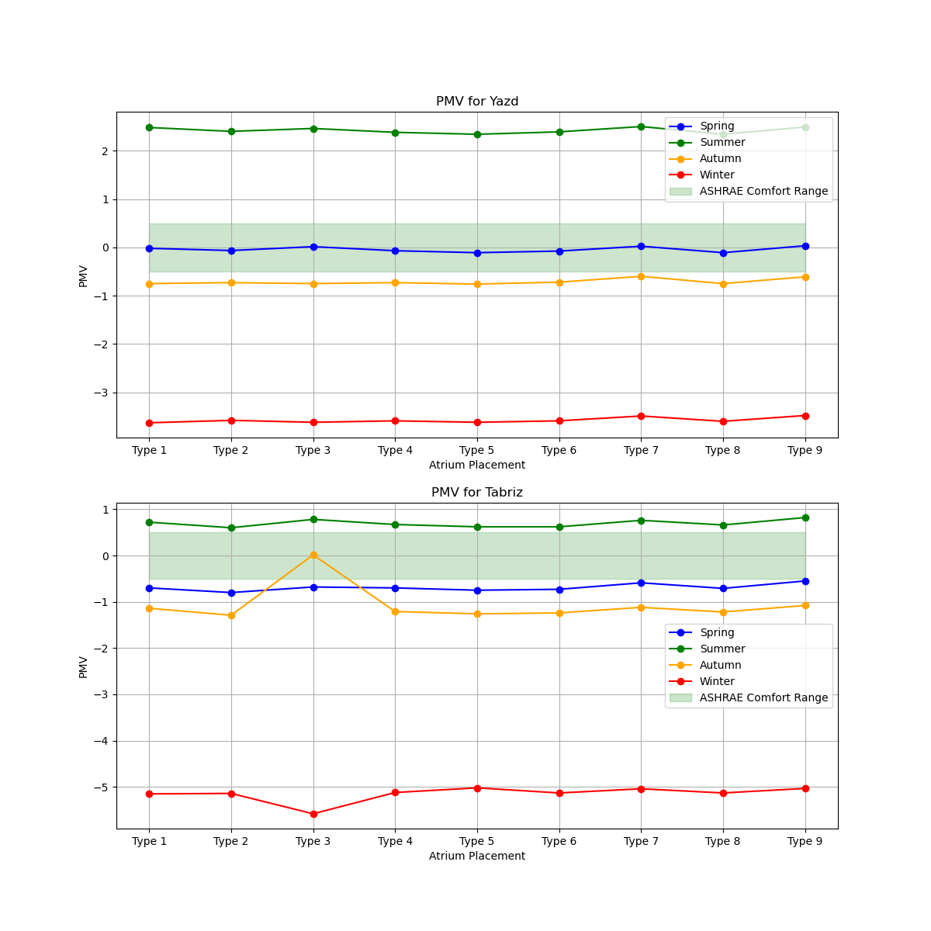

Figure 12. Placement of Atrium base on PMV
Thermal Comfort Index PPD
Thermal comfort is one of the most important factors influencing indoor environmental quality. Occupants of indoor spaces constantly seek environments that provide optimal thermal comfort. According to ASHRAE Standard 55, the ideal PMV range is between 0.5 and -0.5. Within this range, dissatisfaction with environmental conditions decreases. In other words, the closer the PMV is to zero, the lower the percentage of dissatisfied individuals (PPD) will be (Cheung, Schiavon, Parkinson, Li, & Brager, 2019)Equation 9 illustrates how to calculate the index of dissatisfaction in a space based on the PMV. Tables 9 and 10 present the thermal comfort index for all orientations and the number of simultaneous openings, based on the PPD index as determined in the research.$PPD=100-95 ×{e^{-(0.3353×{PMV}^{4}-0.2179 {PMV}^{2} )}}$
(9)
Table 9. Atrium Placement based on PPD in Yazd
Atrium Placement | Spring PPD | Summer PPD | Autumn PPD | Winter PPD
Type 1 | 4.99 | 93.00 | 16.85 | 99.98
Type 2 | 4.91 | 91.10 | 16.22 | 99.98
Type 3 | 4.99 | 92.56 | 16.85 | 99.98
Type 4 | 4.90 | 90.57 | 16.22 | 99.98
Type 5 | 4.75 | 89.46 | 17.17 | 99.98
Type 6 | 4.88 | 90.84 | 15.91 | 99.98
Type 7 | 4.99 | 93.43 | 12.55 | 99.95
Type 8 | 4.75 | 89.46 | 16.85 | 99.98
Type 9 | 4.98 | 93.22 | 12.80 | 99.95
In this analysis, the PPD (Predicted Percentage of Dissatisfied) results for various types of Atrium Placement across different seasons in Yazd are examined, as shown in Table 9.. These PPD values indicate the percentage of people who are dissatisfied with the thermal conditions, reflecting the level of comfort or discomfort in different environments. In Spring, Type 5 and Type 8 with a PPD of 4.75% cause the least discomfort, indicating the most comfortable conditions for this season. Overall, the PPD values for all Atrium Placement types are relatively low in the Spring, but Types 5 and 8 perform the best, providing the most comfort.
In the summer, when thermal conditions are more extreme, Types 5 and 8, with a PPD of 89.46%, create the least discomfort. However, PPD values in Summer are high for all types, indicating significant discomfort. Nonetheless, Type 5 and Type 8 are comparatively better than other Atrium types in providing some comfort.In Autumn, Types 5 and 8, with PPDs of 17.17% and 16.85%, respectively, generate the least discomfort, offering the best performance in this season. These values indicate relatively moderate comfort, although a significant percentage of individuals still report dissatisfaction. Type 5 and Type 8 stand out as better choices in this season compared to other types.In Winter, when the thermal conditions are harsher and colder, Type 5 and Type 8 with a PPD of 99.98% provide the best performance. During this season, all types of Atrial Placement result in significant discomfort for individuals, but Types 5 and 8 perform slightly better, causing less discomfort overall. In conclusion, Type 5 and Type 8 generally provide the best comfort in most seasons, particularly in Spring and Summer. These two types of Atrium Placement are more effective at reducing discomfort compared to others in varying thermal conditions. Therefore, to optimize comfort in Yazd, Type 5 and Type 8 are the better options.
Table 10. Atrium Placement based on PPD in Tabriz
Atrium Placement | Spring PPD | Summer PPD | Autumn PPD | Winter PPD
Type 1 | 10.88 | 5.13 | 40.39 | 99.99
Type 2 | 12.47 | 5.02 | 43.56 | 99.99
Type 3 | 10.36 | 4.67 | 10.00 | 100.00
Type 4 | 10.88 | 4.97 | 41.23 | 99.99
Type 5 | 9.79 | 5.09 | 44.09 | 99.99
Type 6 | 10.13 | 5.09 | 42.73 | 99.99
Type 7 | 14.05 | 4.72 | 48.22 | 99.99
Type 8 | 10.13 | 4.83 | 45.85 | 99.99
Type 9 | 15.42 | 5.13 | 40.39 | 99.99
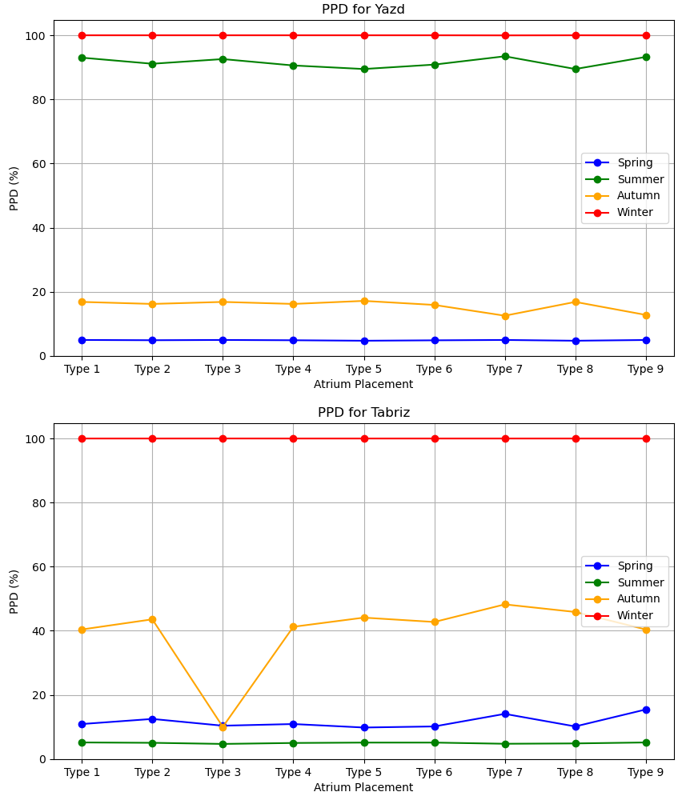
This analysis examines PPD (Predicted Percentage of Dissatisfied) results for different Atrium Placements across Tabriz seasons (Table 10). PPD reflects the percentage dissatisfied with thermal conditions, indicating comfort levels in these environments. In Spring, Type 5 (PPD 9.79%) offers the most comfort, while Type 9 (PPD 15.42%) causes most discomfort. All types are moderate, but Type 5 is best.In the summer, when thermal conditions are more extreme, Type 3 with a PPD of 4.67% and Type 8 with a PPD of 4.83% perform the best, causing the least discomfort. Type 9, with a PPD of 5.13%, also performs well but is not the top performer, exhibiting less discomfort compared to some types and more than others. Although all Atrium Placement types in summer result in significant discomfort, Type 9 still ranks among the better options for this season. In Autumn, Type 3 with a PPD of 10.00% is the best performer, causing the least discomfort. Type 9, with a PPD of 40.39%, creates the most discomfort in this season and ranks the lowest in Autumn. In Autumn, Type 3 provides the most favorable environment in terms of thermal comfort, making it the best choice among the various Atrium Placements.

Figure 13. Placement of Atrium base on PPD
In Winter, the PPD values for all Atrium Placement types are similar, ranging around 99.99%, indicating extreme discomfort for all types during this season. Despite the high discomfort in Winter, Type 9 and the others show near-identical results. In conclusion, Type 9 is the most consistent and best-performing Atrium Placement in Tabriz. While Type 9 shows high discomfort in Winter, it provides relatively better comfort in Summer and Autumn compared to other types. Type 5 and Type 3 also perform well in specific seasons, but Type 9 stands out overall for its ability to reduce discomfort across multiple seasons. In both Yazd and Tabriz, atrium placement plays a crucial role in optimizing thermal comfort. As shown in Figure 13. Placement of the atrium based on PPD, the strategic orientation of the atrium, particularly with respect to solar exposure, can significantly enhance energy efficiency and comfort levels across different seasons.

Yazd
Spring (Apr-May) | Summer (Jun-Jul-Aug)
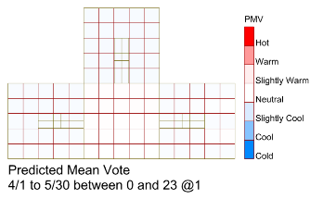 | 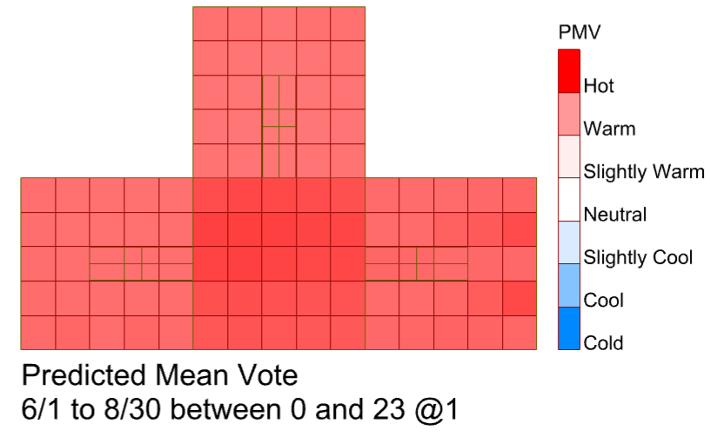
-0.11 | 2.34
Autumn (Sep-Oct-Nov) | Winter (Dec-Jan-Feb-Mar)
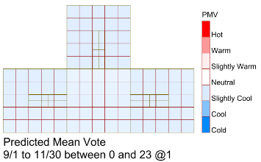 | 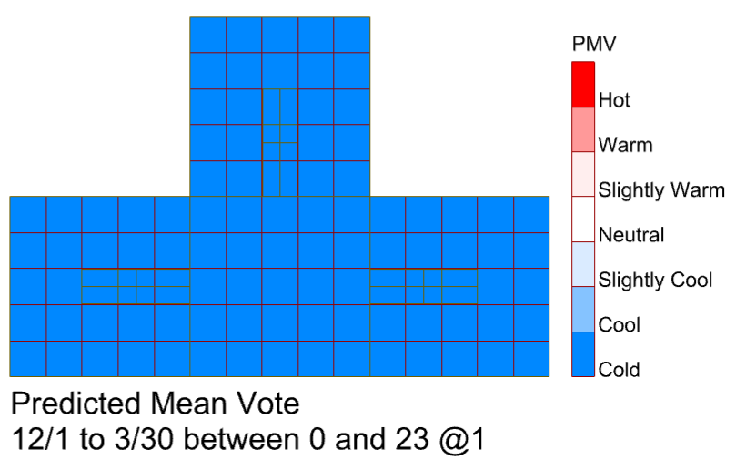
-0.75 | -3.60
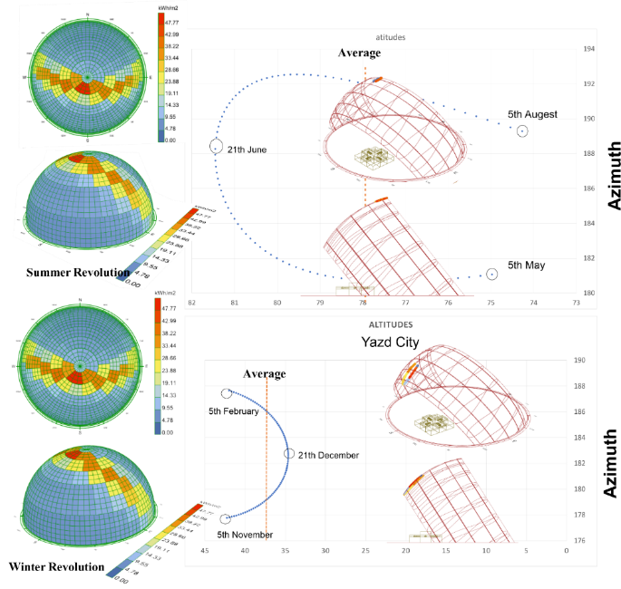
Table 11-Optimal Atrium Configuration in Yazd

Figure 14. Climate Analysis in Yazd
Climatic and solar analysis in Yazd shows that direct solar radiation plays a crucial role in the performance of the atrium system, as it enhances the stack effect and naturally transfers heat to the building during colder seasons. Therefore, the southern façade can be exposed to sunlight throughout the day, improving overall atrium performance Figure 14 illustrate Climate Analysis in Yazd. Considering these conditions, a central placement, specifically Atrium Type 8, which is in the path of daily solar radiation, provides the best thermal performance and maximizes building energy efficiency. In the building plan, this placement is located on the southern side. As shown in Table 11 Optimal Atrium Configuration in Yazd.
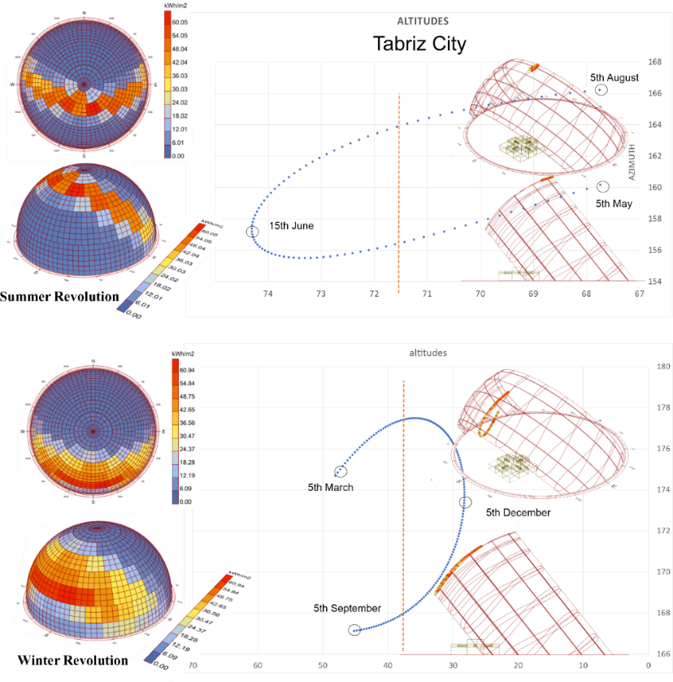
Table 12-Optimal Atrium Configuration in Tabriz
Tabriz
Spring ( Jun- May ) | Summer ( July-Aug)
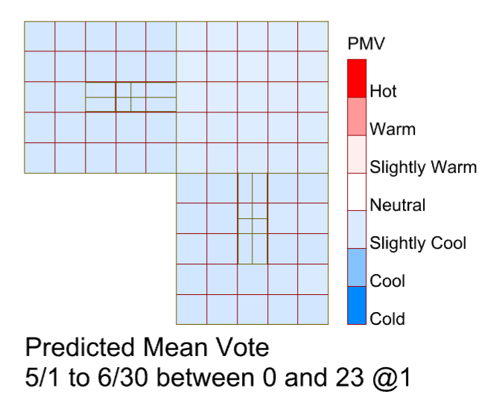 | 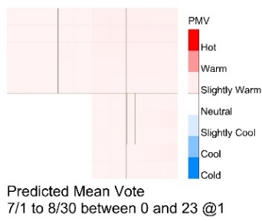
0.014 | 0.78
Autumn ( Sep ) | Winter Jan-Feb-Mar-Apr-Oct-Nov-Dec
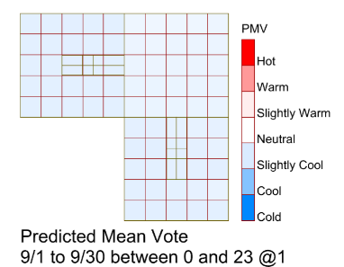 | 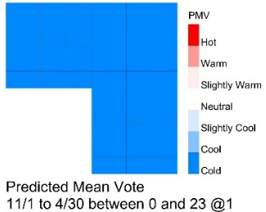
-0.68 | -5.58

Figure 15. Climate Analysis in Yazd
In Tabriz, most PMV values fall outside the comfort range, and only Atrium Type 3 is within the -0.5 to +0.5 range during autumn, indicating that active thermal management is required for other seasons. Similar to Yazd, solar radiation is key for the passive atrium system’s performance, and optimizing sunlight in winter can provide natural heating, as illustrated in Figure 15 Climate Analysis in Tabriz. Therefore, Atrium Type 3, located in the northeast of the building, ensures the best performance by receiving maximum winter solar radiation. As shown in Table 12 Optimal Atrium Configuration in Tabriz.

4.Conclusion
This study analyzed the thermal comfort performance of different atrium placements in two Iranian cities, Yazd and Tabriz, using Predicted Mean Vote (PMV) and Predicted Percentage of Dissatisfied (PPD) indices, alongside climatic and solar radiation analysis. The results reveal clear patterns regarding seasonal performance, comfort optimization, and energy efficiency.
Yazd’s hot and arid climate exhibits extreme thermal conditions, especially in summer and winter. PMV analysis reveals that during the summer, most atrium types exhibit high PMV values (2.34–2.50), indicating reduced comfort. Among these, Type 5 and Type 8 demonstrate the best performance, with a PMV of 2.34, providing relatively better comfort and reducing reliance on mechanical cooling systems. In winter, negative PMV values (-3.48 to -3.63) suggest cold conditions, with Type 5 offering slightly better comfort. In moderate seasons (spring and autumn), PMV values are near zero, particularly for Types 5, 8, and 3, indicating natural thermal comfort without the need for active systems. PPD analysis confirms these findings: Types 5 and 8 consistently generate the least discomfort in most seasons, highlighting their suitability for Yazd’s climate. Climatic analysis emphasizes the significance of solar radiation; a southern-oriented atrium (Type 8) maximizes solar gain during colder months, enhancing passive heating and energy efficiency (Figure 15). Overall, Yazd’s conditions allow moderate passive comfort in spring, but heating in winter and cooling in summer remain necessary for optimal indoor comfort.
Tabriz, with a colder climate and higher seasonal variability, presents more challenging conditions for passive thermal comfort. PMV values indicate that almost all atrium placements fall outside the comfort range in summer and winter, with only Atrium Type 3 achieving comfort during autumn (-0.5 to +0.5), highlighting the need for active thermal management in other seasons. Type 3 performs best due to its favorable exposure to winter solar radiation, maximizing natural heating while providing moderate comfort in spring and autumn (Figure 16). PPD analysis supports these findings, showing that Type 3 maintains the lowest discomfort in autumn and summer, whereas most other types exhibit high dissatisfaction, particularly in winter (PPD ~99.99%). Solar radiation plays a crucial role in the passive atrium system, as maximizing sunlight in winter can reduce heating demand and enhance occupant comfort.
Yazd experiences extreme summer heat, where cooling is critical, while Tabriz requires heating in winter due to very low temperatures. Both climates benefit from solar-oriented atrium placements. Type 8 is optimal for Yazd due to its southern exposure and ability to maximize solar gain, whereas Type 3 is most suitable for Tabriz due to its winter solar access and moderate seasonal comfort.
The strategic placement of atriums can reduce reliance on mechanical HVAC systems. In Yazd, passive heating and cooling during spring and moderate seasons are feasible, whereas in Tabriz, active systems are largely necessary, except in autumn, for Type 3. Direct solar radiation is a key driver for atrium performance in both cities, enhancing the stack effect in cold seasons and contributing to passive thermal comfort. This demonstrates the importance of integrating climate-responsive design strategies when planning atrium placements. The study confirms that atrium placement, solar orientation, and climatic conditions are critical in achieving thermal comfort and reducing energy consumption. For Yazd, Types 5 and 8 provide balanced performance across seasons, particularly excelling in summer and spring. For Tabriz, Type 3 stands out as the most effective atrium design for harnessing solar heat in winter and maintaining comfort in transitional seasons. Overall, the findings emphasize the importance of climate-adapted passive design strategies in improving indoor comfort, reducing energy demand, and optimizing building performance across various climatic zones. Although this study provides practical insights, several avenues remain for future research. Researchers are encouraged to examine different building typologies to assess how atrium placement performs across various functions. The effect of alternative atrium geometries, such as rectangular, circular, or L-shaped forms, also warrants further investigation. Lastly, extending this comparative analysis to other climatic zones within Iran.

Funding
The authors reported no Funding in this study.

Notes on contributors
All authors contributed equally to the preparation of this article.

References:
Abdullah, A. H., Meng, Q., Zhao, L., & Wang, F. (2009). Field study on indoor thermal environment in an atrium in tropical climates. Building and Environment, 44(2), 431-436. doi:https://doi.org/10.1016/j.buildenv.2008.02.011
Acosta, I., Varela, C., Molina, J. F., Navarro, J., & Sendra, J. J. (2018). Energy efficiency and lighting design in courtyards and atriums: A predictive method for daylight factors. Applied Energy, 211, 1216-1228. doi:https://doi.org/10.1016/j.apenergy.2017.11.104
Aguilar-Carrasco, M. T., Díaz-Borrego, J., Acosta, I., Campano, M. Á., & Domínguez-Amarillo, S. (2023). Validation of lighting parametric workflow tools of Ladybug and Solemma using CIE test cases. Journal of Building Engineering, 64, 105608. doi:10.1016/j.jobe.2022.105608
Albuquerque, D. P., Mateus, N., Avantaggiato, M., & Carrilho da Graça, G. (2020). Full-scale measurement and validated simulation of cooling load reduction due to nighttime natural ventilation of a large atrium. Energy and Buildings, 224, 110233. doi:https://doi.org/10.1016/j.enbuild.2020.110233
Aldawoud, A. (2013). The influence of the atrium geometry on the building energy performance. Energy and Buildings, 57, 1-5. doi:https://doi.org/10.1016/j.enbuild.2012.10.038
Ashdown, I., Bedocs, L., Carroll, W., de Boer, J., Dehoff, P., Donn, M., . . . Greenup, P. (2006). CIE 171:2006 Test Cases to Assess the Accuracy of Lighting Computer Programs.
Assadi, M. K., Dalir, F., & Hamidi, A. A. (2011). Analytical model of atrium for heating and ventilating an institutional building naturally. Energy and Buildings, 43(10), 2595-2601. doi:https://doi.org/10.1016/j.enbuild.2011.05.009
Calcagni, B., & Paroncini, M. (2004). Daylight factor prediction in atria building designs. Solar Energy, 76(6), 669-682. doi:https://doi.org/10.1016/j.solener.2004.01.009
Campano Laborda, M., Acosta, I., Leon-Rodriguez, A., & Calama-González, C. M. (2018). Validation Study for Daylight Dynamic Metrics by Using Test Cells in Mediterranean Area. International Journal of Engineering and Technology, 10, 487-491. doi:10.7763/IJET.2018.V10.1107
CheshmehNoor, M., Mehdizadeh Saradj, F., & YazdanFar, S. A. (2020). The effect of atrium adjoining spaces position in term of light distribution and heat gain Case study: Administrative building of Niroo Research Institute. Journal of Sustainable Architecture and Urban Design, 7(2), 119-134. doi:10.22061/jsaud.2020.4617.1363
Cheung, T., Schiavon, S., Parkinson, T., Li, P., & Brager, G. (2019). Analysis of the accuracy on PMV – PPD model using the ASHRAE Global Thermal Comfort Database II. Building and Environment, 153, 205-217. doi:https://doi.org/10.1016/j.buildenv.2019.01.055
Chu, G., Liu, X., Gao, Q., Guo, X., & Shen, W. (2017). Influence of Air Supply Parameters of Building Atrium on Air Conditioning Effect in winter. Procedia Engineering, 205, 1913-1919. doi:https://doi.org/10.1016/j.proeng.2017.10.289
Chu, G., Sun, Y., Jing, T., Sun, Y., & Sun, Y. (2017). A Study on Air Distribution and Comfort of Atrium with Radiant Floor Heating. Procedia Engineering, 205, 3316-3322. doi:https://doi.org/10.1016/j.proeng.2017.10.345
Cuce, E., Sher, F., Sadiq, H., Cuce, P. M., Guclu, T., & Besir, A. B. (2019). Sustainable ventilation strategies in buildings: CFD research. Sustainable Energy Technologies and Assessments, 36, 100540. doi:https://doi.org/10.1016/j.seta.2019.100540
Dolnikova, E., Katunsky, D., & Darula, S. (2020). Assessment of overcast sky daylight conditions in the premises of engineering operations considering two types of skylights. Building and Environment, 180, 106976. doi:https://doi.org/10.1016/j.buildenv.2020.106976
Dyvia, H. A., & Arif, C. (2021). Analysis of thermal comfort with predicted mean vote (PMV) index using artificial neural network. IOP Conference Series: Earth and Environmental Science, 622(1), 012019. doi:10.1088/1755-1315/622/1/012019
Fan, Z., Yang, Z., & Yang, L. (2021). Daylight performance assessment of atrium skylight with integrated semi-transparent photovoltaic for different climate zones in China. Building and Environment, 190, 107299.
Fang, Y., Cho, S., Wang, Y., & He, L. (2023). Sensitivity Analysis and Multi-Objective Optimization of Skylight Design in the Early Design Stage. Energies, 17(1), 219.
Fanger, P. (1970). Thermal comfort. Analysis and applications in environmental engineering: Copenhagen: Danish Technical Press.
Faraji, A., Rashidi, M., Rezaei, F., & Sorooshnia, E. (2022). Determining Appropriate Thermal Comfort Period based on PET and PMV using the RayMan Model: A Case Study in the Subtropical City of Sari. International Journal of Architectural Engineering & Urban Planning, 32(3), 33-50. doi:10.22068/ijaup.569
Ghasemi, M., Kandar, M. Z., & Noroozi, M. (2016). Investigating the effect of well geometry on the daylight performance in the adjoining spaces of vertical top-lit atrium buildings. Indoor and Built Environment, 25(6), 934-948.
Ghasemi, M., Noroozi, M., Kazemzadeh, M., & Roshan, M. (2015). The influence of well geometry on the daylight performance of atrium adjoining spaces: A parametric study. Journal of Building Engineering, 3, 39-47. doi:https://doi.org/10.1016/j.jobe.2015.06.002
Gorji Mahlabani, Y., Azizzadeh Araee, R., Motevali Alamuti, Z., & Mofrad Boushehri, A. A. (2019). Study of Optimal Area of Atrium for Daylight Utilization (Case Study: Administrative Building in Qazvin, Iran). International Journal of Architectural Engineering & Urban Planning, 29(1), 39-46. doi:10.22068/ijaup.29.1.39
Habibi, A., Tafvizi, R., Nikkar, M., & Sharifi, E. (2024). Impact of Design Composition of Canyon Layout, Greenery, and Cool Surfaces on Outdoor Thermal Comfort in Hot-Dry Climate. International Journal of Architectural Engineering & Urban Planning, 34(2), 39-59. doi:10.22068/ijaup.833
Heydari, M., Ghanbaran, A., & ... (2024). The effect of atrium configurations on energy usage and natural ventilation in high-rise office buildings in Tehran climate. International Journal of …. doi:10.1080/14733315.2023.2187536
Huang, Y., Borong, L., Yao, N., & Yingxin, Z. (2015). Functional Relationship Between Lighting Energy Consumption and the Main Parameters for Double Atrium Offices. Procedia Engineering, 121, 1869-1879. doi:https://doi.org/10.1016/j.proeng.2015.09.169
Hussain, S., & Oosthuizen, P. H. (2012). Validation of numerical modeling of conditions in an atrium space with a hybrid ventilation system. Building and Environment, 52, 152-161. doi:https://doi.org/10.1016/j.buildenv.2011.12.016
Institute, A. N. S. (2020). ANSI/ASHRAE Standard 140-2020. Method of Test for Evaluating Building Performance Simulation Software.
Javid, P., Nikghadam, N., Karimpour, A., & Sabernejad, J. (2025a). Design Optimization of Atrium Skylights for Enhanced Office Building Performance Using NSGA-II: Case Study in Yazd, Iran. JOURNAL OF DAYLIGHTING, 12(2), 520-547. doi:https://doi.org/10.15627/jd.2025.31
Javid, P., Nikghadam, N., Karimpour, A., & Sabernejad, J. (2025b). Optimal Skylight-to-Roof Ratio in Central Atriums for Thermal Comfort based on solar-induced ventilation: Case Studies from Yazd and Tabriz. Iranica Journal of Energy & Environment(Articles in Press). doi:https://doi.org/10.5829/ijee.2026.17.02.09
Javid, P., Nikghadam, N., Karimpour, A., & Sabernezhad, Z. (2025). A Systematic Bibliometric Analysis of Energy Optimization Methods in Buildings. The Monthly Scientific Journal of Bagh-e Nazar, 22(142), 41-56. doi:https://doi.org/10.22034/bagh.2025.490974.5717
Khorasani, F., Moazen, S., & Ghane, M. (2025). A Review Human Movement Through Different Altitude Layers of a Dwelling in Hot and Semi-humid Climates. International Journal of Architectural Engineering & Urban Planning, 35(1). doi:10.22068/ijaup.865
Khoroshiltseva, M., Slanzi, D., & Poli, I. (2016). A Pareto-based multi-objective optimization algorithm to design energy-efficient shading devices. Applied Energy, 184, 1400-1410. doi:https://doi.org/10.1016/j.apenergy.2016.05.015
Kim, G., & Kim, J. T. (2010). Luminous impact of balcony floor at atrium spaces with different well geometries. Building and Environment, 45(2), 304-310. doi:https://doi.org/10.1016/j.buildenv.2009.08.014
Laouadi, A., & Atif, M. R. (1998). Comparison between computed and field measured thermal parameters in an atrium building. Building and Environment, 34(2), 129-138. doi:https://doi.org/10.1016/S0360-1323(98)00007-9
Laouadi, A., Atif, M. R., & Galasiu, A. (2002). Towards developing skylight design tools for thermal and energy performance of atriums in cold climates. Building and Environment, 37(12), 1289-1316. doi:https://doi.org/10.1016/S0360-1323(02)00008-2
Lei, W., Zhang, Z., Zheng, Z., Tai, C., Zhang, L., & Zhao, S. (2024). Scaled experiment and numerical study on the effect of a novel makeup air system on smoke control in atrium fires. Journal of Building Engineering, 95, 110237. doi:https://doi.org/10.1016/j.jobe.2024.110237
Li, Y., Guo, X., Hong, Y., & Yao, G. (2025). Enhancing energy efficiency in severe cold plateau regions: Atrium design strategies for zero energy houses. CASE STUDIES IN THERMAL ENGINEERING, 74, 106829. doi:https://doi.org/10.1016/j.csite.2025.106829
Liu, P.-C., Lin, H.-T., & Chou, J.-H. (2009). Evaluation of buoyancy-driven ventilation in atrium buildings using computational fluid dynamics and reduced-scale air model. Building and Environment, 44(9), 1970-1979. doi:https://doi.org/10.1016/j.buildenv.2009.01.013
Lu, Y., Xiang, Y., Chen, G., Liu, J., & Wang, Y. (2020). On-site measurement and zonal simulation on winter indoor environment and air infiltration in an atrium in a severe cold region. Energy and Buildings, 223, 110160. doi:https://doi.org/10.1016/j.enbuild.2020.110160
Mardaljevic, J. (1999). Daylight Simulation: Validation, Sky Models and Daylight Coefficients.
Méndez, J. I., Muñoz, C., Alfaro-Ponce, M., Giorgi, E., & Peffer, T. (2025). Passive Thermal Enhancement of Composite Metallic Roofs Through Rooftop PV Integration: A Calibrated Case Study in Mexico. Processes, 13(6), 1801. Retrieved from https://www.mdpi.com/2227-9717/13/6/1801
Moosavi, L., Mahyuddin, N., & Ghafar, N. (2015). Atrium cooling performance in a low energy office building in the Tropics, a field study. Building and Environment, 94, 384-394. doi:https://doi.org/10.1016/j.buildenv.2015.06.020
Naeemaee, R., & Sü Gül, Z. (2024). Assessment of acoustical comfort in educational atriums of closed central and linear typologies: Reverberation perception and preference. BUILDING AND ENVIRONMENT, 252, 111230. doi:https://doi.org/10.1016/j.buildenv.2024.111230
Nasrollahi, N., Abdolahzadeh, S., & Litkohi, S. (2015). Appropriate geometrical ratio modeling of atrium for energy efficiency in office buildings. Journal of Building Performance, 6(1).
Nikghadam, N., , , , , Sabernejad, Jaleh. Optimization of the Direction and Number of Atrium Openings in a Centralized Model for Improving Thermal Comfort in Office Buildings in Hot and Dry Climates (Case Study of Yazd City). Space Ontology International Journal, 14(3), 43-61. doi:10.71879/soij.2025.1206995
Nikghadam, N., Javid, Parisa , Karimpour, Alireza , Sabernejad, Jaleh. (2026). Bibliometric Study of Energy Simulation Tools in Building Performance Optimization: A Review of Recent Research. Hoviatshahr, 20(1), 129-148. doi:10.71793/hoviatshahr.2026.1218927
Nikghadam, N., Javid, Parisa , Karimpour, Alireza, Sabernejad, Jaleh. (2025). Optimizing Channel Configurations to Enhance Thermal Comfort in Connected Enclosed Atrium (Case Studies: Yazd and Tabriz). International Journal of Architecture and Urban Development, 15(2), 31-50. doi:https://doi.org/10.71711/ijaud.2025.1214474
Omrany, H., Ghaffarianhoseini, A., Berardi, U., Ghaffarianhoseini, A., & Li, D. H. W. (2020). Is atrium an ideal form for daylight in buildings? ARCHITECTURAL SCIENCE REVIEW, 63(1), 47-62. doi:10.1080/00038628.2019.1683508
Pang, J., Fan, Z., Yang, M., Liu, J., Zhang, R., Wang, W., & Sun, L. (2023). Effects of complex spatial atrium geometric parameters on the energy performance of hotels in a cold climate zone in China. Journal of Building Engineering, 72, 106698. doi:https://doi.org/10.1016/j.jobe.2023.106698
Pilechiha, P., Norouziasas, A., & ... (2022). Evaluation of occupant's adaptive thermal comfort behaviour in naturally ventilated courtyard houses. Smart and Sustainable …. doi:10.1108/sasbe-02-2021-0020
Rastegari, M., Pournaseri, S., & Sanaieian, H. (2021). Daylight optimization through architectural aspects in an office building atrium in Tehran. Journal of Building Engineering, 33, 101718. doi:https://doi.org/10.1016/j.jobe.2020.101718
Rastegari, M., Pournaseri, S., & Sanaieian, H. (2023). Analysis of daylight metrics based on the daylight autonomy (DLA) and lux illuminance in a real office building atrium in Tehran. Energy, 263, 125707. doi:https://doi.org/10.1016/j.energy.2022.125707
Sadeghipour Roudsari, M., & Pak, M. (2013). Ladybug: A parametric environmental plugin for grasshopper to help designers create an environmentally-conscious design. Proceedings of BS 2013: 13th Conference of the International Building Performance Simulation Association, 3128-3135.
Samant, S. R. (2011). A parametric investigation of the influence of atrium facades on the daylight performance of atrium buildings. University of Nottingham,
Shaeri, J., & Mahdavinejad, M. (2022). Prediction indoor thermal comfort in traditional houses of Shiraz with PMV/PPD model. International Journal of Ambient …. doi:10.1080/01430750.2022.2092774
Shaeri, J., Mahdavinejad, M., Vakilinejad, R., Bazazzadeh, H., & Monfared, M. (2023). Effects of sea-breeze natural ventilation on thermal comfort in low-rise buildings with diverse atrium roof shapes in BWh regions. Case Studies in Thermal Engineering, 41, 102638. doi:https://doi.org/10.1016/j.csite.2022.102638
Shayanian, A., & Qhadikolaei, F. M. (2024). The Performance of Atriums in Optimizing Energy Consumption in Commercial Complexes in Central Tehran. Islamic Art Studies. Retrieved from https://www.sysislamicartjournal.ir/article_127411_en.html?amp;lang=en&lang=fa&lang=fa&lang=fa
Sher, F., Kawai, A., Güleç, F., & Sadiq, H. (2019). Sustainable energy saving alternatives in small buildings. Sustainable Energy Technologies and Assessments, 32, 92-99. doi:https://doi.org/10.1016/j.seta.2019.02.003
Su, M., Jie, P., Zhu, S., Li, P., Gao, N., Causone, F., . . . Shi, X. (2025). Evaluating the thermal environment of a large atrium in an office building using computational fluid dynamics. Journal of Building Engineering, 100, 111754. doi:https://doi.org/10.1016/j.jobe.2024.111754
van Dijk, D. (1995). Daylighting in architecture: A European reference book. Solar Energy, 55(1), 74.
Vujosevic, M., & Krstic-Furundzic, A. (2018). Dataset on the energy performance of atrium type hotel buildings. Data in Brief, 17, 1336-1347. doi:https://doi.org/10.1016/j.dib.2018.01.040
Vujošević, M., & Krstić-Furundžić, A. (2017). The influence of atrium on energy performance of hotel building. Energy and Buildings, 156, 140-150. doi:https://doi.org/10.1016/j.enbuild.2017.09.068
Wang, H., Zhou, P., Guo, C., Tang, X., Xue, Y., & Huang, C. (2019). On the calculation of heat migration in thermally stratified environment of large space building with sidewall nozzle air-supply. Building and Environment, 147, 221-230. doi:https://doi.org/10.1016/j.buildenv.2018.10.003
Wang, L., Huang, Q., Zhang, Q., Xu, H., & Yuen, R. K. K. (2017). Role of atrium geometry in building energy consumption: The case of a fully air-conditioned enclosed atrium in cold climates, China. Energy and Buildings, 151, 228-241. doi:https://doi.org/10.1016/j.enbuild.2017.06.064
Watson, D. (1985). ENERGY-EFFICIENT atrium design. In Passive and Low Energy Ecotechniques (pp. 172-177): Elsevier.
Xiao, W., Zhong, W., Wu, H., & Zhang, T. (2023). Multiobjective optimization of daylighting, energy, and thermal performance for form variables in atrium buildings in China's hot summer and cold winter climate. Energy and Buildings, 297, 113476. doi:https://doi.org/10.1016/j.enbuild.2023.113476
Xu, D., Li, Y., Li, J., Zhong, H., Li, J., & Huang, Y. (2024). Climate-adaptive fire smoke ventilation strategies for atrium-type metro stations: A NSGA-II multi-objective optimisation study. Energy, 306, 132390. doi:https://doi.org/10.1016/j.energy.2024.132390
Xu, S., Chen, Y., Liu, J., Kang, J., Gao, J., Qin, Y., & ... (2024). Comprehensive improvement of energy efficiency and indoor environmental quality for university library atrium—A multi-objective fast optimization framework: Elsevier.
Xu, S., Chen, Y., Liu, J., Kang, J., Gao, J., Qin, Y., . . . Li, G. (2025). Comprehensive improvement of energy efficiency and indoor environmental quality for university library atrium—A multi-objective fast optimization framework. FRONTIERS OF ARCHITECTURAL RESEARCH, 14(2), 449-470. doi:https://doi.org/10.1016/j.foar.2024.08.010
Yang, Y., Wu, H., Yang, L., Xu, T., Ding, Y., & Fu, P. (2019). Thermal and day-lighting performance of aerogel glazing system in large atrium building under cooling-dominant climates. Energy Procedia, 158, 6347-6357. doi:https://doi.org/10.1016/j.egypro.2019.01.273
Ye, X., Zhang, Q., Li, L., & Braham, W. W. (2025). Research About the Coupling Effect of Solar Chimney-Tunnel Composite Ventilation System in Atrium Space, Singapore.
Zhou, B., Huang, Y., Nie, J., Ding, L., Sun, C., & Chen, B. (2023). Modification and verification of the PMV model to improve thermal comfort prediction at low pressure. J Therm Biol, 117, 103722. doi:10.1016/j.jtherbio.2023.103722

