Ranking of Iranian Metropolises with an Islamic Approach
Mohsen Rafieian*, Alireza Rivaz ² , Abolfazl Mashayekhi ³, Fatemeh Shams ⁴

1Associate Professor, Department of Urbanism, Yazd University, Yazd, Iran (Corresponding Author).
2 PhD Student of Urban Planning and Design, Art University, Isfahan, Iran.
3 PhD Student of Urban Planning and Design, Department of Urbanism, Yazd University, Iran.
4 Assistant Professor, Faculty of Art and Architecture, Guilan University, Rasht, Iran.

Abstract
Numerous ranking systems have been internationally used to rank cities in the world. However, the inappropriateness and inconformity of the conventional indices of city ranking systems to the value and cultural systems of different urban communities have made these indices inefficient in the evaluation and comparison of cities. In Iran's cultural context that combined with Islamic approaches, this problem makes it necessary to extract city ranking indices from an intellectual perspective based on the monotheistic worldview and Islamic teachings and values. This paper aims to apply a theoretical model and an operational assessment framework for city ranking on a national scale with an Islamic approach in order to rank Iranian metropolises (chosen based on the official documents). For this purpose, the paper was carried out in two steps; step 1: semi-structured interviews with experts and qualitative content analysis using MAXQDA software were used to extract indices, and in step 2, eleven Iranian metropolises were ranked using the TOPSIS technique. Findings indicate that the five fundamental pillars of city ranking based on the Iranian-Islamic approach include 1) the intellectual-ideological aspect of Muslim Iranian citizens, 2) the livelihood of Muslim Iranian citizens, 3) the interactions between citizens, 4) the interactions of the city, and 5) the city context. Also, the results of ranking cities based on the Iranian-Islamic approach and the extracted indices indicate that Yazd obtained the first rank (score=0.499), followed by Mashhad (score=0.376), and Rasht (score=0.375). Finally, some suggestions are presented in the form of a promotion document for the improvement of the case studies.

Keywords: City Ranking, Islamic Urban Planning, Iranian Metropolises, MAXQDA, Islamic Indices.

1. Introduction
The permanent and integrated assessment of cities' performance and their progress is inevitable in urban management and planning, and cities require this to progress and transcend each other. Today, standardizing and ranking cities are known as a tool for assessing the performance of cities and comparing them (Acuto et al., 2021: 364). Rankings are attractive to communities because they provide an appearance of technocratic objectivity and satisfy the need for political expediency (Kitchin et al., 2015). That is why ranking is also considered a regulatory tool in management and planning as well as a valuable criterion by city governments (Conger 2015; McArthur and Robin 2019), that can enhance urban "competitiveness" (Giffinger et al. 2010). So, ranking is one of the methods that, along with scientific and up-to-date plans and programs and a good urban management structure, contribute to the progress of metropolises (Greenbaum, 2020). Therefore, ranking and relevant measures are informational policy bodies that can prescribe and form urban perspectives and be used for policy making (Kornberger & Carter, 2010, Elgert, 2018). However, it should be noted that the progress of cities through their rankings is realized only if the indices used in the ranking systems conform to the value and cultural systems in the society assessed (Pinheiro et al., 2018, Rashtbar et al., 2019, Al-Khraif et al., 2022). So, helping to modify such rankings based on the different value and cultural systems included in them (Capitanio 2017) can improve city ranking results and help policymakers decide what issues to focus on (Taylor 2011).
Numerous ranking systems have been internationally used to rank cities in the world so far. Rankings are mainly influenced by specific thought systems, macro thought frameworks, and paradigms. Nowadays, ranking is carried out based on various theories and approaches (Kaklauskas et al. 2018, Ringel et al., 2020). Here, the problem is that there is no ranking developed based on Islamic thought. Iranian cities need to determine their position among other cities to grow to become a model for the cities of the Islamic world (Ghasemi et al., 2019, Assari et al., 2017), and this can only be reached by assessing them according to the indices developed with an Islamic approach. Extracting indices based on a conceptual model derived from Islamic thoughts is the basis for examining the current and future developments of cities and assessing and comparing the performance of Iranian cities with that of other cities (Dalir et al., 2022, Noori et al., 2020, Assari et al., 2017). Considering all the previous measures, the present study aims to develop a theoretical model and an operational framework with an Islamic approach to compare and rank Iranian metropolises using the indices of the Islamic Iranian city. What distinguishes this paper from previous ones is that it considers the context of the case study (i.e. Iran) itself and suggests an assessment framework based on the real capabilities of Islamic cities and the sublime ideas derived from Islamic thoughts.
Therefore, the research goal is to rank Iranian metropolises with an Iranian-Islamic perspective, for which it is required to develop a theoretical model and an operational assessment framework for city ranking on a national scale with an Islamic approach. Thus, the research process includes two steps. In Step 1 (indexing process), a conceptual model is developed with an Iranian-Islamic perspective to extract dimensions, components, and criteria of city ranking. In Step 2, selected Iranian metropolises are compared and ranked according to the extracted indices and their operational definitions.

2. Theoretical Foundations
2.1- City Ranking and Its Importance
Cities have always been competing with each other throughout the history of urbanization. In the era of globalization, the placement of a city in this competitive environment becomes increasingly important. One of the popular tools representing this competition is city ranking. Such city rankings aim to assess and evaluate prominent economic characteristics, the degree of urban and regional development, cultural drivers and forces, the quality of well-being, the quality of happiness, the degree of participation, transparency, governance, and sustainability (Kitchin et al, 2015, McArthur and Robin 2019). Previous studies didn't provide a definition of ranking (Meijering et al., 2014). However, in general, it can be said that city ranking refers to within-group and between-group comparison of cities in terms of urban indices to determine the performance of a region or a city compared to other cities (Acuto and Pejic, 2021: 2). However, the results of rankings can provide suggestions or valuable tips for the promotion and development of the city (Dang et al., 2020; Meijering et al., 2018, Akande et al, 2019). The history of city ranking dates back to 1985. The first city ranking was published by The Economist in 1985 (The Economist, 2016) and the first indices of Latin American cities were published in 2000 by the magazine AméricaEconomía (Portugal et al., 2019). However, the completely different objectives of the different published rankings and different data analysis methods applied by them can produce completely different rankings of the same cities. In general, it can be said that the increasing significance of monitoring and evaluating cities enhances the role of city ranking in determining the future development course of cities (Sáez et al., 2020, Escolar et al., 2019, Meijering et al., 2014). The necessities of ranking are clear, by the way this paper aims to direct Islamic countries to their context values.

2.2- The Pillars of the Islamic City and the Position of Ranking in Islamic Thought
The prevailing contemporary Western theories and Islamic ones are different in terms of worldview, philosophy, and paradigm. For example, Western theories respond to the purely material and maximally psychological aspects of humans, include worldly propositions, and rely on the epistemological sources of sense, reason, and creativity, which are rational and of human knowledge (Amril et al., 2022, Atmaja et al., 2020) while Islamic theories have minimum errors due to following Islamic worldview, philosophy, and paradigm, and respond to the spiritual aspect, along with the material aspect, include spiritualistic propositions, rely on the epistemological sources of reason, sense, intuition, and revelation, and have creativity and rationality in line with divine will (Ashrafi and Naghizadeh, 2016).
According to the Islamic worldview and paradigm, there are five main pillars for the city, including the intellectual-ideological dimension of man, the livelihood dimension of man, interactions between citizens, the interactions of the city, and the city context, which form the phenomenon of the city with the mutual relationships between themselves (Naghizadeh, 2014, Rafieian et al., 2023). The main element is a human being or a believer. Of course, the most important category related to him is his "intellectual dimension" or his "faith". In this way, the "faith" of the people of a city can be considered the most important element forming and defining the "Islamic city" (Correia et al., 2015, Farhan et al., 2021). Therefore, the main factors or pillars forming the Islamic city can be classified into five groups, and maintaining a balance between them logically will lead to the appearance of an "authentic Islamic city". With man (intellectual space) and his Islamic behavior (Islamic action and ethics), this city provides an environment that helps man to live as a Muslim (Omer et al., 2012, Subri, 2019, Sattari Sarbangholi, 2020).
In the Iranian-Islamic thought body, one can identify two categories of factors in developing the conceptual model of city ranking. These two categories include horizontal and vertical factors. The former includes factors that create the biological and spatial qualities of people in any context and are used as conventional ranking indices. These types of factors have general, universal, explicit, and instant content, and are derived from indices applied in conventional ranking systems. The latter includes factors that have secondary, valuable, and implicit content and include ranking indices in accordance with Iranian-Islamic thought (Rafieian et al., 2023). An inference model composed of horizontal and vertical factors can be the conceptual model of city ranking. Vertical factors include the five pillars abovementioned: Iranian Muslim citizen (intellectual-ideological and livelihood dimensions), interactions between citizens, interactions of the city, and city context (Rafiian et al., 1402).
In this way, from the theoretical foundations, one can conclude that the intellectual and theoretical framework governing city rankings is of great importance because the components are the same in all different intellectual frameworks, and what governs the indices shared by different intellectual frameworks and somehow creates a different and new prioritization and ranking is the intellectual body. According to the authors, in this research, which is within the Iranian-Islamic intellectual framework, the following five main pillars must be considered in city ranking: the Muslim Iranian citizen (intellectual-ideological aspect and livelihood), interactions between citizens, interactions of the city, and the city context, which are considered the tent poles.

3. Research Scope and Method
The present study is applied mixed-method research. The research process includes two steps. In Step 1, after presenting the initial conceptual research model, some in-depth structured interviews were conducted to modify and scrutinize the initial conceptual model, and then, the modified pillars, categories, and components were introduced after the content analysis of the interviews using an inductive method in MAXQDA software. The samples were selected from city managers, academic professors, and experienced and active experts in the field of Islamic urban planning and city ranking using the snowball sampling technique, and then, they were interviewed to scrutinize and modify the conceptual model of city ranking with an Iranian-Islam approach.
The in-depth interviews were conducted structurally and with predetermined questions. Each interview lasted about 120 minutes. The interviews were conducted in person or through a phone call. Also, part of the research population included researchers and experts active in the fields of urban management and planning and Islamic urban planning in the geographical area of Iran. After analyzing each interview to identify the ambiguous points or weaknesses of the model and categories, the next person was introduced by the interviewees considering the required expertise. This sampling technique is known as the snowball sampling technique. Therefore, the data collection was continued until the theoretical saturation was reached, i.e. until no difference was observed between the recently collected data and the previously collected ones and they were the same. The interviews were coded in parallel with the interviews, meaning that the data of an interview were coded immediately after conducting that interview to categorize and interpret them. By coding the first few interviews, the initial mental framework was created, and by conducting subsequent interviews, the mental framework was developed using the new codes obtained. This process continued until theoretical saturation was reached and the interviews ended. The data were categorized by identifying initial codes and repeatedly reviewing and merging similar codes to produce main codes. The steps of coding included open coding, axial coding, and selective coding. The author also used note-taking in data collection and analysis as follows. If new ideas or relationships came to the author's mind during data collection and analysis, they were noted down separately. These notes form the basic foundation of the conceptual framework for city ranking.
In Step 2, after extracting the lists of pillars, categories, and components of city ranking with an Iranian-Islamic approach and presenting the operational definition of each indicator, an operational framework for the ranking of Iranian metropolises using the TOPSIS technique was developed considering the categories and components. The TOPSIS technique was applied to 11 metropolises and big cities in Iran, as case studies, with the indicators related to the pillars of ranking with an Iranian-Islamic approach. Since the city ranking process cannot be applied for samples different in the performance scale, in the present research, case studies were divided into three clusters, knowing that the ranking will be meaningful and logical only if the clusters are homogeneous. The clusters included metropolises: Tehran, Mashhad, Tabriz, Shiraz, Isfahan, and Karaj, Qom and Ahvaz Kermanshah, Yazd and Rasht. The studied metropolises were selected based on their population and from different geographical regions of Iran. Moreover, the role and performance of the city on the national and global scales (the cities of Yazd and Rasht) and the macro vision determined for that city, in addition to the criteria of population and geographic distribution, were paid attention. Also, clustering them in the three levels abovementioned was based on the mentality of the public, experts, city officials, and the media towards these metropolises. Figure (1) shows the studied area.
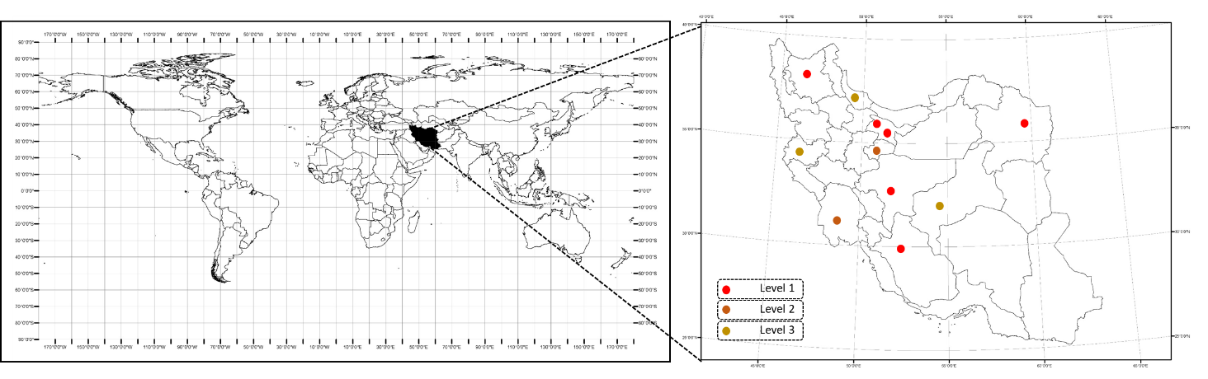
Figure (1). The studied area
The data required for city ranking were collected from statistical yearbooks, electronic portals, and government-affiliated statistical centers. Finally, to use the TOPSIS technique to rank and choose the best option from available options, the steps shown in Figure (2) were followed in order (for more details refer to Rafieian et.al 2023).
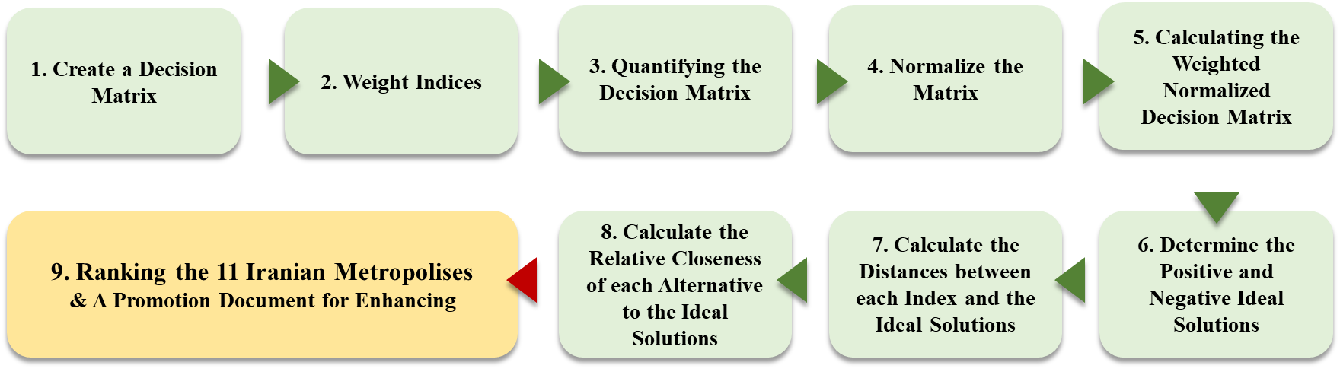
Figure (2). The steps of the TOPSIS technique

4. Findings
4.1- Research Process: Step 1
The content analysis of the interviews was carried out to modify the conceptual research model through coding in the form of keywords and key phrases in the MAXQDA software, the result of which includes the codes and sub-codes listed as components and sub-components in Table (1).
Table (1). The codes and subcodes extracted from the qualitative content analysis of the interviews
No. | Categories obtained from the coding of interviews | Sub-categories obtained from the coding of interviews
1 | More emphasis on the Islamic-Iranian approach in components and sub-components | More attention to indicators with a normative aspect.
1 |  | Removing the sub-components for which there is a specific custodian.
1 |  | Removing general sub-components
1 |  | Merge subcomponents overlapping.
2 | Attention to the universalization of the pillars | Separating the "city context" pillar into two substructure and infrastructure pillars
2 | Attention to the universalization of the pillars | Through a reciprocal process, from pillar to index and vice versa
2 | Attention to the universalization of the pillars | Referring to the" Second Phase of the Revolution" statement and national upstream documents
3 | Attention to the possibility of scoring and indexing | Using words common in urban planning
3 | Attention to the possibility of scoring and indexing | Replacing Islamic components with those applied in urban planning literature
3 | Attention to the possibility of scoring and indexing | Attention to the possibility of indexing categories
3 | Attention to the possibility of scoring and indexing | Deciding on the effect of indices (direct or inverse)
3 | Attention to the possibility of scoring and indexing | Discussing how to index
According to all in-depth interviews, the conceptual research model can be modified and redefined as follows. It should be noted that the tabernacle theory used in the initial conceptual model, and its main and macro components, as mentioned in the "theoretical foundations" Section, are still standing and most modifications were made in the categories and components. Some categories were moved, some that overlapped were merged, and some that could not be indexed and measured were replaced with similar ones, according to the opinions and suggestions of the interviewees. Figure (3) shows the completed and modified conceptual research model.
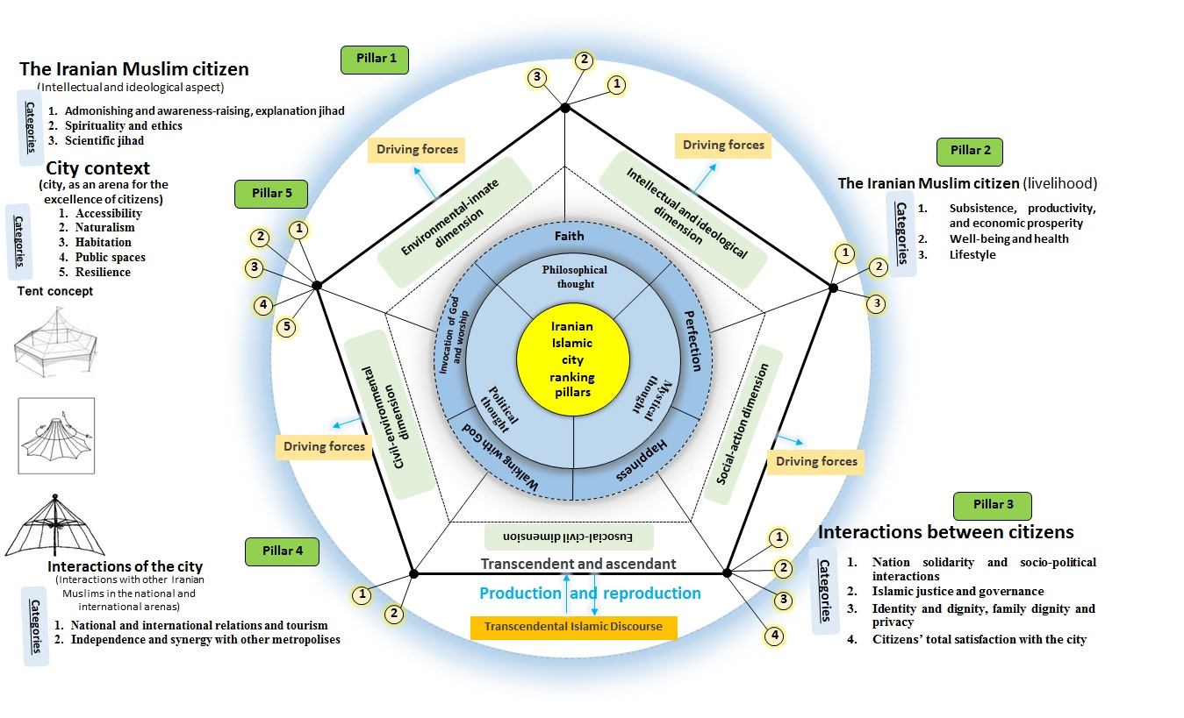
Figure (3). The conceptual model of city ranking with an Iranian-Islamic approach based on ranking pillars and categories

4.2- Presenting the Final List of scored City Ranking Indices with an Iranian-Islamic Approach
In the next section, it was tried to present the operational definitions of the indicators introduced in the previous section. To this end, each indicator related to the five pillars abovementioned was described in the form of a phrase(s) according to the general research approach. Next, screening was done in three stages according to the opinions of the expert group, and the final indicators were extracted. To achieve the final indicators, first, all the indicators were provided to the group of academic experts and professors to be examined in terms of their structural and identity characteristics, such as generality, and being qualitative or quantitative. In addition, duplicate indicators and those that can be merged with other ones were removed. In Step 2 of this process, the remaining indicators from the previous step were provided to a group of religious experts familiar with urban management to be examined in terms of their relevance with the Islamic values mentioned in the research, and their degree of conformity with the thought system including faith, perfection, happiness, walking with God, invocation of God and worship, based on which ranking is performed. At this stage, those indicators that didn't conform to the features of the Islamic city from the research perspective were removed. Finally, in the last stage, the availability of the information of indicators as well as having or not having a special custodian were examined by the research experts. Some indicators have always been considered by various organizations and institutions, and specific organizations are responsible for improving them. Therefore, in this research, it was attempted to consider those indicators for which there was no specific custodian and that have been neglected by various bodies.
Some indicators were removed in Step 1 of screening, due to reasons such as being general, being qualitative, being duplicated, or being merged with another one. In this section, according to the description of Step 2, the relevance of the indicators with Islamic subjects was examined, such as the degree of conformity of indicators with the definition of an Islamic city from the perspective studied and the degree of conformity of indicators with the thought system (faith, perfection, happiness, walking with God, invocation of God and worship), based on which ranking is performed. After the two steps abovementioned, the remaining indicators were investigated in terms of the availability of the information and having a special custodian by research experts, and the results are presented in the table below. In this way, Table (2) presents the final list of pillars, categories, components, indicators, and indexes related to each of the components of city ranking with the Iranian-Islamic approach after the three steps abovementioned.
Table (2). Pillars, categories, components, indexes, and indicators related to each of the components of city ranking with the Iranian-Islamic approach and the operational definitions of indicators.
Pillar | Category | Component | Index | Indicator | Source | Operational definition | Unit of indicator
The intellectual-ideological aspect of Iranian Muslim citizens | Admonishing and awareness-raising, explanation jihad | Social and political awareness of citizens | Political-ideological-religious activities | The number of active jihadist groups | Basij Sazandegi Organization | The number of active jihadist groups in the city per 10,000 people | Number per 10,000 people
 |  |  |  | The number of public endowments in the city | General Directorate of Endowments and Charity Affairs | The number of public endowments per 10,000 people | Number per 10,000 people
 |  |  |  | Number of confraternities in the city | Database of confraternitie, Islamic Development Organization | Number of confraternities per 10,000 people | Number per 10,000 people
 |  |  |  | The number of mosques in the city | Isla mic Development Organization, Setad Eghame Namaz | The number of mosques per 10,000 people | Number per 10,000 people
 | Admonishing and awareness-raising, explanation jihad | Social and political awareness of citizens | Education and activities of Muslim citizens | The number of facilitation centers in all neighborhoods of the city | Statistical yearbook of the city | The number of facilitation centers per 10,000 people | Number per 10,000 people
 | Admonishing and awareness-raising, explanation jihad | Social and political awareness of citizens | Religious cultural activities | The number of libraries in the city | Ministry of Culture and Islamic Culture | The number of libraries per 10,000 people | Number per 100,000 people
 | Spirituality and ethics | Culture of abnegation and self-sacrifice | Culture of abnegation and self-sacrifice | Martyrs of the Iran-Iraq war | Foundation of Martyrs and Veterans Affairs | The number of martyrs of the Iran-Iraq war per 100,000 people | Number per 100,000 people
 |  |  |  | Disabled combatants and repatriated prisoners of war of the Iran-Iraq war and holy shrine defenders | Foundation of Martyrs and Veterans Affairs | The number of disabled combatants and repatriated prisoners of war of the Iran-Iraq war and holy shrine defenders per 100,000 people | Number per 100,000 people
 |  |  |  | The number of charities in the city | Iran's Kheir Atlas | The number of charities per 100,000 people | Number per 100,000 people
 | Spirituality and ethics | Islamic art | Islamic art activities | The throughput of the Islamic art discipline in universities | Ministry of Science, Research, and Technology | The throughput of the Islamic art discipline per 100,000 people | Number per 100,000 people
 | Scientific jihad | Education and training | The quality of primary and higher education | The number of seminary students | Seminary Management Of Iran | The number of seminary students per 100,000 people | Number per 100,000 people
 |  |  |  | The number of university graduates | Ministry of Science, Research, and Technology | The number of university graduates/population over 18 years old | Number
 | Scientific jihad | Research | Research infrastructures and supports | Employment share of faculty members | Ministry of Science, Research, and Technology | The number of faculty members/employed population | Number
The livelihood of Iranian Muslim citizens | Subsistence, jobs, and affordability | Social supports | Insurance coverage | Social security insurance coverage | Social Security Organization | The number of people covered by social security insurance/total population (inverse) | Number
The livelihood of Iranian Muslim citizens | Well-being and health | Guarantee of survival | Life expectancy and healthcare infrastructure | Life expectancy index | Statistical yearbook of the city | Average life expectancy | Year
 |  |  |  | Hospital bed per capita | Ministry of Health and Medical Education | The number of hospital beds per 1,000 people | Number per 1,000 people
 |  |  |  | Under 5 mortality rate | Iranian Legal Medicine Organization | Under 5 mortality rate per 100,000 successful births (inverse) | Number per 100,000 people
The livelihood of Iranian Muslim citizens | Well-being and health | Improvement of survival | Exhilaration, well-being, and exercise | The level of attention to Pahlevani and zourkhaneh rituals | Ministry of Sport and Youth  Zurkhaneh Sports Federation | The number of Pahlevani and Zurkhaneh athletes per 100,000 people | Number per 100,000 people
The livelihood of Iranian Muslim citizens |  | Quality of nutrition | Eating habits | The share of drinking water subscriber | Statistical yearbook of the city | The number of drinking water subscribers/the number of residential units | Number
 |  |  |  | The level of attention to healthy food | The Union Guild of the Vendors of Meat Products, Delis, Pizza, and Fancy Foods | The number of fast food and unhealthy restaurants per 100,000 people (inverse) | Number per 100,000 people
The livelihood of Iranian Muslim citizens |  | Mental health | Effective protection of life and health | The number of psychiatrists | Ministry of Health and Medical Education | The number of psychiatrists per 100,000 people | Number per 100,000 people
Interactions between citizens | Nation solidarity and socio-political interactions | Exchange of information and technology | Informing | Internet usage | Supreme Council of Cyberspace | The average duration of Internet usage | Min/day
Interactions between citizens | Islamic justice and governance | Social justice and equality | Equal opportunities for women and men | The higher education of women | Statistical yearbook of the city | Female students at higher education levels/total students | Number (in person)
 |  |  |  | The employment rate of women | Statistical yearbook | Female employees/male employees in a year | Number (in person)
Interactions between citizens | Identity and dignity, family dignity and privacy | Urban identity and dignity | Urban authenticity and Islamic identity | The level of attention to historical and cultural works | Ministry of Cultural Heritage, Tourism, and Handicrafts | The number of registered historical-cultural works | Number
Interactions of the city (interactions with other Iranian Muslims in the national and international arenas) | National and international relations and tourism | International communication | International communication | Inbound passenger/outbound passengers | Ministry of Roads and Urban Development  civil Aviation Organization | Inbound passenger/outbound passengers | Number (in person)
 | National and international relations and tourism | Tourist attractions | Cultural experience and Islamic tourism infrastructure | The number of museums | Statistical yearbook | The number of museums per 100,000 people | Number per 100,000 people
 |  |  |  | Cinema seat per capita | Ministry of Culture and Islamic Culture | Number of cinema seats/population | Number of seats/person
 |  |  |  | Length of stay in the city | Hotelier Association  Statistical yearbook | The number of hotel and guest rooms in the city | Number
 | Independence and synergy with other metropolises | Entrepreneurship | Innovation | The number of science and technology parks | Ministry of Science, Research, and Technology | The number of science and technology parks in the city | Number
 |  | Vitality and economic attractiveness | Investment opportunities in religious service projects | Inflation rate (inverse) | Statistical yearbook | The percentage change of the price index at two different times relative to each other | Percent
City context (city, as an arena for the excellence of citizens) | Accessibility | Comfort and security of movement | Transportation safety | Traffic-related death rate | Iranian Legal Medicine Organization  Statistical yearbook | Traffic-related death rate/ total death rate in a year | Number
 | Accessibility | Connectivity | Access and movement and access system infrastructure | The longest distance between destinations within the city (inverse) | Statistical yearbook | The longest distance between destinations within the city (km) | Kilometer
 | Naturalism | Environmental Protection | Water, air, and urban waste management | Air quality index | Iran's Meteorological Organization | Number of unhealthy air quality days in a year | day of the year
 |  |  |  | Water consumption per capita (inverse) | Statistical yearbook | Water consumption in a specific time unit by a specific consumer | Liters/day per person
 |  |  |  | Waste collected per capita (inverse) | Statistical yearbook | Waste collection rate/population | Ton/person
 | Naturalism | Environmental Protection | Energy consumption management | Gasoline consumption per capita (inverse) | Ministry of Petroleum | Gasoline consumption in a specific time unit by a specific consumer | Liters/day per person
 |  |  |  | Town gas consumption per capita (inverse) | Ministry of Petroleum | Gas consumption in a specific time unit by a specific consumer | m³/day per person
 | Naturalism | Natural and built landscapes | Respect for divine verses | Attention to the importance of green spaces in divine verses | Statistical yearbook | Hand-planted forests/ the total area of the city | m²
 | Naturalism | Natural and built landscapes | The Islamic image of the city | The number of historical mosques | Ministry of Cultural Heritage, Tourism, and Handicrafts | The number of historical mosques in the city | Number
 | Habitation | Housing | Housing quality | The share of households enjoying minimum electricity | Ministry of Energy | The number of electricity subscribers/number of residential units | Number
 | Habitation | Housing | Quantitative characteristics of housing | The share of residential units with an area above 100 m² | Statistical Centre of Iran | The number of constructed residential units with an area above 100 m²/ total constructed residential units | Number
 |  |  |  | Persons per housing unit (inverse) | Statistical Centre of Iran | The number of people living in each residential unit | People per a residential unit
 | Public spaces | Neighborhoods | The characteristics of neighborhoods and open spaces | The playability of open spaces | Statistical yearbook | The number of local playgrounds per 5,000 people | Number per 5,000 people
 | Public spaces | Collective spaces | Public uses | The level of access to public uses | Statistical yearbook | The number of bus stops/the area of the city | Number (hectares)
 | Resilience | Safety from accidents | Safety from accidents | The number of home fire incidents | Statistical yearbook | Home fire incidents / total incidents during the year (inverse) | Number
 | Resilience | Crisis management | Crisis management | The number of firefighters | Statistical yearbook | The number of firefighters/city's population | Number (in person)

4.3- Research Process: Step 2
After determining the components and indicators of city ranking, their operational definitions, and the sources related to each of the required data, in this step, cities were ranked using the extracted indicators.
4.4- Ranking of Cities in Terms of the Intellectual-Ideological Aspect of Iranian Muslim Citizens
The results of the TOPSIS technique for the 13 indicators of the "intellectual-ideological aspect of Iranian Muslim citizens" pillar show that Yazd Metropolis ranked first, followed by Rasht, Qom, and Tabriz metropolises with a very small difference between them, respectively. Also, Karaj and Tehran metropolises obtained the last ranks, respectively. Table (3) shows the results.
Table (3). The constitutive indicators of the "intellectual-ideological aspect of the Iranian Muslim citizen" pillar
Description | Admonishing and Awareness-raising, Explanation Jihad |  |  |  |  |  |  | Spirituality and Ethics |  |  |  | Scientific Jihad
Description | Social and Political Awareness of Citizens |  |  |  |  |  |  | Culture of Abnegation and Self-sacrifice |  |  | Islamic Art | Education and Training |  | Research
Description | Political-ideological-religious activities |  |  |  | Education and activities of Muslim citizens |  | Religious cultural activities | Culture of abnegation and self-sacrifice |  |  | Islamic art activities | The quality of primary and higher education |  | Research infrastructures and supports
Description | The number of active jihadist groups in the city per 10,000 people | The number of public endowments per 10,000 people | Number of confraternities per 10,000 people | The number of mosques per 10,000 people |  | The number of facilitation centers per 10,000 people | The number of libraries per 10,000 people | The number of martyrs of the Iran-Iraq war per 100,000 people | The number of disabled combatants and repatriated prisoners of war of the Iran-Iraq war and holy shrine defenders per 100,000 people | The number of charities per 100,000 people | The throughput of the Islamic art discipline per 100,000 people | The number of seminary students per 100,000 people | The number of university graduates/population over 18 years old | The number of faculty members/employed population
Isfahan | 13.15 | 9.43 | 7.14 | 5.61 |  | 0.03 | 3.47 | 466.38 | 2492.02 | 131.45 | 1.27 | 18.90 | 26.99 | 6.48
Ahvaz | 5.544 | 23.03 | 16.63 | 2.38 |  | 0.06 | 2.85 | 1069.24 | 2639.91 | 105.26 | 0.00 | 316.81 | 24.83 | 8.11
Tabriz | 25.66 | 56.14 | 17.96 | 3.95 |  | 0.03 | 0.77 | 561.75 | 1448.59 | 97.39 | 22.45 | 192.47 | 23.46 | 6.73
Tehran | 3.87 | 27.00 | 22.13 | 2.21 |  | 0.06 | 0.00 | 224.75 | 757.41 | 54.74 | 3.10 | 77.44 | 29.43 | 7.13
Shiraz | 0.82 | 84.59 | 3.02 | 2.42 |  | 0.10 | 0.48 | 781.08 | 2329.33 | 107.80 | 8.46 | 241.71 | 27.04 | 13.4
Qom | 5.57 | 16.65 | 11.24 | 9.99 |  | 0.02 | 7.33 | 361.73 | 942.42 | 47.70 | 0.00 | 6243.97 | 21.33 | 5.06
Karaj | 1.31 | 8.79 | 3.14 | 1.58 |  | 0.06 | 0.31 | 248.60 | 667.82 | 58.90 | 6.91 | 75.35 | 24.02 | 2.13
Kermanshah | 19.56 | 21.12 | 10.56 | 2.32 |  | 0.10 | 0.42 | 799.34 | 2092.11 | 56.73 | 0.00 | 264.09 | 21.41 | 3.19
Mashhad | 15.67 | 87.16 | 16.33 | 3.92 |  | 0.05 | 2.02 | 494.34 | 1529.70 | 50.49 | 1.63 | 1306.23 | 21.55 | 2.44
Yazd | 17.12 | 208.44 | 26.43 | 8.23 |  | 0.06 | 1.32 | 646.81 | 1795.82 | 195.40 | 20.77 | 415.35 | 24.37 | 4.67
Rasht | 29.41 | 69.45 | 16.91 | 2.01 |  | 0.10 | 0.15 | 949.42 | 3188.70 | 66.32 | 14.71 | 441.18 | 22.08 | 4.49

4.5- Ranking of cities in terms of the livelihood of Iranian Muslim citizens
The results of the TOPSIS technique for the 8 indicators of the "Livelihoods of Iranian Muslim Citizens" show that Yazd Metropolis ranked first, followed by Rasht, Ahvaz, and Tabriz metropolises, with a very small difference between them, respectively. Also, Shiraz and Kermanshah metropolises obtained the last ranks, respectively. Table (4) shows the results.
Table (4). The constitutive indicators of the "livelihood of Iranian Muslim citizens" pillar
Description | Subsistence, Jobs, and Affordability | Well-being and Health
Description | Social Supports | Guarantee of Survival |  |  | Improvement of Survival | Quality of Nutrition |  | Mental Health
Description | Insurance coverage | Life expectancy and healthcare infrastructure |  |  | Exhilaration, well-being, and exercise | Eating habits |  | Effective protection of life and health
Description | The number of people covered by social security insurance/total population (inverse) | Average life expectancy | Hospital bed per capita | Under 5 mortality rate per 100,000 successful births (inverse) | The number of Pahlevani and Zurkhaneh athletes per 100,000 people | The number of drinking water subscribers/the number of residential units | The number of fast food and unhealthy restaurants per 100,000 people (inverse) | The number of psychiatrists per 100,000 people
Isfahan | 0.3 | 76.2 | 2.34 | 6.3 | 16.32 | 0.63 | 61.19 | 2.24
Ahvaz | 0.72 | 72.6 | 5.1 | 0.02 | 47.52 | 1.2 | 40.39 | 3.56
Tabriz | 0.77 | 73.41 | 1.7 | 0.007 | 16.42 | 1.34 | 38.49 | 7.70
Tehran | 0.83 | 76.05 | 1.9 | 0.008 | 3.72 | 1.21 | 166.38 | 4.34
Shiraz | 0.22 | 74.2 | 1.33 | 0.006 | 17.58 | 0.72 | 60.43 | 5.62
Qom | 0.64 | 73.55 | 2.06 | 0.005 | 83.25 | 0.79 | 26.64 | 5.91
Karaj | 0.61 | 74.19 | 0.9 | 0.008 | 43.96 | 0.94 | 75.35 | 4.14
Kermanshah | 0.39 | 72.11 | 1.4 | 0.04 | 22.08 | 0.81 | 68.66 | 4.54
Mashhad | 0.54 | 74.15 | 2.06 | 0.005 | 18.61 | 0.97 | 65.31 | 3.82
Yazd | 0.57 | 74.68 | 2.3 | 0.003 | 755.18 | 0.91 | 132.16 | 3.21
Rasht | 0.63 | 74.51 | 2.17 | 0.006 | 882.36 | 0.94 | 132.35 | 9.12

4.6- Ranking of Cities in Terms of the Interactions between Citizens
The results of the TOPSIS technique for the 4 indicators of the "interactions between citizens" pillar show that Yazd Metropolis ranked first, followed by Tehran, Isfahan, and Shiraz metropolises, with a very small difference between them, respectively. Also, Rasht and Kermanshah metropolises obtained the last ranks, respectively. In the following, the status of metropolises is analyzed and presented in terms of the constituent indicators of the "interactions between citizens" pillar. Figure (4) shows the results.
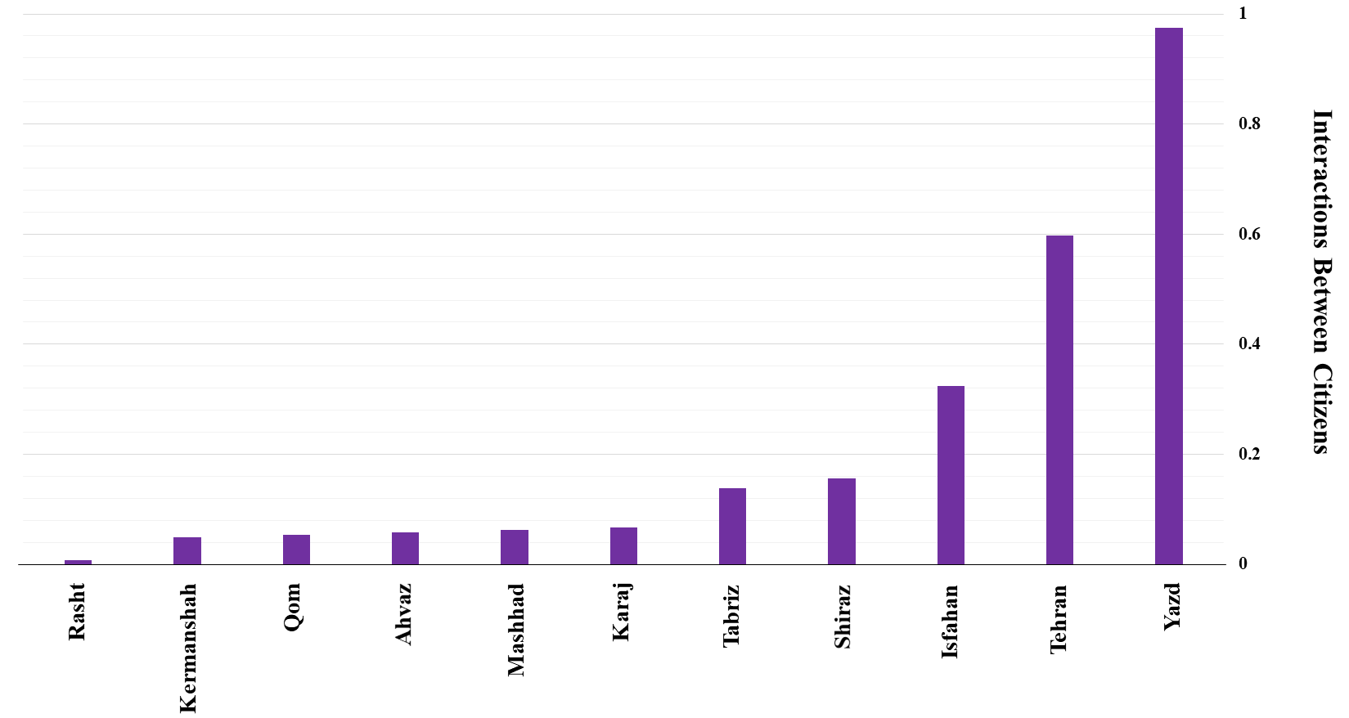
Figure (4). The result of integrating the indicators of the "interactions between citizens" pillar
4.7- Ranking of Cities in Terms of the Interactions of the City
The results of the TOPSIS technique for the 6 indicators of the "interactions of the city (interactions with other Iranian Muslims in the national and international arenas)" pillar show that Mashhad Metropolis ranked first, followed by Tehran, Rasht, and Yazd metropolises, with a very small difference between them, respectively. Also, Karaj and Tabriz metropolises obtained the last ranks, respectively. In the following, the status of metropolises is analyzed and presented in terms of the constituent indicators of the "interactions of the city (interactions with other Iranian Muslims in the national and international arenas)" pillar. Figure (5) shows the results.
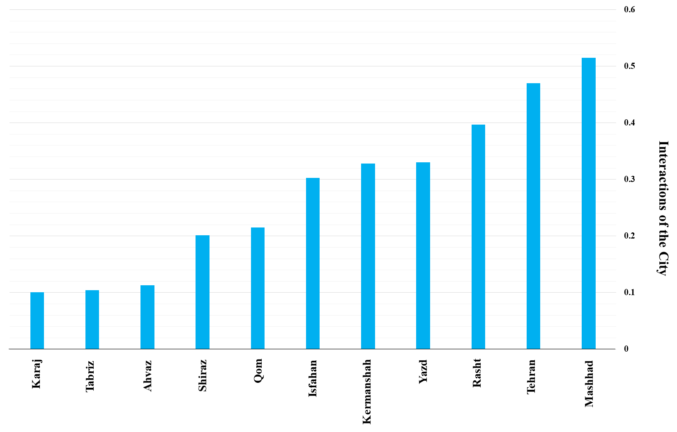
Figure (5). The result of integrating the indicators of the "interactions of the city" pillar
4.8- Ranking of Cities in Terms of the "City Context" Pillar
The results of the TOPSIS technique for the 16 indicators of the "city context (city, as an arena for the excellence of citizens" pillar show that Mashhad metropolis ranked first, followed by Qom, Shiraz, and Tabriz metropolises, with a very small difference between them, respectively. Also, Kermanshah and Rasht metropolises obtained the last ranks, respectively. In the following, the status of the metropolises is analyzed and presented in terms of the constituent indicators of the "city context (city, as an arena for the excellence of citizens)" pillar. Figure (6) shows the results.
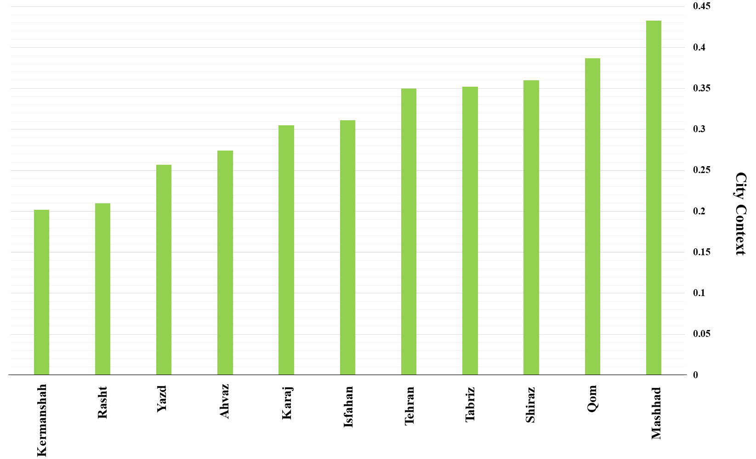
Figure (6). The result of integrating the indicators of the "city context (city, as an arena for the excellence of citizens)" pillar
4.9- Final Rankings of Cities
Finally, this section presents the final rankings of metropolises considering different pillars, components, and indexes using the TOPSIS technique. According to the TOPSIS technique, first, the decision matrix was formed. In the decision matrix, the rows include alternatives (here, metropolises) and the columns include the indicators of pillars. The cells of the matrix present the data extracted from various databases such as statistical yearbooks, etc. related to each indicator. Finally, in the last step, the similarity measure and the rankings of alternatives are calculated and presented. The similarity measure shows the score of each alternative, and the closer this measure is to one, the more superior the alternative is. Table (5) shows the similarity measure and rankings of the alternatives (i.e. metropolises).
Table (5). Similarity measure and rankings of alternatives
Cities | Similarity Measure
Isfahan | 0.311
Ahvaz | 0.282
Tabriz | 0.344
Tehran | 0.344
Shiraz | 0.308
Qom | 0.359
Karaj | 0.199
Kermanshah | 0.237
Mashhad | 0.377
Yazd | 0.449
Rasht | 0.375

As Table (5) shows, based on the criteria and the indicators determined for each criterion and index, and the results of combining the criteria with the same weight, Yazd metropolis ranked first, followed by Mashhad, and Rasht metropolises, respectively. Figure (7) shows the results of combining the criteria and the rankings of metropolises.
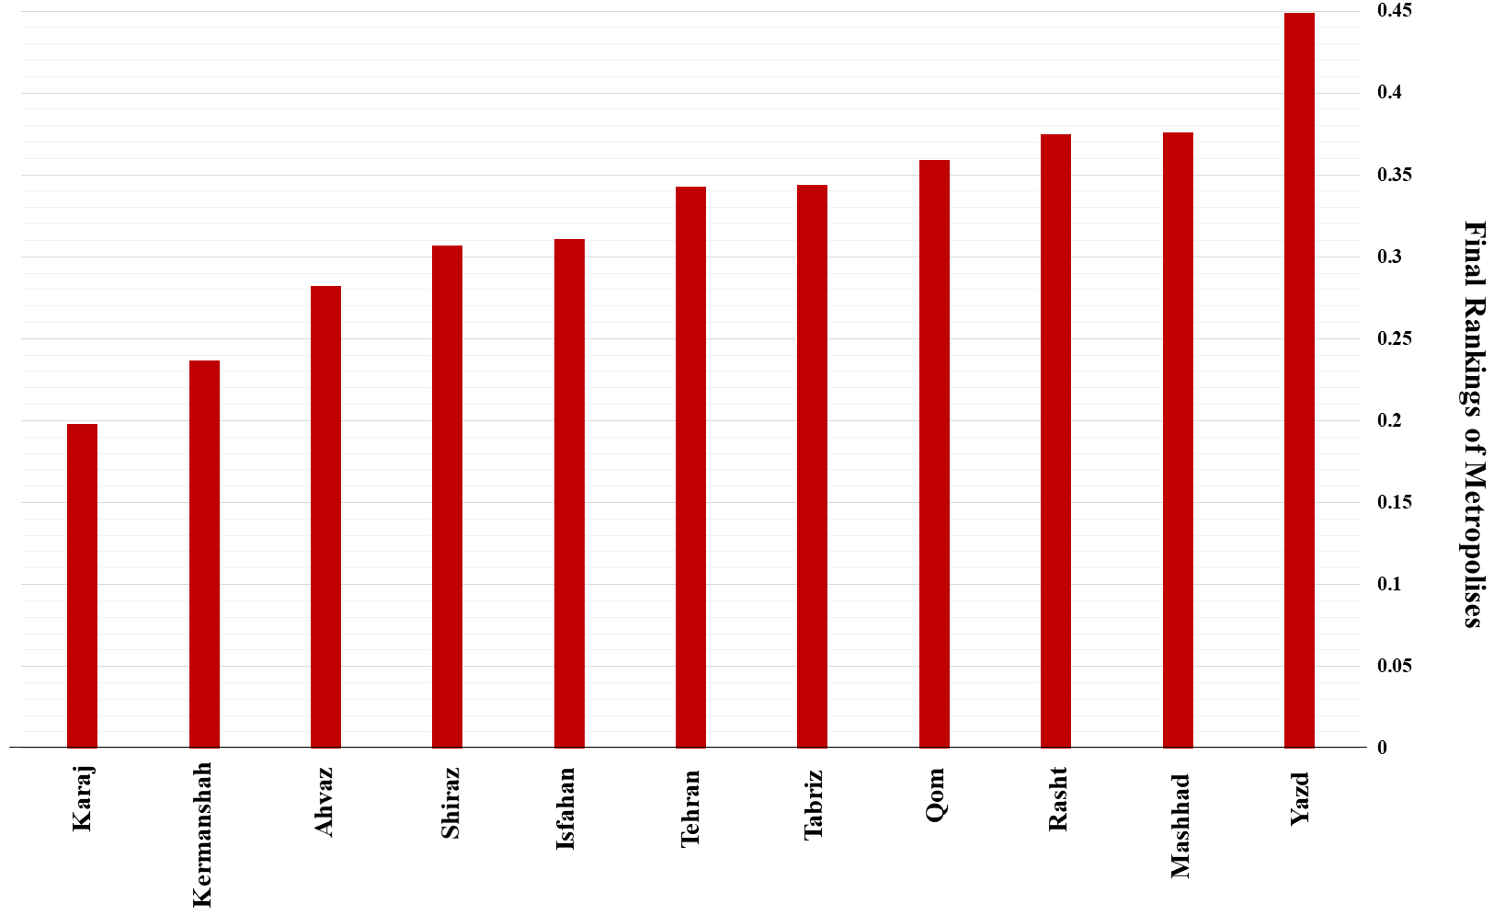
Figure (7). The results of integrating the criteria and the final rankings of metropolises

5. Discussion and Conclusion
According to the research findings, metropolises are regarded as the centers of progress on the national and international scales, and their permanent monitoring allows planning for their development and the elimination of their shortcomings in various fields. On the other hand, they must be evaluated and compared according to indigenous indicators and the value and cultural systems of the community where they are. The aforementioned necessities reveal the need for research in this field and to customize city ranking indicators according to the Islamic-Iranian worldview that combines both material and immaterial (spiritual) needs. Accordingly, considering the Islamic-Iranian perspective that can provide the ground for the realization of the Islamic-Iranian model of progress, the present research attempted to provide a theoretical model and an operational framework for city ranking on a national scale and ranked eleven Iranian metropolises in terms of the indexes extracted. For this purpose, first, the existing definitions of the concept, elements, and pillars were reviewed, and the components and systems of the city from an Islamic perspective, the intellectual paradigm forming the concept of an Islamic city, and the general characteristics and main values governing an ideal city from an Islamic perspective were described, and finally, the dimensions, components, and macro criteria were analyzed through content analysis, a conceptual model and a theoretical and operational framework for Islamic city ranking were developed, and 11 sample Iranian metropolises were ranked using the TOPSIS technique. The results indicated that Yazd metropolis ranked first (with a score of 0.449), followed by Mashhad (with a score of 0.376) and Rasht (with a score of 0.375) metropolises, respectively. Among the reasons for this, one can mention the highest frequencies of endowments, confraternity (relative to Yazd's population), active charities, and Pahlevani and Zurkhaneh athletes in Yazd City. Also, regarding Mashhad City, one can refer to three important indicators: the number of seminary students, the capacity of guesthouses and hotels, and public endowments per capita. Regarding Rasht City, one can refer to the following indicators: the number of martyrs and disabled combatants of the Iran-Iraq war per 100,000 people and the number of Pahlevani and Zurkhaneh athletes. There is an important note here: the "internet usage" indicator has not been evaluated by cities so far despite its great importance. That is why it has been considered the same in all cities. A change in this important indicator may cause a change in the ranking results.
The indicators extracted to rank Iranian metropolises can be generalized at regional and local levels. This was considered a research criterion during the extraction and evaluation of indicators, and it was tried to select indicators capable of being measured at the local level. It should be noted that the stated indicators have a promotive aspect and do not seek to judge the cities to find the superior one. They provide the necessary ground for removing neighborhood shortcomings and enhancing neighborhood progress based on Islamic principles. However, it should be noted that the mentioned indicators were extracted only to customize city ranking indicators and they are only for Iran. For other countries, it is required to identify similar indicators. Therefore, to implement the city ranking at the international level, it is required to revise the indicators and bring the proposed concepts closer to the international indicators. Finally, Figure (8) presents some suggestions in the form of a promotion document for the improvement and promotion of the eleven Iranian metropolises studied in this research.
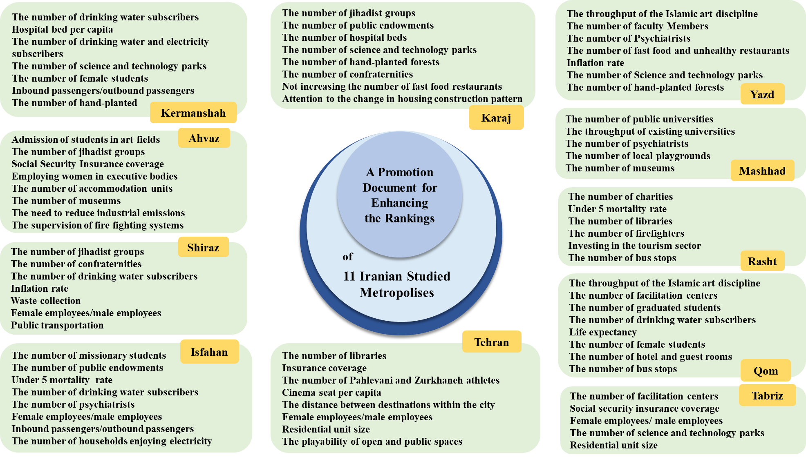
Figure (8). A promotion document for enhancing the rankings of the eleven Iranian metropolises studied in this research.
Research Limitations:
This paper is due to novelty had a lot of challenges. Since the urban ranking index in this research is based on the context of the country’s base of study (based on the Iranian - Islamic perspective), the generalizability of these findings can only be examined in similar contexts. Therefore, other countries should be carefully prepared to use this research because of the existence of different interpretations of Islam, and present their specific rank indices. Also in relation to the effects of research on the society, it can be pointed out that the main purpose of the authors is attracting the attention of societies to the standards and norms of their background and the necessity of considering them in improving the quality of city and citizens. On the other hand, this paper was not able to compare its findings with other studies because of innovation in the field of context- based classification. This can be resolved by performing similar tasks in the next few years.
In this paper, the definition of measure for some variables, because of novelty, requires comprehensive studies and taking advantage of the opinions of experts, in this regard, the authors measure the indices based on similar or equivalent ones. However, the unit of these measures can be discussed. In addition, the difficulty of access to updated and valid data in some measures in the general population of 11 cities was one of the main challenges to the authors. So that if there was no access to a measure, even in one city, that measure was generally excluded from the analysis process. The lack of some data and the absence of access to temporal variations caused some finding to be only partially interpreted. Some of the measures introduced in this study require deep social studies, including interviews and detailed questionnaires in selected cities, which due to time and cost, there was no possibility for their study. Therefore, in future research we suggest completing these measures.

References
- Acuto, M., & Pejic, D. (2021). Shaping a global comparative imagination? Assessing the role of city rankings in the “global city” discourse. Area, 53(2), 247–256. https://doi.org/10.1111/area.12710
- Acuto, M., Pejic, D., & Briggs, J. (2021b). Taking City Rankings Seriously: Engaging with Benchmarking Practices in Global Urbanism. International Journal of Urban and Regional Research. https://doi.org/10.1111/1468-2427.12974
- Akande, A., Cabral, P., Gomes, P. J., & Casteleyn, S. (2019c). The Lisbon ranking for smart sustainable cities in Europe. Sustainable Cities and Society, 44, 475–487. https://doi.org/10.1016/j.scs.2018.10.009
- Al-Khraif, R. M., Elsegaey, I., Al-Mogarry, M., & Salam, A. A. (2022). Saudi Arabia’s City Ranking Index (SACRI) methodology executed: Preliminary findings. Journal of Economics & Management, 44, 376–392. https://doi.org/10.22367/jem.2022.44.15
- Ashrafi, N. Naghizadeh, M. (2016). Clarifying Interaction of Ideas and Effect in the Sassanid Era Architecture. Hoviatshahr. 2, (11). 95-106.
- Assari, A., Maghreby, S., & Nik, M. M. (2017). Investigation of smart growth in traditional Islamic culture: Case study of Isfahan city in Iran. Journal of Geography and Regional Planning, 10(4), 47–56. https://doi.org/10.5897/jgrp2016.0588
- Atmaja, L., & Mustopa, R. R. B. C. (2020). Metaphysics in the Epistemology : A Critical Analysis of Islamic and Western Philosophical tradition. Afkaruna, 16(1). https://doi.org/10.18196/aiijis.2020.0111.22-39
- Capitanio, M. (2017c). The Relativity of Liveability Rankings Examining the Japanese Case against the Global Discourse. World Journal of Social Science, 5(1), 12. https://doi.org/10.5430/wjss.v5n1p12
- Conger, B. (2015). On Livability, Liveability and the Limited Utility of Quality-of-Life Rankings. The School of Public Policy SPP Communiqués, 7(4), 1-8.
- Correia, J., & Taher, M. M. B. (2015). Traditional Islamic cities unveiled: the quest for urban design regularity. Gremium, 2(4), 21–36. https://doi.org/10.56039/rgn04a04
- Cramer-Greenbaum, S. (2020). Who can afford a ‘livable’ place? The part of living global rankings leave out. International Journal of Urban Sustainable Development, 13(1), 70–82. https://doi.org/10.1080/19463138.2020.1812076
- Elgert, L. (2018). Rating the sustainable city: ‘Measurementality’, transparency, and unexpected outcomes at the knowledge-policy interface. Environmental Science & Policy, 79, 16–24. https://doi.org/10.1016/j.envsci.2017.10.006
- Escolar, S., Villanueva, F., Santofimia, M. J., Villa, D., García, X., & López, J. C. (2019). A Multiple-Attribute Decision Making-based approach for smart city rankings design. Technological Forecasting and Social Change, 142, 42–55. https://doi.org/10.1016/j.techfore.2018.07.024
- Farhan, S. L., Akef, Anton, D., Hashim, K., & Zubaidi, S. L. (2021). Factors influencing the transformation of Iraqi holy cities: the case of Al-Najaf. Scientific Review Engineering and Environmental Sciences, 30(2), 365–375. https://doi.org/10.22630/pniks.2021.30.2.31
- Ghasemi, K., Hamzenejad, M., & Meshkini, A. (2019). The livability of Iranian and Islamic cities considering the nature of traditional land uses in the city and the rules of their settlement. Habitat International, 90, 102006. https://doi.org/10.1016/j.habitatint.2019.102006
- Giffinger, R., Haindlmaier, G., & Kramar, H. (2010b). The role of rankings in growing city competition. Urban Research & Practice, 3(3), 299–312. https://doi.org/10.1080/17535069.2010.524420
- Kaklauskas, A., Zavadskas, E. K., Radzevičienė, A., Ubartė, I., Podviezko, A., Podvezko, V., . . . Bučinskas, V. (2018). Quality of city life multiple criteria analysis. Cities, 72, 82–93. https://doi.org/10.1016/j.cities.2017.08.002
- Kitchin, R., Lauriault, T. P., & McArdle, G. (2015c). Knowing and governing cities through urban indicators, city benchmarking and real-time dashboards. Regional Studies, Regional Science, 2(1), 6–28. https://doi.org/10.1080/21681376.2014.983149
- Kornberger, M., & Carter, C. (2010). Manufacturing competition: how accounting practices shape strategy making in cities. Accounting, Auditing & Accountability, 23(3), 325–349. https://doi.org/10.1108/09513571011034325
- McArthur, J., & Robin, E. (2019b). Victims of their own (definition of) success: Urban discourse and expert knowledge production in the Liveable City. Urban Studies, 56(9), 1711–1728. https://doi.org/10.1177/0042098018804759
- Meijering, J., Kern, K., & Tobi, H. (2014c). Identifying the methodological characteristics of European green city rankings. Ecological Indicators, 43, 132–142. https://doi.org/10.1016/j.ecolind.2014.02.026
- Meijering, J., Tobi, H., & Kern, K. (2018). Defining and measuring urban sustainability in Europe: A Delphi study on identifying its most relevant components. Ecological Indicators, 90, 38–46. https://doi.org/10.1016/j.ecolind.2018.02.055
- Naghizadeh, M. (2014). Pattern, Basics, Pillars, Attributes and Principles of Islamic City. CIAUJ 2015; 1 (1) :63-80.
- Noori, N., De Jong, M., & Hoppe, T. (2020b). Towards an integrated framework to measure smart city readiness: the case of Iranian cities. Smart Cities, 3(3), 676–704. https://doi.org/10.3390/smartcities3030035
- Omer, S. (2012). The Concepts of God, Man, and the Environment in Islam: Implications for Islamic Architecture. Journal of Islamic Architecture, 2(1). https://doi.org/10.18860/jia.v2i1.1778
- Pinheiro, F. A., Diogo, M. T., Paúl, C., & De Souza Góis, J. E. (2018). Age-Friendly Cities Performance Assessment Indicators System hierarchization. Revista Kairós. https://doi.org/10.23925/2176-901x.2018v21i4p31-54
- Portugal, A. C. (2019c). The role of city rankings in local public policy design: Urban competitiveness and economic press. Global Media and China, 4(2), 162–178. https://doi.org/10.1177/2059436419853892
- Rafieian, M., Shams, F. and Mashayekhi, A. (2023). Compilation of Theoretical Framework of Urban Ranking on a National Scale with Islamic Approach. Urban Strategic Thought, 1(2), 29-41. https://doi:10.30479/ust.2023.18828.1122
- Rashtbar, H. Nazmfar, H. Samadzadeh, R. (2019). Evaluating enjoyment of urban regions through innovative city indicators with emphasis on social and cultural indicators ( A case study: Tabriz metropolis). Journal of Applied Engineering Sciences. 9(22). 109-114.
- Ringel, L., Branković, J., & Werron, T. (2020). The Organizational Engine of Rankings: Connecting “New” and “Old” institutionalism. Politics and Governance, 8(2), 36–47. https://doi.org/10.17645/pag.v8i2.2576
- Sáez, L., Saizarbitoria, I. H., & Rodríguez-Núñez, E. (2020d). Sustainable city rankings, benchmarking and indexes: Looking into the black box. Sustainable Cities and Society, 53, 101938. https://doi.org/10.1016/j.scs.2019.101938
- Sarbangholi, S. S., & Pakdelfard, M. R. M. R. (2020). Understanding the concepts of Islamic wisdom and its effects on the formation of mosque architecture. Journal of Art and Architecture Studies, 9(2), 39–44. https://doi.org/10.51148/jaas.2020.6
- Siraj, F. M., Amril, A., & Putri, E. W. (2022). Between Western Philosophy and Islamic Philosophy. Ibda’ : Jurnal Kajian Islam Dan Budaya, 20(2), 219–231. https://doi.org/10.24090/ibda.v20i2.6362
- Taylor, Z. (2011). Lies, damned lies and statistics: a critical examination of city ranking studies. Intergovernmental Committee for Economic and Labour Force Development, Canada, urban research.
- The Economist Group - About us. (n.d.). The Economist Group. http://www.economist.com/help/about-us.
- The Economist. (2016). About us. Retrieved from http://www.economist.com/help/about-us.

Mrafian@yazd.ac.ir

