Investigating the time range of architecture compatible with climate

Pedram Hessari*1, Mahdi Zandieh2, Parisa Noor Mohammadi3
- Assistant Professor, Department of Architectural engineering, Faculty of Engineering, Ayatollah Boroujerdi University, Boroujerd, Iran, (Corresponding author) P.Hessari@abru.ac.ir,
- Full Professor in Landscape Architecture, Faculty of Architecture & Urbanism, Imam Khomeini International University, Qazvin, Iran,
2- University of Torbat Heydarieh, Iran

Abstract. Bioclimatic condition is the most important factor that affects the quality of human life, architecture and housing. Lastly, results in bioclimatic design that presents valuable solutions for reducing energy consumption in the building sector while providing thermal comfort.
This paper aims to evaluate the thermal human comfort of bioclimatic conditions according to human comfort with analysis software. In this research, descriptive-analytical method was utilized. Most of the data were gathered through library studies and required climate information was extracted from the data according to the weather station (Mehrabad Airport) in Tehran city throughout 10 years- period (2009-2019). By conclusion, in this city, the fall and winter seasons and the month of April have cold conditions, therefore applying mechanical heating and high thermal mass is needed for most of the year. One third of a year has human comfort conditions. In Tehran city natural and mechanical cooling is required for three months of a year due to warm conditions.
Key words: Evans, Backer, Terjung, Thermo-hygrometric, Climate Consultant.

1. Introduction
Thermal comfort conditions include a range of temperature and moisture in which the regulatory mechanism of body temperature is at the lowest level of activity. Determining the thermal comfort zone has a direct impact on thermal calculations of a building, the size of heating and cooling devices, insulation thickness, type of materials and consumption and waste of energy. Since individuals have the same thermal comfort in similar climatic conditions, it is necessary that the thermal comfort zone be determined accurately for each climatic region (Kamyabi and Dabbaghian, 2015).
2. Definitions
2.1. Olgyay Bioclimatic Chart
One of the most useful factors for examining air temperature conditions in terms of comfort is the Olgyay bio-climatic table. In the 1960’s Olgyay presented a diagram in which the characteristics of the human comfort zone were determined in terms of dry temperature and relative humidity (Eskandarian, 2015).
The Olgyay Bioclimatic chart is the first bioclimatic chart that connects temperature and relative humidity in order to define a comfort zone (Santy, 2017). Durability of annual hot and cold weather in different cities, the degree of seriousness of thermal conditions, type of mechanical systems and the need for mechanical systems are determined according to the amount of moisture and the intensity of heat or cold (Kamyabi and Dabbaghian, 2015).
2.2. Terjung index
This index is one of the most important bioclimatic indexes for assessing human comfort. One of the most important advantages of this index compared with other indexes is simultaneous using of the highest number of climatic indexes which control the human body temperature. Using this index one can indicate the most preferable region for staying and living of people who suffer from climatic illnesses. Terjung is based on comfort coefficient and wind cooling coefficient (Mogholi and Akhgar, 2014).
2.3. Thermo- hygrometric index
The condition of thermo-hygrometric comfort or well-being can be defined, from the psychological point of view, as the psychophysical state in which the subject expresses satisfaction with the thermal environment, or, from the thermo-sensory viewpoint, such as the condition in which the subject does not feel sensation nor of hot or cold (that is a neutral thermo-hygrometric condition) (Cannistraro, Cannistraro and Restivo, 2015).
Dry bulb temperature and dew point temperature are used in this index. This index is used more in warm areas and does not work with windflaw. Thermo-hygrometric index is calculated by the following formula (Mogholi and Akhgar 2014):
Equation 2: DI=0.99T_d+0.36T_dp+41.5
In this relation DI is the thermo-hygrometric index, Td is dry bulb temperature in degree Celsius, and Tdp is dew point temperature in degree Celsius (Hessari and Seyf Shojaee, 2018).
2.6. Wind-chill index
Another coefficient of human comfort is the Wind-chill index or indeed the effect of wind drying. This index represents the amount of energy excretion in terms of kilocalories per hour from the surface of one square meter of the body and in normal conditions, which means lack of physical activity and normal skin temperature, i.e. about 33 degrees Celsius (Ahmadi & Shaemi 2013). The following formula is proposed to calculate the value of the Wind-chill index.
Equation 3: H= (10.45+10√V-V)×(33-T)
V: the average wind speed in meter per second
T: the average temperature in degree Celsius (Ghanbari, Afifi and Sadeghi, 2010).
2.7. Neurotic Pressure Index
This index is aimed to explain the level of comfort using temperature, humidity and wind (Molanejad, 2015).
The Neurotic pressure index for temperatures below than 20°C is:
Equation 4: H=(0.57×V^0.42)(36.5-T)×36
Where H is cooling power in kilo calorie per hour per meter squared; T is air temperature in degree Celsius; V is wind speed in meter per second (Ghalhari, Shakeri et al., 2019).
2.8. Location
Tehran city is located at 35.41 north latitude and 51.15 east longitude and 1,200 meters above sea level (Ministry of Foreign Affairs, 2017). Tehran is the capital of Iran and Tehran Province. With a population of around 8.7 million in the city and 15 million in the larger metropolitan area of Greater Tehran, Tehran is the most populous city in Iran and Western Asia, and has the second-largest metropolitan area in the Middle East (after Cairo). Location of Tehran province is shown in Fig1 and Fig2.

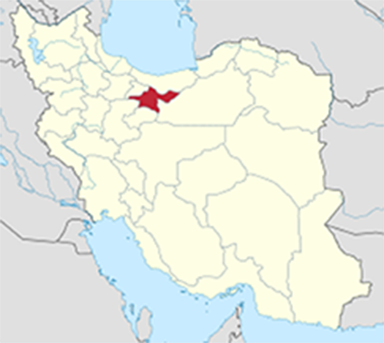
Fig. 1. Location of Tehran province in Iran (Yamaha5, 2013)
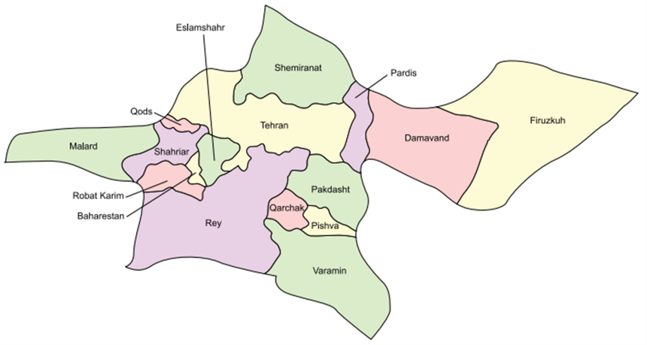Fig. 2. Map of Tehran province (Zifan, 2017)

3. Research methodology
In this study most of the data were gathered through library studies and required climate information was extracted from the data related to weather station (Mehrabad Airport) in Tehran throughout a 10- year time period (2009-2019). Based on the data obtained from the mentioned station, required suggestions and solutions were presented. Table1 indicates climate weather elements of rainfall, temperature, relative humidity and wind speed. Noted that the accuracy of dates shown as one month which includes more days due to simplifying analysis.

Table 1. Climate data for Tehran city (source: Authors)

Monthly amount of rainfall (mm) | Monthly average air temperature (°C) |  |  | Monthly average relative humidity (%) |  |  | Wind speed (m/s) | Month
Monthly amount of rainfall (mm) | Monthly average range (°C) | Monthly average minimum (°C) | Monthly average maximum (°C) | Monthly average range (%) | Monthly average minimum (%) | Monthly average maximum (%) | Wind speed (m/s) | Month
18.32 | 18.43 | 13.48 | 23.37 | 37.18 | 22.00 | 52.36 | 14.57 | Annual
22.42 | 5.87 | 1.87 | 9.88 | 51.45 | 34.69 | 68.2 | 14.5 | Dec 21- Jan 19  (Jan)
29.8 | 6.37 | 2.35 | 10.38 | 51.44 | 33.58 | 69.3 | 13.7 | Jan 20- Feb 18  (Feb)
28.03 | 10.53 | 5.97 | 15.1 | 42.99 | 25.07 | 60.9 | 14.1 | Feb 19- Mar 20  (Mar)
39.5 | 15.84 | 11.08 | 20.57 | 38.61 | 21.22 | 56 | 18.3 | Mar 20- Apr 19  (Apr)
16.06 | 21.61 | 16.24 | 26.97 | 33.59 | 18.58 | 48.6 | 20.89 | Apr 20- May 20  (May)
5.14 | 27.73 | 21.84 | 33.63 | 23.14 | 10.18 | 36.1 | 18.8 | May 21- Jun 20  (Jun)
2.94 | 31.34 | 25.27 | 37.45 | 23.15 | 10.69 | 35.6 | 12.6 | Jun 21- Jul 21  (Jul)
0 | 30.89 | 25.07 | 36.7 | 22.57 | 11.14 | 34 | 10 | Jul 22- Aug 21  (Aug)
2.49 | 27.61 | 22.1 | 33.09 | 25.98 | 13.35 | 38.6 | 13 | Aug 22- Sep 21  (Sep)
4.41 | 21.91 | 16.60 | 27.20 | 30.91 | 16.62 | 45.20 | 14.50 | 22 Sep- 21 Oct  (Oct)
45.52 | 13.62 | 9.46 | 17.75 | 49.45 | 32.59 | 66.3 | 12.1 | Oct 22- Nov 20  (Nov)
23.47 | 7.80 | 3.85 | 11.71 | 52.92 | 36.33 | 69.5 | 12.4 | Nov 21- Dec 20  (Dec)

3.1. Assessing Olgyay index
The following figure is obtained (derived) based on monthly temperature and moisture transfer over 10 years (2009-2019) using the BcChart v2.0 software.

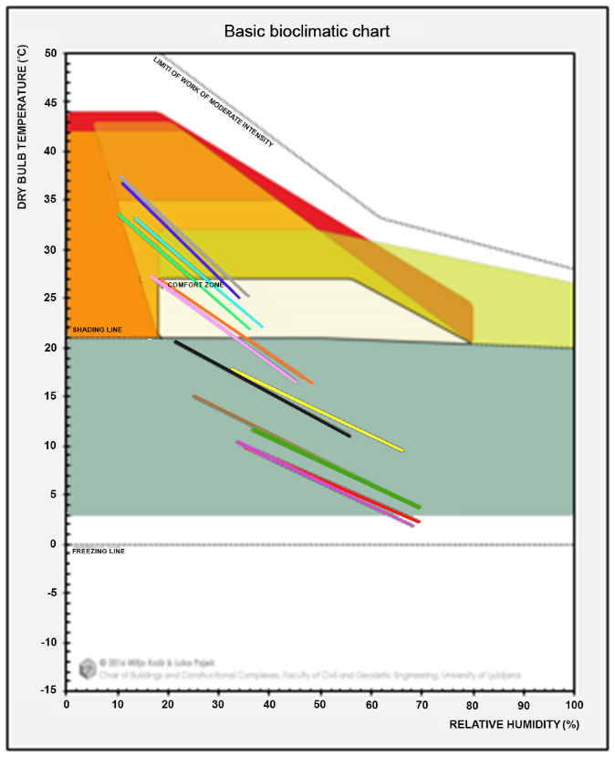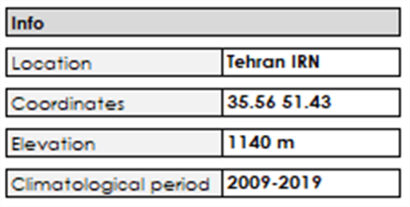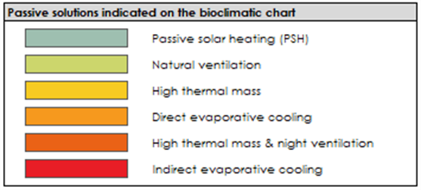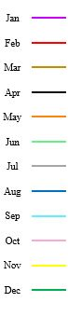
Fig. 3. Basic bioclimatic analysis for the location of Tehran created using BeChart v2.0. Climate data is plotted as monthly daily average minimum and maximum in respect to the selected passive solutions (BcChart v2.0 software)
In the Fig3, the basic bioclimatic chart of Tehran is plotted. This chart illustrates that the comfort zone is in the center with winter and summer ranges indicated separately. The chart also recommends the radiation needed zone, wind needed zone and shading needed zone to make the environment balanced and comfort.
According to the collected data for the period of 2009-2019 from Mehrabad Airport station. The values of the mean daily minimum and maximum temperatures are combined with the maximum and minimum relative humidity, respectively. The lines are created representing the various months and reflect the external conditions. The bottom point of the straight line is the average minimum temperature with the AM (ante meridiem) relative humidity whereas the upper point of the line is the average minimum temperature with the PM (post meridiem) relative humidity. For better legibility each month is drawn with a different color.
This chart shows that the daily time and nighttime temperature of November (Oct 22- Nov 20), December (Nov 21- Dec 20), January (Dec 21- Jan 19), February (Jan 20- Feb 18), March (Feb 19- March 20) and April (March 20- Apr 19) fall below the comfort zone. Therefore, passive solar heating is needed for the cold months of winter and the month of April.
The chart depicts that the months of May (Apr 20- May 20) and October (22 Sep- 21 Oct) fall into two different zones. Half of these months fall under comfort zone and the rest fall below the comfort zone. The promotion of passive solar heating and the prevention of heat losses are the main strategies which have to be employed.
About half of the months of June (May 21- Jun 20) and September (Aug 22- Sep 21) fall in the comfort zone, about one third of these month needs utilization of natural ventilation and for the rest direct evaporative cooling and high thermal mass is required.
A tiny part of July (Jun 21- Jul 21) and August (Jul 22- Aug 21) fall in comfort zone, more or less than half of these months fall above the comfort zone. Therefore, three solutions can offer comfort conditions for these months. Natural ventilation is a solution to offer comfort for half of these months. Almost one third of these monthly lines needs direct evaporate cooling.
3.2. Assessing Evans index
For studying the heat condition of a place with the use of Evans method we should: 1. For the average minimum relative humidity of each month, the range of comfort zone of the days of that month should be extracted from the Table2. For the average maximum relative humidity of each other the range of the comfort zone of the nights of that month should be extracted from the same Table3. The average of the maximum temperature of each month should be compared with the comfort zone of the day, 4. The average minimum temperature of each month should be compared with the comfort zone of the night (Nadimi and Yaghoubzadeh, 2014). The different scales of Evans are shown in Table2. The resulted heat conditions based on Evans index are illustrated in Table3.

Table 2. Different scales used in the model Evans (Barahouei Nezhad, Kurd & Sarhadi 2018)
Daily temperature (°C) | Night temperature (°C) | Relative humidity (%) | Thermal conditions | Scale
29.5-32.5 | 27.5-29.5 | 0-30 | Groups comfortable air flow per area of 1 meter per second | A
28.5-30.5 | 26.5-29 | 30-50 | Groups comfortable air flow per area of 1 meter per second | A
27.5-29.5 | 26-28.5 | 50-70 | Groups comfortable air flow per area of 1 meter per second | A
26-29 | 25.5-28 | 70-100 | Groups comfortable air flow per area of 1 meter per second | A
22.5-30 | 20-27.5 | 0-30 | Area rugs comfort zones per summer dress or a subtle style in the night air flow (0/1 meters per second) | B
22.5-28 | 20-26.5 | 30-50 |  | B
22.5-27.5 | 20-26 | 50-70 |  | B
22.5-27 | 20-25.5 | 70-100 |  | B
18-20 | 16-20 | 0-30 | Per ordinary clothes and warm and comfortable area of thick blankets at night | C
18-20 | 16-20 | 30-50 |  | C
18-20 | 16-20 | 50-70 |  | C
18-20 | 16-20 | 70-100 |  | C

Table 3. What does it represent
Scale | Jan | Feb | Mar | Apr | May | Jun | Jul | Aug | Sep | Oct | Nov | Dec | Period
A | Cold | Cold | Cold | Cold | Cold | Hot | Hot | Hot | Hot | Cold | Cold | Cold | Day
B | Cold | Cold | Cold | Cold | ok | Hot | Hot | Hot | Hot | ok | Cold | Cold | Day
C | Cold | Cold | Cold | Hot | Hot | Hot | Hot | Hot | Hot | Hot | Cold | Cold | Day
A | Cold | Cold | Cold | Cold | Cold | Cold | Cold | Cold | Cold | Cold | Cold | Cold | Night
B | Cold | Cold | Cold | Cold | Cold | ok | ok | ok | ok | Cold | Cold | Cold | Night
C | Cold | Cold | Cold | Cold | ok | Cold | Hot | Hot | Hot | ok | Cold | Cold | Night

As shown in Table3, the months of November (Oct 22- Nov 20), December (Nov 21- Dec 20), January (Dec 21- Jan 19), February (Jan 20- Feb 18), and March (Feb 19- March 20) in Tehran is cold based on Evans index.
April (March 20- Apr 19) in Tehran is cold based on Evans index during day and night. Whereas, this month is cold at night.
The month of October (22 Sep- 21 Oct) is also cold at night whilst it has comfortable conditions for citizens whom use thick blankets at night. This month has climate comfort in scale B (Area rugs comfort zones per summer dress or a subtle style in the night air flow (0/1 meters per second)).
The months of June (May 21- Jun 20), July (Jun 21- Jul 21), August (Jul 22- Aug 21) and September (Aug 22- Sep 21) are hot during day based on Evans index. However, these months have climate comfort in scale B at night.
The month of May (Apr 20- May 20) has climate comfort in scale B during day. This month has cold conditions while it has climate comfort in scale C (Per ordinary clothes and warm and comfortable area of thick blankets at night).
3.3. Assessing Backer’s index
The degrees of cooling power of the environment bioclimatic thresholds according to Backer index is illustrated in Table4. The estimation of the power of cooling index and human climate comfort by Backers method according to Eq. 1, is shown in Table5. In this table the backer index is estimated for day and night based on monthly temperature and wind speed over 10 years (2009-2019).

Table 4. Degrees of cooling power of the Environment Bioclimatic thresholds based on Backer review (Hessari and Seyf Shojaee, 2018)
sign |  | Amount | Environmental conditions | Human bioclimatic conditions
A |  | 0-4 | Hot and humidity and undesirable | Bioclimatic pressure
B | B1 | 5-9 | Bioclimatic welfare | Warm and tolerable
B | B2 | 10-19 | Bioclimatic welfare | Desirable moderate
C |  | 20-29 | Cool | moderate
D | D1 | 30-39 | Moderate to extreme | Cold and a bit restrainer
D | D2 | 40-49 | Restrainer moderate | Very cold
D | D3 | 50-59 | Extremely restrainer | Extreme cold

Table 5. Cooling power of the Environment Bioclimatic thresholds of the months of the year based on Backer index (source: Authors)
Scale |  | Jan | Feb | Mar | Apr | May | Jun | Jul | Aug | Sep | Oct | Nov | Dec
Average maximum  Temperature (°C) |  | 9.88 | 10.38 | 15.1 | 20.57 | 26.97 | 33.63 | 37.45 | 36.7 | 33.09 | 27.2 | 17.75 | 11.71
Average minimum temperature (°C) |  | 1.87 | 2.35 | 5.97 | 11.08 | 16.24 | 21.84 | 25.27 | 25.07 | 22.1 | 16.6 | 9.46 | 3.85
Average temperature (°C) |  | 5.87 | 6.37 | 10.53 | 15.84 | 21.61 | 27.73 | 31.34 | 30.89 | 27.61 | 21.91 | 13.62 | 7.8
Average wind speed (m/s) |  | 14.5 | 13.7 | 14.1 | 18.3 | 20.89 | 18.8 | 12.6 | 10 | 13 | 14.50 | 12.1 | 12.4
Cp index (mcal/cm^2/sec) | Night | 60.87 | 52.29 | 35.64 | 21.86 | 19.63 | 28.51 | 41.84 | 51.13 | 62.99 | 72.82 | 69.59 | 63.21
Cp index (mcal/cm^2/sec) | Sign | D3 | D3 | D1 | C | B2 | C | D2 | D3 | D3 | D3 | D3 | D3
Cp index (mcal/cm^2/sec) | Day | 38.15 | 24.60 | 6.98 | -1.85 | -0.34 | 6.75 | 19.56 | 35.69 | 47.83 | 55.97 | 53.23 | 44.31
Cp index (mcal/cm^2/sec) | Sign | D1 | C | B1 | A | A | B1 | B2 | D1 | D2 | D3 | D3 | D2
Cp index (mcal/cm^2/sec) | Total | 49.48 | 38.43 | 21.32 | 10.04 | 9.63 | 17.60 | 30.68 | 43.55 | 55.37 | 64.41 | 61.40 | 53.77
Cp index (mcal/cm^2/sec) | Sign | D2 | D1 | C | B2 | B1 | B2 | D1 | D2 | D3 | D3 | D3 | D3

Table5 reveals that month of December (Nov 21- Dec 20), January (Dec 21- Jan 19), February (Jan 20- Feb 18), and March (Feb 19- March 20) have extreme cold human bioclimatic conditions. The months of April (March 20- Apr 19) and November (Oct 22- Nov 20) have very cold human bioclimatic conditions. The Human bioclimatic conditions of the months of May (Apr 20- May 20) and October (22 Sep- 21 Oct) are cold and a bit restrainer. The human bioclimatic conditions of the month of August (Jul 22- Aug 21) are warm and tolerable. The month of July (Jun 21- Jul 21) and September (Aug 22- Sep 21) has desirable moderate human bioclimatic conditions. The only month which has moderate human bioclimatic conditions is June (May 21- Jun 20).
3.4. Assessing Terjung index
Fig4 is used to indicate the comfort coefficient. This graph actually shows the comfort human obtain in situation of different mixtures of temperature, humidity, and in normal situation that is in normal clothing and without physical activity (Mogholi and Akhgar, 2014).
In this chart the horizontal axis indicates temperature in Fahrenheit, and the curves illustrate the humidity in percentage. Where these two climatic factors encounter happened in different places which are shown by different numbers and symbols in Table6. According to Fig4 and Table6 human comfort coefficient at the region in which we do research on is shown in Table7.

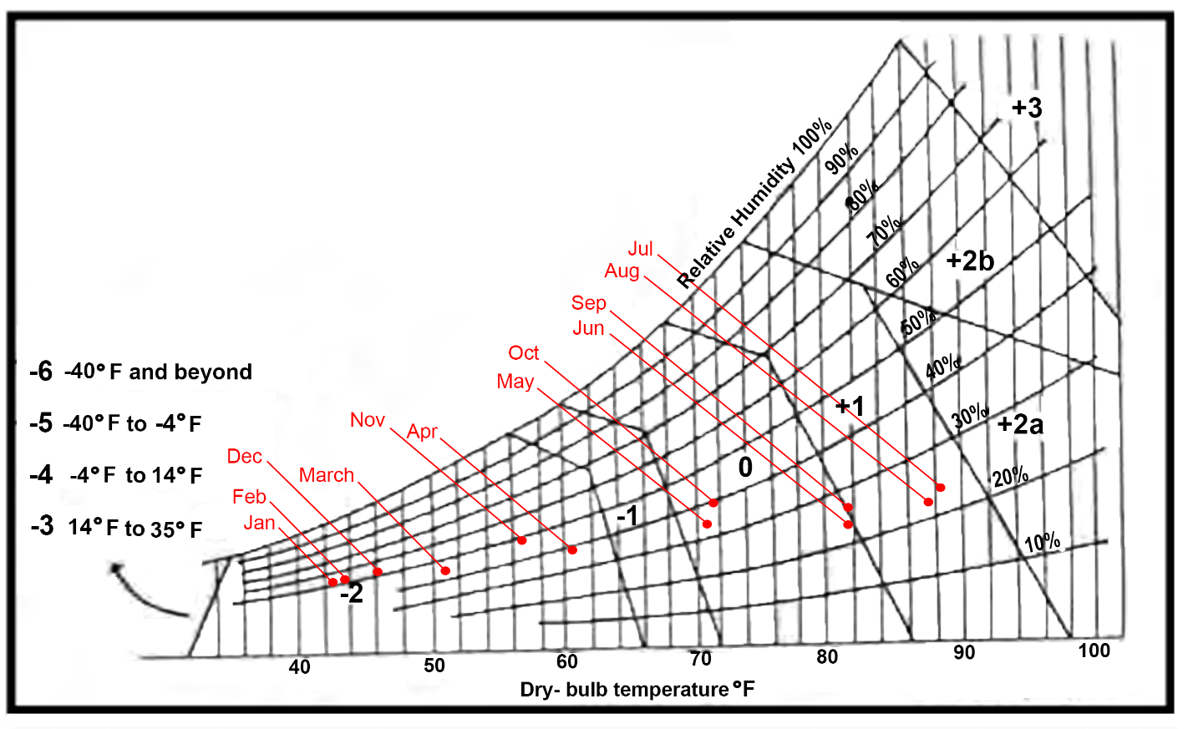
Fig. 4. Comfort limit coefficient based on Terjung (Hessari and Seyf Shojaee, 2018)

Table 6. Terjung concepts, symbols, and signs (Hessari and Seyf Shojaee, 2018)
Symbol | Dominant feeling | Group
-6 | Ultra cold | Uc
-5 | Extremely cold | Ec
-4 | Very cold | Vc
-3 | Cold | Cd
-2 | Keen | K
-1 | Cool | C
0 | Moderate | M
+1 | Warm | W
+2a | Hot | H
+2B | Very hot | S
+3 | Extremely hot | Eh

Table 7. Terjung index (source: Authors)
Scale | Jan | Feb | Mar | Apr | May | Jun | Jul | Aug | Sep | Oct | Nov | Dec
Average relative humidity (%) | 51.45 | 51.44 | 42.99 | 38.61 | 33.59 | 23.14 | 23.15 | 22.57 | 25.98 | 30.91 | 49.45 | 52.92
Average temperature (°F) | 42.57 | 43.47 | 50.95 | 60.51 | 70.90 | 81.91 | 88.41 | 87.60 | 81.70 | 71.44 | 56.52 | 46.04
Comfort coefficient | -2 | -2 | -2 | -2 | 0 | 0 | +1 | +1 | +1 | 0 | -2 | -2
monthly | Keen | Keen | Keen | Keen | Moderate | Moderate | Warm | Warm | Warm | Moderate | Keen | Keen
Mehrabad Airport weather station 10-year statistics is utilized to calculate the Terjung comfort index in Tehran city (table7). Calculations reveals that human bioclimatic conditions are keen in months of November (Oct 22- Nov 20), December (Nov 21- Dec 20), January (Dec 21- Jan 19), February (Jan 20- Feb 18), March (Feb 19- March 20), April (March 20- Apr 19). Another point is that the physiologic changes in fall is almost sudden in a way that between two months of October (22 Sep- 21 Oct) and November (Oct 22- Nov 20) the situation change from moderate to keen. More over the situation change inversely from keen to moderate, between two months of April (March 20- Apr 19) and May (Apr 20- May 20). However, physiologic slow transition in summer make the living situation pleasant in Tehran in a way that comfort coefficient changes between two months of September (Aug 22- Sep 21) and October (22 Sep- 21 Oct) and inversely from warm to moderate between two months of June (May 21- Jun 20) and July (Jun 21- Jul 21) moderate to warm. The months of July (Jun 21- Jul 21), August (Jul 22- Aug 21) and September (Aug 22- Sep 21) have warm human bioclimatic conditions. The two months of spring season as well as May (Apr 20- May 20) and June (May 21- Jun 20) have moderate dominant feeling.
3.5. Assessing Terjung index during day
Day comfort coefficient from relative maximum daily temperature average in Fahrenheit and relative minimum daily humidity in percent is utilize to show day comfort coefficient in different months of year according to Terjung. Therefore, the day comfort coefficient for Tehran is illustrated in Table8.

Table 8. Terjung index (source: Authors)
Scale | Jan | Feb | Mar | Apr | May | Jun | Jul | Aug | Sep | Oct | Nov | Dec
Average maximum temperature (°F) | 49.78 | 50.68 | 59.18 | 69.03 | 80.55 | 92.55 | 99.41 | 98.06 | 91.56 | 80.96 | 63.95 | 53.08
Average minimum relative humidity (%) | 34.69 | 33.58 | 25.07 | 21.22 | 18.58 | 10.18 | 10.69 | 11.14 | 13.35 | 16.62 | 32.59 | 36.33
Comfort index | -2 | -2 | -2 | -1 | +1 | +1 | +2a | +2a | +1 | 0 | -2 | -2
Comfort index for day | Keen | Keen | Keen | Coold | Warm | Warm | Hot | Hot | Warm | Moderate | Keen | Keen
In order to calculate the Terjung comfort index during day in Tehran city, Mehrabad weather station 10-year statistics is utilized. As shown in table7, the bioclimatic conditions are the same as in Table8, the dominant feeling is keen during day in the months of November (Oct 22- Nov 20), December (Nov 21- Dec 20), January (Dec 21- Jan 19), February (Jan 20- Feb 18) and March (Feb 19- March 20). Moreover, the physiologic change during day is almost sudden in a way that between two months of October (22 Sep- 21 Oct) and November (Oct 22- Nov 20) the situation change from moderate to keen.
But there is a slight change in bioclimatic conditions during day from cool to warm between April (March 20- Apr 19) and May (Apr 20- May 20) and the inverse progress between June (May 21- Jun 20) and July (Jun 21- Jul 21) from hot to warm. The only month which has moderate conditions during day is October (22 Sep- 21 Oct).
3.6. Assessing Terjung index at night
Table9 indicates Tehran comfort coefficient of night. Night comfort coefficient during the year based on Terjung is calculated from average of daily minimum temperature in Fahrenheit and average of daily maximum relative humidity in percent. Physiologic situation of Tehran is calculated and illustrated again based on Terjung and the results are shown.

Table 9. Terjung index (source: Authors)
Scale | Jan | Feb | Mar | Apr | May | Jun | Jul | Aug | Sep | Oct | Nov | Dec
Average maximum relative humidity (%) | 68.2 | 69.3 | 60.9 | 56 | 48.6 | 36.1 | 35.6 | 34 | 38.6 | 45.20 | 66.3 | 69.5
Average minimum temperature (°F) | 35.37 | 36.23 | 42.75 | 51.94 | 61.23 | 71.31 | 77.49 | 77.13 | 71.78 | 61.88 | 49.03 | 38.93
Comfort index | -2 | -2 | -2 | -2 | -2 | 0 | 0 | 0 | 0 | -2 | -2 | -2
Comfort index for night | Keen | Keen | Keen | Keen | Keen | Moderate | Moderate | Moderate | Moderate | Keen | Keen | Keen
Table9 reveals that according to Terjung index, the human bioclimatic conditions of the months of October (22 Sep- 21 Oct), November (Oct 22- Nov 20), December (Nov 21- Dec 20), January (Dec 21- Jan 19), February (Jan 20- Feb 18), March (Feb 19- March 20), April (March 20- Apr 19) and May (Apr 20- May 20) have keen bioclimatic conditions at night. The human bioclimatic conditions of the months of June (May 21- Jun 20), July (Jun 21- Jul 21), August (Jul 22- Aug 21) and September (Aug 22- Sep 21) have moderate bioclimatic conditions at night.
3.7. Assessing Thermo-hygrometric index
In this index, if the DI is between 60 and 75, the human bioclimatic situation is equal with comfort feeling (A), and if it is less than 60 coldness feeling (B) and more than 75, about 50% of people get irritated of heat (C), and if this coefficient passes 80, all of people suffer from the heat (Mogholi and Akhgar, 2014).
Monthly statistics of Mehrabad weather station during a 10-year period from 2009 to 2019 are utilized in this study in order to calculate the Thermo-hygrometric index in accordance with Eq. 2 in Terhan city which is shown in Table10.

Table 10. Thermo-hygrometric index (source: Authors)
Scale | Jan | Feb | Mar | Apr | May | Jun | Jul | Aug | Sep | Oct | Nov | Dec
Average dew point temperature (°C) | -3.38 | -2.92 | -1.54 | 1.76 | 4.90 | 4.80 | 7.83 | 7.08 | 6.37 | 3.97 | 3.23 | -1.21
Average temperature (°C) | 5.87 | 6.37 | 10.53 | 15.84 | 21.61 | 27.73 | 31.34 | 30.89 | 27.61 | 21.91 | 13.62 | 7.8
symbol | B | B | B | B | A | A | C | A | A | A | B | B
Thermo-hygrometric index | 46.09 | 46.75 | 51.37 | 57.82 | 64.66 | 70.68 | 75.34 | 74.63 | 71.13 | 64.62 | 56.15 | 48.79
Table10 shows that based on Thermo-hygrometric index, the months of May (Apr 20- May 20), June (May 21- Jun 20), August (Jul 22- Aug 21), September (Aug 22- Sep 21) and October (22 Sep- 21 Oct) have human bioclimatic conditions that illustrate comfort feeling (A), the human bioclimatic conditions of the months of November (Oct 22- Nov 20), December (Nov 21- Dec 20), January (Dec 21- Jan 19), February (Jan 20- Feb 18), March (Feb 19- March 20) and April (March 20- Apr 19) illustrate coldness feeling (B) and July (Jun 21- Jul 21) is the only month with the bioclimatic conditions which people feel warm in (C).
3.8. Assessing Wind-chill index
For calculating wind-chill’s index of Terhan city Monthly statistics of Mehrabad weather station during a 10-year period from 2009 to 2019 are utilized which shown in Table12 based on table11 that illustrates the dominant feeling of Wind-chill index, in accordance with Equation 3.

Table 11. Dominant feeling of Wind-chill index (Hessari and Seyf Shojaee, 2018)
Amount | Symbol | Dominant feeling
< -1400 | -h | Meat freezes in this temperature
-1400 to -1200 | -g | Extremely cold
-1200 to -1000 | -f | uncomfortably cold
-1000 to -800 | -e | Cold
-800 to -600 | -d | Too cool
-600 to -300 | -c | Cool
-300 to -200 | -b | Comfortable and pleasant
-200 to -50 | -a | Warm
-50 to 80 | N | Not warm, not cold
80 to 160 | A | Warm feeling on skin
80 to 160 | B | feeling of unpleasant heat
160 > | C | Feeling of very unpleasant extra heat
Table 12. Dominant feeling of the months of the year according to Wind-chill index (source: Authors)

Scale | Jan | Feb | Mar | Apr | May | Jun | Jul | Aug | Sep | Oct | Nov | Dec
Average Maximum temperature (°C) | 9.88 | 10.38 | 15.1 | 20.57 | 26.97 | 33.63 | 37.45 | 36.7 | 33.09 | 27.2 | 17.75 | 11.71
Average Minimum temperature (°C) | 1.87 | 2.35 | 2.97 | 11.08 | 16.24 | 21.84 | 25.27 | 25.07 | 22.1 | 16.6 | 9.64 | 3.85
Average temperature (°C) | 5.87 | 6.37 | 10.53 | 15.84 | 21.61 | 27.73 | 31.34 | 30.89 | 27.61 | 21.91 | 13.62 | 7.8
Average Wind  Speed (m/s) | 14.5 | 13.7 | 14.1 | 18.3 | 20.89 | 18.8 | 12.6 | 10 | 13 | 14.5 | 12.1 | 12.4
H at night | 1059.32 | 1034.85 | 1018.02 | 765.63 | 591.05 | 390.70 | 257.77 | 254.34 | 365.21 | 558.07 | 774.03 | 969.63
Sign | C | C | C | C | C | C | C | C | C | C | C | C
H for day | 786.75 | 763.73 | 606.81 | 434.16 | 212.65 | -22.06 | -148.39 | -118.67 | -3.02 | 197.37 | 505.31 | 708.18
Sign | C | C | C | C | C | N | -a | -a | N | C | C | C
H for each month | 923.20 | 899.12 | 761.73 | 599.37 | 401.67 | 184.50 | 55.36 | 67.67 | 180.59 | 377.38 | 642.16 | 838.24
Sign | C | C | C | C | C | C | N | N | C | C | C | C
Table12 shows that based on Wind-chill index, the months of April (March 20- Apr 19), May (Apr 20- May 20), June (May 21- Jun 20), July (Jun 21- Jul 21), August (Jul 22- Aug 21), September (Aug 22- Sep 21), October (22 Sep- 21 Oct), November (Oct 22- Nov 20), December (Nov 21- Dec 20), January (Dec 21- Jan 19), February (Jan 20- Feb 18), March (Feb 19- March 20) have human bioclimatic conditions that people feel very unpleasant extra heat at night.
The human bioclimatic conditions of the months of October (22 Sep- 21 Oct), November (Oct 22- Nov 20), December (Nov 21- Dec 20), January (Dec 21- Jan 19), February (Jan 20- Feb 18), March (Feb 19- March 20), April (March 20- Apr 19) and May (Apr 20- May 20) are very unpleasant extra heat during day. The human bioclimatic conditions of the two months of June (May 21- Jun 20) and September (Aug 22- Sep 21) are not warm, not cold (moderate) during day. The two months of July (Jun 21- Jul 21) and August (Jul 22- Aug 21) have the human bioclimatic conditions that people feel warm in during day.
Ten months in year have human bioclimatic conditions which citizens feel very unpleasant extra heat in, that these months are sequence are September (Aug 22- Sep 21), October (22 Sep- 21 Oct), November (Oct 22- Nov 20), December (Nov 21- Dec 20), January (Dec 21- Jan 19), February (Jan 20- Feb 18), March (Feb 19- March 20), April (March 20- Apr 19), May (Apr 20- May 20), June (May 21- Jun 20). The bioclimatic conditions of the two months of July (Jun 21- Jul 21) and August (Jul 22- Aug 21) are moderate (not warm, not cold).
3.9. Assessing Neurotic Pressure index
Degrees of Neurotic Pressure comfort index are indicated in Table 13. Additionally, the results derived from calculating neurotic pressure index of Terhan city based on Monthly statistics of Mehrabad weather station during a 10-year-period from 2009 to 2019 is shown in Table14. These results are in accordance with Equation 4 and Equation 5.

Table 13. Dominant feeling of the months of the year according to Wind-chill index (source: Authors)
Comfort coefficient for temperatures above 20 °C |  | Comfort coefficient for temperatures below 20 °C
Comfort coefficient | Heating condition | Comfort coefficient | Heating condition
<-5 | Cool with uncomfortable condition | 395 to 540 | Cool
-5 to -1 | Cool with uncomfortable condition | 540 to 790 | Too cool
0 | Comfortable | 790 to 1000 | Cold
1 to 5 | Warm with comfortable | 1000 to 1200 | Too cold
5 to 10 | Warm with uncomfortable | 1200 to 1440 | Extremely cold
10 to 15 | Extremely uncomfortable | +1440 | Skin freezes fast
+15 | Totally uncomfortable | - | -
Table 14. Heating condition of the months of the year based on Neurotic Pressure comfort index (source: Authors)
Scale | Jan | Feb | Mar | Apr | May | Jun | Jul | Aug | Sep | Oct | Nov | Dec
Average temperature (°C) | 5.87 | 6.37 | 10.53 | 15.84 | 21.61 | 27.73 | 31.34 | 30.89 | 27.61 | 21.91 | 13.62 | 7.8
Average wind speed (m/s) | 14.5 | 13.7 | 14.1 | 18.3 | 20.89 | 18.8 | 12.6 | 10 | 13 | 14.50 | 12.1 | 12.4
Comfort coefficient (kcal/h/m^2) | 1932.41 | 1856.09 | 1619.28 | 1437.27 | -3.31 | 2.47 | 6.07 | 5.56 | 2.59 | -3.07 | 1337.84 | 1695.49
Comfort degree | Skin freezes fast | Skin freezes fast | Skin freezes fast | Extremely cold | Cool with uncomfortable condition | Warm with comfortable | Warm with uncomfortable | Warm with uncomfortable | Warm with comfortable | Warm with comfortable | Extremely cold | Skin freezes fast
As shown in table14 based on Neurotic Pressure comfort index (Equation 3 and Equation 4), the human bioclimatic conditions in the months of December (Nov 21- Dec 20), January (Dec 21- Jan 19), February (Jan 20- Feb 18), and March (Feb 19- March 20) are in a way that skin freezes fast.
The comfort coefficients of the months of April (March 20- Apr 19) and November (Oct 22- Nov 20) shows that the human bioclimatic conditions are extremely cold.
The months of May (Apr 20- May 20) has cool with uncomfortable bioclimatic conditions.
The months of July (Jun 21- Jul 21) and August (Jul 22- Aug 21) have warm with uncomfortable bioclimatic conditions. The human bioclimatic conditions in the months of June (May 21- Jun 20), September (Aug 22- Sep 21) and October (22 Sep- 21 Oct) are warm with comfortable.
3.10. Assessing comfort zone according to Givoni index using psychometric chart in Climate Consultant software
In accordance with statistical information, by transferring average maximum monthly temperature over 10 years (2009-2019) and average minimum monthly temperature on the chart and also finding monthly relative humidity on it, the following results on Table16 are obtained.Climate Consultant software proposes sixteen passive strategies in this chart, as shown in Table15. By using this Table15, we can attempt to achieve the necessary comfort conditions inside the building based on climatic and constructional characteristics of the region.
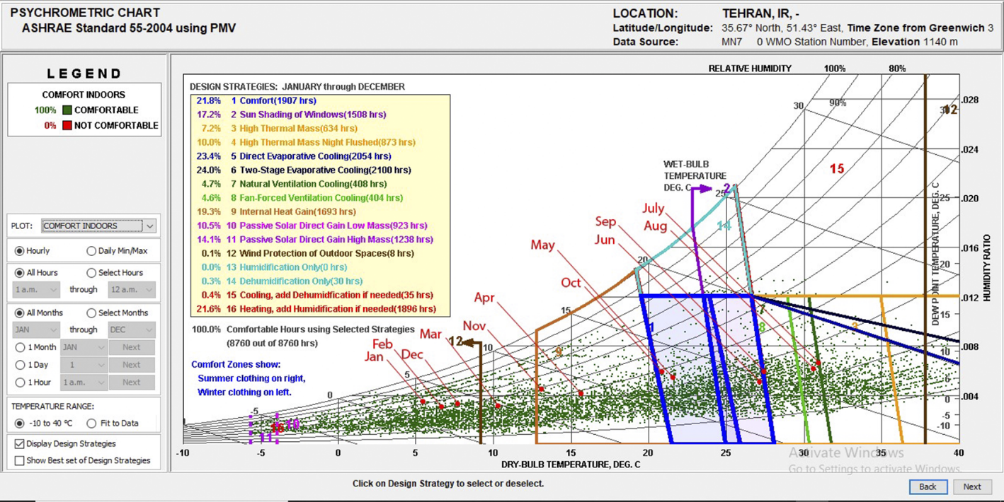
Fig. 5. Climate Consultant display of the Building Bioclimatic Chart for Tehran city (Climate Consultant 6.0)
Fig5 shows that the months of April (March 20- Apr 19) and November (Oct 22- Nov 20) require internal heat gain. The months of January (Dec 21- Jan 19), February (Jan 20- Feb 18) and December (Nov 21- Dec 20) require two design strategies as well as heating, and humidification if needed and wind protection of outdoor spaces.
The month of March (Feb 19- March 20) also requires heating, adding humidification if needed.

The months of April (March 20- Apr 19) and November (Oct 22- Nov 20) need internal heat gain.
The months of May (Apr 20- May 20) and October (22 Sep- 21 Oct) are in human comfort zone if people wear winter clothing in. Furthermore, the months of June (May 21- Jun 20) and September (Aug 22- Sep 21) have human comfort conditions if people wear summer clothing.
For the months of July (Jun 21- Jul 21) and August (Jul 22- Aug 21) need natural ventilation cooling. The results are also illustrated in Table16.

Table 15. Design strategies of Climate Consultant (Climate Consultant 6.0)
Percentage | Design strategies | Number
21.8% | Comfort | 1
17.2% | Sun shading of windows | 2
7.2% | High thermal mass | 3
10% | High thermal mass night flushed | 4
23.4% | Direct evaporative cooling | 5
24% | Two-stage evaporative cooling | 6
4.7% | Natural ventilation cooling | 7
4.6% | Fan-forced ventilation cooling | 8
19.3% | Internal heat gain | 9
10.5% | Passive solar direct gain low mass | 10
14.1% | Passive solar direct gain high mass | 11
0.1% | Wind protection of outdoor spaces | 12
0% | Humidification only | 13
0.3% | Dehumidification only | 14
0.4% | Cooling, add dehumidification if needed | 15
21.6% | Heating, add humidification if needed | 16
Table 16. Design strategies for all months according to Climate Consultant (source: Authors)
Month | Examples of strategies | Number | Relative humidity (%) | Temperature (°C)
Jan | 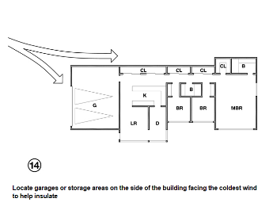 | 12-16 | 51.45 | 5.87
Feb |  | 12-16 | 51.44 | 6.37
Mar |  | 12-16 | 42.99 | 10.53
Apr | 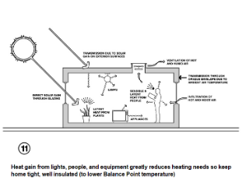 | 9 | 38.61 | 15.84
May |  | 1 | 33.59 | 21.61
Jun |  | 1 | 23.14 | 27.73
Jul | 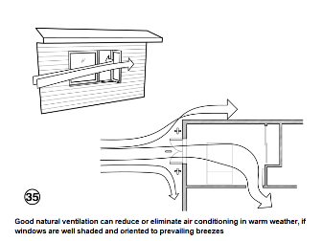 | 7 | 23.15 | 31.34
Aug |  | 7 | 22.57 | 30.89
Sep |  | 1 | 25.98 | 27.61
Oct |  | 1 | 30.91 | 21.91
Nov |  | 9 | 49.45 | 13.62
Dec |  | 12-16 | 52.92 | 7.80
3.11. Assessing Ecotect Analysis

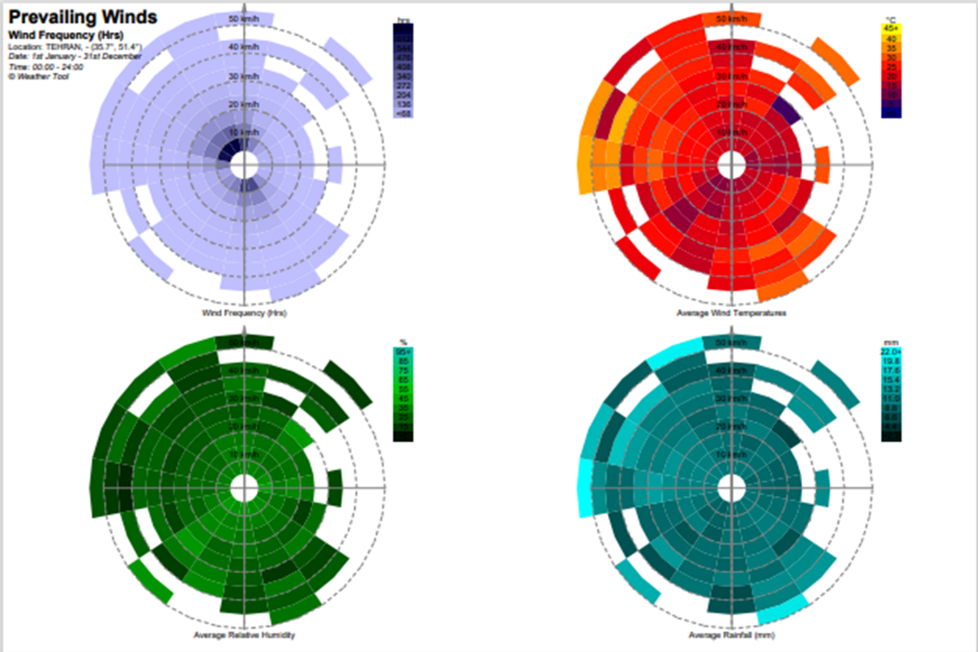
Fig. 6. Multiple information graphs of prevailing winds of Tehran city (Autodesk Ecotect Analysis 2011)
These wind analysis graphs in Fig6 display wind frequency, direction and speed, average wind temperature, average relative humidity and average rainfall. This is analyzed over all year, so it is possible to determine the predominant wind direction during a year.

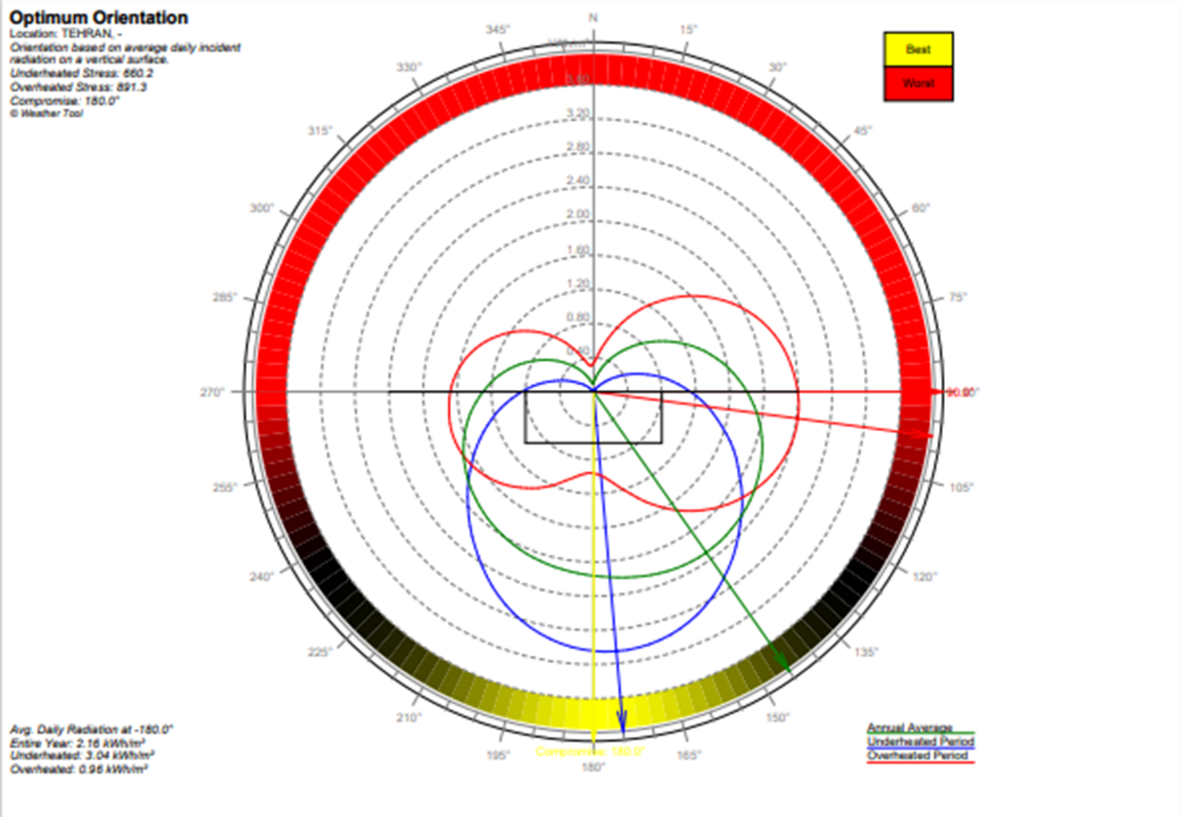
Fig. 7. Optimum orientation based on average daily incident (Autodesk Ecotect Analysis 2011)
The above calculation in Fig7 is done for the full 360 degrees. This table of under-heated/overheated values indicates the most favorable range of orientations for passive solar heating, whilst still considering the effects of unwanted solar gains in summer. The best orientation is 180°.
4. Conclusion
Monthly statistics of Mehrabad weather station during a 10-year period from 2009 to 2019 are utilized in this study in order to calculate the indices as well as Olgyay, Evans, Backer, Terojung, Thermo-hygrometric, Wind-chill and Neurotic Pressure comfort index and Climate consultant analysis tool.
Table17 illustrates the comparison between human bioclimatic conditions in Tehran for all months of a year according to bioclimatic indices and climatic analysis tool. In this table, the eight indices are placed in first column and 12 months are placed in the next columns. In the description of the results of these indices, in order to simplify the comparison of the results, they are named in three classifications of warm, moderate and cold. For each month, bioclimatic conditions are determined by more the same classifications of the results derived from indices which special month have. For instance, the month April (March 20- Apr 19) from the point of view of seven indices has cold conditions but from point of one index it has warm bioclimatic conditions. Accordingly, this month has cold bioclimatic conditions.

Table 17. Comparison of bioclimatic condition in Tehran city (source: Authors)
Scale | Jan  (Dec 21- Jan 19) | Feb  (Jan 20- Feb 18) | Mar  (Feb 19- Mar 20) | Apr  (Mar 20- Apr 19) | May  (Apr 20- May 20) | Jun  (May 21- Jun 20) | Jul  (Jun 21- Jul 21) | Aug  (Jul 22- Aug 21) | Sep  (Aug 22- Sep 21) | Oct  (22 Sep- Oct 21) | Nov  (Oct 22- Nov 20) | Dec  (Nov 21- Dec 20)
Backer | Extremely cold | Extremely cold | Extremely cold | Very cold | cold | Moderate | Moderate | Warm | moderate | cold | Very cold | Extremely cold
Climate consultant | Very cold | Very cold | Very cold | cold | comfortable | comfortable | warm | warm | comfortable | comfortable | cold | Very cold
Evans | cold | cold | cold | Cold | cold | comfortable | Warm and comfortable | comfortable | Warm and comfortable | comfortable | cold | cold
Neurotic Pressure | Skin freezes fast | Skin freezes fast | Skin freezes fast | Extremely cold | Cool with uncomfortable condition | Warm with comfortable | Warm with uncomfortable | Warm with uncomfortable | Warm with comfortable | Warm with comfortable | Extremely cold | Skin freezes fast
Olgyay | Extremely cold | Extremely cold | Extremely cold | Cold | cold and comfortable | Warm and comfortable | Warm | Warm | Warm and comfortable | cold and comfortable | Cold | cold
Terjung | Keen | Keen | Keen | Keen | Moderate | Moderate | Warm | Warm | Warm | Moderate | Keen | Keen
Thermo-hygrometric | Cold | Cold | Cold | Cold | comfortable | comfortable | warm | comfortable | comfortable | comfortable | Cold | Cold
Wind-chill | extremely hot | extremely hot | extremely hot | Extremely hot | Extremely hot | Extremely  hot | Moderate | Moderate | extremely hot | extremely hot | extremely hot | extremely hot
Result | cold | cold | cold | cold | Cold- comfortable | comfortable | warm | Warm | Warm- comfortable | comfortable | cold | cold
The Olgyay chart depicts that the winter season and the months of November, December, and April have cold conditions. Half of the months of May and October are in comfort zone and the rest need the promotion of passive solar heating and the prevention of heat losses. Nearly half of the months of June and September fall in the comfort zone, and the rest require utilization of natural ventilation and the rest requires direct evaporative cooling and the rest requires high thermal mass. A tiny part of July and August fall in comfort zone. And for the rest, natural ventilation and direct evaporate cooling should be employed. So, according to Olgyay index, more than half of the year has cold conditions and it needs passive solar heating and the rest need natural ventilation and cooling. And more or less than four months of a year have human comfort conditions. Considering the Evans index, the winter season and the months of November, December, April and May have cold bioclimatic conditions. The months of June, August and October have human comfort. Whereas, the months of July and September have warm conditions. Therefore, based on Evans comfort index, more than half of the year is cold and need heating and the rest of the year has human comfort. According to the Backers index, the winter and fall seasons and the months of April and May have cold bioclimatic conditions. While, only one month have warm conditions which is August. And three months of June and September have human comfort conditions. So, based on backer index, this city has cold and a little comfortable bioclimatic condition. In accordance with Terjung index, the winter season and the months of November, December and April have cold conditions. Whilst the summer season have warm conditions. Furthermore, bioclimatic conditions of the months of May, June and October are comfortable. So, most of the year in Tehran city have cold conditions and the rest have warm and comfortable.
REFERENCES
Ahmadi H., Shaemi A. (2013), Applying bioclimatic indices to assess the climatic comfort of Illam city, Journal of physics Development planning, 75-88.
Barahouei Nezhad A., Kurd A., Sarhadi E. (2018), Modeling the Bioclimatic Welfare of Mazandaran State by Using Bioclimatic Human Models, IOSR Journal of Engineering 8(5):44-61.
Cannistraro G., Cannistraro M., Restivo R. (2015), Smart Control of Air Climatization System in Function on the Values of Mean Local Radiant, Smart Science 3(3):157-163.
Eskandarian E. (2015), Climatic comfort in Tehran, Research in Science, Engineering and Technology 1(1):57-67.
Ghalhari G. A., Shakeri F., Abbasinia M., Ghanadzadeh M. J., Asghari M., Tajik R. (2019), Use of Becker and neurotic pressure bioclimatic indices in the assessment of thermal comfort in outdoor environments based on meteorological data: Case study in three different climates of Iran, Iran Occupational health 16(1):33-46.
Ghanbari A., Afifi M. E., Sadeghi G. (2010), A view on the evaluation of human comfort in the city of Lar according to bioclimatic indices, Quarterly Journal of Natural Geography 10:93-109.
Hessari P., Seyf Shojaee M. (2018), Determinig the comfort zone of Mashhad city based on environmental indices, 4th National Conference on Civil Engineering and Architecture with Emphasizing the native technology 2(1):1-23.
Kamyabi S., Dabbaghian R. (2015), Assessing Thermal Comfort Indices in line with The Architectural Design Compatible with The Climate in Babolsar, Cumhuriyet University Faculty of Science Science Journal 36(4):1600-1610.
Košir M., Pajek L. (2017), BcChart v2.0 – a tool for bioclimatic potential evaluation, IEA SHC International Conference on Solar Heating and Cooling for Buildings and Industry.
Ministry of Foreign Affairs (2017), General Information about Tehran, https://tehran.embassy.qa/en/iran/general-information-about-tehran
Mogholi M., Akhgar Sh. (2014), Evaluating Human Consolation in Sadra Town Regarding Bioclimatic Indexes, Journal of Civil Engineering and Urbanism 4(6):568-572.
Molanejad M. (2015), Relations between Climate and Human Comfort in Urban Environment Using Neurotic Pressure Index (Case study: Tehran City), Journal of Environmental Studies 41(1):55-57.
Nadimi M., Yaghoubzadeh N. (2014), Comparing climatic indices; mahoney, evans, biker, effective temperature (et) and givoni in rasht city, Scientific Journal of Review 3(7):684-698.
Rahimipour Sheikhani Nejad M. A., Khatami S. S., Modaberi H., Shadpour M., Panahandeh M. (2014), The Study of Climatic Comfort of Historical and Archaeological Museum Sites of Bouye (Amlash Country), Journal of Basic and Applied Scientific Research 4(8):105-113.
Santy H. M. K. T. L. S. (2017), Bioclimatic Analysis in Pre-Design Stage of Passive House in Indonesia, Buildings 7(24):1-25.
Soleymanpour R., Parsaee N., Banaei M. (2015), Climate Comfort Comparison of Vernacular and Contemporary, Asian Conference on Environment-Behaviour Studies 201:49-61.
Tehran Municipality Information and Communication Technology Organization (2008-2009), Statistics of Tehran 2008-2009, Statistical year book of Tehran, Tehran.http://tmicto.tehran.ir/Portals/0/Document/Amarname/NEW_PDF/AmarShahr/87-TehranStatisticalYearBook.pdfOrganization or person (2009-2010), Title, complete URL
Tehran Municipality Information and Communication Technology Organization (2010-2011), Statistics of Tehran 2010-2011, Statistical yearbook of Tehran, http://tmicto.tehran.ir/Portals/0/Document/Amarname/NEW_PDF/AmarShahr/89-TehranStatisticalYearBook.pdf
Tehran Municipality Information and Communication Technology Organization (2011-2012), Statistics of Tehran 2011-2012, Tehran Statistical Yearbook, http://tmicto.tehran.ir/Portals/0/Document/Amarname/NEW_PDF/AmarShahr/90-TehranStatisticalYearBook.pdf
Tehran Municipality Information and Communication Technology Organization (2012-2013), Statistics of Tehran 2012-2013, Statistical Yearbook of Tehran, http://tmicto.tehran.ir/Portals/0/Document/Amarname/NEW_PDF/AmarShahr/91-TehranStatisticalYearBook.pdf
Tehran Municipality Information and Communication Technology Organization (2013-2014), Statistics of Tehran 2013-2014, Statistical Yearbook of Tehran, http://tmicto.tehran.ir/Portals/0/Document/Amarname/NEW_PDF/AmarShahr/92-TehranStatisticalYearBook.pdf
Tehran Municipality Information and Communication Technology Organization (2014-2015), Statistics of Tehran 2014-2015, Statistical Yearbook of Tehran, http://tmicto.tehran.ir/Portals/0/Document/Amarname/NEW_PDF/AmarShahr/93-TehranStatisticalYearBook.pdf
Tehran Municipality Information and Communication Technology Organization (2015-2016), Statistics of Tehran 2015-2016, Statistical Yearbook of Tehran, http://tmicto.tehran.ir/Portals/0/Document/Amarname/NEW_PDF/AmarShahr/94-TehranStatisticalYearBook.pdf
Tehran Municipality Information and Communication Technology Organization (2016-2017), Statistics of Tehran 2016-2017, Statistical Yearbook of Tehran, http://tmicto.tehran.ir/Portals/0/Document/Amarname/NEW_PDF/AmarShahr/95-TehranStatisticalYearBook.pdf
Tehran Municipality Information and Communication Technology Organization (2015), Statistics of Tehran 2017-2018, Statistical Yearbook of Tehran, http://tmicto.tehran.ir/Portals/0/Document/Amarname/NEW_PDF/AmarShahr/96-TehranStatisticalYearBook.pdf
Tehran Municipality Information and Communication Technology Organization (2018-2019), Statistics of Tehran 2018-2019, Statistical Yearbook of Tehran, http://tmicto.tehran.ir/Portals/0/Document/Amarname/NEW_PDF/AmarShahr/97-TehranStatisticalYearBook.pdf
Tehran Municipality Information and Communication Technology Organization (2019-2020), Statistics of Tehran 2019-2020, statistical yearbook of Tehran, http://tmicto.tehran.ir/Portals/0/Document/Amarname/NEW_PDF/AmarShahr/98-TehranStatisticalYearBook.pdf
Trisnawan D. (2017), Ecotect design simulation on existing building to enhance its energy efficiency, IOP Conference Series: Earth Environmental Science 105(1):1-5.
Wikimedia Foundation, Inc. (2021), Tehran, https://en.wikipedia.org/wiki/Tehran#cite_note-IRNA-34
WU Q., JO H.K. (2015), A Study on Ecotect Application of Local Climate at a Residential Area in Chuncheon, Korea, Journal of Environmental Engineering and Landscape Management 23(2):94-101.
Yamaha5. (2013), File:IranTehran-SVG.svg, Online document, WIKIPEDIA, The Free Encyclopedia
Zifan A. (2017), File:Tehran.svg, Online document, WIKIPEIDA The Free Encyclopedia.

