An Investigation of Simultaneous Effects of Place Attachment, Place Experience, and Structured Experiences on the Formation of Each Other in Historical Urban Squares
)Case study: Amir Chakhmagh Square of Yazd)

Ali Riahi Dehkordi¹,Mahdi Montazerolhodjah²
1-PhD Candidate in Urbanism, Art university, Tehran, Iran (ali.riahi137@gmail.com)
2-Associate Professor, PhD in Urbanism, Art & Architecture Faculty, Yazd University,Yazd,Iran (Corresponding Author,montazer@yazd.ac.ir)

Abstract
Generally, the use of places under specific circumstances leads to the development of a sense of attachment in people. These conditions are derived from unique events and experiences, happening by a particular process to affect the quality of places. They usually range from simple to complex and multi-step experiences with a unique structure. Definitely, among the public places in any city, squares are the most suitable for civil events and people’s experiences. Therefore, as the primary goal, this study has examined the effect of three concepts of place attachment, place experience, and structured experiences on each other in a historical square located in Yazd (Amir Chakhmagh). This quantitative and hypothesis-testing research has used observations, interviews, and questionnaires to collect data. surveys, along with descriptive and content analyses are also used to collect and compile theoretical data. The data analysis section uses the causal research method and structural equations modeling (SEM). The results obtained from the analysis of 225 randomly distributed questionnaires through LISREL software indicate that place attachment (P.A) directly and positively affects place experiences (P.E) (1.69) while influences structural experiences (S.E) indirectly (0.997). Also, the place experiences (P.E) have direct impacts on the structural experiences (S.E).
Keywords: Amir Chakhmagh square, Place attachment, place experiences, SEM, structured experiences, Yazd.

1.Introduction
Before fully understanding the effects of loss and its associated behaviors, one must precisely understand attachment theory, which is one of the most influential and widely studied developmental theories (Sawyer, 2019). In the last two decades, attachment theory has become one of the main and extensively used conceptual frameworks for understanding the process of loving rules (Mikulincer et al., 2003). Historically, attachment theory was developed by John Bowlby‎ as an alternative to the psychoanalytic theories of object relations development (Bretherton, 1985). From the perspective of place theory, the idea that one of the place functions is as an attachment goal, representing a reminder of the particular benefits of the attachment forms, may be associated with the emotional qualities of the place used as a haven and base (Counted & Zock, 2019). It can be fully understood that individuals develop attachment behaviors and protect the sense of security that follows throughout the stages of personality development. Accordingly, attachment formation is a universal principle for close relationships between cultures. Attachment relationships stem from personal experiences, availability, and interaction in collective experiences resulting from face-to-face interactions. Then, we can focus our attention on the formation of this feeling in the context of the place, one of which is urban squares that play a significant role in the structure of cities. Squares, especially in historic cities, are the central platform for public gatherings and social events. These city squares draw people in and keep the cities alive. This issue is more prominent in historical cities, where squares are the artery and the places that can enhance people's attachment to cities.
Place attachment was first conceptualized by Kasarda and Janowitz (1974), describing it as a feeling of community arising from confrontation with problematic features in neighborhoods (Zahnow & Tsai, 2019). Researchers in this field have conducted numerous studies to conceptualize, understand, and evaluate individual bonds and attachment to places (Shen, 2019). The concept of place attachment is primarily based on psychology and derived from dependency and attraction theories (Maria & Loureiro, 2014), because of which the early research on place attachment emphasized the behavior-environment topic (Kyle et al., 2003). Furthermore, sociologists emphasize that the environment's symbolic meaning influences human-society interaction. Anthropologists recognize the importance of local culture by studying human quotidian living environments. Geographers develop a sense of place and believe that place attachment is an interplay between a series of emotions, knowledge, beliefs, and behaviors that lead to emotional feelings towards places (Ting, 2018). It can be said that because phenomenologists are interested in experiences and knowledge (dynamic processes) and reject the viewpoints of objective sciences, they have put forward most process theories of place attachment (Eileen Cross, 2015). In other scientific disciplines, tourism researchers claim that the concept of place attachment has been used to analyze the bonds between users and physical sites, places, and destinations (Chen & Dwyer, 2017; Qu, Xu, & LYU, 2019). Initial tourism literature introduces place attachment as a precedent of behavioral intentions (Palau-Saumell et al., 2018), primarily focusing on place experiences (Henderson & Frelke, 2000; Stokowski, 2002; Williams, 2002). Researchers also believe that people's attachment to places would motivate them to protect the environment and help its improvement (Song et al., 2019).
Memorable place experiences for people are among the most substantial issues in many studies (Kim & Chen, 2018), making one of the principal topics in the 1980s research and peaking in the 1990s among researchers in this field (Kim & Chen, 2018). Generally, experience results from services and facilities in the environment (Pine & Gilmore, 1999). Experiences are precious when kept in mind and recollected as a process of reminding (Clawson & Knetsch, 1966). Studies have shown that when people have a positive and satisfying experience in a place, deep memories last regardless of where the future is (Hancfors & Mossberg, 2003). The squares of traditional cities are critical components, in which the best experiences of the place occur. The space of such places is prepared for the formation of different individual and collective experiences. Thus, experiences and places are intertwined, raising the question of whether there are any places better than squares to trigger an experience or not. Mannell (1991) introduced the theory of experience for leisure activities and presence in urban spaces. A couple of years later, the theory of "structured experiences" was put forward for this purpose (TSE; Ellis, Freeman, et al., 2017), which was then carried out in Duerden, Ward, and Freeman's studies, mainly focusing on social and economic sciences (Parasuraman, Zeithaml, & Berry, 1985) and less on environmental psychology, especially urban places.
As mentioned, urban squares are considered a strong joint in the structure of historic cities, where the most vital experiences of each city such as historical and collective events, celebrations, cultural events, and citizens' leisure time take place, tremendously increasing people's attachment. Therefore, this study seeks to investigate the effect of place and structured experiences on the formation of place attachment in historical urban squares from the perspectives of users. Accordingly, Amir Chakhmagh Square in Yazd was selected as the most significant urban square in this city. This historic square is a place where important events and urban experiences occur, making it a real place in the structure of Yazd from physical, historical, cultural, and social dimensions.
2. Literature review
2.1. Place attachment
The motivation by which Bowlby (1958,1969,1973,1980,1982) approached attachment theory came from the adverse effects of medical and hospital care on infants and young children (Brethert, 1985). The ability of humans to form future attachments throughout life depends profoundly on the experiences of early attachment, whether successful or unsuccessful (Green & Sholes, 2003: 2). Whenever there is an attachment, one must subconsciously remember the place. A sense of belonging to the place is a crucial part of human history and culture, as demonstrated in many sources of local intimacy. However, in the mid-19th century, behaviorists systematically began studying the people-place bonds (Scanell & Gifford, 2014), extensively investigated in natural and artificial environments (e.g., Milligan 1998; Schroeder 2000; Stedman et al., 2004).
Place attachment induces meaning in people's lives and facilitates the formation of a sense of community and a desire to protect the places where they live (Lewicka, 2011; Manzo, 2005; Manzo & Devine Wright, 2013). Many theorists have provided various explanations about the concept of place attachment and defined it in their studies. For instance, Heidegger (1962) defined place attachment as the relationship between humans and their environment, which grows with their efforts to acquire identity and then leads to an emotional place attachment. Tuan (1974) knew it as a beneficial relationship between people and places. According to White (1981), place attachment reflects the users' evaluations of the environment's re-creation and consists of two dimensions: functional meaning (activities related to specific needs) and emotional-symbolic meanings. Shumaker & Taylor (1983) defined place attachment as a positive impact between individuals and their residential environment, while according to Schulz (1984), the concept of attachment refers to the physical, emotional, and social dimensions of the environment. Hummon (1992) referred to this concept as the emotional involvement with a place, while Low (1992) introduced it as individual cognition or emotional relationship with a particular environment or territory. On the other hand, Low and Altman (1992) believed that place attachment includes an interaction of influences and feelings, knowledge and beliefs, behaviors, and actions referring to a place. For Riley (1992), place attachment reflects an impressive relationship between people and the environment that goes beyond cognition, preferences, or judgment. To Williams et al. (1992), place attachment refers to the personal connection that one feels with a particular place. On the other hand, Brown and Perkins (1992) believed that place attachment involves a dynamic but sustained and positive bond between people and a valuable community such as the home environment. For Harris et al. (1995), this concept reflects the perfect feeling of well-being and happiness. Twigger-Ross and Uzzell (1996) referred to place attachment as an effective relationship between people and specific places, while Klatenborn (1997) knew it as the relationship between collective effect on the physical environment. Peet (1998) believed that attachment to a place occurs when people find, experience, and live in the place and then interpret, understand, and make sense of it. To Moor (2000), place attachment is focused on evaluating places, while for Cross (2001), it includes the depth and types of attachments to a particular place. Jorgensen and Stedman (2001) characterized place attachment as a structured approach, which provides an insight into the way people view their physical environment. Brown et al. (2002) believed that place attachment is a positive bond to the physical and social environment, supports identity, and offers other psychological benefits. For Trentelman (2009), place attachment is used to examine relationships between individuals and both the natural and man-made environments, while Rollero and Piccoli (2010) regard it as a complex concept that encompasses various aspects of human bonding and considers the interplay of emotions, knowledge, beliefs, behaviors, and practices concerning a place. David Seamon (2013) states that place attachment is rarely constant, and therefore, one must pay attention to how places and emotions change over time. As emphasized by Ujang and Zakariya (2018), place attachment is essential in maintaining the attractiveness and meaning of places. Finally, Lestari and Sumabrata (2018) regarded place attachment as an emotional connection that focuses not only on the physical conditions of the place but also on the physical conditions of the environment, people, and their lives in places.
Hence, place attachment can be described as a meaningful relationship between people and place (surroundings) by emphasizing the definitions and extracting their commonalities and differences. An interest in improving places drives people, and when the places improve, the quality of life enhances, and satisfaction is achieved. Emotional attachment to a place can be formed in the light of living and finding one's experience through others' experiences.
2.2.Dimensions of place attachment
Place attachment is commonly composed of emotional, social, physical, and functional dimensions (Table1) (Mihalca & B. Iovu, 2014: 90). Functional place attachment refers to the ability of a place to empower users to approach their desired goals and activities. If people have persistent relationships with one place (by accommodation or frequent visits), and the place simultaneously supports their valuable purposes, a place attachment will be created. One of the issues raised at this level is the self-efficacy of places to be "controllable environments" to organize local signals and information. Thus, one of the targets of place attachment is giving people a sense of control and security (Livingston et al., 2008: 10, 11). Emotional place attachment relates to people's moods, morality, and feelings about specific places. Place attachment is a fundamental human need, especially because place identity is a component of individual identity and an aspect of the social identity of the place. Accordingly, people identify, develop their identity as a part of a group, and define themselves by a place with specific characteristics (Livingston et al., 2008: 11). Thus, the emotional dimension results in responsive behaviors towards a place while creating a sense of attachment and meaning to one's life (Turan, 1977). Gifford, in his research, considers the social dimension of the environment as one of the most vital but neglected contributors to the environment.
Other scholars such as Lou and Altman have emphasized the social-cultural interactions and relationships in place by emphasizing the social role of the place, interpreting the attachment to the place from a social perspective and a kind of attachment to the memories of the users. As highlighted by Proshansky, the identity of place is a part of social elements in the environment, reflecting the crucial elements of the people's interaction with their environment as a part of the subjective and individual identity. Conway points out the significance of place, context, and time in recording past experiences. By emphasizing the role of socio-cultural components in the formation of the physical environment, Rapport divides the environment into a set of fixed, semi-fixed, and moving physical elements, from which individuals derive their particular meaning according to their cultural codes and paradigms. From this point of view, the place becomes a symbolic concept, in which each element symbolically represents a part of the social culture of their environment, thus attaching and communicating based on attitudes as symbols. Hence, the socio-cultural and physical symbols emerge in the environment, and the individuals discover them and establish their relationship with the environment based on their cultural codes and paradigms (Pretty & Chavis,1999). The role of social interactions occurring in places should not have been overlooked. Hence, attachment develops locally as the interactions between people and their social adaptation occur in a particular place, and the power of place attachment is directly linked to the extent of these relationships (Manor & Mesch, 1998). Higher interaction of physical and social spaces results in attachment enhancement. Also, an inhomogeneous social place is an opportunity for individuals to come together and experience valuable social interactions (Sarkissian & M, 1986). Eventually, physical elements are another essential factor in attachment formation, whose consideration in the attachment process is indispensable. In their studies, Roger and Lavarquas refer to the essential role of physical attachment and recourse to it as rooting, whereby the individuals remember the environment and its physical elements in shaping the meaning of attachment. Physical place attachment focuses on the place characteristics, including space level, specificity, and the prominence of social or physical elements (Bonaiuto et al., 2002; Lansing et al., 1970).
Table.1. Place attachment dimensions
Place attachment dimensions
Functional | Social | physical | Emotional
Sence of contorol and security | Social-cultural interactions | Space levels | Place identity
Desired activities | Relationships in place | Special features | Individual identity
Self-efficacy of place | Subjective identity | Physical elements | Social identity
Controllable environments | Social and cultural elements | Physical elements | Social identity
Desired goals | Social and cultural elements | Physical elements | Social identity
2.3. Place experience
The advent of the place phenomenon was a vague and complex concept, which became clearer during discussions about how human experiences were formed (E. Malps, 1999). The concept of place refers to the mental and intrinsic experiences of human existence in the material world (Koller & Farley, 2019) and emphasizes its position as an experience or a node in linking people's responses to their environment (E. Malps, 1999).
Tuan expresses that the meaning of experiences forms the basis of place. Past experiences can be a constant factor for identity formation in each place (Backlund & Williams, 2003: 320-321). Kaplan et al. (1998) stated that it is essential to know what people need because they do not want to leave where they meet their required needs and even prefer to go there first, expressing their emotions based on the enjoyable and usable spaces. Therefore, experience formation can be specified as the perception and reaction gained from the physical environment (Shahimi et al., 2019). Morgan (2010) provides a model to describe how relationships develop during childhood, stating that mutual sequences of excitement, discoveries, and pleasures that include attraction, excitement, mystery, adventure, freedom, and inner sensory engagement lead to place attachment formation over time. Adult attachment to place highlights childhood memories and reveals the relationship between memories, experiences, and places (Morgan, 2010). David Simon (2014) describes place attachment as a complex, multifaceted, dynamic experience based on complex processes of place. Simon explicitly explains it through the body's movement in space and time while simultaneously using language to extract meanings from emotional experiences (Eileen Cross, 2015).
In other words, memories formed in the mind can be transmitted to solid and material objects and expressed. Objects can mysteriously convey information or relate to experiences on the path that will affect collective memories (Abdolmonem & Selim, 2012). Experience shaping has constructive benefits. In addition, material outcomes have more positive effects on well-being and personal health (Hassenzahl & Tractinsky, 2006); thus, individuals' social experiences have broad links to their mental health over their life span (B. Ehrlich et al., 2019). The place is the term of daily subjects, owing to the interactions because of proximity to places, serving as a functional feature of the attachment relationship in-place experiences. Apart from "proximity to places", a common feature of place attachment may be expected in contemporary life because the environmental and social qualities of places respond to individuals’ psychological needs (Marcheschi et al., 2015).
2.4. Structured experience
The theory of structured experience describes different mental states such as immersion, absorption, and engagement (Fig.1) that lead to involvement and interaction in places. However, consider that they can only be objectively observed and occur if specific conditions exist. These conditions are related to their essence and refer to the presence or absence of behavioral demands and the degree of involvement, both active or inactive, which includes processing information from the environment. Immersion experiences may mainly result from performances involving actions and reactions. Experiences of absorption are activities that pay attention to immediate sensory experience and conflict, while engaging experiences arise from activities that are told through a story or narratives (D. Ellis, A. Freeman, Jamal, & Jiang, 2017). Generally, structured experiences have both objective (observable actions) and subjective (uncontrollable states of mind, attention, and influence) elements and occur in three successive stages of anticipation, participation, and interaction (D. Ellis et al., 2019).
- Immersion
High levels of immersion are defined as a transient condition of action, attention, and intrinsic motivation, characterized by (1) a high focus on a bit of stimulus, (2) an environmental demand for immediate action, (3) automatic responses (actions without conscious and calculated decisions), (4) immediate feedback from actions, and (5) perception control (D. Ellis, A. Freeman, Jamal, & Jiang, 2017).
Immersion-like flow occurs in activities that include tasks and exercises such as games, sports, competitions, performances, and creative productions. The remarkable immersion experiences are immersive state-of-the-art integration experiences, intrinsic motivation, focused attention on a limited stimulus context, automatic response to urgent action requests, feedback on the consequences of those actions, loss of awareness, sense of control, and a sense of change (Csikszentmihalyi 1990, 1996; Massimini & Carli, 1988; Nakamura & Csikszentmihalyi, 2009; Perry, 1999; Wild, Kuiken, & Schopflocher, 1995).
- Absorption
Pine and Gilmour have identified absorption as a fundamental economic proposition in the experience industry, describing it as "capturing people's attention" by recalling the experience in mind. In the context of structured experiences, experiences in the state of absorption are defined as a transient condition of attention, motivation, and emotion characterized by (1) a high level of relaxation and pleasure, (2) a lack of demand for behavioral or mental performance in response to stimuli, and (3) a lack of active thinking. At the high level, as is the case with immersion, they lose consciousness when absorbed in an experience (Langer, 2014: 80). Activities that can take place as experiences in this mode are walking, watching the sights, cycling for fun, and swimming for fun (Bryant, Chadwick, & Kluwe, 2011; Bryant &Veroff, 2007; Jose, Lim, & Bryant, 2012).

- Engagement
Engaging experiences recognize interaction as a transient condition of lavish attention, emotion, and motivation highly focused on (1) the narrative or story that is happening, (2) aggravated emotions, and (3) effective tendencies (Brown & Ryan, 2003; Brown, Ryan, & Creswell, 2007; Douglas, 2007; Frauman & Norman, 2004; Langer, 1992; Langer & Moldoveanu, 2000; Moscardo, 1996; Reeve 2002, 2013). Likewise, engaging and interacting with activity calls attention to an explicit story or narrative. It is a narrative that relates organized events and the sequence of story events in a linear time. This state of experience stimulates individual elements or motivational modes of action such as behavior, affect, and cognition. When individuals experience interaction, they tend to become aware of their inner and outer worlds and the thoughts, feelings, and situations in which they are (Buzinde & Santos, 2009).
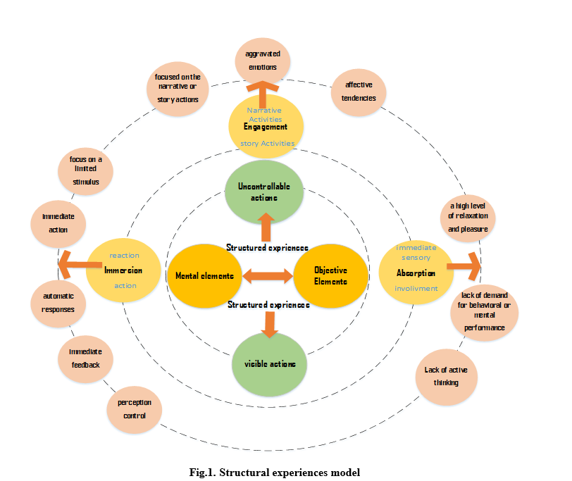
Specifically, it is essential to note that immersion, absorption, and engagement do not occur solely, even though a specific activity may be designed to emphasize one of these. For example, the experience of having a good lunch may be a combination of engaging in conversation and being absorbed in the sensory experience of food. An outdoor sporting event, choosing to enjoy hiking, or a random tennis match may all have the same potential to shape interaction and engagement in experiences; thus, they can be immersed (D. Ellis, A. Freeman, Jamal, Jiang,2017).

3.Methods
3.1. design
This research is quantitative and applied in terms of objectives. In addition, this study is considered a hypothesis testing, conducted through observations, interviews, and questionnaires to collect the required data. Surveys, along with descriptive and content analyses, were also used to collect and compile theoretical data, which were then analyzed using descriptive and content analyses. The data analysis section has used the causal research method and structural equation modeling (SEM).
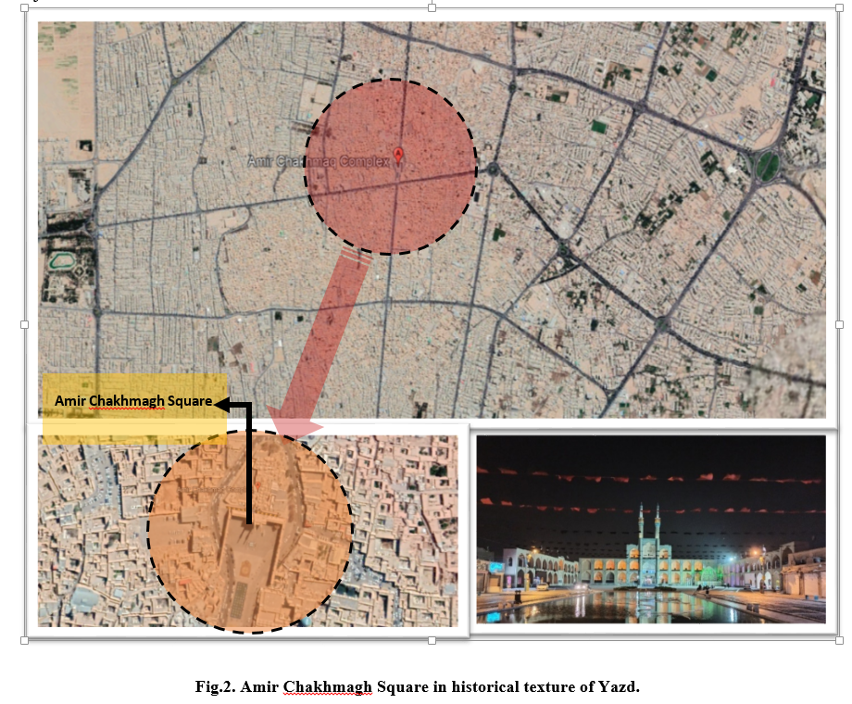
This study attempts to understand the concurrent effects of place experience, structured experiences, and place attachment on each other based on the perspectives of users in urban squares. The main context of this research is in an urban square, Amir Chakhmagh Square, located in the historical texture of Yazd (Fig. 2). This square plays a unique role in the city structure and its extension in different historical periods, attracting many daily visitors. It is one of the most fabulous squares in the historical period of Iranian architecture, known as a symbol of the brick city of Yazd all over the world. After collecting data from users by a comprehensive questionnaire, the study aims to investigate the effect of the three concepts of place experience, structured experiences, and place attachment formation on each other through the structural equation analytic method (SEM) in Lisrel software. Finally, the study will report whether the impacts of the involved concepts on each other are observed and if the research hypotheses are accepted or rejected.
3.2.The study objectives and hypotheses
This research sets out to identify the effect of place experience, structured experiences, and place attachment on each other in traditional urban public spaces (Fig.3), especially urban squares. The main objectives of this study are to measure each of these variables separately and investigate their effects on each other in the historical square of Amir Chakhmagh. Following these objectives and research model, the three hypotheses below are proposed:
  - Place attachment has a direct and positive effect on shaping the place experiences in Amir Chakhmagh Square.
  - Place attachment has a direct and positive effect on shaping the structured experiences in Amir Chakhmagh Square.
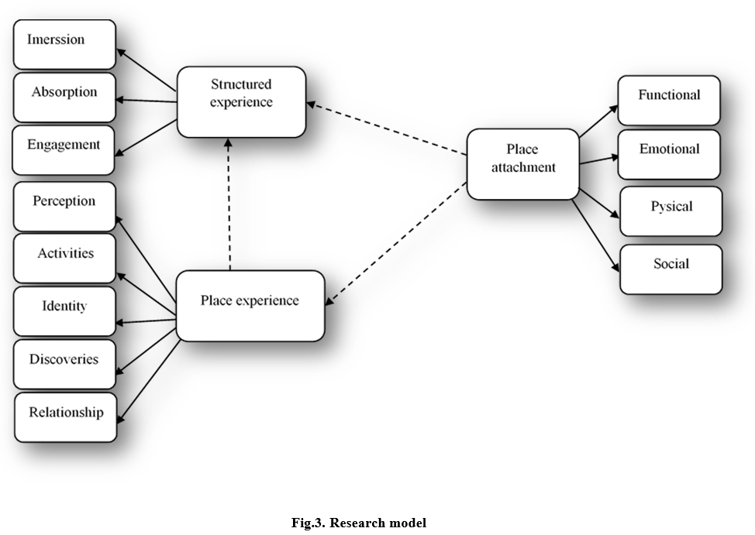
  - Place experiences directly and positively affect shaping the structured experiences in Amir Chakhmagh Square.

3.3. Sample and respondents
Data for this study were collected from visitors and users of Amir Chakhmagh Square in the historical texture of Yazd using questionnaires designed on a 5-point Likert scale according to studies previously conducted. Respondents were asked to answer the questions by selecting one of the options "Very High," "High," "Medium," "Low," and "Very Low." Under research variables, seventy-five questions were used to design the questionnaire to obtain the required data accurately. Accordingly, the questionnaires were randomly distributed among the users and visitors of this square. Due to the uncertainty about the population of visitors, 90 questionnaires had to be distributed according to Cochran's second formula at 90% confidence level with q = p = 0.5 and d = 0.05 with error. However, 235 questionnaires were distributed to ensure the high validity of the research and comply with the condition that the sample size should be at least three times the number of indicators when performing statistical tests. Eventually, 225 questionnaires were received from respondents.

3.4. Data Analysis and Sample
According to the questionnaires distributed among the users of Amir Chakhmagh Square, the highest percentages were allocated to the female (70.56%), married (60.71%), postgraduate (90.36%), and employee (90.44%) respondents in the age range of 15-30 (34.20%). The following table presents the respondents' information for interpretation.
Table2. Demographic information
item | range | percentage
Age | 15-30 | 34/20
Age | 31-45 | 28/40
Age | 46-60 | 21/80
Age | 61-75 | 12/00
Age | Up than 75 | 3/60
Gender | Male | 43/30
Gender | Female | 56/70
Marital status | Single | 21/40
Marital status | Married | 71/60
Adjudication | Diploma and less | 12/00
Adjudication | Bachelor | 33/80
Adjudication | Master | 36/90
Adjudication | PhD | 17/30
Job | Self-employment | 11/60
Job | Employee | 44/90
Job | Housewife | 5/80
Job | Student | 27/60
Job | Unemployed | 10/20
4. Results
4.1. Measurement Model Analysis
The research model was analyzed to pursue the relationships between the variables in the measurement model. Primarily, the research reliability and validity were measured for data accuracy, followed by the assessment of normality of the data. Structural equations evaluate the effects of hidden and observed variables to confirm or reject the hypotheses. Therefore, the face validity of the research instrument (questionnaire) was confirmed by university professors, and its reliability was confirmed using Cronbach's alpha test. This study evaluated three variables of place attachment, place experiences, and structured experiences with separate structures while measuring the impacts of variables on each other.
4.2. Reliability and Validity
The Cronbach's alpha test was used to assess the reliability of the questionnaire, leading to a value of 0.955, which was greater than 0.7. Accordingly, the internal correlation between the items is high, and the questionnaire has desirable reliability.

Table3. Reliability and Validity
Reliability Statistics
Cronbach's Alpha | N of Items
0.955 | 73

4.3. Normality of data distribution
The Kolmogorov–Smirnov test was used to check the normality of data distribution, confirming the normality of data distribution according to the sig obtained. The Bartlett test was then used to determine the correlation between the data, leading to the numerical values of KMO equal to 0.803 (place attachment), 0.793 (place experience), and 0.731(structured experience). Given that these values are greater than 0.7, the correlation between the data is convenient for factor analysis. Besides, the significance level (sig) in the Bartlett test is equal to 0.000, which is less than 0.05 and confirms the ability of the data to be functional.
Table4. Normality of data distribution
KMO and Bartlett's Testª
Place attachment |  |  | Place experiences | Structured experience
Kaiser-Meyer-Olkin Measure of Sampling Adequacy. |  | 0.803 | 0.793 | 0.731
Bartlett's Test of Sphericity | Approx. Chi-Square | 2712.492 | 2170.222 | 4895.850
Bartlett's Test of Sphericity | df | 253 | 171 | 465
Bartlett's Test of Sphericity | Sig. | .000 | .000 | .000

4.4. Descriptive Statistical Analysis
The indicators belonging to place attachment, place experience, and structural experience are demonstrated in Table 5, considering the Likert Scale on a range of 1-5 (from too low to very high).
Table5. Descriptive Statistics
Indicators | N | Mean | Std. Deviation
Indicators | Statistic | Statistic | Statistic
Place attachment
Forming personal identity | 225 | 4.03 | .839
Forming social identity | 225 | 3.96 | .890
Collective Communities | 225 | 3.28 | 1.217
Place identity | 225 | 3.52 | 1.057
Historic walls (Historical environment) | 225 | 3.27 | 1.340
Flooring quality | 225 | 2.60 | 1.134
Covered or open space | 225 | 3.84 | .904
Nearby shops | 225 | 3.16 | 1.098
The closeness between individual beliefs and space | 225 | 3.28 | 1.190
Collective commercial spaces )cafes and restaurants( | 225 | 3.76 | 1.149
Traditional architecture symbole | 225 | 3.84 | 1.171
Water elements | 225 | 3.57 | 1.335
Quality of urban furniture | 225 | 3.44 | 1.141
Available edges for sitting and talking | 225 | 3.70 | 1.043
Junction of Square to the neighboring bazaar | 225 | 2.88 | 1.280
Social elements | 225 | 3.07 | 1.351
Mental identity | 225 | 2.55 | 1.122
New communications | 225 | 3.37 | 1.119
Group visiting | 222 | 3.45 | .925
Different cultures | 225 | 3.98 | 1.087
Transparent environment views | 225 | 3.11 | .955
Visiting goals | 224 | 2.95 | 1.078
Required usage | 225 | 3.39 | 1.179
Place experiences
Eating special food of Yazd | 225 | 3.48 | .936
Diffrent activities | 225 | 3.63 | 1.066
Sence of security | 220 | 3.25 | 1.249
Visibility and transparently | 225 | 3.48 | 1.180
Communication with traditional people of Yazd(receive local signals) | 225 | 3.68 | .994
Motivation for re-visiting | 225 | 3.45 | 1.073
Perceptible enviroment | 225 | 3.41 | 1.185
Value of Square as a unique one | 225 | 3.05 | 1.095
Matching the walls with traditional architecture | 225 | 3.26 | 1.255
Harmony of the flooring with traditional architecture | 225 | 3.01 | 1.324
Role of flooring in understanding the physical environment | 225 | 2.51 | 1.289
Matching square features from farther distances (perception from farther distances) | 225 | 2.21 | 1.195
Feeling aroused in place | 225 | 3.06 | 1.256
Feeling regret in place | 223 | 2.35 | 1.063
Decide to leave immediately | 224 | 3.17 | 1.099
Decide to presence Longerly | 225 | 3.56 | .994
Discover new shapes and information | 225 | 3.34 | 1.095
Attendance with complete enjoyment | 225 | 3.24 | 1.186
Attendance with excitement | 225 | 3.48 | 1.040
Sinking in space | 225 | 3.01 | 1.188
Individual memories formation | 225 | 3.52 | 1.150
Collective memories formation | 225 | 3.04 | .850
Structured experience
Your needs in space) Health, comfort, nutritional, dynamic needs( | 225 | 3.28 | .998
Space unity | 225 | 3.19 | .936
The connection between manner and space | 225 | 2.93 | 1.091
Simultaneous activities | 225 | 2.99 | .832
Dynamic visit | 225 | 3.27 | .965
Stable visit | 225 | 2.97 | .984
Historical background | 225 | 3.09 | 1.044
Awareness of events | 223 | 3.16 | 1.138
Constant look at events | 225 | 3.16 | 1.199
Thinking and moving immediately | 225 | 3.57 | 1.171
Subconscious movement | 225 | 3.24 | .952
Fading in space | 225 | 3.36 | .925
Deep thinking | 225 | 3.49 | .983
Artistic performances and competition | 225 | 2.92 | 1.107
Remembering similar situations | 225 | 3.30 | 1.025
Instant response | 225 | 3.39 | 1.194
Peace creation | 225 | 3.08 | 1.121
Unable to react | 223 | 2.83 | 1.375
Imagination of space | 225 | 3.05 | .994
Walking, watching the scenery | 225 | 2.59 | .979
Cycling in the square | 225 | 3.20 | .885
Continues visiting in periods | 225 | 3.31 | .930
Feeling overly happy or overly upset | 224 | 3.24 | .799
Complementary events | 225 | 3.28 | 1.000
Role in improving space | 225 | 3.25 | 1.062
Consciousness of situation | 225 | 3.48 | .871
Perfect starting and ending | 225 | 3.40 | .950
Different time events intervals | 225 | 3.28 | .834
4.5. SEM statistical Analysis
Place attachment (P.A), which consists of physical, social, functional, and emotional dimensions is a crucial contributor to public spaces, especially urban squares. Furthermore, experiences related to place manifest the dynamics of city life and citizens in public places. The most integral public places of any city are its squares, especially in traditional cities, which are more important and considered the beating urban hearts. All historical, social, and cultural events begin and end in urban squares, which can be the most substantial experience of any city during its history.
Along with the place experiences (P.E), a new concept is also presented as structured experiences (S.E), offering a new perspective on the overlap of experiences, attachment, and urban life, although less considered in urban issues. Thus, this research has also followed the same issue in the basic model.
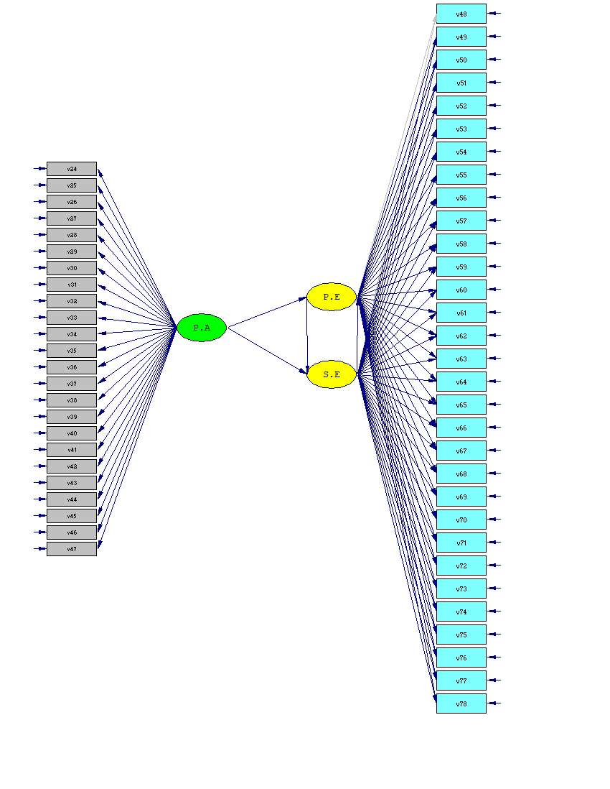

Figure4. Conceptual Model
According to the output of the standard model of structural equations, it is possible to compare the observed variables determining the hidden variables. Therefore, given the research model, P.A has the greatest impact on P.E (1.69) and then S.E (1.53). As can be seen in the model, P.A has an indirect effect on S.E through the structure. The lowest impacts were also related to the effects of S.E on P.E (-1.60). The following formula calculates the indirect effect of this structure.
The indirect effect of P.A on S.E= numerical value of P.A * S.E I.F= 1/69*0/59=0/997
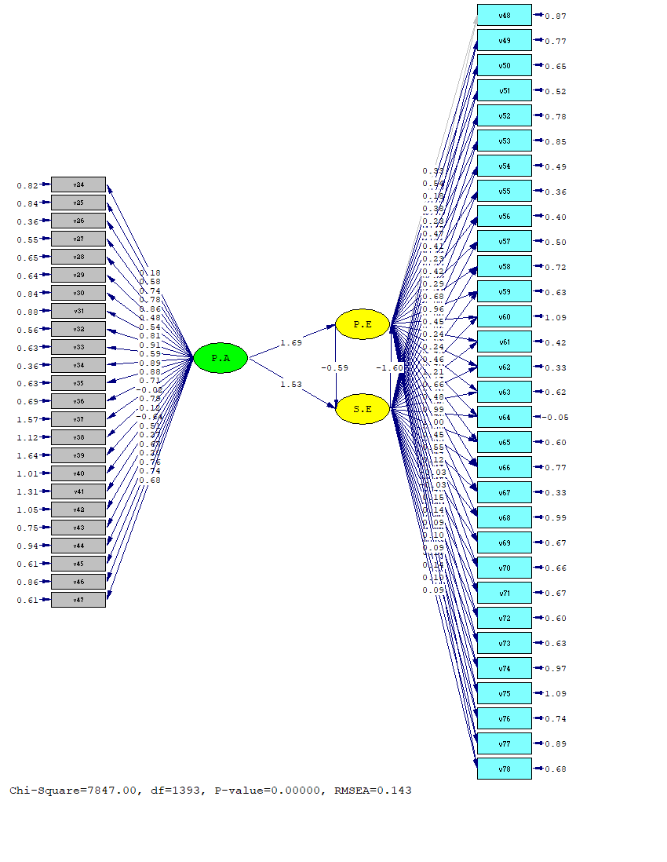
Figure5. Standard Model
In the significance model (T-Value), values greater than 1.96 and less than -1.96 are significant and confirm the existing hypotheses, which are otherwise rejected. Also, LISREL software shows the rejected hypotheses in red color, according to which the second hypothesis is rejected, and other hypotheses are confirmed.
Therefore, it is possible to confirm or reject research hypotheses using the model extracted above and according to the following table.
Table6. Research outcome
No | Hypothesis | Confirmation
1 | i) Place attachment has a direct and positive effect on shaping the place experiences in Amir Chakhmaq Square.
2 | ii) Place attachment has a direct and positive effect on shaping the structured experiences in Amir Chakhmaq Square.
3 | iii) Place experiences have a direct and positive effect on shaping the structured experiences in Amir Chakhmaq Square.

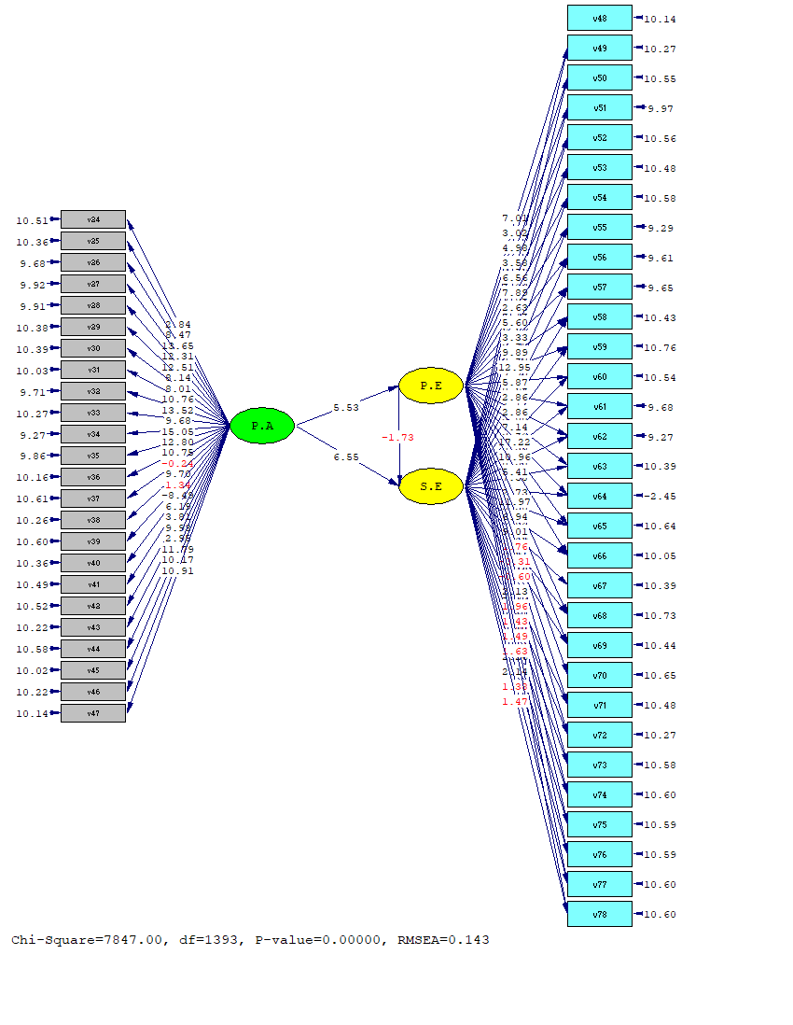
Figure6. T-Value Model
Finally, the statistical indicators of model fit extracted from structural equations can be seen in LISREL software.
Table7. Statistical indicators of model
Item | Rate
Degrees of Freedom | 1389
Full Information ML Chi-Square(P=0) | 7852.50
Root Mean Square Error of Approximation(RMSEA) | 0.14
90 Percent Confidence Interval for RMSEA | (0.15 ; 0.14)
P-Value for Test of Close Fit (RMSEA < 0.05) | 0.00

5. Discussion
Experience and attachment are two intertwined concepts, which flow in any space or place and raise people's feelings. As Ozkan and Yilmaz believe in their research, the primary function of a place is to create a sense of user attachment (Özkan & Yilmaz, 2019). This bond can generally be defined as a positive emotional relationship between a particular place and the people (Dasgupta et al., 2022). In the present study, this place is mainly a square in the heart of the historical context of a city, visited by many visitors. Urban squares, which are the most crucial element of the urban structure, represent the public life of cities. Public squares provide places for citizens to have various outdoor activities. City dwellers can relax, sit, read books, play games, and meet friends in these areas (Z. Memluk, 2013:519). Amir Chakhmagh Square in Yazd, as a notable example of urban-historical squares, is considered an efficient setting for the formation of experiences. As the basis for the formation of this research, this square receives many people daily for different experiences. People's attachment to this place is high because of its location and function in Yazd and support for all group activities such as celebrations, gatherings, art events, etc. This high attachment can guarantee the people's frequent presence, eventually contributing to different experiences for users. Therefore, this study aimed to investigate the interaction of three concepts of place attachment (P.A), place experience (P.E), and structured experiences (S.E). A three-part model of the three mentioned concepts was designed for this research, considering four, five, and three factors for place attachment, place experiences, and structured experiences, respectively.
The initial hypotheses of this study considered the effect of these three variables on each other directly. After extracting the answers of respondents, who used this square in some way, a hierarchical impact cycle was found for these concepts. Accordingly, place attachment (P.A) can lead to more complex and structured experiences (S.E) only after shaping place experiences (P.E). This means that place attachment first motivates different experiences in specific places, after which more structured and complex experiences can be formed, sometimes combining several experiences. As Kaplan et al. pointed out in their research, if a primary perception of an environment is formed, an experience will occur (Kaplan et al.,1998). According to the participants in this study, the attachment to Amir chakhmagh Square has provided an opportunity to comprehend this concept more because of frequent visits, influential features, and historical background. This position facilitates the formation of experiences from simple to complex and multi-stage in this square.
Although Amir Chakhmagh Square supports the physical, social, functional, and emotional dimensions that can easily form a strong place attachment for people, it does not the ability to support the formation of experiences that require movement and stages of growth and development over time. According to D. Ellis et al., structured experiences occur after information processing and passing three steps of anticipation, participation, and interaction (D. Ellis et al., 2019). Experiences have a progressive process and include immediate and thoughtless responses, quick movements, and a distinct beginning and end that are obvious while also covering categories such as seeing the stimulus and moving towards it subconsciously, intuitive running, and making a chain of movements from one point to approach another. In addition, the results of this study show that this historical square is more suitable for sedentary and static experiences related to the characteristics of the place, and people's attachment is more effective than this type of experience. From the users' perspectives, experiences that support emotions and feelings, such as touching walls, excitement, and drowning in space, had more points. This shows that emotional attachment, one of the two types of White’s attitude toward place attachment theory (White, 1981), is more prominent in this square.
To our best knowledge, although the concept of structured experiences (S.E) has been considered in some areas of research such as marketing, tourism, and leisure studies (D. Ellis et al., 2017, Duerden et al., 2015), has not yet been studied enough in the field of urbanism (urban planning and design). This concept combines experiences into three steps and includes the experiences with a unique structure. The basis of these types of experiences can be considered in line with systems theory, according to which the presence of all three stages is necessary for the formation of these, and each stage alone does not lead to the experience formation. The current study has examined these types of experiences, which can be a particular form of experience related to place and a critical topic, which can be a chapter to introduce this concept to urban design.
Based on the review of previous studies, it can be acknowledged that many types of research have been conducted in different areas and contexts in the field of place attachment, including Asia. Researchers in Asian countries have considered this issue very important and investigated it in various fields, from residential to green and public spaces. Research on the role of urban parks and green spaces in shaping this concept has been conducted in some countries such as China, Iran, etc. (Liu et al., 2021, Hosseini et al., 2021).
In Iran, one of the West Asian countries, the study of place attachment is more widely pursued. Researchers try to safely examine this concept in some areas such as public spaces, neighborhoods, and green spaces, combining this concept with others such as quality of life and environmental satisfaction. In a study conducted by Hosseini et al. in Iran, the research context was similar to the present study, which is in the historical context of a city (Hamedan). However, the mentioned research was conducted in the residential context of the city and did not enter the public spaces of the city such as squares. A structural equation model was used to analyze the obtained data as in our research. Another study on place attachment in public spaces was conducted by Firouzmakana and Daneshpour in Iran, investigating the relationship between quality of life and place attachment in Tehran (Firouzmakana & Daneshpour, 2015). Another study in the residential areas of Tehran focused on the relationship between place attachment and public spaces. In this study, in addition to the effect of public spaces, Karami et al. considered peace and security to be important in the formation of place attachment (Karami et al., 2014). In another study by Bazrafshan et al., the target groups were Iranian citizens and Afghan immigrants, whose attachment to urban parks was measured. The specific features of Iranian garden design, long-term presence, and practical and visual perception of the park were introduced as the essential factors (Bazrafshan et al., 2021).
Place attachment has also been studied in East Asian countries such as China, Malaysia, etc., considering contexts such as local and urban landscapes and public urban spaces. Liu et al. conducted a study in China to examine the issue of place attachment to physical environments in multiple regions (Liu et al., 2018). In Malaysia, there has been more research on place attachment in public spaces (Karsono et al., 2021; Ujang et al., 2018). Karsono et al. conducted a study on the extent of place attachment to Riverfront Public Space, focusing on pedestrians as their target group. It is mentioned that research on the issue of spatial attachment in public spaces has been rarely conducted, indicating the importance of addressing this issue (Karsono et al., 2021). In another study, Ujang et al. surveyed the relationship between place attachment and social interaction in public spaces of Kuala Lumpur downtown. In this research, patterns of users' activities and interactions were two leading indicators (Ujang et al., 2018). Research has also been conducted in the Eurasian region, among which the study conducted by Aksel and İmamoğlu can be mentioned focusing on the relationship between place attachment, neighborhood location, and neighborhood satisfaction (Aksel & İmamoğlu, 2021).
Some studies have been conducted on place attachment in European countries. For example, in a study in Poland, Jaśkiewicz examined the relationship between place identity and place attachment in an urban landscape (Jaśkiewicz, 2016). In another study in Switzerland, Von Wirth et al. discussed the relationship between urban change and place attachment, emphasizing the role of urban design in shaping place attachment (von Wirth et al., 2015). The study of place attachment has also been pursued in Central Europe. In his study, Lewicka examined this concept on all scales of a city and measured the degree of attachment to each scale (Lewicka, 2010).
As far as we studied, there has been more research on the experience of tourists visiting places, concerning the concept of place experience. A study by Trauera and Ryan examined the experience of place as one of the factors influencing their study (Trauera & Ryan, 2005). In another study in Italy, Scopellitia and Giuliani examined the experience of place in reconstructed places (Scopellitia & Giuliani, 2004). In a study conducted by Gustafson, the place experience was considered a facilitator for prioritizing the importance of places (Gustafson, 2001). Regarding the relationship between place attachment and place experience, not much research has been conducted based on the literature review. Among the few cases of research in this field, we can mention the studies carried out by Backlund and Williams (2003) and White et al. (2008). The first study addresses place attachment and past experiences in recreational spaces (Backlund & Williams, 2003), while the latter examines the impact of previous experiences and place attachment in protected areas (White et al., 2008). Although the concept of structured experiences has been proposed in other fields, it has not been explored in urban space. Therefore, the study of this concept in urban design is one of our research innovations.
The present research has some strengths:
1. This research has introduced a new concept related to user experience called structured experiences.
2. This research is one of the few pieces of research on place attachment conducted in public spaces.
3. This study has investigated the most important type of such spaces, namely urban squares, which have rarely been approached by researchers in previous studies.
4. This research is one of the studies conducted in one of the urban spaces in a historical city of Iran (Yazd), the results of which can be generalized to other squares in the historical contexts of different cities of the world.
5. This study examines various indicators of the three concepts studied in this field (place attachment, place experience, and structured experience) and has tried to cover all indicators.
On the other hand, this study also has some limitations attributed to the small sample size because of the COVID-19 pandemic and the reduced cooperation of respondents to complete the questionnaires. While a higher number of questionnaires were intended to be distributed to increase the scientific validity of this research, there were barriers due to the existing conditions and general quarantines. Another limitation is the participation of only Iranians in this study, which would be addressed if we could consider the opinions of visitors from other countries in this study.
6. Conclusion
The main focus of this study has been on the effect of place attachment on the formation of place experiences and a new type of experience that can occur in public places. Such experiences go beyond the one-step and straightforward process and are a combination of multiple steps. Structured experiences that follow place experiences have never been considered in public places. The squares of every city are the most critical arena for forming citizenship experiences. Amir Chakhmaqgh Square, the most vital square in the historical city of Yazd, is the main arena for the formation of different experiences. Accordingly, the main concerns of the research in this field were examined. The results obtained in the current study can be generalized to the historical squares of other cities, especially those with a historical context. Future studies can examine the concept of structured experiences in other historical squares as an emerging topic.

References
1. Abdelmonem, M. G., & Selim, G. (2012). Architecture, memory and historical continuity in old Cairo. The Journal of Architecture, 17(2), 163-189.‏
2. Backlund, E. A., & Williams, D. R. (2004). A quantitative synthesis of place attachment research: Investigating past experience and place attachment. In In: Murdy, James, comp., ed. Proceedings of the 2003 Northeastern Recreation Research Symposium; 2003 April 6-8; Bolton Landing, NY. Gen. Tech. Rep. NE-317. Newtown Square, PA: US Department of Agriculture, Forest Service, Northeastern Research Station: 320-325..
3. Bonaiuto, M., Fornara, F., & Bonnes, M. (2003). Indexes of perceived residential environment quality and neighbourhood attachment in urban environments: a confirmation study on the city of Rome. Landscape and Urban Planning, 65(1-2), 41-52.‏
4. Bowlby, J. (1958). The nature of the child's tie to his mother. International journal of psycho-analysis, 39, 350-373.‏
5. Bowlby, J. (1969). Attachment and loss v. 3 (Vol. 1). Random House. Furman, W., & Buhrmester, D.(2009). Methods and measures: The network of relationships inventory: Behavioral systems version. International Journal of Behavioral Development, 33, 470-478.‏
6. Bowlby, J. (1973). Attachment and loss: Volume II: Separation, anxiety and anger. In Attachment and Loss: Volume II: Separation, Anxiety and Anger (pp. 1-429). London: The Hogarth press and the institute of psycho-analysis.‏
7. Bowlby, J. (1980). Loss. vol. 3 of Attachment and loss.‏
8. Bowlby, J. (1982). Attachment and loss: retrospect and prospect. American journal of Orthopsychiatry, 52(4), 664.‏
9. Bretherton, I. (1985). Attachment theory: Retrospect and prospect. Monographs of the society for research in child development, 3-35.‏
10. Bretherton, I., & Waters, E. (Eds.). (1985). Growing points of attachment theory and research (Vol. 50, No. 1). Chicago: University of Chicago Press.‏
11. Brown, B. B., & Perkins, D. D. (1992). Disruptions in place attachment. In Place attachment (pp. 279-304). Springer, Boston, MA.‏
12. Brown, B. B., & Perkins, D. D. (1992). Disruptions in place attachment. In Place attachment (pp. 279-304). Springer, Boston, MA.‏
13. Brown, B., Perkins, D. D., & Brown, G. (2003). Place attachment in a revitalizing neighborhood: Individual and block levels of analysis. Journal of environmental psychology, 23(3), 259-271.
14. Brown, K. W., Ryan, R. M., & Creswell, J. D. (2007). Addressing fundamental questions about mindfulness. Psychological Inquiry, 18(4), 272-281.‏
15. Brown, K. W., Ryan, R. M., & Creswell, J. D. (2007). Mindfulness: Theoretical foundations and evidence for its salutary effects. Psychological Inquiry, 18(4), 211-237.‏
16. Brown, R. P., & Pinel, E. C. (2003). Stigma on my mind: Individual differences in the experience of stereotype threat. Journal of experimental social psychology, 39(6), 626-633.‏
17. Bryant, F. B., & Veroff, J. (2007). Savoring: A new model of positive experience (pp. 184–185).‏
18. Bryant, F. B., Chadwick, E. D., & Kluwe, K. (2011). Understanding the processes that regulate positive emotional experience: Unsolved problems and future directions for theory and research on savoring. International Journal of Wellbeing, 1(1).‏
19. Buzinde, C. N., & Santos, C. A. (2009). Interpreting slavery tourism. Annals of Tourism Research, 36(3), 439-458.‏
20. Carli, M., Fave, A. D., & Massimini, F. (1988). The quality of experience in the flow channels: Comparison of Italian and US students.‏
21. Chavis, D. M., & Pretty, G. M. (1999). Sense of community: Advances in measurement and application. Journal of Community Psychology, 27(6), 635-642.‏
22. Clawson, M., and J. L. Knetsch 1966 Economics of Outdoor Recreation. Baltimore MD: Johns Hopkins University Press.
23. Cohen, E. (1979). The impact of tourism on the Hill Tribes of Northern Thailand. Internationales Asienforum, 10(1/2), 5-38.‏
24. Conway, M. A. (1997). The inventory of experience: Memory and identity. In J. W. Pennebaker, D. Paez, & B. Rime (Eds.), Collective memory of political events (pp. 21–45). Mahwah, NJ: Lawrence Erlbaum.
25. Counted, V., & Zock, H. (2019). Place spirituality: An attachment perspective. Archive for the Psychology of Religion, 41(1), 12-25.‏
26. Cross JE .(2001). What is a sense of place, research on place & space website. [cited 12 March 2003, 20 Feb. 2003]
27. Cross, J. E. (2015). Processes of place attachment: An interactional framework. Symbolic Interaction, 38(4), 493-520.‏
28. Csikszentmihalyi, M. )1975). Beyond Boredom and Anxiety. San Francisco CA: Jossey-Bass.
29. Csikszentmihalyi, M., & Csikzentmihaly, M. (1990). Flow: The psychology of optimal experience (Vol. 1990). New York: Harper & Row.‏
30. Douglas JY, Hargadon A. The pleasures of immersion and engagement: schemas, scripts, and the fifth business. Digit Creative 2001;12(3):153-166. Douglas JY, Hargadon A. The pleasure principle: immersion, engagement, flow. Proc. 11th ACM on Hypertext and Hypermedia 2000:153-160.
31. Duerden, M. D., Ward, P. J., & Freeman, P. A. (2015). Conceptualizing structured experiences: Seeking interdisciplinary integration. Journal of Leisure Research, 47(5), 601-620.‏
32. Dwyer, L., Chen, N., & Lee, J. (2019). The role of place attachment in tourism research. Journal of Travel & Tourism Marketing, 36(5), 645-652.‏
33. Ehrlich, K. B., Stern, J. A., Eccles, J., Dinh, J. V., Hopper, E. A., Kemeny, M. E., ... & Cassidy, J. (2019). A preliminary investigation of attachment style and inflammation in African-American young adults. Attachment & human development, 21(1), 57-69.‏
34. Ellis, G. D., Freeman, P., & Jiang, J. (2017). Creating experiences for study-abroad tourists. Journal of Tourism Insights, 8(1), 4.‏
35. Ellis, G., P. A. Freeman, T. Jamal, and J. Jiang. 2017. “A Theory of Structured Experience.” Annals of Leisure Research 1–22. doi:10.1080/11745398.2017.1312468.
36. Firouzmakan, S., & Daneshpour, S. A. (2015). Promotion quality of life by increasing place attachment in public places. Procedia-Social and Behavioral Sciences, 201, 418-428.
37. Frauman, E., & Norman, W. C. (2004). Mindfulness as a tool for managing visitors to tourism destinations. Journal of Travel Research, 42(4), 381-389.‏
38. Green, M. Scholes, M.(2003). Attachment and Human Survival, Karnac Books.
39. Gustafson, P. (2001). Meanings of place: Everyday experience and theoretical conceptualizations. Journal of environmental psychology, 21(1), 5-16.‏
40. Hancfors M, Mossberg L. 2003. Searching for the extraordinary meal experience.Journal of Business and Management, 9(3), 249–270.
41. Harris, P. B., Werner, C. M., Brown, B. B., & Ingebritsen, D. (1995). Relocation and privacy regulation: A cross-cultural analysis. Journal of environmental psychology, 15(4), 311-320.‏
42. Hassenzahl, M., & Tractinsky, N. (2006). User experience-a research agenda. Behaviour & information technology, 25(2), 91-97.‏
43. Heidegger, M. (1962). Being and Time, trans. john Macquarrie and edward robinson.‏
44. Henderson, K. A., & Frelke, C. E. (2000). Space as a vital dimension of leisure: The creation of place. World Leisure Journal, 42(3), 18-24.‏
45. Hosseini, F., Sajadzadeh, H., Aram, F., & Mosavi, A. (2021). The Impact of Local Green Spaces of Historically and Culturally Valuable Residential Areas on Place Attachment. Land, 10(4), 351.‏
46. Hummon, D.M. (1992). Community Attachment: Local Sentiment and Sense of place. Plenum, New York.
47. Jaśkiewicz, M. (2015). Place attachment, place identity and aesthetic appraisal of urban landscape. Polish Psychological Bulletin, 46(4), 573-578.‏
48. Jorgensen, B. S., & Stedman, R. C. (2001). Sense of place as an attitude: Lakeshore owners' attitudes toward their properties. Journal of environmental psychology, 21(3), 233-248.‏
49. Jose, P. E., Lim, B. T., & Bryant, F. B. (2012). Does savoring increase happiness? A daily diary study. The Journal of Positive Psychology, 7(3), 176-187.‏
50. Kaltenborn, B. P. (1997). Nature of place attachment: A study among recreation homeowners in Southern Norway. Leisure Sciences, 19(3), 175-189.‏
51. Kaplan, R., Kaplan, S., & Ryan, R. L. (1998). With people in mind: Design and management of everyday nature. Washington, DC: Island.
52. Karami, S., Ghafary, M., & Fakhrayee, A. (2014). Analyzing the correlation between urban spaces and place attachment Evidence from: Narmak neighborhood in Tehran. European Online Journal of Natural and Social Sciences: Proceedings, 3(4 (s)), pp-129.‏
53. Karsono, B., Saleh, B. M., Chung, C. O., & Wahid, J. (2021, March). Place Attachment in the Riverfront Public Space Case of Malaysia. In IOP Conference Series: Materials Science and Engineering (Vol. 1101, No. 1, p. 012028). IOP Publishing.‏
54. Kim, H., & Chen, J. S. (2019). The memorable travel experience and its reminiscence functions. Journal of Travel Research, 58(4), 637-649.‏
55. Koller, D., & Farley, M. (2019). Examining elements of children's place attachment. Children's Geographies, 17(4), 491-500.‏
56. Kyle, G. T., Absher, J. D., & Graefe, A. R. (2003). The moderating role of place attachment on the relationship between attitudes toward fees and spending preferences. Leisure sciences, 25(1), 33-50.‏
57. Langer, E. (2014). Mindfulness in the age of complexity. Harvard Business Review, 92(3), 68-73.‏
58. Langer, E. J., & Moldoveanu, M. (2000). The construct of mindfulness. Journal of Social Issues, 56, 1–9
59. Lansing, J. B., Marans, R. W., & Zehner, R. B. (1970). Planned residential environments (No. 269 pp).‏
60. Lestari, W. M., & Sumabrata, J. (2018, March). The influencing factors on place attachment in neighborhood of Kampung Melayu. In IOP Conference Series: Earth and Environmental Science (Vol. 126, No. 1, p. 012190). IOP Publishing.‏
61. Lewicka, M. (2010). What makes neighborhood different from home and city? Effects of place scale on place attachment. Journal of environmental psychology, 30(1), 35-51.‏
62. Lewicka, M. (2011). Place attachment: How far have we come in the last 40 years?. Journal of environmental psychology, 31(3), 207-230.‏
63. Liu, Q., Fu, W., den Bosch, V., Konijnendijk, C. C., Xiao, Y., Zhu, Z., ... & Lan, S. (2018). Do local landscape elements enhance individuals’ place attachment to new environments? A cross-regional comparative study in China. Sustainability, 10(9), 3100.‏
64. Liu, Q., Zhu, Z., Zhuo, Z., Huang, S., Zhang, C., Shen, X., ... & Lan, S. (2021). Relationships between residents’ ratings of place attachment and the restorative potential of natural and urban park settings. Urban Forestry & Urban Greening, 62, 127188.‏
65. Livingston, M., Bailey, N., and Kearns, A. (2010) Neighbourhood attachment in deprived areas: evidence from the north of England , Journal of Housing and the Built Environment 25: 409-27.
66. Loureiro, S. M. C. (2014). The role of the rural tourism experience economy in place attachment and behavioral intentions. International Journal of Hospitality Management, 40, 1-9.‏
67. Low, S. M., & Altman, I. (1992). Place attachment. In Place attachment (pp. 1-12). Springer, Boston, MA.‏
68. Malpas, J. E,1999. PLACE AND EXPERIENCE A Philosophical Topography,university of Cambridge press.
69. Manzo, L. C. (2005). For better or worse: Exploring multiple dimensions of place meaning. Journal of environmental psychology, 25(1), 67-86.‏
70. Manzo, L. C., Devine-Wright, P., & Manzo, L. C. (2013). Place attachment. Taylor & Francis.‏
71. Marcheschi, E., Laike, T., Brunt, D., Hansson, L., & Johansson, M. (2015). Quality of life and place attachment among people with severe mental illness. Journal of Environmental Psychology, 41, 145-154.‏
72. Marcus, C.C. (1992). ‘Environmental memories’, In low, S.M. and Altman, I. (Eds.) Place Attachment, New York, Plenum Press.
73. Marcus, C.C. and Sarkissian, W. (1986). Housing as if People Mattered, Berkeley, University of California Press.
74. Memluk, M. Z. (2013). Designing urban squares. In Advances in Landscape Architecture. IntechOpen.‏
75. Mesch, G. S., & Manor, O. (1998). Social ties, environmental perception, and local attachment. Environment and Behavior, 30(4), 504-519.‏
76. MIHALCA, I. A., & IOVU, M. (2014). MEASURING PLACE ATTACHMENT TO CĂLIMANI NATIONAL PARK (ROMANIA) AMONG LOCAL RESIDENTS AND TOURISTS. PRELIMINARY FINDINGS. Studia Universitatis Babes-Bolyai, Geographia, 59(1).‏
77. Mikulincer, M., Shaver, P. R., & Pereg, D. (2003). Attachment theory and affect regulation: The dynamics, development, and cognitive consequences of attachment-related strategies. Motivation and Emotion, 27(2), 77-102.‏
78. Milligan, M. J. (1998). Interactional past and potential: The social construction of place attachment. Symbolic Interaction, 21(1), 1–33.
79. Moore, J. (2000). Placing home in context. Journal of environmental psychology, 20(3), 207-217.‏
80. Morgan, P. (2010). Towards a developmental theory of place attachment. Journal of environmental psychology, 30(1), 11-22.‏
81. Nakamura, J., & Csikszentmihalyi, M. (2009). Flow theory and research. Handbook of positive psychology, 195-206.‏
82. Peet, R. (1998). Poststructuralism, Postmodernism and Postmodern Geographies. Peet, R. Modern Geographical Thought. Blackwell, Oxford.‏
83. Perry, B. D. (1999). Maltreated children: Experience, brain development and the next generation. Norton.‏
84. Pine, B. J.II, Gilmore, J.H., 1999. The Experience Economy. Harvard Business School Press, Boston, p. 194.
85. Proshansky, H.M., Kaminoff, R.D., 1980. Place-identity: the physical socialization of the self. In: Paper presented at the Annual Convention of the American Psychological Association, Montreal, Canada
86. Qu, Y., Xu, F., & Lyu, X. (2019). Motivational place attachment dimensions and the pro-environmental behaviour intention of mass tourists: A moderated mediation model. Current Issues in Tourism, 22(2), 197-217.‏
87. Rappaport SD. Lessons from online practice: new advertising models. J Advert Res 2007;47(2):135.
88. Reeve, K. L., Shumaker, C. J., Yearwood, E. L., Crowell, N. A., & Riley, J. B. (2013). Perceived stress and social support in undergraduate nursing students' educational experiences. Nurse education today, 33(4), 419-424.‏
89. Riley, R. B. (1992). Attachment to the ordinary landscape. In Place attachment (pp. 13-35). Springer, Boston, MA.‏
90. Rollero, C., & De Piccoli, N. (2010). Does place attachment affect social well-being?. European Review of Applied Psychology, 60(4), 233-238.‏
91. Rollero, C., & De Piccoli, N. (2010). Place attachment, identification and environment perception: An empirical study. Journal of Environmental Psychology, 30(2), 198-205.‏
92. Sawyer, K. (2019). The Embodiment of Attachment and Grief in Adolescents: A Literature Review.‏
93. Scannell, L., & Gifford, R. (2014). Comparing the theories of interpersonal and place attachment. Place attachment: Advances in theory, methods, and applications, 23-36.‏
94. Schroeder, V. (2000). MATLAB functions of ionization and attachment coefficients.‏
95. Schulz, C.N. (1984). The concept of dwelling, New York: Rizzoli. p.9.
96. Scopelliti, M., & Giuliani, M. V. (2004). Choosing restorative environments across the lifespan: A matter of place experience. Journal of environmental psychology, 24(4), 423-437.‏
97. Seamon, D. (2013). Phenomenology and uncanny homecoming‘, in D. Boscaljon (ed.), Resisting the place of belonging, Burlington, Vermont: Ashgate (forthcoming).
98. Shahimi, S. S., Tukiman, I., & Hussain, M. R. M. (2019). People’s Experiences in Relation to the City Liveliness of Urban Heritage Trail.‏
99. Shumaker, S. A., & Taylor, R. B. (1983). Toward a Clarification of People-Place Relationships: A Model of Attachment to Place. In N. R. Feimer, & E. S. Geller (Eds.), Environmental Psychology: Directions and Perspectives (pp. 219-251). New York: Praeger.
100. Song, Z., & Soopramanien, D. (2019). Types of place attachment and pro-environmental behaviors of urban residents in Beijing. Cities, 84, 112-120.‏
101. Stedman, R., Beckley, T., Wallace, S., & Ambard, M. (2004). A picture and 1000 words: Using resident-employed photography to understand attachment to high amenity places. Journal of Leisure Research, 36(4), 580-606.‏
102. Stokowski, P. 2002. Languages of place and discourses of power: Constructing new senses of place. Journal of Leisure Research. 34(4): 368-382.
103. Trauer, B., & Ryan, C. (2005). Destination image, romance and place experience—an application of intimacy theory in tourism. Tourism Management, 26(4), 481-491.
104. Trentelman, C. K. (2009). Place attachment and community attachment: A primer grounded in the lived experience of a community sociologist. Society and natural resources, 22(3), 191-210.‏
105. Tuan, Y. F. (1974). Topophilia: A study of Environment Perception Attitudes and Values Prentice Hall International. New Jersey.‏
106. Turan, B., Osar, Z., Turan, J. M., Ilkova, H., & Damci, T. (2003). Dismissing attachment and outcome in diabetes: The mediating role of coping. Journal of Social and Clinical Psychology, 22, 607–626.
107. Twigger-Ross, C. L., & Uzzell, D. L. (1996). Place and identity processes. Journal of environmental psychology, 16(3), 205-220.‏
108. Ujang, N., & Zakariya, K. (2018). Place attachment as indicator for place significance and value. Asian Journal of Behavioural Studies, 3(10), 95-103.‏
109. Ujang, N., Kozlowski, M., & Maulan, S. (2018). Linking place attachment and social interaction: towards meaningful public places. Journal of Place Management and Development.‏
110. Urry, J. (1990). Theconsumption'of tourism. Sociology, 24(1), 23-35.‏
111. Von Wirth, T., Grêt-Regamey, A., Moser, C., & Stauffacher, M. (2016). Exploring the influence of perceived urban change on residents' place attachment. Journal of environmental psychology, 46, 67-82.‏
112. Vuddhakanok, S., Solt, C. W., Mitchell, J. C., Foreman, D. W., & Alger, F. A. (1993). Histologic evaluation of periodontal attachment apparatus following the insertion of a biodegradable copolymer barrier in humans. Journal of periodontology, 64(3), 202-210.‏
113. White, D. D., Virden, R. J., & Van Riper, C. J. (2008). Effects of place identity, place dependence, and experience-use history on perceptions of recreation impacts in a natural setting. Environmental Management, 42(4), 647-657.‏
114. White, P. C., & Lovett, J. C. (1999). Public preferences and willingness-to-pay for nature conservation in the North York Moors National Park, UK. Journal of Environmental Management, 55(1), 1-13.
115. Wild, T. C., Kuiken, D., & Schopflocher, D. (1995). The role of absorption in experiential involvement. Journal of personality and social psychology, 69(3), 569.‏
116. Williams, D. R., Patterson, M. E., Roggenbuck, J. W., & Watson, A. E. (1992). Beyond the commodity metaphor: Examining emotional and symbolic attachment to place. Leisure sciences, 14(1), 29-46.‏
117. Williams, D.R. 2002. Post-utilitarian forestry: What’s place got to do with it? In Proceedings of the Human Dimensions of Natural Resources in the West Conference, pp. 114-123. Fort Collins, CO: Human Dimensions Unit, College of Natural Resources, Colorado State University.
118. Zahnow, R., & Tsai, A. (2019). Crime Victimization, Place Attachment, and the Moderating Role of Neighborhood Social Ties and Neighboring Behavior. Environment and Behavior, 0013916519875175.‏

